Name of Journal: World Journal of Clinical Cases
Manuscript NO: 70081
Manuscript Type: CASE REPORT

Immunoglobulin G4-related kidney disease involving the renal pelvis and perirenal fat: A case report

He JW et al. A case report of IgG4-RKD

Jun-Wei He, Qian-Ming Zou, Jun Pan, Shu-Sheng Wang, Song-Tao Xiang

Jun-Wei He, Qian-Ming Zou, Jun Pan, Shu-Sheng Wang, Song-Tao Xiang, Department of Urology, the Second Affiliated Hospital of Guangzhou University of Chinese Medicine, Guangzhou 510000, Guangdong Province, China

Author contributions: He JW drafted the manuscript and designed the figures and table; Zou QM and Wang SS analyzed and interpreted the data regarding computed tomography and magnetic resonance imaging; Pan J searched and reviewed the literature; Xiang ST participated in the final diagnosis and reviewed the final version of this work.

Supported by the National Natural Science Foundation of China, No. 8177140433.

Corresponding author: Song-Tao Xiang, PhD, Chief Doctor, Department of Urology, the Second Affiliated Hospital of Guangzhou University of Chinese Medicine, No. 111 Dade Road, Yuexiu District, Guangzhou 510000, Guangdong Province, China. tonyxst@163.com

Received: July 22, 2021
Revised: October 30, 2021
Accepted: February 10, 2022
Published online:

Abstract
BACKGROUND
Immunoglobulin (Ig) G4-related disease (IgG4-RD) is an autoimmune disease associated with chronic and progressive inflammation and fibrosis. It is difficult to differentiate IgG4-RD involving the kidney from infectious diseases and malignancy on imaging.

CASE SUMMARY
We report the case of a 51-year-old Chinese man whose abdominal computed tomography scan showed diffuse bilateral enlargement of the kidneys and perirenal fat, thickening of the renal pelvic walls, and hydronephrosis of the right kidney. Relevant laboratory test results showed a serum creatinine level of 464 μmol/L. The patient was diagnosed with acute renal failure and was started on intermittent hemodialysis. Further tests revealed high serum IgG4 levels (20.8 g/L) and an enlarged right submaxillary lymph node. Biopsy and histopathological examination of the enlarged node led to the diagnosis of IgG4-RD. After corticosteroid therapy, his serum creatinine level quickly decreased to near normal levels.

CONCLUSION
IgG4-RD affecting the renal pelvis or perirenal fat is rare, with atypical imaging features. Multidisciplinary consultation is critical for accurate diagnosis and treatment of this disease. Suspected cases should undergo biopsy to avoid misdiagnosis.

Key Words: Immunoglobulin G4-related disease; Renal pelvic; Perirenal fat; Case report

He JW, Zou QM, Pan J, Wang SS, Xiang ST. Immunoglobulin G4-related kidney disease involving the renal pelvis and perirenal fat: A case report and literature review. World J Clin Cases 2022; In press

Core Tip: In this case, computed tomography showed diffuse bilateral enlargement of the kidneys and perirenal fat, thickening of the renal pelvic walls, and hydronephrosis of the right kidney which was similar to those of infectious diseases and malignancy. Histological examination confirmed the diagnosis of IgG4-RD.

INTRODUCTION
Immunoglobulin (Ig) G4-related disease (IgG4-RD) is an autoimmune disease associated with chronic and progressive inflammation and fibrosis, characterized by heavy IgG4-positive plasma cell infiltration and fibrosis in the affected tissues^{[1]}. It is also known as IgG4-related kidney disease (IgG4-RKD), as it usually involves the renal parenchyma, perirenal fat, renal pelvis, and ureter. The disease manifests on computed tomography (CT) scans as a diffuse enlarged kidney, swollen perirenal fat, and thickened renal pelvis and ureter, which makes it difficult to differentiate from an infectious disease or tumor. Recently, we encountered a 51-year-old Chinese man who was finally diagnosed with IgG4-RD after pathological examination. We report this rare case of IgG4-RD, which is easily misdiagnosed as either a malignant tumor or an infectious disease, along with a summary of relevant literature.

CASE PRESENTATION
Chief complaints
On January 11, 2020, a 51-year-old man was admitted to our hospital with the complaint of chest oppression.

History of present illness
The patient had symptoms of chest oppression for 10 d, with no obvious cause, along with edema of both lower extremities. The patient denied having pain upon urination, low back pain, fever, or any other clinical manifestations.

History of past illness
The patient had no previous medical history.

Personal and family history
The patient had no specific personal and family history.

Physical examination
Physical examination of the heart and lungs was unremarkable, but both lower extremities had moderate edema. Blood pressure was normal without significant fluctuations. The patient also had an enlarged right submaxillary lymph node.

Laboratory examinations
Laboratory tests revealed a serum creatinine (Cr) level of 464 μmol/L, potassium concentration of 5.52 mmol/L, brain natriuretic peptide level of 376.2 pg/mL, and high-sensitivity C-reactive protein level of 20.4 mg/L (normal reference range: 0 to 6.0 mg/L). A routine urine test revealed a red blood cell count of 67.3/μL (normal reference range, 0 to 4/μL) and a white blood cell count of 731/μL (normal reference range, 0 to 5/μL). Serum IgG4 level was found to be high at 20.8 g/L (normal reference range, 0.03 to 2 g/L). Hepatitis B surface antigen, antineutrophil cytoplasmic antibody, and rheumatoid factor were negative, and other test results were within the normal limits.

Imaging examinations
Abdominal CT showed diffuse bilateral enlargement of the kidneys and perirenal fat, thickening of the renal pelvic walls, and hydronephrosis of the right kidney (Figure 1A). On magnetic resonance imaging (MRI) scans, the wall of the renal pelvis and ureter was thickened on contrast-enhanced images (Figure 1B). An ultrasound of the neck revealed an enlarged right submaxillary lymph node measuring approximately 29 mm × 19 mm.

Pathology and immunohistochemical examination
Biopsy of the submaxillary node was performed for histopathological examination, which revealed a dense infiltrate of lymphoplasmacytic cells along with fibrosis. The IgG4+/IgG ratio determined by immunohistochemical staining was 60% in the specimens, and the average IgG4 plasma cell count was 100/high-power field (HPF) (Figure 2).

FINAL DIAGNOSIS
According to the comprehensive diagnostic criteria for IgG4-RD, the patient was finally diagnosed with IgG4-RD.

TREATMENT
The patient first presented with chest oppression to the Cardiovascular Department. However, coronary heart disease was ruled out by the cardiologist according to the laboratory tests. The patient was hospitalized and maintained on intermittent hemodialysis due to acute renal failure. The level of urinary protein excretion was 2129.6 mg/d. Laboratory tests revealed a serum IgG level of 21.15 g/L, and serum complement 4 level of 0.52 g/L. Further tests were conducted to determine the cause of diffuse bilateral enlargement of the kidneys and perirenal and thickening of the renal pelvic walls. Serum IgG4 level was found to be high at 20.8 g/L (normal reference range, 0.03 to 2 g/L), and an enlarged lymph node was found in the right submaxillary area. Ultrasound indicated that the right submaxillary lymph node was enlarged, and was approximately 29 mm × 19 mm in size. Pathological biopsy of the submaxillary mass was performed. Dense lymphoplasmacytic cells with fibrotic changes were found on histopathology. Based on these findings, the patient was diagnosed with IgG4-RD. He was initially started on intravenous methylprednisolone sodium succinate 40 mg/d for 2 wk. Two weeks later, his Cr level decreased to 117 μmol/L; thus, treatment was changed to oral prednisone at 40 mg once a day, and then the dosage was reduced by 10 mg biweekly.

OUTCOME AND FOLLOW-UP
During the follow-up period, urinary tract ultrasound was performed every 6 mo, and the serum Cr level was examined every 2 mo. To date, no recurrence has been identified, and serum Cr level is normal.

DISCUSSION
IgG4-RD is a new disease recognized in the twenty-first century. Kamisawa proposed the concept of IgG4 systemic disease for the first time in 2003 and named the disease IgG4-RD in 2010^{[2,3]}. IgG4-RD is a systemic disease characterized by diffuse enlargement of single or multiple organs and elevated IgG4 serum levels, with infiltration of lymphocytes and IgG4-positive plasma cells, as well as fibrosis, typically seen on histopathology. Two IgG4-RD study groups, the Umehara and Okazaki teams, organized by the Ministry of Health, Labour and Welfare in Japan, established the definitive diagnostic criteria for IgG4-RD in 2011 as follows: (1) Clinical examination showing characteristic diffuse/localized swelling or masses in a single organ or multiple organs; (2) Hematological examination showing elevated serum IgG4 concentrations (≥ 135 mg/dL); and (3) Histopathologic examination showing (a) marked lymphocyte and plasmacyte infiltration and fibrosis and (b) infiltration of IgG4+ plasma cells with a ratio of IgG4+/IgG+ cells >40% and >10 IgG4+ plasma cells/HPF^{[4]}. Corticosteroid therapy has been found to be effective for IgG4-RD. All three criteria were met, and a good outcome was achieved after corticosteroid therapy in our case.
IgG4-RD that involves the kidney, also known as IgG4-RKD, is difficult to differentiate from infectious diseases and malignancy on imaging. The characteristic radiological features of IgG4-RKD are as follows: (1) Multiple low-density areas on contrast CT, (2) Diffuse bilateral enlargement of the kidneys in patients with decreased renal function in whom the administration of contrast medium is inadvisable, and (3) Diffuse thickening of the renal pelvic walls with a smooth luminal surface^{[5]}. Kim et al^{[6]} proposed that the characteristic MRI findings of IgG4-RKD were bilateral, multiple, renal parenchymal nodules with T2 hypointensity, diffusion restriction, and a progressive enhancement pattern.
IgG4-RKD usually involves the renal parenchyma. However, renal pelvis and ureter involvement are rare, and perirenal fat involvement is even rarer. Renal pelvis involvement in IgG4-RKD is usually characterized by thickening of the pelvic wall, which is easily misdiagnosed as carcinoma of the renal pelvis and removed surgically. Naoto et al, in 2009, reported the first case of IgG4 systemic disease involving the renal pelvis. The patient was misdiagnosed on imaging with a renal pelvis tumor and underwent nephroureterectomy; however, histopathological examination prompted the diagnosis of IgG4-related disease of the renal pelvis. This was the first case of pathology-confirmed IgG4 systemic disease involving the renal pelvis^{[7]}. We searched the literature for articles published in the English language between January 2000 and June 2020 concerning manifestations of IgG4-RKD affecting the renal pelvis or perirenal fat. We identified and reviewed 13 articles that reported cases of IgG4-RKD affecting the renal pelvis or perirenal fat^{[8-12]}. Among the cases of IgG4-RD affecting the renal pelvis or perirenal fat reported in the literature, 53.8% (7/13) underwent nephrectomy or nephroureterectomy, and the pathological diagnosis was IgG4-RKD^{[13-17]}. From our literature review, we found that the misdiagnosis rate of IgG4-RD involving the renal pelvis was very high, suggesting that currently, urologists generally lack understanding of this disease^{[18,19]}. This causes a certain delay in the diagnosis and treatment stages. Fortunately, renal function was restored after treatment, and further unnecessary surgery was avoided. The manifestations of this disease on imaging are atypical, involving the renal parenchyma, renal pelvis, ureter, and perirenal fat at the same time. The literature review showed that only two cases of IgG4-RD involving the perirenal fat have been reported globally, which are extremely rare cases^{[17]}.
There has been little attention to urinary system involvement besides renal parenchyma. According to the study by Zhang et al^{[12]}, elevated serum IgG and IgG4 were found in all patients with IgG4-RKD, but no hypocomplementemia was found. Teng et al^{[20]} reported that all patients with IgG4-related urinary disease had marked elevations in serum IgG4 levels, and 76.9% had hyperglobulinemia at diagnosis. The study also showed that 20% of patients with IgG4-related urinary disease had nephritis confirmed by urine tubular injury markers accompanied by acute renal dysfunction and required emergency medical intervention. More than 90% of IgG4-RKD patients have a history of extrarenal lesions, which is an important basis for differential diagnosis. A satisfactory response to corticosteroid therapy is a characteristic feature of IgG4-RD.

CONCLUSION
IgG4-RD is a recently identified disease, which rarely affects the renal pelvis or perirenal fat and has atypical imaging features that make it difficult to differentiate from infectious diseases and malignancy. Therefore, urological surgeons must improve their understanding of these diseases, so they can identify the nonspecific clinical symptoms and the bilateral, multiple, atypical organ lesions on imaging, and confirm the diagnosis with serological examination. There were several characteristic clinical features of IgG4-RKD in our case, including the involvement of multiple organs, high levels of serum IgG and IgG4, and a rapid initial response to corticosteroids. Multidisciplinary consultation is critical for the accurate diagnosis and treatment of this disease. Suspected cases should undergo biopsy to avoid misdiagnosis.

ACKNOWLEDGEMENTS
We thank Xiao-Hua Du, Department of Pathology, for his technical assistance with immunohistochemistry staining.

REFERENCES
1 Kamisawa T, Zen Y, Pillai S, Stone JH. IgG4-related disease. Lancet 2015; 385: 1460-1471 [PMID: 25481618 DOI: 10.1016/S0140-6736(14)60720-0]
2 Kamisawa T, Funata N, Hayashi Y, Eishi Y, Koike M, Tsuruta K, Okamoto A, Egawa N, Nakajima H. A new clinicopathological entity of IgG4-related autoimmune disease. J Gastroenterol 2003; 38: 982-984 [PMID: 14614606 DOI: 10.1007/s00535-003-1175-y]
3 Takahashi H, Yamamoto M, Suzuki C, Naishiro Y, Shinomura Y, Imai K. The birthday of a new syndrome: IgG4-related diseases constitute a clinical entity. Autoimmun Rev 2010; 9: 591-594 [PMID: 20457280 DOI: 10.1016/j.autrev.2010.05.003]
4 Umehara H, Okazaki K, Masaki Y, Kawano M, Yamamoto M, Saeki T, Matsui S, Yoshino T, Nakamura S, Kawa S, Hamano H, Kamisawa T, Shimosegawa T, Shimatsu A, Nakamura S, Ito T, Notohara K, Sumida T, Tanaka Y, Mimori T, Chiba T, Mishima M, Hibi T, Tsubouchi H, Inui K, Ohara H. Comprehensive diagnostic criteria for IgG4-related disease (IgG4-RD), 2011. Mod Rheumatol 2012; 22: 21-30 [PMID: 22218969 DOI: 10.1007/s10165-011-0571-z]
5 Kawano M, Saeki T, Nakashima H, Nishi S, Yamaguchi Y, Hisano S, Yamanaka N, Inoue D, Yamamoto M, Takahashi H, Nomura H, Taguchi T, Umehara H, Makino H, Saito T. Proposal for diagnostic criteria for IgG4-related kidney disease. Clin Exp Nephrol 2011; 15: 615-626 [PMID: 21898030 DOI: 10.1007/s10157-011-0521-2]
6 Kim B, Kim JH, Byun JH, Kim HJ, Lee SS, Kim SY, Lee MG. IgG4-related kidney disease: MRI findings with emphasis on the usefulness of diffusion-weighted imaging. Eur J Radiol 2014; 83: 1057-1062 [PMID: 24768583 DOI: 10.1016/j.ejrad.2014.03.033]
7 Kuroda N, Nakamura S, Miyazaki K, Inoue K, Ohara M, Mizuno K, Sato Y, Yoshino T. Chronic sclerosing pyelitis with an increased number of IgG4-positive plasma cells. Med Mol Morphol 2009; 42: 236-238 [PMID: 20033370 DOI: 10.1007/s00795-008-0425-8]
8 Yoshino T, Moriyama H, Fukushima M, Sanda N. A case of IgG4-related retroperitoneal fibrosis mimicking renal pelvic cancer. Urol Int 2013; 90: 365-368 [PMID: 22964762 DOI: 10.1159/000341703]
9 Inoue S, Takahashi C, Hikita K. A Case of IgG4-Related Retroperitoneal Fibrosis from the Renal Pelvis Mimicking Bilateral Hydronephrosis. Urol Int 2016; 97: 118-122 [PMID: 24732708 DOI: 10.1159/000354765]
10 Tsuzaka Y, Ookubo K, Sugiyama K, Morimoto H, Amano H, Oota N, Kuriki K, Homma Y. [IgG4-related kidney disease: a long-term follow up case of pseudotumor of the renal pelvis]. Nihon Hinyokika Gakkai Zasshi 2014; 105: 51-55 [PMID: 24908817 DOI: 10.5980/jpnjurol.105.51]
11 Wang Y, Chen X, Luo R, Wang H, Wang G, Hou Y, Guo J. IgG4-related systemic disease mimicking renal pelvic cancer: a rare case. World J Surg Oncol 2014; 12: 395 [PMID: 25539994 DOI: 10.1186/1477-7819-12-395]
12 Zhang H, Ren X, Zhang W, Yang D, Feng R. IgG4-related kidney disease from the renal pelvis that mimicked urothelial carcinoma: a case report. BMC Urol 2015; 15: 44 [PMID: 26013281 DOI: 10.1186/s12894-015-0041-6]
13 Inenaga J, Ueno T, Kawada M, Imafuku A, Mise K, Sumida K, Hiramatsu R, Hasegawa E, Hayami N, Suwabe T, Hoshino J, Sawa N, Takaichi K, Fujii T, Ohashi K, Okaneya T, Ubara Y. IgG4-related Disease: A Mass Lesion in the Intrarenal Sinus near the Renal Pelvis. Intern Med 2015; 54: 1897-1900 [PMID: 26234232 DOI: 10.2169/internalmedicine.54.4507]
14 Park HG, Kim KM. IgG4-related inflammatory pseudotumor of the renal pelvis involving renal parenchyma, mimicking malignancy. Diagn Pathol 2016; 11: 12 [PMID: 26796327 DOI: 10.1186/s13000-016-0460-z]
15 Li B, Hou J, Zhang Y, Hou X, Shi H. Retroperitoneal IgG4-related sclerosing disease mimics renal pelvic cancer on (18)F-FDG PET/CT. Rev Esp Med Nucl Imagen Mol 2016; 35: 67-69 [PMID: 26324752 DOI: 10.1016/j.remn.2015.06.001]
16 Amakawa R, Akatsuka J, Suzuki Y, Hamasaki T, Kimura G, Ishii H, Kondo Y. [A CASE OF IgG4-RELATED DISEASE WITH THICKENING OF THE RENAL PELVIS AT LEFT RENAL HILUM DIAGNOSED BY OBTURATOR LYMPH NODE DISSECTION]. Nihon Hinyokika Gakkai Zasshi 2017; 108: 229-233 [PMID: 30333448 DOI: 10.5980/jpnjurol.108.229]
17 Cho YJ, Jung WY, Lee SY, Song JS, Park HJ. Perirenal capsule and scrotal involvement in immunoglobulin G4-related kidney disease: case-based review. Rheumatol Int 2018; 38: 1941-1948 [PMID: 29959468 DOI: 10.1007/s00296-018-4089-y]
18 Zhang S, Yang Q. Imaging findings of IgG4-related kidney disease without extrarenal organ involvement: A case report. Medicine (Baltimore) 2019; 98: e16934 [PMID: 31441884 DOI: 10.1097/MD.0000000000016934]
19 Jiang Y, Hou G, Cheng W. Renal Pelvis Involvement of Immunoglobulin G4-Related Disease Mimicking Malignancy on 18F-FDG PET/CT. Clin Nucl Med 2019; 44: 767-768 [PMID: 31107754 DOI: 10.1097/RLU.0000000000002621]
20 Teng F, Lu H, Zheng K, Chen G, Wen Y, Liu Z, Peng L, Huo L, Zeng X, Zhang W, Li X. Urinary System Manifestation of IgG4-Related Disease: Clinical, Laboratory, Radiological, and Pathological Spectra of a Chinese Single-Centre Study. J Immunol Res 2020; 2020: 5851842 [PMID: 32714995 DOI: 10.1155/2020/5851842]

Footnotes
Informed consent statement: All study participants, or their legal guardian, provided informed written consent prior to study enrollment.

Conflict-of-interest statement: All authors have no conflicts of interest to report.

CARE Checklist (2016) statement: All authors have read the CARE Checklist (2016), and the manuscript was prepared and revised according to the CARE Checklist (2016).

Open-Access: This article is an open-access article that was selected by an in-house editor and fully peer-reviewed by external reviewers. It is distributed in accordance with the Creative Commons Attribution NonCommercial (CC BY-NC 4.0) license, which permits others to distribute, remix, adapt, build upon this work non-commercially, and license their derivative works on different terms, provided the original work is properly cited and the use is non-commercial. See: http://creativecommons.org/Licenses/by-nc/4.0/

Provenance and peer review: Unsolicited article; Externally peer reviewed.
Peer-review model: Single blind

Peer-review started: July 22, 2021
First decision: October 22, 2021
Article in press:

Specialty type: Urology and nephrology
Country/Territory of origin: China
Peer-review report’s scientific quality classification
Grade A (Excellent): 0
Grade B (Very good): 0
Grade C (Good): C
Grade D (Fair): D
Grade E (Poor): 0

P-Reviewer: Liakina V, Pelaez-Luna M S-Editor: Ma YJ L-Editor: Webster JR P-Editor: Ma YJ
Figure Legends

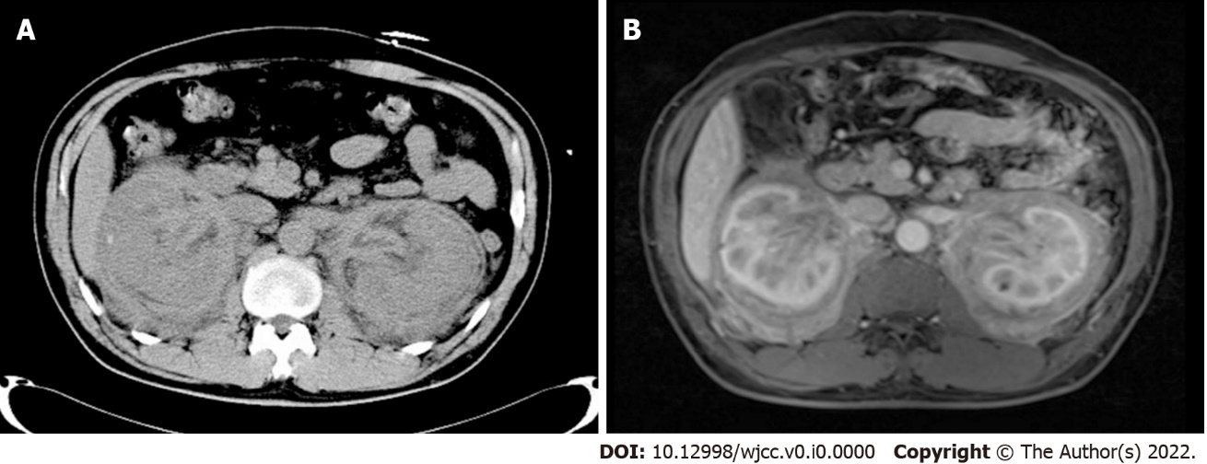
Figure 1 Abdominal computed tomography scan and magnetic resonance imaging scan. A: The scan shows diffuse bilateral enlargement of the kidneys and perirenal fat and thickening of the renal pelvic walls; B: Contrast-enhancement shows thickening of the wall of the renal pelvis.

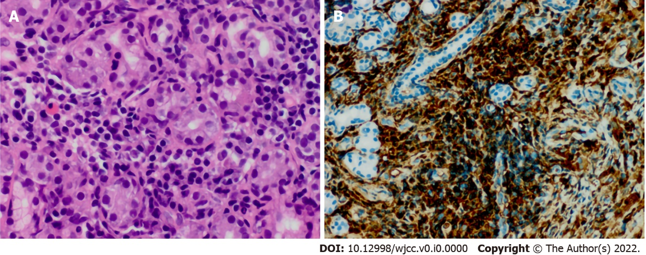
Figure 2 Histopathology of the lymph node. A: The section shows dense lymphoplasmacytic cells with fibrotic changes (H&E 400×); B: Immunohistochemical staining shows an average of 100 IgG4-positive plasma cells per high-power field.

