Name of Journal: World Journal of Meta-Analysis
Manuscript NO: 63686
Manuscript Type: SCIENTOMETRICS

Trends in iron deficiency anemia research 2001-2020: A bibliometric analysis

Frater JL. Iron deficiency anemia research 2001-2020

John L Frater

John L Frater, Department of Pathology and Immunology, Washington University, St. Louis, MO 63110, United States

Author contributions: The manuscript was conceived, designed, and written by Frater JL.

Corresponding author: John L Frater, MD, Associate Professor, Department of Pathology and Immunology, Washington University, 660 South Euclid Avenue, Box 8118 St Louis, 3rd Floor, St. Louis, MO 63110, United States. jfrater@wustl.edu

Received: January 31, 2021
Revised: May 17, 2021
Accepted: July 12, 2021
Published online:

Abstract
BACKGROUND
Iron deficiency anemia has a worldwide impact on individual health and national and international economies, with an estimated one-third of the world population being iron deficient.

AIM
To evaluate the iron deficiency literature published between 2001-2020 with an emphasis on: (1) Identification of collaborative research networks most active in this field; (2) Research topics of greatest importance; and (3) Analysis of the most-cited papers published between 2001-2020 and the most cited papers in 5-year intervals during this period to assess for emerging trends in research in this area.

METHODS
A search of Clarivate Analytics World of Science Core Collection was performed for the topic “iron deficiency anemia”, limited to document type (article or review), language (English), and time span (2001-2020). The following data were extracted from these articles: Year of publication, journal, study design, country of first author, and number of citations. The metadata derived from the search were used to identify publication trends in iron deficiency anemia research and their distribution in countries/regions and institutions. Network visualization by VOSviewer (Leiden University) was performed to identify international collaborative groups and research hotspots.

RESULTS
The search identified 4828 publications. Three international collaborative networks were identified: United States, Canada, and India; Turkey, China, and Japan; and England and other European countries. Five research areas were hotspots: Epidemiologic aspects of iron deficiency anemia, biochemical aspects of iron deficiency anemia, clinical evaluation of causes of iron deficiency anemia, causes of iron deficiency anemia, and bioavailability of dietary iron. Subset analysis of the top-10 overall cited papers, and the top-10 cited papers for each 5-year increment beginning in 2001 showed that the largest number of highly cited papers were from the field of epidemiology, the smallest number from the field of bioavailability of dietary iron.

CONCLUSION
The literature on iron deficiency anemia has a high citation rate compared to studies of other topics using similar methodology and is heavily biased toward studies from the United States and epidemiologic studies.

Key Words: Iron deficiency anemia; Bibliometrics; VOSviewer; Trends

Frater JL. Trends in iron deficiency anemia research 2001-2020: A bibliometric analysis. World J Meta-Anal 2021; In press

Core Tip: Iron deficiency is a common micronutrient deficiency with a worldwide impact. This bibliometric analysis was performed to analyze the literature on iron deficiency published between 2001-2020. Three international collaborative networks based in North America/India, Europe, and Asia were identified. There are 5 areas of greatest focus: Epidemiologic aspects of iron deficiency anemia, biochemical aspects of iron deficiency anemia, clinical evaluation of iron deficiency anemia, causes of iron deficiency anemia, and bioavailability of dietary iron. Evaluation of the papers published during this period identified epidemiology as the most cited area, and bioavailability of iron as the least cited.

INTRODUCTION
Iron deficiency and iron deficiency anemia
Iron deficiency and iron deficiency anemia are health conditions with a worldwide effect on individual health and an impact on national and international economies. An estimated one-third of the world population is affected by iron deficiency, and deficiency of this micronutrient has effects on multiple systems of the body, including the central nervous system and reticuloendothelial systems^{[1,2]}. Health consequences of iron deficiency are widespread and include impaired intellectual function and decreased immunity^{[3,4]}.
Anemia is a common consequence of iron deficiency. The degree of severity of anemia is variable, and it is microcytic and hypochromic as demonstrated by routine laboratory testing, which identifies a moderate to severe decrease in red blood cell count, hemoglobin, and hematocrit, accompanied by a moderately decreased mean corpuscular volume and moderate to marked elevation of red blood cell distribution width^{[1]}.

The bibliometric method as a research tool
Bibliometric methods are useful to evaluate trends in research activities over time^{[5]}. Bibliometrics take advantage of literature databasing technology, including literature metrology, and is an increasingly important method of providing insight into research in specific fields. This format has been used to evaluate the impact of articles in many areas of study. It is valuable to identify the most cited studies that have influenced the evolution of a given scientific field^{[6]}.

Rationale
In this study, the research trends in the field of iron deficiency anemia in the past 20 years were considered. The aims of this study were to: (1) Identify and analyze scientific publications in this field; and (2) Compare the contribution of this research in different countries and institutions. Bibliometric analysis was performed using the functions of the Web of Science Core Collection and further analysis of the metadata was performed using VOSviewer software (Leiden University). Using the features of VOSviewer, a network visualization of international collaborations and a keyword-based visualization of research fields was performed. This study provides a refined understanding of global trends in iron deficiency anemia research.

MATERIALS AND METHODS
This bibliometric analysis was conducted using the Preferred Reporting Items for Systematic Reviews and Meta-analysis (PRISMA) principles (see PRISMA 2009 checklist statement for PRISMA checklist) according to a methodology similar to that described in earlier studies^{[6-10]}, which is detailed below.

Data collection and bibliometric analysis
All articles were searched using the Clarivate Analytics World of Science Core Collection (WOSCC) on August 30, 2020. The study used publicly available data, and thus ethical approval was not required. The search criteria were topic (“iron deficiency anemia”), limited to document type (article or review), language (English), and time span (2001-2020). A topic search includes a search of the following fields: The title of the article or review; the abstract, the keywords; and the keywords plus©, which is a proprietary algorithm using expanded terms from an article’s cited references or bibliography. The following data were extracted from these articles: Year of publication, journal, study design, country of first author, and number of citations. The metadata derived from the search were used to identify publication trends in iron deficiency anemia research and their distribution in countries/regions and institutions. This protocol has not been registered.
VOSviewer bibliometric software (Van Eck and Waltman, Leiden University, Leiden, The Netherlands) was used to perform data mining, mapping, and clustering of the retrieved articles^{[11]}. Keywords and countries were labeled with colored circles, the size of which correlated with the occurrence of the keyword or countries in the title and abstract.

Subset analysis of abstracts/full-text
Because of the large number of search results, the title, abstract and full text of the top 200 cited articles were reviewed for appropriateness to the topic. The entire list of retrieved articles was analyzed, and an additional subset analysis of the articles grouped by publication in 5-year increments (2001-2005; 2006-2010; 2011-2015; 2016-2020) was performed. The top 25 keywords identified in the title and abstract of each publication in each time interval was compiled^{[12]}. In addition, the top 10 articles published in each time interval was identified, along with their number of citations.

RESULTS
The search returned 4828 references. Review of the titles, abstracts, and full texts of the top 200 cited papers in this group was performed to assess the quality of the search, and all papers in this group were appropriate to the topic of iron deficiency anemia.
These publications had an h-index of 137 with an average of 25.42 citations per item. The number of papers published per year in this study has varied from 124 to 402. The year with the largest number of papers published in this study was 2019. The rate of publication of papers in this study has varied from 2.568% to 8.326% (Figure 1).
Of 4163 papers were classified as articles, 695 as reviews. 4569 papers (94.6% of the total) were published in English. Based on WOSCC metadata, the papers were published in 97 different research areas, of which the most common were nutrition and dietetics (n = 672, 13.919% of total), gastroenterology (n = 610, 12.635%), hematology (n = 570, 11.806%), pediatrics (n = 566, 11.723%), and general internal medicine (n = 522, 10.812%).

Country of publication
In total, publications were contributed by 157 countries, with the top ten publishing countries listed in Figure 2.
The United States has contributed the largest number of the papers. Other nations in the top 5 countries of publication were Turkey, China, Italy, and England. The authors in this study represented 4840 institutions. The institutions contributing the most papers to this study were the University of California system (n = 179 records) and Harvard University (n = 126 records). 2411 funding agencies were listed in these publications, of which the largest number of studies were funded by the United States Department of Health and Human Services (n = 448), the National Institutes of Health (United States, n = 431), and the National Natural Science Foundation of China (n = 119).

Collaborations
The collaboration network analysis is illustrated in Figure 3 and includes countries contributing at least 10 papers. Using this criterion, 64 countries are included in the analysis. There are 3 nodes identified using international collaboration data. The largest, illustrated in red, includes the United States, Canada, and India as the largest contributors. The second, illustrated in blue, includes Turkey, China, and Japan as the most prominent contributing members. The third, illustrated in green, includes England and many European countries.

Journals
The papers in this study were published by 1365 journals. 659 journals published ≥ 1 paper; the remaining journals published 1 paper apiece. The top 15 journals, with the number of articles published and the journal’s impact factor (IF), drawn from the 2020 Journal Citation Reports of Clarivate Analytics) are shown in Table 1. The IF for the journals in this group ranged from 17.543 (Blood) to 1.016 (Journal of Pediatric Hematology Oncology). The largest number of papers were published by Journal of Nutrition (n = 107), PLOS One (n = 81), and World Journal of Gastroenterology (n = 76).

Co-occurrence of keywords
Overall, 123 terms appeared 50 times or more in the titles or abstracts of the papers in this study (Figure 4). For example, “iron deficiency anemia” appeared 1533 times, “anemia” appeared 1252 times, “children” appeared 726 times, “iron deficiency” appeared 627 times, and “prevalence” appeared 608 times. Based on the VOSviewer keyword mapping, the terms or phrases associated with iron deficiency anemia were divided into 5 clusters, represented by 5 colors (red, green, blue, yellow, and purple). From the results of co-occurrences, current iron deficiency anemia research was shown to be mainly focused on 5 major areas. These are: (1) Epidemiologic aspects of iron deficiency anemia (red); (2) Bioavailability of dietary iron (purple); (3) Clinical evaluation of causes of iron deficiency anemia (blue); (4) Causes of iron deficiency anemia (yellow); and (5) Biochemical aspects of iron deficiency anemia (green). These 5 topics may thus be regarded as the research hotspots in the field of iron deficiency anemia between 2001-2020.
A subset analysis of the top 25 author-selected keywords of each 5-year interval between 2001-2020 and coded to the 5 areas presented in Figure 4 is presented in Table 2^{[12]}. The distribution of keywords was relatively unchanged over the years. The largest number of keywords mapped to the epidemiologic aspects of iron deficiency anemia (red) cluster (11-12 keywords in each interval), with smaller numbers of keywords mapping to the other clusters.

Top 10 cited papers
The top 10 cited papers published for the entire period 2001-2020, and the top 10 cited papers published in each 5-year interval are listed in Table 3. The total number of citations per paper for the top 10 cited papers published from 2001-2020 ranged from 752 to 4084.

DISCUSSION
This bibliometric analysis was performed to evaluate the research trends in the field of iron deficiency anemia between 2001-2020. The purpose of this study was: (1) To identify and analyze scientific publications in this field; and (2) To compare the contribution of this research in different countries and institutions. The main findings were (1) That the most common topic areas were nutrition and dietetics, gastroenterology, hematology, pediatrics, and general internal medicine; (2) United States-based researchers contributed to the vast majority of papers, although researchers from Turkey, China, Italy, and England also made significant contributions to the literature; (3) Keyword analysis revealed that 5 research areas have developed as current hotspots: Epidemiologic aspects of iron deficiency anemia, biochemical aspects of iron deficiency anemia, clinical evaluation of causes of iron deficiency anemia, causes of iron deficiency anemia, and bioavailability of dietary iron; and (4) Evaluation of the top keywords in 5 year intervals showed that the relative contributions of each research area to the total number of papers has remained static, with the largest contribution to the area of epidemiologic aspects of iron deficiency anemia. The citation rate of the top cited papers in this study is high compared to studies on other research areas using similar methodology^{[13]}.

Epidemiologic aspects of iron deficiency anemia
The topic of iron deficiency anemia has been the subject of numerous epidemiologic studies, including the Global Burden of Disease Study, a large-scale observational epidemiologic survey which was published as a 4-paper series^{[14-17]}. This includes the top-cited paper identified in the current study^{[14]}. Approximately a third of the world population is iron-deficient^{[18]}, though there are clear disparities in the distribution of iron deficiency. Darmon et al^{[19]} established that iron deficiency anemia was more prevalent in individuals from low socioeconomic backgrounds, possibly due to diet quality^{[19]}. Guralnik et al^{[20]}’s 2005 paper identified that iron deficiency anemia contributes to a high percentage of cases of anemia in the elderly^{[20]}. Although at-risk populations are particularly prevalent in the developing world^{[21]}, residents of industrialized national are also impacted, as noted by Dubé et al^{[22]}.
Additional highly cited papers in this study addressed the neurologic implications of iron deficiency and iron deficiency anemia. These include Grantham-McGregor et al^{[23]}’s review of the long-term effects of iron deficiency on neurological functioning in children^{[23]} and Beard and Connor’s seminal paper on iron status and its correlation with neural functioning^{[24]}. The work of Lozoff and colleagues, including their 2006 paper which is highlighted in the current study, detailed that the neurological defects in patients in iron-deficient children may extend into adulthood, even after correction of the underlying nutritional issue^{[25]}.
An important consequence of iron deficiency and iron deficiency anemia is decreased work output, which may have long-term impact on affected individuals and has an established societal effect. These features were described in highly-cited work by Haas and Brownlie^{[2]}.

Bioavailability of dietary iron
Although iron deficiency is a widespread international public health issue, few high-impact studies have been dedication to the critical issue of iron bioavailability, as evidenced from the survey of top 10-cited papers. Two review papers have discussed features of iron bioavailability. The first, by Plum et al^{[26]}, examines the role of zinc in iron metabolism^{[26]}. The second, by Xie et al^{[27]}, examines the physiologic role of polysaccharides derived from medicinal plants, some of which have been identified as having iron-chelating properties^{[27]}.

Biochemical aspects of iron deficiency anemia
Though none of the top-10 cited studies had iron metabolism as a main topic, 4 studies in the quartile analysis were focused on biochemical aspects of iron anemia. Three of these had a particular focus on hepcidin. Hepcidin, a protein produced by the liver and cleared by the kidneys, plays a central role in iron uptake by the duodenum and spleen. Its regulation was described in a highly cited paper identified in this study^{[28]}, which showed that hepcidin expression is upregulated in response to anemia and hypoxia and downregulated by increased hematopoiesis. An immunoassay for hepcidin was described by Ganz et al^{[29]} and Girelli et al^{[30]}. Laboratory testing for serum hepcidin levels can be used to distinguish iron deficiency anemia from anemia of chronic disease (inflammation)^{[1]}.
Another important step in iron metabolism highlighted by the current study is the action of ferroreductase, which acts on ferric (3+) iron-containing molecules in the cytoplasm of phagocytes to produce bioavailable ferrous (2+) iron^{[31,32]}.

Causes of iron deficiency anemia
Numerous health conditions have been implicated in the etiology of iron deficiency anemia. Among these are chronic inflammatory conditions, chronic gastritis (in particular gastritis secondary to Helicobacter pylori), chronic use/abuse of non-steroidal anti-inflammatory drugs (NSAID), and celiac disease. Iron deficiency may also follow gastrointestinal procedures such as bariatric surgery and capsule endoscopy^{[33]}. The role of Helicobacter pylori gastritis and celiac disease were the subjects of 2 papers from the overall top 10-cited group^{[34-36]}. In addition, Graham et al^{[37]} identified the mucosal lesions in the gastrointestinal tracts of chronic NSAID users, many of whom developed iron deficiency anemia^{[37]}. In patients with chronic kidney disease, decreased renal clearance of hepcidin may result in chronic kidney disease, as described by Levin and Rocco^{[38]}.

Clinical evaluation and management of causes of iron deficiency anemia
Several of the papers in the current study that detailed the causes of iron deficiency anemia were consensus papers that also recommended protocols for the clinical evaluation of patients. These include the American college of Gastroenterology guidelines and the Maastricht III report, which provided guidance on the management of Helicobacter pylori infection^{[34,39]}, and the Oslo and American College of Gastroenterology guidelines for celiac disease^{[40,41]}. Presurgical workup of anemias was also a highly-cited topic: An example is the NATA guidelines for the evaluation of anemia in preoperative orthopedic patients^{[42]}. The use of perioperative intravenous iron after abdominal surgery has been an important recent contribution to the list of highly-cited papers^{[36]}.

Limitations
Bibliometric analysis, although a potent means for highlighting the research hotspots of a given field, has some limitations. First, the bibliometric data are best accessed using the Web of Science database, and currently are not as widely available in other databases. This may cause problems with the search, since checklists for systematic reviews such as PRISMA generally recommend the use of 2 or more databases for searches^{[43]}. Another limitation is that since the number of citations of a given paper would be expected to increase over time, it would be expected that older papers would have a higher citation rate than more recently published papers.In the current study, dividing the study period into 5-year quartiles was an attempt to identify papers which had a high citation rate within their cohort.

CONCLUSION
This study was a bibliometric analysis of the medical literature on iron deficiency anemia published over the last 20 years. Five research hotspots were identified; the area of epidemiology had the largest number of highly cited papers, and the area of bioavailability of dietary iron had the lowest. These relative contributions have been apparently unchanged over the course of the study period. Although iron deficiency anemia has a worldwide impact, the published research of this period was highly influenced by studies from the United States.

ARTICLE HIGHLIGHTS
Research background
Iron deficiency is the most common micronutrient deficiency and has a worldwide impact. A bibliometric analysis focused on research trends on the topic of iron deficiency anemia has not been performed.

Research motivation
Analyzing the iron deficiency anemia research published between 2001-2020 what collaborative research networks are most active in this field? What subfields are of greatest importance? Are there any emerging research trends in this area?

Research objectives
The objectives of this study were to evaluate the literature published over the last 2 decades, focusing on: (1) The extent of collaborative research networks in this field; (2) The research topics of greatest prominence; and (3) A subset analysis of the most-cited papers published between 2001-2020 and the most-cited papers in 5-year intervals during this period to assess for emerging trends in research in this area.

Research methods
This study was conducted as a bibliometric analysis using Preferred Reporting Items for Systematic Reviews and Meta-analysis guidelines. A search of the medical literature published between 2001-2020 and related to iron deficiency anemia was performed and data from the search were used to identify publication trends in iron deficiency anemia research. Network visualization by VOSviewer (Leiden University) was performed to identify international collaborative groups and research hotspots in works published during this period.

Research results
Of 4828 publications were included in the study. Network visualization identified 3 international collaborative networks: United States, Canada, and India; Turkey, China, and Japan; and England and other European countries. Five research hotspots were highlighted: (1) Epidemiology of iron deficiency anemia; (2) Biochemistry of iron deficiency anemia; (3) Clinical evaluation of iron deficiency anemia; (4) Causes of iron deficiency anemia; and (5) Bioavailability of iron in the diet. An additional analysis of the top-10 overall cited papers, and the top-10 cited papers for each 5-year increment starting in 2001 showed that the largest number of highly cited papers were from the field of epidemiology, the smallest number from the field of bioavailability of dietary iron.

Research conclusions
Iron deficiency anemia has a high citation rate compared to studies of other topics using similar methodology. Studies from the United States and epidemiologic studies dominate the field.

Research perspectives
Future studies directed from relatively underrepresented areas of the world, and studies directed at less prominently featured areas such as bioavailability of dietary iron may be welcome additions to this already well-developed research area.

REFERENCES
1 Lopez A, Cacoub P, Macdougall IC, Peyrin-Biroulet L. Iron deficiency anaemia. Lancet 2016; 387: 907-916 [PMID: 26314490 DOI: 10.1016/S0140-6736(15)60865-0]
2 Haas JD, Brownlie T 4th. Iron deficiency and reduced work capacity: a critical review of the research to determine a causal relationship. J Nutr 2001; 131: 676S-688S; discussion 688S-690S [PMID: 11160598 DOI: 10.1093/jn/131.2.676S]
3 McCann S, Perapoch Amadó M, Moore SE. The Role of Iron in Brain Development: A Systematic Review. Nutrients 2020; 12 [PMID: 32635675 DOI: 10.3390/nu12072001]
4 Beard JL. Iron biology in immune function, muscle metabolism and neuronal functioning. J Nutr 2001; 131: 568S-579S; discussion 580S [PMID: 11160590 DOI: 10.1093/jn/131.2.568S]
5 Garfield E, Cawkell AE. Citation analysis studies. Science 1975; 189: 397 [PMID: 17840830 DOI: 10.1126/science.189.4200.397]
6 Xie L, Chen Z, Wang H, Zheng C, Jiang J. Bibliometric and Visualized Analysis of Scientific Publications on Atlantoaxial Spine Surgery Based on Web of Science and VOSviewer. World Neurosurg 2020; 137: 435-442.e4 [PMID: 32006737 DOI: 10.1016/j.wneu.2020.01.171]
7 Sweileh WM, Al-Jabi SW, Zyoud SH, Sawalha AF, Abu-Taha AS. Global research output in antimicrobial resistance among uropathogens: A bibliometric analysis (2002-2016). J Glob Antimicrob Resist 2018; 13: 104-114 [PMID: 29224787 DOI: 10.1016/j.jgar.2017.11.017]
8 Sweileh WM, Moh'd Mansour A. Bibliometric analysis of global research output on antimicrobial resistance in the environment (2000-2019). Glob Health Res Policy 2020; 5: 37 [PMID: 32775695 DOI: 10.1186/s41256-020-00165-0]
9 Nafade V, Nash M, Huddart S, Pande T, Gebreselassie N, Lienhardt C, Pai M. A bibliometric analysis of tuberculosis research, 2007-2016. PLoS One 2018; 13: e0199706 [PMID: 29940004 DOI: 10.1371/journal.pone.0199706]
10 Shi H, Mao C, Tang J, Liang H. Research on the health of and interventions for family caregivers of people with dementia: a bibliometric analysis of research output during 1988-2018. BMC Geriatr 2020; 20: 20 [PMID: 31964344 DOI: 10.1186/s12877-020-1421-7]
11 van Eck NJ, Waltman L. Software survey: VOSviewer, a computer program for bibliometric mapping. Scientometrics 2010; 84: 523-538 [PMID: 20585380 DOI: 10.1007/s11192-009-0146-3]
12 Zhang GF, Xie SD, Ho YS. A bibliometric analysis of world volatile organic compounds research trends. Scientometrics 2010; 83: 477-492 [DOI: 10.1007/s11192-009-0065-3]
13 Lu C, Bing Z, Bi Z, Liu M, Lu T, Xun Y, Wei Z, Yang K. Top-100 Most Cited Publications Concerning Network Pharmacology: A Bibliometric Analysis. Evid Based Complement Alternat Med 2019; 2019: 1704816 [PMID: 31467569 DOI: 10.1155/2019/1704816]
14 Vos T, Flaxman AD, Naghavi M, Lozano R, Michaud C, Ezzati M, Shibuya K, Salomon JA, Abdalla S, Aboyans V, Abraham J, Ackerman I, Aggarwal R, Ahn SY, Ali MK, Alvarado M, Anderson HR, Anderson LM, Andrews KG, Atkinson C, Baddour LM, Bahalim AN, Barker-Collo S, Barrero LH, Bartels DH, Basáñez MG, Baxter A, Bell ML, Benjamin EJ, Bennett D, Bernabé E, Bhalla K, Bhandari B, Bikbov B, Bin Abdulhak A, Birbeck G, Black JA, Blencowe H, Blore JD, Blyth F, Bolliger I, Bonaventure A, Boufous S, Bourne R, Boussinesq M, Braithwaite T, Brayne C, Bridgett L, Brooker S, Brooks P, Brugha TS, Bryan-Hancock C, Bucello C, Buchbinder R, Buckle G, Budke CM, Burch M, Burney P, Burstein R, Calabria B, Campbell B, Canter CE, Carabin H, Carapetis J, Carmona L, Cella C, Charlson F, Chen H, Cheng AT, Chou D, Chugh SS, Coffeng LE, Colan SD, Colquhoun S, Colson KE, Condon J, Connor MD, Cooper LT, Corriere M, Cortinovis M, de Vaccaro KC, Couser W, Cowie BC, Criqui MH, Cross M, Dabhadkar KC, Dahiya M, Dahodwala N, Damsere-Derry J, Danaei G, Davis A, De Leo D, Degenhardt L, Dellavalle R, Delossantos A, Denenberg J, Derrett S, Des Jarlais DC, Dharmaratne SD, Dherani M, Diaz-Torne C, Dolk H, Dorsey ER, Driscoll T, Duber H, Ebel B, Edmond K, Elbaz A, Ali SE, Erskine H, Erwin PJ, Espindola P, Ewoigbokhan SE, Farzadfar F, Feigin V, Felson DT, Ferrari A, Ferri CP, Fèvre EM, Finucane MM, Flaxman S, Flood L, Foreman K, Forouzanfar MH, Fowkes FG, Franklin R, Fransen M, Freeman MK, Gabbe BJ, Gabriel SE, Gakidou E, Ganatra HA, Garcia B, Gaspari F, Gillum RF, Gmel G, Gosselin R, Grainger R, Groeger J, Guillemin F, Gunnell D, Gupta R, Haagsma J, Hagan H, Halasa YA, Hall W, Haring D, Haro JM, Harrison JE, Havmoeller R, Hay RJ, Higashi H, Hill C, Hoen B, Hoffman H, Hotez PJ, Hoy D, Huang JJ, Ibeanusi SE, Jacobsen KH, James SL, Jarvis D, Jasrasaria R, Jayaraman S, Johns N, Jonas JB, Karthikeyan G, Kassebaum N, Kawakami N, Keren A, Khoo JP, King CH, Knowlton LM, Kobusingye O, Koranteng A, Krishnamurthi R, Lalloo R, Laslett LL, Lathlean T, Leasher JL, Lee YY, Leigh J, Lim SS, Limb E, Lin JK, Lipnick M, Lipshultz SE, Liu W, Loane M, Ohno SL, Lyons R, Ma J, Mabweijano J, MacIntyre MF, Malekzadeh R, Mallinger L, Manivannan S, Marcenes W, March L, Margolis DJ, Marks GB, Marks R, Matsumori A, Matzopoulos R, Mayosi BM, McAnulty JH, McDermott MM, McGill N, McGrath J, Medina-Mora ME, Meltzer M, Mensah GA, Merriman TR, Meyer AC, Miglioli V, Miller M, Miller TR, Mitchell PB, Mocumbi AO, Moffitt TE, Mokdad AA, Monasta L, Montico M, Moradi-Lakeh M, Moran A, Morawska L, Mori R, Murdoch ME, Mwaniki MK, Naidoo K, Nair MN, Naldi L, Narayan KM, Nelson PK, Nelson RG, Nevitt MC, Newton CR, Nolte S, Norman P, Norman R, O'Donnell M, O'Hanlon S, Olives C, Omer SB, Ortblad K, Osborne R, Ozgediz D, Page A, Pahari B, Pandian JD, Rivero AP, Patten SB, Pearce N, Padilla RP, Perez-Ruiz F, Perico N, Pesudovs K, Phillips D, Phillips MR, Pierce K, Pion S, Polanczyk GV, Polinder S, Pope CA 3rd, Popova S, Porrini E, Pourmalek F, Prince M, Pullan RL, Ramaiah KD, Ranganathan D, Razavi H, Regan M, Rehm JT, Rein DB, Remuzzi G, Richardson K, Rivara FP, Roberts T, Robinson C, De Leòn FR, Ronfani L, Room R, Rosenfeld LC, Rushton L, Sacco RL, Saha S, Sampson U, Sanchez-Riera L, Sanman E, Schwebel DC, Scott JG, Segui-Gomez M, Shahraz S, Shepard DS, Shin H, Shivakoti R, Singh D, Singh GM, Singh JA, Singleton J, Sleet DA, Sliwa K, Smith E, Smith JL, Stapelberg NJ, Steer A, Steiner T, Stolk WA, Stovner LJ, Sudfeld C, Syed S, Tamburlini G, Tavakkoli M, Taylor HR, Taylor JA, Taylor WJ, Thomas B, Thomson WM, Thurston GD, Tleyjeh IM, Tonelli M, Towbin JA, Truelsen T, Tsilimbaris MK, Ubeda C, Undurraga EA, van der Werf MJ, van Os J, Vavilala MS, Venketasubramanian N, Wang M, Wang W, Watt K, Weatherall DJ, Weinstock MA, Weintraub R, Weisskopf MG, Weissman MM, White RA, Whiteford H, Wiersma ST, Wilkinson JD, Williams HC, Williams SR, Witt E, Wolfe F, Woolf AD, Wulf S, Yeh PH, Zaidi AK, Zheng ZJ, Zonies D, Lopez AD, Murray CJ, AlMazroa MA, Memish ZA. Years lived with disability (YLDs) for 1160 sequelae of 289 diseases and injuries 1990-2010: a systematic analysis for the Global Burden of Disease Study 2010. Lancet 2012; 380: 2163-2196 [PMID: 23245607 DOI: 10.1016/S0140-6736(12)61729-2]
15 Global Burden of Disease Study 2013 Collaborators.. Global, regional, and national incidence, prevalence, and years lived with disability for 301 acute and chronic diseases and injuries in 188 countries, 1990-2013: a systematic analysis for the Global Burden of Disease Study 2013. Lancet 2015; 386: 743-800 [PMID: 26063472 DOI: 10.1016/S0140-6736(15)60692-4]
16 GBD 2015 Disease and Injury Incidence and Prevalence Collaborators.. Global, regional, and national incidence, prevalence, and years lived with disability for 310 diseases and injuries, 1990-2015: a systematic analysis for the Global Burden of Disease Study 2015. Lancet 2016; 388: 1545-1602 [PMID: 27733282 DOI: 10.1016/S0140-6736(16)31678-6]
17 GBD 2016 Disease and Injury Incidence and Prevalence Collaborators.. Global, regional, and national incidence, prevalence, and years lived with disability for 328 diseases and injuries for 195 countries, 1990-2016: a systematic analysis for the Global Burden of Disease Study 2016. Lancet 2017; 390: 1211-1259 [PMID: 28919117 DOI: 10.1016/S0140-6736(17)32154-2]
18 Kassebaum NJ, Jasrasaria R, Naghavi M, Wulf SK, Johns N, Lozano R, Regan M, Weatherall D, Chou DP, Eisele TP, Flaxman SR, Pullan RL, Brooker SJ, Murray CJ. A systematic analysis of global anemia burden from 1990 to 2010. Blood 2014; 123: 615-624 [PMID: 24297872 DOI: 10.1182/blood-2013-06-508325]
19 Darmon N, Drewnowski A. Does social class predict diet quality? Am J Clin Nutr 2008; 87: 1107-1117 [PMID: 18469226 DOI: 10.1093/ajcn/87.5.1107]
20 Guralnik JM, Eisenstaedt RS, Ferrucci L, Klein HG, Woodman RC. Prevalence of anemia in persons 65 years and older in the United States: evidence for a high rate of unexplained anemia. Blood 2004; 104: 2263-2268 [PMID: 15238427 DOI: 10.1182/blood-2004-05-1812]
21 Balarajan Y, Ramakrishnan U, Oezaltin E, Shankar AH, Subramanian SV. Anaemia in low-income and middle-income countries. Lancet 2011; 378: 2123-2135 [PMID: 21813172 DOI: 10.1016/S0140-6736(10)62304-5]
22 Dubé C, Rostom A, Sy R, Cranney A, Saloojee N, Garritty C, Sampson M, Zhang L, Yazdi F, Mamaladze V, Pan I, Macneil J, Mack D, Patel D, Moher D. The prevalence of celiac disease in average-risk and at-risk Western European populations: a systematic review. Gastroenterology 2005; 128: S57-S67 [PMID: 15825128 DOI: 10.1053/j.gastro.2005.02.014]
23 Grantham-McGregor S, Ani C. A review of studies on the effect of iron deficiency on cognitive development in children. J Nutr 2001; 131: 649S-666S; discussion 666S-668S [PMID: 11160596 DOI: 10.1093/jn/131.2.649S]
24 Beard JL, Connor JR. Iron status and neural functioning. Annu Rev Nutr 2003; 23: 41-58 [PMID: 12704220 DOI: 10.1146/annurev.nutr.23.020102.075739]
25 Lozoff B, Beard J, Connor J, Barbara F, Georgieff M, Schallert T. Long-lasting neural and behavioral effects of iron deficiency in infancy. Nutr Rev 2006; 64: S34-43; discussion S72-91 [PMID: 16770951 DOI: 10.1301/nr.2006.may.s34-s43]
26 Plum LM, Rink L, Haase H. The essential toxin: impact of zinc on human health. Int J Environ Res Public Health 2010; 7: 1342-1365 [PMID: 20617034 DOI: 10.3390/ijerph7041342]
27 Xie JH, Jin ML, Morris GA, Zha XQ, Chen HQ, Yi Y, Li JE, Wang ZJ, Gao J, Nie SP, Shang P, Xie MY. Advances on Bioactive Polysaccharides from Medicinal Plants. Crit Rev Food Sci Nutr 2016; 56 Suppl 1: S60-S84 [PMID: 26463231 DOI: 10.1080/10408398.2015.1069255]
28 Nicolas G, Bennoun M, Porteu A, Mativet S, Beaumont C, Grandchamp B, Sirito M, Sawadogo M, Kahn A, Vaulont S. Severe iron deficiency anemia in transgenic mice expressing liver hepcidin. Proc Natl Acad Sci U S A 2002; 99: 4596-4601 [PMID: 11930010 DOI: 10.1073/pnas.072632499]
29 Ganz T, Olbina G, Girelli D, Nemeth E, Westerman M. Immunoassay for human serum hepcidin. Blood 2008; 112: 4292-4297 [PMID: 18689548 DOI: 10.1182/blood-2008-02-139915]
30 Girelli D, Nemeth E, Swinkels DW. Hepcidin in the diagnosis of iron disorders. Blood 2016; 127: 2809-2813 [PMID: 27044621 DOI: 10.1182/blood-2015-12-639112]
31 Ohgami RS, Campagna DR, Greer EL, Antiochos B, McDonald A, Chen J, Sharp JJ, Fujiwara Y, Barker JE, Fleming MD. Identification of a ferrireductase required for efficient transferrin-dependent iron uptake in erythroid cells. Nat Genet 2005; 37: 1264-1269 [PMID: 16227996 DOI: 10.1038/ng1658]
32 Palaneeswari M S, Ganesh M, Karthikeyan T, Devi AJ, Mythili SV. Hepcidin-minireview. J Clin Diagn Res 2013; 7: 1767-1771 [PMID: 24086909 DOI: 10.7860/JCDR/2013/6420.3273]
33 Pennazio M, Santucci R, Rondonotti E, Abbiati C, Beccari G, Rossini FP, De Franchis R. Outcome of patients with obscure gastrointestinal bleeding after capsule endoscopy: report of 100 consecutive cases. Gastroenterology 2004; 126: 643-653 [PMID: 14988816 DOI: 10.1053/j.gastro.2003.11.057]
34 Malfertheiner P, Megraud F, O'Morain C, Bazzoli F, El-Omar E, Graham D, Hunt R, Rokkas T, Vakil N, Kuipers EJ. Current concepts in the management of Helicobacter pylori infection: the Maastricht III Consensus Report. Gut 2007; 56: 772-781 [PMID: 17170018 DOI: 10.1136/gut.2006.101634]
35 Hill ID, Dirks MH, Liptak GS, Colletti RB, Fasano A, Guandalini S, Hoffenberg EJ, Horvath K, Murray JA, Pivor M, Seidman EG; North American Society for Pediatric Gastroenterology, Hepatology and Nutrition. Guideline for the diagnosis and treatment of celiac disease in children: recommendations of the North American Society for Pediatric Gastroenterology, Hepatology and Nutrition. J Pediatr Gastroenterol Nutr 2005; 40: 1-19 [PMID: 15625418 DOI: 10.1097/00005176-200501000-00001]
36 Froessler B, Palm P, Weber I, Hodyl NA, Singh R, Murphy EM. The important role for intravenous iron in perioperative patient blood management in major abdominal surgery: A randomized controlled trial. Ann Surg 2018; 267: e39-e40 [PMID: 29300713 DOI: 10.1097/SLA.0000000000002055
37 Graham DY, Opekun AR, Willingham FF, Qureshi WA. Visible small-intestinal mucosal injury in chronic NSAID users. Clin Gastroenterol Hepatol 2005; 3: 55-59 [PMID: 15645405 DOI: 10.1016/s1542-3565(04)00603-2]
38 Levin A, Rocco M. Kdoqi clinical practice guidelines and clinical practice recommendations for anemia in chronic kidney disease - foreword. Am J Kidney Dis 2006; 47: S9-S145 [DOI: 10.1053/j.ajkd.2006.04.023]
39 Chey WD, Wong BC; Practice Parameters Committee of the American College of Gastroenterology. American College of Gastroenterology guideline on the management of Helicobacter pylori infection. Am J Gastroenterol 2007; 102: 1808-1825 [PMID: 17608775 DOI: 10.1111/j.1572-0241.2007.01393.x]
40 Ludvigsson JF, Leffler DA, Bai JC, Biagi F, Fasano A, Green PH, Hadjivassiliou M, Kaukinen K, Kelly CP, Leonard JN, Lundin KE, Murray JA, Sanders DS, Walker MM, Zingone F, Ciacci C. The Oslo definitions for coeliac disease and related terms. Gut 2013; 62: 43-52 [PMID: 22345659 DOI: 10.1136/gutjnl-2011-301346]
41 Rubio-Tapia A, Hill ID, Kelly CP, Calderwood AH, Murray JA; American College of Gastroenterology. ACG clinical guidelines: diagnosis and management of celiac disease. Am J Gastroenterol 2013; 108: 656-76; quiz 677 [PMID: 23609613 DOI: 10.1038/ajg.2013.79]
42 Goodnough LT, Maniatis A, Earnshaw P, Benoni G, Beris P, Bisbe E, Fergusson DA, Gombotz H, Habler O, Monk TG, Ozier Y, Slappendel R, Szpalski M. Detection, evaluation, and management of preoperative anaemia in the elective orthopaedic surgical patient: NATA guidelines. Br J Anaesth 2011; 106: 13-22 [PMID: 21148637 DOI: 10.1093/bja/aeq361]
43 Moher D, Liberati A, Tetzlaff J, Altman DG; PRISMA Group. Preferred reporting items for systematic reviews and meta-analyses: the PRISMA statement. J Clin Epidemiol 2009; 62: 1006-1012 [PMID: 19631508 DOI: 10.1016/j.jclinepi.2009.06.005]
44 Bhutta ZA, Ahmed T, Black RE, Cousens S, Dewey K, Giugliani E, Haider BA, Kirkwood B, Morris SS, Sachdev HP, Shekar M; Maternal and Child Undernutrition Study Group. What works? Interventions for maternal and child undernutrition and survival. Lancet 2008; 371: 417-440 [PMID: 18206226 DOI: 10.1016/S0140-6736(07)61693-6]
45 Walker SP, Wachs TD, Gardner JM, Lozoff B, Wasserman GA, Pollitt E, Carter JA; International Child Development Steering Group. Child development: risk factors for adverse outcomes in developing countries. Lancet 2007; 369: 145-157 [PMID: 17223478 DOI: 10.1016/S0140-6736(07)60076-2]
46 Rostom A, Murray JA, Kagnoff MF. American Gastroenterological Association (AGA) Institute technical review on the diagnosis and management of celiac disease. Gastroenterology 2006; 131: 1981-2002 [PMID: 17087937 DOI: 10.1053/j.gastro.2006.10.004]
47 Walker SP, Wachs TD, Grantham-McGregor S, Black MM, Nelson CA, Huffman SL, Baker-Henningham H, Chang SM, Hamadani JD, Lozoff B, Gardner JM, Powell CA, Rahman A, Richter L. Inequality in early childhood: risk and protective factors for early child development. Lancet 2011; 378: 1325-1338 [PMID: 21944375 DOI: 10.1016/S0140-6736(11)60555-2]
48 Camaschella C. Iron-deficiency anemia. N Engl J Med 2015; 372: 1832-1843 [PMID: 25946282 DOI: 10.1056/NEJMra1401038]
49 Chey WD, Kurlander J, Eswaran S. Irritable bowel syndrome: a clinical review. JAMA 2015; 313: 949-958 [PMID: 25734736 DOI: 10.1001/jama.2015.0954]
50 Chey WD, Leontiadis GI, Howden CW, Moss SF. ACG Clinical Guideline: Treatment of Helicobacter pylori Infection. Am J Gastroenterol 2017; 112: 212-239 [PMID: 28071659 DOI: 10.1038/ajg.2016.563]
51 Amieva M, Peek RM Jr. Pathobiology of Helicobacter pylori-Induced Gastric Cancer. Gastroenterology 2016; 150: 64-78 [PMID: 26385073 DOI: 10.1053/j.gastro.2015.09.004]
52 Global Burden of Disease Pediatrics Collaboration., Kyu HH, Pinho C, Wagner JA, Brown JC, Bertozzi-Villa A, Charlson FJ, Coffeng LE, Dandona L, Erskine HE, Ferrari AJ, Fitzmaurice C, Fleming TD, Forouzanfar MH, Graetz N, Guinovart C, Haagsma J, Higashi H, Kassebaum NJ, Larson HJ, Lim SS, Mokdad AH, Moradi-Lakeh M, Odell SV, Roth GA, Serina PT, Stanaway JD, Misganaw A, Whiteford HA, Wolock TM, Wulf Hanson S, Abd-Allah F, Abera SF, Abu-Raddad LJ, AlBuhairan FS, Amare AT, Antonio CA, Artaman A, Barker-Collo SL, Barrero LH, Benjet C, Bensenor IM, Bhutta ZA, Bikbov B, Brazinova A, Campos-Nonato I, Castañeda-Orjuela CA, Catalá-López F, Chowdhury R, Cooper C, Crump JA, Dandona R, Degenhardt L, Dellavalle RP, Dharmaratne SD, Faraon EJ, Feigin VL, Fürst T, Geleijnse JM, Gessner BD, Gibney KB, Goto A, Gunnell D, Hankey GJ, Hay RJ, Hornberger JC, Hosgood HD, Hu G, Jacobsen KH, Jayaraman SP, Jeemon P, Jonas JB, Karch A, Kim D, Kim S, Kokubo Y, Kuate Defo B, Kucuk Bicer B, Kumar GA, Larsson A, Leasher JL, Leung R, Li Y, Lipshultz SE, Lopez AD, Lotufo PA, Lunevicius R, Lyons RA, Majdan M, Malekzadeh R, Mashal T, Mason-Jones AJ, Melaku YA, Memish ZA, Mendoza W, Miller TR, Mock CN, Murray J, Nolte S, Oh IH, Olusanya BO, Ortblad KF, Park EK, Paternina Caicedo AJ, Patten SB, Patton GC, Pereira DM, Perico N, Piel FB, Polinder S, Popova S, Pourmalek F, Quistberg DA, Remuzzi G, Rodriguez A, Rojas-Rueda D, Rothenbacher D, Rothstein DH, Sanabria J, Santos IS, Schwebel DC, Sepanlou SG, Shaheen A, Shiri R, Shiue I, Skirbekk V, Sliwa K, Sreeramareddy CT, Stein DJ, Steiner TJ, Stovner LJ, Sykes BL, Tabb KM, Terkawi AS, Thomson AJ, Thorne-Lyman AL, Towbin JA, Ukwaja KN, Vasankari T, Venketasubramanian N, Vlassov VV, Vollset SE, Weiderpass E, Weintraub RG, Werdecker A, Wilkinson JD, Woldeyohannes SM, Wolfe CD, Yano Y, Yip P, Yonemoto N, Yoon SJ, Younis MZ, Yu C, El Sayed Zaki M, Naghavi M, Murray CJ, Vos T. Global and National Burden of Diseases and Injuries Among Children and Adolescents Between 1990 and 2013: Findings From the Global Burden of Disease 2013 Study. JAMA Pediatr 2016; 170: 267-287 [PMID: 26810619 DOI: 10.1001/jamapediatrics.2015.4276]
53 Kassebaum NJ; GBD 2013 Anemia Collaborators. The Global Burden of Anemia. Hematol Oncol Clin North Am 2016; 30: 247-308 [PMID: 27040955 DOI: 10.1016/j.hoc.2015.11.002]
54 Trenkwalder C, Allen R, Högl B, Paulus W, Winkelmann J. Restless legs syndrome associated with major diseases: A systematic review and new concept. Neurology 2016; 86: 1336-1343 [PMID: 26944272 DOI: 10.1212/WNL.0000000000002542]
55 Enns RA, Hookey L, Armstrong D, Bernstein CN, Heitman SJ, Teshima C, Leontiadis GI, Tse F, Sadowski D. Clinical Practice Guidelines for the Use of Video Capsule Endoscopy. Gastroenterology 2017; 152: 497-514 [PMID: 28063287 DOI: 10.1053/j.gastro.2016.12.032]
56 Vasanawala SS, Nguyen KL, Hope MD, Bridges MD, Hope TA, Reeder SB, Bashir MR. Safety and technique of ferumoxytol administration for MRI. Magn Reson Med 2016; 75: 2107-2111 [PMID: 26890830 DOI: 10.1002/mrm.26151]

Footnotes
Conflict-of-interest statement: The author declares no conflict-of-interest related to this article.

PRISMA 2009 Checklist statement: The author has read the PRISMA 2009 Checklist, and the manuscript was prepared and revised according to the PRISMA 2009 Checklist.

Open-Access: This article is an open-access article that was selected by an in-house editor and fully peer-reviewed by external reviewers. It is distributed in accordance with the Creative Commons Attribution NonCommercial (CC BY-NC 4.0) license, which permits others to distribute, remix, adapt, build upon this work non-commercially, and license their derivative works on different terms, provided the original work is properly cited and the use is non-commercial. See: http://creativecommons.org/Licenses/by-nc/4.0/

Manuscript source: Invited manuscript

Corresponding Author's Membership in Professional Societies: International Society of Laboratory Hematology.

Peer-review started: January 31, 2021
First decision: May 6, 2021
Article in press:

Specialty type: Medicine, research and experimental
Country/Territory of origin: United States
Peer-review report’s scientific quality classification
Grade A (Excellent): 0
Grade B (Very good): B
Grade C (Good): 0
Grade D (Fair): 0
Grade E (Poor): E

P-Reviewer: Ho YS, Rodrigo L S-Editor: Fan JR L-Editor: P-Editor:
Figure Legends
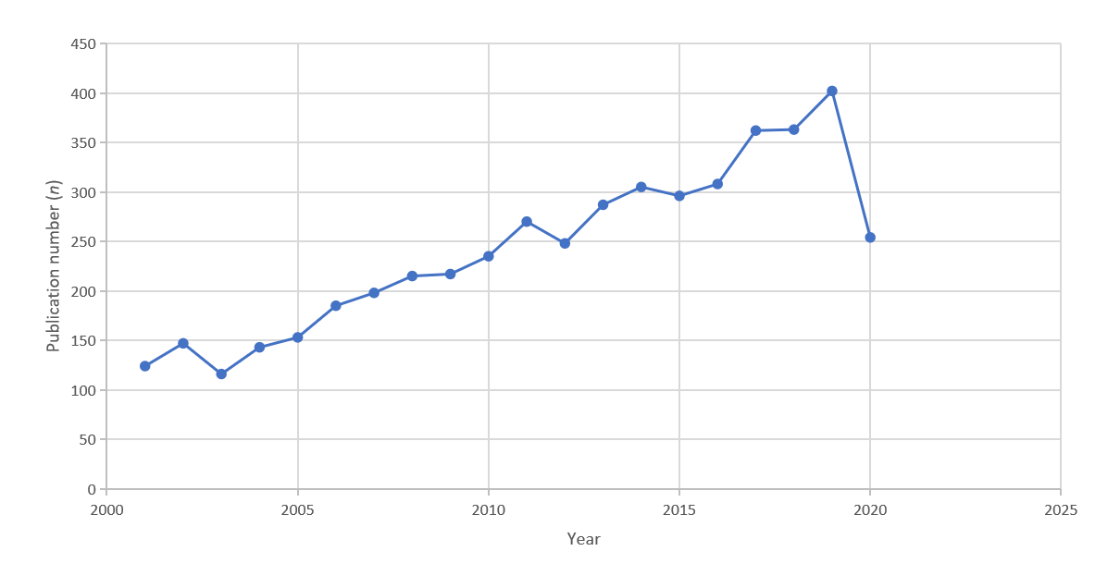
Figure 1 Number of publications (n) per year, 2001-2020.
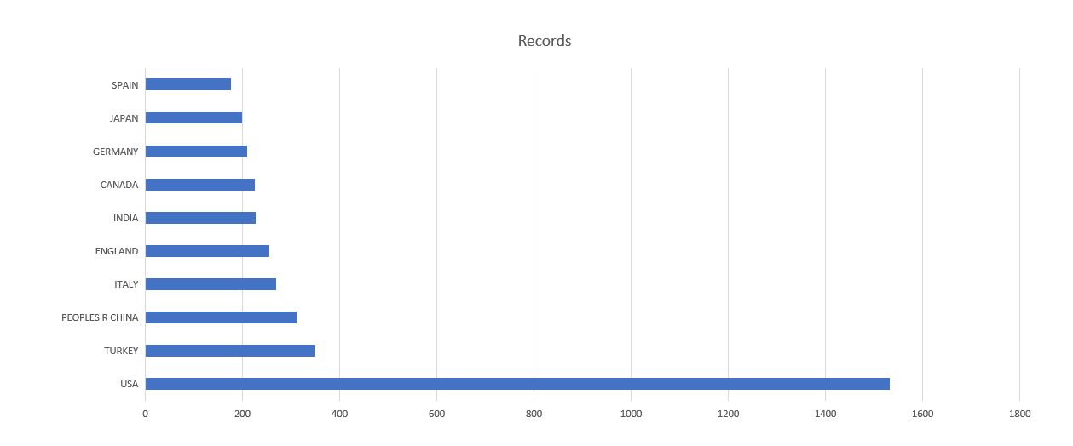
Figure 2 Number of records (n) per country for the top 10 countries contributing papers to this study.
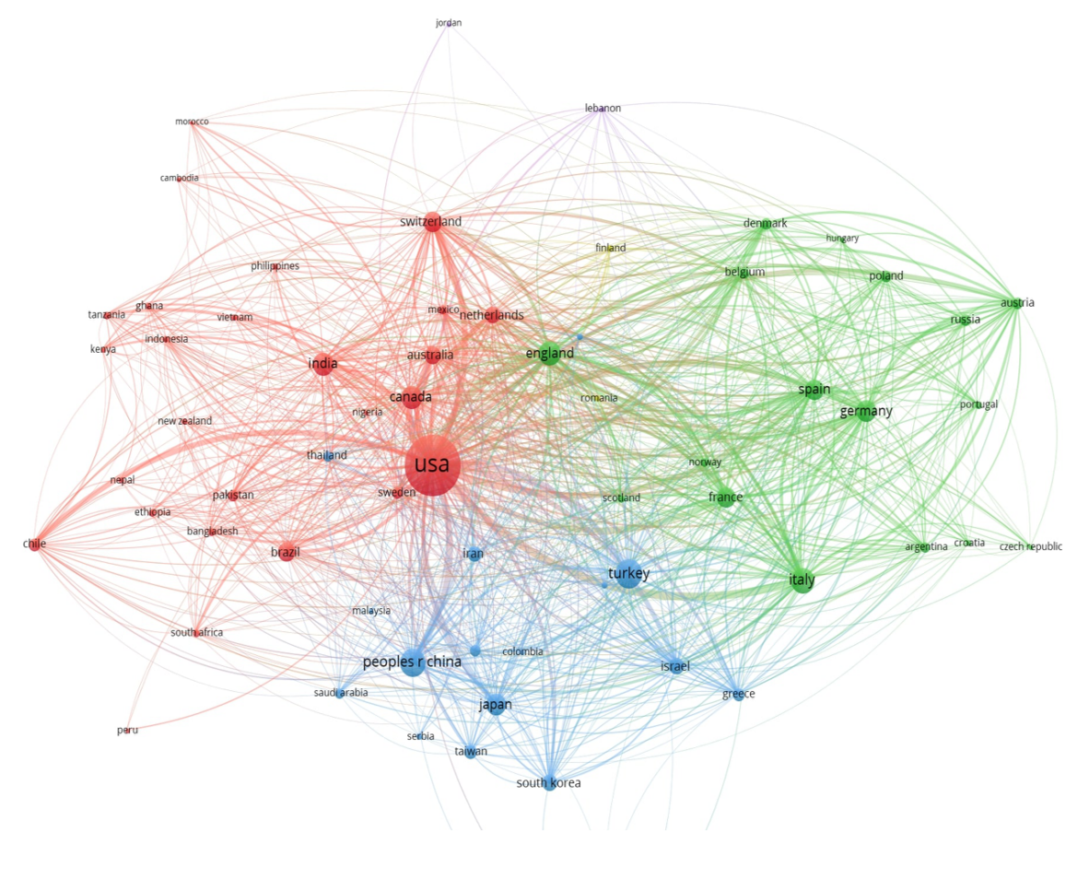
Figure 3 Collaboration network analysis of the 64 countries contributing ≥ 10 papers.
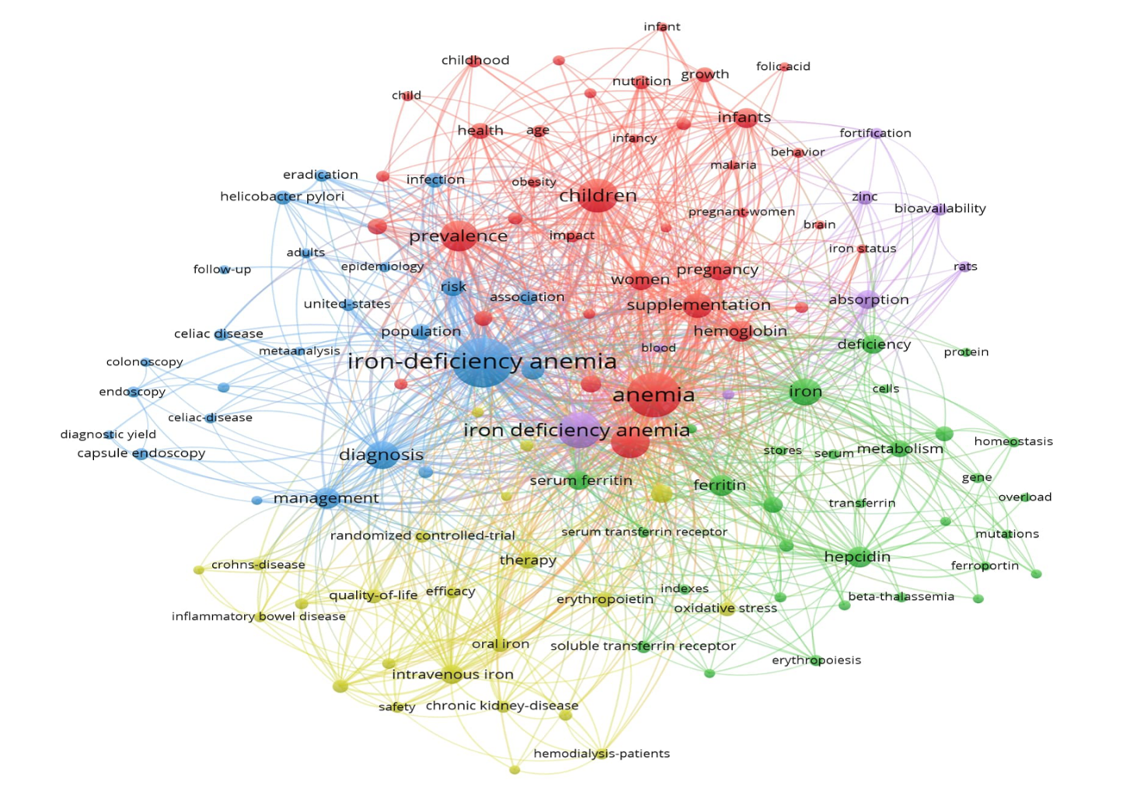
Figure 4 Of 123 terms appearing 50 times or more in the titles or abstracts of the papers in this study.
Table 1 Top 15 journals ranked by number of papers published, and corresponding impact factors
Journal | Records | Impact factor
Journal of nutrition | 107 | 4.281
PLoS One | 81 | 2.740
World Journal of Gastroenterology | 76 | 3.665
American Journal of Clinical Nutrition | 75 | 6.766
Nutrients | 67 | 4.546
Pediatrics | 50 | 5.359
Food and Nutrition Bulletin | 48 | 1.485
Journal of Pediatric Hematology Oncology | 48 | 1.016
Helicobacter | 44 | 4.000
American Journal of Hematology | 39 | 6.973
Blood | 39 | 17.543
Digestive Diseases and Sciences | 35 | 2.751
Pediatric Hematology and Oncology | 34 | 1.232
Biological Trace Element Research | 33 | 2.639
Journal of Pediatric Gastroenterology and Nutrition | 33 | 2.937

Table 2 Top 25 keywords of each 5-year interval between 2001-2020 color coded to the clusters identified in Figure 4
2001 | 2006 |  | 2011 | 2016
Iron-deficiency anemia³ | Iron-deficiency anemia³ |  | Iron-deficiency anemia³ | Iron-deficiency anemia³
Anemia¹ | Anemia¹ |  | Anemia¹ | Anemia¹
Children¹ | Iron deficiency anemia¹ |  | Iron deficiency anemia¹ | Iron deficiency anemia¹
Iron deficiency anemia¹ | Children¹ |  | Children¹ | Prevalence¹
Iron deficiency² | Iron deficiency² |  | Iron deficiency² | Children¹
Iron⁵ | Prevalence¹ |  | Prevalence¹ | Iron deficiency²
Prevalence¹ | Diagnosis³ |  | Iron⁵ | Diagnosis³
Serum ferritin⁵ | Iron⁵ |  | Diagnosis³ | Management³
Ferritin⁵ | Supplementation¹ |  | Supplementation¹ | Iron⁵
Supplementation¹ | Infants¹ |  | Hepcidin⁵ | Supplementation¹
Diagnosis³ | Serum ferritin⁵ |  | Management³ | Pregnancy¹
Absorption² | Women¹ |  | Hemoglobin¹ | Hepcidin⁵
Deficiency⁵ | Hemoglobin¹ |  | Pregnancy¹ | Hemoglobin¹
Infants¹ | Absorption² |  | Ferritin⁵ | Risk³
Erythropoietin⁴ | Deficiency⁵ |  | Intravenous iron⁴ | Intravenous iron⁴
Pregnancy¹ | Hepcidin⁵ |  | Women¹ | Women¹
Women¹ | Therapy⁴ |  | Deficiency anemia¹ | Ferritin⁵
Therapy⁴ | Iron-deficiency¹ |  | Disease³ | Oral iron⁴
Hemoglobin¹ | Growth¹ |  | Inflammation⁵ | Health¹
Eradication³ | Helicobacter pylori³ |  | Risk³ | Disease³
Serum transferrin receptor⁵ | Pregnancy¹ |  | Association³ | Infants¹
Helicobacter pylori³ | Disease³ |  | Metabolism¹ | Deficiency⁵
Iron-deficiency¹ | Risk³ |  | Infants¹ | Iron-deficiency¹
Deficiency anemia¹ | Celiac disease³ |  | Serum ferritin⁵ | Deficiency anemia¹
Disease³ | Expression⁵ |  | Deficiency⁵ | Ferric carboxymaltose⁴
Number of keywords
Red
11 | 12 |  | 11 | 12
Purple
2 | 2 |  | 1 | 1
Blue
5 | 5 |  | 6 | 5
Yellow
2 | 1 |  | 1 | 3
Green
5 | 5 |  | 6 | 4
New items in each quartile
(None) |  | Serum ferritin⁵ | Management³ | Oral iron⁴
 |  | Hepcidin⁵ | Intravenous iron⁴ | Health¹
 |  | Growth¹ | Inflammation⁵ | Ferric carboxymaltose⁴
 |  | Risk³ | Association³
 |  | Celiac disease³ | Metabolism¹
 |  | Expression⁵ | Infants¹
¹Red; ²Purple; ³Blue; ⁴Yellow; ⁵Green. Summary shows the number of keywords in each 5-year quartile by cluster and a list of the keywords appearing for the first time in the top-25 list for each quartile.

Table 3 The top 10 cited papers published for the entire period 2001-2020, and the top 10 cited papers published in each 5-year interval within the study period
2001-2020
Ref. | Title | Journal | Year | Volume | Start page | End page | Times cited | Topic
Vos et al^{[14]}, 2012 | Years lived with disability (YLDs) for 1160 sequelae of 289 diseases and injuries 1990-2010: a systematic analysis for the Global Burden of Disease Study 2010 | Lancet | 2012 | 380 | 2163 | 2196 | 4084 | 1
Malfertheiner et al^{[34]}, 2007 | Current concepts in the management of Helicobacter pylori infection: the maastricht III consensus report | Gut | 2007 | 56 | 772 | 781 | 1481 | 3
Bhutta et al^{[44]}, 2008 | Maternal and Child Undernutrition 3 - What works? Interventions for maternal and child undernutrition and survival | Lancet | 2008 | 371 | 417 | 440 | 1147 | 4
Darmon and Drewnowski^{[19]}, 2008 | Does social class predict diet quality? | American journal of clinical nutrition | 2008 | 87 | 1107 | 1117 | 1061 | 1
Walker et al^{[45]}, 2007 | Child development in developing countries 2 - Child development: risk factors for adverse outcomes in developing countries | Lancet | 2007 | 369 | 145 | 157 | 1033 | 4
Chey and Wong^{[39]}, 2007 | American college of gastroenterology guideline on the management of Helicobacter pylori infection | American journal of gastroenterology | 2007 | 102 | 1808 | 1825 | 830 | 3
Guralnik et al^{[20]}, 2004 | Prevalence of anemia in persons 65 years and older in the United States: evidence for a high rate of unexplained anemia | Blood | 2004 | 104 | 2263 | 2268 | 793 | 1
Ludvigsson et al^{[40]}, 2013 | The Oslo definitions for coeliac disease and related terms | Gut | 2013 | 62 | 43 | 52 | 790 | 3
Rubio-Tapia et al^{[41]}, 2013 | ACG Clinical Guidelines: Diagnosis and Management of Celiac Disease | American journal of gastroenterology | 2013 | 108 | 656 | 676 | 788 | 3
Hill et al^{[35]}, 2005 | Guideline for the diagnosis and treatment of celiac disease in children: Recommendations of the North American Society for Pediatric Gastroenterology, Hepatology and Nutrition | Journal of pediatric gastroenterology and nutrition | 2005 | 40 | 1 | 19 | 752 | 4
2001-2005
Guralnik et al^{[20]}, 2004 | Prevalence of anemia in persons 65 years and older in the United States: evidence for a high rate of unexplained anemia | Blood | 2004 | 104 | 2263 | 2268 | 793 | 1
Hill et al^{[35]}, 2005 | Guideline for the diagnosis and treatment of celiac disease in children: Recommendations of the North American Society for Pediatric Gastroenterology, Hepatology and Nutrition | Journal of pediatric gastroenterology and nutrition | 2005 | 40 | 1 | 19 | 752 | 4
Grantham-McGregor and Ani^{[23]}, 2001 | A review of studies on the effect of iron deficiency on cognitive development in children | Journal of nutrition | 2001 | 131 | 649S | 666S | 736 | 1
Pennazio et al^{[33]}, 2004 | Outcome of patients with obscure gastrointestinal bleeding after capsule endoscopy: Report of 100 consecutive cases | Gastroenterology | 2004 | 126 | 643 | 653 | 688 | 3
Nicolas et al^{[28]}, 2002 | Severe iron deficiency anemia in transgenic mice expressing liver hepcidin | Proceedings of the national academy of sciences of the united states of america | 2002 | 99 | 4596 | 4601 | 694 | 2
Haas and Brownlie^{[2]}, 2001 | Iron deficiency and reduced work capacity: A critical review of the research to determine a causal relationship | Journal of nutrition | 2001 | 131 | 676S | 688S | 573 | 1
Dubé et al^{[22]}, 2005 | The prevalence of celiac disease in average-risk and at-risk Western European populations: A systematic review | Gastroenterology | 2005 | 128 | S57 | S67 | 427 | 1
Ohgami et al^{[31]}, 2005 | Identification of a ferrireductase required for efficient transferrin-dependent iron uptake in erythroid cells | Nature genetics | 2005 | 37 | 1264 | 1269 | 394 | 2
Beard and Connor^{[24]}, 2003 | Iron status and neural functioning | Annual review of nutrition | 2003 | 23 | 41 | 58 | 383 | 1
Graham et al^{[37]}, 2005 | Visible small-intestinal mucosal injury in chronic NSAID users | Clinical gastroenterology and hepatology | 2005 | 3 | 55 | 59 | 391 | 4
2006-2010
Malfertheiner et al^{[34]}, 2007 | Current concepts in the management of Helicobacter pylori infection: the maastricht III consensus report | Gut | 2007 | 56 | 772 | 781 | 1481 | 3
Bhutta et al^{[44]}, 2008 | Maternal and Child Undernutrition 3 - What works? Interventions for maternal and child undernutrition and survival | Lancet | 2008 | 371 | 417 | 440 | 1147 | 4
Darmon and Drewnowski^{[19]}, 2008 | Does social class predict diet quality? | American journal of clinical nutrition | 2008 | 87 | 1107 | 1117 | 1061 | 1
Walker et al^{[45]}, 2007 | Child development in developing countries 2 - Child development: risk factors for adverse outcomes in developing countries | Lancet | 2007 | 369 | 145 | 157 | 1033 | 4
Chey and Wong^{[39]}, 2007 | American college of gastroenterology guideline on the management of Helicobacter pylori infection | American journal of gastroenterology | 2007 | 102 | 1808 | 1825 | 830 | 3
Levin and Rocco^{[38]}, 2006 | KDOQI clinical practice guidelines and clinical practice recommendations for anemia in chronic kidney disease - Foreword | American journal of kidney diseases | 2006 | 47 | S9 | S145 | 565 | 4
Lozoff et al^{[25]}, 2006 | Long-lasting neural and behavioral effects of iron deficiency in infancy | Nutrition reviews | 2006 | 64 | S34 | S43 | 532 | 1
Rostom et al^{[46]}, 2006 | American Gastroenterological Association (AGA) Institute Technical Review on the Diagnosis and Management of Celiac Disease | Gastroenterology | 2006 | 131 | 1981 | 2002 | 514 | 3
Ganz et al^{[29]}, 2008 | Immunoassay for human serum hepcidin | Blood | 2008 | 112 | 4292 | 4297 | 502 | 2
Plum et al^{[26]}, 2010 | The Essential Toxin: Impact of Zinc on Human Health | International journal of environmental research and public health | 2010 | 7 | 1342 | 1365 | 484 | 5
2011-2015
Vos et al^{[14]}, 2012 | Years lived with disability (YLDs) for 1160 sequelae of 289 diseases and injuries 1990-2010: a systematic analysis for the Global Burden of Disease Study 2010 | Lancet | 2012 | 380 | 2163 | 2196 | 4084 | 1
Ludvigsson et al^{[40]}, 2013 | The Oslo definitions for coeliac disease and related terms | Gut | 2013 | 62 | 43 | 52 | 790 | 3
Rubio-Tapia et al^{[41]}, 2013 | ACG Clinical Guidelines: Diagnosis and Management of Celiac Disease | American journal of gastroenterology | 2013 | 108 | 656 | 676 | 788 | 3
Kassebaum et al^{[18]}, 2014 | A systematic analysis of global anemia burden from 1990 to 2010 | Blood | 2014 | 123 | 615 | 624 | 623 | 1
Walker et al^{[47]}, 2011 | Child Development 1 Inequality in early childhood: risk and protective factors for early child development | Lancet | 2011 | 378 | 1325 | 1338 | 621 | 1
Camaschella^{[48]}, 2015 | Iron-Deficiency Anemia | New england journal of medicine | 2015 | 372 | 1832 | 1843 | 402 | multiple
Chey et al^{[49]}, 2015 | Irritable Bowel Syndrome A Clinical Review | Jama-journal of the american medical association | 2015 | 313 | 949 | 958 | 378 | 3
Balarajan et al^{[21]}, 2011 | Anaemia in low-income and middle-income countries | Lancet | 2011 | 378 | 2123 | 2135 | 353 | 1
Pennazio et al^{[33]}, 2004 | Small-bowel capsule endoscopy and device-assisted enteroscopy for diagnosis and treatment of small-bowel disorders: European Society of Gastrointestinal Endoscopy (ESGE) Clinical Guideline | Endoscopy | 2015 | 47 | 352 | 376 | 317 | 3
Goodnough et al^{[42]}, 2011 | Detection, evaluation, and management of preoperative anaemia in the elective orthopaedic surgical patient: NATA guidelines | British journal of anaesthesia | 2011 | 106 | 13 | 22 | 303 | 3
2016-2020
Chey et al^{[50]}, 2017 | ACG Clinical Guideline: Treatment of Helicobacter pylori Infection | American journal of gastroenterology | 2017 | 112 | 212 | 239 | 324 | 3
Amieva and Peek^{[51]}, 2016 | Pathobiology of Helicobacter pylori-Induced Gastric Cancer | Gastroenterology | 2016 | 150 | 64 | 78 | 224 | 4
Kyu et al^{[52]}, 2016 | Global and National Burden of Diseases and Injuries Among Children and Adolescents Between 1990 and 2013 Findings From the Global Burden of Disease 2013 Study | Jama pediatrics | 2016 | 170 | 267 | 287 | 214 | 1
Girelli et al^{[30]}, 2005 | Hepcidin in the diagnosis of iron disorders | Blood | 2016 | 127 | 2809 | 2813 | 147 | 2
Kassebaum^{[53]}, 2016 | The Global Burden of Anemia | Hematology-oncology clinics of north america | 2016 | 30 | 247 | 308 | 141 | 1
Trenkwalder et al^{[54]}, 2016 | Restless legs syndrome associated with major diseases A systematic review and new concept | Neurology | 2016 | 86 | 1336 | 1343 | 117 | 4
Xie et al^{[27]}, 2016 | Advances on Bioactive Polysaccharides from Medicinal Plants | Critical reviews in food science and nutrition | 2016 | 56 | S60 | S84 | 112 | 5
Enns et al^{[55]}, 2017 | Clinical Practice Guidelines for the Use of Video Capsule Endoscopy | Gastroenterology | 2017 | 152 | 497 | 514 | 111 | 3
Froessler et al^{[36]}, 2018 | The Important Role for Intravenous Iron in Perioperative Patient Blood Management in Major Abdominal Surgery A Randomized Controlled Trial | Annals of surgery | 2016 | 264 | 41 | 46 | 98 | 4
Vasanawala et al^{[56]}, 2016 | Safety and technique of ferumoxytol administration for MRI | Magnetic resonance in medicine | 2016 | 75 | 2107 | 2111 | 93 | 3 or 4
For the Topic column, the following numbers correspond to these topics: (1) Epidemiologic aspects of iron deficiency anemia; (2) Biochemical aspects of iron deficiency anemia; (3) Clinical evaluation of causes of iron deficiency anemia; (4) Causes of iron deficiency anemia; and (5) Bioavailability of dietary iron.

