Name of Journal: World Journal of Clinical Cases
Manuscript NO: 81240
Manuscript Type: ORIGINAL ARTICLE

Retrospective Study
Type 2 diabetes mellitus characteristics affect hepatocellular carcinoma development in chronic hepatitis B patients with cirrhosis

Li MY et al. T2DM affects prognosis in CHB patients

Man-Yu Li, Ting-Ting Li, Ke-Jian Li, Cheng Zhou

Man-Yu Li, Ke-Jian Li, Cheng Zhou, Division I of In Vitro Diagnostics for Infectious Diseases, Institute for In Vitro Diagnostics Control, National Institutes for Food and Drug Control, Beijing 100050, China

Ting-Ting Li, Department of Clinical Laboratory, The Fifth Affiliated Hospital of Zhengzhou University, Zhengzhou 450052, Henan Province, China

Author contributions: Li MY designed and performed the research and wrote the paper; Li TT designed the research and contributed to the analysis; Li KJ and Zhou C supervised the report.

Supported by the National Institutes for Food and Drug Control, No. 2022C4.

Corresponding author: Man-Yu Li, PhD, Assistant Professor, Research Assistant Professor, Division I of In Vitro Diagnostics for Infectious Diseases, Institute for In Vitro Diagnostics Control, National Institutes for Food and Drug Control, No. 2 Tiantanxili Road, Dongcheng District, Beijing 100050, China. myli226@163.com

Received: October 31, 2022
Revised: November 24, 2022
Accepted: January 16, 2023
Published online: February 16, 2023

Abstract
BACKGROUND
Type 2 diabetes mellitus (T2DM) has been shown to be correlated with hepatocellular carcinoma (HCC) development. However, further investigation is needed to understand how T2DM characteristics affect the prognosis of chronic hepatitis B (CHB) patients.

AIM
To assess the effect of T2DM on CHB patients with cirrhosis and to determine the risk factors for HCC development.

METHODS
Among the 412 CHB patients with cirrhosis enrolled in this study, there were 196 with T2DM. The patients in the T2DM group were compared to the remaining 216 patients without T2DM (non-T2DM group). Clinical characteristics and outcomes of the two groups were reviewed and compared.

RESULTS
T2DM was significantly related to hepatocarcinogenesis in this study (P = 0.002). The presence of T2DM, being male, alcohol abuse status, alpha-fetoprotein > 20 ng/mL, and hepatitis B surface antigen > 2.0 log IU/mL were identified to be risk factors for HCC development in the multivariate analysis. T2DM duration of more than 5 years and treatment with diet control or insulin ± sulfonylurea significantly increased the risk of hepatocarcinogenesis.

CONCLUSION
T2DM and its characteristics increase the risk of HCC in CHB patients with cirrhosis. The importance of diabetic control should be emphasized for these patients.

Key Words: Chronic hepatitis B; Diabetes mellitus; Hepatocellular carcinoma; Prognosis; Risk factor

©The Author(s) 2023. Published by Baishideng Publishing Group Inc. All rights reserved.

Citation: Li MY, Li TT, Li KJ, Zhou C. Type 2 diabetes mellitus characteristics affect hepatocellular carcinoma development in chronic hepatitis B patients with cirrhosis. World J Clin Cases 2023; 11(5): 1009-1018
URL: https://www.wjgnet.com/2307-8960/full/v11/i5/1009.htm
DOI: https://dx.doi.org/10.12998/wjcc.v11.i5.1009

Core Tip: This retrospective study assessed the risk factors for hepatocellular carcinoma (HCC) development in chronic hepatitis B (CHB) patients with type 2 diabetes mellitus (T2DM). A total of 412 CHB patients were enrolled in this study. T2DM, male sex, alcohol abuse, alpha-fetoprotein > 20 ng/mL, and hepatitis B surface antigen > 2.0 log IU/mL were identified to be risk factors for HCC development. T2DM duration and treatment were also significantly related to HCC development. Thus, T2DM and T2DM characteristics affect the prognosis of CHB patients with cirrhosis.

INTRODUCTION
Hepatitis B virus (HBV) infection is a major public health problem worldwide^{[1]}. It is estimated that over 257 million people are chronically infected with HBV worldwide, causing 887000 deaths annually^{[2]}. Chronic hepatitis B (CHB) can lead to liver fibrosis, cirrhosis, and hepatocellular carcinoma (HCC)^{[1]}. CHB accounts for over 50% of cases of HCC globally, which is the most common type of liver cancer^{[3]}. HCC is the second-leading cause of cancer-related deaths in China^{[4]}. Many non-HBV factors, including age, sex, alcohol consumption, smoking, and type 2 diabetes mellitus (T2DM), may increase HCC risk among CHB patients^{[5,6]}.
Currently, T2DM affects more than 440 million individuals globally^{[7]}. China has the most people affected by T2DM with 110 million estimated T2DM diagnoses^{[8]}. T2DM is a leading cause of death due to renal and heart complications^{[9]} as well as an increased risk of multiple cancers^{[10]}. Patients with T2DM have a 2.5-4.0-fold risk of developing HCC^{[11]}. The precise mechanism of how T2DM affects the development of HCC remains unclear, although it may be related to insulin resistance and insulin-like growth factor 1 signaling pathways^{[12]}. This study investigated the relationship between T2DM clinical characteristics and HCC development in T2DM patients with CHB.

MATERIALS AND METHODS
Study population
This was a retrospective study consisting of consecutive CHB patients at the Fifth Affiliated Hospital of Zhengzhou University in Zhengzhou, China during the period of December 2013 to February 2021. The inclusion criteria were as follows: (1) Hepatitis B surface antigen (HBsAg) positivity for more than 6 mo; (2) Valid clinical characteristics and laboratory outcomes; (3) No hepatotrophic virus coinfection; (4) Presence of cirrhosis; (5) No alcoholic hepatic diseases or HCC; and (6) No type 1 DM. The final number of patients included in this study was 412. Patients were divided into a T2DM group (n = 196) and a non-T2DM group (n = 216). This study was conducted under compliance with the Declaration of Helsinki and was approved by the Human Ethics Committee of the Fifth Affiliated Hospital of Zhengzhou University (KY2021031).

Data collection
Patient data were obtained from the electronic medical record database of the hospital. The prothrombin time and international normalized ratio were measured with an ACL TOP coagulation analyzer (Instrumentation Laboratory, Beckman Coulter, Sydney, NSW, Australia). Platelet count was monitored with an LH 750 Automated Hematology Analyzer (Instrumentation Laboratory, Beckman Coulter). Alanine aminotransferase, aspartate aminotransferase, gamma-glutamyl transferase, albumin, total bilirubin, and creatinine levels were measured using an AU5800 Clinical Chemistry Analyzer (Instrumentation Laboratory, Beckman Coulter). The serum HBV-DNA level was quantified by polymerase chain reaction using a Roche LightCycler (Roche Diagnostics, Basel, Switzerland). HBsAg and hepatitis B e-antigen were determined using an AutoLumo A2000Plus Chemiluminescence Detector (Autobio, Zhengzhou, China).

Statistical analysis
Continuous variables are expressed as medians (the first to third quartiles), and the Mann-Whitney U test was used to assess continuous variables. The χ² test or Fisher’s test was used to analyze categorical variables. The incidence of HCC was analyzed by the Kaplan-Meier method and log-rank test. Cox regression was used to screen and identify factors associated with mortality and hepatocarcinogenesis. Multivariate logistic regression analysis was also performed to identify potential factors associated with T2DM. The model for end-stage liver disease score was calculated according to the standard formula^{[13]}. The following cutoffs of analyzed factors were based on previous reports: Age of 65 years^{[14]}, HBsAg of 2.0 log IU/mL^{[15]}, and HBV-DNA of 20000 IU/mL^{[16]}. P < 0.05 was considered statistically significant. All statistical analyses were performed with the SPSS software package (version 22.0; IBM Corp., Armonk, NY, United States).

RESULTS
Baseline characteristics
A total of 412 CHB patients with cirrhosis were enrolled in this study, including 196 patients with pre-existing T2DM at baseline and 216 patients without. Their characteristics are summarized in Table 1. Compared to patients in the non-T2DM group, patients in the T2DM group had significantly lower prothrombin time [11.8 (10.8-14.1) vs 10.4 (9.6-11.3), respectively, P < 0.001] and international normalized ratio [1.05 (0.96-1.24) vs 0.94 (0.87-1.01), respectively, P < 0.001]. Since nucleos(t)ide analogues (NUCs) may affect HCC development, we compared the use of NUCs between the two groups. We found that the proportion of different HBV therapies between the two groups did not differ significantly (Supplementary Table 1). Therefore, the HBV therapy may not affect the risk of HCC in this study. The other baseline characteristics did not show significant differences between the two groups.

T2DM characteristics
In the T2DM group, 22.4% (44/196) of patients had been diagnosed with T2DM for less than 2.0 years, 21.4% (42/196) for 2.1-5.0 years, 26.5% (52/196) for 5.1-10.0 years, and 29.6% (58/196) for more than 10.0 years. Among all the T2DM patients, 57.1% (112/196) were treated with metformin with or without sulfonylurea treatment, 25.5% (50/196) were treated with insulin with or without sulfonylurea treatment, and 17.3% (34/196) controlled T2DM with diet alone.

Factors associated with hepatocarcinogenesis
The factors related to hepatocarcinogenesis were assessed (Table 2). The analyzed factors included age, sex, smoking status, alcohol abuse status, dyslipidemia, T2DM, ascites, esophagogastric varices, alpha-fetoprotein (AFP), HBsAg, hepatitis B e-antigen, HBV-DNA, and antiviral treatment. The univariate analysis showed that sex (P < 0.001), smoking status (P = 0.013), T2DM (P = 0.002), and ascites (P = 0.016) were significantly related to hepatocarcinogenesis. Then, the multivariate analysis was conducted to analyze the factors associated with hepatocarcinogenesis. The results showed that sex [hazard ratio (HR) = 3.47, 95% confidence interval (CI): 1.36-8.89, P = 0.010], alcohol abuse status (HR = 1.38, 95%CI: 0.80-1.68, P = 0.008), T2DM (HR = 6.73, 95%CI: 2.77-16.36, P < 0.001), AFP (HR = 3.89, 95%CI: 1.06-14.27, P = 0.041), and HBsAg (HR = 4.10, 95%CI: 1.52-11.12, P = 0.005) were significantly related with hepatocarcinogenesis.
The Kaplan-Meier survival curves showed that the hepatocarcinogenesis probability of the T2DM group and non-T2DM group was significantly different (Figure 1). The median time to hepatocarcinogenesis for the T2DM group and non-T2DM group was 30 mo and 34 mo, respectively. We then analyzed the relationship between T2DM and hepatocarcinogenesis among all subgroups (Figure 2). T2DM and hepatocarcinogenesis were significantly correlated in the following subgroups: Males (HR = 2.04, 95%CI: 1.08-3.84, P = 0.028), non-smokers (HR = 10.73, 95%CI: 3.12-36.98, P < 0.001), patients without alcohol abuse (HR = 2.49, 95%CI: 1.27-4.87, P = 0.008), patients with HBsAg > 2.0 log IU/mL (HR = 5.47, 95%CI: 2.36-12.65, P < 0.001), and patients not treated with antiviral medication (HR = 3.29, 95%CI: 1.44-7.54, P = 0.005).

T2DM characteristics and hepatocarcinogenesis
Since T2DM was shown to be associated with hepatocarcinogenesis in CHB patients, we analyzed the relationship between T2DM characteristics and hepatocarcinogenesis in CHB patients with T2DM. We found that patient age over 65 years old (P < 0.001), male sex (P = 0.049), AFP > 20 ng/mL (P = 0.002), HBsAg > 2.0 log IU/mL (P = 0.001), or receipt of antiviral treatment (P = 0.007) were significantly correlated with hepatocarcinogenesis in the T2DM group (Table 3). Among T2DM characteristics, T2DM duration of more than 5 years (HR = 6.74, 95%CI: 2.36-19.29, P < 0.001), insulin ± sulfonylurea therapy (HR = 1.45, 95%CI: 0.26-7.96, P = 0.041), and diet control only (HR = 10.70, 95%CI: 2.91-39.31, P < 0.001) were significantly correlated with hepatocarcinogenesis in the T2DM group.

DISCUSSION
T2DM is a major public health problem in China^{[17]}. It has been suggested that T2DM is a risk factor for HCC development, liver disease progression, and mortality in CHB patients^{[18]}. However, it remains controversial whether T2DM is related to HCC development. Results from the current study suggested that the presence of T2DM significantly increased the risk of HCC development in CHB patients with cirrhosis. Cox regression analysis showed that sex, alcohol abuse status, T2DM, AFP, and HBsAg were significantly related with hepatocarcinogenesis. The T2DM characteristics, including duration and treatment, were found to be significantly related with hepatocarcinogenesis.
In the present study, the incidence of hepatocarcinogenesis was significantly correlated to sex (P = 0.010), alcohol abuse status (P = 0.008), T2DM (P < 0.001), AFP (P = 0.041), and HBsAg (P = 0.005). A recent study showed that gamma-glutamyltranspeptidase (γ-GTP) levels were related with the risk of HCC among HBV patients on NUC therapy^{[19]}. But in this study, the level of γ-GTP did not differ between the two groups in both the univariate and multivariate analyses (P = 0.692 and 0.530, respectively). Thus, whether γ-GTP levels affect the prognosis of CHB patients still needs to be further verified. The Kaplan-Meier survival curves showed that the probability of hepatocarcinogenesis in the T2DM group was significantly different from that in the non-T2DM group. These results suggested that T2DM was an independent risk factor for HCC development. These findings were consistent with prior studies^{[20,21]}. The subgroup analysis showed that the effect of T2DM on HCC development was stronger in CHB patients in the subgroups of male gender, non-smoker, no alcohol abuse, HBsAg > 2.0 log IU/mL, and no antiviral treatment. This difference may be due to the limited number of patients, which still needs to be validated in further studies.
It is notable that T2DM characteristics were associated with hepatocarcinogenesis in this study. In cirrhotic CHB patients with T2DM, patients who were over 65 years old or male, who had AFP > 20 ng/mL or HBsAg > 2.0 log IU/mL, or who received antiviral treatment had a significantly increased risk of hepatocarcinogenesis. T2DM duration of more than 5 years was found to be significantly correlated to the incidence of hepatocarcinogenesis. It had a 6.74-fold increased risk for HCC compared to in T2DM patients with a duration of less than 5 years.
Moreover, T2DM patients who were treated with only diet control or insulin ± sulfonylurea therapy were at a higher risk for HCC development. However, it is still unknown whether different treatment strategies affect HCC development. It has been reported that the use of insulin can elevate the risk of HCC^{[9,22]}. On the contrary, metformin treatment was reported to be associated with a reduced risk of HCC^{[12]}. A large-scale study also showed that the use of metformin among DM patients can significantly reduce the HCC risk in chronic hepatitis C patients^{[23]}. The underlying mechanism has not been fully understood, but it may be related with the anti-proliferative and immune-modulating effect of metformin^{[24]}. Although evidence suggests that sulfonylureas can increase the risk of HCC^{[12,25]}, we found that the use of metformin with or without sulfonylurea had a significantly lower risk of HCC. These results suggest that good diabetic management and appropriate therapy are crucial in cirrhotic CHB patients with T2DM. There are some limitations for this study. This is a single center retrospective study, and the sample size was small. Some details of T2DM patients were not collected, which limited further analysis. Thus, the results need to be validated in larger multicenter studies in the future.

CONCLUSION
In conclusion, T2DM was found to be related to a poor CHB prognosis. Analysis suggested that patients who were male, who abused alcohol, or who had AFP > 20 ng/mL and HBsAg > 2.0 log IU/mL were at a higher risk for poor outcomes. T2DM characteristics, including T2DM duration of more than 5 years, diet control, and insulin ± sulfonylurea therapy, significantly increased the risk of hepatocarcinogenesis. These findings confirmed the importance of diabetic management in CHB patients with cirrhosis. The exact mechanism of how T2DM affects HCC development still warrants further study.

ARTICLE HIGHLIGHTS
Research background
Type 2 diabetes mellitus (T2DM) has been shown to be correlated with hepatocellular carcinoma (HCC) development. However, the T2DM characteristics that affect HCC are unknown.

Research motivation
T2DM affects more than 440 million individuals globally. T2DM is a leading cause of death due to renal and heart complications as well as an increased risk of multiple cancers. Understanding the correlation between T2DM and HCC will benefit these patients.

Research objectives
This study aimed to investigate the relationship between T2DM clinical characteristics and HCC development in pre-existing T2DM patients with chronic hepatitis B (CHB).

Research methods
Among 412 CHB patients enrolled in this study, there were 196 patients with T2DM. The patients were divided into the T2DM group and the non-T2DM group (n = 216). Clinical characteristics and outcomes of the two groups were compared.

Research results
T2DM was found to be significantly related to hepatocarcinogenesis in this study. In the multivariate analysis, T2DM, male sex, alcohol abuse status, alpha-fetoprotein (AFP) > 20 ng/mL, and hepatitis B surface antigen (HBsAg) > 2.0 log IU/mL were identifeid to be risk factors for HCC development. T2DM duration and therapy significantly increased the risk of hepatocarcinogenesis.

Research conclusions
T2DM was found to be related to a poor CHB prognosis. Male sex, alcohol abuse status, AFP > 20 ng/mL and HBsAg > 2.0 log IU/mL were also significantly related with poor outcomes. T2DM characteristics, including T2DM duration more than 5 years and treatment of diet control or insulin ± sulfonylurea significantly increased the risk of hepatocarcinogenesis.

Research perspectives
These findings confirmed the importance of diabetic management in CHB patients. The exact mechanism of how T2DM affects HCC development still warrants further study.

ACKNOWLEDGEMENTS
The authors are very grateful to Dr. Wang Yan (First Clinical Medical College, Shanxi Medical University) for the statistical review.

REFERENCES
1 Yuen MF, Chen DS, Dusheiko GM, Janssen HLA, Lau DTY, Locarnini SA, Peters MG, Lai CL. Hepatitis B virus infection. Nat Rev Dis Primers 2018; 4: 18035 [PMID: 29877316 DOI: 10.1038/nrdp.2018.35]
2 Lee HM, Banini BA. Updates on Chronic HBV: Current Challenges and Future Goals. Curr Treat Options Gastroenterol 2019; 17: 271-291 [PMID: 31077059 DOI: 10.1007/s11938-019-00236-3]
3 Xie Y. Hepatitis B Virus-Associated Hepatocellular Carcinoma. Adv Exp Med Biol 2017; 1018: 11-21 [PMID: 29052129 DOI: 10.1007/978-981-10-5765-6_2]
4 Xu XF, Xing H, Han J, Li ZL, Lau WY, Zhou YH, Gu WM, Wang H, Chen TH, Zeng YY, Li C, Wu MC, Shen F, Yang T. Risk Factors, Patterns, and Outcomes of Late Recurrence After Liver Resection for Hepatocellular Carcinoma: A Multicenter Study From China. JAMA Surg 2019; 154: 209-217 [PMID: 30422241 DOI: 10.1001/jamasurg.2018.4334]
5 Fattovich G, Stroffolini T, Zagni I, Donato F. Hepatocellular carcinoma in cirrhosis: incidence and risk factors. Gastroenterology 2004; 127: S35-S50 [PMID: 15508101 DOI: 10.1053/j.gastro.2004.09.014]
6 McGlynn KA, Petrick JL, El-Serag HB. Epidemiology of Hepatocellular Carcinoma. Hepatology 2021; 73 Suppl 1: 4-13 [PMID: 32319693 DOI: 10.1002/hep.31288]
7 Ma RCW. Epidemiology of diabetes and diabetic complications in China. Diabetologia 2018; 61: 1249-1260 [PMID: 29392352 DOI: 10.1007/s00125-018-4557-7]
8 Yang L, Shao J, Bian Y, Wu H, Shi L, Zeng L, Li W, Dong J. Prevalence of type 2 diabetes mellitus among inland residents in China (2000-2014): A meta-analysis. J Diabetes Investig 2016; 7: 845-852 [PMID: 27181391 DOI: 10.1111/jdi.12514]
9 Hassan MM, Curley SA, Li D, Kaseb A, Davila M, Abdalla EK, Javle M, Moghazy DM, Lozano RD, Abbruzzese JL, Vauthey JN. Association of diabetes duration and diabetes treatment with the risk of hepatocellular carcinoma. Cancer 2010; 116: 1938-1946 [PMID: 20166205 DOI: 10.1002/cncr.24982]
10 Coughlin SS, Calle EE, Teras LR, Petrelli J, Thun MJ. Diabetes mellitus as a predictor of cancer mortality in a large cohort of US adults. Am J Epidemiol 2004; 159: 1160-1167 [PMID: 15191933 DOI: 10.1093/aje/kwh161]
11 Allaire M, Nault JC. Type 2 diabetes-associated hepatocellular carcinoma: A molecular profile. Clin Liver Dis (Hoboken) 2016; 8: 53-58 [PMID: 31041063 DOI: 10.1002/cld.569]
12 Plaz Torres MC, Jaffe A, Perry R, Marabotto E, Strazzabosco M, Giannini EG. Diabetes medications and risk of HCC. Hepatology 2022; 76: 1880-1897 [PMID: 35239194 DOI: 10.1002/hep.32439]
13 Sterling RK, Lissen E, Clumeck N, Sola R, Correa MC, Montaner J, S Sulkowski M, Torriani FJ, Dieterich DT, Thomas DL, Messinger D, Nelson M; APRICOT Clinical Investigators. Development of a simple noninvasive index to predict significant fibrosis in patients with HIV/HCV coinfection. Hepatology 2006; 43: 1317-1325 [PMID: 16729309 DOI: 10.1002/hep.21178]
14 Foster GR, Irving WL, Cheung MC, Walker AJ, Hudson BE, Verma S, McLauchlan J, Mutimer DJ, Brown A, Gelson WT, MacDonald DC, Agarwal K; HCV Research, UK. Impact of direct acting antiviral therapy in patients with chronic hepatitis C and decompensated cirrhosis. J Hepatol 2016; 64: 1224-1231 [PMID: 26829205 DOI: 10.1016/j.jhep.2016.01.029]
15 Zhang C, Yang Z, Wang Z, Dou X, Sheng Q, Li Y, Han C, Ding Y. HBV DNA and HBsAg: Early Prediction of Response to Peginterferon α-2a in HBeAg-Negative Chronic Hepatitis B. Int J Med Sci 2020; 17: 383-389 [PMID: 32132873 DOI: 10.7150/ijms.39775]
16 Chen CJ, Yang HI, Su J, Jen CL, You SL, Lu SN, Huang GT, Iloeje UH; REVEAL-HBV Study Group. Risk of hepatocellular carcinoma across a biological gradient of serum hepatitis B virus DNA level. JAMA 2006; 295: 65-73 [PMID: 16391218 DOI: 10.1001/jama.295.1.65]
17 Song P, Yu J, Chan KY, Theodoratou E, Rudan I. Prevalence, risk factors and burden of diabetic retinopathy in China: a systematic review and meta-analysis. J Glob Health 2018; 8: 010803 [PMID: 29899983 DOI: 10.7189/jogh.08.010803]
18 Shyu YC, Huang TS, Chien CH, Yeh CT, Lin CL, Chien RN. Diabetes poses a higher risk of hepatocellular carcinoma and mortality in patients with chronic hepatitis B: A population-based cohort study. J Viral Hepat 2019; 26: 718-726 [PMID: 30739359 DOI: 10.1111/jvh.13077]
19 Huang CF, Jang TY, Jun DW, Ahn SB, An J, Enomoto M, Takahashi H, Ogawa E, Yoon E, Jeong SW, Shim JJ, Jeong JY, Kim SE, Oh H, Kim HS, Cho YK, Kozuka R, Inoue K, Cheung KS, Mak LY, Huang JF, Dai CY, Yuen MF, Nguyen MH, Yu ML. On-treatment gamma-glutamyl transferase predicts the development of hepatocellular carcinoma in chronic hepatitis B patients. Liver Int 2022; 42: 59-68 [PMID: 34687130 DOI: 10.1111/liv.15085]
20 Shin HS, Jun BG, Yi SW. Impact of diabetes, obesity, and dyslipidemia on the risk of hepatocellular carcinoma in patients with chronic liver diseases. Clin Mol Hepatol 2022; 28: 773-789 [PMID: 35934813 DOI: 10.3350/cmh.2021.0383]
21 Liu GM, Zeng HD, Zhang CY, Xu JW. Key genes associated with diabetes mellitus and hepatocellular carcinoma. Pathol Res Pract 2019; 215: 152510 [PMID: 31591054 DOI: 10.1016/j.prp.2019.152510]
22 Hsiang JC, Gane EJ, Bai WW, Gerred SJ. Type 2 diabetes: a risk factor for liver mortality and complications in hepatitis B cirrhosis patients. J Gastroenterol Hepatol 2015; 30: 591-599 [PMID: 25250942 DOI: 10.1111/jgh.12790]
23 Tsai PC, Kuo HT, Hung CH, Tseng KC, Lai HC, Peng CY, Wang JH, Chen JJ, Lee PL, Chien RN, Yang CC, Lo GH, Kao JH, Liu CJ, Liu CH, Yan SL, Bair MJ, Lin CY, Su WW, Chu CH, Chen CJ, Tung SY, Tai CM, Lin CW, Lo CC, Cheng PN, Chiu YC, Wang CC, Cheng JS, Tsai WL, Lin HC, Huang YH, Yeh ML, Huang CF, Hsieh MH, Huang JF, Dai CY, Chung WL, Chen CY, Yu ML; T-COACH Study Group. Metformin reduces hepatocellular carcinoma incidence after successful antiviral therapy in patients with diabetes and chronic hepatitis C in Taiwan. J Hepatol 2022 [PMID: 36208843 DOI: 10.1016/j.jhep.2022.09.019]
24 Zhang Y, Wang H, Xiao H. Metformin Actions on the Liver: Protection Mechanisms Emerging in Hepatocytes and Immune Cells against NASH-Related HCC. Int J Mol Sci 2021; 22 [PMID: 34065108 DOI: 10.3390/ijms22095016]
25 Lee JY, Jang SY, Nam CM, Kang ES. Incident Hepatocellular Carcinoma Risk in Patients Treated with a Sulfonylurea: A Nationwide, Nested, Case-Control Study. Sci Rep 2019; 9: 8532 [PMID: 31189966 DOI: 10.1038/s41598-019-44447-1]

Footnotes
Institutional review board statement: This study was reviewed and approved by the Human Ethics Committee of the Fifth Affiliated Hospital of Zhengzhou University (KY2021031).

Informed consent statement: Patients were not required to give informed consent for the study because the analysis used anonymous clinical data that were approved by the Human Ethics Committee of the Fifth Affiliated Hospital of Zhengzhou University.

Conflict-of-interest statement: All the authors report no relevant conflicts of interest for this article.

Data sharing statement: No additional data are available.

Open-Access: This article is an open-access article that was selected by an in-house editor and fully peer-reviewed by external reviewers. It is distributed in accordance with the Creative Commons Attribution NonCommercial (CC BY-NC 4.0) license, which permits others to distribute, remix, adapt, build upon this work non-commercially, and license their derivative works on different terms, provided the original work is properly cited and the use is non-commercial. See: https://creativecommons.org/Licenses/by-nc/4.0/

Provenance and peer review: Unsolicited article; Externally peer reviewed.
Peer-review model: Single blind

Peer-review started: October 31, 2022
First decision: November 11, 2022
Article in press: January 16, 2023

Specialty type: Medicine, research and experimental
Country/Territory of origin: China
Peer-review report’s scientific quality classification
Grade A (Excellent): 0
Grade B (Very good): B, B
Grade C (Good): 0
Grade D (Fair): 0
Grade E (Poor): 0

P-Reviewer: Soldera J, Brazil; Yu ML, Taiwan S-Editor: Wang JJ L-Editor: Wang TQ P-Editor: Wang JJ

Figure Legends
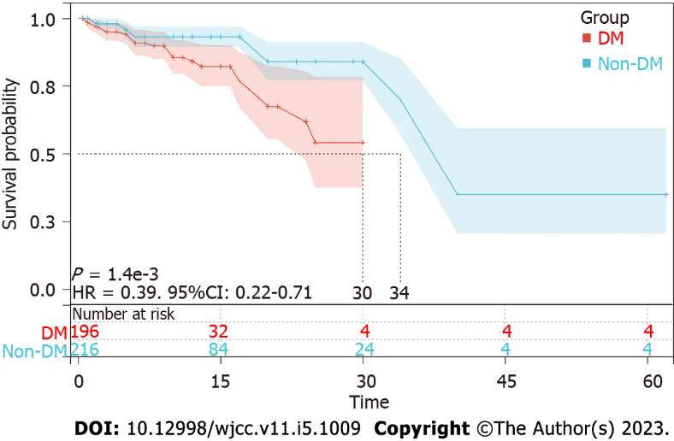
Figure 1 Rates of hepatocellular carcinoma development in patients with or without type 2 diabetes mellitus. The type 2 diabetes mellitus (DM) group had a significantly higher rate of hepatocellular carcinoma development than the non-DM group (P < 0.05). CI: Confidence interval; HR: Hazard ratio; DM: Diabetes mellitus.

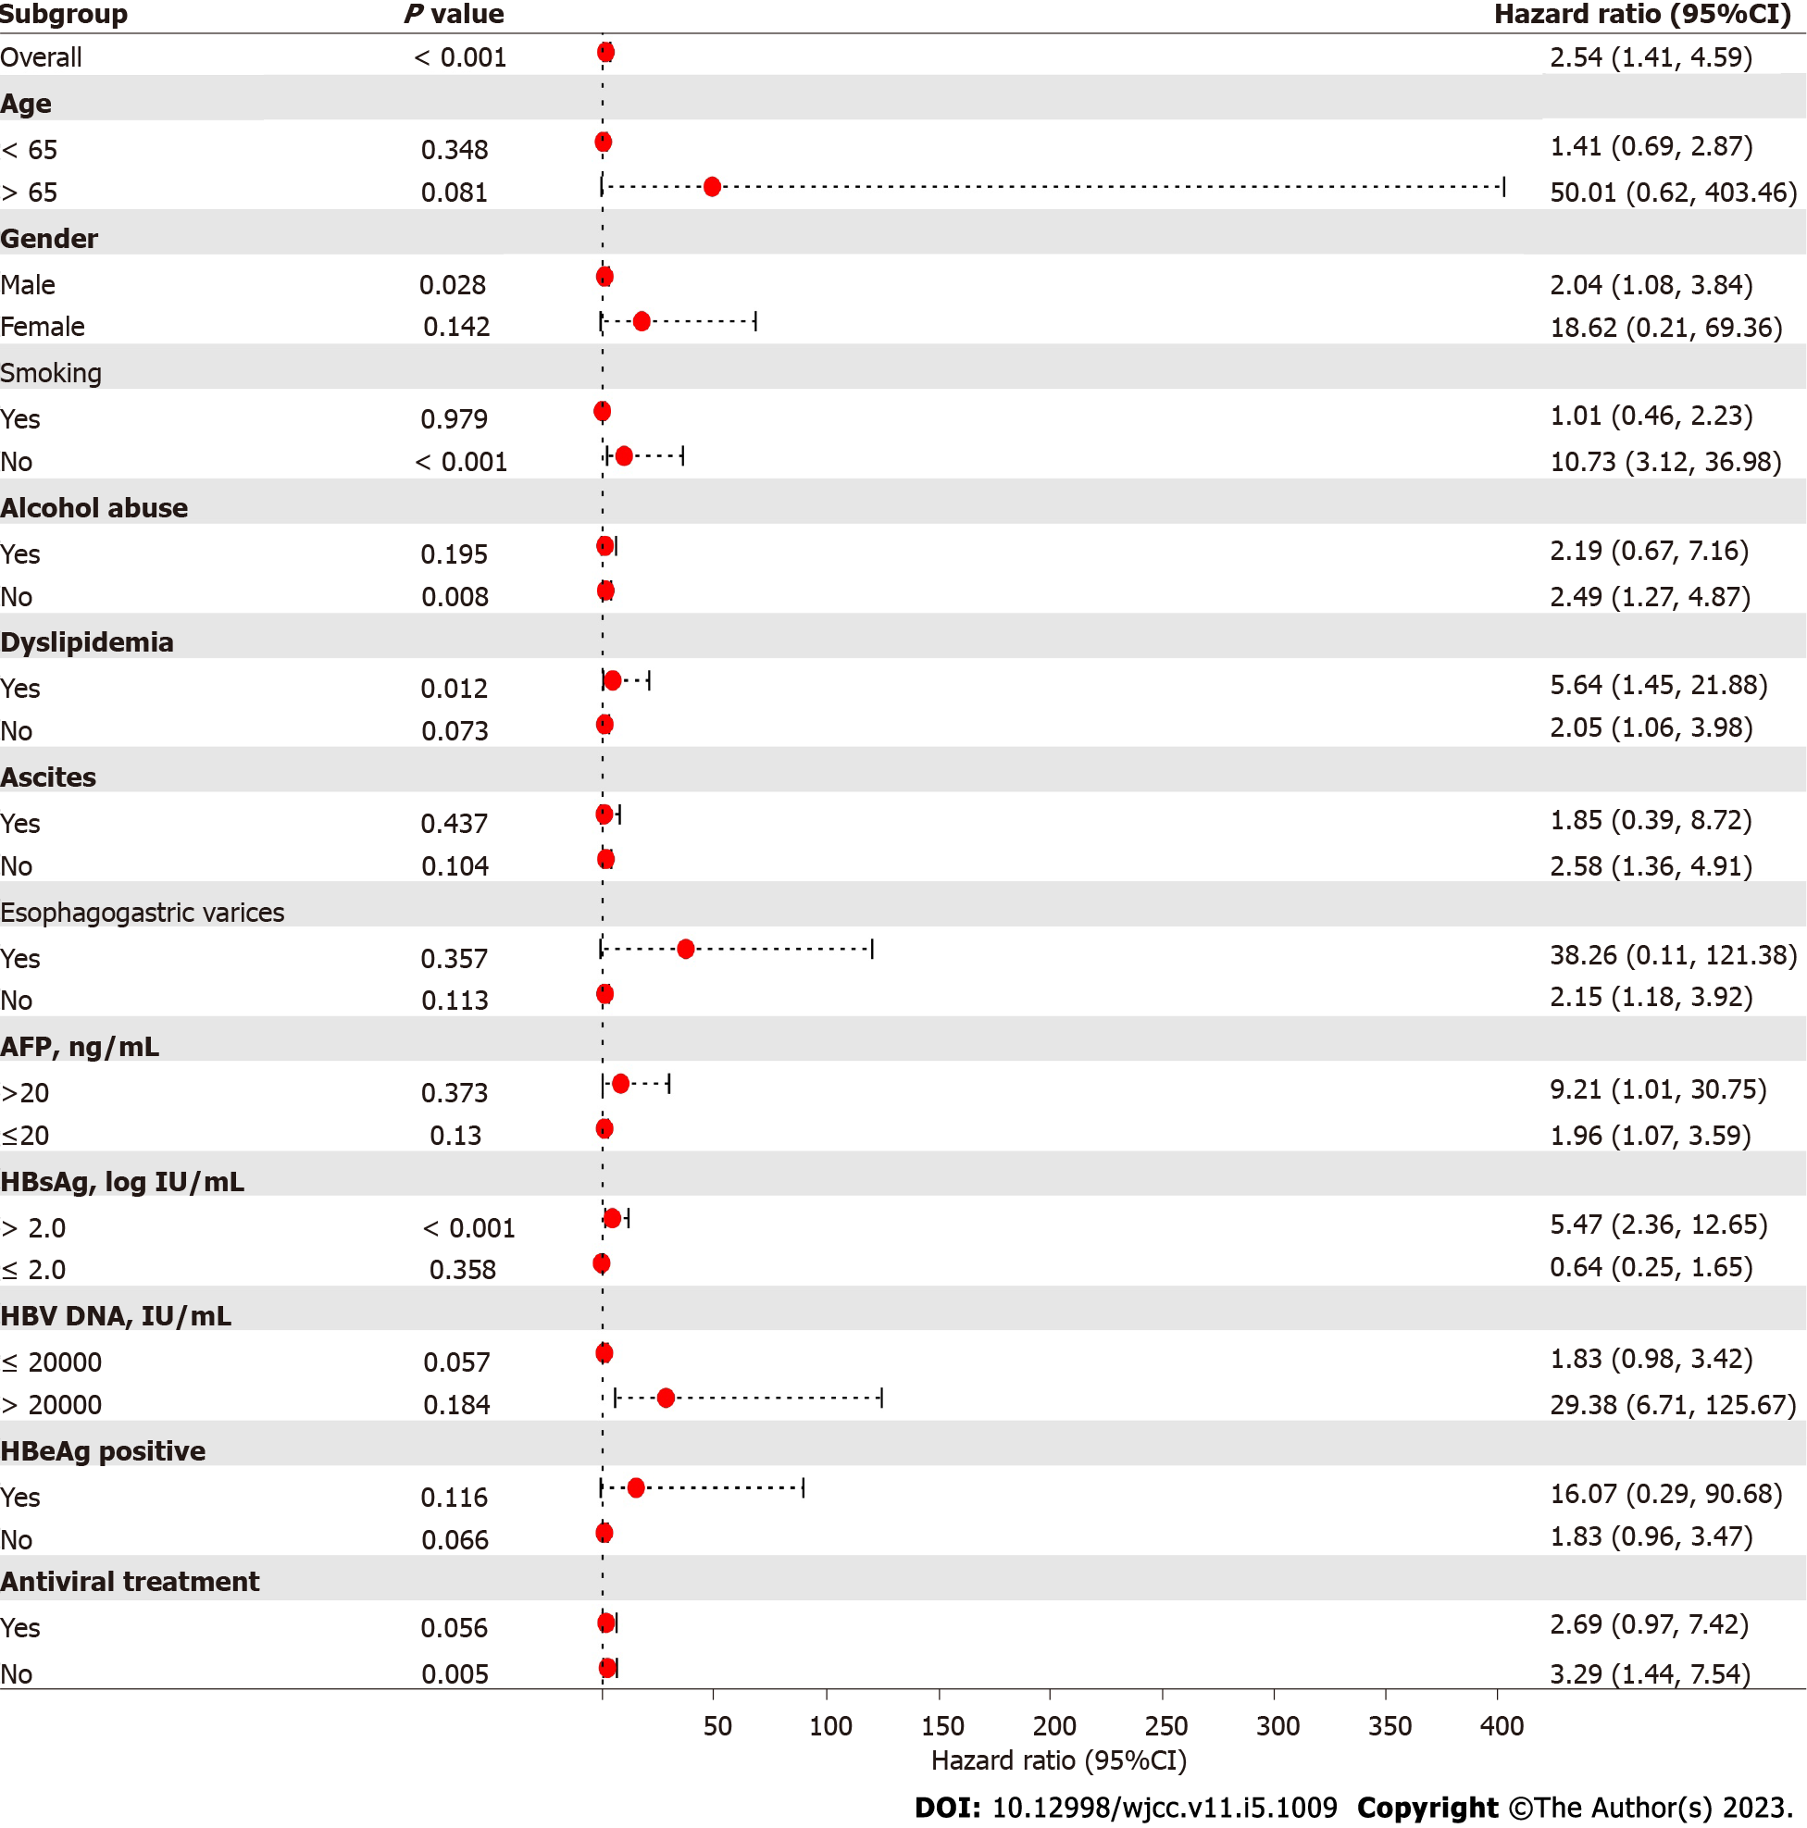
Figure 2 Correlation between type 2 diabetes mellitus and hepatocellular carcinoma development across different subgroups. The results showed that type 2 diabetes mellitus and hepatocarcinogenesis were significantly correlated in the male subgroup, the non-smoker subgroup, the no alcohol abuse subgroup, the hepatitis B surface antigen > 2.0 log IU/mL subgroup, and the no antiviral treatment subgroup (P < 0.05). AFP: Alpha-fetoprotein; CI: Confidence interval; HBV: Hepatitis B virus; HBeAg: Hepatitis B e-antigen.

Table 1 Baseline characteristics of the patients
Characteristic | T2DM at baseline, n = 196 | Non-T2DM at baseline, n = 216 | P value
Age in yr | 55 (50-62) | 54 (49-62) | 0.090
Female sex | 69 (35.2) | 72 (33.3) | 0.690
Smoking status | 98 (50.0) | 125 (57.9) | 0.114
Alcohol abuse status | 76 (38.8) | 74 (34.3) | 0.358
Dyslipidemia | 64 (32.7) | 58 (26.9) | 0.235
Ascites | 9 (4.6) | 15 (6.9) | 0.400
Esophagogastric varices | 6 (3.1) | 12 (5.6) | 0.238
PT | 10.4 (9.6-11.3) | 11.8 (10.8-14.1) | < 0.001
INR | 0.94 (0.87-1.01) | 1.05 (0.96-1.24) | < 0.001
AST in IU/mL | 25 (20-38) | 27 (20-45) | 0.389
ALT in IU/mL | 26 (19-34) | 28 (20-44) | 0.101
Platelet count as × 10⁹/ L | 177 (132-203) | 161 (112-207) | 0.105
AFP in ng/mL | 1.24 (0.56-20.83) | 2.36 (1.53-25.00) | 0.761
GGT in U/L | 29 (17-58) | 33 (19-80) | 0.062
Total bilirubin in μmol/L | 15.0 (10.5-18.5) | 15.1 (11.1-24.9) | 0.096
Albumin in g/L | 39.7 (33.1-42.8) | 37.8 (32.3-41.0) | 0.090
MELD score | 6 (5-8) | 6 (5-10) | 0.191
HBsAg in log IU/mL | 2.50 (1.91-2.68) | 2.64 (2.22-2.69) | 0.104
HBV DNA in IU/mL | 19500 (1260-234000) | 23850 (8738-329000) | 0.936
Creatinine in µmol/L | 60 (52-74) | 61 (50-74) | 0.379
HBeAg positivity | 50 (25.5) | 56 (24.1) | 0.727
Antiviral treatment | 137 (69.9) | 144 (66.7) | 0.526
Duration of T2DM in yr
0-2.0 | 44 (22.4)
2.1-5.0 | 42 (21.4)
5.1-10.0 | 52 (26.5)
> 10.0 | 58 (29.6)
T2DM treatment
Metformin ± sulfonylurea | 112 (57.1)
Insulin ± sulfonylurea | 50 (25.5)
Diet alone | 34 (17.3)
AFP: Alpha-fetoprotein; ALT: Alanine aminotransferase; AST: Aspartate aminotransferase; GGT: Gamma-glutamyl transferase; HBeAg: Hepatitis B e-antigen; HBsAg: Hepatitis B surface antigen; HBV: Hepatitis B virus; INR: International normalized ratio; MELD: Model for end-stage liver disease; PT: Prothrombin time; T2DM: Type 2 diabetes mellitus.

Table 2 Cox regression analysis of factors related to hepatocarcinogenesis in the patients
Variable | Univariate |  | Multivariate
 | HR (95%CI) | P value | HR (95%CI) | P value
Age in yr, > 65 vs ≤ 65 | 1.16 (0.63, 2.10) | 0.649 | 1.38 (0.62, 3.11) | 0.434
Sex, male vs female | 4.37 (1.98, 9.64) | < 0.001 | 3.47 (1.36, 8.89) | 0.010
Smoking status, yes vs no | 1.97 (1.15, 3.38) | 0.013 | 1.46 (0.61, 3.45) | 0.394
Alcohol abuse status, yes vs no | 1.83 (0.44, 2.55) | 0.558 | 1.38 (0.80, 1.68) | 0.008
Dyslipidemia, yes vs no | 1.58 (0.30, 2.09) | 0.090 | 0.80 (0.36, 1.79) | 0.589
Diabetes mellitus, yes vs no | 2.54 (1.41, 4.59) | 0.002 | 6.73 (2.77, 16.36) | < 0.001
Ascites, yes vs no | 2.68 (1.20, 5.98) | 0.016 | 1.41 (0.31, 6.43) | 0.660
Esophagogastric varices, yes vs no | 1.20 (0.37, 3.87) | 0.766 | 0.62 (0.13, 2.97) | 0.552
AFP in ng/mL, > 20 vs ≤ 20 | 1.85 (0.98, 3.51) | 0.059 | 3.89 (1.06, 14.27) | 0.041
γ-GTP in U/L, per SD | 1.24 (0.52, 2.14) | 0.692 | 1.34 (0.75, 3.21) | 0.530
HBsAg, > 2.0 log IU/mL vs ≤ 2.0 log IU/mL | 1.74 (0.43, 2.28) | 0.277 | 4.10 (1.52, 11.12) | 0.005
HBV DNA, ≤ 20000 IU/mL vs > 20000 IU/mL | 0.46 (0.20, 1.07) | 0.072 | 1.09 (0.38, 3.15) | 0.877
HBeAg positivity, yes vs no | 0.59 (0.28, 1.28) | 0.181 | 0.54 (0.20, 1.49) | 0.236
Antiviral treatment, yes vs no | 0.27 (0.16, 2.14) | 0.365 | 0.74 (0.33, 1.67) | 0.475
AFP: Alpha-fetoprotein; CI: Confidence interval; HBeAg: Hepatitis B e-antigen; HBsAg: Hepatitis B surface antigen; HBV: Hepatitis B virus; HR: Hazard ratio; AFP: Alpha-fetoprotein; GTP: Guanosine triphosphate; HR: Hazard ratio.

Table 3 Factors correlated with hepatocarcinogenesis in the type 2 diabetes mellitus group
Variable | HR | 95%CI | P value
Age > 65 yr | 23.54 | 4.59-120.74 | < 0.001
Male sex | 3.64 | 1.01-13.20 | 0.049
Smoking | 3.10 | 0.85-11.38 | 0.088
Alcohol abuse | 0.38 | 0.11-1.31 | 0.125
Dyslipidemia | 1.56 | 0.50-4.85 | 0.440
Ascites | 0.50 | 0.07-3.60 | 0.489
Esophagogastric varices | 0.54 | 0.05-6.34 | 0.623
AFP > 20 ng/mL | 17.44 | 2.86-106.23 | 0.002
γ-GTP in U/L, per SD | 2.31 | 1.55-14.01 | 0.762
HBsAg > 2.0 log IU/mL | 11.93 | 2.82-50.41 | 0.001
HBV DNA > 20000 IU/mL | 0.39 | 0.09-1.60 | 0.190
HBeAg positivity | 0.96 | 0.29-3.11 | 0.941
Antiviral treatment | 0.19 | 0.06-0.64 | 0.007
T2DM duration in yr
≤ 5 | - | - | -
> 5 | 6.74 | 2.36-19.29 | < 0.001
T2DM therapy
Yes/metformin ± sulfonylurea | - | - | -
Yes/insulin ± sulfonylurea | 1.45 | 0.26-7.96 | 0.041
Yes/diet control only | 10.70 | 2.91-39.31 | < 0.001
AFP: Alpha-fetoprotein; CI: Confidence interval; HBeAg: Hepatitis B e-antigen; HBsAg: Hepatitis B surface antigen; HBV: Hepatitis B virus; HR: Hazard ratio; T2DM: Type 2 diabetes mellitus; GTP: Glutamyltranspeptidase; AFP: Alpha-fetoprotein.

Published by Baishideng Publishing Group Inc
7041 Koll Center Parkway, Suite 160, Pleasanton, CA 94566, USA
Telephone: +1-925-3991568
E-mail: bpgoffice@wjgnet.com
Help Desk: https://www.f6publishing.com/helpdesk
https://www.wjgnet.com

© 2023 Baishideng Publishing Group Inc. All rights reserved.

