Name of Journal: World Journal of Gastroenterology
Manuscript NO: 89064
Manuscript Type: REVIEW

Diseases of bile duct in children

Eiamkulbutr S et al. Diseases of bile duct in children

Sutha Eiamkulbutr, Chomchanat Tubjareon, Anapat Sanpavat, Teerasak Phewplung, Nimmita Srisan, Palittiya Sintusek

Sutha Eiamkulbutr, Department of Pediatrics, King Chulalongkorn Memorial Hospital, Bangkok 10330, Thailand

Chomchanat Tubjareon, Department of Pediatrics, Faculty of Medicine, Chulalongkorn University and King Chulalongkorn Memorial Hospital, Bangkok 10330, Thailand

Anapat Sanpavat, Department of Pathology, Chulalongkorn University, Bangkok 10330, Thailand

Teerasak Phewplung, Department of Radiology, Chulalongkorn University, Bangkok 10330, Thailand

Nimmita Srisan, Department of Surgery, Faculty of Medicine, Chulalongkorn University and King Chulalongkorn Memorial Hospital, Bangkok 10330, Thailand

Palittiya Sintusek, Center of Excellence in Thai Pediatric Gastroenterology, Hepatology and Immunology, Division of Gastroenterology, Department of Pediatrics, King Chulalongkorn Memorial Hospital, Chulalongkorn University, Bangkok 10330, Thailand

Co-first authors: Sutha Eiamkulbutr and Chomchanat Tubjareon.

Author contributions: Eiamkulbutr S, Tubjareon C, and Sintusek P contributed to conception of the study, and wrote the manuscript; Phewplung T provided radiology pictures of patients; Sanpavat A provided histopathology pictures of patients; Sintusek P made critical revisions related to the intellectual content of the manuscript; and all authors read and approved the final version of the manuscript.

Supported by Ratchadapiseksompotch Fund, Faculty of Medicine, Chulalongkorn University, RA-MF-18/66.

Corresponding author: Palittiya Sintusek, MD, PhD, Associate Professor, Center of Excellence in Thai Pediatric Gastroenterology, Hepatology and Immunology, Division of Gastroenterology, Department of Pediatrics, King Chulalongkorn Memorial Hospital, Chulalongkorn University, 1873 Rama IV, Pathumwan, Bangkok 10330, Thailand. palittiya.s@chula.ac.th

Received: October 19, 2023
Revised: December 26, 2023
Accepted: February 4, 2024
Published online:

Abstract
Several diseases originate from bile duct pathology. Despite studies on these diseases, certain etiologies of some of them still cannot be concluded. The most common disease of the bile duct in newborns is biliary atresia, whose prognosis varies according to the age of surgical correction. Other diseases such as Alagille syndrome, inspissated bile duct syndrome, and choledochal cysts are also time-sensitive because they can cause severe liver damage due to obstruction. The majority of these diseases present with cholestatic jaundice in the newborn or infant period, which is quite difficult to differentiate regarding clinical acumen and initial investigations. Intraoperative cholangiography is potentially necessary to make an accurate diagnosis, and further treatment will be performed synchronously or planned as findings suggest. This article provides a concise review of bile duct diseases, with interesting cases.

Key Words: Bile duct; Cholestasis; Biliary atresia; Biliary hypoplasia; Biliary imaging; Inspissated bile syndrome; Choledochal cyst

Eiamkulbutr S, Tubjareon C, Sanpavat A, Phewplung T, Srisan N, Sintusek P. Diseases of bile duct in children. World J Gastroenterol 2024; In press

Core Tip: Bile duct diseases are rare conditions in children but are mostly pathologic and require timely investigations and management. Biliary atresia (BA) is a common cause of biliary cirrhosis, and affected children with delayed diagnosis require liver transplantation. Early detection of BA using stool color charts or proposed biomarkers has been integrated into the management of infants with cholestasis in many countries. Extrahepatic biliary obstruction caused by stones and choledochal cysts can be easily diagnosed by abdominal ultrasonography and treated by surgical resection. Nowadays, genetic analysis plays a vital role in many bile duct diseases, such as Alagille syndrome. In addition, advanced endoscopic management can improve treatment outcomes and is less invasive than conventional surgical therapy.

INTRODUCTION
Bile duct diseases can have a congenital or acquired etiology. The majority of bile duct diseases are present in infants with progressive jaundice. Imaging is the mainstay of investigation, and other more invasive procedures such as intraoperative cholangiography and liver biopsy may be needed to confirm the diagnosis. Genetic analysis has recently been helpful for the diagnosis of particular bile duct diseases such as Alagille syndrome (AGS). In addition, genetic predisposition is well described in biliary atresia (BA); however, more informative research is required in this field. This review will focus on bile duct diseases that are mainly present during the infant period, including BA, bile duct hypoplasia, inspissated bile plug, and choledochal cysts (CDCs).

EPIDEMIOLOGY
The worldwide incidence of bile duct disease varies among countries. BA and CDCs are considered more common in Asia than in Europe and America. The prevalence of BA is approximately 1:5000 in Taiwan and 1:20000 in Europe and America^{[1]}. The prevalence of CDCs is 1:1000 live births in Japan and 1:13500 live births in America, whereas it is only 1:100000-500000 live births in Western countries^{[2]}. For AGS, initial estimates suggest that AGS occurs in 1 per 70000 live births; however, with molecular testing, it is likely closer to 1 per 30000 live births (117). In children, the incidence of cholelithiasis ranges from 0.13% to 0.22%^{[3]}. Hemolysis, cystic fibrosis, prolonged fasting period and ceftriaxone use were associated conditions that increased the incidence of cholelithiasis. The link between genetic predisposition and stone formation has been described in reported cases and needs further study.

BA
BA is the most common bile duct disease in infants and generally requires timely surgical management for excellent outcomes. According to the proposed pathogenesis, BA can be classified into three clinical variants^{[4]}. The isolated or perinatal form accounts for 80%-90% of BA cases. Casual factors include genetic predisposition^{[5,6]}, ischemic process^{[7]}, environment^{[8]}, and infection^{[9-11]}. Cytomegalovirus (CMV) is the most common pathogen that may be associated with BA^{[11-13]}. Zhao et al^{[14]} reported that up to 30% of BA cases in China might be related to CMV based on findings in liver histopathology. This finding suggests the potential role of perinatal CMV infection in BA development, from a complex autoimmune process that involves transient viral infection of choanocytes, activating the innate immune system and adaptive T-cell proliferation. In addition, CMV may trigger self-damage, leading to persistent proinflammatory immune responses driven by various immune cells^{[15,16]}. Compared with CMV immunoglobulin (Ig)M-negative controls, CMV IgM-positive infants have worse outcomes, with reduced jaundice clearance, lower native liver survival (NLS), and increased mortality^{[17]}. Nonetheless, no universal consensus has been established on incorporating CMV eradication into BA adjunctive treatment. Genetic predisposition, possibly non-Mendelian, may be involved in BA development. Studies have linked genes such as ADD3, XPNPEP1, and GPC-1 to isolated BA^{[5]}. GPC-1 plays a role in biliary physiology and inflammatory mediators^{[18]}. The overlap between isolated BA and other neonatal cholestasis syndromes such as AGS^{[19]} and progressive familial intrahepatic cholestasis^{[20]} has been reported.
Syndromic or embryonic form is known as BA splenic malformation (BASM) syndrome, which is more common in Europe and America (10%-15%)^{[21,22]} but rare in China and Japan^{[23,24]}. BASM is characterized by distinct visceral anomalies, including polyphemid, situs inversus, preduodenal portal vein, and absence of the intrahepatic vena cava (Figure 1). Cardiac anomalies are also present in approximately half of the cases. BASM likely stems from embryonic defects, possibly related to genetic mutations, including PKD1L1, CFC1, NODAL, FOXA2, and ZIC3, e.g.,^{[25]} or maternal diabetes and other first-trimester factors^{[12]}. Other syndromes that might be linked with BA include cat-eye syndrome or aneuploidy of chromosome 22^{[26]}, Kabuki syndrome^{[27]}, Zimmermann-Laband syndrome, Kartagener syndrome, Hirschsprung disease, and various isolated anomalies such as gastrointestinal atresia and cleft palate^{[12]}.
Cystic BA (CBA) is characterized by the cystic dilatation of the extrahepatic bile ducts and fibrosing obstruction of the duct segments. CBA must be differentiated from CDCs, which can be seen in prenatal ultrasonography but have different clinical courses^{[28]}. In infants, CBA tended to present at a younger age. Jaundice and acholic stools may manifest shortly after birth or following a variable period. In a comprehensive review of BA cases, CBA was observed in approximately 8% of patients^{[29]}. Operative cholangiography is essential for diagnosing an infant with jaundice and postnatally confirmed subhepatic cysts. In CBA, cholangiography may reveal an abnormal, tenuous connection with the intrahepatic ducts or ductules, which is often described as “cloud-like”^{[30]}. This suggests an onset beyond 12 wk of gestation, possibly related to an ischemic event affecting the distal extrahepatic duct^{[12]}. Experimental models have reproduced key CBA features by ligating the common bile duct (CBD) in fetal lambs or the hepatic artery in fetal rabbits, resulting in cystic extrahepatic changes and impaired intrahepatic bile ducts^{[31,32]}. These studies have suggested that ischemia and altered angiogenesis may play a role in the pathogenesis of CBA and other BA variants. Most CBA cases require radical resection and wide portoenterostomy. Compared with other BA variants, CBA generally has a better long-term prognosis; however, some cases may still require liver transplantation (LT) during adulthood^{[33]}.
According to the Japanese Society of Pediatric Surgeons, it is classified into three main types: Type 1, CBD atresia; type 2, common hepatic duct atresia; and type 3, right and left hepatic duct atresia. The classification also considers variations in the gallbladder/CBD and hilar plate. When the proximal biliary tree is absent, the condition is called biliary agenesis. “Correctable” lesion, where the distal CBD is atretic but a portion of the extrahepatic duct connects to the intrahepatic ducts, allows direct drainage via Roux-en-Y anastomosis. The most common lesion (75%-85%) involves complete duct obliteration throughout the porta hepatis (type 3), which is often considered “noncorrectable” atresia. In these cases, residual bile duct remnants may be present within the fibrous tissue. The Kasai portoenterostomy (KPE) attempts biliary drainage by excising the obliterated extrahepatic ducts and reconstructing the transected porta hepatis to the bowel mucosa in Roux-en-Y hepatoportoenterostomy (76) (Figure 2).

Clinical signs and symptoms
Typical presentations of BA include conjugated hyperbilirubinemia and acholic stools at birth for the embryonic form but at 3-4 wk of life for other forms. BA could rapidly progress to hepatomegaly, failure to thrive, pruritus, and coagulopathy within a few months because the affected infants are typically healthy and born at term. Delayed diagnosis is common; hence, early screening for timely surgical management is advocated.

Newborn screening for BA
Timely recognition of BA, ideally by a 2-wk well-baby visit, is paramount for optimal intervention. The Children’s Liver Foundation^{[34]} in the United Kingdom and the American Academy of Pediatrics guidelines^{[35]} introduced a screening program aimed at identifying neonatal liver diseases through jaundice assessment (Table 1).

“Yellow alert” educational campaign
This campaign was initiated in the United Kingdom in 1993 at King’s College Hospital and aimed to ensure bilirubin testing in all babies with persistent jaundice 2 wk after birth. However, relying solely on jaundice detection poses challenges. Infants with BA may not appear jaundiced during the initial well visits because their bilirubin levels can still be below the visual threshold in the first few weeks. In addition, many infants may appear jaundiced because of nonhepatic causes, such as physiologic jaundice or breast milk jaundice. This campaign, which is ongoing and developed by the United Kingdom Children’s Liver Disease Foundation, focuses on raising awareness of jaundice in children. They have also introduced the “Yellow Alert App” to further support this cause.

Stool color card program
Another screening approach uses a stool color card (SCC) program^{[36]}. In 1994, Matsui and Ishikawa^{[37]} introduced a seven-color panel SCC to the Maternal and Child Health Handbook distributed to pregnant women in the Tochigi Prefecture in Japan. Parents returned the completed SCC to the physician either before or during the 1-month follow-up. All suspected cases were referred for investigation. Between 1994 and 2001, 313230 newborns underwent screening, and BA was diagnosed in 32 newborns. The average age at KPE was 60 d, marking a significant reduction from 70 d in the history before the SCC program^{[38]}. In 2002, Taiwan introduced an SCC program to improve the early diagnosis of BA^{[39]}. This study examined the 5-year outcomes of BA both before and after the implementation of the SCC program. When comparing the groups before and after SCC implementation, the rate of KPE performed within 60 d significantly increased from 49.4% to 65.7%. Three months after KPE, the jaundice-free rate [total bilirubin (TB) < 2 mg/dL] increased from 34.8% to 60.8%. The 5-year jaundice-free survival rate with native liver increased from 27.3% to 64.3%, and the overall survival rate improved from 55.7% to 89.3%. Screening with SCC is increasingly used in Europe^{[40-42]}. In Switzerland^{[42]}, the card has been available for voluntary distribution since 2009. It is provided at birth or during the first appointment at 4 wk of age. If an abnormal stool color is noted, the pediatrician is advised to promptly contact a gastroenterologist. The SCC program has been assessed from 2014 to 2016 in British Columbia^{[41]}. All 126 maternity units received SCC. Of the 87583 live births, 6 cases of BA were identified. The screening program successfully referred three of the six BA cases to specialized care (defined as program screen success). Among the three cases in which the program did not detect BA, two families recognized pale stools and promptly consulted their healthcare providers. However, they were reassured, and no further immediate action was taken. The median age at KPE was 49 (range 42-52) d, whereas for the failure to detect the SCC group, it was 116 (range, 49-184) d. The program demonstrated a sensitivity of 50%, specificity of 99%, positive predictive value (PPV) of 4%, and negative predictive value (NPV) of 99%^{[41]}. Currently, small pilot studies with SCC have been conducted in various regions, including Brazil, Cairo (Egypt), Shenzhen (China)^{[43]}, Northern Portugal, and Lower Saxony (Germany)^{[44]}.

Mobile applications
Several centers have developed mobile smartphone applications designed to assist parents and caregivers in identifying abnormal stool color and prompt early referral to specialty care. Notable examples include PoopMD^{[45]}, BabyPoop, and Popòapp, each using smartphone cameras and color analyzer software to assess infant stool color. PoopMD, developed at John Hopkins University in the United States and implemented in 2014, demonstrated a sensitivity of 100% and specificity of 89% in detecting acholic stools^{[44]}. It demonstrates precise discrimination between acholic and normal stool colors, showing substantial agreement among users and nearly perfect concordance across two popular smartphones under various ambient light settings. BabyPoop, which was used in Japan in 2016, analyzed data from 54 BA and 100 non-BA stool images to refine its color detection algorithm. It demonstrated 100% sensitivity and specificity in detecting BA within a test set of 40 stool images, including five from BA cases^{[46]} Popòapp^{®[47]}, created by an Italian team, employs a color analysis algorithm based on a Japanese seven-stool color photo panel. This was validated by four pediatric subspecialists using 160 stool samples from infants aged < 6 months. It provided a sensitivity of 100% and a specificity of 99%.

Fractionated bilirubin levels
The screening approach involves measuring fractionated bilirubin levels in newborns^{[48]}. In 1998, a United Kingdom study pioneered the use of fractionated bilirubin testing for newborn BA screening. This involved measuring conjugated bilirubin levels in infants aged 4-28 d using additional plasma from routine newborn screening^{[49]}. Subsequently, in a prospective study of 23214 patients with defined bilirubin cutoffs, the testing showed high sensitivity (100%), specificity (99.6%), and PPV (10.3%) for BA detection^{[50]}. This method also identified other conditions such as AGS, alpha-1-antitrypsin deficiency, and panhypopituitarism. In the United States, recent studies have focused on bilirubin testing within the first 24-48 h of life, recognizing that newborns with BA display high direct or conjugated bilirubin levels from birth. The screening process involves collecting blood for testing from all infants before discharge from the nursery. Infants with high fractionated bilirubin levels were subsequently retested as outpatients during the routine 2-wk well-child visit, and those with persistently high levels underwent further evaluation. This algorithm was assessed in a pilot study of 11636 infants and a larger follow-up study of 123279 infants, resulting in notable improvements in the timing of KPE. This method is now being used in various United States countries, including San Antonio, Salt Lake City, New Orleans, and their surrounding areas. Studies have shown a sensitivity of 100% and a specificity of 99.5%-99.9% in detecting BA cases^{[49,50]}. Nevertheless, some limitations were noted, including variations in direct bilirubin assays, higher positive rates among Black infants, and the need for coordination between nurseries and primary care providers^{[36]}.

Laboratory markers
Other laboratory markers such as gamma-glutamyl transferase (GGT) and matrix metalloproteinase-7 (MMP-7)^{[51-55]}, which are markers of biliary epithelial injury, have established significance in the diagnosis of BA. Lertudomphonwanit et al^{[52]} demonstrated that combining serum MMP-7 with GGT resulted in a high sensitivity of 97% and specificity of 94% for diagnosing BA. Yang et al^{[54]} analyzed 54 infants with cholestasis aged < 6 months (22 with BA and 32 with non-BA) in comparison with 41 control infants. They assessed the accuracy of MMP-7 in distinguishing BA from other causes of cholestasis. MMP-7 exhibited outstanding diagnostic accuracy for BA, with an area under the curve of 0.990, a cutoff value of 52.85 ng/mL, a sensitivity of 98.67%, and a specificity of 95%. Rohani et al^{[55]} reported a similar finding with a sensitivity of 95.5% and a specificity of 94.5%.

Serum and urine bile acids
A promising screening method under investigation measures BAs in dried blood spots, potentially integrating BA screening with standard newborn metabolic screening^{[36]}. Initial attempts using tandem mass spectrometry did not effectively distinguish between healthy newborns and those with liver disease^{[56]}. However, Zhou et al^{[57]} analyzed primary bile acids in dried blood spots from 8 infants with BA, 17 infants with neonatal jaundice, and 292 comparison infants at 3-4 d of life. Taurocholate (TC) levels were significantly higher in BA (0.98 ± 0.62 mmol/L) than in neonatal jaundice (0.47 ± 0.30 mmol/L) and comparison infants (0.43 ± 0.40 mmol/L). The use of a cutoff of 0.63 mmol/L yields a sensitivity of 79.1% and specificity of 62.5%. This suggests that while TC shows promise as a potential newborn screening marker for BA, further evaluation is needed to assess its cost-effectiveness and ability to detect other liver diseases. A recent prospective multicenter study in Japan^{[58]} investigated urinary oxysterol analysis in patients with BA, suggesting that 27-hydroxycholesterol holds promise as a potential marker for distinguishing BA from other causes of neonatal cholestasis. The study included 14 infants with BA, 10 non-BA cholestatic controls, and 10 healthy controls. Among patients with BA, urinary 27-hydroxycholesterol levels were significantly high compared with patients with non-BA.
In cases with positive screening tests or clinical jaundice with acholic stools, further investigation is needed to confirm the diagnosis of BA. These investigations are as follows: Abdominal ultrasonography serves as the cornerstone in the initial diagnostic approach for identifying the potential causes of obstructive cholestasis in neonates. This modality not only aids in the detection of alternate etiologies. In infants with BA, the gallbladder may appear small, measuring < 15-19 mm in the fasting state^{[59]}. To optimize the accuracy of ultrasonography, the child must have fasted for 3-4 h before the procedure. Non-visualization of the gallbladder is a highly specific finding indicative of BA, although it does not confirm the diagnosis^{[60]}. Additional gallbladder abnormalities associated with BA include the “ghost triad” or “pseudogallbladder”. This condition is characterized by a small gallbladder (< 19 mm) with an indistinct wall and irregular contour. Other findings included the triangular cord sign, absence of the CBD, presence of microcysts or macrocysts near the porta hepatis, increased hepatic artery diameter (> 1.5 mm), peripheral arterialization, and polysplenia^{[60]}. The triangular cord sign refers to a fibrous remnant of the obliterated biliary duct, which is observed adjacent to the anterior right portal vein wall. It is characterized by echogenic thickening of > 3-4 mm near the bifurcation of the main portal vein. In addition, the presence of cysts near the porta hepatis, in the absence of normal CBD, is a specific indicator of BA. Polysplenia has high specificity (100%) but low sensitivity (10%) for BA^{[59]}. It is often associated with other signs of syndromic BA, such as preduodenal portal vein, absence of the inferior vena cava, absence of errant hepatic artery, and abdominal heterotaxy^{[61]} (Table 2 and Figure 3).
Acoustic radiation force impulse can be a valuable tool for assessing liver stiffness or fibrosis, indirectly aiding in the diagnosis of BA. Various elastography techniques, including Virtual Touch Quantification (VTQ) and Virtual Touch IQ^{[66]}, transient elastography (TE)^{[67]}, and super shear wave elastography, have been explored for BA diagnosis. VTQ shows a sensitivity of 76.9%-90.9% and a specificity of 68.4%-78.6%^{[66,68,69]}. However, the limited number of cases in studies raises questions about the reliability of this technique. TE measures liver stiffness, aiding in BA diagnosis. For infants aged < 90 d, a 7.7 kPa cutoff yields 80% sensitivity and 97% specificity, whereas for those aged 91-180 d, an 8.8 kPa cutoff provides 100% sensitivity and specificity^{[67]}.
Hepatobiliary scintigraphy (HBS) evaluates the anatomy and function of the biliary system, particularly the liver’s capacity to excrete bile. A key indicator in these scans is the absence of radiotracer excretion into the small bowel within 24 h. HBS involves a protocol with phenobarbital (5 mg/kg/d in two divided doses) and ursodeoxycholic acid (UDCA, 10-20 mg/kg/d in two divided doses) for 5 d, which might increase the specificity of this investigation^{[70-72]}. Although this finding strongly suggests the possibility of BA, it does not provide a definitive diagnosis. A meta-analysis revealed that HBS had a pooled sensitivity of 98.7% (range 98.1%-99.2%) and a specificity of 70.4% (range, 68.5%-72.2%) of a nondraining HBS for excluding BA^{[73]}. NASPHAN and ESPGHAN concluded that their limited specificity precludes the use of BS scan as a standalone test in making a definite BA diagnosis^{[74]}. Other conditions characterized by impaired hepatocellular function and biliary excretion, such as neonatal hepatitis, can also result in the nonexcretion of the radiotracer into the small bowel^{[61,75]}.
Liver biopsy remains a pivotal component of BA diagnosis. However, the limitation of liver biopsy lies in the availability of skilled pathologists and the time required for the results. A meta-analysis of 22 articles revealed that preoperative liver biopsy exhibited an overall accuracy of 91.7%, sensitivity of 91.2%, and specificity of 93% (n = 1231)^{[76]}. The PPV was 91.2%, and the NPV was 91.6% (n = 1106). In patients aged 60 d at presentation to diagnosis, the pooled sensitivity, specificity, PPV, NPV, and accuracy were 96.4%, 96.3%, 95.8%, 96.3%, and 94.9%, respectively. In the early BA stages, the liver maintains its basic structure, displaying features such as bile duct proliferation, bile stasis, and edema/fibrosis around the portal area. Bile plugs in portal ducts are specific but are present in only 40% of cases^{[4]}. Older infants may exhibit extensive portal fibrosis. Approximately 25%-40% of infants exhibit inflammatory infiltration and giant cell transformation similar to neonatal hepatitis. This differs from idiopathic intrahepatic cholestasis, in which the bile duct remains largely unaffected. Edema in the portal area is more common in patients with BA. In very young infants, initial biopsies may be inconclusive; a repeat biopsy after 7-14 d may offer more clarity (Figure 4).

Intraoperative cholangiography
This invasive procedure is considered the gold standard for BA diagnosis. A contrast dye is injected into the gallbladder while the flow of the dye is monitored. If no contrast flows into the extrahepatic biliary ducts, BA is diagnosed, and a KPE is performed at that time.

Treatment surgical portoenterostomy
The primary treatment for BA is KPE. Despite attempts to enhance surgical techniques, the success rate of KPE remains suboptimal, with approximately 60% of patients with BA remaining transplant-free a decade postsurgery^{[77]}. In addition, native liver survivors are not considered cured because over half of them will experience complications of chronic liver diseases^{[78]}. A long-term study in Japan in the 1970s, involving KPE, showed a 20-year NLS of 44%, but with notable morbidity, including recurrent cholangitis (37%) and gastrointestinal bleeding (17%)^{[79]}. After KPE, medical management focuses on preventing and treating complications such as cholangitis and optimizing nutrition along with fat-soluble vitamin supplementation.

Medical treatment following hepatoportoenterostomy
The postoperative management of infants with BA has three main goals: Prevention of cholangitis.

Antibiotics: Common causative organisms include Klebsiella spp., Escherichia coli (E. coli), Pseudomonas aeruginosa, and others. The infection likely ascends through the Roux loop into the intrahepatic duct system. The choice of drug, duration, and clinical benefit remain debatable. This involves administering broad-spectrum antibiotics perioperatively and for a few days after surgery. This is followed by oral prophylaxis with antibiotics such as trimethoprim–sulfamethoxazole or other antibiotics including cefalexin, amoxicillin-clavulanic acid, third-generation cephalosporin, or neomycin for 3-12 months with a cholangitis rate of 20%-78%^{[80]}.

Probiotics: The use of probiotics, such as Lactobacillus Casei Rhamnosus, is theorized to alter the microbiome toward a less harmful composition. However, reports on its effectiveness are limited. Lien et al^{[81]} conducted a 6-month randomized study comparing oral neomycin and Lactobacillus Casei Rhamnosus. Although the study had statistical limitations because of its small sample size (n = 10), both groups showed a similar low prevalence of cholangitis (approximately 20%), which was notably better than a larger control group (approximately 80%). Stool cultures revealed a decrease in E. coli levels and an increase in Lactobacilli.

Stimulation of choleresis
UDCA: UDCA is a hydrophilic bile acid used to improve choleresis. Although studies have shown that it can lead to benefits such as weight gain and improved liver enzymes, its effect on long-term survival or the need for LT is less clear. In early trials from Japan^{[82]}, UDCA (15 mg/kg/d) with taurine supplements in 16 patients who underwent KPE showed promising results in lowering serum bile acid levels, even in patients with jaundice. A French study of patients with stable status post-KPE on UDCA (25 mg/kg/d) for at least a year found improvements in liver biochemistry but less pronounced effects on the clinical status^{[83]}. The discontinuation and reintroduction of UDCA revealed its positive effect. However, a large retrospective study in Egypt^{[84]} suggested that UDCA did not lead to better outcomes; however, the overall poor results may have influenced this observation. The combination of UDCA and steroids showed significant benefit in a meta-analysis^{[85]}.

Steroids: Steroids have been theorized to potentially improve biliary inflammation and enhance choleretic activity; however, their actual benefit in BA remains uncertain^{[86]}. Some studies revealed that oral administration of prednisolone plays a role in improving jaundice shortly after surgery, particularly in infants aged 70 d. This improvement did not lead to a significant reduction in the need for LT^{[87,88]}. The effectiveness of steroids was extensively evaluated in the multicenter, double-blind Steroid in Biliary Atresia Randomized Trial^{[89]}. In this trial, infants received a 13-wk course of either high-dose steroids or a placebo within 72 h after KPE. The results showed no significant difference in TB levels at 6 months after KPE or in the 2-year survival rate with the native liver for those who received steroids. Moreover, the steroid group experienced growth impairment and a shorter time to the first serious adverse event. Although the authors could not rule out a slight clinical benefit, their findings did not support the routine use of high-dose steroids following KPE.

Provision of nutritional support: Patients with BA require increased caloric intake, approximately 130%-150% of the recommended allowance for their weight^{[90]}. In cases of cholestasis, specific vitamin supplements are crucial to prevent deficiencies, such as vitamins A (5000-25000 IU/d), D (1200-4000 IU/d), E (25 IU/kg/d), and K (2.5-10 mg). Dosage should be adjusted based on blood levels and prothrombin time/international normalized ratio^{[4,90]}.

Other novel adjunctive therapies
Intravenous immunoglobulin: Intravenous immunoglobulin (IVIG) has demonstrated clinical benefits in various inflammatory and autoimmune diseases. It interferes with phagocytosis by innate immune cells, neutralizes autoantibodies, and modulates the adaptive immune response. In murine BA studies, high-dose IVIG administration resulted in decreased bilirubin levels, reduced bile duct inflammation and obstruction, and lowered cytokine levels associated with CD4+ Th1-mediated inflammation^{[91]}. However, the overall survival did not show significant differences. By contrast, a prospective multicenter open-label human trial found no improvement in bilirubin levels 90 d after KPE or in 1-year survival with native liver in the IVIG group compared with the placebo group^{[92]}.

Rituximab: Recent studies have explored immune cell subset-specific therapies for BA. A small-sample study investigating B-cell-depleting agents showed that a single dose of rituximab was safe and well-tolerated; however, long-term clinical outcomes were not reported^{[93]}.

Granulocyte-colony stimulating factors: Another avenue involves hematopoietic stem cell recruitment through granulocyte-colony stimulating factors (GCSFs), which has shown promise in liver diseases. An ongoing clinical trial using GCSFs in patients with BA has demonstrated safety and potential improvement in early biliary drainage and cholangitis frequency^{[94]}. Additional treatment for BA mitigates ongoing hepatic injury caused by oxidative damage and bile acid toxicity.

N-acetylcysteine: N-acetylcysteine (NAC), an antioxidant, has been effective in improving hepatic injury and fibrosis and increasing survival in murine BA^{[95]}. Currently, a single-center, open-label, phase 2 trial is investigating whether NAC administered after KPE can enhance bile flow in humans^{[96]}.

Ileal apical sodium-dependent bile acid transporter inhibitor: Clinical trials of novel agents that inhibit the ileal apical sodium-dependent bile acid transporter (ASBT), such as maralixibat and odevixibat, in BA are ongoing^{[97]}.

Farnesoid x receptor agonists: Farnesoid x receptor (FXR) agonists, which regulate metabolic homeostasis and inhibit bile acid synthesis, are potential therapeutic options for pediatric cholestatic liver diseases^{[98]}.

Prognosis and outcomes: The prognosis after hepatoportoenterostomy depends on several factors: (1) Age at operation is crucial for KPE. Bile flow can be restored in > 80% of infants operated upon within 60 d after birth. However, success drops to 20% for those aged > 90 d; (2) The size of the visualized ducts in the tissue from the porta hepatis. Ductal patency > 150 μm usually leads to successful postoperative bile flow. This is not universally accepted^{[80]}; (3) The degree of proliferation of the periductular glands and the role of the hilar biliary plexus as a drainage route also affect prognosis^{[81]}; (4) The experience and technique of the surgeon play a significant role; and (5) Others: Bacterial cholangitis that potentially leads to re-obstruction^{[4]}. Approximately 20% of patients with BA may have intrahepatic biliary cysts, sometimes preceded by episodes of cholangitis^{[81]}. Intrahepatic portal vein thrombosis can compound existing resistance because of progressive parenchyma fibrosis, often a consequence of ongoing inflammation or recurrent cholangitis. The hepatic artery resistance index via Doppler ultrasound is predictive of rapid deterioration and mortality in children with BA^{[82]}.
Even with successful bile drainage, progressive biliary cirrhosis and liver failure can develop because of factors that have been previously described. When hepatoportoenterostomy fails, leading to worsening liver function, jaundice, failure to thrive, and complications, including bleeding and ascites, LT becomes necessary. The risk of death or the need for LT is approximately 50% within 6 years following the initial episode of esophageal variceal hemorrhage^{[99]}. The prognosis depends on the initial bilirubin level; lower levels have a better survival rate. Among patients with serum bilirubin levels < 4 mg/dL during the first episode of variceal bleeding, > 80% experienced survival without needing LT for up to 4 years. When compared with an age-matched child without variceal bleeding, a patient with BA and bilirubin levels > 10 mg/dL faces a 12-fold higher risk of death or requires LT^{[99]}. Moreover, hepatopulmonary syndrome can occur. It is reversible with LT but causes a higher postoperative risk. Portopulmonary hypertension, a severe lung condition linked to liver disease, is potentially fatal if left untreated. It requires careful evaluation, often with echocardiography.
Although the success rate of portoenterostomy in BA cannot be predicted, it remains the most prudent initial approach. A previous study followed the long-term outcomes of children who underwent portoenterostomy^{[100]}. Approximately 75% had substantial hepatosplenomegaly. Only 9% of the children had normal liver enzyme levels and were free from portal hypertension. In a systematic review^{[101]}, 88% (n = 184) were alive without LT but with complications (60.5%) including cholangitis (100%), portal hypertension (80%), variceal bleeding (45%), and hepatocellular carcinoma (1.3%).
Approximately half of the patients with BA require LT by the age of 2, and most undergo LT in early adulthood. The global incidence of this condition varied widely. The 10-year survival rates ranged from 66.7% to 89%. The NLS rate was 20.3%-75.8% within 1-3 years and 24%-52.8% at 10 years. Beginning KPE at a younger age is linked to better NLS outcomes^{[82]}. There is a growing awareness of the necessity to enhance outcomes for patients who reach adulthood with their native livers. Recently developed prognosis models can help identify those at a higher risk of poor outcomes. Moreover, patients with BA are susceptible to neurodevelopmental challenges and a reduced quality of life. Studies have demonstrated varying degrees of motor and/or language skill impairment^{[83]}.

LT
BA is the leading indication of LT in children, accounting for approximately 50%-70% of pediatric LT cases^{[102,103]}. Today, advancements in preoperative management, surgical techniques, and postoperative care have resulted in high survival rates for children undergoing liver replacement by nearly 90%-95%^{[102,104]}. However, the scarcity of suitable donor organs remains a significant challenge. Reduced-size LT has proven successful in improving patient survival and reducing waiting-list mortality rates^{[105]}. Overall, while LT has a high success rate in children, ongoing challenges are noted. These include improving preoperative management of conditions such as malnutrition, enhancing immunosuppression methods to prevent graft rejection and complications, and developing protocols to avoid growth suppression.
In an upcoming study on LT as primary therapy for BA, Chardot et al^{[106]} showed a 10-year survival rate of 68%. Factors affecting survival included KPE, age at operation, bile duct anatomy, and center expertise. Lemoine et al^{[107]} retrospectively compared patients with BA who underwent primary LT with those who had a prior KPE. The findings indicate that patient and graft survival after primary LT is comparable to that after unsuccessful KPE; however, primary LT eliminates the need for prior interventions. Except for waiting-list mortality, no significant differences were found in pre- or peri-transplant complications between the groups.

Bile duct hypoplasia
Bile duct paucity is characterized by a specific histopathological criterion: A bile duct to hepatic artery ratio of < 0.5, is observed in at least 10 portal tracts in a liver biopsy. The more prevalent and well-studied syndromic form is AGS, also known as arteriohepatic dysplasia. The nonsyndromic form, not linked to AGS, is rare and lacks comprehensive characterization. The development of bile duct paucity can be attributed to either faulty formation of intrahepatic bile ducts in the prenatal or postnatal period or active destruction/atrophy of the already formed ducts^{[108]}. Factors such as in utero toxins, infections, and metabolic abnormalities can lead to toxic effects on bile duct cells, progressing from an inflammatory cholangiopathy to bile duct paucity shortly after birth. Prompt and accurate diagnosis is vital because of the clinical similarities between bile duct paucity and classical BA. This guides appropriate management, with surgical intervention for BA and more conservative approaches for bile duct paucity. In the case of bile duct paucity, the International Olympic Committee shows bile duct hypoplasia that can differentiate from BA (Figure 5A and B). In addition, nonsyndromic bile duct paucity has been linked as a secondary outcome to metabolic disorders, genetic disorders, infections, immune disturbance, and drug-induced vanishing bile duct syndrome (Table 3).

Syndromic bile duct paucity or AGS
AGS is an autosomal dominant genetic disorder that affects multiple body systems. AGS was first identified by Daniel Alagille in 1969^{[111]}. AGS is primarily caused by JAGGED1 (JAG1) mutation, which is responsible for producing the Jagged protein in the Notch signaling pathway^{[112]}. Over 90% of patients have a detectable mutation in JAG1. However, the rest have NOTCH2 mutations^{[113]}. Even with the same genetic mutations, individuals within a family show different AGS characteristics.

Criteria for diagnosis and clinical manifestations
The traditional diagnosis criteria for AGS involved liver histology showing reduced bile ducts and three of the five major clinical features: Cholestasis, eye abnormalities, distinct facial features (Figure 5E), cardiac defects, and skeletal abnormalities (Figure 5D). Recent findings have expanded the criteria, and liver biopsy is no longer mandatory; cholestasis alone is sufficient for diagnosis (Table 4). Moreover, ≥ 4 major criteria are required for the diagnosis of AGS. In the presence of a familial history of AGS, the presence of JAG1 mutation is diagnostic of AGS even if the above criteria are nonexistent. If either a genetic mutation or familial history is positive, at least one major criterion is needed to make the diagnosis.
A molecular diagnosis is confirmed in approximately 96% of individuals. The majority of JAG1 and NOTCH2 mutations can be detected by sequencing all exons and adjacent intronic regions for splice site mutations in each gene. Because JAG1 mutations are more common, this gene is sequenced first. This is followed by analysis for deletions or duplications using methods such as multiplex ligation-dependent probe amplification, chromosomal microarray, or fluorescence in situ hybridization. In cases where no JAG1 mutation is found, sequencing of NOTCH2 uncovers an additional 2%-3% mutation in AGS^{[117]}. For the remaining 2%-4% of patients with clinically diagnosed AGS without an identified causative mutation, employing various next-generation sequencing techniques could reveal the molecular origin in this subgroup^{[111]}.

TREATMENT
Nutritional management
Dietary recommendations have been established for children with cholestasis (Table 5). Moreover, chronic cholestasis leads to osteopenia and fractures, particularly in the long bones. This is worsened by genetic abnormalities in JAG1 and NOTCH2, which are crucial for bone formation and regulation. Frequent fractures often signal the need for LT in patients with AGS. In cases of chronic cholestasis, initiating vitamin D supplementation and providing calcium at a dosage of 50-100 mg/kg/d and phosphorus at 25-50 mg/kg/d are essential^{[114]}.

Symptomatic treatment
Pruritus: Medical intervention for pruritus typically combines various approaches, including choleretics, antihistamines, rifampin, and opiate antagonists such as naltrexone^{[110,119]}. Recent investigations have explored sertraline as an alternative treatment for pruritus in AGS and related cholestatic disorders^{[119]}. Recently, ASBT inhibitors have been studied for pruritus treatment in AGS^{[120]}. Maralixibat, an ASBT inhibitor, showed promising results in reducing pruritus in children with AGS^{[121]}. Similarly, odevixibat, another ASBT inhibitor, improved pruritus and reduced serum bile acids^{[122]} (Table 6).
In severe cases, surgical biliary diversion may be considered. Partial external biliary diversion (PEBD) is a frequently performed procedure in which the gallbladder is externally drained through a jejunal conduit. Wang et al^{[124]} found positive outcomes in 20 patients with AGS who underwent PEBD, including improvements in total serum cholesterol, pruritus severity, and xanthoma. Ileal exclusion and internal biliary diversion are less commonly performed procedures.

Hypercholesterolemia: Xanthoma is a sign of hypercholesterolemia in AGS (Figure 5C). A previous study reported that patients with AGS exhibit varying lipoprotein patterns based on the extent of hyperbilirubinemia^{[125]}. Patients with AGS with mild hyperbilirubinemia (TB < 5.8 mg/dL) have high levels of low-density lipoprotein cholesterol (LDL-C) and high-density lipoprotein cholesterol (HDL-C), as well as high levels of serum apoprotein A-I and apoprotein A-II. Conversely, severe hyperbilirubinemia (TB > 5.8 mg/dL) is associated with dyslipidemia, characterized by reduced levels of LDL-C and HDL-C, accompanied by diminished apoprotein A-I and apoprotein A-II levels^{[125]}. Hypercholesterolemia in AGS is also linked to the presence of lipoprotein X, a type of low-density lipid composed of phospholipids, albumin, and free cholesterol. Lipoprotein X is not considered atherogenic, which means that it does not contribute to an increased risk of cardiovascular disease^{[126]}. Therefore, it does not necessitate dietary adjustments or medical intervention. However, the debate continues regarding whether hypercholesterolemia in AGS leads to atherosclerosis. Some published reports have documented instances of atheromatous vascular disease in patients with AGS^{[127,128]}. Nakajima et al^{[129]} documented successful combination therapy using atorvastatin and fenofibrate to reduce refractory dyslipidemia in patients with AGS. However, the study did not address other prognostic factors, particularly the NLS rate.

LT
LT is mainly recommended for patients with AGS and advanced liver disease. Other indications include the development of hepatocellular carcinoma or uncontrollable itching or frequent fractures. In evaluating suitability for LT, the involvement of multiple systems, including the heart, kidneys, and blood vessels, must be considered. Patients should undergo brain magnetic resonance imaging (MRI)/magnetic resonance angiography, abdominal computed tomography (CT), and echocardiography as part of the assessment for LT. Regarding living-related LT, donors with JAG1 or NOTCH2 mutations must be avoided^{[130]}.

Advanced therapy
Experimental research suggests that AGS offers a unique opportunity for developing therapeutic approaches targeting Notch pathway signaling to enhance cholangiocyte differentiation^{[131,132]}. Unlike structural heart defects, intrahepatic bile duct development continues postnatally. Studies have indicated the potential to target this process to improve the manifestations of cholestatic liver disease. Research is underway to develop personalized therapeutic approaches that could alleviate the clinical manifestations of AGS. Various in vivo and in vitro models of AGS have been developed to gain a better understanding of the disease. Mouse models that focus on perturbations in the Notch signaling pathway have been instrumental in studying AGS^{[132]}. Cell-based models, including bipotent liver progenitor cells and organoid cultures, provide physiologically relevant systems for studying the hepatic features of AGS. Recent advancements in the generation of human hepatic organoids from induced pluripotent stem cells show promise in mimicking liver development and regeneration. These organoids displayed deficiencies in forming duct structures compared with controls^{[133-135]}.

Prognosis and outcomes
Liver disease in AGS can range from mild to severe cholestasis. This leads to malnutrition, deficiencies in fat-soluble vitamins, itching, and xanthomas. Growth failure is common in AGS and can be sufficient to warrant LT. Failure to thrive results from various factors, including genetics, cholestasis, malnutrition, vitamin deficiencies, and associated renal or cardiac problems^{[110]}. These studies also reported abnormal bleeding in patients with AGS. Intracranial bleeding, including subarachnoid, subdural, and epidural hemorrhage, is the most common type, occurring in 11%-14% of cases^{[136,137]}. Mortality over a 10-40-year follow-up ranged from 11% to 35%. The median age at death varied from 2.3 to 4 years^{[138,139]}. Some studies have assessed the health-related quality of life in patients with AGS, and pruritus affected a substantial portion, ranging from 59% to 82% of patients^{[123,140]}. Itching was associated with other symptoms such as skin damage, sleep disturbances, and mood disorders.
Infants with AGS are occasionally misdiagnosed with BA and subsequently undergo KPE. A recent study of 394 patients with AGS found that those who underwent KPE had significantly higher incidences of LT and mortality than those who did not undergo KPE^{[141]}. However, studies have indicated that approximately 20%-30% of patients with AGS may eventually require LT^{[136]}. Recent reports suggest that this number may be even higher, especially for those who develop cholestatic liver disease early in life. In addition, individuals with AGS are at risk of developing hepatocellular carcinoma^{[142]}.
Studies have identified specific markers that can predict later outcomes. For instance, high levels of TB (> 6.5 mg/dL), conjugated bilirubin (> 4.5 mg/dL), and cholesterol (> 520 mg/dL) in children aged < 5 years can predict severe liver disease later in life^{[143]}. This cohort study is constrained by its small sample size and a method for aggregating laboratory data from ages 0-5 years rather than analyzing them annually. Consequently, the predictor may not be widely validated. The type of JAG1 mutation does not appear to affect the outcomes. A larger study involving 144 patients with AGS further supported these findings, indicating that the presence of fibrosis on liver biopsy before the age of 5 years, xanthomas, and TB > 3.8 mg/dL between the ages of 1 and 2 years were predictors of severe long-term liver outcomes^{[144]}. A recent study followed 293 patients with AGS and found that markers of cholestasis tended to peak in infancy and normalize over time^{[145]}. However, complications related to portal hypertension become more common as patients reach the age of 20 years. By this age, 40% of the cohort met the criteria for clinically evident portal hypertension^{[146]}. Overall, the transplant-free survival rate at the age of 18.5 years was 24%. This suggests that while cholestasis is most pronounced in the early years, portal hypertension and associated complications often develop later, sometimes necessitating LT during childhood^{[147]}. By contrast, other cholestatic liver diseases, such as BA, tend to show signs of portal hypertension earlier. For instance, in one study, splenomegaly was reported in 56% of children with BA by the age of 10 years^{[147]}.
A meta-analysis study focused on LT in AGS. They reported that 15%-47% of the patients underwent LT, typically between the ages of 4 and 6.5 years^{[148]}. Common indications for LT include severe pruritus, xanthoma, bone fractures, and signs of advanced liver disease. A study revealed that 79% of patients who underwent LT survived, with an average follow-up of 4.2 (range, 0.7-12.3) years^{[136]}. Children with AGS demonstrated lower survival rates than those with BA at the 1-year mark (87% vs 96%)^{[149]}. Deaths after LT were primarily caused by complications, with most occurring within the first 30 d. The most frequent post-LT complications were vascular, biliary, and renal problems. Moreover, children with existing kidney problems were less likely to show improvement after LT^{[149]}.

Gallstones/inspissated bile syndrome
Pathogenesis: Generally, bile has five major components: Water, bilirubin, cholesterol, bile pigments, and phospholipids. Cholesterol is a precursor for the synthesis of bile acids. Within hepatocytes, cholesterol is converted into primary bile acids, namely, cholic acid and chenodeoxycholic acid, in humans by a complex biochemical pathway involving several different hepatic enzymes. Stone formation occurs from the insoluble components of bile, which are cholesterol, bile pigments, and calcium salts. Nearly all gallstones are a mixture of compositions^{[150]}. Gallstones, also known as cholelithiasis, are an unusual condition in neonates and children. The pathogenesis of stone formation is often multifactorial. Normal bile compositions require an equilibrium percentage of cholesterol, bile salt, and lecithin (phospholipid) in a triangular diagram (Figure 6)^{[151]}. It usually comprises mechanisms that alter either bile composition or gallbladder motility. First, supersaturated bile with cholesterol affects crystal precipitation. The overexpression of ABCG5 and ABCG8 transporters promotes biliary sterol secretion and decreases the absorption of dietary cholesterol. Second, bile kinetics permits nucleation. Finally, gallbladder stasis allows the integration of cholesterol crystals into stones^{[150]}. The different characteristics of cholesterol and pigmented gallstones in children are shown in Table 7.
In the neonatal period, principally premature and small-for-gestational-age neonates with sepsis, prolonged use of diuretics, narcotics, antibiotics, dehydration, or receiving total parenteral nutrition are at risk for gallstones or inspissated bile syndrome^{[150]}. Some genetic factors are susceptible to gallstone formation. Despite the lack of existing specific genes, some possible genes include the human LITH genes lith1 (ABDB11) and lith2 (ABCC2). These gene loci lead to overexpression, which causes stone formation by promoting biliary sterol secretion and decreasing dietary cholesterol absorption^{[152]}. Other genetic diseases of biliary transport can lead to infantile gallstones, including bile salt export pump deficiency, multidrug resistance three deficiency^{[150]}, and pigmented stone formation disorder in cystic fibrosis. The rising incidence starts with greater ultrasonographic surveillance. In children and adolescents, those with genetic causes include hemolytic anemia, which often increases bilirubin production, such as thalassemia, hereditary spherocytosis, sickle cell disease, or erythrocyte enzyme defects (e.g., pyruvate kinase deficiency; Figure 7)^{[152]}. Additional risk factors include dyslipidemia, hypercalcemia, a history of ileal resection, or a family history of gallstones. Ceftriaxone is an antibiotic that is related to biliary stones with dose dependence (Figure 8). It is involved in many proposed mechanisms, such as the high calcium-binding affinity of ceftriaxone, abnormal drug excretion, and impairment of bile flow (Figure 9). Children may present with abdominal pain, jaundice, nausea, and vomiting or may be asymptomatic. This type of cholelithiasis may resolve over a varying period, from days to months after the termination of therapy^{[153]}. Gallstones are classified as cholesterol stones (70% of gallstones) and pigmented (black or brown) stones. There are different characteristics, such as color, composition, risk factors, age, size, number, radiopaque, and recurrence, as shown in Table 7.

Clinical signs and symptoms
The presenting signs and symptoms vary among all age groups. Infants usually have jaundice but sometimes have nonspecific presentations. In older children, classic symptoms include right upper quadrant pain and vomiting. Fever is an unusual finding at any age, and it can present when complications occur, such as cholecystitis or cholangitis. A single large gallstone or multiple gallstones can pass and cause biliary tract obstruction, including choledocholithiasis when the CBD is blocked, pancreatitis when the pancreatic duct is obstructed, or gallbladder perforation. However, gallstones can often be found incidentally on abdominal ultrasound with no symptoms.

Investigation
Transabdominal ultrasound is frequently used to detect gallbladder stones with a sensitivity of up to 96%, and the sensitivity to detect CBD stones drops to ≤ 50% because bowel gas patterns usually obscure clarity. The indirect sign includes CBD dilatation, although this is contentious as the size of CBD varies between 5 and 11 mm with an increase in size, which is related to older age and/or postcholecystectomy^{[154]}.

Treatment
Medical treatment: No definite management guidelines have been established for children with asymptomatic gallstones and normal liver function tests. Medical treatments, such as UDCAs and cholesterol-lowering agents, may prevent the formation of new stones but do not help in the dissolution of gallstones.
FXR agonists such as obeticholic acid are new drugs that activate the FXR pathway by inducing fibroblast growth factor 19 transcription and CYP7A1 inhibition, which is the first and rate-limiting enzyme in bile acid synthesis. This drug can decrease chloride secretion to calcium and cAMP-dependent agonists in the intestinal epithelium, which was previously proposed to treat cholesterol gallstone disease and cholestasis^{[155]}.

Surgical treatment: Two surgical management approaches are available: Open and laparoscopic approaches (Figure 10). In asymptomatic children, particularly those at high risk of stone formation due to hemolytic anemia, elective cholecystectomy is recommended because the incidence of spontaneous resolution is very low during childhood. However, symptomatic children at high risk may prefer the laparoscopic approach of cholecystectomy. Laparoscopic techniques usually require a shorter hospital stay and cause fewer complications such as bile duct injury, particularly in younger children^{[152]}.
Endoscopic retrograde cholangiography (ERCP) is performed in patients with stones in the CBD. This can be performed even if the patient has an unstable status. Even in young children, ERCP may be too difficult to perform or not available. Intraoperative cholangiography can identify stones in the CBD. Thus, it may be necessary to perform cholecystectomy at the same time to clear the common bile stones^{[152]}.
Nowadays, percutaneous cholecystostomy by interventional radiologists is a standard procedure designed for bile drainage. It can be accessed via a percutaneous transhepatic or transcholecystic approach and removes multiple stones in both intra- and extrahepatic bile ducts that obstruct the distal biliary tract. This procedure successfully manages acute calculous cholecystitis, acalculous cholecystitis, and biliary stricture in tumors. Percutaneous cholecystostomy is a vital lifesaving procedure for patients with critical illness^{[156]} (Figure 11).

CDCs
CDCs are congenital malformations of the biliary tract that dilate the intra- and/or extrahepatic biliary tree. These cysts are often associated with an abnormally long common channel between the biliary and pancreatic ducts, i.e., anomalous pancreaticobiliary duct union (APBDU)^{[150,157]}.

Clinical signs and symptoms
Typically, CDCs are found symptomatic during childhood, approximately 20% are diagnosed in adulthood, and 15% are diagnosed antenatally^{[158]}. However, they are often an incidental finding^{[150,159]}. Infants classically present more likely with cholestasis, whereas older children and adults present with abdominal pain or pancreatitis. Some patients may have a right upper quadrant abdominal mass^{[150,160]}. Clinical presentation varies and most often consists of nonspecific abdominal pain^{[159]}. The category of CDCs was based on operative records and radiological imaging findings. A study modified the original Alonso-Lej classification to include five types of CDCs^{[161]}, as shown in Figure 12 and Table 8. It is categorized by the type of dilatation (intrahepatic and/or extrahepatic bile ducts), cystic or fusiform, and locations in the biliary tree. Types I (85%) and IV (10%) are the most common and most probably associated with malignancy. Associated complications occur following stasis of bile or infection. Cyclothiasis and cholangitis are the most common. Other complications such as hepatolithiasis, portal hypertension, spontaneous perforation, acute or chronic pancreatitis, and complications are related to incomplete cyst excision^{[157]}. Long-term sequelae involve bile duct stenosis, anastomotic stricture, and hepatobiliary malignancies^{[158]}.
Differential diagnoses of CDCs include biliary stones, pancreatic pseudocysts, polycystic liver disease (Caroli’s disease), primary sclerosing cholangitis, biliary hamartoma, bile duct tumor, and CBA, which suggest CDCs. CBA must be differentiated from CDCs because of the permanently aggressive long-term sequelae of late treatment in CDCs^{[162]}.

Investigation
Transabdominal ultrasonography is the most commonly used modality for diagnosis because it does not require radiation and is valid and efficient for pediatric patients. It should be initially performed for evaluation in patients suspected of having CDCs. Antenatal ultrasonography could reveal incidental findings of CDCs; however, its accuracy is unclear^{[161]} (Figure 13). Other imaging, such as CT, MRI, or MRCP, may be used in some conditions such as when ultrasonography is unable to determine the cause of a dilated CBD in one-third of patients or certainly identify anomalous pancreaticobiliary duct union. Endoscopic ultrasonography is safe and accurate under these circumstances, particularly in its ability to detect a long common channel and choledochoceles. ERCP stands for the gold standard of this diagnosis. The radiographic appearance of liver cysts could mimic Caroli’s disease or CDC type V, in which the cysts involved in polycystic liver disease are not connected to the biliary tract (Figure 14). In addition, intrahepatic biliary dilatation is indicated for additional imaging beneficial to discriminate type I CDCs from type IVa^{[162]} (Figure 15).

Treatment
Complete surgical excision is recommended when the diagnosis is made, even if the timing is controversial according to the prenatal diagnosis, age at presentation, and coexisting signs and symptoms. In the postnatal period, definitive surgery is performed at the age of 3-6 months because of the caution in general anesthesia and surgery in neonates. The appropriate timing of surgical intervention depends on the clinical presentation. In cases where cholangitis or pancreatitis is the presenting symptom, intervention often must be held until the inflammation wanes. The definite intention is complete surgical excision of the cyst mucosa, with Roux-en-Y choledochojejunostomy proximal to the most distal lesion. It results in the bile duct mucosa directly connecting to the bowel mucosa anastomosis, with the lowest risk of stenosis or stricture. Other historical procedures include aspiration and external drainage, internal decompression, and drainage to the duodenum, namely, cyst duodenostomy, or direct anastomosis to the jejunal Roux-en-Y loop^{[163]}. However, all techniques spared the abnormal mucosa of the cyst wall. The presently recommended treatment includes the elimination of the entire cyst mucosa by complete excision of the extrahepatic cyst and the extrahepatic biliary tree with the creation of a retrocolic, isoperistaltic jejunal Roux-en-Y loop of 35-45 cm. Inadequate drainage leads to stasis and persistent cyst inflammation, resulting in stricture formation, biliary stones, and an increased risk of malignant progression inside the cyst wall^{[161]}.
The extent of any intrahepatic cystic disease is important to define at the time of CDC excision. Optimal attempts are intraoperative cholangiography or preoperative percutaneous transhepatic or ERCP. Unless the cystic disease does not continue with the primary bile duct cyst and has strictures leading to stasis, reconstruction of the hepatic hilum is an appropriate procedure. In Caroli’s disease, which is an intrahepatic cystic disease, interposed areas of stenosis are present; thus, this decompressive method is not suitable. Segmental multifocal cystic disease isolated to a single hepatic lobe can be successfully cured by cyst excision and hepatic lobectomy. In a diffuse intrahepatic disease that involves all hepatic lobes, if complete and successful decompressive drainage is not applicable, LT may be essential^{[161,163]}.

Prognosis and outcome
The incidence of complications, including cholangitis, bile leaks, and anastomotic stricture, is approximately 2%-3% in both Roux-en-Y and hepaticoduodenostomy. Pancreatitis is rare; however, it is secondary to stenosis or stones in the proximal pancreatic duct or sphincter^{[161]}.
Although CDCs are benign, they may increase the risk of cancer in 10%-20% of all cases^{[162]} and remain in 3% of cases after surgical excision in the general population^{[164]}. Biliary cancer is uncommon in children with CDCs; however, the likelihood of its development increases as the patient gets older at the time of diagnosis. Whether the elevation of malignancy risk is associated with incomplete excision or innate biliary cancer susceptibility is indefinite. CDC type I or IV has a higher risk of developing biliary cancer after resection. If diagnosed with a CDC, prompt operative resection is necessary. Long-term surveillance is recommended to monitor the development of biliary cancer. Early detection and treatment can greatly improve prognosis^{[164]}.

CONCLUSION
Overall, bile duct diseases in children typically present with jaundice, abdominal pain, or fever. Although these conditions can occur at any age from birth through adolescence, they are most commonly seen in the first year of life. CBD diseases in children include BA, biliary hypoplasia, inspissated bile syndrome, and CDCs. Cholestatic jaundice can lead to several complications, including malnutrition, liver damage, and liver failure. Early diagnosis and treatment are essential to prevent these complications. Some cases can be managed conservatively, for example, in cases of asymptomatic gallstones or AGS. Many of these conditions require surgical intervention to resolve bile duct obstruction. Some of the most common surgical treatments include KPE for BA, excision with Roux-en-Y choledochojejunostomy or decompression drainage for CDCs, and ERCP and cholecystectomy for gallstones.
However, some, such as those with a genetic predisposition to BA or metabolic diseases, might require further research for effective applicability in patients. Advanced therapy experimental research has found that AGS presents a special opportunity for developing therapeutic approaches that focus on Notch pathway signaling to improve cholangiocyte differentiation. Lastly, LT is a viable option indicated in cases of decompensated liver diseases or some specific complications. The prognosis depends on the initial bilirubin levels; lower levels have a better survival rate in most cases with lower toxicity to the hepatocyte and decreased risk of malignancy.
Moreover, the use of basic to advanced imaging and investigations is important for early detection and decreases complications. Novel investigations and therapies for each disease were developed for a less invasive approach with a more favorable outcome and lower serious long-term complications.

ACKNOWLEDGEMENTS
The authors are very grateful to Dr. Voranush Chongsrisawat, Dr Sittichoke Prachuapthunyachart, and all staff at the Division of Gastroenterology, Department of Pediatrics, Faculty of Medicine, Chulalongkorn University, Thailand, for their best patient care. The authors would like to thank Miss Alisara Pittiyayon at Electricity Generating Authority of Thailand for the image in Figures 2 and 12.

REFERENCES
1 Jimenez-Rivera C, Jolin-Dahel KS, Fortinsky KJ, Gozdyra P, Benchimol EI. International incidence and outcomes of biliary atresia. J Pediatr Gastroenterol Nutr 2013; 56: 344-354 [PMID: 23263590 DOI: 10.1097/MPG.0b013e318282a913]
2 Moslim MA, Takahashi H, Seifarth FG, Walsh RM, Morris-Stiff G. Choledochal Cyst Disease in a Western Center: A 30-Year Experience. J Gastrointest Surg 2016; 20: 1453-1463 [PMID: 27260526 DOI: 10.1007/s11605-016-3181-4]
3 Wesdorp I, Bosman D, de Graaff A, Aronson D, van der Blij F, Taminiau J. Clinical presentations and predisposing factors of cholelithiasis and sludge in children. J Pediatr Gastroenterol Nutr 2000; 31: 411-417 [PMID: 11045839 DOI: 10.1097/00005176-200010000-00015]
4 Bezerra JA, Asai A, Tiao G, Mullapudi B, Balistreri WF. Biliary Atresia and Other Disorders of the Extrahepatic Bile Ducts. In: Suchy FJ, Sokol RJ, Balistreri WF, editors. Liver Disease in Children. 5th ed. Cambridge: Cambridge University Press, 2021: 162-181
5 Garcia-Barceló MM, Yeung MY, Miao XP, Tang CS, Cheng G, So MT, Ngan ES, Lui VC, Chen Y, Liu XL, Hui KJ, Li L, Guo WH, Sun XB, Tou JF, Chan KW, Wu XZ, Song YQ, Chan D, Cheung K, Chung PH, Wong KK, Sham PC, Cherny SS, Tam PK. Genome-wide association study identifies a susceptibility locus for biliary atresia on 10q24.2. Hum Mol Genet 2010; 19: 2917-2925 [PMID: 20460270 DOI: 10.1093/hmg/ddq196]
6 Lam WY, Tang CS, So MT, Yue H, Hsu JS, Chung PH, Nicholls JM, Yeung F, Lee CD, Ngo DN, Nguyen PAH, Mitchison HM, Jenkins D, O'Callaghan C, Garcia-Barceló MM, Lee SL, Sham PC, Lui VC, Tam PK. Identification of a wide spectrum of ciliary gene mutations in nonsyndromic biliary atresia patients implicates ciliary dysfunction as a novel disease mechanism. EBioMedicine 2021; 71: 103530 [PMID: 34455394 DOI: 10.1016/j.ebiom.2021.103530]
7 dos Santos JL, da Silveira TR, da Silva VD, Cerski CT, Wagner MB. Medial thickening of hepatic artery branches in biliary atresia. A morphometric study. J Pediatr Surg 2005; 40: 637-642 [PMID: 15852270 DOI: 10.1016/j.jpedsurg.2004.12.002]
8 Lorent K, Gong W, Koo KA, Waisbourd-Zinman O, Karjoo S, Zhao X, Sealy I, Kettleborough RN, Stemple DL, Windsor PA, Whittaker SJ, Porter JR, Wells RG, Pack M. Identification of a plant isoflavonoid that causes biliary atresia. Sci Transl Med 2015; 7: 286ra67 [PMID: 25947162 DOI: 10.1126/scitranslmed.aaa1652]
9 Saito T, Shinozaki K, Matsunaga T, Ogawa T, Etoh T, Muramatsu T, Kawamura K, Yoshida H, Ohnuma N, Shirasawa H. Lack of evidence for reovirus infection in tissues from patients with biliary atresia and congenital dilatation of the bile duct. J Hepatol 2004; 40: 203-211 [PMID: 14739089 DOI: 10.1016/j.jhep.2003.10.025]
10 Tyler KL, Sokol RJ, Oberhaus SM, Le M, Karrer FM, Narkewicz MR, Tyson RW, Murphy JR, Low R, Brown WR. Detection of reovirus RNA in hepatobiliary tissues from patients with extrahepatic biliary atresia and choledochal cysts. Hepatology 1998; 27: 1475-1482 [PMID: 9620316 DOI: 10.1002/hep.510270603]
11 Fischler B, Ehrnst A, Forsgren M, Orvell C, Nemeth A. The viral association of neonatal cholestasis in Sweden: a possible link between cytomegalovirus infection and extrahepatic biliary atresia. J Pediatr Gastroenterol Nutr 1998; 27: 57-64 [PMID: 9669727 DOI: 10.1097/00005176-199807000-00010]
12 Davenport M, Muntean A, Hadzic N. Biliary Atresia: Clinical Phenotypes and Aetiological Heterogeneity. J Clin Med 2021; 10 [PMID: 34884377 DOI: 10.3390/jcm10235675]
13 Landing BH. Considerations of the pathogenesis of neonatal hepatitis, biliary atresia and choledochal cyst--the concept of infantile obstructive cholangiopathy. Prog Pediatr Surg 1974; 6: 113-139 [PMID: 4856850]
14 Zhao D, Gong X, Li Y, Sun X, Chen Y, Deng Z, Zhang Y. Effects of cytomegalovirus infection on the differential diagnosis between biliary atresia and intrahepatic cholestasis in a Chinese large cohort study. Ann Hepatol 2021; 23: 100286 [PMID: 33189910 DOI: 10.1016/j.aohep.2020.100286]
15 Ortiz-Perez A, Donnelly B, Temple H, Tiao G, Bansal R, Mohanty SK. Innate Immunity and Pathogenesis of Biliary Atresia. Front Immunol 2020; 11: 329 [PMID: 32161597 DOI: 10.3389/fimmu.2020.00329]
16 Kilgore A, Mack CL. Update on investigations pertaining to the pathogenesis of biliary atresia. Pediatr Surg Int 2017; 33: 1233-1241 [PMID: 29063959 DOI: 10.1007/s00383-017-4172-6]
17 Zhao Y, Xu X, Liu G, Yang F, Zhan J. Prognosis of Biliary Atresia Associated With Cytomegalovirus: A Meta-Analysis. Front Pediatr 2021; 9: 710450 [PMID: 34490166 DOI: 10.3389/fped.2021.710450]
18 Cui S, Leyva-Vega M, Tsai EA, EauClaire SF, Glessner JT, Hakonarson H, Devoto M, Haber BA, Spinner NB, Matthews RP. Evidence from human and zebrafish that GPC1 is a biliary atresia susceptibility gene. Gastroenterology 2013; 144: 1107-1115.e3 [PMID: 23336978 DOI: 10.1053/j.gastro.2013.01.022]
19 Sangkhathat S, Laochareonsuk W, Maneechay W, Kayasut K, Chiengkriwate P. Variants Associated with Infantile Cholestatic Syndromes Detected in Extrahepatic Biliary Atresia by Whole Exome Studies: A 20-Case Series from Thailand. J Pediatr Genet 2018; 7: 67-73 [PMID: 29707407 DOI: 10.1055/s-0038-1632395]
20 Mezina A, Karpen SJ. Genetic contributors and modifiers of biliary atresia. Dig Dis 2015; 33: 408-414 [PMID: 26045276 DOI: 10.1159/000371694]
21 Davenport M, Tizzard SA, Underhill J, Mieli-Vergani G, Portmann B, Hadzić N. The biliary atresia splenic malformation syndrome: a 28-year single-center retrospective study. J Pediatr 2006; 149: 393-400 [PMID: 16939755 DOI: 10.1016/j.jpeds.2006.05.030]
22 Fanna M, Masson G, Capito C, Girard M, Guerin F, Hermeziu B, Lachaux A, Roquelaure B, Gottrand F, Broue P, Dabadie A, Lamireau T, Jacquemin E, Chardot C. Management of Biliary Atresia in France 1986 to 2015: Long-term Results. J Pediatr Gastroenterol Nutr 2019; 69: 416-424 [PMID: 31335841 DOI: 10.1097/MPG.0000000000002446]
23 Zhan J, Feng J, Chen Y, Liu J, Wang B. Incidence of biliary atresia associated congenital malformations: A retrospective multicenter study in China. Asian J Surg 2017; 40: 429-433 [PMID: 27210725 DOI: 10.1016/j.asjsur.2016.04.003]
24 Nio M, Wada M, Sasaki H, Tanaka H, Watanabe T. Long-term outcomes of biliary atresia with splenic malformation. J Pediatr Surg 2015; 50: 2124-2127 [PMID: 26613836 DOI: 10.1016/j.jpedsurg.2015.08.040]
25 Tsai EA, Grochowski CM, Falsey AM, Rajagopalan R, Wendel D, Devoto M, Krantz ID, Loomes KM, Spinner NB. Heterozygous deletion of FOXA2 segregates with disease in a family with heterotaxy, panhypopituitarism, and biliary atresia. Hum Mutat 2015; 36: 631-637 [PMID: 25765999 DOI: 10.1002/humu.22786]
26 Allotey J, Lacaille F, Lees MM, Strautnieks S, Thompson RJ, Davenport M. Congenital bile duct anomalies (biliary atresia) and chromosome 22 aneuploidy. J Pediatr Surg 2008; 43: 1736-1740 [PMID: 18779018 DOI: 10.1016/j.jpedsurg.2008.05.012]
27 McGaughran JM, Donnai D, Clayton-Smith J. Biliary atresia in Kabuki syndrome. Am J Med Genet 2000; 91: 157-158 [PMID: 10748418 DOI: 10.1002/(SICI)1096-8628(20000313)91:2<157::AID-AJMG16>3.0.CO;2-F]
28 Yu P, Dong N, Pan YK, Li L. Comparison between cystic biliary atresia and choledochal cyst: a clinical controlled study. Pediatr Surg Int 2022; 38: 109-114 [PMID: 34524520 DOI: 10.1007/s00383-021-05004-y]
29 Davenport M, Caponcelli E, Livesey E, Hadzic N, Howard E. Surgical outcome in biliary atresia: etiology affects the influence of age at surgery. Ann Surg 2008; 247: 694-698 [PMID: 18362634 DOI: 10.1097/SLA.0b013e3181638627]
30 Caponcelli E, Knisely AS, Davenport M. Cystic biliary atresia: an etiologic and prognostic subgroup. J Pediatr Surg 2008; 43: 1619-1624 [PMID: 18778995 DOI: 10.1016/j.jpedsurg.2007.12.058]
31 Morgan WW Jr, Rosenkrantz JC, Hill RB Jr. Hepatic arterial interruption in the fetus--an attempt to simulate biliary atresia. J Pediatr Surg 1966; 1: 342-346 [PMID: 6010996 DOI: 10.1016/0022-3468(66)90336-8]
32 Spitz L. Ligation of the common bile duct in the fetal lamb: an experimental model for the study of biliary atresia. Pediatr Res 1980; 14: 740-748 [PMID: 7383750 DOI: 10.1203/00006450-198005000-00007]
33 Davenport M, Ong E, Sharif K, Alizai N, McClean P, Hadzic N, Kelly DA. Biliary atresia in England and Wales: results of centralization and new benchmark. J Pediatr Surg 2011; 46: 1689-1694 [PMID: 21929975 DOI: 10.1016/j.jpedsurg.2011.04.013]
34 Mowat AP, Davidson LL, Dick MC. Earlier identification of biliary atresia and hepatobiliary disease: selective screening in the third week of life. Arch Dis Child 1995; 72: 90-92 [PMID: 7717750 DOI: 10.1136/adc.72.1.90]
35 . Practice parameter: management of hyperbilirubinemia in the healthy term newborn. American Academy of Pediatrics. Provisional Committee for Quality Improvement and Subcommittee on Hyperbilirubinemia. Pediatrics 1994; 94: 558-565 [PMID: 7755691 DOI: 10.1542/peds.94.4.558]
36 Rabbani T, Guthery SL, Himes R, Shneider BL, Harpavat S. Newborn Screening for Biliary Atresia: a Review of Current Methods. Curr Gastroenterol Rep 2021; 23: 28 [PMID: 34817690 DOI: 10.1007/s11894-021-00825-2]
37 Matsui A, Ishikawa T. Identification of infants with biliary atresia in Japan. Lancet 1994; 343: 925 [PMID: 7908393 DOI: 10.1016/s0140-6736(94)90052-3]
38 Gu YH, Yokoyama K, Mizuta K, Tsuchioka T, Kudo T, Sasaki H, Nio M, Tang J, Ohkubo T, Matsui A. Stool color card screening for early detection of biliary atresia and long-term native liver survival: a 19-year cohort study in Japan. J Pediatr 2015; 166: 897-902.e1 [PMID: 25681196 DOI: 10.1016/j.jpeds.2014.12.063]
39 Hsiao CH, Chang MH, Chen HL, Lee HC, Wu TC, Lin CC, Yang YJ, Chen AC, Tiao MM, Lau BH, Chu CH, Lai MW; Taiwan Infant Stool Color Card Study Group. Universal screening for biliary atresia using an infant stool color card in Taiwan. Hepatology 2008; 47: 1233-1240 [PMID: 18306391 DOI: 10.1002/hep.22182]
40 Madadi-Sanjani O, Kuebler JF, Uecker M, Pfister ED, Baumann U, Kunze-Hullmann B, Blaser J, Buck T, Petersen C. Province-Wide Stool Color Card Screening for Biliary Atresia in Lower-Saxony: Experiences with Passive Distribution Strategies and Results. Int J Neonatal Screen 2021; 7 [PMID: 34842600 DOI: 10.3390/ijns7040075]
41 Woolfson JP, Schreiber RA, Butler AE, MacFarlane J, Kaczorowski J, Masucci L, Bryan S, Collet JP. Province-wide Biliary Atresia Home Screening Program in British Columbia: Evaluation of First 2 Years. J Pediatr Gastroenterol Nutr 2018; 66: 845-849 [PMID: 29570556 DOI: 10.1097/MPG.0000000000001950]
42 Wildhaber BE. Screening for biliary atresia: Swiss stool color card. Hepatology 2011; 54: 367-8; author reply 369 [PMID: 21488071 DOI: 10.1002/hep.24346]
43 Kong YY, Zhao JQ, Wang J, Qiu L, Yang HH, Diao M, Li L, Gu YH, Matsui A. Modified stool color card with digital images was efficient and feasible for early detection of biliary atresia-a pilot study in Beijing, China. World J Pediatr 2016; 12: 415-420 [PMID: 27807737 DOI: 10.1007/s12519-016-0061-7]
44 Schreiber RA, Harpavat S, Hulscher JBF, Wildhaber BE. Biliary Atresia in 2021: Epidemiology, Screening and Public Policy. J Clin Med 2022; 11 [PMID: 35207269 DOI: 10.3390/jcm11040999]
45 Franciscovich A, Vaidya D, Doyle J, Bolinger J, Capdevila M, Rice M, Hancock L, Mahr T, Mogul DB. PoopMD, a Mobile Health Application, Accurately Identifies Infant Acholic Stools. PLoS One 2015; 10: e0132270 [PMID: 26221719 DOI: 10.1371/journal.pone.0132270]
46 Hoshino E, Hayashi K, Suzuki M, Obatake M, Urayama KY, Nakano S, Taura Y, Nio M, Takahashi O. An iPhone application using a novel stool color detection algorithm for biliary atresia screening. Pediatr Surg Int 2017; 33: 1115-1121 [PMID: 28819683 DOI: 10.1007/s00383-017-4146-8]
47 Angelico R, Liccardo D, Paoletti M, Pietrobattista A, Basso MS, Mosca A, Safarikia S, Grimaldi C, Saffioti MC, Candusso M, Maggiore G, Spada M. A novel mobile phone application for infant stool color recognition: An easy and effective tool to identify acholic stools in newborns. J Med Screen 2021; 28: 230-237 [PMID: 33241758 DOI: 10.1177/0969141320974413]
48 Harpavat S, Finegold MJ, Karpen SJ. Patients with biliary atresia have elevated direct/conjugated bilirubin levels shortly after birth. Pediatrics 2011; 128: e1428-e1433 [PMID: 22106076 DOI: 10.1542/peds.2011-1869]
49 Keffler S, Kelly DA, Powell JE, Green A. Population screening for neonatal liver disease: a feasibility study. J Pediatr Gastroenterol Nutr 1998; 27: 306-311 [PMID: 9740202 DOI: 10.1097/00005176-199809000-00007]
50 Powell JE, Keffler S, Kelly DA, Green A. Population screening for neonatal liver disease: potential for a community-based programme. J Med Screen 2003; 10: 112-116 [PMID: 14561261 DOI: 10.1177/096914130301000303]
51 He L, Ip DKM, Tam G, Lui VCH, Tam PKH, Chung PHY. Biomarkers for the diagnosis and post-Kasai portoenterostomy prognosis of biliary atresia: a systematic review and meta-analysis. Sci Rep 2021; 11: 11692 [PMID: 34083585 DOI: 10.1038/s41598-021-91072-y]
52 Lertudomphonwanit C, Mourya R, Fei L, Zhang Y, Gutta S, Yang L, Bove KE, Shivakumar P, Bezerra JA. Large-scale proteomics identifies MMP-7 as a sentinel of epithelial injury and of biliary atresia. Sci Transl Med 2017; 9 [PMID: 29167395 DOI: 10.1126/scitranslmed.aan8462]
53 Wu JF, Jeng YM, Chen HL, Ni YH, Hsu HY, Chang MH. Quantification of Serum Matrix Metallopeptide 7 Levels May Assist in the Diagnosis and Predict the Outcome for Patients with Biliary Atresia. J Pediatr 2019; 208: 30-37.e1 [PMID: 30853207 DOI: 10.1016/j.jpeds.2018.12.006]
54 Yang L, Zhou Y, Xu PP, Mourya R, Lei HY, Cao GQ, Xiong XL, Xu H, Duan XF, Wang N, Fei L, Chang XP, Zhang X, Jiang M, Bezerra JA, Tang ST. Diagnostic Accuracy of Serum Matrix Metalloproteinase-7 for Biliary Atresia. Hepatology 2018; 68: 2069-2077 [PMID: 30153340 DOI: 10.1002/hep.30234]
55 Rohani P, Mirrahimi SB, Bashirirad H, Rahmani P, Kamran N, Alimadadi H, Hajipour M, Sohouli MH. Serum matrix metalloproteinase-7 levels in infants with cholestasis and biliary atresia. BMC Pediatr 2022; 22: 351 [PMID: 35717157 DOI: 10.1186/s12887-022-03409-9]
56 Mushtaq I, Logan S, Morris M, Johnson AW, Wade AM, Kelly D, Clayton PT. Screening of newborn infants for cholestatic hepatobiliary disease with tandem mass spectrometry. BMJ 1999; 319: 471-477 [PMID: 10454398 DOI: 10.1136/bmj.319.7208.471]
57 Zhou K, Lin N, Xiao Y, Wang Y, Wen J, Zou GM, Gu X, Cai W. Elevated bile acids in newborns with Biliary Atresia (BA). PLoS One 2012; 7: e49270 [PMID: 23166626 DOI: 10.1371/journal.pone.0049270]
58 Konishi KI, Mizuochi T, Takei H, Yasuda R, Sakaguchi H, Ishihara J, Takaki Y, Kinoshita M, Hashizume N, Fukahori S, Shoji H, Miyano G, Yoshimaru K, Matsuura T, Sanada Y, Tainaka T, Uchida H, Kubo Y, Tanaka H, Sasaki H, Murai T, Fujishiro J, Yamashita Y, Nio M, Nittono H, Kimura A. A Japanese prospective multicenter study of urinary oxysterols in biliary atresia. Sci Rep 2021; 11: 4986 [PMID: 33654186 DOI: 10.1038/s41598-021-84445-w]
59 Napolitano M, Franchi-Abella S, Damasio MB, Augdal TA, Avni FE, Bruno C, Darge K, Ključevšek D, Littooij AS, Lobo L, Mentzel HJ, Riccabona M, Stafrace S, Toso S, Woźniak MM, Di Leo G, Sardanelli F, Ording Müller LS, Petit P. Practical approach to imaging diagnosis of biliary atresia, Part 1: prenatal ultrasound and magnetic resonance imaging, and postnatal ultrasound. Pediatr Radiol 2021; 51: 314-331 [PMID: 33201318 DOI: 10.1007/s00247-020-04840-9]
60 Koob M, Pariente D, Habes D, Ducot B, Adamsbaum C, Franchi-Abella S. The porta hepatis microcyst: an additional sonographic sign for the diagnosis of biliary atresia. Eur Radiol 2017; 27: 1812-1821 [PMID: 27553925 DOI: 10.1007/s00330-016-4546-5]
61 Brahee DD, Lampl BS. Neonatal diagnosis of biliary atresia: a practical review and update. Pediatr Radiol 2022; 52: 685-692 [PMID: 34331566 DOI: 10.1007/s00247-021-05148-y]
62 Mittal V, Saxena AK, Sodhi KS, Thapa BR, Rao KL, Das A, Khandelwal N. Role of abdominal sonography in the preoperative diagnosis of extrahepatic biliary atresia in infants younger than 90 days. AJR Am J Roentgenol 2011; 196: W438-W445 [PMID: 21427309 DOI: 10.2214/AJR.10.5180]
63 Azuma T, Nakamura T, Nakahira M, Harumoto K, Nakaoka T, Moriuchi T. Pre-operative ultrasonographic diagnosis of biliary atresia--with reference to the presence or absence of the extrahepatic bile duct. Pediatr Surg Int 2003; 19: 475-477 [PMID: 12750934 DOI: 10.1007/s00383-003-0962-0]
64 Zhou W, Zhou L. Ultrasound for the Diagnosis of Biliary Atresia: From Conventional Ultrasound to Artificial Intelligence. Diagnostics (Basel) 2021; 12 [PMID: 35054217 DOI: 10.3390/diagnostics12010051]
65 Lee SM, Cheon JE, Choi YH, Kim WS, Cho HH, Kim IO, You SK. Ultrasonographic Diagnosis of Biliary Atresia Based on a Decision-Making Tree Model. Korean J Radiol 2015; 16: 1364-1372 [PMID: 26576128 DOI: 10.3348/kjr.2015.16.6.1364]
66 Leschied JR, Dillman JR, Bilhartz J, Heider A, Smith EA, Lopez MJ. Shear wave elastography helps differentiate biliary atresia from other neonatal/infantile liver diseases. Pediatr Radiol 2015; 45: 366-375 [PMID: 25238807 DOI: 10.1007/s00247-014-3149-z]
67 Wu JF, Lee CS, Lin WH, Jeng YM, Chen HL, Ni YH, Hsu HY, Chang MH. Transient elastography is useful in diagnosing biliary atresia and predicting prognosis after hepatoportoenterostomy. Hepatology 2018; 68: 616-624 [PMID: 29486516 DOI: 10.1002/hep.29856]
68 Dillman JR, DiPaola FW, Smith SJ, Barth RA, Asai A, Lam S, Campbell KM, Bezerra JA, Tiao GM, Trout AT. Prospective Assessment of Ultrasound Shear Wave Elastography for Discriminating Biliary Atresia from other Causes of Neonatal Cholestasis. J Pediatr 2019; 212: 60-65.e3 [PMID: 31253405 DOI: 10.1016/j.jpeds.2019.05.048]
69 Hanquinet S, Courvoisier DS, Rougemont AL, Dhouib A, Rubbia-Brandt L, Wildhaber BE, Merlini L, McLin VA, Anooshiravani M. Contribution of acoustic radiation force impulse (ARFI) elastography to the ultrasound diagnosis of biliary atresia. Pediatr Radiol 2015; 45: 1489-1495 [PMID: 25943691 DOI: 10.1007/s00247-015-3352-6]
70 Mandelia A, Lal R, Mutt N. Role of Hepatobiliary Scintigraphy and Preoperative Liver Biopsy for Exclusion of Biliary Atresia in Neonatal Cholestasis Syndrome. Indian J Pediatr 2017; 84: 685-690 [PMID: 28687948 DOI: 10.1007/s12098-017-2408-z]
71 Kwatra N, Shalaby-Rana E, Narayanan S, Mohan P, Ghelani S, Majd M. Phenobarbital-enhanced hepatobiliary scintigraphy in the diagnosis of biliary atresia: two decades of experience at a tertiary center. Pediatr Radiol 2013; 43: 1365-1375 [PMID: 23666168 DOI: 10.1007/s00247-013-2704-3]
72 Jeong HJ, Kim CG. Pretreatment with ursodeoxycholic acid (UDCA) as a novel pharmacological intervention in hepatobiliary scintigraphy. Yonsei Med J 2005; 46: 394-398 [PMID: 15988812 DOI: 10.3349/ymj.2005.46.3.394]
73 Kianifar HR, Tehranian S, Shojaei P, Adinehpoor Z, Sadeghi R, Kakhki VR, Keshtgar AS. Accuracy of hepatobiliary scintigraphy for differentiation of neonatal hepatitis from biliary atresia: systematic review and meta-analysis of the literature. Pediatr Radiol 2013; 43: 905-919 [PMID: 23519699 DOI: 10.1007/s00247-013-2623-3]
74 Fawaz R, Baumann U, Ekong U, Fischler B, Hadzic N, Mack CL, McLin VA, Molleston JP, Neimark E, Ng VL, Karpen SJ. Guideline for the Evaluation of Cholestatic Jaundice in Infants: Joint Recommendations of the North American Society for Pediatric Gastroenterology, Hepatology, and Nutrition and the European Society for Pediatric Gastroenterology, Hepatology, and Nutrition. J Pediatr Gastroenterol Nutr 2017; 64: 154-168 [PMID: 27429428 DOI: 10.1097/MPG.0000000000001334]
75 Rozel C, Garel L, Rypens F, Viremouneix L, Lapierre C, Décarie JC, Dubois J. Imaging of biliary disorders in children. Pediatr Radiol 2011; 41: 208-220 [PMID: 20865413 DOI: 10.1007/s00247-010-1829-x]
76 Lee JY, Sullivan K, El Demellawy D, Nasr A. The value of preoperative liver biopsy in the diagnosis of extrahepatic biliary atresia: A systematic review and meta-analysis. J Pediatr Surg 2016; 51: 753-761 [PMID: 26932252 DOI: 10.1016/j.jpedsurg.2016.02.016]
77 Lendahl U, Lui VCH, Chung PHY, Tam PKH. Biliary Atresia - emerging diagnostic and therapy opportunities. EBioMedicine 2021; 74: 103689 [PMID: 34781099 DOI: 10.1016/j.ebiom.2021.103689]
78 Chung PHY, Chan EKW, Yeung F, Chan ACY, Mou JWC, Lee KH, Hung JWS, Leung MWY, Tam PKH, Wong KKY. Life long follow up and management strategies of patients living with native livers after Kasai portoenterostomy. Sci Rep 2021; 11: 11207 [PMID: 34045634 DOI: 10.1038/s41598-021-90860-w]
79 Shinkai M, Ohhama Y, Take H, Kitagawa N, Kudo H, Mochizuki K, Hatata T. Long-term outcome of children with biliary atresia who were not transplanted after the Kasai operation: >20-year experience at a children's hospital. J Pediatr Gastroenterol Nutr 2009; 48: 443-450 [PMID: 19330933 DOI: 10.1097/mpg.0b013e318189f2d5]
80 Calinescu AM, Madadi-Sanjani O, Mack C, Schreiber RA, Superina R, Kelly D, Petersen C, Wildhaber BE. Cholangitis Definition and Treatment after Kasai Hepatoportoenterostomy for Biliary Atresia: A Delphi Process and International Expert Panel. J Clin Med 2022; 11 [PMID: 35159946 DOI: 10.3390/jcm11030494]
81 Lien TH, Bu LN, Wu JF, Chen HL, Chen AC, Lai MW, Shih HH, Lee IH, Hsu HY, Ni YH, Chang MH. Use of Lactobacillus casei rhamnosus to Prevent Cholangitis in Biliary Atresia After Kasai Operation. J Pediatr Gastroenterol Nutr 2015; 60: 654-658 [PMID: 25534776 DOI: 10.1097/MPG.0000000000000676]
82 Yamashiro Y, Ohtsuka Y, Shimizu T, Nittono H, Urao M, Miyano T, Kawakami S, Hayasawa H. Effects of ursodeoxycholic acid treatment on essential fatty acid deficiency in patients with biliary atresia. J Pediatr Surg 1994; 29: 425-428 [PMID: 8201513 DOI: 10.1016/0022-3468(94)90584-3]
83 Willot S, Uhlen S, Michaud L, Briand G, Bonnevalle M, Sfeir R, Gottrand F. Effect of ursodeoxycholic acid on liver function in children after successful surgery for biliary atresia. Pediatrics 2008; 122: e1236-e1241 [PMID: 19029197 DOI: 10.1542/peds.2008-0986]
84 Kotb MA. Review of historical cohort: ursodeoxycholic acid in extrahepatic biliary atresia. J Pediatr Surg 2008; 43: 1321-1327 [PMID: 18639689 DOI: 10.1016/j.jpedsurg.2007.11.043]
85 Qiu JL, Shao MY, Xie WF, Li Y, Yang HD, Niu MM, Xu H. Effect of combined ursodeoxycholic acid and glucocorticoid on the outcome of Kasai procedure: A systematic review and meta-analysis. Medicine (Baltimore) 2018; 97: e12005 [PMID: 30170405 DOI: 10.1097/MD.0000000000012005]
86 Antala S, Taylor SA. Biliary Atresia in Children: Update on Disease Mechanism, Therapies, and Patient Outcomes. Clin Liver Dis 2022; 26: 341-354 [PMID: 35868678 DOI: 10.1016/j.cld.2022.03.001]
87 Davenport M, Stringer MD, Tizzard SA, McClean P, Mieli-Vergani G, Hadzic N. Randomized, double-blind, placebo-controlled trial of corticosteroids after Kasai portoenterostomy for biliary atresia. Hepatology 2007; 46: 1821-1827 [PMID: 17935230 DOI: 10.1002/hep.21873]
88 Davenport M, Parsons C, Tizzard S, Hadzic N. Steroids in biliary atresia: single surgeon, single centre, prospective study. J Hepatol 2013; 59: 1054-1058 [PMID: 23811305 DOI: 10.1016/j.jhep.2013.06.012]
89 Bezerra JA, Spino C, Magee JC, Shneider BL, Rosenthal P, Wang KS, Erlichman J, Haber B, Hertel PM, Karpen SJ, Kerkar N, Loomes KM, Molleston JP, Murray KF, Romero R, Schwarz KB, Shepherd R, Suchy FJ, Turmelle YP, Whitington PF, Moore J, Sherker AH, Robuck PR, Sokol RJ; Childhood Liver Disease Research and Education Network (ChiLDREN). Use of corticosteroids after hepatoportoenterostomy for bile drainage in infants with biliary atresia: the START randomized clinical trial. JAMA 2014; 311: 1750-1759 [PMID: 24794368 DOI: 10.1001/jama.2014.2623]
90 Boster JM, Feldman AG, Mack CL, Sokol RJ, Sundaram SS. Malnutrition in Biliary Atresia: Assessment, Management, and Outcomes. Liver Transpl 2022; 28: 483-492 [PMID: 34669243 DOI: 10.1002/lt.26339]
91 Fenner EK, Boguniewicz J, Tucker RM, Sokol RJ, Mack CL. High-dose IgG therapy mitigates bile duct-targeted inflammation and obstruction in a mouse model of biliary atresia. Pediatr Res 2014; 76: 72-80 [PMID: 24727948 DOI: 10.1038/pr.2014.46]
92 Mack CL, Spino C, Alonso EM, Bezerra JA, Moore J, Goodhue C, Ng VL, Karpen SJ, Venkat V, Loomes KM, Wang K, Sherker AH, Magee JC, Sokol RJ; The ChiLDReN Network. A Phase I/IIa Trial of Intravenous Immunoglobulin Following Portoenterostomy in Biliary Atresia. J Pediatr Gastroenterol Nutr 2019; 68: 495-501 [PMID: 30664564 DOI: 10.1097/MPG.0000000000002256]
93 Wang J, Xu Y, Chen Z, Liang J, Lin Z, Liang H, Xu Y, Wu Q, Guo X, Nie J, Lu B, Huang B, Xian H, Wang X, Wu Q, Zeng J, Chai C, Zhang M, Lin Y, Zhang L, Zhao S, Tong Y, Zeng L, Gu X, Chen ZG, Yi S, Zhang T, Delfouneso D, Zhang Y, Nutt SL, Lew AM, Lu L, Bai F, Xia H, Wen Z, Zhang Y. Liver Immune Profiling Reveals Pathogenesis and Therapeutics for Biliary Atresia. Cell 2020; 183: 1867-1883.e26 [PMID: 33248023 DOI: 10.1016/j.cell.2020.10.048]
94 Holterman A, Nguyen HPA, Nadler E, Vu GH, Mohan P, Vu M, Trinh TT, Bui HTT, Nguyen BT, Quynh AT, Pham HD. Granulocyte-colony stimulating factor GCSF mobilizes hematopoietic stem cells in Kasai patients with biliary atresia in a phase 1 study and improves short term outcome. J Pediatr Surg 2021; 56: 1179-1185 [PMID: 33965236 DOI: 10.1016/j.jpedsurg.2021.03.038]
95 Luo Z, Shivakumar P, Mourya R, Gutta S, Bezerra JA. Gene Expression Signatures Associated With Survival Times of Pediatric Patients With Biliary Atresia Identify Potential Therapeutic Agents. Gastroenterology 2019; 157: 1138-1152.e14 [PMID: 31228442 DOI: 10.1053/j.gastro.2019.06.017]
96 Tessier MEM, Shneider BL, Brandt ML, Cerminara DN, Harpavat S. A phase 2 trial of N-Acetylcysteine in Biliary atresia after Kasai portoenterostomy. Contemp Clin Trials Commun 2019; 15: 100370 [PMID: 31193715 DOI: 10.1016/j.conctc.2019.100370]
97 Karpen SJ, Kelly D, Mack C, Stein P. Ileal bile acid transporter inhibition as an anticholestatic therapeutic target in biliary atresia and other cholestatic disorders. Hepatol Int 2020; 14: 677-689 [PMID: 32653991 DOI: 10.1007/s12072-020-10070-w]
98 Levy C. Targeting the Farnesoid X Receptor in Patients With Cholestatic Liver Disease. Gastroenterol Hepatol (N Y) 2016; 12: 263-265 [PMID: 27231460]
99 Miga D, Sokol RJ, Mackenzie T, Narkewicz MR, Smith D, Karrer FM. Survival after first esophageal variceal hemorrhage in patients with biliary atresia. J Pediatr 2001; 139: 291-296 [PMID: 11487759 DOI: 10.1067/mpd.2001.115967]
100 Laurent J, Gauthier F, Bernard O, Hadchouel M, Odièvre M, Valayer J, Alagille D. Long-term outcome after surgery for biliary atresia. Study of 40 patients surviving for more than 10 years. Gastroenterology 1990; 99: 1793-1797 [PMID: 2227293 DOI: 10.1016/0016-5085(90)90489-n]
101 Bijl EJ, Bharwani KD, Houwen RH, de Man RA. The long-term outcome of the Kasai operation in patients with biliary atresia: a systematic review. Neth J Med 2013; 71: 170-173 [PMID: 23723110]
102 Kakos CD, Ziogas IA, Alexopoulos SP, Tsoulfas G. Management of biliary atresia: To transplant or not to transplant. World J Transplant 2021; 11: 400-409 [PMID: 34631471 DOI: 10.5500/wjt.v11.i9.400]
103 Kasahara M, Umeshita K, Eguchi S, Eguchi H, Sakamoto S, Fukuda A, Egawa H, Haga H, Kokudo N, Sakisaka S, Takada Y, Tanaka E, Uemoto S, Ohdan H. Outcomes of Pediatric Liver Transplantation in Japan: A Report from the Registry of the Japanese Liver Transplantation Society. Transplantation 2021; 105: 2587-2595 [PMID: 33982916 DOI: 10.1097/TP.0000000000003610]
104 Kim WR, Lake JR, Smith JM, Skeans MA, Schladt DP, Edwards EB, Harper AM, Wainright JL, Snyder JJ, Israni AK, Kasiske BL. OPTN/SRTR 2015 Annual Data Report: Liver. Am J Transplant 2017; 17 Suppl 1: 174-251 [PMID: 28052604 DOI: 10.1111/ajt.14126]
105 Barbetta A, Butler C, Barhouma S, Hogen R, Rocque B, Goldbeck C, Schilperoort H, Meeberg G, Shapiro J, Kwon YK, Kohli R, Emamaullee J. Living Donor Versus Deceased Donor Pediatric Liver Transplantation: A Systematic Review and Meta-analysis. Transplant Direct 2021; 7: e767 [PMID: 34557584 DOI: 10.1097/TXD.0000000000001219]
106 Chardot C, Carton M, Spire-Bendelac N, Le Pommelet C, Golmard JL, Auvert B. Prognosis of biliary atresia in the era of liver transplantation: French national study from 1986 to 1996. Hepatology 1999; 30: 606-611 [PMID: 10462364 DOI: 10.1002/hep.510300330]
107 Lemoine CP, LeShock JP, Brandt KA, Superina R. Primary Liver Transplantation vs. Transplant after Kasai Portoenterostomy for Infants with Biliary Atresia. J Clin Med 2022; 11 [PMID: 35683401 DOI: 10.3390/jcm11113012]
108 Mohanty S, Das K, Anne Correa MM. Non Syndromic Paucity of Interlobular Bile Ducts in Children - A Clinicopathological Study. Fetal Pediatr Pathol 2020; 39: 317-333 [PMID: 31437071 DOI: 10.1080/15513815.2019.1652376]
109 Ayoub MD, Kamath BM. Alagille Syndrome: Diagnostic Challenges and Advances in Management. Diagnostics (Basel) 2020; 10 [PMID: 33172025 DOI: 10.3390/diagnostics10110907]
110 Gilbert MA, Loomes KM. Alagille syndrome and non-syndromic paucity of the intrahepatic bile ducts. Transl Gastroenterol Hepatol 2021; 6: 22 [PMID: 33824926 DOI: 10.21037/tgh-2020-03]
111 Mitchell E, Gilbert M, Loomes KM. Alagille Syndrome. Clin Liver Dis 2018; 22: 625-641 [PMID: 30266153 DOI: 10.1016/j.cld.2018.06.001]
112 Li L, Krantz ID, Deng Y, Genin A, Banta AB, Collins CC, Qi M, Trask BJ, Kuo WL, Cochran J, Costa T, Pierpont ME, Rand EB, Piccoli DA, Hood L, Spinner NB. Alagille syndrome is caused by mutations in human Jagged1, which encodes a ligand for Notch1. Nat Genet 1997; 16: 243-251 [PMID: 9207788 DOI: 10.1038/ng0797-243]
113 Kamath BM, Bauer RC, Loomes KM, Chao G, Gerfen J, Hutchinson A, Hardikar W, Hirschfield G, Jara P, Krantz ID, Lapunzina P, Leonard L, Ling S, Ng VL, Hoang PL, Piccoli DA, Spinner NB. NOTCH2 mutations in Alagille syndrome. J Med Genet 2012; 49: 138-144 [PMID: 22209762 DOI: 10.1136/jmedgenet-2011-100544]
114 Menon J, Shanmugam N, Vij M, Rammohan A, Rela M. Multidisciplinary Management of Alagille Syndrome. J Multidiscip Healthc 2022; 15: 353-364 [PMID: 35237041 DOI: 10.2147/JMDH.S295441]
115 Saleh M, Kamath BM, Chitayat D. Alagille syndrome: clinical perspectives. Appl Clin Genet 2016; 9: 75-82 [PMID: 27418850 DOI: 10.2147/TACG.S86420]
116 Salem JE, Bruguiere E, Iserin L, Guiochon-Mantel A, Plouin PF. Hypertension and aortorenal disease in Alagille syndrome. J Hypertens 2012; 30: 1300-1306 [PMID: 22525199 DOI: 10.1097/HJH.0b013e3283531e1f]
117 P Singh S, K Pati G. Alagille Syndrome and the Liver: Current Insights. Euroasian J Hepatogastroenterol 2018; 8: 140-147 [PMID: 30828556 DOI: 10.5005/jp-journals-10018-1280]
118 Mouzaki M, Bronsky J, Gupte G, Hojsak I, Jahnel J, Pai N, Quiros-Tejeira RE, Wieman R, Sundaram S. Nutrition Support of Children With Chronic Liver Diseases: A Joint Position Paper of the North American Society for Pediatric Gastroenterology, Hepatology, and Nutrition and the European Society for Pediatric Gastroenterology, Hepatology, and Nutrition. J Pediatr Gastroenterol Nutr 2019; 69: 498-511 [PMID: 31436707 DOI: 10.1097/MPG.0000000000002443]
119 Thébaut A, Habes D, Gottrand F, Rivet C, Cohen J, Debray D, Jacquemin E, Gonzales E. Sertraline as an Additional Treatment for Cholestatic Pruritus in Children. J Pediatr Gastroenterol Nutr 2017; 64: 431-435 [PMID: 27557426 DOI: 10.1097/MPG.0000000000001385]
120 Shneider BL, Spino C, Kamath BM, Magee JC, Bass LM, Setchell KD, Miethke A, Molleston JP, Mack CL, Squires RH, Murray KF, Loomes KM, Rosenthal P, Karpen SJ, Leung DH, Guthery SL, Thomas D, Sherker AH, Sokol RJ; Childhood Liver Disease Research Network. Placebo-Controlled Randomized Trial of an Intestinal Bile Salt Transport Inhibitor for Pruritus in Alagille Syndrome. Hepatol Commun 2018; 2: 1184-1198 [PMID: 30288474 DOI: 10.1002/hep4.1244]
121 Gonzales E, Hardikar W, Stormon M, Baker A, Hierro L, Gliwicz D, Lacaille F, Lachaux A, Sturm E, Setchell KDR, Kennedy C, Dorenbaum A, Steinmetz J, Desai NK, Wardle AJ, Garner W, Vig P, Jaecklin T, Sokal EM, Jacquemin E. Efficacy and safety of maralixibat treatment in patients with Alagille syndrome and cholestatic pruritus (ICONIC): a randomised phase 2 study. Lancet 2021; 398: 1581-1592 [PMID: 34755627 DOI: 10.1016/S0140-6736(21)01256-3]
122 Ganschow R, Maucksch C. Odevixibat Treatment of Alagille Syndrome: A Case Report. JPGN Rep 2023; 4: e301 [PMID: 37200711 DOI: 10.1097/PG9.0000000000000301]
123 Kronsten V, Fitzpatrick E, Baker A. Management of cholestatic pruritus in paediatric patients with alagille syndrome: the King's College Hospital experience. J Pediatr Gastroenterol Nutr 2013; 57: 149-154 [PMID: 23619030 DOI: 10.1097/MPG.0b013e318297e384]
124 Wang KS, Tiao G, Bass LM, Hertel PM, Mogul D, Kerkar N, Clifton M, Azen C, Bull L, Rosenthal P, Stewart D, Superina R, Arnon R, Bozic M, Brandt ML, Dillon PA, Fecteau A, Iyer K, Kamath B, Karpen S, Karrer F, Loomes KM, Mack C, Mattei P, Miethke A, Soltys K, Turmelle YP, West K, Zagory J, Goodhue C, Shneider BL; Childhood Liver Disease Research Network (ChiLDReN). Analysis of surgical interruption of the enterohepatic circulation as a treatment for pediatric cholestasis. Hepatology 2017; 65: 1645-1654 [PMID: 28027587 DOI: 10.1002/hep.29019]
125 Davit-Spraul A, Pourci ML, Atger V, Cambillau M, Hadchouel M, Moatti N, Legrand A. Abnormal lipoprotein pattern in patients with Alagille syndrome depends on Icterus severity. Gastroenterology 1996; 111: 1023-1032 [PMID: 8831598 DOI: 10.1016/s0016-5085(96)70071-9]
126 Hannoush ZC, Puerta H, Bauer MS, Goldberg RB. New JAG1 Mutation Causing Alagille Syndrome Presenting With Severe Hypercholesterolemia: Case Report With Emphasis on Genetics and Lipid Abnormalities. J Clin Endocrinol Metab 2017; 102: 350-353 [PMID: 27967296 DOI: 10.1210/jc.2016-3171]
127 Quiros-Tejeira RE, Ament ME, Heyman MB, Martin MG, Rosenthal P, Hall TR, McDiarmid SV, Vargas JH. Variable morbidity in alagille syndrome: a review of 43 cases. J Pediatr Gastroenterol Nutr 1999; 29: 431-437 [PMID: 10512403 DOI: 10.1097/00005176-199910000-00011]
128 Pombo F, Isla C, Gayol A, Bargiela A. Aortic calcification and renal cysts demonstrated by CT in a teenager with Alagille syndrome. Pediatr Radiol 1995; 25: 314-315 [PMID: 7567250 DOI: 10.1007/bf02011114]
129 Nakajima H, Tsuma Y, Fukuhara S, Kodo K. A Case of Infantile Alagille Syndrome With Severe Dyslipidemia: New Insight into Lipid Metabolism and Therapeutics. J Endocr Soc 2022; 6: bvac005 [PMID: 35155971 DOI: 10.1210/jendso/bvac005]
130 Hsu E, Rand E. Transplant Considerations in Alagille Syndrome. In: Kamath BM, Loomes KM, editors. Alagille Syndrome. Cham: Springer International Publishing, 2018: 67-76
131 Van Hul N, Lendahl U, Andersson ER. Mouse Models for Diseases in the Cholangiocyte Lineage. Methods Mol Biol 2019; 1981: 203-236 [PMID: 31016657 DOI: 10.1007/978-1-4939-9420-5_14]
132 McCright B, Lozier J, Gridley T. A mouse model of Alagille syndrome: Notch2 as a genetic modifier of Jag1 haploinsufficiency. Development 2002; 129: 1075-1082 [PMID: 11861489 DOI: 10.1242/dev.129.4.1075]
133 Dianat N, Dubois-Pot-Schneider H, Steichen C, Desterke C, Leclerc P, Raveux A, Combettes L, Weber A, Corlu A, Dubart-Kupperschmitt A. Generation of functional cholangiocyte-like cells from human pluripotent stem cells and HepaRG cells. Hepatology 2014; 60: 700-714 [PMID: 24715669 DOI: 10.1002/hep.27165]
134 De Assuncao TM, Sun Y, Jalan-Sakrikar N, Drinane MC, Huang BQ, Li Y, Davila JI, Wang R, O'Hara SP, Lomberk GA, Urrutia RA, Ikeda Y, Huebert RC. Development and characterization of human-induced pluripotent stem cell-derived cholangiocytes. Lab Invest 2015; 95: 684-696 [PMID: 25867762 DOI: 10.1038/labinvest.2015.51]
135 Ogawa M, Ogawa S, Bear CE, Ahmadi S, Chin S, Li B, Grompe M, Keller G, Kamath BM, Ghanekar A. Directed differentiation of cholangiocytes from human pluripotent stem cells. Nat Biotechnol 2015; 33: 853-861 [PMID: 26167630 DOI: 10.1038/nbt.3294]
136 Emerick KM, Rand EB, Goldmuntz E, Krantz ID, Spinner NB, Piccoli DA. Features of Alagille syndrome in 92 patients: frequency and relation to prognosis. Hepatology 1999; 29: 822-829 [PMID: 10051485 DOI: 10.1002/hep.510290331]
137 Lykavieris P, Crosnier C, Trichet C, Meunier-Rotival M, Hadchouel M. Bleeding tendency in children with Alagille syndrome. Pediatrics 2003; 111: 167-170 [PMID: 12509572 DOI: 10.1542/peds.111.1.167]
138 Hoffenberg EJ, Narkewicz MR, Sondheimer JM, Smith DJ, Silverman A, Sokol RJ. Outcome of syndromic paucity of interlobular bile ducts (Alagille syndrome) with onset of cholestasis in infancy. J Pediatr 1995; 127: 220-224 [PMID: 7636645 DOI: 10.1016/s0022-3476(95)70298-9]
139 Kamath BM, Spinner NB, Emerick KM, Chudley AE, Booth C, Piccoli DA, Krantz ID. Vascular anomalies in Alagille syndrome: a significant cause of morbidity and mortality. Circulation 2004; 109: 1354-1358 [PMID: 14993126 DOI: 10.1161/01.Cir.0000121361.01862.A4]
140 Abetz-Webb L, Kennedy C, Hepburn B, Gauthier M, Johnson N, Medendorp S, Dorenbaum A, Shneider BL, Kamath BM. The burden of pruritus on patients with Alagille syndrome: results from a qualitative study with pediatric patients and their caregivers. Proceedings of the Hepatology; 2014; Hoboken, United States
141 Fujishiro J, Suzuki K, Watanabe M, Uotani C, Takezoe T, Takamoto N, Hayashi K. Outcomes of Alagille syndrome following the Kasai operation: a systematic review and meta-analysis. Pediatr Surg Int 2018; 34: 1073-1077 [PMID: 30073479 DOI: 10.1007/s00383-018-4316-3]
142 Bhadri VA, Stormon MO, Arbuckle S, Lam AH, Gaskin KJ, Shun A. Hepatocellular carcinoma in children with Alagille syndrome. J Pediatr Gastroenterol Nutr 2005; 41: 676-678 [PMID: 16254531 DOI: 10.1097/01.mpg.0000179759.60048.c4]
143 Kamath BM, Munoz PS, Bab N, Baker A, Chen Z, Spinner NB, Piccoli DA. A longitudinal study to identify laboratory predictors of liver disease outcome in Alagille syndrome. J Pediatr Gastroenterol Nutr 2010; 50: 526-530 [PMID: 20421762 DOI: 10.1097/MPG.0b013e3181cea48d]
144 Mouzaki M, Bass LM, Sokol RJ, Piccoli DA, Quammie C, Loomes KM, Heubi JE, Hertel PM, Scheenstra R, Furuya K, Kutsch E, Spinner NB, Robbins KN, Venkat V, Rosenthal P, Beyene J, Baker A, Kamath BM. Early life predictive markers of liver disease outcome in an International, Multicentre Cohort of children with Alagille syndrome. Liver Int 2016; 36: 755-760 [PMID: 26201540 DOI: 10.1111/liv.12920]
145 Kamath BM, Ye W, Goodrich NP, Loomes KM, Romero R, Heubi JE, Leung DH, Spinner NB, Piccoli DA, Alonso EM, Guthery SL, Karpen SJ, Mack CL, Molleston JP, Murray KF, Rosenthal P, Squires JE, Teckman J, Wang KS, Thompson R, Magee JC, Sokol RJ; Childhood Liver Disease Research Network (ChiLDReN). Outcomes of Childhood Cholestasis in Alagille Syndrome: Results of a Multicenter Observational Study. Hepatol Commun 2020; 4: 387-398 [PMID: 33313463 DOI: 10.1002/hep4.1468]
146 Bass LM, Shneider BL, Henn L, Goodrich NP, Magee JC; Childhood Liver Disease Research Network (ChiLDReN). Clinically Evident Portal Hypertension: An Operational Research Definition for Future Investigations in the Pediatric Population. J Pediatr Gastroenterol Nutr 2019; 68: 763-767 [PMID: 30908382 DOI: 10.1097/MPG.0000000000002333]
147 Ng VL, Haber BH, Magee JC, Miethke A, Murray KF, Michail S, Karpen SJ, Kerkar N, Molleston JP, Romero R, Rosenthal P, Schwarz KB, Shneider BL, Turmelle YP, Alonso EM, Sherker AH, Sokol RJ; Childhood Liver Disease Research and Education Network (CHiLDREN). Medical status of 219 children with biliary atresia surviving long-term with their native livers: results from a North American multicenter consortium. J Pediatr 2014; 165: 539-546.e2 [PMID: 25015575 DOI: 10.1016/j.jpeds.2014.05.038]
148 Kamath BM, Baker A, Houwen R, Todorova L, Kerkar N. Systematic Review: The Epidemiology, Natural History, and Burden of Alagille Syndrome. J Pediatr Gastroenterol Nutr 2018; 67: 148-156 [PMID: 29543694 DOI: 10.1097/MPG.0000000000001958]
149 Kamath BM, Yin W, Miller H, Anand R, Rand EB, Alonso E, Bucuvalas J; Studies of Pediatric Liver Transplantation. Outcomes of liver transplantation for patients with Alagille syndrome: the studies of pediatric liver transplantation experience. Liver Transpl 2012; 18: 940-948 [PMID: 22454296 DOI: 10.1002/lt.23437]
150 Wyllie R, Hyams JS, Kay M. Pediatric gastrointestinal and liver disease. Sixth edition. Philadelphia: Elsevier, 2021
151 Admirand WH, Small DM. The physicochemical basis of cholesterol gallstone formation in man. J Clin Invest 1968; 47: 1043-1052 [PMID: 5645851 DOI: 10.1172/JCI105794]
152 Goldman DA. Gallbladder, Gallstones, and Diseases of the Gallbladder in Children. Pediatr Rev 2020; 41: 623-629 [PMID: 33262152 DOI: 10.1542/pir.2019-0077]
153 Cuzzolin L, Oggiano AM, Clemente MG, Locci C, Antonucci L, Antonucci R. Ceftriaxone-associated biliary pseudolithiasis in children: do we know enough? Fundam Clin Pharmacol 2021; 35: 40-52 [PMID: 32492204 DOI: 10.1111/fcp.12577]
154 Oluboyede DO, Zafar M, Shirazi F, Dsouza K, Abdulkarim A, Hacikurt K, Whitehead M. The Conservative Management of Choledocholithiasis With Ursodeoxycholic Acid. Cureus 2023; 15: e43850 [PMID: 37736472 DOI: 10.7759/cureus.43850]
155 Marasco G, Cremon C, Barbaro MR, Falangone F, Montanari D, Capuani F, Mastel G, Stanghellini V, Barbara G. Pathophysiology and Clinical Management of Bile Acid Diarrhea. J Clin Med 2022; 11 [PMID: 35683489 DOI: 10.3390/jcm11113102]
156 vanSonnenberg E, Panchanathan R. Percutaneous Transcholecystic Management of Choledocholithiasis: A Next Horizon for Interventional Radiologists? Radiology 2019; 290: 244-245 [PMID: 30226458 DOI: 10.1148/radiol.2018181942]
157 Pakkala AK, Nekarakanti PK, Nagari B, Bansal AK, Thumma V, Gunturi SV. An audit of Complicated Choledochal Cysts- 15-years' experience at a tertiary care center. Langenbecks Arch Surg 2023; 408: 212 [PMID: 37247085 DOI: 10.1007/s00423-023-02952-y]
158 Hyvärinen I, Hukkinen M, Kivisaari R, Parviainen H, Mäkisalo H, Koivusalo A, Pakarinen M. Long-term Morbidity of Choledochal Malformations in Children. J Pediatr Gastroenterol Nutr 2021; 72: 820-825 [PMID: 33470752 DOI: 10.1097/MPG.0000000000003054]
159 Soares KC, Goldstein SD, Ghaseb MA, Kamel I, Hackam DJ, Pawlik TM. Pediatric choledochal cysts: diagnosis and current management. Pediatr Surg Int 2017; 33: 637-650 [PMID: 28364277 DOI: 10.1007/s00383-017-4083-6]
160 Huang CS, Huang CC, Chen DF. Choledochal cysts: differences between pediatric and adult patients. J Gastrointest Surg 2010; 14: 1105-1110 [PMID: 20422306 DOI: 10.1007/s11605-010-1209-8]
161 Suchy FJ. Liver disease in children. Fifth edition. New York: Cambridge University Press, 2020
162 Soares KC, Arnaoutakis DJ, Kamel I, Rastegar N, Anders R, Maithel S, Pawlik TM. Choledochal cysts: presentation, clinical differentiation, and management. J Am Coll Surg 2014; 219: 1167-1180 [PMID: 25442379 DOI: 10.1016/j.jamcollsurg.2014.04.023]
163 Kleinman RE. Walker's pediatric gastrointestinal disease. Sixth edition. North Carolina: People’s Medical Publishing House-USA, 2018
164 Soares KC, Kim Y, Spolverato G, Maithel S, Bauer TW, Marques H, Sobral M, Knoblich M, Tran T, Aldrighetti L, Jabbour N, Poultsides GA, Gamblin TC, Pawlik TM. Presentation and Clinical Outcomes of Choledochal Cysts in Children and Adults: A Multi-institutional Analysis. JAMA Surg 2015; 150: 577-584 [PMID: 25923827 DOI: 10.1001/jamasurg.2015.0226]

Footnotes
Conflict-of-interest statement: All the authors report no relevant conflicts of interest for this article.

Open-Access: This article is an open-access article that was selected by an in-house editor and fully peer-reviewed by external reviewers. It is distributed in accordance with the Creative Commons Attribution NonCommercial (CC BY-NC 4.0) license, which permits others to distribute, remix, adapt, build upon this work non-commercially, and license their derivative works on different terms, provided the original work is properly cited and the use is non-commercial. See: https://creativecommons.org/Licenses/by-nc/4.0/

Provenance and peer review: Invited article; Externally peer reviewed.
Peer-review model: Single blind
Corresponding Author’s Membership in Professional Societies: American Association for the Study of Liver Diseases.

Peer-review started: October 19, 2023
First decision: December 6, 2023
Article in press:

Specialty type: Gastroenterology and hepatology
Country/Territory of origin: Thailand
Peer-review report’s scientific quality classification
Grade A (Excellent): A
Grade B (Very good): B, B
Grade C (Good): C
Grade D (Fair): 0
Grade E (Poor): 0

P-Reviewer: Dilek ON, Turkey; Pan W, China; Rodriguez JC, Spain S-Editor: Wang JJ L-Editor: A P-Editor:

Figure Legends
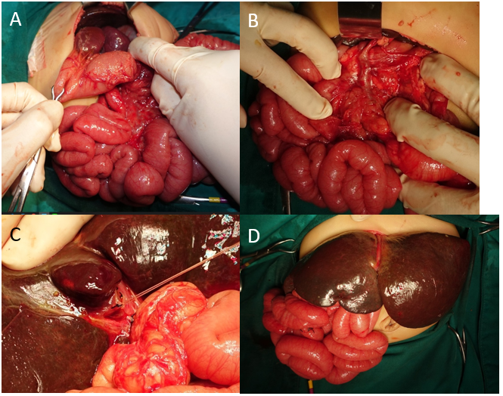
Figure 1 A term female infant with progressive jaundice and pale stool since birth. At the age of 1 month 22 d, biliary atresia was diagnosed by intraoperative cholangiography and exploratory laparotomy for Kasai operation. A: Polysplenia; B: Preduodenal portal vein; C: Atretic gallbladder with a fibrous band; D: Situs ambiguous.

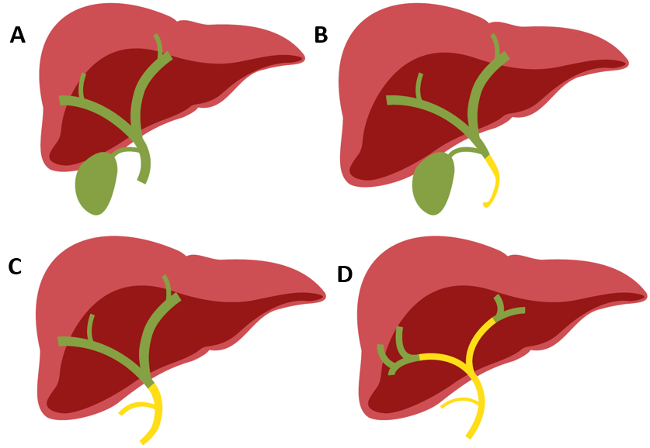
Figure 2 Type of biliary atresia classified by anatomical variants by the Japanese Society of Pediatric Surgeons. A: Normal; B: Type I: 3%; C: Type II: 5%; D: Type III: 90%.

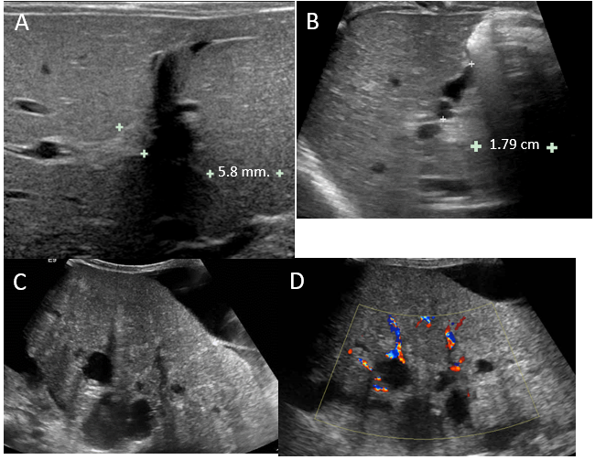
Figure 3 Ultrasound finding of biliary atresia. A: A 25-d-old boy presented with prolong jaundice. Ultrasonography of the upper abdomen showed a thick echogenic band located anterior to the right portal vein and measuring approximately 5.8 mm in thickness, representing a positive triangular cord sign; B: A 49-d-old boy presented with prolonged jaundice and pale stools. Ultrasonography of the upper abdomen revealed: (1) A small size of gallbladder, measuring a maximal length of approximately 15.4 mm; (2) Lack of smooth, complete echogenic mucosal lining with an indistinct wall; and (3) Irregular gallbladder contour. These findings are consistent with a positive gallbladder ghost triad. The common bile duct was not visualized; C and D: An 11-month-old boy presented with clinical obstructive jaundice with abdominal distension. Ultrasonography of the upper abdomen revealed multiple irregular cystic lesions of various sizes in the central region of the right and left hepatic lobes and at the porta hepatis. Some cyst had echogenic content. Liver cirrhosis and ascites were noted.

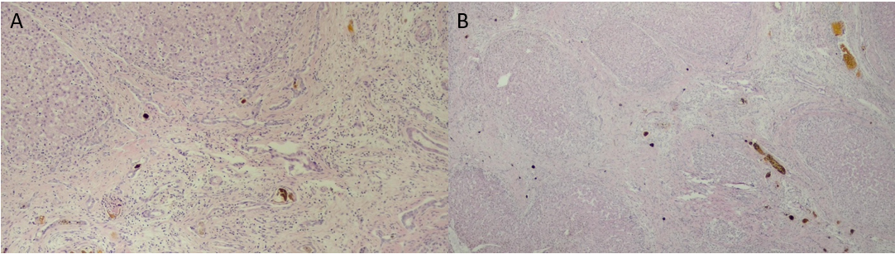
Figure 4 Histopathology of the liver in biliary atresia. A: Ductular reaction and bile plug; B: Nodular, fibrosis and bile plug.

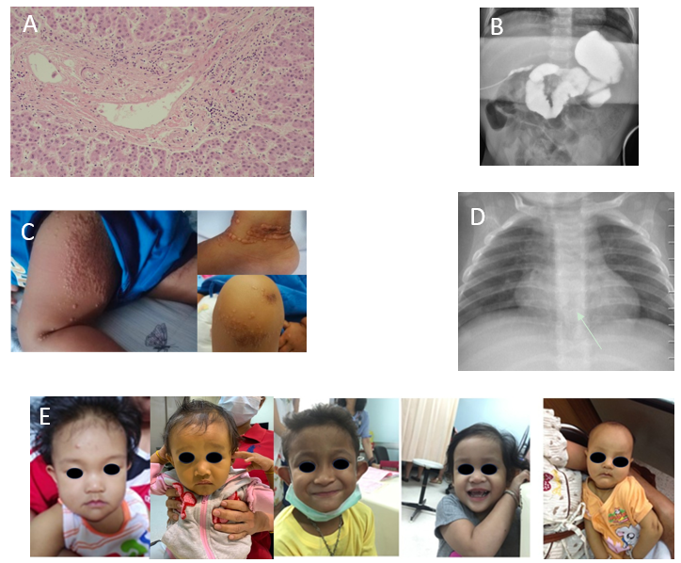
Figure 5 Characteristics of Alagille syndrome. A: Bile duct paucity; B: A potential hypoplasia of the intralobular bile duct from intraoperative cholangiography; C: Xanthomas; D: A butterfly vertebra found on intraoperative cholangiography, the contrast was freely passing through the duodenal area and reasonably passing through the upper to the intrahepatic duct; E: Triangular face, deep-set eyes, hypertelorism, prominent forehead and point chin.

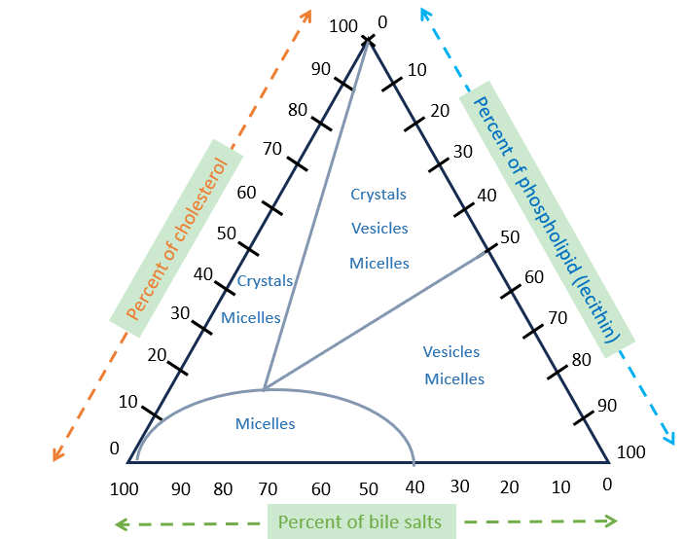
Figure 6 Percentage of the total moles of bile salt, lecithin, and cholesterol in bile composition.

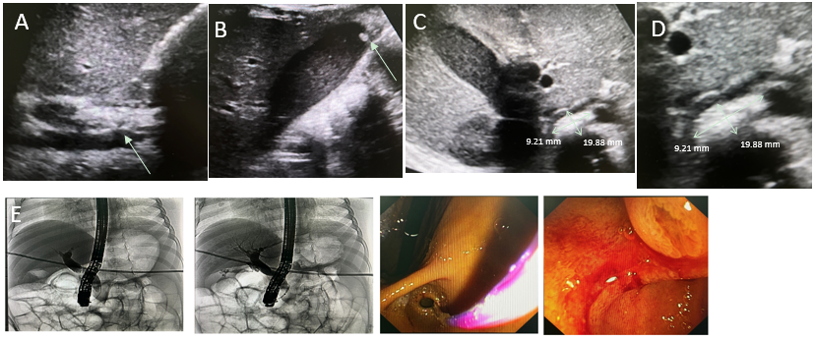
Figure 7 A 2-month-old female infant with anemia caused by chronic hemolysis. Genetic analysis demonstrated heterozygous PKLR1 mutation/large deletion that was compatible with pyruvate kinase deficiency. Subsequently, she received regular blood transfusions every 3-4 wk. At the age of 3 years, the patient experienced intermittent abdominal pain, nausea, jaundice, and decreased appetite with no fever. Liver function test showed total bilirubin (TB) of 33.4, direct bilirubin (DB) of 31.2 mg/dL, aspartate aminotransferase of 270, alanine transaminase of 530, and alkaline phosphatase of 277 U/L. Abdominal ultrasonography showed marked splenomegaly, a dilated common bile duct (CBD) up to 0.9 cm in diameter, mild wall thickening, a suspected 2 cm × 0.9 cm distal CBD stone - well-distended gallbladder with bile sludge, and a 0.4 cm gallstone in the fundus. Subsequently, endoscopic retrograde cholangiography (ERCP) was performed, which revealed a bulging ampulla and CBD dilatation of 1 cm. The CRE balloon (12-15 mm) filled with 40 mL of air was placed for 60 s for sphincteroplasty. Later, balloon sweeping was performed, and small, blackish-pigmented stones were observed. After stone removal, the liver function test improved gradually as TB/DB 7.84/4.57 at 1 wk and normal values at 1 month. A: Dilated CBD, up to 9 mm, with mild wall thickening; B: A well-distended gallbladder with bile sludge and 0.4 cm stone at the fundus; C: A 2 cm × 0.9 cm distal CBD stone; D: A 2 cm × 0.9 cm distal CBD stone (zoom in); E: ERCP with CBD dilation with 12-15 mm CRE balloon filled with 40 mL of air placed for 60 s as sphincteroplasty.

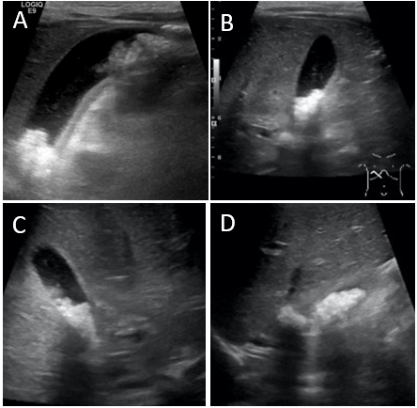
Figure 8 A 3-year-old girl was diagnosed with tetralogy of Fallot and brain abscess. She was admitted for intravenous antibiotic therapy, including ceftriaxone 100 mg/kg/d and metronidazole 30 mg/kg/d for 6 wk. After 3 wk of ceftriaxone administration, she experienced intermittent colicky pain in her right upper abdomen and ultrasonography showed an enlarged gallbladder with multiple gallstones in the posterior dependent part extending to the gallbladder neck. A: Multiple gallstones; B: Enlarged gallbladder measuring 6.3 cm in length, 1.5 mm gallbladder wall, and no pericholecystic fluid; C: Enlarged gallbladder with multiple gallstones in the posterior dependent part extending to gallbladder neck; D: Multiple gallstones.

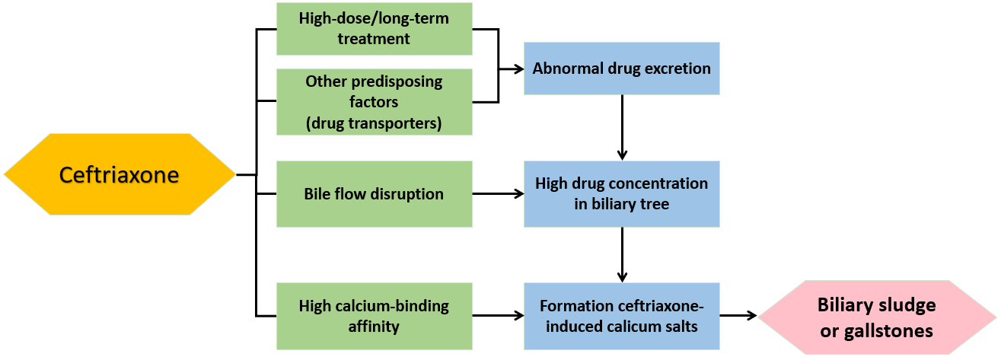
Figure 9 Ceftriaxone excretion in the biliary tract.

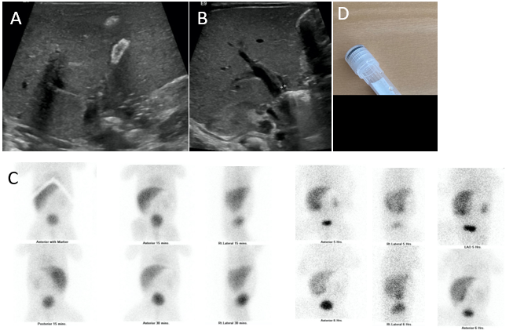
Figure 10 A 29-wk preterm newborn with neonatal sepsis, stage IIA necrotizing enterocolitis, bronchopulmonary dysplasia on the endotracheal tube, and prolonged total parenteral nutrition. He had obvious jaundice and pale stool at 1 month of age. Liver function test showed total bilirubin (TB)/direct bilirubin (DB) values of 8.7/4.6 mg/dL, aspartate aminotransferase of 132, alanine aminotransferase of 52, alkaline phosphatase of 447 U/L, and albumin of 2.8 mg/dL. Intraoperative cholangiography was performed after 3 months of and showed a patent bile duct but the formation of large stone. The histopathology of liver biopsy revealed giant cell transformation with cholestasis in the bile canaliculi and hepatocytes, bile ductopenia, and absence of significant fibrosis. He underwent an eye examination by an ophthalmologist who found the posterior embryotoxon at the inferior of the eyes. The trio-exome showed a NOTCH2 mutation. After stone removal, TB and DB dramatically decreased to normal level in 7 d. A: Ultrasonography showing a small gallbladder with a diffused calcified wall; B: Ultrasonography showing non-dilatation of the intrahepatic or common bile duct (only 3 mm); C: Technetium-99m di-isopropyl iminodiacetic acid shows faint radiotracer excretion into the gastrointestinal tract; D: Gross stone specimen.

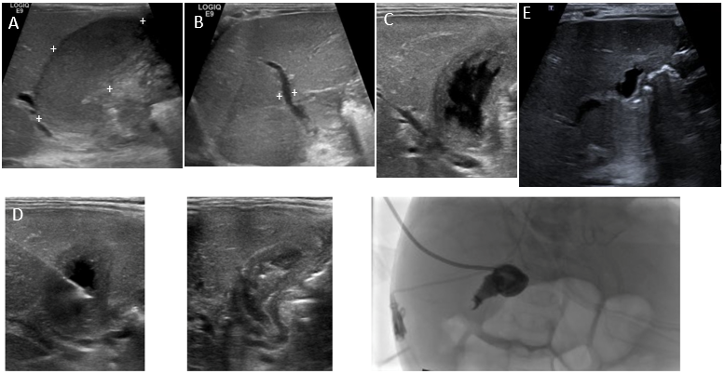
Figure 11 A 30-wk old male infant, with a birth weight of 1130 g, had a short bowel syndrome caused by necrotizing enterocolitis stage IIIB with multiple small bowels, and colonic, and cecal perforations. He underwent multiple exploratory laparotomies with severe intra-abdominal adhesion. At the age of 3 months, he experienced jaundice and multiple episodes of sepsis. Abdominal ultrasonography revealed a marked distended gallbladder containing bile sludge with mucocele, as hydrops gall bladder, with no bile duct dilatation. The maximum total bilirubmin/direct bilirubin (TB/DB) was 28/23 mg/dL, with unclear sepsis. Percutaneous transhepatic cholecystostomy was performed. After the procedure, sepsis was clear, and TB/DB gradually returned to normal levels within 2 months. Before percutaneous cholecystostomy. A: Hydrops gallbladder 5.4 cm × 2 cm (markedly distended gallbladder with bile sludge); B: Mild dilatation ofz the common bile duct measured 3.2 mm in diameter; C: Percutaneous cholecystostomy via a transhepatic approach; D: A 6-F percutaneous cholecystostomy catheter was inserted over 0.035 Terumo wire with its tip located in the gallbladder. A 5 mL aliquot of dark bile was aspirated; then, a drainage catheter was placed in the gallbladder and connected to the drainage bag and cholecystography was performed; follow-up 1.5 years after percutaneous cholecystotomy; E: Small, lobulated gallbladder.

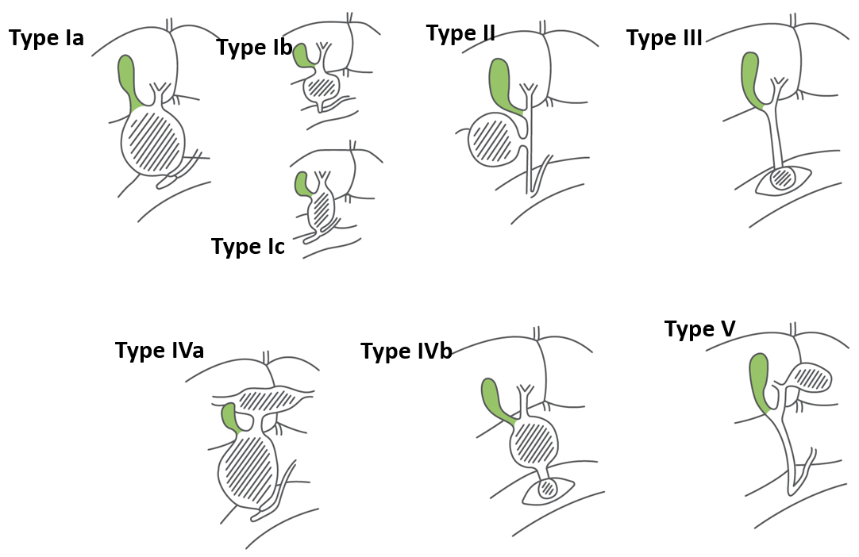
Figure 12 Todani classification of choledochal cysts.

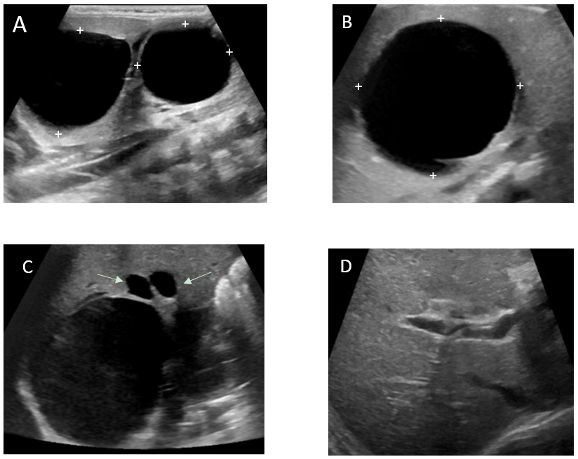
Figure 13 A term female infant with hepatic cyst detected by prenatal ultrasonography, presented with jaundice since birth. Repeated abdominal ultrasonography showed fusiform dilatation of extrahepatic and intrahepatic bile ducts, 3.3 cm × 4.5 cm, suggestive of choledochal cyst type IVa (Todani’s classification), containing bile sludge, and another large hepatic cyst in segment IV, 4.7 cm × 4.3 cm. After conservative treatment, clinical jaundice progressed. Liver function test showed total bilirubin/direct bilirubin (TB/DB) of 10.9/1.68 mg/dL, aspartate aminotransferase of 45, alanine aminotransferase of 23, alkaline phosphatase of 150, gamma-glutamyltransferase of 172 U/L, and albumin of 3.9 mg/dL. Computed tomography revealed a cystic lesion measuring 3.7 cm × 5 cm × 4 cm, at the common bile duct area, slight bilateral intrahepatic duct dilatation, a smooth thin wall hypodense lesions measuring 5.1 cm × 4.6 cm × 4.3 cm at hepatic segment 4a/8, and a few small hypodensity lesions at segment 7 that were suspected to be an infected hepatic cyst. After percutaneous aspiration of the hepatic cyst and intensive antibiotics, the cyst enlarged to 5.4 cm × 5.8 cm. Finally, choledochal cyst excision with Roux-en-Y hepaticojejunostomy of the subcutaneous limb was performed. One year later, ultrasonography revealed a reduction in the size of the lobulated cystic lesion to size 2.9 cm × 2.8 cm × 2.1 cm and mild dilatation of the intrahepatic bile ducts at the porta hepatis region. A: Fusiform dilatation of the extrahepatic cyst and intrahepatic bile ducts, measuring 3.3 cm × 4.5 cm, containing bile sludge; B: Another large cyst, 4.7 cm × 4.3 cm, in hepatic segment IV; C: Decreased size of the lobulated cystic lesion at the porta hepatis region with a few small hypoechoic lesions surroundings the cystic lesion, probably cysts or focal IHD dilatation; D: Mild dilatation of the intrahepatic bile ducts at the porta hepatis region.

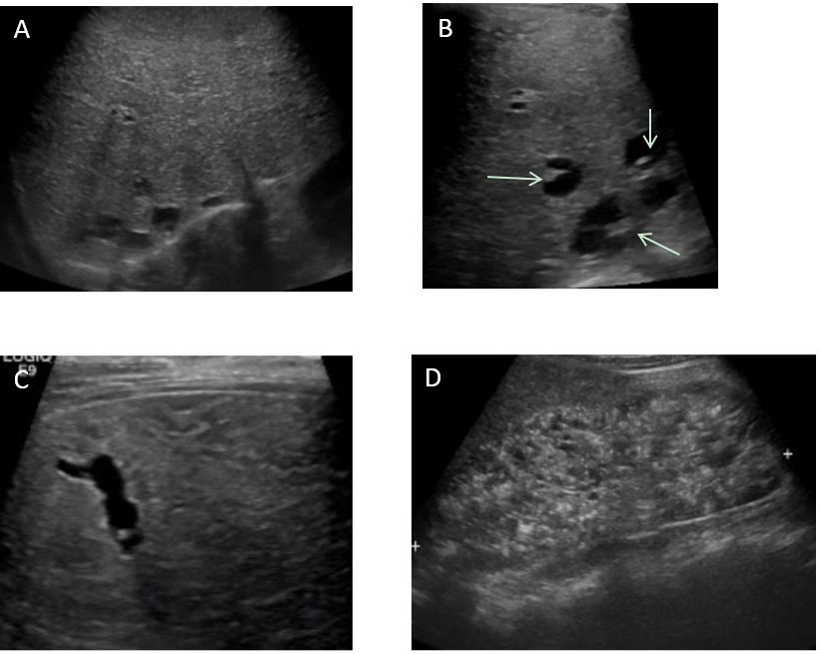
Figure 14 A 32-wk-old female infant with a family history of consanguinity, presented with an abdominal mass. She was diagnosed with Calori syndrome (congenital hepatic fibrosis, choledochal cyst type V, and multiple cysts in the kidneys). Abdominal ultrasonography revealed enlargement of the left hepatic lobe, coarse parenchymal echotexture with a periportal hyperechoic band, small cysts in a posterosuperior segment of the right hepatic lobe, and marked enlargement of both kidneys with evidence suggestive of multi-cystic kidney disease. She had upper gastrointestinal bleeding from esophageal varices that can be controlled with esophageal ligation at the 8-year follow-up. A: Diffusely enlarged liver and coarse parenchymal echogenicity with several round and tubular cystic-like structures; B: Focal intrahepatic dilatation with central dot sign; C: Tubular cystic-like structures; D: Markedly enlarged kidneys with loss of corticomedullary differentiation, and multiple cysts in the medulla and cortices.

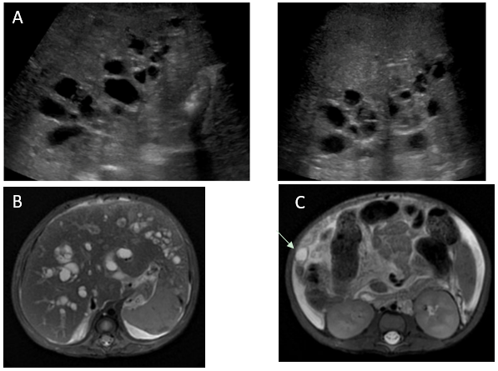
Figure 15 A 2-month-old male infant presented with jaundice and pale stools. Exploratory laparotomy revealed a collapsed gallbladder, yellow bile, and patent right hepatic bile duct. The liver histopathology at the age of 2 months revealed cirrhosis with cholestasis jaundice. At the age of 7 months, repeated ultrasonography showed liver cirrhosis with evidence of portal hypertension, multiple cysts along the periportal distribution with a hyperechogenic area at the periportal region, probably a periportal type of Caroli disease, enlarged and diffusely increased parenchymal echogenicity of both kidneys, splenomegaly, and a moderate amount of ascites. The MRCP findings were diffuse cystic dilatation of bilateral intrahepatic bile ducts with the presence of a central dot sign at the peripheral zone and evidence of liver cirrhosis with portal hypertension. The patient underwent liver transplantation with a favorable outcome and a follow-up period of 10 years. A: Ultrasonography shows liver cirrhosis with multiple cysts along the periportal distribution, probably a periportal type of Caroli disease; B: Magnetic resonance cholangiopancreatography shows diffuse cystic dilatation of bilateral intrahepatic bile ducts; C: A 1.1 cm probable hepatic cyst at segment VI with a central dot sign.

Table 1 Screening methods for biliary atresia
 | Methods | Country (yr) | Sensitivity (%) | Specificity (%) | Prevalence of BA (per 10000 live births) | Outcomes/advantages
Yellow Alert campaign | Testing conjugated bilirubin in all babies with persistent jaundice after 2 wk | United Kingdom (1993) | N/A | N/A | N/A | N/A
SCC | Distribution of a picture of abnormal stool color to raise BA awareness | Japan^{[38]} (1994) | 76.5 | 99.9 | 1.1 | The mean age of Kasai was 59.7 and 68.2 d, and NLS at 12.5 years was 48.5% vs 36.6% (SCC users vs non-users)
 |  | Taiwan (2004) | 84 | 99.9 | 1.7 | 67% of patients with BA underwent Kasai within 60 d
 |  | China^{[57]} (2013) | 100 | 99.9 | 1.3 | N/A
 |  | British Columbia (2014) | 83 | 99.9 | 0.7 | The median age at Kasai was 49 vs 116 d (success vs failed program screening)
Mobile application | PoopMD^{®[44]} | United State (2015) | 100 | 89 | N/A | Easy to use; improve the ability to analyze near-normal stool color; automated reminder every 1-2 wk until 8 wk of life; current contact with a pediatrician if abnormal
 | BabyPoop^{®[45]} | Japan (2017) | 100 | 100 | N/A
 | Popòapp^{®[46]} | Italy (2020) | 100 | 99 | N/A
Fractionated bilirubin screening | Measuring conjugated bilirubin levels in all infants aged 4-28 d infants with conjugated bilirubin > 18 μmol or % conjugated bilirubin > 20% were followed up and further evaluated immediately | United Kingdom^{[49]} (1995) | 100 | 95.5 | N/A | Can also identify other causes of cholestasis jaundice earlier
 | N/A | United States^{[48]} (1998) | 100 | 99.9 | 1.7
Laboratory markers | Matrix metalloproteinase-7 | United States^{[51]} (2017) | 97 | 91 | N/A | N/A
 |  | China^{[52]} (2018) | 98.6 | 95 | N/A | 52.85 ng/mL (AUC 0.99)
 |  | Taiwan^{[58]} (2019) | 97 | 83 | N/A | 1.43 ng/mL (AUC 0.96)
 |  | Iran^{[53]} (2022) | 95.5 | 94.5 | N/A | 7.8 ng/mL (AUC 0.98)
SCC: Stool color card; BA: Biliary atresia; NLS: Native liver survival; N/A: Not applicable; AUC: Area under the curve.

Table 2 Summary of the accuracy of abdominal sonography in the preoperative diagnosis of biliary atresia^{[62-65]}
Finding | Sensitivity (%) | Specificity (%) | Positive predive value (%) | Negative predictive value (%)
Triangular cord sign | 23.3-93 | 97.1-100 | 77.8 | 74.4
Abnormal gallbladder | 83.3-85 | 82.6-94.4 | 67.6 | 91.9
Absent gallbladder | 28-53 | 94-100 | 96-100 | 46-75
Nonvisualized common bile duct | 83-93.3 | 47.8-71 | 43.8-90 | 56-94.3
Negative triangular cord sign with a normal gallbladder | - | - | - | 91.9

Table 3 Disorders associated with nonsyndromic bile duct paucity in children^{[109,110]}
Disease type | Cause
Metabolic and genetic disorders | Alpha-1 antitrypsin deficiency
 | Cystic fibrosis
 | Peroxisomal disorders
 | Niemann pick type C
 | Kabuki syndrome (rare)
 | Chromosomal abnormality (trisomy 17, 18, or 21) (rare)
Infections | Congenital cytomegalovirus, syphilis, and rubella infection
Inflammatory and immune disorders | Hemophagocytic lymphohistiocytosis
 | Graft-versus-host disease
 | Chronic hepatic allograft rejection
 | Sclerosing cholangitis (primary or secondary)
 | Biliary atresia (late)
Others | Drug- or antibiotic-associated vanishing bile duct syndrome
 | Panhypopituitarism
 | Idiopathic

Table 4 Revised diagnostic criteria for diagnosis of Alagille syndrome^{[113-115]}
Major criteria: Organ involvement (%) | Findings | Frequency in mutation-positive patients
 |  | JAG1 | NOTCH2
Hepatic (75%-100%) | Bile duct paucity and/or cholestasis | 100% | 100%
Cardiac (85%-98%) | Peripheral pulmonary artery stenosis, pulmonary atresia, atrial or ventricular septal defect, and Tetralogy of Fallot | 100% | 60%
Skeletal (33%-87%) | Butterfly vertebrae, hemivertebrae, fusion of adjacent vertebrae, and spina bifida occulta | 64% | 10%
Renal (19%-73%) | Uteropelvic junction anomaly or renal tubular acidosis | 40% | 44%
Ocular (56%-88%) | Posterior embryotoxon, optic drusen, pigmentary retinopathy, and angulated retinal vessels | 75% | 63%
Facial characteristics (70%-98%) | Broad forehead, deep-set eyes, up-slanting palpebral fissure, prominent ears, straight nose with bulbous tip, and pointed chin (triangular facies) | 97% | 20%
Vascular (4%-38%) | Aneurysm of intracranial vessels, Moya Moya disease, aneurysm of intra-abdominal vessels, renovascular anomalies, and middle aortic syndrome^{[116]} | N/A | N/A
JAG1: Jagged canonical notch ligand 1; NOTCH2: Neurogenic locus notch homolog protein 1; N/A: Not applicable.

Table 5 Nutritional management in children with cholestasis^{[118]}
Nutrition | Daily requirement
Energy | 130% of the requirement for age
Fat | 30%-50% of total calories (MCT/LCT = 30%/70% of total fat calories)
Protein | 130%-150% of requirement for age
Carbohydrate | 40%-60% of total calories
Vitamins and minerals
Vitamin A | < 10 kg: 5000 IU/d
 | > 10 kg: 10000 IU/d
Vitamin D | Cholecalciferol: 2000-5000 IU/d
Vitamin E | TPGS: 15-25 IU/kg/d
Vitamin K | 2-5 mg/d
MCT: Medium-chain triglyceride; LCT: Long-chain triglyceride; TPGS: Tocophersolan.

Table 6 Medications for cholestasis and pruritus in Alagille syndrome^{[109,114,123]}
Medications | Actions | Dose (kg/d) | Adverse effects
Ursodeoxycholic acid | Choleretic, stimulates bile flow | 10-20 mg | Vomiting, diarrhea, and abdominal pain
Cholestyramine | Bile acid-binding resins | 0.25-0.5 g | Vomiting, diarrhea, and poor palatability
Rifampicin | Pregnane X receptor agonist increases the metabolism of pruritogenic substances | 5-10 mg | Hepatitis, thrombocytopenia, hemolytic anemia, and red discoloration of bodily fluid (sweat, tears)
Phenobarbital | Choleretic enhancement of glucuronyl transferase activity | 5-10 mg | Central nervous system depression and vomiting
Naltrexone | Opioid receptor antagonist | 0.25-0.5 mg | Opioid withdrawal-like reactions, abdominal pain, and irritability
Maralixibat | Ileal bile salt transporter | 380 μg | Diarrhea, abdominal pain, and rash
Ondansetron | Serotonin (5-HT₃) receptor antagonist | 0.1-0.2 mg | Dizziness, constipation
Hydroxyzine | Antihistamine | 2 mg | Rash, drowsiness, and dry mouth
Diphenhydramine | Antihistamine | 5 mg/kg/d | Drowsiness, constipation, and nausea

Table 7 Characteristics of cholesterol and pigmented gallstones in children^{[150,152]}
 | Cholesterol stones | Pigmented stones
 |  | Brown | Black
Mechanism | Hypersecretion of cholesterol. Increased mucin production. Decreased gallbladder motility | Biliary tract infected with bacteria producing β-glucuronidase. Excess bilirubin glucuronides in bile to unconjugated bilirubin or phospholipase A1 hydrolysis of biliary phosphatidylcholines that creates calcium salts | Increased bilirubin production. Decreased enterohepatic circulation (ileal disease) of the endogenous bile salt pool
Content | Cholesterol (50%), glycoprotein and minimal calcium salts | Calcium bilirubinate (60%), calcium palmitate and stearate (15%), cholesterol (15%), and mucin glycoprotein (10%) | Bile-pigmented polymer (40%), calcium carbonate or phosphate salts (15%), and cholesterol (5%)
Risk factor | Obesity, adolescence, Hispanic ethnicity, female, and family history | Bacterial (E.coli) or parasitic infection, bile duct anomaly, and birth control pills | Hemolytic anemia, cirrhosis, TPN, ceftriaxone, and ileal resection
Age | Puberty increases with age | Any | Any
Size, number | Solitary 2-4 cm. Multiple < 5 mm | Vary | Multiple 1-3 cm
Radiopaque | No | No | Yes (50%)
Recurrent | Yes | Yes | No
E.coli: Escherichia coli; TPN: Total parenteral nutrition.

Table 8 Todani classification of choledochal cyst by types and features^{[161]}
Type | Features
I | Cystic dilatation of the common bile ducts
Ia | Large saccular cystic dilatation
Ib | Small localized segmental dilatation
Ic | Diffuse (cyclindric) fusiform dilatation
II | Diverticulum of the common bile duct and/or gallbladder
III | Choledochocele
IV | Multiple cysts
IVa | Intrahepatic and extrahepatic
IVb | Extrahepatic only
V | Fusiform intrahepatic dilatation (may be related to Caroli’s disease)

