Name of Journal: World Journal of Clinical Cases
Manuscript NO: 68815
Manuscript Type: CASE REPORT

Rectal mature teratoma: A case report

Liu JL et al. Rectal mature teratoma

Jia-li Liu, Ping-liang Sun

Jia-li Liu, Department of Anorectal Surgery, Nanjing University of Chinese Medicine, Nanjing 210023, Jiangsu Province, China

Ping-liang Sun, Department of Anorectal Surgery, The First Affiliated Hospital of Guangxi University of Chinese Medicine, Nanning 530023, Guangxi Zhuang Autonomous Region, China

Author contributions: Liu JL and Sun PL designed the research and equally contributed to this work; Liu JL and Sun PL provided figure legends; Liu JL and Sun PL drafted the manuscript; All authors reviewed and approved the final submitted manuscript.

Supported by the Natural Science Foundation of Guangxi, No. 2018JJA140199.

Corresponding author: Jia-li Liu, PhD, Attending Doctor, Surgeon, Surgical Oncologist, Department of Anorectal Surgery, Nanjing University of Chinese Medicine, No. 138 Xianlin Road, Qixia Area, Nanjing 210023, Jiangsu Province, China. 875398819@qq.com

Received: June 5, 2021
Revised: July 24, 2021
Accepted: May 16, 2022
Published online: August 6, 2022

Abstract
BACKGROUND
Rectal mature teratoma is rare and has been reported as a case report in this study. Herein, clinical presentation, magnetic resonance imaging findings, and immunohistochemistry showed a pelvic rectal mature teratoma. The case report and the surgical treatment procedure have been discussed below.

CASE SUMMARY
A 29-year-old Chinese female showed up with over a 1-mo history of perianal mass that emerged after defecation. Physical examination indicated that the mass was 4 cm × 3 cm × 3 cm. The intraoperative procedure involved ligation of the sigmoid colon 10 cm above the upper edge of the tumor, followed by ligation of the rectum 3.5 cm above the upper edge of the tumor, and subsequent complete removal of the mass. The histopathology confirmed the mature teratoma.

CONCLUSION
The tumor can be completely removed using surgery to prevent its recurrence.

Key Words: Rectal; Mature teratoma; Therapy; Case report

©The Author(s) 2022. Published by Baishideng Publishing Group Inc. All rights reserved.

Citation: Liu JL, Sun PL. Rectal mature teratoma: A case report. World J Clin Cases 2022; 10(22): 7883-7889
URL: https://www.wjgnet.com/2307-8960/full/v10/i22/7883.htm
DOI: https://dx.doi.org/10.12998/wjcc.v10.i22.7883

Core Tip: Herein, a rectal mature teratoma patient was reported. However, only a few similar cases have been reported. Currently, it is difficult to diagnose mature rectal teratoma using a computed tomography scan. However, complete removal of the tumor using surgery can prevent its recurrence.

INTRODUCTION
Teratoma is a tumor caused by pluripotent cells, especially the embryonic stem or seed cells in the gonad or embryonic part of the body. It occurs in the midline or on both sides of the body. It often originates from the Hensen’s node, the location of pluripotent stem cells. Teratoma also occurs in the sacral region where pluripotent cells are located^{[1]}. Teratoma is mostly benign with low malignant potential, but it can also develop into a malignancy^{[2]}. Rectal teratoma is rare, and there are few reports worldwide. Mature teratoma is a benign tumor (dermoid cyst) and accounts for over 95% of teratomas. Mature teratoma mostly occurs in women of childbearing age and sometimes in young girls and postmenopausal women. It rarely occurs in males^{[3]}. This study aimed to review the diagnosis and treatment of rectal teratoma and to determine the clinical characteristics associated with this rare tumor.

CASE PRESENTATION
Chief complaints
A 29-year-old female, G1P0, with over a 1-mo history of a perianal mass that emerged after defecation, was hospitalized in the First Affiliated Hospital of Guangxi Chinese Medicine University.

History of present illness
She reported a 1-mo medical history of perianal mass that emerged after defecation and complained about the anal bulge. The patient had not used contraceptives, was not injured, had no pain, chills, or fever, and no difficulty during defecation.

History of past illness
The patient had no past illness.

Personal and family history
The patient had a history of artificial abortion and no family history of rectal mature teratoma. The condition was diagnosed as a rectal mass (nature to be investigated).

Physical examination
The mass was 4 cm × 3 cm × 3 cm inside the anus with a dentate line distance of about 6 cm and was smooth upon palliation. A non-tender mass was seen outside the anus.

Laboratory examinations
Hematological examinations, including serum electrolyte levels, human chorionic gonadotropin, comprehensive metabolic panel, and complete blood count, were normal.

Imaging examinations
Electronic colonoscopy: Rectal mass (nature to be investigated) (Figure 1).
The computed tomography (CT) scan revealed: (1) A 6.3 cm × 4.7 cm × 5.1 cm round mass, flaky low-density shadow and calcification on center, enhanced scanning lesions with circular mild enhancement, non-enhancement on center, and clear boundary on the pelvis (unclear if this is a teratoma); and (2) Double-sided adnexal area low-density shadow (cyst) (Figure 2).
A rectal mass resection was performed via laparoscopy under anesthesia to alleviate the patient’s symptoms.

FINAL DIAGNOSIS
The condition was diagnosed as mature rectal teratoma based on the above physical examinations and imaging data.

TREATMENT
Surgical procedure
A rectal mass resection was conducted via laparoscopy under anesthesia. Intraoperative ligation was conducted on the sigmoid colon 10 cm above the upper edge of the tumor and on the rectal area 3.5 cm above the upper edge of the tumor, followed by complete removal of the mass. Full hemostasis, sigmoid colon and rectal suture repair, placement of a negative pressure drainage tube in the anus and abdominal cavity, and layer-by-layer suture repair of the incision was then conducted (Figure 3).

Pathological examination
In the intestinal section, two connected tumors, about 6 cm × 5 cm × 4 cm and 2 cm × 2 cm × 2 cm, were seen in the intestinal mucosa and intestinal serosal layer, respectively. In the microscopic view, skin and appendages, glands, fat, bone tissue, bone marrow tissue, and brain tissue indicated mature teratoma. No tumor tissue was seen at the two ends (upper and lower margins) after the examination. Six lymph nodes were found, and no tumor metastasis was identified (0/6). Therefore, the condition was diagnosed as mature teratoma (Figure 4).

OUTCOME AND FOLLOW-UP
Postoperatively, the patient was discharged after healing. She returned for a follow-up in August 2018. On examination, there was evident wound healing and no tumor recurrence. Additionally, the patient was free of discomfort, pain, and fecal incontinence.
The colonoscopy and CT scan revealed a rectal mass, 6 cm × 5 cm × 4 cm in the intestinal mucosa and 2 cm × 2 cm × 2 cm in the intestinal serosal layer, which was diagnosed as mature rectal teratoma. Laparoscopic tumor resection was conducted to remove the tumor. No tumor metastasis was found 6 mo after successful 1-mo treatment. The teratoma was located in the rectal wall, which is close to the pelvic cavity. The teratoma volume increases and breaks into the intestinal wall, and bulging occurs to the posterior wall of the rectum. The teratoma then comes out of the anus and can only be returned by hand.

DISCUSSION
Clinical reports of teratoma are common in the sacrococcygeal, appendix, ovary, testis, retroperitoneum, mediastinum, etc. Several studies have shown that the incidence of teratoma may be related to various factors, such as genetic, environmental, and gene-level regulation^{[4,5]}. Teratoma can be divided into benign and malignant transformations based on the degree of tissue differentiation. Teratoma incidence is about 1:35000-1:40000^{[6]} and mostly occurs in women (the ratio of male to female is about 1:2-4) with few occurrences in children and postmenopausal women^{[7,8]}. Although mostly reported in the ovary and testis, it also occurs in the midline of the mediastinum, appendix, sacrococcygeal, pineal body, mediastinum, posterior peritoneal cavity, omentum, uterine rectum, vagina, and cervix^{[9-12]}. Immature teratomas occur in adolescents. Most malignancies transform into cancer (squamous cell carcinoma). About 1%-2% of teratoma cases are malignant and are common in young women (the average age of onset is 11 years to 19 years) with poor prognosis^{[13-15]}. CT images of mature teratoma reveal calcification, adipose tissue, bone, tooth, and obviously cysts^{[16,17]}.
CT scan is sensitive to calcification and fat, common and quick, and combined with enhanced scan can evaluate the soft tissue composition well. However, it lacks specificity for differentiating between tumor types. While magnetic resonance imaging has a higher resolution of fat and soft tissue, which helps to determine the retrorectal tumors and their relationships to surrounding structures and cystic degeneration, but it poorly shows calcification^{[18,19]}. To some extent, magnetic resonance imaging is more accurate than CT to estimate the possible complications such as torsion, rupture, and malignant transformation.
Badmos et al^{[20]} reported that laparoscopic surgery can enlarge the field of view, reducing the incision and intraoperative blood loss. Lee et al^{[21]} also reported that laparoscopic surgery could significantly reduce the body’s inflammatory response compared to open surgery. Chansoon et al^{[22]} reported a case of complicated duodenal mature teratoma, which was resected via laparoscopic surgery. Herein, the mature cystic teratoma was identified, and the patient was discharged after the operation. No recurrence occurred after 6 mo of follow-up. Laparoscopic pelvic and teratogenic teratoma surgery is widely used because of the minimally invasive advantages. Laparoscopic surgery completely removes the tumor without damaging adjacent tissues and organs, avoiding the rupture of the tumor and preventing leakage of the teratoma, thus inhibiting malignant transformation, recurrence, and metastasis^{[23,24]}.
Murdock and Abbas^{[25]} reported that an anorectal cystic teratoma transabdominal approach is necessary, which can be done laparoscopically safely and successfully, even for a large lesion. Wang et al^{[26]} reported that it is generally not recommended to use preoperative biopsy of retrorectal tumors because of the risk of infection or tumor seeding in the pelvis. As such, a definitive diagnosis is best obtained by following complete resection of the tumor. Resection of retrorectal teratoma is generally regarded as appropriate because of the malignant potential.
Aiken et al^{[27]} reported that the diagnosis can be made with endoscopy alone by the presence of hair over the mass. Nam and Kim^{[28]} reported that the mass was removed by polypectomy because the patient’s lesion was a pedunculate polyp measuring approximately 4 cm and located approximately 15 cm from the anus. Endoscopic resection was performed to make a diagnosis. Endoscopic resection is indicated for a pedunculate polyp that measures < 4 cm. If the diagnosis is unclear or malignancy cannot be excluded, surgical resection is preferable. The summaries of reported cases of rectal mature teratoma are shown in Table 1.

CONCLUSION
Rectal teratoma remains a rare disease despite a recent uptick in diagnoses. Radiological imaging is helpful to preoperative diagnosis and planning. Complete surgical excision is the treatment of choice, and regular follow-up after surgery is needed to prevent recurrence. The prognosis of mature teratomas is excellent, and we report this case to raise awareness of this disease.

REFERENCES
1 Yoon HM, Byeon SJ, Hwang JY, Kim JR, Jung AY, Lee JS, Yoon HK, Cho YA. Sacrococcygeal teratomas in newborns: a comprehensive review for the radiologists. Acta Radiol 2018; 59: 236-246 [PMID: 28530139 DOI: 10.1177/0284185117710680]
2 Gatcombe HG, Assikis V, Kooby D, Johnstone PA. Primary retroperitoneal teratomas: a review of the literature. J Surg Oncol 2004; 86: 107-113 [PMID: 15112254 DOI: 10.1002/jso.20043]
3 Patel MD, Feldstein VA, Lipson SD, Chen DC, Filly RA. Cystic teratomas of the ovary: diagnostic value of sonography. AJR Am J Roentgenol 1998; 171: 1061-1065 [PMID: 9762997 DOI: 10.2214/ajr.171.4.9762997]
4 Prener A, Engholm G, Jensen OM. Genital anomalies and risk for testicular cancer in Danish men. Epidemiology 1996; 7: 14-19 [PMID: 8664395 DOI: 10.1097/00001648-199601000-00004]
5 Kuczyk MA, Serth J, Bokemeyer C, Jonassen J, Machtens S, Werner M, Jonas U. Alterations of the p53 tumor suppressor gene in carcinoma in situ of the testis. Cancer 1996; 78: 1958-1966 [PMID: 8909317 DOI: 10.1002/(sici)1097-0142(19961101)78:9<1958::aid-cncr17>3.0.co;2-x]
6 Frazier AL, Weldon C, Amatruda J. Fetal and neonatal germ cell tumors. Semin Fetal Neonatal Med 2012; 17: 222-230 [PMID: 22647545 DOI: 10.1016/j.siny.2012.05.004]
7 Altman RP, Randolph JG, Lilly JR. Sacrococcygeal teratoma: American Academy of Pediatrics Surgical Section Survey-1973. J Pediatr Surg 1974; 9: 389-398 [PMID: 4843993 DOI: 10.1016/s0022-3468(74)80297-6]
8 Peterson CM, Buckley C, Holley S, Menias CO. Teratomas: a multimodality review. Curr Probl Diagn Radiol 2012; 41: 210-219 [PMID: 23009771 DOI: 10.1067/j.cpradiol.2012.02.001]
9 Hegde P. Extragonadal omental teratoma: a case report. J Obstet Gynaecol Res 2014; 40: 618-621 [PMID: 24147579 DOI: 10.1111/jog.12198]
10 Tokunaga M, Seta M, Yamada M, Nishio M, Yamamoto K, Koyasu Y. Coexistent dermoid cysts of the pouch of the Douglas and ovary resected by laparoscopy. Asian J Endosc Surg 2012; 5: 31-33 [PMID: 22776340 DOI: 10.1111/j.1758-5910.2011.00107.x]
11 Koo YJ, Im KS, Jung HJ, Kwon YS. Mature cystic teratoma of the uterosacral ligament successfully treated with laparoendoscopic single-site surgery. Taiwan J Obstet Gynecol 2012; 51: 86-88 [PMID: 22482975 DOI: 10.1016/j.tjog.2012.01.017]
12 Makni A, Ben Rhouma S, Farah J, Jouini M, Kacem M, Ben Safta Z. A case of mature teratoma of the Douglas. Tunis Med 2013; 91: 473-474 [PMID: 24008883]
13 Hackethal A, Brueggmann D, Bohlmann MK, Franke FE, Tinneberg HR, Münstedt K. Squamous-cell carcinoma in mature cystic teratoma of the ovary: systematic review and analysis of published data. Lancet Oncol 2008; 9: 1173-1180 [PMID: 19038764 DOI: 10.1016/S1470-2045(08)70306-1]
14 Lu Z, Chen J. [Introduction of WHO classification of tumours of female reproductive organs, fourth edition]. Zhonghua Bing Li Xue Za Zhi 2014; 43: 649-650 [PMID: 25567588]
15 Farghaly SA. Current diagnosis and management of ovarian cysts. Clin Exp Obstet Gynecol 2014; 41: 609-612 [PMID: 25551948]
16 Asano T, Kawakami S, Okuno T, Tsujii T, Nemoto T, Kageyama Y, Kihara K. Malignant transformation in a mature testicular teratoma left untreated for more than 50 years since childhood. Scand J Urol Nephrol 2003; 37: 177-178 [PMID: 12745729 DOI: 10.1080/00365590310008947]
17 Reis F, Faria AV,Zanardi VA,Menezes JR,Cendes F,Queiroz LS.Neuroimaging in pineal tumors.J Neuroimaging 2006;16:52-58.[PMID: 16483277 DOI: 10.1177/1051228405001514]
18 Sogni P, Chaussade S, Mosnier H, Abecassis JP, Bonnichon P, Louvel A, Couturier D, Guerre J. [Retrorectal tumor in adults. Combination of computed tomography and endorectal echography]. Gastroenterol Clin Biol 1990; 14: 501-503 [PMID: 2194891]
19 Yang BL, Gu YF, Shao WJ, Chen HJ, Sun GD, Jin HY, Zhu X. Retrorectal tumors in adults: magnetic resonance imaging findings. World J Gastroenterol 2010; 16: 5822-5829 [PMID: 21155003 DOI: 10.3748/wjg.v16.i46.5822]
20 Badmos KB, Ibrahim OK, Aboyeji AP, Omotayo JA. Squamous cell carcinoma arising in a mature cystic ovarian teratoma with bladder invasion: a case report. Afr Health Sci 2011; 11: 285-287 [PMID: 21857863]
21 Lee SW, Southall JC, Gleason NR, Huang EH, Bessler M, Whelan RL. Time course of differences in lymphocyte proliferation rates after laparotomy vs CO(2) insufflation. Surg Endosc 2000; 14: 145-148 [PMID: 10656948 DOI: 10.1007/s004649900087]
22 Chansoon T, Angkathunyakul N, Aroonroch R, Jirasiritham J. Duodenal mature teratoma causing partial intestinal obstruction: A first case report in an adult. World J Clin Cases 2020; 8: 1489-1494 [PMID: 32368541 DOI: 10.12998/wjcc.v8.i8.1489]
23 Yoon SS, Tanabe KK, Warshaw AL. Adult primary retroperitoneal teratoma. Surgery 2005; 137: 663-664 [PMID: 15933637 DOI: 10.1016/j.surg.2004.02.002]
24 James J, Dhillon GS, Blewett CJ, Halldorsson A, Cecalupo AJ. A large adrenal teratoma in a neonate. Am Surg 2009; 75: 347-349 [PMID: 19385301 DOI: 10.1097/00006565-199308000-00025]
25 Murdock J, Abbas MA. Laparoscopic abdomino-paracoccygeal resection of anorectal cystic teratoma. JSLS 2010; 14: 583-586 [PMID: 21605528 DOI: 10.4293/108680810X12924466008600]
26 Wang L, Hirano Y, Ishii T, Kondo H, Hara K, Ishikawa S, Okada T, Obara N, Yamaguchi S. Laparoscopic surgical management of a mature presacral teratoma: a case report. Surg Case Rep 2019; 5: 144 [PMID: 31535236 DOI: 10.1186/s40792-019-0702-x]
27 Aiken A, Yu W, Abudoureyimu A, Aizimu X, Tong J. A case of primary rectal teratoma. Turk J Gastroenterol 2020; 31: 835-837 [PMID: 33361050 DOI: 10.5152/tjg.2020.19820]
28 Nam KH, Kim B. Primary Mature Teratoma of the Rectum: A Case Report. Am J Case Rep 2021; 22: e930272 [PMID: 33518697 DOI: 10.12659/AJCR.930272]

Footnotes
Informed consent statement: All participants provided written informed consent before study enrollment.

Conflict-of-interest statement: The authors declare that they have no conflict of interest.

CARE Checklist (2016) statement: The authors confirm that the manuscript followed the CARE Checklist (2016) regulations.

Open-Access: This article is an open-access article that was selected by an in-house editor and fully peer-reviewed by external reviewers. It is distributed in accordance with the Creative Commons Attribution NonCommercial (CC BY-NC 4.0) license, which permits others to distribute, remix, adapt, build upon this work non-commercially, and license their derivative works on different terms, provided the original work is properly cited and the use is non-commercial. See: http://creativecommons.org/Licenses/by-nc/4.0/

Provenance and peer review: Unsolicited article; externally peer reviewed.
Peer-review model: Single blind

Peer-review started: June 5, 2021
First decision: July 15, 2021
Article in press: May 16, 2022

Specialty type: Surgery
Country/Territory of origin: China
Peer-review report’s scientific quality classification
Grade A (Excellent): 0
Grade B (Very good): 0
Grade C (Good): C, C
Grade D (Fair): D
Grade E (Poor): 0

P-Reviewer: Nakaji K, Japan; Ohta H, Japan S-Editor: Gong ZM L-Editor: Filipodia P-Editor: Gong ZM

Figure Legends
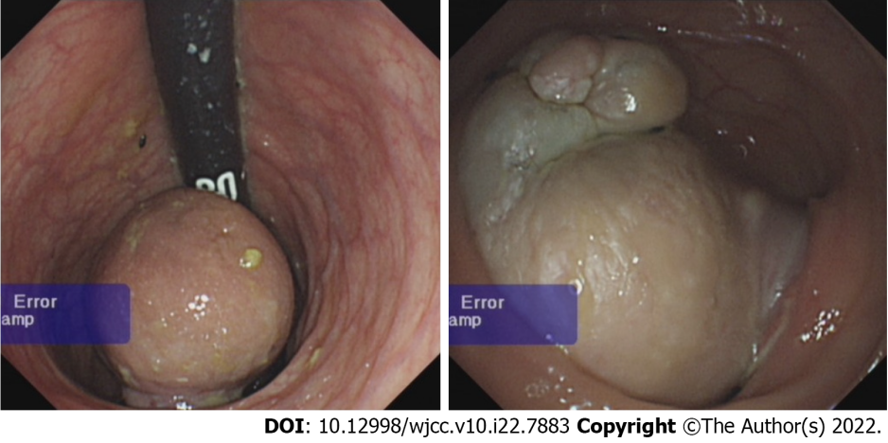
Figure 1 A rectal mass. Intestinal round mass was a teratoma.

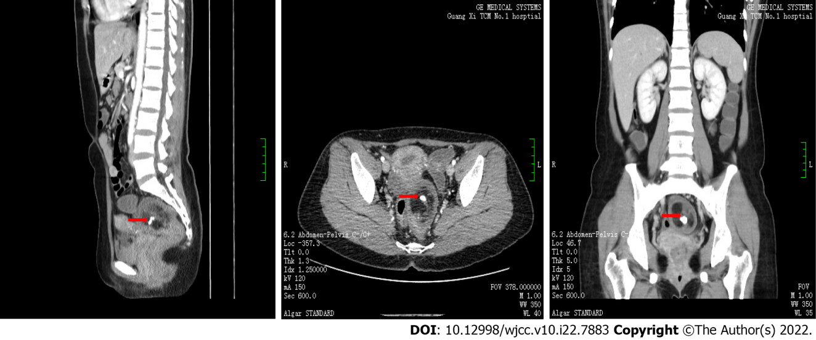
Figure 2 A rectal mass computed tomography examination. The arrow indicates the 6.3 cm × 4.7 cm × 5.1 cm mass on the left side of the pelvic rectal area.

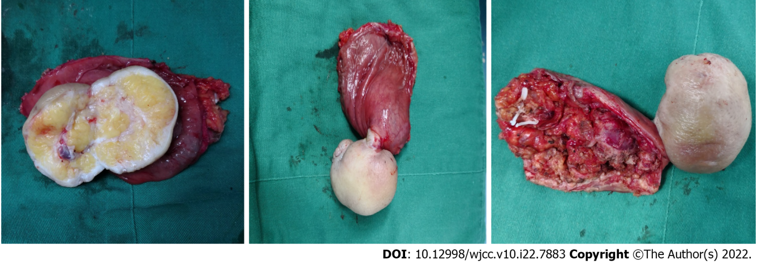
Figure 3 Postoperative mass resection. The postoperative photograph shows that the white was mass, and the bases were in contact with the rectal area.

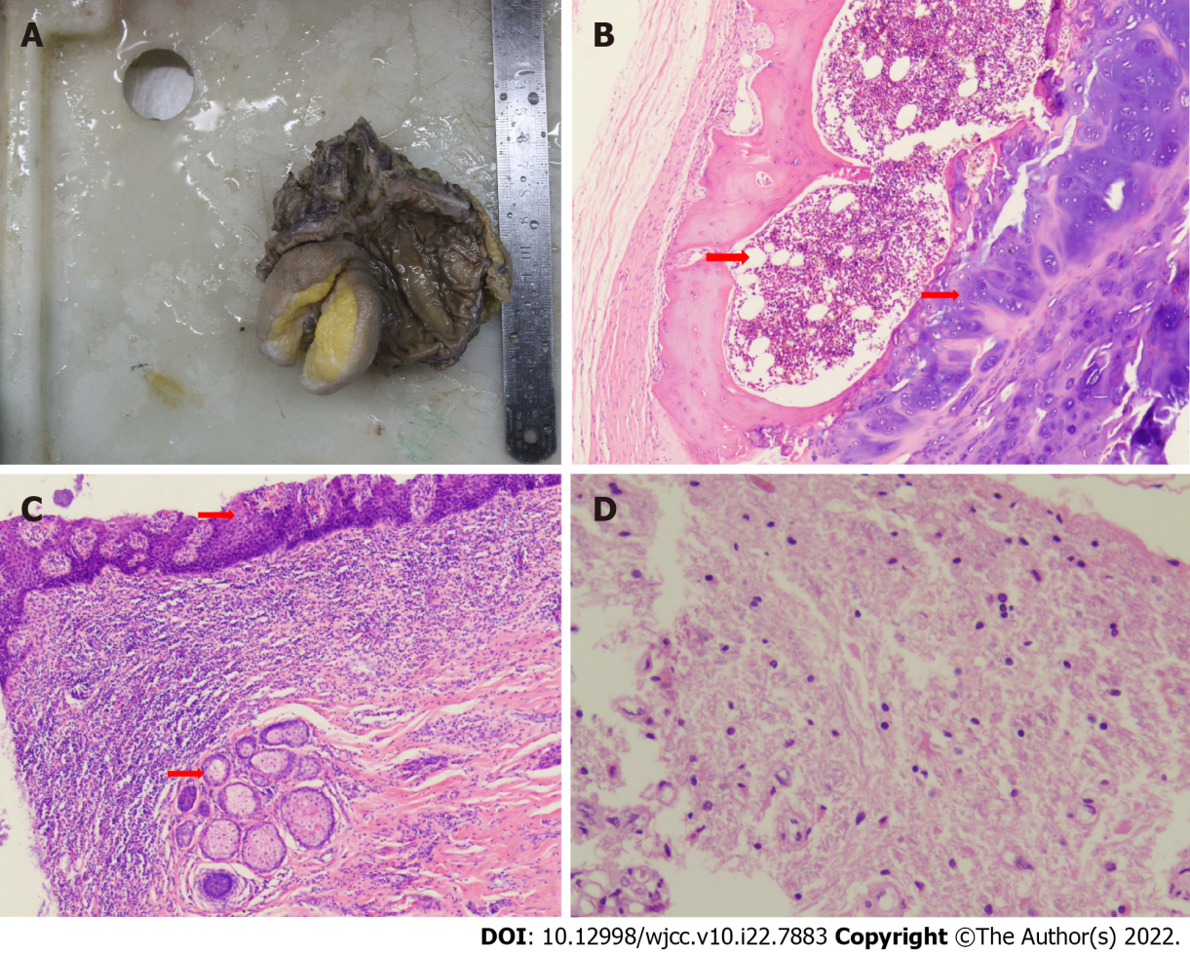
Figure 4 Pathology of rectal teratoma. A: Surgical resection of pathological specimens. The mass was completely removed, and a piece was removed every 1 cm. The tissues were then fixed, dehydrated, soaked in wax, embedded, and stained with hematoxylin and eosin staining (HE); B: Rectal teratoma with bone marrow and cartilage (indicated by the arrow) (HE, 4 × 10 magnification); C: Rectal teratoma with squamous epithelium and sebaceous glands (indicated by the arrow) (HE, 4 × 10 magnification); D: Rectal teratoma with brain tissue (HE, 20 × 10 magnification).

Table 1 Reported cases of rectal mature teratoma
Ref. | Year | Age/sex | Symptoms | Previous history | Method | Final diagnosis
Murdock and Abbas^{[25]} | 2010 | 26/female | right-sided pelvic pain radiating down her lower extremities | transanal drainage of a presumed presacral abscess | laparoscopic abdomino-paracoccygeal resection | Anorectal cystic teratoma
Wang et al^{[26]} | 2019 | 44/female | submucosal rectal mass | Not described | laparoscopic tumor resection | mature retrorectal teratoma
Aiken et al^{[27]} | 2020 | 47/female | bleeding from the rectum for 10 d | Not described | partial resection of the rectum | Rectum mature teratoma
Nam and Kim^{[28]} | 2021 | 68/female | hematochezia | Not described | Polypectomy | Primary mature teratoma of the rectum
Our case | 2021 | 29/female | perianal mass that emerged after defecation | Not described | laparoscopic | Rectal mature teratoma

Published by Baishideng Publishing Group Inc
7041 Koll Center Parkway, Suite 160, Pleasanton, CA 94566, USA
Telephone: +1-925-3991568
E-mail: bpgoffice@wjgnet.com
Help Desk: https://www.f6publishing.com/helpdesk
https://www.wjgnet.com

© 2022 Baishideng Publishing Group Inc. All rights reserved.

