Name of journal: World Journal of Hepatology
ESPS Manuscript NO: 13814
Columns: TOPIC HIGHLIGHT

WJH 6th Anniversary Special Issues (7): Non-alcoholic fatty liver disease

Importance of imaging and recent developments in diagnosis of non-alcoholic fatty liver disease

Koplay M et al. Imaging in nonalcoholic fatty liver disease

Mustafa Koplay, Mesut Sivri, Hasan Erdogan, Alaaddin Nayman

Mustafa Koplay, Mesut Sivri, Hasan Erdogan, Alaaddin Nayman, Department of Radiology, Medical Faculty of Selcuk University, 42031 Konya, Turkey

Author contributions: All authors contributed to this manuscript.

Conflict-of-interest: There are no conflict of interest the between authors. None declared.

Open-Access: This article is an open-access article which was selected by an in-house editor and fully peer-reviewed by external reviewers. It is distributed in accordance with the Creative Commons Attribution Non Commercial (CC BY-NC 4.0) license, which permits others to distribute, remix, adapt, build upon this work non-commercially, and license their derivative works on different terms, provided the original work is properly cited and the use is non-commercial. See: http://creativecommons.org/licenses/by-nc/4.0/

Correspondence to: Mustafa Koplay, MD, Department of Radiology, Medical Faculty of Selcuk University, The Central Campus, 42031 Konya, Turkey. koplaymustafa@hotmail.com

Telephone: +90-332-2243800

Received: September 2, 2014
Peer-review started: September 2, 2014
First decision: September 28, 2014
Revised: December 27, 2014
Accepted: Janurary 9, 2015
Article in press:
Published online:

Abstract
Nonalcoholic fatty liver disease (NAFLD) is one of the most common causes of chronic liver disease and it is a major, global and public health problem in the world. It is a spectrum that includes simple steatosis, nonalcoholic steatohepatitis (NASH), fibrosis and cirrhosis. Recently, NAFLD prevalence in children and adolescence has increased too. The increasing prevalence of it has resulted in the NASH-related with chronic liver disease. Hence, therefore, the early diagnosis and treatment is quite important. Although liver biopsy is still gold standard for diagnosis and staging of NAFLD, particularly for the diagnosis of NASH, imaging methods such as ultrasonography, computed tomography, magnetic resonance imaging with chemical shift imaging and especially magnetic resonance spectroscopy and elastography have been increasingly approved as noninvasive alternatives methods. The aim of this review is to analyze the diagnostic accuracy and limitations of the imaging methods and recent developments in diagnosis of NAFLD.

Key words: Nonalcoholic fatty liver disease; Nonalcoholic steatohepatitis; Imaging methods; Magnetic resonance spectroscopy; Elastography

© The Author(s) 2015. Published by Baishideng Publishing Group Inc. All rights reserved.

Core tip: Nonalcoholic fatty liver disease (NAFLD) is one of the most common causes of chronic liver disease. Although liver biopsy is still gold standard for diagnosis and staging of NAFLD, particularly for the diagnosis of nonalcoholic steatohepatitis (NASH), imaging methods have been increasingly accepted as noninvasive methods. Magnetic resonance spectroscopy is one of the most correct imaging methods for noninvasive evaluation of fatty liver. Elastography is primarily used for the non-invasive evaluation of liver fibrosis and NASH.

Koplay M, Sivri M, Erdogan H, Nayman A. Importance of imaging and recent developments in diagnosis of non-alcoholic fatty liver disease. World J Hepatol 2015; İn press

INTRODUCTION
Nonalcoholic fatty liver disease (NAFLD) is one of the most common causes of chronic liver disease and it is a major, global, public health problem in the world^{[1-3]}. It is defined as accumulation of lipid deposits in the hepatocytes not due to excessive alcohol use^{[4]}. NAFLD encompasses a spectrum of diseases ranging from simple fatty liver (hepatosteatosis) to nonalcoholic steatohepatitis (NASH), which in its most severe form can lead to liver fibrosis, cirrhosis and hepatocellular carcinoma^{[3,5-7}].
The pathophysiology of NAFLD still has not been exactly clarified. In 1998 Day and James put forward the widely known “two-hit” hypothesis. Furthermore, the ‘‘two-hit hypothesis’’ is the commonly accepted model to explain the development of NAFLD and the progression from simple steatosis to NASH. The ‘‘first hit’’ is the collection of lipids in the hepatocytes, and insulin resistance is the key pathogenic factor for the development of hepatosteatosis. The ‘‘second hit’’ leads to inflammation, hepatocyte injury and fibrosis. Oxidative stress, adipokines, proinflammatory cytokines and mitochondrial dysfunction are factors that induct the second hit^{[5,8,9]}. However, there is growing evidence that this hypothesis is likely incorrect. It has been shown that simple steatosis and NASH are two distinct entities with different pathogenetic pathways. Nowadays, one of the accepted theories is 'multiple parallel hits'. The initial hypothesis based on insulin resistance which causing increased uptake and synthesis of free fatty acids; on the other hand 'multiple parallel hits’ theory includes oxidative stress from reactive oxygen species (ROS) and varying the production of adipokines which plays major role in the pathogenesis of NASH. The another theory for explaining the progression from NAFLD to NASH which is named “distinct-hit” pathogenetic heterogeneity obtained via at least two different ways. Genetic predisposition and timing seem to lead to activation of different ways which causing to simple steatosis and NASH ^{[10]}.
The prevalence of NAFLD has been reported to be 10%-46% in the United States and 6%-35% in the rest of the world^{[11]}. With increasing the prevalence of obesity, type 2 diabetes mellitus and metabolic syndrome, there is a dramatic increase in the frequency of NAFLD. The prevalence of NAFLD in children and adolescence has also increased in today. The increasing prevalence of it has resulted in increasing need for NASH-related liver transplantation in the last 10 years^{[12]}. Therefore, the early diagnosis and treatment is quite important.
The diagnosis of NAFLD requires evidence of fatty infiltration of the liver in the absence of excessive alcohol consumption and of other secondary causes of chronic liver disease. According to all recent guidelines, liver biopsy is still best standard for diagnosis and staging of NAFLD. It is also a reliable method for differentiating NASH from simple steatosis^{[3,4,11]}. However, biopsy is an invasive and not practical method for assessment at risk of patient with NAFLD, due to the high disease prevalence. It is highly dependent on the experience of the operator and major complications occur in 0.1%-2.3% of cases^{[11]}. Furthermore, this method, is unsuitable for screening and follow-up of patients with NAFLD. If biopsy samples are small in size, they are subject to sampling error and interobserver variability^{[13,14]}. Non expert physicians and patients are waiting for an almost perfect noninvasive test, which is a biomarker with less than 10% of false positive or false negative results and more than 99% applicability. Therefore, it is an illusion to wait for an almost perfect biomarker with an adjusted area under the receiver operator curve (AUROC) greater than 90% for the diagnosis of NASH. For this reason, noninvasive and simple imaging methods came into use in the diagnosis and evaluating of NAFLD such as ultrasonography (US), computed tomography (CT), magnetic resonance imaging (MRI) with chemical shift imaging (CSI) and magnetic resonance spectroscopy (MRS) and elastography with US and MRI. This article will review the importance of the imaging methods and recent developments in diagnosis of NAFLD.

IMAGING MODALITIES
US
US is the primary imaging method used to determine and identify the fatty liver ^{[15]}. US is widely used for screening asymptomatic patients with increased liver enzymes and suspected NAFLD. It is a safe, non-invasive, non-radiation, widely available, cost-effective and accurate tool in the detection of fatty liver^{[16]}. The convex probe (2-5 MHz) can be used in the examination. Right kidney echogenicity is used for the identification of liver parenchyma echogenicity. Nonsteatotic liver parenchyma shows homogeneous echo texture with similar or a bit higher echogenicity when compared to the kidney cortex and spleen parenchyma. Fatty liver shows echogenicity (bright liver) greater than the kidney cortex and spleen parenchyma due to intracellular accumulation of fat vacuoles^{[3,15,17]}. In addition, US findings of fatty liver include hepatomegaly, vascular blurring of portal or hepatic vein^{[4]}.
The grades of fatty liver (hepatosteatosis) as described previously at US are qualitatively defined using a four-point scale, as follows: normal, mild, moderate, or severe^{[14,17-20]}. With the same kidney cortex and liver parenchyma echogenicity, it is evaluated as normal, no fatty liver (grade 0). Mild (grade 1; Figure 1A): mildly diffuse increase in liver echogenicity and clear visualization of the diaphragm and intrahepatic vessel walls. Moderate (grade 2; Figure 1B): moderate grade diffuse increase in liver echogenicity obscuring the intrahepatic vessel walls and the diaphragm. Severe (grade 3; Figure 1C): prominent liver echogenicity increment in liver echogenicity and poor or nonvisualization of the hepatic vessels and diaphragm.
US is often useful for characterization grade 2 or grade 3 hepatosteatosis but less effective for diagnosing grade 1 hepatosteatosis. Furthermore, it is difficult to distinguish liver fibrosis from hepatosteatosis^{[17,18,21]}. In studies, the sensitivity and specificity of US in detecting hepatosteatosis have been found 60%-94% and 84%-95%, respectively^{[16,18,22,23]}. Hamaguchi et al^{[24]} reported that US has a high sensitivity (91.7%) and specificity (100%) of fatty liver detection. Palmentieri et al^{[25]} reported the finding of 235 patients undergoing US with liver biopsy and they found as 91%, 93%, 89%, and 94% the sensitivity, specificity, positive predictive value and negative predictive value, respectively, for calculating at least 30% steatosis.
Hepatorenal sonographic index is known as the ratio between the mean brightness level of the right kidney and the liver, and ıt has also been suggested as a measure of hepatosteatosis. In a study has been found very high sensitivity (100%) and specificity (91%) with a cut-off of 1.49 for the diagnosis of hepatosteatosis > 5%^{[26]}.
Quantitative methods of measuring liver echogenicity are always unreliable^{[27,28]}. But, quantitative calculation of hepatosteatosis is more accurate than the qualitative assessment of hepatosteatosis at US. The ratios of the quantitative assessment was 77%, 77%, and 71% as the sensitivity, specificity, and diagnostic accuracy, respectively, in comparison with 60%-100%, 77%-95%, and 96%, for qualitativeassessment^{[15,17,28]}.
Despite the benefits of US, such as non-invasive, widely available, low cost, ease of clinician use and interpretation, it has some limitations such as a small field of view, limited use in accompanying chronic liver disease, inability to distinguish degree of fibrosis, cirrhosis and NASH, operator and equipment dependence, limited use in obese patients, low sensitivity when hepatosteatosis is less than 20%-30%^{[15,29]}. In a recent study, Iijima et al^{[30]} used an US contrast matter (Levovist; Sherling, Berlin) to distinguish between simple hepatosteatosis and NASH. They found significantly decrease of the uptake Levovist associated with fibrosis in NASH patients. To overcome of the US limitations needs further clinical and technical investigations.

CT
CT evaluation of hepatosteatosis is depend on the attenuation values named as Hounsfield units (HUs) of the liver parenchyma^{[3]}. The best CT method for the calculation of fatty liver is unenhanced CT, and it allows for a more quantitative evaluation of liver attenuation^{[4,31]}. Based on the physical characteristics of x-ray penetration of tissue, the attenuation in unenhanced CT is measured. The degree of decrease in attenuation on unenhanced CT is the best decisive of the degree of liver fat content^{[31]}. Due to the attenuation characteristics that are based on various factors regarding to the contrast material and scan timing; unenhanced CT is more commonly used than enhanced CT^{[3,15,32]}.
Unenhanced CT can be especially used for evaluating of the fatty liver in transplant donor. It has an important place in diagnosing hepatosteatosis of ≥ 30%, with 100% specificity and 82% sensitivity^{[15,33]}. Three techniques are used to evaluate fatty liver with CT: the absolute measurement of attenuation values (in HUs), the difference in attenuation values between liver and spleen and the ratio of these values liver attenuation index)^{[31,33,34]}. Normal liver has an attenuation value of about 50-65 HU, which is about 8-10 HU higher than a normal spleen^{[15]}. If the liver attenuation is less than 48 HU, fatty liver infiltration is diagnosed^{[35]}. With unenhanced CT, when the liver attenuation values less than 40 HU or a liver-to spleen attenuation difference > 10 HU is a highly predictor of hepatosteatosis^{[16,36]} (Figure 2). Kodama et al^{[31]} reported as 40 HU liver attenuation shows fatty infiltration at about 30%. They found that the attenuation values of liver CT as 64.4 HU, 59.1 HU, 41.9 HU and 25.0 HU at unenhanced scanning connected with the fatty infiltration degrees of 0%, 1%-25%, 26%-50%, and more than 50%. Furthermore, a liver-to spleen ratio of less than 1 is sometimes used to diagnose fatty liver infiltration^{[34]}. Park et al^{[33]} reported as a liver-to-spleen attenuation ratio of <0.8 and the liver-to spleen attenuation difference less than -9 HU has a high specificity (100%) for the diagnosis of grade 2 to 3 hepatosteatosis^{[16]}. However, the sensitivity of the two measures (liver-to-splenic attenuation ratio and liver-to spleen attenuation difference) for the diagnosis of grade 2-3 macrovesicular hepatosteatosis of more than 30% is between 73%-82%^{[15,33,37]}.
Dual energy CT has a great potential and quite a few conceivable clinical indications. It can differentiate among several chemical components in tissueand also be used to quantify fatty liver and includes acquisition at two tube potentials with 80-140 kVp. The theoretical advantages of it have been unsettled clinically until now. In hepatosteatosis, there is a decline in CT liver attenuation at low energy level. When the tube potential increases, the fat attenuation increases. In studies have reported that an attenuation alteration of > 10 HU with the increment of the tube potential from 80 to 140 kVp is consider of fatty liver infiltration of > 25%^{[16,38]}.
Although CT is a quick, non-operator dependent imaging method, radiation exposure should be always kept in mind. CT was quite accurate for the diagnosis of grade 2-3 steatosis but was not as accurate for detecting grade 1 steatosis. In addition, liver parenchymal attenuation in CT may be affected with some factors including the presence of excess iron and glycogen in the liver and the certain drugs such as amiodarone, methotrexate, acute hepatitis or acute toxic hepatic injury and cirrhosis^{[15,39,40]}. Therefore, in patients with hemochromatosis and hemosiderosis, liver attenuation values are unreliable for detecting fat infiltration^{[37]}.

MRI
MRI is one of the most sensitive imaging methods for detection and characterization of fatty liver. It is a radiation-free modality to detect fatty liver even in microscopic quantity. The degree of fatty infiltration can be calculated with chemical shift imaging (CSI) or MR spectroscopy (MRS). A good correlation has been found between MRI and histology in patients with NAFLD. It may be detect steatosis of level down to 3%^{[41]}. The principal MRI physics used in both techniques to differentiate protons in fat from those in water is the chemical-shift phenomenon.
The chemical shift imaging is a method commonly used because of its easy applicability and higher accuracy. Usage of chemical shift techniques are caused by the difference between the mobility frequencies of fat and water protons in order to accurately detect and quantify fatty infiltration^{[42,43]}. The said frequency difference produces tissues that contain fat and water in order to lose signal intensity when the protonmagnetizations are opposed, in out-of phase imaging. The normal liver parenchyma shows similar signal intensity on in-phase (IP) and out-of phase (OP) images. The loss in signal intensity can be observed when out-of-phase images are compared to the in-phase images (Figure 3). Whereas the normal liver parenchyma shows similar signal intensity on in-phase and out-ofphase images, fatty liver exhibits decreased signal intensity on out-of-phase images in the presence of severe fatty infiltration^{[43]}.
At the 1.5 Tesla MRI the frequency shift between fat and water is approximately 220 Hz, which results in OP phase condition at a TE of about 2.4 ms and IP condition at a TE of about 4.8 ms. With the introduction of 3 Tesla MRI, the evaluating of fatty liver has increased. The chemical shift difference between fat and water at 3 Tesla is about 415 Hz^{[15,44]}. With this frequency difference, both İP and OP images can be obtained in a single breath hold by helping to avoid the motion artifacts.
Magnetic resonance spectroscopy is one of the most correct imaging methods for noninvasive evaluation of fatty liver^{[45]}. Single-voxel MRS gives significant information regarding to the chemical composition of the normal organ and chemical changes in the fatty liver such as NAFLD. Small fat amounts can be quantified by this method. In addition, it is particularly useful in the some cases such as the elimination of liver biopsy necessity during the presurgical assessment of liver transplant donors and evaluation of the response to treatment of longitudinal follow-up of patients as metabolic disorders or obesity.
MRS evaluates proton signals as a function of their resonant frequency and shows multiple peaks at different locations (Figure 4).On MRS spectra of the liver, most of the visible peaks are produced from water and fat. The water occurs as a single peak at 4.7 ppm and fat occurs as multiple peaks due to the presence of various chemical component in fat (e.g., at 1.3 ppm a methylene (CH2) peak and at different locations occurs other smaller peaks)^{[3]}. The values obtained with MRS display shows a good correlation with the results of liver biopsy. Hence, it isproposed as an optimal imaging method for calculating the content of hepatic triglyceride^{[46]}.
Technically, either a stimulated echo acquisition mode (STEAM) or a point-resolved spectroscopy (PRESS) sequence can be used. PRESS sequences provide a higher signal-to-noise-ratio than STEAM sequences. However, STEAM is believed more suitable for fat quantification, as it is less sensible to a J-coupling effect^{[3,47]}. MRS sequences should be optimized to minimize relaxation effects. A long repetition time (TR), typically longer than 3000 ms at 1.5 Tesla MRI, can minimize T1-relaxation effects. T2-relaxation effects can be declined by using the shortest possible echo times (TE).
In evaluation of fatty liver except for CSI and MRS can be used the other methods such as fat saturation, and fat-selective excitation approaches^{[42,48,49]}. The signal intensity loss of liver on T2-weighted fat-saturated rapidSE images in comparison with T2-weighted non-fat-saturated rapid SE images is consider of fatty infiltration.
The MRI sensitivities and specificities in detecting histologic steatosis ≥ 5% were 76.7%-90.0% and 87.1%-91%, respectively, and the MRS performances were 80-91% and 80.2%-87%, respectively^{[50,51]}. MRI with CSI and MRS have a higher diagnostic accuracy than US or CT, and these methods can evaluate hepatosteatosis in an objective manner using the quantitative index.
MRI with CSI have several advantages according to MRS. The acquisition and analysis of MRS information requires expertise, time-consuming and is complex. Because single-voxel MRS accumulates information from a small portion of the liver it may be cause sampling error. By comparison, MRI is easily applicable, commonly available and it may be evaluate the entire liver within a short breath-hold^{[7]}.

Elastography
Although imaging methods such as US, CT and MRI can evaluate hepatosteatosis, none of them can evaluate liver fibrosis and NASH^{[11,52]}. Non-invasive evaluation of liver fibrosis and NASH can be mainly performed by US elastography and MR elastography. Both techniques evaluate liver stiffness by measuring the velocity of shear wave using US or MRI. Several US elastography techniques have been defined. These includes transient elastography, supersonic shearwave elastography, acoustic radiation force impulse elastography (ARFI) and real-time tissue elastography.
Transient elastography (FibroScan) is performed with pulse- echo US and measures liver stiffness as a function of the extent of liver infiltration. It can detect liver cirrhosis with high accuracy, but the accuracy is decrease atlower fibrosis stages^{[53,54]}. In studies, they reported that the highly accurate rates in distinguishing severe liver fibrosis from mild liver fibrosis, with 88.9%-100% sensitivities and 75-100% specificities^{[54-57]}. In a study including 246 NAFLD patients were found US elastography for the diagnosis of moderate fibrosis, bridging fibrosis, and cirrhosis of 0.84, 0.93, and 0.95, respectively^{[58]}. Controlled attenuation parameter (CAP) has been proposed as a non-invasive method for the determination and measurement of hepatic steatosis. The mechanism of CAP is the reduction in amplitude of ultrasound as it is amplified through the liver tissue can be estimated using the same radio-frequency data that are used for estimation of liver stiffness using Fibroscan (Echosens, Paris, France), an ultrasound based vibration-controlled transient elastography devic^{[59]}. The shear stiffness of normal liver is between 6.5 and 7 kPa. ARFI is also performed in a similar form, and it measures shearing velocity. Normal velocity of liver is 1 m/s. This velocity reduces when there is fatty infiltration^{[16]}. The other methods alternatives to transient elastography are rarely used currently.
MR elastography occurs to be superior to transient elastography in evaluating of liver fibrosis. It evaluates larger liver volumes and unaffected by obesity^{[60]}. However, data are to-date limited in NAFLD patients. Furthermore, its low availability and high cost limit its use in clinical practice, and more studies are especially needed in terms of MR elastography.
In conclusion, imaging methods allows both qualitative and quantitative evaluation of fatty liver. US is a safe, relatively cheap, easily accessible, no more contraindications technique for screening of NAFLD. Even so limited sensitivity for mild steatosis, operator dependency, patient factors (gas and obesity) are the main disadvantages. CT had excellent specifity but had low sensivity for mild hepatic steatosis. Especially for longitudinal follow-up of patients, radiation exposure is main disadvantage of CT. MRS is currently the most accurate imaging method used to diagnose hepatosteatosis. Technical optimization of MRS and MRI with CSI may result in highly diagnostic accurate rate, and these methods may replace of the liver biopsy as the reference standard for research investigations. US elastography and MR elastography can diagnose liver fibrosis associated with NAFLD and may be play a role in characterization of NASH. However, further studies are needed to increase the sensitivity and specificity of imaging methods in the diagnosis of hepatosteatosis and steatohepatitis.

REFERENCES
1 Sanyal AJ. NASH: A global health problem. Hepatol Res 2011; 41: 670-674 [PMID: 21711426 DOI: 10.1111/j.1872-034X.2011.00824.x]
2 Polyzos SA, Kountouras J, Zavos C, Deretzi G. Nonalcoholic fatty liver disease: multimodal treatment options for a pathogenetically multiple-hit disease. J Clin Gastroenterol 2012; 46: 272-284 [PMID: 22395062 DOI: 10.1097/MCG.0b013e31824587e0]
3 Lee SS, Park SH. Radiologic evaluation of nonalcoholic fatty liver disease. World J Gastroenterol 2014; 20: 7392-7402 [PMID: 24966609 DOI: 10.3748/wjg.v20.i23.7392]
4 Obika M, Noguchi H. Diagnosis and evaluation of nonalcoholic fatty liver disease. Exp Diabetes Res 2012; 2012: 145754 [PMID: 22110476 DOI: 10.1155/2012/145754]
5 Koplay M, Gulcan E, Ozkan F. Association between serum vitamin B12 levels and the degree of steatosis in patients with nonalcoholic fatty liver disease. J Investig Med 2011; 59: 1137-1140 [PMID: 21804402 DOI: 10.231/JIM.0b013e31822a29f5]
6 Farrell GC, Larter CZ. Nonalcoholic fatty liver disease: from steatosis to cirrhosis. Hepatology 2006; 43: S99-S112 [PMID: 16447287]
7 de Alwis NM, Day CP. Non-alcoholic fatty liver disease: the mist gradually clears. J Hepatol 2008; 48 Suppl 1: S104-S112 [PMID: 18304679 DOI: 10.1016/j.jhep.2008.01.009]
8 Wang JT, Liu YL. Non-alcoholic fatty liver disease: the problems we are facing. Hepatobiliary Pancreat Dis Int 2003; 2: 334-337 [PMID: 14599934]
9 Day CP, James OF. Steatohepatitis: a tale of two "hits"? Gastroenterology 1998; 114: 842-845 [PMID: 9547102]
10 Yilmaz Y. Review article: is non-alcoholic fatty liver disease a spectrum, or are steatosis and non-alcoholic steatohepatitis distinct conditions? Aliment Pharmacol Ther 2012; 36: 815-823 [PMID: 22966992]
11 Polyzos SA, Mantzoros CS. Necessity for timely noninvasive diagnosis of nonalcoholic fatty liver disease. Metabolism 2014; 63: 161-167 [PMID: 24290839 DOI: 10.1016/j.metabol.2013.10.010]
12 Agopian VG, Kaldas FM, Hong JC, Whittaker M, Holt C, Rana A, Zarrinpar A, Petrowsky H, Farmer D, Yersiz H, Xia V, Hiatt JR, Busuttil RW. Liver transplantation for nonalcoholic steatohepatitis: the new epidemic. Ann Surg 2012; 256: 624-633 [PMID: 22964732 DOI: 10.1097/SLA.0b013e31826b4b7e]
13 Song HJ, Cho YG, Lee HJ. Dietary sodium intake and prevalence of overweight in adults. Metabolism 2013; 62: 703-708 [PMID: 23357528 DOI: 10.1016/j.metabol.2012.11.009]
14 Tsuchiya H, Ebata Y, Sakabe T, Hama S, Kogure K, Shiota G. High-fat, high-fructose diet induces hepatic iron overload via a hepcidin-independent mechanism prior to the onset of liver steatosis and insulin resistance in mice. Metabolism 2013; 62: 62-69 [PMID: 22854109 DOI: 10.1016/j.metabol.2012.06.008]
15 Chen CL, Cheng YF, Yu CY, Ou HY, Tsang LL, Huang TL, Chen TY, Concejero A, Wang CC, Wang SH, Lin TS, Liu YW, Yang CH, Yong CC, Chiu KW, Jawan B, Eng HL, Chan SC, Sharr WW, Lo CM, Tamura S, Sugawara Y, Kokudo N, Lee KW, Yi NJ, Suh KS, Moon DB, Lee SG, Ahn CS, Huang S, Kim KH, Ha TY, Song GW, Jung DH, Park GC, Namkoong JM, Park HW, Park YH, Park CS, Sung KB, Ko GY, Gwon DI, Kaido T, Ogawa K, Fujimoto Y, Ito T, Toniyama K, Mori A, Ogura Y, Uemoto S, Yap AQ, Lin YH, Liu CY, Chiang YC, Lin CC, Shin M, Joh JW, Kabiling C, Hu TH, Kang SH, Jung BH, Choi YR. Living donor liver transplantation: the Asian perspective. Transplantation 2014; 97 Suppl 8: S3 [PMID: 24849827 DOI: 10.1097/TP.0000000000000060]
16 Singh D, Das CJ, Baruah MP. Imaging of non alcoholic fatty liver disease: A road less travelled. Indian J Endocrinol Metab 2013; 17: 990-995 [PMID: 24381873 DOI: 10.4103/2230-8210.122606]
17 Saadeh S, Younossi ZM, Remer EM, Gramlich T, Ong JP, Hurley M, Mullen KD, Cooper JN, Sheridan MJ. The utility of radiological imaging in nonalcoholic fatty liver disease. Gastroenterology 2002; 123: 745-750 [PMID: 12198701]
18 Joseph AE, Saverymuttu SH, al-Sam S, Cook MG, Maxwell JD. Comparison of liver histology with ultrasonography in assessing diffuse parenchymal liver disease. Clin Radiol 1991; 43: 26-31 [PMID: 1999069]
19 Needleman L, Kurtz AB, Rifkin MD, Cooper HS, Pasto ME, Goldberg BB. Sonography of diffuse benign liver disease: accuracy of pattern recognition and grading. AJR Am J Roentgenol 1986; 146: 1011-1015 [PMID: 3515875]
20 Açikel M, Sunay S, Koplay M, Gündoğdu F, Karakelleoğlu S. Evaluation of ultrasonographic fatty liver and severity of coronary atherosclerosis, and obesity in patients undergoing coronary angiography. Anadolu Kardiyol Derg 2009; 9: 273-279 [PMID: 19666428]
21 Mathiesen UL, Franzén LE, Aselius H, Resjö M, Jacobsson L, Foberg U, Frydén A, Bodemar G. Increased liver echogenicity at ultrasound examination reflects degree of steatosis but not of fibrosis in asymptomatic patients with mild/moderate abnormalities of liver transaminases. Dig Liver Dis 2002; 34: 516-522 [PMID: 12236486]
22 Debongnie JC, Pauls C, Fievez M, Wibin E. Prospective evaluation of the diagnostic accuracy of liver ultrasonography. Gut 1981; 22: 130-135 [PMID: 7215943]
23 Saverymuttu SH, Joseph AE, Maxwell JD. Ultrasound scanning in the detection of hepatic fibrosis and steatosis. Br Med J (Clin Res Ed) 1986; 292: 13-15 [PMID: 3080046]
24 Hamaguchi M, Kojima T, Itoh Y, Harano Y, Fujii K, Nakajima T, Kato T, Takeda N, Okuda J, Ida K, Kawahito Y, Yoshikawa T, Okanoue T. The severity of ultrasonographic findings in nonalcoholic fatty liver disease reflects the metabolic syndrome and visceral fat accumulation. Am J Gastroenterol 2007; 102: 2708-2715 [PMID: 17894848]
25 Palmentieri B, de Sio I, La Mura V, Masarone M, Vecchione R, Bruno S, Torella R, Persico M. The role of bright liver echo pattern on ultrasound B-mode examination in the diagnosis of liver steatosis. Dig Liver Dis 2006; 38: 485-489 [PMID: 16716779]
26 Webb M, Yeshua H, Zelber-Sagi S, Santo E, Brazowski E, Halpern Z, Oren R. Diagnostic value of a computerized hepatorenal index for sonographic quantification of liver steatosis. AJR Am J Roentgenol 2009; 192: 909-914 [PMID: 19304694 DOI: 10.2214/AJR.07.4016]
27 Hamer OW, Aguirre DA, Casola G, Lavine JE, Woenckhaus M, Sirlin CB. Fatty liver: imaging patterns and pitfalls. Radiographics 2006; 26: 1637-1653 [PMID: 17102041]
28 Graif M, Yanuka M, Baraz M, Blank A, Moshkovitz M, Kessler A, Gilat T, Weiss J, Walach E, Amazeen P, Irving CS. Quantitative estimation of attenuation in ultrasound video images: correlation with histology in diffuse liver disease. Invest Radiol 2000; 35: 319-324 [PMID: 10803673]
29 Khov N, Sharma A, Riley TR. Bedside ultrasound in the diagnosis of nonalcoholic fatty liver disease. World J Gastroenterol 2014; 20: 6821-6825 [PMID: 24944472 DOI: 10.3748/wjg.v20.i22.6821]
30 Iijima H, Moriyasu F, Tsuchiya K, Suzuki S, Yoshida M, Shimizu M, Sasaki S, Nishiguchi S, Maeyama S. Decrease in accumulation of ultrasound contrast microbubbles in non-alcoholic steatohepatitis. Hepatol Res 2007; 37: 722-730 [PMID: 17559420]
31 Kodama Y, Ng CS, Wu TT, Ayers GD, Curley SA, Abdalla EK, Vauthey JN, Charnsangavej C. Comparison of CT methods for determining the fat content of the liver. AJR Am J Roentgenol 2007; 188: 1307-1312 [PMID: 17449775]
32 Johnston RJ, Stamm ER, Lewin JM, Hendrick RE, Archer PG. Diagnosis of fatty infiltration of the liver on contrast enhanced CT: limitations of liver-minus-spleen attenuation difference measurements. Abdom Imaging 1998; 23: 409-415 [PMID: 9663278]
33 Park SH, Kim PN, Kim KW, Lee SW, Yoon SE, Park SW, Ha HK, Lee MG, Hwang S, Lee SG, Yu ES, Cho EY. Macrovesicular hepatic steatosis in living liver donors: use of CT for quantitative and qualitative assessment. Radiology 2006; 239: 105-112 [PMID: 16484355]
34 Ricci C, Longo R, Gioulis E, Bosco M, Pollesello P, Masutti F, Crocè LS, Paoletti S, de Bernard B, Tiribelli C, Dalla Palma L. Noninvasive in vivo quantitative assessment of fat content in human liver. J Hepatol 1997; 27: 108-113 [PMID: 9252082]
35 Lee SW, Park SH, Kim KW, Choi EK, Shin YM, Kim PN, Lee KH, Yu ES, Hwang S, Lee SG. Unenhanced CT for assessment of macrovesicular hepatic steatosis in living liver donors: comparison of visual grading with liver attenuation index. Radiology 2007; 244: 479-485 [PMID: 17641368]
36 Schwenzer NF, Springer F, Schraml C, Stefan N, Machann J, Schick F. Non-invasive assessment and quantification of liver steatosis by ultrasound, computed tomography and magnetic resonance. J Hepatol 2009; 51: 433-445 [PMID: 19604596 DOI: 10.1016/j.jhep.2009.05.023]
37 Limanond P, Raman SS, Lassman C, Sayre J, Ghobrial RM, Busuttil RW, Saab S, Lu DS. Macrovesicular hepatic steatosis in living related liver donors: correlation between CT and histologic findings. Radiology 2004; 230: 276-280 [PMID: 14695401]
38 Raptopoulos V, Karellas A, Bernstein J, Reale FR, Constantinou C, Zawacki JK. Value of dual-energy CT in differentiating focal fatty infiltration of the liver from low-density masses. AJR Am J Roentgenol 1991; 157: 721-725 [PMID: 1892025]
39 Pickhardt PJ, Park SH, Hahn L, Lee SG, Bae KT, Yu ES. Specificity of unenhanced CT for non-invasive diagnosis of hepatic steatosis: implications for the investigation of the natural history of incidental steatosis. Eur Radiol 2012; 22: 1075-1082 [PMID: 22138733 DOI: 10.1007/s00330-011-2349-2]
40 Park YS, Park SH, Lee SS, Kim DY, Shin YM, Lee W, Lee SG, Yu ES. Biopsy-proven nonsteatotic liver in adults: estimation of reference range for difference in attenuation between the liver and the spleen at nonenhanced CT. Radiology 2011; 258: 760-766 [PMID: 21212369 DOI: 10.1148/radiol.10101233]
41 Fishbein M, Castro F, Cheruku S, Jain S, Webb B, Gleason T, Stevens WR. Hepatic MRI for fat quantitation: its relationship to fat morphology, diagnosis, and ultrasound. J Clin Gastroenterol 2005; 39: 619-625 [PMID: 16000931]
42 Qayyum A, Goh JS, Kakar S, Yeh BM, Merriman RB, Coakley FV. Accuracy of liver fat quantification at MR imaging: comparison of out-of-phase gradient-echo and fat-saturated fast spin-echo techniques--initial experience. Radiology 2005; 237: 507-511 [PMID: 16244259]
43 Pilleul F, Chave G, Dumortier J, Scoazec JY, Valette PJ. Fatty infiltration of the liver. Detection and grading using dual T1 gradient echo sequences on clinical MR system. Gastroenterol Clin Biol 2005; 29: 1143-1147 [PMID: 16505760]
44 Ramalho M, Altun E, Herédia V, Zapparoli M, Semelka R. Liver MR imaging: 1.5T versus 3T. Magn Reson Imaging Clin N Am 2007; 15: 321-347, vi [PMID: 17893053]
45 Cassidy FH, Yokoo T, Aganovic L, Hanna RF, Bydder M, Middleton MS, Hamilton G, Chavez AD, Schwimmer JB, Sirlin CB. Fatty liver disease: MR imaging techniques for the detection and quantification of liver steatosis. Radiographics 2009; 29: 231-260 [PMID: 19168847 DOI: 10.1148/rg.291075123]
46 Szczepaniak LS, Nurenberg P, Leonard D, Browning JD, Reingold JS, Grundy S, Hobbs HH, Dobbins RL. Magnetic resonance spectroscopy to measure hepatic triglyceride content: prevalence of hepatic steatosis in the general population. Am J Physiol Endocrinol Metab 2005; 288: E462-E468 [PMID: 15339742]
47 Hamilton G, Middleton MS, Bydder M, Yokoo T, Schwimmer JB, Kono Y, Patton HM, Lavine JE, Sirlin CB. Effect of PRESS and STEAM sequences on magnetic resonance spectroscopic liver fat quantification. J Magn Reson Imaging 2009; 30: 145-152 [PMID: 19557733 DOI: 10.1002/jmri.21809]
48 Reeder SB, Cruite I, Hamilton G, Sirlin CB. Quantitative assessment of liver fat with magnetic resonance imaging and spectroscopy. J Magn Reson Imaging 2011; 34: 729-749 [PMID: 21928307 DOI: 10.1002/jmri.22580]
49 Cotler SJ, Guzman G, Layden-Almer J, Mazzone T, Layden TJ, Zhou XJ. Measurement of liver fat content using selective saturation at 3.0 T. J Magn Reson Imaging 2007; 25: 743-748 [PMID: 17347995]
50 Lee SS, Park SH, Kim HJ, Kim SY, Kim MY, Kim DY, Suh DJ, Kim KM, Bae MH, Lee JY, Lee SG, Yu ES. Non-invasive assessment of hepatic steatosis: prospective comparison of the accuracy of imaging examinations. J Hepatol 2010; 52: 579-585 [PMID: 20185194 DOI: 10.1016/j.jhep.2010.01.008]
51 van Werven JR, Marsman HA, Nederveen AJ, Smits NJ, ten Kate FJ, van Gulik TM, Stoker J. Assessment of hepatic steatosis in patients undergoing liver resection: comparison of US, CT, T1-weighted dual-echo MR imaging, and point-resolved 1H MR spectroscopy. Radiology 2010; 256: 159-168 [PMID: 20574093 DOI: 10.1148/radiol.10091790]
52 Musso G, Gambino R, Cassader M, Pagano G. Meta-analysis: natural history of non-alcoholic fatty liver disease (NAFLD) and diagnostic accuracy of non-invasive tests for liver disease severity. Ann Med 2011; 43: 617-649 [PMID: 21039302 DOI: 10.3109/07853890.2010.518623]
53 Talwalkar JA, Kurtz DM, Schoenleber SJ, West CP, Montori VM. Ultrasound-based transient elastography for the detection of hepatic fibrosis: systematic review and meta-analysis. Clin Gastroenterol Hepatol 2007; 5: 1214-1220 [PMID: 17916549]
54 Friedrich-Rust M, Ong MF, Martens S, Sarrazin C, Bojunga J, Zeuzem S, Herrmann E. Performance of transient elastography for the staging of liver fibrosis: a meta-analysis. Gastroenterology 2008; 134: 960-974 [PMID: 18395077 DOI: 10.1053/j.gastro.2008.01.034]
55 Nobili V, Vizzutti F, Arena U, Abraldes JG, Marra F, Pietrobattista A, Fruhwirth R, Marcellini M, Pinzani M. Accuracy and reproducibility of transient elastography for the diagnosis of fibrosis in pediatric nonalcoholic steatohepatitis. Hepatology 2008; 48: 442-448 [PMID: 18563842 DOI: 10.1002/hep.22376]
56 Orlacchio A, Bolacchi F, Antonicoli M, Coco I, Costanzo E, Tosti D, Francioso S, Angelico M, Simonetti G. Liver elasticity in NASH patients evaluated with real-time elastography (RTE). Ultrasound Med Biol 2012; 38: 537-544 [PMID: 22341049 DOI: 10.1016/j.ultrasmedbio.2011.12.023]
57 Palmeri ML, Wang MH, Rouze NC, Abdelmalek MF, Guy CD, Moser B, Diehl AM, Nightingale KR. Noninvasive evaluation of hepatic fibrosis using acoustic radiation force-based shear stiffness in patients with nonalcoholic fatty liver disease. J Hepatol 2011; 55: 666-672 [PMID: 21256907 DOI: 10.1016/j.jhep.2010.12.019]
58 Wong VW, Vergniol J, Wong GL, Foucher J, Chan HL, Le Bail B, Choi PC, Kowo M, Chan AW, Merrouche W, Sung JJ, de Lédinghen V. Diagnosis of fibrosis and cirrhosis using liver stiffness measurement in nonalcoholic fatty liver disease. Hepatology 2010; 51: 454-462 [PMID: 20101745 DOI: 10.1002/hep.23312]
59 Chan WK, Nik Mustapha NR, Mahadeva S. Controlled attenuation parameter for the detection and quantification of hepatic steatosis in nonalcoholic fatty liver disease. J Gastroenterol Hepatol 2014; 29: 1470-1476 [PMID: 24548002 DOI: 10.1111/jgh.12557]
60 Huwart L, Sempoux C, Vicaut E, Salameh N, Annet L, Danse E, Peeters F, ter Beek LC, Rahier J, Sinkus R, Horsmans Y, Van Beers BE. Magnetic resonance elastography for the noninvasive staging of liver fibrosis. Gastroenterology 2008; 135: 32-40 [PMID: 18471441 DOI: 10.1053/j.gastro.2008.03.076]

P-Reviewer: Cassard-Doulcier AM, Yilmaz Y S-Editor: Ji FF L-Editor: E-Editor:

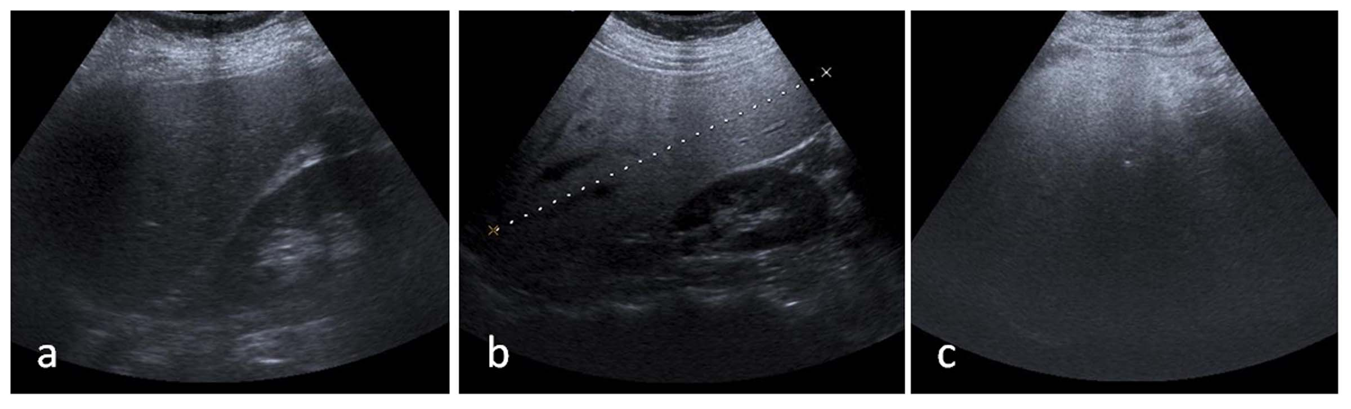 Figure 1 Ultrasonographic images show the hepatosteatos stages. A: Grade 1: Mild fatty liver; B: Grade 2: Moderate fatty liver; C: Grade 3: Severe fatty liver.

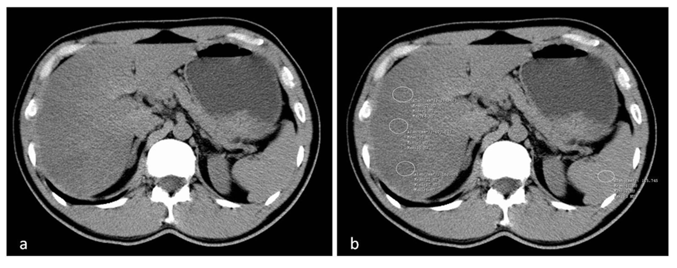
Figure 2 Computed tomography evaluation of fatty liver using a liver-to spleen attenuation difference with unenhanced computed tomography. The image (A) shows diffuse fatty infiltration of liver with attenuation much lower than the spleen on visual analysis; B: Multiple regions-of-interest (white circles-ROIs) show mean hepatic attenuation (25 HU) and splenic attenuation (51 HU) with -26 HU a liver-to spleen attenuation difference, pointing moderate-to-severe hepatosteatosis.
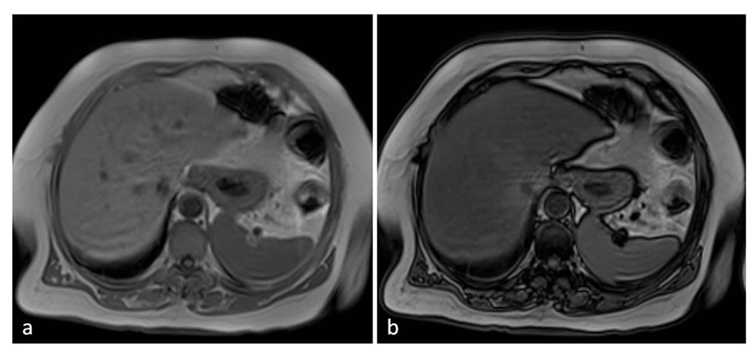
Figure 3 Magnetic resonance imaging evaluation of fatty liver using chemical shift imaging. A: In-phase image; B: Out-of-phase image. When out-of-phase image is compared with in-phase images, it shows the signal intensity decrease.

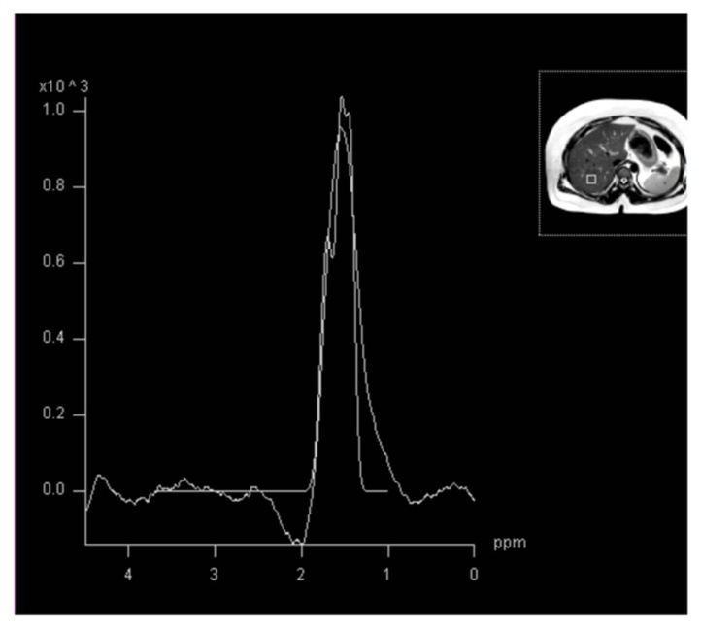
Figure 4 Magnetic resonance spectroscopy image shows a lipid peak in a case of grade 3 hepatosteatosis.

