Name of Journal: World Journal of Stem Cells
Manuscript NO: 54582
Manuscript Type: LETTER TO THE EDITOR

Acquired aplastic anemia: Is bystander insult to autologous hematopoiesis driven by immune surveillance against malignant cells?

Zhao XC et al. AAA, bystander insult driven by malignancies

Xi-Chen Zhao, Xiao-Yun Sun, Bo Ju, Fan-Jun Meng, Hong-Guo Zhao

Xi-Chen Zhao, Xiao-Yun Sun, Bo Ju, Department of Hematology, The Central Hospital of Qingdao West Coast New Area, Qingdao 266555, Shandong Province, China

Fan-Jun Meng, Hong-Guo Zhao, Department of Hematology, The Affiliated Hospital of Qingdao University, Qingdao 266000, Shandong Province, China

Author contributions: Zhao XC, Sun XY, and Ju B performed the research work, analyzed the data, and drafted the manuscript; Meng FJ and Zhao HG supervised the treatment and revised the manuscript; all authors have read and approved the final manuscript.

Corresponding author: Hong-Guo Zhao, MD, Chief Doctor, Professor, Department of Hematology, The Affiliated Hospital of Qingdao University, No. 16 Jiangsu Road, Qingdao 266000, Shandong Province, China. zhaohongguo6201@163.com

Received: February 14, 2020
Revised: September 20, 2020
Accepted: September 25, 2020
Published online:

Abstract
We previously reported a serendipitous finding from a patient with refractory severe aplastic anemia who had gotten an unexpected hematological response to treatment with gut-cleansing preparations (GCPs). This patient experienced three recurrences over the ensuing one year of intermittent GCP treatments, with each recurrence occurring 7-8 wk from a GCP. After his third recurrence, he was prescribed successive treatment with rifampicin, berberine, and monthly administered GCP for 4 mo, and he developed an erythroid proliferative neoplasma and an overwhelming enteropathy, and eventually died of septic shock. Laboratory investigations had validated the resolution of myelosuppression and the appearance of malignant clonal hematopoiesis. From the treatment process and laboratory investigations, it is reasonably inferred that the engagement of gut inflammation is critically required in sustaining the overall pathophysiology of acquired aplastic anemia probably by creating a chronic inflammatory state. Incorporation of rifampicin, berberine, and monthly GCP into cyclosporine can enhance the immunosuppressive effect. In a subgroup of acquired aplastic anemia patients whose pathogenesis is associated with genotoxic exposure, the suppressed normal hematopoiesis may result from the bystander insult that is mediated by the soluble inflammatory cytokines generated in response to the immunogenic products of damaged hematopoietic cells in the context of chronic inflammatory state and may offer a protective antineoplastic mechanism against malignant proliferation.

Key Words: Acquired aplastic anemia; Bystander insult; Malignant clonal hematopoiesis; Immune surveillance; Antineoplastic; Gut inflammation

Zhao XC, Sun XY, Ju B, Meng FJ, Zhao HG. Acquired aplastic anemia: Is bystander insult to autologous hematopoiesis driven by immune surveillance against malignant cells? World J Stem Cells 2020; In press

Core Tip: We previously reported a severe aplastic anemia patient who had gotten an unexpected hematological response to treatment with intermittent gut-cleansing preparations. After his third recurrence, he was prescribed successive treatment with rifampicin, berberine, and monthly administered gut-cleansing preparations for 4 mo, and he developed an erythroid proliferative neoplasma and an overwhelming enteropathy. We hereby make an extrapolation that, in a subgroup of aplastic anemia patients, the suppressed normal hematopoiesis may result from the bystander insult that is generated in response to the antigenic products of damaged hematopoietic cells, and may offer a protective antineoplastic mechanism against malignant proliferation.
TO THE EDITOR
Acquired aplastic anemia (AAA) has been generally accepted as the paradigm of immune-mediated bone marrow failure syndrome, in which the antigen-driven and abnormally activated cellular immune responses trigger the destructive attack on hematopoietic stem and progenitor cells (HSPCs) in genetically susceptible individuals. An inappropriately enhanced inhibitory and pro-apoptotic capacity of these deranged immune reactions to HSPCs from highly sensitized “autoreactive” cytotoxic T lymphocytes (CTLs) by targeting against yet unidentified antigens is responsible for the overall pathophysiology. The significantly increased intramedullary death of HSPCs results in markedly hypocellular bone marrow (BM) and varying degrees of periphery pancytopenia^{[1-3]}. Overproduction of soluble proinflammatory mediators by phenotypically and functionally skewed CTLs, mainly through expressing and secreting high levels of interferon-γ (IFN-γ) and tumor necrosis factor -α (TNF-α), with an IFN-γ predominance, is the distinctive immunological feature. It is the inflammatory cytokines that upregulate the expression of pattern recognition receptors, antigen-presenting and apoptosis-associated molecules on hematopoietic precursors, and exert the direct detrimental effect on normal hematopoiesis in a manner resembling bystander effect^{[4-6]}. A large number of infectious and genotoxic agents have been implicated as the culprit in this chronic inflammatory process^{[1,2]}. However, little is known about what the immunogenic substances are and where the driving force comes to sustain the high responsiveness of these CTLs. Given the vast diversity of implicated offending agents that have been reported to be associated with AAA pathogenesis, the protean presentation in disease severity and comorbidities, the variable therapeutic responses to immunosuppressive therapies (ISTs), the differential prognosis with regard to disease persistence and progression^{[1-3]}, and the great complexity of possible mechanisms that are involved in driving autoimmune diseases^{[7-9]}, AAA may be a heterogenous entity, and the bone marrow suppression (BMS) in AAA is most likely to be a consequence of different priming and sustaining mechanisms in different risk genetic backgrounds in response to different hostile environmental challenges converging upon, irrespective of varying degrees of myelosuppression, the same phenotypically immunological destructive effect on HSPCs. Recently, much like in other autoimmune diseases^{[10]}, the driving force behind the initiation, development, chronicity, and progression of AAA pathophysiology has been proposed to come from the altered composition of gut microbiota and the compromised integrity of the intestinal barrier^{[11-13]}. On the other hand, the overlapping spectrum in clinical and morphological features, immunological profile, genetic abnormalities, and therapeutic responses to ISTs between AAA and hypoplastic myelodysplastic syndrome (hMDS, probably also encompassing a subgroup of low risk MDS)^{[14-19]}, as well as the occurrence of malignant clonal hematopoiesis (MCH) in approximately 10%-15% of AAA patients who had accepted successful ISTs^{[20]} strongly indicates that, at least in a subgroup of AAA patients, the seemingly pathogenic BMS may directly target against the neo-antigens on genetically damaged hematopoietic precursors and may offer a possible protective role: Antineoplastic mechanism against malignant proliferation^{[21,22]}. The emergence of MCH in a patient with refractory severe aplastic anemia (RSAA) following the resolution of BMS by treatment of his gut inflammatory disease with GCP provides indirect but forceful information in support of this extrapolation.
We previously reported a serendipitous finding from a 30-year-old RSAA man who had gotten an unexpected hematological response to treatment of gut inflammatory condition (GIC)^{[23]}. Having a 23-year history of AAA and two relapses, this patient, with relapses and with age, gradually lost the therapeutic response to cyclosporine (CsA), stanozolol, rhG-CSF (recombinant human granulocyte colony-stimulating factor), and eltrombopag treatment, which worsened and accelerated the impairment of already severely reduced hematopoietic capacity. The particularly noteworthy event was the dimethylbenzene exposure due to his house being decorated 8 mo before the disease onset. From March to June 2018, he experienced a 3-mo-long episode of agnogenic febrile disease, and intensive treatment with many kinds of intravenously delivered broad-spectrum antibiotics failed to settle the inflammatory episode. When presenting with abdominal cramps, he accepted orally administered mannitol and gentamycin treatment. This GCP treatment not only resulted in a quick settlement of his fever but also produced an unexpectedly good hematological response. He underwent three recurrences over the ensuing one year of intermittent GCP treatments, with each recurrence occurring 7-8 wk from a GCP. However, subsequent GCP treatment was capable of inducing subsequent remission, and consecutive GCP treatments successfully yielded prolonged hematological improvement, confirming the definitive contribution of GIC to AAA pathophysiology.
Given the eubiotic properties of rifamycin and berberine^{[24,25]}, this patient was prescribed successive administration of rifampicin (450 mg, once per day) and berberine (0.3 g, thrice per day) with monthly administered GCP (1500 mL polyethylene glycol electrolyte solution per day for 2 d) after his third recurrence. Other employed drugs included lactulose oral solution (45-50 mL per day), inulin (15-20 g per day), and probiotics consisting of Lactobacillus acidophilus, Clostridium butyricum, Bifidobacterium, Bacillus coagulans, and Enterococcus. Regularly used drugs (including CsA 125 mg, twice per day; stanozolol 2 mg, thrice per day; eltrombopag 25 mg, once per day; and rhG-CSF 100 µg, twice per day) went on to be delivered at the same dose as before. With the achievement of a rapid increase in white blood cell count (WBC), rhG-CSF was tapered off. These treatments had arrived successfully at a steady hematological improvement, with normal levels of WBC, hemoglobulin (Hb), and platelet count (Plt).
Unfortunately, a steep drop in WBC, Hb, and Plt occurred 4 mo later. On admission, his major complaints were “rapidly aggravated dizziness, fatigue, pallor, and anxiety for 1 wk, and abdominal distension and cramps for 3 d”, in the absence of fever, chills, cough, and expectoration. Upon physical examination, major signs were bruise-looking appearance and abdominal tenderness. Routine blood tests showed the following: WBC, 2600/µL; absolute neutrophil count, 980/µL; red blood cell count, 2560000/µL; Hb, 5.9 g/dL; Plt, 7000/µL; absolute reticulocyte count, 137600/µL; and C-reactive protein, 62.42 mg/L. Examination of the coagulation profile was within normal limits, with a D-dimer of 0.69 mg/L. Biochemical tests showed elevated serum levels of uric acid, urea nitrogen, glucose, potassium, and β2-microglobulin, and reduced serum levels of globulin, sodium, and calcium (Table 1). A reduced serum level of complement component-3 was detected. Computerized tomography examination of the abdomen revealed hepatosplenomegaly (Figure 1A and B) as well as an adynamic ileus and the thickened walls of terminal ileum, ascending, and sigmoid colon (Figure 1C and D). Morphological evaluation of the BM showed a strikingly increased percentage of nucleated erythrocytes that account for 80.5% (with some of them displaying the dysplastic features) of the total nucleated cells, with a markedly reduced percentage of myeloid precursors and lymphocytes (Table 1 and Figure 2A and B). A substantial percentage of nucleated erythrocytes were presented on peripheral blood smears, in the presence of marked morphological abnormalities of anisocytosis, acanthrocytes, and schistocytes in mature erythrocytes (Table 1 and Figure 2C and D). Flow cytometric analysis for the BM revealed a pronounced increase in the percentage of CD45- cells and CD71+ cells as well as a relatively increased percentage of CD8+ cells and CD33+ cells, and a markedly decreased percentage of CD4+ cells and CD19+ cells, without an increase in CD34+ cells and CD117+ cells, indicating an erythroid commitment and CD8+ cytotoxic T cell predominance (Table 1 and Supplementary Figure 1). CD55 and CD59 expression was within the normal levels. Cytogenetic analysis by culturing the BM sample reported a karyotype of 45,XY,-7^{[10]}, confirming the presence of clonal hematopoiesis. Gene mutations in KRAS, RUNX1, PTPN11, and SETBP1 were identified. These above-mentioned data met the criteria for diagnosis of an erythroid proliferative neoplasma with dysplastic features, but it cannot be categorized precisely into any kind of World Health Organization classification of myeloid neoplasms and acute leukemia^{[26]}. A reduced ratio of CD4+/CD8+ cells confirmed the CD8+ CTL-predominated immune responses in excellent concordance with the characteristic immunological profile in AAA^{[1,2]} and other cellular immune-mediated autoimmune diseases, while an increased percentage of CD3+CD5+ cells reinforced the autoimmune nature. An enhanced ratio of CD33+/CD19+ cells and increased percentages of CD14+ cells and CD3-CD56+ cells reflected a bias of the homeostatic hematopoiesis towards innate immune responses against ongoing infections^{[27,28]}. The patient exhibited strong resistance to intravenous antibiotic and glucocorticosteroid treatments, developed an overwhelming enteropathy and systemic inflammatory response syndrome with rapid progression to multiorgan dysfunction, and eventually died of septic shock. Germicultures of the blood reported a positive result for Candida albicans and negative results for aerobic and anaerobic bacteria in the lag period.
From the treatment process and laboratory investigations of this reported case, it is reasonably inferred that: (1) Engagement of GIC is critically required in the sustenance of overall pathophysiology in AAA; (2) incorporation of rifampicin, berberine, and monthly GCP treatments into CsA can enhance the sensitivity of immunosuppressive agents; and (3) in a subgroup of AAA patients, the suppressed normal hematopoiesis may result from the bystander insult that is mediated by the soluble inflammatory cytokines generated in response to the immunogenic products of damaged HSPCs in the context of chronic inflammatory condition and may offer a protective antineoplastic mechanism against malignant proliferation. The finding that the combination of rifampicin, berberine, and monthly GCP with CsA was able to produce good hematological responses strongly indicates the definitive contribution of dysbiotic gut microbiota to the maintenance of chronic and progressive bone marrow failure syndrome^{[11,13,23]}. The contribution of gut microbiota to the immune-mediated pathophysiology has also been corroborated in the induction of chronic graft-vs-host disease by transfusion of allogeneic HSPCs into semi-lethally radiated mice^{[29]}, a pathogenic process resembling that of AAA and being broadly used as animal models to study AAA pathogenesis^{[30]}. The role of GIC in triggering the onset, development, and progression of autoimmune diseases may act as an intensifier that links the host immunogenetics with environmental challenges to augment the already dysregulated autoimmunity^{[31]} and may promote the establishment of an inflammatory state by innate immune cells sensing pathogen-associated molecular patterns on commensal microbes^{[32,33]}, which most likely produces an adjuvant effect to break down the host immune homeostasis and to perpetuate the high responsiveness of specific antigen-primed CTLs^{[34,35]}. It should not be surprising that GICs play such an essential role in the sustenance of AAA pathophysiology because human gastrointestinal tract not only is the largest and most vulnerable interface that links the host psycho-neuro-endocrino-immune system with detrimental environmental factors but also represents the most enriched gut-associated lymphatic tissue and resides the most complex microbial community that play an essential role in the development, education, and maturation of host immune system, and shape the host immune responses to infections and various injuries^{[36,37]}. Impaired intestinal barrier in structure, integrity, and function allows the intestinally derived antigens to penetrate the intestinal epithelium and intrude into the lamina propria, blood, and BM^{[38]}, which likely plays pivotal roles in sustaining the unwanted autoimmunity by persistent exposure of host innate and adaptive immune cells to the exogenous antigens from gut commensal microbes. In contrast to several recurrences earlier, successive administration of rifampicin and berberine with monthly GCP enhanced the immunosuppressive effect of CsA probably due to the reduced gut-derived stimulation that leads to the mitigated adjuvant effect. However, this patient still developed an overwhelming enteropathy in the course of eubiotic treatment, suggesting the appearance of a new dysbiosis in the gut microbial ecology in which the pathogens were resistant to rifamycin and berberine treatment. The absence of respiratory system symptoms and signs indicated that the Candida albicans in blood most likely came from the intestines. The increase in reticulocyte count, the presence of normal cellularity, and the absence of fatty replacement on the BM smears gave the strong evidence to make us to believe with certainty that the previously existing myelosuppressive state had already been resolved, and the Candida infection is not the causative agent in AAA pathogenesis in this patient. The rapidly progressive anemia may result from the increased destruction of red blood cells as evidenced by the presence of anisocytosis, acanthrocytes, and schistocytes in mature erythrocytes, and the decreased platelet count may be caused by the increased consumption of platelet as evidenced by the platelet transfusion refractoriness.
Dimethylbenzene is a well-known genotoxic agent. In addition to AAA, the genotoxicity of dimethylbenzene exposure has been recognized to be closely linked to the pathogenesis of MDS and acute leukemia as well^{[1,39]}. In the present case, dimethylbenzene is the only noticeable history of genotoxic exposure. Although clonal evolution frequently develops due to the selective pressure in the context of severe immunological attack and gradual loss of HSPCs, and may be responsible for the progression and exacerbation of impaired hematopoietic capacity as evidenced by the gradual loss of sensitivity to CsA treatment, it is unconceivable that the gene damages caused by these spontaneous mutations were accumulated so enriched that they are sufficient to induce malignant transformation within only 4 mo, meaning that the oncogenic genes had pre-existed, most probably initiated by the genotoxicity of dimethylbenzene exposure preceding the onset of AAA and precipitated by subsequently spontaneous mutations and selective pressure. Furthermore, the 23-year history of hypocellular and fat-replaced BM, several recurrences in the intermittentence of GCP treatments (indicating the resilience of BMS), and the emergence of MCH that occurred only after the successive administration of rifampicin and berberine with monthly administered GCP, also suggest that the immunogenic antigens on HSPCs had pre-existed for a very long time. Xin et al^{[40]} established an animal model of AAA by using Mx1Cre⁺TGFβ-activated kinase-1(Tak1)^{fx/fx} (Tak1^{mut}) mice in which the gene encoding Tak1 could be spontaneously mutated in a small subset of hematopoietic cells and the suppressive effect on proliferation and differentiation merely occurred in mutated cells. In this animal model, high levels of IFN-γ and TNF-α were identified, and the characteristic AAA morphology developed with a necroptotic manner of cell death, suggesting that BMS could be caused by the bystander insult that was originated from the genetically damaged hematopoietic cells. Despite the absence of direct evidence in the present case due to the lack of more complex and elegant laboratory investigations, the emergence of MCH following the settlement of myelosuppression raises the intriguing possibility that immunogenic neo-epitopes on genetically damaged hematopoietic cells caused by either genotoxic agents or by spontaneously mutated genes may become the directly targeted antigens of host’s potential immunological surveillance against malignant cells and may thereby induce a proinflammatory niche in the BM^{[14-18,21-23]}, one of the consequences of which results in severe hypoplastic BM via the chronic overproduction of proinflammatory mediators superimposed upon non-targeted neighbouring inculpable cells^{[4-6,40]} but yet probably without clear evidence of dysmorphic features. The undetected MCH when he was first referred to our center 7 year earlier may be attributable to the extraordinarily reduced number of hematopoietic cells due to the paucicellular and fat-replaced BM, especially the stealth malignant cells due to the host’s potential immune surveillance that was beyond the capacity of being identified by the conventional laboratory tests. Although clonal evolution could not be completely excluded, it is tempting to speculate that the emergence of MCH is most likely due to the relief of BMS by the synergistic effects of successful treatment of GIC together with the immunosuppressive therapy. When BMS had been relieved, MCH became evident. From this point of view, commensal microbiome in GIC is unlikely to be the original trigger but rather an intensifier via the adjuvant effect by innate immune cells sensing commensal microbes and their metabolites on the background of the presence of antigenic products on targeted cells as the initiating factor and the pre-existence of abnormally activated CTLs in genetically susceptible subjects. If this is true, it could be inferred that the specific immune responses to targeted antigens on HSPCs alone were not sufficient to sustain the chronic inflammatory niche in the BM. It is the chronic inflammatory state generated in response to the constant exposure of host immune cells to the intestinally derived antigens due to the increased permeation of impaired intestinal barrier is critically required for the emergence, development, and progression of AAA. This combined effect of specific immune responses to HSPCs with intestinally derived stimulation appears to be much easier to interpret the preferential insult to HSPCs and the critical requirement of chronic inflammatory conditions. In a similar way, the bystander effect may also play an important role in AAA patients whose pathogenesis is associated with infectious agents (viruses, bacteria, spirochetes, helminths, and so on) that are able to chronically infect and proliferate in hematopoietic cells, immune cells, or the BM environment^{[41-45]}.
As discussed above, it could be extrapolated that, at least in a subgroup of AAA patients, the constant expression of immunogenic neoplastic products on hematopoietic precursors is the initiating factor of such autoimmune responses, and the functional inhibition of normal hematopoiesis may be the consequence of bystander insult that arises from the immune surveillance against malignant cells, in the pathogenic process of which overproduced proinflammatory mediators play a direct inhibitory and pro-apoptotic role. The impaired structural and functional integrity of intestinal barrier may reinforce the myelosuppressive process by offering an adjuvant effect to augment the intensity of systemic inflammatory state and maintain the high sensitivity of autoreactive CTLs. This cellular immune-mediated mechanism characterized by IFN-γ-predominated functional inhibition, commonly in a way of apoptosis or necroptosis, of autologous hematopoiesis, also probably playing a fundamental role in the pathogenesis of hMDS and a subgroup of low risk MDS, is completely distinct from the pathogenic mechanisms in classic MDS that is characterized by the hypercellular BM and ineffective hematopoiesis, in which the innate immune responses were directly elicited by pattern recognition receptors sensing damage-associated molecular patterns in the genetically damaged hematopoietic precursors with the features of increased proliferative activity of clonal hematopoiesis, inflammosome formation, cell death in a manner of pyroptosis, TNF-α predominance, and effective lenalidomide treatment^{[46-48]}. The significance of identification of the initiating factors and recognition of the pathogenic mechanism lies in that it would be helpful for doctors to select an optimal therapeutic approach and to improve the treatment outcome, not only targeting immune-mediated mechanisms as the generally accepted first-line ISTs but also taking into account the initiating factors and the sustaining forces. Overall, the extrapolation is only an indirect implication from the treatment process of a RSAA patient, and further investigations are critically needed to look for the direct evidence and to illustrate the precise mechanism.

ACKNOWLEDGEMENTS
The authors would like to thank Zhe Yong (Department of blood pathology, The Affiliated Hospital of Qingdao University) for assistance in the validation of morphological diagnosis, and Xiu-Shuan Feng (Department of Radiology, The Central Hospital of Qingdao West Coast New Area) for assistance in the reassessment of computerized tomography images.

REFERENCES
1 Segel GB, Lichtman MA. Aplastic anemia: acquired and inherited. In: Williams Hematology. 9th ed. New York: The McGraw-Hill Companies, 2016: 513-537
2 Shallis RM, Ahmad R, Zeidan AM. Aplastic anemia: Etiology, molecular pathogenesis, and emerging concepts. Eur J Haematol 2018; 101: 711-720 [PMID: 30055055 DOI: 10.1111/ejh.13153]
3 Killick SB, Bown N, Cavenagh J, Dokal I, Foukaneli T, Hill A, Hillmen P, Ireland R, Kulasekararaj A, Mufti G, Snowden JA, Samarasinghe S, Wood A, Marsh JC; British Society for Standards in Haematology. Guidelines for the diagnosis and management of adult aplastic anaemia. Br J Haematol 2016; 172: 187-207 [PMID: 26568159 DOI: 10.1111/bjh.13853]
4 Chen J, Feng X, Desierto MJ, Keyvanfar K, Young NS. IFN-Î³-mediated hematopoietic cell destruction in murine models of immune-mediated bone marrow failure. Blood 2015; 126: 2621-2631 [PMID: 26491068 DOI: 10.1182/blood-2015-06-652453]
5 Giudice V, Feng X, Lin Z, Hu W, Zhang F, Qiao W, Ibanez MDPF, Rios O, Young NS. Deep sequencing and flow cytometric characterization of expanded effector memory CD8⁺CD57⁺ T cells frequently reveals T-cell receptor VÎ² oligoclonality and CDR3 homology in acquired aplastic anemia. Haematologica 2018; 103: 759-769 [PMID: 29419434 DOI: 10.3324/haematol.2017.176701]
6 Chen Y, Zou Z, Wu Z, Zhao Z, Luo X, Xie C, Liang Y. TNF-Î±-induced programmed cell death in the pathogenesis of acquired aplastic anemia. Expert Rev Hematol 2015; 8: 515-526 [PMID: 26149913 DOI: 10.1586/17474086.2015.1049593]
7 Christen U. Pathogen infection and autoimmune disease. Clin Exp Immunol 2019; 195: 10-14 [PMID: 30569518 DOI: 10.1111/cei.13239]
8 Rojas M, Restrepo-JimÃ©nez P, Monsalve DM, Pacheco Y, Acosta-Ampudia Y, RamÃrez-Santana C, Leung PSC, Ansari AA, Gershwin ME, Anaya JM. Molecular mimicry and autoimmunity. J Autoimmun 2018; 95: 100-123 [PMID: 30509385 DOI: 10.1016/j.jaut.2018.10.012]
9 Pacheco Y, Acosta-Ampudia Y, Monsalve DM, Chang C, Gershwin ME, Anaya JM. Bystander activation and autoimmunity. J Autoimmun 2019; 103: 102301 [PMID: 31326230 DOI: 10.1016/j.jaut.2019.06.012]
10 Zhang X, Chen BD, Zhao LD, Li H. The Gut Microbiota: Emerging Evidence in Autoimmune Diseases. Trends Mol Med 2020; 26: 862-873 [PMID: 32402849 DOI: 10.1016/j.molmed.2020.04.001]
11 Espinoza JL, Elbadry MI, Nakao S. An altered gut microbiota may trigger autoimmune-mediated acquired bone marrow failure syndromes. Clin Immunol 2016; 171: 62-64 [PMID: 27506961 DOI: 10.1016/j.clim.2016.08.008]
12 Naithani R, Mahapatra M, Kumar R, Rai S. Aplastic anemia and Crohn's disease - coincidence or association? Indian J Gastroenterol 2005; 24: 183 [PMID: 16204922]
13 Salmeron G, Patey N, de Latour RP, Raffoux E, Gluckman E, Brousse N, SociÃ© G, Robin M. Coeliac disease and aplastic anaemia: a specific entity? Br J Haematol 2009; 146: 122-124 [PMID: 19438483 DOI: 10.1111/j.1365-2141.2009.07719.x]
14 Tanaka TN, Bejar R. MDS overlap disorders and diagnostic boundaries. Blood 2019; 133: 1086-1095 [PMID: 30670443 DOI: 10.1182/blood-2018-10-844670]
15 Fozza C, Crobu V, Isoni MA, Dore F. The immune landscape of myelodysplastic syndromes. Crit Rev Oncol Hematol 2016; 107: 90-99 [PMID: 27823655 DOI: 10.1016/j.critrevonc.2016.08.016]
16 Calado RT. Immunologic aspects of hypoplastic myelodysplastic syndrome. Semin Oncol 2011; 38: 667-672 [PMID: 21943673 DOI: 10.1053/j.seminoncol.2011.04.006]
17 Stahl M, DeVeaux M, de Witte T, Neukirchen J, Sekeres MA, Brunner AM, Roboz GJ, Steensma DP, Bhatt VR, Platzbecker U, Cluzeau T, Prata PH, Itzykson R, Fenaux P, Fathi AT, Smith A, Germing U, Ritchie EK, Verma V, Nazha A, Maciejewski JP, Podoltsev NA, Prebet T, Santini V, Gore SD, Komrokji RS, Zeidan AM. The use of immunosuppressive therapy in MDS: clinical outcomes and their predictors in a large international patient cohort. Blood Adv 2018; 2: 1765-1772 [PMID: 30037803 DOI: 10.1182/bloodadvances.2018019414]
18 Mufti GJ, Marsh JCW. Somatic Mutations in Aplastic Anemia. Hematol Oncol Clin North Am 2018; 32: 595-607 [PMID: 30047413 DOI: 10.1016/j.hoc.2018.03.002]
19 Ogawa S. Genetic basis of myelodysplastic syndromes. Proc Jpn Acad Ser B Phys Biol Sci 2020; 96: 107-121 [PMID: 32161209 DOI: 10.2183/pjab.96.009]
20 Nissen C, Stern M. Acquired immune mediated aplastic anemia: is it antineoplastic? Autoimmun Rev 2009; 9: 11-16 [PMID: 30047414 DOI: 10.1016/j.hoc.2018.03.003]
21 Nissen C, Stern M. Acquired immune mediated aplastic anemia: is it antineoplastic? Autoimmun Rev 2009; 9: 11-16 [PMID: 19245859 DOI: 10.1016/j.autrev.2009.02.032]
22 Seguier J, Gelsi-Boyer V, Ebbo M, Hamidou Z, Charbonnier A, Bernit E, Durand JM, HarlÃ© JR, Vey N, Schleinitz N. Autoimmune diseases in myelodysplastic syndrome favors patients survival: A case control study and literature review. Autoimmun Rev 2019; 18: 36-42 [PMID: 30408583 DOI: 10.1016/j.autrev.2018.07.009]
23 Zhao XC, Zhao L, Sun XY, Xu ZS, Ju B, Meng FJ, Zhao HG. Excellent response of severe aplastic anemia to treatment of gut inflammation: A case report and review of the literature. World J Clin Cases 2020; 8: 425-435 [PMID: 32047795 DOI: 10.12998/wjcc.v8.i2.425]
24 Donini G, Balbi F, Giulini N. [Personal experience with ITF 1117 in vaginitis, especially in that caused by Candida albicans]. Minerva Ginecol 1978; 30: 1187-1192 [PMID: 740337 DOI: 10.3748/wjg.v23.i25.4491]
25 Pan C, Guo Q, Lu N. Role of Gut Microbiota in the Pharmacological Effects of Natural Products. Evid Based Complement Alternat Med 2019; 2019: 2682748 [PMID: 31118952 DOI: 10.1155/2019/2682748]
26 Arber DA, Orazi A, Hasserjian R, Thiele J, Borowitz MJ, Le Beau MM, Bloomfield CD, Cazzola M, Vardiman JW. The 2016 revision to the World Health Organization classification of myeloid neoplasms and acute leukemia. Blood 2016; 127: 2391-2405 [PMID: 27069254 DOI: 10.1182/blood-2016-03-643544]
27 Boiko JR, Borghesi L. Hematopoiesis sculpted by pathogens: Toll-like receptors and inflammatory mediators directly activate stem cells. Cytokine 2012; 57: 1-8 [PMID: 22079335 DOI: 10.1016/j.cyto.2011.10.005]
28 Nagai Y, Garrett KP, Ohta S, Bahrun U, Kouro T, Akira S, Takatsu K, Kincade PW. Toll-like receptors on hematopoietic progenitor cells stimulate innate immune system replenishment. Immunity 2006; 24: 801-812 [PMID: 16782035 DOI: 10.1016/j.immuni.2006.04.008]
29 van Bekkum DW, Roodenburg J, Heidt PJ, van der Waaij D. Mitigation of secondary disease of allogeneic mouse radiation chimeras by modification of the intestinal microflora. J Natl Cancer Inst 1974; 52: 401-404 [PMID: 4150164 DOI: 10.1093/jnci/52.2.401]
30 Scheinberg P, Chen J. Aplastic anemia: what have we learned from animal models and from the clinic. Semin Hematol 2013; 50: 156-164 [PMID: 24216172 DOI: 10.1053/j.seminhematol.2013.03.028]
31 Vogelzang A, Guerrini MM, Minato N, Fagarasan S. Microbiota - an amplifier of autoimmunity. Curr Opin Immunol 2018; 55: 15-21 [PMID: 30248521 DOI: 10.1016/j.coi.2018.09.003]
32 Toubi E, Vadasz Z. Innate immune-responses and their role in driving autoimmunity. Autoimmun Rev 2019; 18: 306-311 [PMID: 30639645 DOI: 10.1016/j.autrev.2018.10.005]
33 Hsu HC, Tsai WH, Chen LY, Hsu ML, Ho CH, Lin CK, Wang SY. Overproduction of inhibitory hematopoietic cytokines by lipopolysaccharide-activated peripheral blood mononuclear cells in patients with aplastic anemia. Ann Hematol 1995; 71: 281-286 [PMID: 8534759 DOI: 10.1007/BF01697980]
34 Kohashi O, Kuwata J, Umehara K, Uemura F, Takahashi T, Ozawa A. Susceptibility to adjuvant-induced arthritis among germfree, specific-pathogen-free, and conventional rats. Infect Immun 1979; 26: 791-794 [PMID: 160888 DOI: 10.1128/IAI.26.3.791-794.1979]
35 Yoshitomi H, Sakaguchi N, Kobayashi K, Brown GD, Tagami T, Sakihama T, Hirota K, Tanaka S, Nomura T, Miki I, Gordon S, Akira S, Nakamura T, Sakaguchi S. A role for fungal {beta}-glucans and their receptor Dectin-1 in the induction of autoimmune arthritis in genetically susceptible mice. J Exp Med 2005; 201: 949-960 [PMID: 15781585 DOI: 10.1084/jem.20041758]
36 Shen L. Functional morphology of the gastrointestinal tract. Curr Top Microbiol Immunol 2009; 337: 1-35 [PMID: 19812978 DOI: 10.1007/978-3-642-01846-6_1]
37 Takiishi T, Fenero CIM, CÃ¢mara NOS. Intestinal barrier and gut microbiota: Shaping our immune responses throughout life. Tissue Barriers 2017; 5: e1373208 [PMID: 28956703 DOI: 10.1080/21688370.2017.1373208]
38 Mu Q, Kirby J, Reilly CM, Luo XM. Leaky Gut As a Danger Signal for Autoimmune Diseases. Front Immunol 2017; 8: 598 [PMID: 28588585 DOI: 10.3389/fimmu.2017.00598]
39 Dewi R, Hamid ZA, Rajab NF, Shuib S, Razak SA. Genetic, epigenetic, and lineage-directed mechanisms in benzene-induced malignancies and hematotoxicity targeting hematopoietic stem cells niche. Hum Exp Toxicol 2020; 39: 577-595 [PMID: 31884827 DOI: 10.1177/0960327119895570]
40 Xin J, Breslin P, Wei W, Li J, Gutierrez R, Cannova J, Ni A, Ng G, Schmidt R, Chen H, Parini V, Kuo PC, Kini AR, Stiff P, Zhu J, Zhang J. Necroptosis in spontaneously-mutated hematopoietic cells induces autoimmune bone marrow failure in mice. Haematologica 2017; 102: 295-307 [PMID: 27634200 DOI: 10.3324/haematol.2016.151514]
41 Behzadi Fard M, Kaviani S, Atashi A. Parvovirus B19 Infection in Human Bone Marrow Mesenchymal Stem Cells Affects Gene Expression of IL-6 and TNF-Î± and also Affects Hematopoietic Stem Cells Differentiation. Indian J Hematol Blood Transfus 2019; 35: 765-772 [PMID: 31741634 DOI: 10.1007/s12288-019-01097-7]
42 Zhang T, Liu C, Liu H, Li L, Wang T, Fu R. Epstein Barr Virus Infection Affects Function of Cytotoxic T Lymphocytes in Patients with Severe Aplastic Anemia. Biomed Res Int 2018; 2018: 6413815 [PMID: 29862282 DOI: 10.1155/2018/6413815]
43 Forte E, Zhang Z, Thorp EB, Hummel M. Cytomegalovirus Latency and Reactivation: An Intricate Interplay With the Host Immune Response. Front Cell Infect Microbiol 2020; 10: 130 [PMID: 32296651 DOI: 10.3389/fcimb.2020.00130]
44 Binder D, van den Broek MF, KÃ¤gi D, Bluethmann H, Fehr J, Hengartner H, Zinkernagel RM. Aplastic anemia rescued by exhaustion of cytokine-secreting CD8+ T cells in persistent infection with lymphocytic choriomeningitis virus. J Exp Med 1998; 187: 1903-1920 [PMID: 9607930 DOI: 10.1084/jem.187.11.1903]
45 Johns JL, Macnamara KC, Walker NJ, Winslow GM, Borjesson DL. Infection with Anaplasma phagocytophilum induces multilineage alterations in hematopoietic progenitor cells and peripheral blood cells. Infect Immun 2009; 77: 4070-4080 [PMID: 19564373 DOI: 10.1128/IAI.00570-09]
46 Barreyro L, Chlon TM, Starczynowski DT. Chronic immune response dysregulation in MDS pathogenesis. Blood 2018; 132: 1553-1560 [PMID: 30104218 DOI: 10.1182/blood-2018-03-784116]
47 Ratajczak MZ, Bujko K, Cymer M, Thapa A, Adamiak M, Ratajczak J, Abdel-Latif AK, Kucia M. The Nlrp3 inflammasome as a "rising star" in studies of normal and malignant hematopoiesis. Leukemia 2020; 34: 1512-1523 [PMID: 32313108 DOI: 10.1038/s41375-020-0827-8]
48 Paracatu LC, Schuettpelz LG. Contribution of Aberrant Toll Like Receptor Signaling to the Pathogenesis of Myelodysplastic Syndromes. Front Immunol 2020; 11: 1236 [PMID: 32625214 DOI: 10.3389/fimmu.2020.01236]
Footnotes
Conflict-of-interest statement: The authors declare that they have no conflict of interest to disclose.

Open-Access: This article is an open-access article that was selected by an in-house editor and fully peer-reviewed by external reviewers. It is distributed in accordance with the Creative Commons Attribution NonCommercial (CC BY-NC 4.0) license, which permits others to distribute, remix, adapt, build upon this work non-commercially, and license their derivative works on different terms, provided the original work is properly cited and the use is non-commercial. See: http://creativecommons.org/Licenses/by-nc/4.0/

Manuscript source: Unsolicited manuscript

Peer-review started: February 14, 2020
First decision: September 11, 2020
Article in press:

Specialty type: Cell and tissue engineering
Country/Territory of origin: China
Peer-review report’s scientific quality classification
Grade A (Excellent): 0
Grade B (Very good): B, B
Grade C (Good): C, C, C
Grade D (Fair): 0
Grade E (Poor): 0

P-Reviewer: Avtanski D, Demonacos C, Xavier-Elsas P S-Editor: Zhang L L-Editor: Wang TQ P-Editor:

Figure Legends
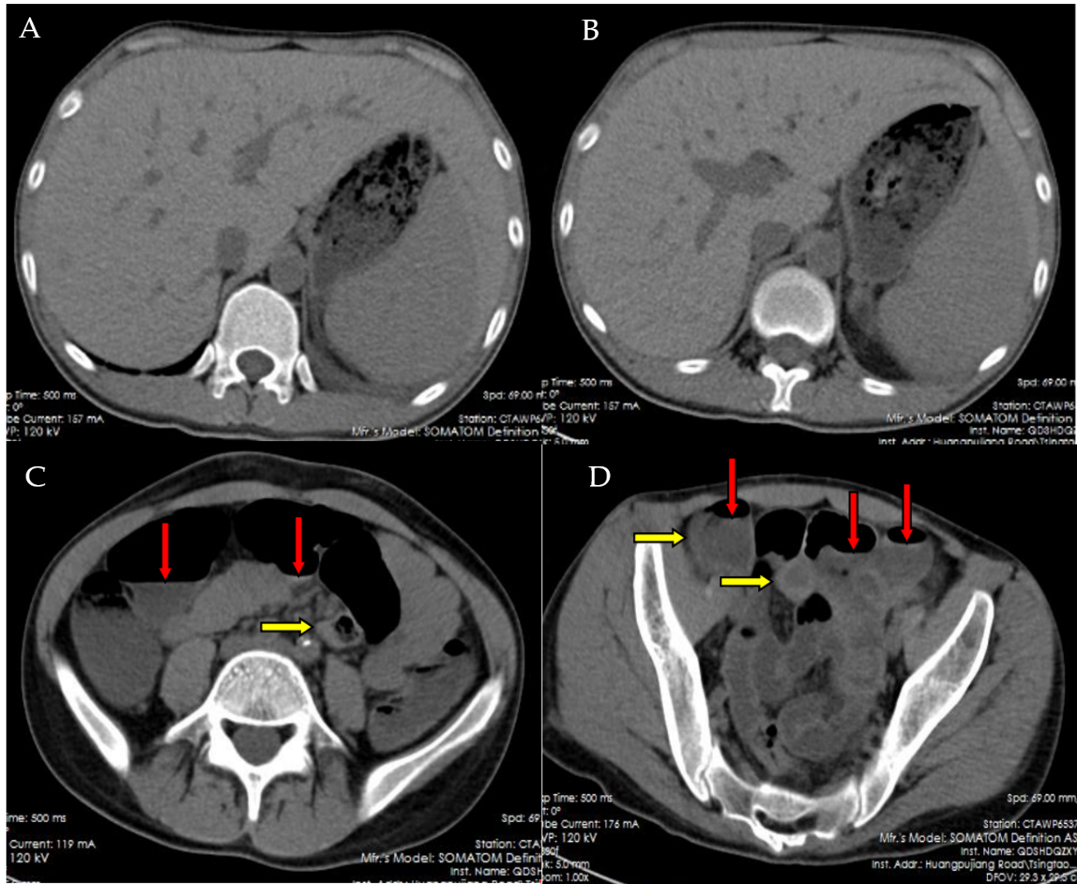Figure 1 Computerized tomography examination of the abdomen. A and B: Computerized tomography examination of the upper abdomen reported an enlarged liver and an enlarged spleen; C and D: Computerized tomography examination of the intermediate and low abdomen displayed the increased fluids and multiple liquid gas interfaces in the intestinal lumen (marked by red arrows) as well as the thickened walls of terminal ileum, ascending, and sigmoid colon (marked by yellow arrows), in accordance with the diagnosis of an adynamic ileus and colonitis that provides evidence for the presence of gut inflammatory disease.
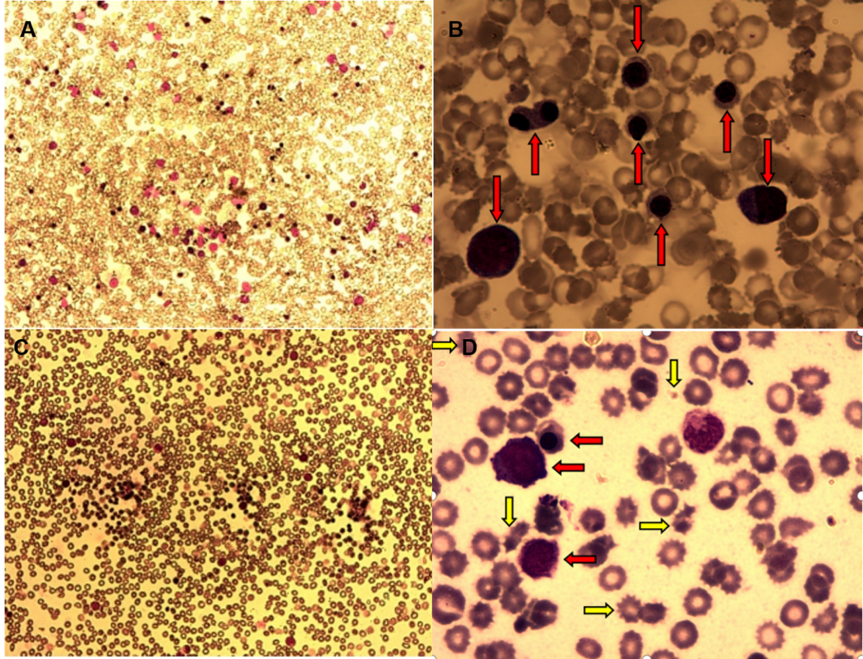Figure 2 Morphological examination of bone marrow and periphery blood smears. A: Morphological examination of bone marrow (BM) smears under low power lens (10 × 10) showed a normal cellularity, in the absence of fatty replacement; B: Morphological enumeration of BM nucleated cells under high power lens (10 × 100) showed an increased percentage of nucleated erythrocytes in multiple stages (marked by red arrows), with markedly reduced percentages of myeloid precursors and lymphocytes; C: Morphological examination of periphery blood (PB) smears under low power lens (10 × 10) showed an increase in nucleated cells, predominantly nucleated erythrocytes; D: Morphological enumeration of PB nucleated cells under high power lens (10 × 100) showed the presence of nucleated erythrocytes in multiple stages (marked by red arrows), with marked anisocytosis, acanthrocyte, and schistocyte in mature erythrocytes (marked by yellow arrows). The morphological features of the BM and PB fulfilled the diagnosis of an erythroid proliferative disease and the toxic damage of erythrocytes.
Table 1 Main laboratory results for the investigation of this patient
Specific results
Complete blood count
WBC, 2600/µL; ANC, 980/µL; RBC, 2560000/µL; Hb, 5.9 g/dL; Plt, 7000 /µL; Ret, 137600/µL, CRP, 62.42 mg/L
Coagulation profile
APTT, 38.4 s; PT, 12.6 s; TT, 17.7 s; Fig, 2.56 g/L; DD 0.69 mg/L
Abnormalities in biochemical tests
Elevated serum levels of: Uric acid, 8.52 mg/dL; Urea nitrogen, 26.04 mg/dL; Glucose, 418.68 mg/dL; Potassium, 23.44 mg/dL; β2-microglobulin, 4.58 mg/L; Reduced serum levels of: Albumin, 33.1g/L; Globulin, 18.1 g/L; Sodium, 3.10 mg/dL; Calcium, 8.24 mg/dL; Carbon dioxide, 19.3 mmol/L
Complements
C3, 0.62 g/L; C4, 0.11 g/L
Germicultures of the blood
Positive result for Candida albicans; Negative results for aerobic and anaerobic bacteria
Morphological evaluation of the BM and PB smears
BM: Promyelocytes, 0.5%; Myelocytes, 1.5%; Metagranulocytes, 2.5%; Stab cells, 3.0%; Segmented granulocytes, 1.5%; Eosinophilic granulocytes, 0.5%; Early erythroblasts, 3.5%; Intermediate erythroblasts, 15.0%; Late erythroblasts, 62.0%; Lymphocytes, 9.5%; Monocytes, 0.5%; PB: Metagranulocytes, 4.0%; Stab cells 18.0%; Segmented granulocytes, 7.0%; Early erythroblasts, 2%; Intermediate erythroblasts, 11%; Late erythroblasts, 49%; Lymphocytes, 9.0%
Flow cytometric analysis for the BM specimen
CD45-, 48.30%; CD45-CD71+, 35.68%; CD34, 2.16%; CD117, 6.86%; HLA-DR, 16.74%; CD34+CD117+, 1.59%; CD34+HLA-DR+, 1.06%; CD13, 39.42; CD33, 36.4%; CD11b, 40.57%; CD16, 24.96%; CD14, 5.52%, CD64, 23.22%; CD13+CD16+, 24.34%; CD15+CD11b+, 29.38%; CD3, 11.71%; CD2, 7.39%; CD4, 9.72%; CD8, 15.78%; CD5, 5.36%; CD7, 5.25%; CD56, 10.63%; CD3+CD2+, 5.57%; CD3+CD4+, 4.57%; CD3+CD8+, 6.97%; CD3+CD5+, 5.24%; CD3+CD56+,1.02%; CD3+CD7+, 4.22%; CD19, 2.19%; CD19+CD20+, 1.57%; CD19+CD10+, 0.14%; CD19+CD5+, 0.12%; CD19+CD38+, 0.13%
PHN clone analysis
Red blood cells: CD55, 99.69%; CD59, 99.51%; Granulocytes: CD55, 98.03%; CD59, 96.30%
Conventional cytogenetic analysis
45,XY,-7^{[10]}
Genetic investigations for hematopoietic malignancy
Positive results for KRAS, 44.2%; RUNX1, 43.8%; PTPN11, 45.4%; SETBP1, 49.5%; Negative results for GNAS, NRAS, HRAS, ASXL1, EZH2, DNMT3A, TET2, SF3B1, SRSF2, U2AF1, ZRSR2, STAG2, CBL, CBLB, CBLC, CUX1, ETV6, GATA2, IDH1, IDH2, JAK2, MPL, CALR, NOTCH1, WT1, TP53
WBC: White blood cell count; Hb: Hemoglobulin level; Plt: Platelet count; BM: Bone marrow; PB: Periphery blood.

