Name of journal: World Journal of Hepatology
ESPS Manuscript NO: 6480
Columns: REVIEW

From portal to liver transplantation and splanchnic venous thrombosis: What surgeons should bear in mind

Lai Q et al. Liver transplantation and splanchnic vein thrombosis

Quirino Lai, Gabriele Spoletini, Rafael S Pinheiro, Fabio Melandro, Nicola Guglielmo, Jan Lerut

Quirino Lai, Jan Lerut, Starzl Unit of Abdominal Transplantation, University Hospitals Saint-Luc, Université Catholique Louvain, B-1200 Brussels, Belgium

Gabriele Spoletini, Oxford Transplant Centre, Churchill Hospital, Oxford University Hospitals NHS Trust, Oxford OX3 7LE, United Kingdom

Rafael S Pinheiro, Department of Gastroenterology, University of São Paulo Medical School, 05508-070 São Paulo, Brazil

Fabio Melandro, Nicola Guglielmo, Department of General Surgery and Organ Transplantation, University Sapienza, Umberto I Hospital, 00186 Rome, Italy

Author contributions: Lai Q gave substantial contributions to conception and design of the research; all the authors wrote the article and revised it critically and gave the final approval of the version to be published.

Correspondence to: Quirino Lai, MD, Starzl Unit Abdominal Transplantation, Universitiy Hospital Saint-Luc, Université Catholique Louvain, Avenue Hippocrate 10, B-1200 Brussels, Belgium. lai.quirino@libero.it

Telephone: +32-2-7641401 Fax: +32-2-7649039
Received: October 20, 2013 Revised: February 9, 2014
Accepted: June 18, 2014

Published online:

Abstract
The present study aims to review the evolution of surgical management of portal (PVT) and splanchnic venous thrombosis (SVT) in the context of liver transplantation over the last 5 decades. PVT is more commonly managed by endovenous thrombectomy, while SVT requires more complex technical expedients. Several surgical techniques have been proposed, such as extensive eversion thrombectomy, anastomosis to collateral veins, reno-portal anastomosis, cavo-portal hemi-transposition, portal arterialization and combined liver-intestinal transplantation. In order to achieve satisfactory outcomes, careful planning of the surgical strategy is mandatory. The excellent results that are obtained nowadays confirm that, even extended, splanchnic thrombosis is no longer an absolute contraindication for liver transplantation. Patients with advanced portal thrombosis may preferentially be referred to specialized centers, in which complex vascular approaches and even multivisceral transplantation are performed.

© 2014 Baishideng Publishing Group Inc. All rights reserved.

Key words: Liver transplantation; Portal vein thrombosis; Splanchnic vein thrombosis; Thrombectomy; Vascular graft; Spleno-renal shunt; Cavo-portal hemi-transposition; Portal vein arterialization; Intestinal transplantation; Multi-visceral transplant

Core tip: The present study aims to review the evolution of surgical management of portal and splanchnic venous thrombosis in the context of liver transplantation.

Lai Q, Spoletini G, Pinheiro RS, Melandro F, Guglielmo N, Lerut J. From portal to splanchnic venous thrombosis: What surgeons should bear in mind. World J Hepatol 2014; In press

INTRODUCTION
Portal vein thrombosis (PVT) has been described as a multi-factorial condition resulting from the combination of both inherited and acquired factors^{[1]}. Cirrhosis represents the most common etiologic factor, accounting for up to 24%-32% of cases^{[2]}. Other common causes include cancer, infection, inflammation and thrombophilic disorders.
The incidence of PVT also correlates with the severity of cirrhosis^{[3]}, thus being a common problem during liver transplantation (LT). PVT usually arises within the liver and extends downwards into the extra-hepatic portion of the portal vein (PV). In some cases the thrombosis further extends to the mesenteric branches resulting in a splanchnic venous thrombosis (SVT).
Until the late 80’ss, PVT and SVT were considered as contra-indications for LT due to concerns about compromised portal allograft inflow.
The first successful LT in a patient with PVT was reported by the Pittsburgh group in 1985 using a free iliac vein allograft^{[4]}. Two years after, the same group presented the first large series of LT in patients with PVT (n = 22), representing a landmark paper in this field^{[5]}. Since that seminal experience, several new techniques have been proposed to overcome this problem. The present study reviews the surgical evolution in this field of LT over the last five decades.

DIAGNOSIS AND CLASSIFICATION
Despite progresses in preoperative and cross sectional imaging, a substantial number of cases of PVT or SVT are still discovered at time of LT^{[6,7]}. Doppler-ultrasound examination remains the most common initial diagnostic tool. However it has limitations in detecting thrombosis due to (spontaneous or medical) recanalization and because of thrombus extension to the mesenteric veins which cannot always be visualised clearly. Computed tomography and magnetic resonance angiography have therefore an important role in diagnosing this condition^{[8]}. The presence of arterial enhancement in contrast-enhanced ultrasound may help differentiating between malignant and benign thromboses^{[9]}.
The sensitivity in detecting complete venous thrombosis ranges from 92% to 100%, decreasing to 14%-50% in partial thrombosis^{[10]}. The preoperative identification of PVT enables surgical planning and the exclusion of patients with malignant thrombosis from listing for liver transplantation.
Several classifications have been proposed so far; the Yerdel classification gained the greatest acceptance and widespread clinical application^{[3]} (Figure 1). Grade I and II PVT can almost always be managed by portal vein resection with or without thrombectomy; grade III and IV PVT require a more complex technique (Figure 2).

Management of Grade I-II PVT
The initial strategy for grades I–II PVT is the removal of the thrombus. This can be best done by removing it together with the innermost layer of the vessel (thromboendovenectomy)^{[3]}. If the thrombosis involves a short segment of the PV, this can be resected; the residual part of the thrombus can also be fixed to the vessel wall^{[3]}. The thrombus is separated from the PV wall using an endarterectomy spatula and the thrombus is freed under direct vision whilst everting the vessel wall^{[11-13]}. Thrombi extending up to the mesenteric vein can be extracted successfully with this technique. Blind extraction using vascular clamps should be avoided as it can rip the vessel, which may result in uncontrollable bleeding, especially at the level of the pancreatic head. The completeness of the thrombectomy can be verified by restoration of an adequate portal blood flow (Figure 3).
Eversion thromboendovenectomy (ETEV) is another surgical technique applicable to types I–III thromboses. Type IV thrombosis can only be occasionally treated with this technique, but typically requires more complex procedures. With ETEV, the clot is progressively and circumferentially freed with the aid of a tonsil clamp by everting the venous wall, and clamping the free edge of the clot with a tonsil. Some authors consider ETEV a risky technique, as a piece of diseased venous wall with thrombogenic potential is left in place^{[14]}.
Pan described a modification of ETEV, called improved eversion thrombectomy, in which 1cm of the anterior wall of the PV is cut, with the final removal of the smooth wall of PT after clot removal^{[15]}. This technique was reported in 23 types I–III cases, with no PVT recurrences or post-operative deaths.
Several single-centre series have been reported in relation to the treatment of Grade I-II PVT^{[14-19]}. A large review of 1957 LT recipients with PVT^{[10]} showed that thrombectomy and/or thromboendovenectomy with end-to-end portal anastomosis was the most frequently used technique (75% of cases) with a very low risk of PVT recurrence and complications.

Management of Grade III PVT
In case of type III PVT, ETEV alone can be insufficient to solve the problem, due to the involvement of the distal portion of the SMV^{[15]}. If portal flow is insufficient, different options can be considered in order to establish an adequate portal flow (> 600 mL/min). Porto-systemic shunt collaterals can be suture-ligated; in case of spontaneous or surgical spleno-renal shunt, left renal vein can be divided^{[20]}. Sometimes a reno-portal anastomosis using a free iliac vein graft between the left renal vein and the PV (end-to-side or end-to-end anastomosis) can provide adequate portal inflow^{[21]}. Another technique in grade III PVT may consist in anastomosing (eventually with a venous graft) the PV to recipient collaterals (coronary or choledochal veins). All these techniques can be considered when the PV is found to be a small fibrotic vessel.
A jump graft can be used in cases in which a low dissection of retro-pancreatic PV or distal SMV part is required. This method avoids hazardous dissection with potential fatal bleeding and risk of pancreatitis^{[5,22]}.
Rodríguez-Castro et al^{[10]}, adopted venous interposition grafting between donor and recipient PV in 158 cases (8.4%), which represented the second most commonly used surgical technique after thrombectomy/thromboendovenectomy.
Kim reported 50 cases of living donor LT with PVT: in one case (2.4%) of partial PVT, the PV was reconstructed using a cryopreserved interposition graft after resection of thrombosed segment; in 3/7 cases of total PVT, the distal SMV or coronary vein were used as for the inﬂow using a jump graft; two patients with SVT, both needed jump grafts^{[17]}.

Management of Grade IV PVT
Up to 15 years ago, patients with diffuse SVT were not considered for LT. More recently, 5 different surgical techniques to restore portal inflow have been suggested: (1) anastomosis to a patent splanchnic tributary (APST); (2) PV arterialization (PVA); (3) reno-portal anastomosis (RPA); (4) cavo-portal hemitransposition (CPHT); (5) hepato-intestinal or (6) multi-visceral transplantation (MVT).

APST represents, when feasible, the preferred approach in case of SVT because it is the “easiest” one to perform. This technique was initially described by Starzl et al^{[5]} and Busuttil et al^{[23]}. In the review by Rodríguez-Castro et al^{[10]}, 49 (2.4%) cases of APST were described; the reported series rarely contain more than 5 cases^{[3,24]}. Virtually any large collateral (2 cm of diameter or more) can suffice to supply the graft; these are mostly a bile duct varix or a middle colic or coronary (left gastric) veins (Figure 4). The venous flow must be tested before implanting the graft to ensure adequate inflow. An interposition graft is sometimes necessary^{[25]}. Particular care must be taken when suturing these variceal structures to the donor portal vein.
PVA is a simple method to restore the portal blood flow into the graft, anastomosing the PV of the graft to the hepatic or gastro-duodenal artery or aorta using an iliac interposition graft. This revascularisation procedure is well documented in surgery for portal hypertension^{[26]} and post-LT arterial thrombosis^{[27]} or, more commonly in the setting of PVT during LT^{[28-35]}. It is occasionally used to deal with early PVT complicating LT. Here, PVA is usually associated with PV thrombectomy. PVA has been reported once in a case of auxiliary heterotopic LT^{[36]}.
The PV can be directly anastomosed to the recipient hepatic artery^{[28,29,32,33]}, or anastomosed to the supra- or infra-renal aorta with an interposition graft from a segment of donor iliac artery^{[28-31]}. In one case, PV was anastomosed to the accessory right hepatic artery originating from the superior mesenteric artery^{[34]}. However, this is associated with a significant mortality due to haemorrhage, right heart failure, acute^{[28,32]} and secondary PVT^{[28,30-34]}. Some patients developed graft fibrosis due to modified hepatic microcirculation^{[28,32]}, right-sided heart decompensation^{[29]} as well as persistent portal hypertension due to ‘‘over-arterialization’’^{[28,32]}. Experimental syngenic rat models confirmed that PV ‘‘overarterialization’’ during LT can lead to liver fibrogenesis^{[37]}. A possible solution for this problem is the surgical modulation of the arterialised portal inflow. There is however no agreement about the ‘‘ideal’’ flow to aim at in this setting; some authors propose 0.6-0.8 L/min^{[33]}, others 1 L/min^{[30]} or even 1.5-1.8 L/min^{[32]}. The calibration of arterio-portal anastomosis can also be done either surgically or radiologically using coil embolization of the artery anastomosed to the PV^{[29,36]}. In the 3 cases in which calibration of PVA was performed either surgically or radiologically favourable outcome were observed, with a follow-up up to 36 mo^{[29,36]}. However, the progressive aneurismal dilatation of intrahepatic portal branches and the possible risk of liver fibrosis suggest that PVA should be used only exceptionally.
RPA was originally reported by Sheil et al^{[38]}, and subsequently modified with a venous interposition graft by Azoulay and Kato^{[39,40]}. This approach represents a good option in grade IV PVT when engorged collateral vessels are unavailable or when their blood flow is inadequate. However, the liver pathophysiological consequences of this reconstruction are not yet clearly elucidated^{[41,42]}. This method, when possible to adopt, is safe^{[43]}. Until now, RPA has been reported in about 50 cases worldwide; however, only a handful of series contain more than five cases^{[39,40]}.
After identification and control of the renal vein, a free iliac vein can be anastomosed either end-to-end or side-to-end to the renal vein. Next the renal vein itself or the interposition graft will be anastomosed to the donor PV. Kocherisation of the duodenum can be useful when the renal vein has a lower location.
This technique also has some complications such as ascites, renal dysfunction, GI-bleeding, deep venous thrombosis and oedema of lower limbs. These events are all due to a persistent portal hypertension that is resolved only partially by this technique^{[44]}.
CPHT represents an exceptional technique to overpass an extensive splanchnic venous thrombosis. The inflow from IVC is used to perfuse the PV of the allograft. CPHT was developed in animal models for the treatment of some metabolic diseases^{[45-47]}. The first human series were performed by Starzl et al^{[48]} and Riddell et al^{[49]} for glycogen storage disease. In 1998, Tzakis^{[50]} reported a series of nine cases of CPHT performed during LT due to diffuse PVT. Until now, 107 cases have been reported worldwide (Table 1) with the largest series described by the group of Tzakis (n = 23)^{[14,15,24,50-80]}.
CPHT can be done either as an end-to-end or an end-to-side anastomosis between IVC and PV; with the latter done in case of IVC sparing hepatectomy (Figure 5). Both connections might need the use of an interposition graft. In the end-to-side fashion IVC is best ligated in order to redirect the systemic venous blood flow to the allograft. This procedure carries a high mortality [36 (33.6%) patients] mainly due to sepsis and multiple organ failure. The longest reported survival is 139 mo.
Postoperative complications are mainly related to anastomotic thrombosis or stenosis, congestion of the IVC and incompletely resolved portal hypertension. Complications related to IVC congestion are mild to severe oedema of the lower torso and limbs and renal dysfunction. Mild renal dysfunction, observed in almost all patients, usually resolves spontaneously without the need for hemodialysis; hemodialysis was required in 13 (12.1%) patients. Within the second group of complications, the most commonly observed ones were ascites and (early or delayed) variceal bleeding. In 21 (19.6%) patients, bleeding occurred post-operatively due to persisting portal hypertension. Varma reported a case in which a venous graft was interposed between a retroperitoneal varix and the PV in order to improve the drainage of the portal venous system^{[53]}. The majority of variceal bleedings were controlled with sclerotherapy, splenic artery embolization or splenectomy with or without gastric devascularization ^{[79]}.
Thrombosis at the level of the anastomosis was seen in 17 (15.9%) patients. Such complication can sometimes be treated by endovascular stenting.
Hepato-intestinal or MVT represents the very last surgical option in grade IV PVT, allowing to replace the entire splanchnic venous system of the recipient^{[81]}. Such radical expedient still represents a major technical and immunological challenge, bearing a high risk of rejection, infection and surgical complications. In recent years, surgical technique and peri-operative management have evolved substantially, achieving one and three years survival rates up to 80% and 70%^{[65,82,83]}. Particular attention should be given to the graft procurement and to keep the cold ischemia time low (≤ 6 h) in order to avoid irreversible intestinal mucosal injury^{[84,85]}. The MVT surgical technique consists of the complete replacement of the abdominal viscera after exenteration^{[86]}. Arterial inflow is established with a unique anastomosis between donor aortic patch encompassing coeliac trunk and superior mesenteric artery and recipient aorta. Venous anastomosis is routinely performed with a piggy back technique. A terminal ileostomy is created in order to allow endoscopic monitoring of the bowel graft. The decision to opt for a MVT may be undertaken during the transplant procedure. If adequate portal flow can be restored, the Indiana group lead by Vianna proposes to only implant the liver only and to split on the back table the multivisceral graft; the remaining organs are next directed towards a backup recipient needing an isolated intestinal transplantation. If portal flow cannot be established, then a MVT is required^{[87]}.
SVT used to represent a common indication for MVT in adults. The Pittsburgh experience consisting of five hundred transplants included MVT for SVT in 10% of cases^{[88]}. The Indiana group obtained excellent one and three years survival rates of 80% and 72%. However, the procedure carried a complication rate of 56% with half the patients requiring a surgical re-exploration^{[83]}. Nowadays MVT is less frequently offered in cases of SVT also because of the introduction of more sophisticated surgical techniques when dealing with extended SVT.

CONCLUSION
PVT and SVT are no longer a contraindication for LT. However, in order to achieve satisfactory outcomes, the surgical strategy needs to be carefully planned before the transplant procedure. Patients with extended splanchnic thrombosis may need complex vascular interventions; few others may even require a multivisceral transplantation.

ACKNOWLEDGMENTS
We thank Reena Ravikumar, Specialty Registrar in General Surgery, London, United Kingdom, for her support with English style revision.

REFERENCES
1 Garcia-Pagan JC, Valla DC. Portal vein thrombosis: a predictable milestone in cirrhosis? J Hepatol 2009; 51: 632-634 [PMID: 19660824 DOI: 10.1016/j.jhep.2009.06.009]
2 Cohen J, Edelman RR, Chopra S. Portal vein thrombosis: a review. Am J Med 1992; 92: 173-182 [PMID: 1543202]
3 Yerdel MA, Gunson B, Mirza D, Karayalçin K, Olliff S, Buckels J, Mayer D, McMaster P, Pirenne J. Portal vein thrombosis in adults undergoing liver transplantation: risk factors, screening, management, and outcome. Transplantation 2000; 69: 1873-1881 [PMID: 10830225]
4 Shaw BW Jr, Iwatsuki S, Bron K, Starzl TE. Portal vein grafts in hepatic transplantation. Surg Gynecol Obstet 1985; 161: 66-68 [PMID: 3892734]
5 Lerut J, Tzakis AG, Bron K, Gordon RD, Iwatsuki S, Esquivel CO, Makowka L, Todo S, Starzl TE. Complications of venous reconstruction in human orthotopic liver transplantation. Ann Surg 1987; 205: 404-414 [PMID: 3551857]
6 Francoz C, Belghiti J, Vilgrain V, Sommacale D, Paradis V, Condat B, Denninger MH, Sauvanet A, Valla D, Durand F. Splanchnic vein thrombosis in candidates for liver transplantation: usefulness of screening and anticoagulation. Gut 2005; 54: 691-697 [PMID: 15831918]
7 Dumortier J, Czyglik O, Poncet G, Blanchet MC, Boucaud C, Henry L, Boillot O. Eversion thrombectomy for portal vein thrombosis during liver transplantation. Am J Transplant 2002; 2: 934-938 [PMID: 12482145]
8 DeLeve LD, Valla DC, Garcia-Tsao G. Vascular disorders of the liver. Hepatology 2009; 49: 1729-1764 [PMID: 19399912 DOI: 10.1002/hep.22772]
9 Raza SA, Jang HJ, Kim TK. Differentiating malignant from benign thrombosis in hepatocellular carcinoma: contrast-enhanced ultrasound. Abdom Imaging 2014; 39: 153-161 [PMID: 24002440]
10 Rodríguez-Castro KI, Porte RJ, Nadal E, Germani G, Burra P, Senzolo M. Management of nonneoplastic portal vein thrombosis in the setting of liver transplantation: a systematic review. Transplantation 2012; 94: 1145-1153 [PMID: 23128996 DOI: 10.1097/TP.0b013e31826e8e53]
11 Stieber AC, Zetti G, Todo S, Tzakis AG, Fung JJ, Marino I, Casavilla A, Selby RR, Starzl TE. The spectrum of portal vein thrombosis in liver transplantation. Ann Surg 1991; 213: 199-206 [PMID: 1998400]
12 Molmenti EP, Roodhouse TW, Molmenti H, Jaiswal K, Jung G, Marubashi S, Sanchez EQ, Gogel B, Levy MF, Goldstein RM, Fasola CG, Elliott EE, Bursac N, Mulligan D, Gonwa TA, Klintmalm GB. Thrombendvenectomy for organized portal vein thrombosis at the time of liver transplantation. Ann Surg 2002; 235: 292-296 [PMID: 11807371]
13 Lerut JP, Mazza D, van Leeuw V, Laterre PF, Donataccio M, de Ville de Goyet J, Van Beers B, Bourlier P, Goffette P, Puttemans T, Otte JB. Adult liver transplantation and abnormalities of splanchnic veins: experience in 53 patients. Transpl Int 1997; 10: 125-132 [PMID: 9089998]
14 Seu P, Shackleton CR, Shaked A, Imagawa DK, Olthoff KM, Rudich SR, Kinkhabwala M, Busuttil RW. Improved results of liver transplantation in patients with portal vein thrombosis. Arch Surg 1996; 131: 840-84; discussion 840-84; [PMID: 8712907]
15 Pan C, Shi Y, Zhang JJ, Deng YL, Zheng H, Zhu ZJ, Shen ZY. Single-center experience of 253 portal vein thrombosis patients undergoing liver transplantation in China. Transplant Proc 2009; 41: 3761-3765 [PMID: 19917382 DOI: 10.1016/j.transproceed.2009.06.215]
16 Tao YF, Teng F, Wang ZX, Guo WY, Shi XM, Wang GH, Ding GS, Fu ZR. Liver transplant recipients with portal vein thrombosis: a single center retrospective study. Hepatobiliary Pancreat Dis Int 2009; 8: 34-39 [PMID: 19208512]
17 Kim SJ, Kim DG, Park JH, Moon IS, Lee MD, Kim JI, Yoon YC, Yoo YK. Clinical analysis of living donor liver transplantation in patients with portal vein thrombosis. Clin Transplant 2011; 25: 111-118 [PMID: 20184630 DOI: 10.1111/j.1399-0012.2010.01217.x]
18 Robles R, Fernández JA, Hernández Q, Marin C, Ramirez P, Sánchez Bueno F, Luján JA, Rodriguez JM, Acosta F, Parrilla P. Eversion thromboendovenectomy for organized portal vein thrombosis encountered during liver transplantation. Transplant Proc 2003; 35: 1915-1917 [PMID: 12962847]
19 Song S, Kwon CH, Shin M, Kim TS, Lee S, Moon HH, Park JB, Kim SJ, Joh JW, Lee SK. A new technique for complete portal vein and superior mesenteric vein thrombosis in a liver transplant recipient. Exp Clin Transplant 2014; 12: 67-70 [PMID: 23901822]
20 Slater RR, Jabbour N, Abbass AA, Patil V, Hundley J, Kazimi M, Kim D, Yoshida A, Abouljoud M. Left renal vein ligation: a technique to mitigate low portal flow from splenic vein siphon during liver transplantation. Am J Transplant 2011; 11: 1743-1747 [PMID: 21668639 DOI: 10.1111/j.1600-6143.2011.03578.x]
21 Akbulut S, Kayaalp C, Yilmaz M, Yilmaz S. Auxiliary reno-portal anastomosis in living donor liver transplantation: a technique for recipients with low portal inflow. Transpl Int 2012; 25: e73-e75 [PMID: 22487422 DOI: 10.1111/j.1432-2277.2012.01471.x]
22 Aydin C, Ersan V, Baskiran A, Unal B, Kayaalp C, Yilmaz S. Controlling massive hemorrhage from the retropancreatic portal vein as a complication of thromboendovenectomy during liver transplantation with balloon catheter tamponade: how to do it. Surg Today 2014; 44: 792-794 [PMID: 23812900]
23 Hiatt JR, Quinones-Baldrich WJ, Ramming KP, Lois JF, Busuttil RW. Bile duct varices. An alternative to portoportal anastomosis in liver transplantation. Transplantation 1986; 42: 85 [PMID: 3523887]
24 Lladó L, Fabregat J, Castellote J, Ramos E, Torras J, Jorba R, Garcia-Borobia F, Busquets J, Figueras J, Rafecas A. Management of portal vein thrombosis in liver transplantation: influence on morbidity and mortality. Clin Transplant 2007; 21: 716-721 [PMID: 17988264]
25 Wu TH, Chou HS, Pan KT, Lee CS, Wu TJ, Chu SY, Chen MF, Lee WC. Application of cryopreserved vein grafts as a conduit between the coronary vein and liver graft to reconstruct portal flow in adult living liver transplantation. Clin Transplant 2009; 23: 751-755 [PMID: 19659513 DOI: 10.1111/j.1399-0012.2009.01045.x]
26 Otte JB, Reynaert M, De Hemptinne B, Geubel A, Carlier M, Jamart J, Lambotte L, Kestens PJ. Arterialization of the portal vein in conjunction with a therapeutic portacaval shunt. Hemodynamic investigations and results in 75 patients. Ann Surg 1982; 196: 656-663 [PMID: 7149816]
27 Melandro F, Lai Q, Levi Sandri GB, Guglielmo N, Di Laudo M, Morabito V, Pretagostini R, Berloco PB, Rossi M. A case of portal vein arterialization after a liver transplant. Exp Clin Transplant 2013; 11: 287-289 [PMID: 23767946]
28 Ott R, Böhner C, Müller S, Aigner T, Bussenius-Kammerer M, Yedibela S, Kissler H, Hohenberger W, Reck T, Müller V. Outcome of patients with pre-existing portal vein thrombosis undergoing arterialization of the portal vein during liver transplantation. Transpl Int 2003; 16: 15-20 [PMID: 12545336]
29 Stange B, Glanemann M, Nüssler NC, Bechstein WO, Neuhaus P, Settmacher U. Indication, technique, and outcome of portal vein arterialization in orthotopic liver transplantation. Transplant Proc 2001; 33: 1414-1415 [PMID: 11267352]
30 Erhard J, Lange R, Giebler R, Rauen U, de Groot H, Eigler FW. Arterialization of the portal vein in orthotopic and auxiliary liver transplantation. A report of three cases. Transplantation 1995; 60: 877-879 [PMID: 7482751]
31 Aspinall RJ, Seery JP, Taylor-Robinson SD, Habib N. Comments on "arterialization of the portal vein in orthotopic and auxiliary liver transplantation". Transplantation 1996; 62: 1375-1376 [PMID: 8932292]
32 Charco R, Margarit C, López-Talavera JC, Hidalgo E, Castells L, Allende H, Segarra A, Moreíras M, Bilbao I. Outcome and hepatic hemodynamics in liver transplant patients with portal vein arterialization. Am J Transplant 2001; 1: 146-151 [PMID: 12099362]
33 Nivatvongs S, Sirijindakul B, Nontasoot B. Portal vein arterialization for liver transplantation with extensive portomesenteric vein thrombosis: a case report. Transplant Proc 2004; 36: 2267-2268 [PMID: 15561214]
34 Paloyo S, Nishida S, Fan J, Tekin A, Selvaggi G, Levi D, Tzakis A. Portal vein arterialization using an accessory right hepatic artery in liver transplantation. Liver Transpl 2013; 19: 773-775 [PMID: 23554089 DOI: 10.1002/lt.23653]
35 Settmacher U, Stange B, Schaser KD, Puhl G, Glanemann M, Steinmüller T, Heise M, Neuhaus P. Primary permanent arterialization of the portal vein in liver transplantation. Transpl Int 2003; 16: 430-433 [PMID: 12819875]
36 Margarit C, Bilbao I, Charco R, Lázaro JL, Hidalgo E, Allende E, Murio E. Auxiliary heterotopic liver transplantation with portal vein arterialization for fulminant hepatic failure. Liver Transpl 2000; 6: 805-809 [PMID: 11084073]
37 Müller V, Ott R, Tannapfel A, Hohenberger W, Reck T. Arterialization of the portal vein in liver transplantation: a new microsurgical model in the rat. Transplantation 2001; 71: 977-981 [PMID: 11349734]
38 Sheil AG, Stephen MS, Chui AK, Ling J, Bookallil MJ. A liver transplantation technique in a patient with a thrombosed portal vein and a functioning renal-lieno shunt. Clin Transplant 1997; 11: 71-73 [PMID: 9067699]
39 Bhangui P, Lim C, Salloum C, Andreani P, Sebbagh M, Hoti E, Ichai P, Saliba F, Adam R, Castaing D, Azoulay D. Caval inflow to the graft for liver transplantation in patients with diffuse portal vein thrombosis: a 12-year experience. Ann Surg 2011; 254: 1008-1016 [PMID: 21869678 DOI: 10.1097/SLA.0b013e31822d7894]
40 Kato T, Levi DM, DeFaria W, Nishida S, Tzakis AG. Liver transplantation with renoportal anastomosis after distal splenorenal shunt. Arch Surg 2000; 135: 1401-1404 [PMID: 11115340]
41 Moon DB, Lee SG, Ahn CS, Kim KH, Hwang S, Ha TY, Song GW, Jung DH, Ryu JH, Kim KW, Choi NK, Ko G, Sung K, Lee S. Technical modification of reno-portal anastomosis in living donor liver transplantation for patients with obliterated portal vein and large spontaneous splenorenal shunts. Hepatogastroenterology 2008; 55: 2193-2199 [PMID: 19260504]
42 Miyamoto A, Kato T, Dono K, Umeshita K, Kawabata R, Hayashi S, Kubota M, Kobayashi S, Nagano H, Nakamori S, Sakon M, Monden M. Living-related liver transplantation with renoportal anastomosis for a patient with large spontaneous splenorenal collateral. Transplantation 2003; 75: 1596-1598 [PMID: 12792522]
43 Paskonis M, Jurgaitis J, Mehrabi A, Kashfi A, Fonouni H, Strupas K, Büchler MW, Kraus TW. Surgical strategies for liver transplantation in the case of portal vein thrombosis--current role of cavoportal hemitransposition and renoportal anastomosis. Clin Transplant 2006; 20: 551-562 [PMID: 16968480]
44 Pécora RA, Canedo BF, Andraus W, Martino RB, Santos VR, Arantes RM, Pugliese V, D Albuquerque LA. Portal vein thrombosis in liver transplantation. Arq Bras Cir Dig 2012; 25: 273-278 [PMID: 23411928]
45 Child CG, Barr D, Holswade GR, Harrison CS. Liver regeneration following portacaval transposition in dogs. Ann Surg 1953; 138: 600-608 [PMID: 13092790]
46 Silen W, Mawdsley DL, Weirich WL, Harper HA. Studies of hepatic function in dogs with Eck fistula or portacaval transposition. AMA Arch Surg 1957; 74: 964-970 [PMID: 13423997]
47 Tarzl TE, Scanlan WA, Thornton FH, Wendel RM, Stearn B, Larzarus RE, Mcallister W, Shoemaker WC. Effect of insulin on glucose metabolism in the dog after portacaval transposition. Am J Physiol 1965; 209: 221-226 [PMID: 14343762]
48 Starzl TE, Putnam CW, Porter KA, Halgrimson CG, Corman J, Brown BI, Gotlin RW, Rodgerson DO, Greene HL. Portal diversion for the treatment of glycogen storage disease in humans. Ann Surg 1973; 178: 525-539 [PMID: 4517839]
49 Riddell AG, Davies RP, Clark AD. Portacaval transposition in the treatment of glycogen-storage disease. Lancet 1966; 2: 1146-1148 [PMID: 4162539]
50 Tzakis AG, Kirkegaard P, Pinna AD, Jovine E, Misiakos EP, Maziotti A, Dodson F, Khan F, Nery J, Rasmussen A, Fung JJ, Demetris A, Ruiz PJ. Liver transplantation with cavoportal hemitransposition in the presence of diffuse portal vein thrombosis. Transplantation 1998; 65: 619-624 [PMID: 9521194]
51 Azoulay D, Hargreaves GM, Castaing D, Bismuth H. Caval inflow to the graft: a successful way to overcome diffuse portal system thrombosis in liver transplantation. J Am Coll Surg 2000; 190: 493-496 [PMID: 10757390]
52 Weeks SM, Alexander JR, Sandhu J, Mauro MA, Fair JH, Jaques PF. Mechanic and pharmacologic treatment of a saddle embolus to the portal vein after liver transplantation and portacaval hemitransposition. AJR Am J Roentgenol 2000; 175: 537-539 [PMID: 10915710]
53 Varma CR, Mistry BM, Glockner JF, Solomon H, Garvin PJ. Cavoportal hemitransposition in liver transplantation. Transplantation 2001; 72: 960-963 [PMID: 11571468]
54 Norrby J, Mjörnstedt L, Liden H, Friman S, Olausson M. Liver transplantation using cavoportal hemitransposition: a possibility in the presence of extensive portal vein thrombosis. Transplant Proc 2001; 33: 2495-2496 [PMID: 11406225]
55 Olausson M, Norrby J, Mjörnstedt L, Liden H, Friman S. Liver transplantation using cavoportal hemitransposition- a life-saving procedure in the presence of extensive portal vein thrombosis. Transplant Proc 2001; 33: 1327-1328 [PMID: 11267310]
56 Santaniello W, Ceriello A, Defez M, Maida P, Monti GN, Sicoli F, Calise F. Liver transplant with cavoportal hemitransposition for portal and mesenteric thrombosis: case report. Transplant Proc 2001; 33: 1488-1489 [PMID: 11267386]
57 Pinna AD, Nery J, Kato T, Levi D, Nishida S, Tzakis AG. Liver transplant with portocaval hemitransposition: experience at the University of Miami. Transplant Proc 2001; 33: 1329-1330 [PMID: 11267311]
58 Bakthavatsalam R, Marsh CL, Perkins JD, Levy AE, Healey PJ, Kuhr CS. Rescue of acute portal vein thrombosis after liver transplantation using a cavoportal shunt at re-transplantation. Am J Transplant 2001; 1: 284-287 [PMID: 12102263]
59 Urbani L, Cioni R, Catalano G, Iaria G, Bindi L, Biancofiore G, Vignali C, Mosca F, Filipponi F. Cavoportal hemitransposition: patient selection criteria and outcome. Transplant Proc 2002; 34: 3331-3333 [PMID: 12493464]
60 Gerunda GE, Merenda R, Neri D, Angeli P, Barbazza F, Valmasoni M, Feltracco P, Zangrandi F, Gangemi A, Miotto D, Gagliesi A, Faccioli AM. Cavoportal hemitransposition: a successful way to overcome the problem of total portosplenomesenteric thrombosis in liver transplantation. Liver Transpl 2002; 8: 72-75 [PMID: 11799489]
61 Azoulay D, Adam R, Castaing D, Muresan S, Essomba A, Vibert E, Savier E, Smail A, Veilhan LA, Bismuth H. [Liver transplantation with cavoportal or renoportal anastomosis: a solution in cases of diffuse portal thrombosis]. Gastroenterol Clin Biol 2002; 26: 325-330 [PMID: 12070406]
62 Shrotri M, Sudhindran S, Gibbs P, Watson CJ, Alexander GJ, Gimson AE, Jamieson NV, Delriviere L. Case report of cavoportal hemitransposition for diffuse portal vein thrombosis in liver transplantation. Transplant Proc 2003; 35: 397-398 [PMID: 12591457]
63 Kumar N, Atkison P, Fortier MV, Grant DR, Wall WJ. Cavoportal transposition for portal vein thrombosis in a pediatric living-related liver transplantation. Liver Transpl 2003; 9: 874-876 [PMID: 12884203]
64 Verran D, Crawford M, Stormon M, Shun A. Liver retransplantation in an infant requiring cavoportal hemi transposition. Pediatr Transplant 2004; 8: 416-419 [PMID: 15265170]
65 Ceulemans B, Aerts R, Monbaliu D, Coosemans W, Verslype C, Van Steenbergen W, Yap P, Fevery J, Nevens F, Pirenne J. Liver transplantation using cavoportal transposition: an effective treatment in patients with complete splanchnic venous thrombosis. Transplant Proc 2005; 37: 1112-1114 [PMID: 15848638]
66 Bertelli R, Nardo B, Montalti R, Beltempo P, Puviani L, Cavallari A. Liver transplantation in recipients with portal vein thrombosis: experience of a single transplant center. Transplant Proc 2005; 37: 1119-1121 [PMID: 15848641]
67 Wang C, Zhang T, Song S, Xiu D, Jiang B. Liver transplant with portocaval hemitransposition: blood supply with only hepatic artery is possible? Transplant Proc 2005; 37: 2163-2165 [PMID: 15964367]
68 Ozden I, Suoglu OD, Aydogan A, Bilge O, Yavru A, Sokucu S, Acarli K. Successful living-donor liver transplantation and retransplantation with cavoportal hemitransposition: a case report. Exp Clin Transplant 2006; 4: 562-566 [PMID: 17238859]
69 Lipshutz GS, Patel S, Hiatt JR, Yersiz H, Farmer DG, McDiarmid SV, Ghobrial RM, Busuttil RW. Portocaval hemitransposition in pediatric liver transplant recipients: a single-center experience. Liver Transpl 2006; 12: 1097-1103 [PMID: 16799947]
70 Egawa H, Tanaka K, Kasahara M, Takada Y, Oike F, Ogawa K, Sakamoto S, Kozaki K, Taira K, Ito T. Single center experience of 39 patients with preoperative portal vein thrombosis among 404 adult living donor liver transplantations. Liver Transpl 2006; 12: 1512-1518 [PMID: 17004256]
71 Selvaggi G, Weppler D, Nishida S, Moon J, Levi D, Kato T, Tzakis AG. Ten-year experience in porto-caval hemitransposition for liver transplantation in the presence of portal vein thrombosis. Am J Transplant 2007; 7: 454-460 [PMID: 17229075]
72 Li FG, Yan LN, Wang WT. Extensive thrombosis of the portal vein and vena cava after orthotopic liver transplantation with cavoportal hemitransposition: a case report. Transplant Proc 2008; 40: 1777-1779 [PMID: 18589194 DOI: 10.1016/j.transproceed.2007.09.048]
73 Yan ML, Zeng Y, Li B, Xu MQ, Wen TF, Wang WT, Yang JY, Yan LN. Postoperative complications after liver transplantation with cavoportal hemitransposition. Hepatobiliary Pancreat Dis Int 2008; 7: 322-324 [PMID: 18522891]
74 Gao PJ, Zhu JY, Li GM, Leng XS. [Liver transplantation for the patients with end stage liver disease and portal vein thrombosis]. Beijing Da Xue Xue Bao 2009; 41: 558-560 [PMID: 19829674]
75 Campsen J, Kam I. Combined piggyback technique and cavoportal hemitransposition for liver transplant. Case Rep Med 2010; 2010: 595289 [PMID: 20671910 DOI: 10.1155/2010/595289]
76 Suarez Artacho G, Barrera Pulido L, Alamo Martinez JM, Serrano Diez-Canedo J, Bernal Bellido C, Marín Gomez LM, Padillo Ruiz J, Gómez Bravo MA. Outcomes of liver transplantation in candidates with portal vein thrombosis. Transplant Proc 2010; 42: 3156-3158 [PMID: 20970634 DOI: 10.1016/j.transproceed.2010.05.057]
77 Ravaioli M, Zanello M, Grazi GL, Ercolani G, Cescon M, Del Gaudio M, Cucchetti A, Pinna AD. Portal vein thrombosis and liver transplantation: evolution during 10 years of experience at the University of Bologna. Ann Surg 2011; 253: 378-384 [PMID: 21183851 DOI: 10.1097/SLA.0b013e318206818b]
78 Shi Z, Yan L, Wen T, Chen Z. Cavoportal hemitransposition in an adult-to-adult, living-donor liver transplantation. Dig Liver Dis 2011; 43: e2 [PMID: 19945363 DOI: 10.1016/j.dld.2009.10.003]
79 Lai Q, Darius T, Monbaliu D, Pinheiro R, Ciccarelli O, Pirenne J, Lerut J. Cavoportal hemitransposition in liver transplant recipients with complete and diffuse splanchnic venous thrombosis. Transplantation 2012; 94 Suppl 10: 168
80 Chmurowicz T, Zasada-Cedro K, Wojcicki M. Cavoportal hemitransposition for unrecognized spontaneous mesocaval shunt after liver transplantation: a case report. Transpl Int 2013; 26: E46-E49 [PMID: 23506649 DOI: 10.1111/tri.12086]
81 Francoz C, Valla D, Durand F. Portal vein thrombosis, cirrhosis, and liver transplantation. J Hepatol 2012; 57: 203-212 [PMID: 22446690 DOI: 10.1016/j.jhep.2011.12.034]
82 Fujishiro J, Pech TC, Finger TF, Praktinjo M, Stoffels B, Standop J, Abu-Elmagd K, Tuerler A, Hirner A, Kalff JC, Schaefer N. Influence of immunosuppression on alloresponse, inflammation and contractile function of graft after intestinal transplantation. Am J Transplant 2010; 10: 1545-1555 [PMID: 20642681 DOI: 10.1111/j.1600-6143.2010.03117.x]
83 Vianna RM, Mangus RS, Kubal C, Fridell JA, Beduschi T, Tector AJ. Multivisceral transplantation for diffuse portomesenteric thrombosis. Ann Surg 2012; 255: 1144-1150 [PMID: 22549750 DOI: 10.1097/SLA.0b013e31825429c0]
84 Nickkholgh A, Contin P, Abu-Elmagd K, Golriz M, Gotthardt D, Morath C, Schemmer P, Mehrabi A. Intestinal transplantation: review of operative techniques. Clin Transplant 2013; 27 Suppl 25: 56-65 [PMID: 23909503 DOI: 10.1111/ctr.12190]
85 Wunderlich H, Brockmann JG, Voigt R, Rauchfuss F, Pascher A, Brose S, Binner C, Bittner H, Klar E. DTG procurement guidelines in heart beating donors. Transpl Int 2011; 24: 733-757 [PMID: 21668528 DOI: 10.1111/j.1432-2277.2011.01266.x]
86 Vianna RM, Mangus RS, Tector AJ. Current status of small bowel and multivisceral transplantation. Adv Surg 2008; 42: 129-150 [PMID: 18953814]
87 Mangus RS, Tector AJ, Kubal CA, Fridell JA, Vianna RM. Multivisceral transplantation: expanding indications and improving outcomes. J Gastrointest Surg 2013; 17: 179-86; discussion p.186-7 [PMID: 23070622]
88 Abu-Elmagd KM, Costa G, Bond GJ, Soltys K, Sindhi R, Wu T, Koritsky DA, Schuster B, Martin L, Cruz RJ, Murase N, Zeevi A, Irish W, Ayyash MO, Matarese L, Humar A, Mazariegos G. Five hundred intestinal and multivisceral transplantations at a single center: major advances with new challenges. Ann Surg 2009; 250: 567-581 [PMID: 19730240 DOI: 10.1097/SLA.0b013e3181b67725]

P-Reviewers: Di Costanzo GG, Xia VW S-Editor: Gou SX L-Editor: E-Editor:

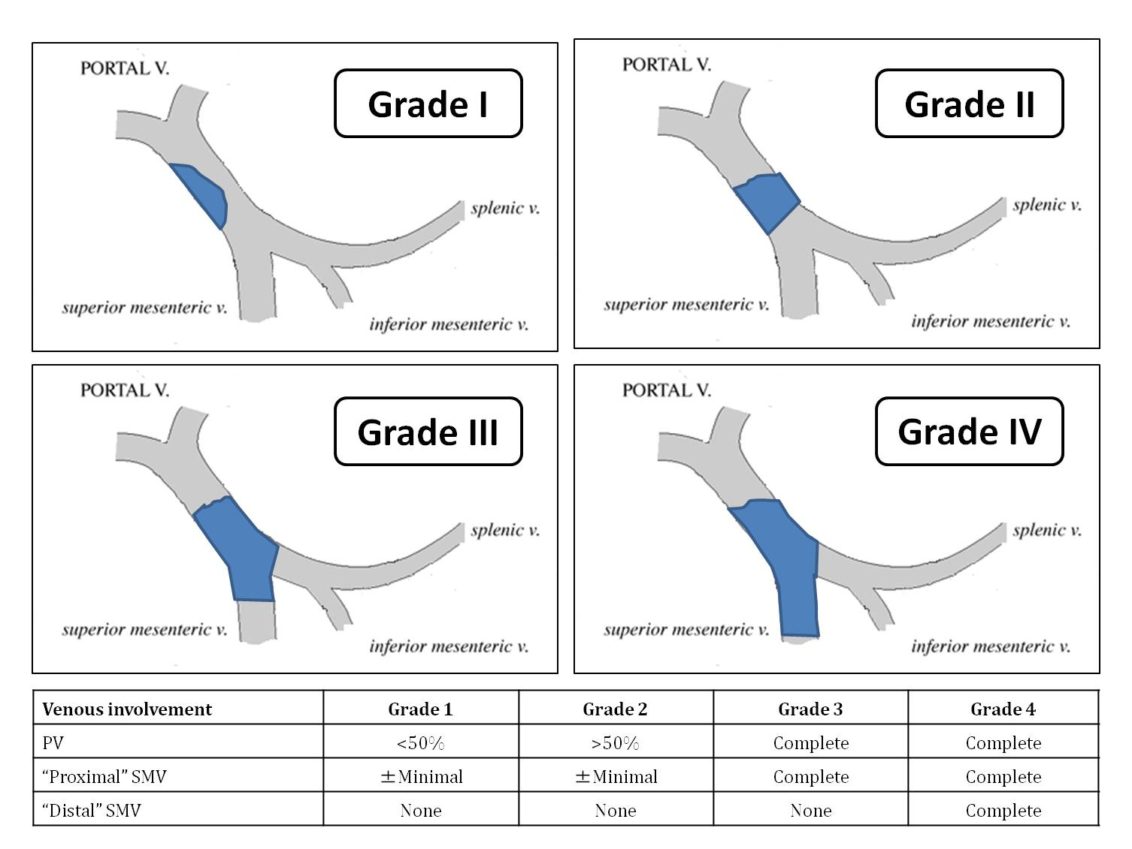
Figure 1 Portal vein thrombosis classification according to Yerdel et al^{[3]}. PV: Portal vein; SMV: Superior mesenteric vein.

PVT grade 1,2
PVT grade 3
PVT grade 4
Low dissection and direct anastomosis
Venous thrombectomy
ETEV
Arterialization of PV
Anastomosis to patent ST
Jump graft from SMV to donor PV
ETEV

Patent SR
shunt

Patent MC
shunt

No flow

Moderate flow

RPA

CPHT

Additional interposition graft between patent ST and PV

Additional arterialization of PV

Conventional hepatectomy

IVC preserving hepatectomy

CPHT S-E

CPHT E-E

Multivisceral transplantation
Figure 2 Algorithm for the management of portal and splanchnic vein thrombosis during liver transplantation. CPHT: Cavo-portal hemitransposition; CPHT E-E: End-to-end cavo-portal hemitransposition; CPHT S-E: Side-to-end cavo-portal hemitransposition; ETEV: Eversion thrombendovenectomy; IVC: Inferior vena cava; MC: Mesocaval shunt (spontaneous or surgical); PV: Portal vein; PVT: Portal vein thrombosis; RPA: Reno-portal anastomosis; SMV: Superior mesenteric vein; SR: Splenorenal shunt (spontaneous or surgical); ST: Splanchnic tributary (coronary, gastroepiploic vein). From Paskonis et al^{[40]}, with modifications.

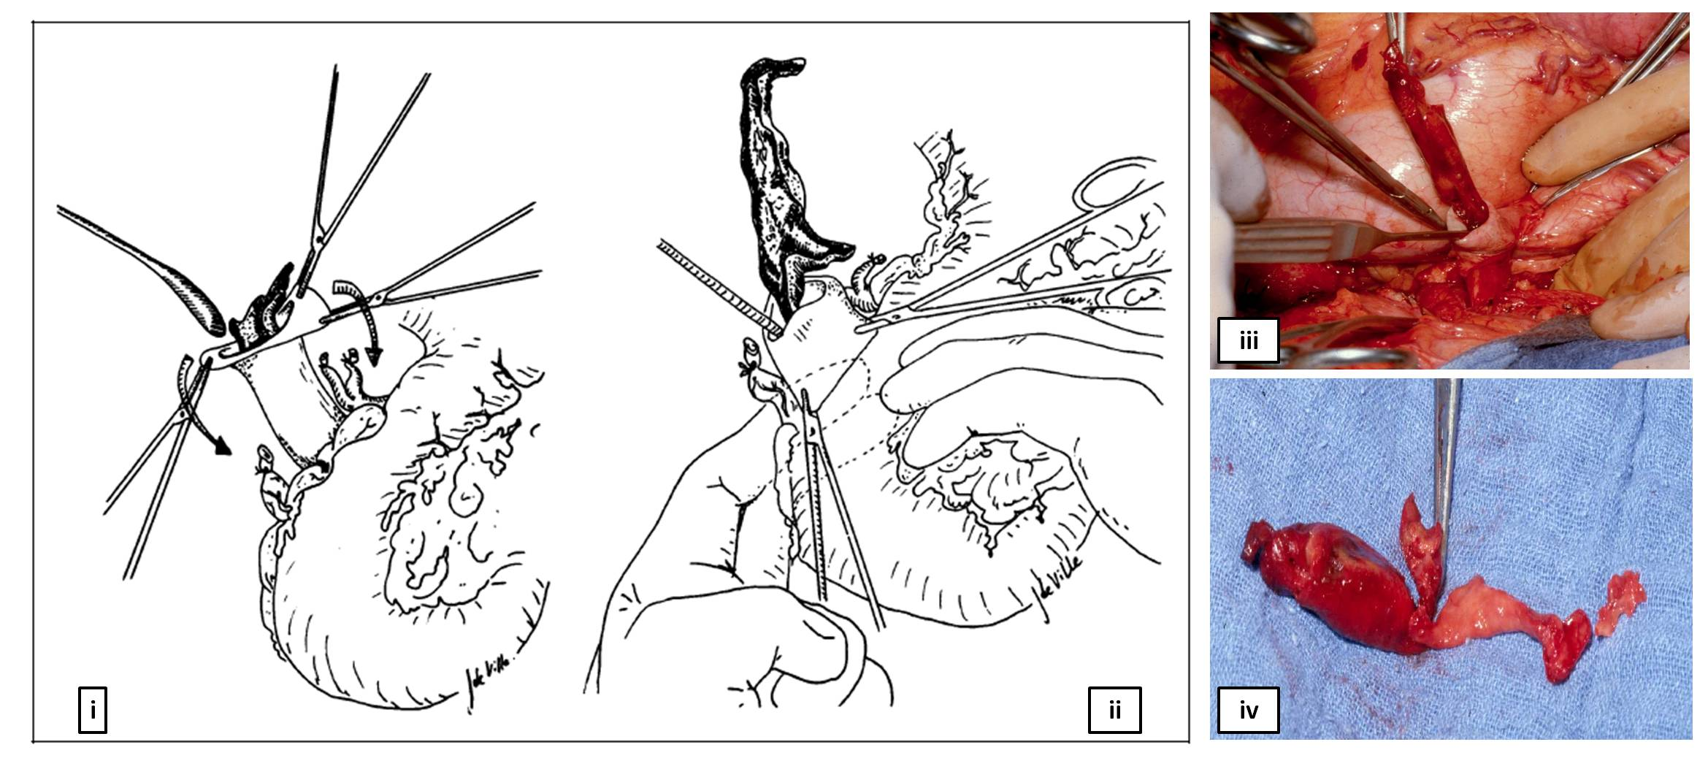
Figure 3 Eversion venous thrombectomy technique. I and II: Schematic representation of the manoeuvre; III: Intraoperative image of thrombectomy procedure; IV: The thrombus removed from the portal vein. Modified from Lerut et al^{[13]}. Figures from the experience of Prof. Jan Lerut.
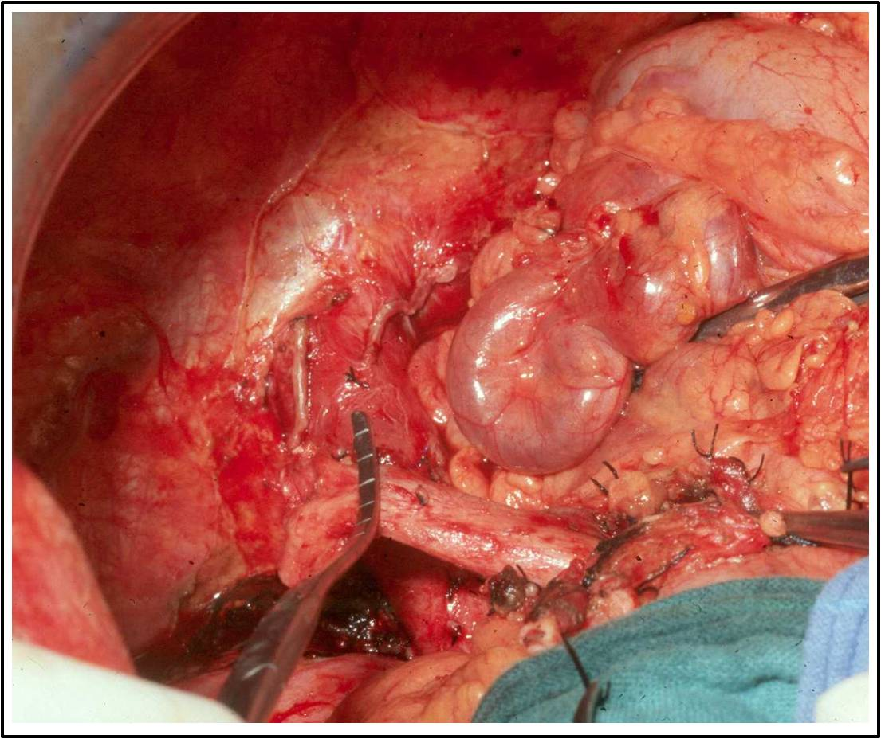
Figure 4 Intraoperative image of a large coronary vein and a thrombosed portal vein. Figure from the experience of Prof. Jan Lerut.

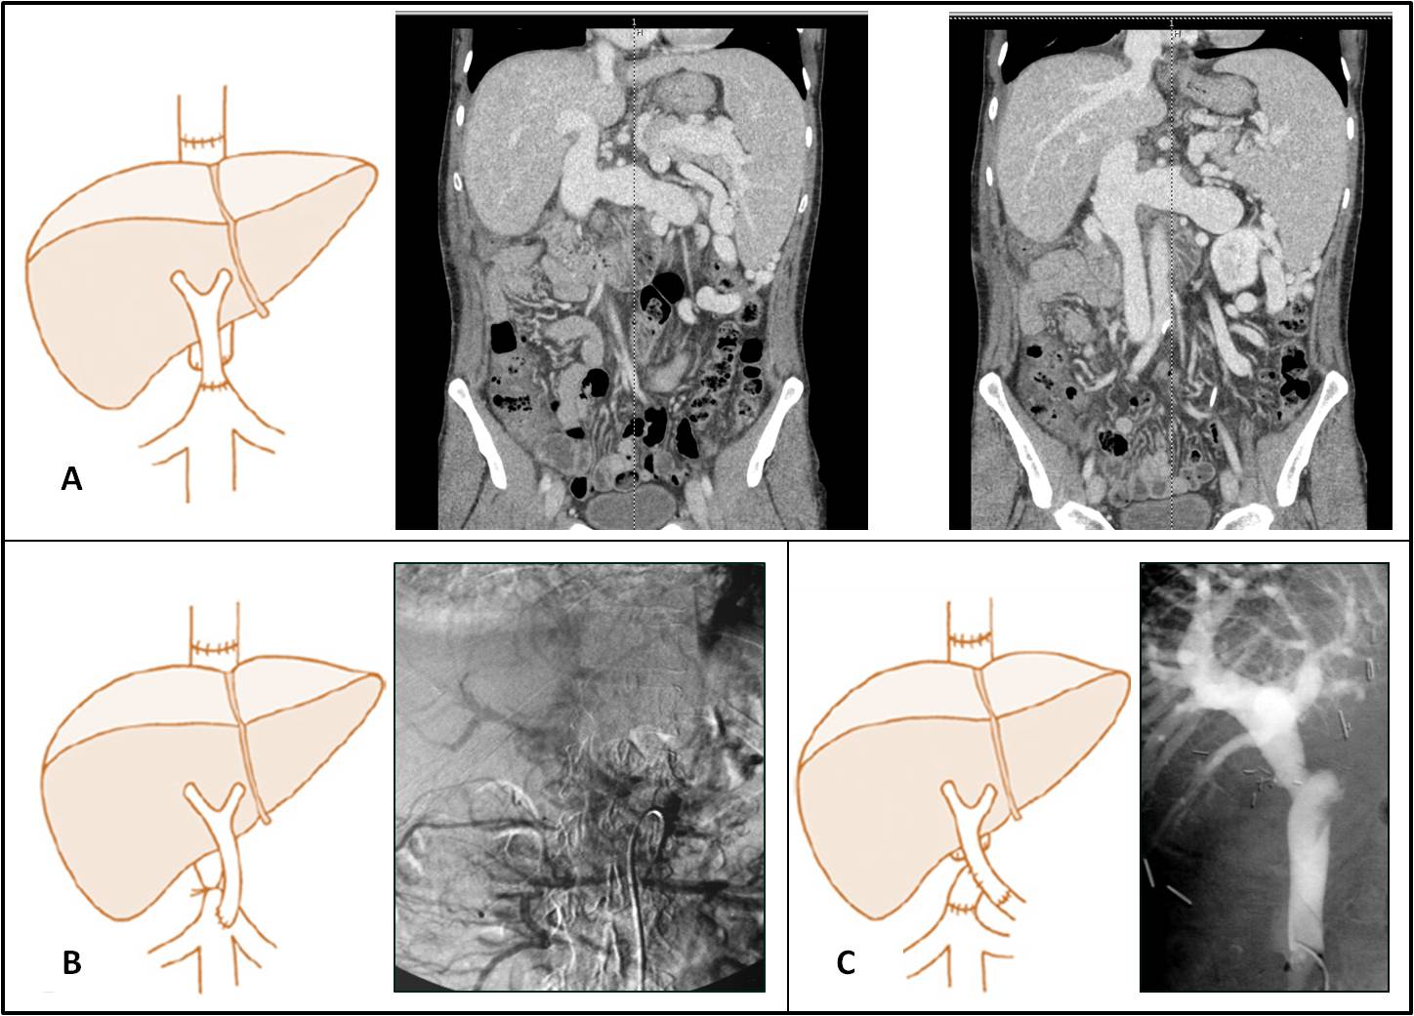
Figure 5 Examples of different techniques of portal flow reconstruction during cavo-portal hemitransposition. A: End-to-end cavoportal anastomosis; B: Side-to-end cavoportal anastomosis with retro-hepatic caval vein constriction; C: End-to-side cavoportal anastomosis using vein interposition graft distal to the conventional portal vein anastomosis. Modified from Paskonis et al^{[43]}. Figures from the experience of Prof. Jan Lerut.

Table 1 Cavoportal hemi-transposition: Experiences worldwide
Ref. | Year | Country | Pts | Post-LT |  |  | Mortality | Survival (mo)¹
 |  |  |  | Variceal  bleeding | Cavo-portal  thrombosis | Severe renal failure
Weeks et al^{[52]} | 2000 | United States | 1 | 0 | 1 | 0 | 0 | 20
Varma et al^{[53]} | 2000 | United States | 1 | 0 | 0 | 0 | 0 | 12
Olausson et al^{[55]} | 2001 | Sweden | 6 (1²) | 1 | 2 | 2 | 1 | 13
Santaniello et al^{[56]} | 2001 | Italy | 1 | 1 | 0 | 1 | 0 | 9
Bakthavatsalam et al^{[58]} | 2001 | United States | 1² | 0 | 0 | 0 | 0 | 12
Urbani et al^{[59]} | 2002 | Italy | 6 (2²) | 1 | 1 | 1 | 1 | 23
Gerunda et al^{[60]} | 2002 | Italy | 2 | 2 | 0 | 2 | 1 | 12
Azoulay et al^{[61]} | 2002 | France | 8 | 2 | 0 | 1 | 3 | 37
Shrotri et al^{[62]} | 2003 | United Kingdom | 1 | 0 | 1 | 0 | 0 | 12
Kumar et al^{[63]} | 2003 | United Kingdom | 1 | 0 | 0 | 0 | 0 | 24
Verran et al^{[64]} | 2004 | Australia | 1² | 0 | 0 | 0 | 0 | 6
Bertelli et al^{[66]} | 2005 | Italy | 1 | 1 | 0 | 0 | 0 | 84
Wang et al^{[67]} | 2005 | China | 1 | 0 | 0 | 0 | 0 | 6
Ozden et al^{[68]} | 2006 | Turkey | 1² | 0 | 0 | 0 | 0 | 13
Lipshutz et al^{[69]} | 2006 | United States | 7 (1²) | 0 | 0 | 0 | 2 | 96
Egawa et al^{[70]} | 2006 | Japan | 1 | 0 | 0 | 1 | 1 | 0
Lladó et al^{[24]} | 2007 | Spain | 1 | 0 | 0 | 0 | 1 | 1
Selvaggi et al^{[71]} | 2007 | United States | 23 | 7 | 6 | 3 | 13 | 112
Li et al^{[72]} | 2008 | China | 1 | 0 | 1 | 0 | 0 | 18
Yan et al^{[73]} | 2008 | China | 3 | 1 | 0 | 0 | 1 | 48
Pan et al^{[14]} | 2009 | China | 1 | 0 | 0 | 0 | 1 | -
Tao et al^{[15]} | 2009 | China | 2 | 0 | 1 | 0 | 0 | -
Gao et al^{[74]} | 2009 | China | 2 | 1 | 0 | 0 | 2 | 6
Campsen et al^{[75]} | 2010 | United States | 10 | 0 | 0 | 0 | 0 | -
Suarez et al^{[76]} | 2010 | Spain | 4 | - | - | - | 2 | -
Ravaioli et al^{[77]} | 2011 | Italy | 6 | 0 | 0 | 0 | 1 | -
Shi et al^{[78]} | 2011 | China | 1 | 0 | 0 | 0 | 0 | -
Lai et al^{[79]} | 2012 | Belgium | 8 | 3 | 4 | 2 | 5 | 139
Chmurowicz et al^{[80]} | 2013 | Poland | 1² | 0 | 0 | 0 | 0 | -
Total |  |  | 103 (7²) | 20 | 17 | 13 | 35
¹Maximum survival in the series; ²Retransplantation. LT: Liver transplantation.

