Name of Journal: World Journal of Stem Cells
Manuscript NO: 87516
Manuscript Type: ORIGINAL ARTICLE

Basic Study
Hypoxia and inflammatory factor preconditioning enhances the immunosuppressive properties of human umbilical cord mesenchymal stem cells

Li H et al. Hypoxia and inflammatory factor pretreated UC-MSCs

Hang Li, Xiao-Qing Ji, Shu-Ming Zhang, Ri-Hui Bi

Hang Li, Department of Histology and Embryology, Shanxi Medical University, Taiyuan 030001, Shanxi Province, China

Xiao-Qing Ji, Shu-Ming Zhang, School of Pharmaceutical Science, Shanxi Medical University, Taiyuan 030001, Shanxi Province, China

Ri-Hui Bi, Department of Hepatobiliary Surgery, Shanxi Bethune Hospital, Shanxi Academy of Medical Sciences, Tongji Hospital Affiliated to Shanxi Medical University, The Third Hospital of Shanxi Medical University, Taiyuan 030002, Shanxi Province, China

Author contributions: Li H, Ji XQ, Zhang SM, and Bi RH designed and coordinated the study; Li H performed experiments and wrote the manuscript; Ji XQ acquired and analyzed the data; Bi RH contributed to ideas, supervision, review and editing; All authors approved the final version of the article.

Supported by the National Natural Science Foundation of China, No. 31200899.

Corresponding author: Ri-Hui Bi, MD, Surgeon, Department of Hepatobiliary Surgery, Shanxi Bethune Hospital, Shanxi Academy of Medical Sciences, Tongji Hospital Affiliated to Shanxi Medical University, The Third Hospital of Shanxi Medical University, No. 99 Longcheng, Xiaodian District, Taiyuan 030002, Shanxi Province, China. birihui@sxmu.edu.cn

Received: August 15, 2023
Revised: September 28, 2023
Accepted: October 30, 2023
Published online: November 26, 2023

Abstract
BACKGROUND
Mesenchymal stem cells (MSCs) have great potential for the treatment of various immune diseases due to their unique immunomodulatory properties. However, MSCs exposed to the harsh inflammatory environment of damaged tissue after intravenous transplantation cannot exert their biological effects, and therefore, their therapeutic efficacy is reduced. In this challenging context, an in vitro preconditioning method is necessary for the development of MSC-based therapies with increased immunomodulatory capacity and transplantation efficacy.

AIM
To determine whether hypoxia and inflammatory factor preconditioning increases the immunosuppressive properties of MSCs without affecting their biological characteristics.

METHODS
Umbilical cord MSCs (UC-MSCs) were pretreated with hypoxia (2% O₂) exposure and inflammatory factors (interleukin-1β, tumor necrosis factor-α, interferon-γ) for 24 h. Flow cytometry, polymerase chain reaction, enzyme-linked immunosorbent assay and other experimental methods were used to evaluate the biological characteristics of pretreated UC-MSCs and to determine whether pretreatment affected the immunosuppressive ability of UC-MSCs in coculture with immune cells.

RESULTS
Pretreatment with hypoxia and inflammatory factors caused UC-MSCs to be elongated but did not affect their viability, proliferation or size. In addition, pretreatment significantly decreased the expression of coagulation-related tissue factors but did not affect the expression of other surface markers. Similarly, mitochondrial function and integrity were retained. Although pretreatment promoted UC-MSC apoptosis and senescence, it increased the expression of genes and proteins related to immune regulation. Pretreatment increased peripheral blood mononuclear cell and natural killer (NK) cell proliferation rates and inhibited NK cell-induced toxicity to varying degrees.

CONCLUSION
In summary, hypoxia and inflammatory factor preconditioning led to higher immunosuppressive effects of MSCs without damaging their biological characteristics.

Key Words: Mesenchymal stem cells; Umbilical cord; Preconditioning; Hypoxia, Inflammatory factors; Immune regulation

©The Author(s) 2023. Published by Baishideng Publishing Group Inc. All rights reserved.

Citation: Li H, Ji XQ, Zhang SM, Bi RH. Hypoxia and inflammatory factor preconditioning enhances the immunosuppressive properties of human umbilical cord mesenchymal stem cells. World J Stem Cells 2023; 15(11): 999-1016
URL: https://www.wjgnet.com/1948-0210/full/v15/i11/999.htm
DOI: https://dx.doi.org/10.4252/wjsc.v15.i11.999

Core Tip: Mesenchymal stem cells (MSCs) are potential candidates for treating many immune diseases due to their unique immunomodulatory abilities, but low survival rates and weakened function after venous transplantation reduces their treatment potential. Therefore, our study reveals a combination pretreatment method based on in vitro hypoxia exposure and inflammatory factor treatment that simulates the harsh in vivo environment to protect MSCs from injury after intravenous transfusion and promote high immunosuppressive effects of MSCs.

INTRODUCTION
In recent years, mesenchymal stem cells (MSCs) have been shown to have a variety of biological properties, such as self-renewal^{[1]}, multilineage differentiation^{[2,3]}, immunomodulation functions^{[4,5]}, tissue repair effects^{[6]}, anti-aging and regeneration activity^{[7]}. Furthermore, due to the abundance and ready availability of MSCs^{[8]}, they do not lead to rejection after allografting^{[9]}; thus, MSCs have great economic value, importance in the cell therapy field and broad application prospects. Although many questions remain unanswered, the immunomodulatory effects of MSCs make them candidates for cell-based tissue repair and disease treatment^{[10-12]}. For example, MSCs have great potential in treating graft-versus-host disease^{[13]}, cardiovascular disease^{[14,15]}, liver disease^{[16,17]}, systemic lupus erythematosus^{[18]}, autoimmune encephalomyelitis^{[19]} and spinal cord injury^{[20]}. Studies have shown that the immunomodulatory ability of MSCs is primarily regulated by cytokines and other soluble factors, including prostaglandin E2 (PGE2), tumor necrosis factor (TNF)-α-stimulated gene protein-6 (TSG-6), inducible indoleamine 2,3-dioxygenase (IDO), interleukin-10 (IL-10) and transforming growth factor-β1 (TGF-β1)^{[21]}. They contribute to MSC-mediated immunosuppression by inhibiting natural killer (NK) cell proliferation, cytotoxicity and cytokine secretion^{[22]}, inhibiting T-cell proliferation, promoting regulatory T cell production^{[5,23,24]}, and inhibiting B-cell proliferation and immunoglobulin release^{[25,26]}.
It has been shown that when MSCs are injected into the body and migrate to damaged tissues or organs, the activation of innate immune cells leads to increased chemokine and cytokine release (such as TNF-α, IL-1α and IL-1β)^{[27]} and is accompanied by the development of a harsh environment caused by hypoxic stress^{[28]}, leading to decreased MSC activity. Therefore, in vitro preconditioning culture developed through hypoxia exposure and inflammatory factor supplementation can effectively mimic the in vivo microenvironment. Preconditioning MSCs in vitro activates various signaling pathways, influencing the biological activities of MSCs in vitro and in vivo, thereby preparing them to survive the harsh environment to which they are subjected during in vivo administration and protecting them from damage^{[29,30]}. In addition, preconditioning can induce MSCs to secrete immunosuppressive molecules to target innate and adaptive immune cells, thereby mediating immune regulation by releasing water-soluble factors^{[31,32]}. Therefore, pretreatment is an adaptive strategy to enhance the efficacy of MSC therapy, which can not only prolong MSC survival and function after transplantation but also endows them with higher immunomodulatory activity levels. Studies have shown that preconditioning with inflammatory factors such as TNF-α and interferon (IFN)-γ can increase MSC immunoregulatory ability^{[33,34]}. Hypoxia preconditioning is often used to enhance the therapeutic effect of MSCs by inducing the expression of survival genes, chemokines, growth factors, and angiogenic factors (such as vascular endothelial growth factor), enabling the MSCs to adapt to the harsh environment of damaged tissue^{[35,36]}.
Although different preconditioning methods can enhance cell properties and increase their function, many are accompanied by safety concerns. In contrast to the aforementioned positive outcomes of pretreatment, improper pretreatment can negatively impact cell morphology and function, damage mitochondrial function^{[37]}, and affect MSC surface marker expression. For example, previous studies have shown that tissue factor (TF/CD142) binds to coagulation factor VII/VIIB to initiate the exogenous coagulation system. The relative cell surface expression of TF is strongly correlated with procoagulant activity^{[38]}. MSCs expressing surface TF show high coagulant activity and promote blood and plasma coagulation^{[39]}. Therefore, high TF expression on MSCs increases the risk of thrombosis after intravenous injection^{[40-43]}.
We found that most studies have been focused on bone marrow- or adipose-derived MSCs (AD-MSCs), but human umbilical cord-derived MSCs (hUC-MSCs) are more suitable for clinical research and large-scale use because they are not associated with ethical problems, are abundant and highly proliferative. Therefore, we chose hUC-MSCs to study. To our knowledge, studies using a combination of hypoxia (2% O₂) exposure and inflammatory factor (IL-1β, TNF-α, IFN-γ) treatment to precondition hUC-MSCs are rare, and our study supports the current theory. Our aim was to simulate the injury-induced environment in vitro using a combination of hypoxia and inflammatory factor preconditioning to determine whether preconditioning increases the immunosuppressive properties of MSCs without affecting their biological characteristics.

MATERIALS AND METHODS
UC-MSC extraction and culture
Umbilical cord and cord blood were obtained with the approval of the Medical Ethics Committee of Shanxi Medical University and the consent of the donors, and experiments were performed in accordance with the Declaration of Helsinki.
Umbilical cord tissue was provided by one hospital, and the donors gave informed consent. After obtaining the umbilical cords, two veins and one artery were removed, and Wharton’s jelly was cut into pieces and placed into a 10 cm² petri dish (Nice) with 5 mL of DMEM/F12 culture medium (Thermo Fisher Scientific, Waltham, MA, United States) containing 2.5% serum substitute (Shanxi Yinshi Cell Technology, Xian, China). Approximately 14 d later, the UC-MSCs were passaged, and P4 generation cells were used for experiments. UC-MSCs were cultured in a carbon dioxide incubator (Thermo Fisher Scientific) at standard oxygen tension with 5% carbon dioxide, 95% air, and 37 °C (i.e. normoxia). When UC-MSCs were 70%-80% confluent, a mixture of IFN-γ (R&D), TNF-α (R&D Systems, Minneapolis, MN, United States) and IL-1β (PeproTech, Cranbury, NJ, United States) was added to the medium. The cells were then immediately placed into a three-gas incubator (Panasonic, Osaka, Japan) with 2% O₂, 5% CO₂, and 93% N₂ at 37 °C (i.e. hypoxia). After 24 h, primed UC-MSCs (PUC-MSCs) were obtained. Therefore, our experiments were divided into two groups: control (UC-MSCs) with no treatment and an experimental group (PUC-MSCs) in which cells were exposed to hypoxia and inflammatory factor supplementation.

Extraction and culture of peripheral blood mononuclear cells
Umbilical cord blood was obtained and centrifuged at 700 × g for 10 min and the plasma was extracted and placed into a water bath at 56 °C for 30 min for heat inactivation. The plasma was removed from the water bath, centrifuged at 850 × g for 10 min, and placed in a refrigerator at 4 °C for later use. The blood cells were resuspended in phosphate buffered saline (PBS) and mixed. The cell suspension was slowly added into a centrifuge tube containing Ficoll human peripheral blood lymphocyte isolation medium (Tianjin Haoyang Biological Products Technology Co., Ltd., Tianjin, China). After centrifugation at 400 × g for 30 min, white cells were extracted and washed twice with PBS. The cells [(1-2) × 10⁶ cells/mL] were inoculated in peripheral blood mononuclear cell (PBMC) medium containing 10% of the heat-inactivated autologous plasma (Shanxi Yin Cell Technology Co., Ltd., Hebei, China) in the presence or absence of UC-MSCs or PUC-MSCs. The PBMCs were treated with 100 U/mL IL-2 (PeproTech). For coculture experiments, PBMCs were inoculated with UC-MSCs or PUC-MSCs at a PBMC/MSC ratio of 3:1 so that the cells were in direct contact, which is the appropriate proportion of cells to obtain MSC-mediated inhibition of PBMC proliferation.

NK cell extraction and culture
Umbilical cord blood was obtained and centrifuged at 700 × g for 10 min, and the plasma was placed into a water bath at 56 °C for 30 min for heat inactivation. The plasma was removed, centrifuged at 850 × g for 10 min, and placed into a refrigerator at 4 °C for later use. The blood cells were resuspended in PBS, mixed, and incubated at room temperature for 20 min with RosetteSepT NK Enrichment Cocktail. The cell suspension was slowly added into a centrifuge tube containing Ficoll human peripheral blood lymphocyte isolation medium (Tianjin Haoyang Biological Products Technology Co., Ltd.). After centrifugation at 400 × g for 30 min, white cells were extracted and washed twice with PBS. The cells [(1-2) × 10⁶ cells/mL] were inoculated into NK medium containing 10% heat-inactivated autologous plasma (Shanxi Yin Cell Technology Co., Ltd.). NK cells were cultured with or without UC-MSCs or PUC-MSCs and treated with 100 U/mL IL-2 (PeproTech).

Cell survival rate and cell size detection
Double fluorescence acridine orange/propidium iodide (AO/PI) cell viability counting was performed. The AO/PI reagent consists of the DNA-binding dye AO, which fluoresces green, and the DNA-binding dye PI, which fluoresces red. AO can pass through a complete cell membrane and enter the nuclei of all cells (living and dead cells), emitting green fluorescence. PI can only pass through an incomplete cell membrane and enter the nuclei of dead cells, resulting in red fluorescence. After mixing 10 μL of cell suspension with 10 μL of AOPI reagent, the viability and size of the cells in suspension were measured by a Countstar Rigel S2 (Shanghai Rui Yu Biotech, Shanghai, China).

Monoclonal antibodies and cytofluorometric analysis
Flow cytometry analysis of UC-MSCs and PUC-MSCs was performed. The cells were resuspended in staining buffer after centrifugation, and the corresponding antibodies were added to the buffer. Cells were incubated for 30 min, neutralized and washed 1-2 times. The UC-MSC or PUC-MSC antigen markers (BD Biosciences, San Jose, CA, United States) were CD105-APC, CD90-FITC, CD73-PE, CD142-PC5.5, CD29-PE, CD34-PE, CD14-PE, CD45-APC, human leukocyte antigen (HLA)-ABC-APC, CD47-APC, CD166-PE, CD44-PE, and CD31-APC.

Reactive oxygen species measurement
Mitochondrial reactive oxygen species (ROS) production was measured by flow cytometry (Beckman Coulter Life Sciences, Brea, CA, United States) using a ROS detection kit (Biyuntian, Shanghai, China). 2,7-dichlorodihydrofluorescein diacetate (DCFH-DA) was diluted in serum-free medium at 1:1000 to a final concentration of 10 μmol/L. After collection, 1 million to 20 million/mL cells were suspended in diluted DCFH-DA and incubated in an infrared carbon dioxide incubator (Thermo Fisher Scientific) at 37 °C for 20 min. The cells were turned over and mixed every 3-5 min to ensure that the probe was in full contact with the cells. The cells were washed with serum-free cell culture solution three times to fully remove excess DCFH-DA. Finally, the results were detected by flow cytometry.

Measurement of mitochondrial membrane potential
Mitochondrial membrane potential (MMP) was detected using MMP detection reagent JC-1 (Beyotime, Jiangsu, China). The culture medium was removed and the cells were washed twice with PBS. JC-1 staining solution (1 mL) was added, mixed thoroughly, and incubated with cells in an infrared carbon dioxide incubator (Thermo Fisher Scientific) at 37 °C for 20 min. During the incubation period, JC-1 staining buffer (1×) was prepared by adding approximately 4 mL distilled water to approximately 1 mL JC-1 staining buffer (5×), and the buffer was placed in an ice bath. After incubation at 37 °C, the supernatant was removed, and the cells were washed twice with JC-1 staining buffer (1×). Finally, 2 mL of the cell culture solution was added. Images were obtained with an inverted fluorescence microscope (CKX53; Olympus, Tokyo, Japan).

Real time-polymerase chain reaction
TRIzol (Invitrogen, Waltham, MA, United States) was used to lyse the cells, total RNA was extracted, and an ultratrace nucleic acid protein detector (Shanghai Jiapeng Materials, Shanghai, China) was used to determine RNA concentration. mRNA expression levels were quantitatively analyzed on a real-time polymerase chain reaction (RT-PCR) instrument (Bio-Rad, Hercules, CA, United States) using a One Step TB Green PrimeScript PLUS RT‒PCR Kit (Takara Bio Inc., Shiga, Japan) to measure the levels of the following transcripts: Catalase, Istanniocalcin-1 (STC1), hemeoxygenase-1 (HOMX1), B-cell lymphoma 2-associated protein (Bax), B-cell lymphoma 2 (Bcl2), silencing information regulator 2-related enzyme 1 (SIRT1), P53, P16, P21, PGE2, kynurenine (KYN), IDO, IL-1 receptor antagonist (IL-1ra), cyclooxygenaese-2 (COX2), IL-10, TGF-β1, HLA-G5, TSG-6, ligands for programmed cell death 1 (PD-L1). All primer sequences for qRT-PCR are listed in Table 1.

Enzyme-linked immunosorbent assays
UC-MSCs and PUC-MSCs supernatants were collected and centrifuged at 210 × g for 5 min, and the suspended cells were removed and stored at -80 °C. The protein levels of PGE2, TSG-6, IDO, IL-10 and TGF-β1 secreted by UC-MSCs and PUC-MSCs were measured by enzyme-linked immunosorbent assay (ELISA) kits (Wuhan Eliret Biotechnology Co, Ltd., Wuhan, China). Finally, the optical density (OD) value of each well was measured on the basis of enzyme label (Thermo Fisher Scientific) absorption at 450 nm.

Annexin V-FITC apoptosis detection
UC-MSC and PUC-MSC suspensions were obtained and washed twice with PBS. Annexin V-FITC apoptosis reagent (Biyuntian) was added and incubated with the cells at room temperature for 10-20 min in the dark, and flow cytometry was performed. Annexin V-FITC emits green fluorescence, and PI emits red fluorescence.

β-galactosidase (SA-β-gal) activity detection
The cell culture medium was removed, the cells were washed once with PBS, and 1 mL/well β-galactosidase (SA-β-gal) staining fixation solution (Solarbio, Beijing, China) was added and incubated at room temperature for 15 min. Fixative was removed, and the cells were washed 3 times with PBS for 3 min each. The PBS was removed, and 1 mL of staining solution was added to each well. The plate was incubated at 37°C overnight and sealed with plastic wrap to prevent evaporation. The positive expression of blue particles was observed under an inverted microscope (CKX53; Olympus), and the number of positive cells per 100 cells was quantified. Each experiment was repeated three times.

Proliferation experiment
NK cells were cultured in the presence or absence of UC-MSCs or PUC-MSCs for 3 d at a 3:1 ratio. The cells were prelabelled with carboxyfluorescein diacetate succinimidyl ester (CFSE) dye (BioLegend, San Diego, CA, United States) and the fluorescence intensity of CFSE was measured by flow cytometry.

Cell growth and proliferation
UC-MSCs and PUC-MSCs were collected for DNA extraction and DNA concentration was determined by an ultramicro nucleic acid protein detector (Shanghai Jiapeng Materials) to evaluate the cell proliferation rate. PBMCs were cultured in the presence or absence of UC-MSCs or PUC-MSCs at a ratio of 3:1. The number of cells (Countstar Rigel S2; Shanghai Rui Yu Biotech) was counted by a cell imaging analyzer for 5 consecutive days and the growth curve was plotted.

Cytotoxicity of K562 target cells
NK cells were cultured alone or in direct contact with MSCs (NK: UC-MSCs or PUC-MSCs = 3:1 ratio) for 72 h. NK cells were then collected and cocultured with CFSE-stained (Biolegend) K562 target cells for 4 h at the effective target ratio of 1:5. All cells were collected and washed twice with PBS. K562 cell apoptosis was analyzed by PI staining (Biyuntian), and the fluorescence intensity was measured by flow cytometry.

Statistical analysis
SPSS 19.0.0 and GraphPad Prism 7 (GraphPad Prism, La Jolla, CA, United States) statistical software were used for data processing. All experimental data are expressed as the mean ± SD. A t test was performed to compare two datasets, and P < 0.05 was considered statistically significant.

RESULTS
Effects of hypoxia and inflammatory factor pretreatment on UC-MSC morphology, size, proliferation and viability
We evaluated the effects of hypoxia and inflammatory factor pretreatment on UC-MSC morphology, vitality and size. The morphological differences between UC-MSCs and PUC-MSCs were compared under a microscope when cell confluency reached 80% to 90%. Untreated UC-MSCs appeared as either short rods or long spindles in an adherent state and were arranged in a spiral pattern. After 24 h of exposure to hypoxia and inflammatory factors, cell morphology changed from short and rod-like to thin and elongated (Figure 1A), but the proliferation rate did not change (Figure 1B). We further evaluated the effects of pretreatment on UC-MSC viability and size using AOPI staining and a cell imaging analyzer. UC-MSC viability (Figure 1C) in suspension was 93.59% ± 3.87% (n = 5) and the mean diameter (Figure 1D) was 18.216 ± 0.78 μm (n = 5), while PUC-MSC viability (Figure 1C) was 92.89% ± 4.13% (n = 5) and the mean diameter (Figure 1D) was 18.628 ± 0.76 μm (n = 5). These results showed that pretreated MSCs became elongated, the measured viability slightly decreased (P = 0.84), and the cells were slightly enlarged (P = 0.47), but these differences were not statistically significant.

MSC surface marker expression
We further evaluated whether preconditioning altered the cellular phenotype by analyzing MSC surface marker expression by flow cytometry. UC-MSCs (Figure 2A) and PUC-MSCs (Figure 2B) from three donors were positive for CD105, CD90, CD73, CD29, CD166, CD47 and HLA-ABC surface expression and negative for CD31, CD45, CD14 and CD34. The results showed that surface marker expression was consistent between PUC-MSCs and UC-MSCs. Interestingly, CD142 expression (59.3%) (Figure 2B) was significantly lower in PUC-MSCs compared to UC-MSCs (99.6%) (Figure 2A).

Effect of pretreatment on UC-MSC mitochondrial function
ROS play key roles in the proapoptotic signaling cascade, and excess ROS attacks the mitochondrial membrane and loss of MMP, leading to MSC apoptosis^{[44]}. Therefore, we used flow cytometry to examine the effect of MSC pretreatment on ROS production. Intracellular ROS levels showed a three-fold increase in DCFH-DA fluorescence intensity in PUC-MSCs compared to untreated UC-MSCs (Figure 3A), but all the effects were within the range of values obtained in positive controls. STC1, catalase and HOMX1 expression levels increased (Figure 3B), indicating that the antioxidant capacity of the cells was increased and that mitochondrial ROS removal was increased, enhancing antioxidant defense effects and preventing ROS-induced DNA damage. Maintaining a stable MMP (Ψm) is essential to ensure efficient ROS clearance and prevent apoptosis or other stress-related events caused by excessive ROS^{[45]}. Therefore, we further determined whether hypoxia and inflammatory factor preconditioning induced MMP dysfunction in UC-MSCs. We used the sensitive fluorescent probe JC-1 to evaluate the effect of pretreatment. We determined whether the membrane potential changed in UC-MSCs by measuring a change in JC-1 red fluorescence to green fluorescence. Microscopically, untreated UC-MSCs showed a normal MMP, as shown by red fluorescence staining with JC-1 (Figure 3C). Neither the red and green fluorescence nor the MMP was significantly different between PUC-MSCs and UC-MSCs. We further measured the JC-1 red/green fluorescence ratio by flow cytometry and confirmed our microscopy results (Figure 3D). These results showed that mitochondrial function in UC-MSCs was not damaged by hypoxia and inflammatory factor pretreatment.

Hypoxia and inflammatory factor preconditioning induces UC-MSC apoptosis and senescence
Bax expression decreased and Bcl2 and SIRT1 expression increased after pretreatment, suggesting that the anti-apoptotic capacity increased after pretreatment (Figure 4A). The expression of the senescence-related genes P53, P16 and P21 was upregulated by pretreatment (Figure 4B). We analyzed apoptosis by Annexin V-PI staining and flow cytometry. We compared the proportion of cells that were positive for both Annexin V-FITC and PI (necrotic cells), and the apoptotic index of PUC-MSCs (15.08% ± 4.11%) significantly increased (Figure 4C) compared to UC-MSCs (6.22% ± 3.03%). Next, we investigated the effect of preconditioning on cell senescence. SA-β-gal has been the most widely accepted senescence marker since Dimri first published its use in 1995^{[46]}, so we performed SA-β-gal staining to evaluate cell senescence ratios. SA-β-gal levels increased in PUC-MSCs (14.83% ± 1.57%) compared to UC-MSCs (4.83% ± 1.34%) (Figure 4D). These results suggest that hypoxia and inflammatory factor preconditioning not only induces UC-MSC apoptosis and senescence but also increases anti-apoptotic factor levels.

Hypoxia and inflammatory factor preconditioning enhances UC-MSC immunosuppressive properties
MSCs are pluripotent stem cells that have been shown to hold promise in tissue regeneration due to their ability to self-renew and differentiate and their broad immunomodulatory properties^{[1-5]}. We evaluated whether UC-MSC immunomodulatory activities increased after pretreatment. qRT-PCR analysis revealed that the expression of PGE2, IDO, KYN, COX2, IL-10, TGF-β1, TSG-6, HLA-G5, and PD-L1 increased in PUC-MSCs compared to untreated UC-MSCs. IL-1ra expression was slightly elevated, but the difference was not statistically significant (Figure 5A). Because paracrine activity is a key mechanism underlying MSC effects, we compared the bioactive factor secretion levels in PUC-MSCs and untreated UC-MSCs. We assessed MSC paracrine function by measuring the protein levels of immunosuppression-related soluble factors released into the culture supernatant, including IDO, PGE2, TGF-β1, TSG-6, and IL-10 by ELISAs. IDO, PGE2, TGF-β1 and TSG-6 levels significantly increased in the PUC-MSC supernatant, while IL-10 levels slightly increased but did not reach statistical significance (Figure 5B). In summary, these data strongly suggest that UC-MSC preconditioning with hypoxia and inflammatory factors upregulates the expression of soluble immunomodulatory factors and enhances their immunomodulatory activity.

Hypoxia and inflammatory factor preconditioning increases UC-MSC immunosuppressive properties
Considering the high expression of immunomodulatory molecules in PUC-MSCs, we evaluated their immunosuppressive capacity. We compared UC-MSC and PUC-MSC immunosuppressive capacity using PBMC and NK cell proliferation assays by analyzing growth dynamics of PBMCs cultured alone, with UC-MSCs or with PUC-MSCs (Figure 6A). Both UC-MSCs and PUC-MSCs significantly inhibited PBMC proliferation compared to PBMCs cultured alone. However, PUC-MSCs had a stronger inhibitory effect on PBMC proliferation, further indicating that pretreatment enhanced UC-MSC immunosuppressive abilities. We further investigated MSC-mediated inhibition of NK cell proliferation in the presence of the two MSC populations. We cultured CFSE-stained NK cells in the presence of IL-2 alone or with UC-MSCs or PUC-MSCs and analyzed CFSE fluorescence intensity by flow cytometry after 3 d. The proliferation rate of NK cells was reduced in cocultures with UC-MSCs or PUC-MSCs compared to NK cells cultured alone, but the PUC-MSC group exerted stronger inhibitory effects on NK cells compared to UC-MSCs (Figure 6B).
Finally, we evaluated the effect of UC-MSC pretreatment with hypoxia exposure and inflammatory factor treatment on NK cell cytotoxic activity. NK cells were cultured alone or with UC-MSCs/PUC-MSCs at a 3:1 ratio for 72 h, then collected and incubated with CFSE-stained K562 target cells at an effective target ratio (E:T = 1:5) for 4 h. The cells were collected, and K562 cell apoptosis was analyzed by PI staining. The results showed that NK cells cocultured with UC-MSCs or PUC-MSCs had lower cytolytic activity, and the inhibition of NK cell-mediated cytotoxic activity was higher with PUC-MSCs than UC-MSCs (Figure 6C).

DISCUSSION
Intravenous injection of MSCs has been increasingly used in clinical research and has shown great potential in the treatment of various diseases. Because of their immunomodulatory functions, MSCs have become a promising alternative treatment for inflammatory diseases. MSCs come from a wide range of sources. Currently, the most studied MSCs are derived from bone marrow and adipose tissue, followed by those from umbilical cord tissue^{[47]}. Compared with those from other sources, umbilical cord-derived MSCs are abundant, easy to collect, genetically stable, and do not readily mutate. Therefore, umbilical cord MSCs have broad application prospects in the cell therapy field^{[48-50]}. Therefore, we focused on UC-MSCs in this study.
In addition to the effects of their origin, MSCs exhibit decreased biological performance when subjected to vein transplantation and exposure to the harsh inflammatory environment of damaged tissue^{[29]}. Studies have shown that preconditioning cells by exposing them to the external environment can enhance their therapeutic effects by preparing them for the harsh conditions they encounter when injected into the body. Antebi et al^{[51]} showed that hypoxic preconditioning of bone marrow MSCs enhanced the therapeutic function of these cells. Gorgun et al^{[34]} analyzed the effects of hypoxia and inflammatory factor (TNF-α, IL-1α) pretreatment on AD-MSC angiogenic potential. In addition, Rodriguez et al^{[52]} pretreated AD-MSCs with a mixture of inflammatory factors under anoxic culture conditions, which significantly enhanced their functional characteristics and immunosuppressive and immunoregulatory functions.
In this study, we developed a combination strategy of hypoxia plus a mixture of TNF-α, IL-1β, and IFN-γ preconditioning to enhance hUC-MSC immunomodulatory capacity. To our knowledge, this is a previously unanalyzed combination pretreatment. We found that this preconditioning approach successfully mimicked the harsh inflammatory environment and effectively enhanced the immunosuppressive function of MSCs. To simulate hypoxia, we cultured UC-MSCs in a special three-gas incubator containing 2% O₂, 5% CO₂ and 93% N₂ at 37°C for 24 h. We had previously evaluated these gas conditions and found them to be most suitable for preserving the functional characteristics of MSCs. To simulate the harsh inflammatory environment, we independently developed and utilized a mixture of IL-1β, IFN-γ and TNF-α. After pretreatment, we found that the cells became elongated, but their proliferation, viability and size did not significantly change. Notably, Klinker et al^{[53]} recently demonstrated that the morphological characteristics of MSCs were significantly correlated with their immunosuppressive ability and can be used to predict their overall immunosuppressive effects^{[53]}. The results of the study by Klinker et al^{[53]} showed that pretreated UC-MSCs became elongated and had stronger immunosuppressive ability, consistent with the results of our study.
Although different forms of preconditioning have been shown to successfully enhance cell properties and increase cell function, there are still noteworthy safety concerns. Because pretreatment may have negative effects on cell function, we used flow cytometry to characterize MSC phenotypes. The expression of specific MSC surface markers can be used as indicators of cell differentiation potential, lineage commitment, aging, and therapeutic function^{[54]}. The International Society for Cell and Gene Therapy defines minimum standards for MSC characterization, and most experiments are conducted on this basis^{[55]}. However, we examined additional MSC surface markers. We found that UC-MSCs and PUC-MSCs from three donors retained high expression levels of CD105, CD90, CD73, CD29, CD166, CD47 and HLA-ABC and were negative for CD31, CD45, CD14, and CD34 expression. These findings indicated that UC-MSCs retained MSC properties after pretreatment. Interestingly, we found that CD142 expression significantly decreased after pretreatment. Oeller et al^{[39]} found that UC-MSCs showed higher procoagulant activity than adipose-derived MSCs, and UC-MSCs showed extensive TF (CD142) expression and long-lasting clotting; a higher cell number significantly increased clot formation, which was partially dependent on coagulation factors^{[43]}. Our study showed that CD142 expression in UC-MSCs without treatment exceeded 99% and CD142 expression significantly decreased after pretreatment (59.3%). Our experiment showed significant decreases in TF expression, which has been shown to be closely related to procoagulant activity^{[38]}. However, Rodriguez et al^{[52]} demonstrated that bone marrow-derived MSCs (BM-MSCs) and AD-MSCs that were pretreated with a combination of hypoxia and inflammatory factors showed increased CD142 expression, which was inconsistent with previous studies^{[53]}. We determined that these discrepancies may be due to different origins of MSCs, MSC heterogeneity and/or differences between culture systems. However, we found pretreatment significantly reduced CD142 expression. In addition, studies have suggested the use of anticoagulants or genetic methods to inhibit TF activity for the clinical application of MSCs to maximize clinical benefits for patients, which also underscores the importance of insights into the mechanisms underlying safety issues related to nonhematopoietic cell transplantation^{[43]}.
The efficacy of MSCs depends on the full function of their mitochondria, which can be damaged after cell exposure to harmful environments^{[56]}. Therefore, we examined the effects of hypoxia and inflammatory factor pretreatment on mitochondrial function. ROS levels were increased after pretreatment but were within the range of those in the positive controls. In addition, the increased expression of antioxidants such as STC1, catalase and HOMX1 can eliminate ROS to maintain cell redox homeostasis^{[57]}. Previous studies have shown that both HMOX1 and catalase play key roles in protecting cells from ROS-induced damage^{[58,59]}. Therefore, although ROS levels increased after pretreatment, the antioxidant capacity of the cells also correspondingly increased and the ROS removal rate increased. In addition, the MMP (Δψm) plays a key role in important mitochondrial functions, and its dissipation is an indicator of mitochondrial dysfunction^{[60]}. Maintaining a stable MMP (Ψm) is essential for ensuring efficient ROS clearance and preventing apoptosis or other stress-related events caused by excessive ROS. Therefore, we examined the MMP and found that pretreatment had no effect on MMP. In summary, although ROS levels increased after pretreatment, the antioxidant capacity also increased, and the MMP did not change, indicating that there was no damage to mitochondrial function after pretreatment.
We next examined the effect of pretreatment on MSC apoptosis and senescence and found that the apoptosis index of UC-MSCs increased to a certain extent after pretreatment. Galleu et al^{[61]} showed that all patients can receive apoptotic MSCs for in vivo injection and that these cells can induce receptor-mediated immune regulation. MSC apoptosis of is critical to their therapeutic functions^{[62]}. BCL-2, BAX and SIRT1 genes play important roles in the apoptosis pathway. In this study, we found increased expression of the SIRT1 gene, which protected cells from apoptosis by activating autophagy^{[63]}. The ratio of BAX/BCL-2 is closely related to the apoptosis potential of cells^{[64]}. In this study, an inverse proportional relationship between BAX and BCL-2 indicated that MSCs exerted stronger anti-apoptosis effects after pretreatment. This may indicate that the cells were protecting themselves from the harmful inflammatory environment. In addition, MSCs showed increased SA-β-gal activity and p53, P16 and p21 expression after hypoxia and inflammatory factor pretreatment, suggesting that MSCs underwent senescence after pretreatment. Salminen et al^{[65]} found that aging MSCs exert stronger immunosuppressive effects. The experimental results showed that even when some of the pretreated UC-MSCs underwent senescence and apoptosis, these effects did not reduce their immunoregulatory abilities, and even apoptotic and senescent MSCs showed increased immunosuppressive abilities.
The pleiotropic effect of MSCs is mostly mediated by soluble paracrine factors, and active paracrine factors produced by these cells regulate cellular immunity when they come into contact with the host^{[66]}. Therefore, we investigated the response of paracrine factors involved in the immune regulation of MSCs to preconditioning. Many bioactive molecules produced by MSCs, such as IDO, PGE2, IL-10, TSG-6, and TGF-β1, effectively regulate innate and adaptive immunity and play a key role in the immunosuppressive effect of MSCs^{[67]}. The detection of immunomodulation-related genes showed that the expression levels of PGE2, KYN, IDO, COX2, IL-10, TGF-β1, TSG-6, HLA-G5 and PD-L1 were significantly increased in addition to that of IL-1ra. In addition, PGE2, TSG-6, TGF-β1 and IDO protein levels in the supernatant were significantly increased. IL-10 levels were slightly increased, but the difference between the pretreatment and control groups was not significant. These results showed that preconditioning can promote the production of immunomodulatory paracrine factors in UC-MSCs and increase their immunomodulatory effect.
Finally, we studied the immunosuppressive effects of MSCs on PBMCs and NK cells. We found that UC-MSCs and PUC-MSCs inhibited PBMCs and NK cell proliferation, but PUC-MSCs exerted a stronger inhibitory effect. Some work has been done to characterize the interaction between BM-MSCs and NK cells^{[22,68,69]}. However, the interaction of UC-MSCs with NK cells has been largely unexplored. Our results add to our understanding of the immunosuppressive effects of UC-MSCs^{[70,71]}. In addition, we found that PUC-MSCs exerted a stronger inhibitory effect on NK cell-mediated cytotoxic activity. Reportedly, IDO and PGE2 or TGF-β1 produced by MSCs are critical for inhibiting NK cell cytotoxicity^{[22,72]}. PUC-MSCs may exert stronger inhibitory effects on NK cell-mediated toxicity due to increased IDO, TGF-β1 and PGE2 expression.
We acknowledge that this study has limitations. Whether the combination of hypoxia (2% O₂) and inflammatory factors (IL-1β, TNF-α, IFN-γ) is superior to other preconditioning methods is unclear. However, our study shows a preconditioning strategy that adds to the existing experimental options to use in further research. In addition, whether these cells exhibit superior immunomodulatory functions under harsh in vivo inflammatory conditions remains to be demonstrated and is the focus of our future work. Moreover, although TF expression is reduced by preconditioning, the mechanism is unclear. Thromboembolism may still have significant clinical consequences for patients who receive MSCs after preconditioning. Therefore, for whole-body cell administration, it is still necessary to use anticoagulants during the clinical application of MSCs to inhibit TF activity and increase the clinical benefits to patients.

CONCLUSION
In conclusion, we successfully developed an in vitro preconditioning method that mimics the impaired environment through a combination of hypoxia (2% O₂) and inflammatory factors (IL-1β, TNF-α, IFN-γ) to enhance UC-MSC immunosuppressive ability without compromising their biological characteristics. Most notably, this approach greatly reduced the expression of the clotting-related TF in MSCs, which was a surprising result.

ARTICLE HIGHLIGHTS
Research background
Mesenchymal stem cells (MSCs) have great potential in the treatment of a variety of immune-related diseases due to their unique immunomodulatory and anti-inflammatory abilities. However, after intravenous transplantation, MSCs cannot effectively exert their biological effects when they encounter a harsh environment in vivo, which reduces the efficacy of cell therapy. To increase transplantation efficacy, appropriate pretreatment methods are particularly important.

Research motivation
Although a variety of pretreatment methods are used to increase MSC transplantation efficacy, suitable and effective in vitro pretreatment methods are still worth studying.

Research objectives
To evaluate whether umbilical cord MSCs (UC-MSCs) pretreated with hypoxia exposure and inflammatory factors show enhanced immunosuppressive effects without affecting cell biological characteristics.

Research methods
In this study, we used a combination of hypoxia (2% O₂) and inflammatory factors (interleukin-1β, tumor necrosis factor-α, interferon-γ) to pretreat UC-MSCs for 24 h to simulate the in vivo injury environment. We then comprehensively evaluated the biological properties of pretreated UC-MSCs and investigated their immunosuppressive properties.

Research results
Our results showed that compared to UC-MSCs, pretreated UC-MSCs were morphologically elongated, but their viability, proliferation and size were not affected, the expression of coagulation-related tissue factors was significantly reduced, and mitochondria maintained their function and integrity. Although some cells underwent apoptosis or senescence, polymerase chain reactions and enzyme-linked immunosorbent assays revealed a significant increase in the levels of immunomodulation-related factors. Coculture with peripheral blood mononuclear cell and natural killer cells exerted a stronger immunosuppressive effect.

Research conclusions
The combined pretreatment of hypoxia exposure and inflammatory factors enhanced the immunosuppressive ability of MSCs but did not affect the biological characteristics of these cells.

Research perspectives
Our study provides new strategies for the preconditioning of UC-MSCs.

ACKNOWLEDGEMENTS
I would like to thank the people who helped me in the process of writing this article, the Second Hospital of Shanxi Medical University for technical support, and my friends and colleagues for their help during the experiments.

REFERENCES
1 Yu M, Ma L, Yuan Y, Ye X, Montagne A, He J, Ho TV, Wu Y, Zhao Z, Sta Maria N, Jacobs R, Urata M, Wang H, Zlokovic BV, Chen JF, Chai Y. Cranial Suture Regeneration Mitigates Skull and Neurocognitive Defects in Craniosynostosis. Cell 2021; 184: 243-256.e18 [PMID: 33417861 DOI: 10.1016/j.cell.2020.11.037]
2 Berebichez-Fridman R, Montero-Olvera PR. Sources and Clinical Applications of Mesenchymal Stem Cells: State-of-the-art review. Sultan Qaboos Univ Med J 2018; 18: e264-e277 [PMID: 30607265 DOI: 10.18295/squmj.2018.18.03.002]
3 Stefańska K, Nemcova L, Blatkiewicz M, Pieńkowski W, Ruciński M, Zabel M, Mozdziak P, Podhorska-Okołów M, Dzięgiel P, Kempisty B. Apoptosis Related Human Wharton's Jelly-Derived Stem Cells Differentiation into Osteoblasts, Chondrocytes, Adipocytes and Neural-like Cells-Complete Transcriptomic Assays. Int J Mol Sci 2023; 24 [PMID: 37373173 DOI: 10.3390/ijms241210023]
4 Zhou T, Yuan Z, Weng J, Pei D, Du X, He C, Lai P. Challenges and advances in clinical applications of mesenchymal stromal cells. J Hematol Oncol 2021; 14: 24 [PMID: 33579329 DOI: 10.1186/s13045-021-01037-x]
5 Gao F, Chiu SM, Motan DA, Zhang Z, Chen L, Ji HL, Tse HF, Fu QL, Lian Q. Mesenchymal stem cells and immunomodulation: current status and future prospects. Cell Death Dis 2016; 7: e2062 [PMID: 26794657 DOI: 10.1038/cddis.2015.327]
6 Li F, Guo X, Chen SY. Function and Therapeutic Potential of Mesenchymal Stem Cells in Atherosclerosis. Front Cardiovasc Med 2017; 4: 32 [PMID: 28589127 DOI: 10.3389/fcvm.2017.00032]
7 Ha DH, Kim HK, Lee J, Kwon HH, Park GH, Yang SH, Jung JY, Choi H, Lee JH, Sung S, Yi YW, Cho BS. Mesenchymal Stem/Stromal Cell-Derived Exosomes for Immunomodulatory Therapeutics and Skin Regeneration. Cells 2020; 9 [PMID: 32392899 DOI: 10.3390/cells9051157]
8 Tsuji M, Mukai T, Sato Y, Azuma Y, Yamamoto S, Cayetanot F, Bodineau L, Onoda A, Nagamura-Inoue T, Coq JO. Umbilical cord-derived mesenchymal stromal cell therapy to prevent the development of neurodevelopmental disorders related to low birth weight. Sci Rep 2023; 13: 3841 [PMID: 36882440 DOI: 10.1038/s41598-023-30817-3]
9 Jiang Y, Zhang P, Zhang X, Lv L, Zhou Y. Advances in mesenchymal stem cell transplantation for the treatment of osteoporosis. Cell Prolif 2021; 54: e12956 [PMID: 33210341 DOI: 10.1111/cpr.12956]
10 Kirwin T, Gomes A, Amin R, Sufi A, Goswami S, Wang B. Mechanisms underlying the therapeutic potential of mesenchymal stem cells in atherosclerosis. Regen Med 2021; 16: 669-682 [PMID: 34189963 DOI: 10.2217/rme-2021-0024]
11 Liang J, Zhang H, Kong W, Deng W, Wang D, Feng X, Zhao C, Hua B, Wang H, Sun L. Safety analysis in patients with autoimmune disease receiving allogeneic mesenchymal stem cells infusion: a long-term retrospective study. Stem Cell Res Ther 2018; 9: 312 [PMID: 30428931 DOI: 10.1186/s13287-018-1053-4]
12 Munir H, McGettrick HM. Mesenchymal Stem Cell Therapy for Autoimmune Disease: Risks and Rewards. Stem Cells Dev 2015; 24: 2091-2100 [PMID: 26068030 DOI: 10.1089/scd.2015.0008]
13 Dunavin N, Dias A, Li M, McGuirk J. Mesenchymal Stromal Cells: What Is the Mechanism in Acute Graft-Versus-Host Disease? Biomedicines 2017; 5 [PMID: 28671556 DOI: 10.3390/biomedicines5030039]
14 White IA, Sanina C, Balkan W, Hare JM. Mesenchymal Stem Cells in Cardiology. Methods Mol Biol 2016; 1416: 55-87 [PMID: 27236666 DOI: 10.1007/978-1-4939-3584-0_4]
15 Brychtova M, Thiele JA, Lysak D, Holubova M, Kralickova M, Vistejnova L. Mesenchymal stem cells as the near future of cardiology medicine - truth or wish? Biomed Pap Med Fac Univ Palacky Olomouc Czech Repub 2019; 163: 8-18 [PMID: 30439932 DOI: 10.5507/bp.2018.071]
16 Wang YH, Wu DB, Chen B, Chen EQ, Tang H. Progress in mesenchymal stem cell-based therapy for acute liver failure. Stem Cell Res Ther 2018; 9: 227 [PMID: 30143052 DOI: 10.1186/s13287-018-0972-4]
17 Zhang Y, Li Y, Zhang L, Li J, Zhu C. Mesenchymal stem cells: potential application for the treatment of hepatic cirrhosis. Stem Cell Res Ther 2018; 9: 59 [PMID: 29523186 DOI: 10.1186/s13287-018-0814-4]
18 Liang J, Zhang H, Hua B, Wang H, Lu L, Shi S, Hou Y, Zeng X, Gilkeson GS, Sun L. Allogenic mesenchymal stem cells transplantation in refractory systemic lupus erythematosus: a pilot clinical study. Ann Rheum Dis 2010; 69: 1423-1429 [PMID: 20650877 DOI: 10.1136/ard.2009.123463]
19 Volkman R, Offen D. Concise Review: Mesenchymal Stem Cells in Neurodegenerative Diseases. Stem Cells 2017; 35: 1867-1880 [PMID: 28589621 DOI: 10.1002/stem.2651]
20 Lo Furno D, Mannino G, Giuffrida R. Functional role of mesenchymal stem cells in the treatment of chronic neurodegenerative diseases. J Cell Physiol 2018; 233: 3982-3999 [PMID: 28926091 DOI: 10.1002/jcp.26192]
21 Fan XL, Zhang Y, Li X, Fu QL. Mechanisms underlying the protective effects of mesenchymal stem cell-based therapy. Cell Mol Life Sci 2020; 77: 2771-2794 [PMID: 31965214 DOI: 10.1007/s00018-020-03454-6]
22 Spaggiari GM, Capobianco A, Abdelrazik H, Becchetti F, Mingari MC, Moretta L. Mesenchymal stem cells inhibit natural killer-cell proliferation, cytotoxicity, and cytokine production: role of indoleamine 2,3-dioxygenase and prostaglandin E2. Blood 2008; 111: 1327-1333 [PMID: 17951526 DOI: 10.1182/blood-2007-02-074997]
23 Fan XL, Zeng QX, Li X, Li CL, Xu ZB, Deng XQ, Shi J, Chen D, Zheng SG, Fu QL. Induced pluripotent stem cell-derived mesenchymal stem cells activate quiescent T cells and elevate regulatory T cell response via NF-κB in allergic rhinitis patients. Stem Cell Res Ther 2018; 9: 170 [PMID: 29921316 DOI: 10.1186/s13287-018-0896-z]
24 Selmani Z, Naji A, Zidi I, Favier B, Gaiffe E, Obert L, Borg C, Saas P, Tiberghien P, Rouas-Freiss N, Carosella ED, Deschaseaux F. Human leukocyte antigen-G5 secretion by human mesenchymal stem cells is required to suppress T lymphocyte and natural killer function and to induce CD4+CD25highFOXP3+ regulatory T cells. Stem Cells 2008; 26: 212-222 [PMID: 17932417 DOI: 10.1634/stemcells.2007-0554]
25 Augello A, Tasso R, Negrini SM, Amateis A, Indiveri F, Cancedda R, Pennesi G. Bone marrow mesenchymal progenitor cells inhibit lymphocyte proliferation by activation of the programmed death 1 pathway. Eur J Immunol 2005; 35: 1482-1490 [PMID: 15827960 DOI: 10.1002/eji.200425405]
26 Corcione A, Benvenuto F, Ferretti E, Giunti D, Cappiello V, Cazzanti F, Risso M, Gualandi F, Mancardi GL, Pistoia V, Uccelli A. Human mesenchymal stem cells modulate B-cell functions. Blood 2006; 107: 367-372 [PMID: 16141348 DOI: 10.1182/blood-2005-07-2657]
27 MacLeod AS, Mansbridge JN. The Innate Immune System in Acute and Chronic Wounds. Adv Wound Care (New Rochelle) 2016; 5: 65-78 [PMID: 26862464 DOI: 10.1089/wound.2014.0608]
28 Hong WX, Hu MS, Esquivel M, Liang GY, Rennert RC, McArdle A, Paik KJ, Duscher D, Gurtner GC, Lorenz HP, Longaker MT. The Role of Hypoxia-Inducible Factor in Wound Healing. Adv Wound Care (New Rochelle) 2014; 3: 390-399 [PMID: 24804159 DOI: 10.1089/wound.2013.0520]
29 Hu C, Li L. Preconditioning influences mesenchymal stem cell properties in vitro and in vivo. J Cell Mol Med 2018; 22: 1428-1442 [PMID: 29392844 DOI: 10.1111/jcmm.13492]
30 Harrell CR, Fellabaum C, Jovicic N, Djonov V, Arsenijevic N, Volarevic V. Molecular Mechanisms Responsible for Therapeutic Potential of Mesenchymal Stem Cell-Derived Secretome. Cells 2019; 8 [PMID: 31100966 DOI: 10.3390/cells8050467]
31 Sarsenova M, Kim Y, Raziyeva K, Kazybay B, Ogay V, Saparov A. Recent advances to enhance the immunomodulatory potential of mesenchymal stem cells. Front Immunol 2022; 13: 1010399 [PMID: 36211399 DOI: 10.3389/fimmu.2022.1010399]
32 Shi Y, Wang Y, Li Q, Liu K, Hou J, Shao C, Wang Y. Immunoregulatory mechanisms of mesenchymal stem and stromal cells in inflammatory diseases. Nat Rev Nephrol 2018; 14: 493-507 [PMID: 29895977 DOI: 10.1038/s41581-018-0023-5]
33 Su Y, Xu C, Cheng W, Zhao Y, Sui L, Zhao Y. Pretreated Mesenchymal Stem Cells and Their Secretome: Enhanced Immunotherapeutic Strategies. Int J Mol Sci 2023; 24 [PMID: 36674790 DOI: 10.3390/ijms24021277]
34 Gorgun C, Ceresa D, Lesage R, Villa F, Reverberi D, Balbi C, Santamaria S, Cortese K, Malatesta P, Geris L, Quarto R, Tasso R. Dissecting the effects of preconditioning with inflammatory cytokines and hypoxia on the angiogenic potential of mesenchymal stromal cell (MSC)-derived soluble proteins and extracellular vesicles (EVs). Biomaterials 2021; 269: 120633 [PMID: 33453634 DOI: 10.1016/j.biomaterials.2020.120633]
35 Liu L, Gao J, Yuan Y, Chang Q, Liao Y, Lu F. Hypoxia preconditioned human adipose derived mesenchymal stem cells enhance angiogenic potential via secretion of increased VEGF and bFGF. Cell Biol Int 2013; 37: 551-560 [PMID: 23505143 DOI: 10.1002/cbin.10097]
36 Ferreira JR, Teixeira GQ, Santos SG, Barbosa MA, Almeida-Porada G, Gonçalves RM. Mesenchymal Stromal Cell Secretome: Influencing Therapeutic Potential by Cellular Pre-conditioning. Front Immunol 2018; 9: 2837 [PMID: 30564236 DOI: 10.3389/fimmu.2018.02837]
37 Paliwal S, Chaudhuri R, Agrawal A, Mohanty S. Regenerative abilities of mesenchymal stem cells through mitochondrial transfer. J Biomed Sci 2018; 25: 31 [PMID: 29602309 DOI: 10.1186/s12929-018-0429-1]
38 Christy BA, Herzig MC, Montgomery RK, Delavan C, Bynum JA, Reddoch KM, Cap AP. Procoagulant activity of human mesenchymal stem cells. J Trauma Acute Care Surg 2017; 83: S164-S169 [PMID: 28628602 DOI: 10.1097/TA.0000000000001485]
39 Oeller M, Laner-Plamberger S, Hochmann S, Ketterl N, Feichtner M, Brachtl G, Hochreiter A, Scharler C, Bieler L, Romanelli P, Couillard-Despres S, Russe E, Schallmoser K, Strunk D. Selection of Tissue Factor-Deficient Cell Transplants as a Novel Strategy for Improving Hemocompatibility of Human Bone Marrow Stromal Cells. Theranostics 2018; 8: 1421-1434 [PMID: 29507631 DOI: 10.7150/thno.21906]
40 Tatsumi K, Ohashi K, Matsubara Y, Kohori A, Ohno T, Kakidachi H, Horii A, Kanegae K, Utoh R, Iwata T, Okano T. Tissue factor triggers procoagulation in transplanted mesenchymal stem cells leading to thromboembolism. Biochem Biophys Res Commun 2013; 431: 203-209 [PMID: 23313481 DOI: 10.1016/j.bbrc.2012.12.134]
41 George MJ, Prabhakara K, Toledano-Furman NE, Wang YW, Gill BS, Wade CE, Olson SD, Cox CS Jr. Clinical Cellular Therapeutics Accelerate Clot Formation. Stem Cells Transl Med 2018; 7: 731-739 [PMID: 30070065 DOI: 10.1002/sctm.18-0015]
42 Coppin L, Sokal E, Stéphenne X. Thrombogenic Risk Induced by Intravascular Mesenchymal Stem Cell Therapy: Current Status and Future Perspectives. Cells 2019; 8 [PMID: 31569696 DOI: 10.3390/cells8101160]
43 Stéphenne X, Vosters O, Najimi M, Beuneu C, Dung KN, Wijns W, Goldman M, Sokal EM. Tissue factor-dependent procoagulant activity of isolated human hepatocytes: relevance to liver cell transplantation. Liver Transpl 2007; 13: 599-606 [PMID: 17394166 DOI: 10.1002/Lt.21128]
44 Maryanovich M, Gross A. A ROS rheostat for cell fate regulation. Trends Cell Biol 2013; 23: 129-134 [PMID: 23117019 DOI: 10.1016/j.tcb.2012.09.007]
45 Brand MD, Buckingham JA, Esteves TC, Green K, Lambert AJ, Miwa S, Murphy MP, Pakay JL, Talbot DA, Echtay KS. Mitochondrial superoxide and aging: uncoupling-protein activity and superoxide production. Biochem Soc Symp 2004: 203-213 [PMID: 15777023 DOI: 10.1042/bss0710203]
46 Dimri GP, Lee X, Basile G, Acosta M, Scott G, Roskelley C, Medrano EE, Linskens M, Rubelj I, Pereira-Smith O. A biomarker that identifies senescent human cells in culture and in aging skin in vivo. Proc Natl Acad Sci U S A 1995; 92: 9363-9367 [PMID: 7568133 DOI: 10.1073/pnas.92.20.9363]
47 Wang ZG, He ZY, Liang S, Yang Q, Cheng P, Chen AM. Comprehensive proteomic analysis of exosomes derived from human bone marrow, adipose tissue, and umbilical cord mesenchymal stem cells. Stem Cell Res Ther 2020; 11: 511 [PMID: 33246507 DOI: 10.1186/s13287-020-02032-8]
48 Ding DC, Chang YH, Shyu WC, Lin SZ. Human umbilical cord mesenchymal stem cells: a new era for stem cell therapy. Cell Transplant 2015; 24: 339-347 [PMID: 25622293 DOI: 10.3727/096368915X686841]
49 Mushahary D, Spittler A, Kasper C, Weber V, Charwat V. Isolation, cultivation, and characterization of human mesenchymal stem cells. Cytometry A 2018; 93: 19-31 [PMID: 29072818 DOI: 10.1002/cyto.a.23242]
50 Beeravolu N, McKee C, Alamri A, Mikhael S, Brown C, Perez-Cruet M, Chaudhry GR. Isolation and Characterization of Mesenchymal Stromal Cells from Human Umbilical Cord and Fetal Placenta. J Vis Exp 2017 [PMID: 28447991 DOI: 10.3791/55224]
51 Antebi B, Rodriguez LA 2nd, Walker KP 3rd, Asher AM, Kamucheka RM, Alvarado L, Mohammadipoor A, Cancio LC. Short-term physiological hypoxia potentiates the therapeutic function of mesenchymal stem cells. Stem Cell Res Ther 2018; 9: 265 [PMID: 30305185 DOI: 10.1186/s13287-018-1007-x]
52 Rodriguez LA 2nd, Mohammadipoor A, Alvarado L, Kamucheka RM, Asher AM, Cancio LC, Antebi B. Preconditioning in an Inflammatory Milieu Augments the Immunotherapeutic Function of Mesenchymal Stromal Cells. Cells 2019; 8 [PMID: 31096722 DOI: 10.3390/cells8050462]
53 Klinker MW, Marklein RA, Lo Surdo JL, Wei CH, Bauer SR. Morphological features of IFN-γ-stimulated mesenchymal stromal cells predict overall immunosuppressive capacity. Proc Natl Acad Sci U S A 2017; 114: E2598-E2607 [PMID: 28283659 DOI: 10.1073/pnas.1617933114]
54 Yin JQ, Zhu J, Ankrum JA. Manufacturing of primed mesenchymal stromal cells for therapy. Nat Biomed Eng 2019; 3: 90-104 [PMID: 30944433 DOI: 10.1038/s41551-018-0325-8]
55 Dominici M, Le Blanc K, Mueller I, Slaper-Cortenbach I, Marini F, Krause D, Deans R, Keating A, Prockop Dj, Horwitz E. Minimal criteria for defining multipotent mesenchymal stromal cells. The International Society for Cellular Therapy position statement. Cytotherapy 2006; 8: 315-317 [PMID: 16923606 DOI: 10.1080/14653240600855905]
56 Meng Y, Eirin A, Zhu XY, Tang H, Chanana P, Lerman A, van Wijnen AJ, Lerman LO. Obesity-induced mitochondrial dysfunction in porcine adipose tissue-derived mesenchymal stem cells. J Cell Physiol 2018; 233: 5926-5936 [PMID: 29243809 DOI: 10.1002/jcp.26402]
57 He L, He T, Farrar S, Ji L, Liu T, Ma X. Antioxidants Maintain Cellular Redox Homeostasis by Elimination of Reactive Oxygen Species. Cell Physiol Biochem 2017; 44: 532-553 [PMID: 29145191 DOI: 10.1159/000485089]
58 Loboda A, Damulewicz M, Pyza E, Jozkowicz A, Dulak J. Role of Nrf2/HO-1 system in development, oxidative stress response and diseases: an evolutionarily conserved mechanism. Cell Mol Life Sci 2016; 73: 3221-3247 [PMID: 27100828 DOI: 10.1007/s00018-016-2223-0]
59 Zhang ZH, Zhu W, Ren HZ, Zhao X, Wang S, Ma HC, Shi XL. Mesenchymal stem cells increase expression of heme oxygenase-1 leading to anti-inflammatory activity in treatment of acute liver failure. Stem Cell Res Ther 2017; 8: 70 [PMID: 28320485 DOI: 10.1186/s13287-017-0524-3]
60 Audi SH, Cammarata A, Clough AV, Dash RK, Jacobs ER. Quantification of mitochondrial membrane potential in the isolated rat lung using rhodamine 6G. J Appl Physiol (1985) 2020; 128: 892-906 [PMID: 32134711 DOI: 10.1152/japplphysiol.00789.2019]
61 Galleu A, Riffo-Vasquez Y, Trento C, Lomas C, Dolcetti L, Cheung TS, von Bonin M, Barbieri L, Halai K, Ward S, Weng L, Chakraverty R, Lombardi G, Watt FM, Orchard K, Marks DI, Apperley J, Bornhauser M, Walczak H, Bennett C, Dazzi F. Apoptosis in mesenchymal stromal cells induces in vivo recipient-mediated immunomodulation. Sci Transl Med 2017; 9 [PMID: 29141887 DOI: 10.1126/scitranslmed.aam7828]
62 Pang SHM, D'Rozario J, Mendonca S, Bhuvan T, Payne NL, Zheng D, Hisana A, Wallis G, Barugahare A, Powell D, Rautela J, Huntington ND, Dewson G, Huang DCS, Gray DHD, Heng TSP. Mesenchymal stromal cell apoptosis is required for their therapeutic function. Nat Commun 2021; 12: 6495 [PMID: 34764248 DOI: 10.1038/s41467-021-26834-3]
63 He F, Li Q, Sheng B, Yang H, Jiang W. SIRT1 Inhibits Apoptosis by Promoting Autophagic Flux in Human Nucleus Pulposus Cells in the Key Stage of Degeneration via ERK Signal Pathway. Biomed Res Int 2021; 2021: 8818713 [PMID: 33728342 DOI: 10.1155/2021/8818713]
64 Perlman H, Zhang X, Chen MW, Walsh K, Buttyan R. An elevated bax/bcl-2 ratio corresponds with the onset of prostate epithelial cell apoptosis. Cell Death Differ 1999; 6: 48-54 [PMID: 10200547 DOI: 10.1038/sj.cdd.4400453]
65 Salminen A, Kaarniranta K, Kauppinen A. Exosomal vesicles enhance immunosuppression in chronic inflammation: Impact in cellular senescence and the aging process. Cell Signal 2020; 75: 109771 [PMID: 32896608 DOI: 10.1016/j.cellsig.2020.109771]
66 Bhujel B, Shin HE, Choi DJ, Han I. Mesenchymal Stem Cell-Derived Exosomes and Intervertebral Disc Regeneration: Review. Int J Mol Sci 2022; 23 [PMID: 35806304 DOI: 10.3390/ijms23137306]
67 Gonzalez-Pujana A, Igartua M, Santos-Vizcaino E, Hernandez RM. Mesenchymal stromal cell based therapies for the treatment of immune disorders: recent milestones and future challenges. Expert Opin Drug Deliv 2020; 17: 189-200 [PMID: 31918562 DOI: 10.1080/17425247.2020.1714587]
68 Sotiropoulou PA, Perez SA, Gritzapis AD, Baxevanis CN, Papamichail M. Interactions between human mesenchymal stem cells and natural killer cells. Stem Cells 2006; 24: 74-85 [PMID: 16099998 DOI: 10.1634/stemcells.2004-0359]
69 Spaggiari GM, Capobianco A, Becchetti S, Mingari MC, Moretta L. Mesenchymal stem cell-natural killer cell interactions: evidence that activated NK cells are capable of killing MSCs, whereas MSCs can inhibit IL-2-induced NK-cell proliferation. Blood 2006; 107: 1484-1490 [PMID: 16239427 DOI: 10.1182/blood-2005-07-2775]
70 Chatterjee D, Marquardt N, Tufa DM, Hatlapatka T, Hass R, Kasper C, von Kaisenberg C, Schmidt RE, Jacobs R. Human Umbilical Cord-Derived Mesenchymal Stem Cells Utilize Activin-A to Suppress Interferon-γ Production by Natural Killer Cells. Front Immunol 2014; 5: 662 [PMID: 25584044 DOI: 10.3389/fimmu.2014.00662]
71 Sarhan D, Wang J, Sunil Arvindam U, Hallstrom C, Verneris MR, Grzywacz B, Warlick E, Blazar BR, Miller JS. Mesenchymal stromal cells shape the MDS microenvironment by inducing suppressive monocytes that dampen NK cell function. JCI Insight 2020; 5 [PMID: 32045384 DOI: 10.1172/jci.insight.130155]
72 Chatterjee D, Marquardt N, Tufa DM, Beauclair G, Low HZ, Hatlapatka T, Hass R, Kasper C, von Kaisenberg C, Schmidt RE, Jacobs R. Role of gamma-secretase in human umbilical-cord derived mesenchymal stem cell mediated suppression of NK cell cytotoxicity. Cell Commun Signal 2014; 12: 63 [PMID: 25266361 DOI: 10.1186/s12964-014-0063-9]

Footnotes
Institutional review board statement: This study was approved by the Medical Ethics Committee of Shanxi Medical University (Approval No. 2018LL016).

Conflict-of-interest statement: The authors report no relevant conflicts of interest for this article.

Data sharing statement: No additional data are available.

Open-Access: This article is an open-access article that was selected by an in-house editor and fully peer-reviewed by external reviewers. It is distributed in accordance with the Creative Commons Attribution NonCommercial (CC BY-NC 4.0) license, which permits others to distribute, remix, adapt, build upon this work non-commercially, and license their derivative works on different terms, provided the original work is properly cited and the use is non-commercial. See: https://creativecommons.org/Licenses/by-nc/4.0/

Provenance and peer review: Unsolicited article; Externally peer reviewed.
Peer-review model: Single blind

Peer-review started: August 15, 2023
First decision: September 5, 2023
Article in press: October 30, 2023

Specialty type: Cell and tissue engineering
Country/Territory of origin: China
Peer-review report’s scientific quality classification
Grade A (Excellent): A
Grade B (Very good): B
Grade C (Good): C
Grade D (Fair): 0
Grade E (Poor): 0

P-Reviewer: Al-Hashmi S, Oman; Li SC, United States S-Editor: Wang JJ L-Editor: Filipodia P-Editor: Cai YX
Figure Legends
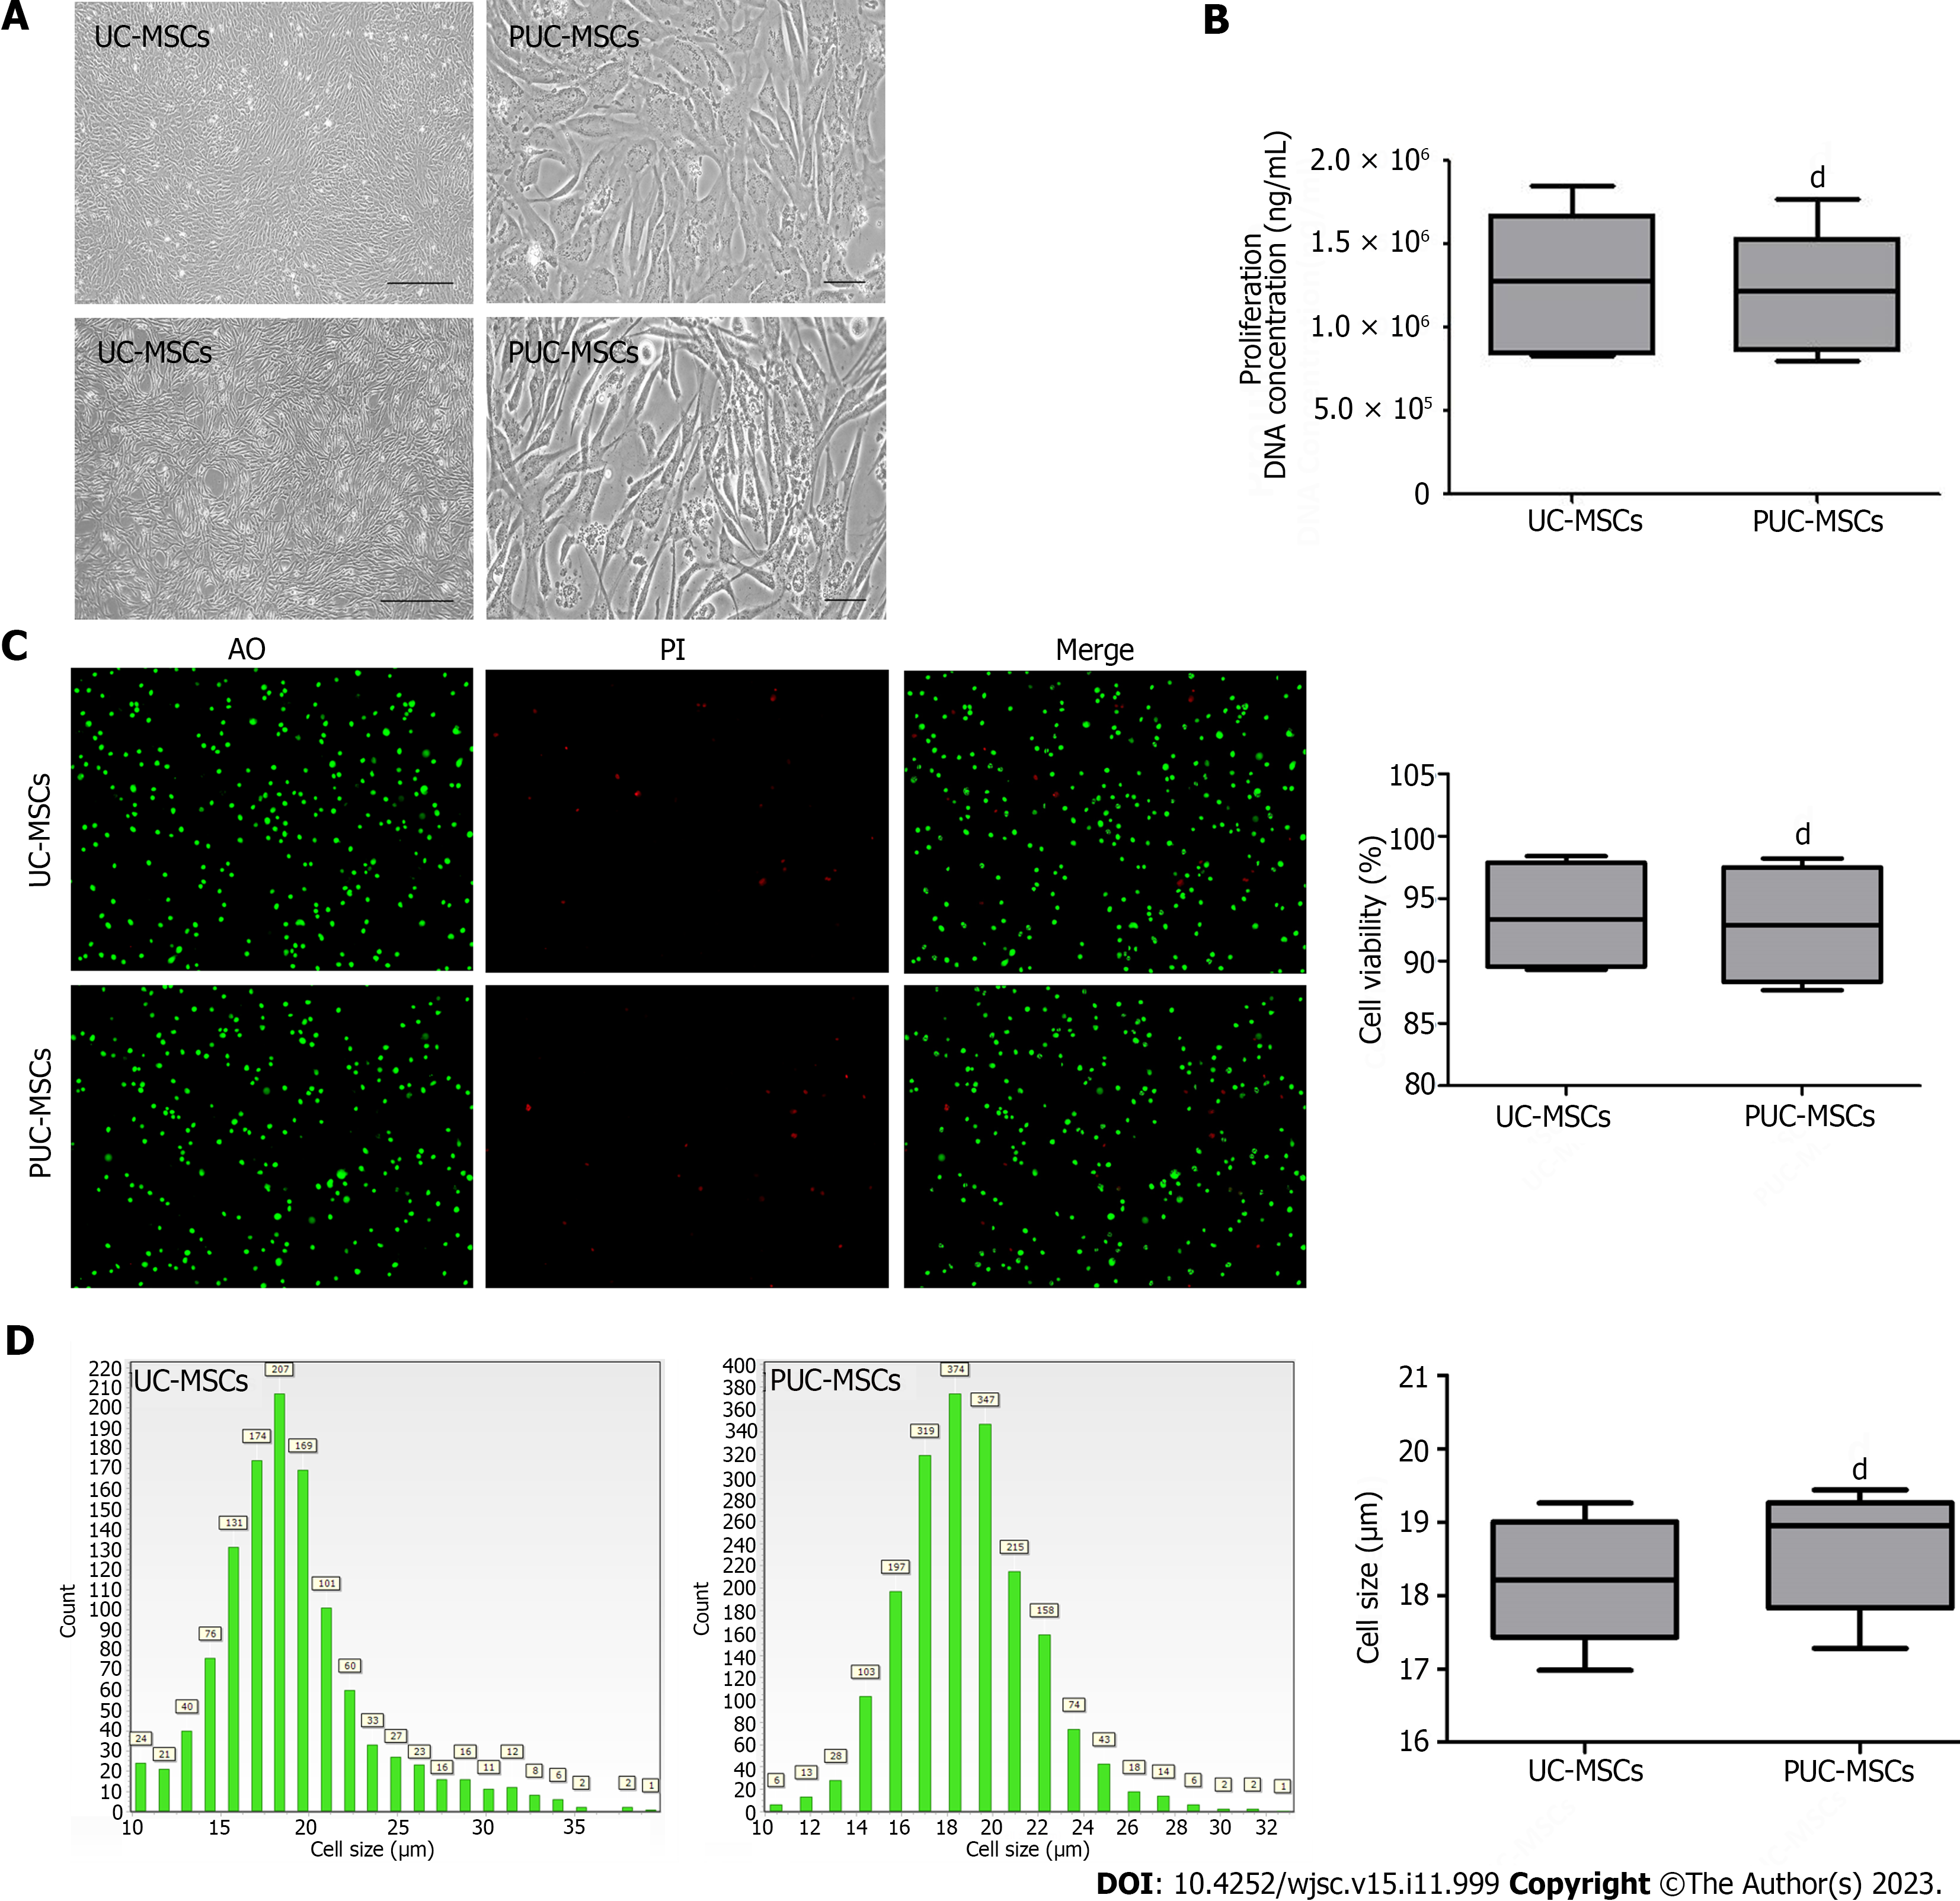
Figure 1 Morphology, viability, proliferation, and size of mesenchymal stem cells. A: Representative micrographs showing umbilical cord mesenchymal stem cells (UC-MSCs) and primed umbilical cord mesenchymal stem cells (PUC-MSCs). Microscopy observation of cell morphology revealed that UC-MSCs were elongated after hypoxia and inflammatory factor pretreatment (Bar = 200 μm); B: The DNA concentration was measured by an ultramicro nucleic acid protein detector. The DNA concentration of PUC-MSCs was not significantly different from that of UC-MSCs, and pretreatment had no effect on their proliferation; C: Cell viability was determined by an acridine orange (AO) propidium iodide (PI) staining cell image analyzer, and no significant difference between UC-MSCs and PUC-MSCs was observed; D: Cell size was determined with a cell imaging analyzer, and the sizes of the UC-MSCs and PUC-MSCs were comparable. ^{d}P > 0.05.

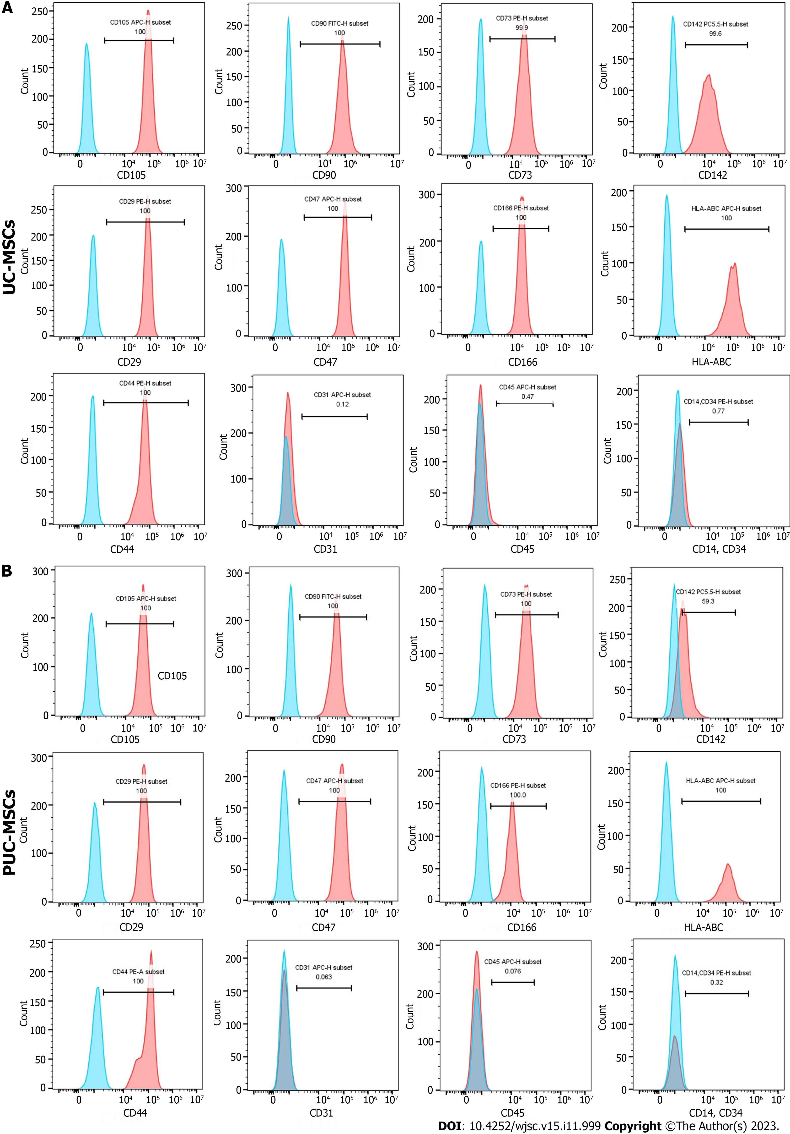
Figure 2 Phenotypes of mesenchymal stem cells were detected by flow cytometry. A: Cell surface markers of umbilical cord mesenchymal stem cells (UC-MSCs); B: Cell surface markers of primed umbilical cord mesenchymal stem cells (PUC-MSCs). The signals from the unstained control cells are shown in blue in the histogram, and the signals from stained cells are shown in red in the histogram. HLA: Human leukocyte antigen.

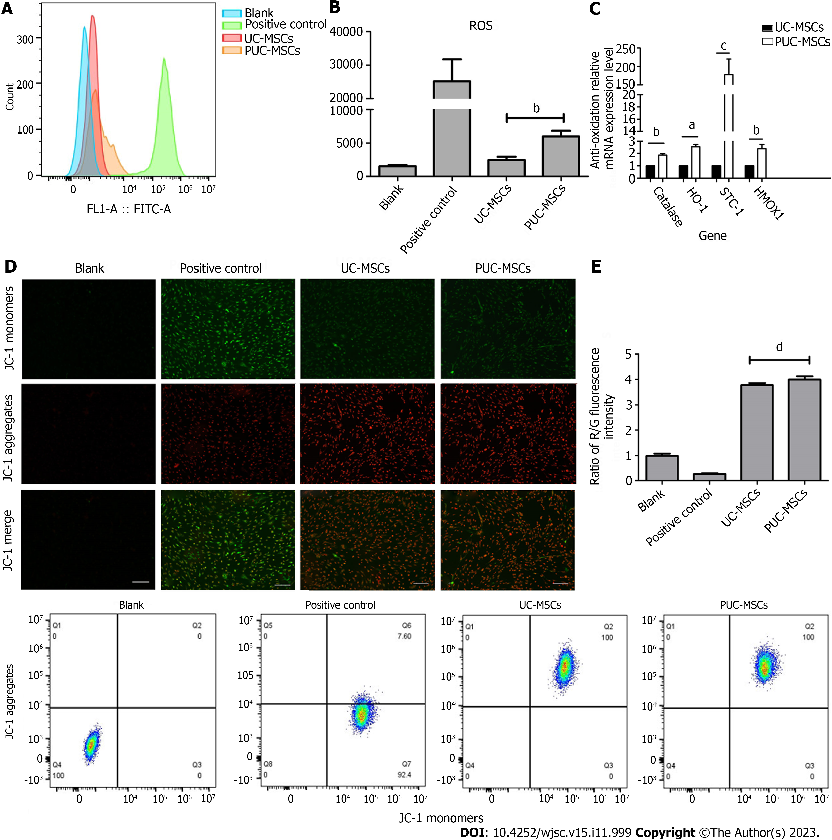
Figure 3 Mitochondrial function. A: Reactive oxygen species (ROS) levels in umbilical cord mesenchymal stem cells (UC-MSCs) and primed UC-MSCs (PUC-MSCs) were analyzed by flow cytometry. The fluorescence intensity of 2,7-dichlorodihydrofluorescein (DCFH-DA) in PUC-MSCs increased by 3-fold compared to UC-MSCs; B: The expression of the antioxidant-related genes catalase, stanniocalcin-1 (STC1), and hemeoxygenase-1 (HOMX1) was increased; C: Representative image showing the mitochondrial membrane potential (MMP) of mesenchymal stem cells stained with JC-1. The red fluorescence of potential-dependent JC-1 aggregation in each group and the green fluorescence of the JC-1 monomer in the cytoplasm after depolarization of the mitochondrial membrane were observed. Fluorescence microscopy showed no significant difference in red and green fluorescence between UC-MSCs and PU-MSCs; Bar = 200 μm; D: Flow cytometry was used to detect the red and green fluorescence of the JC-1 probe in UC-MSCs and PUC-MSCs. There was no difference in the ratios of red and green fluorescence. ªP < 0.05; ^{b}P < 0.01; ^{c}P < 0.001; ^{d}P > 0.05.

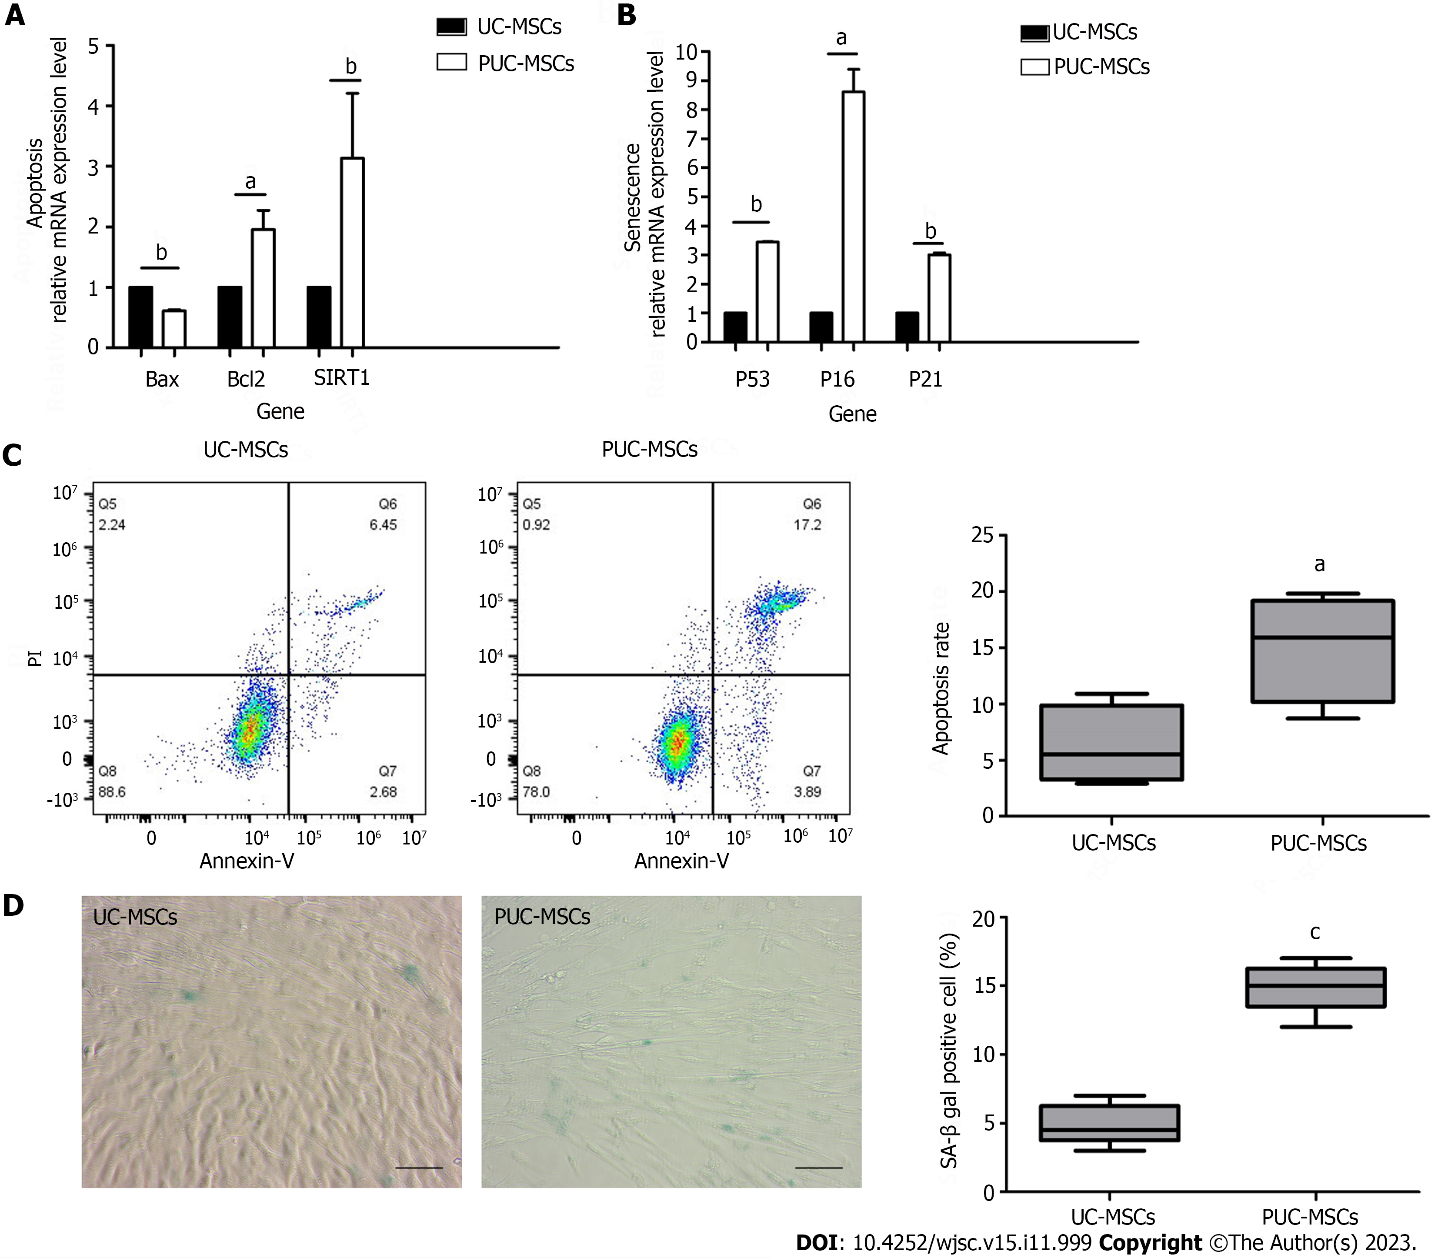
Figure 4 Effects of pretreatment on apoptosis and senescence in mesenchymal stem cells. A: Apoptosis-related gene analysis showed that the expression of B-cell lymphoma 2 (BCL-2)-associated protein (Bax) was decreased and the expression of Bcl2 and silencing information regulator 2-related enzyme 1 (SIRT1) was increased after hypoxia and inflammatory factor pretreatment; B: Expression of P53, P16 and P21 was upregulated after hypoxia and inflammatory factor pretreatment; C: Umbilical cord mesenchymal stem cells (UC-MSCs) and primed UC-MSCs (PUC-MSCs) were stained with Annexin V-FITC apoptosis assay kit reagents and apoptotic cells were detected by flow cytometry. The results showed that the apoptosis index of PUC-MSCs increased; D: Representative images of β-galactosidase (SA-β-gal) staining and quantitative analysis of positive SA-β-gal staining. Compared with that of the UC-MSCs, the number of SA-β-gal-positive PUC-MSCs was significantly increased; Bar = 100 μm. ªP < 0.05; ^{b}P < 0.01; ^{c}P < 0.001.

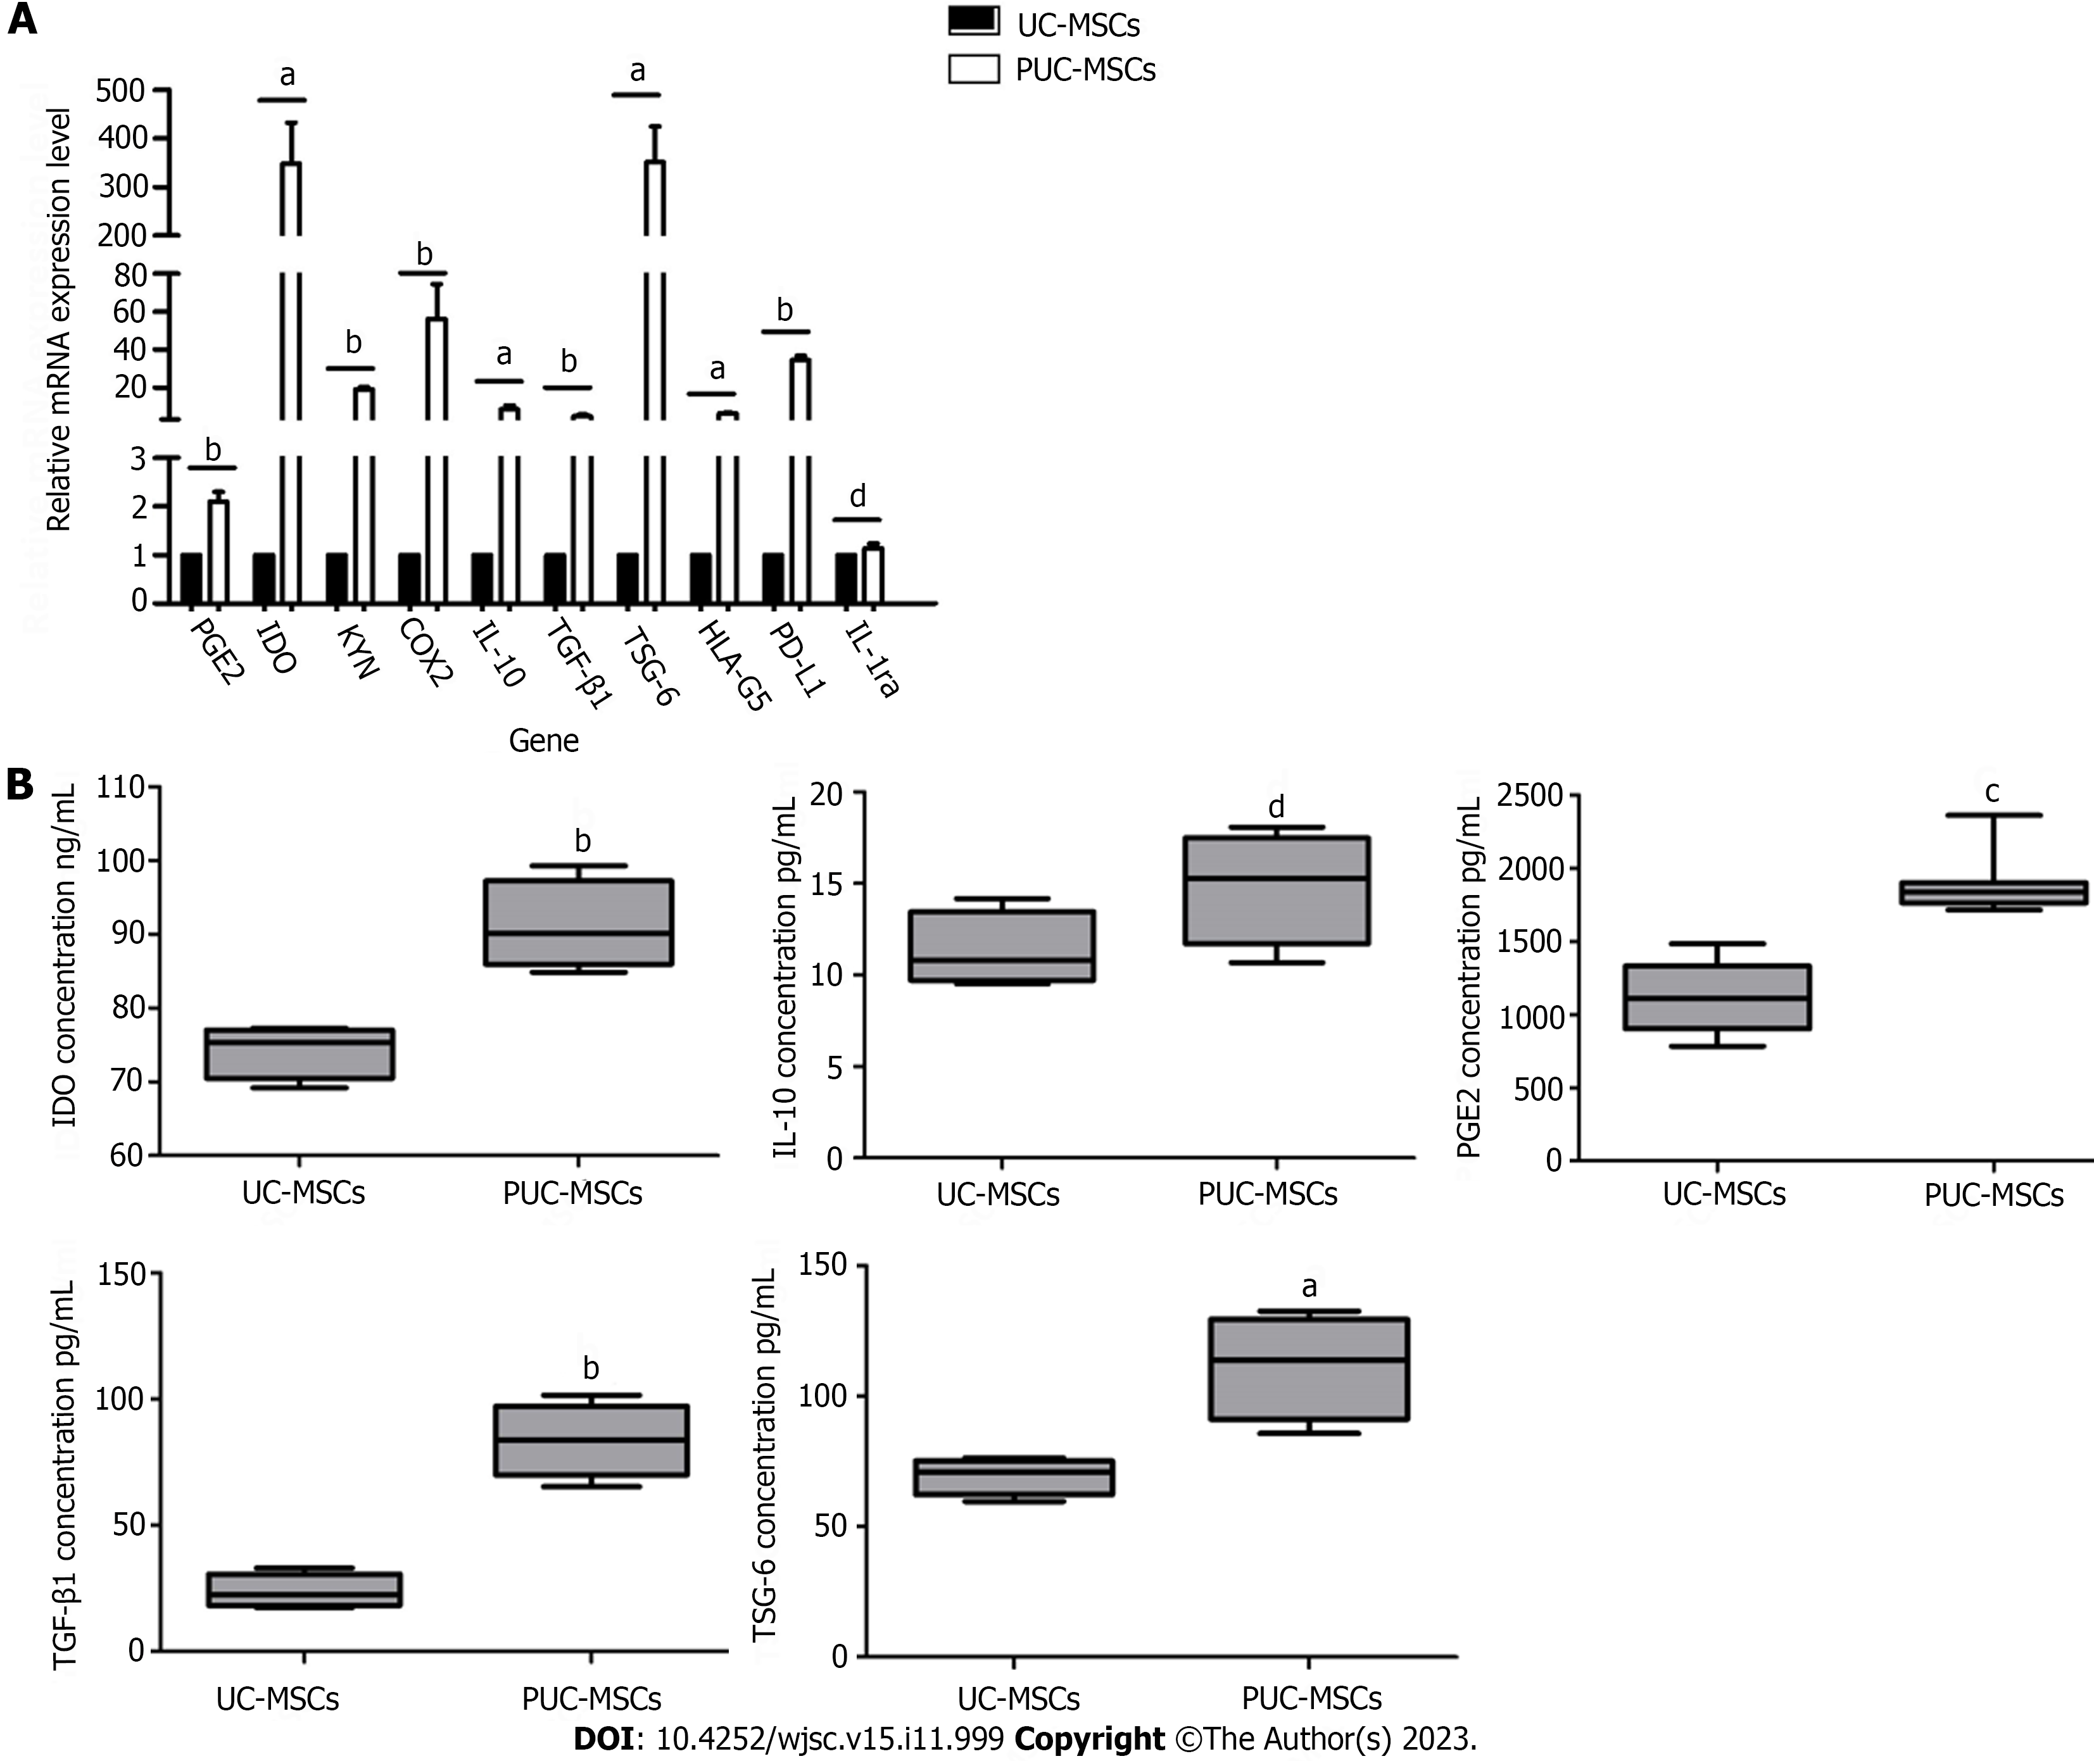
Figure 5 Relative expression of immunomodulatory genes and proteins in umbilical cord mesenchymal stem cells after pretreatment. A: Gene expression levels of umbilical cord mesenchymal stem cells (UC-MSCs) and primed UC-MSCs (PUC-MSCs) were analyzed by quantitative real-time polymerase chain reaction. Expression levels of prostaglandin E2 (PGE2), kynurenine, idoleamine-2,3-dioxygenase (IDO), cyclooxygenaese-2 (COX2), interleukin-10 (IL-10), transforming growth factor-beta 1 (TGF-β1), human leukocyte antigen-G5 (HLA-G5), tumor necrosis factor-α-induced protein-6 (TSG-6) and ligands for programmed cell death 1 (PD-L1) were all increased after hypoxia and inflammatory factor preconditioning. IL-1 receptor antagonist (IL-1ra) was not significantly different between the two groups; B: Levels of immunoregulatory proteins in UC-MSCs and PUC-MSCs were detected by enzyme-linked immunosorbent assay. After hypoxia and inflammatory factor pretreatment, the protein levels of IDO, PGE2, TGF-β1 and TSG-6 were increased, while the expression of IL-10 was not significantly different, as determined via three independent experiments. ªP < 0.05; ^{b}P < 0.01; ^{c}P < 0.001; ^{d}P > 0.05.

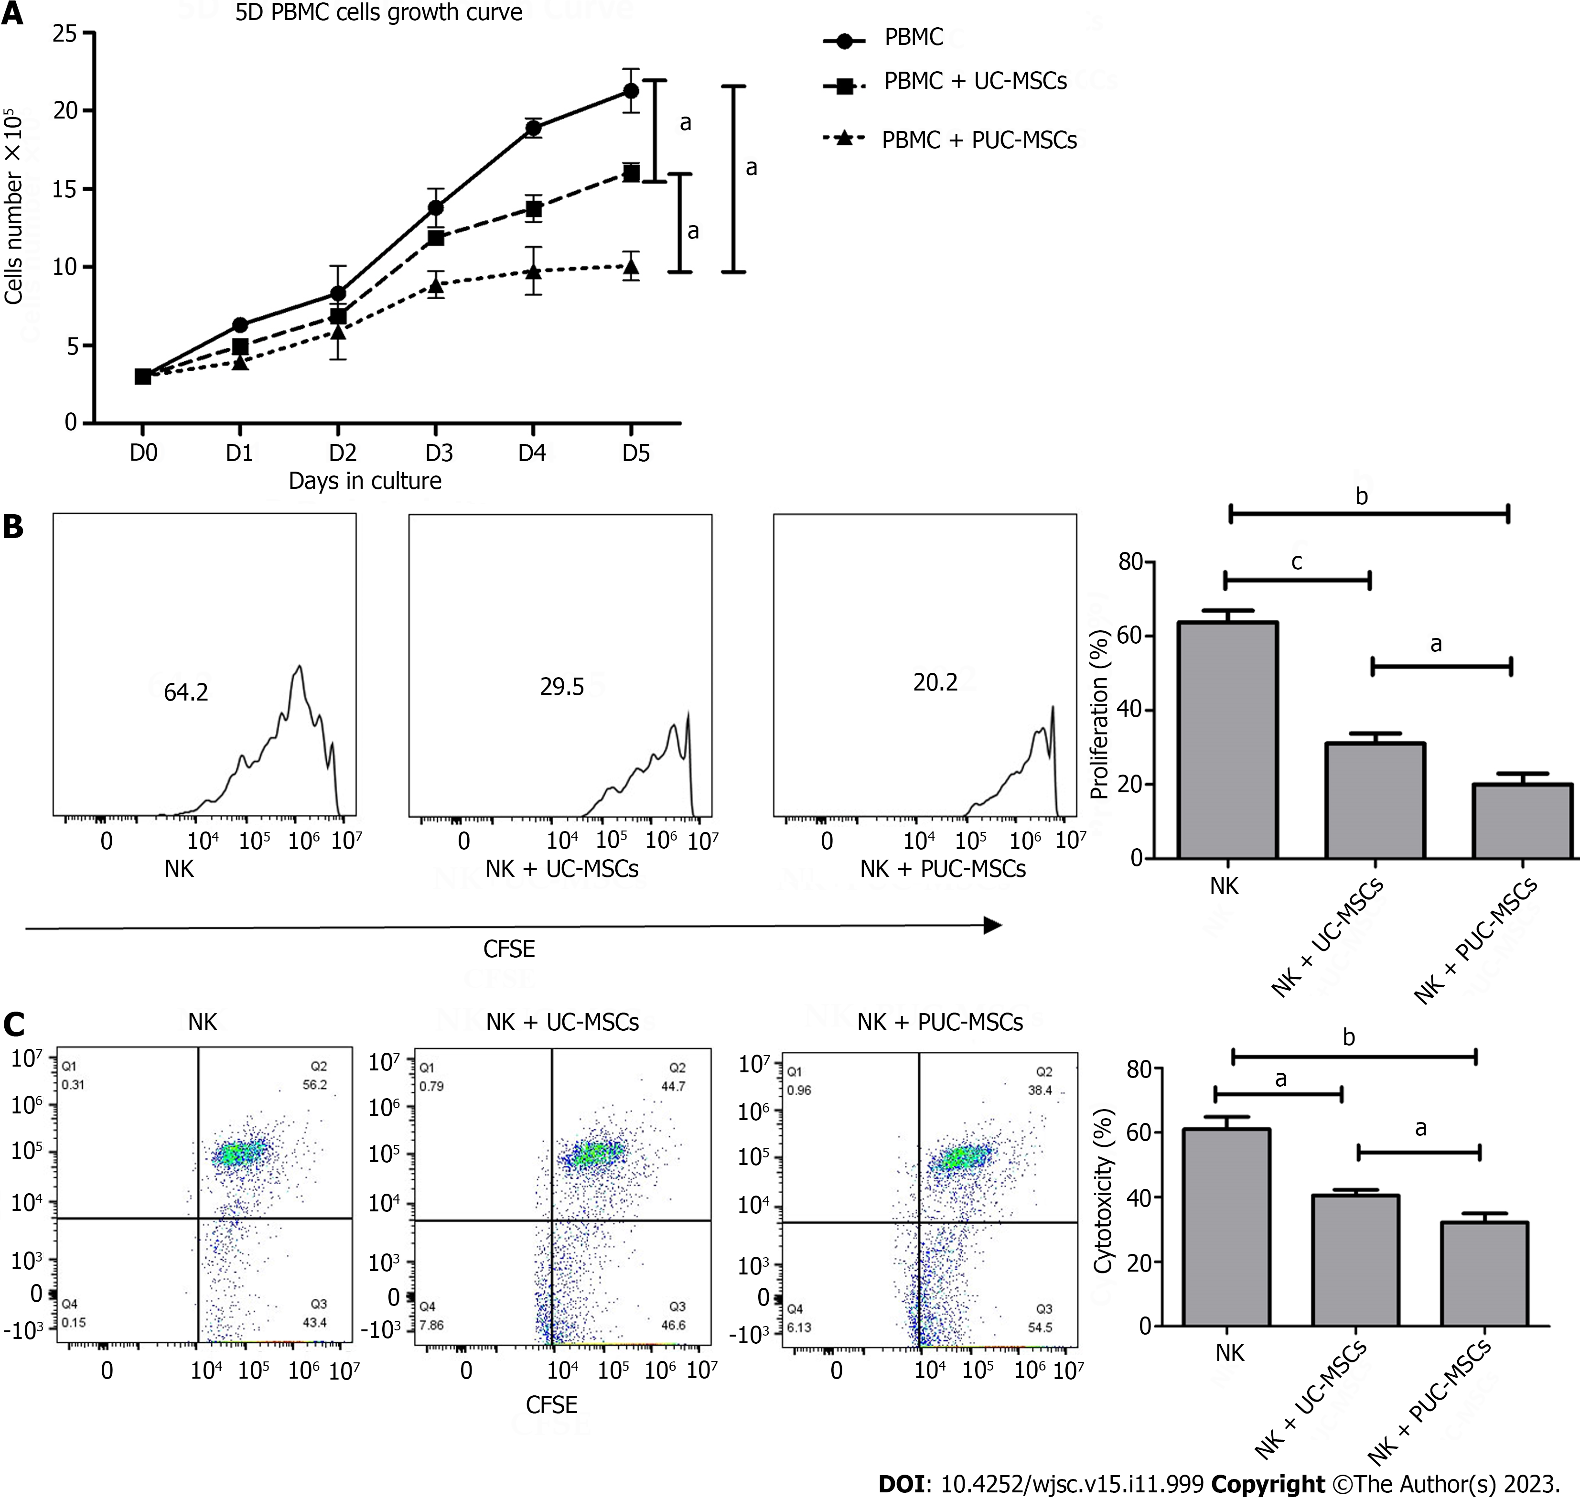
Figure 6 Detection of the immunomodulatory function of umbilical cord mesenchymal stem cells after preconditioning. A: Peripheral blood mononuclear cells (PBMCs) alone or directly exposed to umbilical cord mesenchymal stem cells (UC-MSCs/primed UC-MSCs) for 5 d in a 3:1 ratio. The number of PBMCs in three groups was measured daily and the growth curve was plotted; B: Carboxyfluorescein diacetate succinimidyl ester (CFSE)-stained natural killer (NK) cells were cultured alone or cocultured with UC-MSCs/PUC-MSCs at a 3:1 ratio for 72 h. NK cells were harvested, and the fluorescence intensity of CFSE was measured by flow cytometry to measure the proliferation rate of NK cells; C: NK cells were collected and incubated with CFSE-stained K562 target cells for 4 h at an effector ratio (E:T = 1:5). Effector cell (NK cell)-mediated cytotoxicity of K562 cells was analyzed by flow cytometry. ªP < 0.05; ^{b}P < 0.01; ^{c}P < 0.001; ^{d}P > 0.05.

Table 1 Primer used to amplify the human transcripts during real-time quantitative polymerase chain reaction
Gene | Sequence, 5’ to 3’ | Application
Catalae (human) | Upper: TTCTGTTGAAGATGCGGCGAGAC | qRT-PCR
 | Lower: GGGGTACTTTCCTGTGGCAATGG
STC-1 (human) | Upper: CCATGAGGCGGAGCAGAATGAC | qRT-PCR
 | Lower: GCCGACCTGTAGAGCACTGTTG
HMOX1 (human) | Upper: TGCCAGTGCCACCAAGTTCAAG | qRT-PCR
 | Lower: TGTTGAGCAGGAACGCAGTCTTG
Bax (human) | Upper: ACCAAGAAGCTGAGCGAGTGTC | qRT-PCR
 | Lower: TGTCCACGGCGGCAATCATC
Bcl2 (human) | Upper: TGAGTTCGGTGGGGTCATGT | qRT-PCR
 | Lower: TTCCACAAAGGCATCCCAGC
SIRT1 (human) | Upper: CCTGGACAATTCCAGCCATCT | qRT-PCR
 | Lower: TGCAAAGGAACCATGACACTGA
P53 (human) | Upper: GCCCATCCTCACCATCATCACAC | qRT-PCR
 | Lower: GCACAAACACGCACCTCAAAGC
P16 (human) | Upper: CCGTGGACCTGGCTGAGGAG | qRT-PCR
 | Lower: CGGGGATGTCTGAGGGACCTTC
P21 (human) | Upper: CTTGTACCCTTGTGCCTCGC | qRT-PCR
 | Lower: AGAAGATCAGCCGGCGTTTG
β-actin (human) | Upper: AGTGTGACGTGGACATCCGCA | qRT-PCR
 | Lower: ATCCACATCTGCTGGAAGGTGGAC
PGE2 (human) | Upper: ATTCTCCTGGCTATCATGAC | qRT-PCR
 | Lower: GAACAGGAGGCCTAAGGATG
IDO (human) | Upper: CTCTGCCAAATCCACAGGAAA | qRT-PCR
 | Lower: ATGACCTTTGCCCCACACAT
KYN (human) | Upper: CAAGCGAAGGGTTGTTATGTTGGC | qRT-PCR
 | Lower: GGAACACCAGCAGGCAAAATCAAC
COX2 (human) | Upper: AATCTGGCTGCGGGAACACAAC | qRT-PCR
 | Lower: TGTCTGGAACAACTGCTCATCACC
IL-1ra (human) | Upper: GTGCCTGTCCTGTGTCAAGTCTG | qRT-PCR
 | Lower: GCCACTGTCTGAGCGGATGAAG
IL-10 (human) | Upper: GCCAAGCCTTGTCTGAGATGATCC | qRT-PCR
 | Lower: GCCTTGATGTCTGGGTCTTGGTTC
TGF-β1 (human) | Upper: AGCAACAATTCCTGGCGATACCTC | qRT-PCR
 | Lower: TCAACCACTGCCGCACAACTC
HLA-G5 (human) | Upper: AGAGGAGACACGGAACACCAAGG | qRT-PCR
 | Lower: CAGGTCGCAGCCAATCATCCAC
TSG-6 (human) | Upper: AGAGAAGCACGGTCTGGCAAATAC | qRT-PCR
 | Lower: GCCATCCATCCAGCAGCACAG
PD-L1 (human) | Upper: TGACCTACTGGCATTTGCTGAACG | qRT-PCR
 | Lower: CACTGCTTGTCCAGATGACTTCGG
Bax: B-cell lymphoma 2-associated protein; Bcl2: B-cell lymphoma 2; COX2: Cyclooxygenaese-2; HLA-G5: Human leukocyte antigen-G5; HOMX1: Hemeoxygenase-1; IDO: Idoleamine-2,3-dioxygenase; IL-1ra: Interleukin-1 receptor antagonist; IL-10: Interleukin-10; KYN: Kynurenine; PD-L1: Ligands for programmed cell death 1; PGE2: Prostaglandin E2; qRT-PCR: Quantitative real-time polymerase chain reaction; SIRT1: Silencing information regulator 2-related enzyme 1; STC1: Stanniocalcin-1; TGF-β1: Transforming growth factor-beta 1; TSG-6: Tumor necrosis factor-α-induced protein-6.

Published by Baishideng Publishing Group Inc
7041 Koll Center Parkway, Suite 160, Pleasanton, CA 94566, USA
Telephone: +1-925-3991568
E-mail: bpgoffice@wjgnet.com
Help Desk: https://www.f6publishing.com/helpdesk
https://www.wjgnet.com

© 2023 Baishideng Publishing Group Inc. All rights reserved.

