Name of Journal: World Journal of Hepatology
Manuscript NO: 41931
Manuscript Type: CASE REPORT

Non-uremic calciphylaxis associated with alcoholic hepatitis: A case report

Sammour YM et al. Non-uremic calciphylaxis associated with alcoholic hepatitis

Yasser M Sammour, Haitham M Saleh, Mohamed M Gad, Brayden Healey, Melissa Piliang

Yasser M Sammour, Mohamed M Gad, Melissa Piliang, Heart and Vascular Institute, Cleveland Clinic, Cleveland, OH 44195, United States

Haitham M Saleh, Department of Dermatology, Ain Shams University, Cairo 11566, Egypt

Brayden Healey, College of Osteopathic Medicine of the Pacific-Northwest, Western University of Health Sciences, Lebanon, OR 97355, United States

ORCID number: Yasser M Sammour (0000-0002-1763-9340); Haitham M Saleh (0000-0001-6719-0548); Mohamed M Gad (0000-0003-0218-3317); Brayden Healey (0000-0003-3523-6139); Melissa Piliang (0000-0002-1499-1525).

Author contributions: Sammour YM designed the research and collected the patient’s clinical data; Piliang M provided the patient’s histopathological information; Sammour YM, Saleh HM, Gad MM, Healey B, Piliang M analyzed the data and wrote the paper.

Informed consent statement: A phone consent was obtained from the patient’s husband after the patient passed away. The phone conversation was documented in the patient’s electronic medical record.

Conflict-of-interest statement: No conflict of interest to disclose.

CARE Checklist (2016) statement: The authors have read the CARE Checklist (2016), and the manuscript was prepared and revised according to the CARE Checklist (2016).

Open-Access: This article is an open-access article which was selected by an in-house editor and fully peer-reviewed by external reviewers. It is distributed in accordance with the Creative Commons Attribution Non Commercial (CC BY-NC 4.0) license, which permits others to distribute, remix, adapt, build upon this work non-commercially, and license their derivative works on different terms, provided the original work is properly cited and the use is non-commercial. See: http://creativecommons.org/licenses/by-nc/4.0/

Manuscript source: Unsolicited manuscript

Corresponding author: Yasser M Sammour, MD, Research Fellow, Heart and Vascular Institute, Cleveland Clinic, 9500 Euclid Ave, J2-606, Cleveland, OH 44195, United States. sammouy@ccf.org
Telephone: +1-216-3346144

Received: September 4, 2018
Peer-review started: September 4, 2018
First decision: October 15, 2018
Revised: December 2, 2018
Accepted: January 3, 2019
Article in press:
Published online:

Abstract
BACKGROUND
Calciphylaxis is a form of vascular calcification more commonly associated with renal disease. While the exact mechanism of calciphylaxis is poorly understood, most cases are due to end stage kidney disease. However, it can also be found in patients without kidney disease and in such cases is termed non-uremic calciphylaxis for which have multiple proposed etiologies.

CASE SUMMARY
We describe a case of a thirty-year-old morbidly obese Caucasian female who had a positive history of alcoholic hepatitis and presented with painful calciphylaxis wounds of the abdomen, hips, and thighs. The hypercoagulability panel showed low levels of Protein C and normal Protein S, low Antithrombin III and positive lupus anticoagulant and negative anticardiolipin. Wound biopsy confirmed the diagnosis of non-uremic calciphylaxis in the setting of alcoholic liver disease. The calciphylaxis wounds did not improve when Sodium Thiosulfate was used alone. The patient underwent a series of bedside and surgical debridement. Broad spectrum antibiotics were also used for secondary wound bacterial infections. The patient passed away shortly after due to sepsis and multiorgan failure.

CONCLUSION
Non-uremic Calciphylaxis can occur in the setting of alcoholic liver disease. The treatment of choice is still unknown.

Key words: Calciphylaxis; Alcoholic hepatitis; Vascular calcification; Sodium thiosulfate; Debridement; Case report

© The Author(s) 2019. Published by Baishideng Publishing Group Inc. All rights reserved.

Core tip: In this case report, we present a patient with alcoholic liver disease and low levels of Protein C who developed calciphylaxis and died shortly after due to complications. The pathogenesis is not completely understood but the disruption of calcium-phosphate-byproduct has been implicated to play a role in the disease process. Liver dysfunction can lead to low levels of coagulation inhibitors specifically Protein C and Protein S. The aim of the medical treatment is to lower the calcium-phosphate-byproduct and decrease the vascular calcification. The use of surgical wound debridement is less established.

Sammour YM, Saleh HM, Gad MM, Healey B, Piliang M. Non-uremic calciphylaxis associated with alcoholic hepatitis: A case report. World J Hepatol 2019; In press

INTRODUCTION
Calciphylaxis is a form of vascular calcification commonly associated with renal disease. Patients diagnosed with calciphylaxis usually face an unfavorable prognosis with most patients dying within 12 mo of diagnosis^{[1]}. Although rare, calciphylaxis has an incidence rate of 35 per 10000 patients in the United States with around 70% of the patients being females and the average age of diagnosis being at 50-70 years^{[1]}. The vascular calcification in calciphylaxis results in ischemic skin lesions that are very painful, treatment resistant, and predisposed to bacterial infections. Most patients with calciphylaxis have a diagnosis of end stage renal disease or other forms of kidney dysfunction including chronic kidney disease, kidney transplantation, or acute kidney injury. Some studies have reported calciphylaxis in patients with normal kidney function, termed non-uremic calciphylaxis^{[2,3]}. Other non-uremic causes of calciphylaxis reported in the literature included primary hyperparathyroidism, malignancy, connective tissue disease, and liver disease^{[1]}. As the main clinical manifestation associated with calciphylaxis, the cutaneous lesions can range from minor painful induration to skin necrosis^{[3]}.

CASE PRESENTATION
A thirty-year-old Caucasian female was transferred to our medical center for further management of painful wounds of the abdomen, hips, and thighs. She had a past medical history of alcoholic hepatitis, diagnosed four months earlier with a liver biopsy that showed steatohepatitis and stage 3 fibrosis rather than cirrhosis, and morbid obesity (BMI = 56) status post Roux-en-Y gastric bypass done twelve years ago (unknown pre-surgical BMI). History was negative for diabetes mellitus, kidney dysfunction, autoimmune diseases, hyperparathyroidism or Warfarin intake.
Eight weeks after the onset of alcoholic hepatitis, the patient developed tender erythema on her abdomen, hips, and thighs, which evolved into painful firm subcutaneous nodules.
On admission to our hospital, vital signs were notable for temperature 36.7 °C (98.1 °F), blood pressure 98/41 mmHg, pulse 119 bpm, and respiratory rate 20/min. Physical examination showed woody, indurated, exquisitely tender erythematous plaques on the abdomen, hips, and thighs, with central stellate necrotic eschar and purpura (Figure 1A). She also had anterior abdominal wall edema and bilateral lower extremity pitting edema. Laboratory workup was significant for leukocytosis 24 × 10⁹/L , with absolute neutrophil count 21.5 × 10⁹/L , hemoglobin 7.2 g/dL, MCV 87.5 fL, total protein 6.1 g/dL, albumin 1.7 g/dL, AST 56 U/L, ALT 19 U/L, alkaline phosphatase 172 U/L, total bilirubin 1.8 mg/dL, PT 17.7 s, INR 1.6, APTT 37.3, BUN 15 mg/dL, creatinine 1.32 mg/dL, calcium 8.2 mg/dL, phosphorus 3.9 mg/dL, PTH 22 (normal), and 1,25 OH Vit D3 5.8 (low). The hypercoagulability panel showed low levels of Protein C 33 IU/dL (normal: 76-147), low normal levels of protein S 67 IU/dL (normal: 65-135), low antithrombin III levels, positive lupus anticoagulant and negative anticardiolipin. Wound biopsy showed dermal hemorrhage, dermal vascular occlusion, calcium deposition within the walls of large veins and the surrounding adipose tissue (Figure 2). These pathologic findings, correlated clinically, were most consistent with non-uremic calciphylaxis in the setting of alcoholic liver disease.

FINAL DIAGNOSIS
These pathologic findings, correlated clinically, were most consistent with non-uremic calciphylaxis in the setting of alcoholic liver disease.

TREATMENT
Management consisted of sodium thiosulfate infusions, a series of bedside non-excisional and surgical excisional debridement (Figure 1B); in addition to broad spectrum antibiotic treatment for secondary pseudomonas aeruginosa and morganella morganii wound bacterial infections.

OUTCOME AND FOLLOW-UP
The patient was eventually transferred to a regional burn unit for specialized management of the extensive calciphylaxis wounds. Shortly after, the patient passed away due to sepsis and multiorgan failure.

DISCUSSION
We present a patient with alcoholic liver disease and low normal levels of protein C who developed calciphylaxis and died shortly thereafter from related complications.
The pathogenesis of non-uremic calciphylaxis is not completely understood, but disruption in the calcium-phosphate-byproduct has been implicated to play a role in the disease process^{[4]}. Abnormalities of the Receptor Activator of Nuclear Factor-B (RANK, NF-κB), RANK ligand, and osteoprotegerin may be involved. Factors such as liver disease, hyperparathyroidism and corticosteroid use are known to stimulate the expression of RANK ligand and decrease osteoprotegerin, thus activating NF-κB and ultimately leading to osseous mineral loss and extraosseous mineral deposits^{[5]}.
Liver dysfunction can lead to low levels of coagulation inhibitors, specifically protein C and S, which can lead to vascular injury^{[6]} as well as thromboembolic manifestations such as deep venous thrombosis and pulmonary embolism. Another theory behind the link between liver dysfunction and calciphylaxis could be related to Fetuin-A which is a protein synthesized in the liver that acts as a circulating inhibitor of vascular ossification-calcification. Its effects are mediated by ‘‘calciprotein particles’’, which clear the circulating calcium and phosphorus, and therefore selectively inhibit vascular ossification–calcification without affecting the bone mineralization. Another inhibitor of that pathway is the Matrix-GLA-Protein (MGP). Activated MGP, through Vitamin K dependent carboxylation, forms a complex with fetuin-A which inhibits the Bone-Morphogenetic-Protein-2 induced osteogenic differentiation. Thus, liver dysfunction induced vitamin K deficiency can lead to decreased MGP activity and increased vascular ossification-calcification. This mechanism may also explain the association between calciphylaxis and Warfarin-a Vitamin K antagonist^{[7]}. Total uncarboxylated MGP (t-ucMGP) could reflect arterial calcification, with lower values being associated with more widespread calcium deposits^{[8]}. However, its level was not assessed in our patient; its measurement in future studies may be required.
Gastric bypass surgery can also predispose to Vitamin D and Calcium deficiency with secondary hyperparathyroidism due to alterations in the digestive anatomy which could set up a suitable environment for calciphylaxis^{[9]}.
The abdomen and thighs are the commonest predilection sites for calciphylaxis lesions due to higher adipose tissue density. The lesions present as indurated plaques or nodules that may have ulcerations and eschar and can be associated with livedo reticularis^{[10]}. A tissue biopsy is essential to confirm the diagnosis^{[11,12]}. Histopathologic changes are similar in both uremic and non-uremic calciphylaxis. Microscopic findings include calcification of dermal vessels and diffuse dermal thrombi. Dermal angioplasia was frequently reported^{[13]}. Pseudoxanthoma elasticum-like changes were also reported and described as thickened, fragmented and curled elastic fibers^{[14]}.
Non-uremic calciphylaxis usually has a poor prognosis with mortality that can reach 50%, most commonly due to sepsis^{[4]}. When calciphylaxis affects proximal areas of the body, such as the abdomen, thighs and buttocks, the mortality rates can reach up to 63%. Distal calciphylaxis, however, is associated with lower mortality, being 23% as reported in one series. The presence of associated ulceration carries a mortality rate of greater than 80%^{[1,5]}.
The aim of medical treatment is to reduce the serum calcium-phosphate-byproduct, which can decrease the vascular calcification. Sodium thiosulfate increases the solubility of the calcium deposits and is considered a successful therapy for uremic calciphylaxis^{[1,2]} but our non-uremic patient did not improve when sodium thiosulfate was used alone. Cases of calciphylaxis are usually treated with analgesics, wound care, and proper nutrition. Treatments that have been studied specifically for such cases include sodium thiosulfate, bisphosphonate, and hyperbaric oxygen therapy. The use of surgical wound debridement is less established and the decision is typically individualized based on the patient characteristics and presentation^{[1]}. No effective treatment is available for non-uremic etiologies of calciphylaxis as the pathology remains unclear^{[6]}. Few cases of non-uremic calciphylaxis were reported with alcoholic liver disease and were treated mainly by serial debridement procedures with wound care and sodium thiosulfate infusions^{[6,15]}.
Corticosteroid use was believed to be a predisposing factor for non-uremic calciphylaxis^{[3]}, however, Biswas et al^{[16]} reported a case with acute non-uremic calciphylaxis that improved on systemic corticosteroids. Similarly, Elamin et al^{[17]} described another case of calcifying panniculitis that was treated with a 10 d course of oral prednisone resulting in complete healing.
An increasing number of cases of calciphylaxis have been reported in the setting of alcoholic liver disease. The treatment of choice for those patients is still unknown. There is a gap in literature about the role of extensive debridement of the calciphylaxis wounds and whether it can lead to improvement of the outcomes or cause more complications such as sepsis. At this time, further research and interventional studies need to be done to better understand the mechanism of calciphylaxis in those patients, which can help us develop a more effective treatment regimen.

CONCLUSION
An increasing number of cases of calciphylaxis in the setting of liver failure have recently been reported, but no primary treatment option has been discovered. Surgical debridement and sodium thiosulfate were utilized in this patient, but success was unable to be evaluated as the patient passed from complications before healing could occur. Future studies should expand upon and investigate other therapeutic options for management of non-uremic calciphylaxis in the setting of liver failure.
REFERENCES
1 Nigwekar SU, Thadhani R, Brandenburg VM. Calciphylaxis. N Engl J Med 2018; 378: 1704-1714 [PMID: 29719190 DOI: 10.1056/NEJMra1505292]
2 Chan SQ, Wagner I, Vittor GS. Calciphylaxis in the absence of renal failure and hyperparathyroidism in a nonagenarian. BMJ Case Rep 2015; 2015 [PMID: 25878225 DOI: 10.1136/bcr-2014-205483]
3 Nigwekar SU, Wolf M, Sterns RH, Hix JK. Calciphylaxis from nonuremic causes: a systematic review. Clin J Am Soc Nephrol 2008; 3: 1139-1143 [PMID: 18417747 DOI: 10.2215/CJN.00530108]
4 Hammadah M, Chaturvedi S, Jue J, Buletko AB, Qintar M, Madmani ME, Sharma P. Acral gangrene as a presentation of non-uremic calciphylaxis. Avicenna J Med 2013; 3: 109-111 [PMID: 24327971 DOI: 10.4103/2231-0770.120504]
5 Sibai H, Ishak RS, Halawi R, Otrock ZK, Salman S, Abu-Alfa A, Kharfan-Dabaja MA. Non-uremic calcific arteriolopathy (calciphylaxis) in relapsed/refractory Hodgkin's lymphoma: a previously unreported association. J Clin Oncol 2012; 30: e88-e90 [PMID: 22231039 DOI: 10.1200/JCO.2011.39.4551]
6 Shah N, Arshad HMS, Li Y, Silva R. Calciphylaxis in the Setting of Alcoholic Cirrhosis: Case Report and Literature Review. J Investig Med High Impact Case Rep 2017; 5: 2324709617710039 [PMID: 28589153 DOI: 10.1177/2324709617710039]
7 Oliveira TM, Frazão JM. Calciphylaxis: from the disease to the diseased. J Nephrol 2015; 28: 531-540 [PMID: 25835730 DOI: 10.1007/s40620-015-0192-2]
8 Epstein M. Matrix Gla-Protein (MGP) Not Only Inhibits Calcification in Large Arteries But Also May Be Renoprotective: Connecting the Dots. EBioMedicine 2016; 4: 16-17 [PMID: 26981564 DOI: 10.1016/j.ebiom.2016.01.026]
9 Allegretti AS, Nazarian RM, Goverman J, Nigwekar SU. Calciphylaxis: a rare but fatal delayed complication of Roux-en-Y gastric bypass surgery. Am J Kidney Dis 2014; 64: 274-277 [PMID: 24787764 DOI: 10.1053/j.ajkd.2014.02.029]
10 Hesse A, Herber A, Breunig M. Calciphylaxis in a patient without renal failure. JAAPA 2018; 31: 28-30 [PMID: 29957603 DOI: 10.1097/01.JAA.0000532115.75508.72]
11 Kramer ON, Garden BC, Altman I, Braniecki M, Aronson IK. The Signs Aligned: Nonuremic Calciphylaxis. Am J Med 2017; 130: 1051-1054 [PMID: 28601542 DOI: 10.1016/j.amjmed.2017.05.006]
12 Fergie B, Valecha N, Miller A. A Case of Nonuremic Calciphylaxis in a Caucasian Woman. Case Rep Dermatol Med 2017; 2017: 6831703 [PMID: 28191356 DOI: 10.1155/2017/6831703]
13 Chen TY, Lehman JS, Gibson LE, Lohse CM, El-Azhary RA. Histopathology of Calciphylaxis: Cohort Study With Clinical Correlations. Am J Dermatopathol 2017; 39: 795-802 [PMID: 29053546 DOI: 10.1097/DAD.0000000000000824]
14 Nathoo RK, Harb JN, Auerbach J, Guo R, Vincek V, Motaparthi K. Pseudoxanthoma elasticum-like changes in nonuremic calciphylaxis: Case series and brief review of a helpful diagnostic clue. J Cutan Pathol 2017; 44: 1064-1069 [PMID: 28869660 DOI: 10.1111/cup.13034]
15 Akhtar E, Parikh DA, Torok NJ. Calciphylaxis in a Patient With Alcoholic Cirrhosis. ACG Case Rep J 2015; 2: 209-210 [PMID: 26203440 DOI: 10.14309/crj.2015.60]
16 Biswas A, Walsh NM, Tremaine R. A Case of Nonuremic Calciphylaxis Treated Effectively With Systemic Corticosteroids. J Cutan Med Surg 2016; 20: 275-278 [PMID: 26700539 DOI: 10.1177/1203475415624104.]
17 Elamin EM, McDonald AB. Calcifying panniculitis with renal failure: a new management approach. Dermatology 1996; 192: 156-159 [PMID: 8829502 DOI: 10.1159/000246347]

P-Reviewer: Farshadpour F, Malnick SDH, Inoue K S-Editor: Cui LJ
L-Editor: E-Editor:

Specialty type: Gastroenterology and hepatology
Country of origin: United States
Peer-review report classification
Grade A (Excellent): 0
Grade B (Very good): B
Grade C (Good): C, C
Grade D (Fair): 0
Grade E (Poor): 0

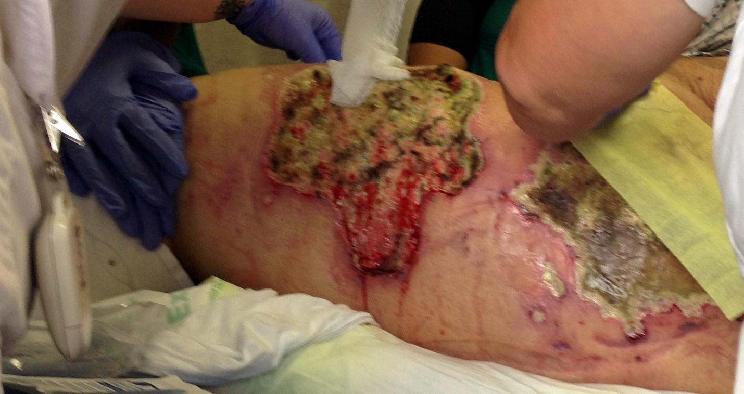
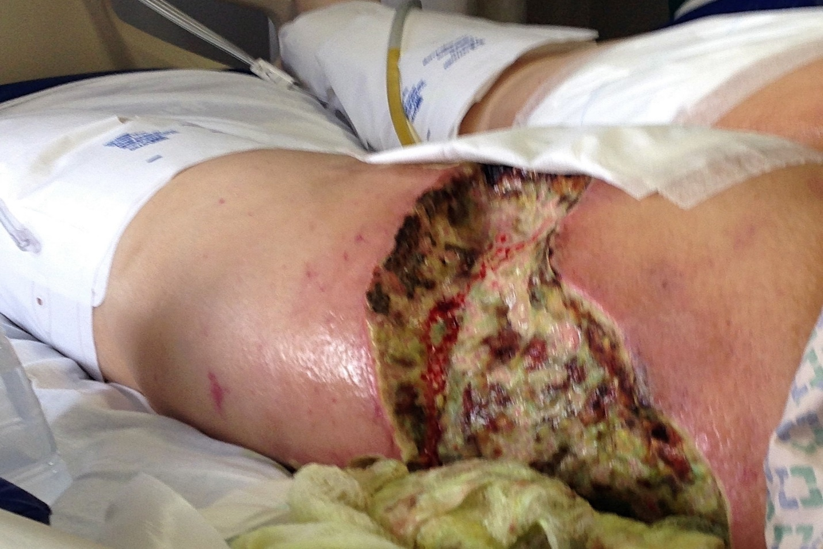
Figure 1 Calciphylaxis wounds in the thigh. A: Before debridement; B: After debridement.

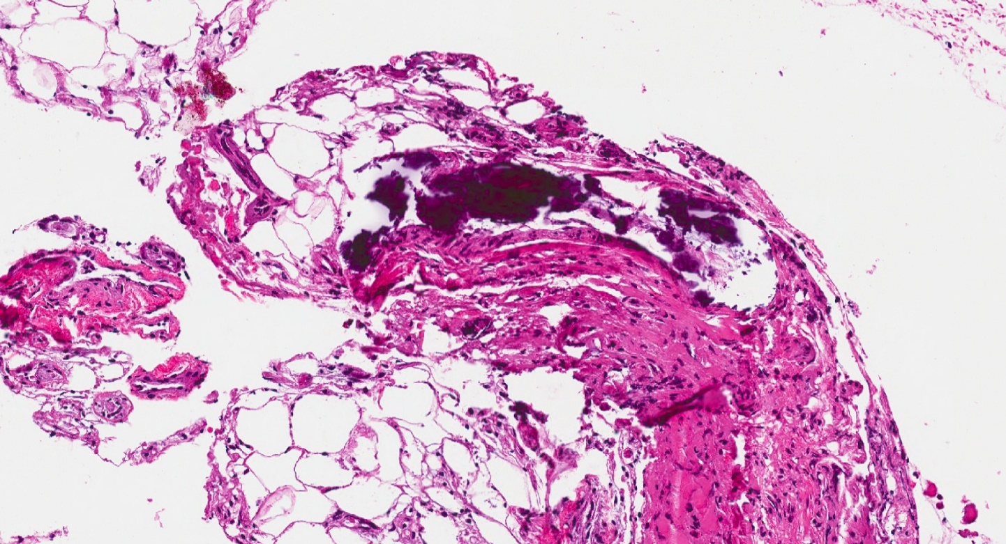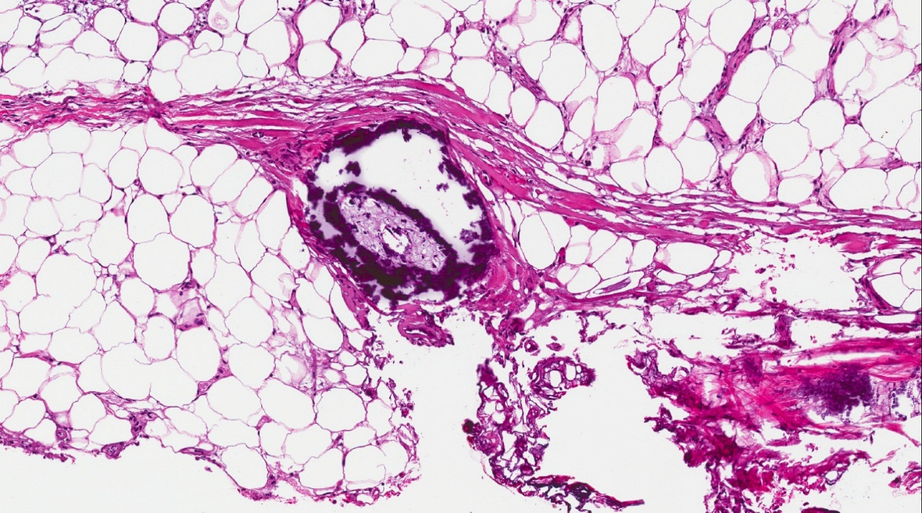
Figure 2 Dermal vascular occlusion and calcium deposition within the walls of large veins and the surrounding adipose tissue.

