Name of Journal: World Journal of Clinical Cases
Manuscript NO: 72169
Manuscript Type: CASE REPORT

Hem-o-lok clip migration to the common bile duct after laparoscopic common bile duct exploration: A case report

Liu DR et al. Post-operative clip migration to common bile duct

Da-Ren Liu, Jin-Hong Wu, Jiang-Tao Shi, Huan-Bing Zhu, Chao Li

Da-Ren Liu, Jin-Hong Wu, Jiang-Tao Shi, Huan-Bing Zhu, Chao Li, Department of Hepatobiliary Surgery, The Second Affiliated Hospital, Zhejiang University School of Medicine, Hangzhou 310009, Zhejiang Province, China

Author contributions: Liu DR, Wu JH, and Shi JT were the patient’s surgeons, reviewed the literature, and drafted the manuscript (contributed equally to this article); Zhu HB and Li C reviewed the literature and contributed to manuscript drafting; Liu DR and Li C were responsible for the revision of the manuscript for important intellectual content; All authors issued final approval for the version to be submitted.

Supported by Medical and Health Technology Plan of Zhejiang Province, No. 2019RC179.

Corresponding author: Chao Li, MD, PhD, Chief Doctor, Surgeon, Surgical Oncologist, Department of Hepatobiliary Surgery, The Second Affiliated Hospital, Zhejiang University School of Medicine, No. 88 Jiefang Road, Hangzhou 310009, Zhejiang Province, China. zjlichaoweb@zju.edu.cn

Received: October 11, 2021
Revised: March 18, 2022
Accepted: May 14, 2022
Published online: July 6, 2022

Abstract
BACKGROUND
Laparoscopic cholecystectomy (LC) and laparoscopic common bile duct exploration (LCBDE) has been widely used for management of gallbladder and common bile duct (CBD) stones. Post-operative clip migration is a rare complication of laparoscopic biliary surgery, which can serve as a nidus for stone formation and cause recurrent cholangitis.

CASE SUMMARY
A 59-year-old female was admitted to hospital because of fever and acute right upper abdominal pain. She has a history of LC and had a LCBDE surgery 2 mo ago. Physical examination revealed tenderness in the upper quadrant of right abdomen. Computed tomography scan demonstrated a high-density shadow at the distal CBD, which was considered as migrated clips. The speculation was confirmed by endoscopic retrograde cholangiopancreatography examination, and two displaced Hem-o-lok clips were removed with a stone basket. No fever or abdominal pain presented after the operation. In addition to the case report, literature regarding surgical clip migration after laparoscopic biliary surgery was reviewed and discussed.

CONCLUSION
Incidence of postoperative clip migration may be reduced by using clips properly and correctly; however, new methods should be explored to occlude cystic duct and vessels. If a patient with a past history of LC or LCBDE presents with features of sepsis and recurrent upper quadrant pain, clip migration must be considered as one of the differential diagnosis.

Key Words: Laparoscopic cholecystectomy; Laparoscopic common bile duct exploration; Surgical clip; Postoperative migration; Case report

©The Author(s) 2022. Published by Baishideng Publishing Group Inc. All rights reserved.

Citation: Liu DR, Wu JH, Shi JT, Zhu HB, Li C. Hem-o-lok clip migration to the common bile duct after laparoscopic common bile duct exploration: A case report. World J Clin Cases 2022; 10(19): 6548-6554
URL: https://www.wjgnet.com/2307-8960/full/v10/i19/6548.htm
DOI: https://dx.doi.org/10.12998/wjcc.v10.i19.6548

Core Tip: Surgical clip migration is a rare complication of laparoscopic biliary surgery. Herein, we report a case of Hem-o-lok clip migration into the common bile duct after laparoscopic cholecystectomy and laparoscopic common bile duct exploration operation which were removed by a basket in endoscopic retrograde cholangiopancreatography. Furthermore, literature regarding clip migration post-laparoscopic biliary surgery were reviewed. We suggest that the incidence of postoperative clip migration may be reduced by using clips properly and correctly; however, new methods should be explored to occlude cystic duct and vessels.

INTRODUCTION
Gallbladder stone combined with common bile duct (CBD) stone is a common disease in developed countries, with a prevalence ranging from 8% to 18%^{[1]}. Laparoscopic cholecystectomy (LC) and laparoscopic common bile duct exploration (LCBDE) are widely used procedures for the treatment of cholelithiasis combined with choledocholithiasis. Clearly dissecting the Carlo’s triangle and properly closing the cystic artery and cystic duct are the key steps of this surgery. Hem-o-lok clips are commonly used to ligate gallbladder blood vessels and cystic ducts. Complications of LCBDE include bile leakage, stone recurrence, infection, bleeding, and postoperative clip migration.
Postoperative clip migration is a rare but well-established complication of laparoscopic biliary surgery. The clip may migrate to CBD^{[2-12]}, T-tube sinus wall^{[11,13]}, duodenum^{[8,14]}, or the pulmonary artery^{[15]}. Herein, we report a case of clip migration after LC and LCBDE and review cases of clip migration reported in literatures after LC or LCBDE, hoping to draw lessons from these cases.

CASE PRESENTATION
Chief complaints
A 59-year-old woman presented to the emergency department of our hospital complaining of fever and right upper abdominal pain for 3 d.

History of present illness
The patient’s symptoms started 3 d ago with fever and acute right upper abdominal pain, which had worsened in the last 24 h.

History of past illness
The patient had a history of LC and LCBDE surgery 2 mo ago.

Personal and family history
The patient has no personal and family history.

Physical examination
The patient’s temperature was 38.9 °C, heart rate was 93 bpm, respiratory rate was 18 breaths per minute, blood pressure was 105/60 mmHg, and oxygen saturation in room air was 99%. Physical examination revealed that the abdomen was soft, but tenderness was present in the right upper quadrant of abdomen without rebound tenderness.

Laboratory examinations
Laboratory examination showed aspartate aminotransferase 639 U/L, alanine aminotransferase 681 U/L, and total bilirubin 74 μmol/L. Blood routine examination showed a white cell count of 16.1 × 10⁹/L, a neutrophil percentage of 89%, and a hemoglobin of 135 g/L.

Imaging examinations
Computed tomography scan demonstrated a slightly dilated common bile duct with a high-density shadow at the distal CBD, which was considered as migrated clips (Figure 1). Therefore, endoscopic retrograde cholangiopancreatography (ERCP) was performed, which confirmed that Hem-o-lok clips migrated into the CBD (Figure 2A).

FINAL DIAGNOSIS
Acute cholangitis caused by migrated Hem-o-lok clips applied in the LC and LCBDE surgery.

TREATMENT
Two displaced Hem-o-lok clips were removed by stone basket after sphincterotomy through ERCP (Figure 2B and C).

OUTCOME AND FOLLOW-UP
No fever or abdominal pain was presented after the operation, and the patient was discharged 3 d later in a stable condition. There was no abdominal pain, jaundice, abdominal pain, or other discomfort during the follow-up period.

DISCUSSION
Choledocholithiasis is a common disease, with an incidence increasing year by year. Comparing to open surgery, the LCBDE is safe, effective, minimally invasive, and has an faster recovery rate^{[16]}. Advances in laparoscopy have made LC and LCBDE a widely accepted strategy for patients with gallstones and choledocholithiasis. In our practice, the Carlo's triangle was initially dissected to expose cystic duct and cystic artery, and they were separated and clipped with three and one Hem-o-lok clips, respectively. Secondly, the CBD was exposed, and the anterior aspect wall of CBD was cut with electroacupuncture 1 cm below the confluence of cystic duct and CBD, and the cholesterol crystals were removed by basket under direct view. Thirdly, a 24# Silicone T-tube was placed into the CBD, which was then sutured with a 4-0 Vicryl. Finally, the gallbladder was resected using electroacupuncture, and T-tube was set on the right abdominal through the incision of rectus abdominis. Postoperative clip migration is a rare complication of laparoscopic cystic and biliary operation, which has been occasionally presented as case report. Migrated clips in the bile duct may function as a nidus for gallstone formation, leading to biliary obstruction, acute pancreatitis, duodenal ulcer, biliary-colonic fistula, and subdiaphragmatic abscess. Any type of surgical clip has a risk of migration. If a patient with a history of receiving LC or LCBDE presents with features of recurrent upper quadrant pain, with or without sepsis or liver function test derangement, clip displacement must be considered as one of the differential diagnosis.
We searched through MEDLINE, PubMed, Scopus, Web of Science, Google Scholar, and the CNKI databases using the keywords ’clip migration and laparoscopic cholecystectomy (LC) or clip migration and laparoscopic common bile duct exploration (LCBDE)’ from 1990 to 2021. A total of 14 articles including 36 cases about clip migration after LC or LCBDE have been reported^{[2-15]} (Table 1). Twenty-five cases received LC and LCBDE (69.4%) and 11 cases received LC (30.6%) as previous laparoscopic surgery. The age of patients ranged from 31-years-old to 83-years-old. Symptoms occurred from 1 mo to 7 years after laparoscopic surgery. Nineteen patients remained asymptomatic that were mainly diagnosed by choledochoscopy through T-tube sinus tract. The most common manifestations due to clip migration were abdominal pain, fever, and jaundice, which were similar to those of non-iatrogenic choledocholithiasis. In 27 cases, the clips wedged into the CBD (75%)， while the clips became a part of T-tube sinus in 6 cases (16.7%) and the clips migrated into duodenum in 2 cases (5.6%). The types of clips include Hem-o-lok (61.1%), metallic (16.7%), and absorbable (8.3%). Initial treatment included removing clips by basket in ERCP, endoscopic removal, and observation, while surgical treatment was required in 6 cases.
The mechanism of postoperative clip migration remains controversial; however, some possible hypotheses of pathogenesis were suggested. Firstly, inappropriate application of surgical clips, including improper placement of clips and incomplete closure of cyst duct may lead to the formation of biloma, which would be reabsorbed later into the bile duct and leave the clips behind^{[2]}. Secondly, the compression of clips to the bile duct wall caused by the surrounding structures or a pulled cystic duct during operation may result in clip corroding into the lumen of CBD^{[17]}. Additionally, the number of clips used in surgery is also an important factor^{[5,18]}. Thirdly, bile leakage caused by an intraoperative bile tract injury and the subsequent inflammation make surrounding tissues brittle, which may induce clips to invade into the biliary tract through the incision of CBD mechanically^{[17]}. In addition, the pressure exerted from abdominal organ movements accelerates the process of clip migration^{[10,18]}. Finally, the rejection response by the immune system to clips as a foreign body may also contribute to the displacement of surgical clips^{[4]}.
In order to reduce the incidence of postoperative clip migration, all technical factors in surgery should be considered. During the operation, the relationship of Calot’s triangle should be carefully confirmed, and the placement of surgical clips should not be too close to the CBD; the number of clips should be minimized, and unnecessary surgical procedures should be avoided, such as the blind application of clips to control bleeding^{[19]}. It has also been suggested that the risk of postoperative clip migration can be lowered by using absorbable clips when compared with non-absorbable clips; however, reports about absorbable clip migration still exists^{[4,8]}, including a report by Cetta et al^{[20]}, which suggested that absorbable clips could also cause postoperative clip migration and be a nidus of stone formation. Furthermore, new vessel and duct sealing technologies such as a Harmonic scalpel can be applied as an alternative to clips in laparoscopic operation. The Harmonic scalpel is well accepted as a reasonable alternative for closure of cystic duct, which occupies the advantages of shorter operation time, fewer complications, and avoiding clip migration^{[21]}.

CONCLUSION
In summary, although postoperative clip migration is rare, it is a well-recognized phenomenon and cannot be ignored. Any type of surgical clip has a risk of displacement. Using clips properly and correctly, as well as exploring new methods to occluded cystic duct may help to reduce the incidence of postoperative clip migration. If patients with a past history of LC with or without CBD exploration present with features of sepsis and recurrent upper quadrant pain, with or without derangement of liver function test, clip migration may be considered as one of the differential diagnoses.

REFERENCES
1 Manes G, Paspatis G, Aabakken L, Anderloni A, Arvanitakis M, Ah-Soune P, Barthet M, Domagk D, Dumonceau JM, Gigot JF, Hritz I, Karamanolis G, Laghi A, Mariani A, Paraskeva K, Pohl J, Ponchon T, Swahn F, Ter Steege RWF, Tringali A, Vezakis A, Williams EJ, van Hooft JE. Endoscopic management of common bile duct stones: European Society of Gastrointestinal Endoscopy (ESGE) guideline. Endoscopy 2019; 51: 472-491 [PMID: 30943551 DOI: 10.1055/a-0862-0346]
2 Raoul JL, Bretagne JF, Siproudhis L, Heresbach D, Campion JP, Gosselin M. Cystic duct clip migration into the common bile duct: a complication of laparoscopic cholecystectomy treated by endoscopic biliary sphincterotomy. Gastrointest Endosc 1992; 38: 608-611 [PMID: 1397923 DOI: 10.1016/s0016-5107(92)70531-8]
3 Alberts MS, Fenoglio M, Ratzer E. Recurrent common bile duct stones containing metallic clips following laparoscopic common bile duct exploration. J Laparoendosc Adv Surg Tech A 1999; 9: 441-444 [PMID: 10522543 DOI: 10.1089/Lap.1999.9.441]
4 Liu Y, Ji B, Wang Y, Wang G. Hem-o-lok clip found in common bile duct after laparoscopic cholecystectomy and common bile duct exploration: a clinical analysis of 8 cases. Int J Med Sci 2012; 9: 225-227 [PMID: 22408572 DOI: 10.7150/ijms.4023]
5 Tsai CH, Tsai MC, Lin CC. Unusual cause of abdominal pain after laparoscopic cholecystectomy. Gastroenterology 2013; 144: e8-e9 [PMID: 23623876 DOI: 10.1053/j.gastro.2013.02.044]
6 Rawal KK. Migration of Surgical Clips into the Common Bile Duct after Laparoscopic Cholecystectomy. Case Rep Gastroenterol 2016; 10: 787-792 [PMID: 28203125 DOI: 10.1159/000453658]
7 Qu JW, Wang GY, Yuan ZQ, Li KW. Hem-o-lok Clips Migration: An Easily Neglected Complication after Laparoscopic Biliary Surgery. Case Rep Surg 2017; 2017: 7279129 [PMID: 29062580 DOI: 10.1155/2017/7279129]
8 Zheng Y, Wang Y, Bai X, Liu D, Li F. Letter to the editor on "The cystic duct and artery were clipped using a clip applier". Nonmetal clip migration after laparoscopic cholecystectomy. Asian J Surg 2018; 41: 585-587 [PMID: 30316664 DOI: 10.1016/j.asjsur.2018.09.001]
9 Barabino M, Luigiano C, Piccolo G, Pellicano R, Polizzi M, Giovenzana M, Santambrogio R, Pisani Ceretti A, Andreatta E, Palamara MA, Giacobbe G, Consolo P, Opocher E. Hem-o-Lok clip migration into the duodenum after laparoscopic digestive surgery: a systematic review. Minerva Chir 2019; 74: 496-500 [PMID: 31958943 DOI: 10.23736/S0026-4733.19.08152-5]
10 Roh YJ, Kim JW, Jeon TJ, Park JY. Common bile duct stone development due to a Hem-o-lok clip migration: a rare complication of laparoscopic cholecystectomy. BMJ Case Rep 2019; 12 [PMID: 31352393 DOI: 10.1136/bcr-2019-230178]
11 Pang L, Yuan J, Zhang Y, Wang Y, Kong J. Clip-stone and T clip-sinus: A clinical analysis of six cases on migration of clips and literature review from 1997 to 2017. J Minim Access Surg 2019; 15: 192-197 [PMID: 29794362 DOI: 10.4103/jmas.JMAS_53_18]
12 Kihara Y, Takeda Y, Ohmura Y, Katsura Y, Shinke G, Ikeshima R, Katsuyama S, Kawai K, Hiraki M, Sugimura K, Masuzawa T, Takeno A, Hata T, Murata K. Migration of non-absorbable polymer clips in hepato-biliary-pancreatic surgery: a report of four cases. Surg Case Rep 2021; 7: 183 [PMID: 34390417 DOI: 10.1186/s40792-021-01269-6]
13 Wang YL, Zhang GY, Wang L, Hu SY. Metallic clip migration to T-tube sinus tract after laparoscopic choledochotomy. Acta Chir Belg 2009; 109: 242-244 [PMID: 19499691 DOI: 10.1080/00015458.2009.11680415]
14 Seyyedmajidi M, Hosseini SA, Hajiebrahimi S, Vafaeimanesh J. Hem-o-Lok Clip in the First Part of Duodenum after Laparoscopic Cholecystectomy. Case Rep Gastrointest Med 2013; 2013: 251634 [PMID: 23738158 DOI: 10.1155/2013/251634]
15 Ammann K, Kiesenebner J, Gadenstätter M, Mathis G, Stoss F. Embolism of a metallic clip: an unusual complication following laparoscopic cholecystectomy. Dig Surg 2000; 17: 542-544 [PMID: 11124567 DOI: 10.1159/000051959]
16 Grubnik VV, Tkachenko AI, Ilyashenko VV, Vorotyntseva KO. Laparoscopic common bile duct exploration versus open surgery: comparative prospective randomized trial. Surg Endosc 2012; 26: 2165-2171 [PMID: 22350244 DOI: 10.1007/s00464-012-2194-7]
17 Kitamura K, Yamaguchi T, Nakatani H, Ichikawa D, Shimotsuma M, Yamane T, Takahashi T. Why do cystic duct clips migrate into the common bile duct? Lancet 1995; 346: 965-966 [PMID: 7564747]
18 Chong VH, Chong CF. Biliary complications secondary to post-cholecystectomy clip migration: a review of 69 cases. J Gastrointest Surg 2010; 14: 688-696 [PMID: 20049550 DOI: 10.1007/s11605-009-1131-0]
19 Yang CP, Cao JL, Yang RR, Guo HR, Li ZH, Guo HY, Shao YC, Liu GB. Efficacy of electrocoagulation in sealing the cystic artery and cystic duct occluded with only one absorbable clip during laparoscopic cholecystectomy. J Laparoendosc Adv Surg Tech A 2014; 24: 72-76 [PMID: 24180354 DOI: 10.1089/lap.2013.0193]
20 Cetta F, Baldi C, Lombardo F, Monti L, Stefani P, Nuzzo G. Migration of metallic clips used during laparoscopic cholecystectomy and formation of gallstones around them: surgical implications from a prospective study. J Laparoendosc Adv Surg Tech A 1997; 7: 37-46 [PMID: 9453863 DOI: 10.1089/lap.1997.7.37]
21 Kavlakoglu B, Pekcici R, Oral S. Verification of clipless closure of cystic duct by harmonic scalpel. J Laparoendosc Adv Surg Tech A 2010; 20: 591-595 [PMID: 20822415 DOI: 10.1089/lap.2010.0222]

Footnotes
Informed consent statement: Informed written consent was obtained from the patient for publication of this report and any accompanying images.

Conflict-of-interest statement: The authors declare that they have no conflict of interest.

CARE Checklist (2016) statement: The authors have read the CARE Checklist (2016), and the manuscript was prepared and revised according to the CARE Checklist (2016).

Open-Access: This article is an open-access article that was selected by an in-house editor and fully peer-reviewed by external reviewers. It is distributed in accordance with the Creative Commons Attribution NonCommercial (CC BY-NC 4.0) license, which permits others to distribute, remix, adapt, build upon this work non-commercially, and license their derivative works on different terms, provided the original work is properly cited and the use is non-commercial. See: https://creativecommons.org/Licenses/by-nc/4.0/

Provenance and peer review: Unsolicited article; Externally peer reviewed.
Peer-review model: Single blind

Peer-review started: October 11, 2021
First decision: March 14, 2022
Article in press: May 14, 2022

Specialty type: Surgery
Country/Territory of origin: China
Peer-review report’s scientific quality classification
Grade A (Excellent): 0
Grade B (Very good): 0
Grade C (Good): C, C
Grade D (Fair): D
Grade E (Poor): 0

P-Reviewer: Hori T, Japan; Kumar A, India A-Editor: Liu X S-Editor: Gong ZM L-Editor: Filipodia P-Editor: Gong ZM

Figure Legends
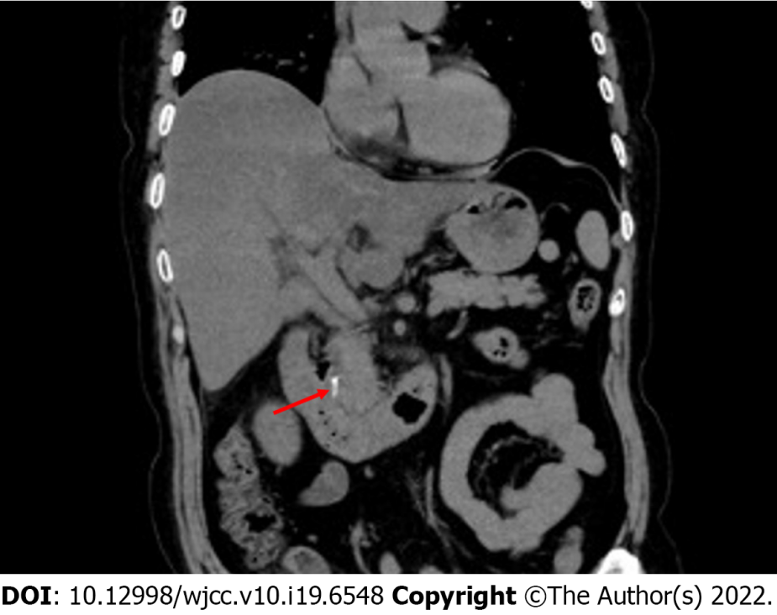
Figure 1 Abdominal computed tomography demonstrated hyperdense material in the common bile duct corresponding to the migrated Hem-o-lok clips.

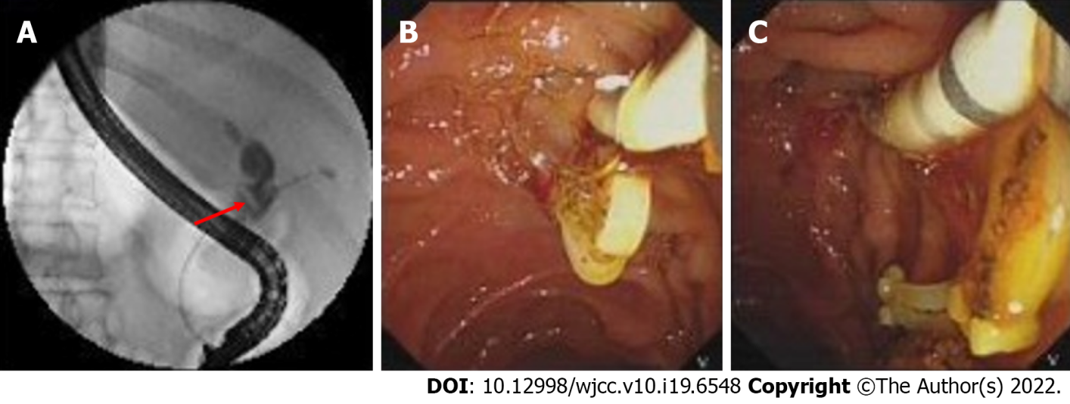
Figure 2 Migrated Hem-o-lok clips were detected and removed by endoscopic retrograde cholangiopancreatography. A: Endoscopic retrograde cholangiopancreatography (ERCP) showed the filling-defect in the common bile duct corresponding to the migrated Hem-o-lok clips (red arrow); B and C: Hem-o-lok clips were removed by stone basket by ERCP
Table 1 Summary of cases of surgical clips migration after laparoscopic biliary surgery
Ref. | Case number | Age in yr | Sex | Operation | Clips | Migrated site | Duration of migration in mo | Finding approach | Clinical manifestation | Treatment
Raoul et al^{[2]}, 1992 | 4 | 34-65 | F | LC | NA | CBD | 5-10 | NA | Abdominal pain, fever, jaundice | Removed by ERCP
Alberts et al^{[3]}, 1999 | 1 | 52 | M | LC + LCBDE | Metallic clips | CBD | 24 | CT | Abdominal pain | Removed by ERCP
Ammann et al^{[15]}, 2000 | 1 | 32 | F | LC + laparotomy | Metallic clips | Pulmonary artery | 18 | CT | Dyspnea | NA
Wang et al^{[13]}, 2009 | 2 | 42-73 | NA | LC + LCBDE | Metallic clips | T-tube sinus | 1 | Found in drainage bag | Asymptomatic | Drained by T-tube
Wang et al^{[13]}, 2009 | 1 | 42-73 | NA | LC + LCBDE | Metallic clips | Wall of T-tube sinus | 1 | T-tube choledochoscopy | Asymptomatic | Observation
Liu et al^{[4]}, 2012 | 8 | 35-76 | 6 M  2 F | LC + LCBDE | H | CBD | 2-3 | T-tube choledochoscopy | Asymptomatic | Removed by choledochoscopy
Tsai et al^{[5]}, 2013 | 1 | 66 | F | LC | NA | CBD | 84 | CT | Abdominal pain, fever | Removed by ERCP
Seyyedmajidi et al^{[14]}, 2013 | 1 | 41 | F | LC | H | Duodenum | 8 | EDG | Abdominal pain | Removed by grasping forceps
Rawal^{[6]}, 2016 | 1 | 38 | F | LC | Metallic clips | CBD | 4 | Ultrasonography | Abdominal pain, fever， jaundice | Removed by ERCP
Qu et al^{[7]}, 2017 | 1 | 54 | F | LC + LCBDE | H | CBD | 12 | MRCP | Abdominal pain | Removed by ERCP
Zheng et al^{[8]}, 2018 | 1 | NA | M | LC + LCBDE | H | Duodenum | 4 | EDG | Abdominal pain | Observation
Zheng et al^{[8]}, 2018 | 2 | NA | NA | LC + LCBDE | H | CBD | 27, 50 | NA | Jaundice | Laparotomy operation
Zheng et al^{[8]}, 2018 | 3 | NA | NA | LC + LCBDE | Absorbable clips | CBD | 6 | T-tube choledochoscopy | Asymptomatic | Removed by choledochoscopy
Barabino et al^{[9]}, 2019 | 1 | 65 | M | LC | H | CBD | 3 | CT | Fever and abdominal pain | Roux-en-Y choledochojejunostomy
Roh et al^{[10]}, 2019 | 1 | 65 | M | LC | H | CBD | 13 | CT | Abdominal pain and fever | Removed by ERCP
Pang et al^{[11]}, 2019 | 3 | 31-83 | F | LC + LCBDE | H | Wall of T-tube sinus | 3-6 | T-tube choledochoscopy | Asymptomatic | Removed by choledochoscopy
Pang et al^{[11]}, 2019 | 1 | 61 | F | LC | H | CBD | NA | Ultrasound | Jaundice, abdominal pain | Roux-en-Y choledochojejunostomy
Pang et al^{[11]}, 2019 | 1 | 72 | F | LC + LCBDE | H | CBD | 18 | CT | Abdominal pain | Laparotomy bile duct exploration
Pang et al^{[11]}, 2019 | 1 | 64 | F | LC + LCBDE | H | CBD | 4 | T-tube cholangiography | Jaundice，fever | PTBD and stent implantation
Kihara et al^{[12]}, 2021 | 1 | 80 | M | LC | H | CBD | 36 | CT + MRCP | Asymptomatic | Laparoscopic bile duct resection and reconstruction
CBD: Common bile duct; CT: Computed tomography; EDG: Esophagogastroduodenoscopy; F: Female; H: Hem-o-lok clips; LC: Laparoscopic cholecystectomy; LCBDE: Laparoscopic common bile duct exploration; M: Male; MRCP: Magnetic resonance cholangiopancreatography; NA: Not available; PTBD: Percutaneous transhepatic biliary drainage.

Published by Baishideng Publishing Group Inc
7041 Koll Center Parkway, Suite 160, Pleasanton, CA 94566, USA
Telephone: +1-925-3991568
E-mail: bpgoffice@wjgnet.com
Help Desk: https://www.f6publishing.com/helpdesk
https://www.wjgnet.com

© 2022 Baishideng Publishing Group Inc. All rights reserved.

