Name of Journal: World Journal of Clinical Cases
Manuscript NO: 68014
Manuscript Type: ORIGINAL ARTICLE

Retrospective Study
Potential effects of the nursing work environment on the work-family conflict in operating room nurses

Fu CM et al. nursing work environment on the work-family conflicts

Chun-Mei Fu, Jie Ou, Xiao-Mei Chen, Mei-Ye Wang

Chun-Mei Fu, Department of Ophthalmology, Hainan West Central Hospital, Danzhou 571700, Hainan Province, China

Jie Ou, Department of Critical Care Medicine, Hainan General Hospital, Haikou 570311, Hainan Province, China

Xiao-Mei Chen, Operation Room, The Second Affiliated Hospital of Hainan Medical College, Haikou 570311, Hainan Province, China

Mei-Ye Wang, Department of General Practice, Hainan West Central Hospital, Danzhou 571700, Hainan Province, China

Author contributions: Fu CM was responsible for conceptualization, data curation, and methodology and wrote the original draft; Ou J and Chen XM were responsible for visualization and software; Wang MY was responsible for validation and supervision and reviewed and edited the manuscript; All authors approved the final submission.

Corresponding author: Mei-Ye Wang, BMed, Associate Professor, Department of General Practice, Hainan West Central Hospital, No. 2 Fubo East Road, Nada Town, Danzhou 571700, Hainan Province, China. 452448172@qq.com

Received: May 9, 2021
Revised: June 16, 2021
Accepted: July 20, 2021
Published online:

Abstract
BACKGROUND
The nursing working environment is an important subsystem in the hospital environment. A good working environment could have a positive impact on nurses. However, the work-family conflict and unsatisfactory working environment could significantly reduce their working enthusiasm, efficacy as well as the overall quality of the nursing, increase their fatigue, and thereby compromise their career status.

AIM
To explore the possible status quo and to analyze the correlation between work environment perception and the work-family conflict among nurses in the operating room.

METHODS
A total of 312 operating room nurses from two first-class hospitals at Grade 2 and two first-class hospitals at Grade 3 in China from May to September 2017 were included in this research using the cluster sampling method. The data, including the general information questionnaire, the practice environment scale of the nursing work index (PES-NWI), and the work-family conflict scale, were systematically collected. Pearson correlation analysis was applied to analyze the correlation between the two scores, with influencing factors analyzed by hierarchical regression analysis.

RESULTS
A total of 312 questionnaires were issued, and the response rate and effective questionnaire rate were both 96.15% (300/312). The total scores of the PES-NWI scale and the work-family conflict scale were 3.07 ± 0.43 (vs maximum up to 4 points) and 52.32 ± 8.79 (vs maximum up to 90 points), respectively. The scores of the PES-NWI scale were negatively correlated with that of work-family conflict scale (all P < 0.05). The perception of the nursing work environment and the number of night shifts per month were the major factors contributing to the work-family conflict (all P < 0.05).

CONCLUSION
The nursing work environment and the work-family conflict among nurses in the operating room were both found at a medium level with a negative correlation between the two.

Key Words: Operating room nurses; Perception of nursing work environment; Work-family conflict; Correlation; Influencing factors

Fu CM, Ou J, Chen XM, Wang MY. Potential effects of the nursing work environment on the work-family conflict in operating room nurses. World J Clin Cases 2021; In press

Core Tip: This was a retrospective study that aimed to explore the status quo and analyze the possible correlation between the work environment perception and the work-family conflict among nurses in the operating room. A total of 312 operating room nurses were included. The results indicated that the nursing work environment and the work-family conflict among nurses in the operating room were both at a medium level, and there was a negative correlation between the two.

INTRODUCTION
As a complex system integrating biotechnology and psychosocial activities, the tense working environment and complex contradictions in the hospital can significantly undermine the mental health of medical staff^{[1]}. The nurse working environment is an important subsystem within the hospital environment, which is a platform for nurses to provide efficient nursing service and to improve the nursing quality. A good working environment could have a positive impact on nurses^{[2]}. In recent years, a number of studies have shown that a good nurse-working environment can promote improvement in job performance, cause alleviation of job burnout, and lead to a reduction in the turnover rate and thus subsequently improve patient outcomes^{[1-3]}. Additionally, compared with other departments, operating room nurses endure heavy workload, high pressure, and irregular scheduling. Moreover, with an increase of age and seniority levels, they play more critical roles in hospitals and their families, such as nursing decision makers, caregivers, mothers, etc., resulting in the potential conflict between their work and family, namely work-family conflict^{[4,5]}. The work-family conflict may, to some extent, reduce their efficacy, working enthusiasm as well as the quality of service, increase their fatigue, and compromise their career status^{[6-8]}. A few clinical studies have found that most operating room nurses feel guilty about not spending adequate time with their families, which can undermine the quality of nursing, while a comfortable working environment could significantly aid to reduce the sense of job burnout and effectively mobilize their work enthusiasm^{[9,10]}. Previous research from nearly 100000 nurses in has countries has shown that poor hospital work environments are common and are associated with nurse outcomes such as job-related burnout and with patient outcomes such as mortality^{[11]}. Against such a backdrop, the aim of this study was to analyze systematically the effect of the perception in the nursing work environment on their work-family conflict among operating room nurses. Our findings also pointed to specific areas that hospital leaders and policy-makers could target in efforts to preserve the nurse workforce and improve quality and safety of care, namely improved staffing, better nurse and physician relations, more involvement of nurses in hospital decisions, and greater managerial support of those who provide clinical care at the operation room.

MATERIALS AND METHODS
Research subjects
A total of 312 operating room nurses from two first-class hospitals at Grade 2 and two first-class hospitals at Grade 3 in China from May to September 2017 were selected in this research based on the cluster sampling. In this study, there were 3 males and 309 females, mean age 33.7 ± 3.2 years, range 20-50 years, with 14.7 ± 4.3 working years, range 1-25 years. The study was approved by the Ethics Committee of Hainan West Central Hospital (106159-E). The inclusion criteria used were as follows: (1) 20-50-years-old; (2) Nursed in the operating room; (3) Nursed in the first-class hospitals at Grade 2 and Grade 3; (4) Have a nurse professional qualification certificate with working period ≥ 1 year; and (5) Understood the content and purpose of this study and volunteered to participate. Exclusion criteria included: (1) Those who did not work independently, practice nurses and refresher nurses; and (2) Nurses who refused to take part in the study.

Research tools
General information: According to the “General Information Questionnaire for Operating Room Nurses” designed by our department, the basic information of the subjects such as age, gender, marital status, hospital grade, professional title, education levels, years of working, nature of work, daily hours of working, and number of night shifts per month was recorded. The Cronbach’s coefficient of the questionnaire was 0.756, and the test-retest reliability was 0.739.

Perception of the nursing work environment: The practice environment scale of the nursing work index (PES-NWI) was adopted to evaluate the perception of the nursing work environment for nurses in an operating room. The scale was mainly used to measure the different characteristics of the nursing work environment in the hospital. Wang and Li^{[12]} have made a localized revision based on the LAKE’s nursing work index-revised (NWI-R) to develop a Chinese version of PES-NWI. There were 31 items of five dimensions in the scale, including three items for the medical and nursing cooperation, five items for the ability of nursing managers and the type of leadership, nine items for nurses that participate in the hospital affairs, four items for an abundance of human and material resources, and 10 items for the foundation of high-quality nursing service. Each item was scored by Liker’s 4-point scoring method, that is, 1-4 points represent response ranging from very disagree to very agree. The total score of the scale was 31-124, which was positively correlated with the nursing work environment^{[12]}. The Cronbach’s coefficient of the scale was 0.914, and the test-retest reliability was 0.942.

Work-family conflict: The work-family conflict scale developed by Carlson and revised by Lu JF was adopted in this study^{[13]}. It could be divided into two different directions: Family-work conflict and work-family conflict. Each direction involved three major aspects: Time, behavior, and stress. There were 18 items in total. Each item was scored by Liker’s 5-point scoring method, that is, 1-5 points represented complete disagreement-complete agreement. The total score was 18 to 90, and the degree of work-family conflict was positively correlated with the scores obtained^{[14]}. The Cronbach’s coefficient of the scale was 0.868, and the test-retest reliability was 0.813.

Quality control: With the consent of the hospitals, the investigators distributed the questionnaires to the various participants centrally in the morning shift time after explaining the purpose, content, and precautions. The questionnaires were completed by the nurses independently and were returned within 60 min following the principles of informed consent, anonymity, and confidentiality. After the questionnaires were returned, obvious scoring rules violators and incomplete questionnaires were removed during analysis.

Statistical analysis
The SPSS 22.0 software (Armonk, NY, United States) was used to proofread the whole data. The measurement data was analyzed by an independent t test and was described by (mean ± standard deviation). The correlation was analyzed by Pearson correlation analysis; the influencing factors were analyzed by hierarchical regression analysis. P value < 0.05 was considered statistically significant.

RESULTS
General information of operating room nurses
A total of 312 questionnaires were issued, and the response rate and effective questionnaire rate were both 96.15% (300/312). Among all the participants, most (99.33%, 298/300) were female, while only 2 (0.67%, 2/300) were male. The majority (58.33%, 175/300) aged 31-40-years-old, compared with 39.33% (118/300) between 20-30-years-old and 2.34% (7/300) were 41-50-years-old. For the years of working, 40.33% (121/300) had worked for more than 10 years, 31.00% (93/300) for 5-10 years, and 28.67% (86/300) for less than 5 years. Most of the participants were nurses and nurse practitioners (69.33%, 208/300), or contracted nurses (60.67%, 182/300), and the majority worked in a first-class hospital at Grade 2 (66.00%, 198/300). For the workload, most had 4-5 night shifts per month (51.33%, 154/300) and 8 h of daily working (52.67%, 158/300) (Table 1).

Perception of operating room nurses’ working environment
The PES-NWI score of the participants is shown in Table 2 and Figure 1. The scores of the five dimensions in PES-NWI were as follows: 3.23 ± 0.51 for medical and nursing cooperation, 3.52 ± 0.49 for the ability of nursing managers and the type of leadership, 2.61 ± 0.39 for nurses participate in the hospital affairs, 3.21±0.46 for an abundance of human and material resources, and 3.09 ± 0.48 for the foundation of the high-quality nursing service. The total average score of the PES-NWI scale of the operating room nurses was 3.07 ± 0.43.

Work-family conflict of operation room nurses
We scored work-family conflicts among the participants with the work-family conflict scale, and the results are shown in Table 3 and Figure 2. The scores of the time, pressure, and behavior were 17.65 ± 4.09, 17.42 ± 3.49, and 16.48 ± 3.85, respectively. The total score of work-family conflict of operating room nurses was (52.32 ± 8.79). The results of statistical analysis indicated that the score of work-family conflict was significantly higher than that of family-work conflict (t = 17.236, P = 0.000). This may be attributed to the status of being married or having children among the study majority (while being married and having younger children at home was protective against family-work conflict).

Correlation between operating room nurses’ perception of working environment and work-family conflict
The r value of correlation analysis between PES-NWI scale scores and work-family conflict scores is shown in Table 4. The correlation coefficients are shown in Figure 3. The results of statistical analysis showed that the scores of the PES-NWI scale were negatively correlated with the scores of work-family conflict (P < 0.05) since a reverse relationship with exhaustion increasing the risk for subsequent work-family conflict.

Analysis on influencing factors of work-family conflict in operation room nurses
The total score of work-family conflict was considered as a dependent variable, and an independent variable was assigned, including gender, age, years of working, professional title, the hospital grade, education background, the nature of work, the number of night shifts per month, and daily hours of working (Table 5). Thereafter, the various influencing factors of work-family conflict among the participants were determined, and the results have been shown in Table 6. Hierarchical regression analysis showed the number of nine shifts per month and the perception of the nursing work environment were primary influencing factors of work-family conflict (both P < 0.05).

DISCUSSION
In this paper we studied the associations between nurse practice environment dimensions, work-family conflict, and the influencing factors using hierarchical regression analysis. The nursing work environment is an important factor for ensuring optimal quality in nursing^{[2]}. It refers to the place where nurses provide nursing services and supporting system in work. It is a conjunction of the nursing staff configuration, hospital management practice, organizational culture, and work plan design. The majority of operating room nurses are female, who suffer hard while dealing with different patients suffering from acute and critical diseases every day^{[9]}. In view of the long-term overloaded and high work pressure environment as well as irregular lifestyle, operating room nurses are generally perceived to be involved in a high-risk profession^{[9,13]}.
A number of clinical studies have found that long-term excessive work pressure can effectively induce stress-related physical and mental diseases as well as various systematic organ responses, thereby leading to compromised individual behaviors, body resistance, job burnout, rapid turnover, absence from work, and unsatisfactory performance^{[15]}. In this study, the average total score of PES-NWI was 3.07 ± 0.43. The score for the ability of nursing managers and the type of leadership was the highest, whereas the score for nurses participating in the hospital affairs was the lowest. This indicated that the operating room nurses gave medium evaluation of nursing work environment, which indicated the existence of a harmonious atmosphere. The management model, rules, and regulations were clear and stable. It may be partially explained by the respect among nurses when working in the operation room and a high degree of cooperation and communication between them and other stakeholders. Besides, both doctors and nurses were motivated together by a common interest to ensure that the patients receive high-quality nursing and to perform noticeably well under pressure. Operating room nurses were able to communicate effectively with anesthesiologists and surgeons, so as to ensure a better treatment and effective nursing care^{[16]}. In addition, nurses were relatively less satisfied with the material support such as the manpower and other material resources. At present, most of the hospitals in China are controlled by the department heads, and nurses have low participation in the management of the hospital affairs. Therefore, it is recommended for the managers to improve the working mode of nurses, to train specialized nurses, to allocate the human and material resources rationally, and to adjust scheduling systems to promote a greater satisfaction among nurses with the working environment^{[17-19]}.
Work-family conflict is a special form of role conflict, which can deeply affect nurses’ life and family satisfaction, subjective well-being, and overall job satisfaction. In severe cases, it can endanger an individual’s physical and mental health^{[9]}. In this study, the total score of work-family conflict among operating room nurses was 52.32 ± 8.79, which was found to be at the medium level. The scores of each dimension in turn included time, pressure, and behavior patterns. Interestingly, it was noted that the score of work-family conflict was significantly higher than that of family-work conflict. The reasons might refer to the nature of the work in operating room: (1) The workload assigned is generally “heavy”, and the operating room nurses are in a state of long-term high concentration. They are overloaded physically and mentally, coupled with weekly night shift frequency and regularly expected professionalism^{[20]}; (2) Working on operation room calls for great cares. As the state changes rapidly during illness and critical diseases, the nurses should effectively improve their theoretical knowledge and the practical skills constantly to avoid adverse events such as medical disputes; and (3) Working time is “tight”. Due to the need to communicate with the surgeons and anesthesiologists and the likely emergency situations during the operation, it is necessary for nurses to make pre-judgments and administer treatment in the shortest possible time^{[21,22]}.
Additionally, Table 3 showed that perception of the nursing work environment was negatively correlated with the work-family conflict. This indicated that the better the nursing work environment could lead to a significantly lower work-family conflict. An accountable reason for this observation is that in an amicable and comfortable working environment, nurses often find themselves in a good state both physically and mentally, thus resulting in improved performance and also perceive a sense of professional value. More important, the nursing services provided are observable and easily understood by patients and their families and are also recognized by the society, leading to significant reduction in work-family conflict^{[23,24]}. In addition, this study found that more night shifts per month brought about more serious work-family conflict. Therefore, this report proposed the following suggestions for alleviating the work-family conflict of nurses: (1) Individual operating room nurses should allocate their energy and time reasonably, conduct the job of family cycle planning and career development planning carefully, balance the relationship between family and work, and determine the priorities at the different stages of life. For many roles, there should be some foci and motivation. They should analyze the potential major roles at a particular stage, so as to make good self-judgment, learn to decompress themselves, adjust their mentality, and thereby accept their own deficiencies to get the maximal support from their families; and (2) The nurse managers should communicate with the nurses actively, establish a multi-layered communication mechanisms, know the work attitudes of the nurses, try to find about their difficulties in maintaining life and work balance, pay attention to the work-family conflict, and promote their overall social support and belonging. In addition, in order to help the nurses master their daily timetable, the system of work sharing and reasonable scheduling should be carefully formulated according to the work-family conflict of the nurses to reduce the unnecessary pressure on their work and family^{[25]}.
However, due to the medical level and the severity of patient’s disease, the nurses’ perception in the working environment could be adversely affected to a certain extent and to some degree. Thus, this study has some limitations about the evaluation of perception of nurses on overall working environment^{[26]}. We will study in the future the potential impact of different grades of the hospitals and severity of the patient’s conditions on the nurse’s perception of the overall working environment to explore further the different confounding factors affecting the perception of the nurse’s working environment.

CONCLUSION
In conclusion, nursing work environment of nurses in the operating room and work-family conflict in this study were both at medium levels, and there was found a negative correlation between the two. The nurses should explore stress compensatory mechanisms actively and plan their schedule accordingly. Nursing managers should make efforts to establish a good nursing work environment and formulate systemic interventions for mitigating the various influencing factors, so as to promote the successful development of nurses’ career, alleviate conflicts, and achieve “win-win” results between nurses and patients.

ARTICLE HIGHLIGHTS
Research background
Organizational behavior has been identified as an important factor in improving overall quality and safety of the hospital care. Yet, there are only few studies that compare the potential impact of the various organizational features of the hospital work environment on nursing service.

Research motivation
Recent research findings have shown that the practice environment scale of the nursing work index (PES-NWI) composite score and the individual subscales might be associated with the nursing outcomes. However, until now, data are not available to describe exactly and compare the work environments of nurses and the nursing outcomes.

Research objectives
To determine the possible effects of hospital work environments and work-family conflict among operating room nurses.

Research methods
A convenience sample comprising 312 operating room nurses from four hospitals in China was created. The data were collected from nurses about their level of job satisfaction and work-to-family conflict in 2017. PES-NWI and work-family conflict scale were used to evaluate the perception of the nursing work environment and the controversy over balance between the life and work. The correlation was analyzed by Pearson correlation analysis, and the influencing factors were determined using hierarchical regression analysis.

Research results
Overall, 300 nurses (96.15%) returned the completed questionnaires. The total average score of the PES-NWI scale of the operating room nurses was 3.07 ± 0.43. The total score of work-family conflict of operating room nurses was 52.32 ± 8.79. Consistent with the published research from other countries, the scores of the PES-NWI scale were found to be negatively correlated with the scores of work-family conflict. In addition, hierarchical regression analysis showed the number of nine shifts per month and the perception of the nursing work environment were major influencing factors of work-family conflict.

Research conclusions
Our study showed that the nursing work environment of nurses in the operating room and work-family conflict were both operative at medium levels. The findings from this study clearly indicate the importance of work-to-family conflict and work environments to the nursing work. While work setting has a strong as well as well-documented influence on overall job satisfaction, nursing managers should establish a conducive nursing work environment and formulate systemic interventions for the various influencing factors, so as to promote the development of careers of nurses.

Research perspectives
The characteristics mentioned above might help people to pay more attention to the nursing work environment and work-family conflict.

REFERENCES
1 Aiken LH, Sloane DM, Clarke S, Poghosyan L, Cho E, You L, Finlayson M, Kanai-Pak M, Aungsuroch Y. Importance of work environments on hospital outcomes in nine countries. Int J Qual Health Care 2011; 23: 357-364 [PMID: 21561979 DOI: 10.1093/intqhc/mzr022]
2 Wang X. Impact of professional practice environment on job burnout of the nurses. Huli Guanli Zazhi 2013; 13: 460-462
3 Zhang HF, Liu YH, Yang Y and Liu JY. The influencing factors of nurses’ turnover tendency. Zhongguo Hulixue Zazhi 2015; 50: 155-160
4 Chen IH, Brown R, Bowers BJ, Chang WY. Work-to-family conflict as a mediator of the relationship between job satisfaction and turnover intention. J Adv Nurs 2015; 71: 2350-2363 [PMID: 26043649 DOI: 10.1111/jan.12706]
5 Aazami S, Akmal S, Shamsuddin K. A model of work-family conflict and well-being among Malaysian working women. Work 2015; 52: 687-695 [PMID: 26409393 DOI: 10.3233/WOR-152150]
6 Vignoli M, Guglielmi D, Bonfiglioli R, Violante FS. How job demands affect absenteeism? The mediating role of work-family conflict and exhaustion. Int Arch Occup Environ Health 2016; 89: 23-31 [PMID: 25808748 DOI: 10.1007/s00420-015-1048-8]
7 Hill RT, Morganson VJ, Matthews RA, Atkinson TP. LMX, Breach Perceptions, Work-Family Conflict, and Well-Being: A Mediational Model. J Psychol 2016; 150: 132-149 [PMID: 25802949 DOI: 10.1080/00223980.2015.1014307]
8 Richter A, Näswall K, Lindfors P, Sverke M. Job insecurity and work-family conflict in teachers in Sweden: Examining their relations with longitudinal cross-lagged modeling. Psych J 2015; 4: 98-111 [PMID: 26261909 DOI: 10.1002/pchj.88]
9 Ma GZ, Ma LN, Chen Y and Lian AL. Influence of positive psychological intervention on occupational stress and mental health in operating room nurses. Zhonghua Xiandai Huli Zazhi 2015; 21: 1048-1050
10 Robson A, Robson F. Do nurses wish to continue working for the UK National Health Service? A comparative study of three generations of nurses. J Adv Nurs 2015; 71: 65-77 [PMID: 24961395 DOI: 10.1111/jan.12468]
11 Berkman LF, Liu SY, Hammer L, Moen P, Klein LC, Kelly E, Fay M, Davis K, Durham M, Karuntzos G, Buxton OM. Work-family conflict, cardiometabolic risk, and sleep duration in nursing employees. J Occup Health Psychol 2015; 20: 420-433 [PMID: 25961758 DOI: 10.1037/a0039143]
12 Wang L and Li LZ. Reliability and vadility of Chinese version of the Practice Enviroment Scale. Zhongguo Hulixue Zazhi 2011; 46: 121-123
13 Ogata Y, Nagano M, Fukuda T, Hashimoto M. [Job retention and nursing practice environment of hospital nurses in Japan applying the Japanese version of the Practice Environment Scale of the Nursing Work Index (PES-NWI)]. Nihon Koshu Eisei Zasshi 2011; 58: 409-419 [PMID: 21970075]
14 Lu JF, Shi K and JohnJ.Lawler. A preliminary study of work-family conflict. Zhongguo Yingyun Xinlixue Zazhi 2002; 8: 45-50
15 Qiu L, Fan J. Family boundary characteristics, work-family conflict and life satisfaction: A moderated mediation model. Int J Psychol 2015; 50: 336-344 [PMID: 25331584 DOI: 10.1002/ijop.12107]
16 Mauno S, Ruokolainen M, Kinnunen U. Work-family conflict and enrichment from the perspective of psychosocial resources: comparing Finnish healthcare workers by working schedules. Appl Ergon 2015; 48: 86-94 [PMID: 25683534 DOI: 10.1016/j.apergo.2014.11.009]
17 Leineweber C, Westerlund H, Chungkham HS, Lindqvist R, Runesdotter S, Tishelman C. Nurses' practice environment and work-family conflict in relation to burn out: a multilevel modelling approach. PLoS One 2014; 9: e96991 [PMID: 24820972 DOI: 10.1371/journal.pone.0096991]
18 Chan HC, Jiang D, Fung HH. Role conflict and satisfaction in the work-family context: Age differences in the moderating effect of role commitment. Psych J 2015; 4: 20-27 [PMID: 26263527 DOI: 10.1002/pchj.89]
19 Galdikien N, Asikainen P, Balčiūnas S, Suominen T. Do nurses feel stressed? A perspective from primary health care. Nurs Health Sci 2014; 16: 327-334 [PMID: 25389543 DOI: 10.1111/nhs.12108]
20 Parro-Moreno A, Serrano-Gallardo P, Díaz-Holgado A, Aréjula-Torres JL, Abraira V, Santiago-Pérez IM, Morales-Asencio JM. Impact of primary care nursing workforce characteristics on the control of high-blood pressure: a multilevel analysis. BMJ Open 2015; 5: e009126 [PMID: 26644122 DOI: 10.1136/bmjopen-2015-009126]
21 Yedidia MJ, Chou J, Brownlee S, Flynn L, Tanner CA. Association of faculty perceptions of work-life with emotional exhaustion and intent to leave academic nursing: report on a national survey of nurse faculty. J Nurs Educ 2014; 53: 569-579 [PMID: 25275990 DOI: 10.3928/01484834-20140922-03]
22 Unruh L, Zhang NJ, Chisolm L. Job and Professional Leaving Among Newly Licensed RNs: A Structural Equation Model. West J Nurs Res 2016; 38: 5-26 [PMID: 25433000 DOI: 10.1177/0193945914559290]
23 Chau JP, Lo SH, Choi KC, Chan EL, McHugh MD, Tong DW, Kwok AM, Ip WY, Lee IF, Lee DT. A longitudinal examination of the association between nurse staffing levels, the practice environment and nurse-sensitive patient outcomes in hospitals. BMC Health Serv Res 2015; 15: 538 [PMID: 26637190 DOI: 10.1186/s12913-015-1198-0]
24 Rettke H, Frei IA, Horlacher K, Kleinknecht-Dolf M, Spichiger E, Spirig R. [Nursing care in the run-up to Swiss DRG – Nurses' experiences with interprofessional collaboration, leadership, work load and job satisfaction]. Pflege 2015; 28: 133-144 [PMID: 26308267 DOI: 10.1024/1012-5302/a000421]
25 Mixer SJ, Lindley L, Wallace H, Fornehed ML, Wool C. The relationship between the nursing environment and delivering culturally sensitive perinatal hospice care. Int J Palliat Nurs 2015; 21: 423-429 [PMID: 26412272 DOI: 10.12968/ijpn.2015.21.9.423]
26 Mazerolle SM, Eason CM, Pitney WA, Mueller MN. Sex and Employment-Setting Differences in Work-Family Conflict in Athletic Training. J Athl Train 2015; 50: 958-963 [PMID: 26381472 DOI: 10.4085/1052-6050-50.2.14]

Footnotes
Institutional review board statement: This study was approved by the Ethics Committee of the Hainan West Central Hospital.

Informed consent statement: This study aims to explore the correlation of nursing work environment perception and work-family conflict among the operating room nurses. It is not involved in the patients’ information, so the informed consent is waived by the ethics committee.

Conflict-of-interest statement: All authors have no conflict of interests to declare.

Data sharing statement: No additional data are available.

Open-Access: This article is an open-access article that was selected by an in-house editor and fully peer-reviewed by external reviewers. It is distributed in accordance with the Creative Commons Attribution NonCommercial (CC BY-NC 4.0) license, which permits others to distribute, remix, adapt, build upon this work non-commercially, and license their derivative works on different terms, provided the original work is properly cited and the use is non-commercial. See: http://creativecommons.org/Licenses/by-nc/4.0/

Manuscript source: Unsolicited manuscript

Peer-review started: May 9, 2021
First decision: June 5, 2021
Article in press:

Specialty type: Nursing
Country/Territory of origin: China
Peer-review report’s scientific quality classification
Grade A (Excellent): 0
Grade B (Very good): B
Grade C (Good): C
Grade D (Fair): 0
Grade E (Poor): 0

P-Reviewer: Hilliard ME, Martins N S-Editor: Ma YJ L-Editor: Filipodia P-Editor:
Figure Legends
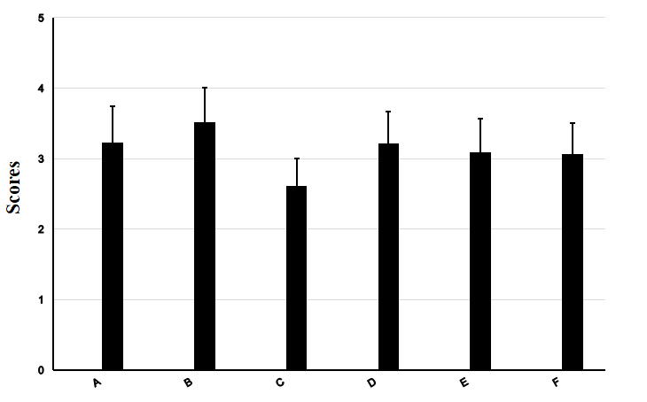
Figure 1 Practice environment scale of the nursing work index score of 300 operation room nurses. A: Medical and nursing cooperation; B: Ability of nursing managers and the type of leadership; C: Nurses participating in hospital affairs; D: The foundation of high-quality nursing service; E: Abundance of human and material resources; F: Total average score.
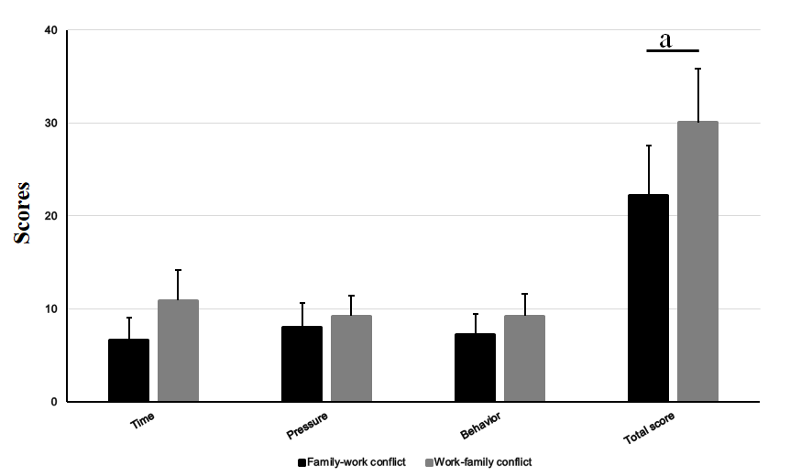
Figure 2 The scores of work-family conflicts among 300 operation room nurses. Compared with family-work conflict, ªP < 0.05.
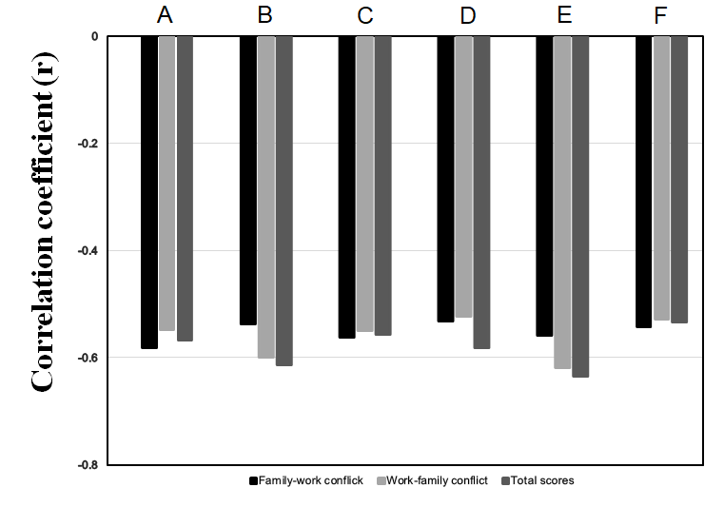
Figure 3 Correlation analysis on the scores of practice environment scale of the nursing work index scale and work family conflict. A: Medical and nursing cooperation; B: Ability of nursing managers and the way of leadership; C: Nurses participating in hospital affairs; D: The foundation of high-quality nursing service; E: Abundance of the human and material resources; F: Total average score. The results were found to be statistically significant (P < 0.05).
Table 1 General information of 300 operating room nurses
Item | n (%)
Gender
Male | 2 (0.67)
Female | 298 (99.33)
Age (yr)
20-30 | 118 (39.33)
31-40 | 175 (58.33)
41-50 | 7 (2.34)
Years of working (yr)
1-4 | 86 (28.67)
5-10 | - (31.00)
> 10 | 121 (40.33)
Professional title
Nurses and nurse practitioners | 208 (69.33)
Chief nurses | 77 (25.67)
Co-chief superintendent nurse and above | 15 (5.00)
Hospital grade
First-class hospital at Grade 2 | 198 (66.00)
First-class hospital at Grade 3 | 102 (34.00)
Education background
Technical secondary school degree | 35 (11.67)
College degree | 124 (41.33)
Bachelor degree or above | 141 (47.00)
Nature of work
Staff nurses | 100 (33.33)
Personnel agency | 18 (6.00)
Contracted nurses | 182 (60.67)
Number of night shifts per month (n)
≤ 3 | 72 (24.00)
4-5 | 154 (51.33)
≥ 6 | 74 (24.67)
Daily hours of working (h)
≤ 8 | 142 (47.33)
> 8 | 158 (52.67)
Marital status
Single | 118 (39.33)
Married | 182 (60.67)

Table 2 practice environment scale of the nursing work index score of 300 operating room nurses (mean ± SD)
Item | Score
Medical and nursing cooperation | 3.23 ± 0.51
Ability of nursing managers and the way of leadership | 3.52 ± 0.49
Nurses participating in the hospital affairs | 2.61 ± 0.39
Foundation of the high-quality nursing services | 3.21 ± 0.46
Abundance of the human and material resources | 3.09 ± 0.48
Total average score | 3.07 ± 0.43

Table 3 The scores of work-family conflicts among 300 operation room nurses (mean ± SD)
Item | Family-work conflict | Work-family conflict | Total score
Time | 6.63 ± 2.39 | 10.89 ± 3.24 | 17.65 ± 4.09
Pressure | 8.02 ± 2.59 | 9.23 ± 2.21 | 17.42 ± 3.49
Behavior | 7.24 ± 2.21 | 9.25 ± 2.35 | 16.48 ± 3.85
Total score | 22.26 ± 5.32 | 30.07 ± 5.77ª | 52.32 ± 8.79
Compared with family-work conflict, ªP < 0.05.

Table 4 Correlation analysis on the scores of practice environment scale of the nursing work index scale and work-family conflict (r value)
Item | Family-work conflict | Work-family conflict | Total score
Medical and nursing cooperation | -0.581ª | -0.547ª | -0.568^{b}
Ability of nursing managers and the way of leadership | -0.537ª | -0.599ª | -0.613^{b}
Nurses participating in the hospital affairs | -0.562ª | -0.549ª | -0.557^{b}
Foundation of the high-quality nursing services | -0.531ª | -0.522ª | -0.581^{b}
Abundance of the human and material resources | -0.559ª | -0.619ª | -0.634^{b}
Total average score | -0.542ª | -0.528ª | -0.534^{b}
ªP < 0.05; ^{b}P < 0.01.

Table 5 Assignment of the various variables
Variable | Assignment
Gender
Male | 0
Female | 1
Age (yr)
20-30 | 1
31-40 | 2
41-50 | 3
Years of working (yr)
1-4 | 1
5-10 | 2
> 10 | 3
Professional title
Nurses and nurse practitioners | 1
Chief nurses | 2
Co-chief superintendent nurse and above | 3
Hospital grade
First-class hospital at Grade 2 | 1
First-class hospital at Grade 3 | 0
Education background
Technical secondary school degree | 1
College degree | 2
Bachelor degree or above | 3
Nature of work
Staff nurses | 0
Personnel agency | 1
Contracted nurses | 2
Number of night shifts per month (n)
≤ 3 | 1
4-5 | 2
≥ 6 | 3
Daily hours of working (h)
≤ 8 | 0
> 8 | 1

Table 6 Analysis on the different influencing factors of work-family conflict in operation room nurses
Item | B | β | t | P value
The first floor
Constant terms | 0.412 | - | 13.562 | 0.000
Number of night shifts per month | 0.831 | 0.782 | 2.812 | 0.009
The second floor
Constant terms | 0.426 | - | 3.624 | 0.007
Medical and nursing cooperation | 0.581 | 0.625 | 4.642 | 0.000
Ability of nursing managers and the way of leadership | 0.592 | 0.253 | 4.982 | 0.000
Nurses participating in hospital affairs | 0.263 | 0.154 | 2.876 | 0.008
Abundance of human and material resources | 0.262 | 0.119 | 2.756 | 0.011
The first floor: R² = 0.032, F = 3.882, P = 0.000; the second floor: R² = 0.584, F = 4.627, P = 0.000.

