Name of Journal: World Journal of Clinical Cases
Manuscript NO: 65848
Manuscript Type: ORIGINAL ARTICLE

Retrospective Study
Quantitative analysis of early diabetic retinopathy based on optical coherence tomography angiography biological image

Li B et al. Analysis of early diabetic retinopathy

Yan Shi, Peng-Yao Lin, Yi-Meng Ruan, Cheng-Fei Lin, Shan-Shan Hua, Bo Li

Yan Shi, Peng-Yao Lin, Yi-Meng Ruan, Cheng-Fei Lin, Shan-Shan Hua, Bo Li, Department of Ophthalmology, Ningbo First Hospital, Ningbo 315000, Zhejiang Province, China

Author contributions: Shi Y and Lin PY design the study; Ruan YM and Lin CF drafted the work and collected the data; Hua SS and Li B analysed and interpreted data and wrote the article.

Supported by Ningbo Natural Science Foundation of China, No. 2018A610362.

Corresponding author: Bo Li, MD, Attending Doctor, Department of Ophthalmology, Ningbo First Hospital, No. 59 Liuting Street, Haishu District, Ningbo 315000, Zhejiang Province, China. nblibo@foxmail.com

Received: April 8, 2021
Revised: July 3, 2021
Accepted: July 28, 2021
Published online:

Abstract
BACKGROUND
With the development of the economy and improvements in living standards, the incidences of diabetes mellitus (DM) and diabetic retinopathy (DR), which is a complication of DM, are on the rise.

AIM
To analyze early DR in patients with macular zone changes in biological images using optical coherence tomography angiography

METHODS
A prospective case study was performed on 59 participants: 35 healthy eyes (control group), 35 eyes with diabetes but no DR group (no DR group), and 35 eyes with mild DR (NPDR group). All quantitative comparisons of parameters, including the fovea vascularity area, circularity index, and vascular complexity parameters, were performed using a biological image analysis software.

RESULTS
The foveal avascular zone (FAZ) area, FAZ circularity index, number of branches in the area, and the total of the single branches’ length in the area was 0.366 ± 0.031, 0.834 ± 0.037, 3241.8 ± 268.3, and 3.860 × 10⁷ ± 0.194 × 10⁷, and 0.421 ± 0.030, 0.739 ± 0.023, 2956.6 ± 476.4, and 3.177 × 10⁷ ± 0.161 × 10⁷ in the no DR group and the NPDR group, respectively, which were significantly different from the corresponding parameters of the control group (P < 0.05). Moreover, there were significant differences between these two groups (P < 0.05).

CONCLUSION
This study shows that early microcirculation changes in the macular area of the retina is associated with disease progression. Early changes in DR can be analyzed using optical coherence tomography angiography.

Key Words: Optical coherence tomography angiography; Quantitative analysis; Diabetic retinopathy

Shi Y, Lin PY, Ruan YM, Lin CF, Hua SS, Li B. Quantitative analysis of early diabetic retinopathy based on optical coherence tomography angiography biological image. World J Clin Cases 2021; In press

Core Tip: Optical coherence tomography angiography has the advantage of being rapid, noninvasive, high-resolution, repeatable, and consistent. It can also be used as an early fundus screening method for patients with diabetes mellitus.

INTRODUCTION
Diabetic retinopathy (DR) occurs in 24.8% to 37.5% of patients with diabetes mellitus (DM) in China according to the latest epidemiological survey data from the International Diabetes Federation. With the development of the economy and improvements in living standards, the incidence of DM and DR, which is a complication of DM, are on the rise^{[1]}. DR is characterized by lesions caused by microvascular retinal damage. Macular ischemia is a significant feature of DR and is thought to be caused by occlusion, loss, or degeneration of the capillary network in the macular area^{[2,3]}. This condition is characterized by a reduction in the capillary network in the fovea. DR is the main cause of blindness in most developing countries^{[4]}. Its early prevention and treatment are challenging and represent urgent public health problems.
Fluorescein angiography is used to visualize the vascular structures in DR for staging purposes. However, this is an invasive technique that only produces images of whole blood vessels and obscures the details of the individual layers of blood vessels. In recent years, noninvasive blood flow imaging technology, known as optical coherence tomography angiography (OCTA), has been developed. It has the advantage of being rapid, noninvasive, high-resolution, repeatable, and consistent^{[5]}. To date, some scholars have applied the OCTA built-in program for DR analysis, but OCTA and biographic software are yet to be used to evaluate changes in microvessels in the macular area in patients with early DM. In this study, OCTA was used to evaluate the macular area and demonstrate that it can be used as an early fundus screening method for DR in patients with DM.

MATERIALS AND METHODS
Study design and participant selection
This was a prospective case study. There were 59 participants in this study. Thirty-eight patients with DM (70 eyes) underwent fundus fluorescein angiography (FFA) at Ningbo First Hospital from May 2019 to December 2019. The group included 18 male patients (35 eyes) and 20 female patients (35 eyes), aged 38-70 years (mean ± SD: 53.11 ± 6.21 years). There were 35 eyes that had no diabetic retinopathy (no DR) and 35 eyes that had non proliferative diabetic retinopathy (NPDR). Another 21 healthy subjects (35 eyes) with matched age participated as the control group and included 13 males (20 eyes) and 8 females (15 eyes), aged 36-63 years (mean ± SD: 53.11 ± 5.81 years).
Exclusion criteria were as follows: (1) Proliferative diabetic retinopathy observed on fundus examination after pupil dilatation; (2) Failure to cooperate with the required examination; (3) History of glaucoma and uveitis; (4) History of retinal photocoagulation, vitrectomy, and other intraocular surgery in any form; and (5) The refractive media was cloudy. In this study, all participants and their families were informed of the details of the study and signed an informed consent form. This study was approved by the Medical Ethics Committee of Ningbo First Hospital.

Methods
All selected participants underwent examination for best-corrected visual acuity and intraocular pressure (IOP), optometry, slit lamp examination, fundus examination, FFA, and OCTA (Heidelberg Engineering, Germany). Both FFA and OCTA were performed on the same day by the same ophthalmologist. DR staging was confirmed by FFA and confirmed by another ophthalmologist. Before OCTA, the participants’ pupils were dilated with compound tropicamide eye drops for about 30 min, with the pupils dilated to at least 5 mm. Participants were asked to sit in front of the OCTA instrument, and a series of OCTA images were collected.

Image analysis and observation
The software used was ImageJ analysis (version 1.52 p, http://imagej.nih.gov/ij/;Provided in the public Domain by the National Institutes of Health, Bethesda, MD, United States)^{[6]}. The superficial plexus (SCP) indexes were used in this study because the foveal avascular zone (FAZ) is more superficial and more abstract. SCP imaging and selection tool were used to draw the outline of the FAZ manually, and the circumference and area of FAZ were calculated automatically by this software. Then the circularity index (CI) of FAZ was measured using the following formula: FAZ CI = (4π x area)/ (circumference)². CI is the expression of shape regularity, and the closer its value is to 1, the more similar its shape is^{[7]}. The images were converted to 8-bit, subjected to binarization, and skeletonized for image skeletal analysis, focusing on two parameters: number of branches in the area (NoB) and total of the single branches’ length in the area (tBL)^{[8]}.

Statistical methods
All data were analyzed using SPSS 25.0, and variable data are presented as mean ± SD. A one-way ANOVA was used for each variable, and a Scheffe test was used for comparison among groups. Statistical significance was set at P < 0.05.

RESULTS
General information
There were no statistically significant differences in age, sex, IOP, or visual acuity between the groups (P > 0.05).

Macular area parameter data
All parameters of the no DR group and the NPDR group were significantly different from those of the control group (F = 136.94, 105.41, 74.96, 130.22, P = 0.000, 0.000; P = 0.035, 0.000; P = 0.000, 0.000; P = 0.033, 0.000), and there were significant differences in parameters between the no DR and NPDR groups (P = 0.000, 0.000, and 0.002; Table 1).
The box diagrams in Figures 1-4 indicate that the FAZ area gradually increased with the development of DR, while FAZ CI, NoB, and tBL gradually decreased with the development of DR.

DISCUSSION
OCTA is a newly introduced clinical method that can provide a detailed image of the retinal microvascular system by segmenting the retinal vascular layers. It is a noninvasive imaging technique that measures the related and phase characteristics of the signal strength in seconds to generate high-resolution angiographic images of retinal blood flow. Images of the retina and choroid microvasculature can be compared by calculating the position of the retina during repeated scanning movements. OCTA is advantageous for the examination of non-perfused areas in DR microcirculation assessment.
Recently, Gildea^{[9]} published a review of the diagnostic value of OCTA in evaluating multiple microvascular parameters in patients with DM, highlighting the role of OCTA in the identification and location of small aneurysms, preoperative neovascularization and capillary non-perfusion visualization, detection of FAZ amplification, and the reconstruction and quantification of vascular perfusion and branching complexity. Several studies have used OCTA to focus on FAZ measurements as markers of microvascular injury, demonstrating that the FAZ region is larger in patients with DM than in healthy controls^{[10-14]}. The following data are shown in our study of OCTA measurement: the FAZ area was significantly larger in the no DR and NPDR groups than in the control group. For patients with no DR, although the fundus examination showed no obvious pathological changes, the FAZ area expansion indicated that macular occlusion and a nonperfusion status had started. Additionally, we found that the FAZ area in the early period of DM was significantly different between patients without DR and patients with NPDR. As retinopathy progressed, the FAZ area increased, suggesting that macular retinal capillary occlusion and nonperfusion increased in severity.
Recently, different quantitative methods for the evaluation of roundness of the FAZ in patients with DM have been proposed^{[15,16]}. In this study, CI was an early parameter for FAZ variation in the SCP. From the control group to the no DR and DR groups, there was a significant downward trend in CI, indicating that with the progression of retinal microvascular injury caused by diabetes, the regularity of the FAZ gradually changed significantly in patients with DM compared with that in the control participants.
In this study, we found that compared with the values in the control group, NoB and tBL in the macular area in the NPDR group were significantly decreased. The findings were consistent with the conclusion of Stela V^{[17]}, where the same method was used to study the area around the optic disc in patients with DM. They found that patients with DM without clinical DR symptoms had a significant reduction in the area around the optic discs compared with that in healthy participants. Therefore, we believe that the decrease in NoB and tBL may be due to the loss of small branch vessels, which leads to a reduction in retinal branch complexity^{[18]}. Additionally, these findings support the hypothesis that the complexity of the microvascular network decreases gradually as DR severity increases^{[18]}.
This study had some limitations. OCTA cannot be applied to all patients with DR, as patients need to have a clear refractive media and good vision. Thus, it is challenging to perform in patients with poor vision, such as those with PDR. A larger sample size is also needed to understand better the exact extent of microvascular damage in the early stages of DR.

CONCLUSION
In summary, this study shows that in patients with DM, fundus lesions with vascular parameters were visible through quantitative OCTA analysis before microcirculation changes in the macular area. OCTA is a new screening tool for patients with DM, and timely monitoring of clinical fundus changes before disease progression might allow for early diagnosis and treatment of DR.

ARTICLE HIGHLIGHTS
Research background
According to the latest epidemiological survey data from the International Diabetes Federation, diabetic retinopathy (DR) occurs in 24.8% to 37.5% of patients with diabetes mellitus (DM) in China.

Research motivation
The early prevention and treatment of DR are challenging and are urgent problems to be solved.

Research objectives
Optical coherence tomography angiography (OCTA) was used to evaluate the macular area and demonstrate that it can be used as an early fundus screening method for patients with DM.

Research methods
All selected participants underwent examination for best-corrected visual acuity and intraocular pressure, optometry, slit lamp examination, fundus examination, fundus fluorescein angiography, and OCTA (Heidelberg Engineering, Germany).

Research results
The values of the foveal avascular zone (FAZ), FAZ circularity index, number of branches in the area, and the total of the single branches’ length in the area of the no DR group and the NPDR groups were statistically different from the control group. The said parameters are also statistically different between the two groups.

Research conclusions
OCTA is a new screening tool for patients with DM, and timely monitoring of clinical fundus changes before disease progression might allow for early diagnosis and treatment of DR.

Research perspectives
A novel approach provides novel insights for the diagnosis and treatment of diseases.

REFERENCES
1 Cao D, Yang D, Yu H, Xie J, Zeng Y, Wang J, Zhang L. Optic nerve head perfusion changes preceding peripapillary retinal nerve fibre layer thinning in preclinical diabetic retinopathy. Clin Exp Ophthalmol 2019; 47: 219-225 [PMID: 30203562 DOI: 10.1111/ceo.13390]
2 Spaide RF, Klancnik JM Jr, Cooney MJ. Retinal vascular layers imaged by fluorescein angiography and optical coherence tomography angiography. JAMA Ophthalmol 2015; 133: 45-50 [PMID: 25317632 DOI: 10.1001/jamaophthalmol.2014.3616]
3 Noordzij MJ, Mulder DJ, Oomen PH, Brouwer T, Jager J, Castro Cabezas M, Lefrandt JD, Smit AJ. Skin autofluorescence and risk of micro- and macrovascular complications in patients with Type 2 diabetes mellitus-a multi-centre study. Diabet Med 2012; 29: 1556-1561 [PMID: 22937960 DOI: 10.1111/dme.12005]
4 Varma R, Bressler NM, Doan QV, Gleeson M, Danese M, Bower JK, Selvin E, Dolan C, Fine J, Colman S, Turpcu A. Prevalence of and risk factors for diabetic macular edema in the United States. JAMA Ophthalmol 2014; 132: 1334-1340 [PMID: 25125075 DOI: 10.1001/jamaophthalmol.2014.2854]
5 Mastropasqua R, Toto L, Mastropasqua A, Aloia R, De Nicola C, Mattei PA, Di Marzio G, Di Nicola M, Di Antonio L. Foveal avascular zone area and parafoveal vessel density measurements in different stages of diabetic retinopathy by optical coherence tomography angiography. Int J Ophthalmol 2017; 10: 1545-1551 [PMID: 29062774 DOI: 10.18240/ijo.2017.10.11]
6 Schindelin J, Arganda-Carreras I, Frise E, Kaynig V, Longair M, Pietzsch T, Preibisch S, Rueden C, Saalfeld S, Schmid B, Tinevez JY, White DJ, Hartenstein V, Eliceiri K, Tomancak P, Cardona A. Fiji: an open-source platform for biological-image analysis. Nat Methods 2012; 9: 676-682 [PMID: 22743772 DOI: 10.1038/nmeth.2019]
7 Mancia G, Fagard R, Narkiewicz K, Redon J, Zanchetti A, Böhm M, Christiaens T, Cifkova R, De Backer G, Dominiczak A, Galderisi M, Grobbee DE, Jaarsma T, Kirchhof P, Kjeldsen SE, Laurent S, Manolis AJ, Nilsson PM, Ruilope LM, Schmieder RE, Sirnes PA, Sleight P, Viigimaa M, Waeber B, Zannad F, Redon J, Dominiczak A, Narkiewicz K, Nilsson PM, Burnier M, Viigimaa M, Ambrosioni E, Caufield M, Coca A, Olsen MH, Schmieder RE, Tsioufis C, van de Borne P, Zamorano JL, Achenbach S, Baumgartner H, Bax JJ, Bueno H, Dean V, Deaton C, Erol C, Fagard R, Ferrari R, Hasdai D, Hoes AW, Kirchhof P, Knuuti J, Kolh P, Lancellotti P, Linhart A, Nihoyannopoulos P, Piepoli MF, Ponikowski P, Sirnes PA, Tamargo JL, Tendera M, Torbicki A, Wijns W, Windecker S, Clement DL, Coca A, Gillebert TC, Tendera M, Rosei EA, Ambrosioni E, Anker SD, Bauersachs J, Hitij JB, Caulfield M, De Buyzere M, De Geest S, Derumeaux GA, Erdine S, Farsang C, Funck-Brentano C, Gerc V, Germano G, Gielen S, Haller H, Hoes AW, Jordan J, Kahan T, Komajda M, Lovic D, Mahrholdt H, Olsen MH, Ostergren J, Parati G, Perk J, Polonia J, Popescu BA, Reiner Z, Rydén L, Sirenko Y, Stanton A, Struijker-Boudier H, Tsioufis C, van de Borne P, Vlachopoulos C, Volpe M, Wood DA. 2013 ESH/ESC guidelines for the management of arterial hypertension: the Task Force for the Management of Arterial Hypertension of the European Society of Hypertension (ESH) and of the European Society of Cardiology (ESC). Eur Heart J 2013; 34: 2159-2219 [PMID: 23771844 DOI: 10.1093/eurheartj/eht151]
8 Vujosevic S, Toma C, Villani E, Gatti V, Brambilla M, Muraca A, Ponziani MC, Aimaretti G, Nuzzo A, Nucci P, De Cilla' S. Early Detection of Microvascular Changes in Patients with Diabetes Mellitus without and with Diabetic Retinopathy: Comparison between Different Swept-Source OCT-A Instruments. J Diabetes Res 2019; 2019: 2547216 [PMID: 31281849 DOI: 10.1155/2019/2547216]
9 Gildea D. The diagnostic value of optical coherence tomography angiography in diabetic retinopathy: a systematic review. Int Ophthalmol 2019; 39: 2413-2433 [PMID: 30382465 DOI: 10.1007/s10792-018-1034-8]
10 Vujosevic S, Muraca A, Alkabes M, Villani E, Cavarzeran F, Rossetti L, De Cillaʼ S. Early microvascular and neural changes in patients with type 1 and type 2 diabetes mellitus without clinical signs of diabetic retinopathy. Retina 2019; 39: 435-445 [PMID: 29206758 DOI: 10.1097/IAE.0000000000001990]
11 de Carlo TE, Chin AT, Bonini Filho MA, Adhi M, Branchini L, Salz DA, Baumal CR, Crawford C, Reichel E, Witkin AJ, Duker JS, Waheed NK. Detection of microvascular changes in eyes of patients with diabetes but not clinical diabetic retinopathy using optical coherence tomography angiography. Retina 2015; 35: 2364-2370 [PMID: 26469537 DOI: 10.1097/IAE.0000000000000882]
12 Dimitrova G, Chihara E, Takahashi H, Amano H, Okazaki K. Quantitative Retinal Optical Coherence Tomography Angiography in Patients With Diabetes Without Diabetic Retinopathy. Invest Ophthalmol Vis Sci 2017; 58: 190-196 [PMID: 28114579 DOI: 10.1167/iovs.16-20531]
13 Di G, Weihong Y, Xiao Z, Zhikun Y, Xuan Z, Yi Q, Fangtian D. A morphological study of the foveal avascular zone in patients with diabetes mellitus using optical coherence tomography angiography. Graefes Arch Clin Exp Ophthalmol 2016; 254: 873-879 [PMID: 26344729 DOI: 10.1007/s00417-015-3143-7]
14 Takase N, Nozaki M, Kato A, Ozeki H, Yoshida M, Ogura Y. Enlargement of foveal avascular zone in diabetic eyes evaluated by en face optical coherence tomography angiography. Retina 2015; 35: 2377-2383 [PMID: 26457396 DOI: 10.1097/IAE.0000000000000849]
15 Krawitz BD, Mo S, Geyman LS, Agemy SA, Scripsema NK, Garcia PM, Chui TYP, Rosen RB. Acircularity index and axis ratio of the foveal avascular zone in diabetic eyes and healthy controls measured by optical coherence tomography angiography. Vision Res 2017; 139: 177-186 [PMID: 28212983 DOI: 10.1016/j.visres.2016.09.019]
16 Alam M, Zhang Y, Lim JI, Chan RVP, Yang M, Yao X. Quantitative optical coherence tomography angiography features for objective classification and staging of diabetic retinopathy. Retina 2020; 40: 322-332 [PMID: 31972803 DOI: 10.1097/IAE.0000000000002373]
17 Vujosevic S, Muraca A, Gatti V, Masoero L, Brambilla M, Cannillo B, Villani E, Nucci P, De Cillà S. Peripapillary Microvascular and Neural Changes in Diabetes Mellitus: An OCT-Angiography Study. Invest Ophthalmol Vis Sci 2018; 59: 5074-5081 [PMID: 30357402 DOI: 10.1167/iovs.18-24891]
18 Reif R, Qin J, An L, Zhi Z, Dziennis S, Wang R. Quantifying optical microangiography images obtained from a spectral domain optical coherence tomography system. Int J Biomed Imaging 2012; 2012: 509783 [PMID: 22792084 DOI: 10.1155/2012/509783]

Footnotes
Institutional review board statement: The study was reviewed and approved by the Ningbo No. 1 Hospital Institutional Review Board (Approval No. 2018-R072).

Informed consent statement: All study participants, or their legal guardian, provided informed written consent prior to study enrollment.

Conflict-of-interest statement: None of the authors has a financial interest in any of the products, devices, or drugs mentioned in this manuscript.

Data sharing statement: No additional data are available.

Open-Access: This article is an open-access article that was selected by an in-house editor and fully peer-reviewed by external reviewers. It is distributed in accordance with the Creative Commons Attribution NonCommercial (CC BY-NC 4.0) license, which permits others to distribute, remix, adapt, build upon this work non-commercially, and license their derivative works on different terms, provided the original work is properly cited and the use is non-commercial. See: http://creativecommons.org/Licenses/by-nc/4.0/

Manuscript source: Unsolicited manuscript

Peer-review started: April 8, 2021
First decision: April 28, 2021
Article in press:

Specialty type: Ophthalmology
Country/Territory of origin: China
Peer-review report’s scientific quality classification
Grade A (Excellent): 0
Grade B (Very good): 0
Grade C (Good): C
Grade D (Fair): 0
Grade E (Poor): 0

P-Reviewer: Cankurtaran V S-Editor: Yan JP L-Editor: P-Editor:
Figure Legends
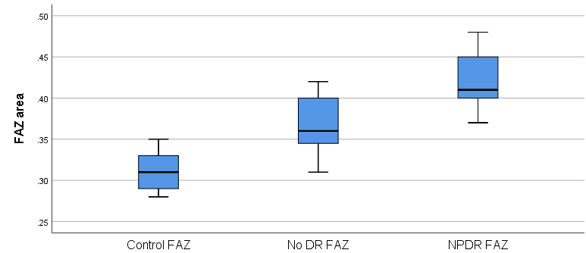
Figure 1 Foveal avascular zone area changes with diabetic retinopathy progress. FAZ: Foveal avascular zone; DR: Diabetic retinopathy; NPDR: Non proliferative diabetic retinopathy.
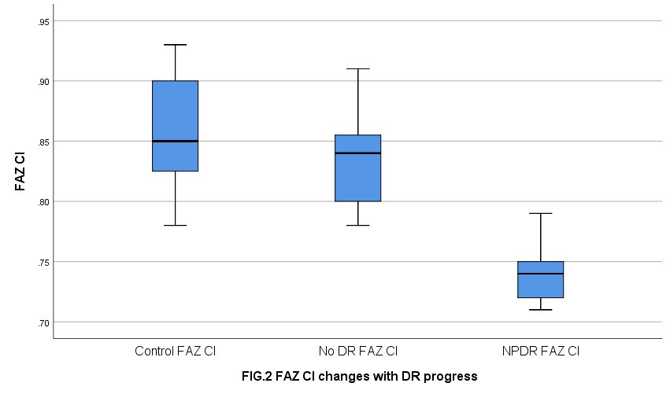
Figure 2 Foveal avascular zone circularity index changes with diabetic retinopathy progress. FAZ: Foveal avascular zone; DR: Diabetic retinopathy; NPDR: Non proliferative diabetic retinopathy; CI: Circularity index.

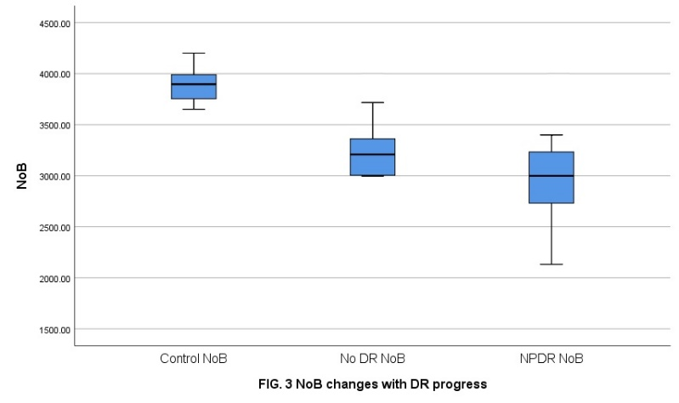
Figure 3 Number of branches in the area changes with diabetic retinopathy progress. DR: Diabetic retinopathy; NPDR: Non proliferative diabetic retinopathy; NoB: Number of branches in the area.

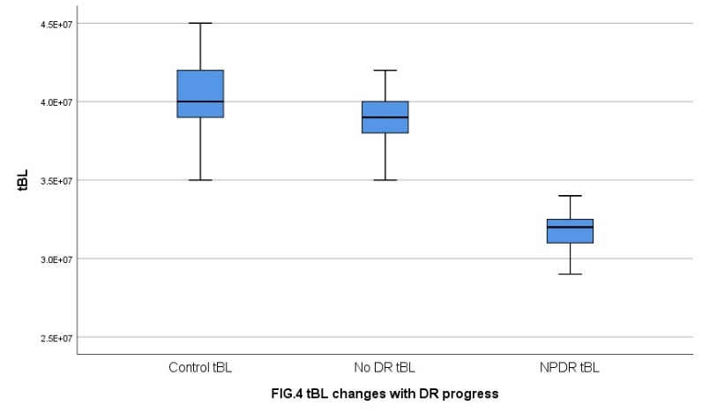
Figure 4 Total of the single branches’ length in the area changes with diabetic retinopathy progress. DR: Diabetic retinopathy; NPDR: Non proliferative diabetic retinopathy; tBL: Total of the single branches’ length in the area.

Table 1 Parameters and data of macular area
Parameters | Control group | No DR group | NPDR group
FAZ | 0.312 ± 0.019 | 0.366 ± 0.031^{b} | 0.421 ± 0.030^{b,c}
FAZ CI SCP | 0.857 ± 0.044 | 0.834 ± 0.037ª | 0.739 ± 0.023^{b,c}
NoB SCP | 3896.4 ± 162.2 | 3241.8 ± 268.3^{b} | 2956.6 ± 476.4^{b,c}
tBL SCP | 4.006 × 10⁷ ± 0.307 × 10⁷ | 3.860 × 10⁷ ± 0.194 × 10^{7,a} | 3.177 × 10⁷ ± 0.161 × 10^{7,b,c}
Comparison with control group: ªP < 0.05; ^{b}P < 0.01; Comparison between the two groups: ^{c}P < 0.01. FAZ: The foveal avascular zone; CI: Circularity index; SCP: Superficial plexus; NoB: Number of branches in the area; tBL: Total of the single branches’ length in the area.

