Name of Journal: World Journal of Virology
Manuscript NO: 62659
Manuscript Type: EDITORIAL

New Year’s greeting and overview of World Journal of Virology in 2021

Wang DM et al. New Year’s greeting and overview of WJV in 2021

Dong-Mei Wang, En-Qiang Chen, Mahmoud El-Bendary

Dong-Mei Wang, Science Editor Development Department, Baishideng Publishing Group Inc, Pleasanton, CA 94566, United States

En-Qiang Chen, Center of Infectious Diseases, West China Hospital of Sichuan University, Chengdu 610041, Sichuan Province, China

Mahmoud El-Bendary, Department of Tropical Medicine and Hepatology, Faculty of Medicine, Mansoura University, Mansoura 35111, Egypt

Author contributions: Wang DM drafted this editorial; Chen EQ and El-Bendary M reviewed and revised this editorial.

Corresponding author: Dong-Mei Wang, BSc, Assistant Editor, Science Editor Development Department, Baishideng Publishing Group Inc, 7041 Koll Center Parkway, Suite 160, Pleasanton, CA 94566, United States. d.m.wang@wjgnet.com

Received: January 14, 2021
Revised: January 30, 2021
Accepted: February 5, 2021
Published online: March 25, 2021

Abstract
The 2020 year-end wrap-up session of Baishideng Publishing Group was held on December 31, 2020. All staff attended this session. We shared our key results area and made a business plan regarding the journal management. World Journal of Virology (WJV) is now abstracted and indexed in PubMed and PubMed Central. It received 23 manuscripts and published 9 papers which included 6 articles reporting coronavirus 19 in 2020. On the other hand, we made major strategies for WJV’s development in 2021. At present, WJV only has 28 Editorial Board members and cannot receive many manuscripts. We must redouble our efforts to invite more highly influential scientists to join our Editorial Board member and write high-quality manuscripts.

Key Words: World Journal of Virology; Publication; Editorial board; Virology

©The Author(s) 2021. Published by Baishideng Publishing Group Inc. All rights reserved.

Wang DM, Chen EQ, El-Bendary M. New Year’s greeting and overview of World Journal of Virology in 2021. World J Virol 2021; 10(2): 30-33 URL: https://www.wjgnet.com/2220-3249/full/v10/i2/30.htm DOI: https://dx.doi.org/10.5501/wjv.v10.i2.30

Core Tip: At the 2020 year-end wrap-up session of Baishideng Publishing Group, we made a report on the work of World Journal of Virology (WJV) in 2020 and made a business plan regarding the development of WJV.

INTRODUCTION
World Journal of Virology (WJV) is a high-quality, online, open-access, single-blind peer-reviewed journal published by the Baishideng Publishing Group (BPG). WJV accepts both solicited and unsolicited manuscripts. Articles published in WJV are high-quality, basic and clinical, influential research articles by established academic authors as well as new researchers. The paramount objective of WJV is to showcase and promote distinguished research in the field of virology, to help advance development of this field. The types of articles published in WJV include Editorial, Opinion Review, Frontier, Review, Minireview, Basic Study, Clinical Research, Systematic Review, Meta-analysis, Evidence-based Medicine, Field of Vision, Clinical Guidelines, Letter to the Editor, and Case Report^{[1]}.

REVIEW OF OUR WORK IN 2020
Submissions and publishing articles
In 2020, we received 23 submissions from around the world. The Science Editor Development Department made the first decisions for 18 manuscripts, and edited and made the second decisions for 11 manuscripts, and rejected 2 manuscripts (8.7%, 2/23). The Production Department published 9 articles (39.1%, 9/23) (Figure 1).
Among these 9 articles, 6 were published on the theme of the coronavirus 19 (COVID-19), 4 were invited manuscripts (44.4%, 4/9), 5 were unsolicited manuscripts (55.6%, 5/9), and 1 original article (11.1%, 1/9), 7 review articles (77.8%, 7/9), 1 other type article (11.1%, 1/9) (Figure 2A). The articles came from 6 countries and regions, including 3 articles from Chinese authors (33.3%, 3/9), 2 American authors (22.2%, 2/9), 1 Italian author (11.1%, 1/9), 1 Irish author (11.1%, 1/9), 1 South African author (11.1%, 1/9), and 1 author from Saudi Arabia (11.1%, 1/9) (Figure 2B).

Invited manuscripts
In 2020, WJV accepted a total of 97 manuscript titles, including 74 for review articles (76.3%, 74/97), 21 for original articles (21.7%, 21/97), and 2 for editorials (2.1%, 2/97) (Figure 3). Among them, 9 (9.3%) manuscripts have been submitted online, and 4 (4.1%) manuscripts were submitted after the deadline. Eighty-four (86.6%) manuscripts have not been submitted yet.

Review statistics
In 2020, WJV invited peer reviewers and editorial board members to review manuscripts 664 times. Of these invitations, 100 were accepted (15.1%, 100/664), 78 were rejected (11.70%, 78/664), 486 did not receive a response (73.2%, 486/664). Of the 100 accepted invitations, 31 peer review comments were submitted on time (31.0%, 31/100), 67 failed to submit peer review comments on time (67.0%, 67/100), and 2 have not yet submitted peer review comments.

Editorial Board members
In 2020, the WJV Editorial Board consisted of 28 members^{[2]}. In addition, 4 scientists applied for the Editorial Board and are awaiting evaluation. WJV Editorial Board members are from 17 countries and regions, including 6 from the United States (21.4%), 4 from Italy (14.3%), 3 from Ireland (10.7%), 2 from Egypt (7.1%), and 13 from various countries and regions (46.4%) (Figure 4). Seventeen Editorial Board members (60.7%) have completed a peer review on a manuscript, and nine members (32.1%) have not yet completed a peer review on a manuscript.

CONCLUSION
The BPG appreciates the continuous support and submissions from authors and the dedicated efforts and expertise by our invited reviewers, many who are also serving on the Editorial Board.
Despite the challenges caused by the worldwide COVID-19 pandemic, scientists made great progress in the field of virology during 2020. We would appreciate the consideration of WJV for virology submissions. In 2021, we will continue to apply current publishing standards and take stronger steps to grow the Editorial Board and attract more high-quality submissions.

REFERENCES
1 Baishideng Publishing Group Inc. World Journal of Virology. Available from: https://www.wjgnet.com/2220-3249/about.htm
2 Baishideng Publishing Group Inc. Editorial Board Members of World Journal of Virology. Available from: https://www.wjgnet.com/2220-3249/editorialboard.htm

Footnotes
Conflict-of-interest statement: The authors have nothing to disclose.

Open-Access: This article is an open-access article that was selected by an in-house editor and fully peer-reviewed by external reviewers. It is distributed in accordance with the Creative Commons Attribution NonCommercial (CC BY-NC 4.0) license, which permits others to distribute, remix, adapt, build upon this work non-commercially, and license their derivative works on different terms, provided the original work is properly cited and the use is non-commercial. See: http://creativecommons.org/Licenses/by-nc/4.0/

Manuscript source: Invited manuscript

Peer-review started: January 14, 2021
First decision: January 25, 2021
Article in press: February 5, 2021

Specialty type: Virology
Country/Territory of origin: United States
Peer-review report’s scientific quality classification
Grade A (Excellent): 0
Grade B (Very good): 0
Grade C (Good): C
Grade D (Fair): 0
Grade E (Poor): 0

P-Reviewer: Menendez-Arias L S-Editor: Wang JL L-Editor: Filipodia P-Editor: Xing YX

Figure Legends

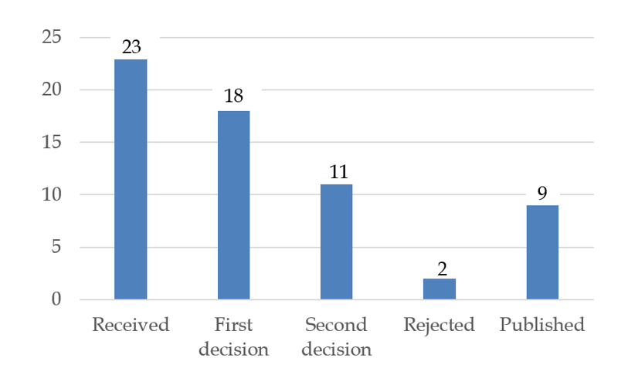
Figure 1 World Journal of Virology 2020 manuscript processing. The numbers of manuscripts processed from submission through publication.

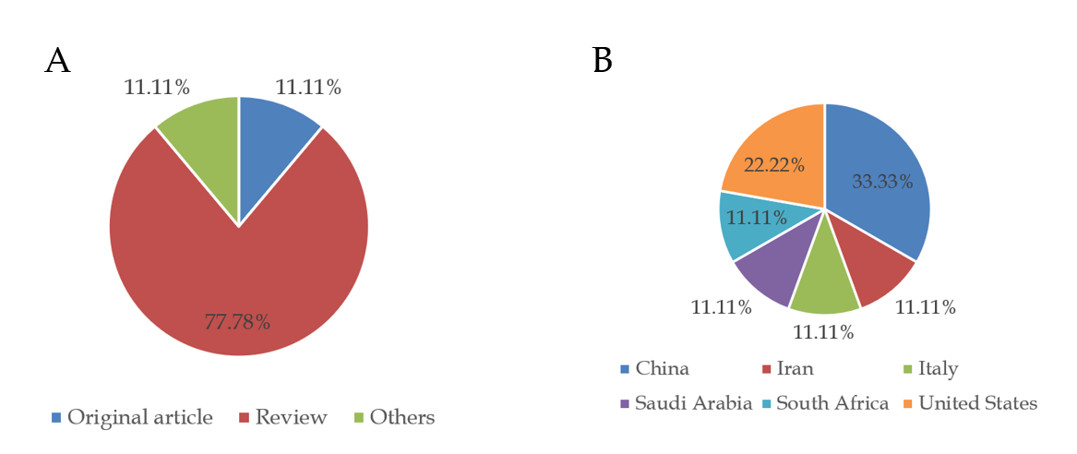
Figure 2 Bibliographic data for articles published by the World Journal of Virology in 2020. A: Article types; B: Authors’ countries.
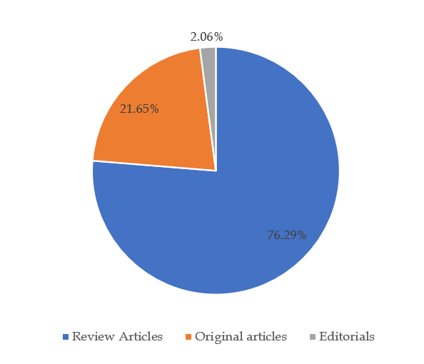
Figure 3 Titles of invited manuscripts submitted for the various types of articles for consideration of publication in 2021 by the World Journal of Virology.

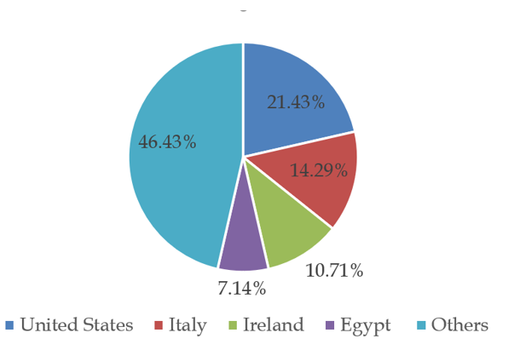
Figure 4 World Journal of Virology Editorial Board members are from 17 countries or regions.

Published by Baishideng Publishing Group Inc
7041 Koll Center Parkway, Suite 160, Pleasanton, CA 94566, USA
Telephone: +1-925-3991568
E-mail: bpgoffice@wjgnet.com
Help Desk: https://www.f6publishing.com/helpdesk
https://www.wjgnet.com

© 2021 Baishideng Publishing Group Inc. All rights reserved.

