Name of Journal: World Journal of Gastroenterology
ESPS Manuscript NO: 25074
Manuscript Type: ORIGINAL ARTICLE

Prospective Study
Usefulness of portal vein pressure for predicting the effects of tolvaptan in cirrhotic patients

Nakagawa A et al. portal vein pressure and tolvaptan

Ai Nakagawa, Masanori Atsukawa, Akihito Tsubota, Chisa Kondo, Tomomi Okubo, Taeang Arai, Norio Itokawa, Yoshiyuki Narahara, Katsuhiko Iwakiri

Ai Nakagawa, Masanori Atsukawa, Chisa Kondo, Tomomi Okubo, Taeang Arai, Norio Itokawa, Division of Gastroenterology, Department of Internal Medicine, Nippon Medical School Chiba Hokusoh Hospital, Chiba 270-1694, Japan

Akihito Tsubota, Core Research Facilities for Basic Science, Research Center for Medical Sciences, Jikei University School of Medicine, Tokyo 105-8471, Japan

Yoshiyuki Narahara, Katsuhiko Iwakiri, Division of Gastroenterology, Department of Internal Medicine, Nippon Medical School, Tokyo 113-8603, Japan

Author contributions: Nakagawa A, Atsukawa M, Kondo C, Okubo T, Arai T and Itokawa N designed the study and measured porta vein pressure; Atsukawa M and Tsubota A contributed equally to the preparation of this manuscript; Tsubota A, Narahara Y and Iwakiri K supervised the study; all authors have read and approved the final version to be published.

Institution review board statement: The protocol was approved by the Ethics Review Board of Nippon Medical School Chiba Hokusoh Hospital (approval No. 526012). All patients and their families received a sufficient explanation of the aim and contents of this study before the entry.

Conflict-of-interest statement: The authors declare that they have no conflict of interest.

Informed consent statement: All patients and their families received a sufficient explanation of the aim and contents of this study before the entry. Patients who provided written informed consent participated in this study. All procedures followed were in accordance with the ethical standards of the responsible committee on human experimentation and with Helsinki Declaration of 1975, as revised in 2008

Data sharing statement: No additional data are available.

Open-Access: This article is an open-access article which was selected by an in-house editor and fully peer-reviewed by external reviewers. It is distributed in accordance with the Creative Commons Attribution Non Commercial (CC BY-NC 4.0) license, which permits others to distribute, remix, adapt, build upon this work non-commercially, and license their derivative works on different terms, provided the original work is properly cited and the use is non-commercial. See: http://creativecommons.org/licenses/by-nc/4.0/

Correspondence to: Masanori Atsukawa, MD, PhD, Department of Internal Medicine, Division of Gastroenterology, Nippon Medical School Chiba Hokusoh Hospital, 1715, Kamakari, Inzai, Chiba 270-1694, Japan. momogachi@yahoo.co.jp
Telephone: +81-4-76991111
Fax: +81-4-769911111908

Received: February 23, 2016
Peer-review started: February 23, 2016
First decision: March 7, 2016
Revised: March 19, 2016
Accepted: March 30, 2016
Article in press:
Published online:

Abstract
AIM: To elucidate influencing factors of treatment response, then tolvaptan has been approved in Japan for liquid retention.

METHODS: We herein conducted this study to clarify the influencing factors in 40 patients with decompensated liver cirrhosis complicated by liquid retention. Tolvaptan was administered at a dosage of 7.5 mg once a day for patients with conventional diuretic-resistant hepatic edema for 7 d. At the initiation of tolvaptan, the estimated hepatic venous pressure gradient (HVPG) value which was estimated portal vein pressure was measured using hepatic venous catheterization. We analyzed the effects of tolvaptan and influencing factors associated with treatment response.

RESULTS: Subjects comprised patients with a median age of 65 (range, 40-82) years. According to the Child-Pugh classification, class A was 3 patients, class B was 19, and class C was 18. Changes from the baseline in body weight were -1.0 kg (P = 2.04 × 10⁻⁶) and -1.3 kg (P = 1.83 × 10⁻⁵), respectively. The median HVPG value was 240 (range, 105-580) mmH₂O. HVPG was only significant influencing factor of the weight loss effect. When patients with body weight loss of 2 kg or greater from the baseline was defined as responders, receiver operating characteristic curve analysis showed that the optimal HVPG cutoff value was 190 mmH₂O in predicting treatment response. The response rate was 87.5% (7/8) in patients with HVPG of 190 mmH₂O or less, whereas it was only 12.5% (2/16) in those with HVPG of greater than 190 mmH₂O (P = 7.46 × 10⁻⁴). We compared each characteristics factors between responders and non-responders. As a result, HVPG (P = 0.045) and serum hyaluronic acid (P = 0.017) were detected as useful factors.

CONCLUSION: The present study suggests that tolvaptan in the treatment of liquid retention could be more effective for patients with lower portal vein pressure.

Key words: Tolvaptan; V₂ receptor antagonist; Portal vein pressure; Hepatic venous pressure gradient; Decompensated chirrosis

© The Author(s) 2016. Published by Baishideng Publishing Group Inc. All rights reserved.

Core tip: To clarify the factors influencing the effect of tolvaptan, a V₂ receptor antagonist, in patients with decompensated liver cirrhosis complicated by liquid retention, we conducted this study. As a result, hepatic venous pressure gradient (HVPG) was the only significant factor that influenced the weight loss effect of tolvaptan. The response rate was 87.5% (7/8) in patients with HVPG of 190 mmH₂O or less, whereas it was only 12.5% (2/16) in those with HVPG of greater than 190 mmH₂O. The present study suggests that tolvaptan in the treatment of liquid retention related to decompensated liver cirrhosis could be more effective for patients with lower portal vein pressure.

Nakagawa A, Atsukawa M, Tsubota A, Kondo C, Okubo T, Arai T, Itokawa N, Narahara Y, Iwakiri K. Usefulness of portal vein pressure for predicting the effects of tolvaptan in cirrhotic patients. World J Gastroenterol 2016; In press

INTRODUCTION
Liquid retention is a primary complication associated with decompensated liver cirrhosis. Ascites develops at an incidence of approximately 50% within 10 years of the onset of liver cirrhosis^{[1]}. Existence of ascites reduces dietary intakes and deteriorates nutritional statuses, which, in turn, have a negative impact on the quality of life of liver cirrhosis patients^{[2,3]}. Furthermore, the 5-year survival rate after the development of ascites is reportedly 45%^{[1]}.
Resting, salt restriction, and therapy with diuretics, such as loop diuretics and anti-aldosterone drugs, have been performed as conventional treatments for ascites related to liver cirrhosis^{[4,5]}. Loop diuretics reduce the reabsorption of sodium and potassium by inhibiting sodium/potassium/chloride cotransporters in the ascending limb of Henle’s loop. Anti-aldosterone drugs promote sodium excretion and consequently decrease the excretion of potassium by inhibiting aldosterone receptors. However, the effects of these diuretics are compromised by the progression of liver cirrhosis, leading to electrolyte abnormalities, including hyposodiumemia, a reduction in plasma osmotic pressure, and kidney hypofunction due to a decrease in renal blood flow. The effects of the loop diuretic, furosemide, were previously suggested to be attenuated in patients with liver cirrhosis characterized by a decrease in serum albumin level and reduction in renal blood flow/the glomerular filtration rate^{[6,7]}. If ascites is not improved by these treatments, it is defined as refractory ascites, which is treated with abdominal paracentesis, albumin reinfusion, peritoneal venous shunt (Denver shunt), cell-free and concentrated ascites reinfusion therapy (CART), and transjugular intrahepatic portosystemic shunt (TIPS), but not liver transplantation^{[4,6,7]}. However, there are quite a few patients who are not able to receive these treatments due to complications or conditions that do not meet the indication criteria.
On the other hand, previous studies reported that the V₂ receptor antagonist, tolvaptan, exhibited diuretic effects on heart failure and hyposodiumemia^{[8-11]}. The antidiuretic hormone, vasopressin, enhances water permeability and promotes water reabsorption through V₂ receptors, which exist in the renal collecting ducts. Tolvaptan has been shown to inhibit the vasopressin-related reabsorption of water, thereby increasing water excretion without enhancing the excretion of electrolytes (water-diuretic actions). Since tolvaptan acts on the vascular side around the renal collecting ducts, it differs from the loop diuretic, furosemide. Therefore, its actions are not influenced by a kidney hypofunction-related decrease in the glomerular filtration rate or hypoalbuminemia^{[12]}. Previous studies indicated that tolvaptan prevented conventional diuretic-induced hyposodiumemia in patients with liquid retention^{[10,13]}. Sakaida et al^{[14]} conducted a clinical study of tolvaptan for cirrhotic patients with liquid retention and reported increases in the initial 24-hour urine volume, even in those with low serum albumin levels. Zhang et al^{[15]} indicated that adverse reactions to tolvaptan administration with a daily dosage of 15 mg included thirst and dry mouth, which were tolerable and safe. Accordingly, tolvaptan for liquid retention in cirrhotic patients who do not respond to conventional diuretics, such as loop diuretics, has been approved in Japan in 2013.
However, not all patients with liquid retention respond to tolvaptan. Furthermore, little is known about the characteristics of patients who respond well to tolvaptan and factors predictive of the therapeutic effect. The present study was conducted to clarify the baseline factors that influence the effect of tolvaptan in cirrhotic patients with conventional diuretic-resistant liquid retention.

materials AND METHODS
Study design
Forty-seven patients with decompensated liver cirrhosis and liquid retention (pleural effusion, ascites, or lower-limb edema) were recruited for this prospective study in Nippon Medical School Chiba Hokusoh Hospital between September 2013 and August 2015. Patients were eligible for enrollment if they fulfilled the following criteria: (1) patients aged 20 to 85 years; (2) patients diagnosed as liver cirrhosis based on the results of imaging modality (abdominal CT or ultrasonography) or proven by liver biopsy; (3) conventional diuretic-resistant patients in whom liquid retention was not improved with furosemide at a dosage of 20 mg/d or more and/or spironolactone at a dosage of 25 mg/d or more for at least 7 d with salt-restricted diet (5-7 g salinity/day) in-hospital or on an outpatient basis; and (4) patients in whom body weight before breakfast was stable (within the range of ± 1 kg) during the pretreatment observation period. Criteria for exclusion included: (1) uncontrollable hepatocellular carcinoma, such as the Barcelona clinic liver cancer (BCLC) stage D. BCLC stage D is end-stage hepatocellular carcinoma in a patient with disturbed liver function (Child-Pugh C) and/or performance status 3-4, and with an average predicted survival of 3 months; (2) esophageal varices with requiring treatment; (3) existence of portal vein thrombosis based on imaging modality (abdominal CT or ultrasonography); (4) hepatic encephalopathy stage 2 or higher according to The West Haven classification of hepatic encephalopathy including Asterixis^{[16,17]}; (5) type 1 hepatorenal syndrome; and (6) a serum sodium level of 147 mEq/L or higher. All patients and their families received a sufficient explanation of the aim and contents of this study before the entry. Patients who provided written informed consent participated in this study. All procedures followed were in accordance with the ethical standards of the responsible committee on human experimentation and with Helsinki Declaration of 1975, as revised in 2008. The protocol was approved by the Ethics Review Board of Nippon Medical School Chiba Hokusoh Hospital (approval No. 526012). All patients and their families received a sufficient explanation of the aim and contents of this study before the entry.

Treatment protocol
Patients were initially instructed to receive salt-restricted diet therapy (5 to 7 g/d) and conventional diuretics for at least 7 d. Tolvaptan (SAMUSKA, Otsuka Pharmaceutical Co., Ltd., Tokyo, Japan) was orally administered at a dosage of 7.5 mg once a day. Water intake was not restricted during the administration of tolvaptan. No albumin preparation was infused, and ascites and pleural effusion were not removed by paracentesis during the first 7 d of tolvaptan treatment. Based on previous clinical studies using tolvaptan, patients with a decrease of 2 kg or greater from the baseline in body weight were regarded as responders^{[18,19]}.

Laboratory tests
Body weight and 24-h urine volume were daily measured before the administration of tolvaptan and during at least 7 d of treatment. Body weight was measured at the time of awaking. Clinical symptoms and vital signs (blood pressure, pulse rate, body temperature, and arterial blood oxygen saturation) were closely monitored every day. Biochemical tests (serum sodium, creatinine, urea nitrogen, albumin, and blood ammonia levels) and urinalysis (urinary osmotic pressure) were performed at 1, 3, 5 and 7 d of treatment.

Measurement of portal vein pressure
At the initiation of tolvaptan, the estimated portal vein pressure [i.e., the hepatic venous pressure gradient (HVPG)]^{[20,21]} was measured using hepatic venous catheterization to investigate whether or not HVPG influenced the response of tolvaptan, when patients agreed with the optional HVPG measurement study. The right internal jugular vein (or the left internal jugular vein when the right-sided puncture was difficult or failed) was punctured with an 18-gauge needle, and subsequently a 5F sheath (Super Sheath: MEDKIT, Tokyo) was inserted along a guide wire. A 2.9F balloon catheter (Selecon MP catheter 2: TERUMO CLINICAL SUPPLY, Gifu, Japan) was then inserted into the inferior vena cava (IVC) to measure IVC pressure, which was used as a zero adjustment in portal vein pressure measurement. The balloon catheter was further inserted into the right hepatic vein to occlude it with the balloon. Hepatic venography was performed using Iopamidol (Bayer Medicine, Osaka, Japan) to confirm retrograde contrast enhancement involving the portal trunk and the presence of a hepatic vein-hepatic vein shunt and portal thrombosis. Wedged hepatic venous pressure (WHVP) was subsequently measured, and the balloon was removed to determine the free hepatic venous pressure (FHVP). The difference between WHVP and FHVP, which is equal to HVPG, was regarded as the estimated portal vein pressure. Seven days after the start of tolvaptan, HVPG was repeatedly measured using the same procedures to evaluate the influence of tolvaptan on portal vein pressure, when patients agreed with the optional HVPG measurement study.

Statistical analysis
Changes in 24-h urine volumes and body weights after the administration of tolvaptan were evaluated using Wilcoxon’s signed rank test. Subjects were divided into two groups based on the medians of baseline values in quantitative variables, and the two groups were compared using the Mann-Whitney U-test. Categorical data were analyzed using the Fisher’s exact test. The cut-off value of HVPG for the efficacy assessment was calculated using a receiver operating characteristic (ROC) curve. A P value of 0.05 was regarded as significant. Excel Statistics 2015 software (SSRI Institute, Tokyo) was used for statistical analyses.

RESULTS
Patients
Among the 47 recruited patients, 7 were excluded from this prospective study: 4 met the exclusion criteria and 3 did not provide informed consent. Therefore, 40 patients were subjected to the clinical study and subsequent analysis. Patient characteristics are shown in Table 1. Patients consisted of 26 males (65.0%) and 14 females (35.0%), with the median age of 65 years (range, 40-82 years). The etiology of liver diseases was hepatitis C for 15 patients, hepatitis B for 3, alcoholic hepatitis for 15, primary biliary cirrhosis for 3, primary sclerosing cholangitis for 1, and non-alcoholic steatohepatitis for 3. According to the Child-Pugh classification, 3 patients were classified into class A, 19 into class B, and 18 into class C. Twelve patients had hepatocellular carcinoma. Twenty-five patients had esophageal varices, but did not require the treatment at the entry. Median serum albumin, sodium and creatinine levels were 2.6 (range, 1.6-3.7) g/dL, 139 (range, 124-146) mEq/L, 0.95 (range, 0.45-6.45) mg/dL, respectively. The median HVPG value and hyaluronic acid value were 240 (range, 105-580) mmH₂O and 420.7 (range, 122-6984), respectively. The median urinary osmotic pressure was 414.5 (range, 254-954) mOsm/L. The daily dosages of furosemide and spironolactone before the administration of tolvaptan were 37.0 ± 29.5 mg and 43.4 ± 26.8 mg, respectively.

Effects of tolvaptan, biochemical tests, and urinalysis
Changes in body weight and 24-h urine volume after the administration of tolvaptan are shown in Figure 1. Median 24-h urine volumes on days 1 and 7 were 1600 mL and 1582 mL, respectively. The median volume increases from the baseline were +492 mL (P = 6.97 × 10⁻⁵) and +474 mL (P = 4.87 × 10⁻⁴), respectively. The median body weight decreases from the baseline on days 1 and 7 were 1.0 kg (P = 2.04 × 10⁻⁶) and 1.3 kg (P = 1.83 × 10⁻⁵), respectively.
Patients were divided into two groups based on the median value of each baseline quantitative variable. Changes in body weight loss during 7 d were compared between the two groups (Figures 2a-g). Hyaluronic acid level was a marginally significant factor influencing the weight loss effect. Patients with lower hyaluronic acid level had favorable response to tolvaptan compared with those with higher hyaluronic acid level, though not significant (P = 0.088) (Figure 2g).

Association between HVPG and the effect of tolvaptan
Twelve patients rejected measurement of the HVPG. Therefore, the HVPG measurement procedures were performed in 28 patients before the administration of tolvaptan. Of these, 4 were excluded from subsequent analysis due to a hepatic vein-hepatic vein shunt on hepatic venography.
Patients were divided into two groups: those with HVPG of higher than 200 mmH₂O, which is the cutoff value for the diagnosis of portal hypertension and those with HVPG of 200 mmH₂O or lower. The median changes in body weight loss on day 7 were -0.2 kg in the former and -3.05 kg in the latter (P = 0.012) (Figure 2h). Using the ROC curve, the cutoff value of 190 mmH₂O (sensitivity: 75.0%, specificity: 93.3%, area under the curve: 0.825) was the most useful in discriminating responders from non-responders (Figure 3). Among patients with HVPG of 190 mmH₂O or lower, 7 of 8 patients (87.5%) were responders. By contrast, among those with HVPG of higher than 190 mmH₂O, only 2 of 16 patients (12.5%) were responders (P = 7.46 × 10⁻⁴) (Figure 4).
To examine the influence of tolvaptan on portal vein pressure, changes in HVPG after the administration of tolvaptan were evaluated in 19 patients, in whom the post-treatment HVPG was measured. HVPG values prior to and after the treatment were 213 (range, 105-305) and 210 (range, 150-340) mmH₂O, respectively (not significant, P = 0.938, Figure 5a). Even when patients were sub-divided into two groups: those with HVPG of 190 mmH₂O and lower (n = 7) and higher than 190 mmH₂O (n = 12), no significant changes in HVPG prior to and after the treatment were observed in both subgroups (P = 0.108 and 0.684, respectively; Figures 5b and 5c).

Differences in background factor according to responses for tolvaptan
Next, based on previous clinical studies using tolvaptan, patients with a body weight decrease of 2 kg or greater from the baseline were regarded as responders. On the other hand, patients with decreases of less than 2 kg or increases from the baseline were regarded as non-responders. We analyzed differences in background factor according to responses for tolvaptan. HVPG (P = 0.045) and serum hyaluronic acid (P = 0.017) were detected as useful factors. All other characteristics factors did not have the significant difference between both groups (Table 2).

Safety
Adverse events were observed in 13 of 40 subjects (32.5%). The most frequent adverse event was pollakiuria, which occurred in six patients (15.0%). Thirst was noted in five patients. Malaise was observed in two patients. Serum creatinine levels increased in three patients: one of them discontinued tolvaptan after 5 d of treatment [serum creatinine = 2.34 mg/dl (+1.59 mg/dl from baseline)] and recovered rapidly after the cessation. No other severe adverse events were noted.

DISCUSSION
Tolvaptan was approved as a drug for heart failure in Japan in 2010. Thereafter, its favorable therapeutic effects have been reported^{[22]}. Furthermore, a phase III study of tolvaptan for liquid retention was conducted in Japan. Sakaida et al^{[23]} reported that body weight decreased by 1.95 kg and 24-h urine volume increased by 633 mL during a 7-d administration period, suggesting the efficacy and safety of tolvaptan in the treatment of liquid retention. In response to the encouraging data, tolvaptan is clinically available in Japan since 2013. In some patients, however, tolvaptan does not improve liquid retention. Little is known about the characteristics of patients who respond well to tolvaptan and the factors influencing the therapeutic effect. Furthermore, the role of tolvaptan in the therapeutic strategy for liquid retention currently remains unclear: whether tolvaptan is used separately from or in combination with conventional diuretics should be determined, and the commencing time of tolvaptan needs to be clarified.
The present study is the first to show that response to tolvaptan correlated closely with HVPG, which reflects portal vein pressure in cirrhotic patients. Measurement of HVPG makes it possible to estimate the stage of liver fibrosis regardless of disease etiology^{[24,25]}, and to assess the severity and prognosis of liver cirrhosis^{[26,27]} and the risk of complications, such as the rupture of esophageal varices, ascites, hepatic encephalopathy, and hepatorenal syndrome^{[28,29]}. Ripoll et al^{[30]} reported that decompensated liver cirrhosis was more likely to deteriorate in patients with HVPG of 10.0 mmHg (approximately 136 mmH₂O) or higher. Kumar et al^{[31]} found that HVPG of 13.0 mmHg (approximately 177 mmH₂O) or higher was predictive of advanced fibrosis. In the present study, the cut-off value of 190 mmH₂O was the most useful in predicting treatment response, suggesting that tolvaptan exerts its effects on conventional diuretic-resistant patients with lower HVPG. For those with higher HVPG, combination with other treatments, such as TIPS, may be needed to improve tolvaptan-resistant liquid retention. However, HVPG was not decreased even in responders, indicating that tolvaptan has little impact on portal vein pressure. This phenomenon may be attributed to the antagonistic action site of tolvaptan, a vasopressin V2 receptor, which is in the uriniferous tubules of the kidney alone, and thus does not cause vasoconstriction^{[12]}. In other words, tolvaptan has no anti-vasoconstrictive effect on splanchnic vessels. By contrast, terlipressin, which acts on the vasopressin V1 receptor, has vasoconstrictive effects on the visceral vessels and consequently reduces portal blood flow^{[32]}.
The direct relationship between high portal vein pressure and low responsiveness to tolvaptan is unclear. We examined the correlations between HVPG and various biochemical data in the present study. Although no significant factor could be found, low serum albumin and low eGFR levels might be associated with relatively high HVPG (data not shown). These variables reflect the reserved function of the liver and kidneys. Such patients with impaired liver and kidney functions are likely to have high HVPG, which attenuates the effect of tolvaptan.
The limitations of this study included the small number of patients examined and variations in the etiology of liver diseases. Only the short-term effect of tolvaptan was evaluated, water restriction and water intake were not measured, and drinking-related changes in body fluid volumes were not accurately assessed. However, a response criterion used in the present study (body weight loss of 2 kg or greater) may be appropriate, because the change in body weight after the administration of tolvaptan was reported to correlate with that in ascites volume^{[33]}. Akiyama et al^{[34]} administered tolvaptan for 42 d to patients: the initial significant effects lasted during the treatment period, though the mid- to long-term effects of tolvaptan remain controversial. A large-scale clinical trial has not yet been conducted, and it remains unknown whether tolvaptan improves the prognosis of patients with liquid retention.
Since hepatic venous catheterization to measure HVPG is relatively invasive, simple non-invasive tests and biomarkers are required. Previous studies reported that hepatic/splenic stiffness on transient elastography correlated with HVPG^{[35,36]}, whereas others indicated that the portal blood flow velocity and intrahepatic passage time measured using contrast-enhanced ultrasonography reflected severe portal hypertension^{[37]}. However, these examinations are not useful in decompensated liver cirrhosis patients with ascites^{[38]}. A recent study reported that the ICG value at 15 min^{[39]} and inflammatory biomarkers, such as IL-1β and VCAM-1, correlated with portal blood pressure^{[40]}, though these studies involved only patients with compensated liver cirrhosis. A previous study showed that von Willebrand Factor antigen correlated with HVPG in decompensated liver cirrhosis patients with HVPG of 12 mmHg (approximately 163 mmH₂O) or more^{[41]}, though this test is not clinically available. Further studies are needed to develop an easy-to-implement, non-invasive method that sufficiently reflects HVPG even in patients with decompensated liver cirrhosis and predicts the therapeutic effects of tolvaptan.
The present study showed that responders to tolvaptan were likely to have lower HVPG and that tolvaptan had little impact on portal vein pressure. If high portal vein pressure in non-responders is decreased by beta-blocker, splenic artery embolization or TIPS, which could reduce portal vein pressure^{[42-46]}, the effect of tolvaptan may be improved. Additive or synergistic effects on liquid retention may be produced by lowering portal vein pressure in combination with these treatments.
In conclusion, the present study suggests that tolvaptan is effective for liquid retention in decompensated liver cirrhosis patients with lower portal vein pressure. By contrast, patients with higher HVPG have the likelihood of treatment failure. In the future, therapeutic strategy needs to be established to treat liquid retention in refractory patients.

AcknowledgementS
We thank Yoshiko Seki (Division of Gastroenterology, Nippon Medical School Chiba Hokusoh Hospital) for their excellent technical support.

Comments
Background
A V₂ receptor antagonist became clinically available in Japan in 2013 for the treatment of liquid retention. On the other hand, factors influencing treatment response have not yet been elucidated. The authors conducted this prospective study to clarify such factors in 40 patients with decompensated liver cirrhosis complicated by liquid retention.

Research frontiers
Changes from the baseline in body weight were -1.0 kg and -1.3 kg on days 1 and 3, respectively. hepatic venous pressure gradient (HVPG) was only significant factor influencing the weight loss effect of tolvaptan. When patients with body weight loss of 2 kg or greater from the baseline were defined as responders, the response rate was 87.5% (7/8) in patients with HVPG of 190 mmH₂O or less, whereas it was only 12.5% (2/16) in those with HVPG of greater than 190 mmH₂O.

Innovations and breakthroughs
At the initiation of tolvaptan treatment, the HVPG value, which was estimated from portal vein pressure, was measured using hepatic venous catheterization. The authors analyzed factors influencing the effects of tolvaptan including HVPG.

Applications
Since hepatic venous catheterization to measure HVPG is relatively invasive, simple non-invasive tests and biomarkers are required.

Terminology
The present study suggests that tolvaptan in the treatment of liquid retention is more effective for patients with lower portal vein pressure. On the other hand, patients with high portal vein pressure need to be treated by beta-blocker, splenic artery embolization or TIPS, which may reduce portal vein pressure.

Peer- review
The paper is devoted to the analysis of the efficacy of a V2 antagonist used in heart failure and hyponatemia in cirrhotic patients with severe liquid retention.

References
1 Ginés P, Quintero E, Arroyo V, Terés J, Bruguera M, Rimola A, Caballería J, Rodés J, Rozman C. Compensated cirrhosis: natural history and prognostic factors. Hepatology 1987; 7: 122-128 [PMID: 3804191 DOI: 10.1002/hep.1840070124]
2 Solà E, Watson H, Graupera I, Turón F, Barreto R, Rodríguez E, Pavesi M, Arroyo V, Guevara M, Ginès P. Factors related to quality of life in patients with cirrhosis and ascites: relevance of serum sodium concentration and leg edema. J Hepatol 2012; 57: 1199-1206 [PMID: 22824819 DOI: 10.1016/j.jhep.2012.07.020]
3 Ginès P, Cárdenas A, Arroyo V, Rodés J. Management of cirrhosis and ascites. N Engl J Med 2004; 350: 1646-1654 [PMID: 15084697 DOI: 10.1056/NEJMra035021]
4 Moore KP, Wong F, Gines P, Bernardi M, Ochs A, Salerno F, Angeli P, Porayko M, Moreau R, Garcia-Tsao G, Jimenez W, Planas R, Arroyo V. The management of ascites in cirrhosis: report on the consensus conference of the International Ascites Club. Hepatology 2003; 38: 258-266 [PMID: 12830009 DOI: 10.1053/jhep.2003.50315]
5 Wong F. Management of ascites in cirrhosis. J Gastroenterol Hepatol 2012; 27: 11-20 [PMID: 21916992 DOI: 10.1111/j.1440-1746.2011.06925.x]
6 Arroyo V, Ginès P, Gerbes AL, Dudley FJ, Gentilini P, Laffi G, Reynolds TB, Ring-Larsen H, Schölmerich J. Definition and diagnostic criteria of refractory ascites and hepatorenal syndrome in cirrhosis. International Ascites Club. Hepatology 1996; 23: 164-176 [PMID: 8550036 DOI: 10.1002/hep.510230122]
7 Cárdenas A, Arroyo V. Refractory ascites. Dig Dis 2005; 23: 30-38 [PMID: 15920323 DOI: 10.1159/000084723]
8 Zmily HD, Daifallah S, Ghali JK. Tolvaptan, hyponatremia, and heart failure. Int J Nephrol Renovasc Dis 2011; 4: 57-71 [PMID: 21694950 DOI: 10.2147/IJNRD.S7032]
9 Schrier RW, Gross P, Gheorghiade M, Berl T, Verbalis JG, Czerwiec FS, Orlandi C; SALT Investigators. Tolvaptan, a selective oral vasopressin V2-receptor antagonist, for hyponatremia. N Engl J Med 2006; 355: 2099-2112 [PMID: 17105757 DOI: 10.1056/NEJMoa065181]
10 Cárdenas A, Ginès P, Marotta P, Czerwiec F, Oyuang J, Guevara M, Afdhal NH. Tolvaptan, an oral vasopressin antagonist, in the treatment of hyponatremia in cirrhosis. J Hepatol 2012; 56: 571-578 [PMID: 22027579 DOI: 10.1016/j.jhep.2011.08.020]
11 Costanzo MR, Jessup M. Treatment of congestion in heart failure with diuretics and extracorporeal therapies: effects on symptoms, renal function, and prognosis. Heart Fail Rev 2012; 17: 313-324 [PMID: 21559880 DOI: 10.1007/s10741-011-9248-0]
12 Decaux G, Soupart A, Vassart G. Non-peptide arginine-vasopressin antagonists: the vaptans. Lancet 2008; 371: 1624-1632 [PMID: 18468546 DOI: 10.1016/S0140-6736(08)60695-9]
13 Gaglio P, Marfo K, Chiodo J. Hyponatremia in cirrhosis and end-stage liver disease: treatment with the vasopressin V₂-receptor antagonist tolvaptan. Dig Dis Sci 2012; 57: 2774-2785 [PMID: 22732834 DOI: 10.1007/s10620-012-2276-3]
14 Sakaida I, Nakajima K, Okita K, Hori M, Izumi T, Sakurai M, Shibasaki Y, Tachikawa S, Tsubouchi H, Oka H, Kobayashi H. Can serum albumin level affect the pharmacological action of tolvaptan in patients with liver cirrhosis? A post hoc analysis of previous clinical trials in Japan. J Gastroenterol 2015; 50: 1047-1053 [PMID: 25689936 DOI: 10.1007/s00535-015-1052-5]
15 Zhang X, Wang SZ, Zheng JF, Zhao WM, Li P, Fan CL, Li B, Dong PL, Li L, Ding HG. Clinical efficacy of tolvaptan for treatment of refractory ascites in liver cirrhosis patients. World J Gastroenterol 2014; 20: 11400-11405 [PMID: 25170228 DOI: 10.3748/wjg.v20.i32.11400]
16 Blei AT, Córdoba J; Practice Parameters Committee of the American College of Gastroenterology. Hepatic Encephalopathy. Am J Gastroenterol 2001; 96: 1968-1976 [PMID: 11467622]
17 Ferenci P, Lockwood A, Mullen K, Tarter R, Weissenborn K, Blei AT. Hepatic encephalopathy--definition, nomenclature, diagnosis, and quantification: final report of the working party at the 11th World Congresses of Gastroenterology, Vienna, 1998. Hepatology 2002; 35: 716-721 [PMID: 11870389 DOI: 10.1053/jhep.2002.31250]
18 Ginès P, Wong F, Watson H, Milutinovic S, del Arbol LR, Olteanu D; HypoCAT Study Investigators. Effects of satavaptan, a selective vasopressin V(2) receptor antagonist, on ascites and serum sodium in cirrhosis with hyponatremia: a randomized trial. Hepatology 2008; 48: 204-213 [PMID: 18508290 DOI: 10.1002/hep.22293]
19 Ginès P, Wong F, Watson H, Terg R, Bruha R, Zarski JP, Dudley F; NormoCAT Study Investigators. Clinical trial: short-term effects of combination of satavaptan, a selective vasopressin V2 receptor antagonist, and diuretics on ascites in patients with cirrhosis without hyponatraemia--a randomized, double-blind, placebo-controlled study. Aliment Pharmacol Ther 2010; 31: 834-845 [PMID: 20102356 DOI: 10.1111/j.1365-2036.2010.04236.x]
20 Groszmann RJ, Wongcharatrawee S. The hepatic venous pressure gradient: anything worth doing should be done right. Hepatology 2004; 39: 280-282 [PMID: 14767976 DOI: 10.1002/hep.20062]
21 Armonis A, Patch D, Burroughs A. Hepatic venous pressure measurement: an old test as a new prognostic marker in cirrhosis? Hepatology 1997; 25: 245-248 [PMID: 8985299 DOI: 10.1002/hep.510250145]
22 Dohi K, Ito M. Novel diuretic strategies for the treatment of heart failure in Japan. Circ J 2014; 78: 1816-1823 [PMID: 25008484 DOI: 10.1253/circj.CJ-14-0592]
23 Sakaida I, Kawazoe S, Kajimura K, Saito T, Okuse C, Takaguchi K, Okada M, Okita K; ASCITES-DOUBLEBLIND Study Group. Tolvaptan for improvement of hepatic edema: A phase 3, multicenter, randomized, double-blind, placebo-controlled trial. Hepatol Res 2014; 44: 73-82 [PMID: 23551935 DOI: 10.1111/hepr.12098]
24 Suk KT, Kim DJ. Staging of liver fibrosis or cirrhosis: The role of hepatic venous pressure gradient measurement. World J Hepatol 2015; 7: 607-615 [PMID: 25848485 DOI: 10.4254/wjh.v7.i3.607]
25 Bosch J, Abraldes JG, Berzigotti A, García-Pagan JC. The clinical use of HVPG measurements in chronic liver disease. Nat Rev Gastroenterol Hepatol 2009; 6: 573-582 [PMID: 19724251 DOI: 10.1038/nrgastro.2009.149]
26 Albilllos A, Garcia-Tsao G. Classification of cirrhosis: the clinical use of HVPG measurements. Dis Markers 2011; 31: 121-128 [PMID: 22045397 DOI: 10.3233/DMA-2011-0834]
27 Suk KT, Kim CH, Park SH, Sung HT, Choi JY, Han KH, Hong SH, Kim DY, Yoon JH, Kim YS, Baik GH, Kim JB, Kim DJ. Comparison of hepatic venous pressure gradient and two models of end-stage liver disease for predicting the survival in patients with decompensated liver cirrhosis. J Clin Gastroenterol 2012; 46: 880-886 [PMID: 22810110 DOI: 10.1097/MCG.0b013e31825f2622]
28 Wadhawan M, Dubey S, Sharma BC, Sarin SK, Sarin SK. Hepatic venous pressure gradient in cirrhosis: correlation with the size of varices, bleeding, ascites, and child's status. Dig Dis Sci 2006; 51: 2264-2269 [PMID: 17080245]
29 Garcia-Tsao G, Groszmann RJ, Fisher RL, Conn HO, Atterbury CE, Glickman M. Portal pressure, presence of gastroesophageal varices and variceal bleeding. Hepatology 1985; 5: 419-424 [PMID: 3873388 DOI: 10.1002/hep.1840050313]
30 Ripoll C, Groszmann R, Garcia-Tsao G, Grace N, Burroughs A, Planas R, Escorsell A, Garcia-Pagan JC, Makuch R, Patch D, Matloff DS, Bosch J; Portal Hypertension Collaborative Group. Hepatic venous pressure gradient predicts clinical decompensation in patients with compensated cirrhosis. Gastroenterology 2007; 133: 481-488 [PMID: 17681169 DOI: 10.1053/j.gastro.2007.05.024]
31 Kumar M, Kumar A, Hissar S, Jain P, Rastogi A, Kumar D, Sakhuja P, Sarin SK. Hepatic venous pressure gradient as a predictor of fibrosis in chronic liver disease because of hepatitis B virus. Liver Int 2008; 28: 690-698 [PMID: 18433395 DOI: 10.1111/j.1478-3231.2008.01711.x]
32 Narahara Y, Kanazawa H, Taki Y, Kimura Y, Atsukawa M, Katakura T, Kidokoro H, Harimoto H, Fukuda T, Matsushita Y, Nakatsuka K, Sakamoto C. Effects of terlipressin on systemic, hepatic and renal hemodynamics in patients with cirrhosis. J Gastroenterol Hepatol 2009; 24: 1791-1797 [PMID: 19686420 DOI: 10.1111/j.1440-1746.2009.05873.x]
33 Sakaida I, Okita K. Correlation between changes in bodyweight and changes in ascites volume in liver cirrhosis patients with hepatic edema in short-term diuretic therapy. Hepatol Res 2014; 44: 735-739 [PMID: 23711300 DOI: 10.1111/hepr.12171]
34 Akiyama S, Ikeda K, Sezaki H, Fukushima T, Sorin Y, Kawamura Y, Saitoh S, Hosaka T, Akuta N, Kobayashi M, Suzuki F, Suzuki Y, Arase Y, Kumada H. Therapeutic effects of short- and intermediate-term tolvaptan administration for refractory ascites in patients with advanced liver cirrhosis. Hepatol Res 2015; 45: 1062-1070 [PMID: 25429910 DOI: 10.1111/hepr.12455]
35 Procopet B, Berzigotti A, Abraldes JG, Turon F, Hernandez-Gea V, García-Pagán JC, Bosch J. Real-time shear-wave elastography: applicability, reliability and accuracy for clinically significant portal hypertension. J Hepatol 2015; 62: 1068-1075 [PMID: 25514554 DOI: 10.1016/j.jhep.2014.12.007]
36 Rockey DC. Noninvasive assessment of liver fibrosis and portal hypertension with transient elastography. Gastroenterology 2008; 134: 8-14 [PMID: 18166342 DOI: 10.1053/j.gastro.2007.11.053]
37 Jeong WK, Kim TY, Sohn JH, Kim Y, Kim J. Severe portal hypertension in cirrhosis: evaluation of perfusion parameters with contrast-enhanced ultrasonography. PLoS One 2015; 10: e0121601 [PMID: 25798930 DOI: 10.1371/journal.pone.0121601]
38 Vizzutti F, Arena U, Romanelli RG, Rega L, Foschi M, Colagrande S, Petrarca A, Moscarella S, Belli G, Zignego AL, Marra F, Laffi G, Pinzani M. Liver stiffness measurement predicts severe portal hypertension in patients with HCV-related cirrhosis. Hepatology 2007; 45: 1290-1297 [PMID: 17464971 DOI: 10.1002/hep.21665]
39 Lisotti A, Azzaroli F, Buonfiglioli F, Montagnani M, Cecinato P, Turco L, Calvanese C, Simoni P, Guardigli M, Arena R, Cucchetti A, Colecchia A, Festi D, Golfieri R, Mazzella G. Indocyanine green retention test as a noninvasive marker of portal hypertension and esophageal varices in compensated liver cirrhosis. Hepatology 2014; 59: 643-650 [PMID: 24038116 DOI: 10.1002/hep.26700]
40 Buck M, Garcia-Tsao G, Groszmann RJ, Stalling C, Grace ND, Burroughs AK, Patch D, Matloff DS, Clopton P, Chojkier M. Novel inflammatory biomarkers of portal pressure in compensated cirrhosis patients. Hepatology 2014; 59: 1052-1059 [PMID: 24115225 DOI: 10.1002/hep.26755]
41 Ferlitsch M, Reiberger T, Hoke M, Salzl P, Schwengerer B, Ulbrich G, Payer BA, Trauner M, Peck-Radosavljevic M, Ferlitsch A. von Willebrand factor as new noninvasive predictor of portal hypertension, decompensation and mortality in patients with liver cirrhosis. Hepatology 2012; 56: 1439-1447 [PMID: 22532296 DOI: 10.1002/hep.25806]
42 Garcia-Tsao G, Bosch J, Groszmann RJ. Portal hypertension and variceal bleeding--unresolved issues. Summary of an American Association for the study of liver diseases and European Association for the study of the liver single-topic conference. Hepatology 2008; 47: 1764-1772 [PMID: 18435460 DOI: 10.1002/hep.22273]
43 Yoshida H, Mamada Y, Taniai N, Yamamoto K, Kaneko M, Kawano Y, Mizuguchi Y, Kumazaki T, Tajiri T. Long-term results of partial splenic artery embolization as supplemental treatment for portal-systemic encephalopathy. Am J Gastroenterol 2005; 100: 43-47 [PMID: 15654779 DOI: 10.1111/j.1572-0241.2005.40559.x]
44 Kondo C, Atsukawa M, Tsubota A, Shimada N, Abe H, Itokawa N, Nakagawa A, Fukuda T, Matsushita Y, Nakatsuka K, Kawamoto C, Iwakiri K, Aizawa Y, Sakamoto C. Safety and efficacy of partial splenic embolization in telaprevir-based triple therapy for chronic hepatitis C. Intern Med 2015; 54: 119-126 [PMID: 25743001 DOI: 10.2169/internalmedicine.54.3066]
45 Matsushita Y, Narahara Y, Fujimori S, Kanazawa H, Itokawa N, Fukuda T, Takahashi Y, Kondo C, Kidokoro H, Atsukawa M, Nakatsuka K, Sakamoto C. Effects of transjugular intrahepatic portosystemic shunt on changes in the small bowel mucosa of cirrhotic patients with portal hypertension. J Gastroenterol 2013; 48: 633-639 [PMID: 22968470 DOI: 10.1007/s00535-012-0660-6]
46 Narahara Y, Kanazawa H, Fukuda T, Matsushita Y, Harimoto H, Kidokoro H, Katakura T, Atsukawa M, Taki Y, Kimura Y, Nakatsuka K, Sakamoto C. Transjugular intrahepatic portosystemic shunt versus paracentesis plus albumin in patients with refractory ascites who have good hepatic and renal function: a prospective randomized trial. J Gastroenterol 2011; 46: 78-85 [PMID: 20632194 DOI: 10.1007/s00535-010-0282-9]

P-Reviewer: Bordas JM S-Editor: Ma YJ L-Editor: E-Editor:

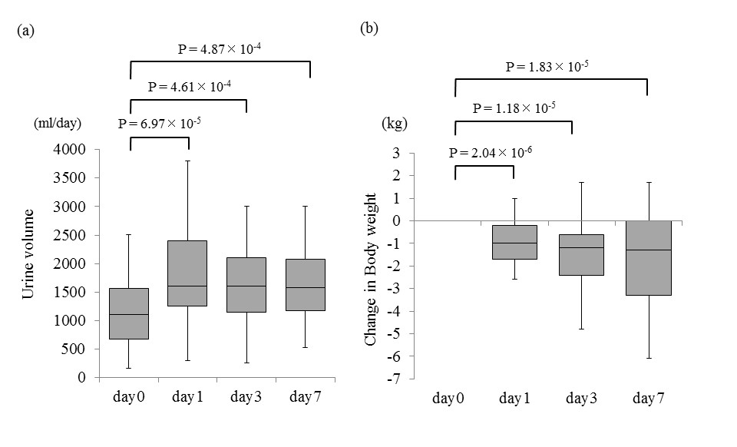
Figure 1 Effects of tolvaptan on liquid retention in all of the patients included in this study. a: Box and whisker plots of daily urine volumes during the first week of tolvaptan administration in all of the patients. Median values were 1108 ml, 1600 ml, 1500 ml and 1582 ml on day 0, 1, 3 and 7, respectively; b: Box and whisker plots of changes in body weight from baseline during the first week of tolvaptan administration in all of the patients. Median changes in body weight were -1 kg, -1.2 kg, and -1.3 kg on day 1, 3 and 7, respectively. Difference between day 0 (= baseline) and day1, 3 and 7 were compared by using Wilcoxon signed rank test.

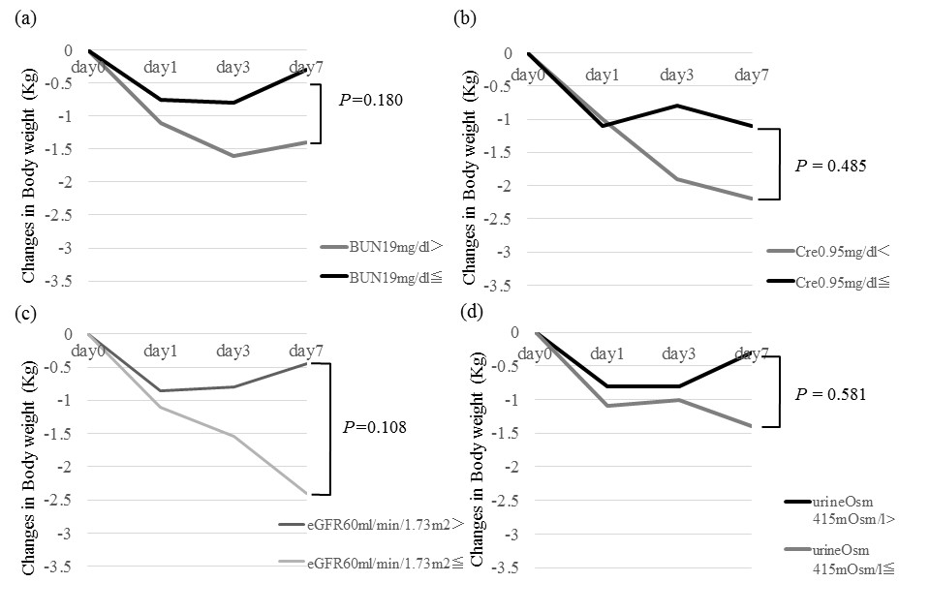

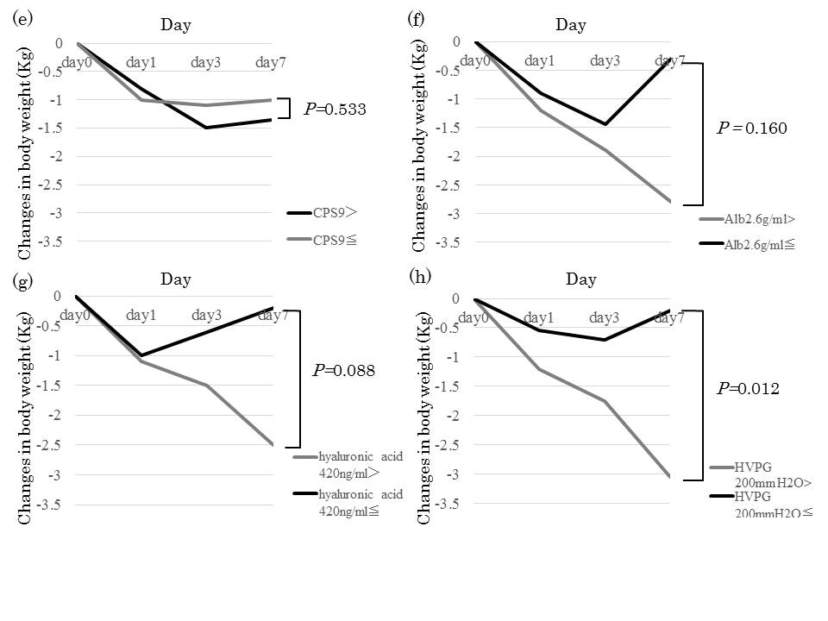
Figure 2 Change in body weight from baseline on each baseline factor during the first week of tolvaptan administration. Data are expressed as median. Patients were divided into two groups using the median value of each baseline variable: (a) serum BUN; (b) serum creatinine; (c) serum eGFR; (d) urine osmolality; (e) Child-Pugh Score (CPS); (f) serum albumin (Alb); (g) serum hyaluronic acid; and (h) Hepatic venous pressure gradient (HVPG).

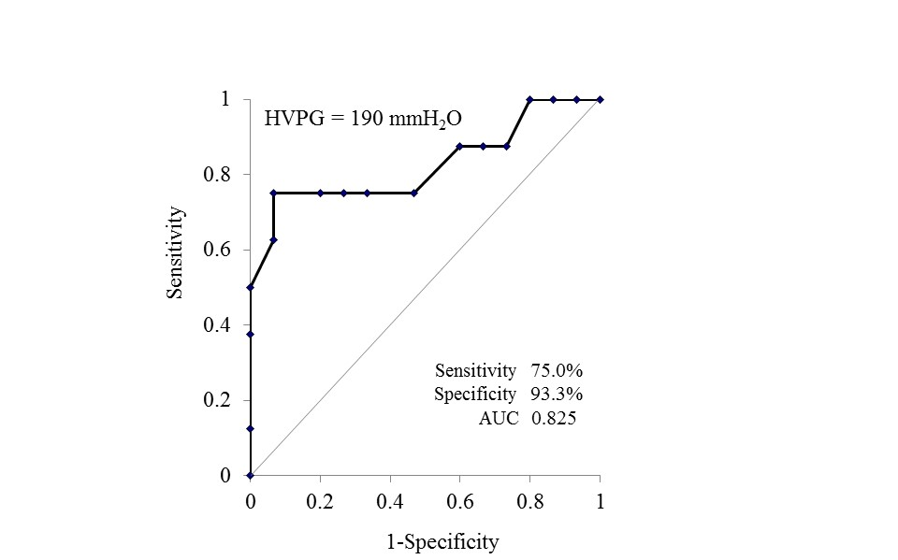

Figure 3 Optimal cutoff value of hepatic venous pressure gradient of the efficacy assessment was determined using ROC curve. The value of 190 mmH₂O [sensitivity, 75.0%; specificity, 93.3%; and area under the curve (AUC), 0.825] was the most useful in predicting treatment response, defined as body weight loss of 2 kg or greater from the baseline. HVPG: Hepatic venous pressure gradient.
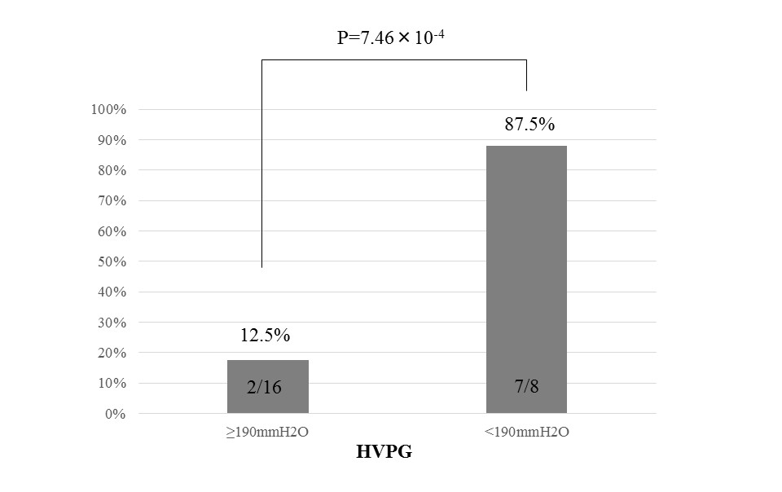
Figure 4 Difference in treatment response rates between patients with low and high hepatic venous pressure gradient. The response rate of 87.5% in the latter with 190 mmH₂O or greater was significantly higher than that of 12.5% in the former with less than 190 mmH₂O (P = 7.46 × 10⁻⁴). HVPG: Hepatic venous pressure gradient.

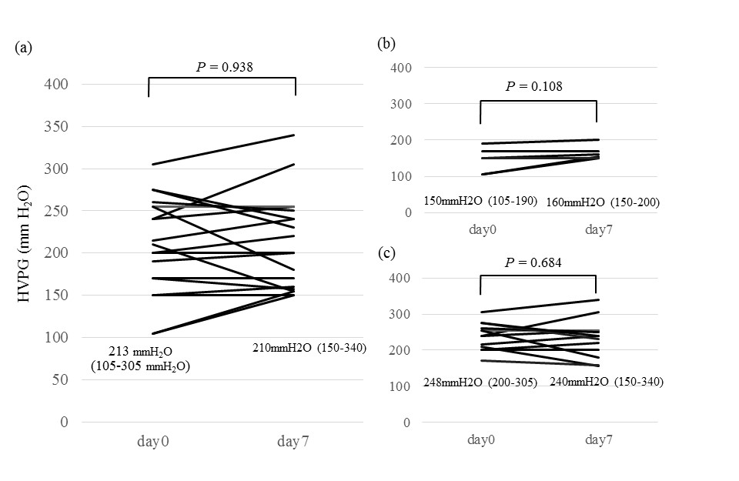

Figure 5 Changes in hepatic venous pressure gradient levels at day 0 and 7. Data are expressed as median (range in parenthesis). (a) overall patients (n = 19); (b) patients (n = 7) with low HVPG (≤ 190 mmH₂O); (c) patients (n = 12) with high HVPG (> 190 mmH₂O). There was not significant difference in any groups, indicating that tolvaptan had little impact on HVPG. HVPG: Hepatic venous pressure gradient.

Characteristics | n = 40
Age (yr) | 65 (40-82)
Gender (M/F) | 26/14
Body weight (kg) | 61.9 (44.8-88.5)
Liver disease etiology | 3/15/15/3/1/3
Hepatitis B/Hepatitis C/Alcohol/PBC/PSC/NASH
Child-Pugh classification A/ B/ C | 3/19/18
Total bilirubin (mg/dL) | 1.0 (0.4-26.2)
Serum albumin (g/dL) | 2.6 (1.6-3.7)
Serum creatinine (mg/dL) | 0.95 (0.45-6.45)
Serum eGFR (ml/min/1.73m²) | 60 (8-112)
Serum sodium (mEq/L) | 139 (124-146)
Serum hyaluronic acid (ng/ml) | 420.7 (122-6984)
BUN (mg/dl) | 19 (8.1-81.8)
Urine osmolality (mOsm/l) | 414.5 (254-954)
Hepatic venous pressure gradient (mmH₂O)¹ | 240 (105-580)
Dose of furosemide (mg/d) | 37.0 ± 29.5
Dose of spironolactone (mg/d) | 43.4 ± 26.8
Hepatocellular carcinoma (with/without) | 12/28
Esophageal varix (with/without) | 25/15
Table 1 Demographic and clinical characteristics at baseline
¹Hepatic venous pressure gradient was measured in 24 patients. Categorical variables are given as number. Almost continuous variables are given as median (range). Dose of furosemide and spironolactone are given as mean ± SD). BUN: Blood urea nitrogen; PBC: Pimary biliary cirrhosis; PSC: Primary sclerosing cholangitis; NASH: Nonalcoholic steatohepatitis; eGFR: Estimated glomerular filtration rat.

Table 2 Comparison of demographic and clinical characteristics at baseline between responders and non-responders

Characteristics | responder (n = 17) | non-responder (n = 23) | P value
Age (y.o) | 66 (45-80) | 61 (40-82) | 0.8137
Body weight (kg) | 62.3 (44.8-88.5) | 61.7 (50.3-79.2) | 0.7857
Liver disease etiology | 3/5/5/2/1/1 | 0/10/10/1/0/2 | －
(Hepatitis B/Hepatitis C/Alcohol/PBC/ PSC/ NASH)
Child-Pugh classification (A-B/C) | 9/8 | 13/10 | 1.000
Total bilirubin (mg/dL) | 0.8 (0.4-11.4) | 1.3 (0.5-26.2) | 0.332
Serum albumin (g/dL) | 2.5 (1.9-3.5) | 2.6 (1.6-3.7) | 0.733
Serum creatinine (mg/dL) | 0.91 (0.62-1.83) | 1.1 (0.45-6.45) | 0.480
Serum eGFR (ml/min/1.73m2) | 62 (24-85) | 51 (8-112) | 0.290
Serum sodium (mEq/L) | 137.5 (125-146) | 140 (124-144) | 0.855
Serum hyaluronic acid (ng/ml) | 335 (181-2843) | 567.9 (122-6984) | 0.017
BUN (mg/dl) | 18.1 (8.1-81) | 20.9 (10.1-81.8) | 0.211
Urine osmolality (mOsm/l) | 418 (257-700) | 361.5 (254-954) | 0.293
Hepatic venous pressure gradient (mmH2O)¹ | 170 (105-580) | 255 (150-350) | 0.045
Hepatocellular carcinoma (with/without) | 6/11 | 6/17 | 0.729
Esophageal varix (with/ without) | 10/7 | 15/8 | 0.518
¹Hepatic venous pressure gradient was measured in 24 patients. Categorical variables are given as number. Continuous variables are given as median (range). BUN: Blood urea nitrogen; PBC: Pimary biliary cirrhosis; PSC: Primary sclerosing cholangitis; NASH: Nonalcoholic steatohepatitis.

