Name of Journal: World Journal of Gastrointestinal Endoscopy
Manuscript NO: 46479
Manuscript Type: CASE REPORT

Post-oesophagectomy gastric conduit outlet obstruction following caustic ingestion, endoscopic management using a SX-ELLA biodegradable stent: A case report

Musbahi A et al. Endoscopic management of pyloric caustic stricture using biodegradable stent

A Musbahi, YKS Viswanath

A Musbahi, YKS Viswanath, Upper GI Laparoscopic and Endoscopic Unit, James Cook University Hospital, Middlesbrough TS43BW, Cleveland, United Kingdom

ORCID number: A Musbahi (0000-0001-7020-9457); YKS Viswanath (0000-0003-3880-1172).

Author contributions: Musbahi A compiled case notes and wrote the first draft; Viswanath YKS contributed to editing, redrafted few times and submitted.

Informed consent statement: All study participants, or their legal guardian, provided informed written consent prior to study enrollment

Conflict-of-interest statement: Nothing to disclose.

CARE Checklist (2016) statement: The authors have read the CARE Checklist (2016), and the manuscript was prepared and revised according to the CARE Checklist (2016).

Open-Access: This article is an open-access article which was selected by an in-house editor and fully peer-reviewed by external reviewers. It is distributed in accordance with the Creative Commons Attribution Non Commercial (CC BY-NC 4.0) license, which permits others to distribute, remix, adapt, build upon this work non-commercially, and license their derivative works on different terms, provided the original work is properly cited and the use is non-commercial. See: http://creativecommons.org/licenses/by-nc/4.0/

Manuscript source: Invited manuscript

Corresponding author: YKS Viswanath, FRCS, MBBS, Professor, Consultant, Upper GI Laparoscopic and Endoscopic Unit, James Cook University Hospital, Marton Road, Middlesbrough TS43BW, Cleveland, United Kingdom. yksviswanath@nhs.net
Telephone: +44-1642-854863
Fax: +44-1642-282872

Received: February 28, 2019
Peer-review started: March 1, 2019
First decision: April 5, 2019
Revised: April 23, 2019
Accepted: May 1, 2019
Article in press: May 1, 2019
Published online: May 16, 2019

Abstract
BACKGROUND
Benign oesophageal strictures secondary to caustic ingestion are rare and difficult to manage. They often present with symptoms such as chest pain, dysphagia and vomiting. Surgical resection is often not justified in majority of these cases who later presents with recurrent benign stricture.

CASE SUMMARY
We present a unique case of a patient who presented with post-oesophagectomy gastric conduit outlet obstruction (POGO) secondary to caustic ingestion. Our patient had already undergone two stage oesophagectomy with pyloroplasty for operable oesophageal cancer with curative intent 5 years prior. This is a distinctive case, where a successful deployment of a SX-ELLA biodegradable (BD) stent (019-10A-28/23/28-080) after failed dilatations. We have briefly reviewed literature with regards to the role BD stents in patients with recurrent benign stricture and discussed management dilemma.

CONCLUSION
We recommend the attending gastroenterologist should bear the usefulness of BD stents in the management of refractory POGO after oesophagectomy.

Key words: Biodegradable; Stent; Oesophagectomy; Case report

© The Author(s) 2019. Published by Baishideng Publishing Group Inc. All rights reserved.

Core tip: A 69 years old, who had previous oesophagectomy, presented with weight loss, regurgitation and vomiting. He gave a history of recent caustic ingestion. Subsequent assessments revealed, delayed gastric conduit emptying with features indicative of post-oesophagectomy gastric conduit outlet obstruction (POGO). Initial conservative measures followed by 3 attempts at dilatations failed, and later endoscopically managed by deployment of SX Ella biodegradable (BD) stent across the scarred pyloric channel. He has remained symptom free and has put on weight at 8 mo follow up. This is a distinctive case of utilization of BD stent in the management of post caustic pyloric stricture after previous two stage Ivor Lewis oesophagectomy.

Citation: Musbahi A, Viswanath YKS. Post-oesophagectomy gastric conduit outlet obstruction following caustic ingestion, endoscopic management using a SX-ELLA biodegradable stent: A case report. World J Gastrointest Endosc 2019; 11(5): 389-394
URL: https://www.wjgnet.com/1948-5190/full/v11/i5/389.htm
DOI: https://dx.doi.org/10.4253/wjge.v11.i5.389

INTRODUCTION
Benign upper gastrointestinal and oesophageal strictures secondary to caustic ingestion are rare and management remains challenging. They often present with symptoms such as chest pain, dysphagia and vomiting^{[1]}. Symptomatic strictures often require endoscopic intervention usually via dilatation either using a balloon or bougie^{[2]}. Patients with recurrent strictures are offered endoscopic stent using a biodegradable (BD) stent rather a self-expanding metallic stent. The later are associated with problems secondary to migration, erosions and the need for their removal. Surgical resection is often not justified in majority of these cases who later presents with recurrent benign stricture.
We report a patient with a back-ground history of psychiatric illness and who have undergone Ivor Lewis oesophagectomy with vagotomy for operable cancer 5 years prior. He presents with chest pain vomiting and weight loss with recent history of caustic ingestion. Endoscopy and imaging assessments revealed post-oesophagectomy gastric conduit outlet obstruction (POGO) and he failed to respond to initial endoscopy dilatations. Consequently, a decision to manage POGO with a BD stent was taken with a successful outcome.

CASE PRESENTATION
Chief complaints
We present a 69-year-old man with previous curative two stage Ivor Lewis oesophagectomy with concomitant pyloroplasty, 5 years prior for operable oesophageal adenocarcinoma.

History of past illness
He carried a past history of bipolar psychiatric illness requiring multiple emergency admissions with history of deliberate self-harm.

History of present illness
He presented to emergency room with history of caustic ingestion with symptoms of odynophagia, dysphagia, hematemesis, chest pain and vomiting. Patient was treated conservatively with high dose proton pump inhibitors, tranexamic acid, blood products, antibiotics, total parenteral nutrition initially followed by enteral nutrition. After initial endoscopic assessments, he was discharged on high dose proton pump inhibitors. Three months later, he represents with weight loss, chest pain and vomiting.

FINAL DIAGNOSIS
Subsequent assessments on endoscopy, CT, chest X ray (Figure 1A), contrast swallow (Figure 1B), a diagnosis of caustic stricture with fibrosis at pyloric channel of the gastric conduit was established (POGO, Enteral naso-jejunal feed was used to oversee his nutrition and allowed intake of his routine medication. Treatment with initial two balloon dilatations and one bougie dilatation (Figure 2) failed with follow-on recurrence of vomiting. All along, at endoscopy he was found to have lot of fluid residue in the gastric conduit alongside negotiable pyloric channel with difficulty. This was due to angulation diaphragmatic hiatus and associated scarring on over one third of its circumference. He was then considered for the possibility of placement of a BD stent with definitive intent rather a removable metallic stent.

TREATMENT
Placement of BD stent; Under sedation, with midazolam (5 mg) and Alfentanyl (150 micrograms), a 24 mm SX-ELLA (019-10A-28/23/28-080) BD stent (Figure 3A) was placed over a guidewire under X-ray guidance. The deployed Ella BD stent had a diameter of 23 mm for the body and 28 mm for proximal and distal flare. A conclusion contrast stentogram confirmed satisfactory position of BD stent, so also on check completion endoscopy (Figure 3B and C). He was kept as an inpatient for 48 h with intravenous antiemetics and was allowed oral fluids and liquid diet for 6 wk.

OUTCOME AND FOLLOW-UP
Follow up at 8 wk and 6 mo revealed complete symptomatic resolution with improved nutritional status and subsequently he was discharged. Follow up X ray confirmed normal looking shadow of the decompressed conduit without a fluid level (Figure 4)

DISCUSSION
In upper gastrointestinal tract, oesophageal strictures of benign etiology can occur commonly secondary to gastro-esophageal reflux disease, post-surgery such as oesophagectomy at the anastomosis, after radiotherapy or secondary to caustic ingestion^{[1]}. However, benign stricture following caustic ingestion causing pyloric channel stricture at the outlet of gastric conduit are rare.
Management of benign upper GI and esophageal strictures remains challenging. Mainly in majority of endoscopy units, the dilation is carried out with either a bougie or a balloon. More than 80% of these patients usually respond and a proportion of them need more than one session. Around 10% develop a refractory or recurrent stricture. These usually require several dilatations raising risks of bleeding and perforation^{[2]}.
Oesophageal strictures can be simple or complex. Simple strictures are short (< 2 cm), focal, straight, and passable with an endoscope such oesophageal web or Schatzki’s ring. A non-passable or significantly narrowed diameter (< 12 mm) stricture, that is longer than 2 cm and tortuous are deemed complex. These are mainly occur following surgery, radiotherapy or corrosive ingestion and are difficult treat^{[3]}. Management of POGO remains a challenge, endoscopic intervention is technically demanding given the angulation at the level of diaphragm and postsurgical anatomic configuration
Recurrent and refractory strictures are usually distinguished by; fibrotic stenosis restricting the oesophageal lumen, absence of active inflammation or motility disorder, and failure to achieve a luminal diameter of 14 mm for 4 wk after 5, two weekly dilatations^{[3]}.
There are no defined characteristics for refractory POGO published in the literature. In this case, persistent symptoms and failed 3 dilations are taken in to account prior to the placement of a BD stent.
Since 2008, BD stents are accessible for endoscopic intervention; they usually degrade after 11-12 wk. Therefore, BD stents are an attractive substitute to treat dysphagia secondary to benign or malignant strictures^{[4]}. Placement of a BD stent is seen as an alternative to repeated dilatations in a patient with benign refractory stricture, with the objective of reducing dilatations and allowing remodeling at stricture site^{[5]}.
The use of stents as a palliative measure in malignant strictures has been well established. A range of benign stenosing disorders of the esophagus and upper gastro-intestinal tract can also be treated safely with a self-expanding or BD plastic stent such as benign oesophageal strictures secondary to peptic disease or caustic injury^{[5]}. In this case, ingested caustic caused initial inflammation with ulceration followed by pyloric channel fibrosis, resulting in POGO. This is a distinctive case report we know of a BD stent being used in an obstructed gastric conduit in a post-oesophagectomy patient to treat a caustic stricture of the pylorus. We advocate attending gastroenterologist to contemplate using BD stents in selected patients at similar clinical situations.

CONCLUSION
In this article, authors have illustrated the role of a BD stent in the management of caustic pyloric stricture. The treating endoscopic physician should contemplate the usage of a BD stent in these challenging situations even after oesophagectomy. The role of a BD stent in the management caustic Upper GI refractory stricture is not well understood needs further investigation.

REFERENCES
1 Evrard S, Le Moine O, Lazaraki G, Dormann A, El Nakadi I, Devière J. Self-expanding plastic stents for benign esophageal lesions. Gastrointest Endosc 2004; 60: 894-900 [PMID: 15605003 DOI: 10.1016/S0016-5107(04)02278-3]
2 Repici A, Vleggaar FP, Hassan C, van Boeckel PG, Romeo F, Pagano N, Malesci A, Siersema PD. Efficacy and safety of biodegradable stents for refractory benign esophageal strictures: the BEST (Biodegradable Esophageal Stent) study. Gastrointest Endosc 2010; 72: 927-934 [PMID: 21034894 DOI: 10.1016/j.gie.2010.07.031]
3 van Hooft JE, van Berge Henegouwen MI, Rauws EA, Bergman JJ, Busch OR, Fockens P. Endoscopic treatment of benign anastomotic esophagogastric strictures with a biodegradable stent. Gastrointest Endosc 2011; 73: 1043-1047 [PMID: 21392754 DOI: 10.1016/j.gie.2011.01.001]
4 Hirdes MM, Vleggaar FP, Siersema PD. Stent placement for esophageal strictures: an update. Expert Rev Med Devices 2011; 8: 733-755 [PMID: 22029470 DOI: 10.1586/erd.11.44]
5 Dhar A, Close H, Viswanath YK, Rees CJ, Hancock HC, Dwarakanath AD, Maier RH, Wilson D, Mason JM. Biodegradable stent or balloon dilatation for benign oesophageal stricture: pilot randomised controlled trial. World J Gastroenterol 2014; 20: 18199-18206 [PMID: 25561787 DOI: 10.3748/wjg.v20.i48.18199]

P-Reviewer: Dinç T, El-Shabrawi MHF, Qi XS, Sterpetti AV S-Editor: Ji FF L-Editor: A E-Editor: Xing YX

Specialty type: Gastroenterology and hepatology
Country of origin: United Kingdom
Peer-review report classification
Grade A (Excellent): 0
Grade B (Very good): B
Grade C (Good): C, C
Grade D (Fair): D
Grade E (Poor): 0

A B
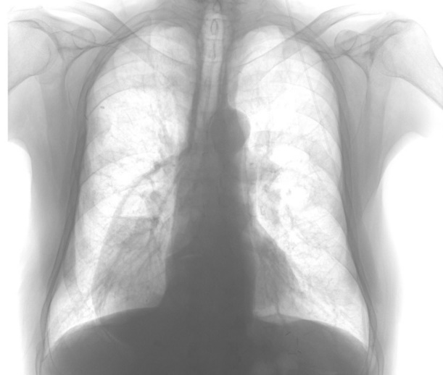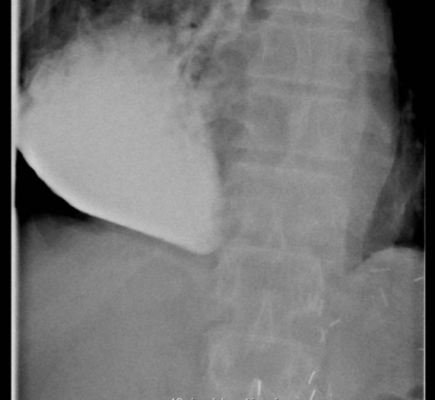

Figure 1 Chest x ray with a dilated gastric conduit with air fluid level and a contrast X ray showing meagre passage of contrast with dilated gastric conduit. A: Chest X ray demonstration a dilated gastric conduit with air fluid level; B: Contrast X ray showing meagre passage of contrast with dilated gastric conduit.

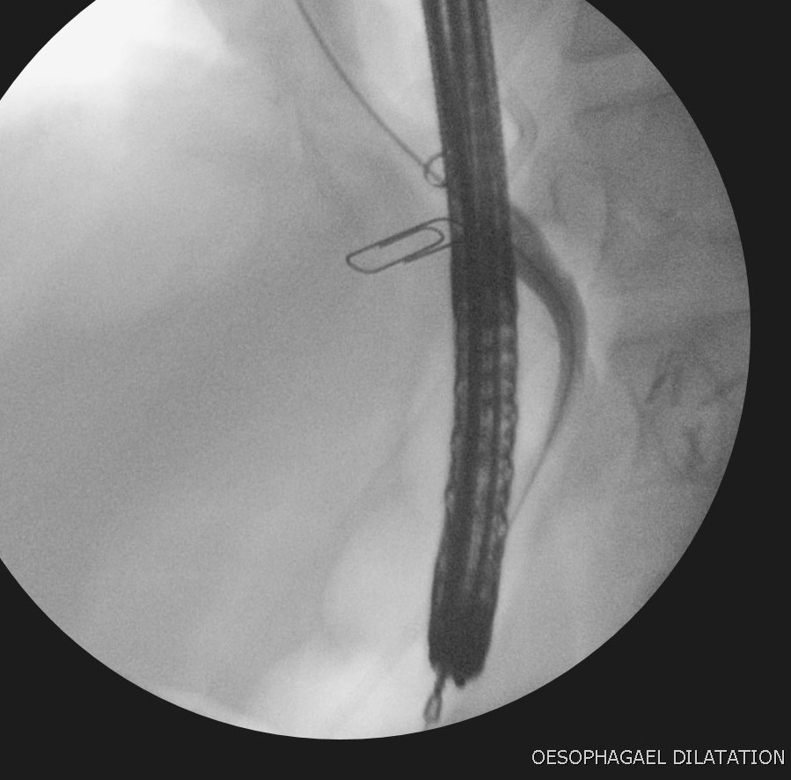

Figure 2 Bougie dilatation with two clip markers at the site of pyloric stricture.

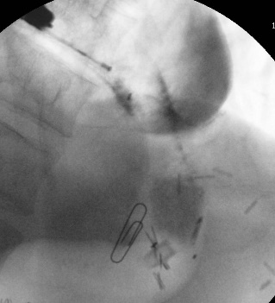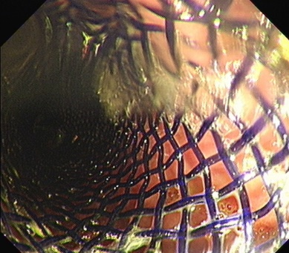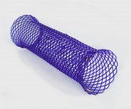

Figure 3 Contract X ray deployed biodegradable stent with endoscope in the gastric conduit together injection catheter, endoscopic and outside view of the biodegradable stent. A: Contrast in the deployed biodegradable (BD) stent with endoscope in the gastric conduit together injection catheter; B: Endoscopic view of the deployed BD stent; C: Sx Ella BD stent.

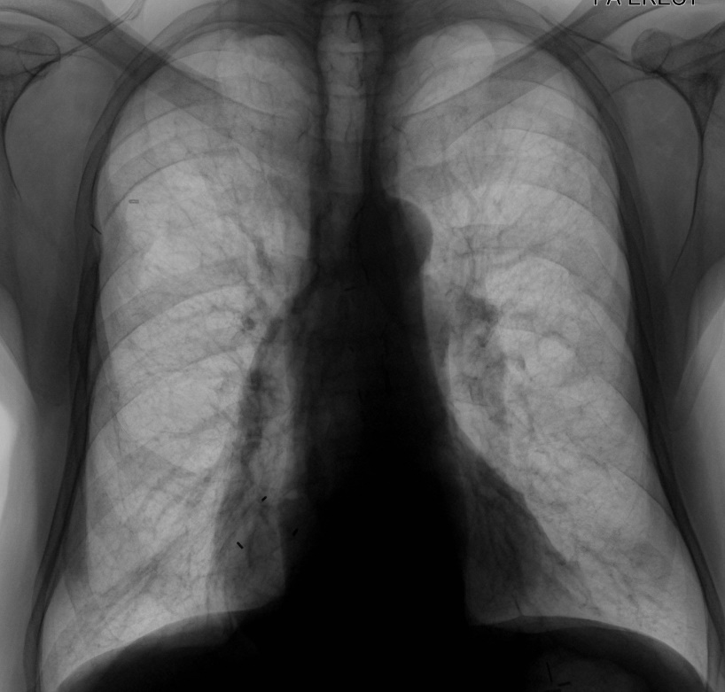

Figure 4 X ray showing well decompressed gastric conduit with proximal radio opaque markers of the biodegradable stent.

