Name of Journal: World Journal of Clinical Cases
Manuscript NO: 76528
Manuscript Type: CASE REPORT

Discoid medial meniscus of both knees: A case report

Zheng et al. Discoid medial meniscus

Zhong-Ren Zheng, Hui Ma, Fei Yang, Long Yuan, Guo-Dong Wang, Xiao-Wei Zhao, Long-Fei Ma

Zhong-Ren Zheng, Long Yuan, School of Clinical Medicine, Jining Medical University, Jining 272067, Shandong Province, China

Hui Ma, Guo-Dong Wang, Xiao-Wei Zhao, Long-Fei Ma, Department of Orthopedics, The Affiliated Hospital of Jining Medical University, Jining 272000, Shandong Province, China

Fei Yang, Department of Orthopedics, The People’s Hospital of Bozhou, Bozhou 236800, Anhui Province, China

Author contributions: Zheng ZR collected the data, imaging, and surgical reports and wrote the initial draft of the manuscript and subsequent revisions; Ma H and Yuan L were the primary physicians during the patient’s hospital stay; Zhao XW, Wang GD, and Yang F were involved in editing and overseeing the text; Ma LF is the senior author who was the treating surgeon and was responsible for overseeing the report and editing the manuscript; All authors read and approved the final manuscript.

Supported by the National Natural Science Foundation of China, No. 81871814; and Jining City Key Research and Development Plan, No. 2021YXNS076.

Corresponding author: Long-Fei Ma, MD, Attending Doctor, Department of Orthopedics, The Affiliated Hospital of Jining Medical University, No. 89 Guhuai Road, Jining 272000, Shandong Province, China. doctormlf@yeah.net

Received: March 20, 2022
Revised: June 29, 2022
Accepted: July 27, 2022
Published online: September 6, 2022

Abstract
BACKGROUND
Discoid meniscus is a congenital anomaly that typically affects the lateral meniscus. The appearance of the discoid medial meniscus in both knees is extremely rare, with an incidence of only 0.012%.

CASE SUMMARY
Our patient was a 30-year-old female. Under no obvious predisposing causes, she began to experience pain in both knees, which worsened while walking and squatting. The pain was aggravated after exercise, and joint flexion and extension activities were accompanied by knee snapping. Apley’s test was positive on physical examination, and there was a pressing pain in the medial articular space. Plain radiographs of both knees revealed no obvious abnormalities in the bilateral knee joint space. Partial meniscectomy as well as menisci reformation were performed on both knees under arthroscopy. Under the guidance of rehabilitation, the patient’s range of motion in both knees returned to normal without pain and knee snapping.

CONCLUSION
This study showed that the clinical manifestations of the discoid medial meniscus injury are identical to those of the conventional medial meniscus injury, and arthroscopic surgery is effective.

Key Words: Medial discoid meniscus; Arthroscopy; Knee joint; Menisci reformation; Magnetic resonance imaging; Case report

©The Author(s) 2022. Published by Baishideng Publishing Group Inc. All rights reserved.

Citation: Zheng ZR, Ma H, Yang F, Yuan L, Wang GD, Zhao XW, Ma LF. Discoid medial meniscus of both knees: A case report. World J Clin Cases 2022; 10(25): 9020-9027
URL: https://www.wjgnet.com/2307-8960/full/v10/i25/9020.htm
DOI: https://dx.doi.org/10.12998/wjcc.v10.i25.9020

Core Tip: Discoid medial meniscus is very rare, and the bilateral discoid medial meniscus is extremely rare. We present the case of a 30-year-old female with features of a meniscal tear in two symptomatic knees and radiographic findings of discoid menisci in both knees. A provisional diagnosis of bilateral discoid medial menisci was made. Magnetic resonance imaging confirmed the discoid nature of the medial menisci in both knees. Both knees underwent partial meniscectomy and menisci reformation by arthroscopy. After 6 mo of follow-up, the patient had good clinical and functional outcomes.

INTRODUCTION
The meniscus is an annular wedge fibrous cartilage tissue with a thick edge and thin middle filling between the femur and tibia in the knee joint. The main function of the meniscus is to fill and lubricate the gap between the knee joint, making the upper and lower bones more stable, smooth, and uniformly stressed^{[1-3]}.
Discoid meniscus is an anatomical congenital abnormality in which the meniscus is thicker and larger than normal^{[4]}. It usually affects the lateral meniscus of the knee joint and impacts both knees. The appearance of the discoid medial meniscus of the knee is extremely rare and even rarer in bilateral knees. Related reports show that the incidence of the discoid lateral meniscus is 1.2%–5.2%, and the incidence of the discoid meniscus on the medial meniscus is 0.12%–0.3%. The incidence of the bilateral knees with the discoid medial meniscus is only 0.012%^{[5,6]}. Since Murdoch^{[7]} reported the first case of the medial discoid meniscus in both knees in 1956, there have only been 20 reports of the medial discoid meniscus in both knees. In general, the bilateral discoid meniscus lesions do not cause notable clinical symptoms, and many people only visit the hospital when they experience severe pain, acid swelling, and motor dysfunction; thus, the actual incidence may be higher than the statistical data^{[8]}.
This article reports a patient with a medial discoid meniscus in both knees. Following magnetic resonance imaging (MRI) and arthroscopy confirmation of the diagnosis, partial meniscectomy as well as menisci reformation were performed on both knees by arthroscopy. The short-term follow-up results were satisfactory.

CASE PRESENTATION
Chief complaints
A 30-year-old female patient presented to our orthopedic outpatient clinic with pain in both knees with limited range of motion for more than 3 years.

History of present illness
Three years ago, under no obvious predisposing causes, she began to experience pain in both knees, which worsened while walking and squatting. The pain was aggravated after exercise, and joint flexion and extension activities were accompanied by knee snapping. She even displayed the symptom of joint locking.

History of past illness
The patient has no history of other diseases.

Personal and family history
The patient had no family or genetic disease history.

Physical examination
On specialized examination, the following results were observed: no bilateral knee joint swelling, normal skin temperature, no varus or valgus knee deformity, negative floating patella sign, positive Apley’s test, pressing pain of the medial articular space, negative over-flexion test, positive McMurray test, negative drawer test, negative Lachman Test, and negative lateral stress test. The joint motion of the left knee was 0-110° and that of the right knee was 0-120°. The Lysholm score was 40.

Laboratory examinations
On preoperative laboratory examination, no abnormalities were found.

Imaging examinations
Plain radiographs of both knees revealed no significant abnormalities in the knee joint space (Figure 1). MRI is currently the imaging method of choice for diagnosing the discoid meniscus. The presence of three or more consecutive, 5-mm thick, sagittal images that demonstrate contiguity between the anterior and posterior horns of the meniscus is pathognomonic for discoid meniscus. The medial meniscus fills the medial joint space in the coronal view, extending to the medial side of the intercondylar fossa. However, the most accurate criterion for diagnosis is a ratio of the minimal meniscus width to the maximal tibial width of > 20% in the coronal plane. Three consecutive images at the sagittal position of the bilateral knee showed the anterior and posterior corners of the meniscus joined, body hypertrophy, and the medial meniscus was filled in the medial joint space extending to the intercondylar fossa in the coronal position. The medial meniscus showed a horizontal tear (Figures 2 and 3).

FINAL DIAGNOSIS
A medial discoid meniscus tear in both knees.

TREATMENT
After confirming the diagnosis of the meniscus injury in both knees with general anesthesia and a nerve block, the traditional anteromedial and anterolateral approaches under arthroscopy were used; thus, the left and right knee joints were explored successively. The intraoperative examination revealed left knee synovial hyperplasia, discoid medial meniscus, lamellar and longitudinal fissures, obvious edge relaxation, intermediate hypertrophy, intact lateral meniscus, and no obvious cruciate ligament or cartilage damage (Figure 4A). The examination of the right knee revealed synovial hyperplasia, discoid medial meniscus, lamellar and longitudinal fissures, obvious relaxation at the edge, hypertrophy in the middle, intact meniscus outside, and no obvious cruciate ligament or cartilage damage (Figure 4B). A partial meniscectomy was performed on both knees, and the discoid medial meniscus was reformed by saucerization.
The knee joint activity training, ankle pump exercise, and straight leg raising training were started immediately postoperatively; weight-bearing walking practice with crutches was started on the 1st postoperative day.

OUTCOME AND FOLLOW-UP
At the 1-mo postoperative follow-up, the wound had healed well and showed no signs of infection. The patient could walk without a brace, and normal activities were completely restored. Six months after the operation, outpatient and telephone follow-ups revealed that the joint motion of the bilateral knees was completely normal without pain and knee snapping. Her Lysholm score was raised to 95.

DISCUSSION
Congenital variations of the discoid meniscus always occur in the lateral meniscus of the knee. The medial discoid meniscus is rare, and cases of a discoid meniscus of the medial of both knees are even rarer. In 1889, an anatomical study by Young et al^{[9]}found the first discoid meniscus in the lateral space of the knee joint, and people began to understand the discoid variation of the meniscus. In 1941, Cave^{[10]} reported that the medial side of the knee joint can also have a discoid meniscus. Murdoch^{[7]} reported the first case of the bilateral medial discoid meniscus in 1956. Since then, only 20 cases of the discoid meniscus on the medial knees have been reported.
Because most patients do not have any clinical symptoms, the current domestic and international studies on the incidence of the discoid medial meniscus have not been determined. Smillie^{[11]} found 467 cases of the discoid lateral meniscus and only 7 (0.07%) cases of discoid medial meniscus among 10000 meniscectomy cases. Dickason et al^{[12]}, in a retrospective study of 14731 patients with a meniscus injury, studied 8040 cases of medial meniscus injury, of which only 10 (0.12%) cases were discoid meniscus, and 102 (1.5%) cases were discoid meniscus among 6691 cases of the lateral meniscus.
Discoid meniscus is more common in Asians than in westerners, whereas medial discoid meniscus is rare in both eastern and western populations. Fukuta et al^{[13]} reported that the incidence of the discoid meniscus in China, Japan, and South Korea was approximately 13%. Kim et al^{[14]} reported a discoid meniscus incidence of approximately 10.9% in South Korea. Rao et al^{[15]} reported a study of 1643 knee arthroscopies in South Asia and found 95 cases of the discoid meniscus, with an incidence of 5.8%. Murlimanju et al^{[16]} reported that the incidence of discoid lateral meniscus was approximately 17.9% in the autopsy of the South Indian population.
Currently, the causes of the discoid meniscus are unknown, and the hypotheses of strain hyperplasia, high mobility of the meniscus, embryonic development stagnation, genetic factors, and congenital factors are controversial^{[17]}. Smillie^{[11]} pointed out that the discoid meniscus is caused by a reabsorption disorder in the center of the cartilage disc from neonatal to adult development. Kaplan’s^{[18]} research showed that the meniscus in the early embryo was crescent-shaped rather than discoid. He believed mechanical stress factors, such as excessive root activity behind the meniscus, gradually formed the discoid meniscus. Ahmed Ali^{[19]} reported a familial case of medial discoid meniscus tear, suggesting that discoid meniscus may be associated with a genetic abnormality. Recent studies have shown that a discoid meniscus is abnormal in both morphology and histomorphology. Papadopoulos et al^{[20]} found that the collagen fibers in the discoid meniscus were heterogeneous leading to the destruction of the collagen network and speculated that this destruction weakened the ultrastructure of the collagen, inducing a meniscus tear. However, there is no consensus on which theory of the medial discoid meniscus formation mechanism is correct.
Based on arthroscopic appearance, Watanabe et al^{[21]} categorized the discoid meniscus into three different types: complete, incomplete, and Wrisberg-ligament type. This classification is currently the most widely used for lateral discoid meniscus. The size of the disc-shaped meniscus covering the tibial plateau determines the complete and incomplete types. In the Wrisberg-ligament type, only the Wrisberg ligament attaches to the lateral side of the medial femoral condyle, and structural abnormalities or the absence of the coronal ligament prevent the meniscus from properly attaching on the posterior side of the tibial plateau. As a result, the meniscus is pulled between the condyles when the knee is extended and repositioned when the knee is flexed. The lateral meniscus develops a secondary thickening and disc shape as a result of repeated abnormal activity and mechanical stimulation. At present, the medial discoid meniscus has only complete and incomplete types reported in the literature with no report on the Wrisberg-ligament type. Monllau et al^{[22]} expanded on this basis with a fourth lateral discoid meniscus type: annular discoid meniscus with a normal attachment of the posterior horn of the meniscus to the posterior border of the tibial plateau. However, this additional classification is not used in clinical treatment decisions. Additionally, the value deserves further study.
The discoid meniscus is not strong enough to bear the body weight due to the shape and movement characteristics of the knee joint surface and is easily crushed and torn^{[23]}. Because the medial articular surface of the knee is usually the primary weight-bearing part of the body, a medial disc meniscus tear is theoretically more likely than a lateral one. The most common symptom of a discoid medial meniscus injury is knee pain without obvious predisposing causes. Other symptoms depend on the stability of the meniscus^{[24]}. When the meniscus is unstable, knee snapping may occur, and when the meniscus is torn, joint swelling, soft legs, and joint locking may occur. A positive McMurray’s test can be detected during physical examination^{[25]}. The mechanism of discoid medial meniscus injury is mainly through the internal knee rotation, and most of the injuries are longitudinal and lamellar fissures. Dickason et al^{[12]} summarized the MRI findings of 18 cases of discoid meniscus injury on the medial side of the knee joint, including 10 cases of lamellar tears, 3 cases of Bucket-handle tears, 1 case of horizontal tear, and 4 cases without an obvious tear.
Because of the lack of typical clinical symptoms, the discoid meniscus is primarily diagnosed using MRI or arthroscopy. The MRI diagnosis of the discoid medial meniscus is the same as that of the discoid lateral meniscus^{[26]}. The observations are as follows: the diagnosis is made when the anterior and posterior corners of the meniscus form a “bowknot” in the sagittal view, which can be seen at 3 or more continuous layers at 5-mm thickness intervals. At the coronal level, the discoid meniscus is diagnosed accurately when the ratio of the minimum meniscus width to the maximum tibial width is > 20%^{[27]}. The X-ray film of the knee joint shows that the bony structure development is normal, but the extension of the edge of the discoid medial meniscus to the femoral intercondylar region of the femur can cause the widening of the medial space. The clinical manifestations are a “cup-like” appearance of the medial tibial plateau, the collapse of the proximal medial joint, flattening of the femoral condyle, and widening of the medial joint space^{[28]}. With the widespread use of MRI, more cases of asymptomatic discoid medial meniscus are being diagnosed. However, MRI requires a lengthy examination and is unavailable in all centers. Moreover, it has limitations for claustrophobic patients or those with metal implants^{[29]}. However, arthroscopy remains the “gold standard” for diagnosing a discoid meniscus.
The blood supply to the meniscus is very complex, with a very poor blood supply. As a result, it can barely heal on its own after injury, and conservative treatment is less effective. Meniscus repair surgery is often needed to relieve pain and restore joint function. Because the incidence of the discoid medial meniscus is very rare, there is no systematic summary of its treatment. Kramer et al^{[30]} noted that the surgical indications for discoid medial meniscus injury are similar to those for normal meniscus, and asymptomatic discoid medial meniscus should be treated conservatively. If symptoms develop, surgery is required. The objective of the operation is to eliminate the symptoms and signs caused by the discoid meniscus while preserving as much meniscus function as possible.
Tachibana et al^{[31]} performed arthroscopic menisci reformation on 4 cases of discoid medial meniscus, with satisfactory clinical results. Song et al^{[32]} suggested that the central part of the discoid meniscus be removed during the formation of the discoid medial meniscus, while the intact meniscus tissue with a width of 6–8 mm be preserved. The short-term clinical effect of discoid meniscectomy is satisfactory, but the long-term effect is poor. Räber et al^{[33]} studied 19.8 years of clinical follow-up after discoid lateral meniscus resection and found that the risk of osteoarthritis of the knee joint was significantly increased after discoid lateral meniscus resection.
In this study, the patient had obvious pain in the bilateral knees, which seriously affected her quality of life. Partial meniscectomy and menisci reformation were performed. The patient recovered well in postoperative follow-up. In general, whether to use partial or total meniscectomy is determined primarily by the location and severity of the discoid meniscus injury but also by the patients’ age, whether associated with other injuries, the duration of symptoms, and the functional status of the knee joint itself. The meniscectomy of the discoid meniscus is best suited for older patients who have severe meniscus tears, poor meniscus texture, and so on^{[34]}. Discoid menisci reformation is used to repair the meniscus to a natural arc and restore the thickness and width to normal ranges^{[35]}. In general, the treatment of discoid meniscus must be individualized. Comprehensively, although the effect of arthroscopic treatment of discoid meniscus is satisfactory, a long follow-up is still needed to clarify its benefits and disadvantages^{[36]}.

CONCLUSION
Discoid meniscus on the medial knee is rare, and discoid meniscus of the bilateral knees is even rarer. A timely MRI examination of the knees can aid in preoperative diagnosis. When the discoid medial meniscus of the knee is detected on one side, an MRI examination of the contralateral knee is recommended to help the patient take preventive measures to avoid the recurrence of a similar injury in the contralateral asymptomatic knee. Arthroscopy is the “gold standard” for diagnosing and treating discoid meniscus. To diagnose discoid medial meniscus injury, comprehensive consideration of the patient’s condition is essential.

ACKNOWLEDGEMENTS
We thank the patient for providing consent to publish this case report.

REFERENCES
1 Nguyen JC, De Smet AA, Graf BK, Rosas HG. MR imaging-based diagnosis and classification of meniscal tears. Radiographics 2014; 34: 981-999 [PMID: 25019436 DOI: 10.1148/rg.344125202]
2 Hutchinson ID, Moran CJ, Potter HG, Warren RF, Rodeo SA. Restoration of the meniscus: form and function. Am J Sports Med 2014; 42: 987-998 [PMID: 23940202 DOI: 10.1177/0363546513498503]
3 Barber BR, McNally EG. Meniscal injuries and imaging the postoperative meniscus. Radiol Clin North Am 2013; 51: 371-391 [PMID: 23622090 DOI: 10.1016/j.rcl.2012.10.008]
4 Saavedra M, Sepúlveda M, Jesús Tuca M, Birrer E. Discoid meniscus: current concepts. EFORT Open Rev 2020; 5: 371-379 [PMID: 32818064 DOI: 10.1302/2058-5241.5.190023]
5 Komatsu T, Hashimoto Y, Sakanaka H, Gotani H, Yamano Y. Bilateral discoid medial menisci accompanied by distal arthrogryposis: a case report. Knee Surg Sports Traumatol Arthrosc 2007; 15: 424-426 [PMID: 16983564 DOI: 10.1007/s00167-006-0178-7]
6 Yang X, Shao D. Bilateral discoid medial Meniscus: Two case reports. Medicine (Baltimore) 2019; 98: e15182 [PMID: 30985708 DOI: 10.1097/MD.0000000000015182]
7 MURDOCH G. Congenital discoid medial semilunar cartilage. J Bone Joint Surg Br 1956; 38-B: 564-566 [PMID: 13332004 DOI: 10.1302/0301-620X.38B2.564]
8 Chico-Carpizo F, Arauz de Robles S, Alonso-Hernández J. Symptomatic bilateral medial discoid meniscus treated with arthroscopic meniscal remodeling: clinical case. Rev Esp Cir Ortop Traumatol (Engl Ed) 2020; 64: 350-354 [PMID: 32741686 DOI: 10.1016/j.recot.2020.02.005]
9 Young RB. The external semilunar cartilage as a complete disc. Memoirs & Memoranda in Anatomy
10 Cave EF. Congenital discoid meniscusA cause of internal derangement of the knee. Am J Surg 1941; 54
11 Smillie IS. The congenital discoid meniscus. J Bone Joint Surg Br 1948; 30B: 671-682 [PMID: 18894619]
12 Dickason JM, Del Pizzo W, Blazina ME, Fox JM, Friedman MJ, Snyder SJ. A series of ten discoid medial menisci. Clin Orthop Relat Res 1982: 75-79 [PMID: 6896680]
13 Fukuta S, Masaki K, Korai F. Prevalence of abnormal findings in magnetic resonance images of asymptomatic knees. J Orthop Sci 2002; 7: 287-291 [PMID: 12077651 DOI: 10.1007/s007760200049]
14 Kim SJ, Lee YT, Kim DW. Intraarticular anatomic variants associated with discoid meniscus in Koreans. Clin Orthop Relat Res 1998: 202-207 [PMID: 9917685 DOI: 10.1097/00003086-199811000-00027]
15 Rao PS, Rao SK, Paul R. Clinical, radiologic, and arthroscopic assessment of discoid lateral meniscus. Arthroscopy 2001; 17: 275-277 [PMID: 11239348 DOI: 10.1053/jars.2001.19973]
16 Murlimanju BV, Nair N, Ray B, Pai MM, Amin S, Pai SR. Morphological variants of lateral meniscus of the knee: a cadaveric study in South Indian human fetuses. Anat Sci Int 2011; 86: 63-68 [PMID: 20549581 DOI: 10.1007/s12565-010-0088-0]
17 Chen J, Gao S, Chen B. Discoid medial meniscus with a horizontal cleavage tear: a juvenile who suffered for 3 years. J Pediatr Orthop B 2012; 21: 425-427 [PMID: 21912338 DOI: 10.1097/BPB.0b013e328349efba]
18 Kaplan EB. Discoid lateral meniscus of the knee joint; nature, mechanism, and operative treatment. J Bone Joint Surg Am 1957; 39-A: 77-87 [PMID: 13385265]
19 Ahmed Ali R, McKay S. Familial discoid medial meniscus tear in three members of a family: a case report and review of literature. Case Rep Orthop 2014; 2014: 285675 [PMID: 25548700 DOI: 10.1155/2014/285675]
20 Papadopoulos A, Kirkos JM, Kapetanos GA. Histomorphologic study of discoid meniscus. Arthroscopy 2009; 25: 262-268 [PMID: 19245988 DOI: 10.1016/j.arthro.2008.10.006]
21 Watanabe M, Ikeuchi H, Takeda S. Atlas of arthroscopy. Springer, 1978
22 Monllau JC, León A, Cugat R, Ballester J. Ring-shaped lateral meniscus. Arthroscopy 1998; 14: 502-504 [PMID: 9681543 DOI: 10.1016/s0749-8063(98)70079-9]
23 Atay OA, Doral MN, Leblebicioğlu G, Tetik O, Aydingöz U. Management of discoid lateral meniscus tears: observations in 34 knees. Arthroscopy 2003; 19: 346-352 [PMID: 12671616 DOI: 10.1053/jars.2003.50038]
24 Tyler PA, Jain V, Ashraf T, Saifuddin A. Update on imaging of the discoid meniscus. Skeletal Radiol 2022; 51: 935-956 [PMID: 34546382 DOI: 10.1007/s00256-021-03910-9]
25 Lukas K, Livock H, Kontio K, Carsen S. Bilateral Discoid Medial Menisci: A Case Report and Review of the Literature. J Am Acad Orthop Surg Glob Res Rev 2020; 4: e20.00069 [PMID: 32769707 DOI: 10.5435/JAAOSGlobal-D-20-00069]
26 Luckenbill DB, Peer CW. Ring-Shaped Lateral Meniscus Without a Bony Anterior Root Attachment. Orthopedics 2021; 44: e146-e147 [PMID: 33002180 DOI: 10.3928/01477447-20200923-06]
27 Yaniv M, Blumberg N. The discoid meniscus. J Child Orthop 2007; 1: 89-96 [PMID: 19308479 DOI: 10.1007/s11832-007-0029-1]
28 Kim SJ, Seo YJ. Bilateral discoid medial menisci: Incomplete type in one knee and complete type in opposite knee. Knee 2006; 13: 255-257 [PMID: 16531047 DOI: 10.1016/j.knee.2006.01.009]
29 Sharafat Vaziri A, Aghaghazvini L, Jahangiri S, Tahami M, Borazjani R, Tahmasebi MN, Rabie H, Mamaghani HJ, Vosoughi F, Salimi M. Determination of Normal Reference Values for Meniscal Extrusion Using Ultrasonography During the Different Range of Motion: A Pilot, Feasibility Study. J Ultrasound Med 2022 [PMID: 35137975 DOI: 10.1002/jum.15955]
30 Kramer J, Breitenseher M, Stöger A, Huber H, Scheurecker A. [MRI after meniscus and cruciate ligament surgery]. Radiologe 2006; 46: 36-45 [PMID: 16252126 DOI: 10.1007/s00117-005-1291-1]
31 Tachibana Y, Yamazaki Y, Ninomiya S. Discoid medial meniscus. Arthroscopy 2003; 19: E12-E18 [PMID: 12966402 DOI: 10.1016/s0749-8063(03)00688-1]
32 Song IS, Kim JB, Lee JK, Park BS. Discoid Medial Meniscus Tear, with a Literature Review of Treatments. Knee Surg Relat Res 2017; 29: 237-242 [PMID: 28854771 DOI: 10.5792/ksrr.15.054]
33 Räber DA, Friederich NF, Hefti F. Discoid lateral meniscus in children. Long-term follow-up after total meniscectomy. J Bone Joint Surg Am 1998; 80: 1579-1586 [PMID: 9840625 DOI: 10.2106/00004623-199811000-00003]
34 Sevillano-Perez E, Espejo-Reina A, Espejo-Reina MJ. Symptomatic Bilateral Torn Discoid Medial Meniscus Treated with Saucerization and Suture. Case Rep Orthop 2016; 2016: 8487194 [PMID: 27656305 DOI: 10.1155/2016/8487194]
35 Franceschi F, Longo UG, Ruzzini L, Simoni P, Zobel BB, Denaro V. Bilateral complete discoid medial meniscus combined with posterior cyst formation. Knee Surg Sports Traumatol Arthrosc 2007; 15: 266-268 [PMID: 16917782 DOI: 10.1007/s00167-006-0191-x]
36 Kim SJ, Lubis AM. Medial and lateral discoid menisci: a case report. Sports Med Arthrosc Rehabil Ther Technol 2010; 2: 21 [PMID: 20731824 DOI: 10.1186/1758-2555-2-21]

Footnotes
Informed consent statement: The patient provided informed consent as evidenced by her signature.

Conflict-of-interest statement: The authors declare that they have no conflicts of interest.

CARE Checklist (2016) statement: The authors have read the CARE Checklist (2016), and the manuscript was prepared and revised following the CARE Checklist (2016).

Open-Access: This article is an open-access article that was selected by an in-house editor and fully peer-reviewed by external reviewers. It is distributed in accordance with the Creative Commons Attribution NonCommercial (CC BY-NC 4.0) license, which permits others to distribute, remix, adapt, build upon this work non-commercially, and license their derivative works on different terms, provided the original work is properly cited and the use is non-commercial. See: https://creativecommons.org/Licenses/by-nc/4.0/

Provenance and peer review: Unsolicited article; Externally peer reviewed.
Peer-review model: Single blind

Peer-review started: March 20, 2022
First decision: June 16, 2022
Article in press: July 27, 2022

Specialty type: Orthopedics
Country/Territory of origin: China
Peer-review report’s scientific quality classification
Grade A (Excellent): A
Grade B (Very good): B
Grade C (Good): C
Grade D (Fair): 0
Grade E (Poor): 0

P-Reviewer: Abulsoud MI, Egypt; Salimi M, Iran S-Editor: Zhang H L-Editor: Filipodia P-Editor: Zhang H

Figure Legends
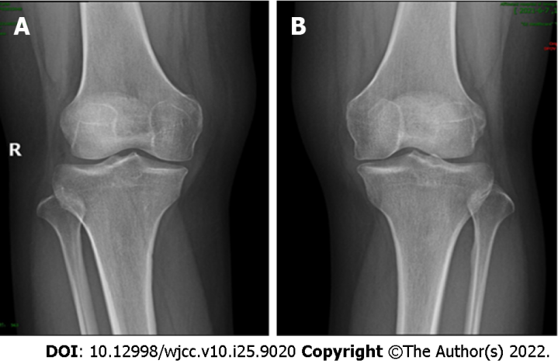
Figure 1 X-ray. A and B: Representative radiographs of the knees show no abnormalities.

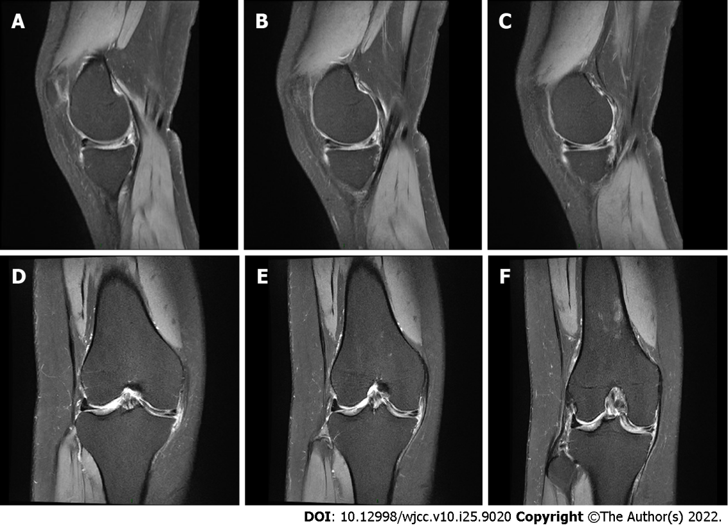
Figure 2 Magnetic resonance imaging examination of the right knee. A-C: Three consecutive images in the sagittal view show a complete medial discoid meniscus; D-F: Coronal views showing a horizontal tear of the medial meniscus.

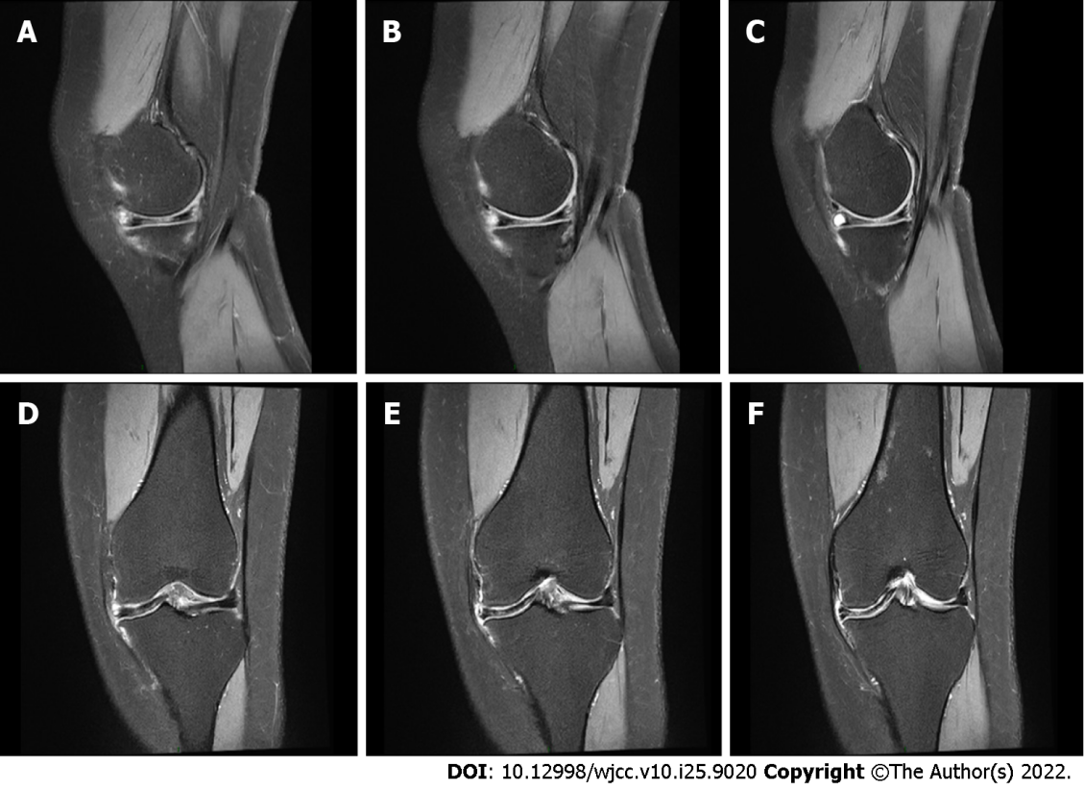
Figure 3 Magnetic resonance imaging examination of the left knee. A-C: Three consecutive images in the sagittal view show a complete medial discoid meniscus; D-F: Coronal views showing a horizontal tear of the medial meniscus.

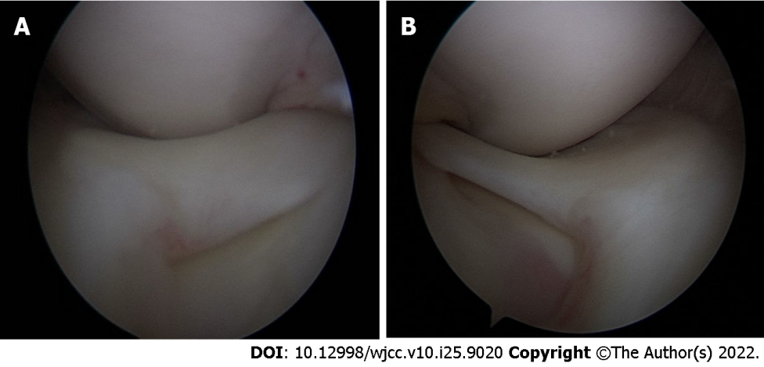
Figure 4 Arthroscopy. A: Left discoid medial meniscus; B: Right discoid medial meniscus.

Published by Baishideng Publishing Group Inc
7041 Koll Center Parkway, Suite 160, Pleasanton, CA 94566, USA
Telephone: +1-925-3991568
E-mail: bpgoffice@wjgnet.com
Help Desk: https://www.f6publishing.com/helpdesk
https://www.wjgnet.com

© 2022 Baishideng Publishing Group Inc. All rights reserved.

