Name of Journal: World Journal of Clinical Cases
Manuscript NO: 74417
Manuscript Type: CASE REPORT

Dilated left ventricle with multiple outpouchings — a severe congenital ventricular diverticulum or left-dominant arrhythmogenic cardiomyopathy: A case report

Zhang X et al. Left-dominant arrhythmogenic cardiomyopathy

Xin Zhang, Run-Yu Ye, Xiao-Ping Chen

Xin Zhang, Run-Yu Ye, Xiao-Ping Chen, Department of Cardiology, West China Hospital, Sichuan University, Chengdu 610041, Sichuan Province, China

Author contributions: Zhang X and Ye RY contributed equally to this article; Zhang X and Ye RY were the patient’s cardiologists, reviewed the literature, and contributed to manuscript drafting; Chen XP was responsible for the revision of the manuscript for important intellectual content; All authors issued final approval for the version to be submitted.

Supported by Chengdu Science and Technology Bureau, China, No. 2020-YF05-00290-SN.

Corresponding author: Xiao-Ping Chen, MD, Chief Doctor, Cardiology Department, West China Hospital, Sichuan University, No. 37 Guoxue Alley, Wuhou District, Chengdu 610041, Sichuan Province, China. xiaopingchen111@126.com

Received: December 26, 2021
Revised: March 20, 2022
Accepted: April 24, 2022
Published online: June 26, 2022

Abstract
BACKGROUND
Left-dominant arrhythmogenic cardiomyopathy (LDAC) is a relatively rare disease characterized by poor prognosis that exacerbates the incidence of sudden cardiac death and ventricular arrhythmias. Clinically, LDAC is constantly overlooked or misdiagnosed as myocardial infarction, myocarditis, and dilated cardiomyopathy, owing to atypical and nonspecific clinical manifestations at an early stage.

CASE SUMMARY
A 57-year-old woman was diagnosed with sinus bradycardia and chronic bifascicular block during a health check. She occasionally experienced mild chest pain and paroxysmal palpitation during activity in the past 2 years. Comprehensive auxiliary examinations, including electrocardiogram, echocardiography, coronary computerized tomography angiography, and magnetic resonance imaging, revealed that she had LDAC instead of congenital ventricular diverticulum. The physicians prescribed standard oral therapy for heart failure and implantable cardioverter-defibrillator. Consequently, her left ventricular systolic function and symptoms remained stable at the 2-year follow-up after discharge.

CONCLUSION
Based on this case, clinicians need to be aware of LDAC in patients with localized left ventricular lesions and multiple electrocardiographic abnormalities. Multimodality cardiovascular imaging is effective in identification of multiple types of cardiomyopathy and cardiac inner structures.

Key Words: Congenital ventricular diverticulum; Left-dominant arrhythmogenic cardiomyopathy; Magnetic resonance imaging; Case report

©The Author(s) 2022. Published by Baishideng Publishing Group Inc. All rights reserved.

Citation: Zhang X, Ye RY, Chen XP. Dilated left ventricle with multiple outpouchings — a severe congenital ventricular diverticulum or left-dominant arrhythmogenic cardiomyopathy: A case report. World J Clin Cases 2022; 10(18): 6289-6297
URL: https://www.wjgnet.com/2307-8960/full/v10/i18/6289.htm
DOI: https://dx.doi.org/10.12998/wjcc.v10.i18.6289

Core Tip: Left-dominant arrhythmogenic cardiomyopathy is a relatively rare disease, characterized by poor prognosis. We present a case with a dilated left ventricle that manifested with reduced ejection fraction, multiple outpouchings, left chest leads low voltage, and fragmented QRS. Multimodality cardiovascular imaging diagnosed the patient with left-dominant arrhythmogenic cardiomyopathy instead of congenital ventricular diverticulum. This case alerts clinicians to be aware of left-dominant arrhythmogenic cardiomyopathy in patients with localized left ventricular lesions and multiple electrocardiographic abnormalities.

INTRODUCTION
Left-dominant arrhythmogenic cardiomyopathy (LDAC) is a non-hypertrophic, non-hypertensive, and non-valvular progressive cardiomyopathy with fibrofatty myocardium infiltration that prominently occurs in the left ventricle^{[1]}. LDAC might present with ventricular outpouching, which makes it difficult to differentiate from congenital ventricular diverticulum from the echocardiography^{[2]}. Here, we present a case of LDAC with left chest leads low voltage, fragmented QRS (f-QRS), left ventricle (LV) dilation, LV systolic impairment, LV outpouchings, and late gadolinium enhancement of LV myocardium, which was finally diagnosed using multimodality cardiovascular imaging.

CASE PRESENTATION
Chief complaints
A 57-year-old woman, presenting with a dilated left ventricle, reduced ejection fraction, and chronic bifascicular block, was referred to the cardiology department, West China Hospital, on December 10, 2019.

History of present illness
She occasionally experienced mild chest pain and paroxysmal palpitation during activity in the past 2 years. Her exercise capacity was also mildly reduced. She did not manifest symptoms of fatigue, dizziness, syncope, peripheral edema, and abdominal distention.

History of past illness
The patient had neither prior medical comorbidities nor addictions.

Personal and family history
Her father had a premature sudden cardiac death at the age of 40.

Physical examination
The patient showed good nutrition, active position, clear mind, fluent language, and was cooperative in examination. Examinations on her whole skin and mucous membrane revealed no yellow staining, cyanosis, and bleeding spots. She had a blood pressure and resting heart rate of 120/68 mmHg and 60 beats per min, respectively, and auscultation of both lungs was normal with neither dry nor wet rales. The apical pulse was located 0.5 cm lateral to the midclavicular line on the left side of the fifth rib, while her heart rhythm was regular. The first and second heart sounds were basically normal, without extra and splitting of the heart sound. No valvular murmurs were detected in any of the auscultation areas. In addition, she did not exhibit any physical signs of heart failure, including edema, ascites, jugular venous distention, and hepatojugular reflux.

Laboratory examinations
Results from the routine blood test and plasma biochemical examinations, including kidney and liver function, glucose, lipid, and electrolyte, were normal. Similarly, thyroid function, kappa and lambda urine free light chains as well as coagulation profile and autoimmune antibodies were also within the normal range. The plasma N-terminal fragment of the pro-brain natriuretic peptide was 325 ng/L.

Imaging examinations
The electrocardiogram (Figure 1) revealed left anterior branch block, complete right bundle branch block (RBBB), high sidewall abnormal Q wave, and left chest leads (V4-V6) low voltage with poor R wave progression. On the other hand, Holter monitoring (Figures 2 and 3) revealed sinus arrest with a 1.74 s R-R interval, multisource premature ventricular beats, non-sustained ventricular tachycardia with an RBBB pattern, and f-QRS in leads V3-V6. Transthoracic echocardiography (TTE) showed a dilated LV with a diameter of 60 mm as well as a reduced LV ejection fraction of 35% and a left ventricular apex cystic outpouching (12 mm × 13 mm) that displayed synchronous contractility (Figure 4A-C). Myocardial contrast echocardiography revealed contractile outpouching without obvious filling defects (Figure 4D). Coronary computerized tomography angiography (CCTA) revealed right dominant coronary artery circulation without obvious stenosis, LV multiple outpouchings, uneven thickness of the LV wall (Figure 5A, B, E, and F), hypodense region (CT value -90~-114 HU) at localized myocardium of LV septum (Figure 5C), and free wall (Figure 5D). These findings were consistent with profiles of fatty tissue infiltration. In addition, we used cardiac magnetic resonance imaging (CMRI) to evaluate the cardiac structure, bilateral ventricular function, segmental movement, and tissue characterization in the patient. CMRI results revealed LV dilatation, abnormal activity of the LV wall (Figure 6A and B), an outpouching at the LV apex, and a low signal in the septum myocardium midwall after contrast injection (Figure 6C). Moreover, late gadolinium enhancement in the midwall of the left ventricular septum and free wall myocardium were also evident (Figure 6D).

Genetic testing
High-throughput sequencing revealed no genetic variation with high clinical phenotype correlation and sufficient evidence of pathogenicity.

FINAL DIAGNOSIS
These findings highly pointed to LDAC.

TREATMENT
After comprehensive evaluation of the patient, we prescribed sacubitril valsartan sodium tablets (50 mg bid) and spironolactone (20 mg qd). We did not administer a beta-blocker in this case, owing to multiple atrioventricular conduction abnormalities. In addition, she was given low-dose thiazide diuretics when needed to relieve edema and congestion symptoms. Three months later, her left ventricular size and systolic function had not changed compared to baseline. Consequently, she was subjected to an implantable cardioverter-defibrillator after full discussion in our department.

OUTCOME AND FOLLOW-UP
Two years later, we re-evaluated her symptoms and clinical indexes and found that the symptoms improved after taking standard oral medication for ejection fraction reduced heart failure. The pacemaker program did not record sustained ventricular tachycardia or ventricular fibrillation. Echocardiography revealed that left ventricular size and systolic function were almost similar to 2 years prior to treatment.

DISCUSSION
This case affirms the need for clinicians to be aware of LDAC in patients with localized left ventricular lesions and multiple electrocardiographic abnormalities. Notably, multimodality cardiovascular imaging and electrocardiogram (ECG) should be considered in this situation.
The patient in the present case revealed various ECG abnormalities, including sinus node dysfunction, chronic bifascicular block, abnormal Q wave, left chest leads low voltage (V4-6), poor R wave progression in leads V4-V6, and f-QRS in leads V3-V6. These were all indicative of left ventricular myocardial abnormality and extensive conduction system disorder. f-QRS, which has been defined as the presence of additional R’ waves or a notch in the R or S wave in two contiguous leads^{[3]}, indicates myocardial scarring and represents distortion of signal conduction as well as depolarization processes within ventricles^{[4]}. Previous studies have shown that f-QRS is an independent predictor for cardiac events, ventricular arrhythmias, and sudden cardiac death^{[5]}. Notably, it has been detected in patients with various structural heart or primary electrical diseases, such as Brugada syndrome, arrhythmogenic right ventricular dysplasia, and acquired long QT syndrome^{[6]}. Therefore, careful differential diagnosis for cardiomyopathy was imperative for the patient in the present case. Furthermore, there is a need to consider multimodality cardiovascular imaging.
CMRI combined with CCTA is effective in identification of multiple types of cardiomyopathy and cardiac inner structures. Initially, we considered the left ventricular apex outpouching with a thick wall, narrow communication, and synchronous contractility to be a diverticulum based on evidence from echocardiography and myocardial contrast echocardiography. However, CCTA and CMRI generated more details for differential diagnosis. Previous studies have shown that CCTA, a noninvasive approach, can effectively distinguish outpouchings caused by myocardial infarction and ischemic cardiomyopathy related to occlusion (or lack thereof) of the coronary arteries^{[7,8]}. Furthermore, CMRI has a unique advantage in identifying cardiomyopathy. Black blood with T1 and T2 sequences as well as dynamic bring blood were used to evaluate the cardiac structure, tissue characterization, bilateral ventricular function, and segmental movement. In addition, delayed enhancement imaging following administration of gadolinium can result in more information on fibrosis, scarring, and fat infiltration in the local myocardium^{[9]}. In the present case, CCTA and CMRI results revealed LV septum and free wall local myocardium replaced by fatty tissue as well as LV midwall late gadolinium enhancement, multiple LV outpouchings, and uneven thickness of the LV wall, without stenosis of coronary arteries. These abnormalities were accompanied by non-sustained ventricular tachycardia with an RBBB pattern and f-QRS in the left chest leads. Consequently, we considered that this patient had arrhythmogenic cardiomyopathy.
Arrhythmogenic cardiomyopathy refers to a category of non-hypertrophic, non-hypertensive, and non-valvular progressive cardiomyopathy with fibrofatty myocardium infiltration^{[10]}. Previous studies have classified arrhythmogenic cardiomyopathy into classical arrhythmogenic right ventricular cardiomyopathy, LDAC, and biventricular involvement categories^{[11]}. The patient in the present study was eventually diagnosed with LDAC. LDAC, which was first described by Sen-Chowdhry et al^{[1]} in 2008, has been easily overlooked or misdiagnosed as myocardial infarction, myocarditis, and dilated cardiomyopathy in clinical practice. Notably, LDAC is a relatively rare disease. For example, it accounted for less than 0.15% of 35845 consecutive patients who were referred for CMRI examinations in Fuwai Hospital (Beijing, China), National Center for Cardiovascular Diseases^{[12]}.
Clinically, LDAC patients mainly manifest palpitations, presyncope, exertional dyspnea, and chest pain with normal coronary angiography, with only a handful of cases found to be asymptomatic^{[12,13]}. Patients with LDAC have poor prognosis. For example, Feliu et al^{[13]} found that 32.4% of all LDAC patients studied manifested major adverse cardiovascular events, which were mainly accompanied by sudden cardiac death and ventricular arrhythmias, during a mean follow-up of 3.74 years.
At present, no specific diagnostic criteria exist for LDAC. In 2008, Dr. Chowdhry established the following initial diagnostic features of LDAC: (1) Arrhythmia: sustained or non-sustained ventricular tachycardia; (2) Imaging: (a) LV aneurysms; and (b) mild LV dilation and/or systolic impairment; (3) Biopsy/CMRI: (a) cardiomyocyte loss with fibrofatty replacement on histology; and (b) extensive late gadolinium enhancement of LV myocardium (with subepicardial/midmyocardial distribution); and (4) Unexplained T-wave inversion in V5, V6 ± V4, I, and AVL^{[1]}. Recently, Corrado et al^{[11]} suggested that the following elements should be considered as LDAC: (1) ECG changes, such as low QRS voltages in limb leads and inverted T waves in the inferolateral leads; (2) Ventricular arrhythmias with an RBBB pattern; and (3) Structural and functional imaging features consistent with ‘hypokinetic and fibrotic LV.’ Interestingly, the ultrasonographer initially misdiagnosed the patient in the present study as congenital ventricular diverticulum (CVD), according to the left ventricular apex cystic outpouching displaying synchronous contractility with the corresponding cardiac chamber.
CVD, first described in 1816, was often asymptomatic and incidentally detected during a regular physical check-up. Generally, the left ventricular diverticulum was in a thick wall, comprising endocardium, myocardium, and pericardium, with a narrow communication between the cavity and ventricular and displayed synchronous contractility with the LV^{[14]}. This was likened to an appendix originating from the ventricle. The left ventricular diverticulum has an average size that varies from 0.5 cm to as large as 8.0-9.0 cm^{[15]}. Notably, the left ventricular diverticulum not only has low prevalence, as evidenced by 0.4%-2.2% across different studies^{[16]}, but has also been associated with occurrence of other congenital abnormalities, including septal defects, dextrocardia, and pulmonary stenosis. Generally, CVD combined with midline thoraco-abdominal congenital abnormalities, diaphragmatic and sternal defects, and partial absence of diaphragmatic pericardium is referred to as Cantrell’s syndrome^{[17]}.
CVD has the atypical and nonspecific clinical manifestations at an early stage, namely arrhythmias, cardiac rupture, heart failure, and embolism^{[18,19]}, which make it easily confused with LDAC. However, some of these features can be adopted during the differential diagnosis between CVD and LDAC. First, most CVD are single and located at the cardiac apex^{[20,21]}. Second, the left ventricular wall exhibits neither signal alterations nor signs of necrosis or fibrous tissue in CVD cases^{[22]}. Third, CVD patients exhibit more frequent extracardiac anomalies than those with LDAC^{[19]}. Fourth, the size of CVD does not change over time, suggesting a benign course^{[23]}. However, the patient in the present study not only manifested multiple left ventricular outpouchings but also exhibited uneven-thickness left ventricular wall with multiple flaky fatty infiltrations. This interesting case indicates that clinicians should not ignore LDAC upon detecting left ventricle outpouching on TTE.
Although myocardial biopsy is the gold standard diagnostic criterion, this patient refused this invasive examination. After comprehensively analyzing a combination of the medical history and positive clues on auxiliary examinations, including ECG, TTE, CCTA, and CMRI, the specialists in our department unanimously diagnosed the patient with LDAC. She was subsequently administered with standard oral therapy for heart failure with reduced ejection fraction and implantable cardioverter-defibrillator. The patient was very satisfied with the process of diagnosis, treatment, and follow-up.

CONCLUSION
LDAC is a relatively rare disease, which requires multimodality cardiovascular imaging for diagnosis. CMRI combined with CCTA is an excellent approach for identification of multiple types of cardiomyopathy and cardiac inner structures. From the present case, clinicians are advised to consider LDAC in patients with localized left ventricular lesions and multiple electrocardiographic abnormalities.

ACKNOWLEDGEMENTS
The authors thank the radiology department of West China Hospital, Sichuan University for technical support. Second, we thank Dr. Jerry, PhD from the Home for researchers editorial team for editing the language of this manuscript.

REFERENCES
1 Sen-Chowdhry S, Syrris P, Prasad SK, Hughes SE, Merrifield R, Ward D, Pennell DJ, McKenna WJ. Left-dominant arrhythmogenic cardiomyopathy: an under-recognized clinical entity. J Am Coll Cardiol 2008; 52: 2175-2187 [PMID: 19095136 DOI: 10.1016/j.jacc.2008.09.019]
2 Andreini D, Conte E, Casella M, Mushtaq S, Pontone G, Dello Russo A, Nicoli F, Carità P, Catto V, Vettor G, Gasperetti A, Sommariva E, Rizzo S, Basso C, Tondo C, Pepi M. Cardiac magnetic resonance features of left dominant arrhythmogenic cardiomyopathy: differential diagnosis with myocarditis. Int J Cardiovasc Imaging 2022; 38: 397-405 [PMID: 34546457 DOI: 10.1007/s10554-021-02408-8]
3 Jain R, Singh R, Yamini S, Das MK. Fragmented ECG as a risk marker in cardiovascular diseases. Curr Cardiol Rev 2014; 10: 277-286 [PMID: 24827794 DOI: 10.2174/1573403x10666140514103451]
4 Brohet C. Fragmentation of the QRS complex: the latest electrocardiographic craze? Acta Cardiol 2019; 74: 185-187 [PMID: 30950722 DOI: 10.1080/00015385.2019.1600827]
5 Haukilahti MA, Eranti A, Kenttä T, Huikuri HV. QRS Fragmentation Patterns Representing Myocardial Scar Need to Be Separated from Benign Normal Variants: Hypotheses and Proposal for Morphology based Classification. Front Physiol 2016; 7: 653 [PMID: 28082919 DOI: 10.3389/fphys.2016.00653]
6 Ratheendran AC, Subramanian M, Bhanu DK, Prabhu MA, Kannan R, Natarajan KU, Saritha Sekhar S, Thachathodiyil R, Harikrishnan MS, Pai PG. Fragmented QRS on electrocardiography as a predictor of myocardial scar in patients with hypertrophic cardiomyopathy. Acta Cardiol 2020; 75: 42-46 [PMID: 30602338 DOI: 10.1080/00015385.2018.1547355]
7 Al'Aref SJ, Min JK. Cardiac CT: current practice and emerging applications. Heart 2019; 105: 1597-1605 [PMID: 31142595 DOI: 10.1136/heartjnl-2018-314229]
8 Ramsey BC, Fentanes E, Choi AD, Branch KR, Thomas DM. Myocardial Assessment with Cardiac CT: Ischemic Heart Disease and Beyond. Curr Cardiovasc Imaging Rep 2018; 11: 16 [PMID: 29963220 DOI: 10.1007/s12410-018-9456-2]
9 Yoneyama K, Kitanaka Y, Tanaka O, Akashi YJ. Cardiovascular magnetic resonance imaging in heart failure. Expert Rev Cardiovasc Ther 2018; 16: 237-248 [PMID: 29478345 DOI: 10.1080/14779072.2018.1445525]
10 Towbin JA, McKenna WJ, Abrams DJ, Ackerman MJ, Calkins H, Darrieux FCC, Daubert JP, de Chillou C, DePasquale EC, Desai MY, Estes NAM 3rd, Hua W, Indik JH, Ingles J, James CA, John RM, Judge DP, Keegan R, Krahn AD, Link MS, Marcus FI, McLeod CJ, Mestroni L, Priori SG, Saffitz JE, Sanatani S, Shimizu W, van Tintelen JP, Wilde AAM, Zareba W. 2019 HRS expert consensus statement on evaluation, risk stratification, and management of arrhythmogenic cardiomyopathy. Heart Rhythm 2019; 16: e301-e372 [PMID: 31078652 DOI: 10.1016/j.hrthm.2019.05.007]
11 Corrado D, van Tintelen PJ, McKenna WJ, Hauer RNW, Anastastakis A, Asimaki A, Basso C, Bauce B, Brunckhorst C, Bucciarelli-Ducci C, Duru F, Elliott P, Hamilton RM, Haugaa KH, James CA, Judge D, Link MS, Marchlinski FE, Mazzanti A, Mestroni L, Pantazis A, Pelliccia A, Marra MP, Pilichou K, Platonov PGA, Protonotarios A, Rampazzo A, Saffitz JE, Saguner AM, Schmied C, Sharma S, Tandri H, Te Riele ASJM, Thiene G, Tsatsopoulou A, Zareba W, Zorzi A, Wichter T, Marcus FI, Calkins H; International Experts. Arrhythmogenic right ventricular cardiomyopathy: evaluation of the current diagnostic criteria and differential diagnosis. Eur Heart J 2020; 41: 1414-1429 [PMID: 31637441 DOI: 10.1093/eurheartj/ehz669]
12 He J, Xu J, Li G, Zhou D, Li S, Zhuang B, Chen X, Duan X, Li L, Fan X, Huang J, Yin G, Jiang Y, Wang Y, Zhao S, Lu M. Arrhythmogenic Left Ventricular Cardiomyopathy: A Clinical and CMR Study. Sci Rep 2020; 10: 533 [PMID: 31953454 DOI: 10.1038/s41598-019-57203-2]
13 Feliu E, Moscicki R, Carrillo L, García-Fernández A, Martínez Martínez JG, Ruiz-Nodar JM. Importance of cardiac magnetic resonance findings in the diagnosis of left dominant arrythmogenic cardiomyopathy. Rev Esp Cardiol (Engl Ed) 2020; 73: 885-892 [PMID: 31992505 DOI: 10.1016/j.rec.2019.12.004]
14 Srichai MB, Hecht EM, Kim DC, Jacobs JE. Ventricular diverticula on cardiac CT: more common than previously thought. AJR Am J Roentgenol 2007; 189: 204-208 [PMID: 17579172 DOI: 10.2214/AJR.06.1223]
15 Ohlow MA. Congenital left ventricular aneurysms and diverticula: definition, pathophysiology, clinical relevance and treatment. Cardiology 2006; 106: 63-72 [PMID: 16612072 DOI: 10.1159/000092634]
16 Sharma A, Kumar S. Overview of left ventricular outpouchings on cardiac magnetic resonance imaging. Cardiovasc Diagn Ther 2015; 5: 464-470 [PMID: 26675616 DOI: 10.3978/j.issn.2223-3652.2015.11.02]
17 Vazquez-Jimenez JF, Muehler EG, Daebritz S, Keutel J, Nishigaki K, Huegel W, Messmer BJ. Cantrell's syndrome: a challenge to the surgeon. Ann Thorac Surg 1998; 65: 1178-1185 [PMID: 9564963 DOI: 10.1016/s0003-4975(98)00089-7]
18 Ohlow MA. Congenital left ventricular aneurysms and diverticula: an entity in search of an identity. J Geriatr Cardiol 2017; 14: 750-762 [PMID: 29581714 DOI: 10.11909/j.issn.1671-5411.2017.12.005]
19 Ohlow MA, von Korn H, Lauer B. Characteristics and outcome of congenital left ventricular aneurysm and diverticulum: Analysis of 809 cases published since 1816. Int J Cardiol 2015; 185: 34-45 [PMID: 25782048 DOI: 10.1016/j.ijcard.2015.03.050]
20 Restrepo CS, Lane MJ, Murillo H. Cardiac aneurysms, pseudoaneurysms, and diverticula. Semin Roentgenol 2012; 47: 262-276 [PMID: 22657116 DOI: 10.1053/j.ro.2011.11.011]
21 Cresti A, Cannarile P, Aldi E, Solari M, Sposato B, Franci L, Limbruno U. Multimodality Imaging and Clinical Significance of Congenital Ventricular Outpouchings: Recesses, Diverticula, Aneurysms, Clefts, and Crypts. J Cardiovasc Echogr 2018; 28: 9-17 [PMID: 29629254 DOI: 10.4103/jcecho.jcecho_72_17]
22 Romagnoli A, Ricci A, Morosetti D, Fusco A, Citraro D, Simonetti G. Congenital left ventricular diverticulum: Multimodality imaging evaluation and literature review. J Saudi Heart Assoc 2015; 27: 61-67 [PMID: 25544824 DOI: 10.1016/j.jsha.2014.07.004]
23 Scagliola R, Rosa GM, Seitun S. Cardiac Outpouchings: Definitions, Differential Diagnosis, and Therapeutic Approach. Cardiol Res Pract 2021; 2021: 6792643 [PMID: 34567801 DOI: 10.1155/2021/6792643]

Footnotes
Informed consent statement: Written informed consent was obtained from the patient for the publication of this case report and the accompanying images.

Conflict-of-interest statement: The authors declare that they have no competing interests to declare.

CARE Checklist (2016) statement: The authors have read the CARE Checklist (2016), and the manuscript was prepared and revised according to the CARE Checklist (2016).

Open-Access: This article is an open-access article that was selected by an in-house editor and fully peer-reviewed by external reviewers. It is distributed in accordance with the Creative Commons Attribution NonCommercial (CC BY-NC 4.0) license, which permits others to distribute, remix, adapt, build upon this work non-commercially, and license their derivative works on different terms, provided the original work is properly cited and the use is non-commercial. See: https://creativecommons.org/Licenses/by-nc/4.0/

Provenance and peer review: Unsolicited article; Externally peer reviewed.
Peer-review model: Single blind

Peer-review started: December 26, 2021
First decision: March 7, 2022
Article in press: April 24, 2022

Specialty type: Cardiac and Cardiovascular Systems
Country/Territory of origin: China
Peer-review report’s scientific quality classification
Grade A (Excellent): 0
Grade B (Very good): B
Grade C (Good): C
Grade D (Fair): 0
Grade E (Poor): 0

P-Reviewer: Mishra AK, United States; Wang H, United States S-Editor: Gong ZM L-Editor: Filipodia P-Editor: Gong ZM

Figure Legends
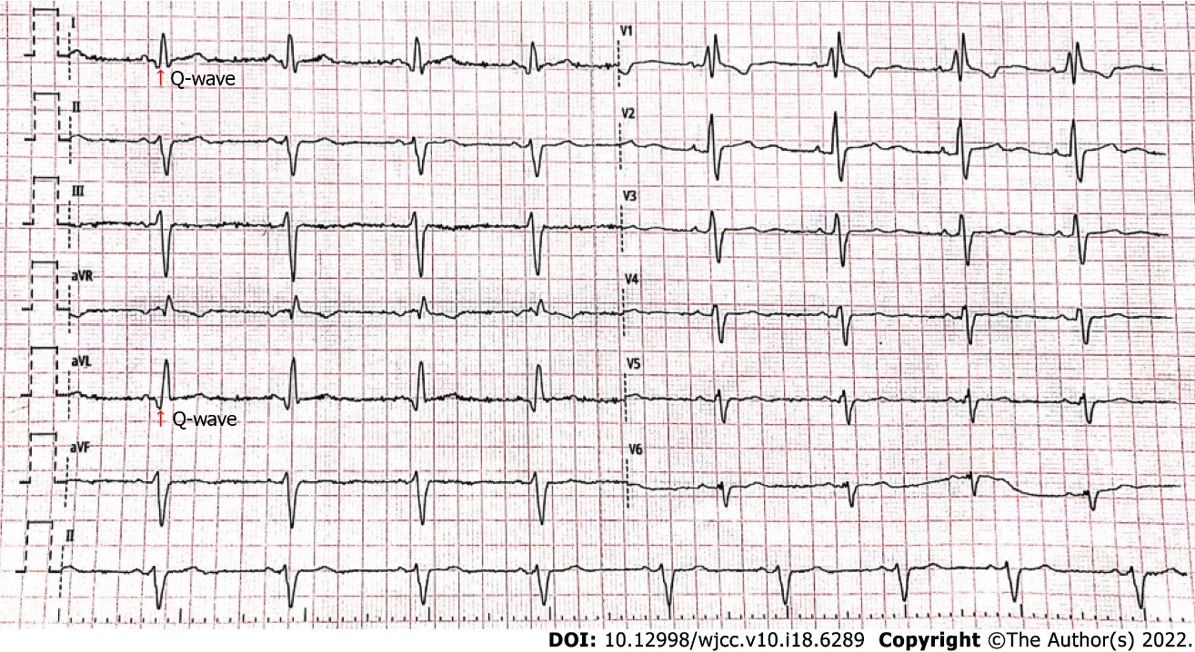
Figure 1 Routine 12-leads electrocardiogram results of the patient under this study. Electrocardiogram showed left anterior branch block, complete right bundle branch block, high sidewall (I, AVL) abnormal Q wave, and left chest leads low voltage (V4-6) with poor R wave progression.

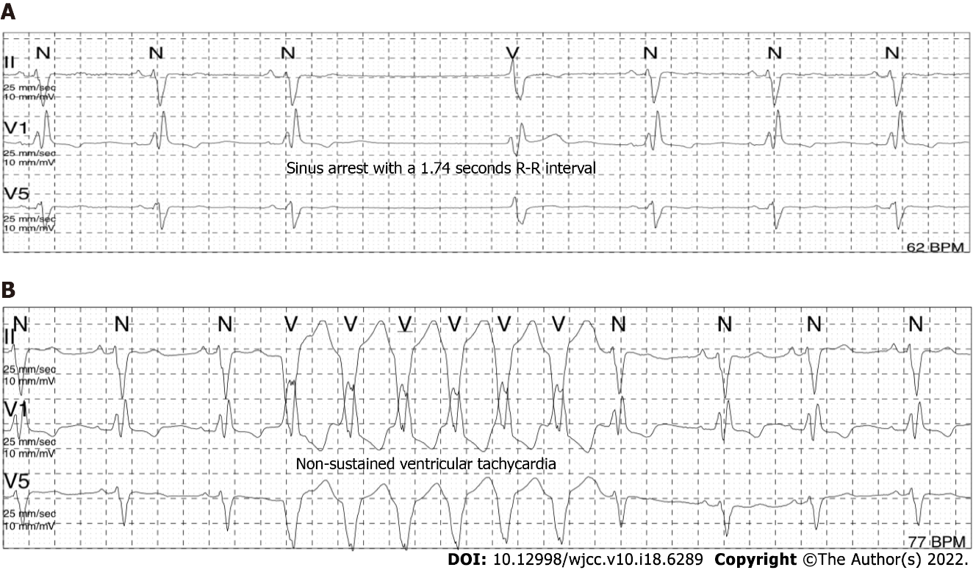
Figure 2 Sinus arrest (A) and ventricular tachycardia (B) recorded in Holter monitoring for this case.

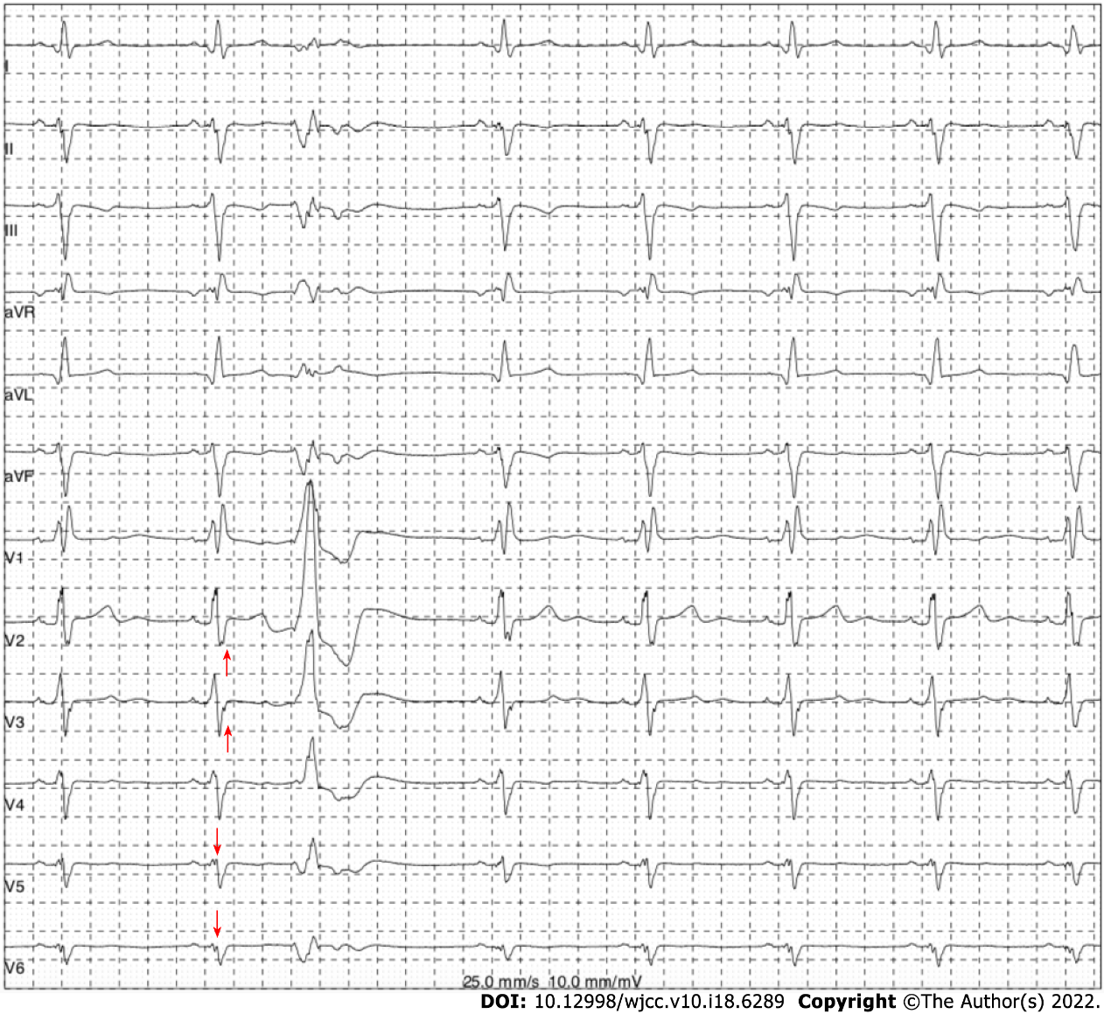
Figure 3 Fragmented QRS and ventricular premature beats recorded in Holter monitoring for this case. Holter monitoring showed ventricular premature beats with a right bundle branch block pattern and fragmented QRS in leads V3-V6 (marked using red arrows).

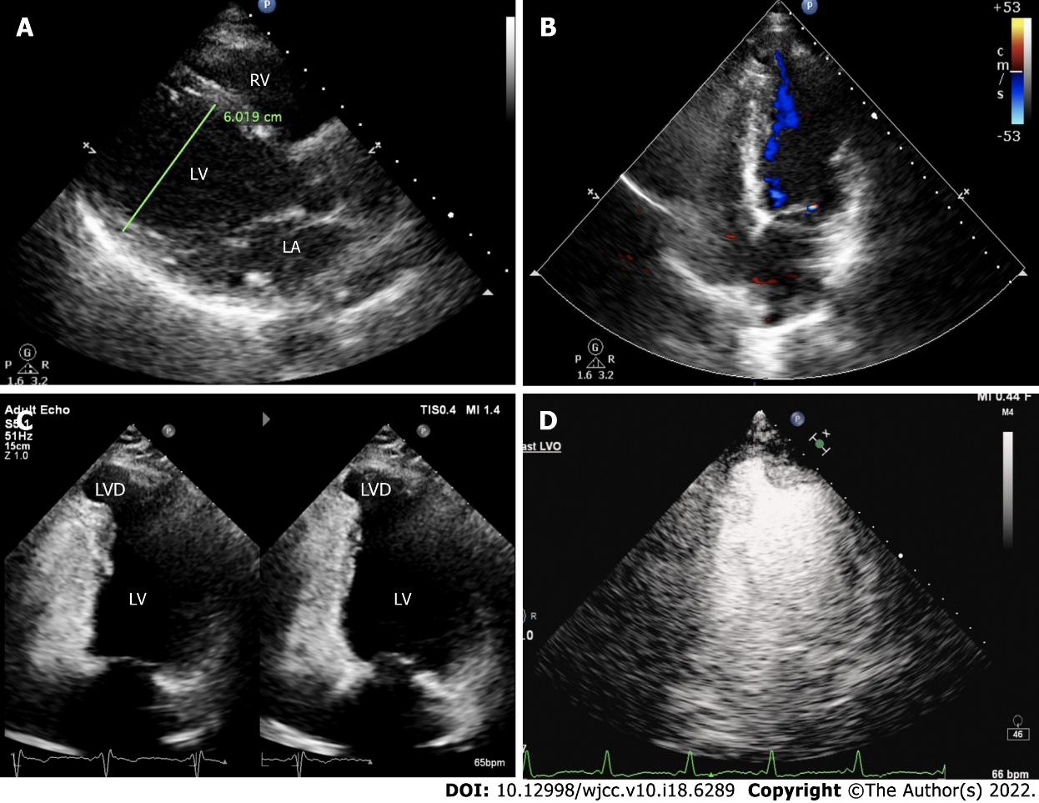
Figure 4 Transthoracic echocardiography results of the patient under this study. A: Long-axis view of the left ventricle at the end of diastole. The left ventricle was dilated with a diameter of 60 mm; B: Cystic outpouching in the left ventricular apical septum on the apical four-chamber view and intra-cystic blood flow signals were seen during systole; C: Cystic outpouching had an approximate size of 12 mm × 13 mm with a continuous muscle wall, while its activity synchronized with ventricular contraction and diastole; D: Myocardial contrast echocardiograph revealed no obvious filling defect in the cystic structure.

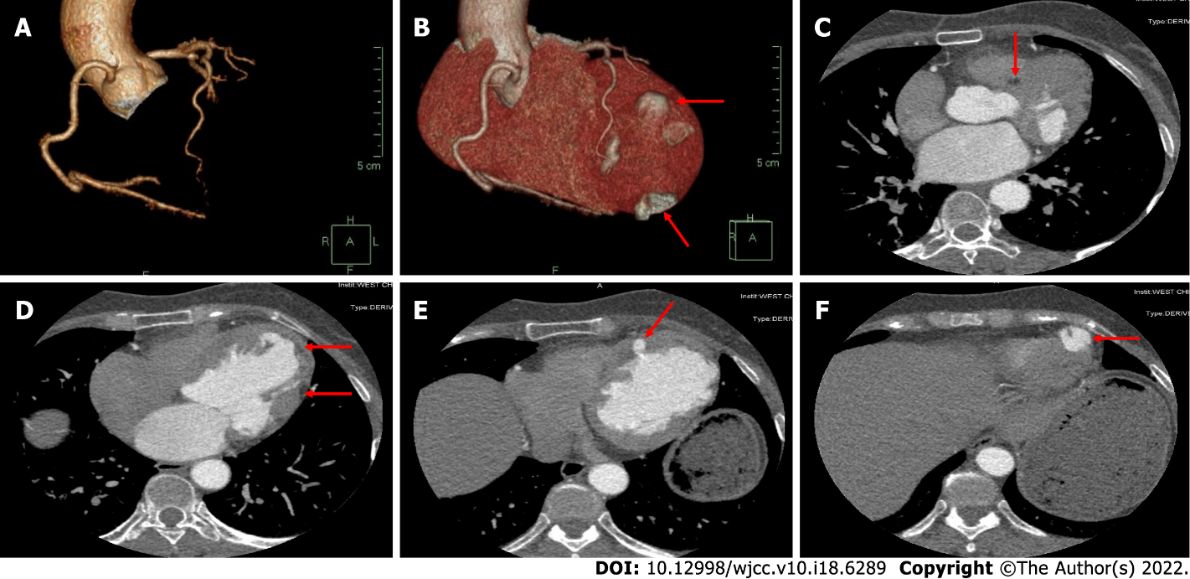
Figure 5 Coronary computerized tomography angiography results of the patient under this study. A: Three-dimensional reconstruction of coronary arteries and right dominant coronary artery circulation showed no obvious stenosis; B: Three-dimensional reconstruction of the heart showed multiple outpouchings on the left ventricular wall; C: The left ventricular septum myocardium exhibited uneven enhancement. The degree of enhancement is shown by the red arrow and was lower than that of the surrounding tissue, computed tomography value -90 HU; D: Uneven enhancement in the left ventricle free wall myocardium. The degree of enhancement is shown by the red arrow and was lower than that of the surrounding tissue, computed tomography value -114 HU; E: The left ventricular wall exhibited a disordered structure. The uneven thickness of the ventricular wall and local diverticulum is denoted by the red arrow; F: Diverticulum in the apex of the left ventricle is shown by the red arrow.

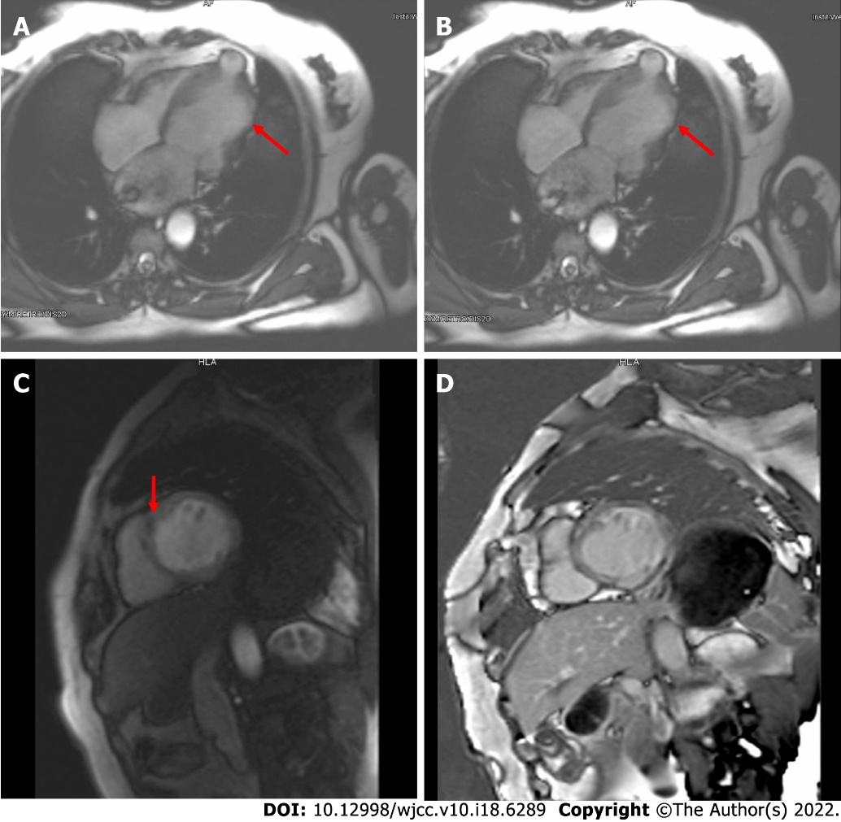
Figure 6 Cardiac magnetic resonance imaging results of the patient under this study. A and B: Four-chamber cine images at end-diastole (A) and end-systole (B) showed left ventricular dilatation, abnormal activity of the ventricular wall (arrows indicate severely diminished contractility), and outpouching at the left ventricular apex; C: Short-axis first-pass perfusion showed a low signal at the midwall of the septum myocardium; D: Short-axis delayed enhancement imaging demonstrated diffuse stripes of hyperenhancement in the midwall of the left ventricular septum and free wall myocardium.

Published by Baishideng Publishing Group Inc
7041 Koll Center Parkway, Suite 160, Pleasanton, CA 94566, USA
Telephone: +1-925-3991568
E-mail: bpgoffice@wjgnet.com
Help Desk: https://www.f6publishing.com/helpdesk
https://www.wjgnet.com

© 2022 Baishideng Publishing Group Inc. All rights reserved.

