Name of Journal: World Journal of Orthopedics
Manuscript NO: 81910
Manuscript Type: ORIGINAL ARTICLE

Clinical Trials Study
Does orthotics use improve comfort, speed, and injury rate during running? A randomised control trial

Fortune AE et al. Advantages of orthotics whilst running

Alice E Fortune, Jonathan M G Sims, George Ampat

Alice E Fortune, School of Medicine, University of Liverpool, Liverpool L69 3GE, United Kingdom

Jonathan M G Sims, Research Unit, Talita Cumi Ltd., Southport, PR8 3NS, United Kingdom

George Ampat, School of Medicine, University of Liverpool, Liverpool L69 3GE, Merseyside, United Kingdom

Author contributions: Fortune AE, Sims JMG, and Ampat G designed the research study; Sims JMG was involved in recruitment and data collection; Ampat G performed telephone consultations with all participants on enrolment to the study; Fortune AE and Sims JMG analysed the data. Fortune AE, Sims JMG and Ampat G wrote the manuscript; All authors have read and approved the final manuscript.

Supported by Aetrex, Inc. 414 Alfred Avenue Teaneck, NJ 07666, USA.

Corresponding author: George Ampat, FRCS, FRCS (Gen Surg), MBBS, Consultant Physician-Scientist, Doctor, Lecturer, School of Medicine, University of Liverpool, Cedar House, Ashton Street, Liverpool L69 3GE, Merseyside, United Kingdom. geampat@gmail.com

Received: November 28, 2022
Revised: February 2, 2023
Accepted: April 6, 2023
Published online: May 18, 2023

Abstract
BACKGROUND
Running is a hugely popular sport. Unfortunately, running-related injury (RRI) rates are high, particularly amongst amateur and recreational runners. Finding ways to reduce RRI rates and maximise comfort and performance for runners is important. Evidence regarding whether orthotics can successfully improve these parameters is limited and contradicting. Further research is required to provide runners with clearer guidance on the usefulness of orthotics.

AIM
To investigate the effect of Aetrex Orthotics on comfort, speed and RRI rates during recreational running.

METHODS
One hundred and six recreational runners were recruited on a voluntary basis via running clubs and social media pages and randomised into either the intervention or control group. Participants in the intervention group ran with Aetrex L700 Speed Orthotics inserted in their usual running shoes, whilst participants in the control group ran in their usual running shoes with no orthotics. The study ran for an 8-wk period. Participants provided data relating to running comfort, distance, and time during weeks 3-6. Participants provided data relating to any RRIs they sustained during all 8 wks. Running distance and time were used to calculate running speed in miles per hour (mph). For each outcome variable, 95% confidence intervals and P values were calculated to assess the statistical significance between the groups. For comfort and speed data, univariate multi-level analysis was performed, and for outcome variables with significant between group differences, multi-level multivariate analysis was performed to evaluate any confounding effects of gender and age.

RESULTS
Ninety-four participants were included in the final analysis (drop-out rate = 11%). Comfort and speed from 940 runs and 978 injury data reports were analysed. Participants who ran with orthotics reported, on average, speeds 0.30 mph faster (P = 0.20) and comfort scores 1.27 points higher (P ≤ 0.001) than participants who ran with no orthotics. They were also 2.22 times less likely to sustain an injury (P = 0.08) than participants who ran with no orthotics. However, findings were only significant for comfort and not for speed or injury rates. Age and gender were found to be significant predictors of comfort. However, the improvements in comfort reported by participants who ran with orthotics were still significant after adjusting for age and gender.

CONCLUSION
This study found orthotics to improve comfort and speed and prevent RRIs whilst running. However, these findings were only statistically significant for comfort.

Key Words: Running; Foot orthoses; Running related injuries; Pain; Patient comfort; Athletic performance.

©The Author(s) 2023. Published by Baishideng Publishing Group Inc. All rights reserved.

Citation: Fortune AE, Sims JMG, Ampat G. Does orthotics use improve comfort, speed, and injury rate during running? A randomised control trial. World J Orthop 2023; 14(5): 348-361
URL: https://www.wjgnet.com/2218-5836/full/v14/i5/348.htm
DOI: https://dx.doi.org/10.5312/wjo.v14.i5.348

Core Tip: Running-related injuries are common, necessitating research into ways to prevent injury. Foot orthotics have been suggested as a method to reduce running-related injury rates and improve comfort and performance, which are important components of running. Previous evidence regarding this is limited and mixed. This randomised control trial finds that running with Aetrex L700 Speed Orthotics inserted into normal running shoes reduces the rate of running-related injuries and improves both comfort and speed. These findings were only statistically significant for comfort. Providing increased comfort may encourage individuals to take up running, improving their health and decreasing the demand on healthcare systems.

INTRODUCTION
Running is a highly popular sport, likely due to its accessibility and wide range of health benefits. It has been found to prevent many common health conditions and reduce overall mortality^{[1-5]}. However, amongst people who run, there are high rates of injuries reported^{[6,7]}. Several studies have found running-related injury (RRI) rates to be particularly high amongst amateur and recreational runners compared to professional runners^{[8-11]}. Common RRIs include medial tibial stress syndrome, Achilles tendinopathy and plantar fasciitis^{[12-14]}. RRIs frequently lead to pain and discomfort and may cause individuals to stop running or seek medical treatment^{[14]}. The high prevalence of RRIs necessitates research into prevention, especially when considering the need to encourage individuals to run in order to gain the many health benefits.
Comfort is an important factor whilst running. It has been shown that increased comfort of running can, in turn, lead to improved running performance^{[15]}. Additionally, the experience of pain and injury overlaps with the experience of discomfort and therefore comfort. Hence, improving comfort may reduce pain and subsequently reduce reported injury rates and time taken off work or any activity due to injury. There is, therefore, a substantial incentive to improve comfort for runners.
Orthotics are a type of shoe insert often used within the running community. They can be prefabricated or custom-made to fit an individual’s foot shape and size. Orthotics act to correct lower limb alignment by reducing foot pronation^{[16]}, whilst also providing enhanced cushioning, support and comfort for the foot^{[17]}. As well as injury and comfort, another factor important to many runners is performance: Typically measured as running speed. Previous research into the benefits of orthotics on running performance, comfort and injury rates is limited and, at times, contradicting. Some studies have found orthotics to improve running performance and comfort, whereas others have shown orthotics to negatively impact these parameters^{[18-22]}. Evidence regarding the impact of orthotics on RRI rates is also mixed^{[23-25]}. Hence, further research is required to determine the relationship between orthotics and running comfort, running speed and RRI rates. Exploring modalities to improve comfort, performance and injury rates whilst running is important and valuable, as this would hopefully encourage more people to take up running, leading to substantial health benefits. Exploring ways to prevent RRIs in amateur and recreational runners is particularly relevant as these groups are thought to have the highest injury rates^{[8-11]}.
The aim of this study is to explore the effects of prefabricated Aetrex^{[26]} Orthotics on running comfort, running speed and RRI rates compared to running with no orthotics. The results of this study will add to the current evidence concerning orthotics usage in running, building on previous work by Ampat et al^{[27]}. This will provide runners with enhanced guidance on the possible benefits of orthotics and, hopefully, if the results are positive, encourage non-runners to take up running, thereby improving their health^{[1]}.
This article presents the findings from the full study cohort, building on the findings in the preliminary study report^{[28]}. The study design was previously registered in clinical trials (https://www.ijclinicaltrials.com/index.php/ijct/article/view/586) in May 2021 (NCT04901442) and published^{[29]}.

MATERIALS AND METHODS
This study was conducted as a randomised control trial. The primary objective was to investigate whether running with prefabricated orthotics inserted into participants’ usual running shoes vs running without would improve comfort and speed and reduce injury rates.

Recruitment
Results of our previous study found an improvement of two points on the comfort scale when using orthotics compared to usual running trainers with no orthotics^{[27]}. For the sample size estimate for this study, a conservative improvement of 1.5 points, with a standard deviation of 2.45, was used. Based on this, a target sample size of one hundred and six participants was determined through a sample size calculation, using a target significance level of 5%, target power of 80% and allowing for a 20% dropout rate. All 106 participants were recruited between July 2021 and April 2022 on a voluntary basis via advertisements displayed on social media pages and at local running clubs. Individuals who contacted the research team were screened for eligibility and provided with a participant information sheet (PIS). Recipients were allowed sufficient time to read and understand the PIS in full. If, following this, they were willing to participate, a phone call with the lead investigator was arranged to answer any remaining questions. Following this, individuals willing to participate provided informed, written consent, either by post or online via legalesign.com.
Inclusion criteria for the study were: Aged 18 and over and used to completing runs of at least 5km distance during the last year. Exclusion criteria were: Current use of prescription orthotics, having any ongoing pain or deformity in the foot, having any serious health condition which had led to a doctor advising them not to exercise or having undergone any surgery in the past six months or any surgery to the feet during their lifetime. Participants were informed that they could withdraw from the study at any time if they wished to, without needing to provide a reason.

Randomisation
Following recruitment, participants were randomised into one of two groups using a 1:1 allocation: Group A (intervention group), in which participants ran with Aetrex^{[26]} L700 Speed Orthotics inserted into their usual running shoes, or Group B (control group), in which participants ran in their usual running shoes with no orthotics. Randomisation and group allocation occurred using pre-filled and sealed envelopes, each containing a note to assign a participant to either Group A (intervention group) or Group B (control group). All envelopes were shuffled thoroughly before opening and randomly selected and opened by an individual independent of the study. Blinding of participants and researchers to group allocation was not possible due to the nature of the study intervention.
Participants allocated to Group A (intervention group) received a pair of Aetrex^{[26]} L700 Speed Orthotics in their correct shoe size via post. They also received an instruction sheet clearly explaining how to use the orthotics. The Aetrex^{[26]} L700 Speed Orthotics provided to Group A (intervention group) in this study are pictured in Figure 1.

Data collection
Upon recruitment to the study, basic demographic information was collected from each participant. Collection of data for all three primary outcomes (comfort, speed, and injury rate) then took place over an 8-wk period. To minimise confounding variables and risk to participants, participants were asked to run as they usually would during the 8-wk study period, with no changes made other than the addition of the orthotics for the intervention group. Participants provided all data remotely and could choose whether they wished to provide data via an online or a paper survey provided to the researchers via post. All participants opted to provide data via the online method.
The majority of data collection took place during weeks 3, 4, 5 and 6 of the 8-wk data collection period. Weeks 1 and 2 were allocated as an ‘acclimatisation period’ to allow individuals in the intervention group to become familiar with using the orthotics. Weeks 7 and 8 were allocated as a ‘run-through period’ with the purpose of collecting data regarding any injuries that occurred following the main data collection weeks. During weeks 3, 4, 5, and 6, participants provided data relating to running comfort, running duration, and running distance immediately after every run they completed. Participants were asked to complete and provide data from at least 10 runs during this 4-wk period. Comfort was scored using a self-report visual analogue scale (VAS) of 0 to 10, where 0 represented “No Comfort” and 10 represented “Maximum comfort”. VAS was selected as this is a widely used and validated method of scoring patient-perceived comfort^{[30,31]}. Running duration was reported in hours and minutes, and running distance was reported in miles/kilometres. Running duration and distance were used to calculate running speed in miles per hour (mph). Speed was used to represent running performance in this study, in line with the way that running performance is measured in running events around the world.
Participants were asked to provide data relating to any RRIs they had sustained at least once per week during the whole 8-wk period. This data was reported via a self-report survey, and all participants were provided with an injury identification sheet about common RRIs to assist them in providing this data, as depicted in Figure 2. Data was submitted regarding whether the injury led to disruption of running (disruption of distance, speed, duration, or frequency of running), and if so, how long for. Participants also self-reported the nature of the injury (e.g., iliotibial band syndrome, Achilles tendinopathy) based on the injury identification sheet and whether the injury was new or pre-existing. For an injury to be included in analysis, it had to meet the definition “running-related musculoskeletal pain in the lower limbs that causes a restriction or stoppage of running (distance, speed, duration, or training) for at least 7 d or 3 consecutive scheduled training sessions”. This is the consensus definition presented by Yamato et al^{[32]} following their work on defining RRIs. Pre-existing injuries were included only if they flared up during the study period.
Data collection was monitored by a data monitoring committee consisting of an orthopaedic surgeon, a patient and a statistician, all independent of the research team.
All individuals who took part in the study were provided with a free pair of Aetrex^{[26]} L700 Speed Orthotics to thank them for their time and participation in the study. Those in Group B (control group) were provided these after the data collection period.

Statistical analysis
All participants were analysed (intention to treat) within their original assigned groups. The primary outcomes comfort and speed data were analysed using multi-level univariate analysis. This was done to group together the data provided by each individual (i.e., runners having data on multiple runs), allowing any internal correlations to be accounted for. 95% confidence intervals and P values were calculated for each outcome variable to determine if between-group differences were statistically significant. This was done using the Chi-squared test for comfort and speed data and Fisher’s exact test for injury data. Statistical significance was considered if P < 0.05. For outcome variables with significant findings, multi-level multivariate analysis using a logistic regression model was performed to evaluate any confounding effects of gender or age on the findings.
All statistical analysis was reviewed by a National Institute for Health and Care Research-funded statistician from the Department of Biostatistics, University of Liverpool.

RESULTS
One hundred and six individuals were recruited to the study; 53 were randomised to the intervention group and 53 to the control group. During the study, 12 participants withdrew (6 from the intervention group, and 6 from the control group), two due to illness, two due to injury and eight stopped responding. This left a total of 94 participants to be included in the analysis (drop-out rate of 11%). Full details of participant flow, including reasons for withdrawal, are detailed in Figure 3.
The final study cohort (n = 94) ranged in age from 19 to 66 years old, with an overall mean age of 39 and a higher proportion of males than females. The intervention group contained slightly more women than men (n = 24 vs 23), whereas the control group contained more men than women (n = 29 vs 18). On average, participants in the intervention group were older than those in the control group, with mean ages of 40.8 and 37.9, respectively. Complete demographic data for the study population can be found in Table 1.
All the 94 participants included in the analysis provided data from at least 10 runs across weeks 3, 4, 5 and 6, and injury data at least once per week during weeks 1-8. The first 10 runs provided by each participant were included in the analysis. From these, comfort, and speed data for runs over two hours long were considered outlier variables and excluded from the analysis. Such runs, of which there were 65 in total (6.91%), were removed because the purpose of this study is to investigate amateur and recreational runners, for whom a run longer than two hours is not considered typical. The injury data of the two participants who withdrew from the study due to injury was removed from the analysis. This left a total of 875 sets of comfort and speed data and 978 sets of injury data in the final analysed dataset.
Regression coefficients, 95% confidence intervals and P values for comfort and speed data are provided in Table 2. On average, participants who ran with Aetrex^{[26]} Orthotics reported comfort scores that were 1.27 points higher than those who ran with no orthotics. This finding was statistically significant, with a P value of < 0.001. Running speeds reported by participants in the intervention (orthotic) group were, on average, 0.30 mph faster than those reported by participants in the control (no orthotic) group. However, this finding was not statistically significant (P = 0.20).
Numbers of injuries reported by both groups and the odds ratios, 95% confidence intervals and P values calculated for injury data are provided in Table 3. Participants in the intervention group were 2.22 times less likely to report an injury that disrupted running for ≥ 7 d compared with participants in the control group). However, these findings were not statistically significant (P = 0.08).
Table 4 reports data for injuries lasting ≥ 7 d in more detail, showing the frequency of injury at different sites and overall injury rates. Upper leg and knee injuries were rarely reported in the intervention group, whilst they were the most common injured sites in the control group. Overall, injuries occurred less frequently in the orthotic group; however, of the injuries that did occur, a large proportion of these was in the ankle. One participant from each group experienced two injuries that lasted ≥ 7 d. Hence, 5 participants reported 6 injuries lasting ≥ 7 d in the orthotic group, and 10 participants reported 11 injuries in the control group.
The orthotic group reported three ankle injuries, all of which were ankle sprains. Conversely, the control group reported no ankle sprains. To explore the potential reason for this discrepancy, all participants who experienced an ankle sprain were contacted to enquire about the type of terrain on which they were running when the ankle sprain occurred (on or off road). All three participants reported that they were running off-road at the time of the injury.
Multilevel multivariate analysis of comfort scores is provided in Table 5. Age and gender were found to be significant predictors of comfort scores. Male participants provided scores that were, on average, 0.55 points higher than females (P = 0.039), and comfort scores increased by 0.04 points for every one-year increase in participant age (P = 0.003). However, the increase in comfort scores in the intervention group remained significant after adjusting for the effects of gender and age (P ≤ 0.001).
Generally, the spread of data for all variables was broad, reflected by wide confidence intervals, and this was wide enough to produce non-significant findings for injury and speed.
It was ensured that no participants experienced any additional harm or injury by participating in the study. This was mitigated by instructing all participants to run as they normally would, without changing the running frequency, speed, or duration. The only alteration was the addition of orthotics in intervention group, who were shown to have a reduced RRI rate as compared to the control group. Two participants withdrew from the study due to injury. However, the participants did not require any medical intervention other than cessation of running.

DISCUSSION
This randomised control trial explores the effect of orthotics on running comfort, speed and RRI rates. It finds that participants who ran with Aetrex^{[26]} L700 Speed Orthotics reported, on average, higher comfort scores, higher running speeds and lower injury rates over the 8-wk study period than participants who ran with no orthotics. These findings, however, were statistically significant for comfort only and not for injury or speed.
Previous studies have similarly found that orthotics provided non-significant improvements in injury rates and/or speed but significant improvements in comfort^{[27,33]}. Ampat et al^{[27]}, reported on 37 participants who ran with and without the orthotics on alternate weeks, reporting distance, time, comfort and RRIs. In line with the current findings, Ampat et al^{[27]} found significant improvements in comfort only and non-significant improvements in both injury rate and performance. Mündermann et al^{[33]} assessed the effects of various shoe inserts on comfort and injury frequency in military personnel. As compared to the control condition (no insert), all shoe inserts allowed for significantly higher comfort ratings. The incidence of injury and pain at various locations was also reduced, albeit not significantly. However, this study assessed these effects during general physical activity, and not exclusively whilst running. Whilst these studies found somewhat similar findings to the current, discrepancies in findings exist within the literature. For instance another study found only non-significant improvements in comfort^{[20]}. However, unlike the current study, this assessed the effects of custom-made orthotics on well-trained male athletes in a controlled setting, in which participants ran on a treadmill for six minutes at high and low speeds in three footwear conditions; standardized footwear (control), custom made orthotics made from ethyl-vinyl acetate, and custom-made orthotics made from expanded thermoplastic polyurethane. Although not significant, arch height comfort and medio-lateral control comfort were improved in both orthotic conditions^{[20]}. Additionally, a 2017 systematic review found significant reductions in overall injury rates with orthotics but non-significant reductions in injury rates when data for individual types of injury were analysed^{[23]}. Contrastingly, a 2007 meta-analysis found orthotics to significantly reduce rates of lower limb overuse injuries specifically^{[30]}. In summary, findings in the literature vary greatly. A likely factor contributing to this is the variation in RRI definitions used between studies. This has led to wide variation in reported RRI rates, ranging from 15.6% to 79.3% in previous studies^{[7,10,34]}. For comparison, the overall number of participants who experienced a RRI in this study was 16%. Another likely contributor to the heterogenicity between study findings is the influence of various confounding variables. These variables include terrain, speed, experience, history of previous injury and distance. This study could have been improved by exerting greater control over confounding variables, such as those listed above. However, a strength of this study was the use of the consensus definition for a RRI, which was agreed upon in work done by Yamato and colleagues^{[32]}.
In this study, the rate of injuries lasting ≥ 7 d was lower in the intervention group at all sites except for the foot and ankle, where injuries were more common amongst individuals running with orthotics. Such findings from the orthotic group are harmonious with the findings of a 2012 systematic review which investigated the incidence and prevalence of running-related musculoskeletal injuries and found that foot and ankle injuries may be some of the most prevalent^{[35]}. The higher rate of ankle injuries with the orthotic, namely ankle sprains, may also be explained by the fact that all participants in the orthotic group who experienced such injuries did so when running off-road. Ankle sprains are the most common injury to occur during off-road running^{[36]}. This suggests that the terrain might have contributed to the injury, rather than the use of orthotics.
Unlike barefoot runners, who experience more accurate proprioceptive input from the feet during running and usually land on the ball of the foot^{[37]}, individuals who wear trainers whilst running have poorer proprioception and often land with their heels hitting the ground first. This causes overpronation of the foot and internal rotation of the lower limb joints, with simultaneous external rotation of the patella, which can lead to injury. The current working principle is that orthotics act to reduce this, as well as to distribute pressure more evenly across the foot^{[38-40]}. The redistribution of pressure is illustrated in Figure 4. Additionally, orthotics are thought to provide impact cushioning, absorbing some of the forces that pass through the foot and lower leg during running, thereby reducing injury^{[17]}. It would be beneficial for the running population that such orthotics are readily accessible and affordable. Prefabricated orthotics, which are at least 2.5 times less costly than custom-made orthotics, would be preferred^{[27]}. This preference is supported by the results of previous research, which suggest that there is no significant difference when using pre-fabricated orthotics instead of customised orthotics to prevent RRIs^{[30]}.
The strengths of this study include power analysis prior to commencement, achievement of target sample size, and a drop-out rate of just 11%, well below the drop-out rate allowed for, in the study size calculation. This allowed data collection of sufficient quantity and power to produce statistically significant findings. The wide range of ages of participants in this study increases its applicability to the broader running population. Additionally, the collection of data detailing the length of disruption to running following an injury, and injury sites, allowed more detailed exploration into the effect of orthotics usage on RRIs.
The study was not without limitations. No blinding of researchers or participants to group allocation took place. Some participants in the intervention group may have expected that the orthotics would improve their running experience, which could have created bias. This risk of bias is further emphasized when taking into consideration the newly developed ‘comfort filter’ paradigm, which suggests that injury risk is automatically reduced if a shoe or insert is deemed more comfortable by the runner as assessed by their own ‘comfort filter’^{[41]}. Additionally, comfort could have been explored in more depth by assessing comfort in various parts of the foot, as done in other studies^{[33]}, rather than simply an overall comfort measure. Furthermore, the study results may have benefited from all participants being queried further regarding their running experience. Recreational runners have been defined as individuals with over 3 mo of running experience, whilst anyone with less than 3 mo of running experience is referred to as novice runners^{[8]}. Experienced runners have been defined as runners who have been running for over a year^{[9]}. It has been found that the incidence of RRIs is significantly higher in novice than experienced runners, with one study finding that novice runners experience 8.78 RRIs per 1000 hours of running, as compared to 4.24 per 1000 hours for experienced runners^{[9]}. Hence, whilst the current study aimed to focus on recreational runners, the use of these definitions to sub-group participants would have been advantageous, as it would have allowed for further analysis into the relationship between running experience and its effects on injury rate. It would have also been beneficial for the researchers to evaluate participants history of previous RRIs, as this has been associated with an increased likelihood of a further injury and a poorer prognosis following a new injury^{[42]}. Again, the inclusion of this data would have allowed sub-group analysis, enabling any existing correlations to be identified. The collection of data regarding each participant’s usual running terrain is also a consideration for future studies as, once more, it would have allowed sub-group analysis to ascertain the relationship between the terrain on which participants ran and their injury types and injury rate. The lack of data collection concerning the participants running footwear could also be viewed as a limitation. Gathering this data would have allowed for sub-group analysis to determine if differences in footwear effected running performance or injury rate, as bias may exist. However, the researchers did not wish to control the participants running shoes, as the aim of the study was to ascertain the level of benefit orthotics can provide to general runners, irrespective of their usual running footwear. To improve the clarity of findings, it could also be favorable if future studies request a maximum of one weekly injury report and one comfort report for the entire week.
In this study, there was a much higher proportion of males (n = 29) than females (n = 18) in the control group. The UK running population is estimated to contain more males than females^{[43]}, but not at such an extreme ratio as in this participant group. In contrast, the intervention group contained slightly more females (n = 24) than males (n = 23). This difference in numbers of males and females in each group is relevant as it will have confounded the study findings, as demonstrated in the multivariate analysis of comfort. Closer monitoring of the participant recruitment process in future studies and using a sampling technique, such as stratified sampling, would prevent discrepancies like this from occurring in the future.
The wide confidence intervals found during the analysis of all outcomes demonstrate a wide spread of data from the mean values for each outcome and each group. These confidence intervals were wide enough to cause the improvements in speed and injury rate to be non-significant. This broad spread of data may be partially explained by the nature of the outcomes explored by this study. Natural tendencies for injury, running speeds and expectations for comfort vary between individuals, which may have led to a wider spread of data.
The burden of cardiovascular diseases, cancers and diabetes mellitus within the general population is substantial, and lack of exercise is a significant contributor to this^{[2-5,44-46]}. Recreational running is an accessible, affordable way to exercise and reduces the risk of these health conditions^{[47,48]}. This study finds that Aetrex L700 Speed Orthotics allows at least some improvements in performance and injury reduction and significant improvements in comfort.
This study advances current knowledge regarding the use of prefabricated orthotics in reducing RRI rates and improving running comfort and speed. However, the lack of significant findings for injury and speed necessitates further research. This is particularly important as reducing discomfort and injury may encourage more individuals to take up running and improve their health thereby decreasing the strain on healthcare services.

CONCLUSION
This randomised control trial finds that running with Aetrex^{[26]} L700 Speed Orthotics improves comfort and speed whilst running and reduces RRI rates compared to running with no orthotics. However, data were only significant for comfort and not for injury rate or speed.

ARTICLE HIGHLIGHTS
Research background
Current evidence regarding the effect of orthotics on comfort, speed and injuries during running is limited and mixed.

Research motivation
Running is a highly popular sport; however, the rate of running-related injuries is high. Exploring the ability of orthotics to reduce injury and improve speed and comfort during running would be valuable to runners and, if the results are positive, encourage individuals to take up running, thereby improving their health.

Research objectives
To explore whether running with Aetrex^{[26]} Orthotics inserted into normal running shoes reduces the rate of running-related injuries and improves comfort and speed.

Research methods
In this randomised control trial, participants were recruited on a voluntary basis and allocated to either the intervention (orthotic) group or the control (no orthotic) group. Participants in the intervention group were asked to run with a pair of Aetrex^{[26]} L700 Speed Orthotics inserted into their normal running shoes, whilst participants in the control group were asked to run in their normal running shoes with no orthotics. Data for any related running-related injuries was collected over an 8-wk period. Comfort scores and run duration and distance data were collected immediately after any run performed during weeks 3-6. Univariate multi-level analysis was performed for comfort and speed data. Odds ratios were calculated for injury data, and 95% confidence intervals and P values were calculated for all three outcomes. Multilevel multivariate analysis was performed for outcomes with significant findings between groups to evaluate any confounding effects of gender and age.

Research results
Data from 94 participants were included in the final analysis. On average, participants in the intervention (orthotic) group reported higher comfort scores, faster running speeds and fewer injuries. This data was significant for comfort but not for injury rates or running speed. Gender and age were found to significantly affect comfort, but significant improvements in comfort when wearing the orthotic were still present after adjusting for gender and age.

Research conclusions
This study provides evidence that running with prefabricated orthotics inserted into normal running shoes increases comfort and speed and reduces the rate of running-related injuries. However, data were only significant for comfort and not for speed or injury rates.

Research perspectives
Further research on this subject is required due to the ongoing need to find a cost-effective way to reduce injury rates in recreational runners and encourage individuals to take up running to improve their health. Future studies should consider collecting data regarding the tendency for running injury and usual running speeds to allow adjustment of results for these confounding variables.

ACKNOWLEDGEMENTS
The authors would like to thank all participants who took part in this study.

REFERENCES
1 Chakravarty EF, Hubert HB, Lingala VB, Fries JF. Reduced disability and mortality among aging runners: a 21-year longitudinal study. Arch Intern Med 2008; 168: 1638-1646 [PMID: 18695077 DOI: 10.1001/archinte.168.15.1638]
2 Bernstein L, Patel AV, Ursin G, Sullivan-Halley J, Press MF, Deapen D, Berlin JA, Daling JR, McDonald JA, Norman SA, Malone KE, Strom BL, Liff J, Folger SG, Simon MS, Burkman RT, Marchbanks PA, Weiss LK, Spirtas R. Lifetime recreational exercise activity and breast cancer risk among black women and white women. J Natl Cancer Inst 2005; 97: 1671-1679 [PMID: 16288120 DOI: 10.1093/jnci/dji374]
3 Howard RA, Freedman DM, Park Y, Hollenbeck A, Schatzkin A, Leitzmann MF. Physical activity, sedentary behavior, and the risk of colon and rectal cancer in the NIH-AARP Diet and Health Study. Cancer Causes Control 2008; 19: 939-953 [PMID: 18437512 DOI: 10.1007/s10552-008-9159-0]
4 Booth FW, Chakravarthy MV, Spangenburg EE. Exercise and gene expression: physiological regulation of the human genome through physical activity. J Physiol 2002; 543: 399-411 [PMID: 12205177 DOI: 10.1113/jphysiol.2002.019265]
5 Dobrosielski DA. How can exercise reduce cardiovascular disease risk? A primer for the clinician. Pol Arch Intern Med 2021; 131 [PMID: 34706491 DOI: 10.20452/pamw.16122]
6 Fredericson M, Misra AK. Epidemiology and aetiology of marathon running injuries. Sports Med 2007; 37: 437-439 [PMID: 17465629 DOI: 10.2165/00007256-200737040-00043]
7 van Gent RN, Siem D, van Middelkoop M, van Os AG, Bierma-Zeinstra SM, Koes BW. Incidence and determinants of lower extremity running injuries in long distance runners: a systematic review. Br J Sports Med 2007; 41: 469-80; discussion 480 [PMID: 17473005 DOI: 10.1136/bjsm.2006.033548]
8 Linton L, Valentin S. Running with injury: A study of UK novice and recreational runners and factors associated with running related injury. J Sci Med Sport 2018; 21: 1221-1225 [PMID: 29853263 DOI: 10.1016/j.jsams.2018.05.021]
9 Kemler E, Blokland D, Backx F, Huisstede B. Differences in injury risk and characteristics of injuries between novice and experienced runners over a 4-year period. Phys Sportsmed 2018; 46: 485-491 [PMID: 30071170 DOI: 10.1080/00913847.2018.1507410]
10 van Poppel D, Scholten-Peeters GG, van Middelkoop M, Verhagen AP. Prevalence, incidence and course of lower extremity injuries in runners during a 12-month follow-up period. Scand J Med Sci Sports 2014; 24: 943-949 [PMID: 23957385 DOI: 10.1111/sms.12110]
11 Videbæk S, Bueno AM, Nielsen RO, Rasmussen S. Incidence of Running-Related Injuries Per 1000 h of running in Different Types of Runners: A Systematic Review and Meta-Analysis. Sports Med 2015; 45: 1017-1026 [PMID: 25951917 DOI: 10.1007/s40279-015-0333-8]
12 Lopes AD, Hespanhol Júnior LC, Yeung SS, Costa LO. What are the main running-related musculoskeletal injuries? A Systematic Review. Sports Med 2012; 42: 891-905 [PMID: 22827721 DOI: 10.1007/BF03262301]
13 Kakouris N, Yener N, Fong DTP. A systematic review of running-related musculoskeletal injuries in runners. J Sport Health Sci 2021; 10: 513-522 [PMID: 33862272 DOI: 10.1016/j.jshs.2021.04.001]
14 Nielsen RO, Rønnow L, Rasmussen S, Lind M. A prospective study on time to recovery in 254 injured novice runners. PLoS One 2014; 9: e99877 [PMID: 24923269 DOI: 10.1371/journal.pone.0099877]
15 Van Alsenoy K, van der Linden ML, Girard O, Santos D. Increased footwear comfort is associated with improved running economy - a systematic review and meta-analysis. Eur J Sport Sci 2023; 23: 121-133 [PMID: 34726119 DOI: 10.1080/17461391.2021.1998642]
16 McCulloch MU, Brunt D, Vander Linden D. The effect of foot orthotics and gait velocity on lower limb kinematics and temporal events of stance. J Orthop Sports Phys Ther 1993; 17: 2-10 [PMID: 8467332 DOI: 10.2519/jospt.1993.17.1.2]
17 O'Leary K, Vorpahl KA, Heiderscheit B. Effect of cushioned insoles on impact forces during running. J Am Podiatr Med Assoc 2008; 98: 36-41 [PMID: 18202332 DOI: 10.7547/0980036]
18 Crago D, Bishop C, Arnold JB. The effect of foot orthoses and insoles on running economy and performance in distance runners: A systematic review and meta-analysis. J Sports Sci 2019; 37: 2613-2624 [PMID: 31423908 DOI: 10.1080/02640414.2019.1651582]
19 Fuller JT, Bellenger CR, Thewlis D, Tsiros MD, Buckley JD. The effect of footwear on running performance and running economy in distance runners. Sports Med 2015; 45: 411-422 [PMID: 25404508 DOI: 10.1007/s40279-014-0283-6]
20 Van Alsenoy K, Ryu JH, Girard O. The Effect of EVA and TPU Custom Foot Orthoses on Running Economy, Running Mechanics, and Comfort. Front Sports Act Living 2019; 1: 34 [PMID: 33344957 DOI: 10.3389/fspor.2019.00034]
21 Girard O, Morin JB, Ryu JH, Van Alsenoy K. Custom foot orthoses improve performance, but do not modify the biomechanical manifestation of fatigue, during repeated treadmill sprints. Eur J Appl Physiol 2020; 120: 2037-2045 [PMID: 32607818 DOI: 10.1007/s00421-020-04427-0]
22 Lucas-Cuevas AG, Pérez-Soriano P, Priego-Quesada JI, Llana-Belloch S. Influence of foot orthosis customisation on perceived comfort during running. Ergonomics 2014; 57: 1590-1596 [PMID: 25009959 DOI: 10.1080/00140139.2014.938129]
23 Bonanno DR, Landorf KB, Munteanu SE, Murley GS, Menz HB. Effectiveness of foot orthoses and shock-absorbing insoles for the prevention of injury: a systematic review and meta-analysis. Br J Sports Med 2017; 51: 86-96 [PMID: 27919918 DOI: 10.1136/bjsports-2016-096671]
24 Larsen K, Weidich F, Leboeuf-Yde C. Can custom-made biomechanic shoe orthoses prevent problems in the back and lower extremities? A randomized, controlled intervention trial of 146 military conscripts. J Manipulative Physiol Ther 2002; 25: 326-331 [PMID: 12072853 DOI: 10.1067/mmt.2002.124419]
25 Franklyn-Miller A, Wilson C, Bilzon J, McCrory P. Foot orthoses in the prevention of injury in initial military training: a randomized controlled trial. Am J Sports Med 2011; 39: 30-37 [PMID: 21041512 DOI: 10.1177/0363546510382852]
26 Aetrex. Aetrex.com [Internet]. Aetrex.com: Aetrex Worldwide, Inc.; 2022. Available from: https://www.aetrex.com/search?q=L700&search-button=&lang=en_US
27 Ampat G, Baxter R, Geoghegan F. Pedobarograph based prefabricated orthotics reduces self-reported minor injuries and improves comfort whilst running. MOJ Orthopedics & Rheumatology 2020; 12 [DOI: 10.15406/mojor.2020.12.00505]
28 Fortune AE, Sims JMG, Rhodes SJ, Ampat G. Does orthotics use improve comfort, speed and injury rate during running? Preliminary analysis of a randomised control trial. World J Orthop 2022; 13: 652-661 [PMID: 36051374 DOI: 10.5312/wjo.v13.i7.652]
29 Ampat G, Rhodes S, Sims J, Ismail SABS. A randomised control trial to compare comfort, rate of injury and speed whilst running using prefabricated orthotics inserted into running shoes vs running with no additional orthotics inside the running shoe. Int J Clin Trials 2022; 9: 118 [DOI: 10.18203/2349-3259.ijct20221111]
30 Collins N, Bisset L, McPoil T, Vicenzino B. Foot orthoses in lower limb overuse conditions: a systematic review and meta-analysis. Foot Ankle Int 2007; 28: 396-412 [PMID: 17371668 DOI: 10.3113/FAI.2007.0396]
31 Lindorfer J, Kröll J, Schwameder H. Comfort assessment of running footwear: Does assessment type affect inter-session reliability? Eur J Sport Sci 2019; 19: 177-185 [PMID: 30044208 DOI: 10.1080/17461391.2018.1502358]
32 Yamato TP, Saragiotto BT, Lopes AD. A consensus definition of running-related injury in recreational runners: a modified Delphi approach. J Orthop Sports Phys Ther 2015; 45: 375-380 [PMID: 25808527 DOI: 10.2519/jospt.2015.5741]
33 Mündermann A, Stefanyshyn DJ, Nigg BM. Relationship between footwear comfort of shoe inserts and anthropometric and sensory factors. Med Sci Sports Exerc 2001; 33: 1939-1945 [PMID: 11689747 DOI: 10.1097/00005768-200111000-00021]
34 Van Middelkoop M, Kolkman J, Van Ochten J, Bierma-Zeinstra SM, Koes B. Prevalence and incidence of lower extremity injuries in male marathon runners. Scand J Med Sci Sports 2008; 18: 140-144 [PMID: 17555538 DOI: 10.1111/j.1600-0838.2007.00683.x]
35 Relph N, Greaves H, Armstrong R, Prior TD, Spencer S, Griffiths IB, Dey P, Langley B. Running shoes for preventing lower limb running injuries in adults. Cochrane Database Syst Rev 2022; 8: CD013368 [PMID: 35993829 DOI: 10.1002/14651858.CD013368.pub2]
36 Vincent HK, Brownstein M, Vincent KR. Injury Prevention, Safe Training Techniques, Rehabilitation, and Return to Sport in Trail Runners. Arthrosc Sports Med Rehabil 2022; 4: e151-e162 [PMID: 35141547 DOI: 10.1016/j.asmr.2021.09.032]
37 Robbins S, Waked E, McClaran J. Proprioception and stability: foot position awareness as a function of age and footwear. Age Ageing 1995; 24: 67-72 [PMID: 7762465 DOI: 10.1093/ageing/24.1.67]
38 Bonanno DR, Landorf KB, Menz HB. Pressure-relieving properties of various shoe inserts in older people with plantar heel pain. Gait Posture 2011; 33: 385-389 [PMID: 21256025 DOI: 10.1016/j.gaitpost.2010.12.009]
39 Albert S, Rinoie C. Effect of custom orthotics on plantar pressure distribution in the pronated diabetic foot. J Foot Ankle Surg 1994; 33: 598-604 [PMID: 7894408]
40 Desmyttere G, Hajizadeh M, Bleau J, Begon M. Effect of foot orthosis design on lower limb joint kinematics and kinetics during walking in flexible pes planovalgus: A systematic review and meta-analysis. Clin Biomech (Bristol, Avon) 2018; 59: 117-129 [PMID: 30227277 DOI: 10.1016/j.clinbiomech.2018.09.018]
41 Nigg BM, Baltich J, Hoerzer S, Enders H. Running shoes and running injuries: mythbusting and a proposal for two new paradigms: 'preferred movement path' and 'comfort filter'. Br J Sports Med 2015; 49: 1290-1294 [PMID: 26221015 DOI: 10.1136/bjsports-2015-095054]
42 Fokkema T, Burggraaff R, Hartgens F, Kluitenberg B, Verhagen E, Backx FJG, van der Worp H, Bierma-Zeinstra SMA, Koes BW, van Middelkoop M. Prognosis and prognostic factors of running-related injuries in novice runners: A prospective cohort study. J Sci Med Sport 2019; 22: 259-263 [PMID: 30268637 DOI: 10.1016/j.jsams.2018.09.001]
43 Sport England. Active Lives Adult Survey: May 16/17 Report [Internet]. England: Sport England; 2017 [DOI: 10.1093/ww/9780199540884.013.u225130]
44 Siegel RL, Miller KD, Fuchs HE, Jemal A. Cancer statistics, 2022. CA Cancer J Clin 2022; 72: 7-33 [PMID: 35020204 DOI: 10.3322/caac.21708]
45 Balakumar P, Maung-U K, Jagadeesh G. Prevalence and prevention of cardiovascular disease and diabetes mellitus. Pharmacol Res 2016; 113: 600-609 [PMID: 27697647 DOI: 10.1016/j.phrs.2016.09.040]
46 Colberg SR, Grieco CR. Exercise in the treatment and prevention of diabetes. Curr Sports Med Rep 2009; 8: 169-175 [PMID: 19584602 DOI: 10.1249/JSR.0b013e3181ae0654]
47 Schnohr P, O'Keefe JH, Marott JL, Lange P, Jensen GB. Dose of jogging and long-term mortality: the Copenhagen City Heart Study. J Am Coll Cardiol 2015; 65: 411-419 [PMID: 25660917 DOI: 10.1016/j.jacc.2014.11.023]
48 Lee DC, Pate RR, Lavie CJ, Sui X, Church TS, Blair SN. Leisure-time running reduces all-cause and cardiovascular mortality risk. J Am Coll Cardiol 2014; 64: 472-481 [PMID: 25082581 DOI: 10.1016/j.jacc.2014.04.058]

Footnotes
Institutional review board statement: This study was reviewed and approved by Wales Research Committee 5 (Approval No. 21/WA/0098).

Clinical trial registration statement: This study is registered at https://clinicaltrials.gov/ct2/show/NCT04901442. The registration identification number is: NCT04901442.

Informed consent statement: All study participants gave their informed, written consent (via an online e-form) prior to study inclusion.

Conflict-of-interest statement: George Ampat and Jonathan M G Sims are Directors/employees of Talita Cumi Ltd. Talita Cumi Ltd has a commercial relationship with Aetrex, Inc. 414 Alfred Avenue Teaneck, NJ 07666, USA. Alice E Fortune has no conflict of interest.

Data sharing statement: The anonymised dataset is available from the corresponding author at g.ampat@liverpool.ac.uk. Participants gave informed consent for sharing of anonymised data.

CONSORT 2010 statement: The authors have read the CONSORT 2010 Statement, and the manuscript was prepared and revised according to the CONSORT 2010 Statement.

Open-Access: This article is an open-access article that was selected by an in-house editor and fully peer-reviewed by external reviewers. It is distributed in accordance with the Creative Commons Attribution NonCommercial (CC BY-NC 4.0) license, which permits others to distribute, remix, adapt, build upon this work non-commercially, and license their derivative works on different terms, provided the original work is properly cited and the use is non-commercial. See: https://creativecommons.org/Licenses/by-nc/4.0/

Provenance and peer review: Unsolicited article; Externally peer reviewed.
Peer-review model: Single blind

Peer-review started: November 28, 2022
First decision: January 20, 2023
Article in press: April 6, 2023

Specialty type: Orthopedics
Country/Territory of origin: United Kingdom
Peer-review report’s scientific quality classification
Grade A (Excellent): 0
Grade B (Very good): B
Grade C (Good): C
Grade D (Fair): 0
Grade E (Poor): 0

P-Reviewer: Ghannam WM, Egypt; Wen J, China S-Editor: Liu GL L-Editor: A P-Editor: Liu GL
Figure Legends
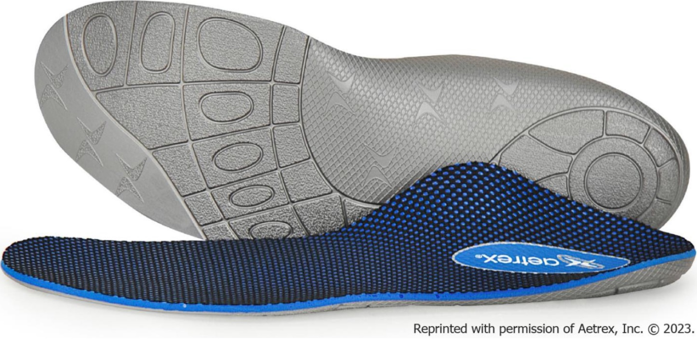
Figure 1 Aetrex L700 Speed Orthotics. Image of Aetrex L700 Speed Orthotics, provided to participants in the intervention group. Reprinted with permission of Aetrex, Inc. © 2022.

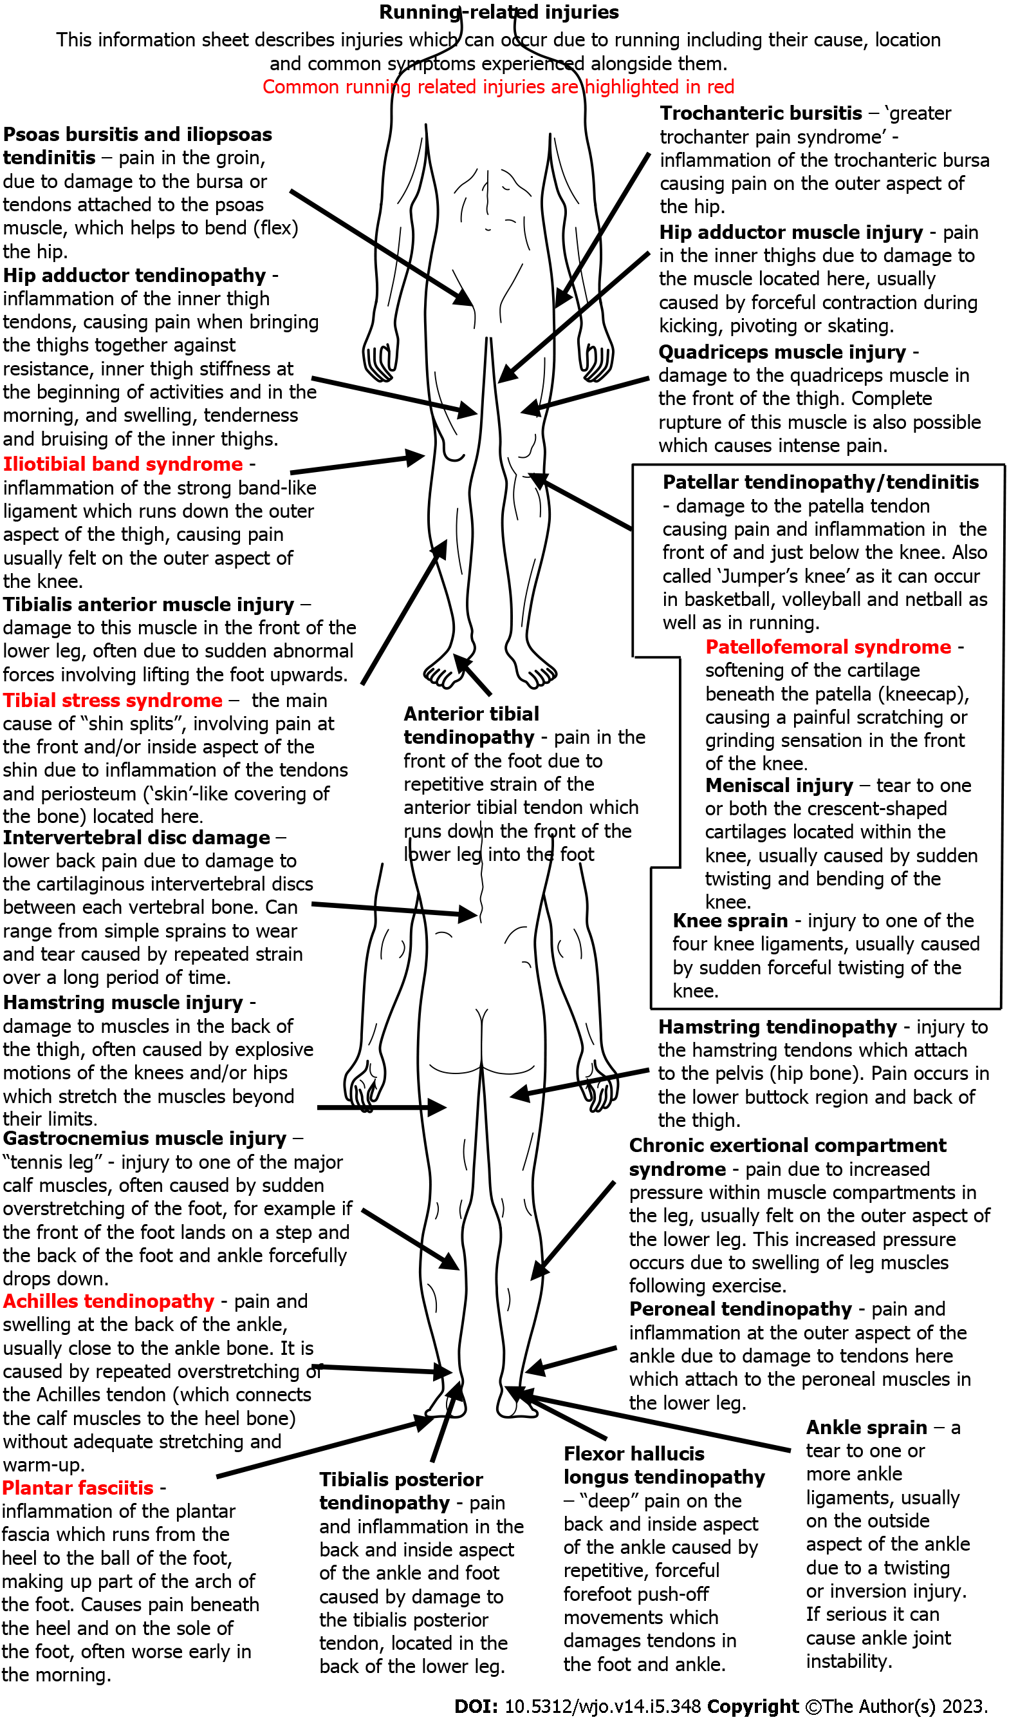
Figure 2 Injury identification sheet. Injury identification sheet regarding common running-related injuries provided to participants to assist them in reporting injuries.

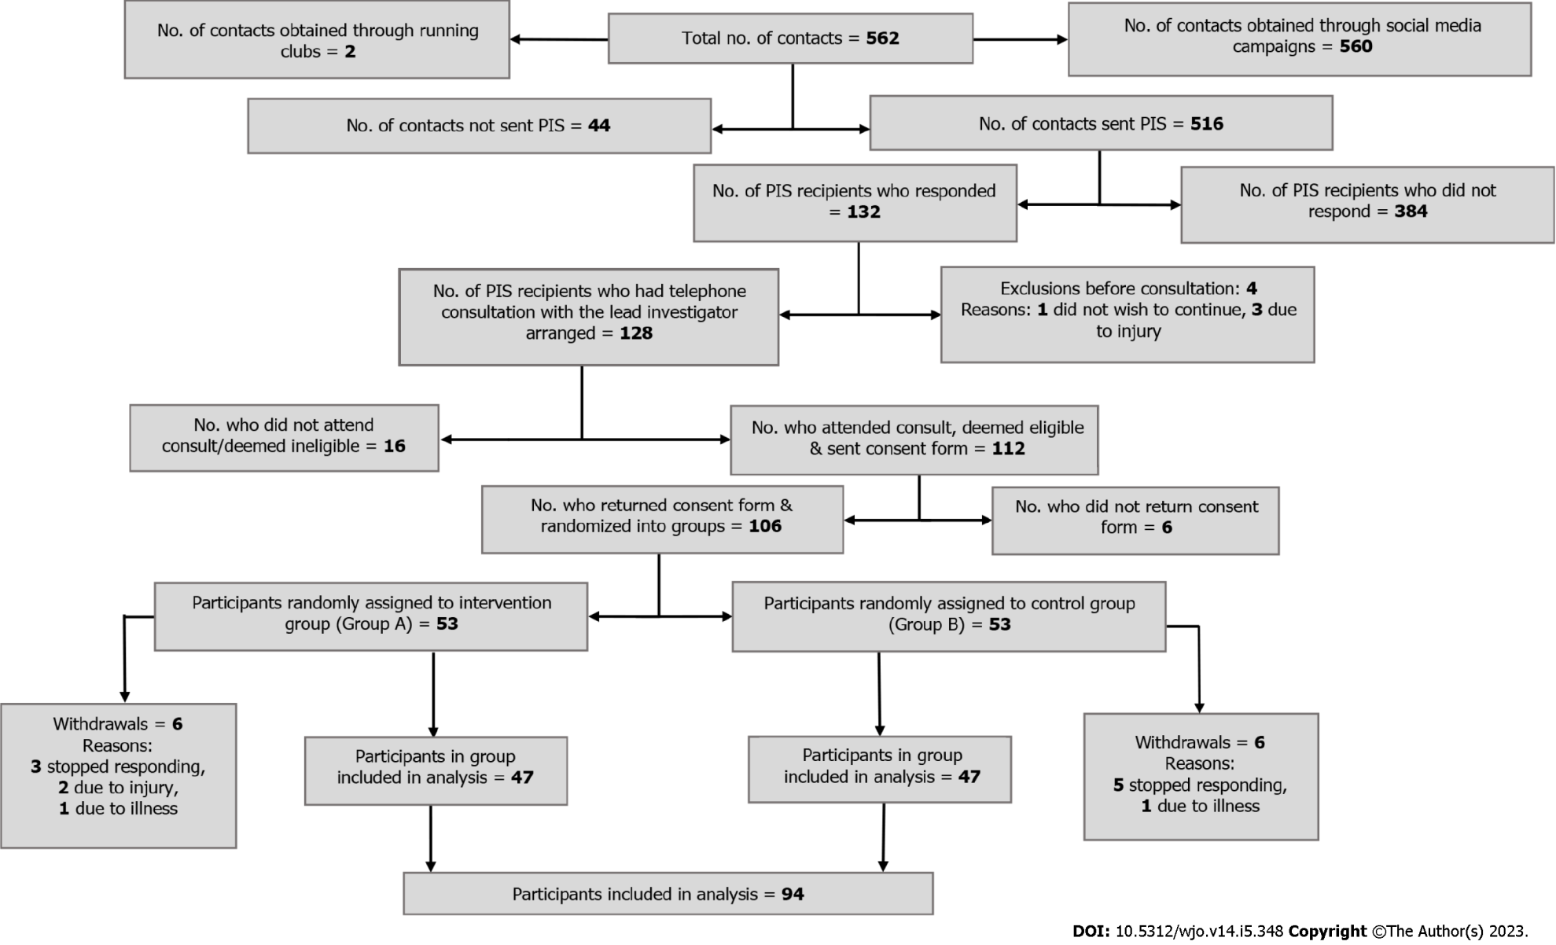
Figure 3 Participant flow. Participant flow, including randomised group assignment and any withdrawals. No.: Number; PIS: Participant information sheet.

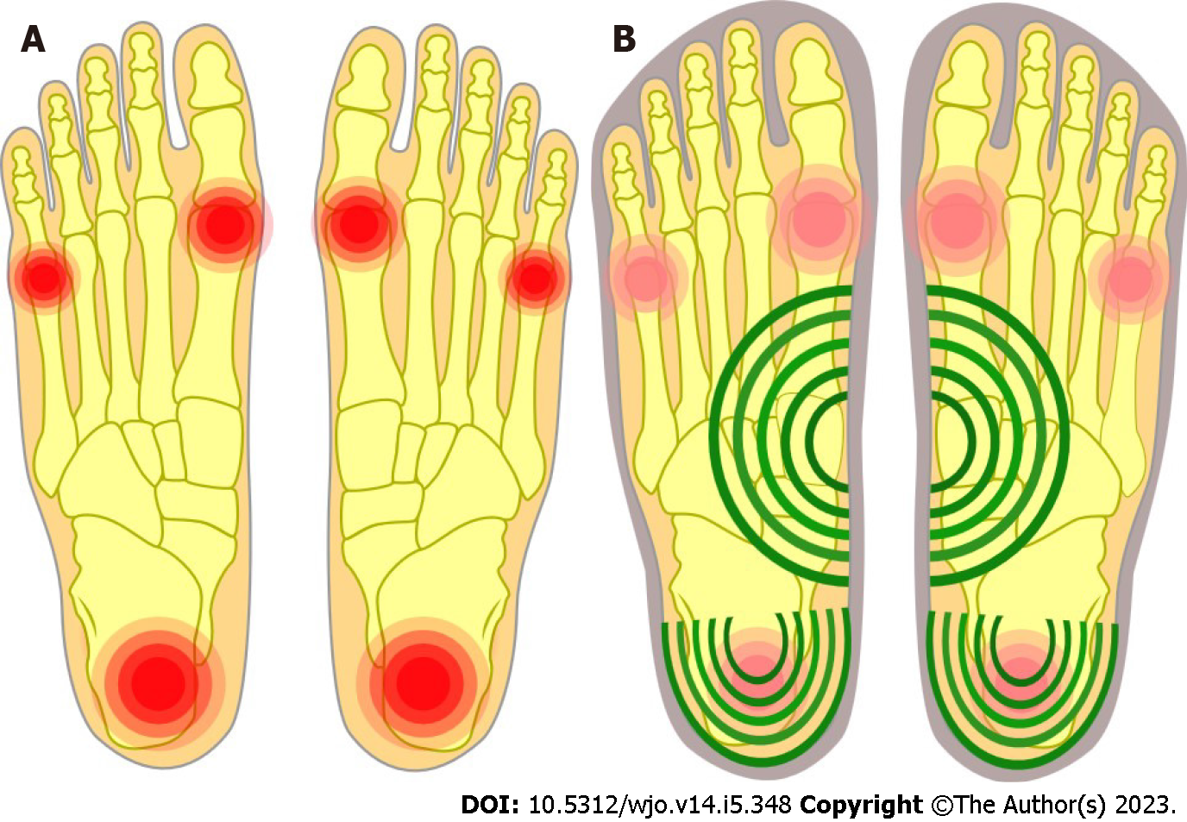
Figure 4 Comparison of pressure in the feet with and without orthotics. A: Increased pressure at three points without orthotics compared to; B: Reduced pressure using orthotics with arch support and a cupped heel.

Table 1 Basic demographic information for participants included in analysis, n (%)
 | Intervention (orthotic) group | Control (no orthotic) group | Both groups
Sex
Male | 23 (48.94) | 29 (61.70) | 52 (55.32)
Female | 24 (51.06) | 18 (38.30) | 42 (44.68)
Age (yr)
< 20 | 1 (2.1) | 1 (2.13) | 1 (1.06)
20-29 | 9 (19.1) | 9 (19.15) | 16 (17.02)
30-39 | 10 (21.3) | 15 (31.91) | 26 (27.66)
40-49 | 16 (34.0) | 13 (27.66) | 30 (39.91)
50-59 | 8 (17.0) | 7 (14.89) | 16 (17.02)
60-69 | 3 (6.4) | 2 (4.26) | 5 (5.32)
Mean age | 40.79 | 38.49 | 38.97
Total | 47 | 47 | 94

Table 2 Findings and multi-level analysis of comfort and speed data for both groups
Outcome measure | Regression coefficient (95%CI) | P value
Comfort | 1.27 (0.69 - 1.84) | < 0.001
Speed | 0.30 (-0.16 - 0.75) | 0.20

Table 3 Findings and statistical analysis of injury data for both groups
Outcome measure | Participants experiencing outcome in intervention (orthotic) group | Participants experiencing outcome in control (no orthotic) group | Odds ratio (95%CI) | P value
Injury | 5 | 10 | 2.27 (0.71 - 7.25) | 0.26

Table 4 Frequency of injuries lasting > 7 d for both groups classified by injury site
Injury site | Injury frequency
 | Intervention (orthotic) group | Control (no orthotic) group | Both groups
Upper leg | 0 | 6 | 6
Knee | 1 | 3 | 4
Lower leg | 1 | 1 | 2
Ankle | 3 | 1 | 4
Foot | 1 | 0 | 1
All sites | 6 | 11 | 17

Table 5 Findings from multivariate analysis of comfort data
Outcome measure = comfort
Variable | Regression Coefficient (95%CI) | P value
Group (Intervention vs control) | 1.22 (0.67 - 1.78) | < 0.001
Gender | 0.55 (0.03 - 1.07) | 0.039
Age | 0.04 (0.01 - 0.06) | 0.003

Published by Baishideng Publishing Group Inc
7041 Koll Center Parkway, Suite 160, Pleasanton, CA 94566, USA
Telephone: +1-925-3991568
E-mail: bpgoffice@wjgnet.com
Help Desk: https://www.f6publishing.com/helpdesk
https://www.wjgnet.com

© 2023 Baishideng Publishing Group Inc. All rights reserved.

