Name of Journal: World Journal of Gastroenterology
Manuscript NO: 40054
Manuscript Type: ORIGINAL ARTICLE

Retrospective Study
Application of modified primary closure of the pelvic floor in laparoscopic extralevator abdominal perineal excision for low rectal cancer

Wang YL et al. Pelvic Reconstruction in LELAPE

Yan-Lei Wang, Xiang Zhang, Jia-Jia Mao, Wen-Qiang Zhang, Hao Dong, Fan-Pei Zhang, Shuo-Hui Dong, Wen-Jie Zhang, Yong Dai

Yan-Lei Wang, Xiang Zhang, Jia-Jia Mao, Wen-Qiang Zhang, Hao Dong, Fan-Pei Zhang, Shuo-Hui Dong, Wen-Jie Zhang, Yong Dai, Department of Colorectal and Anal Surgery, Qilu Hospital of Shandong University, Jinan 250012, Shandong Province, China

ORCID number: Yan-Lei Wang (0000-0003-1420-9529); Xiang Zhang (0000-0001-7417-6082); Jia-Jia Mao (0000-0002-2210-8456); Wen-Qiang Zhang (0000-0003-1162-2350); Hao Dong (0000-0002-7185-9002); Fan-Pei Zhang (0000-0001-9276-8436); Shuo-Hui Dong (0000-0002-2912-8046); Wen-Jie Zhang (0000-0003-1976-1523); Yong Dai (0000-0001-6163-8022).

Author contributions: Wang YL and Dai Y designed the study; Wang YL, Zhang X and Dai Y performed the surgery; Mao JJ performed subject follow up and control subject data collection; Zhang WQ and Dong SH performed the statistical analysis; Zhang X, Zhang FP, Zhang WJ and Dong H wrote the manuscript; Wang YL, Zhang X, Mao JJ, Zhang WQ, Dong H, Zhang FP, Dong SH, Zhang WJ, Dai Y revised the manuscript for final submission.

Supported by the National Key and Development Program of China, No. 2016YFC0106003; the National Natural Science Foundation of China, No. 81700708/H0712; and the Key and Development Program of Shandong Province, No. 2016GSF201125.

Institutional review board statement: This study was approved by the Ethics Committee of Scientific Research of Shandong University Qilu Hospital.

Conflicts of interest statement: The authors declare that there are no conflicts of interest related to this study.

Data sharing statement: No additional data are available.

Open-Access: This article is an open-access article which was selected by an in-house editor and fully peer-reviewed by external reviewers. It is distributed in accordance with the Creative Commons Attribution Non Commercial (CC BY-NC 4.0) license, which permits others to distribute, remix, adapt, build upon this work non-commercially, and license their derivative works on different terms, provided the original work is properly cited and the use is non-commercial. See: http://creativecommons.org/licenses/by-nc/4.0/

Manuscript source: Unsolicited manuscript

Correspondence to: Yong Dai, MD, PhD, Attending Doctor, Chief Doctor, Surgeon, Department of Colorectal and Anal Surgery, Qilu Hospital of Shandong University, No. 107 West Wenhua Road, Jinan 250012, Shandong Province, China. yongdai@hotmail.com
Telephone: +86-531-82166391

Received: May 31, 2018
Peer-review started: May 31, 2018
First decision: June 15, 2018
Revised: June 18, 2018
Accepted: June 30, 2018
Article in press:
Published online:
Abstract
AIM
To introduce a novel modified primary closure technique of laparoscopic extralevator abdominal perineal excision (LELAPE) for low rectal cancer.

METHODS
We retrospectively analyzed data from 76 patients with rectal cancer undergoing LELAPE from March 2013 to May 2016. Patients were classified into the modified primary closure group (32 patients) and the biological mesh closure group (44 patients). Total operating time, reconstruction time, postoperative stay, total cost, postoperative complications and tumor recurrence were compared.

RESULTS
All surgery was successfully performed. The pelvic reconstruction time was 14.6 ± 3.7 min for the modified primary closure group, which was significantly longer than that of the biological mesh closure group (7.2 ± 1.9 min, P < 0.001). The total operating time was not different between the two groups (236 ± 20 vs 248 ± 43 min, P = 0.143). Postoperative hospital stay was 8.1 ± 1.9 d and the total cost was 9297 ± 1260 USD for the modified primary closure group; both of which were significantly less than those of the biological mesh closure group (P = 0.001 and P = 0.003, respectively). No difference in other perioperative data, long-term complications or oncological outcomes was observed.

CONCLUSION
The modified primary closure method for reconstruction of the pelvic floor in LELAPE for low rectal cancer is technically feasible, safe and cost-effective.

Key words: Extralevator abdominoperineal excision; Rectal cancer; Pelvic floor; Laparoscopy

© The Author(s) 2018. Published by Baishideng Publishing Group Inc. All rights reserved.

Core tip: The modified primary closure approach requires closure of the pelvic peritoneum laparoscopically and layered closure of the perineal defect. By using this modified approach, the length of hospital stay and the total cost were decreased significantly, while other clinical outcomes did not differ except a relatively longer time for the pelvic reconstruction (14.6 ± 3.7 vs 7.2 ± 1.9 min). The conclusion comes to that the modified primary closure method for reconstruction of the pelvic floor in laparoscopic extralevator abdominal perineal excision for low rectal cancer is technically feasible, safe and cost-effective.

Wang YL, Zhang X, Mao JJ, Zhang WQ, Dong H, Zhang FP, Dong SH, Zhang WJ, Dai Y. Application of modified primary closure of the pelvic floor in laparoscopic extralevator abdominal perineal excision for low rectal cancer. World J Gastroenterol 2018; In press
INTRODUCTION
To improve the oncological outcome of patients with low rectal cancer, extralevator abdominal perineal excision (ELAPE) has been introduced to reduce the rate of positive circumferential margin (CRM) and intraoperative perforation (IOP)^{[1-4]}. Assisted by laparoscopy, ELAPE can minimize physical invasion while ensuring oncological benefits^{[5,6]}. However, the extended resection of ELAPE may increase the risk of severe perineal wound complications, including perineal hernia, with a reported incidence of 20%-26%^{[7]}. Thus, how to reconstruct the pelvic floor and close the perineum after massive resection has become a major concern and challenge in laparoscopic ELAPE (LELAPE). The established reconstruction methods include: primary perineal closure, omentoplasty, biological or synthetic mesh placement, myocutaneous flaps, and negative wound pressure therapy^{[8-12]}. These methods all have their own advantages as well as restrictions, and no consensus has been reached so far. In traditional abdominoperineal resection (APR), the pelvic peritoneum is usually closed prior to reconstruction of the pelvic floor, in order to separate the small intestine from the presacral operating field, which is technically challenging in LELAPE. Recently, we have modified the primary closure technique by adding the procedure of laparoscopic pelvic peritoneum suture, and applied it to LELAPE. In the present study, we compare this method with biological mesh closure in the reconstruction of the pelvic floor after LELAPE, and evaluate its feasibility, safety and cost-effectiveness.

MATERIALS AND METHODS
Study design
We retrospectively analyzed the data from 76 patients with rectal cancer undergoing LELAPE from March 2013 to May 2016. Patients were classified into the modified primary closure group (32 patients) and the biological mesh closure group (44 patients). Total operating time, reconstruction time, postoperative stay, total cost, postoperative complications and tumor recurrence were compared. The protocol was approved by the Ethics Committee of Qilu Hospital, Shandong University, Jinan, China.

General procedure
We have described the LELAPE procedure in a previous report^{[13]}. The abdominal procedure was performed with the patient being placed in the Trendelenburg position, and the port placement was set up as shown in Figure 1A. After laparoscopic exploration, dissection and division of the pedicle of the inferior mesenteric vessels were performed. The sigmoid colon was mobilized from medial to lateral and the rectum was mobilized following the total mesorectal excision principle. The sigmoid mesentery was trimmed at the rectosigmoid junction where the rectum was transected with an endoscopic linear stapler (Figure 1B). The distal rectum and mesorectum were pushed down to the pelvic cavity (Figure 1C).

Modified primary closure
For modified primary closure, the pelvic peritoneum was closed with continuous suturing using a barbed suture (Covidien, Shanghai, China) (Figure 1D and E) before creation of a colostomy. For tension-free suturing, the adjacent pelvic peritoneum was dissected to reduce tension if necessary (Figure 1F and G). The patient was turned over to the prone jackknife position. The levator ani was transected at its origin and a cylindrical specimen was removed. The procedure was completed with the placement of one negative-pressure drainage tube in the presacral space and layered closure of the ischiorectal fat and skin. The drainage tube was removed when the drainage fluid was clear and < 10 mL in volume. The coccyx was not routinely removed.

Biological mesh closure
For biological mesh closure, the patient was changed to a prone position for perineal dissection after creation of a colostomy. The levator ani was transected at its origin and a cylindrical specimen was removed. A human acellular dermal matrix mesh (Ruinuo, Qingyuanweiye Bio‑Tissue Engineering Ltd., Beijing, China) was implanted and fixed to the tendinous arch by continuous prolene sutures (Covidien) for reconstruction of the pelvic floor (Figure 1H). The procedure was completed with the placement of one negative-pressure drainage tube below the mesh and layered closure of the ischiorectal fat and skin. All the operations were finished by the same surgical group.

Statistical analysis
Numerical data were expressed as mean ± SD and analyzed with Student’s t test. Categorical data were analyzed with the X² test or Fisher’s exact test. Repeated measures analysis of variance was performed for postoperative drainage and temperature change. All analyses were performed using SPSS 19.0 (SPSS Inc., Chicago, IL, United States). P < 0.05 was considered to be statistically significant.

RESULTS
The baseline characteristics, including male/female ratio, age, body mass index, neoadjuvant therapy, distance to anal verge, and postoperative TNM staging were comparable between the two groups (P > 0.05 each, Table 1). All patients were successfully followed up for 1 year postoperatively.
All operations were successfully performed without serious intraoperative complications. The pelvic reconstruction time was 14.6 ± 3.7 min for the modified primary closure group, which was significantly longer than that of the biological mesh closure group (7.2 ± 1.9 min, P < 0.001). The total operating time did not differ between the two groups (236 ± 20 vs 248 ± 43 min, P = 0.143). One patient developed bowel perforation due to a large tumor within the anterior wall of the rectum in the biological mesh closure group. No positive CRM was observed in either group. Intraoperative blood loss and recovery of bowel function were comparable between the two groups (both P > 0.05) (Table 2). The drainage tube was removed at 6.6 ± 1.1 d postoperatively in the modified primary closure group, which was earlier than in the biological mesh closure group (7.3 ± 2.0 d, P = 0.094). The volume of drainage fluid peaked at 2 d postoperatively and then decreased gradually, without any difference between the two groups (P treatment > 0.05, P interaction > 0.05) (Figure 2A). The temperature change after operation showed a similar pattern to drainage volume, with no difference between the groups (P treatment > 0.05, P interaction > 0.05) (Figure 2B). Postoperative hospital stay was 8.1 ± 1.9 d and the total cost was 9297 ± 1260 USD for the modified primary closure group; both of which were significantly less than those of the biological mesh closure group (P = 0.001 and P = 0.003, respectively) (Table 2). One patient in the biological mesh closure group developed intestinal obstruction at 40 d postoperatively. Conservative therapy did not work, and a laparoscopic exploration was performed at 42 d. The middle part of the ileum, ~100 cm to the ileocecal junction, adhered to the pelvic floor, leading to dilation of the proximal small intestine (Figure 3). The patient was healed by decompression of the small intestine and intestinal rearrangement under laparotomy.
In the modified primary closure group, five patients had perineal wound infection. Within the first 10 d postoperatively, three patients had haemoserous discharge from the perineal wound, and were healed following potassium permanganate hip bath after 1 mo. At 12 d, one patient showed purulent discharge, which was solved after daily dressing change and thermal therapy. At 15 d, the perineal wound broke down in one female patient with type 2 diabetes. Debridement and secondary suturing were performed at 33 d after daily dressing change. Likewise, in the biological mesh closure group, five patients had perineal wound infection within the first 10 d (Table 3), and recovered within 60 d after appropriate treatment. No difference in infection rate or grade was found between the two groups (P > 0.05 each). Perineal hernia is theoretically expected to be more frequent without placement of meshes. However, at 12 mo postoperatively, no perineal hernia occurred in either of the groups. Notably, four patients in the modified primary closure group and two in the biological mesh group experienced the feeling of bulging. Computed tomography (CT) at 12 mo showed that in the modified primary closure group, the small intestine was kept in the pelvic cavity with a clear descent of the pelvic peritoneum. In the biological mesh group, without suturing the pelvic peritoneum, the small intestine was also kept in the presacral space. No obvious difference in CT scan was detected between the two groups at 12 mo postoperatively (Figure 4).
Postoperative chemotherapy (XELOX or FOLFOX regimen) and radiotherapy were given to 23 and seven patients in the modified primary closure group, as well as 28 and 14 patients in the biological mesh closure group, respectively (P = 0.330 and P = 0.339). In the biological mesh closure group, local recurrence occurred in one patient receiving only postoperative chemotherapy with the XELOX regimen, and the patient was treated with radiotherapy subsequently. Three patients had minor liver metastases and were cured with local ablative treatment. In the modified primary closure group, minor lung metastasis and minor liver metastases were found in two patients, respectively. Both of the patients received local ablative treatment. No patients died in either of the two groups.

DISCUSSION
The necessity of reconstruction of the pelvic floor after ELAPE has been widely accepted in order to avoid postoperative perineal complications^{[14,15]}. However, the feasibility and superiority of various methods proposed for the reconstruction remain to be investigated. In the present study, we compared two methods, modified primary closure and biological mesh closure, in 76 patients with lower rectal cancer undergoing LELAPE. The major findings were that modified primary closure required longer reconstruction time, but shorter postoperative hospital stay and was more cost-effective, compared to biological mesh closure. No difference in other perioperative data, long-term complications or oncological outcomes was observed.
Various methods have been developed for perineal wound healing after ELAPE; among which, perineal closure with myocutaneous flaps, biological or synthetic mesh placement, and omentoplasty with perineal closure are most widely performed currently^{[8-12]}. Myocutaneous flaps can be obtained by various approaches, including gluteal rotation/advancement flaps^{[16]}, inferior gluteal artery myocutaneous island transposition flap (IGAM)^{[17]}, transverse rectus/vertical rectus abdominis (TRAM/VRAM)^{[18,19]} and gracilis^{[20]}. Myocutaneous flaps have the benefits of delivering good perfusion and oxygenation, facilitating the healing process of large perineal defect. However, this approach requires plastic surgeons and may cause additional complications (e.g., a donor site hernia)^{[14]}. Mesh repair has the advantages of reducing operative duration, and accordingly, is more cost-effective compared to myocutaneous flaps^{[21]}. However, it should be noted that the inertness of biomesh might be a reason for small bowel obstruction^{[22]} and synthetic mesh carries potential for fistula formation^{[23]}. By contrast, omentoplasty with perineal closure represents a safer approach for reconstruction of the pelvic floor. Owing to its rich lymphovascular supply, the mobilized omentum in the pelvic cavity inhibits regional fluid collection, and hence prevents small intestine adhesion to the pelvic floor, dramatically reducing related complications^{[24]}. For some patients, this technique may not apply when it is technically not feasible to mobilize the omentum to reach the pelvic cavity, or the omentum has been resected previously.
The major strength of the modified primary closure method is the reconstruction of the pelvic peritoneum, which keeps the small intestine in the abdominal and pelvic cavities, thus avoiding adhesion to extraperitoneal tissues. In the present study, one case of intestinal obstruction in the biological mesh closure group appeared, which was caused by adhesion of the small intestine to the pelvic floor. However, probably due to insufficient study power, the rate of postoperative intestinal obstruction did not show any difference between the two groups. Compared with biological mesh closure, modified primary closure reduced postoperative hospital stay and total cost.
The pelvic floor is usually left open after APR because of the concern that incomplete closure of the pelvic floor may cause pelvic floor hernia and intestinal obstruction. However, APR per se is associated with clinically significant perineal hernia, albeit < 1% of the incidence^{[23]}. ELAPE requires extensive resection of the pelvic floor, and thus contributes to the development of perineal hernia, with an incidence of 2.8% vs 0.8% compared to traditional APR^{[1]}. As to LELAPE, perineal hernia could occur in nearly half of the patients without reconstruction of the pelvic floor^{[25]}. In LELAPE, closure of the pelvic peritoneum is more challenging because the distal rectum has not been removed at that time. When mobilizing the sigmoid and rectum, the peritoneum on both sides should be intentionally preserved for re-approximation of the pelvic peritoneum. One possible concern is that the intentionally preserved peritoneum may lead to compromised oncological outcomes. However, in the present study, the oncological outcomes did not show any difference between the two groups. The rectum should be transected at the sigmoidorectal junction area, or even lower if possible. A continuous suture with barbed thread is recommended to facilitate the procedure. In obese patients, the peripheral peritoneum should be dissected to reduce tension. The perineal wound was sutured directly in layers. No pelvic floor hernia and perineal hernia occurred in all of our patients with a mean follow-up of 12 mo. With regard to patients with rigid peritoneum after neoadjuvant radiotherapy or large pelvic peritoneum defect, this procedure may not be eligible and other reconstructive methods should be applied.
In conclusion, based on our preliminary experience, the modified primary closure method for reconstruction of the pelvic floor is technically feasible, safe and cost-effective. However, as the present study was retrospective, the safety and feasibility of this method still warrants high evidence level research.

ARTICLE HIGHLIGHTS
Research background
Laparoscopic extralevator abdominal perineal excision (LELAPE) has been introduced to reduce the rate of positive circumferential margin and intraoperative perforation, but its extensive dissection requires reconstruction of the pelvic floor.

Research motivation
To introduce a novel modified primary closure technique of LELAPE for low rectal cancer.

Research objectives
To assess the feasibility, safety and cost-effectiveness of the newly introduced technique by comparing with the traditional method.

Research methods
Data from 76 patients with rectal cancer undergoing LELAPE from March 2013 to May 2016 were retrospectively analyzed. Patients were classified into the modified primary closure group (32 patients) and the biological mesh closure group (44 patients). Total operating time, reconstruction time, postoperative stay, total cost, postoperative complications and tumor recurrence were compared

Research results
The modified primary closure of the pelvic floor requires longer reconstruction time but total operating time was not different compared with the biological mesh closure group. Postoperative length of hospital stay as well as the cost was less with the modified primary closure group. No difference in other perioperative data, long-term complications or oncological outcomes was observed.

Research conclusions
The modified primary closure method for reconstruction of the pelvic floor in LELAPE for low rectal cancer is technically feasible, safe and cost-effective.

Research perspectives
Future multicentered randomized controlled trials should be performed to confirm the conclusion in the present study.
REFERENCES
1 West NP, Anderin C, Smith KJ, Holm T, Quirke P; European Extralevator Abdominoperineal Excision Study Group. Multicentre experience with extralevator abdominoperineal excision for low rectal cancer. Br J Surg 2010; 97: 588-599 [PMID: 20186891 DOI: 10.1002/bjs.6916]
2 Yu HC, Peng H, He XS, Zhao RS. Comparison of short- and long-term outcomes after extralevator abdominoperineal excision and standard abdominoperineal excision for rectal cancer: a systematic review and meta-analysis. Int J Colorectal Dis 2014; 29: 183-191 [PMID: 24271080 DOI: 10.1007/s00384-013-1793-7]
3 Yang Y, Xu H, Shang Z, Chen S, Chen F, Deng Q, Luo L, Zhu L, Shi B. Outcome of extralevator abdominoperineal excision over conventional abdominoperineal excision for low rectal tumor: a meta-analysis. Int J Clin Exp Med 2015; 8: 14855-14862 [PMID: 26628967]
4 Stelzner S, Hellmich G, Sims A, Kittner T, Puffer E, Zimmer J, Bleyl D, Witzigmann H. Long-term outcome of extralevator abdominoperineal excision (ELAPE) for low rectal cancer. Int J Colorectal Dis 2016; 31: 1729-1737 [PMID: 27631643 DOI: 10.1007/s00384-016-2637-z]
5 Chi P, Chen ZF, Lin HM, Lu XR, Huang Y. Laparoscopic extralevator abdominoperineal resection for rectal carcinoma with transabdominal levator transection. Ann Surg Oncol 2013; 20: 1560-1566 [PMID: 23054115 DOI: 10.1245/s10434-012-2675-x]
6 Kipling SL, Young K, Foster JD, Smart NJ, Hunter AE, Cooper E, Francis NK. Laparoscopic extralevator abdominoperineal excision of the rectum: short-term outcomes of a prospective case series. Tech Coloproctol 2014; 18: 445-451 [PMID: 24081545 DOI: 10.1007/s10151-013-1071-2]
7 Christensen HK, Nerstrøm P, Tei T, Laurberg S. Perineal repair after extralevator abdominoperineal excision for low rectal cancer. Dis Colon Rectum 2011; 54: 711-717 [PMID: 21552056 DOI: 10.1007/DCR.0b013e3182163c89]
8 Musters GD, Buskens CJ, Bemelman WA, Tanis PJ. Perineal wound healing after abdominoperineal resection for rectal cancer: a systematic review and meta-analysis. Dis Colon Rectum 2014; 57: 1129-1139 [PMID: 25101610 DOI: 10.1097/DCR.0000000000000182]
9 Peirce C, Martin S. Management of the Perineal Defect after Abdominoperineal Excision. Clin Colon Rectal Surg 2016; 29: 160-167 [PMID: 27247542 DOI: 10.1055/s-0036-1580627]
10 Sumrien H, Newman P, Burt C, McCarthy K, Dixon A, Pullyblank A, Lyons A. The use of a negative pressure wound management system in perineal wound closure after extralevator abdominoperineal excision (ELAPE) for low rectal cancer. Tech Coloproctol 2016; 20: 627-631 [PMID: 27380256 DOI: 10.1007/s10151-016-1495-6]
11 Alam NN, Narang SK, Köckerling F, Daniels IR, Smart NJ. Biologic Mesh Reconstruction of the Pelvic Floor after Extralevator Abdominoperineal Excision: A Systematic Review. Front Surg 2016; 3: 9 [PMID: 26909352 DOI: 10.3389/fsurg.2016.00009]
12 Ge W, Jiang SS, Qi W, Chen H, Zheng LM, Chen G. Extralevator abdominoperineal excision for rectal cancer with biological mesh for pelvic floor reconstruction. Oncotarget 2017; 8: 8818-8824 [PMID: 27732566 DOI: 10.18632/oncotarget.12502]
13 Wang YL, Dai Y, Jiang JB, Yuan HY, Hu SY. Application of laparoscopic extralevator abdominoperineal excision in locally advanced low rectal cancer. Chin Med J (Engl) 2015; 128: 1340-1345 [PMID: 25963355 DOI: 10.4103/0366-6999.156779]
14 Butt HZ, Salem MK, Vijaynagar B, Chaudhri S, Singh B. Perineal reconstruction after extra-levator abdominoperineal excision (eLAPE): a systematic review. Int J Colorectal Dis 2013; 28: 1459-1468 [PMID: 23440362 DOI: 10.1007/s00384-013-1660-6]
15 Jensen KK, Rashid L, Pilsgaard B, Møller P, Wille-Jørgensen P. Pelvic floor reconstruction with a biological mesh after extralevator abdominoperineal excision leads to few perineal hernias and acceptable wound complication rates with minor movement limitations: single-centre experience including clinical examination and interview. Colorectal Dis 2014; 16: 192-197 [PMID: 24251666 DOI: 10.1111/codi.12492]
16 Anderin C, Martling A, Lagergren J, Ljung A, Holm T. Short-term outcome after gluteus maximus myocutaneous flap reconstruction of the pelvic floor following extra-levator abdominoperineal excision of the rectum. Colorectal Dis 2012; 14: 1060-1064 [PMID: 21981319 DOI: 10.1111/j.1463-1318.2011.02848.x]
17 Boccola MA, Rozen WM, Ek EW, Grinsell D, Croxford MA. Reconstruction of the irradiated extended abdominoperineal excision (APE) defect for locally advanced colorectal cancer. J Gastrointest Cancer 2011; 42: 26-33 [PMID: 20972664 DOI: 10.1007/s12029-010-9224-2]
18 Petrie N, Branagan G, McGuiness C, McGee S, Fuller C, Chave H. Reconstruction of the perineum following anorectal cancer excision. Int J Colorectal Dis 2009; 24: 97-104 [PMID: 18688618 DOI: 10.1007/s00384-008-0557-2]
19 McMenamin DM, Clements D, Edwards TJ, Fitton AR, Douie WJ. Rectus abdominis myocutaneous flaps for perineal reconstruction: modifications to the technique based on a large single-centre experience. Ann R Coll Surg Engl 2011; 93: 375-381 [PMID: 21943461 DOI: 10.1308/003588411X572268]
20 Shibata D, Hyland W, Busse P, Kim HK, Sentovich SM, Steele G Jr, Bleday R. Immediate reconstruction of the perineal wound with gracilis muscle flaps following abdominoperineal resection and intraoperative radiation therapy for recurrent carcinoma of the rectum. Ann Surg Oncol 1999; 6: 33-37 [PMID: 10030413]
21 Peacock O, Pandya H, Sharp T, Hurst NG, Speake WJ, Tierney GM, Lund JN. Biological mesh reconstruction of perineal wounds following enhanced abdominoperineal excision of rectum (APER). Int J Colorectal Dis 2012; 27: 475-482 [PMID: 22006494 DOI: 10.1007/s00384-011-1325-2]
22 Jess P, Bulut O. Small bowel obstruction after reconstruction of the pelvic floor with porcine dermal collagen (Permacol) after extended abdominoperineal extirpation for rectal cancer: report of two cases. Colorectal Dis 2010; 12: e178-e179 [PMID: 19832869 DOI: 10.1111/j.1463-1318.2009.02060.x]
23 Mjoli M, Sloothaak DA, Buskens CJ, Bemelman WA, Tanis PJ. Perineal hernia repair after abdominoperineal resection: a pooled analysis. Colorectal Dis 2012; 14: e400-e406 [PMID: 22308975 DOI: 10.1111/j.1463-1318.2012.02970.x]
24 Hultman CS, Sherrill MA, Halvorson EG, Lee CN, Boggess JF, Meyers MO, Calvo BA, Kim HJ. Utility of the omentum in pelvic floor reconstruction following resection of anorectal malignancy: patient selection, technical caveats, and clinical outcomes. Ann Plast Surg 2010; 64: 559-562 [PMID: 20395804 DOI: 10.1097/SAP.0b013e3181ce3947]
25 Sayers AE, Patel RK, Hunter IA. Perineal hernia formation following extralevator abdominoperineal excision. Colorectal Dis 2015; 17: 351-355 [PMID: 25413255 DOI: 10.1111/codi.12843]

P-Reviewer: S-Editor: Wang XJ
L-Editor: E-Editor:

Specialty type: Gastroenterology and hepatology
Country of origin: China
Peer-review report classification
Grade A (Excellent): 0
Grade B (Very good): B, B, B, B
Grade C (Good): 0
Grade D (Fair): 0
Grade E (Poor): 0

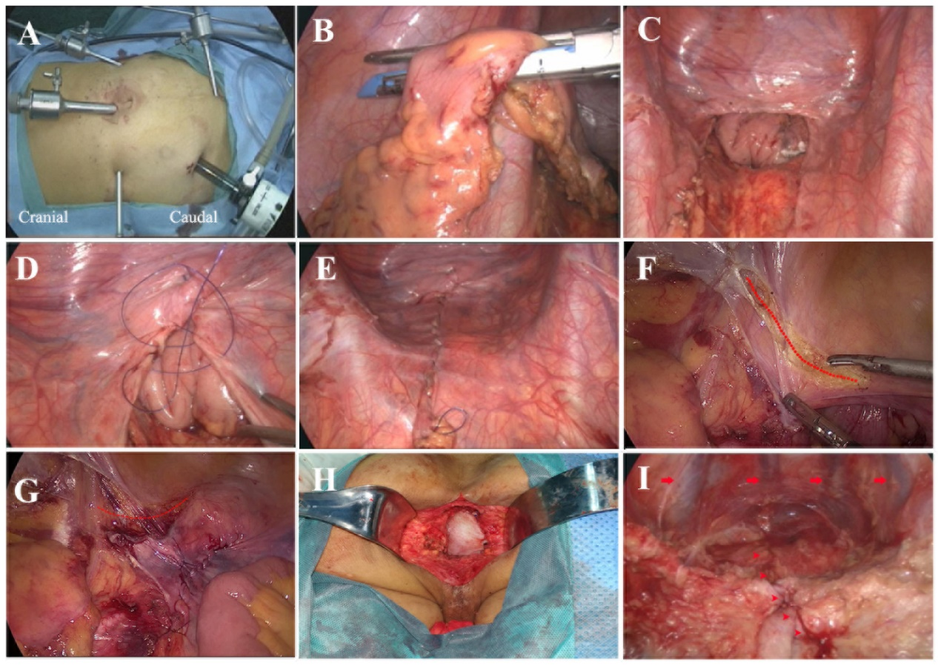
Figure 1 Surgical procedures. A: Port placement; B: Transection of the rectum at the rectosigmoid junction with an ENDO-GIA; C: Distal rectum pushed down to the pelvis; D: Closure of the pelvic peritoneum with a continuous suture using a barbed thread; E: Closure of the pelvic peritoneum; F: Tension reduction of the adjacent peritoneum (dotted line shows the incised peritoneum); G: Closure of the peritoneum after tension reduction (dotted line shows the incised peritoneum); H: Reconstruction of the pelvic floor with biological mesh; I: View of the closed peritoneum from the perineal wound in the prone position (the arrows show the presacral veins, and the arrowheads show the closed peritoneum).

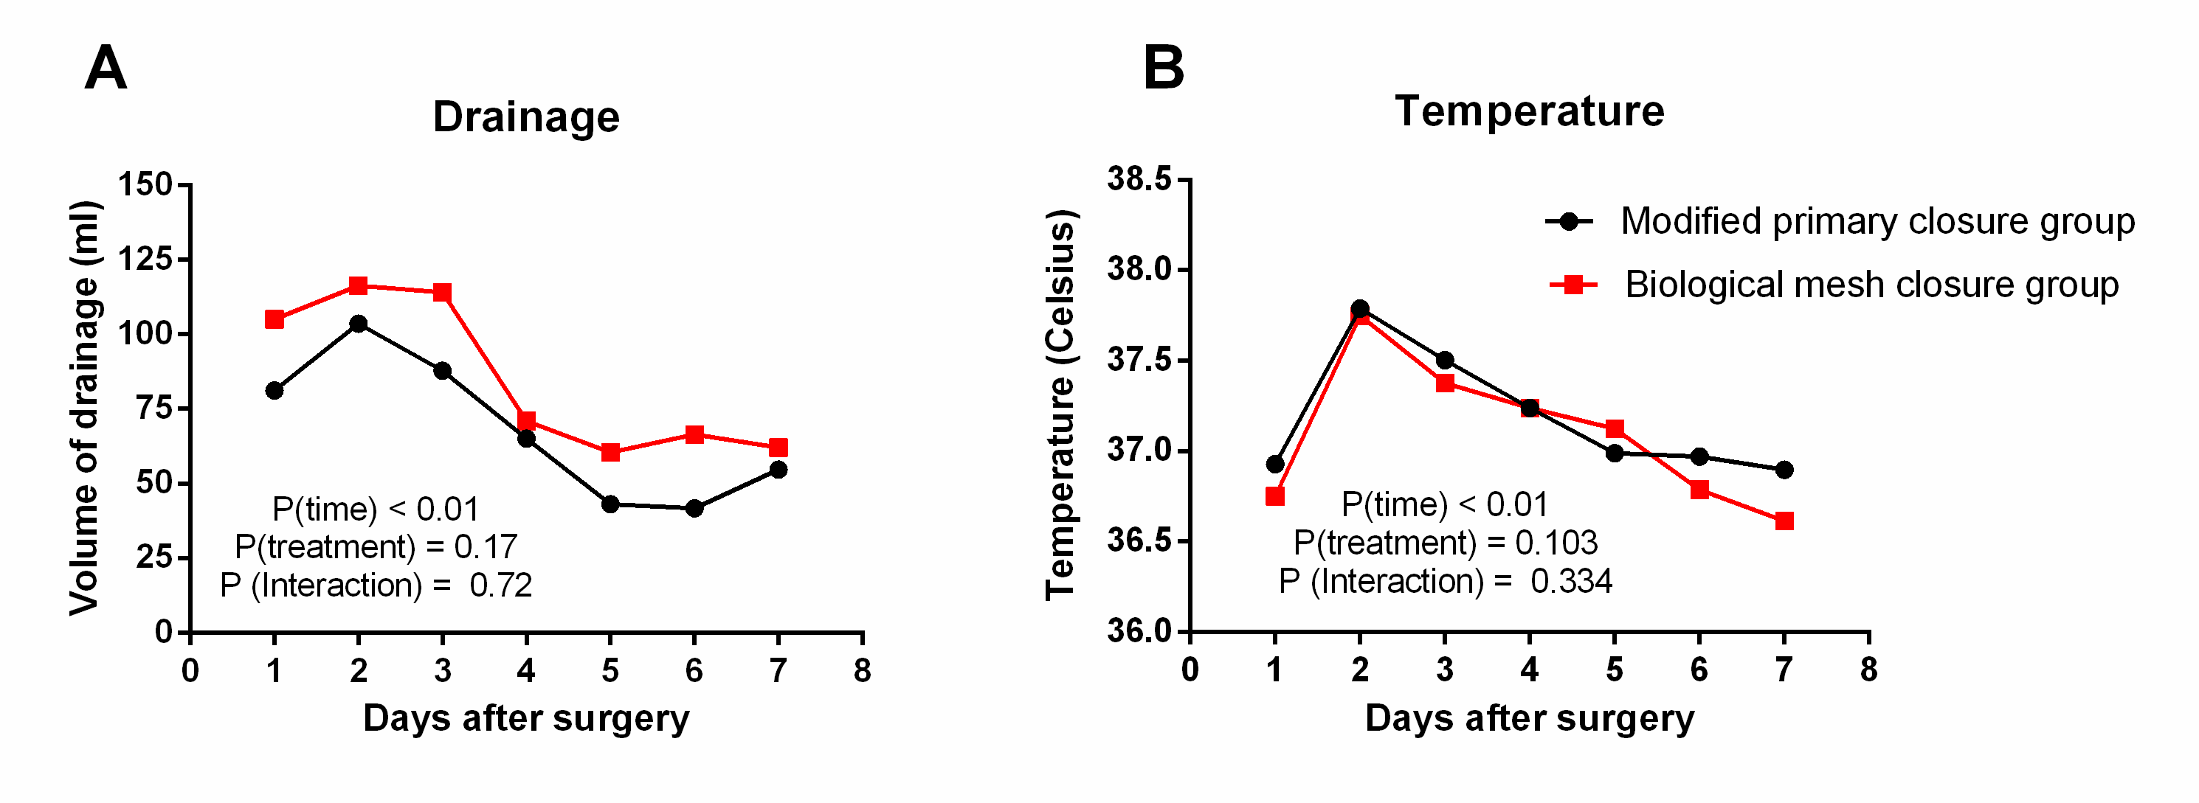
Figure 2 Drainage and temperature changes. A: Volume of the drainage postoperatively in the two groups; B: Temperature change postoperatively in the two groups.

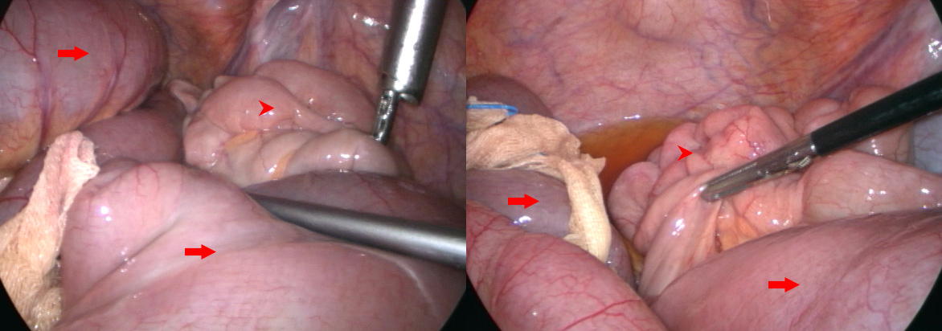
Figure 3 Laparoscopic exploration of the abdominal cavity in the patient with intestinal obstruction (arrow shows the proximal dilated small intestine, and arrowhead shows the distal normal small intestine).

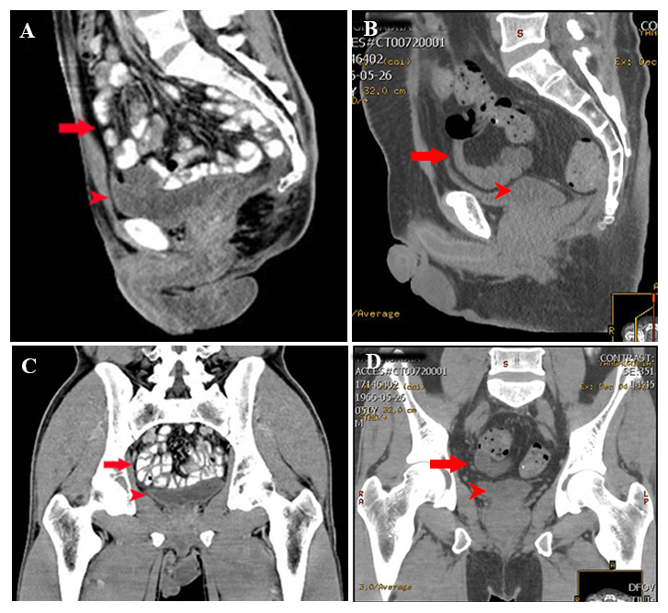
Figure 4 Postoperative MRI imaging. A: Sagittal CT scan 12 mo postoperatively in the modified primary closure group; B: Sagittal CT scan 12 mo postoperatively in the biological mesh closure group; C: Coronal CT scan 12 mo postoperatively in the modified primary closure group; D: Coronal CT scan 12 mo postoperatively in the biological mesh closure group (arrow shows the small intestine, and arrowhead shows the bladder). MRI: Magnetic Resonance Imaging; CT: Computed tomography.

Table 1 Baseline characteristics
 | Modified primary closure  (n = 32) | Biological mesh closure  (n = 44) | P value
Male/female | 24/8 | 31/13 | 0.662
Age (yr) | 52.8 ± 12.2 | 58.2 ± 12.5 | 0.137
BMI | 26.8 ± 3.2 | 25.7 ± 2.7 | 0.097
Neoadjuvant therapy | 8 | 7 | 0.326
Tumor location, Distance to anal verge (cm) | 2.6 ± 0.8 | 2.8 ± 0.9 | 0.278
Postoperative TNM staging
II | 23 | 29 | 0.581
III | 9 | 15
BMI: Body mass index.

Table 2 Perioperative data
 | Modified primary closure  (n = 32) | Biological mesh closure  (n = 44) | P value
Reconstruction time (min) | 14.6 ± 3.7 | 7.2 ± 1.9 | < 0.001
Total operative time (min) | 236 ± 20 | 248 ± 43 | 0.143
Intraoperative blood loss (mL) | 165 ± 57 | 149 ± 52 | 0.242
Positive CRM | 0 | 0 | N/A
Bowel perforation | 0 | 1 | 1.000
Recovery of bowel function (h) | 22.8 ± 4.7 | 23.6 ± 5.0 | 0.475
Intestinal obstruction | 0 | 1 | 1.000
Drainage removal (days after surgery) | 6.6 ± 1.1 | 7.3 ± 2.0 | 0.094
Postoperative hospital stay (d) | 8.1 ± 1.9 | 10.1 ± 2.8 | 0.001
Cost (USD) | 9297 ± 1260 | 10719 ± 2360 | 0.003
CRM: Circumferential margin.
Table 3 Follow-up data
 | Modified primary closure (n = 32) | Biological mesh closure (n = 44) | P value
Normal perineal wound healing¹
10 d postoperatively | 29 | 39 | 0.546
30 d postoperatively | 27 | 41 | 0.270
60 d postoperatively | 32 | 44 | 1.000
Perineal wound infection | 5 | 5 | 0.734
Clear or haemoserous discharge | 3 | 1 | 0.304
Pus/purulent discharge | 1 | 2 | 1.000
Deep infection with or without tissue break down | 1 | 2 | 1.000
Perineal hernia (at 12 mo postoperatively) | 0 | 0 | N/A
Feeling of bulge (at 12 mo postoperatively) | 4 | 2 | 0.233
Postoperative chemotherapy | 23 | 28 | 0.330
Postoperative radiotherapy | 7 | 14 | 0.339
Local recurrence (at 12 mo postoperatively) | 0 | 1 | 1.000
Liver/lung metastasis (at 12 mo postoperatively) | 2 | 3 | 1.000
Death (at 12 m postoperatively) | 0 | 0 | N/A
¹Grade 0 or Grade I by the Southampton Wound Scoring System.

