Name of Journal: World Journal of Orthopedics

Manuscript NO: 53408

Manuscript Type: ORIGINAL ARTICLE

Prospective Study
Kitesurf injury trauma evaluation study: A prospective cohort study evaluating kitesurf injuries

van Bergen CJA et al. The KITE study

Christiaan JA van Bergen, Rik IK Weber, Tim Kraal, Gino MMJ Kerkhoffs, Daniël Haverkamp

Christiaan JA van Bergen, Department of Orthopedic Surgery, Amphia Hospital, Breda 4818 CK, the Netherlands

Christiaan JA van Bergen, Gino MMJ Kerkhoffs, Academic Center for Evidence based Sports Medicine, Amsterdam 1105 AZ, the Netherlands

Rik IK Weber, Department of Sports Medicine, University Medical Center, Utrecht 3584 CX, the Netherlands

Tim Kraal, Department of Orthopedic Surgery, Spaarne Hospital, Hoofddorp 2134 TM, the Netherlands

Gino MMJ Kerkhoffs, Department of Orthopedic Surgery, Amsterdam University Medical Center, Amsterdam 1105 AZ, the Netherlands

Daniël Haverkamp, Department of Orthopedic Surgery, Xpert Clinic, Amsterdam 1103 TB, the Netherlands

Author contributions: van Bergen CJA, Weber RIK and Kraal T are kitesurfers, analyzed the data and wrote the paper; Weber RIK, Kraal T and Haverkamp D designed and performed the study; Kerkhoffs GMMJ and Haverkamp D commented on the drafts.

Corresponding author: Christiaan JA van Bergen, MD, PhD, Surgeon, Department of Orthopedic Surgery, Amphia Hospital, Molengracht 21, Breda 4818 CK, the Netherlands. cvanbergen@amphia.nl

Received: December 18, 2019
Revised: March 14, 2020
Accepted: March 26, 2020
Published online:

Abstract
BACKGROUND
Kitesurfing is an increasingly popular and potentially dangerous extreme water sport. We hypothesized that kitesurfing has a higher injury rate than other (contact) sports and that the minority of injuries are severe.

AIM
To investigate the incidence and epidemiology of kitesurfing injuries in a Dutch cohort during a complete kitesurfing season.

METHODS
Injury data of 194 kitesurfers of various skill levels, riding styles and age were surveyed prospectively during a full kitesurf season. The participants were recruited through the Dutch national kitesurf association, social media, local websites and kitesurf schools. Participants completed digital questionnaires monthly. The amount of time kitesurfing was registered along with all sustained injuries. If an injury was reported, an additional questionnaire explored the type of injury, injury location, severity and the circumstances under which the injury occurred.

RESULTS
The mean age of participants was 31 years (range, 13-59) and the majority of the study population was male (74.2%). A total of 177 injuries were sustained during 16816 kitesurf hours. The calculated injury rate was 10.5 injuries per 1000 h of kitesurfing. The most common injuries were cuts and abrasions (25.4%), followed by contusions (19.8%), joint sprains (17.5%) and muscle sprains (10.2%). The foot and ankle were the most common site of injury (31.8%), followed by the knee (14.1%) and hand and wrist (10.2%). Most injuries were reported to occur during a trick or jump. Although the majority of injuries were mild, severe injuries like an anterior cruciate ligament tear, a lumbar spine fracture, a bimalleolar ankle fracture and an eardrum rupture were reported.

CONCLUSION
The injury rate of kitesurfing is in the range of other popular (contact) sports. Most injuries are relatively mild, although kitesurfing has the potential to cause serious injuries.

Key words: Kite boarding; Water sports; Sports medicine; Injuries; Epidemiology; Extreme sports

van Bergen CJA, Weber RIK, Kraal T, Kerkhoffs GMMJ, Haverkamp D. Kitesurf injury trauma evaluation study: A prospective cohort study evaluating kitesurf injuries. World J Orthop 2020; In press

Core tip: Kitesurfing is an increasingly popular extreme water sports with the potential to cause serious injuries. This paper presents a unique prospective cohort study investigating injuries during a complete kitesurf season. An injury rate of 10.5 per 1000 h of kitesurfing was found. Most of the injuries associated with kitesurfing are relatively mild, although kitesurfing causes severe injuries as well. Furthermore, it was shown that the foot and ankle are the most injured body parts. The outcomes of this study may provide clues for prevention.
INTRODUCTION
Since its introduction in the mid-1990s, kitesurfing has become an increasingly popular sport. It is probably the fastest growing water sports and has become an Olympic sport recently^{[1]}. Although retrospective studies report injury risks within the range of other sports^{[1,2]}, kitesurfing is considered an extreme sport^{[3-5]} and kitesurfers are often seen as thrill seekers. Prospective high quality studies concerning the injury risk of kitesurfing are scarce^{[5]}. Therefore, the image of the sport is most likely based on media headlines.
Kitesurfing is a water sport that combines elements of several different sports like power kiting, wakeboarding, surfing and windsurfing. A kite, ranging in size from approximately 5 to 20 m², is used to convert wind energy into forward motion. The kitesurfer is attached to this kite by four or five lines, a handlebar and harness (Figure 1). The athlete stands on a board; this board varies in size and shape, dependent on the style of kitesurfing preferred by the athlete. Kitesurfing can roughly be divided in three different disciplines. Freestyle mostly revolves around performing jumps and tricks (Figure 2); athletes generally use rectangular symmetrically shaped boards (twintips). The course race discipline is more similar to sailing; these kitesurfers use larger non-symmetrical boards (raceboards) with the aim to reach a finish line as fast as possible. The wave discipline is aimed at surfing waves; these boards closely resemble regular surfboards (directionals). One could imagine that the injury risks differ per discipline. In general, most recreational kitesurfers will incorporate different aspects of these disciplines in their kitesurf sessions. As with every relatively new sport, kitesurfing is subject to significant change and evolution, leading to a range of different safety systems and protective gear. Safety systems to depower the kite and a quick-release system to detach the kite from the harness have become standard in recent years and are now widely used. Other changes in kite design, lines and control bars have made kites considerably easier to control, making the sport more accessible and easier to learn.
There is no recent prospective study evaluating the injury risk and epidemiology of kitesurfing injuries after these innovations. The only prospective cohort study amongst kitesurfers was done in 2002. In this study, the authors concluded that kitesurfing is an extreme sport with the potential to cause serious harm to its participants. There has not been another prospective study evaluating injury risk in kitesurfing. Thus, the safety of the sport can only be judged on outdated literature. Meanwhile, kitesurf equipment and protective gear has developed significantly. Therefore, the purpose of this study was to determine the current injury rate, the severity of the injuries and possible factors influencing the safety aspects of kitesurfing.

MATERIALS AND METHODS
This is a prospective cohort study during a single kitesurf season from April to November. The local medical ethics committee approved the study protocol. Kitesurfers were recruited through the Dutch national kitesurf association, local kitesurf websites (www.hanglos.nl, www.kitehigh.nl), social media (Facebook) and Dutch kitesurfschools. Dutch speaking riders of all skill levels, riding styles and age were included for participation. Informed consent was obtained from all kitesurfers prior to study participation. Participants were able to register on a website with an online database system with anonymous registration of the data but allowing the researcher to follow up on missing data. The data was collected monthly and a reminder was sent to all participants failing to enter their monthly update.
At baseline registration, all participants completed a web-based questionnaire with data including age, sex, years of experience, type of equipment used, hours of kitesurf lessons received, competitive riding level, safety system usage and hours spent practicing different sports per week. All participants were asked to monitor the amount of hours spent kitesurfing per month. Participants were instructed to report every type of physical injury, including cuts and abrasions, due to kitesurfing sustained in the concerned month. If an injury was reported, an additional questionnaire explored the type and severity of the injury and the circumstances under which the injury occurred. If a participant sustained more than one injury during a month, he or she was instructed to fill out a separate questionnaire for each injury.
The injury-specific questionnaire was divided in three distinct parts. The first part evaluated the circumstances and possible causes which led to the sustained injury: the style of riding at the time of the injury, the time of the injury (beginning, middle, or end of the session), water conditions (flat water, choppy, waves), wind speed and direction. Further questions evaluated potential causes of the injury: attempted trick or maneuvers, kite control, equipment failure, lack of experience, collision with other persons. The second part of the questionnaire evaluated the specifics of the injury itself: the anatomical location of the injury, the type and severity of injury, consultation of medical care, received diagnostics and treatment, the diagnosis, days admitted in hospital and the period the athlete was unable to kitesurf due to the injury. The final part of the questionnaire evaluated the gear used at the time of the injury: production year of the kite, type of board, type of bindings (footpads and straps, boots or strapless), protective gear used, and whether a quick-release system was used.
At the end of the kitesurfing season all athletes who still had missing data were contacted by e-mail with a request to report the missing data retrospectively. Kitesurfers who never responded in any month (due to incorrect e-mails or other reasons) were considered non-responders. In addition to the data provided by the participating athletes, local and national media were monitored for fatal accidents amongst the participants of the study.

Statistical analysis
Descriptive statistics were used for the demographic characteristics of participants. Injury location was classified in nominal categories with respect to the different body areas. A descriptive analysis for injury severity was used referring to the consequences of the injury. The injury rate per 1000 h of kitesurfing was calculated. Injury rates were compared between different levels of experience using the χ² test. A P-value of 0.05 was considered statistically significant.

RESULTS
Baseline characteristics
A total of 253 kitesurfers registered for participation on the website. Eight participants ended their cooperation due to personal reasons. Another 51 participants were non-responders. This left 194 kitesurfers eligible for data collection during the season. The average monthly response rate of these 194 included kitesurfers was 89.2%. The mean age of participants was 31 years (range, 13-59) and the majority of the study population was male (74.2%). The largest portion of participants (43.8%) had 3-5 years of experience. Three to ten hours of kitesurfing lessons was reported by 42.8% of the participants and only 14.9% received no lessons at all. The vast majority (91.8%) of the participating kitesurfers used a twintip kiteboard with straps (Table 1).

Injury rate
The 194 participants recorded a total of 16816 h of kitesurfing during the study period. A total of 177 injuries were reported. This leads to a calculated injury rate of 10.5 injuries per 1000 h of kitesurfing.

Injury type and location
The most common injuries were cuts and abrasions (25.4%), followed by contusions (19.8%), joint sprains (17.5%) and muscle sprains (10.2%). There were only 7 (4.0%) fractures reported (Table 2), including foot, spine, ankle and wrist fractures. All were treated nonoperatively. The foot and ankle were the most common sites of injury (31.8%), followed by the knee (14.1%) and hand and wrist (10.2%) (Table 3). Injuries of the foot and ankle included a bimalleolar ankle fracture, three phalangeal fractures and three ankle sprains. Injuries of the knee included 13 knee sprains, two meniscal tears and two anterior cruciate ligament tears. Hand and wrist injuries included five abrasions, three wrist sprains, and one metacarpal fracture. Other fractures included a cervical spine fracture and a lumbar spine fracture.

Injury severity and consequences
A medical doctor was consulted in 14.1% of the injuries. This concerned a medical specialist in 7.3%, a general practitioner in 5.1% and an emergency physician in 1.7% of the cases. Only 2.9% of the injuries led to an admission in the hospital. In 83.1% of the injuries the athlete was able to return to kitesurfing within one week. In 3.9% of the injuries the kitesurfer reported to be unable to kite for two months up to a complete season. There were no kitesurf injuries that prevented a kitesurfer from ever practicing the sport again. There were no fatal injuries in our study cohort.

Injury cause and environmental factors
The majority of the injuries were sustained in wind speeds of 4-6 Beaufort and flat to small wave (choppy) conditions, which are typical Dutch conditions. The vast majority (91.0%) of the injuries were sustained on the water. However, 49.2% of the injuries were sustained in shallow water and nine percent of the injuries were caused by an accident on the shore. Interestingly, all fractures were either sustained in shallow water or on the shore. Half of all of injuries were sustained attempting a jump or trick (Table 4). In 15.8% of the injuries the athlete reported that lack of experience played a role in sustaining the injury. Loss of kite control was reported in 10.7% as a cause of the injury, and gear failure in 3.4%. In only 2.8%, the injury was caused by contact or collision with someone else on the water.
Most injuries were found amongst kitesurfers with 3-5 years of experience, but this was also the largest group of participants that reported the most hours of kitesurfing in the study period. A trend was observed for a decreasing injury rate with an increasing level of experience. Beginners with less than one year of experience had an injury rate of 17.5. With 3-5 years of experience the injury rate was 11.5 and this decreased to 7.8 injuries per 1000 h in participants with more than 10 years of experience. However, this did not reach statistical significance (OR = 2.23; 95%CI: 0.99-4.98; P = 0.052).

Injury prevention
In 97.9% of the injuries the athlete was in possession of a quick-release system to detach the kite from their harness. However, in only 7.3% of the injuries the quick-release was actually used. An impact-vest was used by 19.5% of participants on a regular basis, and 4.0% used a helmet on a regular basis. Other protective gear such as a knee brace or spine protector was used by 12.3% of the kitesurfers.

DISCUSSION
This prospective cohort study collected data regarding kitesurfing injuries among a representative group of Dutch kitesurfers during one full season in the Netherlands. The majority of the injuries were mild, demonstrated by our results that more than 80% of the athletes were able to return to kitesurfing within one week and medical help was sought in only 14% of the injuries.
An injury rate of 10.5/1000 h was found in this study. A wide range in injury rate is described for kitesurfing in the existing literature from 1.04/1000 h^{[6]} up to 18.5/1000 h^{[2]} in competitive kitesurfers. Nickel et al^{[4]} conducted the only comparable prospective study on kitesurfing injuries in 2002, reporting an injury rate of 7/1000 h. These injury rates of kitesurfing are not disproportionally high compared to other sports, such as motocross (22.7/1000 h)^{[7]}, soccer (18.5/1000 h)^{[8]}, and American football (36/1000 h)^{[9]} (Figure 3). van Bergen et al^{[10]} reported a higher injury rate amongst kitesurfers (7.0/1000 h) in comparison with windsurfers (5.2/1000 h).
It is important to note that the injury rate is an outcome parameter that can be influenced greatly by several factors, concerning both the numerator and the denominator. At first, there is no strict definition of an injury. It can be questioned if an abrasion or a skin cut from shells really is a “countable” injury if it does not lead to inability to practice the sport. Furthermore, for a sport like kitesurfing, it is difficult to report the exact amount of time that the sport is practiced, given the recreational nature of the sport without scheduled training moments. In our study, the participants reported the amount of hours spent kitesurfing at the end of each month.
In accordance to our findings, similar types of injuries were described by Nickel et al^{[4]}, with contusions, lacerations and joint sprains being the most common injuries. Also consistent with our findings, the foot and ankle were the most common locations of injury. We hypothesize that the contact forces during landing and fixation of the forefoot in straps during rotational maneuvers are related to the common foot and ankle injuries.
A contrasting finding is that the use of a quick-release system was available in only 18% of the athletes in 2002^{[4]}, which increased to 97.9% in our study. A quick-release system is typically used when there is loss of kite control. It is generally accepted that the current quick-release systems are easier to use and more reliable than > 10 years ago. Nickel et al^{[4]} already described a trend toward a decreasing injury rate with the use of a quick-release system. Interestingly, we noted that the quick-release system was used in only 7.3% of the injuries. This is most likely related to the finding that loss of kite control was only reported in 10.7% of the injuries. Another possible explanation might be a high threshold to actually use the quick-release system.
Although kitesurfing equipment has become safer in recent years, our study did not demonstrate a lower injury rate compared to previous studies. Similarly, Baumbach et al^{[2]} in 2018 reported a high injury rate of 18.5/1000 h despite a statistically significant influence of the equipment used. Several explanations can be hypothesized for this discrepancy. With the increased popularity of kitesurfing and the improved equipment, the sport has become more accessible to people who are less physically fit and not familiar with watersports or flying a kite, compared to the early years of kitesurfing. The increased popularity can also lead to crowding of kitesurf spots, causing accidents. However, in our study, injuries caused by collisions with others was reported in only 2.8%. Another factor is that even minor injuries like cuts and abrasions were included in this study.
Although the majority of the injuries reported in our study were mild, there is no doubt about the potential for severe injuries due to kitesurfing. A combination of an anterior cruciate ligament with medial collateral ligament injury was reported after a valgus rotational trauma during a landing of a powered trick (a railey). A lumbar spine fracture was reported, sustained on the beach after loss of kite control during landing the kite. An eardrum tear was reported due to a crash with the ear on the water while attempting a kiteloop. Further examples of serious injuries in our study were a cervical spine fracture and a bimalleolar ankle fracture. The potential for serious risks in kitesurfing are also displayed in the case series of Spanjersberg et al^{[5]} and Driessen et al^{[3]} in which they report severe multitrauma patients with various injuries leading to persisting handicap and even death in several cases.
The relatively large amount of non-responders is a limitation of this study. This was probably due to the fact that only after online registration participants realized the quantity of data that we requested for participation. Medical diagnoses of the reported injuries were not confirmed with physical examination or diagnostic imaging by the authors of the study. This study relied on the description of the injury from the injured participant. Furthermore, a clear definition of an injury with respect to the severity was not found in the literature. In this study, we chose to use an injury definition that took every form of physical harm into account, as advised in multiple consensus statements by experts in sports medicine^{[11-14]}. With this approach, the risk of underestimating the occurrence of injuries is minimized. The downside is that some of the smaller injuries that participants registered, such as blisters, might be considered as normal “side effects” of the sport instead of real injuries. There were a relative low number of participants in the disciplines wave and race compared to freestyle. This made it impossible to distinguish the risks between the different kitesurfing disciplines.
In conclusion, an injury rate of 10.5/1000 h kitesurfing was found in this prospective cohort study. The injury rate is not disproportionally high compared with other contact sports. A decreased injury rate compared to previous literature with the evolution of the sport was not demonstrated. Most of the injuries were relatively mild. However, this study also confirms that kitesurfing has the potential to cause severe injuries.

ARTICLE HIGHLIGHTS
Research background
Kitesurfing is a rapidly growing extreme water sport with a high injury potential.

Research motivation
The only prospective study on kitesurf injuries is from 2004. Kitesurf equipment has developed over the past years.

Research objectives
The purpose of the study was to identify injury patterns and incidence rates of kitesurfers with modern equipment.

Research methods
A prospective study was performed investigating a large number of kitesurfers during a full kitesurf season.

Research results
The injuries were similar to previous research, despite the use of modern equipment. Furthermore, the injury rate was within the range of other extreme sports.

Research conclusions
Kitesurfing is a relatively safe water sport, although severe injuries do occur.

Research perspectives
To further decrease the risk of injuries, future studies can be directed towards the use of protective gear as well as other protective measures such as designated areas.

REFERENCES
1 Steffen K, Soligard T, Mountjoy M, Dallo I, Gessara AM, Giuria H, Perez Alamino L, Rodriguez J, Salmina N, Veloz D, Budgett R, Engebretsen L. How do the new Olympic sports compare with the traditional Olympic sports? Injury and illness at the 2018 Youth Olympic Summer Games in Buenos Aires, Argentina. Br J Sports Med 2020; 54: 168-175 [PMID: 31796464 DOI: 10.1136/bjsports-2019-101040]
2 Baumbach SF, Stawinski T, Schmitz D, Schoeneberg C, Jäger M, Wedemeyer C, Kauther MD. Influence of kitesurf equipment on injury rates. J Sports Med Phys Fitness 2018; 58: 1482-1489 [PMID: 28738666 DOI: 10.23736/S0022-4707.17.07152-3]
3 Driessen A, Probst C, Sakka SG, Eikermann C, Mutschler M. Bilateral carotid artery dissection in a kite surfer by strangulation with the kite lines. Unfallchirurg 2015; 118: 567-570 [PMID: 25135706 DOI: 10.1007/s00113-014-2641-0]
4 Nickel C, Zernial O, Musahl V, Hansen U, Zantop T, Petersen W. A prospective study of kitesurfing injuries. Am J Sports Med 2004; 32: 921-927 [PMID: 15150038 DOI: 10.1177/0363546503262162]
5 Spanjersberg WR, Schipper IB. Kitesurfing: when fun turns to trauma-the dangers of a new extreme sport. J Trauma 2007; 63: E76-E80 [PMID: 17554218 DOI: 10.1097/TA.0b013e318046edfd]
6 Bourgois JG, Boone J, Callewaert M, Tipton MJ, Tallir IB. Biomechanical and physiological demands of kitesurfing and epidemiology of injury among kitesurfers. Sports Med 2014; 44: 55-66 [PMID: 24105613 DOI: 10.1007/s40279-013-0103-4]
7 Gobbi A, Tuy B, Panuncialman I. The incidence of motocross injuries: a 12-year investigation. Knee Surg Sports Traumatol Arthrosc 2004; 12: 574-580 [PMID: 15133584 DOI: 10.1007/s00167-004-0510-z]
8 Nielsen AB, Yde J. Epidemiology and traumatology of injuries in soccer. Am J Sports Med 1989; 17: 803-807 [PMID: 2516415 DOI: 10.1177/036354658901700614]
9 Dick R, Ferrara MS, Agel J, Courson R, Marshall SW, Hanley MJ, Reifsteck F. Descriptive epidemiology of collegiate men's football injuries: National Collegiate Athletic Association Injury Surveillance System, 1988-1989 through 2003-2004. J Athl Train 2007; 42: 221-233 [PMID: 17710170]
10 van Bergen CJ, Commandeur JP, Weber RI, Haverkamp D, Breederveld RS. Windsurfing vs kitesurfing: Injuries at the North Sea over a 2-year period. World J Orthop 2016; 7: 814-820 [PMID: 28032034 DOI: 10.5312/wjo.v7.i12.814]
11 Kwiatkowski A. Unfall- und Präventionsmechanismen beim Kitesurfen unter Wettkampf- und Freizeitbedingungen. 2009; 1-127. Available from: http://ediss.sub.uni-hamburg.de/volltexte/2010/4699/
12 Fuller CW, Ekstrand J, Junge A, Andersen TE, Bahr R, Dvorak J, Hägglund M, McCrory P, Meeuwisse WH. Consensus statement on injury definitions and data collection procedures in studies of football (soccer) injuries. Br J Sports Med 2006; 40: 193-201 [PMID: 16505073 DOI: 10.1136/bjsm.2005.025270]
13 Fuller CW, Molloy MG, Bagate C, Bahr R, Brooks JH, Donson H, Kemp SP, McCrory P, McIntosh AS, Meeuwisse WH, Quarrie KL, Raftery M, Wiley P. Consensus statement on injury definitions and data collection procedures for studies of injuries in rugby union. Br J Sports Med 2007; 41: 328-331 [PMID: 17452684 DOI: 10.1136/bjsm.2006.033282]
14 Bahr R, Maehlum S. Clinical Guide to Sports Injuries: An Illustrated Guide to the Management of Injuries in Physical Activity. Champaign, IL: Human Kinetics, 2004

Footnotes
Institutional review board statement: The study was reviewed and approved by the Slotervaartziekenhuis and Reade Institutional Review Board.

Clinical trial registration statement: This study was not registered in a clinical trial registration.

Informed consent statement: All involved persons gave their informed consent prior to study inclusion.

Conflict-of-interest statement: The authors have no conflict of interest to report.

Data sharing statement: There is no additional data available.

CONSORT 2010 statement: The authors have read the CONSORT 2010 Statement. The manuscript was prepared and revised according to the CONSORT 2010 Statement as far as possible because the study is not a randomized controlled trial.

Open-Access: This article is an open-access article that was selected by an in-house editor and fully peer-reviewed by external reviewers. It is distributed in accordance with the Creative Commons Attribution NonCommercial (CC BY-NC 4.0) license, which permits others to distribute, remix, adapt, build upon this work non-commercially, and license their derivative works on different terms, provided the original work is properly cited and the use is non-commercial. See: http://creativecommons.org/licenses/by-nc/4.0/

Manuscript source: Invited manuscript

Peer-review started: December 18, 2019
First decision: January 6, 2020
Article in press:

Specialty type: Orthopedics
Country of origin: Netherlands
Peer-review report classification
Grade A (Excellent): 0
Grade B (Very good): B, B
Grade C (Good): 0
Grade D (Fair): 0
Grade E (Poor): 0

P-Reviewer: Malik H, Mesquita J S-Editor: Dou Y L-Editor: E-Editor:

Figure Legends
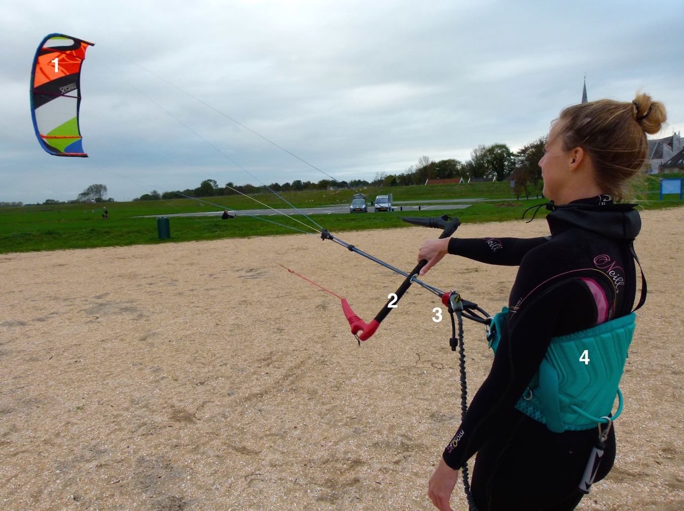Figure 1 A fully equipped kitesurfer. 1: Kite; 2: Handlebar; 3: Quick-release system; 4: Harness.

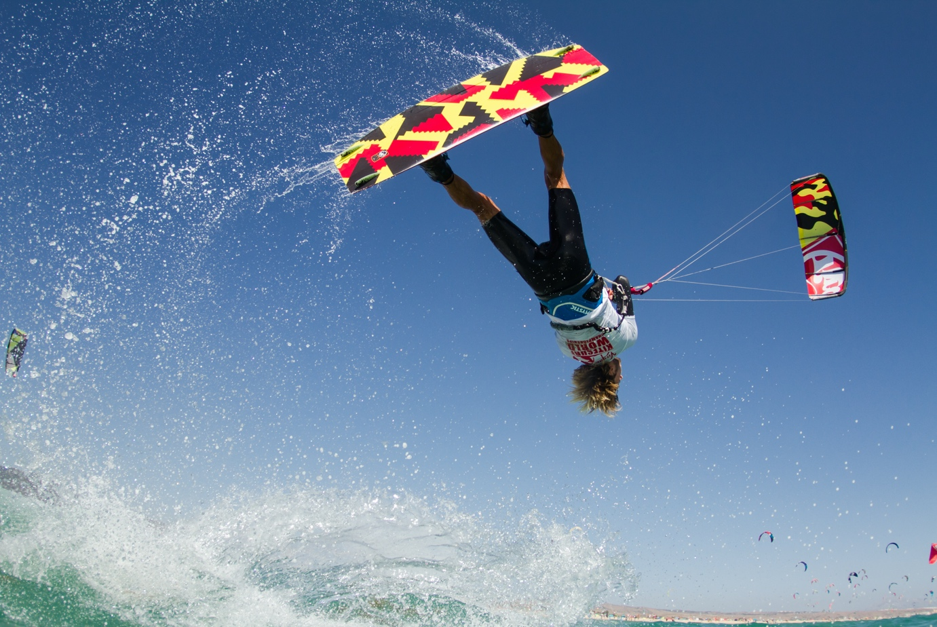Figure 2 A kitesurfer on a twintip board performing a freestyle jump.

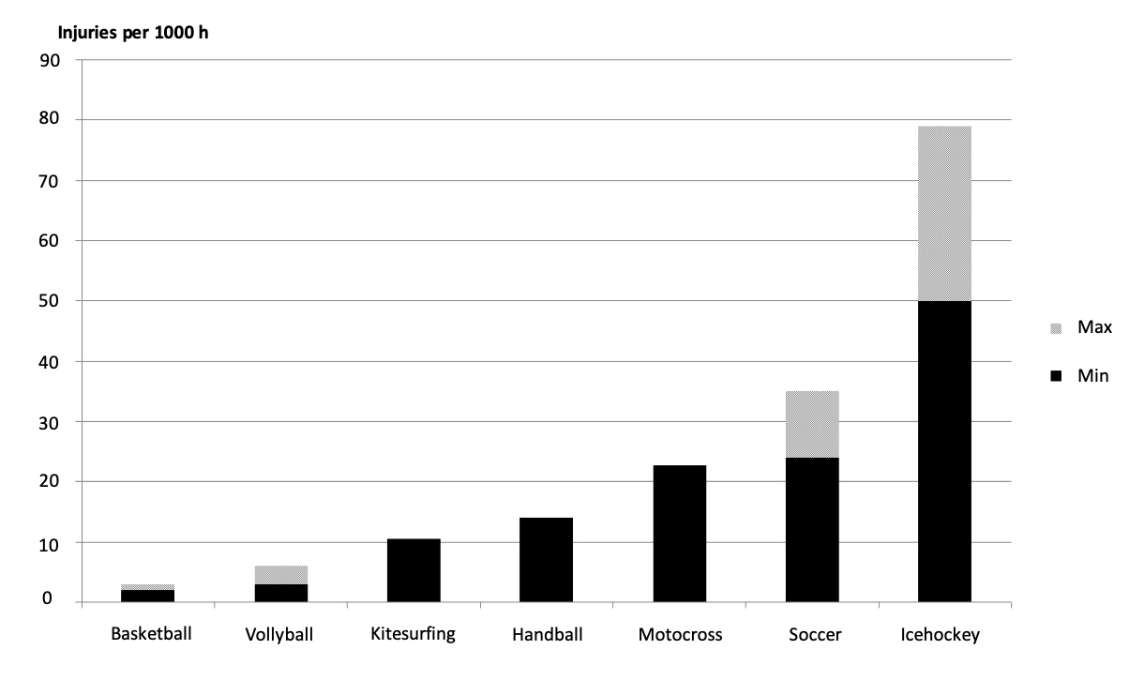Figure 3 Injury rates in different sports compared with kitesurfing^{[6,7,11,12]}.
Table 1 Baseline characteristics
Characteristic | n | %
Sex
Male | 144 | 74
Female | 50 | 26
Age (yr)
10-20 | 21 | 11
20-30 | 79 | 41
30-40 | 63 | 32
40-50 | 24 | 12
50-60 | 8 | 4.1
Experience (yr)
< 1 | 13 | 6.7
1-2 | 27 | 14
3-5 | 85 | 44
5-10 | 51 | 26
> 10 | 18 | 9.2
Lessons
0 | 29 | 15
1-3 | 44 | 23
3-10 | 84 | 43
> 10 | 37 | 19
Board type
Twintip | 178 | 92
Directional | 11 | 5.6
Race | 1 | 0.5
Different | 4 | 2.1
Protection
Quick-release | 190 | 98
Impact vest | 38 | 20
Helmet | 8 | 4.1
Different | 24 | 12

Table 2 The types of injuries
Injury | n | %
Abrasion | 45 | 25
Contusion | 35 | 19
Joint sprain | 31 | 19
Muscular sprain | 18 | 10
Deep/open wound | 16 | 9.0
Fracture | 7 | 4.0
Concussion | 7 | 4.0
Ligament rupture | 4 | 2.2
Meniscus tear | 2 | 1.1
Nerve damage | 1 | 0.6
Other | 11 | 6.2
Total | 177 | 100

Table 3 Affected anatomical locations
Location | n | %
Foot | 45 | 25
Knee | 25 | 14
Hand/wrist | 18 | 10
Head | 14 | 7.9
Calf | 14 | 7.9
Ankle | 11 | 6.2
Shoulder | 8 | 4.5
Chest | 7 | 4.0
Fingers | 7 | 4.0
Upper arm | 4 | 2.3
Elbow | 4 | 2.3
Hip | 4 | 2.3
Back | 4 | 2.3
Neck | 3 | 1.7
Upper leg | 2 | 1.1
Forearm | 1 | 0.6
Other | 6 | 3.4
Total | 177 | 100

Table 4 Maneuver at the time of the injury
Maneuver | n | %
Jump or trick | 87 | 49
Cruising | 46 | 26
Walking with kite | 16 | 9.0
Wave riding | 10 | 5.6
Landing kite | 3 | 1.7
Launching kite | 2 | 1.1
Other | 13 | 7.3
Total | 177 | 100

