Name of Journal: World Journal of Hepatology
Manuscript NO: 38791
Manuscript Type: MINIREVIEWS

MR with Gd-EOB-DTPA in assessment of liver nodules in cirrhotic patients

Inchingolo R et al. New prospective in liver nodules

Riccardo Inchingolo, Riccardo Faletti, Luigi Grazioli, Eleonora Tricarico, Marco Gatti, Anna Pecorelli, Davide Ippolito

Riccardo Inchingolo, Eleonora Tricarico, Division of Interventional Radiology, Department of Radiology, Madonna delle Grazie Hospital, Matera 75100, Italy

Riccardo Faletti, Marco Gatti, Department of Surgical Sciences, Radiology Unit, University of Turin, Turin 10126, Italy

Luigi Grazioli, Department of Radiology, University of Brescia “Spedali Civili”, Brescia 25123, Italy

Anna Pecorelli, Davide Ippolito, Department of Diagnostic Radiology, School of Medicine, University of Milano-Bicocca, Monza 20900, Italy

ORCID number: Riccardo Inchingolo (0000-0002-0253-5936); Riccardo Faletti (0000-0002-8865-8637); Luigi Grazioli (0000-0002-2345-1571); Eleonora Tricarico (0000-0001-9805-2551); Marco Gatti (0000-0001-8168-5280); Anna Pecorelli (0000-0001-9791-6709); Davide Ippolito (0000-0002-2696-7047).

Author contributions: All authors equally contributed to this paper with conception and design of the study, literature review and analysis, drafting and critical revision and editing, and final approval of the final version.

Conflict-of-interest statement: All the authors are aware of the content of the manuscript and have no conflict of interest.

Open-Access: This article is an open-access article which was selected by an in-house editor and fully peer-reviewed by external reviewers. It is distributed in accordance with the Creative Commons Attribution Non Commercial (CC BY-NC 4.0) license, which permits others to distribute, remix, adapt, build upon this work non-commercially, and license their derivative works on different terms, provided the original work is properly cited and the use is non-commercial. See: http://creativecommons.org/licenses/by-nc/4.0/

Manuscript source: Invited manuscript

Correspondence to: Riccardo Inchingolo, MD, Doctor, Division of Interventional Radiology, Department of Radiology, Madonna delle Grazie Hospital, Via Montescaglioso, Matera 75100, Italy. riccardoin@hotmail.it
Telephone: +39-333-4601735
Fax: +39-835-253857

Received: March 26, 2018
Peer-review started: March 27, 2018
First decision: April 18, 2018
Revised: April 25, 2018
Accepted: May 30, 2018
Article in press:
Published online:

Abstract
To date the imaging diagnosis of liver lesions is based mainly on the identification of vascular features, which are typical of overt hepatocellular carcinoma (HCC), but the hepatocarcinogenesis is a complex and multistep event during which, a spectrum of nodules develop within the liver parenchyma, including benign small and large regenerative nodule (RN), low-grade dysplastic nodule (LGDN), high-grade dysplastic nodule (HGDN), early HCC, and well differentiated HCC. These nodules may be characterised not only on the basis of their respective different blood supplies, but also on their different hepatocyte function. Recently, in liver imaging the introduction of hepatobiliary magnetic resonance imaging contrast agent offered the clinicians the possibility to obtain, at once, information not only related to the vascular changes of liver nodules but also information on hepatocyte function. For this reasons this new approach becomes the most relevant diagnostic clue for differentiating low-risk nodules (LGDN-RN) from high-risk nodules (HGDN/early HCC or overt HCC) and consequently new diagnostic algorithms for HCC have been proposed. The use of hepatobiliary contrast agents is constantly increasing and gradually changing the standard of diagnosis of HCC. The main purpose of this review is to underline the added value of Gd-EOB-DTPA in early-stage diagnoses of HCC. We also analyse the guidelines for the diagnosis and management of HCC, the key concepts of HCC development, growth and spread and the imaging appearance of precursor nodules that eventually may transform into overt HCC.

Key Word: Hepatobiliary contrast materials; Gadoxetic acid; Cirrhosis; Magnetic resonance imaging; Liver

© The Author(s) 2018. Published by Baishideng Publishing Group Inc. All rights reserved.

Core tip: Hepatobiliary contrast agents improve detection and characterization of focal liver lesions in patients with cirrhotic liver. Gd-EOB-DTPA provides information not only on vascular changes but also on hepatocyte function. Based on the recent advances in liver magnetic resonance imaging (MRI) technology, in this review, we discuss the pivotal role of Gd-EOB-DTPA enhanced MRI for the future of hepatocellular carcinoma’s management.

Inchingolo R, Faletti R, Grazioli L, Tricarico E, Gatti M, Pecorelli A, Ippolito D. MR with Gd-EOB-DTPA in assessment of liver nodules in cirrhotic patients. World J Hepatol 2018; In press

INTRODUCTION
Liver cancer is the fifth most common cancer in men, the ninth in women and is the second most common cause of death from cancer worldwide^{[1]}. Hepatocellular carcinoma (HCC) is a primary tumour of the liver and several risk factors for its development have been identified. These include hepatitis C viral (HCV) infection, hepatitis B virus (HBV) infection, hereditary hemochromatosis and cirrhosis of almost any cause^{[2]}.
The diagnosis of HCC can be difficult and often requires the use of one or more imaging modalities^{[3-6]}. Surveillance for HCC aims to reduce disease-related mortality because an accurate and early detection and characterization of focal liver nodule is mandatory since the management of HCC patients differs to other malignant or benign nodules and the prognosis of HCC depends mostly on the stage at which the tumour is identified^{[7]}.
Liver cirrhosis is the underlying and common condition associated with hepatocarcinogenesis. Cirrhosis develops after a long period of chronic liver disease when the risk of HCC is still low. The nodules that could be potentially find in a cirrhotic liver comprise: regenerative nodule (RN), low-grade dysplastic nodule (LGDN), high-grade dysplastic nodule (HGDN), early HCC, well differentiated HCC and moderately-poorly differentiated HCC. Hepatocarcinogenesis is a multistep event during which cell density increase, Kuppfer cells decrease, nodules enlarge and hemodynamics changes occur. To date, the imaging diagnosis of HCC is based on the characterization of vascular features, which are typical for overt HCC^{[3,6,8]}. In fact, in the final step of hepatocarcinogenesis, the tumor blood supply consists of nontriadal or unpaired arteries and sinusoidal capillarization, with reduced or absent portal blood supply^{[9]}. However, an atypical vascular behaviour is quite common in small (< 2 cm) nodule and almost one-third of these are malignant (‘‘the one-third rule’’)^{[10]}. These features depends on intra-nodular perfusional changes during carcinogenesis, starting with arterial hypovascularity with portal supply still present, followed by a decrease of both arterial and portal blood flow and, subsequently, to an hypervascular pattern^{[5]}.
At the same time organic anionic transporting polypeptide (OATP), transporters of bile salts, simultaneously and gradually decrease. OATP is expressed in RNs and LGDNs and its levels are lower in many HGDNs, early HCCs and progressed HCCs. The hemodynamic changes are well depict during dynamic multi detector computed tomography (MDCT) and magnetic resonance imaging (MRI) and both European and American guidelines have endorsed this techniques for the diagnosis of HCC > 1 cm, based on the typical hallmarks of hypervascularity in arterial phase with wash-out in portal phase, avoiding liver biopsy^{[10,11]}. Moreover, OATP8 expression level reduces prior to complete neoangiogenesis^{[12]} and the use of hepatospecific contrast media in MRI is considered a “new” HCC diagnostic tools that allows either to increase sensitivities for detection of HCC of all sizes^{[13]} or would make it possible to identify preneoplastic lesions, such as HGDNs^{[14]}. Furthermore, MRI offers additional imaging sequences that can be helpful in nodule characterization, including T2-weighted imaging (T2-WI) and diffusion-weighted imaging (DWI), which provides information on cellularity and has shown additional value to gadolinium-enhanced MRI by increasing the detection rate of HCC^{[15]}. However, precise differentiation of preneoplastic lesions remain uncertain to date. The recent introduction of hepatobiliary MRI contrast agent gadolinium-ethoxybenzyl-dieth-ylenetriamine pentaacetic acid (Gd-EOB-DTPA, Primovist®; Bayer Schering Pharma, Berlin, Germany) which gives information not only on vascular changes but also on hepatocyte function, raises the sensitivity for the detection of early HCC to 91%-93%^{[16]}. Many authors^{[9,16-21]} suggested that Gd-EOB-DTPA-enhanced MRI is itself the most relevant diagnostic tool for differentiating low-risk nodules (LGDN, RN) from high-risk nodules (HGDN, early HCC, overt HCC) and hence new diagnostic algorithms for HCC have been proposed^{[4,22]}.
Based on the recent advances in MRI imaging technology and since early-stage diagnoses of HCC have increased and opened the possibilities to curative therapy, the purpose of these review is to the analyze the guidelines for the diagnosis and management of HCC; the basic MRI protocol and the advanced techniques, the key concepts of HCC development, growth and spread and the imaging appearance of precursor nodules that eventually may transform into overt HCC in order to elucidate the pivotal role of Gd-EOB-DTPA- enhanced MRI for the future of HCC’s management, through a review of the published literature.

INTERNATIONAL GUIDELINES
Many studies have examined the clinical management of HCC, detecting guidelines to define a standardized approach to surveillance, diagnosis and treatment, with the aim of improve timely diagnosis and early intervention.
Guidelines in fact could be a roadmap to develop decision making algorithms, improving quality of treatment and patients’ outcomes according with support of regional or national resources. From 2001 to 2017 at least 20 guidelines have been published worldwide, with some differences in surveillance and diagnostic criteria^{[23]}.
The American Association for the Study of Liver Diseases (AASLD) was founded in 1950, providing recommendation for surveillances, diagnosis, staging and treatment of HCC, in a similar way of European Association for the Study of the Liver (EASL) ^{[8]}, while the first edition of practice guidelines for HCC in Japan was published in 2005^{[24]}. Most of the guidelines devises the form of surveillance depending on risk factors for HCC and on individuating patients with risk factor that have to be monitored. Risk factors are divided into those that are cirrhosis-related (HBV, HCV, alcoholic cirrhosis, genetic causes such as hemochromatosis, non-alcoholic steatohepatitis, stage IV primary biliary cirrhosis, alpha one antitrypsin deficiency) and those that are non-cirrhosis related, (being an HBV carrier with family history of HCC, being Asian and > 40 years old, being African/North American black infected with HBV). The distribution of risk factors is different among the world, being HBV the leading cause of HCC in Africa and East Asia, instead HCV is the main cause in Europe, Japan and North American. However, cirrhosis of any aetiology, is the strongest predictor of HCC^{[25,26]}.
The main differences in surveillance among guidelines is represented by the use of serologic markers [alpha-fetoprotein (AFP), agglutinin-reactive fraction of AFP, des-gamma-carboxy prothrombin (DCP)] and grouping the patients depending on risk to develop HCC^{[23,27]}. The use of serologic markers in HCC surveillance is still recommended only by the Japan Society of Hepatology (JSH) Guideline and Japan-HCC (J-HCC) Guideline^{[4,24]}, while guidelines in many western countries, such as the AASLD Guideline, the National Comprehensive Cancer Network (NCCN) Guideline and the EASL guideline have excluded serologic markers from surveillance criteria^{[3,8,28]}.
Guidelines have some differences in definition of high-risk population: JSH Guideline and J-HCC Guideline divide patients in very-high risk population, including individuals with HBV and HCV cirrhosis, and high risk population, including individuals with cirrhosis with other causes or with chronic HBV or HCV infection. The two groups of patients have a different surveillance protocol: very high-risk patients undergo ultrasound (US) and measurement of serologic markers every 3-4 mo, or dynamic CT/MRI every 6-12 mo for patients that are not suitable for US examination, while high-risk patients undergo US and measurement of tumour markers every 6 mo^{[23]}.
The NCCN guideline and EASL guideline divide patients in cirrhosis group and non-cirrhosis group, including liver function for EASL guideline. NCCN Guideline considers only cirrhotic patients as candidates for surveillance, while EASL Guideline recommends surveilling the non-cirrhosis group for chronic HCV with advanced fibrosis^{[3]}.
In NCCN, EASL and AASLD guidelines surveillance is performed with only US scan every 6 mo. If a nodule ≤ 1 cm is found at US, EASL and AASLD guidelines recommend another ultrasound examination performed every 3 or 4 mo; if the lesion grows and exceed 1 cm, CT or MRI are performed, instead a stable lesion undergo US follow-up every 3 or 4 mo for 1 or 2 years, with regular checking every 6 mo thereafter. NCCN Guideline recommends CT, MRI or US examination with contrast enhancement (CEUS) at 3 to 6 mo if a nodule < 1 cm is found. MDCT or MRI examinations are mandatory if the nodule at first US examination exceeds 1 cm, and the non-invasive diagnosis of HCC is possible if the nodule shows arterial enhancement and venous equilibrium phase washout. A difference between EASL guideline and AASLD guidelines is that EASL guideline states that typical feature of HCC have to be identified in both CT and MRI for 1 to 2 cm nodules in other than centres of excellence; a single imaging modality is sufficient for 1 to 2 cm nodules for AASLD guideline, independently from the centre of examination. If the typical pattern of HCC is not observed the patient undergo the other imaging modality, and if this is not diagnostic too, biopsy is recommended and if it is inconclusive, US is performed after 4 mo.
All these pathways examined, extensively used in western countries are “size based”, while J-HCC, JSH and APASL guidelines’ algorithms are “non-size based”, with all patients undergo dynamic imaging regardless of nodule size. If dynamic CT/MRI reveal typical HCC pattern a definitive diagnosis can be made. JSH Guideline includes Gd-EOB-DTPA MRI (gadoxetic acid disodium, a liver-specific contrast agent) as a tool for first-line surveillance and diagnosis of HCC. Otherwise, J-HCC guidelines recommend the use of Gd-EOB-DTPA MRI, together with SPIO-MRI, CEUS, CTA and biopsy for nodules larger than 1 cm revealing only hypervascularity with no wash-out, while only US follow-up at 3 mo is suggested for nodule < 1 cm^{[24]}.
The APASL Guideline recommend SPIO-enhanced MRI or Sonazoid CEUS for patients with atypical vascular pattern: diagnosis of HCC can be made if there is not uptake, otherwise follow-up is recommended^{[27]}.
On summary, the main differences among guidelines are represented by the use or serologic markers for surveillance, the distribution of patients in different risk categories and finally in the use of more detailed algorithm in J-HCC, JSH and APASL guidelines in case of hypervascular and hypovascular nodules, which maybe makes them more defined pathways.

RNS AND LGDNS
HCC is a complicated disease with a multi-step process from preneoplastic lesions, including cirrhosis, RN, LGDN, HGDN to HCC^{[29]}. A RN is a well-defined area of liver parenchyma that has enlarged in response to necrosis, altered perfusion or other stimuli and consist of proliferating normal liver cells surrounded by a fibrous stroma^{[30]}.
Because of their histopathological nature, RNs are often not visible on T1­ and T2­WI. However, they may appear hypointense, isointense or hyperintense related to the background liver on T1-WI or to the presence of paramagnetic materials a glycogen which contributes to T1-WI hyperintensity (Figure 1). On T2-WI, the signal intensity of the RNs is not hyper (unlike HCC) and they are often hypointense or isointense; low signal intensity may be due to iron deposition^{[9,31]}. On DWI, RNs could be iso or less than a few times mild hyperintense compared to the surrounding parenchyma and the likely explanation for this mild hyperintensity was local areas of active fibrosis or infarction^{[32,33]}.
These nodules preserve hepatocellular function and lack neoangiogenesis. Thus, after extracellular contrast agent injection, enhancement is similar to, or slightly lower than that of the surrounding liver parenchyma while, after hepatobiliary MRI contrast agent injection, they usually appear iso- or hyper-intense on hepatobiliary phase images when compared to the surrounding liver^{[9,31]}.
The pre-malignant potentiality of RNs was controversial, but recently Sato et al^{[34]} reported a rate of progression to malignancy of 13.6% at 50 mo and 32% at 100 mo for large RNs and these data stressed the outcome reported by Kobayashi et al^{[35]} who reported an evolution rate into HCC of 12.4% in a 5-year period.
A DN is a focal area of hepatocytes ≥ 1 mm in diameter with dysplasia, without definite histologic malignant features^{[30]}. They are classified into LGDNs and HGDNs based on cytological and architectural atypia as seen on microscopic evaluation.
In LGDNs, the hepatocytes rarely show a clonal population, there is minimal nuclear atypia and only an initial increase in the nuclear/cytoplasmic ratio. Large cell change is often present, but mitotic figures are absent. Without obvious clonal population, the distinction between LGDN and a large RN is difficult and does not comport any practical consequences as long as features of HGDN are absent^{[30]}.
The combination of iso- or hyper-intensity on T1-WI and iso- or hypo-intensity on T2-WI strongly suggests a DN. The reasons for the high intensity on T1 images include fatty change, intratumoral copper and increased zinc in the surrounding parenchyma. As RNs, LGDNs are iso or mild hyperintense compared to the surrounding parenchyma on DWI^{[32,33]}. LGDNs display enhancement characteristics similar to that of the background liver parenchyma on all dynamic phases; because they remain mainly supplied by the portal circulation. LGDNs have been recently demonstrated as the tipping point (i.e., pre-HCC state rather than HCC state) of hepatocarcinogenesis^{[36]} and the evolution of dysplastic nodules into early HCC includes appearance of arterial blood supply and stromal invasion^{[37]}. Channual et al^{[19]} recently reported that LGDNs show lower relative intensity ratio on T2-WI and higher unenhanced to arterial signal intensities when compared with HGDNs and HCC.
All LGDNs demonstrated OATP1B3 expression similar to or higher than that of the surrounding liver and because of this OATP1B3 expression, commonly show iso/hyperintensity relative to surrounding liver in the hepatobiliary (HB) phase (Figure 2). According to the latest EASL and AASLD guidelines^{[3,5]}, DNs should not be treated or managed as cancers, nevertheless also LGDNs should be followed by regular imaging studies, since as firstly reported by Kobayashi et al^{[35]} there is an annual transition rate of 10% for patients with LGDN and a 5-year cumulative transition rate of 30.2 and more recently Sato et al^{[34]} studied founded a 50-mo transition rate of 40% in DNs.
Many authors demonstrated that reduction of signal intensity on both the late dynamic and hepatobiliary phase should then be considered an high feature of malignancy and could predict malignant transformation^{[16,38,39]}. Therefore, a more frequent surveillance imaging is fundamental in these cases taking into account that the difference in the rates of malignant transformation between RNs and DNs is also important and highlighting the importance of classifying non-HCC lesions in cirrhotic liver into RNs and DNs. MRI features proposed by different authors for LGDN are summarized in Table 1.

HGDN
HGDNs usually have a vaguely nodular shape and lack of a capsule. Their cells are structured in an irregular trabecular pattern and are increased in density (2 times higher than the normal surrounding parenchyma). HGDNs often contain fat and sometimes copper and/or iron. Unpaired arteries are present even if in small number, and feeding portal veins are diminishing but still present. Finally organic anionic transporting polypeptide (OATP) expression progressively decrease^{[35]}. The histopathological features of HGDNs are responsible for the lack of typical enhancement hallmark of HCC, that is arterial enhancement and delayed wash-out, and for their different appearance on the radiological imaging. MRI, better than other imaging techniques, is able to depict all this hepatocarcinogenesis changes^{[40]}.
Depending on iron or fat concentration, HDGNs can differently appear on pre-contrast sequences. Non-siderotic dysplastic nodules typically are hyperintense on T1-weighted sequence and iso-hypointense on T2-weighted sequence^{[41]}. With the increase of iron concentration HGDNs will appear as hypointense both on T1w and T2w images, although hyperintensity on T1w in siderotic nodules has been described which is related to low amount of iron^{[42]} (Figure 3). Fat-rich HGDNs show hyperintensity on T1w in-phase images with a signal drop on out-of-phase images^{[43]}. However intracellular fat is typical also in early HCC and can even found in overt HCC. In DWI, which provides information about cellular density, HGDNs have no restriction. For all this reason a correct characterization only based on pre-contrast images is not possible and the use of hepatospecific contrast agent to differentiate pre-neoplastic lesions and HCC is essential. A PubMed search using “high grade displastic nodules”, “HGDN”, “Gd-EOB-DTPA” and “Primovist” as keywords, identified 9 studies from 2011 to 2017, of whom only 4 focused on vascular pattern^{[1,11,16,17,44-48]}. Typically, after hepatobiliary contrast agent injection, dysplastic nodules appear iso or hypointense on the arterial phase due to the uncomplete capillarization, and hypointense in delayed phase. Bartolozzi et al^{[17]}, in their study correlated dynamic MRI with histological findings on explanted cirrhotic lesions. They found 30 HGDNs of whom the majority (20/30) were iso-hypointense on arterial phase and hypointense on late phase and the remaining 10 cases were iso-hyperintense on both arterial and late phases^{[17]}. Kim et al^{[45]} confirmed the prevalence of the iso-hypointense appearance of HGDNs in arterial phase. However vascular changes are a dynamic event and HGDNs may show hypervascular arterial enhancement^{[45]}. Golfieri et al^{[10,16]} in two different studies (2011 and 2012) reported a non-negligible amount of hypervascular enhancement in arterial phase, probably related to the fact that in both series HGDNs and early HCC were considered in the same group. The different radiological appearance clearly reflect the hemodynamic changes: Hypointense nodules in arterial phase are those lesions with arterial hypovascularity and a normal portal perfusion, isointense nodules are lesions with a perfect balance in the decrease of both arterial and portal blood supply and finally hyperintense nodules are lesions with an increase in arterial vascularity and the complete disappear of portal perfusion. In all studies the majority of HGDNs were hypointense on hepatobiliary phase (HBP). During hepatocarcinogenesis, OATP expression reduces prior to complete neoangiogenesis and increased arterial flow and so dysplastic nodules appear non-hypervascular and hypointense on HBP^{[9]}. HB hypointensity is the most sensitive MRI feature to discriminate benign from malignant/pre-malignant lesions^{[49]}. Moreover according to the literature non-hypervascular nodules with hypointensity on HBP have been shown to develop subsequent hypervascularization (range, 31%-35%) during the follow-up period of 1–3 years, being a risk factor for the development of HCC^{[50]}. The probability to become hypervascular nodule increases with the nodule’s dimension. According Kumada et al^{[51]} a tumour diameter of 15 mm is the critical threshold for the vascularization of hypointense nodule since, at this size, nodules proliferate more actively and develop unpaired arteries. Akai et al^{[52]} confirm these results. In fact, in their series hypointense nodules = 15 mm has a higher risk to progress to overt HCC in comparison to hypointense nodules > 15 mm (HR = 3.55; 95%CI: 0.79.12.3), although no significant difference was observed. As previously reported HGDNs have no restriction in the DWI. Shin et al^{[44]} demonstrated that hyperintensity in DWI, combined with high signal intensity on T2, was the most specific feature to differentiate atypical HCCs from dysplastic nodules (sensitivity 80.0%, specificity 100%, positive predictive value 100%, negative predictive value 78.3%) due to the low cellularity of HGDNs when compared to HCC.
To conclude the combination of all MRI features (lesion size, intranodular fat, T2 and T1 intensity, DWI, HBP intensity), improves the characterization of lesions developed in a cirrhotic liver without the typical vascular pattern of HCC^{[53]}.

EARLY HCC
The multistep process of hepatocarcinogenesis, from RN to overt HCC, passes through an early stage of HCC. From a pathological point of view cancer cells of early HCC show unremarkable cellular atypia however nuclear-cytoplasmic ratio is increased and cellular density may be more than twice that of the surrounding non-cancerous liver tissue^{[54]}. Early HCC proliferates by replacing adjacent hepatocytes in a trabecular pattern at the boundary with surrounding normal liver tissues, resulting in a poorly demarcated margin^{[55]}. The pathologic features of early HCC closely resemble those of high grade dysplastic nodule (HGDN) and a distinct pathological differentiation between them is still lacking. According the International Consensus Group for Hepatocellular Neoplasia (ICGHN), stromal invasion should be considered as the most characteristics pathologic findings of early HCC^{[56]}. The challenge for the radiologists is not only to differentiate between early HCC and HGDN but also with progressed HCC since early HCC shows a longer time to recurrence and a higher 5-year survival rate^{[57]}. In this setting, magnetic resonance imaging using hepatospecific such as Gd-EOB-DTPA represents a major breakthrough in the proper characterization of liver nodules. In the last years some authors have described the MRI findings of histologically proven early HCC^{[10,58]}. The largest series, published by Sano et al^{[59]}, described the MRI behaviour of 180 resected early HCC. In this study authors demonstrated that early HCC (n = 30) mostly appear as isointense on T1-WIand isointense or hyperintense on T2-WI. In some cases it may contain fat and appear as hypointense on T1-weighted sequences “out of phase” (Figure 4). Regarding contrast enhancement behaviour early-HCC is mainly hypovascular during arterial phase due to the lack of unpaired arteries. However some early HCCs may show hypervascular foci within them and this is the so called “nodule in nodule” appearance. During portal and delayed phases early HCC mostly appears as hypointense due to the progressive reduction of portal blood flow and in hepatobiliary phase is typically hypointense, because of the absence or the reduction of OATP1B3 carriers^{[59]}. However, hypointensity in the hepatobiliary phase is not an peculiar finding of early or progressed HCC but can also be seen in dysplastic nodules, particularly in high grade^{[38]}. In this setting, hyperintensity on DWI is the more accurate imaging feature to differentiate between early HCC/HCC and HGDN, with a sensitivity of 72.0%, higher than that of hyperintensity on T2 weighted images which is about 40.0% as reported by Hwang et al^{[60]}. This finding has been recently confirmed by Renzulli et al^{[61]}. In their series of 420 liver nodules, all the 24 histologically proven early-HCC were hypointense on hepatobiliary phase, hypovascular during arterial phase and hyperintense on DWI^{[61]}. The explanation of the restriction to the diffusion, which is responsible for the hyperintensity on DWI, may rely on the increased cellular density during the histologic transition from dysplastic nodule to HCC. MRI features proposed by different authors for HGDN and early-HCC are summarized in Table 2.

HCC
HCC may arise from pre-existing DN or from an early HCC. In both cases, it can take the macroscopic and radiological feature of the well-known “nodule in nodule”. At the earliest stage, progressed HCC can be small, less than 2 cm and it is rarely a diagnostic dilemma either from a radiological and histological point of view. It is characterized by a destructive growth pattern with neoarterialization and microscopic vascular invasion in 1/4 of the cases. Portal tracts are no visible anymore and the borders of the tumour are usually rimmed by fibrosis that create a tumour capsule. Histologically, small but progressed HCC is usually well to moderately differentiated (G1/G2)^{[62]}.
According to the AASLD practice guidelines, typical enhancement of HCC during dynamic phases was defined as a combination of iso- to hypo-intensity on precontrast images, hyperintensity on arterial phase images, and hypointensity on PVP or delayed phase images, which represents washout^{[5]}.This is based on previous studies that have demonstrated that HCCs contain solely arterial blood, whereas the normal liver parenchyma contains both arterial and portal blood^{[63]}. However, many nodules in cirrhotic liver may have atypical enhancement patterns especially smaller ones (< 2 cm), and following “the one-third rule”, approximately 30% of these are malignant^{[10]}.
In fact, HCC nodules smaller than 20 mm may be hypovascular, showing isointensity during the arterial and portal venous phases or may not have wash-out in portal phase^{[64]}. Yoon et al^{[64]} reported that the probability to have arterial phase enhancement was not only related to the size of the tumor, but also to the degree of tumor differentiation, with poor differentiated HCC nodules having more probability to have arterial phase enhancement. In the same studies, the authors show that also the wash-out in portal phase was also related the degree of dedifferentiation with moderately and poorly differentiated HCCs have more probability to have wash-out than well-differentiated tumors. The atypical enhancement of small HCCs and well-differentiated HCCs during dynamic phase MR imaging may be explained by their immature arterialization during hepatocarcinogenesis^{[34,35,65,66]}.
Several previous studies^{[49,67]} have demonstrated that HB phase imaging of hepatocyte-specific contrast agents such as Gd-EOB-DTPA can improve the detection and characterization of small nodules in the cirrhotic liver in comparison with dynamic phase imaging. However, Choi et al^{[68]} have shown in their study that 10%-27% of HCCs remain iso- to hyper-intense on HBP images (Figure 5). The signal intensity on HBP may not depend on tumor differentiation, but rather on the degree of OATP8 expression and other potential genetic alterations, with possibility of poor differentiated HCC showing a high degree of OATP8 expression^{[12,69]}. Furthermore, HCC can produce bile, thus appearing macroscopically green after fixing with formalin, the so called “green HCC”^{[55]}. Asayama et al^{[70]} in their study, significantly correlated the uptake of Gd-EOB-DTPA with green HCC, even if it was found that the location of uptake of Gd-EOB-DTPA in the tumor did not macroscopically correspond to the greenish areas.
Atypical enhancement pattern on dynamic phase images and iso- to hyperintensity on HBP images were more frequently detected in patients with worse Child Pugh class. The reason is that both the tumor and liver characteristics can affect the relative signal intensity of HCC and the gadoxetic acid uptake in the liver at HBP can particularly be diminished and delayed in the cirrhotic liver^{[67]}. Therefore in cirrhotic patients the imaging interpretation of HCCs has to include a multiparametric assessment with other MR sequences.
However, Renzulli et al^{[61]}, in a recent study, included HBP hypointensity as an hallmark sufficient for diagnosis of HCC together with arterial phase hyperintensity and DWI restriction, purposing that only these three elements allow the diagnosis, excluding portal venous and delayed phase evaluation. Their diagnostic algorithm shows higher sensitivity and a specificity not very lower than that of the AASLD even for lesion smaller than 2 cm in cirrhotic patients evaluated with Gd-EOB-DTPA MRI, suggesting the increase value of the HBP signal intensity for diagnosis of HCC.

CONCLUSION
In summary, the use of MR with Gd-EOB-DTPA is increasing and progressively changing the standard of diagnosis of HCC and some international groups have boosted its role in new diagnostic algorithms for HCC. Indeed, to date the use of Gd-EOB-DTPA should be considered as an integral part and first line approach in diagnostic management of liver nodules in patients with liver cirrhosis, because it offers information not only related to the vascular pattern but also significant information on hepatocellular function. In most of cases the Gadoxetic acid improves detection of focal liver lesions and the categorization from LGDN form HGDN and early HCCs lesions, avoiding the liver biopsy, an invasive procedure, that should be considered only in very few and specific cases. Moreover the identification of the borderline nodules from those with progression to HCC on the basis of the imaging appearance, related to hepatocellular function, is critical for determining the better management strategy of these patients and MR with Gd-EOB-DTPA can thus play a crucial role for the correct and non-invasive of HCC’s management.

ACKNOWLEDGEMENT
We wish to thank Professor Adam Cassels for his contribution in amending and polishing the language of this manuscript.

REFERENCES
1 Ferlay J, Soerjomataram I, Dikshit R, Eser S, Mathers C, Rebelo M, Parkin DM, Forman D, Bray F. Cancer incidence and mortality worldwide: sources, methods and major patterns in GLOBOCAN 2012. Int J Cancer 2015; 136: E359-E386 [PMID: 25220842 DOI: 10.1002/ijc.29210]
2 Sun S, Wang GL, Huang Y, Diwu HL, Luo YC, Su J, Xiao YH. The effects of 2-hydroxyethyl methacrylate on matrix metalloproteinases 2 and 9 in human pulp cells and odontoblast-like cells in vitro. Int Endod J 2018; 51 Suppl 2: e157-e166 [PMID: 28667765 DOI: 10.1111/iej.12812]
3 European Association For The Study Of The Liver; European Organisation For Research And Treatment Of Cancer. EASL-EORTC clinical practice guidelines: management of hepatocellular carcinoma. J Hepatol 2012; 56: 908-943 [PMID: 22424438 DOI: 10.1016/j.jhep.2011.12.001]
4 Kudo M, Matsui O, Izumi N, Iijima H, Kadoya M, Imai Y, Okusaka T, Miyayama S, Tsuchiya K, Ueshima K, Hiraoka A, Ikeda M, Ogasawara S, Yamashita T, Minami T, Yamakado K; Liver Cancer Study Group of Japan. JSH Consensus-Based Clinical Practice Guidelines for the Management of Hepatocellular Carcinoma: 2014 Update by the Liver Cancer Study Group of Japan. Liver Cancer 2014; 3: 458-468 [PMID: 26280007 DOI: 10.1159/000343875]
5 Bruix J, Sherman M; American Association for the Study of Liver Diseases. Management of hepatocellular carcinoma: an update. Hepatology 2011; 53: 1020-1022 [PMID: 21374666 DOI: 10.1002/hep.24199]
6 Mitchell DG, Bruix J, Sherman M, Sirlin CB. LI-RADS (Liver Imaging Reporting and Data System): summary, discussion, and consensus of the LI-RADS Management Working Group and future directions. Hepatology 2015; 61: 1056-1065 [PMID: 25041904 DOI: 10.1002/hep.27304]
7 Fateen W, Ryder SD. Screening for hepatocellular carcinoma: patient selection and perspectives. J Hepatocell Carcinoma 2017; 4: 71-79 [PMID: 28553624 DOI: 10.2147/JHC.S105777]
8 Adachi K, Honma Y, Miyake T, Kawakami K, Takahashi T, Suzumiya J. Tamoxifen enhances the differentiation-inducing and growth-inhibitory effects of all-trans retinoic acid in acute promyelocytic leukemia cells. Int J Oncol 2016; 48: 1095-1102 [PMID: 26797574 DOI: 10.3892/ijo.2016.3348]
9 Park HJ, Choi BI, Lee ES, Park SB, Lee JB. How to Differentiate Borderline Hepatic Nodules in Hepatocarcinogenesis: Emphasis on Imaging Diagnosis. Liver Cancer 2017; 6: 189-203 [PMID: 28626731 DOI: 10.1159/000455949]
10 Golfieri R, Renzulli M, Lucidi V, Corcioni B, Trevisani F, Bolondi L. Contribution of the hepatobiliary phase of Gd-EOB-DTPA-enhanced MRI to Dynamic MRI in the detection of hypovascular small (≤ 2 cm) HCC in cirrhosis. Eur Radiol 2011; 21: 1233-1242 [PMID: 21293864 DOI: 10.1007/s00330-010-2030-1]
11 Kitao A, Matsui O, Yoneda N, Kozaka K, Shinmura R, Koda W, Kobayashi S, Gabata T, Zen Y, Yamashita T, Kaneko S, Nakanuma Y. The uptake transporter OATP8 expression decreases during multistep hepatocarcinogenesis: correlation with gadoxetic acid enhanced MR imaging. Eur Radiol 2011; 21: 2056-2066 [PMID: 21626360 DOI: 10.1007/s00330-011-2165-8]
12 Tsuboyama T, Onishi H, Kim T, Akita H, Hori M, Tatsumi M, Nakamoto A, Nagano H, Matsuura N, Wakasa K, Tomoda K. Hepatocellular carcinoma: hepatocyte-selective enhancement at gadoxetic acid-enhanced MR imaging--correlation with expression of sinusoidal and canalicular transporters and bile accumulation. Radiology 2010; 255: 824-833 [PMID: 20501720 DOI: 10.1148/radiol.10091557]
13 Eisenberg E, Burstein Y, Suzan E, Treister R, Aviram J. Spinal cord stimulation attenuates temporal summation in patients with neuropathic pain. Pain 2015; 156: 381-385 [PMID: 25599230 DOI: 10.1097/01.j.pain.0000460342.69718.a2]
14 Choi JY, Lee JM, Sirlin CB. CT and MR imaging diagnosis and staging of hepatocellular carcinoma: part II. Extracellular agents, hepatobiliary agents, and ancillary imaging features. Radiology 2014; 273: 30-50 [PMID: 25247563 DOI: 10.1148/radiol.14132362]
15 Gluskin JS, Chegai F, Monti S, Squillaci E, Mannelli L. Hepatocellular Carcinoma and Diffusion-Weighted MRI: Detection and Evaluation of Treatment Response. J Cancer 2016; 7: 1565-1570 [PMID: 27471573 DOI: 10.7150/jca.14582]
16 Fishman B, Segev H, Kopper O, Nissenbaum J, Schulman M, Benvenisty N, Itskovitz-Eldor J, Kitsberg D. Targeting pancreatic progenitor cells in human embryonic stem cell differentiation for the identification of novel cell surface markers. Stem Cell Rev 2012; 8: 792-802 [PMID: 22592939 DOI: 10.1007/s12015-012-9363-x]
17 Bartolozzi C, Battaglia V, Bargellini I, Bozzi E, Campani D, Pollina LE, Filipponi F. Contrast-enhanced magnetic resonance imaging of 102 nodules in cirrhosis: correlation with histological findings on explanted livers. Abdom Imaging 2013; 38: 290-296 [PMID: 23053453 DOI: 10.1007/s00261-012-9952-9]
18 Külpmann WR, Lagemann J, Sander R, Maibaum P. A comparison of reference method values for sodium, potassium and chloride with method-dependent assigned values. J Clin Chem Clin Biochem 1985; 23: 865-874 [PMID: 3831226 DOI: 10.1515/cclm.1985.23.12.865]
19 Channual S, Tan N, Siripongsakun S, Lassman C, Lu DS, Raman SS. Gadoxetate Disodium-Enhanced MRI to Differentiate Dysplastic Nodules and Grade of Hepatocellular Carcinoma: Correlation With Histopathology. AJR Am J Roentgenol 2015; 205: 546-553 [PMID: 26295640 DOI: 10.2214/AJR.14.12716]
20 Cho HJ, Kim B, Lee JD, Kang DR, Kim JK, Lee JH, Shin SJ, Lee KM, Yoo BM, Lee KJ, Kim SS, Cheong JY, Cho SW. Development of Risk Prediction Model for Hepatocellular Carcinoma Progression of Indeterminate Nodules in Hepatitis B Virus-Related Cirrhotic Liver. Am J Gastroenterol 2017; 112: 460-470 [PMID: 27779194 DOI: 10.1038/ajg.2016.480]
21 Di Martino M, Anzidei M, Zaccagna F, Saba L, Bosco S, Rossi M, Ginanni Corradini S, Catalano C. Qualitative analysis of small (≤2 cm) regenerative nodules, dysplastic nodules and well-differentiated HCCs with gadoxetic acid MRI. BMC Med Imaging 2016; 16: 62 [PMID: 27835984 DOI: 10.1186/s12880-016-0165-5]
22 Renzulli M, Golfieri R; Bologna Liver Oncology Group (BLOG). Proposal of a new diagnostic algorithm for hepatocellular carcinoma based on the Japanese guidelines but adapted to the Western world for patients under surveillance for chronic liver disease. J Gastroenterol Hepatol 2016; 31: 69-80 [PMID: 26312574 DOI: 10.1111/jgh.13150]
23 Song P, Cai Y, Tang H, Li C, Huang J. The clinical management of hepatocellular carcinoma worldwide: A concise review and comparison of current guidelines from 2001 to 2017. Biosci Trends 2017; 11: 389-398 [PMID: 28904327 DOI: 10.5582/bst.2017.01202]
24 Japan Society of Hepatology. Clinical practice guidelines for hepatocellular carcinoma (2013 version). Available from: URL: https://www.jsh.or.jp/English/guidelines_en/Guidelines_for_hepatocellular_carcinoma_2013
25 Fattovich G, Stroffolini T, Zagni I, Donato F. Hepatocellular carcinoma in cirrhosis: incidence and risk factors. Gastroenterology 2004; 127: S35-S50 [PMID: 15508101 DOI: 10.1053/j.gastro.2004.09.014]
26 Sherman M. Hepatocellular carcinoma: epidemiology, surveillance, and diagnosis. Semin Liver Dis 2010; 30: 3-16 [PMID: 20175029 DOI: 10.1055/s-0030-1247128]
27 Omata M, Cheng AL, Kokudo N, Kudo M, Lee JM, Jia J, Tateishi R, Han KH, Chawla YK, Shiina S, Jafri W, Payawal DA, Ohki T, Ogasawara S, Chen PJ, Lesmana CRA, Lesmana LA, Gani RA, Obi S, Dokmeci AK, Sarin SK. Asia-Pacific clinical practice guidelines on the management of hepatocellular carcinoma: a 2017 update. Hepatol Int 2017; 11: 317-370 [PMID: 28620797 DOI: 10.1007/s12072-017-9799-9]
28 Benson AB 3rd, D'Angelica MI, Abrams TA, Are C, Bloomston PM, Chang DT, Clary BM, Covey AM, Ensminger WD, Iyer R, Kelley RK, Linehan D, Malafa MP, Meranze SG, Park JO, Pawlik T, Posey JA, Scaife C, Schefter T, Sigurdson ER, Tian GG, Vauthey JN, Venook AP, Yen Y, Zhu AX, Hoffmann KG, McMillian NR, Sundar H. Hepatobiliary cancers, version 2.2014. J Natl Compr Canc Netw 2014; 12: 1152-1182 [PMID: 25099447 DOI: 10.6004/jnccn.2014.0112]
29 Niu ZS, Niu XJ, Wang WH, Zhao J. Latest developments in precancerous lesions of hepatocellular carcinoma. World J Gastroenterol 2016; 22: 3305-3314 [PMID: 27022212 DOI: 10.3748/wjg.v22.i12.3305]
30 International Working Party. Terminology of nodular hepatocellular lesions. Hepatology 1995; 22: 983-993 [PMID: 7657307 DOI: 10.1016/0270-9139(95)90324-0]
31 Choi BI, Lee JM, Kim TK, Dioguardi Burgio M, Vilgrain V. Diagnosing Borderline Hepatic Nodules in Hepatocarcinogenesis: Imaging Performance. AJR Am J Roentgenol 2015; 205: 10-21 [PMID: 26102378 DOI: 10.2214/AJR.14.12655]
32 Lee MH, Kim SH, Park MJ, Park CK, Rhim H. Gadoxetic acid-enhanced hepatobiliary phase MRI and high-b-value diffusion-weighted imaging to distinguish well-differentiated hepatocellular carcinomas from benign nodules in patients with chronic liver disease. AJR Am J Roentgenol 2011; 197: W868-W875 [PMID: 22021534 DOI: 10.2214/AJR.10.6237]
33 Chen ML, Zhang XY, Qi LP, Shi QL, Chen B, Sun YS. Diffusion-weighted images (DWI) without ADC values in assessment of small focal nodules in cirrhotic liver. Chin J Cancer Res 2014; 26: 38-47 [PMID: 24653625 DOI: 10.3978/j.issn.1000-9604.2014.01.07]
34 Kasang G. [Tritium-labelling of the sex attractant bombycol]. Z Naturforsch B 1968; 23: 1331-1335 [PMID: 4387310 DOI: 10.1515/znb-1968-1011]
35 Kobayashi M, Ikeda K, Hosaka T, Sezaki H, Someya T, Akuta N, Suzuki F, Suzuki Y, Saitoh S, Arase Y, Kumada H. Dysplastic nodules frequently develop into hepatocellular carcinoma in patients with chronic viral hepatitis and cirrhosis. Cancer 2006; 106: 636-647 [PMID: 16369988 DOI: 10.1002/cncr.21607]
36 Lu L, Jiang Z, Dai Y, Chen L. Low-Grade Dysplastic Nodules Revealed as the Tipping Point during Multistep Hepatocarcinogenesis by Dynamic Network Biomarkers. Genes (Basel) 2017; 8: [PMID: 29027943 DOI: 10.3390/genes8100268]
37 Kojiro M, Roskams T. Early hepatocellular carcinoma and dysplastic nodules. Semin Liver Dis 2005; 25: 133-142 [PMID: 15918142 DOI: 10.1055/s-2005-871193]
38 Kogita S, Imai Y, Okada M, Kim T, Onishi H, Takamura M, Fukuda K, Igura T, Sawai Y, Morimoto O, Hori M, Nagano H, Wakasa K, Hayashi N, Murakami T. Gd-EOB-DTPA-enhanced magnetic resonance images of hepatocellular carcinoma: correlation with histological grading and portal blood flow. Eur Radiol 2010; 20: 2405-2413 [PMID: 20490505 DOI: 10.1007/s00330-010-1812-9]
39 Park MJ, Kim YK, Lee MW, Lee WJ, Kim YS, Kim SH, Choi D, Rhim H. Small hepatocellular carcinomas: improved sensitivity by combining gadoxetic acid-enhanced and diffusion-weighted MR imaging patterns. Radiology 2012; 264: 761-770 [PMID: 22843769 DOI: 10.1148/radiol.12112517]
40 Lee JM, Yoon JH, Kim KW. Diagnosis of hepatocellular carcinoma: newer radiological tools. Semin Oncol 2012; 39: 399-409 [PMID: 22846858 DOI: 10.1053/j.seminoncol.2012.05.010]
41 Hanna RF, Aguirre DA, Kased N, Emery SC, Peterson MR, Sirlin CB. Cirrhosis-associated hepatocellular nodules: correlation of histopathologic and MR imaging features. Radiographics 2008; 28: 747-769 [PMID: 18480482 DOI: 10.1148/rg.283055108]
42 Gaffuri G. [Use of a preparation with a base of L-citrulline and L-acetylaspartic acid in minors with "mental fatigue" and slight "mental retardation"]. G Psichiatr Neuropatol 1966; 94: 701-713 [PMID: 4381170]
43 Martín J, Sentís M, Zidan A, Donoso L, Puig J, Falcó J, Bella R. Fatty metamorphosis of hepatocellular carcinoma: detection with chemical shift gradient-echo MR imaging. Radiology 1995; 195: 125-130 [PMID: 7892452 DOI: 10.1148/radiology.195.1.7892452]
44 Shin SK, Kim YS, Choi SJ, Shim YS, Jung DH, Kwon OS, Choi DJ, Kim JH. Characterization of small (≤3 cm) hepatic lesions with atypical enhancement feature and hypointensity in hepatobiliary phase of gadoxetic acid-enhanced MRI in cirrhosis: A STARD-compliant article. Medicine (Baltimore) 2017; 96: e7278 [PMID: 28723741 DOI: 10.1097/MD.0000000000007278]
45 Kim BR, Lee JM, Lee DH, Yoon JH, Hur BY, Suh KS, Yi NJ, Lee KB, Han JK. Diagnostic Performance of Gadoxetic Acid-enhanced Liver MR Imaging versus Multidetector CT in the Detection of Dysplastic Nodules and Early Hepatocellular Carcinoma. Radiology 2017; 285: 134-146 [PMID: 28609205 DOI: 10.1148/radiol.2017162080]
46 Sugimori K, Numata K, Okada M, Nihonmatsu H, Takebayashi S, Maeda S, Nakano M, Tanaka K. Central vascular structures as a characteristic finding of regenerative nodules using hepatobiliary phase gadolinium ethoxybenzyl diethylenetriaminepentaacetic acid-enhanced MRI and arterial dominant phase contrast-enhanced US. J Med Ultrason (2001) 2017; 44: 89-100 [PMID: 27771842 DOI: 10.1007/s10396-016-0750-9]
47 Sugimoto K, Moriyasu F, Shiraishi J, Saito K, Taira J, Saguchi T, Imai Y. Assessment of arterial hypervascularity of hepatocellular carcinoma: comparison of contrast-enhanced US and gadoxetate disodium-enhanced MR imaging. Eur Radiol 2012; 22: 1205-1213 [PMID: 22270142 DOI: 10.1007/s00330-011-2372-3]
48 Choi SH, Byun JH, Lim YS, Yu E, Lee SJ, Kim SY, Won HJ, Shin YM, Kim PN. Diagnostic criteria for hepatocellular carcinoma ⩽3 cm with hepatocyte-specific contrast-enhanced magnetic resonance imaging. J Hepatol 2016; 64: 1099-1107 [PMID: 26820629 DOI: 10.1016/j.jhep.2016.01.018]
49 Ahn SS, Kim MJ, Lim JS, Hong HS, Chung YE, Choi JY. Added value of gadoxetic acid-enhanced hepatobiliary phase MR imaging in the diagnosis of hepatocellular carcinoma. Radiology 2010; 255: 459-466 [PMID: 20413759 DOI: 10.1148/radiol.10091388]
50 Yoon JH, Lee JM, Yang HK, Lee KB, Jang JJ, Han JK, Choi BI. Non-hypervascular hypointense nodules ≥1 cm on the hepatobiliary phase of gadoxetic acid-enhanced magnetic resonance imaging in cirrhotic livers. Dig Dis 2014; 32: 678-689 [PMID: 25376284 DOI: 10.1159/000368000]
51 Kumada T, Toyoda H, Tada T, Sone Y, Fujimori M, Ogawa S, Ishikawa T. Evolution of hypointense hepatocellular nodules observed only in the hepatobiliary phase of gadoxetate disodium-enhanced MRI. AJR Am J Roentgenol 2011; 197: 58-63 [PMID: 21701011 DOI: 10.2214/AJR.10.5390]
52 Akai H, Matsuda I, Kiryu S, Tajima T, Takao H, Watanabe Y, Imamura H, Kokudo N, Akahane M, Ohtomo K. Fate of hypointense lesions on Gd-EOB-DTPA-enhanced magnetic resonance imaging. Eur J Radiol 2012; 81: 2973-2977 [PMID: 22280873 DOI: 10.1016/j.ejrad.2012.01.007]
53 Merkle EM, Zech CJ, Bartolozzi C, Bashir MR, Ba-Ssalamah A, Huppertz A, Lee JM, Ricke J, Sakamoto M, Sirlin CB, Ye SL, Zeng M. Consensus report from the 7th International Forum for Liver Magnetic Resonance Imaging. Eur Radiol 2016; 26: 674-682 [PMID: 26070500 DOI: 10.1007/s00330-015-3873-2]
54 Dondelinger RF, Kurdziel JC. Biliary endoprostheses adapted from percutaneous drainage catheters. Ann Radiol (Paris) 1986; 29: 142-147 [PMID: 3740734]
55 Liver Cancer Study Group of Japan. General rules for the clinical and pathological study of primary liver cancer. 3rd English edition. Tokyo: Kanehara Co. Ltd., 2010
56 International Consensus Group for Hepatocellular Neoplasia, The International Consensus Group for Hepatocellular Neoplasia. Pathologic diagnosis of early hepatocellular carcinoma: a report of the international consensus group for hepatocellular neoplasia. Hepatology 2009; 49: 658-664 [PMID: 19177576 DOI: 10.1002/hep.22709]
57 Sakamoto M, Hirohashi S, Shimosato Y. Early stages of multistep hepatocarcinogenesis: adenomatous hyperplasia and early hepatocellular carcinoma. Hum Pathol 1991; 22: 172-178 [PMID: 1848205 DOI: 10.1016/0046-8177(91)90039-R]
58 Rhee H, Kim MJ, Park YN, Choi JS, Kim KS. Gadoxetic acid-enhanced MRI findings of early hepatocellular carcinoma as defined by new histologic criteria. J Magn Reson Imaging 2012; 35: 393-398 [PMID: 21990116 DOI: 10.1002/jmri.22828]
59 Sano K, Ichikawa T, Motosugi U, Sou H, Muhi AM, Matsuda M, Nakano M, Sakamoto M, Nakazawa T, Asakawa M, Fujii H, Kitamura T, Enomoto N, Araki T. Imaging study of early hepatocellular carcinoma: usefulness of gadoxetic acid-enhanced MR imaging. Radiology 2011; 261: 834-844 [PMID: 21998047 DOI: 10.1148/radiol.11101840]
60 Hwang J, Kim YK, Jeong WK, Choi D, Rhim H, Lee WJ. Nonhypervascular Hypointense Nodules at Gadoxetic Acid-enhanced MR Imaging in Chronic Liver Disease: Diffusion-weighted Imaging for Characterization. Radiology 2015; 276: 137-146 [PMID: 25734551 DOI: 10.1148/radiol.15141350]
61 Renzulli M, Biselli M, Brocchi S, Granito A, Vasuri F, Tovoli F, Sessagesimi E, Piscaglia F, D'Errico A, Bolondi L, Golfieri R. New hallmark of hepatocellular carcinoma, early hepatocellular carcinoma and high-grade dysplastic nodules on Gd-EOB-DTPA MRI in patients with cirrhosis: a new diagnostic algorithm. Gut 2018 [PMID: 29437912 DOI: 10.1136/gutjnl-2017-315384]
62 Roncalli M, Terracciano L, Di Tommaso L, David E, Colombo M; Gruppo Italiano Patologi Apparato Digerente (GIPAD); Società Italiana di Anatomia Patologica e Citopatologia Diagnostica/International Academy of Pathology, Italian division (SIAPEC/IAP). Liver precancerous lesions and hepatocellular carcinoma: the histology report. Dig Liver Dis 2011; 43 Suppl 4: S361-S372 [PMID: 21459342 DOI: 10.1016/S1590-8658(11)60592-6]
63 Baron RL, Peterson MS. From the RSNA refresher courses: screening the cirrhotic liver for hepatocellular carcinoma with CT and MR imaging: opportunities and pitfalls. Radiographics 2001; 21 Spec No: S117-S132 [PMID: 11598252 DOI: 10.1148/radiographics.21.suppl_1.g01oc14s117]
64 Yoon SH, Lee JM, So YH, Hong SH, Kim SJ, Han JK, Choi BI. Multiphasic MDCT enhancement pattern of hepatocellular carcinoma smaller than 3 cm in diameter: tumor size and cellular differentiation. AJR Am J Roentgenol 2009; 193: W482-W489 [PMID: 19933622 DOI: 10.2214/AJR.08.1818]
65 Willatt JM, Hussain HK, Adusumilli S, Marrero JA. MR Imaging of hepatocellular carcinoma in the cirrhotic liver: challenges and controversies. Radiology 2008; 247: 311-330 [PMID: 18430871 DOI: 10.1148/radiol.2472061331]
66 Kitao A, Zen Y, Matsui O, Gabata T, Nakanuma Y. Hepatocarcinogenesis: multistep changes of drainage vessels at CT during arterial portography and hepatic arteriography--radiologic-pathologic correlation. Radiology 2009; 252: 605-614 [PMID: 19703890 DOI: 10.1148/radiol.2522081414]
67 Cruite I, Schroeder M, Merkle EM, Sirlin CB. Gadoxetate disodium-enhanced MRI of the liver: part 2, protocol optimization and lesion appearance in the cirrhotic liver. AJR Am J Roentgenol 2010; 195: 29-41 [PMID: 20566795 DOI: 10.2214/AJR.10.4538]
68 Choi JW, Lee JM, Kim SJ, Yoon JH, Baek JH, Han JK, Choi BI. Hepatocellular carcinoma: imaging patterns on gadoxetic acid-enhanced MR Images and their value as an imaging biomarker. Radiology 2013; 267: 776-786 [PMID: 23401584 DOI: 10.1148/radiol.13120775]
69 Vavricka SR, Jung D, Fried M, Grützner U, Meier PJ, Kullak-Ublick GA. The human organic anion transporting polypeptide 8 (SLCO1B3) gene is transcriptionally repressed by hepatocyte nuclear factor 3beta in hepatocellular carcinoma. J Hepatol 2004; 40: 212-218 [PMID: 14739090 DOI: 10.1016/j.jhep.2003.10.008]
70 Asayama Y, Tajima T, Nishie A, Ishigami K, Kakihara D, Nakayama T, Okamoto D, Fujita N, Aishima S, Shirabe K, Honda H. Uptake of Gd-EOB-DTPA by hepatocellular carcinoma: radiologic-pathologic correlation with special reference to bile production. Eur J Radiol 2011; 80: e243-e248 [PMID: 21109378 DOI: 10.1016/j.ejrad.2010.10.032]

P-Reviewer: Jarcuska P, Kaya M, Takahashi T S-Editor: Ji FF L-Editor: E-Editor:

Specialty type: Gastroenterology and hepatology
Country of origin: Italy
Peer-review report classification
Grade A (Excellent): 0
Grade B (Very good): 0
Grade C (Good): C, C
Grade D (Fair): D
Grade E (Poor): 0

Table 1 Magnetic resonance imaging features of low-grade dysplastic nodules according to various authors

 | No. of nodules | T1w | T2w | Arterial phase | Delayed phase | DWI | HB
Golfieri et al^{[10]} | 38 |  | =/- | = | = |  | =/-
Bartolozzi et al^{[17]} | 32 | NA |  | =/+ | =/+ |  | +/=
Golfieri et al^{[16]} | 27 | =/+ | =/+ | = | = |  | =/+
Chen et al^{[33]} | 10 | + | =/- | =/+ | =/- | =/+
Di Martino et al^{[21]} | 29 | + | - | =/- | = |  | =/+
Shin et al^{[44]} | 6 | =/- | =/- | = | = | =

+: Hyperintense; =: Isointense; -: Hypointense; NA: Not available; DWI: Diffusion-weighted imaging; HB: Hepatobiliary.

Table 2 Magnetic resonance imaging features of high-grade dysplastic nodules and early hepatocellular carcinoma according to various authors

 | Number of nodules | T2w | Arterial phase | Delayed phase | DWI | HB
High grade dysplastic nodules
Golfieri et al^{[10]} | 20 | + | +/= | = |  | -
Golfieri et al^{[16]} | 41 |  | +/= | = |  | -
Bartolozzi et al^{[17]} | 30 |  | -/= | - |  | -
Choi et al^{[48]} | 17 |  |  |  |  | -
Sugimori et al^{[46]} | 7 |  |  |  |  | -
Kim et al^{[45]} | 17 |  | -/= |  |  | -
Shin et al^{[44]} | 12 | -/= |  |  | -
Early HCC
Sano et al^{[59]} | 180 | =/+ | +/= | - |  | -
Renzulli et al^{[61]} | 24 | =/+ | + | - | + | -
+: Hyperintense; =: Isointense; -: Hypointense; DWI: Diffusion-weighted imaging; HB: Hepatobiliary.

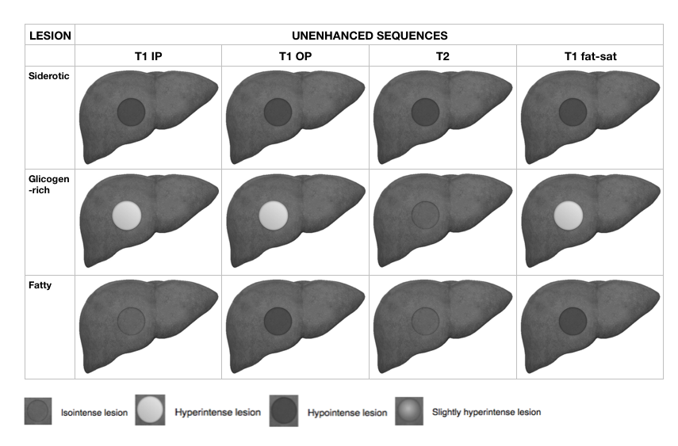
Figure 1 Schematic representation showing pre-contrast magnetic resonance imaging features of cirrhotic nodules such as siderotic (iron reach), glicogen rich and fatty nodule. T1 IP: T1-weighted in-phase image; T1 OP: T1-weighted out-of-phase image.

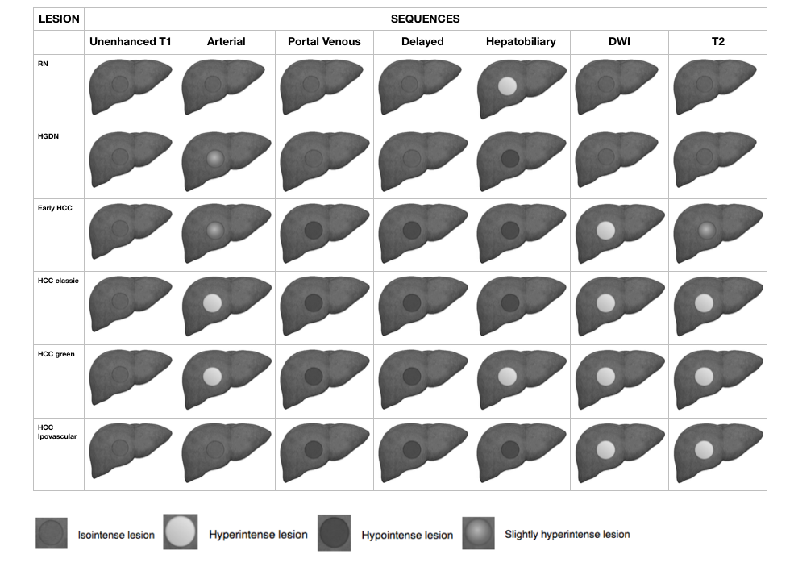
Figure 2 Schematic representation showing dynamic, diffusion weighted images and T2-weighted features, of regenerative nodules, high-grade dysplastic nodule, early hepatocellular carcinoma, classic hepatocellular carcinoma, green hepatocellular carcinoma and hypovascular hepatocellular carcinoma. DWI: Diffusion weighted images; HGDN: High-grade dysplastic nodule; RN: Regenerative nodule; HCC: Hepatocellular carcinoma.

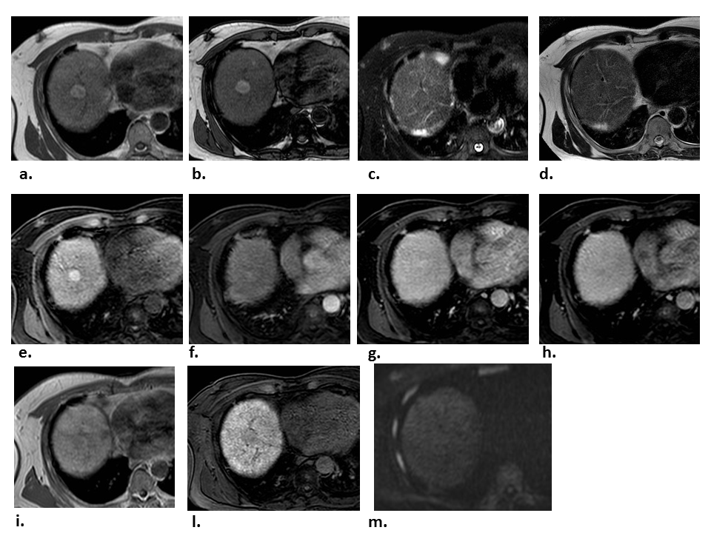
Figure 3 High-grade dysplastic nodule. Gd-EOB-DTPA enhanced MR images of a 57 years old cirrhotic patient with a liver nodule in the VIII segment. A and B: Axial T1-weighted sequences both ”in phase” and “out of phase” show a hyperintense nodule; C and D: On T2-weighted image with and without fat saturation the nodule appears as isointense; E-H: during the dynamic contrast-enhanced images the nodule shows a slight enhancement in the arterial phase, without wash-out in portal and delayed phases; I and L: Diffusion weighted image demonstrate no restriction to the diffusion; M: In hepatobiliary phase the nodule is hypointense in comparison to the surrounding liver parenchyma. The MRI features, suggestive of high grade dysplastic nodule, have been later confirmed by the histological examination. MRI: Magnetic resonance imaging.

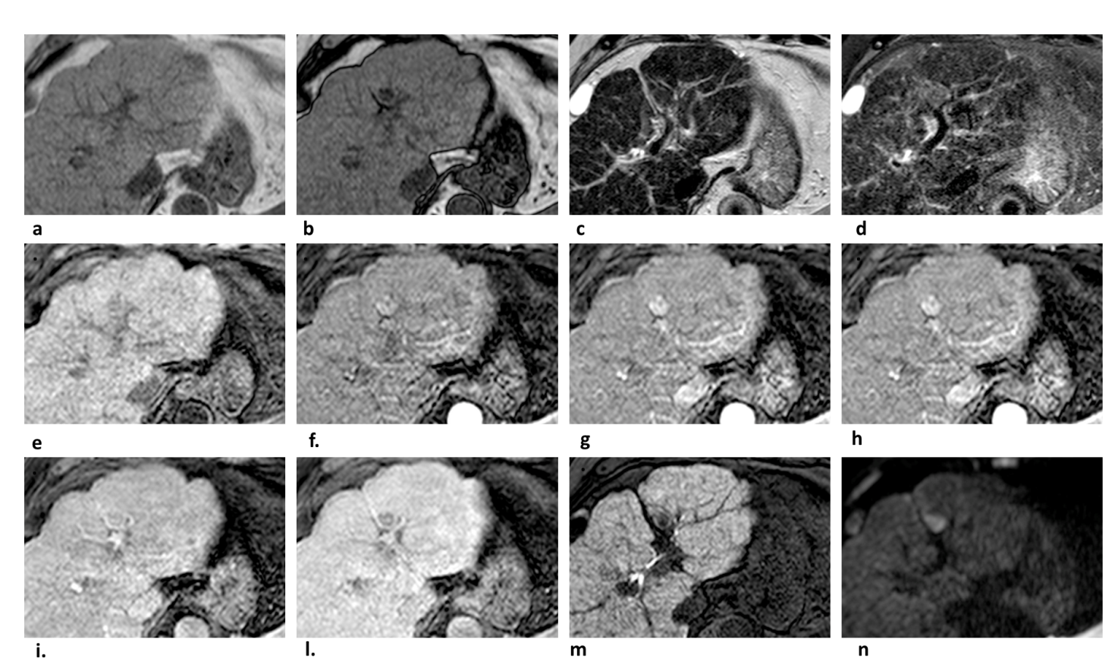
Figure 4 Typical case of lipid-rich hepatocellular carcinoma. A and B: The signal loss of nodule on opposed-phase compared to in-phase indicates intralesional fat; C and D: There is mild signal intensity on T2 and DWI restriction (N); E: The nodule appears hypointense in pre-contrast phase; G-L: Note the typical arterial phase hyperenhancement (G and H) followed by washout appearance in the portal venous (I) and/or delayed phase (L) that is the key diagnostic feature of HCC; M: The lesion also demonstrate hypointensity in the hepatobiliary phase; F-H: Note how the multi-arterial phase imaging (F and H) able improve the conspicuity of the HCC, especially in the late arterial phase (H). DWI: Diffusion weighted images; HCC: Hepatocellular carcinoma.

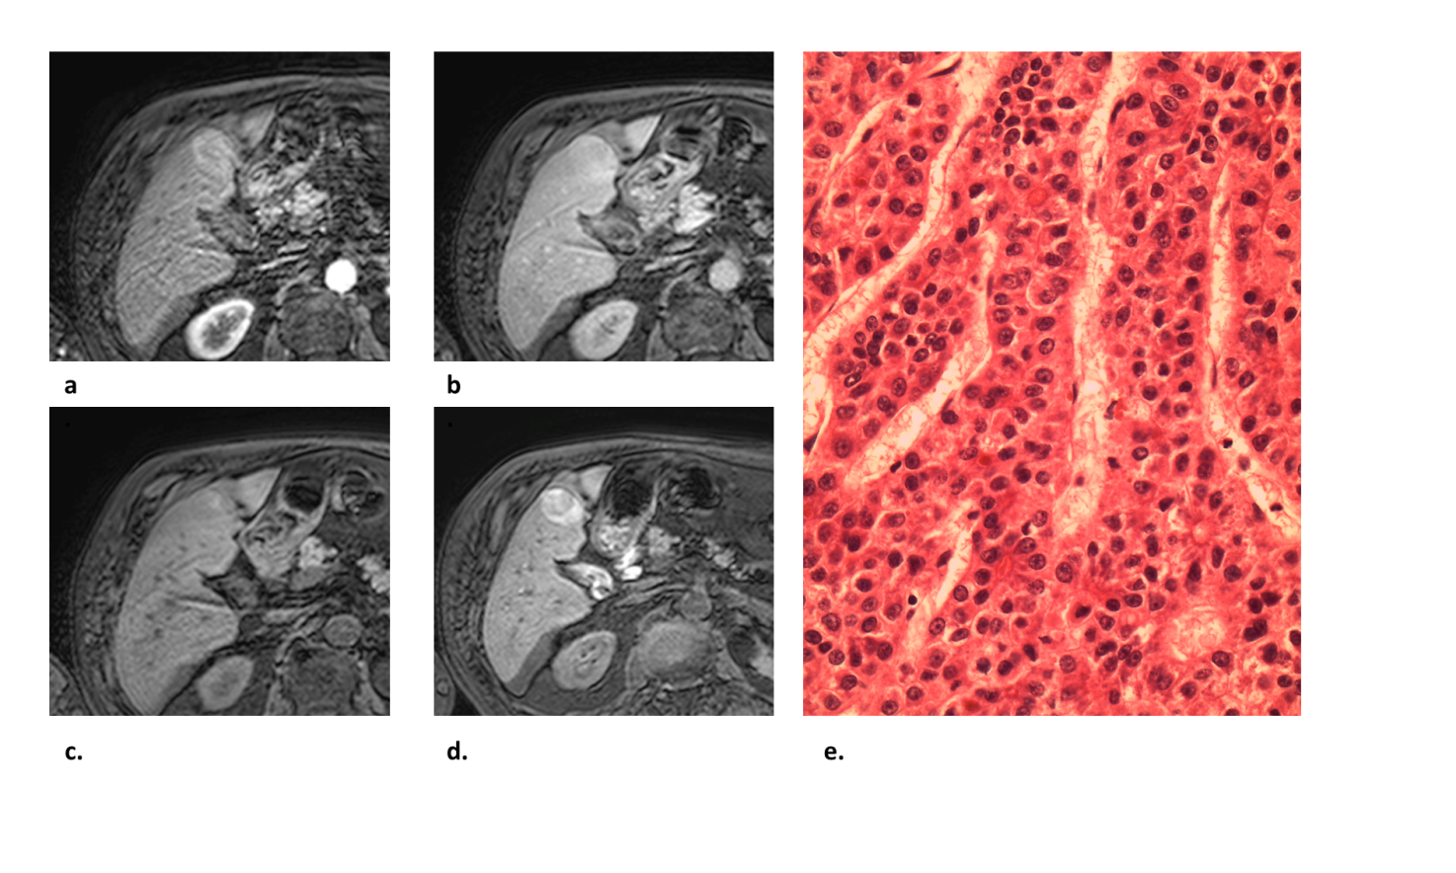
Figure 5 Atypical hepatocellular carcinoma. A and B: There is arterial phase (A) mild hyperenhancement and absence of washout appearance in the portal venous phase (B); C and D: In the delayed phase (C), there is a minimum hypointensity of the nodule, suspected for washout. The nodule resulted hyperintense in hepatobiliary phase (D); E: The lesion was biopsied and the specimen diagnosis was HCC solid-trabecular; G2, pT3a in non-cirrhotic liver with mild (< 5%) macrovescicular steatosis with portal fibrous enlargement and without septae formation.

