Name of Journal: World Journal of Experimental Medicine
Manuscript NO: 91271
Manuscript Type: ORIGINAL ARTICLE

Basic Study
Hepatic and renal effects of oral stingless bee honey in a streptozotocin-induced diabetic rat model

Nasir SM et al. Hepatic and renal effect of SBH

Suriati Mohd Nasir, Anis Farihan Ismail, Tuan Salwani Tuan Ismail, Wan Faiziah Wan Abdul Rahman, Wan Amir Nizam Wan Ahmad, Tengku Ahmad Damitri Al- Astani Tengku Din, Kuttulebbai Nainamohammed Salam Sirajudeen

Suriati Mohd Nasir, Anis Farihan Ismail, Tengku Ahmad Damitri Al- Astani Tengku Din, Department of Chemical Pathology, School of Medical Sciences, Universiti Sains Malaysia, Kota Bharu 16150, Kelantan, Malaysia

Tuan Salwani Tuan Ismail, Endocrinology Laboratory, Department of Chemical Pathology, School of Medical Sciences, Universiti Sains Malaysia, Kota Bharu 16150, Kelantan, Malaysia

Wan Faiziah Wan Abdul Rahman, Department of Pathology, School of Medical Sciences, Universiti Sains Malaysia, Kota Bharu 16150, Kelantan, Malaysia

Wan Amir Nizam Wan Ahmad, Biomedicine Program, School of Health Sciences, Health Campus, Universiti Sains Malaysia, Kota Bharu 16150, Kelantan, Malaysia

Kuttulebbai Nainamohammed Salam Sirajudeen, Department of Basic Medical Sciences, Kuliyyah of Medicine, International Islamic University Malaysia, Bandar Indera Mahkota, Kuantan 25200, Pahang, Malaysia

Author contributions: Mohd Nasir S and Ismail AF conducted animal study and laboratory analysis; Tuan Ismail TS and Sirajudeen KNS designed the study objective and methodology; Wan Ahmad WAN and Wan Abdul Rahman WF reviewed and validated the histological analysis; Tengku Din TADAA conducted statistical analysis and guided the animal and laboratory study; All the authors contributed to manuscript writing; Tuan Ismail TS edited and proofread the manuscripts.

Supported by Ministry of Higher Education, Malaysia for Fundamental Research Grant Scheme FRGS/1/2019/SKK06/USM/03/6, No. 291983-329281.

Corresponding author: Tuan Salwani Tuan Ismail, MBBS, Associate Professor, Doctor, Endocrinology Laboratory, Department of Chemical Pathology, School of Medical Sciences, Universiti Sains Malaysia, Kubang Kerian, Kota Bharu 16150, Kelantan, Malaysia. tusti@usm.my

Received: December 26, 2023
Revised: January 24, 2024
Accepted: March 1, 2024
Published online:

Abstract
BACKGROUND
Diabetes is known damage the liver and kidney, leading to hepatic dysfunction and kidney failure. Honey is believed to help in lowering the blood glucose levels of diabetic patients and reducing diabetic complications. However, the effect of stingless bee honey (SBH) administration in relieving liver and kidney damage in diabetes has not been well-studied.

AIM
To investigate the effect of SBH administration on the kidney and liver of streptozotocin-induced (STZ; 55 mg/kg) diabetic Sprague Dawley rats.

METHODS
The rats were grouped as follows (n = 6 per group): non-diabetic (ND), untreated diabetic (UNT), metformin-treated (MET), and SBH+metformin-treated (SBME) groups. After successful diabetic induction, ND and UNT rats were given normal saline, whereas the treatment groups received SBH (2.0 g/kg and/or metformin (250 mg/kg) for 12 d. Serum biochemical parameters and histological changes using hematoxylin and eosin (H&E) and periodic acid–Schiff (PAS) staining were evaluated.

RESULTS
On H&E and PAS staining, the ND group showed normal architecture and cellularity of Bowman’s capsule and tubules, whereas the UNT and MET groups had an increased glomerular cellularity and thickened basement membrane. The SBH-treated group showed a decrease in hydropic changes and mild cellularity of the glomerulus vs the ND group based on H&E staining, but the two were similar on PAS staining. Likewise, the SBME-treated group had an increase in cellularity of the glomerulus on H&E staining, but it was comparable to the SBH and ND groups on PAS staining. UNT diabetic rats had tubular hydropic tubules, which were smaller than other groups. Reduced fatty vacuole formation and dilated blood sinusoids in liver tissue were seen in the SBH group. Conversely, the UNT group had high glucose levels, which subsequently increased MDA levels, ultimately leading to liver damage. SBH treatment reduced this damage, as evidenced by having the lowest fasting glucose, serum alanine transaminase, aspartate transaminase, and alkaline phosphatase levels compared to other groups, although the levels of liver enzymes were not statistically significant.

CONCLUSION
The cellularity of the Bowman’s capsule, as well as histological alteration of kidney tubules, glomerular membranes, and liver tissues in diabetic rats after oral SBH resembled those of ND rats. Therefore, SBH exhibited a protective hepatorenal effect in a diabetic rat model.

Key Words: Diabetes; Streptozotocin; Stingless bee honey; Hematoxylin and eosin; Periodic acid–Schiff; Liver; Kidney

Mohd Nasir S, Ismail AF, Tuan Ismail TS, Wan Abdul Rahman WF, Wan Ahmad WAN, Tengku Din TADAA, Sirajudeen KNS. Hepatic and renal effects of oral stingless bee honey in a streptozotocin-induced diabetic rat model. World J Exp Med 2024; In press

Core Tip: Honey products are widely recognized for their abundant vitamin content and bioactive components, which enhance their potential therapeutic benefits in the management of diabetes. This study demonstrated the hepatic and renal protective properties of stingless bee honey, which improved the architecture of the kidney and liver in diabetic rats. Thus, stingless bee honey could be useful in the treatment or prevention of liver and kidney impairment in diabetes.

INTRODUCTION
Diabetes mellitus (DM) is becoming an increasingly prevalent major health concern, characterized by hyperglycemia secondary to insulin deficiency or resistance^{[1]}. In 2019, 9.3% (463 million) of individuals worldwide had diabetes, according to the International Diabetes Federation^{[2]}, and this is expected to increase to 10.2% (578 million) by 2030 and 10.9% (700 million) by 2045 if effective prevention strategies are not applied^{[3].} In particular, Malaysia has the highest rate of diabetes in the Western Pacific region and one of the highest in the world, costing around 600 million United States dollars per year^{[2]}. Diabetics are predisposed to macrovascular problems, such as cardiovascular, cerebrovascular, and peripheral vascular illnesses, as well as microvascular consequences, such as retinopathies, nephropathies, and neuropathies^{[4]}.
One complication of uncontrolled diabetes is diabetic nephropathy, characterized by pathological quantities of urine albumin excretion, diabetic glomerular lesions, and loss of glomerular filtration rate in diabetics^{[5]}. DM has also been associated with many liver abnormalities, such as abnormal glycogen deposition, nonalcoholic fatty liver disease, fibrosis, cirrhosis, hepatocellular carcinomas, abnormal elevated hepatic enzymes, acute liver disease, and viral hepatitis^{[6]}. This worsens insulin resistance and leads to severe metabolic dysfunction. Moreover, it can destroy hepatocytes and contribute to increased morbidity and mortality among diabetic patients.
Regulating blood glucose levels is essential for reducing the risk of diabetic complications and improving the health of diabetic patients^{[7]}. Until recently, conventional therapies have only attempted to manage blood glucose levels, but efforts to control diabetic complications have been unsuccessful^{[8]}. Honey is a natural substance that consists of carbohydrates, water, organic acids, amino acids, enzymes, pigment, and pollens with antibacterial and antiinflammatory features^{[9,10]}. Clinically speaking, honey is believed to help lower the blood glucose levels of diabetic patients and reduce diabetic complications^{[11]}. Despite many studies on the therapeutic properties of different types of honey, it is still not regularly applied in practice, since there is still controversy regarding glycemic control in individuals with oral honey supplementation and the role of honey in diabetic complications.
Oxidative stress plays a vital role in the development of diabetic complications^{[12]}. Honey has been studied in various ailments in animal and human models and has been discovered as a novel antioxidant agent^{[13]}. The composition of honey depends primarily on its floral source and seasonal and environmental factors^{[14-16]}, and thus its different varieties may exhibit various health-promoting properties. In particular, SBH includes various compounds (i.e., phenolic acids, flavonoid enzymes, organic acids, and other minor compounds) that act as antioxidants, which are believed to have a synergistic effect. The phenolic and anti-inflammatory properties of SBH are believed to have a hepatorenal protective effect against diabetes. This study aimed to evaluate the effects of oral SBH on serum biochemical parameters and histological changes in the liver and kidney in a streptozotocin (STZ)-induced diabetic Sprague Dawley (SD) rat model.

MATERIALS AND METHODS
Animal model
The experimental animals in this study were male SD rats (n = 30), 8–10 wk old, weighing 200–250 g, purchased from the Animal Research and Service Centre (ARASC), University Sains Malaysia, Health Campus, Kubang Kerian. All rats were housed in plastic cages and maintained under standard laboratory conditions (21°C ± 2°C) with a 12 h light/dark cycle. Rats were given free access to normal standard rat pellet diet (10%/kg) supplied by ARASC USM and water ad libitum. The rats were acclimatized for one week before the experiment to reduce stress and familiarize them with human contacts. This study was conducted in accordance with the Institutional Guidelines for the Care and Use of Animals for Scientific Purposes (IACUC @ USM V4.Apr18).

Induction of STZ in diabetic rat model
The rats were divided into five groups based on the treatment given: non-diabetic (ND) rats as the control group (given normal saline), untreated diabetic (UNT) rats (given normal saline), SBH-treated (2.0 g/kg) diabetic rats, metformin-treated (MET) (250 mg/kg) diabetic rats, and SBH+metformin-treated (SBME) diabetic rats. In all except the ND group, Diabetes was induced by a single intraperitoneal injection of a freshly prepared solution of STZ (Sigma Aldrich, United States) 50 mg/kg BW in 0.1 M cold sodium citrate buffer (pH 4.5) after overnight fasting^{[17]}. Diabetes was confirmed based on elevated fasting capillary plasma glucose (CPG) levels determined on days 3 and 7 after STZ injection; those persistently exhibiting CPG > 11.1 mmol/L were used for the experiment^{[18]}. In this study, the range of CPG before treatment was 15.02–19.95 mmol/L, which was not more than 21.0 mmol/L. No mortality was observed during DM induction. The treatment was given via oral gavage by means of a tube inserted into the stomach through the mouth.

Histological analysis
Rats were euthanized via cervical dislocation under anesthesia using ketamine plus xylazin. The kidneys and livers of all rats were harvested and preserved in 10% formalin. Samples then underwent a standard dehydration process in a series of increasing ethanol concentrations for 24 h using a processing machine. The tissue was then degreased with xylene, embedded in paraffin, and sectioned using a histological microtome. Afterward, 2.5-μm tissue sections were mounted on a glass slide, stained using hematoxylin and eosin (H&E) and periodic acid–Schiff (PAS) staining, then visualized under a light microscope at 40× magnification (Olympus BX41) and image analyzer.

Biochemical analysis
CPG was measured using a URight blood glucometer (Uright, TD 4279) using the tail-prick technique to obtain tail vein blood. To collect fresh small medium of blood, an appropriate restraint device was used, and the withdrawal site was cleaned with alcohol. A finger prick lancet was used on the tail vein, and then capillary blood glucose was measured using a glucometer. After 12 d of treatment, the rat was euthanized before blood collection using cardiac puncture. The blood samples were then centrifuged at 4500 rpm for 10 min, and the serum samples were stored at 80°C until further analysis. Serum urea, creatinine, sodium (Na⁺), potassium (K⁺), calcium (Ca), magnesium (Mg), albumin, total protein, alanine transaminase (ALT), aspartate transaminase (AST), and alkaline phosphatase (ALP) were analyzed using an auto analyzer (Abbott ARCHITECT analyzer). Serum MDA was analyzed using the MDA ELISA Kit from Elabscience, USA, which uses the Sandwich-ELISA principle. All procedures were performed according to the manufacturer’s instructions.

Statistical analysis
Experimental data are presented as the mean ± SE of the mean in this study. One-way and two-way repeated measures of analysis of variance (ANOVA) were used to analyze CPG. Biochemical results were compared between groups by one-way ANOVA. All the analyses conducted were followed by Tukey’s post-test and performed using GraphPad Prism, v9.0 software (GraphPad, San Diego, CA, United States; alkaline phosphatase), with P < 0.05 denoting statistical significance.

RESULTS
To evaluate the antihyperglycemic effects of SBH, changes in CPG levels were measured on days 0 and 13 of treatment. Table 1 shows the effect of SBH and SBME on fasting blood glucose (FBG) concentrations in the diabetic rat groups on days 0 and 13 of treatment. The SBH, MET, and SBME groups had consistently reduced FBG levels throughout the treatment period. On day 13, the SBH- and MET-treated groups showed lower FBG levels than the SBME group. Meanwhile, UNT diabetic rats had the highest FBG compared to the other groups at all time points.

Biochemical analysis
Serum urea and creatinine levels were measured to assess renal function and injury (Table 2). UNT diabetic rats showed the highest serum urea (14.28 + 4.92 mmol/L) and creatinine levels and (50.67 + 1.80 µmol/L) compared with ND rats. The SBH group had a lower serum urea compared with UNT diabetic rats. However, across the different treatment groups, SBME had the lowest serum urea level, followed by the SBH and MET groups. Meanwhile, for serum creatinine level, MET-treated diabetic rats had the lowest level of creatinine followed by SBME- and SBH-treated groups, but none of them were statistically significant.
Na⁺ levels in all diabetic rats were not significantly different compared to ND rats, but this was highest in UNT diabetic rats. The SBH group had a lower Na⁺ level compared to the UNT group. However, the MET groups had the lowest Na⁺ levels compared to all the treatment groups. The UNT group had a lower level of K⁺ (4.45 + 0.10 mmol/L) vs controls. Compared to the UNT group, the highest level of K⁺ was seen in the MET group (4.56 + 0.32 mmol/L), followed by the MET (4.52 + 0.17 mmol/L) and SBME (4.48 + 0.11 mmol/L) groups. The serum Ca²⁺ level of the UNT group was also lower than controls. The SBH, SBME, and MET groups had higher Ca²⁺ levels than that the UNT group, but this was not statistically significant. Meanwhile, serum Mg²⁺ levels were reduced in UNT rats vs ND rats. Serum Mg²⁺ was highest in the SBG group, followed by the SBME and MET groups.
Serum albumin in the SBH and SBME groups was higher than that of the UNT group, but lower than that of the ND group. The MET group had the lowest albumin level (28.40 + 0.51 g/L) out of all the groups of rats, but this was not significantly different. UNT rats had lower serum total protein than the ND rats. The SBME group, as well as the SBH and MET groups, had a higher total protein level than UNT diabetic rats, but this was not statistically significant.
Serum ALT was higher in the UNT group (75.50 + 33.18 U/L) vs ND rats. The SBH group had a lower serum ALT vs the UNT group. Conversely, serum AST (121.00 + 7.44 U/L) and ALP (162.00 + 25.65 U/L) were highest in the UNT group, compared to the ND and treatment groups. Meanwhile, the lowest serum ALP was seen in the MET group (126.70 + 14.84 U/L), followed by the SBH (131.70 + 23.92 U/L) and SBME (149.30 + 7.75 U/L) groups. The biochemical evaluation of liver function tests in rats treated with different treatments for 12 d are shown in Table 3.
An MDA assay was performed to determine the role of SBH supplementation in the lipid peroxidation process. Figure 1 shows the MDA levels after 12 d of treatment. The MDA level was significantly higher in the UNT group vs ND rats (P < 0.05), whereas it was significantly lower in the treatment groups than in the UNT group (P < 0.01). The SBME group had significantly lower MDA levels compared to the SBH group (P < 0.05).

Hematoxylin and eosin staining of the kidneys
ND rats showed a normal architecture of Bowman’s capsule and tubules; the glomeruli had normal cellularity and no hydropic changes of the tubules (Figure 2A). Contrarily, the UNT group had increased glomerular cellularity and tubular hydropic changes was also observed (Figure 2B). In the SBH-treated groups, the kidney architecture showed a decrease in hydropic changes and mild cellularity of the glomerulus compared with the ND group (Figure 2C). The MET and SBME groups had higher cellularity than the SBH group as well as tubular hydropic changes were seen (figure 2D and 2E). Mesangial matrix expansion was observed in the kidneys of both MET and SBME rats.

PAS
The ND rats showed a thin layer of glomeruli basement membrane when stained with PAS (Figure 3A). UNT diabetic rats showed tubular hydropic tubules, which appeared to be smaller than that of other groups. Figure 3B also indicates thickening of the basement membrane of glomeruli, tubules, and blood capillaries as the intensity of PAS stain increased. The basement membrane of the SBH-treated rat kidney (Figure 3C) appears to resemble the ND rat kidney. The MET-treated rat kidney (Figure 3D) showed mild thickening of the glomeruli basement membrane. The basement membrane of the rat kidney in the SBME-treated group (Figure 3E) was also comparable to that of the SBH and ND groups.

Effect of SBH on rat liver after treatment
Hematoxylin and eosin staining: Compared to controls (Figure 4A), histological alterations were detected in the liver tissue of UNT diabetic rats, which revealed significant steatosis harboring lipid droplet formation in hepatocytes with dilated blood sinusoids and congestion surrounding the central veins (Figure 4B). This was in accordance with an increase in the serum ALT and AST, which are indicators of hepatocyte damage. However, these pathological alterations were reduced after treatment with SBH (Figure 4C), which showed a normal structure of the hepatic cells, specifically, reduced steatosis and congestion of sinusoids. MET-treated rats still showed dilation of sinusoids but had reduced formation of lipid droplets compared to the UNT group (Figure 4D). The SBME group had similar liver structure to the SBH group, wherein the fatty vacuoles and dilation of sinusoids were decreased vs UNT diabetic rats (Figure 4E). Thus, SBH administration ameliorated STZ-induced diabetic hepatic toxicity and hyperlipidemia.

Periodic acid–Schiff staining: The ND rat liver showed normal staining of glycogen content on PAS (Figure 5A). In the UNT group, the glycogen content in the liver structure of rats can be observed clearly (Figure 5B). Interestingly, after treatment with SBH for 12 consecutive days, the glycogen content was decreased, as only some cells were maintained (Figure 5C). Similarly, in the SBME group, only some cells had a positive PAS stain effect (Figure 5D). Treatment with MET (Figure 5E) did not change the rat liver structure, since it was still similar to that of the UNT group, wherein the intensity of glycogen stain increases in almost all hepatocytes.

DISCUSSION
The International Diabetes Federation estimates that 537 million people were living with diabetes in 2021, with an expected increase to 784 million by the year 2045^{[19]}. The association between liver illness and diabetes mellitus (DM) is well established^{[20]}. Diabetes is the most common cause of kidney failure requiring kidney transplantation or dialysis worldwide^{[21]}.
In this study, after 12 d of treatment, the concentrations of serum urea and creatinine for all groups of rats were within a normal reported range. UNT rats had the highest level of serum urea and creatinine compared with ND rats, suggesting that STZ-induced toxic effects on the kidneys^{[22]}. Tavafi^{[23]} reported significantly high levels of serum urea and creatinine in diabetic rats (induced by alloxan) compared with normal control rats after 8 wk, which might be due to a longer period of treatment taken for treating DM rats than in our current study of only 12 d.
Histological findings revealed tubular hydropic alterations and an increase in glomerular cellularity of kidney sections in UNT diabetic rats vs ND rats. Structural changes in the kidney could be related to diabetic metabolic changes. After staining with H&E and PAS, kidney sections from STZ-induced diabetic rats showed significant vacuolar degeneration of tubules, increased glomerular cellularity, mesangial matrix enlargement, and basement membrane thickening, likely caused by the extreme hyperglycemia from STZ induction. In line with this, Obi-Ezeani et al^{[24]} described tubular epithelial alterations, increased capsular space, and glomerular degeneration in diabetic rats. Treatment with SBH had a favorable effect in mitigating renal injury by reducing hydropic alterations and improving basement membrane integrity. Compared to SBH-treated diabetic rats, high glomerular cellularity and mesangial matrix growth can still be detected with MET and SBME treatment. Furthermore, after staining with PAS, MET-treated rat kidneys had a slightly thickened glomeruli basement membrane. SBME-treated animals had similar basement membranes to those of the SBH and ND groups. Thus, therapy with SBH alone considerably reduced the changes identified on H&E and PAS staining, indicating its preventive role in renal injury.
MDA is a highly toxic aldehyde produced as a result of polyunsaturated fatty acid peroxidation, and it is a common indicator of lipid peroxidation^{[24]}. DM can cause tissue damage through lipid peroxidation. Our findings revealed that the UNT group had the highest serum MDA level, likely from an increase in reactive oxygen species production caused by persistent hyperglycemia in UNT diabetic rats. Hyperglycemia reduces antioxidant levels in rats while increasing free radicals. However, treatment with SBME in our study significantly suppressed MDA levels in STZ-induced diabetic rats; this could help reduce oxidative stress. Our findings were consistent with those of other studies that indicated that SBH improved the MDA level in diabetic rats^{[25]}.
Elevated serum aminotransferase activity is a common indicator of liver illness. ALT and AST are common serum biochemical indicators that are regularly examined to diagnose liver injury and abnormalities^{[24,26]}. The biochemical data in our study agreed with our histological observations using H&E and PAS staining. In UNT diabetic rats, lipid droplets accumulated in the cytoplasm of hepatocytes (Figure 4B and D). STZ caused acute liver injury in the current investigation, as evidenced by an increase in liver enzymes and histological abnormalities in the liver tissue of UNT diabetic rats (Figure 5B) after 12 d compared with ND rats, but these differences were not statistically significant. Nevertheless, after 12 d of SBH and MET treatment, ALT, AST, and ALP activity were all reduced, possibly because of the hepatoprotective effects of SBH and MET. Thus, even if hyperglycemia increased the MDA levels, causing oxidative liver damage, treatment with SBH was able to protect the liver by lowering blood ALT, AST, and ALP levels, possibly due to its hypoglycemic and antioxidant properties. Therefore, SBH can help improve impaired liver function in STZ-induced diabetic rats.
The current study has some limitations. The short treatment period may have contributed to the non-significant changes in biochemical results, despite clear histological changes seen in the liver and kidneys of diabetic rats. Moreover, during the 12-d treatment period, the ND rats did not receive SBH treatment. Future studies should explore the potential benefits and effects of oral SBH delivery in ND rats.

CONCLUSION
Although there were no significant variations in serum creatinine and urea levels between the groups, kidneys from the SBH group showed a normal thin layer of glomeruli basement membrane, equivalent to that of ND rats, and less hydropic alteration than the other groups. Although the decrease serum ALT, AST, and ALP levels were not significant, SBH treatment caused a histologically evident improvement in hepatocytes and reduced the formation of fatty vacuoles and dilatations of blood sinusoids in diabetic rat livers.

ARTICLE HIGHLIGHTS
Research background
Studies have demonstrated an inverse relationship between honey consumption and the risk of diabetes and its complications. The argument about using honey to lower blood glucose and prevent hepatorenal diabetic complications however, continued.

Research motivation
Recent research has focused on exploring the biochemical and histological effects on kidney and liver of diabetic rats given oral stingless bee honey (SBH) and compared with rats given metformin (MET), combination SBH+MET, untreated and non-diabetic rats.

Research objectives
We investigated the effect of SBH administration on the serum biochemical parameters and the histological changes in streptozotocin induced diabetic rats’ kidney and liver using hematoxylin and eosin (H&E), Periodic Acid Schiff (PAS) staining.

Research methods
Sprague Dawley rats (n = 30) grouped into 5, i.e. SBH-treated, metformin-treated (MET) and SBH+metformin-treated (SBME) non-diabetic (ND) and untreated diabetic (UNT) groups. The rats were sacrificed after 12 d of treatment, and serum, kidney and liver collected from the rats were used for biochemical parameters assessment.

Research results
SBH-treated group showed reduce in hydropic changes and mild cellularity of glomerulus as compared to ND group on H&E staining, but resembled ND group on PAS staining. Liver tissues of SBH-treated groups revealed lower fatty vacuoles formation and dilatation of blood sinusoids as compared to other groups. Biochemically, glucose reduction and lowest serum MDA, AST, ALT and ALP observed in SBH-treated compared to MET, SBME and UNT groups.

Research conclusions
The oral SBH prevent diabetic complications development indicated by liver and kidney histology of SBH-treated diabetic rats. This finding offers a good perspective of honey role in managing diabetes.

Research perspectives
Longer duration of treatment might improve the biochemical parameters. Future study on honey role in diabetic patients and metabolomic analysis to profile the serum of human treated with SBH and MET is necessary to uncover the underlying mechanisms.

ACKNOWLEDGEMENTS
We extend our heartfelt gratitude and appreciation to the personnel and staff of ARASC and Endocrine laboratory and Chemical Pathology laboratory staff, Universiti Sains Malaysia for their invaluable support throughout this research endeavor.

REFERENCES
1 Thangavel P, Ramachandran B, Chakraborty S, Kannan R, Lonchin S, Muthuvijayan V. Accelerated Healing of Diabetic Wounds Treated with L-Glutamic acid Loaded Hydrogels Through Enhanced Collagen Deposition and Angiogenesis: An In Vivo Study. Sci Rep 2017; 7: 10701 [PMID: 28878327 DOI: 10.1038/s41598-017-10882-1]
2 Akhtar S, Nasir JA, Ali A, Asghar M, Majeed R, Sarwar A. Prevalence of type-2 diabetes and prediabetes in Malaysia: A systematic review and meta-analysis. PLoS One 2022; 17: e0263139 [PMID: 35085366 DOI: 10.1371/journal.pone.0263139]
3 Wang H, Li N, Chivese T, Werfalli M, Sun H, Yuen L, Hoegfeldt CA, Elise Powe C, Immanuel J, Karuranga S, Divakar H, Levitt N, Li C, Simmons D, Yang X; IDF Diabetes Atlas Committee Hyperglycaemia in Pregnancy Special Interest Group. IDF Diabetes Atlas: Estimation of Global and Regional Gestational Diabetes Mellitus Prevalence for 2021 by International Association of Diabetes in Pregnancy Study Group's Criteria. Diabetes Res Clin Pract 2022; 183: 109050 [PMID: 34883186 DOI: 10.1016/j.diabres.2021.109050]
4 Ganasegeran K, Hor CP, Jamil MFA, Loh HC, Noor JM, Hamid NA, Suppiah PD, Abdul Manaf MR, Ch'ng ASH, Looi I. A Systematic Review of the Economic Burden of Type 2 Diabetes in Malaysia. Int J Environ Res Public Health 2020; 17 [PMID: 32784771 DOI: 10.3390/ijerph17165723]
5 Lim AKh. Diabetic nephropathy - complications and treatment. Int J Nephrol Renovasc Dis 2014; 7: 361-381 [PMID: 25342915 DOI: 10.2147/IJNRD.S40172]
6 Mohamed, J., Nazratun Nafizah, A. H., Zariyantey, A. H. & Budin, S. B. Mechanisms of diabetes-induced liver damage: The role of oxidative stress and inflammation. Sultan Qaboos Univ. Med. J. 16, e132–e141 (2016)
7 Yang DK, Kang HS. Anti-Diabetic Effect of Cotreatment with Quercetin and Resveratrol in Streptozotocin-Induced Diabetic Rats. Biomol Ther (Seoul) 2018; 26: 130-138 [PMID: 29462848 DOI: 10.4062/biomolther.2017.254]
8 Du M, Hu X, Kou L, Zhang B, Zhang C. Lycium barbarum Polysaccharide Mediated the Antidiabetic and Antinephritic Effects in Diet-Streptozotocin-Induced Diabetic Sprague Dawley Rats via Regulation of NF-κB. Biomed Res Int 2016; 2016: 3140290 [PMID: 27200371 DOI: 10.1155/2016/3140290]
9 Nikpour M, Shirvani MA, Azadbakht M, Zanjani R, Mousavi E. The effect of honey gel on abdominal wound healing in cesarean section: a triple blind randomized clinical trial. Oman Med J 2014; 29: 255-259 [PMID: 25170405 DOI: 10.5001/omj.2014.68]
10 Mohd Rafie AZ, Syahir A, Wan Ahmad WAN, Mustafa MZ, Mariatulqabtiah AR. Supplementation of Stingless Bee Honey from Heterotrigona itama Improves Antiobesity Parameters in High-Fat Diet Induced Obese Rat Model. Evid Based Complement Alternat Med 2018; 2018: 6371582 [PMID: 30643535 DOI: 10.1155/2018/6371582]
11 Biluca FC, Braghini F, Gonzaga LV, Costa ACO, Fett R. Physicochemical profiles, minerals and bioactive compounds of stingless bee honey (Meliponinae). J Food Compos Anal 2016; 50: 61-69 [DOI: 10.1016/j.jfca.2016.05.007]
12 Ali H, Abu Bakar MF, Majid M, Muhammad N, Lim SY. In vitro anti-diabetic activity of stingless bee honey from different botanical origins. Food Res 2020; 4: 1421-1426 [DOI: 10.26656/fr.2017.4(5).411]
13 Ahmed S, Sulaiman SA, Baig AA, Ibrahim M, Liaqat S, Fatima S, Jabeen S, Shamim N, Othman NH. Honey as a Potential Natural Antioxidant Medicine: An Insight into Its Molecular Mechanisms of Action. Oxid Med Cell Longev 2018; 2018: 8367846 [PMID: 29492183 DOI: 10.1155/2018/8367846]
14 Erejuwa OO, Nwobodo NN, Akpan JL, Okorie UA, Ezeonu CT, Ezeokpo BC, Nwadike KI, Erhiano E, Abdul Wahab MS, Sulaiman SA. Nigerian Honey Ameliorates Hyperglycemia and Dyslipidemia in Alloxan-Induced Diabetic Rats. Nutrients 2016; 8: 95 [PMID: 26927161 DOI: 10.3390/nu8030095]
15 Alvarez-Suarez JM, Gasparrini M, Forbes-Hernández TY, Mazzoni L, Giampieri F. The Composition and Biological Activity of Honey: A Focus on Manuka Honey. Foods 2014; 3: 420-432 [PMID: 28234328 DOI: 10.3390/foods3030420]
16 Zakaria F, Rosli W, Ishak W, Sze N, Shazwan M. Assessment of Glycaemic Effect of Benincasa hispida Aqueous Extract in Streptozotocin Diabetic Rats 2016; 1-12. Available from:https://www.researchgate.net/publication/307974568_Assessment_of_Glycaemic_Effect_of_Benincasa_hispida_Aqueous_Extract_in_Streptozotocin_Diabetic_Rats
17 Nain P, Saini V, Sharma S, Nain J. Antidiabetic and antioxidant potential of Emblica officinalis Gaertn. leaves extract in streptozotocin-induced type-2 diabetes mellitus (T2DM) rats. J Ethnopharmacol 2012; 142: 65-71 [PMID: 22855943 DOI: 10.1016/j.jep.2012.04.014]
18 Shamsudin S, Selamat J, Sanny M, A R SB, Jambari NN, Khatib A. A Comparative Characterization of Physicochemical and Antioxidants Properties of Processed Heterotrigona itama Honey from Different Origins and Classification by Chemometrics Analysis. Molecules 2019; 24 [PMID: 31671885 DOI: 10.3390/molecules24213898]
19 Weng J, Zhou J, Liang L, Li L. UHPLC/QTOF-MS-based metabolomics reveal the effect of Melastoma dodecandrum extract in type 2 diabetic rats. Pharm Biol 2019; 57: 807-815 [PMID: 31794270 DOI: 10.1080/13880209.2019.1693605]
20 de Boer IH, Khunti K, Sadusky T, Tuttle KR, Neumiller JJ, Rhee CM, Rosas SE, Rossing P, Bakris G. Diabetes Management in Chronic Kidney Disease: A Consensus Report by the American Diabetes Association (ADA) and Kidney Disease: Improving Global Outcomes (KDIGO). Diabetes Care 2022; 45: 3075-3090 [PMID: 36189689 DOI: 10.2337/dci22-0027]
21 Hamed AE, Elsahar M, Elwan NM, El-Nakeep S, Naguib M, Soliman HH, Ahmed Aboubakr A, AbdelMaqsod A, Sedrak H, Assaad SN, Elwakil R, Esmat G, Salh S, Mostafa T, Mogawer S, Sadek SE, Saber MM, Ezelarab H, Mahmoud AA, Sultan S, El Kassas M, Kamal E, ElSayed NM, Moussa S. Managing diabetes and liver disease association. Arab J Gastroenterol 2018; 19: 166-179 [PMID: 30420265 DOI: 10.1016/j.ajg.2018.08.003]
22 Nørgaard SA, Søndergaard H, Sørensen DB, Galsgaard ED, Hess C, Sand FW. Optimising streptozotocin dosing to minimise renal toxicity and impairment of stomach emptying in male 129/Sv mice. Lab Anim 2020; 54: 341-352 [PMID: 31510860 DOI: 10.1177/0023677219872224]
23 Tavafi M. Diabetic nephropathy and antioxidants. J Nephropathol 2013; 2: 20-27 [PMID: 24475422 DOI: 10.5812/nephropathol.9093]
24 Obi-Ezeani NC. Evaluation of oxidative stress-induced diabetic complications on alloxan-treated hyperglycaemic rats, using some biochemical parameters and histological profiles of three major organs. MOJ Toxicol 2018; 4: 59-67 [DOI: 10.15406/mojt.2018.04.00091]
25 Touzani S, Al-Waili N, Imtara H, Aboulghazi A, Hammas N, Falcão S, Vilas-Boas M, Arabi IE, Al-Waili W, Lyoussi B. Arbutus Unedo Honey and Propolis Ameliorate Acute Kidney Injury, Acute Liver Injury, and Proteinuria via Hypoglycemic and Antioxidant Activity in Streptozotocin-Treated Rats. Cell Physiol Biochem 2022; 56: 66-81 [PMID: 35218633 DOI: 10.33594/000000496]
26 Ahmed Z, Ahmed U, Walayat S, Ren J, Martin DK, Moole H, Koppe S, Yong S, Dhillon S. Liver function tests in identifying patients with liver disease. Clin Exp Gastroenterol 2018; 11: 301-307 [PMID: 30197529 DOI: 10.2147/CEG.S160537]

Footnotes
Institutional animal care and use committee statement: This study was approved by the Institutional Animal Care and Use Committee USM, Kubang Kerian [USM/IACUC/2019/(120) (1020)].

Conflict-of-interest statement: All the authors declare no conflict of interest in conducting this research.

Data sharing statement: No additional data is available.

ARRIVE guidelines statement: The authors have read the ARRIVE guidelines, and the manuscript was prepared and revised according to the ARRIVE guidelines.

Open-Access: This article is an open-access article that was selected by an in-house editor and fully peer-reviewed by external reviewers. It is distributed in accordance with the Creative Commons Attribution Non Commercial (CC BY-NC 4.0) license, which permits others to distribute, remix, adapt, build upon this work non-commercially, and license their derivative works on different terms, provided the original work is properly cited and the use is non-commercial. See: https://creativecommons.org/Licenses/by-nc/4.0/

Provenance and peer review: Invited article; Externally peer reviewed.
Peer-review model: Single blind

Peer-review started: December 26, 2023
First decision: January 11, 2024
Article in press:

Specialty type: Health care sciences & services
Country/Territory of origin: Malaysia
Peer-review report’s scientific quality classification
Grade A (Excellent): 0
Grade B (Very good): B
Grade C (Good): 0
Grade D (Fair): 0
Grade E (Poor): 0

P-Reviewer: Roomi AB, Iraq S-Editor: Liu JH L-Editor: A P-Editor:
Figure Legends
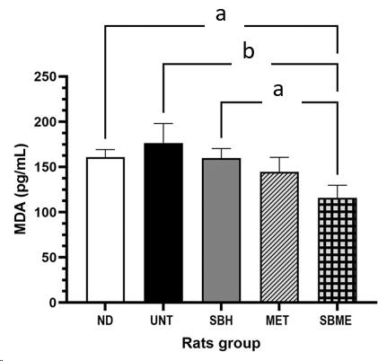
Figure 1 MDA level in diabetic rats in response to different treatments over 12 d. Data were analyzed using one-way analysis of variance, followed by Tukey ’spost test. Data showed in mean ± SEM; ^{a,b}P < 0.05. ND: Non-diabetic group; UNT: Untreated diabetic group; SBH: Stingless bee honey group; MET: Metformin group; SBME: Stingless bee honey plus metformin group.

C
B
A

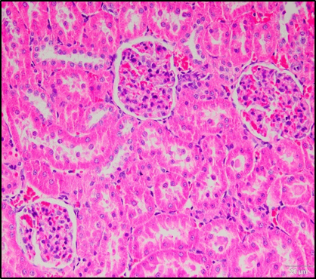
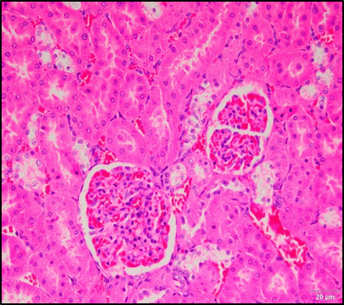
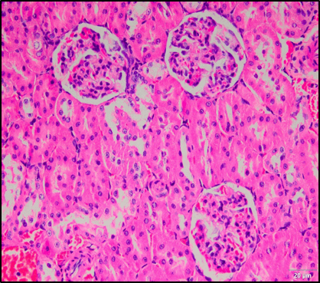
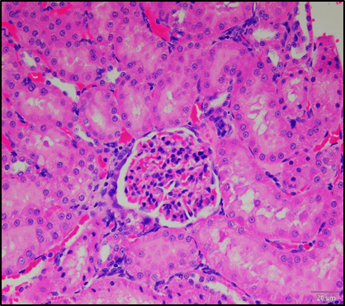
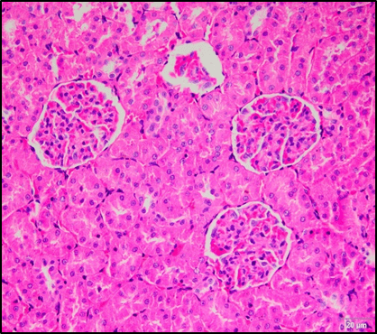
G
HC
HC
MC
HC
G
HC
G
CB
T
G
G
CB
C
B
A
E
D
IC
IC
G
HC

Figure 2 H&E staining of kidney tissue samples on day 13. A: Tissue sample for the non-diabetic control group; B: Untreated (UNT) diabetic group; C: Stingless bee honey (SBH) treatment group; D: Metformin (MET) treatment group; E: Stingless bee honey plus metformin (SBME) treatment group. The UNT group showed an increase in glomerular cellularity and tubular hydropic changes. The MET and SBME groups showed high cellularity and mesangial matrix expansion. The SBH group showed a decrease in hydropic changes and mild cellularity of the glomerulus (H&E staining, 40 ×). G: Glomerulus; CB: Capsule Bowman; T: Tubules; HC: Hydropic changes; IC: Increased cellularity; C: Capillary; M: Mesangial cell; MC: Mild cellularity.

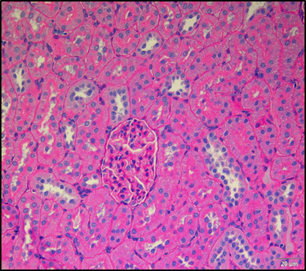
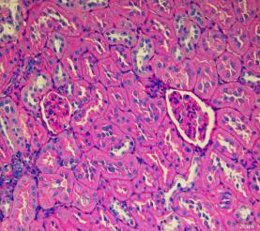
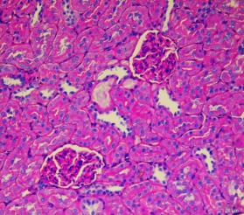
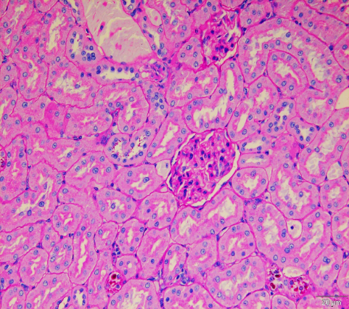
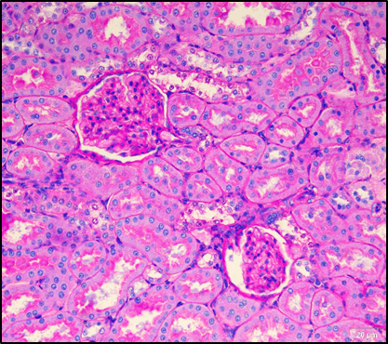
A
D
G
THBM
G
TBM
G
MTBM
E
G
THBM
AT
TT
C
B
G
T
TBM

Figure 3 Periodic acid–Schiff staining of kidney tissue sample on day 13. A: Tissue sample for the non-diabetic (ND) control group; B: Untreated (UNT) diabetic group; C: Stingless bee honey plus metformin (SBME) treatment group; D: Stingless bee honey (SBH) treatment group; E: Metformin (MET) treatment group. The ND control group showed normal kidney tissue architecture. The UNT group had hydropic tubules and thickened basement membrane of the glomeruli, tubules, and blood capillaries. The SBH group showed improvement in these basement membrane changes. The MET group showed mild thickening of the glomerular basement membrane. The SBME group showed improvement of the basement membrane (PAS staining, 40 ×). G: Glomerulus; TBM: Thin layer basement membrane of glomeruli; T: Tubules; THBM: Thickening basement membrane of glomeruli; TT: Thickening basement membrane of tubules; AT: Atrophic tubules; MTBM: Mild thickening basement membrane of glomeruli.

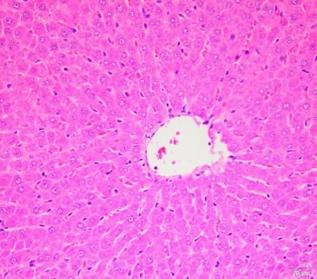
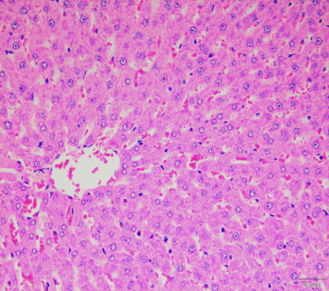
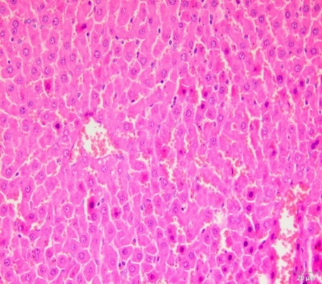
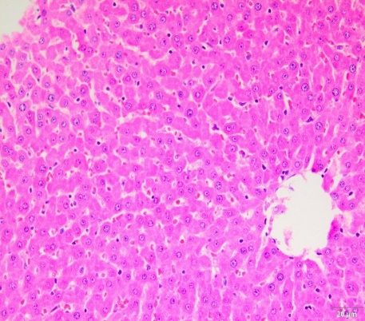
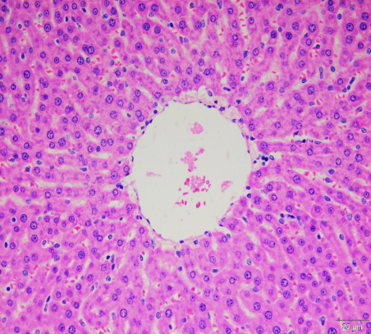
CV
CV
CV
LD
LD
CV
DBS
CV
LD
DBS
E
D
C
B
A
CV

Figure 4 H&E staining of liver tissue sample on day 13. A: Tissue sample for the non-diabetic (ND) control group; B: Untreated (UNT) diabetic group; C: Stingless bee honey (SBH) treatment group; D: Metformin (MET) treatment group; E: Stingless bee honey plus metformin (SBME) treatment group. The ND control group showed normal liver architecture. The UNT group had lipid droplet formation in hepatocytes with dilated blood sinusoids and congestion surrounding central veins. The SBH group showed significant reduction in steatosis and sinusoid congestion. The MET group showed a reduction in steatosis, but sinusoids congestion was still present. The SBME group had decreased lipid droplet formation and dilated blood sinusoids (H&E staining, 40 ×). CV: Central vein; BS: Blood sinusoids; H: Hepatocytes; LD: Lipid droplet; DBS: Dilated blood sinusoids.

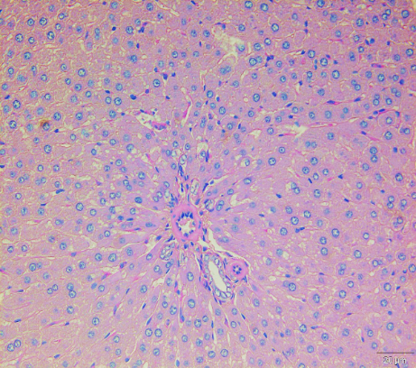
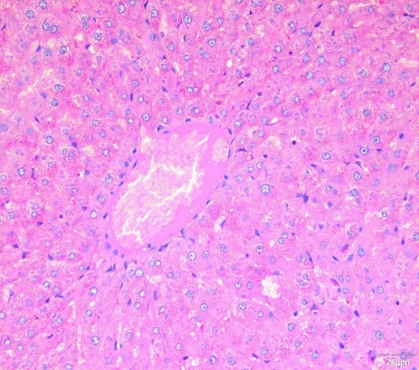
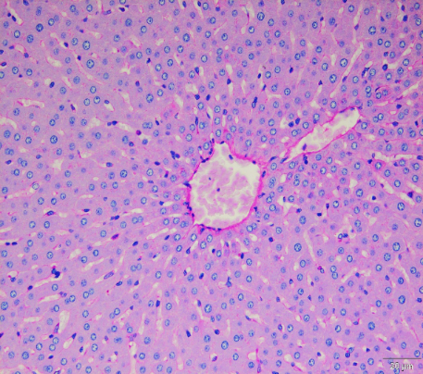
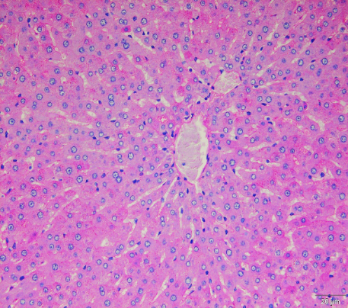
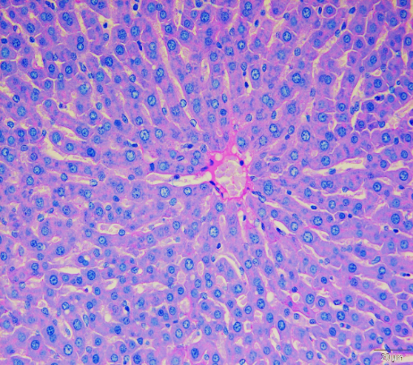
CV
CV
GC
D
E
C
CV
B
A
CV
GC
CV

Figure 5 Periodic acid–Schiff staining of liver tissue sample on the 13th day of study. A: Tissue sample for the non-diabetic (ND) control group; B: Untreated diabetic (UNT) group; C: Stingless bee honey (SBH) treatment group; D: Stingless bee honey plus metformin (SBME) treatment group; E: Metformin treatment (MET) group. The ND control group showed normal architecture. The UNT group showed an increase in glycogen content. The SBH diabetic group showed a reduction in glycogen content. The MET group showed an increase in glycogen content. The SBME group showed a reduction in glycogen content (PAS staining, 40 ×). CV: Central vein; GC: Glycogen content showed an increase in glycogen content.

Table 1 Mean fasting capillary blood glucose (day 0 and day 13) in response to different treatments over 12 d
Group | Fasting capillary plasma glucose (mmol/L)
 | Day 0 | Day 13
Non-diabetic | 4.85 ± 0.26 | 4.48 ± 0.38
Untreated diabetic | 20.00 ± 1.69 | 21.38 ± 2.94
Stingless bee honey | 14.74 ± 2.25 | 7.66 ± 1.60
Metformin-treated | 13.78 ± 1.18 | 7.00 ± 2.44
Stingless bee honey plus metformin | 12.25 ± 2.43 | 9.73 ± 3.72
Data was analyzed using one-way and two-way repeated measures ANOVA, followed by Tukey’s post-test. Data are expressed as mean + SEM.

Table 2 Biochemical evaluation of renal function in response to different treatments over 12 d
Analytes | ND | UNT | SBH | MET | SBME
Urea (mmol/L) | 8.28 ± 0.59 | 14.28 ± 4.92 | 7.95 ± 1.85 | 9.70 ± 0.30 | 7.30 ± 3.20
Creatinine (µmol/L) | 46.00 ± 1.73 | 50.67 ± 1.80 | 46.17 ± 2.48 | 37.82 ± 8.62 | 40.80 ± 11.91
Na⁺ (mmol/L) | 135.30 ± 1.93 | 138.40 ± 0.68 | 136.30 ± 0.88 | 134.40 ± 1.12 | 135.00 ± 1.23
K⁺ (mmol/L) | 4.68 ± 0.12 | 4.45 ± 0.10 | 4.56 ± 0.32 | 4.52 ± 0.17 | 4.48 ± 0.11
Ca²⁺ (mmol/L) | 2.36 ± 0.06 | 2.28 ± 0.04 | 2.35 ± 0.05 | 2.32 ± 0.04 | 2.36 ± 0.03
Mg²⁺ (mmol/L) | 0.95 ± 0.03 | 0.88 ± 0.03 | 1.07 ± 0.05 | 0.93 ± 0.05 | 1.01 ± 0.14
Data were analyzed using one-way ANOVA, followed by Tukey ’spost test. Data were expressed as mean + SEM. Among these five groups, there were no statistically significant differences in all parameters.

Table 3 Biochemical evaluation of liver function in response to different treatments over 12 d
Group | Analytes
 | Albumin (g/L) | Total | ALT (U/L) | AST (U/L) | ALP (U/L)
 |  | Protein (g/L)
Non-diabetic | 32.00 ± 1.10 | 54.25 ± 0.75 | 58.00 ± 5.40 | 110.40 ± 12.14 | 134.60 ± 5.59
Untreated diabetic | 28.50 ± 0.65 | 49.67 ± 2.19 | 75.50 ± 33.18 | 121.00 ± 7.44 | 162.00 ± 25.65
Stingless bee honey | 29.33 ± 0.71 | 52.67 ± 2.32 | 64.20 ± 0.80 | 108.30 ± 11.46 | 131.70 ± 23.92
Metformin | 28.40 ± 0.51ª | 50.33 ± 0.33 | 69.00 ± 7.41 | 110.30 ± 6.921 | 126.70 ± 14.84
Stingless bee honey plus metformin | 29.50 ± 0.87 | 53.67 ± 1.20 | 71.50 ± 15.50 | 116.00 ± 11.41 | 149.30 ± 7.75
ªP < 0.05 compared with non-diabetic.
Data were analyzed using one-way ANOVA, followed by Tukey ’spost test. Data were expressed as mean + SEM. ALT: Alanine transaminase; AST: Aspartate transaminase; ALP: Alkaline phosphatase.

