Name of Journal: World Journal of Orthopedics
Manuscript NO: 89243
Manuscript Type: META-ANALYSIS

Meta-analysis of factors influencing anterior knee pain after total knee arthroplasty

Feng H et al. Factors influencing AKP

Hui Feng, Ming-Li Feng, Jing-Bo Cheng, Xiang Zhang, Hai-Cheng Tao

Hui Feng, Ming-Li Feng, Jing-Bo Cheng, Xiang Zhang, Hai-Cheng Tao, Department of Orthopaedic Surgery, Xuanwu Hospital, Capital Medical University, Beijing 100053, China

Author contributions: Feng H contributed to conceptualization, methodology, investigation, formal analysis, writing-original draft; Feng ML contributed to conceptualization, funding acquisition, resources, supervision, writing-review, and editing; Cheng JB contributed to data curation and writing-original draft; Tao HC contributed to visualization and investigation; Zhang X contributed to visualization and investigation.

Supported by the Capital Fund Project for Clinical Diagnosis and Treatment Technology Research and Translational Application, No. Z201100005520091; and Beijing Traditional Chinese Medicine Science and Technology Development Fund Project, No. JJ-2020-67.

Corresponding author: Ming-Li Feng, MD, Chief Physician, Department of Orthopaedic Surgery, Xuanwu Hospital, Capital Medical University, No. 45 Changchun Ave, Xicheng District, Beijing 100053, China. fengmingli6666@163.com

Received: October 25, 2023
Revised: December 20, 2023
Accepted: January 22, 2024
Published online:

Abstract
BACKGROUND
Total knee arthroplasty (TKA) is a mature procedure recommended for correcting knee osteoarthritis deformity, relieving pain, and restoring normal biomechanics. Although TKA is a successful and cost-effective procedure, patient dissatisfaction is as high as 50%. Knee pain after TKA is a significant cause of patient dissatisfaction; the most common location for residual pain is the anterior region. Between 4% and 40% of patients have anterior knee pain (AKP).

AIM
To investigate the effect of various TKA procedures on postoperative AKP.

METHODS
We searched PubMed, Embase, and Cochrane from January 2000 to September 2022. Randomized controlled trials with one intervention in the experimental group and no corresponding intervention (or other interventions) in the control group were collected. Two researchers independently read the title and abstract of the studies, preliminarily screened the articles, and read the full text in detail according to the selection criteria. Conflicts were resolved by consultation with a third researcher. And relevant data from the included studies were extracted and analyzed using Review Manager 5.4 software.

RESULTS
There were 25 randomized controlled trials; 13 were comparative studies with or without patellar resurfacing. The meta-analysis showed no significant difference between the experimental and control groups (P = 0.61). Six studies were comparative studies of circumpatellar denervation vs non-denervation, divided into three subgroups for meta-analysis. The two-subgroup meta-analysis showed no significant difference between the experimental and the control groups (P = 0.31, P = 0.50). One subgroup meta-analysis showed a significant difference between the experimental and control groups (P = 0.001). Two studies compared fixed-bearing TKA and mobile-bearing TKA; the results meta-analysis showed no significant difference between the experimental and control groups (P = 0.630). Two studies compared lateral retinacular release vs non-release; the meta-analysis showed a significant difference between the experimental and control groups (P = 0.002); two other studies compared other factors.

CONCLUSION
Patellar resurfacing, mobile-bearing TKA, and fixed-bearing TKA do not reduce the incidence of AKP. Lateral retinacular release can reduce AKP; however, whether circumpatellar denervation can reduce AKP is controversial.

Key Words: Total knee arthroplasty; Anterior knee pain; Knee osteoarthritis; Interventions; Meta-analysis

Feng H, Feng ML, Cheng JB, Zhang X, Tao HC. Meta-analysis of factors influencing anterior knee pain after total knee arthroplasty. World J Orthop 2024; In press

Core Tip: In our meta-analysis, we searched PubMed, Embase, and Cochrane from January 2000 to September 2022, and we included only high level randomized controlled trials in order to get more accurate results. We discussed the influence of multiple factors on anterior knee pain after total knee arthroplasty, with different results from previous studies.

INTRODUCTION
Knee osteoarthritis is a chronic joint disease characterized by articular cartilage degeneration and secondary hyperosteogeny^{[1]}. The primary symptom is pain during knee joint weight-bearing and activity, severely affecting the quality of life. In the early stage, conservative treatment with medication is effective; however, in the middle and late stages (especially in the end stage), knee pain is severe, and the effective treatment is knee replacement^{[2,3]}. Total knee arthroplasty (TKA) is a mature procedure recommended for correcting knee osteoarthritis deformity, relieving pain, and restoring normal biomechanics^{[4]}. The patients enjoy excellent long-term survival^{[5-8]}. Although TKA is a successful and cost-effective procedure, patient dissatisfaction is as high as 50%. Knee pain after TKA is a significant cause of patient dissatisfaction; the most common location for residual pain is the anterior region^{[9]}. Between 4% and 40% of patients have anterior knee pain (AKP)^{[10-12]}. In this review, we searched PubMed, Embase, and the Cochrane database for randomized controlled trials related to AKP after TKA to explore the effects of various TKA approaches on AKP.

MATERIALS AND METHODS
Eligibility criteria and outcome definitions
Studies were selected based on the following inclusion criteria: (1) Type of studies: A randomized controlled trial; (2) subjects: Patients undergoing TKA for the first time; (3) intervention: Not limited; (4) control group: Intervention different from the experimental group or no intervention; and (5) evaluation indicators: Occurrence of AKP (incidence and pain degree). The exclusion criteria were as follows: Patellar surgery, fracture history, high tibial osteotomy, no AKP, review or expert reports, cadaveric studies, model studies, and case reports.

Information sources and search strategy
PubMed, Embase, and the Cochrane Library were searched from January 2000 to September 2022. The keywords were “Total Knee Arthroplasty”, “Anterior Knee Pain”, and other related Medline search heading terms or expressions.

Study selection and data extraction
Two researchers independently read the title and abstract of the studies, preliminarily screened the articles, and read the full text in detail according to the selection criteria. Conflicts were resolved by consultation with a third researcher. We retrieved 294 articles from three databases. After reading the title and abstract, 67 articles were identified. After reading the full text, articles without AKP were excluded, and the controversies were resolved. Finally, 25 articles were included in this review. A flowchart of the studies considered for inclusion is shown in Figure 1.

Quality assessment
According to the Cochrane Risk of Bias tool, the risk of bias of each randomized controlled trial was graded as low, high, or unclear based on (1) random sequence generation; (2) allocation concealment; (3) blinding of participants and personnel; (4) blinding of outcome assessment; (5) incomplete outcome data; (6) selective reporting, and (7) other bias. The risk of bias assessments is shown in Figures 2 and 3.

Data synthesis and analysis
Data on study design, study population, interventions, and outcomes were extracted from the included articles’ text, figures, and tables. Dichotomous outcomes were expressed as risk ratios with 95% confidence intervals (95%CIs), while continuous outcomes were expressed as mean or standard mean differences with 95%CI. Heterogeneity was expressed as P and I². This value of I² ranges from 0% (complete consistency) to 100% (complete inconsistency). If the P value of the heterogeneity test was < 0.1 or I² > 50%, a random-effects model was used in place of the fixed modality.
Publication bias was tested using funnel plots. Forest plots were used to graphically present the results of individual studies and the respective pooled effect size estimate. All statistical analyses were performed using Review Manager version 5.4.

RESULTS
Effect of patellar resurfacing on AKP
We included 13 studies on the effect of patellar replacement on AKP after TKA^{[4,13-24]}. Ten reported the number of patients with AKP in each group, and the remaining three evaluated AKP using a visual analog scale (VAS) and hospital for special surgeries patellar score. These three studies did not conduct meta-analyses. There were 1197 TKA patients in these ten studies, including 586 TKA patients with patellar resurfacing (121 AKP) and 611 TKA patients without patellar resurfacing (100 AKP). The basic information of the ten studies (Table 1) and the forest plot (Figure 4) and funnel plot (Figure 5) of the meta-analysis are as follows (I² = 0%, using the fixed modality, P = 0.13, suggesting that there was no significant difference between the two groups. The funnel plot was symmetrical, suggesting no publication bias).

Effect of circumpatellar denervation on AKP
Six studies^{[25-30]} compared circumpatellar denervation with non-denervation in TKA. The patellofemoral Feller score (PFS) was used to evaluate postoperative AKP in two studies, VAS was used in two studies, and the remaining two reported the number of cases of AKP in each group; therefore, they were divided into three subgroups for meta-analysis. The basic information of the six articles is presented in Tables 2 and 3.

PFS score subgroup
There were two studies^{[25,26]} with 138 cases in the denervation group and 131 in the non-denervation group. The meta-analysis forest plot is shown in Figure 6A (I² = 66%, using the random-effects model, P = 0.31, suggesting no significant difference between the groups).

VAS score subgroup
There were two studies with 85 patients in the denervation group and 84 in the non-denervation group^{[27,30]}. The meta-analysis forest plot is shown in Figure 6B (I² = 34%, using the fixed modality, P = 0.001, suggesting that the difference between the groups was statistically significant).

Subgroup of the number of patients with AKP
There were two studies with 213 patients in the denervation group and 213 in the non-denervation group^{[28,29]}. The meta-analysis forest plot is shown in Figure 6C (I² = 90%, using the random-effects model, P = 0.50, suggesting no significant difference between the groups).

Effects of using fixed or mobile-bearing TKA on AKP
There were two studies comparing mobile-bearing and fixed-bearing designs. There were 88 cases of fixed-bearing and 71 of mobile-bearing^{[31,32]}. The basic information of the studies (Table 4) and the forest plot of meta-analysis (Figure 6D) are as follows (I² = 12%, using the fixed modality, P = 0.63, suggesting that there was no significant difference between the two groups).

Effect of lateral retinacular release on AKP
We included two comparative studies of lateral retinacular release and non-release, with 135 cases in the release group and 130 in the non-release group^{[33,34]}. The basic information of the two studies (Table 5) and the forest plot of meta-analysis (Figure 6E) are as follows (I² = 0%, using the fixed modality, P = 0.002, suggesting that the difference between the two groups was statistically significant).

Effect of other factors on AKP
Yuan et al^{[35]} reported differences in patellofemoral function, clinical outcomes, and radiographic parameters between the freehand and cutting guide patellar resection techniques in patients undergoing TKA. The authors randomly assigned 100 patients to the freehand technique group and the cutting guide technique group, with 50 patients in each group. Finally, 42 patients in the cutting guide technique group and 44 patients in the freehand technique group were available for analysis. AKP occurred in 7.14% of the patients in the cutting guide technique group and 9.09% in the freehand technique group. There was no significant difference between the two groups. Fahmy et al^{[36]} randomized into an experimental group, including patients with complete excision of the infrapatellar pad of fat (IPFP) and the control group with IPFP preservation. The authors randomly assigned 90 patients to the experimental and the control groups. At 6 months follow-up, 10 knees and 14 knees had AKP in IPFP preservation and excision group patients, respectively. The pain decreased during the follow-up period until the number of cases was almost equal at the final visit. There was no significant difference in AKP between the groups. Each group’s mean VAS pain scores were comparable throughout the recorded follow-up period.

DISCUSSION
Effect of patellar resurfacing on AKP
Patellar resurfacing in TKA has long been controversial; some authors believe that patellar resurfacing can improve patient satisfaction, reduce postoperative AKP, and reduce the revision rate^{[37-40]}, while others hold the opposite view^{[41,42]}. We analyzed 13 randomized controlled trials of patellar resurfacing and non-resurfacing. Of these, 12 showed no significant difference in postoperative AKP between the groups. Wood et al^{[23]} showed that postoperative AKP was lower in the patellar resurfacing group than in the non-resurfacing group. In that study, surgery was performed by one of six experienced surgeons or their trainees under their supervision, and the follow-up time varied substantially (36-79 months, mean 48 months). Different surgeons have different surgical preferences, and the postoperative results also show substantial differences. The patients were followed up for a minimum of 36 months and a maximum of 79 months. The incidence of AKP and the severity of pain after TKA decreased with time. Therefore, comparing results at 36 and 79 months is not appropriate. These reasons may explain the different results between Wood et al^{[23]} and other studies
Our meta-analysis showed no significant difference in the incidence of postoperative AKP between the patellar resurfacing group and the non-resurfacing group. Patellar resurfacing increases the operative time and blood loss. Furthermore, the patella in Asians is generally thin, leading to an increased risk of postoperative patellar fracture^{[41,42]}. Therefore, we do not recommend patellar resurfacing in TKA.

Effect of circumpatellar denervation on AKP
The peripatellar soft tissue and retropatellar fat pad have been reported to be the source of AKP^{[43,44]}. Immunohistochemical studies of nerve distribution in this area have shown the presence of substance-p nociceptive fibers in the peripatellar soft tissue^{[45]}. Electrocautery disables these pain receptors and achieves desensitization or denervation of the anterior knee region. Thus, postoperative AKP can be reduced^{[46,47]}. In our review, six studies compared circumpatellar denervation and non-denervation in TKA. Due to the inconsistency of the indicators to evaluate postoperative AKP, the meta-analysis was divided into three subgroups.
The results of the PFS score subgroup with AKP showed no significant difference between the denervation and non-denervation groups, while the VAS score subgroup showed that denervation was superior to non-denervation. Due to the large incision of TKA, peripatellar soft tissue and retropatellar fat pad are injured to a greater extent; therefore, achieving the surgical goal by performing only circumpatellar denervation is challenging. The heterogeneity among the six studies was considerable. The sample size was small, and the power of meta-analysis was weak; therefore, more studies are needed.

Effects of fixed or mobile-bearing TKA on AKP
The theoretical advantage of the mobile-bearing TKA is the ability to self-align and accommodate minor mismatches^{[32]}. The design of the mobile-bearing TKA could lead to a better range of motion during knee flexion activities^{[48]}. Breugem et al^{[12]} found that over a one-year follow-up, the incidence of postoperative AKP of mobile-bearing TKA was lower than that of fixed-bearing TKA. However, postoperative AKP tended to be the same over time^{[32]}. This result is similar to other studies^{[49,50]}. This review included two studies comparing fixed-bearing TKA and mobile-bearing TKA, with follow-up times of 5.0 and 7.9 years, respectively. The meta-analysis showed no difference in the incidence of AKP between the groups. Therefore, the advantage of mobile-bearing TKA might decrease over time.

Effect of lateral retinacular release on AKP
Theoretically, proper lateral retinacular release improves patellar tracking and reduces patellofemoral contact pressure. These factors have been reported to be closely related to AKP^{[51,52]}. In a prospective cohort study of 271 patients, Lee et al^{[51]} found that patients who underwent patellar decompression had less AKP than those who did not. Wilson et al^{[52]} found that patients with AKP had abnormal patellar tracking compared with patients without AKP. This review included two studies comparing lateral retinacular release and non-release in TKA. The meta-analysis showed that lateral retinacular release reduced AKP. No studies reported that lateral retinacular release produces adverse postoperative complications. Proper lateral retinacular release increases the intraoperative field of vision, which is conducive to successful outcomes.

Effect of other factors on AKP
In patellar resections when conducting TKA, a number of principles should be considered including restoring patellar height, performing a symmetric resection, avoiding under-resection, and minimizing over-stuffing of the patellofemoral joint^{[53]}. Reasonable patellar excision is more beneficial to the installation of patellar components. At the same time, reasonable excision can reduce AKP, patellar fracture and patellar injury^{[54,55]}. This review included one study comparing freehand and cutting guide patellar resection techniques in TKA. In their prospective randomized controlled trial, no statistically significant difference was observed in the incidence of AKP between the two groups. Therefore, better knee function may be more related to basic principles, including excellent lower limb alignment, proper prosthetic placement, intact ligaments, and greater lower limb strength^{[35]}.
The IPFP is a piece of fat tissue located between the patellar ligament, the inferior patellar end, and the proximal tibia. Anatomically, it is considered to be an intraarticular extrasynovial compartment that may support effective joint lubrication^{[56]}. The sufficient surgical exposure often prompts many surgeons to remove it during surgery, as there is debate about the effectiveness of its removal, but there is not complete agreement. In the study of Fahmy et al^{[36]}, the difference of the postoperative AKP, range of motion, oxford knee score and the clinical outcomes whether infrapatellar fat pad was excised or not were statistically insignificant. Therefore, surgeons had better to save the IPFP if conventional exposure can be reached; otherwise, resection is preferred to improve exposure.
The exact pathogenesis of AKP may be multifactorial. Laubach et al^{[57]} concluded that quadriceps muscle strength, inlay thickness, and the patella position might be of particular relevance in avoiding postsurgical AKP. The results of another study suggest that the successful repair of the medial patellofemoral ligament after using a medial parapatellar approach in TKA could reduce the high rate of postoperative AKP^{[58]}. There are many other factors that may be related to AKP after TKA^{[59-61]}. Due to the lack of randomized controlled trials in the exploration of these factors, they were not included in the meta-analysis of this study.
Our meta-analysis had several strengths. First, it resulted in a different conclusion from the 2 reached in earlier meta-analyses^{[62,63]}. In the study by Duan et al^{[62]}, the results showed that patellar resurfacing had a significant protective effect on AKP with low heterogeneity and robust results. In our analysis, the incidence of AKP was not statistically significant with or without patellar replacement in TKA. A meta-analysis conducted by Xie et al^{[63]}. concluded that patellar denervation could significantly relieve AKP during follow-up up to 12 months, but not beyond 12 months. We found that the results of different assessment methods for AKP were different. Second, only randomized controlled trials were included in our study, and the results obtained were more accurate. Third, the studies we included were screened independently by two researchers according to inclusion and exclusion criteria, we used Cochrane Risk of Bias tool to assess publication bias, and these results indicated that publication bias was well controlled. This meta-analysis also had limitations. First, only a small number of trials was analyzed since we only included randomized controlled trials. Second, there is no single definition of AKP, and distinguishing patellofemoral pain syndrome is difficult. Third, the studies included in the meta-analysis applied different techniques and diagnostic criteria to AKP, which could lead to performance bias. Given these limitations, more high-level research is still needed in the future.

CONCLUSION
This meta-analysis of currently available evidence indicates that patellar resurfacing, mobile-bearing TKA, and fixed-bearing TKA can’t relieve AKP postoperatively after TKA. We do not recommend patellar replacement in TKA unless patellar replacement is necessary. In evaluating the effect of patellar denervation on TKA, the results of different assessment methods for AKP were different. Therefore, future high-level research is warranted for validation. Besides, lateral retinacular release in TKA is recommended because it is safe and result in good clinical outcomes in controlling AKP.

ARTICLE HIGHLIGHTS
Research background
Knee osteoarthritis seriously affects the quality of life of the elderly. Total knee arthroplasty (TKA) is an effective treatment for end-stage osteoarthritis. Anterior knee pain (AKP) after TKA is the main cause of dissatisfaction in the elderly. The management of AKP after total knee replacement is very important.

Research motivation
Although total knee replacement is very successful, postoperative AKP is common and a major cause of patient dissatisfaction. By studying the influencing factors of AKP after TKA, we can improve the quality of life of patients and improve the surgical methods.

Research objectives
To study the influencing factors of AKP after TKA. We identified certain intraoperative factors that may improve the occurrence of postoperative AKP. It provides some help for the management of AKP after TKA.

Research methods
This study is a meta-analysis. We combined some previous randomized controlled trials to get new conclusions. We analyzed the influence of several different factors on AKP after TKA.

Research results
There are few randomized controlled trials for many factors, and more high-quality studies are needed to further explore.

Research conclusions
We found that patellar replacement or not did not affect the incidence of postoperative AKP. We found that different assessment methods for AKP may produce different results.

Research perspectives
More randomized controlled trials are needed for further validation in the future.

REFERENCES
1 Hussain SM, Neilly DW, Baliga S, Patil S, Meek R. Knee osteoarthritis: a review of management options. Scott Med J 2016; 61: 7-16 [PMID: 27330013 DOI: 10.1177/0036933015619588]
2 Jang S, Lee K, Ju JH. Recent Updates of Diagnosis, Pathophysiology, and Treatment on Osteoarthritis of the Knee. Int J Mol Sci 2021; 22 [PMID: 33807695 DOI: 10.3390/ijms22052619]
3 Michael JW, Schlüter-Brust KU, Eysel P. The epidemiology, etiology, diagnosis, and treatment of osteoarthritis of the knee. Dtsch Arztebl Int 2010; 107: 152-162 [PMID: 20305774 DOI: 10.3238/arztebl.2010.0152]
4 Agarwala S, Shetty V, Karumuri LK, Vijayvargiya M. Patellar Resurfacing versus Nonresurfacing with Patellaplasty in Total Knee Arthroplasty. Indian J Orthop 2018; 52: 393-398 [PMID: 30078898 DOI: 10.4103/ortho.IJOrtho_512_16]
5 Gill GS, Joshi AB. Long-term results of cemented, posterior cruciate ligament-retaining total knee arthroplasty in osteoarthritis. Am J Knee Surg 2001; 14: 209-214 [PMID: 11703032]
6 Pavone V, Boettner F, Fickert S, Sculco TP. Total condylar knee arthroplasty: a long-term followup. Clin Orthop Relat Res 2001: 18-25 [PMID: 11451118 DOI: 10.1097/00003086-200107000-00005]
7 Rodriguez JA, Bhende H, Ranawat CS. Total condylar knee replacement: a 20-year followup study. Clin Orthop Relat Res 2001: 10-17 [PMID: 11451106 DOI: 10.1097/00003086-200107000-00004]
8 Ritter MA, Faris PM, Keating EM, Meding JB. Postoperative alignment of total knee replacement. Its effect on survival. Clin Orthop Relat Res 1994: 153-156 [PMID: 8119010 DOI: 10.1097/00003086-199402000-00021]
9 Park CN, White PB, Meftah M, Ranawat AS, Ranawat CS. Diagnostic Algorithm for Residual Pain After Total Knee Arthroplasty. Orthopedics 2016; 39: e246-e252 [PMID: 26811953 DOI: 10.3928/01477447-20160119-06]
10 Popovic N, Lemaire R. Anterior knee pain with a posterior-stabilized mobile-bearing knee prosthesis: the effect of femoral component design. J Arthroplasty 2003; 18: 396-400 [PMID: 12820079 DOI: 10.1016/S0883-5403(03)00059-7]
11 Waters TS, Bentley G. Patellar resurfacing in total knee arthroplasty. A prospective, randomized study. J Bone Joint Surg Am 2003; 85: 212-217 [PMID: 12571296 DOI: 10.2106/00004623-200302000-00005]
12 Breugem SJ, Sierevelt IN, Schafroth MU, Blankevoort L, Schaap GR, van Dijk CN. Less anterior knee pain with a mobile-bearing prosthesis compared with a fixed-bearing prosthesis. Clin Orthop Relat Res 2008; 466: 1959-1965 [PMID: 18523833 DOI: 10.1007/s11999-008-0320-6]
13 Deroche E, Batailler C, Swan J, Sappey-Marinier E, Neyret P, Servien E, Lustig S. No difference between resurfaced and non-resurfaced patellae with a modern prosthesis design: a prospective randomized study of 250 total knee arthroplasties. Knee Surg Sports Traumatol Arthrosc 2022; 30: 1025-1038 [PMID: 33661323 DOI: 10.1007/s00167-021-06521-y]
14 Raaij TMV, Meij EV, Vries AJ, Raay JJAMV. Patellar Resurfacing Does Not Improve Clinical Outcome in Patients with Symptomatic Tricompartmental Knee Osteoarthritis. An RCT Study of 40 Patients Receiving Primary Cruciate Retaining Total Knee Arthroplasty. J Knee Surg 2021; 34: 1503-1509 [PMID: 32434236 DOI: 10.1055/s-0040-1710369]
15 Thiengwittayaporn S, Srungboonmee K, Chiamtrakool B. Resurfacing in a Posterior-Stabilized Total Knee Arthroplasty Reduces Patellar Crepitus Complication: A Randomized, Controlled Trial. J Arthroplasty 2019; 34: 1969-1974 [PMID: 31126775 DOI: 10.1016/j.arth.2019.04.050]
16 Koh IJ, Kim MS, Sohn S, Song KY, Choi NY, In Y. Patients undergoing total knee arthroplasty using a contemporary patella-friendly implant are unaware of any differences due to patellar resurfacing. Knee Surg Sports Traumatol Arthrosc 2019; 27: 1156-1164 [PMID: 30132051 DOI: 10.1007/s00167-018-5120-2]
17 Ha C, Wang B, Li W, Sun K, Wang D, Li Q. Resurfacing versus not-resurfacing the patella in one-stage bilateral total knee arthroplasty: a prospective randomized clinical trial. Int Orthop 2019; 43: 2519-2527 [PMID: 31227852 DOI: 10.1007/s00264-019-04361-7]
18 Chawla L, Bandekar S M, Dixit V, Ambareesh P, Krishnamoorthi A, Mummigatti S. Functional outcome of patellar resurfacing vs non resurfacing in Total Knee Arthoplasty in elderly: a prospective five year follow-up study. Journal Arthrosc Jt Surg 2019; 6: 65-69 [DOI: 10.1016/j.jajs.2018.09.006]
19 Zou YG, Chen ZW, Feng ZQ, Xing JS. [Factors related to anterior knee pain after total knee arthroplasty]. Nan Fang Yi Ke Da Xue Xue Bao 2011; 31: 1428-1430 [PMID: 21868338]
20 Burnett RS, Boone JL, Rosenzweig SD, Steger-May K, Barrack RL. Patellar resurfacing compared with nonresurfacing in total knee arthroplasty. A concise follow-up of a randomized trial. J Bone Joint Surg Am 2009; 91: 2562-2567 [PMID: 19884428 DOI: 10.2106/JBJS.H.00109]
21 Burnett RS, Boone JL, McCarthy KP, Rosenzweig S, Barrack RL. A prospective randomized clinical trial of patellar resurfacing and nonresurfacing in bilateral TKA. Clin Orthop Relat Res 2007; 464: 65-72 [PMID: 17589364 DOI: 10.1097/BLO.0b013e31812f783b]
22 Burnett RS, Haydon CM, Rorabeck CH, Bourne RB. Patella resurfacing versus nonresurfacing in total knee arthroplasty: results of a randomized controlled clinical trial at a minimum of 10 years' followup. Clin Orthop Relat Res 2004: 12-25 [PMID: 15534514 DOI: 10.1097/01.blo.0000148594.05443.a3]
23 Wood DJ, Smith AJ, Collopy D, White B, Brankov B, Bulsara MK. Patellar resurfacing in total knee arthroplasty: a prospective, randomized trial. J Bone Joint Surg Am 2002; 84: 187-193 [PMID: 11861723 DOI: 10.2106/00004623-200202000-00004]
24 Barrack RL, Bertot AJ, Wolfe MW, Waldman DA, Milicic M, Myers L. Patellar resurfacing in total knee arthroplasty. A prospective, randomized, double-blind study with five to seven years of follow-up. J Bone Joint Surg Am 2001; 83: 1376-1381 [PMID: 11568201 DOI: 10.2106/00004623-200109000-00013]
25 Goicoechea N, Hinarejos P, Torres-Claramunt R, Leal-Blanquet J, Sánchez-Soler J, Monllau JC. Patellar denervation does not reduce post-operative anterior knee pain after primary total knee arthroplasty with patellar resurfacing. Knee Surg Sports Traumatol Arthrosc 2021; 29: 3346-3351 [PMID: 32761276 DOI: 10.1007/s00167-020-06164-5]
26 Kwon SK, Nguku L, Han CD, Koh YG, Kim DW, Park KK. Is Electrocautery of Patella Useful in Patella Non-Resurfacing Total Knee Arthroplasty?: A Prospective Randomized Controlled Study. J Arthroplasty 2015; 30: 2125-2127 [PMID: 26100474 DOI: 10.1016/j.arth.2015.05.057]
27 Altay MA, Ertürk C, Altay N, Akmeşe R, Işıkan UE. Patellar denervation in total knee arthroplasty without patellar resurfacing: a prospective, randomized controlled study. Orthop Traumatol Surg Res 2012; 98: 421-425 [PMID: 22552314 DOI: 10.1016/j.otsr.2012.03.002]
28 Pulavarti RS, Raut VV, McLauchlan GJ. Patella denervation in primary total knee arthroplasty - a randomized controlled trial with 2 years of follow-up. J Arthroplasty 2014; 29: 977-981 [PMID: 24291230 DOI: 10.1016/j.arth.2013.10.017]
29 van Jonbergen HP, Scholtes VA, van Kampen A, Poolman RW. A randomised, controlled trial of circumpatellar electrocautery in total knee replacement without patellar resurfacing. J Bone Joint Surg Br 2011; 93: 1054-1059 [PMID: 21768628 DOI: 10.1302/0301-620X.93B8.26560]
30 Deekshith SRK, Reddy KJ, Raviteja R. RETRACTED ARTICLE: Patelloplasty in total knee arthroplasty with circumpatellar denervation versus without denervation - a randomized prospective study. Arthroplasty 2020; 2: 26 [PMID: 35236444 DOI: 10.1186/s42836-020-00044-6]
31 Feczko PZ, Jutten LM, van Steyn MJ, Deckers P, Emans PJ, Arts JJ. Comparison of fixed and mobile-bearing total knee arthroplasty in terms of patellofemoral pain and function: a prospective, randomised, controlled trial. BMC Musculoskelet Disord 2017; 18: 279 [PMID: 28662692 DOI: 10.1186/s12891-017-1635-9]
32 Breugem SJ, van Ooij B, Haverkamp D, Sierevelt IN, van Dijk CN. No difference in anterior knee pain between a fixed and a mobile posterior stabilized total knee arthroplasty after 7.9 years. Knee Surg Sports Traumatol Arthrosc 2014; 22: 509-516 [PMID: 23124601 DOI: 10.1007/s00167-012-2281-2]
33 Zhu Y, Li Y, Yan C, Du X, Xing Z, Chen P. [Influence of lateral retinacular release on anterior knee pain following total knee arthroplasty]. Zhongguo Xiu Fu Chong Jian Wai Ke Za Zhi 2017; 31: 541-546 [PMID: 29798542 DOI: 10.7507/1002-1892.201701052]
34 Zha GC, Sun JY, Dong SJ. Less anterior knee pain with a routine lateral release in total knee arthroplasty without patellar resurfacing: a prospective, randomized study. Knee Surg Sports Traumatol Arthrosc 2014; 22: 517-525 [PMID: 24288077 DOI: 10.1007/s00167-013-2789-0]
35 Yuan F, Sun Z, Wang H, Chen Y, Yu J. Clinical and radiologic outcomes of two patellar resection techniques during total knee arthroplasty: a prospective randomized controlled study. Int Orthop 2019; 43: 2293-2301 [PMID: 30539221 DOI: 10.1007/s00264-018-4264-5]
36 Fahmy M, Seifeldin AF. The impact of infrapatellar fat pad excision vs preservation after total knee replacement on anterior knee pain, functional outcome and patellar height: Randomized controlled trial. J Orthop, Trau and Rehabil 2022; 29 [DOI: 10.1177/22104917221085723]
37 Adravanti P, Tecame A, de Girolamo L, Ampollini A, Papalia R. Patella Resurfacing in Total Knee Arthroplasty: A Series of 1280 Patients at Midterm Follow-Up. J Arthroplasty 2018; 33: 696-699 [PMID: 29074323 DOI: 10.1016/j.arth.2017.09.050]
38 Longo UG, Ciuffreda M, Mannering N, D'Andrea V, Cimmino M, Denaro V. Patellar Resurfacing in Total Knee Arthroplasty: Systematic Review and Meta-Analysis. J Arthroplasty 2018; 33: 620-632 [PMID: 29032861 DOI: 10.1016/j.arth.2017.08.041]
39 Maney AJ, Koh CK, Frampton CM, Young SW. Usually, Selectively, or Rarely Resurfacing the Patella During Primary Total Knee Arthroplasty: Determining the Best Strategy. J Bone Joint Surg Am 2019; 101: 412-420 [PMID: 30845035 DOI: 10.2106/JBJS.18.00389]
40 Migliorini F, Eschweiler J, Niewiera M, El Mansy Y, Tingart M, Rath B. Better outcomes with patellar resurfacing during primary total knee arthroplasty: a meta-analysis study. Arch Orthop Trauma Surg 2019; 139: 1445-1454 [PMID: 31367842 DOI: 10.1007/s00402-019-03246-z]
41 Allen W, Eichinger J, Friedman R. Resurfaced versus Non-Resurfaced Patella in Total Knee Arthroplasty. J Knee Surg 2019; 32: 611-615 [PMID: 30812045 DOI: 10.1055/s-0039-1681077]
42 Grassi A, Compagnoni R, Ferrua P, Zaffagnini S, Berruto M, Samuelsson K, Svantesson E, Randelli P. Patellar resurfacing versus patellar retention in primary total knee arthroplasty: a systematic review of overlapping meta-analyses. Knee Surg Sports Traumatol Arthrosc 2018; 26: 3206-3218 [PMID: 29335747 DOI: 10.1007/s00167-018-4831-8]
43 Maculé F, Sastre S, Lasurt S, Sala P, Segur JM, Mallofré C. Hoffa's fat pad resection in total knee arthroplasty. Acta Orthop Belg 2005; 71: 714-717 [PMID: 16459863]
44 Lehner B, Koeck FX, Capellino S, Schubert TE, Hofbauer R, Straub RH. Preponderance of sensory versus sympathetic nerve fibers and increased cellularity in the infrapatellar fat pad in anterior knee pain patients after primary arthroplasty. J Orthop Res 2008; 26: 342-350 [PMID: 17902175 DOI: 10.1002/jor.20498]
45 Wojtys EM, Beaman DN, Glover RA, Janda D. Innervation of the human knee joint by substance-P fibers. Arthroscopy 1990; 6: 254-263 [PMID: 1702291 DOI: 10.1016/0749-8063(90)90054-H]
46 Maralcan G, Kuru I, Issi S, Esmer AF, Tekdemir I, Evcik D. The innervation of patella: anatomical and clinical study. Surg Radiol Anat 2005; 27: 331-335 [PMID: 16172870 DOI: 10.1007/s00276-005-0334-7]
47 Vega J, Golanó P, Pérez-Carro L. Electrosurgical arthroscopic patellar denervation. Arthroscopy 2006; 22: 1028.e1-1028.e3 [PMID: 16952734 DOI: 10.1016/j.arthro.2006.01.023]
48 Haas BD, Komistek RD, Stiehl JB, Anderson DT, Northcut EJ. Kinematic comparison of posterior cruciate sacrifice versus substitution in a mobile bearing total knee arthroplasty. J Arthroplasty 2002; 17: 685-692 [PMID: 12216020 DOI: 10.1054/arth.2002.33550]
49 Pagnano MW, Trousdale RT, Stuart MJ, Hanssen AD, Jacofsky DJ. Rotating platform knees did not improve patellar tracking: a prospective, randomized study of 240 primary total knee arthroplasties. Clin Orthop Relat Res 2004: 221-227 [PMID: 15534546 DOI: 10.1097/01.blo.0000148892.31464.81]
50 Aglietti P, Baldini A, Buzzi R, Lup D, De Luca L. Comparison of mobile-bearing and fixed-bearing total knee arthroplasty: a prospective randomized study. J Arthroplasty 2005; 20: 145-153 [PMID: 15902852 DOI: 10.1016/j.arth.2004.09.032]
51 Lee GW, Lee SM, Jang SJ, Son JH. The efficacy of patellar decompression for improving anterior knee pain following total knee arthroplasty without patellar resurfacing. Arch Orthop Trauma Surg 2013; 133: 561-567 [PMID: 23435648 DOI: 10.1007/s00402-013-1702-0]
52 Wilson NA, Press JM, Koh JL, Hendrix RW, Zhang LQ. In vivo noninvasive evaluation of abnormal patellar tracking during squatting in patients with patellofemoral pain. J Bone Joint Surg Am 2009; 91: 558-566 [PMID: 19255215 DOI: 10.2106/JBJS.G.00572]
53 Rand JA. Patellar resurfacing in total knee arthroplasty. Clin Orthop Relat Res 1990: 110-117 [PMID: 2225612]
54 Fu C, Wai J, Lee E, Myden C, Batuyong E, Hutchison CR, Anglin C. Computer-assisted patellar resection for total knee arthroplasty. Comput Aided Surg 2012; 17: 21-28 [PMID: 22145788 DOI: 10.3109/10929088.2011.638399]
55 Pagnano MW, Trousdale RT. Asymmetric patella resurfacing in total knee arthroplasty. Am J Knee Surg 2000; 13: 228-233 [PMID: 11269543]
56 Yao B, Samuel LT, Acuña AJ, Faour M, Roth A, Kamath AF, Mont MA. Infrapatellar Fat Pad Resection or Preservation during Total Knee Arthroplasty: A Systematic Review. J Knee Surg 2021; 34: 415-421 [PMID: 31505700 DOI: 10.1055/s-0039-1696692]
57 Laubach M, Hellmann JT, Dirrichs T, Gatz M, Quack V, Tingart M, Betsch M. Anterior knee pain after total knee arthroplasty: A multifactorial analysis. J Orthop Surg (Hong Kong) 2020; 28: 2309499020918947 [PMID: 32338135 DOI: 10.1177/2309499020918947]
58 Keshmiri A, Dotzauer F, Baier C, Maderbacher G, Grifka J, Sendtner E. Stability of capsule closure and postoperative anterior knee pain after medial parapatellar approach in TKA. Arch Orthop Trauma Surg 2017; 137: 1019-1024 [PMID: 28493040 DOI: 10.1007/s00402-017-2706-y]
59 Aliyev O, Sarıkaş M, Uçan V, Uzer G, Tuncay İ, Yıldız F. Sagittal Patellar Offset Ratio Can Be a Predictor of Anterior Knee Pain after Primary Total Knee Arthroplasty without Patella Resurfacing. Z Orthop Unfall 2022 [PMID: 35654392 DOI: 10.1055/a-1823-1463]
60 Antinolfi P, Manfreda F, Ricchiuto I, Petruccelli R, Caraffa A. Role of positioning of femoral component in the anterior-posterior direction on postoperative anterior pain in TKA. Eur J Orthop Surg Traumatol 2020; 30: 1049-1056 [PMID: 32277295 DOI: 10.1007/s00590-020-02666-7]
61 Ertürk C, Altay MA, Işikan UE. Patelloplasty with patellar decompression to relieve anterior knee pain in total knee arthroplasty. Acta Orthop Traumatol Turc 2011; 45: 425-430 [PMID: 22245819 DOI: 10.3944/AOTT.2011.2590]
62 Duan G, Liu C, Lin W, Shao J, Fu K, Niu Y, Wang F. Different Factors Conduct Anterior Knee Pain Following Primary Total Knee Arthroplasty: A Systematic Review and Meta-Analysis. J Arthroplasty 2018; 33: 1962-1971.e3 [PMID: 29398258 DOI: 10.1016/j.arth.2017.12.024]
63 Xie X, Pei F, Huang Z, Tan Z, Yang Z, Kang P. Does patellar denervation reduce post-operative anterior knee pain after total knee arthroplasty? Knee Surg Sports Traumatol Arthrosc 2015; 23: 1808-1815 [PMID: 25758982 DOI: 10.1007/s00167-015-3566-z]

Footnotes
Conflict-of-interest statement: The authors declare that they have no conflict of interest to disclose.

PRISMA 2009 Checklist statement: The authors have read the PRISMA 2009 Checklist, and the manuscript was prepared and revised according to the PRISMA 2009 Checklist.

Open-Access: This article is an open-access article that was selected by an in-house editor and fully peer-reviewed by external reviewers. It is distributed in accordance with the Creative Commons Attribution NonCommercial (CC BY-NC 4.0) license, which permits others to distribute, remix, adapt, build upon this work non-commercially, and license their derivative works on different terms, provided the original work is properly cited and the use is non-commercial. See: https://creativecommons.org/Licenses/by-nc/4.0/

Provenance and peer review: Unsolicited article; Externally peer reviewed.
Peer-review model: Single blind

Peer-review started: October 25, 2023
First decision: December 11, 2023
Article in press:

Specialty type: Orthopedics
Country/Territory of origin: China
Peer-review report’s scientific quality classification
Grade A (Excellent): 0
Grade B (Very good): B
Grade C (Good): 0
Grade D (Fair): D
Grade E (Poor): 0

- Reviewer: Ng BW, Malaysia; Velázquez-Saornil J, Spain S-Editor: Chen YL L-Editor: A P-Editor:

Figure Legends
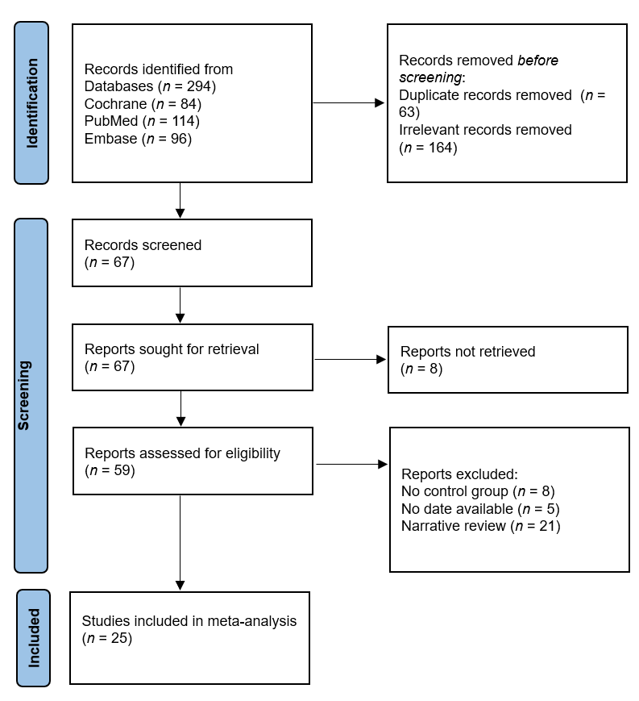
Figure 1 Flowchart of included studies.

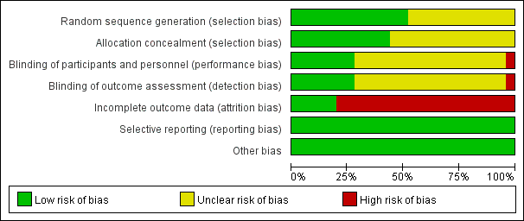
Figure 2 Proportions in the methodological quality assessment.

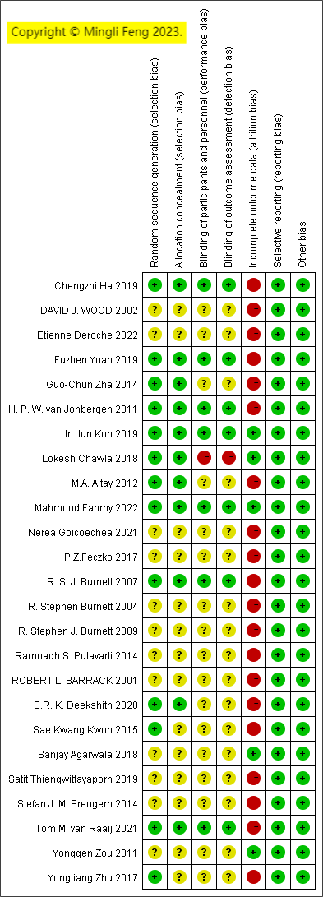
Figure 3 Methodological quality.

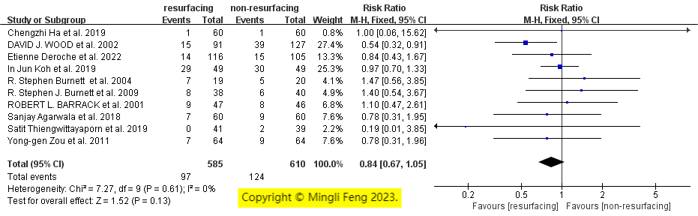
Figure 4 Forest plot for patellar resurfacing vs no resurfacing. 95%CI: 95% confidence interval.

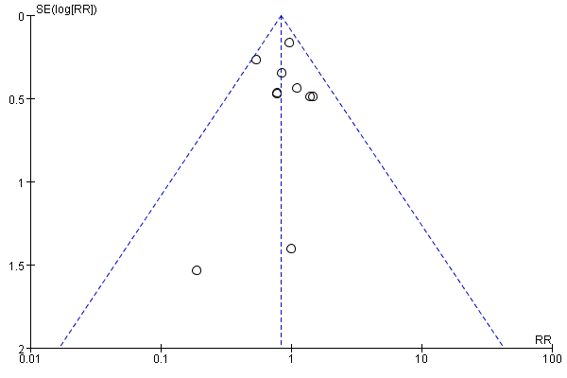
Figure 5 Funnel plot for patellar resurfacing vs no resurfacing.

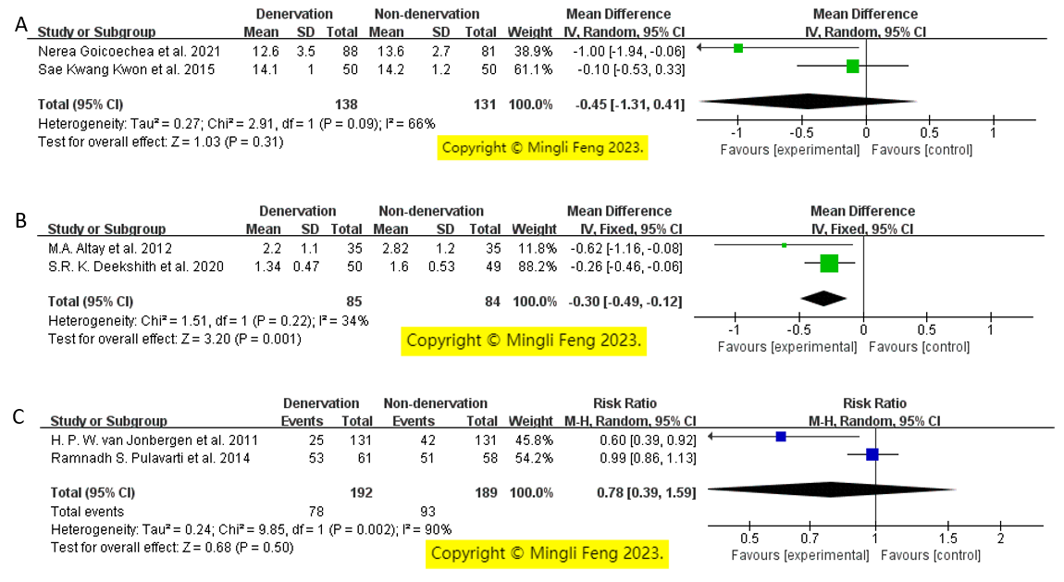
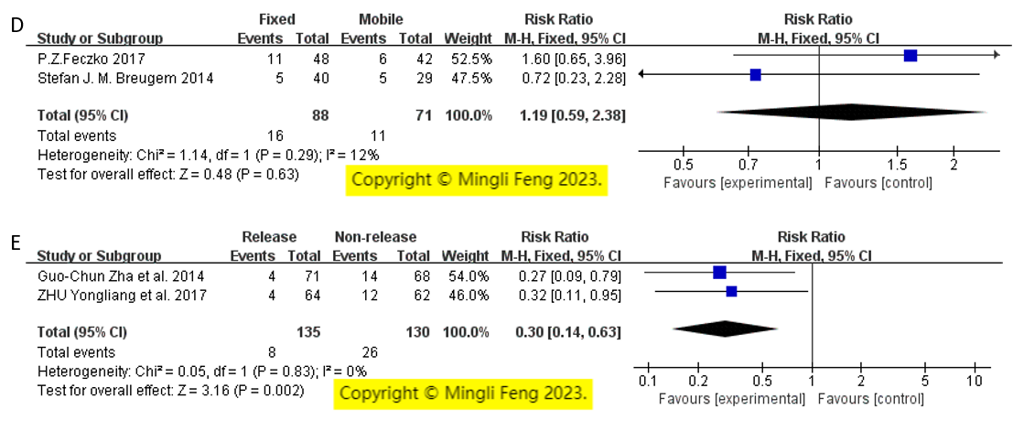
Figure 6 Forest plot. A: Forest plot for patellofemoral Feller score subgroups; B: Forest plot for the visual analog scale score subgroup; C: Forest plot for the subgroup of patients with anterior knee pain; D: Forest plot for using fixed or mobile-bearing total knee arthroplasty; E: Forest plot for lateral retinacular release vs non-release. 95%CI: 95% confidence interval.

Table 1 Basic information (e.g., patellar resurfacing vs no patellar resurfacing)
Ref. | Follow-up time | Patients included (resurfacing/non-resurfacing) | Resurfacing |  | Non-resurfacing
 |  |  | Patients with AKP | Patients available | Patients with AKP | Patients available
Koh et al^{[16]}, 2019 | 5 yr | 49/49 | 29 | 49 | 30 | 49
Thiengwittayaporn et al^{[15]}, 2019 | 1 yr | 42/42 | 0 | 41 | 2 | 39
Ha et al^{[17]}, 2019 | 5 yr | 66/66 | 1 | 60 | 1 | 60
Deroche et al^{[13]}, 2022 | 18.0 months (mean) | 123/123 | 14 | 116 | 15 | 105
Agarwala et al^{[4]}, 2018 | 19.0 months | 60/60 | 7 | 60 | 9 | 60
Zou et al^{[19]}, 2011 | 16.5 months (mean) | 64/64 | 7 | 64 | 9 | 64
Burnett et al^{[22]}, 2004 | 10 yr | 50/50 | 7 | 19 | 5 | 20
Burnett et al^{[20]}, 2009 | 10 yr | 59/59 | 8 | 38 | 6 | 40
Barrack et al^{[24]}, 2001 | 70.5 months | 59/59 | 9 | 47 | 8 | 46
Wood et al^{[23]}, 2002 | 48.0 months (mean) | 110/110 | 15 | 91 | 39 | 127
AKP: Anterior knee pain.

Table 2 The basic information of the studies (with or without circumpatellar denervation)
Ref. | Follow-up time | Patients included (denervation/non-denervation) | Denervation |  | Non-denervation
 |  |  | Patients with AKP | Patients available | Patients with AKP | Patients available
Jonbergen et al^{[29]}, 2011 | 1 yr | 150/150 | 25 | 131 | 42 | 131
Pulavarti et al^{[28]}, 2014 | 2 yr | 63/63 | 53 | 61 | 51 | 58
AKP: Anterior knee pain.

Table 3 The basic information of the studies (with or without circumpatellar denervation)
Ref. | Follow-up time | Patients available (denervation/non-denervation) | Score | Denervation |  | Non-denervation
 |  |  |  | Mean | SD | Mean | SD
Kwon et al^{[26]}, 2015 | 5 yr | 50/50 | PFS | 14.10 | 1.00 | 14.20 | 1.20
Goicoechea et al^{[25]}, 2021 | 1 yr | 88/81 | PFS | 12.60 | 3.50 | 13.60 | 2.70
Altay et al^{[27]}, 2012 | 3 yr | 35/35 | VAS | 2.20 | 1.10 | 2.82 | 1.20
Deekshith et al^{[30]}, 2020 | 2 yr | 50/49 | VAS | 1.34 | 0.47 | 1.60 | 0.53
VAS: Visual analog scale; PFS: Patellofemoral Feller score.

Table 4 The basic information of the studies (effects of using fixed or mobile-bearing total knee arthroplasty)
Ref. | Follow-up time | Fixed |  | Mobile
 |  | Patients with AKP | Patients available | Patients with AKP | Patients available
Feczko et al^{[31]}, 2017 | 5.0 yr | 11 | 48 | 6 | 42
Breugem et al^{[32]}, 2014 | 7.9 yr | 5 | 40 | 5 | 29
AKP: Anterior knee pain.

Table 5 The basic information of the studies (lateral retinacular release vs non-release)
Ref. | Follow-up time | Lateral retinacular release |  | Non-release
 |  | Patients with AKP | Patients available | Patients with AKP | Patients available
Zhu et al^{[33]}, 2017 | 5 years | 4 | 64 | 12 | 62
Zha et al^{[34]}, 2014 | 7.9 years | 4 | 71 | 14 | 68
AKP: Anterior knee pain.

