Name of journal: World Journal of Gastroenterology
Manuscript NO.: 40150
Manuscript type: CASE REPORT

Infant cholestasis patient with a novel missense mutation in the AKR1D1 gene successfully treated by early adequate supplementation with chenodeoxycholic acid: A case report and review of literature

Wang HH et al. A case with the AKR1D1 mutation

Hui-Hui Wang, Fei-Qiu Wen, Dong-Ling Dai, Jian-She Wang, Jing Zhao, Kenneth DR Setchell, Li-Na Shi, Shao-Ming Zhou, Si-Xi Liu, Qing-Hua Yang

Hui-Hui Wang, Fei-Qiu Wen, Dong-Ling Dai, Shao-Ming Zhou, Si-Xi Liu, Qing-Hua Yang, Gastroenterology Department, Shenzhen Children's Hospital, Shenzhen 518036, Guangdong Province, China

Jian-She Wang, Jing Zhao, Center for Pediatric Liver Diseases, Children’s Hospital of Fudan University, Shanghai 201102, China

Kenneth DR Setchell, Department of Pathology and Laboratory Medicine, Cincinnati Children's Hospital Medical Center, Cincinnati, OH 45229, United States

Li-Na Shi, MyGenostics Incorporation, Konggang Industrial Park, Beijing 101318, China

ORCID number: Hui-Hui Wang (0000-0002-0469-1641); Fei-Qiu Wen (0000-0002-3551-738X); Dong-Ling Dai (0000-0002-3002-4631); Jian-She Wang (0000-0003-0823-586X); Jing Zhao (0000-0002-4982-9843); Kenneth DR Setchell (0000-0002-2472-2476); Li-Na Shi (0000-0002-7629-7301); Shao-Ming Zhou (0000-0001-7269-4214); Si-Xi Liu (0000-0003-1674-2685); Qing-Hua Yang (0000-0002-7325-2968).

Author contributions: Wang HH drafted the manuscript and analyzed the data; Wang JS, Wen FQ and Zhao J contributed to sample analysis and patients’ treatment regimens; Setchell KDR contributed to the analysis, interpretation of urinary bile acids and finalized the manuscript; Wang HH, Dai DL, Liu SX, Zhou SM and Yang QH were involved in patient management and follow-up; Shi LN performed gene sequencing and analysis; Dai DL conceived and supervised the study; Wang HH and Wen FQ contributed equally to this work. All of the authors approved submission.

Supported by the Guangdong Medical Research Foundation, No. A2018550.

Informed consent statement: Consent was obtained from the parents of the patient for publication of the case report and any accompanying images.

Conflict-of-interest statement: The authors who took part in this study declare that they do not have anything to disclose regarding funding or a conflict of interest with respect to this manuscript.

CARE Checklist (2013) statement: The authors have read the CARE Checklist (2013). The manuscript was prepared and revised according to the CARE Checklist (2013).

Open-Access: This is an open-access article that was selected by an in-house editor and fully peer-reviewed by external reviewers. It is distributed in accordance with the Creative Commons Attribution Non Commercial (CC BY-NC 4.0) license, which permits others to distribute, remix, adapt, build upon this work non-commercially, and license their derivative works on different terms, provided the original work is properly cited and the use is non-commercial. See: http://creativecommons.org/licenses/by-nc/4.0/

Manuscript source: Unsolicited manuscript

Correspondence to: Dong-Ling Dai, MD, PhD, Chief Doctor, Gastroenterology Department, Shenzhen Children's Hospital, 7019 Yitian Road, Futian District, Shenzhen 518036, Guangdong Province, China. daidong3529@sina.com
Telephone: +86-755-83008333
Fax: +86-755-83008333

Received: June 7, 2018
Peer-review started: June 7, 2018
First decision: June 20, 2018
Revised: July 17, 2018
Accepted: August 1, 2018
Article in press:
Published online:

Abstract
Steroid 5β-reductase [aldo-keto reductase family 1 member D1 (AKR1D1)] is essential for bile acid biosynthesis. Bile acid deficiency caused by genetic defects in AKR1D1 leads to life-threatening neonatal hepatitis and cholestasis. There is still limited experience regarding the treatment of this disease. We describe an infant who presented with hyperbilirubinemia and coagulopathy but normal bile acid and γ-glutamyltransferase. Gene analysis was performed using genomic DNA from peripheral lymphocytes from the patient, his parents, and his elder brother. The patient was compound heterozygous for c.919C>T in exon 8 and exhibited a loss of heterozygosity of the AKR1D1 gene, which led to an amino acid substitution of arginine by cysteine at amino acid position 307 (p. R307C). Based on these mutations, the patient was confirmed to have primary 5β-reductase deficiency. Ursodeoxycholic acid (UDCA) treatment did not have any effect on the patient. However, when we changed to chenodeoxycholic acid (CDCA) treatment, his symptoms and laboratory tests gradually improved. It is crucial to supplement with an adequate dose of CDCA early to improve clinical symptoms and to normalize laboratory tests.

Key words: Aldo-keto reductase family 1 member D1; Cholestasis; Congenital bile acid synthesis defect; Gene mutation

© The Author(s) 2018. Published by Baishideng Publishing Group Inc. All rights reserved.

Core tip: We report a case of an infant with primary 3-oxo-∆4-steroid 5β-reductase deficiency with a novel missense mutation in the aldo-keto reductase family 1 member D1 (AKR1D1) gene. The patient was successfully treated by early adequate supplementation with chenodeoxycholic acid (CDCA). This case suggests that a novel compound heterozygous R307C mutation and loss of heterozygosity in the AKR1D1 gene play a pathogenic role in congenital bile acid synthesis defect type 2. Accurate diagnosis of the disease and early adequate supplementation with CDCA are vital for the amelioration of symptoms in clinical practice.

Wang HH, Dai DL, Wang JS, Zhao J, Setchell KDR, Shi LN, Zhou SM, Liu SX, Yang QH, Wen FQ. Infant cholestasis patient with a novel missense mutation in the AKR1D1 gene successfully treated by early adequate supplementation with chenodeoxycholic acid: A case report and review of literature. World J Gastroenterol 2018; In press
Introduction
Congenital bile acid synthesis defect type 2 (CBAS2) is a rare and autosomal recessive inherited disease presenting with infant intrahepatic cholestasis, normal or slightly elevated total bile acids (TBA) and γ-glutamyltransferase (GGT) in serum^{[1,2]}. This inborn error of bile acid synthesis is caused by a defect in the aldo-ketoreductase family 1 member D1 (AKR1D1) gene, which encodes ∆⁴-3-oxosteroid 5β-reductase, the key enzyme involved in bile acid biosynthesis^{[3]}. This enzyme catalyzes the reduction of the Δ⁴-3-ketosteroid to form the AB cis ring structure; its deficiency results in a lack of primary bile acids and an increase in the synthesis of 3-oxo-∆⁴ bile and allo-bile acids^{[4]}.
In 1988, Clayton et al^{[5]} reported that severe liver disease in pediatric patients was detected with predominant unusual 3-oxo-∆⁴ bile acids secondary to 5β-reductase deficiency. Primary 5β-reductase deficiency was characterized by Setchell et al^{[6]} the same year. It is difficult to distinguish primary 5β-reductase deficiency from another cholestasis secondary to a variety of severe liver diseases based on clinical symptoms and regular laboratory tests^{[1,7,8]}. Thus, genetic analysis of the AKR1D1 gene is essential for the accurate diagnosis of primary 5β-reductase deficiency. Thus far, more than 20 cases of this inborn error have been reported, and over 10 variant mutations of the AKR1D1 gene are attributed to a defect in 5β-reductase^{[1,7-13]}. Most of these mutations are missense mutations, causing an amino acid alteration in the protein. Drury et al^{[3]} further investigated 5 reported point mutations (L106F, P133R, P198L, G223E, and R261C) in the AKR1D1 gene to evaluate their effects on the enzymatic properties of 5β-reductase. They found that these mutations result in significantly decreased 5β-reductase activity and subsequently contribute to the progression of bile acid deficiency.
Primary bile acid supplementation can ameliorate the symptoms of CBSA2 and normalize liver function by offering feedback repression of the 7α-hydroxylase gene (CYP7A1) and improving the absorption of fat and fat-soluble vitamins^{[14]}. Treatment with primary bile acids includes monotherapy or the combination of cholic acid (CA), ursodeoxycholic acid (UDCA) and chenodeoxycholic acid (CDCA). Early treatment of these bile acids, especially CA and CDCA, is essential to reserve liver function and avoid liver transplantation. A delayed diagnosis would lead to a poor response to primary bile acids treatment and an unfavorable prognosis. There is still limited experience on the treatment of this disease. Here we describe a case of CBS2 diagnosed by genetic analysis with a novel compound heterozygous mutation in the AKR1D1 gene and review the treatments and prognoses of genetically diagnosed CBS2 cases.

Case report
A male patient was delivered via Caesarean section at term after an uneventful pregnancy with a birth weight of 3400 g. He was the second child of his family and the third pregnancy of his mother. One of his mother’s pregnancies was terminated by abortion for social reasons. His parents were non-consanguineous and healthy, his elder brother was healthy, and none of them presented with any liver disease. The patient soon developed progressive jaundice after birth, with dark urine and pale stool. He was referred to our hospital at the age of 2 mo. Laboratory tests indicated total bilirubin (TBil) 204.8 μmol/L, direct bilirubin (DBil) 112.4 μmol/L, alanine aminotransferase (ALT) 339 IU/L, aspartate aminotransferase (AST) 619 IU/L, γ-glutamyltransferase (GGT) 50 IU/L, total bile acids (TBA) 1.8 μmol/L, activated partial thromboplastin time (APTT) 62.6 s, prothrombin time (PT) 23.6 s, and international normalized ratio (PT-INR) 2.1. Chronic hepatitis virus tests, including hepatitis B, hepatitis C and cytomegalovirus (CMV), were negative, and autoimmune hepatitis was ruled out by an appropriate laboratory test. Abdominal ultrasound showed a visible gallbladder and hepatomegaly; no other bile duct dysplasia was observed. Analysis of the amino acid and acylcarnitine spectrum of genetic metabolic diseases showed elevated tyrosine, which was speculated secondary to impaired liver function. Comprehensive analysis of urinary organic acids was normal.
Since we were unavailable to perform bile acid analysis in our hospital, we performed genetic analysis with a cholestasis panel (Supplementary Table 1), which included prevalent pathogenic genes associated with infant cholestasis, to confirm the patient’s diagnosis. With informed consent, gene analysis was performed using genomic DNA from peripheral lymphocytes from the patient (Figure 1A), his parents (Figure 1B and C), and his elder brother (Figure 1D). The patient was compound heterozygous for c.919C>T in exon 8 (Figure 1A) and exhibited loss of heterozygosity of the AKR1D1 gene (Figure 1E), leading to an amino acid substitution of arginine by cysteine at amino acid position 307 (p. R307C) (Figure 2).
The patient was initially given UDCA treatment; however, there was no improvement in his clinical symptoms or liver function. UDCA was then changed to CDCA (80 mg/d) after one week of UCDA treatment. The jaundice began to alleviate after 5 d of CDCA treatment and his liver function gradually improved (Figure 3). To evaluate the response of bile acid metabolism subsequent to CDCA treatment, we sent the patient’s urine sample to Cincinnati Children's Hospital Medical Center via the Children’s Hospital of Fudan University. Urine bile acid analysis was performed using fast atom bombardment ionization mass spectrometry (FAB-MS) after 2 mo of CDCA treatment (80 mg/d). The profile revealed significant elevations in taurine and glycine conjugates of unsaturated oxo-dihydroxy and oxo-trihydroxy bile acids. Ions at m/z 444, 460, 494 and 510 reflected the presence of Δ⁴-3-oxo bile acids that are characteristic of the bile acid synthetic disorder involving a deficiency in the activity of the Δ⁴-3-oxosteroid 5β-reductase enzyme. Although these are not exceptionally high in concentration, it is difficult to know how responsive the patient was to CDCA therapy because we had no record of having analyzed a urine sample before treatment began. There is clear evidence of compliance to therapy from the presence of ions that reflect metabolites of CDCA. However, based on this mass spectrum, it appeared that the current dose of CDCA was not sufficient to complete the suppression of atypical bile acids. Thus, we increased the dose of CDCA to 100 mg/d and sent a second urine sample for bile acid analyses 1 mo later. The profile showed a good response in terms of down-regulation in hepatic bile acid synthesis. Thus, the dose of CDCA appeared adequate.

Discussion
We summarized published CBAS2 cases with a confirmed AKR1D1 mutation reported in the NCBI database through the end of December, 2017 (Table 1). As demonstrated, missense mutations were present in 11 of 15 cases; the other 4 cases had a frameshift mutation. These cases consisted of 7 homozygous and 8 heterozygous mutations. All 4 cases in which the patient was deceased were homozygous and had remarkable prolonged INR (1.8 or above), comprising three frameshift mutations and one missense mutation. In the other three homozygous cases, two showed a good response to primary bile acids treatment and had good prognoses; one patient was referred for liver transplantation and remains alive. All heterozygous cases remain alive and were effectively treated with primary bile acids treatment; only one patient required liver transplantation.
The patient we describe herein developed progressive jaundice in early infancy, with elevated DBIL and ALT but normal TBA and GGT. After exclusion of bile duct dysplasia, metabolic disorder, viral hepatitis and autoimmune hepatitis, we highly suspected hereditary cholestasis. We were unable to perform bile acid profile analyses in our hospital at that time. To identify the cause of cholestasis, we screened gene disorders using a hereditary cholestasis panel. Genetic analyses revealed that the patient had one heterozygous mutation (R307C) in the AKR1D1 gene from his mother and loss of heterozygosity in the AKR1D1 gene from his father, making him compound heterozygous. Family genetic analyses indicated that the R307C mutation in the AKR1D1 gene was heterozygous both in the patient’s mother and brother but absent in his father. On the other hand, the loss of heterozygosity in the AKR1D1 gene was found in the patient and his father but was absent in his mother and brother. As predicted by SWISS-MODEL Homology Modeling, the R307C mutation could cause an alteration in the amino acid side chain, which may subsequently lead to 5β-reductase deficiency.
However, the patient’s brother did not develop cholestasis even though he also had the heterozygous R307C mutation but without loss of heterozygosity in the AKR1D1 gene. Accordingly, we speculate that the combination of the R307C mutation and loss of heterozygosity cause the loss of 5β-reductase function.
The patient described herein showed an effective response to CDCA monotherapy (80 mg/d), consistent with a previous report^{[12]}. After 2 mo of oral CDCA treatment, the laboratory tests and clinical presence of the patient improved. However, urine bile acid analyses indicated that the CDCA dose of 80 mg/d was insufficient to complete the suppression of atypical bile acids. Thus, we increased the dose of CDCA to 100 mg/d, which proved adequate to down-regulate hepatic bile acid synthesis according to the second urine bile acid analyses. All laboratory tests had normalized when the patient was 8 mo old, and 100 mg/d CDCA was used to maintain treatment. Seki et al^{[12]} reported that 5 mg/(kg.d) CDCA may not be able to induce negative feedback, and Gonzales et al^{[15]} suggested a CDCA dose of 10 mg/(kg.d) to provide effective negative feedback at cholesterol 7α-hydroxylase. Our case required an even higher dose of CDCA to maintain effective feedback repression of 7α-hydroxylase. CA is considered more effective than CDCA in activating negative feedback of 7α-hydroxylase and is less hepatotoxic^{[15]}. Clayton et al^{[16]} reported that 5β-reductase deficiency was responsive to the combination of CDCA and CA treatment but irresponsive to UCDA. As illustrated in Table 1, Lemonde et al^{[7]} was also successful when combining CDCA [8 mg/(kg.d)) and CA [8 mg/(kg.d)] to treat a homozygous patient with normal PT. Nevertheless, the same treatment failed in two other homozygous patients with prolonged PT. The combination of CDCA and CA requires a smaller dose of CDCA, which may reduce the accumulation of potential hepatotoxic CDCA metabolites. According to our experience, an adequate dose of CDCA monotherapy was effective in alleviating clinical symptoms and normalizing laboratory tests of AKR1D1 deficiency, and the adjustment of bile acid dose should be based on urine bile acid analyses. Long-term follow-up, including liver function monitoring and urine bile acid analyses, are required to evaluate the hepatotoxicity of CDCA monotherapy and dose regulation. Although it is well-accepted that UCDA is not an optimal choice for the treatment of 5β-reductase deficiency^{[16,17]}, some reported cases, all of which were heterozygous, still benefited from UCDA treatment^{[8,13]}. The natural immaturity of 5β-reductase during early infancy may promote the advancement of cholestasis caused by a defect in AKR1D1^{[18,19]}. Thus, the presence of cholestasis and liver dysfunction in cases with a heterozygous mutation in the AKR1D1 gene may not require bile acid supplementation due to the natural physiological maturation of 5β-reductase.
Clayton et al^{[1]} reported that patients with an INR of 1.4 or above at diagnosis were not responsive to bile acid treatment and had unfavorable outcomes. As more cumulative cases have been reported, it has been revealed that patients with significant prolonged INR are predisposed to bad prognoses. Moreover, all reported cases in which the patients are deceased were homozygous and had an INR of 1.8 or above. However, although the case we encountered had an INR of 2.1, the patient had a good response to primary bile acids treatment. Due to the suspicion of an inborn error of bile acid synthesis, we soon substituted UDCA with CDCA after one week of invalid UDCA treatment. We believe that early supplementation with CDCA in our case may have avoided deterioration of his liver function despite impaired coagulation function.
In conclusion, the case described herein was confirmed to have a novel compound heterozygous R307C mutation and loss of heterozygosity in the AKR1D1 gene. Early supplementation with and an adequate dose of CDCA monotherapy showed a favorable response and improved clinical symptoms and normalization of laboratory tests.

Article Highlights
Case characteristics
A 2-month-old male infant presented with hyperbilirubinemia and coagulopathy but normal bile acid and γ-glutamyltransferase.

Clinical diagnosis
Infant cholestatic liver disease, diagnosed by elevated direct bilirubin and alanine aminotransferase.

Differential diagnosis
Virus hepatitis, congenital bile duct dysplasia, genetic metabolic diseases, autoimmune hepatitis.

Laboratory diagnosis
Hyperbilirubinemia, coagulopathy, impaired liver function.

Treatment
The patient was initially given ursodeoxycholic acid (UDCA) treatment. We changed UDCA to chenodeoxycholic acid (CDCA) (80 mg/d) after one week of ineffective UCDA treatment. After 2 mo of oral CDCA treatment, urine bile acid analyses indicated that the CDCA dose of 80 mg/d was insufficient to complete the suppression of atypical bile acids. Thus, we increased the dose of CDCA to 100 mg/d, which proved adequate to down-regulate hepatic bile acid synthesis based on the second urine bile acid analyses.

Related reports
More than 20 cases of primary 5β-reductase deficiency have been reported, and over 10 variant mutations in the aldo-ketoreductase family 1 member D1 (AKR1D1) gene are attributed to a defect in 5β-reductase.

Term explanation
Aldo-ketoreductase family 1 member D1 (AKR1D1) encodes ∆⁴-3-oxosteroid 5β-reductase; its deficiency results in a lack of primary bile acids and increased synthesis of 3-oxo-∆⁴ bile and allo-bile acids.

Experiences and lessons
Gene analysis is essential for the accurate diagnosis of primary 3-oxo-∆4-steroid 5β-reductase deficiency. Early diagnosis and adequate supplementation with CDCA are vital for the amelioration of clinical symptoms.

ACKNOWLEDGMENTS
We thank the patient’s family for providing background information and allowing us to publish this manuscript.

References
1 Clayton PT. Disorders of bile acid synthesis. J Inherit Metab Dis 2011; 34: 593-604 [PMID: 21229319 DOI: 10.1007/s10545-010-9259-3]
2 Heubi JE, Setchell KD, Bove KE. Inborn errors of bile acid metabolism. Semin Liver Dis 2007; 27: 282-294 [PMID: 17682975 DOI: 10.1055/s-2007-985073]
3 Drury JE, Mindnich R, Penning TM. Characterization of disease-related 5beta-reductase (AKR1D1) mutations reveals their potential to cause bile acid deficiency. J Biol Chem 2010; 285: 24529-24537 [PMID: 20522910 DOI: 10.1074/jbc.M110.127779]
4 Kondo KH, Kai MH, Setoguchi Y, Eggertsen G, Sjöblom P, Setoguchi T, Okuda KI, Björkhem I. Cloning and expression of cDNA of human delta 4-3-oxosteroid 5 beta-reductase and substrate specificity of the expressed enzyme. Eur J Biochem 1994; 219: 357-363 [PMID: 7508385]
5 Clayton PT, Lake BD, Hjelm M, Stephenson JB, Besley GT, Wanders RJ, Schram AW, Tager JM, Schutgens RB, Lawson AM. Bile acid analyses in "pseudo-Zellweger" syndrome; clues to the defect in peroxisomal beta-oxidation. J Inherit Metab Dis 1988; 11 Suppl 2: 165-168 [PMID: 3141700]
6 Setchell KD, Suchy FJ, Welsh MB, Zimmer-Nechemias L, Heubi J, Balistreri WF. Delta 4-3-oxosteroid 5 beta-reductase deficiency described in identical twins with neonatal hepatitis. A new inborn error in bile acid synthesis. J Clin Invest 1988; 82: 2148-2157 [PMID: 3198770 DOI: 10.1172/JCI113837]
7 Lemonde HA, Custard EJ, Bouquet J, Duran M, Overmars H, Scambler PJ, Clayton PT. Mutations in SRD5B1 (AKR1D1), the gene encoding delta(4)-3-oxosteroid 5beta-reductase, in hepatitis and liver failure in infancy. Gut 2003; 52: 1494-1499 [PMID: 12970144]
8 Ueki I, Kimura A, Chen HL, Yorifuji T, Mori J, Itoh S, Maruyama K, Ishige T, Takei H, Nittono H, Kurosawa T, Kage M, Matsuishi T. SRD5B1 gene analysis needed for the accurate diagnosis of primary 3-oxo-Delta4-steroid 5beta-reductase deficiency. J Gastroenterol Hepatol 2009; 24: 776-785 [PMID: 19175828 DOI: 10.1111/j.1440-1746.2008.05669.x]
9 Cheng Y, Guo L, Deng M, Song YZ. [Clinical feature and genetic analysis of a family affected by congenital bile acid synthesis defect type 2: identification of 2 novel mutations in AKR1D1 gene]. Zhongguo Dang Dai Er Ke Za Zhi 2017; 19: 734-740 [PMID: 28697823]
10 Gonzales E, Cresteil D, Baussan C, Dabadie A, Gerhardt MF, Jacquemin E. SRD5B1 (AKR1D1) gene analysis in delta(4)-3-oxosteroid 5beta-reductase deficiency: evidence for primary genetic defect. J Hepatol 2004; 40: 716-718 [PMID: 15030995 DOI: 10.1016/j.jhep.2003.12.024]
11 Morgan NV, Hartley JL, Setchell KD, Simpson MA, Brown R, Tee L, Kirkham S, Pasha S, Trembath RC, Maher ER, Gissen P, Kelly DA. A combination of mutations in AKR1D1 and SKIV2L in a family with severe infantile liver disease. Orphanet J Rare Dis 2013; 8: 74 [PMID: 23679950 DOI: 10.1186/1750-1172-8-74]
12 Seki Y, Mizuochi T, Kimura A, Takahashi T, Ohtake A, Hayashi S, Morimura T, Ohno Y, Hoshina T, Ihara K, Takei H, Nittono H, Kurosawa T, Homma K, Hasegawa T, Matsuishi T. Two neonatal cholestasis patients with mutations in the SRD5B1 (AKR1D1) gene: diagnosis and bile acid profiles during chenodeoxycholic acid treatment. J Inherit Metab Dis 2013; 36: 565-573 [PMID: 23160874 DOI: 10.1007/s10545-012-9526-6]
13 Zhao J, Fang LJ, Setchell KD, Chen R, Li LT, Wang JS. Primary ∆4-3-oxosteroid 5β-reductase deficiency: two cases in China. World J Gastroenterol 2012; 18: 7113-7117 [PMID: 23323017 DOI: 10.3748/wjg.v18.i47.7113]
14 Russell DW, Setchell KD. Bile acid biosynthesis. Biochemistry 1992; 31: 4737-4749 [PMID: 1591235]
15 Gonzales E, Gerhardt MF, Fabre M, Setchell KD, Davit-Spraul A, Vincent I, Heubi JE, Bernard O, Jacquemin E. Oral cholic acid for hereditary defects of primary bile acid synthesis: a safe and effective long-term therapy. Gastroenterology 2009; 137: 1310-1320.e1-3 [PMID: 19622360 DOI: 10.1053/j.gastro.2009.07.043]
16 Clayton PT, Mills KA, Johnson AW, Barabino A, Marazzi MG. Delta 4-3-oxosteroid 5 beta-reductase deficiency: failure of ursodeoxycholic acid treatment and response to chenodeoxycholic acid plus cholic acid. Gut1996; 38: 623-628 [PMID: 8707100]
17 Setchell KD, Heubi JE. Defects in bile acid biosynthesis--diagnosis and treatment. J Pediatr Gastroenterol Nutr 2006; 43 Suppl 1: S17-S22 [PMID: 16819396 DOI: 10.1097/01.mpg.0000226386.79483.7b]
18 Inoue T, Kimura A, Aoki K, Tohma M, Kato H. Developmental pattern of 3-oxo-delta 4 bile acids in neonatal bile acid metabolism. Arch Dis Child Fetal Neonatal Ed 1997; 77: F52-F56 [PMID: 9279184]
19 Kimura A, Mahara R, Inoue T, Nomura Y, Murai T, Kurosawa T, Tohma M, Noguchi K, Hoshiyama A, Fujisawa T, Kato H. Profile of urinary bile acids in infants and children: developmental pattern of excretion of unsaturated ketonic bile acids and 7beta-hydroxylated bile acids. Pediatr Res 1999; 45: 603-609 [PMID: 10203155 DOI: 10.1203/00006450-199904010-00022]
P-Reviewer: Deneau M, Schwarz SM
S-Editor: Gong ZM L-Editor: E-Editor:
Specialty type: Gastroenterology and hepatology
Country of origin: China
Peer-review report classification
Grade A (Excellent): A
Grade B (Very good): B
Grade C (Good): 0
Grade D (Fair): 0
Grade E (Poor): 0

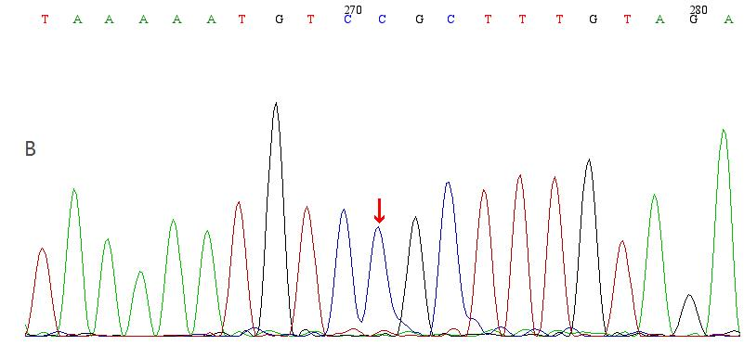
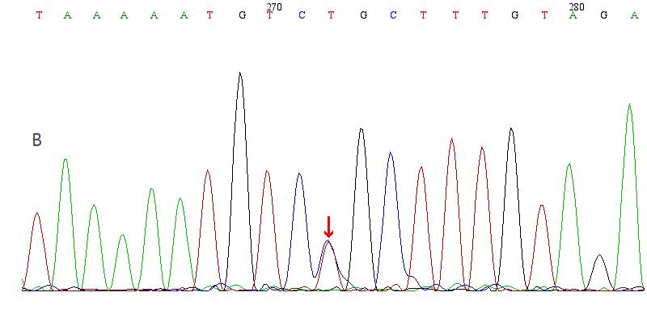 | 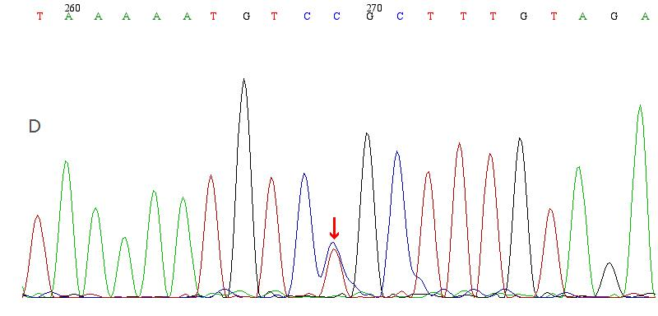
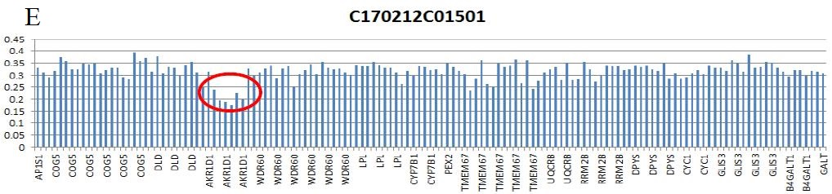
Figure 1 Genomic DNA sequences in exon 8 of the AKR1D1 gene in the patient and his family. A: Compound heterozygote in the patient (c.919C>T, R307C); B: No variant in his father; C: Heterozygote in his mother; D: Heterozygote in his brother; E: Loss of heterozygosity in exons 1-9 of AKR1D1 in the patient. AKR1D1: Aldo-ketoreductase family 1 member D1.

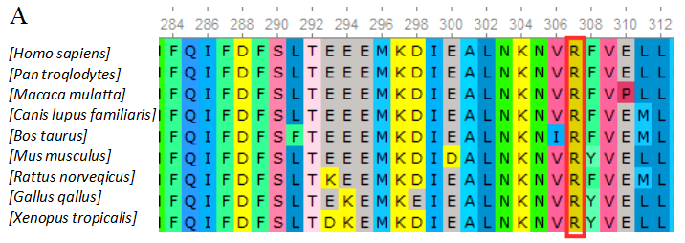
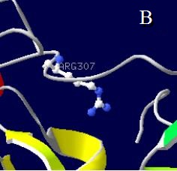 | 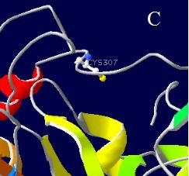
Figure 2 Multiple sequence alignment from different species and structural model of the aldo-ketoreductase family 1 member D1 protein. A: Multiple sequence alignment; the red outline in the alignment shows the amino acid affected by the mutation; B: Wild-type model; C: The mutant model shows the alteration of the amino acid side chain caused by the R307C mutation.

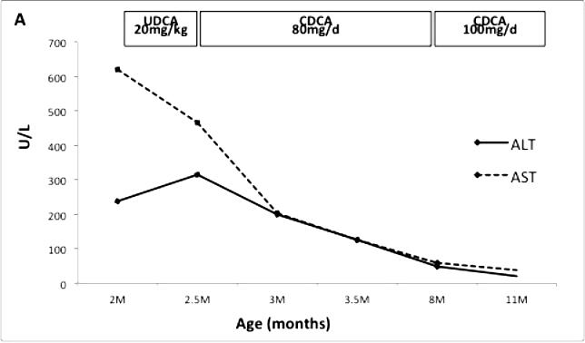 | 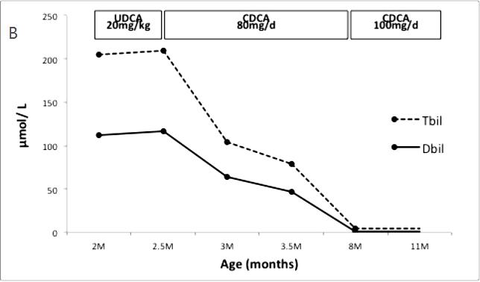
Figure 3 Responses of liver function after treatment with ursodeoxycholic acid and chenodeoxycholic acid. A: Transaminase 1; B: Bilirubin. UDCA: Ursodeoxycholic acid; CDCA: Chenodeoxycholic acid.
Table 1 Summary of the mutations reported in the AKR1D1 gene and patient prognoses
Variant | Zygotic type | Age | Sex | Treatment | Outcome | INR | Ref.
c.662C>T (p. P198L) | Homozygote | 8 mo | F | CDCA 8 mg/(kg.d) CA 8 mg/(kg.d) | Alive and well | 1.00 | [7]
c.511delT (frameshift) | Homozygote | 8 wk | M | CDCA 8 mg/(kg.d) CA 8 mg/(kg.d) | Liver transplantation; alive and well | 1.40
c.385C>T (p. L106F) | Homozygote | 6 wk | F | UDCA 60 mg/d CDCA 30 mg/d | Liver transplantation and died | 2.00
.467C>G (p. P133R) c.850C>T (p. R261C) | Heterozygote | 8 mo | F | CA 10 mg/(kg.d) | Alive and well | / | [10]
c.737G>A (p. G223Q) | Heterozygote | 3 mo | F | UDCA 5-10 mg/(kg.d) | Alive and well | / | [8]
c.217C>T (Arg50 stop) | Heterozygote | 2 mo | F | CDCA 12 mg/(kg.d) | Liver transplantation | /
c.850C>T (p.R261C) | Homozygote | 6 mo | / | CA 8 mg/(kg.d) | Died | 2.50 | [1]
c.797G>A (p. R266Q) | Heterozygote | 11 mo | M | UDCA 40 mg/(kg.d) | Alive and well | / | [13]
c.396C>A (nonsense mutation) c.722A>T (p. D241V) | Heterozygote | 11wk | M | UDCA 40 mg/(kg.d) for 4 mo; CDCA 25 mg/(kg.d) | Alive and cerebral dysplasia | /
c.866G>A (p. R266Q) | Heterozygote | 6 mo | M | UDCA 7.5 mg/(kg.d); CDCA 5 mg/(kg.d) | Alive and well | / | [12]
c.737G>A (p. G223E) c.850C>T (p. R261C) | Heterozygote | 8 mo | F | UDCA 7.5 mg/(kg.d); CDCA 10 mg/(kg.d) | Alive and well | /
c.587delG (frameshift) | Homozygote | 9 wk | F | UCDA | Died | / | [11]
c.587delG (frameshift) | Homozygote | 6 mo | F | UCDA | Died | /
c.587delG (frameshift) | Homozygote | 5 wk | F | CA 15 mg/(kg.d) | Alive and well | /
c.579+2delTc.853C>T (p. Q285X) | Heterozygote | 8 mo | M | CDCA | Alive and well | / | [9]
/: No data; CA: Cholic acid; CDCA: Chenodeoxycholic acid; INR: International normalized ratio; UDCA: Ursodeoxycholic acid; F: Female; M: Male.

