Name of Journal: World Journal of Clinical Cases
Manuscript NO: 60070
Manuscript Type: CASE REPORT

Samonella typhi infection-related appendicitis: A case report

Zheng BH et al. Samonella typhi infection-related appendicitis

Bo-Hao Zheng, Wei-Ming Hao, Hung-Chen Lin, Guo-Guo Shang, Han Liu, Xiao-Jian Ni

Bo-Hao Zheng, Han Liu, Xiao-Jian Ni, Department of General Surgery, Zhongshan Hospital, Fudan University, Shanghai 200032, China

Wei-Ming Hao, Hung-Chen Lin, Shanghai Medical College, Fudan University, Shanghai 200032, China

Guo-Guo Shang, Department of Pathology, Zhongshan Hospital, Shanghai 200032, China

Author contributions: Liu H and Ni XJ designed the case report; Zheng BH, Hao WM, and Lin HC analyzed and interpreted the patient data, and wrote the manuscript; Shang GG took the pathological examination; Zheng BH, Hao WM, Liu H, and Ni XJ participated in patient management; all authors read and approved the final manuscript.

Supported by National Natural Science Foundation of China, No. 81702586.

Corresponding author: Xiao-Jian Ni, MD, PhD, Doctor, Surgeon, Department of General Surgery, Zhongshan Hospital, Fudan University, No. 180 Fenglin Road, Shanghai 200032, China. nixiaojian13154@126.com

Received: June 7, 2021
Revised: July 5, 2021
Accepted: August 2, 2021
Published online:

Abstract
BACKGROUND
Acute appendicitis is one of the most common acute abdominal emergencies around the world, which is always associated with infection. Infection with Salmonella typhi, an enteric pathogen, is a rare cause of acute appendicitis. We here report a patient with acute appendicitis associated with Samonella typhi infection, accompanied with spleen and kidney infarction, providing a rare example for a common surgical emergency.

CASE SUMMARY
A 25-year-old Pakistani man presented to the hospital with a 3-d history of fevers, vomiting, and abdominal pain. Computed tomography (CT) revealed a thickened intestinal wall of the ileocecal junction with multiple enlarged lymph nodes nearby. He was diagnosed with acute appendicitis and received laparoscopic appendectomy, which showed mild inflammation of the appendix. After the surgery, the patient presented again with a high fever (> 39 °C) and diarrhea. A CT angiography scan indicated spleen and kidney infarction. According to the blood culture, the diagnosis was finally clear to be Samonella typhi infection. The pyrexia and enteric symptoms were relieved after the application of intravenous levofloxacin.

CONCLUSION
This case, characterized by the combination of Salmonella typhi infection, acute appendicitis, and renal and splenic infraction, serves as a rare example for a common surgical emergency.

Key Words: Acute appendicitis; Samonella typhi infection; Enteric pathogen; Laparoscopic appendectomy; Case report

Zheng BH, Hao WM, Lin HC, Shang GG, Liu H, Ni XJ. Samonella typhi infection-related appendicitis: A case report. World J Clin Cases 2021; In press

Core Tip: Acute appendicitis is one of the most common acute abdominal emergencies around the world, which is always associated with infection. Infection with Salmonella typhi, an enteric pathogen, is a rare cause of acute appendicitis. We here report a patient with acute appendicitis associated with Samonella typhi infection, accompanied by spleen and kidney infarction, providing a rare example for a common surgical emergency. This case might remind emergency doctors that the etiology of appendicitis needs to be clarified to give appropriate treatment to patients with appendicitis.

INTRODUCTION
Acute appendicitis is one of the most common acute abdominal emergencies around the world, with a lifetime risk of approximately 7%-8%^{[1]}. Although infection has been considered as an important cause and trigger factor of acute appendicitis, the pathogenic mechanism and the full range of the infectious agents remain poorly understood^{[2,3]}. As an enteric pathogen, Samonella typhi can be associated with some non-specific gastrointestinal symptoms like diarrhea, vomiting, and abdominal pain and is the main cause of typhoid fever^{[4]}. In some rare cases, Samonella typhi infection could cause acute appendicitis^{[5,6]}. Moreover, splenic and renal infarction is rarely reported in typhoid fever^{[7,8]}. We here report a patient with acute appendicitis associated with Samonella typhi infection, accompanied with spleen and kidney infarction, serving as a rare example for a common surgical emergency.

CASE PRESENTATION
Chief complaints
A 25-year-old Pakistani man presented to the hospital with a 3-d history of subjective fevers, vomiting, and abdominal pain.

History of present illness
Within a month, the patient experienced several days of diarrhea. His symptoms worsened over the last 3 d and presented to the hospital with subjective fevers, vomiting, and abdominal pain.

History of past illness
The patient had no significant medical or surgical history, and he did not take any regular medications.

Personal and family history
The patient did not have a history of smoking or drinking.

Physical examination
On presentation to the Emergency Department, the physical examination revealed a body temperature of 39.7 °C, blood pressure of 105/85 mmHg, and pulse of 108 beats per minute (slight tachycardia). Right lower abdominal pain with mild whole abdominal tenderness was found on abdominal palpation. No rashes were found.

Laboratory examinations
Initial laboratory tests showed a normal white blood cell (WBC) level at 7.45 × 10⁹/L with neutrophils at 6.5 × 10⁹/L, zero eosinophils, and increased procalcitonin, alkaline phosphatase, and C-recreative protein.

Imaging examinations
Abdominal computerized tomography (CT) was performed, which revealed a fatty liver and a thickened intestinal wall of the ileocecal junction with multiple enlarged lymph nodes nearby, indicating appendicitis (Figure 1).

FINAL DIAGNOSIS
Final pathology supported the diagnosis of acute appendicitis. Meanwhile, the blood culture later reported Gram-negative bacillus, which was later tested to be Salmonella species, confirming the diagnosis of Samonella typhi infection.

TREATMENT
The admission diagnosis that we first considered was acute appendicitis. Therefore, after a general discussion and family agreement, the patient was taken for laparoscopic appendectomy. During the operation, we found a congested, 7 cm long non-perforated appendix with a little exudate (Figure 2). Pathology reported lamina propria hyperplasia and macrophage reactive hyperplasia in the submucosa, and the normal lymphoid follicular structure disappeared in the lamina propria massive macrophage reactive hyperplasia with a small amount of neutrophil and lymphocyte infiltration, and partial mucosal ulcers (Figure 3). Affected tissue was restricted in the lamina propria, while the submucosal and muscle layers were normal. Focal deposition of collagen fibers and neutrophilic invasion were found in the serosal layer, which supported the diagnosis of acute appendicitis.
However, on the second post-surgery day, the patient presented again with a high fever of more than 39 °C and diarrhea with loose yellow-green stools. Urine and stool routine tests were performed at once and the fecal occult blood test was positive. Routine blood test showed that WBC was 4.1 × 10⁹ with zero eosinophils, platelet count was 77 × 10⁹/L, and D-dimer was higher than 40 mg/L. Cefoperazone and sulbactam plus metronidazole were used immediately. A CT scan showed swelling of the cecal and ascending colonic wall, with multiple enlarged celiacs and retroperitoneal lymph nodes. A multi-disciplinary consultation was called on differential diagnoses: Secondary abdominal infections, leak of the appendiceal stump, and lymphoma. Considering the inflammation appearance and foreigner identity of the patients, unclear infectious agent from the epidemic area was suspected and the chance of thrombosis was concerned. A CT angiography scan was performed and showed multiple spleen infarctions and right renal infarction (Figure 4). Blood culture later reported Gram-negative bacillus, which turned out to be Salmonella species sensitive to ciprofloxacin, levofloxacin, ceftazidime, and cefaloridine. Levofloxacin and low-molecular-weight heparin were then used intravenously.

OUTCOME AND FOLLOW-UP
The temperature decreased to 37-38 °C within 3 d. This patient's enteric symptoms were also relieved much. He was then transferred to the Shanghai Public Health Clinical Center for further treatment of typhoid fever according to the epidemic prevention provisions. At the 1-mo follow-up, the patient had recovered well.

DISCUSSION
In this case report, we present a patient with acute appendicitis associated with Samonella typhi infection, thus serving as a rare example of a common surgical emergency.
In general, appendicitis is an infection-related disease, and the infectious agents include viruses, bacteria, fungi, and parasites^{[9]}. In bacterial infections causing appendicitis, Samonella typhi infection-related acute appendicitis has been rarely reported, and clinical presentation and histologic findings are identical to those of acute nonspecific appendicitis^{[2]}. In one case reported by Sartori et al^{[10]}, the pathology demonstrated early acute appendicitis as appendiceal lymphoid follicle hyperplasia, neutrophilic invasion in the mucosa, and crypt abscesses. Besides, Boyd reported^{[11]} histologic changes of the appendixes in nine patients dying of typhoid fever, and the main histological change of one case was mucosal hyperplasia and epithelial granuloma formation. Previously, it has been reported that Samonella typhi might invade the intestinal mucosa of the ileocecal junction through M cells gathering at follicle-associated epithelium (FAE)^{[12]}, which leads to leucocytes infiltrating into the lamina propria. Some bacteria even went inside intestinal lymphoid tissue and then drained into mesenteric nodes^{[4]}. All these studies might explain the pathological feature of Samonella typhi-related acute appendicitis. Consistent with these previous reports, appendix involvements of typhoid fever in our case presented with milder unspecific inflammation such as lamina propria hyperplasia and neutrophilic invasion, and typical histopathological changes were consistent with intestinal typhoid as partial mucosal ulcers and enlarged lymph nodes. Enlarged lymph nodes and an appendix with mucosal hyperplasia and ulcers were found at the same time in our patient. This might indicate involvements of typhoid inflammation in both the appendix and lymph node system, possibly associated with FAE and lymphoid follicles.
Of note, the appendicitis symptoms in some cases related to typhoid fever can be mimics of mesenteric lymphadenitis^{[13,14]}. In this condition, a normal appendix may be found during laparoscopic exploration. Therefore, careful examinations should be carried out to differentiate mesenteric lymphadenitis from appendicitis in typhoid fever patients.
In a case without early immediate surgery, the patient developed gangrenous appendicitis^{[15]}. Moreover, it has been reported that patients with Salmonella infection-related appendicitis often remain febrile postoperatively, and need antibiotic treatment following appendectomy^{[2,10]}. All these reports supported that Salmonella infection-related appendicitis requires immediate appendectomy and postoperative antibiotic treatment.
Splenic and renal infarction is usually caused by hematological and rheumatological diseases, as well as human immunodeficiency virus (HIV) infection^{[16]}. In our case, rheumatoid factor, antinuclear acid antibody, and HIV tests all showed negative results, which ruled out hematological and rheumatological diseases, and HIV infection. There are few reported cases of splenic infarction and typhoid fever^{[7,8,17]}. However, the possible mechanisms of solid organ infarction in typhoid fever have not been clarified. An animal study has indicated inflammation related to thrombosis via C type lectin-like receptor-2 on platelets in Samonella infections, and the bacteria may colonize solid organs, thus triggering inflammations and thrombosis responses^{[18]}.
Epidemic focus and normal WBC also provided significant clues in this case. Southern Asia is a high-risk region for typhoid fever, where our patient came from. Pre- and post-operation routine blood tests all showed normal WBC with zero eosinophils. CT scan gives some hints for pre-surgery differential diagnosis, but not enough to preclude the surgery, especially in cases with suppurative appendicitis.
In conclusion, we here report a rare case of Samonella typhi infection-related acute appendicitis. This case might remind emergency doctors that the etiology of appendicitis needs to be clarified to give appropriate treatment to patients with appendicitis. Besides, some improvements would have been needed in our clinical practice in this case: First of all, enough attention on the patient's epidemic focus history was not paid until the late course of the diagnosis. Second, we only performed a routine stool test without sending a stool sample for bacterial cultivation.

CONCLUSION
This case, characterized by the association of Salmonella typhi infection with acute appendicitis and renal and splenic infarction, serves as a rare example for a common surgical emergency.

REFERENCES
1 Stewart B, Khanduri P, McCord C, Ohene-Yeboah M, Uranues S, Vega Rivera F, Mock C. Global disease burden of conditions requiring emergency surgery. Br J Surg 2014; 101: e9-22 [PMID: 24272924 DOI: 10.1002/bjs.9329]
2 Lamps LW. Infectious causes of appendicitis. Infect Dis Clin North Am 2010; 24: 995-1018, ix-ix [PMID: 20937462 DOI: 10.1016/j.idc.2010.07.012]
3 Snyder MJ, Guthrie M, Cagle S. Acute Appendicitis: Efficient Diagnosis and Management. Am Fam Physician 2018; 98: 25-33 [PMID: 30215950]
4 Bhan, M.K., R. Bahl, and S. Bhatnagar, Typhoid and paratyphoid fever. Lancet 2005; 366: 749-762 [DOI: 10.1016/S0140-6736(05)67181-4]
5 Golakai VK, Makunike R. Perforation of terminal ileum and appendix in typhoid enteritis: report of two cases. East Afr Med J 1997; 74: 796-799 [PMID: 9557425]
6 Kazlow PG, Freed J, Rosh JR, Reiner M, Dische R, Benkov K, LeLeiko NS. Salmonella typhimurium appendicitis. J Pediatr Gastroenterol Nutr 1991; 13: 101-103 [PMID: 1919941 DOI: 10.1097/00005176-199107000-00019]
7 Gautier-Benoit C, Pontac MO, Hochedez G, Houcke M. [Splenic infarct revealing paratyphoid fever in a child]. Lille Med 1975; 20: 630-631 [PMID: 815730]
8 Küpeli S, Alehan D, Akpinar E. Isolated splenic infarction owing to group B Salmonella: case report. Ann Trop Paediatr 2002; 22: 380-382 [PMID: 12530289 DOI: 10.1179/027249302125002056]
9 Bhangu A, Søreide K, Di Saverio S, Assarsson JH, Drake FT. Acute appendicitis: modern understanding of pathogenesis, diagnosis, and management. Lancet 2015; 386: 1278-1287 [PMID: 26460662 DOI: 10.1016/S0140-6736(15)00275-5]
10 Sartori DJ, Sun K, Hopkins MA, Sloane MF. Typhoid Fever and Acute Appendicitis: A Rare Association Not Yet Fully Formed. Case Rep Gastroenterol 2017; 11: 446-451 [DOI: 10.1159/000479310]
11 Boyd JF. Pathology of the alimentary tract in Salmonella typhimurium food poisoning. Gut 1985; 26: 935-944 [PMID: 3896961 DOI: 10.1136/gut.26.9.935]
12 Pier GB, Grout M, Zaidi T, Meluleni G, Mueschenborn SS, Banting G, Ratcliff R, Evans MJ, Colledge WH. Salmonella typhi uses CFTR to enter intestinal epithelial cells. Nature 1998; 393: 79-82 [PMID: 9590693 DOI: 10.1038/30006]
13 Likitnukul S, Wongsawat J, Nunthapisud P. Appendicitis-like syndrome owing to mesenteric adenitis caused by Salmonella typhi. Ann Trop Paediatr 2002; 22: 97-99 [PMID: 11926059 DOI: 10.1179/027249302125000247]
14 Martin HC, Goon HK. Salmonella ileocecal lymphadenitis masquerading as appendicitis. J Pediatr Surg 1986; 21: 377-378 [PMID: 3701557 DOI: 10.1016/s0022-3468(86)80210-x]
15 Stewart-Parker EP, Atta M, Doddi S. A curious cause of appendicitis. BMJ Case Rep 2016; 2016 [PMID: 27489071 DOI: 10.1136/bcr-2016-216150]
16 Nores M, Phillips EH, Morgenstern L, Hiatt JR. The clinical spectrum of splenic infarction. Am Surg 1998; 64: 182-188 [PMID: 9486895]
17 Mehta LK, Arya SC, Mathai G. Infarction of the spleen in typhoid fever. Saudi Med J 2007; 28: 271-272 [PMID: 17268709]
18 Hitchcock JR, Cook CN, Bobat S, Ross EA, Flores-Langarica A, Lowe KL, Khan M, Dominguez-Medina CC, Lax S, Carvalho-Gaspar M, Hubscher S, Rainger GE, Cobbold M, Buckley CD, Mitchell TJ, Mitchell A, Jones ND, Van Rooijen N, Kirchhofer D, Henderson IR, Adams DH, Watson SP, Cunningham AF. Inflammation drives thrombosis after Salmonella infection via CLEC-2 on platelets. J Clin Invest 2015; 125: 4429-4446 [PMID: 26571395 DOI: 10.1172/JCI79070]

Footnotes
Informed consent statement: Informed written consent was obtained from the patient for publication of this report and any accompanying images.

Conflict-of-interest statement: The authors declare that they have no conflict of interest to report.

CARE Checklist (2016) statement: The authors have read the CARE Checklist (2016), and the manuscript was prepared and revised according to the CARE Checklist (2016).

Open-Access: This article is an open-access article that was selected by an in-house editor and fully peer-reviewed by external reviewers. It is distributed following the Creative Commons Attribution-NonCommercial (CC BY-NC 4.0) license, which permits others to distribute, remix, adapt, build upon this work non-commercially, and license their derivative works on different terms, provided the original work is properly cited and the use is non-commercial. See: http://creativecommons.org/Licenses/by-nc/4.0/

Manuscript source: Unsolicited manuscript

Peer-review started: June 7, 2021
First decision: June 25, 2021
Article in press:

Specialty type: Medicine, research, and experimental
Country/Territory of origin: China
Peer-review report’s scientific quality classification
Grade A (Excellent): 0
Grade B (Very good): B
Grade C (Good): 0
Grade D (Fair): 0
Grade E (Poor): 0

P-Reviewer: Lee KG S-Editor: Wang LL L-Editor: Wang TQ P-Editor:
Figure Legends
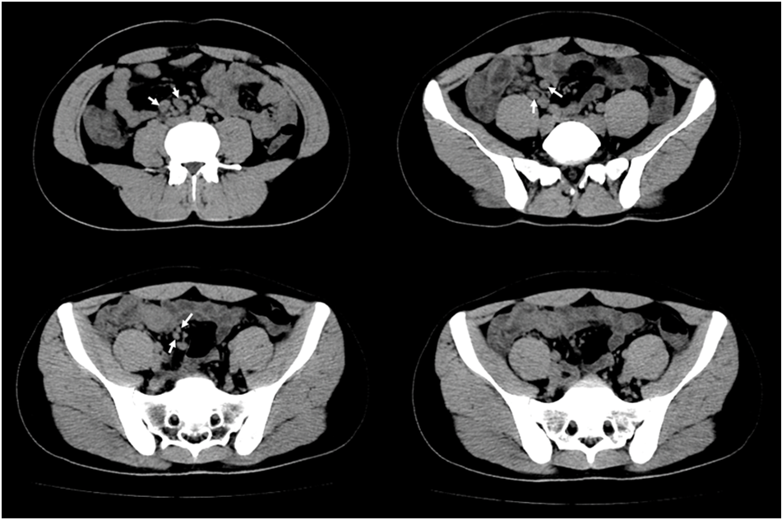
Figure 1 Pre-operative abdominal computed tomography showed a thickened intestinal wall of the ileocecal junction with multiple enlarged lymph nodes (white arrows) nearby.
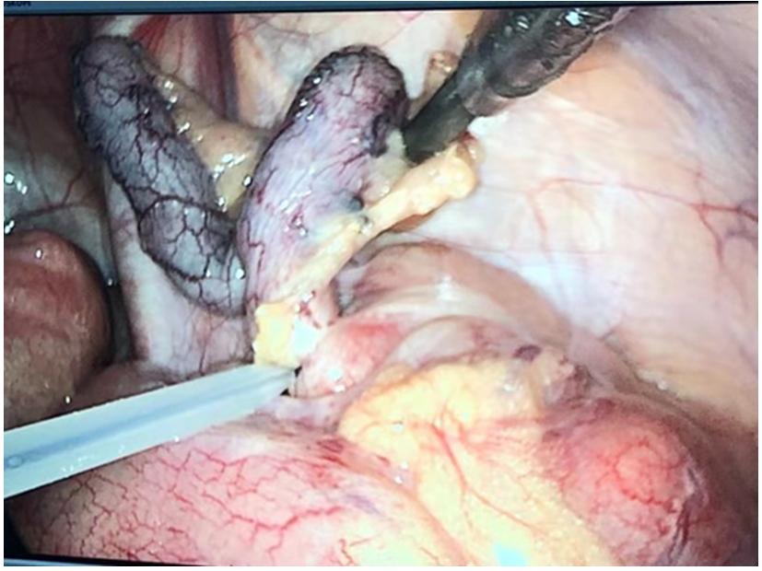
Figure 2 Intraoperative image of the appendix.
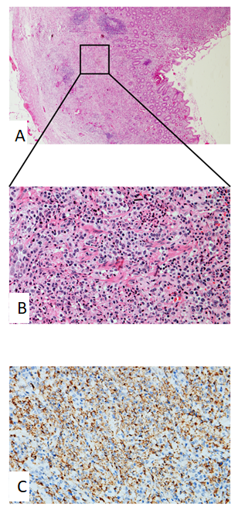

Figure 3 Pathological images of Samonella typhi infection-related appendicitis. A: Macrophage reactive hyperplasia in the submucosa is visible, and the normal lymphoid follicular structure disappears in the lamina propria (Hematoxylin-eosin staining, original magnification × 40); B: A magnification scope of Figure A, which shows massive macrophage reactive hyperplasia with a small amount of neutrophil and lymphocyte infiltration (Hematoxylin-eosin staining, original magnification × 400); C: Immunohistochemical staining for CD68 (Original magnification × 400).
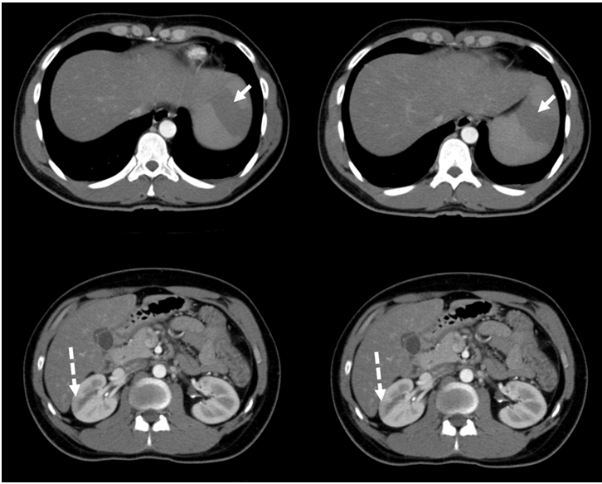
Figure 4 Post-operative abdominal computed tomography showed swelling of the cecal and ascending colonic wall, with multiple enlarged celiac and retroperitoneal lymph nodes, multiple spleen infarctions (white arrows in solid line), and right renal infarction (white arrows in dotted line).

