Name of Journal: World Journal of Gastroenterology
Manuscript NO: 85076
Manuscript Type: OPINION REVIEW

Very early onset perinatal constipation: Can it be cow’s milk protein allergy?

Arakoni R et al. Perinatal constipation and cow’s milk allergy

Rajalakshmy Arakoni, Hebat Kamal, Sam Xianjun Cheng

Rajalakshmy Arakoni, Department of Pediatrics, University of Florida Shands Children's Hospital, Gainesville, FL 32608, United States

Hebat Kamal, Sam Xianjun Cheng, Department of Pediatric Gastroenterology, Hepatology, and Nutrition, University of Florida Shands Children's Hospital, Gainesville, FL 32608, United States

Author contributions: Cheng SX conceived the idea for the manuscript; Arakoni R and Cheng SX reviewed the literature and drafted the manuscript; Kamal H edited the manuscripts.

Corresponding author: Sam Xianjun Cheng, MD, MSc, PhD, Attending Doctor, Department of Pediatric Gastroenterology, Hepatology, and Nutrition, University of Florida Shands Children's Hospital, 1600 SW Archer Rd, HD 606, Gainesville, FL 32608, United States. sam.cheng@ufl.edu

Received: April 10, 2023
Revised: July 21, 2023
Accepted: August 15, 2023
Published online: September 7, 2023

Abstract
Delayed passage of meconium or constipation during the perinatal period is traditionally regarded as a signal to initiate further work up to evaluate for serious diagnoses such as Hirschsprung’s disease (HD), meconium ileus due to Cystic Fibrosis, etc. The diagnosis of HD particularly warrants invasive testing to confirm the diagnosis, such as anorectal manometry or rectal suction biopsy. What if there was another etiology of perinatal constipation, that is far lesser known? Cow’s milk protein allergy (CMPA) is often diagnosed in infants within the first few weeks of life, however, there are studies that show that the CMPA allergen can be passed from mother to an infant in-utero, therefore allowing symptoms to show as early as day one of life. The presentation is more atypical, with perinatal constipation rather than with bloody stools, diarrhea, and vomiting. The diagnosis and management would be avoidance of cow's milk protein within the diet, with results and symptom improvement in patients immediately. Therefore, we discuss whether an alternative pathway to address perinatal constipation should be further discussed and implemented to potentially avoid invasive techniques in patients. This entails first ruling out CMPA with safe, noninvasive techniques with diet modification, and if unsuccessful, then moving forward with further diagnostic modalities.

Key Words: Delayed passage of meconium; Perinatal constipation; Cow's milk protein allergy; In-utero; Alternate pathway; Hirschsprung’s disease

©The Author(s) 2023. Published by Baishideng Publishing Group Inc. All rights reserved.

Citation: Arakoni R, Kamal H, Cheng SX. Very early onset perinatal constipation: Can it be cow’s milk protein allergy? World J Gastroenterol 2023; 29(33): 4920-4926
URL: https://www.wjgnet.com/1007-9327/full/v29/i33/4920.htm
DOI: https://dx.doi.org/10.3748/wjg.v29.i33.4920

Core Tip: Cow’s milk protein allergy (CMPA) is a far lesser known cause of perinatal constipation compared to more frequently considered diagnoses such as Hirschsprung’s, Cystic fibrosis related meconium ileus, etc. The presentation during the perinatal period is considered atypical caused by a non-immunoglobulin E (IgE) mechanism as opposed to the typical presentation caused by an IgE-mediated mechanism. The likelihood of CMPA is significant in the perinatal period, therefore should be considered more often. Here we discuss an alternative pathway for the workup of perinatal constipation focusing on CMPA as an etiology. The use of this pathway can avoid invasive tests among patients.

INTRODUCTION
Delayed passage of meconium or constipation is defined as failure to pass stool within the first 48 h after birth^{[1]}. With a positive history of delayed meconium passage, providers traditionally regard this as a signal towards serious diagnoses such as Hirschsprung’s disease (HD), meconium ileus (MI) due to cystic fibrosis (CF), or intestinal obstruction, and initiate work up such as barium enema, anorectal manometry, and or rectal suction biopsy per current recommendations^{[2]}. We rarely consider cow's milk protein allergy (CMPA), even though it has been described to occur in the perinatal period^{[3,4]} and causes disease that mimics HD^{[5-8]}. Since there’s still no available diagnostic laboratory tests, the diagnosis of CMPA has to be clinical. We recently reported 3 cases of infants who had delayed passage of meconium with subsequent early-onset perinatal constipation that did not respond to conventional therapies and required rectal stimulation to defecate. The symptoms resolved when the milk protein component was withheld and recurred when milk proteins were reintroduced for the patients. The symptoms subsequently resolved again when switched to an extensively hydrolyzed or amino acid-based formula^{[9]}. Thus, it had not only avoided more aggressive and invasive workup, but had also significantly improved the care of this very vulnerable young patient population. Unfortunately, per our recent survey, this early-onset atypical perinatal form of CMPA was rarely recognized by a large majority of care providers including gastroenterologists, contrasting the typical form of CMPA that occurs later in life. This is not surprising; it indicates that more presentations of this condition to gastroenterology communities are necessary. In fact, even for its typical, more known counterpart of CMPA, it has taken approximately 20 years of time before it became widely recognized by providers. CMPA was rarely diagnosed before 1950, but since 1970 the condition has been further documented^{[10]}. This paper will discuss 4 burning questions regarding the atypical CMPA, typical CMPA, and HD.

What is the prevalence of HD vs. CMPA in infants with constipation?
A number of conditions can cause delayed passage of meconium or early-onset perinatal constipation. This includes HD, intestinal obstruction, MI, meconium plug syndrome, functional ileus, small left colon, drug effect, hypothyroidism, and megacystis-microcolon-intestinal hypoperistalsis syndrome^{[2]}. However, these conditions might be much less common than we think when thinking about perinatal constipation. For example, a study conducted in 2008 looked at causes of meconium plug syndrome (radiological form of perinatal constipation) in the largest cohort of a patient population to that date, which actually indicated that only about 13% were due to HD, and none were caused by CF^{[11]}. Table 1 below summarizes the incidences in pubmed of HD, meconium plug syndrome, MI, anorectal malformation, and CMPA in infants, whereas Table 2 lists the frequencies of HD relative to CMPA. As shown, the incidences of these congenital diagnoses are extremely low, less than 0.1%^{[2]} for all four diagnoses individually, in contrast to CMPA, which is estimated to occur in 0.5%-17%^{[10,12]}. Thus, it is possible that the majority of the cases of perinatal constipation are not caused by HD or other congenital etiologies, but by acquired CMPA. In accordance with this, we recently observed 25 neonates/young infants referred to our clinic for intractable perinatal constipation and found 23 responded to cow’s milk protein (CMP) avoidance, suggesting that this very early onset constipation is largely related to CMPA, specifically the atypical CMPA.

What is atypical CMPA and how does it differ from typical CMPA?
CMPA is an abnormal immunological response to CMP. According to time of onset, CMPA can be categorized into two forms: Atypical form that occurs early in life before, during, or shortly after birth, and typical form that commonly happens later in life, typically weeks or months after birth. Table 3 compares their differences in clinical presentation, way of allergen transmission, type of allergy reaction, and intestinal tissue and brief mechanism involved as well as their diagnosis, management, and relative awareness. The development of CMPA requires exposure followed by an immunological response to the milk allergen, which can take up to months to occur. Therefore, CMPA has been thought to most commonly occur within weeks or months after their first postnatal feed. However, cow’s milk allergens are not only transported postnatally via the oral route; they can also pass through the placenta and amniotic fluid to sensitize fetuses and cause allergy^{[3-4]}. This indicates that the process of developing CMPA can occur prenatally. To support this, there are studies that show α-lactalbumin, β-lactoglobulin, and α-casein were found in full-term neonates, which are indications of responses of cord blood lymphocytes to cow’s milk allergen^{[3,13]}. Figure 1 demonstrates the passage of CMP from maternal ingestion through the placenta, affecting the infant in-utero, eventually leading to perinatal constipation. The typical, late-onset form of CMPA is now well known to care providers, however the early-onset form is often overlooked, particularly when this type of CMPA presents with atypical symptoms. Most pediatricians including pediatric gastroenterologists are not aware of the early-onset CMPA. As a result, many atypical cases of neonate infants CMPA were missed, leaving them undiagnosed or misdiagnosed. This resulted in delay of initiating the appropriate treatment for this very treatable condition or led to many unnecessary workup procedures.

What is the mechanism by which CMPA causes perinatal constipation?
The exact mechanism by which CMPA causes perinatal constipation has remained incompletely understood. CMP can cause constipation in at least two ways: Nonspecifically through CMP constipating effect and specifically through CMPA. CMPA, rather than CMP constipation, is considered a more probable etiology for perinatal constipation, because for the CMP constipation to occur, patients will require a prolonged consumption of the CMP and this is unlikely to occur in this neonatal patient population, during the perinatal period. Then, how does CMPA lead to perinatal constipation? CMPA occurs by two primary mechanisms: an immunoglobulin E (IgE)-mediated immediate hypersensitivity reaction and a non-IgE-mediated delayed hypersensitivity reaction^{[9]}. As shown in Table 3, the former is primarily seen in the typical CMPA, while the latter is speculated to cause the atypical CMPA. The IgE-mediated reaction is described as IgE antibodies that are secreted in response to the allergen and bind to the surface of mast cells and basophils, causing subsequent release of histamine and inflammatory mediators, leading to eosinophilia, allergic colitis and proctitis, and bloody/mucousy stools^{[5]}. The non-IgE mediated reaction is not as well-known as compared to the IgE-mediated reaction, but hypotheses include milk antigens binding to immune complexes of immunoglobulin A or immunoglobulin G or directly binding and stimulating T cells, resulting in activation of an inflammatory cascade^{[14]} that involves neuromodulation of the enteric nervous system^{[15]}, leading to alteration of the function of smooth muscle and intestinal motility that is functionally similar to that of HD^{[5]}, with increased anal pressure at rest^{[16]} causing difficulties in stooling. As illustrated in one of our cases^{[9]}, early-onset constipation had normal appearing colorectal histology, with no evidence of lamina propria/muscularis mucosa eosinophilia nor increased mast cell infiltration, therefore the etiology of the perinatal constipation is likely not the IgE-mediated but more consistent with the non-IgE mediated mechanism. Also, all of our observed cases mentioned in the previous case series^{[9]} and subsequent new cases did not respond to stool softeners but required rectal stimulation/rectal insertion for bowel movement, suggesting that the mechanism of constipation is likely not simply related to the hardness of the stool but the dysmotility of the muscle of the distal colon, either due to distal colon spasm or failure to relax (Figure 1).

What is the best management algorithm for care providers to differentiate atypical CMPA from HD in patients with perinatal constipation?
How to effectively diagnose the infants with acquired condition from the infants with congenital disease as in HD and other anatomical obstructions without extensive testing remains clinically challenging.
Current guidelines recommend a moderate level of suspicion for HD, although practice varies regarding the evaluation of these infants. At a minimum, they should be closely observed and evaluated promptly for HD if they develop symptoms of constipation even though a great majority of those patients are not due to HD^{[2]}. We designate this management algorithm the “top-down” approach (Figure 2A).
Our practice has adopted a new management guideline in managing these patients^{[9]} given that CMPA rather than HD causes most of these presentations. The new guideline has recommended performing a 2-week trial of CMP avoidance as the initial diagnostic procedure before performing a contrast enema, anorectal manometry, and or suction biopsy. We designate this new management algorithm the “bottom-up” approach (Figure 2B).
The top-down approach relies on highly sophisticated investigations (i.e., contrast enema, anorectal manometry or suction biopsy) to first rule out HD, which are rare and expensive; whereas the bottom-up protocol uses relatively simple food elimination diet to first rule in CMPA before rare entities are considered, which is common and inexpensive. With this new approach, we have promptly identified and successfully treated CMPA in 23 of 25 infants with intractable early-onset constipation without the need to go to any of the invasive testings (Cheng et al, unpublished observation). Thus, if this is validated by other clinical centers or practices, the new recommendation would largely help avert many unnecessary investigations, which are not only costly but are also invasive and expose patients to various potential complications.

CONCLUSION
Further understanding of the mechanism of CMPA makes it clear that infants can present with the manifestations immediately after birth. Therefore, shouldn’t we consider CMPA in our patients who present with perinatal constipation early on? There is no doubt that the serious diagnoses such as HD and CF related MI cannot be missed, however, if there is a way to eliminate invasive tests, we should, as providers, incorporate it into our medical practice. There are many unanswered questions that have yet to be further studied. For example, in our studies, all the mothers of patients with perinatal constipation consumed dairy products during pregnancy, however, this does not mean all mothers who consume dairy products during pregnancy will necessarily give birth to infants who will develop CMPA or symptoms of perinatal constipation. What factor(s) determines who develops and who does not develop sensitization and allergy remains unclear. Also unclear is the factor(s) that determines the type of CMPA, typical vs. atypical. Similarly, although we know CMP allergens can pass the placenta and amniotic fluid to sensitize fetuses and cause allergy, we still do not know how long this sensitization process lasts and how long the allergens remain effective. The fact that our patients’ symptoms resolved following the 2-week elimination period of the allergen, however, seems to suggest that this could approximate the timeline of allergen effectiveness. Also, the overall prognosis of typical CMPA is good, with a total recovery of 56% at 1 year, 77% at 2 years, 87% at 3 years, 92% at 5 and 10 years and 97% at 15 years of age^{[17]}. Whether this applies to atypical CMPA in the perinatal population requires further investigation. Regardless of what the type of CMPA is, our recommendation for treatment of CMPA is the same, that is, once a diagnosis of CMPA is confirmed, a milk-free diet will be continued until a new milk challenge has shown development of tolerance. All infants with CMPA will be rechallenged at 12 mo of age and, in the event of continued clinical sensitivity to CMP, controlled rechallenges will be performed every 6 mo up to 3 years of age; and thereafter every 12 mo until tolerance develops.

ACKNOWLEDGEMENTS
We thank Joseph Neu, MD, for discussions of the objectives of this manuscript and the feedback in regards to the alternative pathway when addressing delayed passage of meconium in the neonatal population. The artwork in Figure 1 is an original drawing by Alamelu Arakoni, B.Tech.

REFERENCES
1 Clark DA. Times of first void and first stool in 500 newborns. Pediatrics 1977; 60: 457-459 [PMID: 905009]
2 Loening-Baucke V, Kimura K. Failure to pass meconium: diagnosing neonatal intestinal obstruction. Am Fam Physician 1999; 60: 2043-2050 [PMID: 10569507]
3 Szépfalusi Z, Nentwich I, Gerstmayr M, Jost E, Todoran L, Gratzl R, Herkner K, Urbanek R. Prenatal allergen contact with milk proteins. Clin Exp Allergy 1997; 27: 28-35 [PMID: 9117877]
4 Feiterna-Sperling C, Rammes S, Kewitz G, Versmold H, Niggemann B. A case of cow's milk allergy in the neonatal period--evidence for intrauterine sensitization? Pediatr Allergy Immunol 1997; 8: 153-155 [PMID: 9532257 DOI: 10.1111/j.1399-3038.1997.tb00170.x]
5 Vitaliti G, Cimino C, Coco A, Praticò AD, Lionetti E. The immunopathogenesis of cow's milk protein allergy (CMPA). Ital J Pediatr 2012; 38: 35 [PMID: 22824011 DOI: 10.1186/1824-7288-38-35]
6 Carroccio A, Iacono G. Review article: Chronic constipation and food hypersensitivity--an intriguing relationship. Aliment Pharmacol Ther 2006; 24: 1295-1304 [PMID: 17059511 DOI: 10.1111/j.1365-2036.2006.03125.x]
7 Bloom DA, Buonomo C, Fishman SJ, Furuta G, Nurko S. Allergic colitis: a mimic of Hirschsprung disease. Pediatr Radiol 1999; 29: 37-41 [PMID: 9880614 DOI: 10.1007/s002470050530]
8 Iacono G, Bonventre S, Scalici C, Maresi E, Di Prima L, Soresi M, Di Gesù G, Noto D, Carroccio A. Food intolerance and chronic constipation: manometry and histology study. Eur J Gastroenterol Hepatol 2006; 18: 143-150 [PMID: 16394795 DOI: 10.1097/00042737-200602000-00006]
9 Madala A, Lure AC, Cheng S, Cheng SX. Case Reports of Cow's Milk Protein Allergy Presenting as Delayed Passage of Meconium With Early Onset Infant Constipation. Front Pediatr 2022; 10: 858476 [PMID: 35498816 DOI: 10.3389/fped.2022.858476]
10 Høst A. Cow's milk protein allergy and intolerance in infancy. Some clinical, epidemiological and immunological aspects. Pediatr Allergy Immunol 1994; 5: 1-36 [PMID: 7704117]
11 Keckler SJ, St Peter SD, Spilde TL, Tsao K, Ostlie DJ, Holcomb GW 3rd, Snyder CL. Current significance of meconium plug syndrome. J Pediatr Surg 2008; 43: 896-898 [PMID: 18485962 DOI: 10.1016/j.jpedsurg.2007.12.035]
12 Rona RJ, Keil T, Summers C, Gislason D, Zuidmeer L, Sodergren E, Sigurdardottir ST, Lindner T, Goldhahn K, Dahlstrom J, McBride D, Madsen C. The prevalence of food allergy: a meta-analysis. J Allergy Clin Immunol 2007; 120: 638-646 [PMID: 17628647 DOI: 10.1016/j.jaci.2007.05.026]
13 Kondo N, Kobayashi Y, Shinoda S, Kasahara K, Kameyama T, Iwasa S, Orii T. Cord blood lymphocyte responses to food antigens for the prediction of allergic disorders. Arch Dis Child 1992; 67: 1003-1007 [PMID: 1520001 DOI: 10.1136/adc.67.8.1003]
14 Brill H. Approach to milk protein allergy in infants. Can Fam Physician 2008; 54: 1258-1264 [PMID: 18791102]
15 Undem BJ, Taylor-Clark T. Mechanisms underlying the neuronal-based symptoms of allergy. J Allergy Clin Immunol 2014; 133: 1521-1534 [PMID: 24433703 DOI: 10.1016/j.jaci.2013.11.027]
16 Miceli Sopo S, Arena R, Greco M, Bergamini M, Monaco S. Constipation and cow's milk allergy: a review of the literature. Int Arch Allergy Immunol 2014; 164: 40-45 [PMID: 24853450 DOI: 10.1159/000362365]
17 Høst A, Halken S, Jacobsen HP, Christensen AE, Herskind AM, Plesner K. Clinical course of cow's milk protein allergy/intolerance and atopic diseases in childhood. Pediatr Allergy Immunol 2002; 13: 23-28 [PMID: 12688620 DOI: 10.1034/j.1399-3038.13.s.15.7.x]
18 Burge D, Drewett M. Meconium plug obstruction. Pediatr Surg Int 2004; 20: 108-110 [PMID: 14760494 DOI: 10.1007/s00383-003-1098-y]
19 Kubota A, Kawahara H, Okuyama H, Shimizu Y, Nakacho M, Ida S, Nakayama M, Okada A. Cow's milk protein allergy presenting with Hirschsprung's disease-mimicking symptoms. J Pediatr Surg 2006; 41: 2056-2058 [PMID: 17161204 DOI: 10.1016/j.jpedsurg.2006.08.031]
20 Van Leeuwen G, Glenn L, Woodruff C, Riley WC. Meconium plug syndrome with aganglionosis. Pediatrics 1967; 40: 665-666 [PMID: 6051066]
21 Al-Beltagi M, Saeed NK, Bediwy AS, Elbeltagi R. Cow's milk-induced gastrointestinal disorders: From infancy to adulthood. World J Clin Pediatr 2022; 11: 437-454 [PMID: 36439902 DOI: 10.5409/wjcp.v11.i6.437]
22 Martorell A, Plaza AM, Boné J, Nevot S, García Ara MC, Echeverria L, Alonso E, Garde J, Vila B, Alvaro M, Tauler E, Hernando V, Fernández M. Cow's milk protein allergy. A multi-centre study: clinical and epidemiological aspects. Allergol Immunopathol (Madr) 2006; 34: 46-53 [PMID: 16606545 DOI: 10.1157/13086746]
Footnotes
Conflict-of-interest statement: The authors declare no conflicts of interest.

Open-Access: This article is an open-access article that was selected by an in-house editor and fully peer-reviewed by external reviewers. It is distributed in accordance with the Creative Commons Attribution NonCommercial (CC BY-NC 4.0) license, which permits others to distribute, remix, adapt, build upon this work non-commercially, and license their derivative works on different terms, provided the original work is properly cited and the use is non-commercial. See: https://creativecommons.org/Licenses/by-nc/4.0/

Provenance and peer review: Invited article; Externally peer reviewed.

Peer-review model: Single blind

Peer-review started: April 10, 2023
First decision: June 17, 2023
Article in press: August 15, 2023

Specialty type: Gastroenterology and hepatology
Country/Territory of origin: United States
Peer-review report’s scientific quality classification
Grade A (Excellent): 0
Grade B (Very good): B
Grade C (Good): C
Grade D (Fair): 0
Grade E (Poor): 0

P-Reviewer: Tang ST, China; Torres MRF, Brazil S-Editor: Lin C L-Editor: A P-Editor: Cai YX
Figure Legends
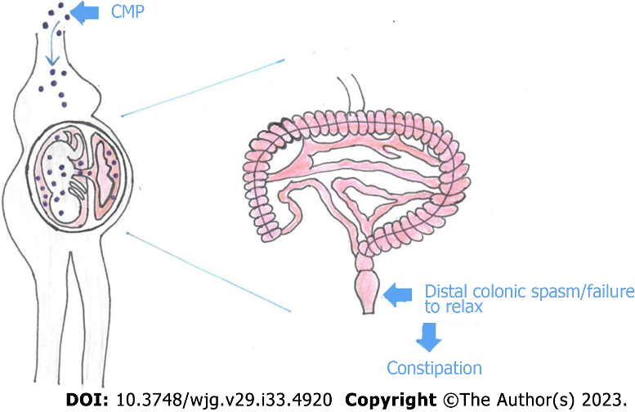
Figure 1 How cow’s milk protein allergen from maternal diet passes into the fetus causing distal colon spasm or failure to relax leading to Hirschsprung’s disease-like constipation. As mentioned in the text, the suspected mechanism involves neuromodulation of the enteric nervous system, with increased anal pressure at rest. CMP: Cow’s milk protein.

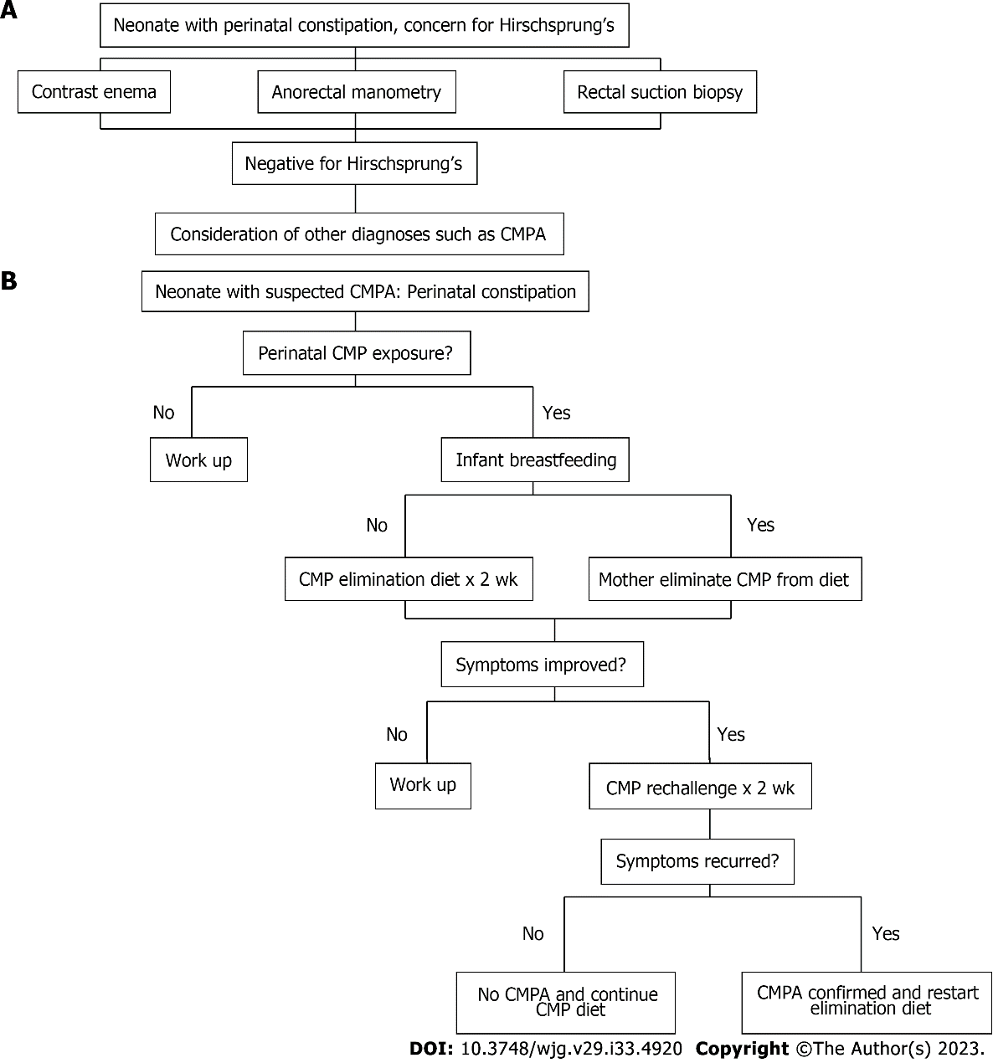
Figure 2 Two algorithms for clinical management of patients with intractable early onset perinatal constipation. A: Top-down approach and current guideline for management of perinatal constipation. B: Bottom-up approach; new guideline to consider which suspects cow’s milk protein allergy as a diagnosis. CMP: Cow’s milk protein; CMPA: Cow’s milk protein allergy.

Table 1 Incidences of various diagnoses in infants with very early-onset constipation
Diagnosis | Incidence | Ref.
Hirschsprung’s disease | 0.025% | Loening-Baucke and Kimura^{[2]}
Meconium plug syndrome | 0.1%-0.2 | Loening-Baucke and Kimura^{[2]}
Meconium ileus | 0.04 | Loening-Baucke and Kimura^{[2]}
Anorectal malformation | 0.025%-0.05% | Loening-Baucke and Kimura^{[2]}
CMPA | 0.5%-17% | Høst^{[10]}, Rona et al^{[12]}
CMPA: Cow’s milk protein allergy.

Table 2 Relative frequencies of Hirschsprung’s disease vs. cow’s milk protein allergy in infants with very early-onset constipation
Ref. | HD (%) | CMPA (%)
Burge and Drewett^{[18]} | 38.1
Kubota et al^{[19]} | 34.6 | 65.4
Van Leeuwen et al^{[20]} | 25.0
Keckler et al^{[11]} | 13.0
Cheng et al (unpublished observation) | 8.0 | 92.0
CMPA: Cow’s milk protein allergy; HD: Hirschsprung’s disease.

Table 3 Comparison of atypical vs. typical cow’s milk protein allergy
 | Atypical CMPA | Typical CMPA
Time of onset | Perinatal period^{[3]} | Early infancy^{[21,22]}
Way of transmission of allergen | Vertically via placenta and amniotic fluid^{[3]} | Vertically via breast feeding
 |  | Horizontally by oral ingestion^{[21,22]}
Typical presentation | Intractable constipation^{[5,6]} | Vomiting and diarrhea, bloody stools^{[21]}
Type of allergy reaction | Non IgE mediated^{[5]} | IgE mediated^{[5]}
Tissues involved | Enteric neurons and smooth muscle^{[5-8]} | Intestinal mucosa^{[5]}
Mechanism involved | Immune mediated neuromuscular dysfunction leading to persistent spasm or failure to relax of the anorectum (HD like changes)^{[5-8]} | Allergic enterocolitis^{[5]}
Diagnosis | CMP avoidance and challenge. Both blood and skin allergy testings are of no diagnostic value^{[9]} | CMP avoidance and challenge with or without blood and skin allergy testing^{[21]}
Treatment | CMP avoidance^{[9]} | CMP avoidance^{[9]}
Awareness to providers | Rarely aware/reported | Well known/reported
CMP: cow’s milk protein; CMPA: cow’s milk protein allergy; HD: Hirschsprung’s disease; IgE: Immunoglobulin E.

Published by Baishideng Publishing Group Inc
7041 Koll Center Parkway, Suite 160, Pleasanton, CA 94566, USA
Telephone: +1-925-3991568
E-mail: bpgoffice@wjgnet.com
Help Desk: https://www.f6publishing.com/helpdesk
https://www.wjgnet.com

© 2023 Baishideng Publishing Group Inc. All rights reserved.

