Name of Journal: World Journal of Gastroenterology
ESPS Manuscript NO: 29181
Manuscript Type: CASE REPORT

Response to olaparib in BRCA1-mutated gallbladder cancer: A case report

Xie Y et al. BRCA1-mutated gallbladder cancer

Yuan Xie, Xiao-bo Yang, An-qiang Wang, Yong-chang Zheng, Xue-shuai Wan, Xin-ting Sang, Da-dong Zhang, Jia-jia Xu, Kai Wang, Fu-gen Li, Hai-tao Zhao

Yuan Xie, Xiao-bo Yang, An-qiang Wang, Yong-chang Zheng, Xue-shuai Wan, Xin-ting Sang, Hai-tao Zhao, Department of Liver Surgery, Peking Union Medical College Hospital, Chinese Academy of Medical Sciences and Peking Union Medical College, Beijing 100730, China

Da-dong Zhang, Jia-jia Xu, Kai Wang, Fu-gen Li, Institute of Precision Medicine, 3D Medicines Inc., Shanghai 201114, China

Author contributions: Xie Y and Yang XB contributed equally to this work; Wang AQ, Zheng YC, Wan XS made a follow-up for the patient; Zhang DD, Xu JJ, Wang K provided genetic analysis for the variants tested in the patient; Li FG analyzed the genetic data and revised the manuscript; Sang XT and Zhao HT provided financial support for this work; Xie Y and Yang XB wrote the paper; all authors have read and approved the final manuscript.

Supported by International Science and Technology Cooperation Projects, No. 2015DFA30650 and No. 2010DFB33720; Capital Special Research Project for Health Development, No. 2014-2-4012; and Capital research project for the characteristics clinical application, No. Z151100004015170.

Institutional review board statement: The publication of this manuscript has been reviewed and approved by the PUMCH institutional review board.

Informed consent statement: The patient and his family signed informed consent before gene test and drug treatment.

Conflict-of-interest statement: We declare that the authors have no conflict of interest.

Open-Access: This article is an open-access article which was selected by an in-house editor and fully peer-reviewed by external reviewers. It is distributed in accordance with the Creative Commons Attribution Non Commercial (CC BY-NC 4.0) license, which permits others to distribute, remix, adapt, build upon this work non-commercially, and license their derivative works on different terms, provided the original work is properly cited and the use is non-commercial. See: http://creativecommons.org/licenses/by-nc/4.0/

Manuscript source: Unsolicited manuscript

Correspondence to: Hai-tao Zhao, MD, Department of Liver Surgery, Peking Union Medical College Hospital, Chinese Academy of Medical Sciences and Peking Union Medical College, 1 Shuaifuyuan, Wangfujing, Beijing 100730, China. zhaoht@pumch.cn
Telephone: +86-10-69156042
Fax: +86-10-69156042

Received: July 31, 2016
Peer-review started: August 1, 2016
First decision: August 19, 2016
Revised: September 1, 2016
Accepted: September 28, 2016
Article in press:
Published online:

Abstract
Gallbladder cancer (GBC), although considered as a relatively rare malignancy, is the most common neoplasm of the biliary tract system. The late diagnosis and abysmal prognosis present challenges to treatment. The overall 5-year survival rate for metastatic GBC patients is extremely low. BRCA1 and BRCA2 are the breast cancer susceptibility genes and their mutation carriers are at a high risk for cancer development, both in men and women. Olaparib, an oral poly ADP-ribose polymerase inhibitor, has been approved by Food and Drug Administration and European commission for the treatment of ovarian cancer with any BRCA1/2 mutations. The first case of a BRCA1-mutated GBC patient responded to olaparib treatment is reported here.

Key words: BRCA; Mutation; Olaparib; poly ADP-ribose polymerase inhibitor; Gallbladder cancer

© The Author(s) 2016. Published by Baishideng Publishing Group Inc. All rights reserved.

Core tip: Gallbladder cancer (GBC) is the most common neoplasm of the biliary tract system. BRCA1, the first major breast cancer susceptibility gene, has been widely studied in breast and ovarian cancers. Olaparib, an oral poly ADP-ribose polymerase (PARP) inhibitor, has been approved by FDA and European commission for the treatment of ovarian cancer with any BRCA1/2 mutations. However, there is no report of germline BRCA1 functional mutation in GBC prior to this case. Even further the GBC with BRCA1 mutation responded to PARP inhibitor olaparib.

Xie Y, Yang Xb, Wang Aq, Zheng Yc, Wan Xs, Sang Xt, Zhang Dd, Xu Jj, Wang K, Li Fg, Zhao Ht. Response to olaparib in BRCA1-mutated gallbladder cancer: A case report. World J Gastroenterol 2016; In press

INTRODUCTION
Gallbladder cancer (GBC) derives from the mucosal epithelial lining of the gallbladder and the cystic duct. It is a relatively rare malignancy but the most frequent malignant neoplasm of the biliary tract system. Epidemiological studies have demonstrated that the incidence of GBC is characterized by remarkable geographic distribution and ethnic disparities. The incidence is extraordinarily high in American Indians, elevated in Southeast Asia and quite low elsewhere in the Americas^{[1]}. Although GBC limits in Southeast Asia, with increasing global migration, the incidence is also increasing in the west, and spreads worldwide. The prognosis of GBC is dismal and the median survival for locally advanced GBC with non-surgically treatment is about 8 mo^{[2]}. Some patients detected incidentally during routine cholecystectomy for cholelithiasis have a long-term survival, but they only account for 2% of all cases with GBC^{[3].} Clinically, the adjuvant treatment for GBC is gemcitabine or 5-fluorouracil (5-FU)-based chemotherapy, with or without radiotherapy^{[4]}. Even though response rate remains low, there is no effective treatment. Here we reported that a BRCA1-mutated GBC patient responded to poly ADP-ribose polymerase inhibitor (PARPi) olaparib.

CASE REPORT
A 74-year-old man, with a past history of primary hypertension, atrial fibrillation, coronary disease and cholelithiasis, presented with epigastric pain. The patient underwent a robot-assisted prostate cancer surgery on November 29, 2013 and his mother had died of esophageal cancer. Computed tomography (CT) of the abdomen revealed multiple low-density intrahepatic lesions besides gallbladder on May 7, 2015. PET-CT revealed multiple hypermetabolic intrahepatic lesions apart from porta hepatis on May 14, 2015. A laparoscopic exploration was performed and an intrahepatic biopsy was conducted on May 26, 2015. Histologic examination indicated GBC (Figure 1). Considering the dismal prognosis and his poor physical conditions, systemic chemotherapy was not preferred. After obtained consent from the patient and his family, we tested the tissue. Two specimens from different liver metastases and blood sample have been sent for next generation sequencing panel. We detected all genomic alteration types on over 390 genes commonly associated with cancers and found a somatic MET P1086A mutation in one of two liver metastases. But there was no literature to confirm this was a functional mutation. Bioinformatics analysis also suspected MET P1086A could have impact on MET function. However, we also detected a germinal BRCA1 Q858* mutation in both liver metastases and further Sanger sequencing confirmed this result (Figure 2). Furthermore, the patient’s offspring and siblings also had been done for BRCA mutation screening from their saliva samples and some family members were also BRCA1 Q858* mutation carriers (Figure 3). The nonsense mutation may lead to the premature termination of BRCA1 protein translation and nonsense-mediated mRNA decay (NMD), and the loss-of-function disenables its involvement in transcriptional regulation of gene expression and repair of DNA damage, particularly double-strand breaks^{[5]}. Several studies have demonstrated that BRCA1 mutations increase the risks of breast, ovarian, prostate and pancreatic cancer^{[5-7]}. Poly ADP-ribose polymerase (PARP) inhibitors have been studies as potential cancer therapeutics by inhibiting base excision repair as well as trapping PARP^{[8,9]}. A number of clinical trials have shown patients with germline BRCA1/2 mutation, especially in breast and ovarian cancer to PARP inhibitor olaparib with survival benefit^{[10-12]}. Based on the gene alteration testing report and the clinical trial studies, the patient was started on olaparib 400 mg twice daily on July 21, 2015 (Figure 4). The patient can tolerate the dose and subsequently his pain was relieved significantly. On August 23, 2015, CT of the abdomen revealed the shrinkage of both intra and extra hepatic lesions and even some extra hepatic lesions appeared to be invisible (Figure 5). The patient responded well to olaparib until the occurrence of obstructive jaundice. On October 9, 2015, CT of the abdomen indicated that intrahepatic lesions dwindled, nevertheless, extrahepatic lesions became large and progressed (Figure 6). Subsequently, a PTCD was performed to reduce the serum bilirubin level and the olaparib treatment was suspended since then. We intended to resume olaparib treatment in combination with platinum agents after some while. Unfortunately, the patient passed away as a result of severe biliary tract infection on November 25, 2015.

DISCUSSION
Like other cancers, substantial molecular alterations in genes contribute to the pathogenesis of GBC. Hitherto, in the GBC, over 1450 single nucleotide variants (SNV), 34 deletions have been reported. The most frequent mutations are TP53 (18%-63%), KRAS, ERRB3 and ERBB2 (HER2)^{[13]}. BRCA1, the first major breast cancer susceptibility gene, has been widely studied in breast and ovarian cancers. However, there is no report of germline BRCA1 functional mutation in GBC prior to this case. Even further the GBC with BRCA1 mutation responded to PARP inhibitor olaparib.
Association of BRCA1/2 mutations with susceptibility to breast and ovarian cancer has been investigated for years. It is estimated that about 60% of women with BRCA1/2 mutations have developed breast cancer^{[14]}. A woman, who carries a germline BRCA1/2 mutation could be 5 times more likely to develop breast cancer than the one, who does not carry any BRCA1/2 mutation^{[15]}. Men who have BRCA1/2 mutations are more likely to have prostate or pancreatic cancers. Men are 3.5 times and 8.6 times more likely to develop prostate cancer for BRCA1 and BRCA2 mutation carriers by age 65, respectively^{[16]}. Similar to prostate cancer, BRCA1/2 poses a risk of pancreatic cancer development. Overall, BRCA1 mutation increases the risk by 0- to 4.11-fold, while the BRCA2 mutation increases the risk by 2.13- to 21.7-fold^{[17]}.
The BRCA proteins play a pivotal role in repair of double-strand DNA breaks (DSB) via homologous recombination (HR). Due to deficiency in BRCA proteins, BRCA-mutated cells are not capable of locating the DNA recombinase RAD51 to damaged DNA and hence are unable to perform HR efficiently. Subsequently, an error-prone DNA repair mechanism, such as nonhomologous end joining (NHEJ), is compelled to use by cells, which often leads to cell death. Base excision repair (BER), as one of single strand DNA break (SSB) repair mechanism, is crucial to address damaged single strand DNA. Olaparib is an oral PARPi, and it has been approved by FDA and European commission for the treatment of ovarian cancer with any BRCA1/2 mutations in 2014. Olaparib, by means of blocking base excision repair, can convert single-strand DNA breaks to double-strand breaks, which gives rise to selective death of HR-deficient tumor cells. Mounting Evidence has indicated that BRCA-mutated cancers are highly sensitive to PARP inhibitors and platinum agents. Compared with wild-type cells, BRCA-mutated cells are 1000-fold and 5-fold more sensitive to PARPi and platinum agents respectively^{[18,19]}.
In this case, we observed that the intrahepatic lesions had a favourable response to olaparib, while the extrahepatic lesions had a progression with the emergence of olaparib resistance. Despite olaparib holds considerable promise in targeted therapies for BRCA-mutated breast or ovarian cancers, drug resistance has became of a potential issue. As far, several resistance mechanisms have been proposed. Olaparib-triggered, secondary BRCA mutations are perhaps considered as the most well-validated mechanism in patients, others include up-regulation of PgP transporter, loss of 53BP1 as well as PARP expression^{[20-22]}. The comprehensive genomic alteration testing may provide novel clinical strategies for personalized therapy in advanced GBC. More mechanisms for the chemoresistance are expected to explore and understand in the future, which will help re-sensitize tumor cells to PARPi and improve the long-term effectiveness.

COMMENTS
Case characteristics
A 74-year-old man, with a past history of primary hypertension, atrial fibrillation, coronary disease and cholelithiasis, presented with epigastric pain.

Clinical diagnosis
The physical examination revealed tenderness of the epigastrium, without rebound tenderness and muscle tonus.

Differential diagnosis
Hepatocellular carcinoma, intrahepatic cholangiocarcinoma, metastatic lesions of non-hepatic origins, gallbladder cancer.

Laboratory diagnosis
The blood test for tumor markers revealed elevation of carbohydrate antigen (CA) 19-9 (4815.0 U/mL) and carcinoembryonic antigen (CEA) (12.5 ng/mL), while alpha-fetoprotein (AFP) and prostate specific antigen (PSA) were within normal limits. The blood test for liver function revealed elevation of total bilirubin (TBil) (23.0 μmol/L)and direct bilirubin (DBil) (9.2 μmol/L), while alanine aminotransferase (ALT) was within normal limit and the test for hepatitis virus was negative.

Imaging diagnosis
Computed tomography (CT) revealed multiple low-density intrahepatic lesions besides gallbladder. Positron emission tomography–CT (PET-CT) revealed multiple hypermetabolic intrahepatic lesions apart from porta hepatis.

Pathological diagnosis
Pathological examination revealed gallbladder cancer with hepatic infiltration.

Treatment
The patient underwent a laparoscopic exploration and an intrahepatic biopsy. Two specimens from different liver metastases and blood sample had been sent for next generation sequencing panel. A germinal BRCA1 Q858* mutation in both liver metastases had been detected and further Sanger sequencing confirmed this result. Based on the gene alteration testing report and the clinical trial studies, the patient was started on olaparib 400 mg twice daily.

Related reports
There is no report of germline BRCA1 functional mutation in gallbladder cancer prior to this case. Even further the gallbladder cancer with BRCA1 mutation responded to PARP inhibitor olaparib.

Term explanation
BRCA1, the first major breast cancer susceptibility gene, has been widely studied in breast and ovarian cancers, their mutation carriers are at a high risk for cancer development. Olaparib, an oral poly ADP-ribose polymerase (PARP) inhibitor, has been approved by FDA and European commission for the treatment of ovarian cancer with any BRCA1/2 mutations.

Experiences and lessons
This case report describes the response of a germline BRCA1-mutated gallbladder cancer patient to poly ADP-ribose polymerase inhibitor (PARPi) olaparib. While the comprehensive genomic alteration testing may provide novel clinical strategies for personalized therapy in advanced gallbladder cancer, drug resistance has become of a potential issue. More discoveries concerning the mechanisms for chemoresistance will help re-sensitize tumor cells to PARPi and improve the long-term effectiveness.

Peer-review
This is a very interesting case report. In this manuscript, the authors reported a 74-year-old man, with a past history of primary hypertension, atrial fibrillation, coronary disease and cholelithiasis, presented with epigastric pain.

REFERENCES
1 Hundal R, Shaffer EA. Gallbladder cancer: epidemiology and outcome. Clin Epidemiol 2014; 6: 99-109 [PMID: 24634588 DOI: 10.2147/CLEP.S37357]
2 Boutros C, Gary M, Baldwin K, Somasundar P. Gallbladder cancer: past, present and an uncertain future. Surg Oncol 2012; 21: e183-e191 [PMID: 23025910 DOI: 10.1016/j.suronc.2012.08.002]
3 Dutta U. Gallbladder cancer: can newer insights improve the outcome? J Gastroenterol Hepatol 2012; 27: 642-653 [PMID: 22168580 DOI: 10.1111/j.1440-1746.2011.07048.x]
4 Siegel R, Ma J, Zou Z, Jemal A. Cancer statistics, 2014. CA Cancer J Clin 2014; 64: 9-29 [PMID: 24399786 DOI: 10.3322/caac.21208]
5 Ferrone CR, Levine DA, Tang LH, Allen PJ, Jarnagin W, Brennan MF, Offit K, Robson ME. BRCA germline mutations in Jewish patients with pancreatic adenocarcinoma. J Clin Oncol 2009; 27: 433-438 [PMID: 19064968 DOI: 10.1200/JCO.2008.18.5546]
6 Friedenson B. The BRCA1/2 pathway prevents hematologic cancers in addition to breast and ovarian cancers. BMC Cancer 2007; 7: 152 [PMID: 17683622 DOI: 10.1186/1471-2407-7-152]
7 Friedenson B. BRCA1 and BRCA2 pathways and the risk of cancers other than breast or ovarian. MedGenMed 2005; 7: 60 [PMID: 16369438]
8 Murai J, Huang SY, Das BB, Renaud A, Zhang Y, Doroshow JH, Ji J, Takeda S, Pommier Y. Trapping of PARP1 and PARP2 by Clinical PARP Inhibitors. Cancer Res 2012; 72: 5588-5599 [PMID: 23118055 DOI: 10.1158/0008-5472.CAN-12-2753]
9 Bryant HE, Schultz N, Thomas HD, Parker KM, Flower D, Lopez E, Kyle S, Meuth M, Curtin NJ, Helleday T. Specific killing of BRCA2-deficient tumours with inhibitors of poly(ADP-ribose) polymerase. Nature 2005; 434: 913-917 [PMID: 15829966 DOI: 10.1038/nature03443]
10 Audeh MW, Carmichael J, Penson RT, Friedlander M, Powell B, Bell-McGuinn KM, Scott C, Weitzel JN, Oaknin A, Loman N, Lu K, Schmutzler RK, Matulonis U, Wickens M, Tutt A. Oral poly(ADP-ribose) polymerase inhibitor olaparib in patients with BRCA1 or BRCA2 mutations and recurrent ovarian cancer: a proof-of-concept trial. Lancet 2010; 376: 245-251 [PMID: 20609468 DOI: 10.1016/S0140-6736(10)60893-8]
11 Gelmon KA, Tischkowitz M, Mackay H, Swenerton K, Robidoux A, Tonkin K, Hirte H, Huntsman D, Clemons M, Gilks B, Yerushalmi R, Macpherson E, Carmichael J, Oza A. Olaparib in patients with recurrent high-grade serous or poorly differentiated ovarian carcinoma or triple-negative breast cancer: a phase 2, multicentre, open-label, non-randomised study. Lancet Oncol 2011; 12: 852-861 [PMID: 21862407 DOI: 10.1016/S1470-2045(11)70214-5]
12 Ledermann J, Harter P, Gourley C, Friedlander M, Vergote I, Rustin G, Scott C, Meier W, Shapira-Frommer R, Safra T, Matei D, Macpherson E, Watkins C, Carmichael J, Matulonis U. Olaparib maintenance therapy in platinum-sensitive relapsed ovarian cancer. N Engl J Med 2012; 366: 1382-1392 [PMID: 22452356 DOI: 10.1056/NEJMoa1105535]
13 Bizama C, García P, Espinoza JA, Weber H, Leal P, Nervi B, Roa JC. Targeting specific molecular pathways holds promise for advanced gallbladder cancer therapy. Cancer Treat Rev 2015; 41: 222-234 [PMID: 25639632 DOI: 10.1016/j.ctrv.2015.01.003]
14 Foulkes WD, Shuen AY. In brief: BRCA1 and BRCA2. J Pathol 2013; 230: 347-349 [PMID: 23620175 DOI: 10.1002/path.4205]
15 Cavanagh H, Rogers KM. The role of BRCA1 and BRCA2 mutations in prostate, pancreatic and stomach cancers. Hered Cancer Clin Pract 2015; 13: 16 [PMID: 26236408 DOI: 10.1186/s13053-015-0038-x]
16 Castro E, Eeles R. The role of BRCA1 and BRCA2 in prostate cancer. Asian J Androl 2012; 14: 409-414 [PMID: 22522501 DOI: 10.1038/aja.2011.150]
17 Luo G, Lu Y, Jin K, Cheng H, Guo M, Liu Z, Long J, Liu C, Ni Q, Yu X. Pancreatic cancer: BRCA mutation and personalized treatment. Expert Rev Anticancer Ther 2015; 15: 1223-1231 [PMID: 26402249 DOI: 10.1586/14737140.2015.1086271]
18 Farmer H, McCabe N, Lord CJ, Tutt AN, Johnson DA, Richardson TB, Santarosa M, Dillon KJ, Hickson I, Knights C, Martin NM, Jackson SP, Smith GC, Ashworth A. Targeting the DNA repair defect in BRCA mutant cells as a therapeutic strategy. Nature 2005; 434: 917-921 [PMID: 15829967 DOI: 10.1038/nature03445]
19 Bhattacharyya A, Ear US, Koller BH, Weichselbaum RR, Bishop DK. The breast cancer susceptibility gene BRCA1 is required for subnuclear assembly of Rad51 and survival following treatment with the DNA cross-linking agent cisplatin. J Biol Chem 2000; 275: 23899-23903 [PMID: 10843985 DOI: 10.1074/jbc.C000276200]
20 Lord CJ, Ashworth A. Mechanisms of resistance to therapies targeting BRCA-mutant cancers. Nat Med 2013; 19: 1381-1388 [PMID: 24202391 DOI: 10.1038/nm.3369]
21 Tangutoori S, Baldwin P, Sridhar S. PARP inhibitors: A new era of targeted therapy. Maturitas 2015; 81: 5-9 [PMID: 25708226 DOI: 10.1016/j.maturitas.2015.01.015]
22 Montoni A, Robu M, Pouliot E, Shah GM. Resistance to PARP-Inhibitors in Cancer Therapy. Front Pharmacol 2013; 4: 18 [PMID: 23450678 DOI: 10.3389/fphar.2013.00018]
P-Reviewer: Charco R, Lee MW, Tsegmed U S-Editor: Gong ZM
L-Editor: E-Editor:
Specialty type: Gastroenterology and hepatology
Country of origin: China
Peer-review report classification
Grade A (Excellent): 0
Grade B (Very good): b, b, b
Grade C (Good): 0
Grade D (Fair): 0
Grade E (Poor): 0

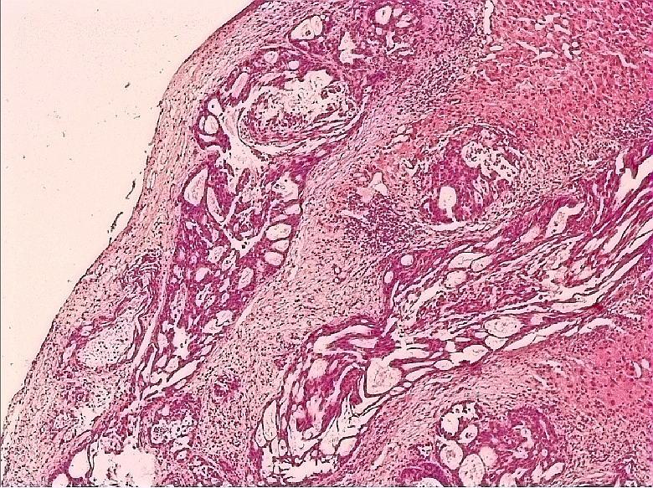
Figure 1 Histologic examination indicated gallbladder cancer with hepatic infiltration.

Figure 2 Genomic images from the integrated genome viewer for the alteration in BRCA1 found in the patient’s blood sample. The number of reads for the reference allele and variant allele are shown for each alteration.

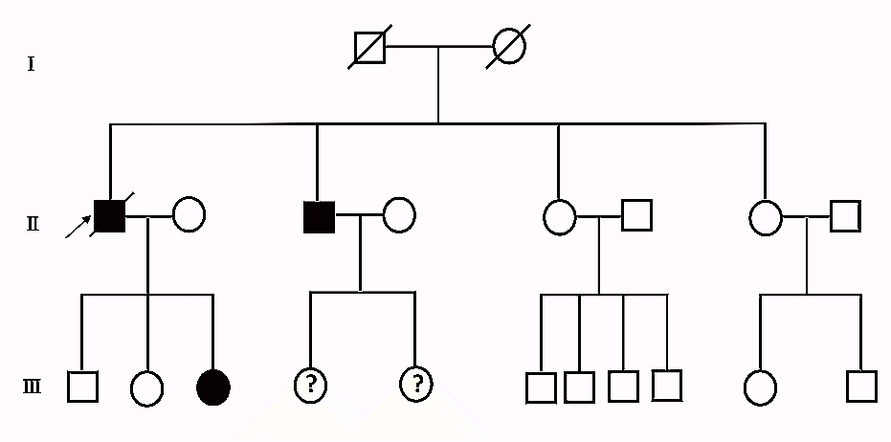
Figure 3 Pedigree of 74-year-old man affected by gallbladder cancer found to be carrier of BRCA1 gene mutation (indicated with arrow). Black denotes carrier of BRCA1 mutation.

Figure 4 baseline (July 21, 2015) computed tomography of the abdomen revealed many intra and extra hepatic lesions when to initiate olaparib treatment.

Figure 5 One month post-olaparib treatment (August 23, 2015). computed tomography of the abdomen revealed the shrinkage in both intra and extra hepatic lesions and even extra hepatic lesions appeared to be invisible.

Figure 6 Two and half months post-olaparib treatment (October 9, 2015). computed tomography of the abdomen indicated that intrahepatic lesions dwindled, nevertheless, extrahepatic lesions became large and progressed.

