Name of Journal: World Journal of Orthopedics
Manuscript NO: 79993
Manuscript Type: EDITORIAL

Osteoarthritis, an old wine in a new bottle!

Muthu S. Subtypes in osteoarthritis

Sathish Muthu

Sathish Muthu, Department of Orthopaedics, Government Medical College, Dindigul 624001, India

Sathish Muthu, Department of Orthopaedics, Orthopaedic Research Group, Coimbatore 641045, Tamil Nadu, India

Sathish Muthu, School of Engineering and Technology, Sharda University, Greater Noida 201310, Uttar Pradesh, India

Author contributions: Muthu S performed the conceptualisation, data curation, data analysis, and manuscript writing and revision.

Corresponding author: Sathish Muthu, MS, Assistant Professor, Research Associate, Department of Orthopaedics, Government Medical College, Adiyanoothu Village, Dindigul 624001, India. drsathishmuthu@gmail.com

Received: September 13, 2022
Revised: November 30, 2022
Accepted: December 21, 2022
Published online: January 18, 2023

Abstract
Osteoarthritis (OA) is the most common form of arthritis that has a major impact on patient morbidity and health care services. Despite its prevalence and impact, we do not have any effective management strategy to prevent or control their manifestations. Several decades of pharmacological development have failed to deliver a disease-modifying solution to OA. This editorial article outlines the lacunae in the research efforts of the past, the challenges that we are facing at present, and the exciting opportunities we have in the future for the management of OA. OA research has to be made more personalized concerning the phenotypic and endotypic disease variants. To begin with, robust disease classification criteria need to be defined for early OA, and biomarkers to detect such early diseases to aid in patient stratification. We also need to refine our clinical research design to make them more objective to meet the demands of the patient and the regulatory agencies. Embracing the current technologies such as artificial intelligence along with the use of genomic profiling from the omics platforms, the future of OA is more promising in developing appropriate management of OA.

Key Words: Osteoarthritis; Management; Phenotypes; Endotypes; Theratypes

©The Author(s) 2023. Published by Baishideng Publishing Group Inc. All rights reserved.

Citation: Muthu S. Osteoarthritis, an old wine in a new bottle!. World J Orthop 2023; 14(1): 1-5
URL: https://www.wjgnet.com/2218-5836/full/v14/i1/1.htm
DOI: https://dx.doi.org/10.5312/wjo.v14.i1.1

Core Tip: We analyzed the current landscape of management of osteoarthritis (OA) and identified the challenges we are facing to develop an effective management strategy for OA at present and commented on the exciting opportunities available in the future. We also detailed the patient stratification based on the phonotypic and endotypic disease variants. We suggest that by embracing the current technologies such as artificial intelligence, and genomic profiling of patients, personalized management of OA is amenable with predictable results tailored for individual patient needs.
INTRODUCTION
Osteoarthritis (OA) remains the most common form of arthritis causing a huge burden on the health care system^{[1]}. The prevalence of the disease keeps on increasing due to the aging population compounded by the increasing obesity epidemic. But we do not find comparable progress in disease control and its management options^{[2]}. Over the past 3 decades, all the pharmacological ventures to develop a disease-modifying OA drug (DMOADS) have resulted in disappointing results making OA a “graveyard of drug development”^{[3]}. Any drug that is being developed for OA cannot impact the structure of the joint as seen by radiographs and this has been the key reason for failure in the past decades of drug development for OA^{[4]}. The clear expectations of the regulatory agencies such as the United States Food and Drug Administration for any DMOADs involve establishing the impact of the drugs on the subjective patient feeling, improvement in their function, and prolonged joint survival following the treatment^{[5]}.

OA phenotypes
OA is now being understood as a multifaceted heterogeneous disease with multiple causative factors, clinical phenotypes, and molecular endotypes^{[6]}. The clinical phenotypes in OA refer to the cluster of visible properties such as associated mechanical deformities that individualize the disease expression in a certain group of patients^{[7]}. Similarly, a comprehensive set of such visible parameters including age, sex, race, disease duration, symptoms, and radiological features such as joint space narrowing, osteophytes, and subchondral sclerosis needs to be utilized to characterize the patient's response to the treatment outcomes. The various phenotypes proposed for OA include chronic pain phenotype, inflammatory phenotype, metabolic syndrome phenotype, mechanical overload phenotype, minimal joint disease phenotype, senescent phenotype, endocrine phenotype, and sarcopenic phenotype as shown in Figure 1^{[6,8,9]}. Prospective studies are needed to validate the efficacy of these phenotypic subtype-based management methods to surpass or prevent symptoms at an early stage before progressive and irreversible changes occur^{[10]}.

OA endotypes
While the clinical phenotypes describe the presenting features of the OA individual, endotypes refer to the compilation of disease mechanisms that explains the disease expression in the group of patients. In OA, the disease expression is mostly based on a few typical endotypes such as inflammatory endotype, metabolic syndrome endotype, senescent endotype, endocrine endotype, and senescent endotype with characteristic biomarkers in serum and synovial fluid of the joint^{[6]}. The biomarkers used in defining a characteristic endotype involve cartilage matrix destruction markers, proteases, subchondral bone matrix destruction markers, signaling markers, synovial inflammatory markers, and systemic inflammatory markers^{[11,12]}. Hence a typical OA endotype may present as various OA phenotypes and on the contrary, every OA phenotype may have an overlap with various OA endotypes as illustrated in Figure 1 before presenting as an end-stage disease. Angelini et al^{[11]} in their endotypic stratification based on clustering of biochemical marker data was proved to potentially drive the stratification of the clinical studies and contribute to precision medicine strategies for OA progression in the future.

Current challenges
Having identified OA to be a multifactorial, heterogenous, multi-dimensional complex disease, the challenges before us to develop DMOADs include the introduction of the OA phenotypes and endotypes into clinical study designs to test the efficacy of biomarkers and newly developed DMOADs. Although we have various newer ortho-rheumatological tools to grade joint degeneration^{[13]}, we do not have a defined early disease identification and categorization tool to embark on the enrolment of patients in clinical studies. We do not have the necessary genetic and polyomic tools to stratify patients into therapeutic subgroups to test their efficacy. However, by harmonizing the data collection from the clinical studies in OA, true stratification of the patients by clinical data from all the interventional and observational studies provides the future to predict the response to treatment^{[14]}. Current research has identified various key biomarkers such as oncostatin M, a cytokine from the interleukin-6 family, and metabolite of C-reactive protein was identified as candidate biomarkers to stratify the patients of inflammatory subtype^{[12]}. However, the list is not sufficient to comprehensively enlist all the OA subtypes into their appropriate phenotypic and endotypic subclassification to tailor their clinical management algorithms.

Future research perspectives
Before the development of therapeutic DMOADs, measures to develop a robust early classification criterion for OA need to be established. The other main focus of future research in OA involves identifying the key biomarkers that would enable the categorization of OA patients into individual subtypes for optimal management. This involves studying the disease at a molecular level in the early stages without evident radiographic changes which enables us to distinguish between the molecular endotypes and corresponding phenotypes before all the phenotypes coalesce into a final common presentation as classical end-stage OA as shown in Figure 1.
Further, research on the key biomarkers that differentiate between the different subgroups of OA needs to be identified. The current platforms (e.g., omics techniques) help in the assessment of a panel of markers to find their relationship with a particular phenotype rather than just a few markers tested in the conventional methods. The ideal substrate suitable for such categorization might be the local biochemical markers (e.g., synovial fluid) that better distinguishes the molecular endotypes free from the systemic sources with noise such as comorbidities. With the identified phenotypic and endotypic markers in OA, we can identify the potential theratypes in OA where predicted treatment responses could be contemplated based on their endotypic categorization.

CONCLUSION
Tailoring an effective early management strategy for OA involves the development of early disease identification methods, and disease stratification algorithms based on the distinctive phenotypic and endotypic expression in the individuals using their molecular signature patterns. The future of OA management is focussed more on prevention and early identification of disease process rather than redemption of the joint from an end-stage disease.

ACKNOWLEDGEMENTS
I thank the Editorial team of the World Journal of Orthopaedics for considering this Editorial for their reputed journal despite being a non-commissioned article.

REFERENCES
1 Zhang Y, Jordan JM. Epidemiology of osteoarthritis. Clin Geriatr Med 2010; 26: 355-369 [PMID: 20699159 DOI: 10.1016/j.cger.2010.03.001]
2 Hunter DJ, March L, Chew M. Osteoarthritis in 2020 and beyond: a Lancet Commission. Lancet 2020; 396: 1711-1712 [PMID: 33159851 DOI: 10.1016/S0140-6736(20)32230-3]
3 Wan J, Zhang J, Tao W, Jiang G, Zhou W, Pan J, Xiong W, Guo H. [A report of first fatal case of H10N8 avian influenza virus pneumonia in the world]. Zhonghua Wei Zhong Bing Ji Jiu Yi Xue 2014; 26: 120-122 [PMID: 24524404 DOI: 10.3760/cma.j.issn.2095-4352.2014.02.013]
4 Latourte A, Kloppenburg M, Richette P. Emerging pharmaceutical therapies for osteoarthritis. Nat Rev Rheumatol 2020; 16: 673-688 [PMID: 33122845 DOI: 10.1038/s41584-020-00518-6]
5 Kim Y, Levin G, Nikolov NP, Abugov R, Rothwell R. Concept End Points Informing Design Considerations for Confirmatory Clinical Trials in Osteoarthritis. Arthritis Care Res (Hoboken) 2022; 74: 1154-1162 [PMID: 33345469 DOI: 10.1002/acr.24549]
6 Mobasheri A, van Spil WE, Budd E, Uzieliene I, Bernotiene E, Bay-Jensen AC, Larkin J, Levesque MC, Gualillo O, Henrotin Y. Molecular taxonomy of osteoarthritis for patient stratification, disease management and drug development: biochemical markers associated with emerging clinical phenotypes and molecular endotypes. Curr Opin Rheumatol 2019; 31: 80-89 [PMID: 30461544 DOI: 10.1097/BOR.0000000000000567]
7 Dório M, Deveza LA. Phenotypes in Osteoarthritis: Why Do We Need Them and Where Are We At? Clin Geriatr Med 2022; 38: 273-286 [PMID: 35410680 DOI: 10.1016/j.cger.2021.11.002]
8 Dell'Isola A, Allan R, Smith SL, Marreiros SS, Steultjens M. Identification of clinical phenotypes in knee osteoarthritis: a systematic review of the literature. BMC Musculoskelet Disord 2016; 17: 425 [PMID: 27733199 DOI: 10.1186/s12891-016-1286-2]
9 Berenbaum F. Deep phenotyping of osteoarthritis: a step forward. Ann Rheum Dis 2019; 78: 3-5 [PMID: 30154088 DOI: 10.1136/annrheumdis-2018-213864]
10 Im GI. The Concept of Early Osteoarthritis and Its Significance in Regenerative Medicine. Tissue Eng Regen Med 2022; 19: 431-436 [PMID: 35244885 DOI: 10.1007/s13770-022-00436-6]
11 Angelini F, Widera P, Mobasheri A, Blair J, Struglics A, Uebelhoer M, Henrotin Y, Marijnissen AC, Kloppenburg M, Blanco FJ, Haugen IK, Berenbaum F, Ladel C, Larkin J, Bay-Jensen AC, Bacardit J. Osteoarthritis endotype discovery via clustering of biochemical marker data. Ann Rheum Dis 2022; 81: 666-675 [PMID: 35246457 DOI: 10.1136/annrheumdis-2021-221763]
12 Henrotin Y. Osteoarthritis in year 2021: biochemical markers. Osteoarthritis Cartilage 2022; 30: 237-248 [PMID: 34798278 DOI: 10.1016/j.joca.2021.11.001]
13 Khanna M, Selvaraj P, Jeyaraman M, Muthu S, Khanna V. Degenerative Joint Scoring System-An Ortho-Rheumatological assessment tool. Clin Epidemiol Glob Health 2022; 16 [DOI: 10.1016/j.cegh.2022.101093]
14 Bernotiene E, Bagdonas E, Kirdaite G, Bernotas P, Kalvaityte U, Uzieliene I, Thudium CS, Hannula H, Lorite GS, Dvir-Ginzberg M, Guermazi A, Mobasheri A. Emerging Technologies and Platforms for the Immunodetection of Multiple Biochemical Markers in Osteoarthritis Research and Therapy. Front Med (Lausanne) 2020; 7: 572977 [PMID: 33195320 DOI: 10.3389/fmed.2020.572977]

Footnotes
Conflict-of-interest statement: The author declares no conflict of interest to disclose.

Open-Access: This article is an open-access article that was selected by an in-house editor and fully peer-reviewed by external reviewers. It is distributed in accordance with the Creative Commons Attribution NonCommercial (CC BY-NC 4.0) license, which permits others to distribute, remix, adapt, build upon this work non-commercially, and license their derivative works on different terms, provided the original work is properly cited and the use is non-commercial. See: https://creativecommons.org/Licenses/by-nc/4.0/

Provenance and peer review: Invited article; Externally peer reviewed.
Peer-review model: Single blind

Peer-review started: September 13, 2022
First decision: November 25, 2022
Article in press: December 21, 2022

Specialty type: Orthopedics
Country/Territory of origin: India
Peer-review report’s scientific quality classification
Grade A (Excellent): 0
Grade B (Very good): B
Grade C (Good): C
Grade D (Fair): D
Grade E (Poor): 0

P-Reviewer: Nambi G, Saudi Arabia; Rezus E, Romania; Zhou X, China S-Editor: Chen YL L-Editor: A P-Editor: Chen YL
Figure Legends
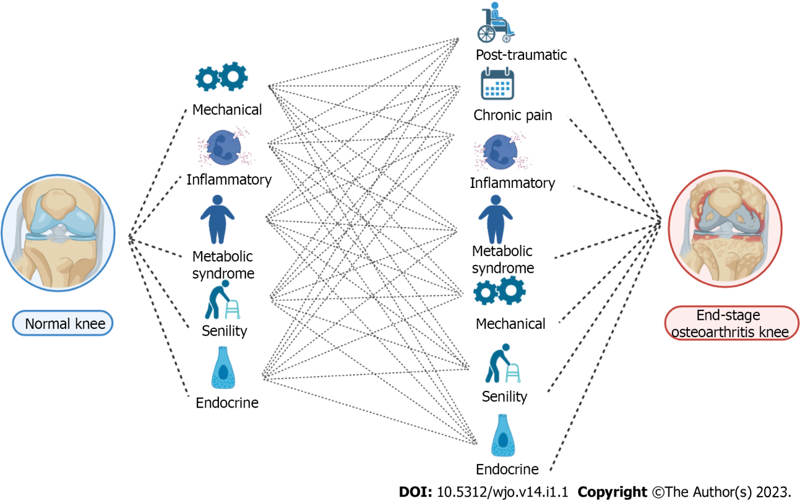
Figure 1 Illustration of the interplay between the various endotypes and phenotypes proposed in osteoarthritis.

Published by Baishideng Publishing Group Inc
7041 Koll Center Parkway, Suite 160, Pleasanton, CA 94566, USA
Telephone: +1-925-3991568
E-mail: bpgoffice@wjgnet.com
Help Desk: https://www.f6publishing.com/helpdesk
https://www.wjgnet.com

© 2023 Baishideng Publishing Group Inc. All rights reserved.

