Name of journal: World Journal of Gastroenterology
Manuscript NO: 31883
Manuscript Type: ORIGINAL ARTICLE

Basic Study
Intestinal anti-inflammatory activity of Ground Cherry (Physalis angulata L.) standardized CO₂ phytopharmaceutical preparation

Almeida-Junior et al. Groud Cherry in intestinal inflammation

Luiz Domingues Almeida Junior, Ana Elisa Valencise Quaglio, Celso Acácio Rodrigues de Almeida Costa, Luiz Claudio Di Stasi

Luiz Domingues Almeida Junior, Ana Elisa Valencise Quaglio, Celso Acácio Rodrigues de Almeida Costa, Luiz Claudio Di Stasi, Laboratory of Phytomedicines, Pharmacology and Biotechnology (PhytoPharmaTech), Department of Pharmacology, Institute of Biociences, Universidade Estadual Paulista UNESP, Botucatu, São Paulo, CEP 18618-970, Brazil

Author contributions: This paper was part of the Master research of Almeida Junior LD, who drafted the manuscript, was responsible for animal care and management, supervised and accompanied all of the experiments; Quaglio AEV contributed to perform the appropriate statistical treatments and supervised the molecular analyses; de Almeida Costa CAR accompanied of the experiments and contributed to the revision of the manuscript; Di Stasi LC is the senior author designed experiments, contributed to the draft, supervised the entire work and gave final approval of the manuscript.

Supported by São Paulo Research Foundation (FAPESP), No. 11/50512-2 and No. 15/15267-8; Fellowships: Almeida-Junior from Coordination for the Improvement of Higher Education Personnel (Brazilian Ministry of Education); Costa from São Paulo Research Foundation (FAPESP); and Quaglio and Di Stasi from National Council for Scientific and Technological Development (CNPq — Brazilian Ministry of Science and Technology).
Institutional animal care and use committee statement: Approved by the Ethical Committee for Animal Research (Protocol number 042/04-CEEA), Institute of Biosciences, Universidade Estadual Paulista (UNESP).
Conflict-of-interest statement: The authors declare that they have no conflicts of interest.

Open-Access: This article is an open-access article which was selected by an in-house editor and fully peer-reviewed by external reviewers. It is distributed in accordance with the Creative Commons Attribution Non Commercial (CC BY-NC 4.0) license, which permits others to distribute, remix, adapt, build upon this work non-commercially, and license their derivative works on different terms, provided the original work is properly cited and the use is non-commercial. See: http://creativecommons.org/licenses/by-nc/4.0/

Manuscript source: Invited manuscript

Correspondence to: Luiz Claudio Di Stasi, Professor, Laboratory of Phytomedicines, Pharmacology and Biotechnology (PhytoPharmaTech), Department of Pharmacology, Institute of Biosciences, Universidade Estadual Paulista UNESP, Botucatu, São Paulo, CEP 18618-970, Brazil. ldistasi@ibb.unesp.br
Telephone: +55-14-38800216
Fax: +55-14-38113744

Received: December 13, 2016
Peer-review started: December 14, 2016
First decision: February 9, 2017
Revised: February 25, 2017
Accepted: April 12, 2017
Article in press:
Published online:

Abstract
AIM
To investigate the effects of Ground Cherry (Physalis angulata L.) standardized supercritical CO₂ extract in trinitrobenzenesulphonic acid model of rat intestinal inflammation

METHODS
The animals were divided into groups that received vehicle or P. angulata extract (PACO₂) orally at the doses 25, 50 and 100 mg/kg daily by 5 days before TNBS damage. Protective effects of PACO₂ was performed by macroscopic analysis, biochemical determinations of the myeloperoxidase (MPO), alkaline phosphatase (AP), glutathione and cytokines such as INF-γ; IL-1β, IL-6, IL-10, TNF-α, gene expression evaluation, including Hsp70, heparanase, NF-kB, mitogen-activated protein kinases 1, 3, 6 and 9, mucins genes (Muc 1,2,3 and 4) and histopathological studies using optical, and electronic (transmission and scanning) microscopy.

RESULTS
PACO₂ extract promoted a significant reduction in MPO and AP activities, reducing oxidative stress and neutrophil infiltration. These effects were accompanied by significant reduction of colonic levels of IFN-γ and IL-6 and down-regulation of heparanase, Hsp70, Mapk3, Mapk9, Muc1 and Muc2 genes expression when compared with TNBs-control animals. In addition, protective effects were also evidenced by reduced neutrophil infiltration, recovery of cell architecture and replacement of mucin by histopathological and ultrastructural analysis.

CONCLUSION
Physalis angulata supercritical CO₂ extract is an intestinal anti-inflammatory product that modulates oxidative stress, immune response and expression of inflammatory mediators potentially useful to treat inflammatory bowel disease.

Key words: Intestinal disease; Inflammatory bowel disease; Physalis angulata L. trinitrobenzenosulfonic acid

© The Author(s) 2017. Published by Baishideng Publishing Group Inc. All rights reserved.

Core tip: We reported, at the first time, the protective effects of a supercritical CO₂ plant extract from aerial parts of Ground Cherry (Physalis angulata L.) in a model of intestinal inflammation induced by trinitrobenzenesulphonic acid in rats. The effects were related to presence of plant steroids, compounds chemically related to glucocorticoids, reference drug to treat human inflammatory bowel disease (IBD). The intestinal anti-inflammatory activity of Physalis angulata plant extract was related to its capacity to modulate oxidative stress, immune response and gene expression of inflammatory mediators. This way, the standardized plant extract of ground-cherry enriched with phytosterols is a potential product useful to treat IBD.

Almeida Junior LD, Quaglio AEV, de Almeida Costa CAR, Di Stasi LC. Intestinal anti-inflammatory activity of Ground Cherry (Physalis angulata L.) standardized CO₂ phytopharmaceutical preparation. World J Gastroenterol 2017; In press

Introduction
Inflammatory bowel disease (IBD) comprising ulcerative colitis (UC) and Crohn's disease (CD) are diseases of modern society associated with a modern and urbanized life style caused by an increase in stress, bad diet habits and sedentariness^{[1,2]}. CD and UC are chronic inflammatory disorders affecting the gastrointestinal tract characterized by periods of exacerbation followed by prolonged intervals of remission of symptoms^{[3,4]}. The etiopathogenesis of these diseases has not been fully elucidated, but is actually presumed to result from a complex interplay among genetic, environmental, microbial and immune factors^{[5]}. An exaggerated and inappropriate mucosal immune response mediated by mucosal T cells, triggers intense synthesis and release of several pro-inflammatory mediators including reactive species of oxygen and nitrogen, and a lot of pro and anti-inflammatory cytokines^{[6,7]}.
The available drugs such as 5-aminosalicylate derivatives, glucocorticoids, immunosuppressive and monoclonal antibodies have exhibited beneficial effects in the treatment of IBD, but not represent a definitive cure. Indeed, these drugs have several side effects, and many patients do not respond to these treatments^{[3,8,9]}. Dissatisfaction with current pharmacological treatments has resulted in an increased interest to use complementary medicine approaches, including medicinal plant extracts or natural active compounds^{[10]}. Based on this, our research group has been interested in studying the pharmacological activities of natural products against intestinal inflammation focusing in tropical medicinal plants, of which ground cherry (Physalis angulata L.) was selected based in ethnopharmacological, pharmacological and chemical data.
Ground cherry is a native Brazilian weed from Solanaceae family that grows especially in the Brazilian Amazon Forest and other tropical countries of Africa, America and Asia, where is traditionally used as an anti-inflammatory herbal product and to treat several health disorders such as cold, cough, fever, pain, malaria and nervous diseases^{[11,12]}. Fruits from ground cherry are used as food in several countries as a sophisticated food is salads. Reputed pharmacological effects such as antinociceptive, immunosuppressive, anti-protozoal, antineoplastic and anti-inflammatory have been associated to presence of sitosterol, stigmasterol and other phytosterols, the major components of plant extract^{[13-16]}.
Based on ethnopharmacological data, pharmacological and chemical studies, a standardized CO₂ supercritical preparation from aerial parts of P. angulata containing 10%-18% of phytosterols was patented by our research group, claiming corticoid-like effects evidenced by reduction of TNF-α, IL-6, IL1-β and COX-2 levels in non-stimulated and stimulated human fibroblasts and keratinocytes^{[17]}. In this work, we evaluated this standardized plant extract from P. angulata in a model of intestinal inflammation induced by trinitrobenzenesulphonic acid (TNBS) in rats.

Material and Methods

Plant material and extract standardization
Physalis angulata L. was cultivated using organic agricultural methods and submitted to taxonomic identification at herbarium Irina Gemtchujinikov (Department of Botany, Institute of Biosciences, Universidade Estadual Paulista – UNESP/SP/BR), where a voucher specimen was deposited. The aerial parts were collected, dehydrated in hothouse with air circulation and renewal, and pulverized in an industrial mill.
A supercritical extraction system (Autoclave Engineers) under the following conditions of 300 bar, 40 ºC and CO₂ flux of 5 L/min during 150 min was used to generate a supercritical CO₂ extract enriched with phytosterols, including sitosterol, stigmasterol and physalins, which are the main constituents from Physalis plants. The enrichment of supercritical CO₂ extract was compared with water: butileneglycol 1:1 extract and evaluated by Liebermann-Burchard reaction and ultraviolet spectrometry at 621 nm (Hewlett-Packard). P. angulata L. supercritical CO₂ extract (PACO₂) was standardized in 10-18% of total phytosterols and provided by Chemyunion Química Ltda (Sorocaba, Brazil).

Animals
Male Wistar rats (180–200 g) obtained from ANILAB – Animais de Laboratório, Paulínia, São Paulo (Brazil), were housed in standard environmental conditions (21 ºC, 60%–70% humidity) with 12 h light/dark cycle and air ﬁltration. Animals had free access to water and food (Biobase). Experimental protocols met the ‘‘Guidelines of Animal Experimentation’’ approved by the Ethical Committee for Animal Research (Protocol number 042/04-CEEA), Institute of Biosciences, Universidade Estadual Paulista (UNESP).

Induction of colitis and assessment of the inflammatory process
Colitis was induced using the method originally described by Morris^{[18]}. Brieﬂy, animals were fasted overnight and then anaesthetized. Under anesthesia, they were inoculated with 10 mg of trinitrobenzenesulphonic acid (TNBS) dissolved in 0.25 mL 50% ethanol (v/v) using a Teﬂon cannula inserted 8 cm into the anus. During and after TNBS administration, the rats remained in a head-down position until they recovered from the anesthesia.
Rats received 25, 50 or 100 mg/kg of the PACO₂ extract orally at 96, 72, 48, 24 and 2 h before colitis induction, using an esophageal catheter (volume: 10 mL/kg).Two additional groups were included for reference: a non-colitis group and a colitic group (TNBS-control group) that received vehicle (10 mL/kg methylcellulose) orally. The animal body weights, the occurrence of diarrhea (as detected by perianal fur soiling) and the total food intakes for each group were recorded daily. Animals from all groups (n = 7) were killed 48 h after colitis induction. The colonic segments were obtained after laparotomy and the adhesions eventual occurrence between the colon and adjacent organs were noted. These colonic segments were placed on an ice-cold plate, cleaned of fat and mesentery, blotted on ﬁlter paper, and the colon was weighed and its length measured under a constant load (2 g). The colon was opened longitudinally and scored for macroscopically visible damage on a 0–10 scale, according to Bell^{[19]}. Subsequently the colon was longitudinally divided into different pieces to be used for the determinations: myeloperoxidase (MPO), and alkaline phosphatase (AP) activity, total glutathione (GSH) content, IL-1β, IL-6, IL-10, TNF-α and INF-γ levels and gene expression analysis.

Biochemical assays in colonic specimens
Myeloperoxidase (MPO) activity was measured according to the technique described by Krawisz^{[20]} and the results are expressed as MPO units per g of wet tissue. Total Glutathione (GSH) content was quantiﬁed with the recycling assay^{[21]} and the results are expressed as nmol per g of wet tissue. Alkaline phosphatase (ALP) activity was measured spectrophotometrically as previously described and the results are expressed as mU per mg of protein^{[22,23]}. Quantification of cytokines (TNF-α, IL-1β, IL-6, IL-10, and INF-γ ) was made on colonic samples previously weighed, homogenized, minced on an ice-cold plate and resuspended in a centrifugation tube containing 10 mM/L phosphate buffered saline pH 7.4 (1:5 w/v). The tubes were placed in a shaker submerged in a 37 ºC water bath for 20 min and then centrifuged at 9000 g for 30 s at 4 ºC. The supernatants were frozen at -80 ºC until assayed. The TNF-α, IL-1β, IL-6, IL-10 and INF-γ levels were quantified by a DuoSet ELISA Kit to measure the concentration of the natural and recombinant rat enzyme according to the manufacturer’s instructions (R&D Systems, Inc., Minneapolis, Minnesota, USA). The results were expressed as pg per mL.

Gene expression analysis
Colon samples (100mg) were collected and stored in -80 °C until use for analyses of genes: GAPDH, β-actin, HPRT, HSP70, Heparanase, NF-κB, MAPK1, MAPK3, MAPK6, MAPK9, MUC1, MUC2, MUC3, MUC4. For the homogenization, were used 1ml of Trizol® (Invitrogen™ Life Technologies) and a Polytron. The total RNA extraction was made according to the Trizol® manufacturer’s protocol. The purity was determined by A₂₆₀/A₂₈₀ ratio using a Nanodrop 2000 (Thermo Scientific). After that, 1 µg from total RNA of colon tissue samples were incubated with DNAse I (1 U/mg RNA; Invitrogen™), and then reverse transcribed with SuperScript® III (200 U/ml; Life Technologies™) and oligo-d (T) primer. Primers for targets and reference genes were designed based on the rat sequences using IDT primer quest software (http://www.idtdna.com/primerquest/Home/Index; Invitrogen™). Relative real-time RT-PCR analysis was performed with a StepOne Plus™ (Applied Biosystems®) using Power SYBR Green PCR Master Mix® (Life Technologies™) for all the genes. Amplification efficiencies for target and reference genes were similar. The primer sequences, fragment size, annealing temperature, primer concentration, NCBI Reference Sequence and sample concentration for each gene are shown in Table 1.
Reactions were optimized to provide maximum amplification efficiency for each gene. PCR was performed in 25 µl reaction volumes in duplicate, in a MicroAmp® Fast Optical 96-Well Reaction Plate, 0.1 mL (Applied Biosystems®) and the specificity of each PCR product was determined by melting curve analysis. Negative controls (water replacing cDNA) were run in every plate.
The relative expression of each target gene was calculated using the DDCt method with efficiency correction^{[24]}; the control was a cDNA sample from each cell type analyzed. To select the most stable reference gene for detailed analyses, GAPDH (glyceraldehyde-3-phosphate dehydrogenase), β-actin and HPRT amplification profiles were compared using the RefFinder software http://www.leonxie.com/referencegene.php?type=reference). All gene expression analysis was performed with β-actin as the reference gene for colon tissue.

Histological evaluation and ultrastructure analysis
A representative colon fragment located 1 cm above the lesion was collected for histological slide preparation and stained with hematoxylin and eosin (HE) for analysis of the microscopic damage. Images were acquired using Zeiss Imager Axio Vision 4.8.2.0 software. Samples of the colon were fixed in 2.5% glutaraldehyde and 4% paraformaldehyde solutions in 0.1 M phosphate buffer (pH 7.3) for transmission electron microscopy (TEM) analysis. Afterwards, the material was post-fixed in a 1% osmium tetroxide solution in 0.1 M phosphate buffer (pH 7.3) at room temperature for 2 h, dehydrated through a graded series of acetone, and embedded in Araldite® resin. Ultra-thin sections (70 ηm) were double-stained with uranyl acetate and lead citrate. All samples were analyzed and images were acquired using a Tecnai Spirit Transmission Electron Microscope from Fei Company, 80 kV. For scanning electron microscopy (SEM) analysis, small fragments of the colon were fixed in a 2.5% glutaraldehyde solution in 0.1 M phosphate buffer (pH 7.3) and post-fixed in 1% osmium tetroxide in 0.1 M phosphate buffer (pH 7.3) at room temperature for 2 h. Samples were dehydrated through the serial application of increasingly concentrated ethanol, critical-point-dried with liquid CO2, and sputter-coated with gold (10 ηm). All samples were analyzed and images were acquired using a QUANTA 200 Scanning Electron Microscope from Fei Company, 80 kV.

Statistical analysis
The parametric results are expressed as the mean ± SEM, and the differences between means were tested for statistical signiﬁcance using one-way analysis of variance (ANOVA) followed by Dunnet's posttest. Nonparametric data (score) are expressed as the median (range) and were analyzed with the Kruskal–Wallis test, followed by Dunn posttest. Differences between proportions were analyzed by Fisher's exact test. Statistical signiﬁcance was set at P ≤ 0.05.

Results
TNBS instillation resulted in a colonic inflammation, which was evidenced after 48 h by severe necrosis of the mucosa, extending for 2 to 3 cm along the colon, hyperemia, significant increase in the colonic weight/length ratio, incidence of diarrhea and adherence to adjacent organs (Table 2). These effects were related to significant reduction in both body weight and food intake (data not shown).
Biochemically, the colonic damage induced by TNBS was characterized by increased MPO (13-fold) and AP (4-fold) activities and high levels of colonic TNF-α, IL-1β, IL-6, IFN-γ, and IL-10 when compared with healthy animals. Furthermore, significant colonic GSH depletion took place in the inflamed colon.
Administration of P. angulata extract (PACO₂) at the doses of 50 and 100 mg/kg decreased AP activity relative to TNBS-control group. Reduction of INF-γ and IL-6 colonic levels and, MPO activity were observed after treatment with 50 and 100 mg/kg, respectively. The 25mg/kg dose of PACO₂ did not alter any cytokine analyzed (Table 3 and Table 4).
Expression of genes involved in the inflammatory process (Hpse, Hsp70, Mapk1, Mapk3, Mapk6, Mapk9, and NF-κB) and genes involved in the protective functions (Muc1, Muc2, Muc3, and Muc4) were differentially affected by plant extract treatment. PACO₂ was able to diminish the expression of Hsp70, Mapk3, Mapk9, Muc1, and Muc2 at doses of 25, 50 and 100 mg/kg and Hpse at doses of 25 and 100 mg/kg, when compared with TNBS-control group (Figure 1).
Histopathological evaluation demonstrated that treatments with PACO₂ got better the colon cytoarchitecture, including the restoration of tubular glands containing goblet cells, especially at the doses of 50 mg/kg and 100 mg/kg and edema was significantly reduced, when compared to the TNBS-control group (Figure 2). In Scanning electron microscopy, PACO₂ at a dose of 25 mg/kg showed a slight recovery of polygonal shape of absorptive cells; however the number of goblet cells remained elevated. At a dose of 50mg/kg, it was observed a greater recovery of polygonal appearance and increase of the main compared to TNBS-control group. PACO₂ at a dose of 100 mg/kg exhibited a good recovery of mucosa architecture, with goblet cells similar to healthy animals including crypts and mucin (Figure 3). In transmission ultrastructure analysis, it was observed reduced of the mucin granules in colonic goblet cells at a dose of 25 mg/kg, but the intercellular edema was lower. Already at dose of 50 mg/kg the colonocytes are juxtaposed with nucleus in basal position and preserved microvilli. 100mg/kg treated group, the goblet cells showing the mucus granules similar to healthy animals; nucleus in basal position; mild intercellular edema and atypical microvilli (Figure 4).

Discussion
The combination of products that improve the anti-inflammatory activity of drugs would be an important approach for IBD treatment, since the current pharmacological treatments for IBD including aminosalicylates, corticosteroids, biological agents and immunosuppressant results in serious side effects and most patients do not answer to these therapies^{[3,8,9]}. Therefore the results of this study showed that a phytosterol standardized extract obtained from aerial parts of P. angulata improved the response of animals throughout the intestinal damage induced by TNBS, modulating oxidative stress, immune response and inflammatory genes expression.
The biochemical changes that occur after administration of TNBS were similar to what occurs in humans, mainly by excessive production of reactive oxygen and nitrogen metabolites^{[25]}. Neutrophils are responsible for tissue injury in inflammatory diseases, by producing free radicals and hypochlorous acid that increase the local oxidative stress and cause damage^{[26]}. In this process, myeloperoxidase (MPO) plays a central generating reactive intermediates, primarily hypochlorous acid, leading to oxidative damage of lipids and proteins, thereby acting as an enzyme strongly linked to both inflammation and oxidative stress^{[27]}. Indeed, MPO acts as inflammatory marker, so that activity reduction of this enzyme is also related to lower cellular infiltration into the colon. Alkaline phosphatase (AP) is also a sensitive inflammatory process biochemical marker, which is increased as a consequence of tissue-nonspecific isoform and associated with an influx of inflammatory cells^{[28,29]}. However, studies suggest that alkaline phosphatase release occur as consequence of lipid peroxidation of membranes^{[30]}. Although oxidative stress can also be measured by glutathione (GSH) levels, which is the first line of defense against the toxic products of oxygen and other hydroperoxides^{[31,32]}, PACO₂ at tested dose was ineffective to avoid the GSH depletion induced by inflammatory process. Nevertheless, the inhibitory effects on the MPO and AP activity can be interpreted either antioxidant or anti-inflammatory properties of the PACO₂.
The focus on the adaptive immune response in IBD led to a consensus that the mucosa is dominated by CD4+ (Th1) lymphocyte phenotypes, characterized by the production of INF-γ^{[33]}. Immune response in the colon after TNBS administration is also characterized by increased production of IFN-γ^{[34]}. The increased synthesis of IFN-γ has been associated with the aggravation of disease in patients with IBD^{[35]}. IL-6 plays a central role in diverse inflammatory responses recruiting CD4 (Th17) lymphocyte phenotypes, so it is evident that neutralization of IL-6 has a beneficial effect on intestinal inflammation, acting in tissue remodeling and neutrophil infiltration^{[35-37]}. Our results showed that PACO₂ anti-inflammatory properties was also related to down regulation of colonic IFN-γ and IL-6 levels, but at the tested doses no effects were observed on other cytokines such as TNF-α, IL-1β and IL-10.
The genetic profiling identified a number of genes or genetic loci that have been associated with IBD conditions, and many of these genes is directly related to signaling pathways that regulate innate and adaptive immune system, triggering complex intracellular cascades^{[38,39]}. One of these ways of controlling signaling are the mitogen-activated protein kinases (Mapk), an evolutionary conserved family of serine/threonine kinases involved in a wide range of biological processes as cell growth, proliferation, differentiation, migration and apoptosis^{[40,41]}. Studies show that Mapk1 and Mapk3 were significantly expressed in animals from TNBS-control group, indicating that these genes play a significant role in the inflammation caused by TNBS, and are expressed in the active phases of IBD^{[38,42]}. Indeed, evidences shown that Mapk3 activation plays an essential role in the signalling mechanisms that lead to increased neutrophil adhesion^{[43]}. Our data show that PACO₂ decreased expression of Mapk3 genes, probably contributing with reduced neutrophil infiltration evidenced by histopathological analysis. In fact, reduced neutrophil infiltration promoted by PACO₂ can be closely associated to inhibition of MPO activity and reduction of IL-6 colonic levels.
Another kinase that has ability to phosphorylate other protein targets is Mapk9, also known as JNK2^{[38]}. In our research we found an increased Mapk9 gene expression after TNBS administration, indicating a participation of this Mapk in the development of inflammation. Mapk9 has been implicated as an important regulator of cytokine release and in the response of the neutrophils to release inflammatory stimuli^{[44]}. Indeed, a specific inhibitor of Mapk9 in murine IBD model reduces production of inflammatory cytokines, including IFN-γ and IL-6^{[45]}. This way, it is possible to suggest that modulatory effects of PACO₂ on cytokine production was dependent of down regulation of Mapk9 gene expression
A complex network involving heparanase and other inflammatory pathways, such as hsp70 and NF-κB has been proposed to explain immunomodulatory response in inflammatory conditions^{[46,47]}. Heparanase has important role in body physiology and inflammatory responses, where its expression is an important mechanism underlying chronic colonic inflammation^{[48]}. In fact, it has hypothesized that heparanase activates macrophages, increasing NF-κB signaling and releasing several cytokines and reactive oxygen species, as well as heparanase, via TNF-α dependent mechanisms, promotes a disruption of cell membrane^{[46-49]}. Recently, the imbricated relationship among heparanase, hsp70, NF-κB and cytokine profile was identified by our research group in the TNBS-model of intestinal inflammation, demonstrating the pharmacological importance of the heparanase modulation as target of new drugs^{[50]}. Indeed, in the complex inflammatory response, heat shock proteins have been implicated in the pathogenesis of IBD, mainly Hsp70 that confers resistance to various tissues and are synthesized rapidly after exposure to the offending agent, being useful in maintaining homeostasis, facilitating the repair of damaged areas and providing protection against injuries^{[51,52]}. According to results, the anti-inflammatory properties of PACO₂ was closely related to inhibitory gene expression both heparanase and Hsp70, lead to a lower colonic damage as observed by histopathological analysis.
Another important factor related to gut homeostasis is the mucus production, responsible to forms a gel layers covering the gastrointestinal tract and provides a semi-permeable barrier between the lumen and the epithelium^{[53]}. The mucus gel barrier, formed by building blocks of mucins, which determine the thickness and properties of mucus, contributes to maintaining the integrity of the epithelium in the colon plays a key role in the IBD^{[53,54]}. In small and large intestine, Muc2 is the major secretory mucin synthesized and secreted by goblet cells, whereas goblet and absorptive cells express membrane bound mucins, Muc1, Muc3, Muc4, Muc13 in the apical membrane^{[53-55]}. Although the hypothesis that mucins and mucus barrier are protective factors in IBD is difficult to prove in humans, animal models, including TNBS, permit detailed analysis of the role of mucins in intestinal inflammation. In fact, our results showed that TNBS increased colonic Muc1 and Muc2 expression, probably as a response against inflammatory process and to maintain the mucosal barrier integrity^{[56]}. Although PACO₂ reversed these effects, an increased production of mucus was observed by histopathological analysis as clearly evidenced in the transmission and scanning electronic microscopy.
The main structural damages induced by TNBS were detected by histopathological analysis, including membrane disruption, reduction in mucus production and increase of inflammatory cells. These effects were clearly related to reduction in MPO activity and modulation of IL-6 and INF-γ, whereas membrane integrity was affected by heparanase and Hsp70 up-regulation. These damaged effects were completely reversed by treatment with different doses of PACO₂, which acted as an anti-inflammatory agent modulating oxidative stress, immune response and inflammatory gene expression.
All protective effects produced by PACO₂ can be partially attributed to presence of phytosterols in the standardized plant extract, natural compounds with several pharmacological activities able to regulate the balance of Th1 and Th2 response, inhibition of nitric oxide production, TNF-α and IFN-γ^{[9,57]}. The main group of sterols in this plant are the seco-sterols named physalins and molecules derived from ergostane^{[9,58]}, which were identified as active compounds from P. angulata reducing vascular permeability, neutrophil infiltration^{[59]}, inflammatory cytokine production such as IFN-γ and IL-6 and modulating the expression of Mapks^{[60]}, as observed in our experiments. Indeed, administration of seco-sterols of P. angulata has been useful to treat autoimmune diseases, allergies or in cases of transplant rejection with lower toxicity when compared to glucocorticoids^{[59]}. These studies shown that phytosterols of P. angulata are promising compounds for treatment of inflammatory diseases, suggesting that the search of new natural compounds similar to steroids such as glucocorticoids, is a promising field of research to obtain new drugs with efficacy and safety.
In conclusion, the standardized extract of P. angulata L. (PACO₂) have intestinal anti-inflammatory effect by modulating a series of pathways and mediators of the inflammatory response, mainly related to oxidative stress and immune response. These effects were related to presence of phytosterols, natural compounds structurally related to steroids, which are promising substances for the treatment of inflammatory diseases. This way, PACO2 from Physalis angulata is an innovative active ingredient and a phytopharmaceutical preparation with potential clinical applications to control intestinal inflammation

ACKNOWLEDGMENTS

The authors acknowledge the technical support provided by Aline W. Fantinati, Alexandre S. Chagas, Alexandre Tanimoto, Adriana Del Ben, Tainan F. S. Curimbaba, Juliana Severi e Juliana R. Ribeiro. Chemyunion Chemistry provided us with standard extract of Physalis angulata (PACO₂).

COMMENTS
Background
Inflammatory bowel disease (IBD) is a chronical inflammatory process of the gut, including two different disorders: ulcerative colitis and Crohn’s disease. Nowadays, the search of new drugs to treat IBD is based in imunomodulators, modulators of intestinal microbiota and antioxidative natural and synthetic compounds. This manuscript is a study of a potential product for use as complementary therapy based in a phytopharmaceutical preparation with Physalis angulata, a rich phytosterols medicinal plant.

Research frontiers
The manuscript demonstrated that a CO₂ supercritical herbal preparation containing steroidal natural compounds produce a potent intestinal inflammatory activity. This data open a new perspective for use of supercritical extraction method as well as to study phytosterols as active components with intestinal anti-inflammatory effects.

Innovations and breakthroughs
Several medicinal plants has been studied as immunomodulators in several chronical diseases, but our research is the first study of ground cherry using supercritical carbon dioxide extraction and fractionation on the intestinal inflammation chemically induced.

Applications
The main application of this manuscript is their potential use as a phytopharmaceutical preparation complementary to current drugs to treat IBD.

Peer-review
This is very well done study, very supportive, results are excellent, and observations do support the conclusion. The article is good work, perfectly analyzed, presented the results and discussed them perfectly.

REFERENCES
1 Danese S, Fiocchi C. Ulcerative colitis. N Engl J Med 2011; 365: 1713-1725 [PMID: 22047562 DOI: 10.1056/NEJMra1102942]
2 Crohn BB, Ginzburg L, Oppenheimer GD. Regional ileitis: a pathologic and clinical entity. 1932. Mt Sinai J Med 2000; 67: 263-268 [PMID: 10828911]
3 Pithadia AB, Jain S. Treatment of inflammatory bowel disease (IBD). Pharmacol Rep 2011; 63: 629-642 [PMID: 21857074]
4 Gitnick G. Inflammatory bowel disease: a new assessment. Scand J Gastroenterol Suppl 1996; 220: 83-86 [PMID: 8898442]
5 Witaicenis A, Luchini AC, Hiruma-Lima CA, Felisbino SL, Garrido-Mesa N, Utrilla P, Gálvez J, Di Stasi LC. Suppression of TNBS-induced colitis in rats by 4-methylesculetin, a natural coumarin: comparison with prednisolone and sulphasalazine. Chem Biol Interact 2012; 195: 76-85 [PMID: 22119283 DOI: 10.1016/j.cbi.2011.11.004]
6 Tang C, Chen S, Qian H, Huang W. Interleukin-23: as a drug target for autoimmune inflammatory diseases. Immunology 2012; 135: 112-124 [PMID: 22044352 DOI: 10.1111/j.1365-2567.2011.03522.x]
7 Műzes G, Molnár B, Tulassay Z, Sipos F. Changes of the cytokine profile in inflammatory bowel diseases. World J Gastroenterol 2012; 18: 5848-5861 [PMID: 23139600 DOI: 10.3748/wjg.v18.i41.5848]
8 Yamamoto T, Nakahigashi M, Saniabadi AR. Review article: diet and inflammatory bowel disease--epidemiology and treatment. Aliment Pharmacol Ther 2009; 30: 99-112 [PMID: 19438426 DOI: 10.1111/j.1365-2036.2009.04035.x]
9 Morrison G, Headon B, Gibson P. Update in inflammatory bowel disease. Aust Fam Physician 2009; 38: 956-961 [PMID: 20369146]
10 Kong SC, Hurlstone DP, Pocock CY, Walkington LA, Farquharson NR, Bramble MG, McAlindon ME, Sanders DS. The Incidence of self-prescribed oral complementary and alternative medicine use by patients with gastrointestinal diseases. J Clin Gastroenterol 2005; 39: 138-141 [PMID: 15681910]
11 Di Stasi LC, Hiruma CA, Guimarães EM, Santos CM. Medicinal Plants popularly used in brazilian amazon. Fitoterapia 1994; 65: 529-540
12 Richter RK, Carlson TJ. Reporting biological assay results on tropical medicinal plants to host country collaborators. J Ethnopharmacol 1998; 62: 85-88 [PMID: 9720617]
13 Jin Z, Mashuta MS, Stolowich NJ, Vaisberg AJ, Stivers NS, Bates PJ, Lewis WH, Hammond GB. Physangulidines A, B, and C: Three New Antiproliferative Withanolides from Physalis angulataL. Org Lett 2012; 14: 1230–1233 [PMID: 22329497 DOI: 10.1021/ol203498a]
14 Lima Mda S, Evangelista AF, Santos GG, Ribeiro IM, Tomassini TC, Pereira Soares MB, Villarreal CF. Antinociceptive properties of physalins from Physalis angulata. J Nat Prod 2014; 77: 2397-2403 [PMID: 25396337 DOI: 10.1021/np5003093]
15 Wu SY, Leu YL, Chang YL, Wu TS, Kuo PC, Liao YR, Teng CM, Pan SL. Physalin F induces cell apoptosis in human renal carcinoma cells by targeting NF-kappaB and generating reactive oxygen species. PLoS One 2012; 7: e40727 [PMID: 22815798 DOI: 10.1371/journal.pone.0040727]
16 Yu Y, Sun L, Ma L, Li J, Hu L, Liu J. Investigation of the immunosuppressive activity of Physalin H on T lymphocytes. Int Immunopharmacol 2010; 10: 290-297 [PMID: 19951747 DOI: 10.1016/j.intimp.2009.11.013]
17 Velasquez Pereda MC, Nogueira C, de Campos Diemant G, Berlin S, Mussi L, De Tarso Vieira e Rosa P, Polezel MA, inventors. Brazil. 2009
18 Morris GP, Beck PL, Herridge MS, Depew WT, Szewczuk MR, Wallace JL. Hapten-induced model of chronic inflammation and ulceration in the rat colon. Gastroenterology 1989; 96: 795-803 [PMID: 2914642]
19 Bell CJ, Gall DG, Wallace JL. Disruption of colonic electrolyte transport in experimental colitis. Am J Physiol 1995; 268: G622-G630 [PMID: 7733288]
20 Krawisz JE, Sharon P, Stenson WF. Quantitative assay for acute intestinal inflammation based on myeloperoxidase activity. Assessment of inflammation in rat and hamster models. Gastroenterology 1984; 87: 1344-1350 [PMID: 6092199]
21 Anderson ME. Determination of glutathione and glutathione disulfide in biological samples. Methods Enzymol 1985; 113: 548-555 [PMID: 4088074]
22 BESSEY OA, LOWRY OH, BROCK MJ. A method for the rapid determination of alkaline phosphates with five cubic millimeters of serum. J Biol Chem 1946; 164: 321-329 [PMID: 20989492]
23 Smith GP, Harris H, Peters TJ. Studies of the biochemical and immunological properties of human neutrophil alkaline phosphatase with comparison to the established alkaline phosphatase isoenzymes. Clin Chim Acta 1984; 142: 221-230 [PMID: 6499206]
24 Pfaffl MW. A new mathematical model for relative quantification in real-time RT-PCR. Nucleic Acids Res 2001; 29: e45 [PMID: 11328886]
25 Kruidenier L, Verspaget HW. Antioxidants and mucosa protectives: realistic therapeutic options in inflammatory bowel disease? Mediators Inflamm 1998; 7: 157-162 [PMID: 9705602 DOI: 10.1080/09629359891081]
26 Dhiman M, Estrada-Franco JG, Pando JM, Ramirez-Aguilar FJ, Spratt H, Vazquez-Corzo S, Perez-Molina G, Gallegos-Sandoval R, Moreno R, Garg NJ. Increased myeloperoxidase activity and protein nitration are indicators of inflammation in patients with Chagas' disease. Clin Vaccine Immunol 2009; 16: 660-666 [PMID: 19297613 DOI: 10.1128/CVI.00019-09]
27 Karakas M, Koenig W. Myeloperoxidase production by macrophage and risk of atherosclerosis. Curr Atheroscler Rep 2012; 14: 277-283 [PMID: 22407325 DOI: 10.1007/s11883-012-0242-3]
28 Sánchez de Medina F, Vera B, Gálvez J, Zarzuelo A. Effect of quercitrin on the early stages of hapten induced colonic inflammation in the rat. Life Sci 2002; 70: 3097-3108 [PMID: 12008093]
29 Tuin A, Poelstra K, de Jager-Krikken A, Bok L, Raaben W, Velders MP, Dijkstra G. Role of alkaline phosphatase in colitis in man and rats. Gut 2009; 58: 379-387 [PMID: 18852260 DOI: 10.1136/gut.2007.128868]
30 Dalaklioglu S, Genc GE, Aksoy NH, Akcit F, Gumuslu S. Resveratrol ameliorates methotrexate-induced hepatotoxicity in rats via inhibition of lipid peroxidation. Hum Exp Toxicol 2013; 32: 662-671 [PMID: 23424212 DOI: 10.1177/0960327112468178]
31 DeLeve LD, Kaplowitz N. Glutathione metabolism and its role in hepatotoxicity. Pharmacol Ther 1991; 52: 287-305 [PMID: 1820580]
32 Masella R, Di Benedetto R, Varì R, Filesi C, Giovannini C. Novel mechanisms of natural antioxidant compounds in biological systems: involvement of glutathione and glutathione-related enzymes. J Nutr Biochem 2005; 16: 577-586 [PMID: 16111877 DOI: 10.1016/j.jnutbio.2005.05.013]
33 Corridoni D, Arseneau KO, Cominelli F. Inflammatory bowel disease. Immunol Lett 2014; 161: 231-235 [PMID: 24938525 DOI: 10.1016/j.imlet.2014.04.004]
34 Strober W, Fuss IJ, Blumberg RS. The immunology of mucosal models of inflammation. Annu Rev Immunol 2002; 20: 495-549 [PMID: 11861611 DOI: 10.1146/annurev.immunol.20.100301.064816]
35 Sanchez-Munoz F, Dominguez-Lopez A, Yamamoto-Furusho JK. Role of cytokines in inflammatory bowel disease. World J Gastroenterol 2008; 14: 4280-4288 [PMID: 18666314 DOI: 10.3748/wjg.14.4280]
36 Yen D, Cheung J, Scheerens H, Poulet F, McClanahan T, McKenzie B, Kleinschek MA, Owyang A, Mattson J, Blumenschein W, Murphy E, Sathe M, Cua DJ, Kastelein RA, Rennick D. IL-23 is essential for T cell–mediated colitis and promotes inflammation via IL-17 and IL-6. J Clin Invest 2006; 116: 1310-1316 [PMID: 16670770 DOI: 10.1172/jci21404]
37 Shen W, Durum SK. Synergy of IL-23 and Th17 cytokines: new light on inflammatory bowel disease. Neurochem Res 2010; 35: 940-946 [PMID: 19915978 DOI: 10.1007/s11064-009-0091-9]
38 Broom OJ, Widjaya B, Troelsen J, Olsen J, Nielsen OH. Mitogen activated protein kinases: a role in inflammatory bowel disease? Clin Exp Immunol 2009; 158: 272-280 [PMID: 19793335 DOI: 10.1111/j.1365-2249.2009.04033.x]
39 Xavier RJ, Podolsky DK. Unravelling the pathogenesis of inflammatory bowel disease. Nature 2007; 448: 427-434 [DOI: 10.1038/nature06005]
40 Dhillon AS, Hagan S, Rath O, Kolch W. MAP kinase signalling pathways in cancer. Oncogene 2007; 26: 3279-3290 [PMID: 17496922 DOI: 10.1038/sj.onc.1210421]
41 Chang L, Karin M. Mammalian MAP kinase signalling cascades. Nature 2001; 410: 37-40 [PMID: 11242034 DOI: 10.1038/35065000]
42 Quaglio AE, Castilho AC, Di Stasi LC. Experimental evidence of MAP kinase gene expression on the response of intestinal anti-inflammatory drugs. Life Sci 2015; 136: 60-66 [PMID: 26141991 DOI: 10.1016/j.lfs.2015.06.012]
43 József L, Khreiss T, Fournier A, Chan JS, Filep JG. Extracellular signal-regulated kinase plays an essential role in endothelin-1-induced homotypic adhesion of human neutrophil granulocytes. Br J Pharmacol 2002; 135: 1167-1174 [PMID: 11877323 DOI: 10.1038/sj.bjp.0704561]
44 Mitsuyama K, Suzuki A, Tomiyasu N, Tsuruta O, Kitazaki S, Takeda T, Satoh Y, Bennett BL, Toyonaga A, Sata M. Pro-inflammatory signaling by Jun-N-terminal kinase in inflammatory bowel disease. Int J Mol Med 2006; 17: 449-455 [PMID: 16465391]
45 Assi K, Pillai R, Gómez-Muñoz A, Owen D, Salh B. The specific JNK inhibitor SP600125 targets tumour necrosis factor-alpha production and epithelial cell apoptosis in acute murine colitis. Immunology 2006; 118: 112-121 [PMID: 16630028 DOI: 10.1111/j.1365-2567.2006.02349.x]
46 Hermano E, Lerner I, Elkin M. Heparanase enzyme in chronic inflammatory bowel disease and colon cancer. Cell Mol Life Sci 2012; 69: 2501-2513 [PMID: 22331282 DOI: 10.1007/s00018-012-0930-8]
47 Goldberg R, Meirovitz A, Hirshoren N, Bulvik R, Binder A, Rubinstein AM, Elkin M. Versatile role of heparanase in inflammation. Matrix Biol 2013; 32: 234-240 [PMID: 23499528 DOI: 10.1016/j.matbio.2013.02.008]
48 Vlodavsky I, Beckhove P, Lerner I, Pisano C, Meirovitz A, Ilan N, Elkin M. Significance of Heparanase in Cancer and Inflammation. Cancer Microenvironment 2011; 5: 115-132 [DOI: 10.1007/s12307-011-0082-7]
49 Edovitsky E, Lerner I, Zcharia E, Peretz T, Vlodavsky I, Elkin M. Role of endothelial heparanase in delayed-type hypersensitivity. Blood 2006; 107: 3609-3616 [PMID: 16384929 DOI: 10.1182/blood-2005-08-3301]
50 Quaglio AE, Castilho AC, Di Stasi LC. Experimental evidence of heparanase, Hsp70 and NF-κB gene expression on the response of anti-inflammatory drugs in TNBS-induced colonic inflammation. Life Sci 2015; 141: 179-187 [PMID: 26434698 DOI: 10.1016/j.lfs.2015.09.023]
51 Kaufmann SH. Heat shock proteins and the immune response. Immunol Today 1990; 11: 129-136 [PMID: 2187470]
52 Wu C. Heat shock transcription factors: structure and regulation. Annu Rev Cell Dev Biol 1995; 11: 441-469 [PMID: 8689565 DOI: 10.1146/annurev.cb.11.110195.002301]
53 Einerhand AW, Renes IB, Makkink MK, van der Sluis M, Büller HA, Dekker J. Role of mucins in inflammatory bowel disease: important lessons from experimental models. Eur J Gastroenterol Hepatol 2002; 14: 757-765 [PMID: 12169985]
54 Buisine MP, Desreumaux P, Debailleul V, Gambiez L, Geboes K, Ectors N, Delescaut MP, Degand P, Aubert JP, Colombel JF, Porchet N. Abnormalities in mucin gene expression in Crohn's disease. Inflamm Bowel Dis 1999; 5: 24-32 [PMID: 10028446]
55 Kim YS, Ho SB. Intestinal Goblet Cells and Mucins in Health and Disease: Recent Insights and Progress. Curr Gastroenterol Rep 2010; 12: 319-330 [PMID: 20703838 DOI: 10.1007/s11894-010-0131-2]
56 Hoebler C, Gaudier E, Coppet P, Rival M, Cherbut C. MUC Genes Are Differently Expressed During Onset and Maintenance of Inflammation in Dextran Sodium Sulfate-Treated Mice. Dig Dis Sci 2006; 51: 381-389 [PMID: 16534686 DOI: 10.1007/s10620-006-3142-y]
57 Sun L, Liu J, Liu P, Yu Y, Ma L, Hu L. Immunosuppression effect of Withangulatin A from Physalis angulata via heme oxygenase 1-dependent pathways. Process Biochemistry 2011; 46: 482-488 [DOI: 10.1016/j.procbio.2010.09.022]
58 Bastos GN, Santos AR, Ferreira VM, Costa AM, Bispo CI, Silveira AJ, Do Nascimento JL. Antinociceptive effect of the aqueous extract obtained from roots of Physalis angulata L. on mice. J Ethnopharmacol 2006; 103: 241-245 [PMID: 16169699 DOI: 10.1016/j.jep.2005.08.008]
59 Vieira AT, Pinho V, Lepsch LB, Scavone C, Ribeiro IM, Tomassini T, Ribeiro-dos-Santos R, Soares MB, Teixeira MM, Souza DG. Mechanisms of the anti-inflammatory effects of the natural secosteroids physalins in a model of intestinal ischaemia and reperfusion injury. Br J Pharmacol 2005; 146: 244-251 [PMID: 16025143 DOI: 10.1038/sj.bjp.0706321]
60 Sun L, Liu J, Cui D, Li J, Yu Y, Ma L, Hu L. Anti-inflammatory function of Withangulatin A by targeted inhibiting COX-2 expression via MAPK and NF-kappaB pathways. J Cell Biochem 2010; 109: 532-541 [PMID: 19950196 DOI: 10.1002/jcb.22430]
P-Reviewer: Al-Rejaie SS, Prasad S S-Editor: Yu J L-Editor: E-Editor:
Specialty type: Gastroenterology and hepatology
Country of origin: Brazil
Peer-review report classification
Grade A (Excellent): 0
Grade B (Very good): B
Grade C (Good): C
Grade D (Fair): 0
Grade E (Poor): 0

Table 1 Details of primers used for real-time PCR analysis.
Target | Sequence | Annealing  (°C) | Oligo concentration (nM) | Fragment size (bp) | NCBI reference sequence | cDNA concentration (μL)
GAPDH | F TGACTCTACCCACGGCAAGTTCAA  R ACGACATACTCAGCACCAGCATCA | 60 | 200 | 141 | NM_017008.3 | 1
β-actin | F TTGCTGACAGGATGCAGAAGGAGA  R ACTCCTGCTTGCTGATCCACATCT | 60 | 100 | 159 | NM_031144.2 | 1
HPRT | F AGGGAAGTGACAATCTACCTGACG  R GAAATGTCTGTTGCTGCGTCCCTT | 60 | 100 | 81 | AA900579.1 | 0.125
HSP70 | F ACTCCTTCGTTCGGTCTGCAATCA  R CTGGGAATGCAAAGCACACGTGAA | 60 | 200 | 92 | NM_031971.2 | 0.125
Heparanase | F TGTCAAGAGTGAAAGGCCCAGACA  R GCAGCTTCAAGTGCTTGGTGACAT | 60 | 200 | 141 | NM_022605.1 | 0.125
NF-κB | F AAACCAAAGCCCTGAAAGGCCATC  R TCGGAAGGCCTCGAATGACATCAA | 60 | 200 | 120 | XM_342346.4 | 0.125
MAPK1 | F AACAGGTTGTTCCCAAACGCTGAC  R AGTCGTCCAGCTCCATGTCAAACT | 60 | 200 | 187 | NM_053842.1 | 0.5
MAPK3 | F TACCTGGACCAGCTCAACCACATT  R AGCAGGTCAAGAGCTTTGGAGTCA | 60 | 200 | 173 | NM_017347.2 | 0.5
MAPK6 | F AACTGAGCCAGTGGAAGAAGGGAA  R TTAACGTGGCCTGGATGGACTTGA | 60 | 200 | 164 | NM_031622.2 | 1
MAPK9 | F TCATGGGAGAGCTGGTGAAAGGTT  R ATGAACTCTGCGGATGGTGTTCCT | 60 | 200 | 106 | NM_017322.2  NM_001270544.1  NM_001270545.1 | 1
MUC1 | F CCGCTACTACCAAGAACTGAAG  R GAGCCTGACCTGAACTTGATAG | 60 | 200 | 102 | NM_012602.1 | 0.5
MUC2 | F GGCTCTGCTCTCTGTGTTATAG  R CAGTTTGGGAAGAAGGTAGGG | 60 | 200 | 123 | U68172.1 | 1
MUC3 | F GGGAAATAGACCCTGCAGTTAG  R GATCATCGCTTGCCGTCATA | 60 | 200 | 107 | U76551.1 | 0.125
MUC4 | F ATGTGGAGGTGGGAGAAATG  R CCCTGGAACTGGAATTAGAGAC | 60 | 200 | 122 | AF240632.1 | 0.5

Table 2 Macroscopic effects of the PACO₂ standardized extract (25, 50 or 100 mg/kg) in acute phase response of intestinal inflammation induced by trinitrobenzenosulphonic acid
Group | Damage score  (0–10)¹ | Extension of lesion (cm)² | Colonic weight (mg/cm)² | Diarrhea (%)³ | Adherence  (%)³
Non-colitic | 0ª | 0ª | 82.7 ± 2.10ª | 0ª | 0ª
TNBS-control | 7 (2-8) | 2.55 ± 0.28 | 136.0 ± 5.87 | 87.5 | 81.25
PACO₂ – 25 mg/kg | 7 (5-8) | 2.44 ± 0.18 | 135.0 ± 6.86 | 100 | 71.42
PACO₂ – 50 mg/kg | 7 (2-9) | 2.11 ± 0.34 | 124.0 ± 7.72 | 85.71 | 71.42
PACO₂ – 100 mg/kg | 7 (4-9) | 2.93 ± 0.20 | 162.0 ± 5.04 | 100 | 57.14
¹Score data are expressed as the median (range); ²Extension of lesion and colonic weight data are expressed as the mean ± SEM; ³Diarrhea and adherence were analyzed by Fisher's exact test. ªP ≤ 0.01.

Table 3 Effects of the PACO₂ standardized extract (25, 50 or 100 mg/kg) on glutathione content, myeloperoxidase and alkaline phosphatase activities in acute phase response of intestinal inflammation induced by trinitrobenzenosulphonic acid
Group | GSH  (nmol/g tissue) | MPO  (U/g tissue) | AP  (mU/mg protein)
Non-colitic | 1687± 54.2ª | 104 ± 13.7ª | 8.91± 2.17ª
TNBS-Control | 1295 ± 60 | 1703 ± 390 | 28.9 ± 3.07
PACO₂ – 25 mg/kg | 1208 ± 33.8 | 1360 ± 286 | 21.0 ± 2.44
PACO₂ – 50 mg/kg | 1350 ±85.1 | 921 ± 181 | 18.0 ± 1.62^{c}
PACO₂ – 100 mg/kg | 1428 ± 50.6 | 831 ± 108^{c} | 19.5 ± 1.50^{c}
Data are expressed as mean ± SEM. ^{c}P ≤ 0.05 and ªP ≤ 0.01. GSH: Glutathione; MPO: Myeloperoxidase; AP: Alkaline phosphatase.

Table 4 Effects of the PACO₂ standardized extract (25, 50 or 100 mg/kg) on cytokines levels in acute phase response of intestinal inflammation induced by trinitrobenzenosulfonic acid
Group | IFN-γ | TNF-α | IL1-β | IL-6 | IL-10
Non-colitic | 78.2 ± 7.9^{c} | 121.2 ± 7.0ª | 1395.0 ± 136.9ª | 421.1 ± 45.3ª | 467.1 ± 31.1ª
TNBS-control | 125 ± 20.4 | 240.3 ± 34.3 | 2205.0 ± 147.4 | 893.8 ± 105.5 | 675.5 ± 38.6
PACO₂ – 25 mg/kg | 92.1 ± 8.6 | 246.6 ± 34.3 | 1867.0 ± 221.4 | 891.9 ± 87.09 | 674.5 ± 40.4
PACO₂ – 50 mg/kg | 67 ± 11.7^{c} | 167.9 ± 23.6 | 2106.0 ± 128.9 | 563.4 ± 55.5^{c} | 626.9 ± 66.5
PACO₂ – 100 mg/kg | 76.4 ± 12.7^{c} | 205.5 ± 34.5 | 2323.0 ± 154.1 | 649.5 ± 86.9 | 537.4 ± 41.1

Data are expressed as mean ± SEM. ^{c}P ≤ 0.05 and ªP ≤ 0.01.

Figure 1 Effects of the PACO₂ standardized extract (25, 50 or 100 mg/kg) in the Mapk3, Mapk9, Heparanase, Hsp70, Muc1 and Mc2 gene expression in acute phase response of intestinal inflammation induced by trinitrobenzenosulfonic acid. Data are expressed as mean ± SEM. ^{c}P ≤ 0.05, ªP ≤ 0.01 vs TNBS-control group.

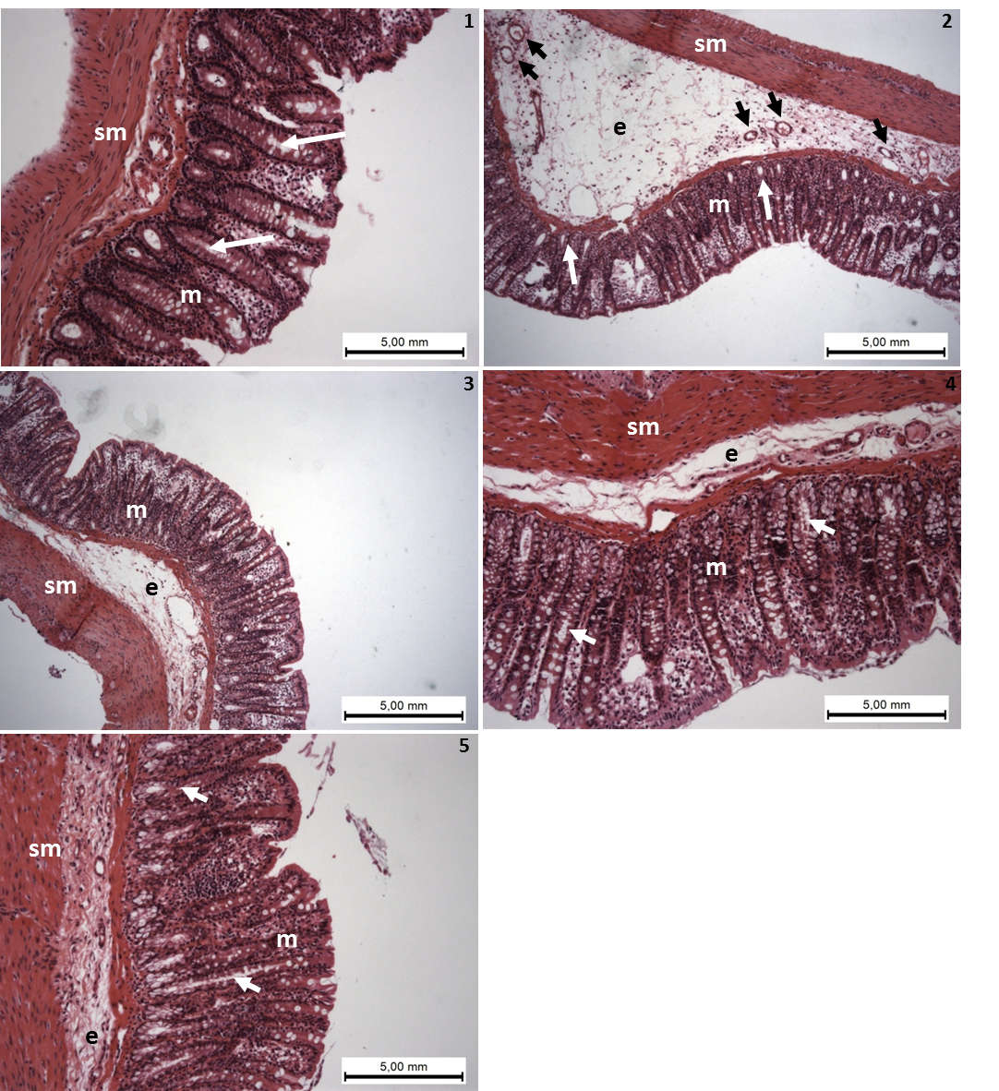
Figure 2 Photomicrography (haematoxylin and eosin) of colon samples from different experimental groups. Mucosa (m), tubular glands (white arrows), blood vessels (black arrow), submucosa (sm) and edema (e). In 1 (non-colitic group): the mucosa (m) contains numerous straight tubular glands (white arrows) with many lightly stained goblet cells; the crypt (black arrow), submucosa (sm) and luminal epithelium was intact with a typical morphology. In 2 (TNBS-control group): tubular glands (white arrows) were reduced and the goblet cells were atypical; a disruption with extensive edema (e) and blood vessels (black arrow) can be observed. In PACO₂ treated groups, colon cytoarchitecture was recovering and included the restoration of tubular glands (white arrows) containing goblet cells, especially at the doses of 50mg/kg (4) and 100 mg/kg (5); edema (e) was significantly reduced in animals treated with at doses of 50 mg/kg (4) and 100 mg/kg (5) and in a lower proportion in animals treated with doses of 25 mg/kg (3), when compared to the TNBS-control group (2).

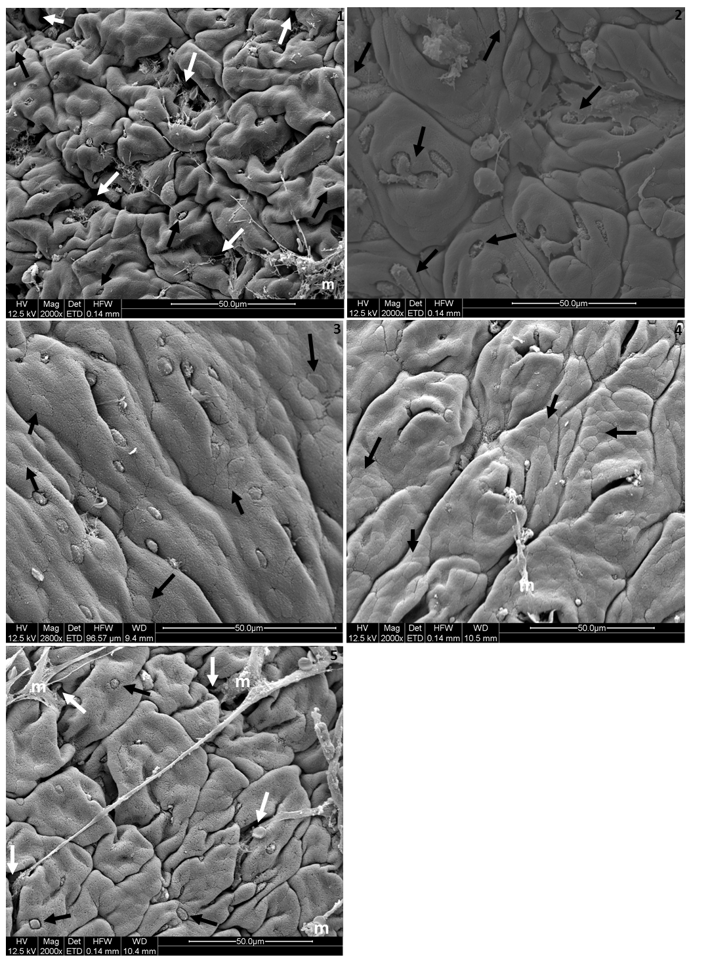

Figure 3 Electromicrographs (Scanning electron microscopy) of colon samples from different experimental groups. Crypts (white arrows), goblet cells (black arrows) and mucin (m). In 1 (non-colitic group): a regular mucosal architecture with polygonal units as structural subunits, regular microvilli giving a smooth velvety appearance, crypts (white arrows), goblet cells (black arrows) and mucin (m) extruded. In 2 (TNBS-control group): a complete loss of the smooth velvety appearance and polygonal shape of absorptive cells, hyperplasia of goblet cells (white arrows), absence of mucin extrusion and crypts, characteristics of ulcerative colitis and Crohn’s disease. In 3 (PACO₂ 25 mg/kg treated group): showed a slight recovery of polygonal shape (black arrows) of absorptive cells, however the number of goblet cells remained elevated. In 4 (PACO₂ 50 mg/kg treated group): an smaller number of goblet cells, a greater recovery of polygonal appearance (black arrows) and increased mucin (m) compared to TNBS-control group. In 5 (PACO₂ 100mg/kg treated group): a good recovery of mucosa architecture, with goblet cells (black arrows) similar to healthy animals including crypts (white arrows) and mucin (m) for protection.

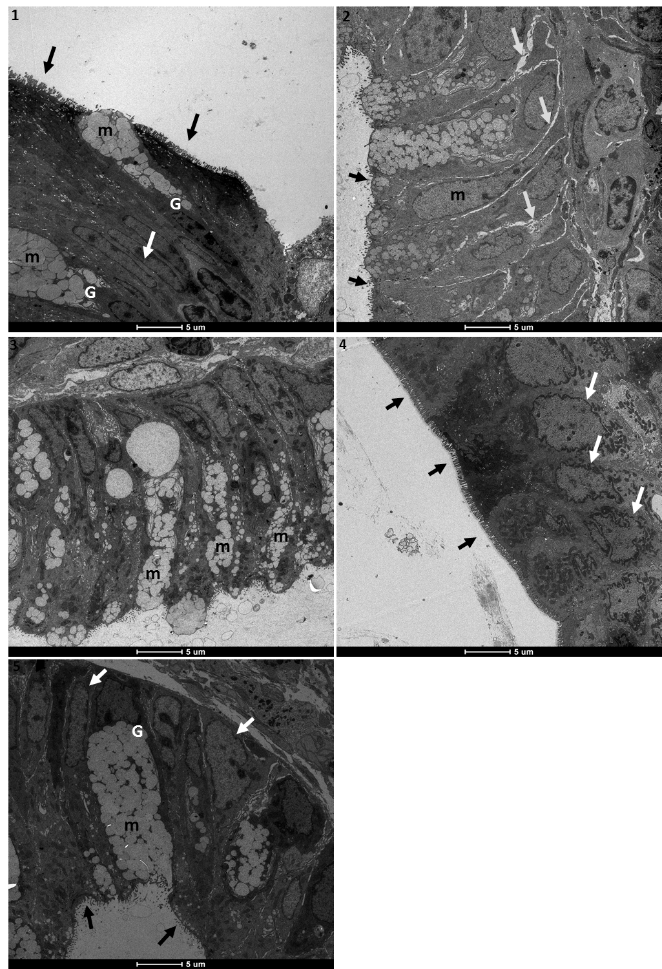
Figure 4 Electromicrographs (Transmission electron microscopy) of colon samples from different experimental groups. Goblet cells (G), mucus granules (m); Microvilli (black arrows); nucleus in a basal position (white arrow); edema (grey arrows). In 1 (non-colitic group): colonic goblet cells (G) showing the mucus granules (m); absorptive epithelial cells with a well-developed brush border containing numerous regular microvilli (black arrows) typical of enterocytes and its nucleus in a basal position (n) shows chromatin (white arrow). In 2 (TNBS-control group): mucin granules in colonic goblet cells are reduced and disarrangement (m); surface cells have no distinct brush border with atypical microvilli (black arrow); the intercellular space was enhanced as a signal of edema (white arrows); In 3 (PACO₂ 25 mg/kg treated group): mucin granules in colonic goblet cells are reduced and disarrangement (m), but intercelular edema is reduced (white arrows). In 4 (PACO₂ 50 mg/kg treated group): juxtaposed colonocytes with nucleus in basal position (white arrows) and preserved microvilli (black arrows). In 5 (PACO₂ 100 mg/kg treated group): the goblet cells (G) showing the mucus granules (m) similar to healthy animals; nucleus in basal position (yellow arrows); mild intercellular edema and atypical microvilli (black arrows).

