Name of Journal: World Journal of Clinical Cases
Manuscript NO: 81862
Manuscript Type: CASE REPORT

Soft tissue tuberculosis detected by next-generation sequencing: A case report and review of literature

He Y et al. Soft tissue tuberculosis detected by NGS

Yan-Gai He, Ya-Hui Huang, Xiao-Lan Yi, Kao-Liang Qian, Ying Wang, Hui Cheng, Jun Hu, Yuan Liu

Yan-Gai He, Ya-Hui Huang, Xiao-Lan Yi, Ying Wang, Yuan Liu, Department of Infectious Diseases, The First Affiliated Hospital of Nanjing Medical University, Nanjing 210029, Jiangsu Province, China

Kao-Liang Qian, Hui Cheng, Jun Hu, Department of Orthopedics, The First Affiliated Hospital of Nanjing Medical University, Nanjing 210029, Jiangsu Province, China

Author contributions: He YG and Huang YH drafted the manuscript, interpreted the patient data. Xi XL, Qian KL, Wang Y, and Cheng H collected information from the patients and searched the related literature. Liu Y and Hu J contributed to supervision and final approval. All authors have read and approved the final manuscript.

Supported by the National Natural Science Foundation of China, No. 82272544.

Corresponding author: Yuan Liu, MD, PhD, Academic Research, Department of Infectious Diseases, The First Affiliated Hospital of Nanjing Medical University, No. 300 Guangzhou Road, Nanjing 210029, Jiangsu Province, China. liuyuan@jsph.org.cn

Received: November 26, 2022
Revised: December 21, 2022
Accepted: January 5, 2023
Published online: January 26, 2023

Abstract
BACKGROUND
Soft tissue tuberculosis is rare and insidious, with most patients presenting with a localized enlarged mass or swelling, which may be factors associated with delayed diagnosis and treatment. In recent years, next-generation sequencing has rapidly evolved and has been successfully applied to numerous areas of basic and clinical research. A literature search revealed that the use of next-generation sequencing in the diagnosis of soft tissue tuberculosis has been rarely reported.

CASE SUMMARY
A 44-year-old man presented with recurrent swelling and ulcers on the left thigh. Magnetic resonance imaging suggested a soft tissue abscess. The lesion was surgically removed and tissue biopsy and culture were performed; however, no organism growth was detected. Finally, Mycobacterium tuberculosis was confirmed as the pathogen responsible for infection through next-generation sequencing analysis of the surgical specimen. The patient received a standardized anti-tuberculosis treatment and showed clinical improvement. We also performed a literature review on soft tissue tuberculosis using studies published in the past 10 years.

CONCLUSION
This case highlights the importance of next-generation sequencing for the early diagnosis of soft tissue tuberculosis, which can provide guidance for clinical treatment and improve prognosis.

Key Words: Mycobacterium tuberculosis; Soft tissue infection; Next-generation sequencing; Extrapulmonary tuberculosis; Diagnosis; Case report

©The Author(s) 2023. Published by Baishideng Publishing Group Inc. All rights reserved.

Citation: He YG, Huang YH, Yi XL, Qian KL, Wang Y, Cheng H, Hu J, Liu Y. Soft tissue tuberculosis detected by next-generation sequencing: A case report and review of literature. World J Clin Cases 2023; 11(3): 709-718
URL: https://www.wjgnet.com/2307-8960/full/v11/i3/709.htm
DOI: https://dx.doi.org/10.12998/wjcc.v11.i3.709

Core Tip: The diagnosis of extrapulmonary tuberculosis can be challenging, especially for tuberculosis in rare sites such as soft tissues. Soft tissue tuberculosis is rare and easily misdiagnosed. A delay in soft tissue tuberculosis diagnosis may worsen the disease, increase tuberculosis transmission, and accelerate the evolution of drug resistance. This case report emphasizes the importance of next-generation sequencing for early diagnosis of soft tissue tuberculosis, which can provide guidance for clinical treatment and improve prognosis.

INTRODUCTION
Tuberculosis (TB) is a chronic infectious disease caused by mycobacterium TB (MTB). Extrapulmonary TB (EPTB) in China constitutes 15%-20% of all TB cases, it can involve any organ, with the most usual sites of infection being the pleura (49.8%), bronchi (14.8%), lymph nodes (8.56%), meninges (7.6%), thoracic vertebra (2.55%), and skeletal joints (0.56%)^{[1,2]}. Isolated soft tissue TB is rare and accounts for only 1-2% of all pulmonary TB (PTB) and EPTB cases. Current knowledge of soft tissue TB is largely based on the analysis of a single patient and case series^{[3,4]}. Therefore, the low incidence and lack of typical symptoms of soft tissue TB may lead to difficulties and delays in diagnosis.
The traditional gold standard for TB diagnosis is the MTB culture assay, which has a lower positivity rate of 23.03%. In EPTB, the positivity rate is approximately 18.45%^{[5]}. The MTB culture assay demands laboratory biosafety requirements, and rapid diagnosis is challenging. Molecular biology techniques, such as real-time fluorescent polymerase chain reaction (PCR) and cross-primer amplification, have facilitated the rapid diagnosis. However, the diagnostic sensitivity of these methods for EPTB is limited and varies among specimen types^{[6]}. For example, the sensitivity of Xpert MTB/ rifampin (RIF) assay for PTB and EPTB was found to be 95.5% and 76.5%, respectively^{[7]}.
Next-generation sequencing (NGS) is an emerging and promising technology that is used for disease diagnosis, drug resistance determination, and epidemiological investigations. It has the potential to significantly reduce response time for the identification of pathogens, such as bacteria, viruses, tuberculosis, fungi, and parasites^{[8-12]}. For TB, next-generation sequencing can be used for early diagnosis, identification of drug resistance gene mutations associated with conventional anti-TB drugs, and detection of mixed infections^{[13]}. However, there are only a few reports on the rapid diagnosis of MTB infection in soft tissue using NGS. In this report, we present a case of soft tissue TB in an immunocompetent patient with no history of TB. We used NGS technology to detect the surgically resected lesion tissue, and the patient was finally diagnosed with soft tissue TB. In addition, we reviewed the main features of soft tissue TB cases reported in the past decade.

CASE PRESENTATION
Chief complaints
A 44-year-old man admitted to Department of Orthopaedics of the First Affiliated Hospital of Nanjing Medical University presented with a history of left thigh ulceration and swelling for 10 d.

History of present illness
The patient showed similar symptoms in 2018, some tests including bacterial and tuberculosis culture, acid-fast staining, and tuberculosis infection T-lymphocyte spot test (T-SPOT). TB tests, were negative at that time. And the patient recovered gradually after debridement. Through careful history investigation, we found that the patient had an open wound on the left thigh caused by trauma 18 years ago, which improved after debridement and suturing.

History of past illness
There is no relevant history of past illness.

Personal and family history
The patient’s personal and family histories were unremarkable.

Physical examination
Two old scars were observed on the patient's left thigh, and there was a red and swollen ruptured wound above them. The skin temperature of the limb was normal, and no movement limitation was observed. A physical examination revealed no other positive signs. Breath sounds of both lungs were clear, no obvious dry or wet rales were heard, and there was no pleural friction rub.

Laboratory examinations
On day 2 after admission, laboratory tests, such as routine blood examination, coagulation function tests, erythrocyte sedimentation rate, and serum biochemical indicators, did not show any significant abnormalities.

Imaging examinations
A radiograph of the left femur indicated no bone erosion (Figure 1A). Bone single-photon emission computed tomography did not reveal any abnormalities in bone metabolism (Figure 1B). On day five after admission, magnetic resonance imaging (MRI) of the left hip was performed, which revealed abnormal signals in the soft tissue of the left upper femur and oedema of the subcutaneous soft tissue. In addition, MRI revealed a chronic abscess with sinus tract formation (Figure 1C-E). Computed tomography of the chest showed scattered nodules in both lungs (Figure 1F). But the symptoms of tuberculosis are not obvious.

Further diagnostic work-up
Considering that the abscess was large, we performed abscess resection of the left thigh and vacuum sealing drainage therapy. We observed inflammation and degeneration in subcutaneous tissue and cystic infected tissue wrapped in the deep layer, which had tough capsule walls and a size of approximately 8 cm × 6 cm (Figure 2A and B). After incision of the purulent cyst, gelatinous necrotic tissue which was grey and white, was observed. Furthermore, we performed histological examination, bacterial culture, and NGS testing of the specimen.
Histological examination revealed fibrous connective tissue hyperplasia with necrosis, acute and chronic inflammatory cell infiltration, and focal granulomatous inflammation with multinucleated giant cell formation (Figure 2C). Bacterial culture of the surgically excised specimen was negative on day seven after admission. However, MTB was detected by NGS simultaneously. The distribution of bacteria and fungi identified by NGS revealed that MTB was the main pathogen (Figure 3A), and 24 sequence reads were identified (Figure 3B).
The pathology department was then contacted for an additional acid-fast bacillus staining test of the intraoperative specimen, and scattered suspicious antacid staining positive rods were observed microscopically (Figure 2D). Further, the T-SPOT. TB test results were positive.

FINAL DIAGNOSIS
Combined with the patient’s medical history and outcome of NGS, the patient was finally diagnosed with soft tissue tuberculosis.

TREATMENT
We planned a standardized anti-tuberculosis treatment with four drugs, isoniazid, rifampicin, ethambutol, and pyrazinamide, for 2 mo. Further isoniazid and rifampicin were given for four months. But the patient stopped the drug because of gastrointestinal discomfort during the 3rd month of treatment and suspended for 2 wk, then he continued to take the medicine again for 3 mo.

OUTCOME AND FOLLOW-UP
Currently, the wound has healed adequately and the patient is undergoing follow-up. A summary of the timeline is shown in Figure 4.

DISCUSSION
According to a global TB report published by WHO, TB deaths have increased because of reduced access to TB diagnosis and treatment in the face of the COVID-19 pandemic for the first time in over a decade^{[14]}. China has the second-highest number of TB cases worldwide, accounting for approximately 9% of the global TB incidence. One study indicated that the prevalence of smear-positive TB in China decreased from 170/100 000 population in 1990 to 59 /100 000 population in 2010, a reduction of more than 50 percent^{[15]}. Despite past success in controlling TB, the limited epidemiologic information available suggests that the incidence of EPTB may be increasing steadily worldwide, including in China^{[16,17]}.
The diagnosis of EPTB can be challenging, especially for TB in rare sites such as soft tissues. A delay in soft tissue TB diagnosis may worsen the disease, increase TB transmission, and accelerate the evolution of drug resistance. The conventional gold standards for TB diagnosis are MTB culture and drug sensitivity tests. However, it is tedious and can take 6-8 wk because of slow growth of MTB^{[18]}. Molecular diagnostic techniques, such as Xpert MTB/RIF, loop-mediated isothermal amplification (LAMP), and line probe assay (LPA), can effectively reduce turnaround time and improve diagnostic performance. However, these techniques have limited diagnostic sensitivity for specimens with low bacterial content, such as EPTB^{[19,20]}. For example, a meta-analysis found that the pooled sensitivity of Xpert MTB/RIF for diagnosing abdominal TB was only 23%^{[21]}. Another meta-analysis reported that the pooled sensitivity of LAMP for detecting EPTB was 77%^{[22]}. Only a few studies have evaluated the role of LPA in EPTB specimens. A study from India reported a sensitivity of 46.1% with a specificity of 91% in EPTB specimens, with liquid culture as the reference standard^{[23]}.
Soft tissue TB is rare and easily misdiagnosed. Therefore, rapid, efficient, and accurate diagnosis of soft tissue TB is an urgent clinical problem. NGS is a revolutionary development of first-generation sequencing methods that can sequence millions of DNA fragments simultaneously with high throughput and short detection cycles. A study found that the positivity rate of NGS is approximately 15% higher than that of traditional pathogen culture in a pairwise manner for infectious diseases^{[24]}. Xpert MTB/RIF and NGS tests were performed on various samples of sputum, cerebrospinal fluid, and pus from patients with suspected active TB infection. Compared with Xpert MTB/RIF, NGS showed better sensitivity in all clinical (76.9% vs 61.5%), pulmonary (87.5% vs 75.0%), and extrapulmonary samples (60.0% vs 40.0%)^{[13]}. In this case, NGS rapidly detected the sequence of MTB in the sample, which was important for us to confirm the diagnosis of soft tissue TB early and to treat it with anti-tuberculosis drugs in time. Below, we review the relevant literature on soft tissue TB.
Recent case reports on soft tissue TB published in the past 10 years were identified by searching PubMed (Table 1). We found 17 case reports including 10 males and 7 females. The ages of the patients ranged from 7 to 79 years. There were 12 cases distributed in Asian countries, four cases in African countries and one case in America. No underlying diseases were reported in 10 patients. In 13 patients, the lesions were located on the extremities, including the thigh, calf, forearm, and wrist. The other four patients had lesions in the gluteus, back, thorax, and iliopsoas.
Soft tissue TB occurs mostly in the extremities, and patients present with local masses, swelling, and weakness. Only a small percentage of patients present with constitutional symptoms such as fever and weight loss^{[25,26]}. Most cases of soft tissue TB reported in the literature were diagnosed by histological examination and MTB culture, whereas some were confirmed by rapid PCR. Although the culture and gene Xpert were negative, two patients recovered after empirical anti-TB therapy^{[27,28]}. Empirical treatment for TB was initiated without a confirmed bacterial diagnosis. Moreover, factors contributing to the probability of a patient developing TB and experiencing adverse outcomes were weighed against the threshold for initiating anti-TB therapy. This threshold is subjective and may vary among the clinicians. Factors considered in empirical anti-TB treatment include the background TB epidemiology in the geographic area, exposure to TB patients, clinical manifestations suggestive of TB disease, comorbidities such as HIV co-infection, and the results of other diagnostic methods such as imaging outcomes if available^{[29]}.
There are many traditional tests for TB, including smear, culture, pathological biopsy, imaging, purified protein derivative testing, interferon-gamma release assay, and TB antibody testing^{[30,31]}. Confirmation of TB over the past few decades often requires a combination of these tests. Over the last decade, advances have been made in the field of TB diagnostics in the form of new molecular tests. Often referred to as nucleic acid amplification tests, these assays rely on amplification of a targeted genetic region of the MTB complex, typically by PCR^{[32]}. GeneXpert MTB/RIF is a fully automated closed system that performs sample preparation and real-time PCR and produces results within 2 h. This system can detect RIF resistance (targeting the rpoB gene). In 2011, the WHO recommended GeneXpert MTB/RIF for the early diagnosis of drug-resistant TB, which was further expanded in 2013 to replace smear and culture for the rapid diagnosis of EPTB^{[33]}. The new version of Xpert MTB Ultra improved overall sensitivity and was endorsed by the WHO in 2017^{[34]}. In 2017, the UK used NGS for TB diagnosis, drug resistance detection, and MTB typing for the first time^{[35]}. Several studies have shown its advantages in the diagnosis and treatment of EPTB^{[36,37]}. However, the value of NGS in the rapid diagnosis of TB has not been verified in large samples, and there is a lack of unified standards and procedures. Guidelines for the clinical interpretation of NGS reports need to be improved.

CONCLUSION
We reported the case of a patient who was immunocompetent and had no history of TB and was diagnosed with soft tissue TB by NGS. The patient received timely anti-TB treatment, which improved. Clinicians should consider atypical pathogens such as MTB in the diagnosis of patients with local masses or swelling. NGS may be a useful method for identifying the pathogens responsible for soft tissue infections without typical clinical manifestations.

REFERENCES
1 Baykan AH, Sayiner HS, Aydin E, Koc M, Inan I, Erturk SM. Extrapulmonary tuberculosıs: an old but resurgent problem. Insights Imaging 2022; 13: 39 [PMID: 35254534 DOI: 10.1186/s13244-022-01172-0]
2 Kang W, Liu S, Du J, Tang P, Chen H, Liu J, Ma J, Li M, Qin J, Shu W, Zong P, Zhang Y, Dong Y, Yang Z, Mei Z, Deng Q, Wang P, Han W, Yan X, Chen L, Zhao X, Tan L, Li F, Zheng C, Liu H, Li X, A E, Du Y, Liu F, Cui W, Wang Q, Chen X, Han J, Xie Q, Feng Y, Liu W, Yang S, Zhang J, Zheng J, Chen D, Yao X, Ren T, Li Y, Li Y, Wu L, Song Q, Shen X, Zhang J, Liu Y, Guo S, Yan K, Yang M, Lei D, Zhang Y, Wu M, Li L, Tang S. Epidemiology of concurrent extrapulmonary tuberculosis in inpatients with extrapulmonary tuberculosis lesions in China: a large-scale observational multi-centre investigation. Int J Infect Dis 2022; 115: 79-85 [PMID: 34781005 DOI: 10.1016/j.ijid.2021.11.019]
3 Franco-Paredes C, Chastain DB, Allen L, Henao-Martínez AF. Overview of Cutaneous Mycobacterial Infections. Curr Trop Med Rep 2018; 5: 228-232 [PMID: 34164254 DOI: 10.1007/s40475-018-0161-7]
4 Zeng Y, Liu Y, Xie Y, Liang J, Kuang J, Lu Z, Zhou Y. Muscular Tuberculosis: A New Case and a Review of the Literature. Front Neurol 2019; 10: 1031 [PMID: 31632334 DOI: 10.3389/fneur.2019.01031]
5 Sun WW, Gu J, Fan L. Application value of metagenomic next-generation sequencing (mNGS) in the diagnosis of different types of tuberculosis. Zhonghua Jie He He Hu Xi Za Zhi 2021; 44: 96-100 [PMID: 33535323 DOI: 10.3760/cma.j.cn112147-20200316-00343]
6 Tadesse M, Abebe G, Bekele A, Bezabih M, Yilma D, Apers L, de Jong BC, Rigouts L. Xpert MTB/RIF assay for the diagnosis of extrapulmonary tuberculosis: a diagnostic evaluation study. Clin Microbiol Infect 2019; 25: 1000-1005 [PMID: 30583052 DOI: 10.1016/j.cmi.2018.12.018]
7 Allahyartorkaman M, Mirsaeidi M, Hamzehloo G, Amini S, Zakiloo M, Nasiri MJ. Low diagnostic accuracy of Xpert MTB/RIF assay for extrapulmonary tuberculosis: A multicenter surveillance. Sci Rep 2019; 9: 18515 [PMID: 31811239 DOI: 10.1038/s41598-019-55112-y]
8 Goelz H, Wetzel S, Mehrbarzin N, Utzolino S, Häcker G, Badr MT. Next- and Third-Generation Sequencing Outperforms Culture-Based Methods in the Diagnosis of Ascitic Fluid Bacterial Infections of ICU Patients. Cells 2021; 10 [PMID: 34831447 DOI: 10.3390/cells10113226]
9 Sahajpal NS, Mondal AK, Njau A, Petty Z, Chen J, Ananth S, Ahluwalia P, Williams C, Ross TM, Chaubey A, DeSantis G, Schroth GP, Bahl J, Kolhe R. High-Throughput Next-Generation Sequencing Respiratory Viral Panel: A Diagnostic and Epidemiologic Tool for SARS-CoV-2 and Other Viruses. Viruses 2021; 13 [PMID: 34696495 DOI: 10.3390/v13102063]
10 Oreskovic A, Waalkes A, Holmes EA, Rosenthal CA, Wilson DPK, Shapiro AE, Drain PK, Lutz BR, Salipante SJ. Characterizing the molecular composition and diagnostic potential of Mycobacterium tuberculosis urinary cell-free DNA using next-generation sequencing. Int J Infect Dis 2021; 112: 330-337 [PMID: 34562627 DOI: 10.1016/j.ijid.2021.09.042]
11 Tiew PY, Thng KX, Chotirmall SH. Clinical Aspergillus Signatures in COPD and Bronchiectasis. J Fungi (Basel) 2022; 8 [PMID: 35628736 DOI: 10.3390/jof8050480]
12 Ryan U, Zahedi A, Feng Y, Xiao L. An Update on Zoonotic Cryptosporidium Species and Genotypes in Humans. Animals (Basel) 2021; 11 [PMID: 34828043 DOI: 10.3390/ani11113307]
13 Zhou X, Wu H, Ruan Q, Jiang N, Chen X, Shen Y, Zhu YM, Ying Y, Qian YY, Wang X, Ai JW, Zhang WH. Clinical Evaluation of Diagnosis Efficacy of Active Mycobacterium tuberculosis Complex Infection via Metagenomic Next-Generation Sequencing of Direct Clinical Samples. Front Cell Infect Microbiol 2019; 9: 351 [PMID: 31681628 DOI: 10.3389/fcimb.2019.00351]
14 Daley CL. The Global Fight Against Tuberculosis. Thorac Surg Clin 2019; 29: 19-25 [PMID: 30454918 DOI: 10.1016/j.thorsurg.2018.09.010]
15 Wang L, Zhang H, Ruan Y, Chin DP, Xia Y, Cheng S, Chen M, Zhao Y, Jiang S, Du X, He G, Li J, Wang S, Chen W, Xu C, Huang F, Liu X, Wang Y. Tuberculosis prevalence in China, 1990-2010; a longitudinal analysis of national survey data. Lancet 2014; 383: 2057-2064 [PMID: 24650955 DOI: 10.1016/s0140-6736(13)62639-2]
16 Pang Y, An J, Shu W, Huo F, Chu N, Gao M, Qin S, Huang H, Chen X, Xu S. Epidemiology of Extrapulmonary Tuberculosis among Inpatients, China, 2008-2017. Emerg Infect Dis 2019; 25: 457-464 [PMID: 30789144 DOI: 10.3201/eid2503.180572]
17 Chen L, Fu X, Tian P, Li Q, Lei D, Peng Z, Liu Q, Li N, Zhang J, Xu P, Zhang H. Upward trends in new, rifampicin-resistant and concurrent extrapulmonary tuberculosis cases in northern Guizhou Province of China. Sci Rep 2021; 11: 18023 [PMID: 34504296 DOI: 10.1038/s41598-021-97595-8]
18 Baker JJ, Johnson BK, Abramovitch RB. Slow growth of Mycobacterium tuberculosis at acidic pH is regulated by phoPR and host-associated carbon sources. Mol Microbiol 2014; 94: 56-69 [PMID: 24975990 DOI: 10.1111/mmi.12688]
19 Kohli M, Schiller I, Dendukuri N, Dheda K, Denkinger CM, Schumacher SG, Steingart KR. Xpert(®) MTB/RIF assay for extrapulmonary tuberculosis and rifampicin resistance. Cochrane Database Syst Rev 2018; 8: CD012768 [PMID: 30148542 DOI: 10.1002/14651858.CD012768.pub2]
20 Mhimbira FA, Bholla M, Sasamalo M, Mukurasi W, Hella JJ, Jugheli L, Reither K. Detection of Mycobacterium tuberculosis by EasyNAT diagnostic kit in sputum samples from Tanzania. J Clin Microbiol 2015; 53: 1342-1344 [PMID: 25609720 DOI: 10.1128/jcm.03037-14]
21 Sharma V, Soni H, Kumar-M P, Dawra S, Mishra S, Mandavdhare HS, Singh H, Dutta U. Diagnostic accuracy of the Xpert MTB/RIF assay for abdominal tuberculosis: a systematic review and meta-analysis. Expert Rev Anti Infect Ther 2021; 19: 253-265 [PMID: 32845790 DOI: 10.1080/14787210.2020.1816169]
22 Yu G, Shen Y, Zhong F, Ye B, Yang J, Chen G. Diagnostic accuracy of the loop-mediated isothermal amplification assay for extrapulmonary tuberculosis: A meta-analysis. PLoS One 2018; 13: e0199290 [PMID: 29944682 DOI: 10.1371/journal.pone.0199290]
23 Sharma SK, Kohli M, Chaubey J, Yadav RN, Sharma R, Singh BK, Sreenivas V, Sharma A, Bhatia R, Jain D, Seenu V, Dhar A, Soneja M. Evaluation of Xpert MTB/RIF assay performance in diagnosing extrapulmonary tuberculosis among adults in a tertiary care centre in India. Eur Respir J 2014; 44: 1090-1093 [PMID: 25063241 DOI: 10.1183/09031936.00059014]
24 Miao Q, Ma Y, Wang Q, Pan J, Zhang Y, Jin W, Yao Y, Su Y, Huang Y, Wang M, Li B, Li H, Zhou C, Li C, Ye M, Xu X, Li Y, Hu B. Microbiological Diagnostic Performance of Metagenomic Next-generation Sequencing When Applied to Clinical Practice. Clin Infect Dis 2018; 67: S231-S240 [PMID: 30423048 DOI: 10.1093/cid/ciy693]
25 Manicketh I, Panjwani P, Ravikumar G, Prince Mathan L. Soft tissue tuberculosis - An unusual presentation of a common disease. Indian J Tuberc 2018; 65: 96-97 [PMID: 29332661 DOI: 10.1016/j.ijtb.2017.04.002]
26 Tone K, Hirano Y, Kuwano K. Iliopsoas gravity abscess secondary to a tuberculous empyema. Int J Mycobacteriol 2021; 10: 335-337 [PMID: 34494577 DOI: 10.4103/ijmy.ijmy_129_21]
27 Hashimoto K, Nishimura S, Oka N, Kakinoki R, Akagi M. Tuberculoma with phlegmon-like symptoms mimicking soft tissue sarcoma in the wrist: A case report. Mol Clin Oncol 2018; 9: 207-210 [PMID: 30101023 DOI: 10.3892/mco.2018.1652]
28 Fahad S, Baloch N, Din NU. Tuberculosis of the flexor carpi radialis muscle - a case report. J Pak Med Assoc 2020; 70: 1645-1647 [PMID: 33040129 DOI: 10.5455/jpma.40799]
29 Dartois VA, Rubin EJ. Anti-tuberculosis treatment strategies and drug development: challenges and priorities. Nat Rev Microbiol 2022; 20: 685-701 [PMID: 35478222 DOI: 10.1038/s41579-022-00731-y]
30 Nishimura T, Hasegawa N, Mori M, Takebayashi T, Harada N, Higuchi K, Tasaka S, Ishizaka A. Accuracy of an interferon-gamma release assay to detect active pulmonary and extra-pulmonary tuberculosis. Int J Tuberc Lung Dis 2008; 12: 269-274 [PMID: 18284831]
31 Procop GW. Laboratory Diagnosis and Susceptibility Testing for Mycobacterium tuberculosis. Microbiol Spectr 2016; 4 [PMID: 28087944 DOI: 10.1128/microbiolspec.TNMI7-0022-2016]
32 Acharya B, Acharya A, Gautam S, Ghimire SP, Mishra G, Parajuli N, Sapkota B. Advances in diagnosis of Tuberculosis: an update into molecular diagnosis of Mycobacterium tuberculosis. Mol Biol Rep 2020; 47: 4065-4075 [PMID: 32248381 DOI: 10.1007/s11033-020-05413-7]
33 WHO Guidelines Approved by the Guidelines Review Committee. Xpert MTB/RIF Implementation Manual: Technical and Operational ‘How-To’; Practical Considerations. Geneva: World Health Organization, 2014
34 Chakravorty S, Simmons AM, Rowneki M, Parmar H, Cao Y, Ryan J, Banada PP, Deshpande S, Shenai S, Gall A, Glass J, Krieswirth B, Schumacher SG, Nabeta P, Tukvadze N, Rodrigues C, Skrahina A, Tagliani E, Cirillo DM, Davidow A, Denkinger CM, Persing D, Kwiatkowski R, Jones M, Alland D. The New Xpert MTB/RIF Ultra: Improving Detection of Mycobacterium tuberculosis and Resistance to Rifampin in an Assay Suitable for Point-of-Care Testing. mBio 2017; 8 [PMID: 28851844 DOI: 10.1128/mBio.00812-17]
35 Satta G, Lipman M, Smith GP, Arnold C, Kon OM, McHugh TD. Mycobacterium tuberculosis and whole-genome sequencing: how close are we to unleashing its full potential? Clin Microbiol Infect 2018; 24: 604-609 [PMID: 29108952 DOI: 10.1016/j.cmi.2017.10.030]
36 Sun W, Lu Z, Yan L. Clinical efficacy of metagenomic next-generation sequencing for rapid detection of Mycobacterium tuberculosis in smear-negative extrapulmonary specimens in a high tuberculosis burden area. Int J Infect Dis 2021; 103: 91-96 [PMID: 33227518 DOI: 10.1016/j.ijid.2020.11.165]
37 Yu G, Wang X, Zhu P, Shen Y, Zhao W, Zhou L. Comparison of the efficacy of metagenomic next-generation sequencing and Xpert MTB/RIF in the diagnosis of tuberculous meningitis. J Microbiol Methods 2021; 180: 106124 [PMID: 33321144 DOI: 10.1016/j.mimet.2020.106124]
38 Arora S, Sabat D, Sural S, Dhal A. Isolated tuberculous pyomyositis of semimembranosus and adductor magnus: a case report. Orthop Surg 2012; 4: 266-268 [PMID: 23109314 DOI: 10.1111/os.12011]
39 Lee HJ, Kim KW, Kim KS, Ryu SH, Ha YC. Primary musculoskeletal mycobacterium infection with large cystic masses after total hip arthroplasty. J Arthroplasty 2013; 28: 374.e1-374.e3 [PMID: 22749661 DOI: 10.1016/j.arth.2012.05.009]
40 Elshafie KT, Al-Hinai MM, Al-Habsi HA, Al-Hattali MS, Hassan O, Al-Sukaiti R. A massive tuberculosis abscess at the erector spinae muscles and subcutaneous tissues in a young man. Sultan Qaboos Univ Med J 2013; 13: 601-605 [PMID: 24273676 DOI: 10.12816/0003325]
41 Neogi DS, Bandekar SM, Chawla L. Skeletal muscle tuberculosis simultaneously involving multiple sites. J Pediatr Orthop B 2013; 22: 167-169 [PMID: 22561909 DOI: 10.1097/BPB.0b013e328354b04d]
42 Meena M, Dixit R, Samaria JK, Vijayakandeepan Kumaresan SH. Tuberculosis of the triceps muscle. BMJ Case Rep 2015; 2015 [PMID: 25564636 DOI: 10.1136/bcr-2014-207032]
43 Dhakal AK, Shah SC, Shrestha D, Banepali N, Geetika KC. Tuberculosis presenting as multiple intramuscular nodules in a child: a case report. J Med Case Rep 2015; 9: 72 [PMID: 25885776 DOI: 10.1186/s13256-015-0543-6]
44 Sbai MA, Benzarti S, Msek H, Boussen M, Khorbi A. Pseudotumoral form of soft-tissue tuberculosis of the wrist. Int J Mycobacteriol 2016; 5: 99-101 [PMID: 26927998 DOI: 10.1016/j.ijmyco.2015.08.001]
45 Al-Khazraji A, Takher J, Alkhawam H, Fabbri M. Primary Tuberculous Pyomyositis of the Calf Muscles. Am J Med Sci 2017; 353: 187-188 [PMID: 28183421 DOI: 10.1016/j.amjms.2016.05.010]
46 Alaya Z, Osman W. Isolated muscular tuberculosis: unusual location of the Koch bacillus. Pan Afr Med J 2017; 26: 158 [PMID: 28533881 DOI: 10.11604/pamj.2017.26.158.11795]
47 Zitouna K, Riahi H, Goubantini A, Barsaoui M. Isolated tuberculous abscess in longissimus muscle. Int J Mycobacteriol 2019; 8: 403-405 [PMID: 31793514 DOI: 10.4103/ijmy.ijmy_139_19]
48 Moyano-Bueno D, Blanco JF, López-Bernus A, Gutiérrez-Zubiaurre N, Gomez Ruiz V, Velasco-Tirado V, Belhassen-García M. Cold abscess of the chest wall: A diagnostic challenge. Int J Infect Dis 2019; 85: 108-110 [PMID: 31163270 DOI: 10.1016/j.ijid.2019.05.031]
49 Murugesh Anand S, Edwin Fernando M, Srinivasaprasad ND, Sujit S, Thirumalvalavan K. Tuberculous myositis and cellulitis in a renal transplant recipient. Indian J Tuberc 2020; 67: 353-356 [PMID: 32825866 DOI: 10.1016/j.ijtb.2019.04.010]

Footnotes
Informed consent statement: Informed written consent was obtained from the patient and his family for publication of this report and any accompanying images.

Conflict-of-interest statement: All the authors report no relevant conflicts of interest for this article.

CARE Checklist (2016) statement: The authors have read the CARE Checklist (2016), and the manuscript was prepared and revised according to the CARE Checklist (2016).

Open-Access: This article is an open-access article that was selected by an in-house editor and fully peer-reviewed by external reviewers. It is distributed in accordance with the Creative Commons Attribution NonCommercial (CC BY-NC 4.0) license, which permits others to distribute, remix, adapt, build upon this work non-commercially, and license their derivative works on different terms, provided the original work is properly cited and the use is non-commercial. See: https://creativecommons.org/Licenses/by-nc/4.0/

Provenance and peer review: Unsolicited article; Externally peer reviewed.
Peer-review model: Single blind

Peer-review started: November 26, 2022
First decision: December 13, 2022
Article in press: January 5, 2023

Specialty type: Medicine, research and experimental
Country/Territory of origin: China
Peer-review report’s scientific quality classification
Grade A (Excellent): 0
Grade B (Very good): B
Grade C (Good): 0
Grade D (Fair): 0
Grade E (Poor): E

P-Reviewer: Shen TC, Taiwan; Vyshka G, Albania S-Editor: Wang LL L-Editor: A P-Editor: Wang LL

Figure Legends
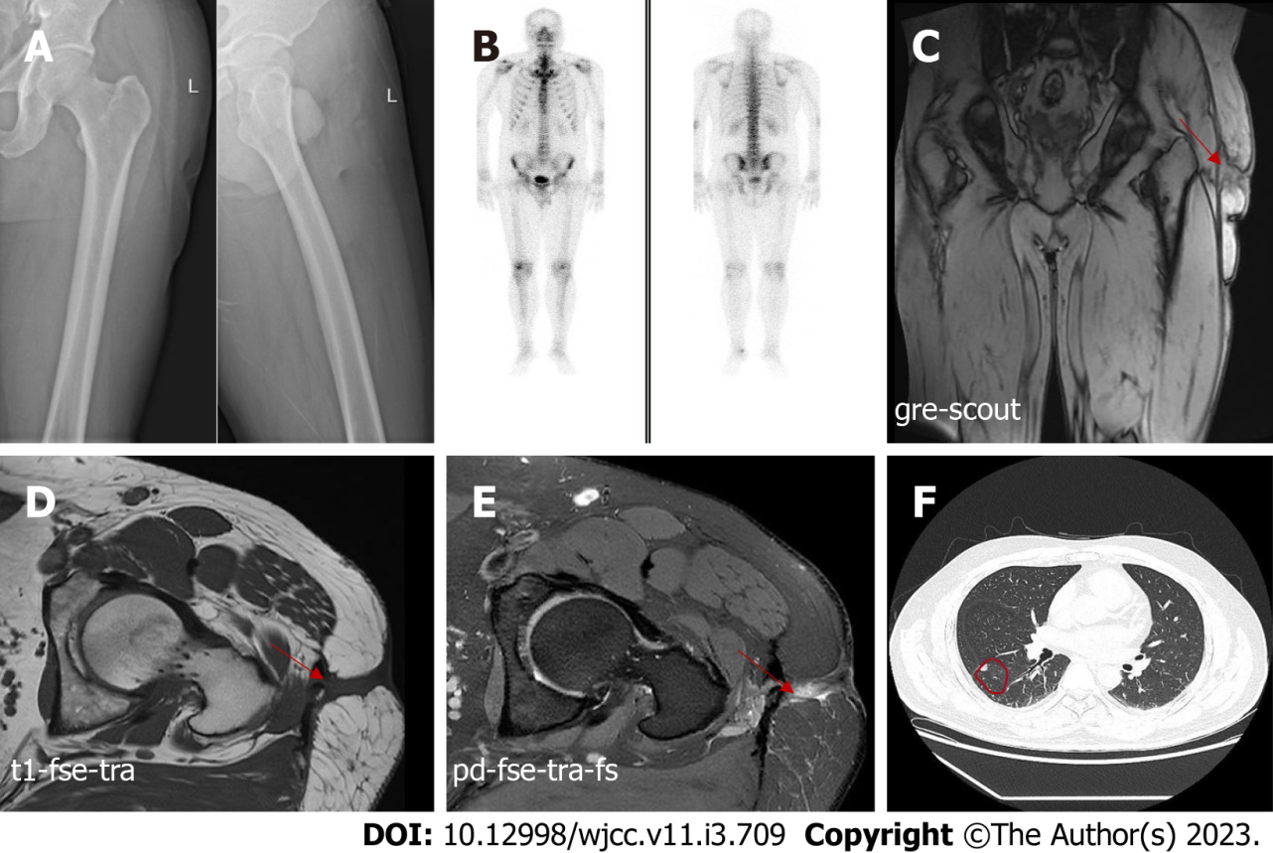
Figure 1 Imaging pictures of the patient. A: Anteroposterior and lateral radiographs of the left femur are normal; B: Bone single-photon emission computed tomography did not reveal any abnormalities in bone metabolism; C-E: Magnetic resonance imaging of the left hip showing abnormal signals in the soft tissue of the left upper femur and suggesting a chronic abscess with sinus tract formation; F: Computed tomography of the chest showing scattered nodules in both lungs, the largest nodule in the right lung with a length of 8 mm.

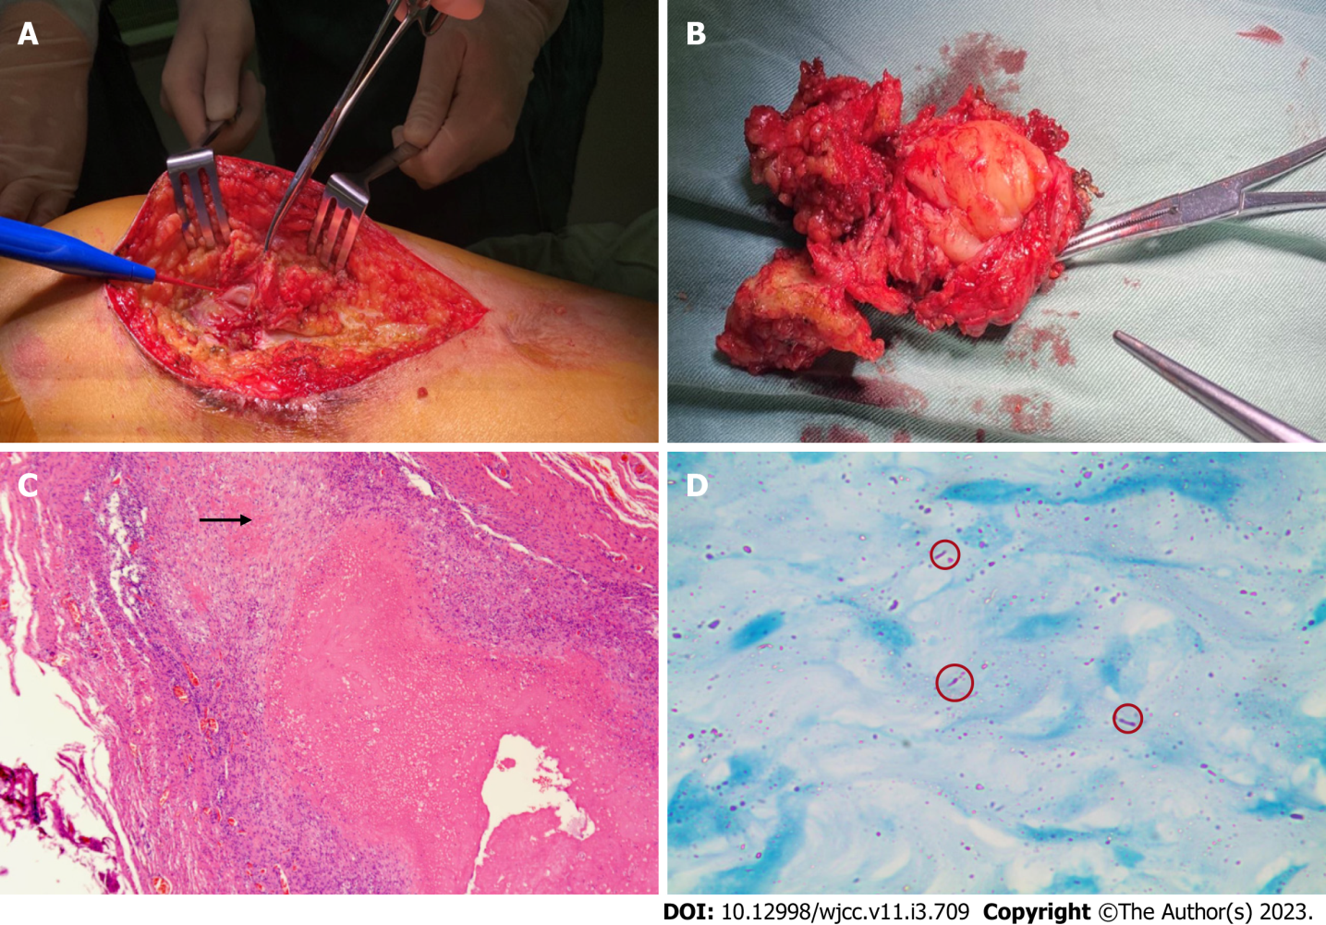
Figure 2 Intraoperative photographs of the left thigh and histopathological examination of resected specimens. A: Intraoperative photograph; B: Excised specimen (8 cm × 6 cm); C: Granulomas are embedded among the muscle fibers with lymphocyte infiltration and multinucleated giant cell aggregation (× 40); D: The acid-fast bacilli staining test showed scattered, suspicious antacid staining-positive rods (× 1000).

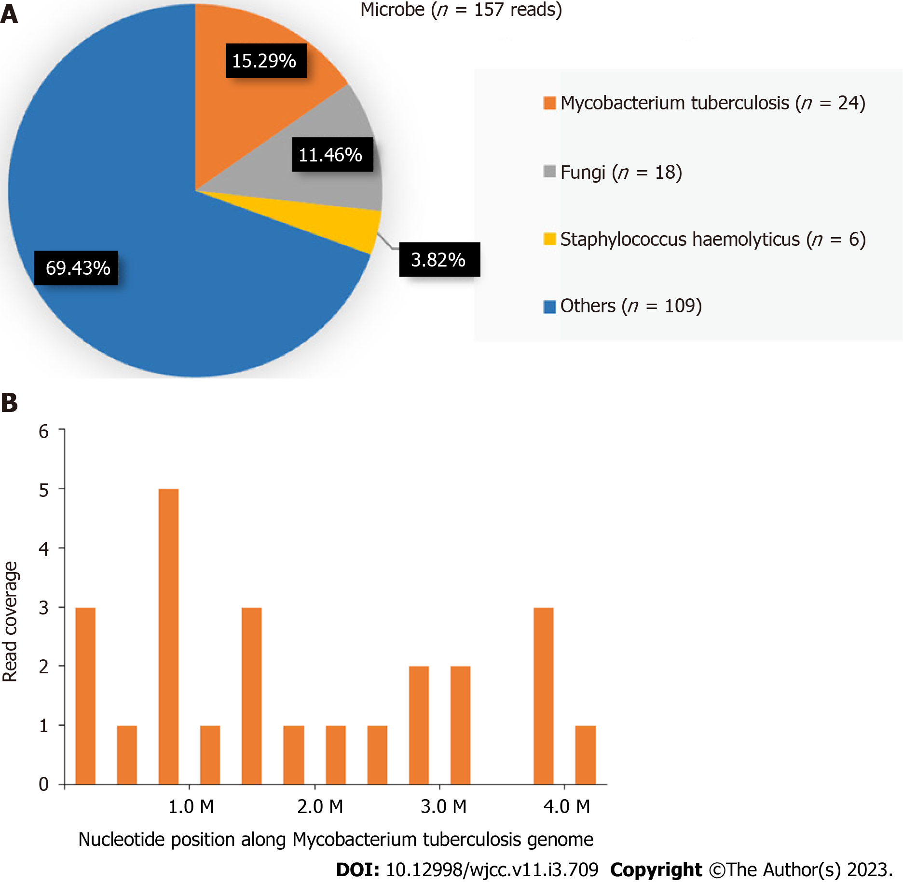
Figure 3 Next-generation sequencing results of surgically resected specimen. A: Distribution of the sequences detected by next-generation sequencing of surgically excised specimens; B: Twenty-four sequence reads of mycobacterium tuberculosis are observed, with a coverage rate of 0.005%.

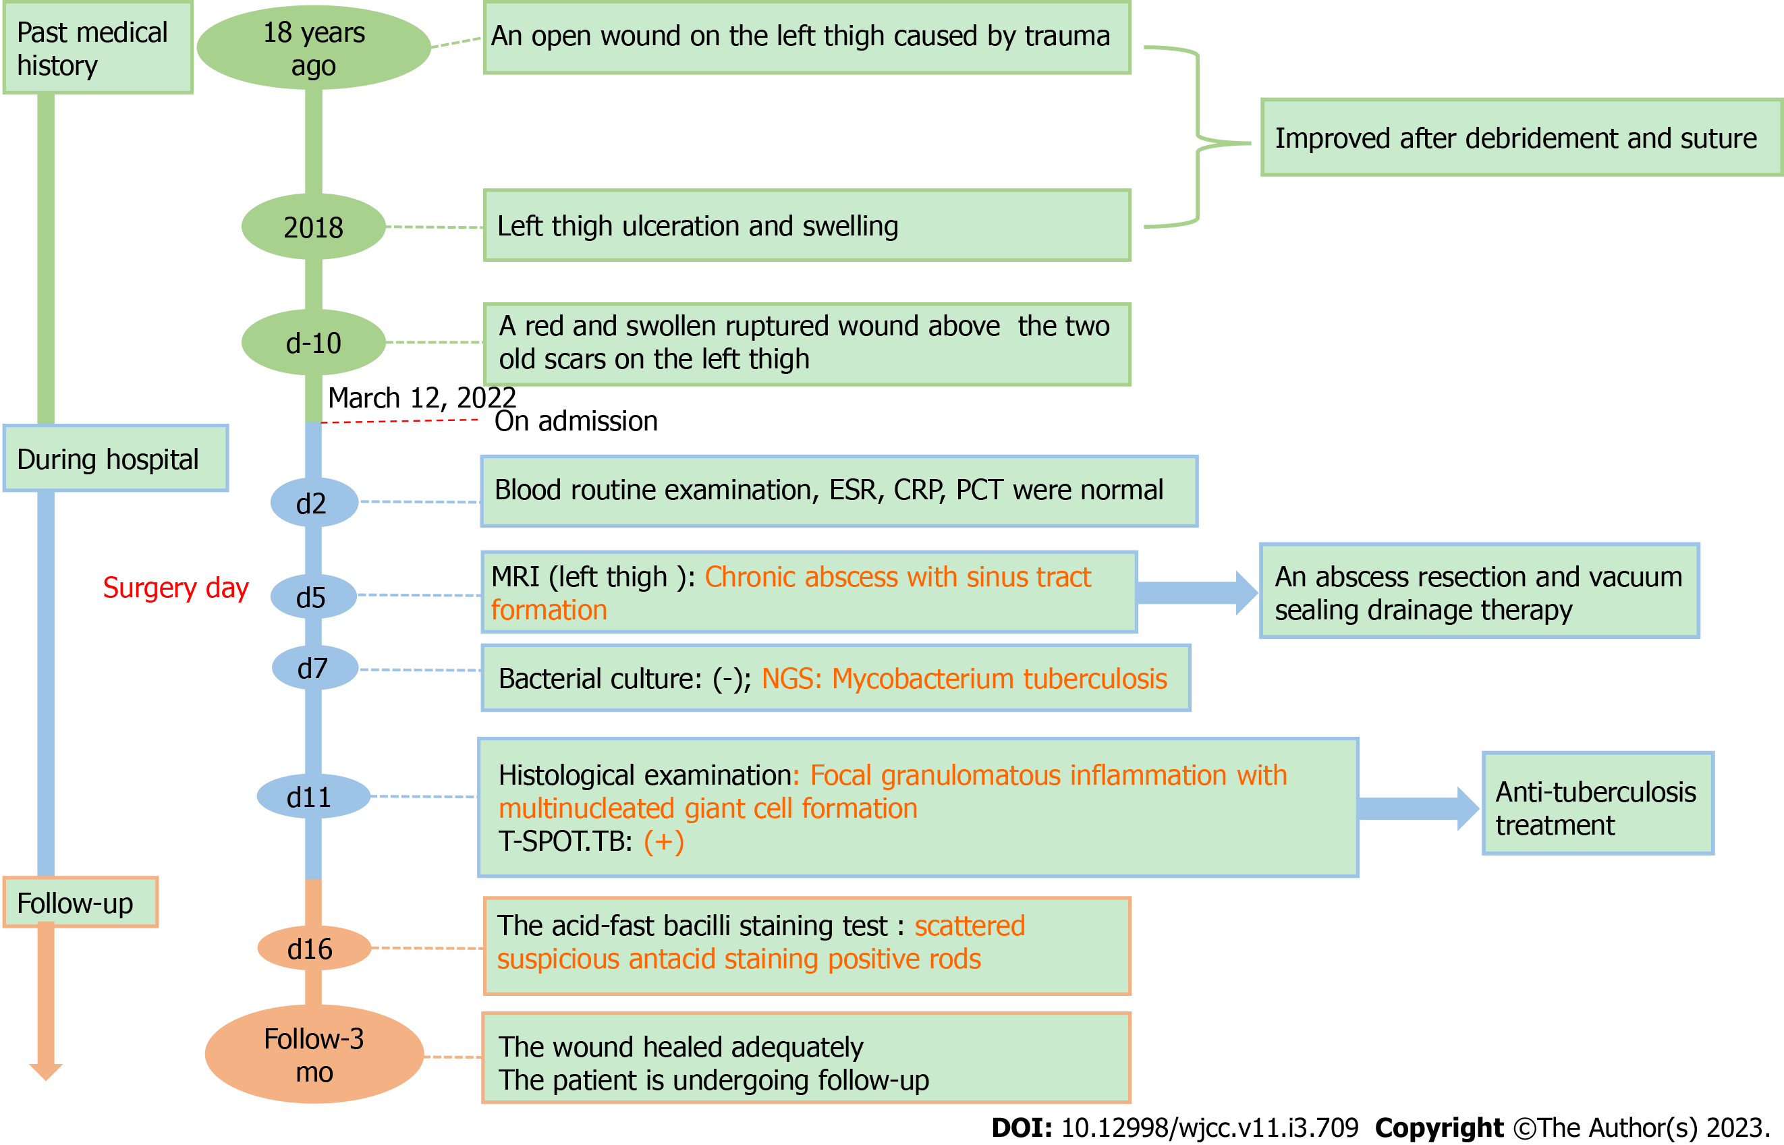
Figure 4 A timeline showing the progress of the disease and the patient’s treatment and follow-up. ESR: Erythrocyte sedimentation rate; CRP: C-reactive protein; PCT: Procalcitonin; MRI: Magnetic resonance imaging; NGS: Next-generation sequencing.

Table 1 Main features of reported cases of soft tissue tuberculosis
Ref. | Gender/age (yr) | Country | Underlying disease | Main clinical manifestations | Involved sites | Diagnostic methods
Arora et al^{[38]}, 2012 | Male/15 | India | None | Swelling, anorexia, weight loss | Left thigh | Mycobacterium tuberculosis culture
Lee et al^{[39]}, 2013 | Male/62 | Korea | Right total hip arthroplasty | Mass | Right thigh | Histological examination, and culture
Elshafie et al^{[40]}, 2013 | Male/25 | Oman | Exposed to suspected tuberculosis, diarrhea | Enlarging swelling | Right gluteus | Histological examination, and culture
Neogi et al^{[41]}, 2013 | Female/11 | India | None | Swelling | Right thigh, right calf, and left arm | Histological examination, and culture
Meena et al^{[42]}, 2015 | Male/25 | India | None | Swelling, fatigue, weight loss | Right triceps | Mycobacterium tuberculosis PCR
Dhakal et al^{[43]}, 2015 | Female/9 | Nepal | None | Swelling | Forearm, right calf | Histological examination
Sbai et al^{[44]}, 2016 | Male/45 | Tunisia | None | Pain, swelling | Right wrist | Tissue biopsy and culture
Al-khazraji et al^{[45]}, 2017 | Female/33 | America | Lupus nephritis, hormonal therapy | Pain, weakness, swelling, redness | Right calf | Fluid culture
Alaya et al^{[46]}, 2017 | Female/23 | Tunisia | None | Swelling, pain | Left thigh | Mycobacterium tuberculosis
Manicketh et al^{[25]}, 2018 | Female/55 | India | Pulmonary tuberculosis | Swelling, fever | Left wrist and right calf | A Ziehl-Nielsen stain
Hashimoto et al^{[27]}, 2018 | Male/79 | Japan | None | Swelling, erythema | Left wrist | Histological examination
Zeng et al^{[4]}, 2019 | Male/49 | China | Pulmonary tuberculosis; steroid treatment | Pain, mass, swelling | Both thighs and calves | Mycobacterium tuberculosis, Tissue biopsy and culture
Zitouna et al^{[47]}, 2019 | Female/42 | Tunisia | None | Mass, swelling | Right mid-back | Tissue biopsy and culture
Moyano et al^{[48]}, 2019 | Male/29 | Senegal | None | Pain, increase in size of hemithorax | Right hemithorax | Mycobacterium tuberculosis and culture
Fahad et al^{[28]}, 2020 | Female/45 | Pakistan | None | Swelling, pain | Right forearm | Histological examination
Murugesh et al^{[49]}, 2020 | Male/31 | India | Renal transplant with immuno-suppressants | Fever, pain, swollen erythematous | Right foot and calf | Nucleic acid amplification test
Tone et al^{[26]}, 2021 | Male/29 | Japan | Right tuberculous pleurisy | Fever, pain | Right iliopsoas | Mycobacterium tuberculosis
PCR: Polymerase chain reaction.

Published by Baishideng Publishing Group Inc
7041 Koll Center Parkway, Suite 160, Pleasanton, CA 94566, USA
Telephone: +1-925-3991568
E-mail: bpgoffice@wjgnet.com
Help Desk: https://www.f6publishing.com/helpdesk
https://www.wjgnet.com

© 2023 Baishideng Publishing Group Inc. All rights reserved.

