Answering to Reviewer

Reviewer #1.
A case of ST-segment elevation myocardial infarction in an adult male with a history of Kawasaki disease was reported. The author systematically summarized 30 related similar cases, but there are still relevant questions to be raised: 1. Page 8 "The combination of aspirin and warfarin has been shown to reduce the risk of Thrombosis in subjects with Giant aneurysms (Z Score > 10) "can you specify how to prevent bleeding while anticoagulation, and how often should coagulation function be monitored? 2. "Governmental initiatives may be necessary to Educate and promote physicians." To make guardians of children with Kawasaki disease aware of the lifelong nature of vascular management. This case is very well written, informative and detailed. If the above two points can be supplemented, it will be more perfect.

Comment 1: Page 8 "The combination of aspirin and warfarin has been shown to reduce the risk of Thrombosis in subjects with Giant aneurysms (Z Score > 10) "can you specify how to prevent bleeding while anticoagulation, and how often should coagulation function be monitored?

Reply to comment 1: Thank you for your inspiring comments. In the AHA expert consensus statement (reference 17 in the manuscript), it is recommended to set the International Normalized Ration (INR) level between 2 and 3 with daily INR check until reaching the target INR when first diagnosed with giant aneurysm. Monthly INR testing is followed unless the patient is sick or change the medication or diet[1]. We added this information to the discussion section of the manuscript. (Page 8 line #12 ~ #15)

Comment 2: "Governmental initiatives may be necessary to Educate and promote physicians." To make guardians of children with Kawasaki disease aware of the lifelong nature of vascular management.

Reply to comment 2: We agree with your opinion. At the government level, it is necessary to educate the progress of Kawasaki disease (KD) to clinicians as well as caregivers. We updated this to the discussion section of the manuscript (Page 9 line #27~ #28, page 10 line #1~ #2)

Reviewer #2.
The manuscript title "ST-segment Elevation Myocardial Infarction in a Young Adult with a History of Kawasaki Disease: A Case Report of an Often-Neglected Arena" demonstrates a high quality case-report supported by a good quality imaging data as well as case-series literature review data. I highly recommend the article to be published.

Reply to Reviewer #2: We really appreciate your comments.

Reviewer #3.
The authors revealed that imaging surveillance and medical therapy were performed with low rate (1/19) and through the case series (19 patients including their own case) of underlying definite Kawasaki disease presenting with ACS. This reviewer would like to give some comments in this study. Major: 1. Their own case doesn’t seem to have specific characteristics which distinguish between their case and previously reported cases. 2. The authors searched only cases of Kawasaki disease presented with ACS. This reviewer think it is quite natural that ACS tend to occur in those cases without imaging surveillance and/or medical therapy. To confirm the benefit of imaging surveillance, medical therapy, or Z score in preventing thrombotic outcomes, comparison with cases that have adequate follow-up is necessary. Minor In page 6 1, smoking for 5 years→ He is current smoker or not? 3. ST elevation in leads in leads II, III and aVF and V4-6 4. Why there is no abnormal Q and T inversion despite after one day since onset? 5. left ventricular systolic function (left ventricle ejection fraction (LVEF): 47%). In page 7 6. We were not able to further advance the IVUS catheter into the OM due to resistance and angulation→ there was no coronary stenosis around the aneurysm? 7. A drug-eluting stent (GenossTM 4.5 x 23 mm, Genoss, Suwon, Korea)→ Why the authors used the DES but not large size BMS? Thrombosis formation outside the stent might be difficult when DES was used. 8. There is nor description of Z score in Table1. 9. Please explain Figure 3 in figure legend. What means the boxes in the first and second rows.

Comment 1: Their own case doesn’t seem to have specific characteristics which distinguish between their case and previously reported cases.

Reply to comment 1: Thank you for your inspiring comments. As you know, Kawasaki disease patients presenting with acute coronary syndrome (ACS) has been previously reported. We acknowledge that the current case has similar features to the previous cases. We therefore analyzed a case series altogether to derive clinical implication in such situations. In addition, this case can be used to educate clinicians about the need for long term management of KD patients.

Comment 2: The authors searched only cases of Kawasaki disease presented with ACS. This reviewer think it is quite natural that ACS tend to occur in those cases without imaging surveillance and/or medical therapy. To confirm the benefit of imaging surveillance, medical therapy, or Z score in preventing thrombotic outcomes, comparison with cases that have adequate follow-up is necessary.

Reply to comment 2: Thank you for your inspiring comments. We agree with your comments. First, to date, there is no study comparing the outcome in those with or without appropriate follow up and imaging surveillance. However, it was found that the prognosis of patients differed according to the Z score[1-4]. So, appropriate imaging surveillance and regular follow up are recommended by expert consensus[1]. Second, there is some evidence for antithrombotic treatment in CAA. Although there is still limited data on the use of antiplatelet, it is recommended by expert consensus [1]. In the presence of giant aneurysms (Z score > 10), the risk of coronary artery thrombosis was higher without anticoagulation[5]. This has been updated in discussion section of the manuscript. (Page 8 line #3~ #9)

Comment 3: smoking for 5 years → He is current smoker or not?

Reply to comment 3: The patient stopped smoking 10 year prior to visiting the emergency room. This has been updated in case presentation section of the manuscript. (Page 5 line #11~ #12)

Comment 4: ST elevation in leads in leads II, III and aVF and V4-6.

Reply to comment 4: Thank you for your comments. We have corrected the manuscript regarding this notion. (Page 5 line #21)

Comment 5: ST elevation in leads in leads II, III and aVF and V4-6 4. Why there is no abnormal Q and T inversion despite after one day since onset?

Reply to comment 5: The patient said that he had intermittent pain once a day before and there was no more pain. The next day, the pain got worse. So, he visited the emergency room. It is known that pathologic Q waves may take up to 24 hours to develop^{[6]}. We have corrected the manuscript regarding this notion. (Page 5 line #4~ #5)

Comment 6: left ventricular systolic function (left ventricle ejection fraction (LVEF): 47%)

Reply to comment 6: Thank you for your comments. We have corrected the manuscript regarding this notion. (Page 6 line #1)

Comment 7: In page 7 We were not able to further advance the IVUS catheter into the OM due to resistance and angulation → there was no coronary stenosis around the aneurysm?

Reply to comment 7: We think that this is an important issue that we have failed to address. At the time of the procedure, we were not able to advance the IVUS down the OM and failed to evaluate IVUS images. During the follow-up CT angiography, we found that there was no stenotic lesion in the OM. We believe our inability to advance the IVUS catheter into the OM may have been associated with angulation. We have updated our manuscript regarding this issue in the case presentation section. (Page 6 #17~ #18, Figure 2D)
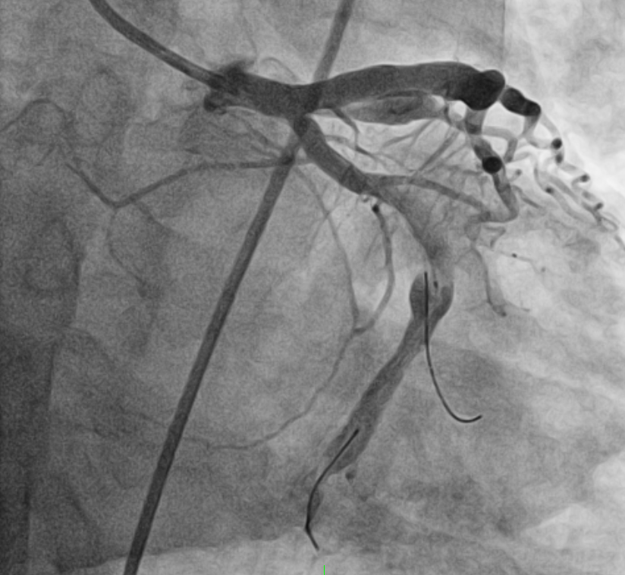

Comment 8: A drug-eluting stent (GenossTM 4.5 x 23 mm, Genoss, Suwon, Korea)→ Why the authors used the DES but not large size BMS? Thrombosis formation outside the stent might be difficult when DES was used.

Reply to comment 8: Thank you for your comments. The America Heart Association scientific statement recommends choosing drug eluting stent (DES) or bare metal stent (BMS) according to the patient’s situation. Since current case’s patient was not a giant aneurysm, anticoagulation was not required. The use of DES during PCI is reasonable for KD patient who does not require long term anticoagulation^{[1]}. We have updated our manuscript regarding this issue in the case presentation section. (Page 6 #22~ #24)

Comment 9: There is nor description of Z score in Table1.

Reply to comment 9: Thank you for your kindly comments. We have corrected the manuscript regarding this notion. (Table 1)

Comment 10: Please explain Figure 3 in figure legend. What means the boxes in the first and second rows.

Reply to comment 10: Thanks for your comments on what might be confusing. The box means to focus on a specific area where we want to show you.

Reviewer #4.
KD is an important cause of coronary artery lesions in children. So far, there are only a few a studies focusing on the sequelae of KD in adult period. This case report provided a complete case of coronary artery thrombosis in adult caused by KD induced coronary artery lesions. There are several questions about this study: 1. How long had the patient been followed-up for KD in childhood? Have he been found to have coronary artery lesion in the acute stage of KD? 2. The patient was at high risk of thrombosis. Why do you choose dual antiplatelets instead of 1 antiplatelet drug+ 1 anticoagulation drug? 3. The use of stent is contoversial in KD. More literature review on stenting may helpful for the further treatment. 4. Was MRI considered for the evaluation of myocardial recovery in folow-up?

Comment 1: How long had the patient been followed-up for KD in childhood? Have he been found to have coronary artery lesion in the acute stage of KD?

Reponse to comment 1: The current patient was diagnosed and hospitalized for with KD during childhood. He was no longer visited the hospital thereafter. hospital for further management. We were unable to obtain childhood medical records.

Comment 2: The patient was at high risk of thrombosis. Why do you choose dual antiplatelets instead of 1 antiplatelet drug+ 1 anticoagulation drug?

Reply to comment 2: Thank you for your comments. Because the patient does not have a giant CAA, the use of warfarin is not required.

Comment 3: The use of stent is contoversial in KD. More literature review on stenting may helpful for the further treatment.

Reply to comment 3: Thank you for your comment. In young patients in acute or subacute phase of KD, the use of stent is controversial. However, the adult with ST elevation myocardial infarction (STEMI) with a remote history of KD, PCI is recommended in the America Heart Association scientific statement[1]. However, there are complications that can occur after stent implantation, more research is needed[7].

Comment 4: Was MRI considered for the evaluation of myocardial recovery in folow-up?

Reply to comment 4: Thank you for your comment. We also considered cardiac MRI to confirm myocardial recovery, but we were unable to proceed with additional test due to cost concerns.

References.
1 McCrindle BW, Rowley AH, Newburger JW, Burns JC, Bolger AF, Gewitz M, Baker AL, Jackson MA, Takahashi M, Shah PB, Kobayashi T, Wu MH, Saji TT, Pahl E. Diagnosis, Treatment, and Long-Term Management of Kawasaki Disease: A Scientific Statement for Health Professionals From the American Heart Association. Circulation 2017; 135(17): e927-e999 [PMID: 28356445 DOI: 10.1161/cir.0000000000000484]
2 Friedman KG, Gauvreau K, Hamaoka-Okamoto A, Tang A, Berry E, Tremoulet AH, Mahavadi VS, Baker A, deFerranti SD, Fulton DR, Burns JC, Newburger JW. Coronary Artery Aneurysms in Kawasaki Disease: Risk Factors for Progressive Disease and Adverse Cardiac Events in the US Population. J Am Heart Assoc 2016; 5(9) [PMID: 27633390 PMCID: PMC5079009 DOI: 10.1161/jaha.116.003289]
3 Miura M, Kobayashi T, Kaneko T, Ayusawa M, Fukazawa R, Fukushima N, Fuse S, Hamaoka K, Hirono K, Kato T, Mitani Y, Sato S, Shimoyama S, Shiono J, Suda K, Suzuki H, Maeda J, Waki K, Group aTZ-sPnSS. Association of Severity of Coronary Artery Aneurysms in Patients With Kawasaki Disease and Risk of Later Coronary Events. JAMA Pediatrics 2018; 172(5): e180030-e180030 [DOI: 10.1001/jamapediatrics.2018.0030]
4 Santimahakullert K, Vijarnsorn C, Wongswadiwat Y, Chanthong P, Khrongsrattha S, Panamonta M, Chan-On P, Durongpisitkul K, Chungsomprasong P, Kanjanauthai S, Soongswang J. A retrospective cohort study of major adverse cardiac events in children affected by Kawasaki disease with coronary artery aneurysms in Thailand. PloS one 2022; 17(1): e0263060 [PMID: 35085339 PMCID: PMC8794099 DOI: 10.1371/journal.pone.0263060]
5 Manlhiot C, Newburger JW, Low T, Dahdah N, Mackie AS, Raghuveer G, Giglia TM, Dallaire F, Mathew M, Runeckles K, Pahl E, Harahsheh AS, Norozi K, de Ferranti SD, Friedman K, Yetman AT, Kutty S, Mondal T, McCrindle BW. Low-Molecular-Weight Heparin vs Warfarin for Thromboprophylaxis in Children With Coronary Artery Aneurysms After Kawasaki Disease: A Pragmatic Registry Trial. The Canadian journal of cardiology 2020; 36(10): 1598-1607 [PMID: 32621885 DOI: 10.1016/j.cjca.2020.01.016]
6 Morris F, Brady WJ. ABC of clinical electrocardiography: Acute myocardial infarction-Part I. Bmj 2002; 324(7341): 831-834 [PMID: 11934778 PMCID: PMC1122768 DOI: 10.1136/bmj.324.7341.831]
7 Tsuda E. Insights into stent implantation for coronary artery lesions caused by Kawasaki disease. Cardiology in the young 2020; 30(7): 911-918 [PMID: 32513335 DOI: 10.1017/s104795112000133x]

