Name of Journal: World Journal of Meta-Analysis
Manuscript NO: 83941
Manuscript Type: SYSTEMATIC REVIEWS

Exploratory systematic review and meta-analysis on period poverty

Delanerolle G et al. Period poverty in Low- And Middle- income- cOunTries

Gayathri Delanerolle, Xiao-Jie Yang, Heitor Cavalini, Om P Kurmi, Camilla Mørk Røstvik, Ashish Shetty, Lucky Saraswat, Julie Taylor, Sana Sajid, Shanaya Rathod, Jian-Qing Shi, Peter Phiri

Gayathri Delanerolle, Heitor Cavalini, Sana Sajid, Shanaya Rathod, Jian-Qing Shi, Peter Phiri, Department of Research & Innovation, Southern Health NHS Foundation Trust, Southampton SO30 3JB, United Kingdom

Gayathri Delanerolle, Nuffield Department of Medicine, University of Oxford, Oxford OX3 7JX, United Kingdom

Xiao-Jie Yang, School of Statistics and Mathematics, Yunnan University of Finance and Economics, Kunming 650221, Yunnan Province, China

Xiao-Jie Yang, Ashish Shetty, University College London, London WC1E 6BT, United Kingdom

Om P Kurmi, Centre for Intelligent Healthcare, Institute of Health and Wellbeing, Coventry University, Coventry CV1 5LB, United Kingdom

Camilla Mørk Røstvik, Centre for Contemporary Art, University of St Andrews, Scotland KY16 9AJ, United Kingdom

Ashish Shetty, Pain Management Centre, University College London Hospitals NHS Foundation Trust, London W1T 4AJ, United Kingdom

Lucky Saraswat, Aberdeen Centre for Women’s Health, University of Aberdeen, Aberdeen AB24 3FX, United Kingdom

Julie Taylor, School of Nursing, University of Birmingham, Birmingham B152TT, United Kingdom

Jian-Qing Shi, Statistics and Data Science, Southern University of Science and Technology, Shenzhen 518055, Guangdong Province, China

Peter Phiri, School of Psychology, Faculty of Environmental and Life Sciences, University of Southampton, Southampton SO17 1BJ, United Kingdom

Author contributions: Delanerolle G conceptualised the PLATO project as part of the ELEMI program which includes three work-packages; Delanerolle G, Cavalini H, Shi JQ and Phiri P developed the systematic review protocol and embedded this within the PLATO project’s work package 1; Delanerolle G and Shi JQ designed the statistical analysis plan; Yang XJ, Delanerolle G, and Shi JQ completed the analysis; Sajid S and Phiri P completed the risk of bias and Newcastle-Ottawa Scale; All authors critically appraised and commented on previous versions of the manuscript; All authors read and approved the final manuscript.

Corresponding author: Peter Phiri, BSc, PhD, RN, Director, Senior Research Fellow, Senior Researcher, Department of Research & Innovation, Southern Health NHS Foundation Trust, Tom Rudd Unit Moorgreen Hospital Botley Road West End, Southampton SO30 3JB, United Kingdom. peter.phiri@southernhealth.nhs.uk

Received: February 17, 2023
Revised: April 18, 2023
Accepted: May 6, 2023
Published online: June 18, 2023

Abstract
BACKGROUND
Period poverty is a global health and social issue that needs to be addressed. It has been reported that many females compromise their education, employment, and social commitments during their menstruation days due to a number of reasons, including lack of access to toilets or menstrual products.

AIM
To provide a comprehensive understanding on period poverty, including outcomes associated with menstruation.

METHODS
All observational and randomised clinical trials reporting menstruation challenges, menstrual poverty and menstrual products were included. Our search strategy included multiple electronic databases of PubMed, Web of Science, ScienceDirect, ProQuest and EMBASE. Studies published in a peer review journal in English between the 30th of April 1980 and the 30th of April 2022 were included. The Newcastle-Ottawa Scale was used to assess the risk of bias of the systematic included studies. Pooled odds ratios (ORs) together with 95% confidence intervals (CIs) are reported overall and for sub-groups.

RESULTS
A total of 80 studies were systematically selected, where 38 were included in the meta-analysis. Of the 38 studies, 28 focused on children and young girls (i.e., 10-24 years old) and 10 included participants with a wider age range of 15-49 years. The prevalence of using disposable sanitary pads was 45% [95%CI = (0.35, 0.58)]. The prevalence of menstrual education pre-menarche was 68% [95%CI = (0.56, 0.82)]. The prevalence of good menstrual hygiene management (MHM) was 39% [95%CI = (0.25, 0.61)]. Women in rural areas [OR = 0.30, 95%CI = (0.13, 0.69)] were 0.70 times less likely to have good MHM practices than those living in urban areas.

CONCLUSION
There was a lack of evidence, especially from low- and middle- income countries. Further research to better understand the scope and prevalence of period poverty should be considered. This will enable the development of improved policies to increase access to menstrual products and medical support where necessary.

Key Words: Period poverty; Menstruation; Mental health; Menstrual education; Menstrual hygiene

©The Author(s) 2023. Published by Baishideng Publishing Group Inc. All rights reserved.

Citation: Delanerolle G, Yang XJ, Cavalini H, Kurmi OP, Røstivik CM, Shetty A, Saraswat L, Taylor J, Sajid S, Rathod S, Shi JQ, Phiri P. Exploratory systematic review and meta-analysis on period poverty. World J Meta-Anal 2023; 11(5): 196-217
URL: https://www.wjgnet.com/2308-3840/full/v11/i5/196.htm
DOI: https://dx.doi.org/10.13105/wjma.v11.i5.196

Core Tip: Period poverty is an important health issue, impacting social and psychological wellbeing. Issues are predominantly seen in low- and middle- income countries, affected by conflicts, disasters, and economic struggles. Evidence showed a link between menstruation and prevalence of stress, anxiety, and depression. Whilst menstruation is a physical health issue, there are clear associations with mental health. Despite the global scale of period poverty, it is under-researched and is not well understood. Further research in this area will help to form healthcare policies and support for women and girls.

INTRODUCTION
The World Health Organization (WHO) defines health as complete mental, physical, and social well-being, thus not a mere absence of a disease or infirmity^{[1]}. For women, menstrual health is integral to maintain their overall health as menstruation occurs between menarche and menopause, which may have a significant impact on their mental, physical, and social wellbeing. Menstruation, or periods, is a biological process that is part of nearly every biological female’s life and is defined as cyclical bleeding that occurs as a result of the regeneration of the uterine endometrium corpus. Clinically, the normal menstrual process is of 4 phases across a cycle of 28-35 days^{[2,3]}. The regularity of these cycles, duration of each of the bleeding episodes within a cycle, and the volume or heaviness of the bleed varies across women and can change throughout an individual’s lifespan^{[2,3]}. All women do not experience normal menstrual bleeding, with approximately 30% experiencing alterations to their pattern or volume of menstrual flow due to multiple aetiologies^{[2,4]}. Many women also report symptoms such as pain, anxiety, fatigue, dysmenorrhea, and depression associated with their menstrual cycle that may require clinical involvement to diagnose potential reproductive health issues such as premenstrual dysphoric disorder, premenstrual syndrome, or endometriosis^{[2-4]}. To promote positive health and wellbeing outcomes to all genders and clinicians, it is important to understand menstrual cycles and menstrual health that can be promoted in the first instance by way of menstrual health literacy and various public interventions such as maintaining good hygiene practices and access to menstrual products.
Access to menstrual products is as vital as access to other hygiene products. The WHO and United Nations International Children’s Emergency Fund has reported that many girls miss school and put their lives on hold to remain at home during their menstruation days due to a number of reasons, including access to toilets or menstrual products^{[5,6]}. This is commonly reported as period or menstruation poverty^{[7]}. Period poverty is a global health issue impacting people who do not have access to hygienic and safe menstrual products. This is particularly important for regions with conflicts and disasters, which leave menstruating people with minimal or no access to safe menstrual products or clean toilets. This could lead to the use of unconventional methods to manage the bleeding such as the use of clothing, rags or sitting on old tin cans^{[8-10]}. Ancient traditions such as Chhaupadi practices could further risk girls and women from securely managing their menstruation^{[11]}. Chhaupadi is practiced in some far western rural regions in Nepal where young girls are banished into sheds or mud huts during menstruation or even longer as they believe this brings ill health or bad luck to the families^{[11]}. Often these people have little or no access to washing facilities or supplies leading to health issues, including physical and psychological hardship^{[11,12]}. Despite Chhaupadi being illegal in Nepal since 2005, Action Aid reports that it is practiced in some communities to date^{[12]}. Whilst poverty and stigma impact the right for a girl child’s education, especially in low-middle-income countries, The United Nations Educational, Scientific and Cultural Organization reports that 1 in 10 girls in Africa alone misses school during their menstruation^{[13]}. Missing school could lead to dropping out, risking child marriage and pregnancy at a younger age, as reported by Action Aid^{[14]}.
It has been reported for many decades that menstrual poverty is associated with stigma and shame and impacts the dignity and overall wellbeing. Despite being a developed country, over 37% of women in the United Kingdom (UK) have experienced period shaming by way of isolation, bullying and jokes, based on an Action Aid survey report^{[15]}. Approximately 40% of women reported being humiliated by their partners, while over half of UK women said they were embarrassed when they got their periods for the first time. In addition, over 52% reported they hide sanitary products when taking these to the toilet to prevent anyone else from being embarrassed, whilst 43% reported they felt people would make inappropriate remarks. The New York Post reported similar findings from a study commissioned by THINX, which indicated 58% of women felt embarrassed during the menstruation period whilst 42% experienced period-shaming, where 1 in 5 of those women reported these feelings were due to comments made by male friends^{[16]}.
It is evident that period poverty appears to be a global phenomenon, and key sociological as well as clinical features may differ due to varying risk factors in diverse geographical regions. To identify the impact of period poverty in diverse populations and common denominators observed between low-middle-income countries (LMICs) and high-income countries, it is vital to better understand current gaps in knowledge, policies and practice. Prior to this study, a comprehensive evidence synthesis had not been conducted to demonstrate the impact of period poverty. To achieve this, we developed the PLatform for the Analysis, Translation, and Organization of large-scale data project (PLATO) with the first component focusing on an evidence synthesis of the existing peer reviewed literature.

MATERIALS AND METHODS
A systematic methodology was developed and published as a protocol in PROSPERO (CRD42022339536) to explore period poverty. A meta-analysis was conducted in addition to two key thematic variables identified through the systematic review of homelessness, infections, lived experiences and mental health impact due to menstruation.
Within the context of this study, rural and urban areas of the study were defined by natural administrative division of the location as reported within the peer review publications. The division of LMIC, middle-low-income countries (MICs) and high-income countries were defined based on the dividing standards of the World Banking Group.
The primary aim of this study was to provide a comprehensive understanding on period poverty, including outcomes associated menstruation such as affordability of menstrual products, disposable sanitary pads, accessibility to menstruation education tools, adequate menstrual hygiene management (MHM) practice and urinary tract infections. The difference in MHM practices in a variety of contexts such as age groups, religious beliefs, parents’ educational status, and school absenteeism due to dysmenorrhea were also explored.

Inclusion/exclusion
All observational and randomised clinical trials reporting menstruation challenges, menstrual poverty and menstrual products were included. Studies published in a peer review journal in English between the 30th of April 1980 and the 30th of April 2022 were included. All editorials, letters to editors and commentaries, and papers published in languages other than English were excluded.

Patient and public involvement
All the data used in this systematic review is publicly available. No further patient or public involvement was implemented for this paper.

Search strategy
Our search strategy included multiple electronic databases of PubMed, Web of Science, ScienceDirect, ProQuest and EMBASE. Subject index terms used were: Menstrual education, anthropology, period poverty, pads, sanitary pads, sanitary facilities, menstrual hygiene, urinary tract infections, menstrual health, and women's periods. The title and abstract of each publication were screened independently by two investigators. A consensus was reached for studies that were unsuitable for inclusion. Articles that were included were reviewed in in full independently by two investigators. These were re-reviewed independently prior to the data extraction. Difference of opinions and queries were resolved by the by the Principal Investigator and Chief Investigator.

Data extraction
We developed an extraction template specific to the objectives of the study although the aim was to gather a wider dataset to ensure vital data was not missed to answer the research aims comprehensively. Participants included in the study populations were those who live and/or are at risk of menstrual poverty. All studies reporting a menstrual product and/or an educational intervention associated with menstruation were extracted by way of the instruments, measures of tool and questionnaires. The final dataset was independently reviewed before the analysis commenced.
Participants included in the study populations were those who have experienced or are at risk of menstrual poverty. All studies reporting a menstrual product and/or an educational intervention associated with menstruation were extracted by way of the instruments, measures of tool and questionnaires. The final dataset was independently reviewed before the analysis commenced.

Risk of bias
The Newcastle-Ottawa Scale was used to assess the risk of bias (RoB) of the systematic included studies. A risk of bias table has been made available as a supplementary file. The RoB table reflects a fixed set of biases linked to the study design, conduct and reporting (Table 1).

Meta-analyses
Out of the 1432 studies screened, 1182 were excluded. Of the 250 studies assessed for eligibility, 170 were excluded. Hence, 80 studies were systematically included, and 38 were included in the meta-analysis (Figure 1). The 38 studies were explored to obtain several indicators of period poverty, such as access to menstrual education tools, use of menstrual pads and MHM practice, as well as their related issues such as urinary tract infections, religious status, educational level of parents, geographical location including urban and rural areas, and the presence of a financial allowance.
To calculate the summary effect size across studies, meta-analysis of single proportions was applied to (a)-(c), and meta-analysis for comparison of two interventions was applied to (d)-(k)^{[17,18]}. Since almost all outcomes of interest in the current analysis were dichotomous, meta-analysis with binary data was performed, and accordingly the pooled odds ratio (OR) with a 95% confidence interval (CI) was used to access the effect of two interventions^{[19,20]}. Statistical heterogeneity was evaluated by the commonly used measure I² with P value, and further I² larger than 50% with a much small P value indicates strong heterogeneity. In comparison, I² less than 50% with a large P value indicates fairly weak heterogeneity^{[20]}. In the presence of high heterogeneity, the random effects model was employed; instead, the fixed effects model was used if there was weak or no heterogeneity^{[21]}. In some cases, subgroup analysis was carried out to identify the sources of heterogeneity, and sensitivity analysis was conducted for mainly assessing robustness of the synthesized results. Finally, publication bias was addressed seriously in the discussion part. All statistical outputs were reported using R^{[22,23]}.
A systematic analysis was used for studies that were excluded from the meta-analysis including those reporting lived experiences and the mental health impact associated with menstruation.

RESULTS
Studies with limited discussion about menstrual products, menstruation knowledge and MHM practice were excluded, resulting in a final dataset of 80 studies (Table 2). Of the 80 studies, 38 studies were selected for meta-analysis. Of 38 the studies, 34 were from LMICs and 4 from developed countries (non-LMICs).

Meta-analysis
Prevalence of using disposable sanitary pads: We explored the link of disposable sanitary pads as an indicator of period poverty. A meta-analysis of single proportions was applied to 32 studies with a sample of 212459 women, that indicated a prevalence of 45% [95%CI = (0.35, 0.58)]. Figure 2A shows the forest plot for 32 studies. The value of 100% of I² (P value = 0) indicates a significant statistical heterogeneity.
To explore the sources of heterogeneity, a subgroup analysis was conducted using the geographical locations of the studies and demonstrated in a forest plot (Figure 2B). A statistically significant difference (P value < 0.01) was identified between LMICs and non-LMICs using sanitary pads where the pooled prevalence was 43% [95%CI = (0.33, 0.56)] and 76% [95%CI = (0.60, 0.96)], respectively. Figure 2B also showed that heterogeneity remained unchanged in LMICs (I² = 100%, P value = 0) and non-LMICs (I² = 98%, P value < 0.01), indicating that the identified heterogeneity was not geographical location influenced.

Prevalence of having knowledge/awareness on menstruation before menarche
Several surveys were meta-analysed to better understand adolescent girls' menstrual education and pre-menarche awareness. Common survey questions notably included, “were you familiar with menstruation before you got your first period ^{(Study 3)}”, “Information availability before reaching menarche ^{(Study 4)}”, “heard about menstruation before menarche ^{(Study 9)}”, and “prior knowledge about menstruation before menarche ^{(Study 11)}” and “awareness about menarche before its onset ^{(Study 79)}”. This information was used to conduct a meta-analysis of 11 studies with a sample size of 4944 young women. A high heterogeneity was detected with I² = 98% and P value < 0.01) (Figure 3A). The random effects model reported the overall prevalence to be 68% [95%CI = (0.56, 0.82)].

Prevalence of good MHM practice
Good MHM practice during menstruation is essential to prevent various other health issues such as urinary tract infections (UTIs)^{[24]}. MHM practice lacks a standardised definition although a consensus is that it is expected that throughout the bleeding phase, people require clean absorbents, adequate frequency of absorbent change, washing the body with soap and water, adequate disposal, and privacy for managing menstruation. All involved studies predesigned some practice-related questions in research studies to determine the level of MHM practice, defined simply as good or bad. Figure 3B demonstrates a forest plot of the prevalence of good MHM practice across ten studies with a total of 5432 women. The random effects model was used due to strong heterogeneity indicated by I² = 99% and P value < 0.01. The overall prevalence of good MHM practice was 39% [95%CI = (0.25, 0.61)].

Rural-urban difference in MHM practice level (good/bad)
A total of 5 studies with a sample size of 2705 women reported differences of MHM practice levels within rural and urban settings. The pooled OR of good MHM practice between rural and urban areas was 0.30 [95%CI = (0.13, 0.69)], indicating that women living in rural area were 0.70 times less likely to have good MHM practices in comparison to those living in an urban area. A high heterogeneity of 91% of I² (P value < 0.01) was identified (Figure 3C), possibly due to the differences in covariates, assessment tools and other factors.

Difference of MHM practice level (good/bad) between two age groups
Based on available data from 3 studies with a total of 1637 adolescent girls, special attention is paid to two groups aged at less than or equal to 15 years and 16 to 19 years. The random effects model yielded a I² of 82% with a pooled OR of good MHM practices between two age groups of 0.77 [95%CI = (0.44, 1.34)], which is not statistically significant (Figure 4A).

Difference of MHM practice level (good/bad) among adolescent girls with uneducated and educated father/mother
Parents’ educational background showed an impact on MHM practices among adolescent girls. In some studies father’s or mother’s educational status was divided into illiterate and literate, while in other studies categorised as uneducated, primary education, secondary or high school education, and college or above. To simplify the data, father’s or mother’s educational status was defined as uneducated, where either parent lacked primary education whilst, educated was anyone that had any above secondary. Figure 4B showed a forest plot for difference of MHM practice level (good/bad) among adolescent girls with uneducated and educated fathers, and the pooled OR was 0.55 [95%CI = (0.36, 0.83)]. This provides significant evidence of the lower prevalence of good MHM practice among adolescent girls with uneducated fathers. Similarly, Figure 4C demonstrated that adolescent girls with uneducated mothers were 0.48 times less likely to have good MHM practices than those with educated mothers.

Difference of MHM practice level (good/bad) among adolescent girls without and with pocket money
To some extent, the possibility of getting a financial allowance, also referred to as a pocket money indicated the socioeconomic status of the family which would indicate their affordability to disposable sanitary pads. Thus, two studies that reported on the use of disposable sanitary pads with a total of 731 adolescent girls were analysed. The forest plot (Figure 5A) demonstrates the difference of MHM practice levels among adolescent girls with and without pocket money. The I² = 0 (P value = 0.41) means that there was very weak statistical heterogeneity. The pooled OR was 0.45 [95%CI = (0.32, 0.64)], indicating that adolescent girls who have no pocket money were 0.55 times less likely to have good MHM practices than those who have pocket money.

Difference of MHM practice level (good/bad) among adolescent girls of having no and having discussion about menstruation with parents
Discussion points between a parent and a young girl were explored where the paradigm indicated open discussions around menstruation issues. Responses to these questions reflects the parent-child relationship. The forest plot indicates (Figure 5B) a difference between MHM practices among adolescent girls who did not have a discussion with their parents vs those who had a discussion was 0.46 [95%CI = (0.28, 0.75)].

Difference of MHM practice level (good/bad) among female followers of different religions
Literature indicated the presence of a correlation between religious views and MHM practices, as demonstrated within 3 studies conducted in Ethiopia, with a combined sample size of 1128 adolescent girls. Thus, a pairwise meta-analysis was employed to compare the MHM practice levels among women of Orthodox, Protestant and Islamic beliefs. Figures 5C-E demonstrated forest plots comparing Orthodox vs Protestant, Protestant vs Islam, and Orthodox vs Islam, respectively. The corresponding pooled ORs were 1.81 [95%CI = (0.47, 6.99)], 0.66 [95%CI = (0.23, 1.92)], and 0.66 [95%CI = (0.87, 1.72)]. Based on the CIs, there is no statistically significant difference in MHM practice levels among women from Orthodox, Protestant and Islamic beliefs.

School absenteeism due to dysmenorrhea
Dysmenorrhea is another key feature of menstruation indicating an important reason for school absenteeism among adolescent girls. Two studies reported mild and moderate menstrual pain among their participants. We combined mild to moderate pain and defined as not severe menstrual pain for the analyses. This was combined with four studies. The total sample size was 1582 (Supplementary Figure 1). The pooled OR of school absenteeism between adolescent girls with severe and not severe menstrual pain was 4.26 [95%CI = (2.27, 7.99)], indicating those with severe menstrual pain were 4.26 times more likely to miss school than those without menstrual pain.
Participants in study 7 were aged between 19 to 25 years of age, whilst others were less than 19 years old. There appears to be high heterogeneity (I² =83%, P value < 0.01) in the sample. Thus, it was excluded, and the heterogeneity was re-evaluated where the pooled OR is 2.98 [95%CI = (2.29, 3.87)]. Supplementary Figure 2 indicates I² to be 0 with a P value of < 0.01. The heterogeneity, therefore, was specific to Study 7. The participant group of 19 to 25 years old, or, more precisely, age group may be one of the main sources of heterogeneity.
To explore the association between school absenteeism and whether or not using disposable sanitary pads have any impact, a meta-analysis was applied to 3 studies with a total sample size of 1280 adolescent girls. Supplementary Figure 3 indicated significant evidence of statistical heterogeneity (I² =83%, P value < 0.01). The pooled OR of 2.08 [95%CI = (1.10, 3.91)] indicates that adolescent schoolgirls who did not use disposable sanitary pads were 1.08 times more likely to be absent from school than those using sanitary pads.

Association between dysmenorrhea and regularity of menstrual cycle
As presented in the former part, there is a statistically significant association between the severity of dysmenorrhea and school absenteeism. To further identify the possible causes of dysmenorrhea, two studies were meta-analysed with a total sample size of 1285 with confirmed experience of regular or irregular menstrual cycles. Supplementary Figure 4 indicated a lack of statistical heterogeneity (I² = 0, P value = 0.89) and thus the fixed effects model was used. The pooled OR was 2.31 [95%CI = (1.76, 3.02)], indicating the prevalence of dysmenorrhea among adolescent girls with irregular menstrual cycles is 2.31 times as high as those with a regular cycle.
Another key area of period poverty is the associated mental health impact, which can differ between those who suffer from mental illness and those who do not. Whilst there was insufficient data for a meta-analysis, there was evidence to suggest a link between menstruation and prevalence of stress, anxiety, and depression^{[3]}. In addition, socioeconomic status can impact the prevalence of stress, anxiety and depression experienced by different populations.

DISCUSSION
Period poverty is a global health issue, more prominent in low-middle-income countries. There are varying risk factors dependent on geographical location and this reflects in the differing sociological and clinical features, as explored in this paper.
This study demonstrates correlations between severity of dysmenorrhea and school absenteeism among girls between 14-19 years of age with and without regular menstruation. Another key area of period poverty is the associated mental health impact, which can differ between those who suffer from mental illness and those who do not. Whilst there was insufficient data for a meta-analysis, there was evidence to suggest a link between menstruation and prevalence of stress, anxiety, and depression^{[3]}. In addition, socioeconomic status can impact the prevalence of stress, anxiety and depression experienced by different populations. This could be exacerbated among those acquiring UTIs^{[24,25]}.
UTIs have been reported by Das and colleagues to be a common problem among those without pad use. Janoowalla and colleagues demonstrated no change in the prevalence of urinary tract infections between those using and not-using pads in the Kibogora region in Rwanda^{[26]}. Das and colleagues indicated a higher risk of urogenital infections among women using reusable absorbent pads within the Odisha region in India^{[24]}. Bacterial vaginosis (BV) is another issue impacting women with poorer menstrual practices. Das and colleagues reported that menstrual hygiene practices were associated with a symptomatic BV or UTI^{[24]}.
MHM practices were another key endpoint in this study which demonstrated to differ among women of Islamic, Protestant and Orthodox religious beliefs in Ethiopia. Representativeness of these findings to other ethnicities requires further research.
Homelessness is another facet that is vital to explore to identify the impact of period poverty. For example, in the United States, 553000 experience homelessness in a night compared to 32000 in the UK^{[27,28]}. It is reported that 25% of homeless service users in the UK are single women and 28% in the United States. These could be underestimated as hidden homeless is another facet where people do not access services but stay in temporary accommodation settings, including friends and relatives. Many official reports lack information regarding experiences of menstruation among the homeless. Padgett and colleagues demonstrate that this multifaceted concern or as a feature of reproductive health is now being explored, although comprehensive evidence is required^{[29]}. Phenomenology demonstrates homeless menstrual lived experiences, which is an important aspect of understanding period poverty by exploring the interrelatedness between the consciousness, body, and the flesh of a woman^{[30]}. Homeless people are a marginalised community; thus, menstruation could emphasize their vulnerability. Historically, social sciences research has focused on commodification, medicalisation and stigma associated with menstruation. Anglo-American publications have also failed to discuss intersectionality and focus primarily on white, middle-class, cisgender women or in a developmental context where women are in poverty^{[31-34]}. The sociopsychological and socioeconomic aspects associated with women living in poverty vs those not can sometimes be polarised from a period poverty perspective. Health outcomes among disenfranchised groups of women due to lack of or minimal access to menstrual products can have significant effects where clinical interventions would be required to manage the symptoms, including systemic issues. Another facet is that the supply of menstrual products to homeless services such as shelters, and day centers should be more effective. This should include the availability of staff that could be approached to talk about menstruation or any associated problems^{[35]}.
Another facet of period poverty is the composition of menstrual pads which is not the same in terms of their textile and polymer composition. Varying viscosity of menstrual flow could also impact the suitability of the differing pads, given that these are worn for different periods. Another aspect to consider as an external factor for menstrual products would be to produce material that can be disposed of in a biodegradable manner. Velasco Perez et al^{[36]} and Hait et al^{[37]} indicated that sanitary pads have a higher negative environmental footprint due to eutrophication and climate change. Limited evidence is available about menstrual underwear and menstrual cups associated with environmental impact. This further complicates menstrual hygiene issues, equitable availability, and acceptability, especially among LMIC populations.
Whilst this study has indicated the majority of the evidence on period poverty is within LMIC and MICs, there appears to be a lack of studies available within developed countries despite the definition of “period poverty”, including the inability to afford menstrual products. Given the risk of living costs, many media publications and social media posts indicate that period poverty is a concern within developed countries. For example, Cardoso and colleagues indicated that women in the United States reported 14.2% experienced period poverty in 2020, with an additional 10% experiencing it monthly^{[25]}. Whilst knowledge, attitude and practices associated with menstruation among poorer and vulnerable communities are likely to be lower regardless of the geographical location. As a result, the psychosocial dynamics may have a negative impact. The findings of these studies may have been exacerbated due to the coronavirus disease 2019 pandemic with substantial increases in unemployment and cost of living. Basic goods and service cost increase includes those of menstrual products. Thus, the pandemic has had gendered implications impacting the vulnerability of women. Caretaker roles of women have significantly grown as a result of lockdowns, and such requirements have been inadequately explored^{[38]}.
In addition, limited evidence is demonstrated around mental health implications due to the period of poverty. Cardoso and colleagues demonstrated an association between period poverty and depression among women within the United States who were previously depression naïve^{[25]}. This is similar to the findings reported between food insecurity associated with depression in adults and anxiety, depression and suicidal ideation among adolescents^{[25,39-41]}. Similarly, depression and anxiety were reported among people experiencing housing insecurities compared to those with stable houses^{[42,43]}.
The data identified is limited to either smaller sample sizes and/or geographical locations that could limit the generalisability of the findings to introduce impactful and meaningful changes to policy and clinical practice

CONCLUSION
Period poverty is an international issue, varying based on geographical locations, social implications, and economical factors. Better understandings of this problem will highlight current gaps in knowledge, policies, and practice. Undoubtedly, many issues affect the experiences of managing menstruation and access to menstrual products. To address the current gaps and ensure period poverty can be minimised, comprehensive research would be required. Policymakers and independent authorities should consider improved healthcare legislation, equitable access to menstrual products, information, and healthcare providers.

ARTICLE HIGHLIGHTS
Research background
Period poverty is an international health concern, impacting thousands of women and girls, especially those in underdeveloped regions or those struck with conflict and disaster. Due to issues with menstrual education and access to menstrual hygiene products, many females compromise their daily routines (e.g., not attending school or going to work). There is a lack of a comprehensive evidence synthesis in relation to period poverty hence the PLatform for the Analysis, Translation, and Organization of large-scale data project (PLATO) was developed with this systematic review and meta-analysis as the first stage.

Research motivation
Period poverty influences various health and social factors to varying degrees, dependent on the geographic location and other risk factors – this effect is amplified in low- and middle- income countries. To better understand the impact of period poverty, research exploring and highlighting current gaps in knowledge in key. Following this, improved legislation and policies for women and girls will enable better access to menstrual hygiene products and accurate menstrual education.

Research objectives
Due to the sheer lack in period poverty research, especially in low- and middle- income countries, this systematic review and meta-analysis aimed to explore current understandings and highlight any areas for future research. The primary outcomes included factors associated to menstrual hygiene products, such as accessibility and affordability, but also menstrual hygiene management and education. Variations in relation to age, location, religion, and parental and individual education was also explored.

Research methods
A systematic review and meta-analysis were conducted to explore period poverty with all related observational and randomised clinical trials included in this report. Studies published in English, between the 30th of April 1980 and the 30th of April 2022 were included. An extraction template was specifically developed in line with the objectives of the study to ensure that research aims were addressed comprehensively.

Research results
Overall, 80 studies were included in the systematic review and 38 in the meta-analysis and various statistically significant findings were uncovered. Sanitary pads were used a lot more in non-Low- and Middle-income countries, with women in rural areas being 0.7 times less likely to have good menstrual hygiene and management practices. School girls who reported irregular menstrual cycles experienced severe menstrual pain and those with severe pain were almost 5 times more like to miss out on school.

Research conclusions
This study demonstrates correlations between severity of dysmenorrhea and school absenteeism among girls with and without regular menstruation. It also explored how period poverty is the associated mental health impact, with evidence to suggest a link between menstruation and prevalence of stress, anxiety, and depression. This study has indicated that the majority of the evidence on period poverty is within low-middle-income countries and middle-low-income countries. It is possible that the findings of this study could have been exacerbated due to the coronavirus disease 2019 pandemic.

Research perspectives
Period poverty is an under-researched area despite is being a global social and health issue. This research has outlined current understandings of period poverty but also where the gaps lie. Following on from this, policies and practices can be introduced and developed to ensure women and girls are supported across the globe in relation to menstrual products, information, and healthcare providers.
REFERENCES
1 World Health Organization (WHO). Constitution of the World Health Organization [Internet]. n.d. [Accessed on September 21st 2022]. Constitution of the World Health Organization. Available from: https://www.who.int/
2 Munro MG, Critchley HOD, Fraser IS; FIGO Menstrual Disorders Committee. The two FIGO systems for normal and abnormal uterine bleeding symptoms and classification of causes of abnormal uterine bleeding in the reproductive years: 2018 revisions. Int J Gynaecol Obstet 2018; 143: 393-408 [PMID: 30198563 DOI: 10.1002/ijgo.12666]
3 Sharp HT, Johnson JV, Lemieux LA, Currigan SM. Executive Summary of the reVITALize Initiative: Standardizing Gynecologic Data Definitions. Obstet Gynecol 2017; 129: 603-607 [PMID: 28277367 DOI: 10.1097/AOG.0000000000001939]
4 Kjerulff KH, Erickson BA, Langenberg PW. Chronic gynecological conditions reported by US women: findings from the National Health Interview Survey, 1984 to 1992. Am J Public Health 1996; 86: 195-199 [PMID: 8633735 DOI: 10.2105/ajph.86.2.195]
5 United Nations International Children’s Emergency Fund (UNICEF). Menstrual Hygiene [Internet]. [cited September 2022] Available from: https://www.unicef.org/wash/menstrual-hygiene
6 World Health Organization (WHO). WHO statement on menstrual health and rights [Internet]. 2022 [cited September 2022]. Available from: https://www.unwater.org/news/who-statement-menstrual-health-and-rights
7 Action Aid. Period Poverty [Internet]. 2022 [cited in October 2022]. Available from: https://www.actionaid.org.uk/our-work/womens-rights/period-poverty
8 WaterAid. Menstrual Hygiene Matters. [Internet]. 2017. [cited in October 2022]. Menstrual hygiene matters | WASH Matters. Available from: https://wateraid.org
9 Garg S, Anand T. Menstruation related myths in India: strategies for combating it. J Family Med Prim Care 2015; 4: 184-186 [PMID: 25949964 DOI: 10.4103/2249-4863.154627]
10 ActionAid. Periods in humanitarian disasters [Internet]. 2022 [cited in October 2022]. Available from: https://www.actionaid.org.uk/our-work/period-poverty/periods-in-humanitarian-disasters
11 ActionAid. Chhaupadi and menstruation taboos [Internet]. 2023 [cited in October 2022]. Available from: https://www.actionaid.org.uk/our-work/period-poverty/chhaupadi-and-menstruation-taboos
12 The Guardian. Mother and two boys suffocate in Nepal's latest 'period hut' tragedy [Internet]. 2019 [cited in October 2022]. Available from: https://www.theguardian.com/globaldevelopment/2019/jan/10/mother-and-two-boys-suffocate-in-nepal-latest-period-hut-tragedy
13 United Nations Educational, Scientific, and Cultural Organization (UNESCO). Puberty education & menstrual hygiene management. UNESCO. 2014. Available from: Puberty education & menstrual hygiene management - UNESCO Digital Library
14 ActionAid UK. Girls Education [Internet]. 2022 [Accessed in September 2022]. Available from: https://www.actionaid.org.uk/our-work/womens-rights/girls-education
15 ActionAid UK. More than one in three UK women face period stigma [Internet]. 2018 [Accessed in September 2022]. Available from: https://www.actionaid.org.uk/latest-news/more-one-three-uk-women-face-period-stigma
16 MenstrualHygieneDay. Nearly half of US women have experienced ‘period shaming’ | MH Day [Internet]. 2022 [Acessed on September 21st, 2022]. Available from: https://menstrualhygieneday.org/nearly-half-us-women-experienced-period-shaming
17 Barendregt JJ, Doi SA, Lee YY, Norman RE, Vos T. Meta-analysis of prevalence. J Epidemiol Community Health 2013; 67: 974-978 [PMID: 23963506 DOI: 10.1136/jech-2013-203104]
18 Fleiss JL. The statistical basis of meta-analysis. Stat Methods Med Res 1993; 2: 121-145 [PMID: 8261254 DOI: 10.1177/096228029300200202]
19 Hartung J, Knapp G. A refined method for the meta-analysis of controlled clinical trials with binary outcome. Stat Med 2001; 20: 3875-3889 [PMID: 11782040 DOI: 10.1002/sim.1009]
20 Higgins JP, Thompson SG. Quantifying heterogeneity in a meta-analysis. Stat Med 2002; 21: 1539-1558 [PMID: 12111919 DOI: 10.1002/sim.1186]
21 Borenstein M, Hedges LV, Higgins JP, Rothstein HR. A basic introduction to fixed-effect and random-effects models for meta-analysis. Res Synth Methods 2010; 1: 97-111 [PMID: 26061376 DOI: 10.1002/jrsm.12]
22 Schwarzer G, Antes G, Schumacher M. A test for publication bias in meta-analysis with sparse binary data. Stat Med 2007; 26: 721-733 [PMID: 16755545 DOI: 10.1002/sim.2588]
23 Rothstein HR, Sutton AJ, Borenstein M. Publication bias in meta-analysis. Publication bias in meta-analysis: Prevention, assessment and adjustments. 2005; 7: 1-7 [DOI: 10.1002/0470870168.ch1]
24 Das P, Baker KK, Dutta A, Swain T, Sahoo S, Das BS, Panda B, Nayak A, Bara M, Bilung B, Mishra PR, Panigrahi P, Cairncross S, Torondel B. Menstrual Hygiene Practices, WASH Access and the Risk of Urogenital Infection in Women from Odisha, India. PLoS One 2015; 10: e0130777 [PMID: 26125184 DOI: 10.1371/journal.pone.0130777]
25 Cardoso LF, Scolese AM, Hamidaddin A, Gupta J. Period poverty and mental health implications among college-aged women in the United States. BMC Womens Health 2021; 21: 14 [PMID: 33407330 DOI: 10.1186/s12905-020-01149-5]
26 Janoowalla H, Keppler H, Asanti D, Xie X, Negassa A, Benfield N, Rulisa S, Nathan LM. The impact of menstrual hygiene management on adolescent health: The effect of Go! pads on rate of urinary tract infection in adolescent females in Kibogora, Rwanda. Int J Gynaecol Obstet 2020; 148: 87-95 [PMID: 31560131 DOI: 10.1002/ijgo.12983]
27 US Department of Housing and Urban Development. The 2018 Annual Homeless Assessment Report (AHAR) to Congress [Internet]. 2019 [Accessed on September 13 rd., 2022] Available from: https://www.hudexchange.info/resources/documents/2018-AHAR-Part-1.pdf
28 Shelter. Homelessness in Great Britain: The Numbers Behind the Story [Internet]. 2018 [Accessed on September 13 rd., 2022]. Available from: https://england.shelter.org.uk/professional_resources/policy_and_research/policy_library/research_homelessness_in_great_britain_-_the_numbers_behind_the_story
29 Padgett DK, Hawkins RL, Abrams C, Davis A. In their own words: trauma and substance abuse in the lives of formerly homeless women with serious mental illness. Am J Orthopsychiatry 2006; 76: 461-467 [PMID: 17209714 DOI: 10.1037/1040-3590.76.4.461]
30 Merleau-Ponty M. Phenomenology of Perception. Routledge; 2013 Apr 15. Available from: https://voidnetwork.gr/wp-content/uploads/2016/09/Phenomenology-of-Perception-by-Maurice-Merleau-Ponty.pdf
31 Ensign J. Reproductive health of homeless adolescent women in Seattle, Washington, USA. Women Health 2000; 31: 133-151 [PMID: 11289683 DOI: 10.1300/j013v31n02_07]
32 Gharib M. Why 2015 Was the Year of the Period, and We Don’t Mean Punctuation [Internet]. 2015 [Accessed on September 13 rd., 2022] Available from: https://www.npr.org/sections/health-shots/2015/12/31/460726461/why-2015-was-the-year-of-the-period-and-we-dont-mean-punctuation
33 Gerrard J, Farrugia D. The ‘lamentable sight’of homelessness and the society of the spectacle. Urban Studies. 2015; 52: 2219-2233 [DOI: 10.1177/0042098014542135]
34 Gruer C, Hopper K, Smith RC, Kelly E, Maroko A, Sommer M. Seeking menstrual products: a qualitative exploration of the unmet menstrual needs of individuals experiencing homelessness in New York City. Reprod Health 2021; 18: 77 [PMID: 33849575 DOI: 10.1186/s12978-021-01133-8]
35 Maulik PK, Mascarenhas MN, Mathers CD, Dua T, Saxena S. Prevalence of intellectual disability: a meta-analysis of population-based studies. Res Dev Disabil 2011; 32: 419-436 [PMID: 21236634 DOI: 10.1016/j.ridd.2010.12.018]
36 Velasco Perez M, Sotelo Navarro PX, Vazquez Morillas A, Espinosa Valdemar RM, Hermoso Lopez Araiza JP. Waste management and environmental impact of absorbent hygiene products: A review. Waste Manag Res 2021; 39: 767-783 [PMID: 32907518 DOI: 10.1177/0734242X20954271]
37 Hait A, Powers SE. The value of reusable feminine hygiene products evaluated by comparative environmental life cycle assessment. Resour Conserv Recycl 2019; 150: 104422 [DOI: 10.1016/j.resconrec.2019.104422]
38 Sommer M, Phillips-Howard PA, Gruer C, Schmitt ML, Nguyen AM, Berry A, Kochhar S, Gorrell Kulkarni S, Nash D, Maroko AR. Menstrual Product Insecurity Resulting From COVID-19‒Related Income Loss, United States, 2020. Am J Public Health 2022; 112: 675-684 [PMID: 35319956 DOI: 10.2105/AJPH.2021.306674]
39 Heflin CM, Siefert K, Williams DR. Food insufficiency and women's mental health: findings from a 3-year panel of welfare recipients. Soc Sci Med 2005; 61: 1971-1982 [PMID: 15927331 DOI: 10.1016/j.socscimed.2005.04.014]
40 Pryor L, Lioret S, van der Waerden J, Fombonne É, Falissard B, Melchior M. Food insecurity and mental health problems among a community sample of young adults. Soc Psychiatry Psychiatr Epidemiol 2016; 51: 1073-1081 [PMID: 27294729 DOI: 10.1007/s00127-016-1249-9]
41 McLaughlin KA, Green JG, Alegría M, Jane Costello E, Gruber MJ, Sampson NA, Kessler RC. Food insecurity and mental disorders in a national sample of U.S. adolescents. J Am Acad Child Adolesc Psychiatry 2012; 51: 1293-1303 [PMID: 23200286 DOI: 10.1016/j.jaac.2012.09.009]
42 Stahre M, VanEenwyk J, Siegel P, Njai R. Housing Insecurity and the Association With Health Outcomes and Unhealthy Behaviors, Washington State, 2011. Prev Chronic Dis 2015; 12: E109 [PMID: 26160295 DOI: 10.5888/pcd12.140511]
43 Burgard SA, Seefeldt KS, Zelner S. Housing instability and health: findings from the Michigan Recession and Recovery Study. Soc Sci Med 2012; 75: 2215-2224 [PMID: 22981839 DOI: 10.1016/j.socscimed.2012.08.020]
44 Montgomery P, Hennegan J, Dolan C, Wu M, Steinfield L, Scott L. Menstruation and the Cycle of Poverty: A Cluster Quasi-Randomised Control Trial of Sanitary Pad and Puberty Education Provision in Uganda. PLoS One 2016; 11: e0166122 [PMID: 28002415 DOI: 10.1371/journal.pone.0166122]
45 Sychareun V, Chaleunvong K, Essink DR, Phommavongsa P, Durham J. Menstruation practice among school and out-of-school adolescent girls, Lao PDR. Glob Health Action 2020; 13: 1785170 [PMID: 32741349 DOI: 10.1080/16549716.2020.1785170]
46 Ha MAT, Alam MZ. Menstrual hygiene management practice among adolescent girls: an urban-rural comparative study in Rajshahi division, Bangladesh. BMC Womens Health 2022; 22: 86 [PMID: 35321715 DOI: 10.1186/s12905-022-01665-6]
47 Fialkov C, Haddad D, Ajibose A, Flufy CL, Ndungu M, Kibuga R. The impact of Menstrual Hygiene Management and gender on psychosocial outcomes for adolescent girls in Kenya. Int J Adolesc Youth, 2021; 26: 1, 172-184 [DOI: 10.1080/02673843.2021.1898424]
48 Miiro G, Rutakumwa R, Nakiyingi-Miiro J, Nakuya K, Musoke S, Namakula J, Francis S, Torondel B, Gibson LJ, Ross DA, Weiss HA. Menstrual health and school absenteeism among adolescent girls in Uganda (MENISCUS): a feasibility study. BMC Womens Health 2018; 18: 4 [PMID: 29298699 DOI: 10.1186/s12905-017-0502-z]
49 Al-Jefout M, Andreadis N, Tokushige N, Markham R, Fraser I. A pilot study to evaluate the relative efficacy of endometrial biopsy and full curettage in making a diagnosis of endometriosis by the detection of endometrial nerve fibers. Am J Obstet Gynecol 2007; 197: 578.e1-578.e4 [PMID: 18060940 DOI: 10.1016/j.ajog.2007.04.032]
50 Birhane AD, Serbessa MK, Degfie TT. Menstrual hygiene management: A study of adolescent schoolgirls in sebeta town, romia region, Ethiopia. 2019. Available from: https://pdfs.semanticscholar.org/1d06/303a8c7d5749bbdd7d77762053f4125974c6.pdf
51 Felleke AA, Gerada AA. Assessment of menstrual hygiene practice and associated factor among High school female students in Harar Eastern Ethiopia 2019. Available from: https://www.medrxiv.org/content/10.1101/2020.03.16.20036913v2.full.pdf
52 Kitesa B, Getahun T, Wako K. Assessment of Knowledge and Practice of Adolescent In-School Girls Towards Menstrual Hygiene Management and Determining Factors in Lucy Village of Ethiopian Great Rift Valley. 2016; International Journal of Immunology 2016; 4: 52-63 [DOI: 10.11648/j.iji.20160406.12]
53 Bekele, Frehiwot, Serbesa, Masresha Leta, and Iffa, Maleda Tefera. Assessment of Menstrual Hygiene Practices and its Associated Factors among Adolescent Students in Batu High School in Batu Town, East Shewa, Ethiopia: A Descriptive School-Based Cross-Sectional Study. In: Journal of Health and Medical Sciences 2018; 1: 71-80 [DOI: 10.31014/aior.1994.01.01.9]
54 Shah V, Nabwera HM, Sosseh F, Jallow Y, Comma E, Keita O, Torondel B. A rite of passage: a mixed methodology study about knowledge, perceptions and practices of menstrual hygiene management in rural Gambia. BMC Public Health 2019; 19: 277 [PMID: 30845945 DOI: 10.1186/s12889-019-6599-2]
55 Austrian K, Kangwana B, Muthengi E, Soler-Hampejsek E. Effects of sanitary pad distribution and reproductive health education on upper primary school attendance and reproductive health knowledge and attitudes in Kenya: a cluster randomized controlled trial. Reprod Health 2021; 18: 179 [PMID: 34465344 DOI: 10.1186/s12978-021-01223-7]
56 Ocaktan ME, Baran E, Akdur R. Evaluation of habitual behavior related to genital hygiene in women living in a health care center area. Saudi Med J 2010; 31: 1251-1256 [PMID: 21063658]
57 Kumari S, Sood S, Davis S, Chaudhury S. Knowledge and practices related to menstruation among tribal adolescent girls. Ind Psychiatry J 2021; 30: S160-S165 [PMID: 34908683 DOI: 10.4103/0972-6748.328808]
58 Boosey R, Prestwich G, Deave T. Menstrual hygiene management amongst schoolgirls in the Rukungiri district of Uganda and the impact on their education: a cross-sectional study. Pan Afr Med J 2014; 19: 253 [PMID: 25852796 DOI: 10.11604/pamj.2014.19.253.5313]
59 Amatya P, Ghimire S, Callahan KE, Baral BK, Poudel KC. Practice and lived experience of menstrual exiles (Chhaupadi) among adolescent girls in far-western Nepal. PLoS One 2018; 13: e0208260 [PMID: 30532183 DOI: 10.1371/journal.pone.0208260]
60 Caruso BA, Portela G, McManus S, Clasen T. Assessing Women's Menstruation Concerns and Experiences in Rural India: Development and Validation of a Menstrual Insecurity Measure. Int J Environ Res Public Health 2020; 17 [PMID: 32429238 DOI: 10.3390/ijerph17103468]
61 Sveinsdóttir H. Menstruation, objectification and health-related quality of life: A questionnaire study. J Clin Nurs 2018; 27: e503-e513 [PMID: 28833784 DOI: 10.1111/jocn.14049]
62 Sveinsdóttir H. The role of menstruation in women's objectification: a questionnaire study. J Adv Nurs 2017; 73: 1390-1402 [PMID: 27878860 DOI: 10.1111/jan.13220]
63 Mukherjee A, Lama M, Khakurel U, Jha AN, Ajose F, Acharya S, Tymes-Wilbekin K, Sommer M, Jolly PE, Lhaki P, Shrestha S. Perception and practices of menstruation restrictions among urban adolescent girls and women in Nepal: a cross-sectional survey. Reprod Health 2020; 17: 81 [PMID: 32487096 DOI: 10.1186/s12978-020-00935-6]
64 Hennegan J, Shannon AK, Rubli J, Schwab KJ, Melendez-Torres GJ. Women's and girls' experiences of menstruation in low- and middle-income countries: A systematic review and qualitative metasynthesis. PLoS Med 2019; 16: e1002803 [PMID: 31095568 DOI: 10.1371/journal.pmed.1002803]
65 Gharacheh M, Ranjbar F, Hajinasab N, Haghani S. Acceptability and safety of the menstrual cups among Iranian women: a cross-sectional study. BMC Womens Health 2021; 21: 105 [PMID: 33714263 DOI: 10.1186/s12905-021-01259-8]
66 Lee YC, Karlamangla AS, Yu Z, Liu CC, Finkelstein JS, Greendale GA, Harlow SD, Solomon DH. Pain Severity in Relation to the Final Menstrual Period in a Prospective Multiethnic Observational Cohort: Results From the Study of Women's Health Across the Nation. J Pain 2017; 18: 178-187 [PMID: 27836812 DOI: 10.1016/j.jpain.2016.10.012]
67 Hennegan J, Zimmerman L, Shannon AK, Exum NG, OlaOlorun F, Omoluabi E, Schwab KJ. The Relationship between Household Sanitation and Women's Experience of Menstrual Hygiene: Findings from a Cross-Sectional Survey in Kaduna State, Nigeria. Int J Environ Res Public Health 2018; 15 [PMID: 29751539 DOI: 10.3390/ijerph15050905]
68 Mao L, Xi S, Bai W, Yao C, Zhou Y, Chen X, Sun Y. Menstrual patterns and disorders among Chinese women of reproductive age: A cross-sectional study based on mobile application data. Medicine (Baltimore) 2021; 100: e25329 [PMID: 33879662 DOI: 10.1097/MD.0000000000025329]
69 Roy A, Paul P, Saha J, Barman B, Kapasia N, Chouhan P. Prevalence and correlates of menstrual hygiene practices among young currently married women aged 15-24 years: an analysis from a nationally representative survey of India. Eur J Contracept Reprod Health Care 2021; 26: 1-10 [PMID: 32938257 DOI: 10.1080/13625187.2020.1810227]
70 Komada Y, Ikeda Y, Sato M, Kami A, Masuda C, Shibata S. Social jetlag and menstrual symptoms among female university students. Chronobiol Int 2019; 36: 258-264 [PMID: 30395733 DOI: 10.1080/07420528.2018.1533561]
71 Crankshaw TL, Strauss M, Gumede B. Menstrual health management and schooling experience amongst female learners in Gauteng, South Africa: a mixed method study. Reprod Health 2020; 17: 48 [PMID: 32293481 DOI: 10.1186/s12978-020-0896-1]
72 Afiaz A, Biswas RK. Awareness on menstrual hygiene management in Bangladesh and the possibilities of media interventions: using a nationwide cross-sectional survey. BMJ Open 2021; 11: e042134 [PMID: 33858864 DOI: 10.1136/bmjopen-2020-042134]
73 Smith AD, Muli A, Schwab KJ, Hennegan J. National Monitoring for Menstrual Health and Hygiene: Is the Type of Menstrual Material Used Indicative of Needs Across 10 Countries? Int J Environ Res Public Health 2020; 17 [PMID: 32290529 DOI: 10.3390/ijerph17082633]
74 Toffol E, Koponen P, Luoto R, Partonen T. Pubertal timing, menstrual irregularity, and mental health: results of a population-based study. Arch Womens Ment Health 2014; 17: 127-135 [PMID: 24276415 DOI: 10.1007/s00737-013-0399-y]
75 McMaster J, Cormie K, Pitts M. Menstrual and premenstrual experiences of women in a developing country. Health Care Women Int 1997; 18: 533-541 [PMID: 9416037 DOI: 10.1080/07399339709516309]
76 Ademas A, Adane M, Sisay T, Kloos H, Eneyew B, Keleb A, Lingerew M, Derso A, Alemu K. Does menstrual hygiene management and water, sanitation, and hygiene predict reproductive tract infections among reproductive women in urban areas in Ethiopia? PLoS One 2020; 15: e0237696 [PMID: 32822377 DOI: 10.1371/journal.pone.0237696]
77 Bromberger JT, Schott LL, Matthews KA, Kravitz HM, Randolph JF Jr, Harlow S, Crawford S, Green R, Joffe H. Association of past and recent major depression and menstrual characteristics in midlife: Study of Women's Health Across the Nation. Menopause 2012; 19: 959-966 [PMID: 22510936 DOI: 10.1097/gme.0b013e318248f2d5]
78 Strine TW, Chapman DP, Ahluwalia IB. Menstrual-related problems and psychological distress among women in the United States. J Womens Health (Larchmt) 2005; 14: 316-323 [PMID: 15916505 DOI: 10.1089/jwh.2005.14.316]
79 Mansoor H, Salman M, Asif N, Mustafa ZU, Nawaz AS, Mohsin J, Arif B, Sheikh A, Noor-E-Hira, Shehzadi N, Hussain K, Masood A. Menstrual knowledge and practices of Pakistani girls: A multicenter, cross-sectional study. Heliyon 2020; 6: e03157 [PMID: 32042953 DOI: 10.1016/j.heliyon.2020.e03157]
80 Cardoso LF, Clark CJ, Rivers K, Ferguson G, Shrestha B, Gupta J. Menstrual restriction prevalence and association with intimate partner violence among Nepali women. BMJ Sex Reprod Health 2018; 45: 38-43 [PMID: 30266716 DOI: 10.1136/bmjsrh-2017-101908]
81 Choi H, Lim NK, Jung H, Kim O, Park HY. Use of Menstrual Sanitary Products in Women of Reproductive Age: Korea Nurses' Health Study. Osong Public Health Res Perspect 2021; 12: 20-28 [PMID: 33659151 DOI: 10.24171/j.phrp.2021.12.1.04]
82 Shimamoto K, Hirano M, Wada-Hiraike O, Goto R, Osuga Y. Examining the association between menstrual symptoms and health-related quality of life among working women in Japan using the EQ-5D. BMC Womens Health 2021; 21: 325 [PMID: 34493264 DOI: 10.1186/s12905-021-01462-7]
83 Nohara M, Momoeda M, Kubota T, Nakabayashi M. Menstrual cycle and menstrual pain problems and related risk factors among Japanese female workers. Ind Health 2011; 49: 228-234 [PMID: 21173526 DOI: 10.2486/indhealth.MS1047]
84 Ahamed F, Lohiya A, Kankaria A, Silan V, Kharya P, Rizwan SA. Menstrual Disorders and Its Determinants Among Married Women of Rural Haryana. J Clin Diagn Res 2015; 9: LC06-LC09 [PMID: 26500925 DOI: 10.7860/JCDR/2015/13101.6441]
85 Alirezaei S, Azmoude E, Mokhtari N. Relationships between Gender Roles and Attitudes Towards Menstruation and Perception of Menstrual Pain in Iranian Women. Current Women's Health Reviews 2022; 18: 66-70 [DOI: 10.2174/1573404817666210612023250]
86 Warner P, Critchley HO, Lumsden MA, Campbell-Brown M, Douglas A, Murray G. Referral for menstrual problems: cross sectional survey of symptoms, reasons for referral, and management. BMJ 2001; 323: 24-28 [PMID: 11440940 DOI: 10.1136/bmj.323.7303.24]
87 Nishikitani M, Nakao M, Tsurugano S, Inoure M, Yano E. Relationship between menstruation status and work conditions in Japan. Biopsychosoc Med 2017; 11: 26 [PMID: 29026436 DOI: 10.1186/s13030-017-0112-x]
88 Tanaka E, Momoeda M, Osuga Y, Rossi B, Nomoto K, Hayakawa M, Kokubo K, Wang EC. Burden of menstrual symptoms in Japanese women - an analysis of medical care-seeking behavior from a survey-based study. Int J Womens Health 2013; 6: 11-23 [PMID: 24368891 DOI: 10.2147/IJWH.S52429]
89 Zhou M, Wege N, Gu H, Shang L, Li J, Siegrist J. Work and family stress is associated with menstrual disorders but not with fibrocystic changes: cross-sectional findings in Chinese working women. J Occup Health 2010; 52: 361-366 [PMID: 20944439 DOI: 10.1539/joh.L10057]
90 Chang YT, Chen YC, Hayter M, Lin ML. Menstrual and menarche experience among pubescent female students in Taiwan: implications for health education and promotion practice. J Clin Nurs 2009; 18: 2040-2048 [PMID: 19207804 DOI: 10.1111/j.1365-2702.2008.02545.x]
91 Yirsaw MT, Wale MZ. Menstrual related discomfort and associated factors among undergraduate students in Ambo University, Central Ethiopia. SAGE Open Med 2021; 9: 20503121211003361 [PMID: 33854774 DOI: 10.1177/20503121211003361]
92 Gokyildiz S, Aslan E, Beji NK, Mecdi M. The Effects of Menorrhagia on Women's Quality of Life: A Case-Control Study. ISRN Obstet Gynecol 2013; 2013: 918179 [PMID: 23970973 DOI: 10.1155/2013/918179]
93 Jiang Z, Wang J, Guo X, Feng L, Yu M, Zhou J, Ye Y, Mei L, Ju L, Yu D, Shi L, Lu Alex C, Yu W, Lou J. Menstrual disorders and occupational exposures among female nurses: A nationwide cross-sectional study. Int J Nurs Stud 2019; 95: 49-55 [PMID: 31059897 DOI: 10.1016/j.ijnurstu.2019.04.010]
94 Parent C, Tetu C, Barbe C, Bonneau S, Gabriel R, Graesslin O, Raimond E. Menstrual hygiene products: A practice evaluation. J Gynecol Obstet Hum Reprod 2022; 51: 102261 [PMID: 34785400 DOI: 10.1016/j.jogoh.2021.102261]
95 Schoep ME, Nieboer TE, van der Zanden M, Braat DDM, Nap AW. The impact of menstrual symptoms on everyday life: a survey among 42,879 women. Am J Obstet Gynecol 2019; 220: 569.e1-569.e7 [PMID: 30885768 DOI: 10.1016/j.ajog.2019.02.048]
96 Onieva-Zafra MD, Fernández-Martínez E, Abreu-Sánchez A, Iglesias-López MT, García-Padilla FM, Pedregal-González M, Parra-Fernández ML. Relationship between Diet, Menstrual Pain and other Menstrual Characteristics among Spanish Students. Nutrients 2020; 12 [PMID: 32545490 DOI: 10.3390/nu12061759]
97 Abedian Z, Kabirian M, Mazlom SR, Mahram B. The effects of peer education on health behaviors in girls with dysmenorrhea. Journal of American Science, 2011; 7: 431-438
98 Beksinska ME, Smit J, Greener R, Todd CS, Lee ML, Maphumulo V, Hoffmann V. Acceptability and performance of the menstrual cup in South Africa: a randomized crossover trial comparing the menstrual cup to tampons or sanitary pads. J Womens Health (Larchmt) 2015; 24: 151-158 [PMID: 25682816 DOI: 10.1089/jwh.2014.5021]
99 Blake S, Boone M, Yenew Kassa A, Sommer M. Teaching girls about puberty and menstrual hygiene management in rural Ethiopia: Findings from a pilot evaluation. J Adolesc Res 2018; 33: 623-646 [DOI: 10.1177/0743558417701246]
100 Djalalinia S, Tehrani FR, Afzali HM, Hejazi F, Peykari N. Parents or School Health Trainers, which of them is Appropriate for Menstrual Health Education? Int J Prev Med 2012; 3: 622-627 [PMID: 23024851]
101 El-Mowafy RI, Moussa M, El-Ezaby HH. Effect of health education program on knowledge and practices about menstrual hygiene among adolescents girls at orphanage home. IOSR J Nurs Health Sci 2014; 3: 48-55 [DOI: 10.9790/1959-03614855]
102 Fakhri M, Hamzehgardeshi Z, Hajikhani Golchin NA, Komili A. Promoting menstrual health among persian adolescent girls from low socioeconomic backgrounds: a quasi-experimental study. BMC Public Health 2012; 12: 193 [PMID: 22420743 DOI: 10.1186/1471-2458-12-193]
103 Hennegan J, Montgomery P. Do Menstrual Hygiene Management Interventions Improve Education and Psychosocial Outcomes for Women and Girls in Low and Middle Income Countries? A Systematic Review. PLoS One 2016; 11: e0146985 [PMID: 26862750 DOI: 10.1371/journal.pone.0146985]
104 Hennegan J. Interventions to Improve Menstrual Health in Low- and Middle-Income Countries: Do We Know What Works? 2020 Jul 25. In: The Palgrave Handbook of Critical Menstruation Studies [Internet]. Singapore: Palgrave Macmillan; 2020– [PMID: 33347149]
105 Deshpande TN, Patil SS, Gharai SB, Patil SR, Durgawale PM. Menstrual hygiene among adolescent girls - A study from urban slum area. J Family Med Prim Care 2018; 7: 1439-1445 [PMID: 30613539 DOI: 10.4103/jfmpc.jfmpc_80_18]
106 Sahin M, Mason L, Laserson K, Oruko K, Nyothach E, Alexander K, Odhiambo F, Eleveld A, Isiye E, Ngere I, Omoto J, Mohammed A, Vulule J, Phillips-Howard P. Adolescent schoolgirls' experiences of menstrual cups and pads in rural western Kenya: a qualitative study. Waterlines 2015; 15-30 [DOI: 10.3362/1756-3488.2015.003]
107 Sebert Kuhlmann A, Key R, Billingsley C, Shato T, Scroggins S, Teni MT. Students' Menstrual Hygiene Needs and School Attendance in an Urban St. Louis, Missouri, District. J Adolesc Health 2020; 67: 444-446 [PMID: 32646832 DOI: 10.1016/j.jadohealth.2020.05.040]
108 B H, M G, M P, A S, M S, S F, L M, L S, K S, M S, S F, R H, H A. Access to menstrual hygiene products through incentivised, community-based, peer-led sexual and reproductive health services before and during the COVID-19 pandemic: findings from the Yathu Yathu trial. BMC Public Health 2022; 22: 554 [PMID: 35313860 DOI: 10.1186/s12889-022-12915-5]
109 Sebert Kuhlmann A, Peters Bergquist E, Danjoint D, Wall LL. Unmet Menstrual Hygiene Needs Among Low-Income Women. Obstet Gynecol 2019; 133: 238-244. [PMID: 30633137 DOI: 10.1097/AOG.0000000000003060]
110 Shibeshi BY, Emiru AA, Asresie MB. Disparities in menstrual hygiene management between urban and rural schoolgirls in Northeast, Ethiopia. PLoS One 2021; 16: e0257853 [PMID: 34591900 DOI: 10.1371/journal.pone.0257853]
111 Kumbeni MT, Otupiri E, Ziba FA. Menstrual hygiene among adolescent girls in junior high schools in rural northern Ghana. Pan Afr Med J 2020; 37: 190 [PMID: 33447345 DOI: 10.11604/pamj.2020.37.190.19015]
112 Udigwe IB, Adogu PO, Nwabueze AS, Adinma ED, Ubajaka CF, Onwasigwe C. Factors influencing sexual behavior among female adolescents in Onitsha, Nigeria. Open J Obstet Gynecol 2014; 4: 987 [DOI: 10.4236/ojog.2014.416139]
113 Eswi A, Helal H, Elarousy W. Menstrual Attitude and Knowledge among Egyptian Female Adolescents. Journal of American Science 2012; 8: 555-565
114 El-Hameed NAA, Mohamed MS, Ahmed NH, Ahmed ER. Assessment of dysmenorrhea and menstrual hygiene practices among adolescent girls in some nursing schools at El-Minia Governorate, Egypt. The journal of American science 2011; 7: 216-223
115 Abed MM, Yousef YE. Assessment of Knowledge, Attitude and Practice toward Menstruation among Adolescent Girls at Sohag City. Assiut Scientific Nursing Journal 2015; 3: 69-81 [DOI: 10.21608/asnj.2015.59791]
116 Mohamed EM. Epidemiology of dysmenorrhea among adolescent students in Assiut City, Egypt. Life Sci J 2012; 9: 348-53
117 Abd El-Mawgod MM, Alshaibany AS, Al-Anazi AM. Epidemiology of dysmenorrhea among secondary-school students in Northern Saudi Arabia. J Egypt Public Health Assoc 2016; 91: 115-119 [PMID: 27749642 DOI: 10.1097/01.EPX.0000489884.20641.95]
118 Zegeye DT, Megabiaw B, Mulu A. Age at menarche and the menstrual pattern of secondary school adolescents in northwest Ethiopia. BMC Womens Health 2009; 9: 29 [PMID: 19804623 DOI: 10.1186/1472-6874-9-29]

Footnotes
Conflict-of-interest statement: Peter Phiri has received a research grant from Novo Nordisk and other, educational from the Queen Mary University of London, other from John Wiley & Sons, other from Otsuka, outside the submitted work. Shanaya Rathod reports other from Janssen, Lundbeck and Otsuka outside the submitted work. All other authors report no conflict of interest. The views expressed are those of the authors and not necessarily those of the NHS, the National Institute for Health and Social Care Research, the Department of Health and Social Care or the Academic institutions.

PRISMA 2009 Checklist statement: The authors have read the PRISMA 2020 Checklist, and the manuscript was prepared and revised according to the PRISMA 2020 Checklist.

Open-Access: This article is an open-access article that was selected by an in-house editor and fully peer-reviewed by external reviewers. It is distributed in accordance with the Creative Commons Attribution NonCommercial (CC BY-NC 4.0) license, which permits others to distribute, remix, adapt, build upon this work non-commercially, and license their derivative works on different terms, provided the original work is properly cited and the use is non-commercial. See: https://creativecommons.org/Licenses/by-nc/4.0/

Provenance and peer review: Unsolicited article; Externally peer reviewed.
Peer-review model: Single blind

Peer-review started: February 17, 2023
First decision: April 13, 2023
Article in press: May 6, 2023

Specialty type: Obstetrics and gynecology
Country/Territory of origin: United Kingdom
Peer-review report’s scientific quality classification
Grade A (Excellent): 0
Grade B (Very good): B, B
Grade C (Good): 0
Grade D (Fair): 0
Grade E (Poor): 0

P-Reviewer: Liu XQ, China; Tavan H, Iran S-Editor: Liu JH L-Editor: A P-Editor: Yu HG
Figure Legends
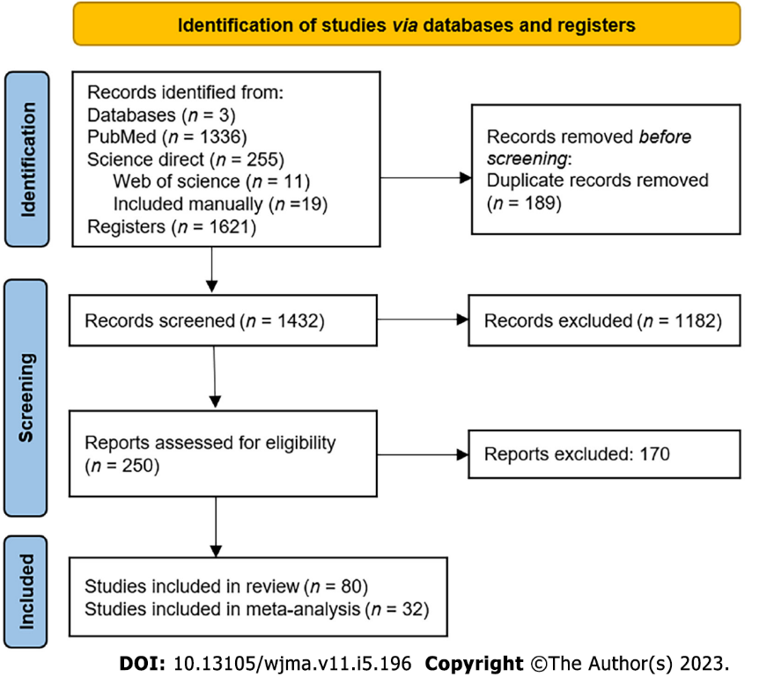
Figure 1 PRISMA 2020 flow diagram showing study selection.

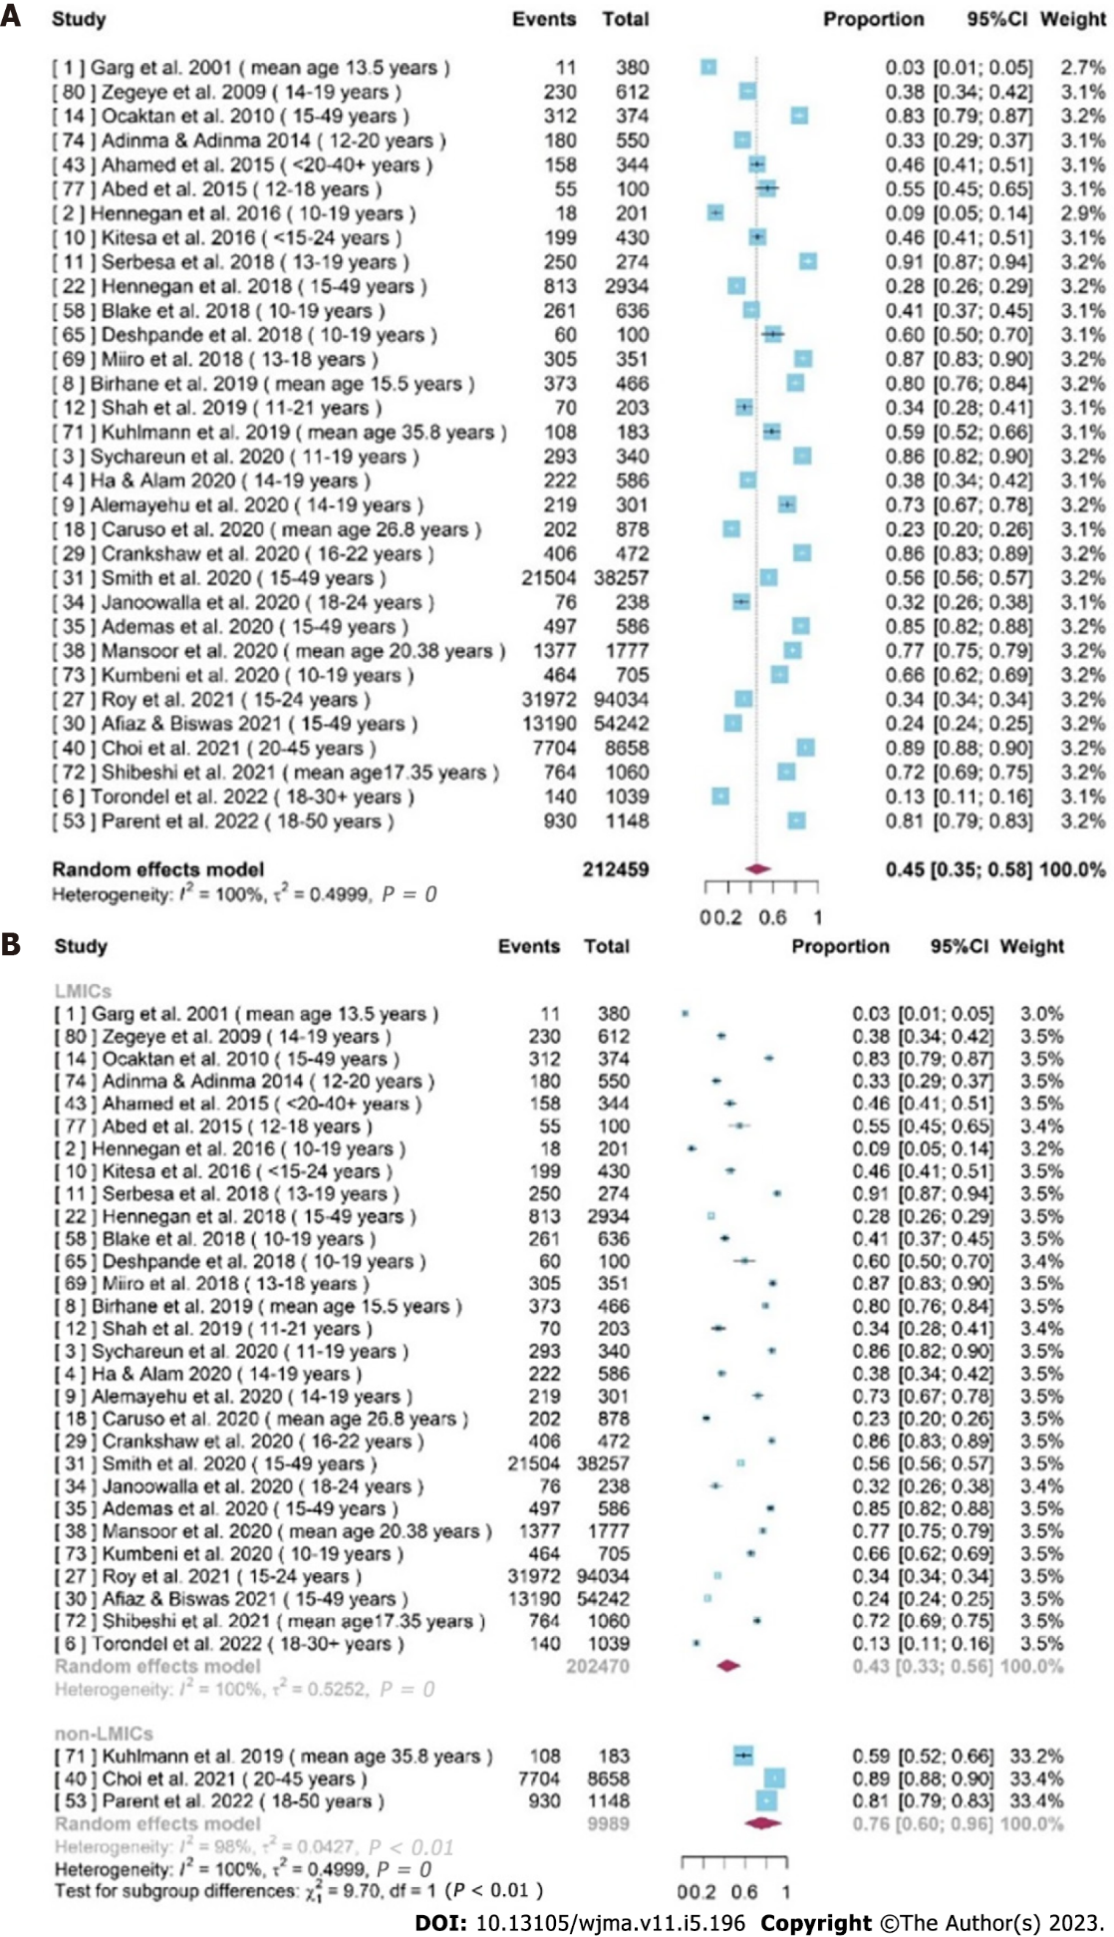
Figure 2 Forest plots showing the prevalence of using disposable sanitary pads. A: Forest plot shows the prevalence of using disposable sanitary pads across 32 studies; B: Forest plot shows the prevalence of using disposable sanitary pads in low-middle-income countries (LMICs) and non-LMICs, respectively.

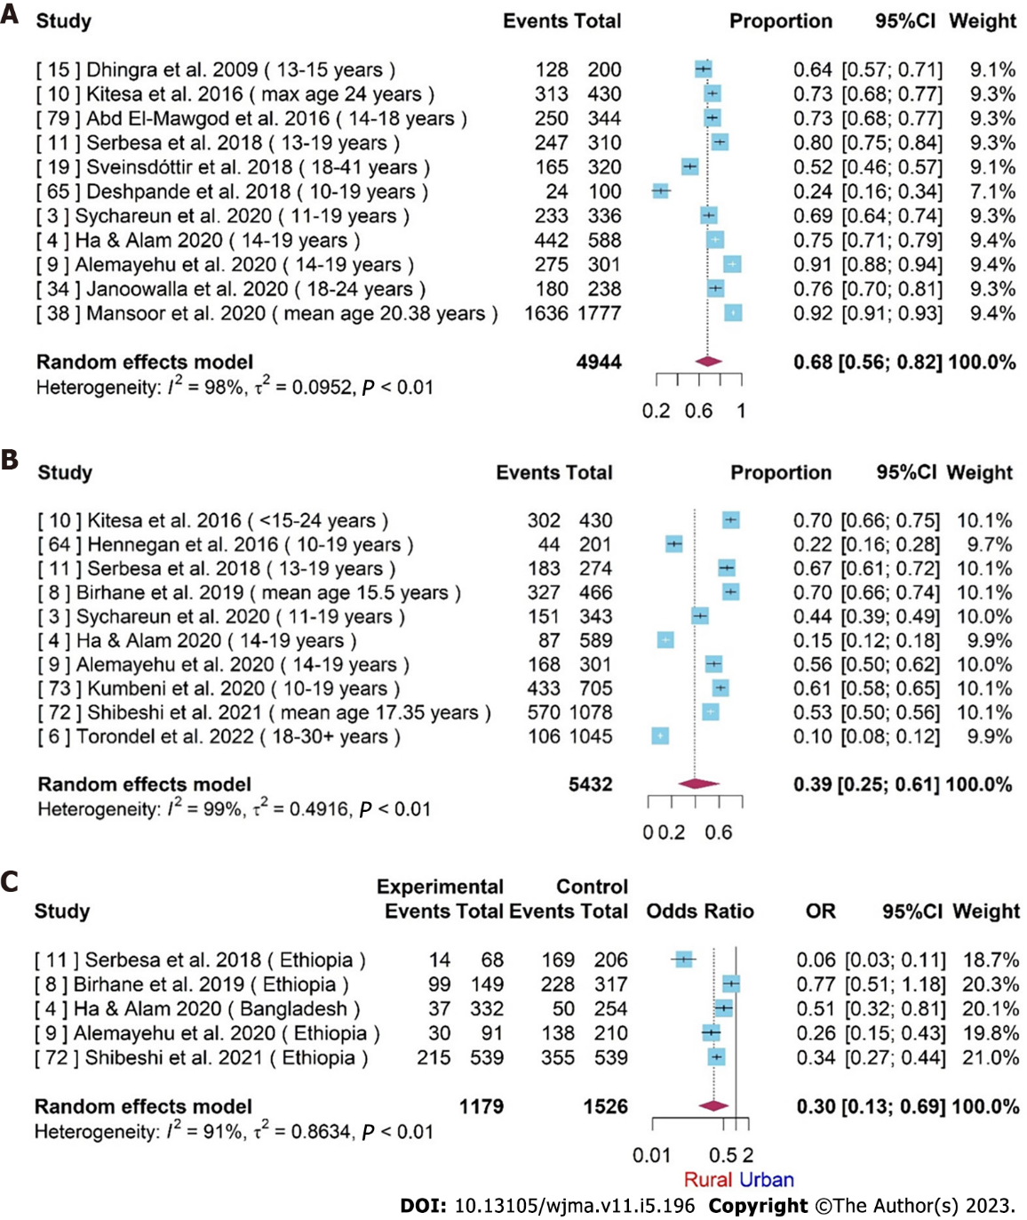
Figure 3 Forest plots exploring menstrual education and hygiene management practices. A: Forest plot for the prevalence of having knowledge/awareness on menstruation before menarche across 11 studies; B: Forest plot for the prevalence of good menstrual hygiene management (MHM) practice across ten studies; C: Forest plot for the rural-urban difference of MHM practice level (good/bad).

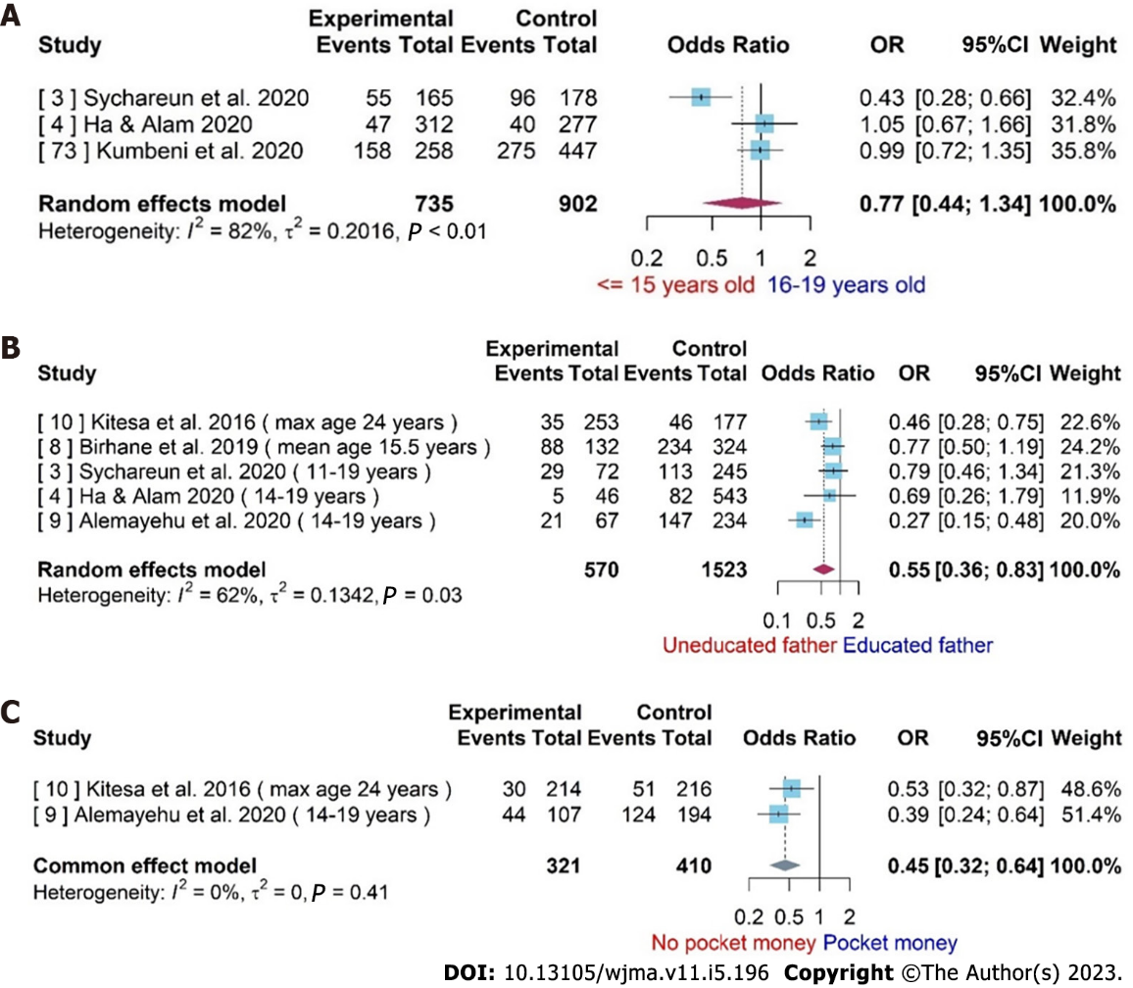
Figure 4 Forest plot for the difference of menstrual hygiene management. A: Forest plot for the difference of menstrual hygiene management (MHM) practice level (good/bad) between two age groups; B: Forest plot for difference of MHM practice level (good/bad) among adolescent girls with uneducated and educated father; C: Forest plot for difference of MHM practice level (good/bad) among adolescent girls with uneducated and educated mother. Available in supplemental material.
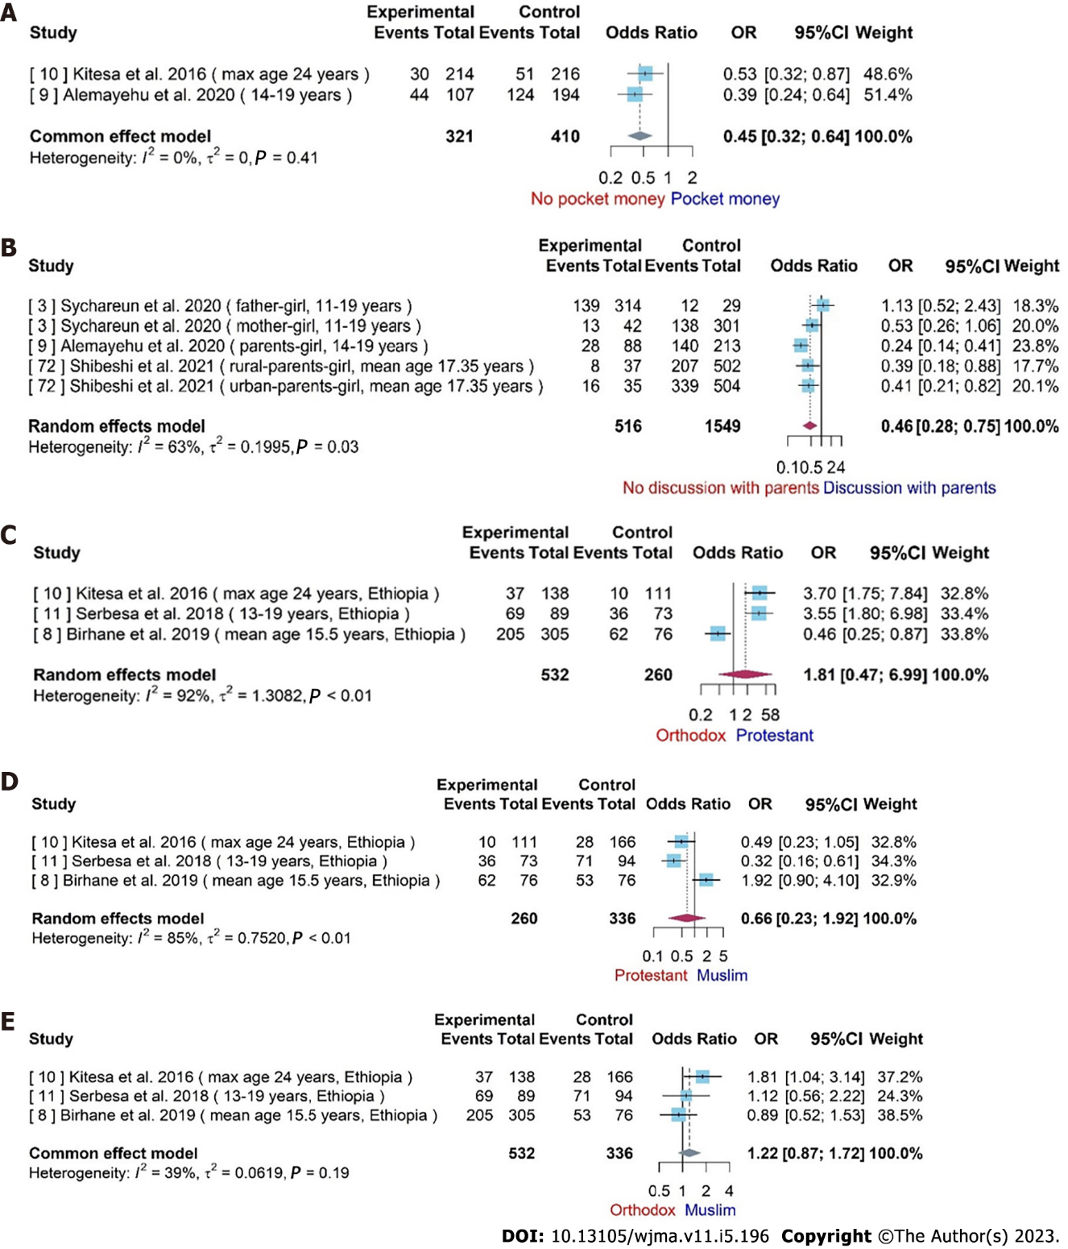
Figure 5 Forest plots showing the differences in menstrual hygiene management across various factors. A: Forest plot for difference of menstrual hygiene management (MHM) practice level (good/bad) among adolescent girls without and with pocket money; B: Forest plot for difference of MHM practice level (good/bad) among adolescent girls of having no and having discussion about menstruation with parents. Available in supplemental material; C: Forest plot for the difference of MHM practice level (good/bad) among adolescent girls with orthodox and protestant; D: Forest plot for difference of MHM practice level (good/bad) among adolescent girls with protestant and Muslim. Available in supplemental material; E: Forest plot for difference of MHM practice level (good/bad) among adolescent girls with orthodox and Muslim. Available in supplemental material.

Table 1 Quality assessment of studies using a modified Newcastle-Ottowa scale
 | Ref. | Selection |  |  |  | Comparability (⋆⋆) | Outcome |  | Total (10⋆)
 |  | Representativeness of the sample (⋆) | Sample size (⋆) | Non-respondents (⋆) | Ascertainment of exposure (⋆⋆) |  | Assessment of outcome (⋆⋆) | Statistical test (⋆)
1 | Garg et al^{[9]}, 2001 | ⋆ | - | - | ⋆ | ⋆⋆ | ⋆ | ⋆ | 6⋆
2 | Hennegan et al^{[44]}, 2016 | ⋆ | - | - | ⋆ | ⋆⋆ | ⋆ | ⋆ | 6⋆
3 | Sychareun et al^{[45]}, 2020 | ⋆ | ⋆ | - | ⋆ | ⋆⋆ | ⋆ | ⋆ | 7⋆
4 | Ha et al^{[46]}, 2020 | ⋆ | ⋆ | - | ⋆ | ⋆⋆ | ⋆ | ⋆ | 7⋆
5 | Fialkov et al^{[47]}, 2021 | ⋆ | - | - | ⋆⋆ | ⋆ | ⋆ | ⋆ | 6⋆
6 | Torondel et al^{[48]}, 2022 | ⋆ | ⋆ | - | ⋆ | ⋆⋆ | ⋆ | ⋆ | 7⋆
7 | Al-Jefout et al^{[49]}, 2015 | - | - | - | ⋆ | ⋆⋆ | ⋆ | ⋆ | 5⋆
8 | Birhane et al^{[50]}, 2019 | ⋆ | ⋆ | - | ⋆ | ⋆⋆ | ⋆ | ⋆ | 7⋆
9 | Alemayehu et al^{[51]}, 2020 | ⋆ | ⋆ | - | ⋆ | ⋆⋆ | ⋆ | ⋆ | 7⋆
10 | Kitesa et al^{[52]}, 2016 | ⋆ | ⋆ | - | ⋆ | ⋆⋆ | ⋆ | ⋆ | 7⋆
11 | Serbesa et al^{[53]}, 2018 | ⋆ | ⋆ | ⋆ | ⋆ | ⋆⋆ | ⋆ | ⋆ | 8⋆
12 | Shah et al^{[54]}, 2019 | ⋆ | ⋆ | ⋆ | ⋆ | ⋆⋆ | ⋆ | ⋆ | 8⋆
13 | Austrian et al^{[55]}, 2021 | ⋆ | ⋆ | ⋆ | ⋆ | ⋆⋆ | ⋆⋆ | ⋆ | 9⋆
14 | Ocaktan et al^{[56]}, 2010 | ⋆ | ⋆ | - | ⋆ | ⋆⋆ | ⋆ | ⋆ | 7⋆
15 | Dhingra et al^{[57]}, 2009 | ⋆ | ⋆ | - | ⋆ | ⋆⋆ | ⋆⋆ | ⋆ | 7⋆
16 | Boosey et al^{[58]}, 2014 | ⋆ | - | - | ⋆ | ⋆ | ⋆⋆ | ⋆ | 6⋆
17 | Amatya et al^{[59]}, 2018 | ⋆ | ⋆ | - | ⋆ | ⋆ | ⋆⋆ | ⋆ | 7⋆
18 | Caruso et al^{[60]}, 2020 | ⋆ | ⋆ | ⋆ | ⋆ | ⋆⋆ | ⋆ | ⋆ | 8⋆
19 | Sveinsdóttir et al^{[61]}, 2018 | ⋆ | - | - | ⋆⋆ | ⋆⋆ | ⋆ | ⋆ | 7⋆
20 | Sveinsdóttir et al^{[62]}, 2017 | ⋆ | ⋆ | - | ⋆⋆ | ⋆⋆ | ⋆ | ⋆ | 8⋆
21 | Mukherjee et al^{[63]}, 2020 | ⋆ | ⋆ | - | ⋆ | ⋆⋆ | ⋆ | ⋆ | 7⋆
22 | Hennegan et al^{[64]}, 2018 | ⋆ | - | - | ⋆ | ⋆⋆ | ⋆ | ⋆ | 6⋆
23 | Gharacheh et al^{[65]}, 2021 | ⋆ | ⋆ | - | ⋆ | ⋆⋆ | ⋆ | ⋆ | 7⋆
24 | Lee et al^{[66]}, 2017 | ⋆ | - | - | ⋆ | ⋆⋆ | ⋆ | ⋆ | 6⋆
25 | Hennegan et al^{[67]}, 2021 | ⋆ | ⋆ | - | ⋆ | ⋆⋆ | ⋆ | ⋆ | 7⋆
26 | Mao et al^{[68]}, 2021 | ⋆ | ⋆ | - | ⋆ | ⋆⋆ | ⋆ | ⋆ | 7⋆
27 | Roy et al^{[69]}, 2021 | ⋆ | ⋆ | - | ⋆ | ⋆⋆ | ⋆ | ⋆ | 7⋆
28 | Komada et al^{[70]}, 2019 | - | - | - | ⋆⋆ | ⋆⋆ | ⋆ | ⋆ | 6⋆
29 | Crankshaw et al^{[71]}, 2020 | ⋆ | ⋆ | - | ⋆ | ⋆⋆ | ⋆ | ⋆ | 7⋆
30 | Afiaz et al^{[72]}, 2021 | ⋆ | ⋆ | - | ⋆ | ⋆⋆ | ⋆⋆ | ⋆ | 8⋆
31 | Smith et al^{[73]}, 2020 | ⋆ | - | - | ⋆ | ⋆⋆ | ⋆ | ⋆ | 6⋆
32 | Toffol et al^{[74]}, 2014 | ⋆ | ⋆ | ⋆ | ⋆⋆ | ⋆⋆ | ⋆⋆ | ⋆ | 10⋆
33 | McMaster et al^{[75]}, 1997 | ⋆ | - | - | ⋆ | ⋆ | ⋆ | ⋆ | 5⋆
34 | Janoowalla et al^{[26]}, 2020 | ⋆ | - | - | ⋆ | ⋆⋆ | ⋆⋆ | ⋆ | 7⋆
35 | Ademas et al^{[76]}, 2020 | ⋆ | ⋆ | - | ⋆ | ⋆⋆ | ⋆ | ⋆ | 7⋆
36 | Bromberger et al^{[77]}, 2012 | ⋆ | ⋆ | ⋆ | ⋆ | ⋆⋆ | ⋆⋆ | ⋆ | 9⋆
37 | Strine et al^{[78]}, 2005 | ⋆ | ⋆ | - | ⋆ | ⋆⋆ | ⋆ | ⋆ | 7⋆
38 | Mansoor et al^{[79]}, 2020 | ⋆ | ⋆ | - | ⋆ | ⋆⋆ | ⋆ | ⋆ | 7⋆
39 | Cardoso et al^{[80]}, 2019 | ⋆ | - | - | ⋆ | ⋆⋆ | ⋆ | ⋆ | 6⋆
40 | Choi et al^{[81]}, 2021 | ⋆ | ⋆ | - | ⋆ | ⋆⋆ | ⋆ | ⋆ | 7⋆
41 | Shimamoto et al^{[82]}, 2021 | - | - | - | ⋆ | ⋆⋆ | ⋆ | ⋆ | 5⋆
42 | Nohara et al^{[83]}, 2011 | ⋆ | ⋆ | - | ⋆ | ⋆⋆ | ⋆ | ⋆ | 7⋆
43 | Ahamed et al^{[84]}, 2015 | ⋆ | ⋆ | - | - | ⋆⋆ | ⋆ | ⋆ | 6⋆
44 | Mokhtari et al^{[85]}, 2020 | ⋆ | ⋆ | - | ⋆ | ⋆⋆ | ⋆ | ⋆ | 7⋆
45 | Warner et al^{[86]}, 2001 | ⋆ | - | ⋆ | ⋆ | ⋆⋆ | ⋆⋆ | ⋆ | 8⋆
46 | Nishikitani et al^{[87]}, 2017 | ⋆ | ⋆ | - | ⋆ | ⋆⋆ | ⋆ | ⋆ | 7⋆
47 | Tanaka et al^{[88]}, 2013 | ⋆ | ⋆ | - | ⋆ | ⋆⋆ | ⋆ | ⋆ | 7⋆
48 | Zhou et al^{[89]}, 2010 | ⋆ | - | - | ⋆ | ⋆⋆ | ⋆⋆ | ⋆ | 7⋆
49 | Chang et al^{[90]}, 2009 | ⋆ | - | - | ⋆ | ⋆⋆ | ⋆ | ⋆ | 6⋆
50 | Yirsaw et al^{[91]}, 2021 | ⋆ | ⋆ | - | ⋆ | ⋆⋆ | ⋆ | ⋆ | 7⋆
51 | Gokyildiz et al^{[92]}, 2013 | ⋆ | - | - | ⋆ | ⋆⋆ | ⋆ | ⋆ | 6⋆
52 | Jiang et al^{[93]}, 2019 | ⋆ | ⋆ | - | ⋆ | ⋆⋆ | ⋆ | ⋆ | 7⋆
53 | Parent et al^{[94]}, 2022 | ⋆ | - | - | ⋆ | ⋆⋆ | ⋆ | ⋆ | 6⋆
54 | Schoep et al^{[95]}, 2019 | ⋆ | - | - | ⋆ | ⋆⋆ | ⋆ | ⋆ | 6⋆
55 | Fernández-Martínez et al^{[96]}, 2020 | ⋆ | ⋆ | - | ⋆ | ⋆⋆ | ⋆⋆ | ⋆ | 8⋆
56 | Abedian et al^{[97]}, 2011 | - | ⋆ | - | ⋆⋆ | ⋆⋆ | ⋆ | ⋆ | 7⋆
57 | Beksinska et al^{[98]}, 2015 | ⋆ | ⋆ | - | ⋆ | ⋆⋆ | ⋆ | ⋆ | 7⋆
58 | Blake et al^{[99]}, 2018 | ⋆ | ⋆ | - | ⋆ | ⋆⋆ | ⋆ | ⋆ | 7⋆
59 | Djalalinia et al^{[100]}, 2012 | ⋆ | ⋆ | - | ⋆ | ⋆⋆ | ⋆ | ⋆ | 7⋆
60 | El-Mowafy et al^{[101]}, 2014 | ⋆ | ⋆ | - | ⋆ | ⋆⋆ | ⋆ | ⋆ | 7⋆
61 | Fakhri et al^{[102]}, 2012 | ⋆ | - | - | ⋆ | ⋆⋆ | ⋆ | ⋆ | 6⋆
62 | Montgomery et al^{[103]}, 2012 | ⋆ | - | - | ⋆ | ⋆⋆ | ⋆ | ⋆ | 6⋆
63 | Montgomery et al^{[44]}, 2016 | ⋆ | ⋆ | ⋆ | ⋆ | ⋆⋆ | ⋆ | ⋆ | 8⋆
64 | Hennegan et al^{[104]}, 2016 | ⋆ | - | - | ⋆ | ⋆⋆ | ⋆ | ⋆ | 6⋆
65 | Deshpande et al^{[105]}, 2018 | ⋆ | ⋆ | - | ⋆ | ⋆⋆ | ⋆ | ⋆ | 7⋆
66 | Cardoso et al^{[25]}, 2021 | ⋆ | - | - | ⋆ | ⋆⋆ | ⋆ | ⋆ | 6⋆
67 | Nyothach et al^{[106]}, 2015 | ⋆ | - | - | ⋆ | ⋆⋆ | ⋆⋆ | ⋆ | 7⋆
68 | Kuhlmann et al^{[107]}, 2020 | - | - | - | ⋆ | ⋆⋆ | ⋆ | ⋆ | 5⋆
69 | Miiro et al^{[48]}, 2018 | ⋆ | - | - | ⋆ | ⋆⋆ | ⋆⋆ | ⋆ | 7⋆
70 | Hensen et al^{[108]}, 2022 | ⋆ | ⋆ | - | ⋆ | ⋆⋆ | ⋆⋆ | ⋆ | 8⋆
71 | Kuhlmann et al^{[109]}, 2019 | ⋆ | - | - | ⋆ | ⋆⋆ | ⋆⋆ | ⋆ | 7⋆
72 | Shibeshi et al^{[110]}, 2021 | ⋆ | ⋆ | - | ⋆ | ⋆⋆ | ⋆⋆ | ⋆ | 8⋆
73 | Kumbeni et al^{[111]}, 2020 | ⋆ | ⋆ | - | ⋆ | ⋆⋆ | ⋆⋆ | ⋆ | 8⋆
74 | Adinma et al^{[112]}, 2014 | ⋆ | ⋆ | - | ⋆ | ⋆ | ⋆ | ⋆ | 6⋆
75 | Eswi et al^{[113]}, 2012 | ⋆ | - | - | ⋆ | ⋆⋆ | ⋆ | ⋆ | 6⋆
76 | El-Hameed et al^{[114]}, 2011 | ⋆ | - | - | ⋆ | ⋆⋆ | ⋆ | ⋆ | 6⋆
77 | Abed et al^{[115]}, 2015 | - | - | - | ⋆ | ⋆⋆ | ⋆ | ⋆ | 5⋆
78 | Mohamed^{[116]}, 2012 | ⋆ | - | - | ⋆ | ⋆⋆ | ⋆ | ⋆ | 6⋆
79 | El-Mawgod et al^{[117]}, 2016 | ⋆ | ⋆ | - | ⋆ | ⋆⋆ | ⋆ | ⋆ | 7⋆
80 | Zegeye et al^{[118]}, 2009 | ⋆ | ⋆ | - | ⋆ | ⋆⋆ | ⋆ | ⋆ | 7⋆

Table 2 Characteristics of the studies included in the systematic review
Study ID | Ref. | Year | Study type | Sample size | Country | Mean age | Meta-analysis inclusion Y/N
1 | Garg et al^{[9]} | 2001 | Epidemiological and sociological study | 380 | India |  | Y
2 | Hennegan et al^{[44]} | 2016 | Cross-sectional study | 201 | Uganda | 14.2 | Y
3 | Sychareun et al^{[45]} | 2020 | Cross-sectional study | 343 | LAO | 15.6 | Y
4 | Ha et al^{[46]} | 2020 | Cross-sectional study design with systematic random sampling | 589 | Bangladesh | 15.5 | Y
5 | Fialkov et al^{[47]} | 2021 | Pre- and post-test design that compared six cohort groups | 311 | Kenya |  | N
6 | Torondel et al^{[48]} | 2022 | Nested within a pair-matched cohort study | 1045 | India | 27 | Y
7 | Al-Jefout et al^{[49]} | 2015 | Cross-sectional study | 272 | Jordanian | 22 | Y
8 | Birhane et al^{[50]} | 2019 | Cross-sectional study | 466 | Ethiopia | 15.5 | Y
9 | Alemayehu et al^{[51]} | 2020 | Cross-sectional study | 301 | Ethiopia | 15.87 | Y
10 | Kitesa et al^{[52]} | 2016 | Cross-sectional study | 430 | Ethiopia | 16 | Y
11 | Serbesa et al^{[53]} | 2018 | Cross-sectional study | 310 | Ethiopia | 15.72 | Y
12 | Shah et al^{[54]} | 2019 | Cross-sectional study | 331 | Gambia | 15.3 | Y
13 | Austrian et al^{[55]} | 2021 | Cluster RCT | 3489 | Kenya | 14.8 | N
14 | Ocaktan et al^{[56]} | 2010 | Cross-sectional study | 400 | Turkey | 32.19 | Y
15 | Dhingra et al^{[57]} | 2009 | Cross-sectional study | 200 | India | 13.97 | Y
16 | Boosey et al^{[58]} | 2014 | Cross-sectional study | 140 | Uganda | 14.45 | N
17 | Amatya et al^{[59]} | 2018 | Cross-sectional mixed-methods study | 104 | Nepal | 15 | N
18 | Caruso et al^{[60]} | 2020 | Cross-sectional study | 878 | India | 26.8 | Y
19 | Sveinsdóttir et al^{[61]} | 2018 | Cross-sectional study | 319 | Iceland | 30 | Y
20 | Sveinsdóttir et al^{[62]} | 2017 | Cross-sectional study | 319 | Iceland | 30 | N
21 | Mukherjee et al^{[63]} | 2020 | Cross-sectional study | 1342 | Nepal |  | N
22 | Hennegan et al^{[64]} | 2018 | Cross-sectional study | 2934 | Nigeria | 26.66 | Y
23 | Gharacheh et al^{[65]} | 2021 | Cross-sectional study | 515 | Iran | 29.61 | N
24 | Lee et al^{[66]} | 2017 | Prospective observational cohort study | 1495 | USA | 46.8 | N
25 | Hennegan et al^{[67]} | 2021 | Secondary data analysis | 11806 | Burkina Faso, Niger, Nigeria |  | N
26 | Mao et al^{[68]} | 2021 | Cross-sectional study | 156055 | China | 26.32 | N
27 | Roy et al^{[69]} | 2021 | Secondary data analysis | 94034 | India |  | Y
28 | Komada et al^{[70]} | 2019 | Cross-sectional study | 150 | Japan | 18.8 | N
29 | Crankshaw et al^{[71]} | 2020 | Mixed-method study | 472 | South Africa | 17.5 | Y
30 | Afiaz et al^{[72]} | 2021 | Cross-sectional study | 54242 | Bangladesh | 29 | Y
31 | Smith et al^{[73]} | 2020 | Secondary data analysis | 38257 | Uganda, Kenya， Ethiopia etc. |  | Y
32 | Toffol et al^{[74]} | 2014 | Cross-sectional study | 4391 | Finland | 56.2 | N
33 | McMaster et al^{[75]} | 1997 | exploratory phase of the study | 50 | Zimbabwe |  | N
34 | Janoowalla et al^{[26]} | 2020 | Prospective cohort study | 240 | Rwanda | 19.1 | Y
35 | Ademas et al^{[76]} | 2020 | Cross-sectional study | 602 | Ethiopia |  | Y
36 | Bromberger et al^{[77]} | 2012 | Multisite study | 934 | USA |  | N
37 | Strine et al^{[78]} | 2005 | Cross-sectional study | 11648 | USA |  | N
38 | Mansoor et al^{[79]} | 2020 | Cross-sectional study | 1777 | Pakistan | 20.38 | Y
39 | Cardoso et al^{[80]} | 2019 | Baseline data from a larger RCT | 1800 | Nepal | 34.5 | N
40 | Choi et al^{[81]} | 2021 | Cross-sectional study | 8658 | Korea | 35.1 | Y
41 | Shimamoto et al^{[82]} | 2021 | Self-reporting questionnaire survey | 6048 | Japan |  | N
42 | Nohara et al^{[83]} | 2011 | Cross-sectional study | 2166 | Japan |  | N
43 | Ahamed et al^{[84]} | 2015 | Cross-sectional study | 344 | India | 28 | Y
44 | Mokhtari et al^{[85]} | 2020 | Cross-sectional study | 164 | Iran | 27.78 | N
45 | Warner et al^{[86]} | 2001 | Cross-sectional study | 952 | Scotland |  | N
46 | Nishikitani et al^{[87]} | 2017 | Cross-sectional study | 505 | Japan |  | N
47 | Tanaka et al^{[88]} | 2013 | Online survey | 19254 | Japan | 33.6 | N
48 | Zhou et al^{[89]} | 2010 | Cross-sectional study | 1642 | China | 37 | N
49 | Chang et al^{[90]} | 2009 | Cross-sectional survey | 1095 | Taiwan |  | N
50 | Yirsaw et al^{[91]} | 2021 | Cross-sectional study | 713 | Ethiopia | 21.13 | N
51 | Gokyildiz et al^{[92]} | 2013 | Case-control study | 295 | Turkey |  | N
52 | Jiang et al^{[93]} | 2019 | Cross-sectional study | 12881 | China |  | N
53 | Parent et al^{[94]} | 2022 | Cross-sectional study | 1153 | France | 31.7 | Y
54 | Schoep et al^{[95]} | 2019 | Cross-sectional study | 42879 | Netherlands | 28.7 | N
55 | Fernández-Martínez et al^{[96]} | 2020 | Cross-sectional study | 7208 | Spain | 19.51 | N
56 | Abedian et al^{[97]} | 2011 | RCT | 165 | Iran |  | N
57 | Beksinska et al^{[98]} | 2015 | Randomized two-period Cross-over trial | 124 | South Africa | 29 | N
58 | Blake et al^{[99]} | 2018 | Mixed-methods evaluation | 636 | Ethiopia | 13.45 | Y
59 | Djalalinia et al^{[100]} | 2012 | Community-based participatory research | 1823 | Iran |  | N
60 | El-Mowafy et al^{[101]} | 2014 | Quasi-experimental study | 234 | Egypt |  | N
61 | Fakhri et al^{[102]} | 2012 | Quasi-experimental study | 698 | Iran | 15.7 | N
62 | Montgomery et al^{[103]} | 2012 | Non-randomized trial | 120 | Ghana | 15.7 | N
63 | Montgomery et al^{[44]} | 2016 | Cluster quasi-randomised controlled trial | 1124 | Uganda |  | N
64 | Hennegan et al^{[104]} | 2016 | Secondary data analysis | 205 | Uganda. | 14.2 | Y
65 | Deshpande et al^{[105]} | 2018 | Cross-sectional study | 100 | India |  | Y
66 | Cardoso et al^{[25]} | 2021 | Online survey | 471 | United States | 20.6 | N
67 | Nyothach et al^{[106]} | 2015 | Retrospective study |  | Kenya |  | N
68 | Kuhlmann et al^{[107]} | 2020 | Cross-sectional study | 58 | USA | 15.21 | N
69 | Miiro et al^{[48]} | 2018 | Cross-sectional study | 352 | Uganda | 15.6 | Y
70 | Hensen et al^{[108]} | 2022 | Mixed-methods analysis | 7546 | Zambia. |  | N
71 | Kuhlmann et al^{[109]} | 2019 | Cross-sectional study | 183 | USA | 35.8 | Y
72 | Shibeshi et al^{[110]} | 2021 | Cross-sectional study | 1078 | Ethiopia | 17.35 | Y
73 | Kumbeni et al^{[111]} | 2020 | Cross-sectional study | 705 | Ghana |  | Y
74 | Adinma et al^{[112]} | 2014 | Cross-sectional study | 550 | Nigeria |  | Y
75 | Eswi et al^{[113]} | 2012 | Cross-sectional study | 200 | Egypt | 15.45 | N
76 | El-Hameed et al^{[114]} | 2011 | Cross-sectional study | 160 | Egypt | 17.2 | N
77 | Abed et al^{[115]} | 2015 | Cross-sectional study | 100 | Egypt | 14.25 | Y
78 | Mohamed^{[116]} | 2012 | Cross-sectional study | 885 | Egypt | 16 | Y
79 | El-Mawgod et al^{[117]} | 2016 | Cross-sectional study | 344 | Saudi Arabia | 16.2 | Y
80 | Zegeye et al^{[118]} | 2009 | Cross-sectional study | 612 | Ethiopia | 16.9 | Y
RCT: Randomized control trial.

Published by Baishideng Publishing Group Inc
7041 Koll Center Parkway, Suite 160, Pleasanton, CA 94566, USA
Telephone: +1-925-3991568
E-mail: bpgoffice@wjgnet.com
Help Desk: https://www.f6publishing.com/helpdesk
https://www.wjgnet.com

© 2023 Baishideng Publishing Group Inc. All rights reserved.

