Name of Journal: World Journal of Clinical Cases
Manuscript NO: 84324
Manuscript Type: CASE REPORT

Indium chloride bone marrow scintigraphy for hepatic myelolipoma: A case report

Sato et al. Bone marrow scintigraphy for hepatic myelolipoma

Akio Sato, Kazuhiro Saito, Koichiro Abe, Katsutoshi Sugimoto, Toshitaka Nagao, Aoi Sukeda, Daisuke Yunaiyama

Akio Sato, Kazuhiro Saito, Koichiro Abe, Daisuke Yunaiyama, Department of Radiology, Tokyo Medical University Hospital, Shinjuku-ku 160-0023, Tokyo, Japan

Katsutoshi Sugimoto, Department of Gastroenterology and Hepatology, Tokyo Medical University Hospital, Shinjuku-ku 160-0023, Tokyo, Japan

Toshitaka Nagao, Aoi Sukeda, Department of Anatomic Pathology, Tokyo Medical University Hospital, Shinjuku-ku 160-0023, Tokyo, Japan

Author contributions: Sato A designed the report; Sugimoto K collected the patient’s clinical data; Sato A, Saito K, Abe K, Nagao T, Sukeda A, and Yunaiyama D analyzed the data and wrote the paper; All authors have read and approved the final manuscript.

Corresponding author: Akio Sato, MD, Doctor, Department of Radiology, Tokyo Medical University Hospital, 6-7-1 Nishishinjuku, Shinjuku-ku 160-0023, Tokyo, Japan. sato.akio.8j@tokyo-med.ac.jp

Received: March 13, 2023
Revised: May 2, 2023
Accepted: May 22, 2023
Published online: June 26, 2023

Abstract
BACKGROUND
As hepatic myelolipoma is rarely encountered, its radiological diagnosis using ultrasonography (US), computed tomography (CT), and magnetic resonance imaging (MRI) is challenging. Hepatic myelolipoma is similar to fat-contained hepatic lesions seen in hepatocellular carcinoma and angiomyolipoma. Therefore, further development of techniques to diagnose hepatic myelolipoma is warranted.

CASE SUMMARY
A 44-year-old obese man was found to have a hepatic lesion during his medical checkup. The lesion was 50 mm × 57 mm in size and was detected in segment 8 (S8) of the liver by US. The patient was diagnosed with hepatic lesion 20 years ago, but it was left unresolved. The patient had no symptoms, liver dysfunction, hepatitis virus antibody, or tumor marker elevation. Plain CT showed a well-defined lesion in S8 of the liver. The central and peripheral areas of the lesion primarily exhibited fat density and hypodensity, respectively. MRI revealed a capsule-like structure. Biopsy was performed to address the probability of hepatocellular carcinoma. The lesion was pathologically confirmed as a myelolipoma. Bone marrow scintigraphy performed using ¹¹¹InCl₃ revealed accumulation of the radiopharmaceutical in the soft tissue component, except in the fat-dominant part of the tumor, as well as in the surrounding liver parenchyma due to the presence of reticuloendothelial cells in the liver.

CONCLUSION
This is the first report on the diagnosis of hepatic myelolipoma using ¹¹¹InCl₃ scintigraphy. The effectiveness of bone marrow scintigraphy for diagnosing hepatic myelolipoma might be limited. As radiopharmaceuticals accumulate in both hematopoietic and reticuloendothelial cells, the accumulation of radiopharmaceuticals in the lesion is obscure.

Key Words: Liver; ¹¹¹InCl₃; Myelolipoma; Magnetic resonance imaging; Benign tumor; Case report

©The Author(s) 2023. Published by Baishideng Publishing Group Inc. All rights reserved.

Citation: Sato A, Saito K, Abe K, Sugimoto K, Nagao T, Sukeda A, Yunaiyama D. Indium chloride bone marrow scintigraphy for hepatic myelolipoma: A case report. World J Clin Cases 2023; 11(18): 4377-4383
URL: https://www.wjgnet.com/2307-8960/full/v11/i18/4377.htm
DOI: https://dx.doi.org/10.12998/wjcc.v11.i18.4377

Core Tip: We attempted to perform bone marrow scintigraphy for hepatic myelolipoma to determine whether ¹¹¹InCl₃ accumulates in the lesion. We found that the radiopharmaceutical accumulated in the soft tissue component, except for the fat-dominant part. However, the radiopharmaceutical also accumulated in the surrounding liver parenchyma, which comprised reticuloendothelial cells. Therefore, the effectiveness of bone marrow scintigraphy in diagnosing hepatic myelolipoma may be limited.

INTRODUCTION
Myelolipoma is a rare, nonfunctioning benign tumor that comprises mature fat tissue and hematopoietic cells. It is usually detected in the adrenal cortex and rarely outside the adrenal gland. When the lesion develops outside the adrenal gland, it is most often detected in the anterior sacral region^{[1]}. According to previous reports, myelolipomas of liver origin are lesions with fatty and soft tissue density components accompanied by capsular-like structures^{[2-4]}. Therefore, it is crucial to differentiate it from other tumors, including hepatocellular carcinoma. Yamamoto et al^{[5]} reported that bone marrow scintigraphy is helpful in the diagnosis of adrenal myelolipoma as indium chloride (¹¹¹InCl₃) accumulates in hematopoietic cells in myelolipoma^{[5]}. However, no study has diagnosed hepatic myelolipoma with bone marrow scintigraphy. In this study, we report a rare case of hepatic myelolipoma who underwent various imaging techniques, including bone marrow scintigraphy.

CASE PRESENTATION
History of present illness
This study included a 44-year-old obese male (BMI 32.0) who showed no symptoms. Twenty years ago, he was diagnosed with a hepatic mass but the mass was not treated. In July 2020, during an abdominal ultrasound examination at a medical checkup, a 50 mm × 57 mm hyperechoic lesion was observed in segment 8 (S8) of the liver. He came to our hospital with suspected hepatocellular carcinoma.

History of past illness
The patient developed systemic lupus erythematosus and lupus nephritis aged 24 years, and type 2 diabetes and hypertension aged 32 years.

Physical examination
Physical examination was normal.

Laboratory examinations
His blood tests showed mild inflammatory reaction and renal dysfunction but no liver dysfunction. The patient did not have hepatitis virus or tumor marker elevation. Urinalysis showed mildly elevated urine protein but no other abnormalities.

Imaging examinations
Ultrasonography (US) revealed a hyperechoic mass with a 79 mm oval halo in S8 of the liver (Figure 1). An abdominal plain computed tomography (CT) scan indicated a heterogeneous low-density mass with internal fat (Figure 2). The patient suffered from renal dysfunction and could not undergo contrast-enhanced CT. We performed abdominal magnetic resonance imaging (MRI) of the T1-weighted image using the Dixon method. The T1-weighted opposed phase image showed an apparent signal drop in the peripheral area of the lesion. The center of the lesion showed a predominant fat component, and the surrounding area showed a mixed fat component. The T2-weighted image showed hyperintensity, the diffusion-weighted image (DWI) showed a hyperintensity area in the peripheral region of the lesion, and the apparent diffusion coefficient (ADC) map showed hypointensity corresponding to the hyperintensity area on DWI, which indicated restricted diffusion. The central fat-predominant area showed hypointensity on the DWI and mixed hypo- and hyper-intensity on the ADC map (Figure 3).

Pathology
The lesion contained erythroblastosis cells on glycophorin C staining, granulocytic cells on myeloperoxidase staining, and megakaryocytes on CD61 immunostaining. Hematoxylin and eosin staining showed fat droplet deposition in the background liver tissue, which suggested chronic liver inflammation (Figure 4).

FINAL DIAGNOSIS
Hepatic myelolipoma with background tissue of nonalcoholic fatty liver disease.

TREATMENT
The patient had no subjective symptoms and few objective symptoms. The clinician then had consent to follow-up with the patient.

OUTCOME AND FOLLOW-UP
The patient was diagnosed with myelolipoma and underwent bone marrow scintigraphy with ¹¹¹InCl₃ to confirm the presence of bone-marrow elements radiologically (Table 1). ¹¹¹InCl₃ bone marrow scintigraphy showed a mild accumulation of radiopharmaceutical in areas of poor fatty tissue in the peripheral region of the lesion. The radiopharmaceutical accumulation was absent in the center of the mass corresponding to the fat-dominant part. ¹¹¹InCl₃ also mildly accumulated in the bone marrow and spleen (Figure 5). The tumor was in a stable condition and did not cause new symptoms.

DISCUSSION
This is the first report to diagnose a case of hepatic myelolipoma with ¹¹¹InCl₃ scintigraphy. The etiology of hepatic myelolipoma is unknown, but several hypotheses exist. Among the most promising ideas are that it is due to an ectopic adrenal gland, an alteration of hepatocytes, or embryonic stem cells remaining in the liver^{[1,4]}. Extra-adrenal myelolipomas tend to occur after middle age, with a male-to-female ratio of 1:2^{[4]}. Myelolipoma is usually asymptomatic in the case of a small lesion, but spontaneous rupture due to mass effect, acute abdomen, and bleeding may occur as the lesion grows^{[1]}. Resection is unnecessary unless the diagnosis is unclear or the lesion is symptomatic^{[6]}.
The radiological diagnosis of hepatic myelolipoma using US, CT, and MRI is challenging. Myelolipoma has a capsule-like structure at the lesion periphery and intratumoral fat^{[4]}. These radiological findings are similar to hepatocellular carcinoma. Therefore, we used bone marrow scintigraphy to facilitate the distinction between these two entities^{[5,7]}.
Bone marrow scintigraphy showed accumulation of the radiopharmaceutical in the lesion’s soft tissue components, except for the fat-dominant part. Therefore, the efficacy of the radiopharmaceutical was confirmed. However, the conspicuity of the accumulation of radiopharmaceutical was weak because it accumulated in the surrounding liver parenchyma owing to the presence of reticuloendothelial cells^{[6]}.
¹¹¹InCl₃ radiopharmaceutical accumulates in bone marrow and the reticuloendothelial system in the liver parenchyma^{[8]}. Therefore, ¹¹¹InCl₃ may mildly accumulate in well-differentiated hepatocellular carcinoma as in myelolipoma as it accumulates in the reticuloendothelial system. This prediction is based on previous reports indicating that superparamagnetic iron oxide (SPIO) accumulates in well-differentiated hepatocellular carcinoma with reticuloendothelial cells on SPIO-enhanced MRI^{[9]}. Such hepatocellular carcinomas have less aggressiveness^{[10]}. To our knowledge, no study has applied ¹¹¹InCl₃ to diagnose hepatocellular carcinoma. However, it could be suggested that hepatic lesions with an accumulation of ¹¹¹InCl₃ are less aggressive as the differential diagnosis includes myelolipoma and well-differentiated hepatocellular carcinoma.

CONCLUSION
Bone marrow scintigraphy has limited utility in diagnosing hepatic myelolipoma. As radiopharmaceuticals accumulate in both hematopoietic and reticuloendothelial cells, the accumulation of radiopharmaceuticals in the lesion is obscure.

REFERENCES
1 Temizoz O, Genchellac H, Demir MK, Unlu E, Ozdemir H. Bilateral extra-adrenal perirenal myelolipomas: CT features. Br J Radiol 2010; 83: e198-e199 [PMID: 20846975 DOI: 10.1259/bjr/28801968]
2 Xu SY, Xie HY, Zhou L, Zheng SS, Wang WL. Synchronous occurrence of a hepatic myelolipoma and two hepatocellular carcinomas. World J Gastroenterol 2016; 22: 9654-9660 [PMID: 27920487 DOI: 10.3748/wjg.v22.i43.9654]
3 Kaurich JD, Coombs RJ, Zeiss J. Myelolipoma of the liver: CT features. J Comput Assist Tomogr 1988; 12: 660-661 [PMID: 3292607 DOI: 10.1097/00004728-198807000-00028]
4 Xin H, Li H, Yu H, Zhang J, Peng W, Peng D. MR imaging to detect myelolipomas of the liver: A case report and literature review. Medicine (Baltimore) 2019; 98: e16497 [PMID: 31335715 DOI: 10.1097/MD.0000000000016497]
5 Yamamoto T, Koizumi M, Kohno A, Numao N, Inamura K. A case report on 111In chloride bone marrow scintigraphy in management of adrenal myelolipoma. Medicine (Baltimore) 2019; 98: e14625 [PMID: 30813194 DOI: 10.1097/MD.0000000000014625]
6 Li KY, Wei AL, Li A. Primary hepatic myelolipoma: A case report and review of the literature. World J Clin Cases 2020; 8: 4615-4623 [PMID: 33083426 DOI: 10.12998/wjcc.v8.i19.4615]
7 Lilien DL, Berger HG, Anderson DP, Bennett LR. 111 In-chloride: a new agent for bone marrow imaging. J Nucl Med 1973; 14: 184-186 [PMID: 4685418]
8 Gilbert EH, Earle JD, Goris ML, Kaplan HS, Kriss JP. The accuracy of 111InCl3 as a bone marrow scanning agent. Radiology 1976; 119: 167-168 [PMID: 1257437 DOI: 10.1148/119.1.167]
9 Imai Y, Murakami T, Yoshida S, Nishikawa M, Ohsawa M, Tokunaga K, Murata M, Shibata K, Zushi S, Kurokawa M, Yonezawa T, Kawata S, Takamura M, Nagano H, Sakon M, Monden M, Wakasa K, Nakamura H. Superparamagnetic iron oxide-enhanced magnetic resonance images of hepatocellular carcinoma: correlation with histological grading. Hepatology 2000; 32: 205-212 [PMID: 10915725 DOI: 10.1053/jhep.2000.9113]
10 Tanaka M, Nakashima O, Wada Y, Kage M, Kojiro M. Pathomorphological study of Kupffer cells in hepatocellular carcinoma and hyperplastic nodular lesions in the liver. Hepatology 1996; 24: 807-812 [PMID: 8855180 DOI: 10.1053/jhep.1996.v24.pm0008855180]

Footnotes
Informed consent statement: Informed written consent was obtained from the patient for the publication of this report and any accompanying images.

Conflict-of-interest statement: All the authors report no relevant conflicts of interest for this article.

CARE Checklist (2016) statement: The authors have read the CARE Checklist (2016), and the manuscript was prepared and revised according to the CARE Checklist (2016).

Open-Access: This article is an open-access article that was selected by an in-house editor and fully peer-reviewed by external reviewers. It is distributed in accordance with the Creative Commons Attribution NonCommercial (CC BY-NC 4.0) license, which permits others to distribute, remix, adapt, build upon this work non-commercially, and license their derivative works on different terms, provided the original work is properly cited and the use is non-commercial. See: https://creativecommons.org/Licenses/by-nc/4.0/

Provenance and peer review: Unsolicited article; Externally peer reviewed.

Peer-review model: Single blind

Peer-review started: March 13, 2023
First decision: April 19, 2023
Article in press: May 22, 2023

Specialty type: Medicine, research and experimental
Country/Territory of origin: Japan
Peer-review report’s scientific quality classification
Grade A (Excellent): 0
Grade B (Very good): 0
Grade C (Good): C, C
Grade D (Fair): 0
Grade E (Poor): 0

P-Reviewer: Jeong KY, South Korea; Shuang W, China S-Editor: Li L L-Editor: Webster JR P-Editor: Li L

Figure Legends
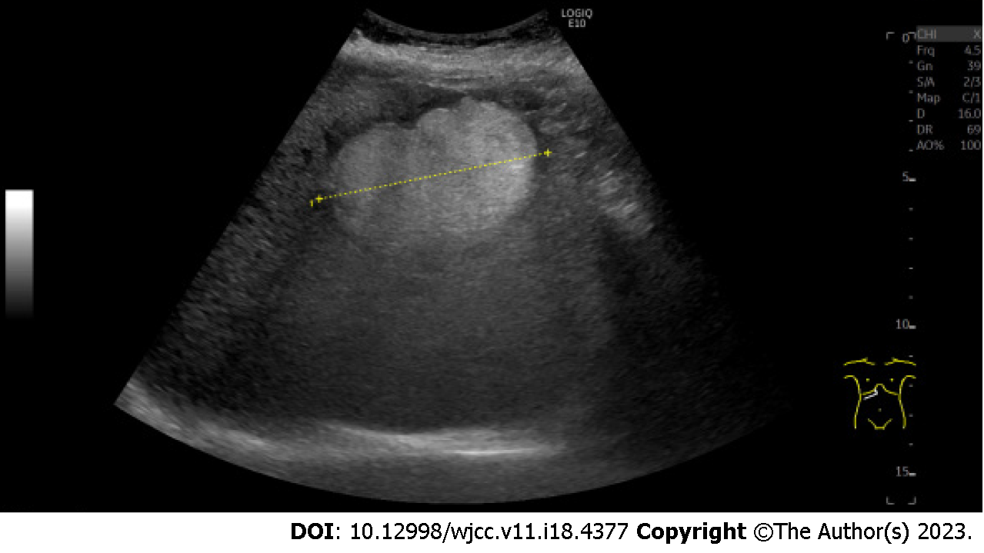
Figure 1 Ultrasonography. The image shows the hyperechoic lesion in segment 8 of the liver. The lesion size was 79 mm × 73 mm × 52 mm.

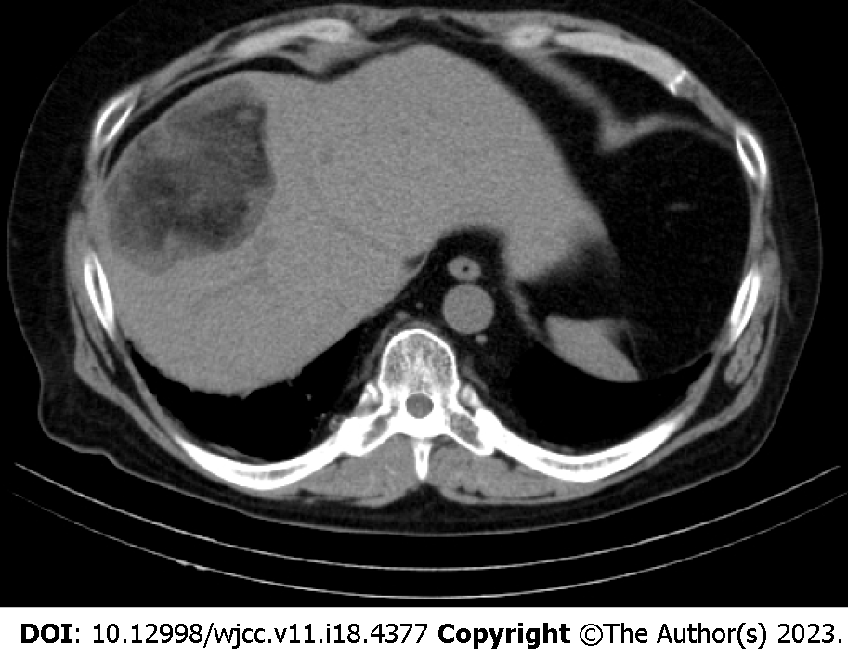
Figure 2 Plain computed tomography. The image shows a well-defined lesion in segment 8 of the liver. The center of the lesion mainly shows the fat density and the peripheral area of the lesion shows hypodensity.
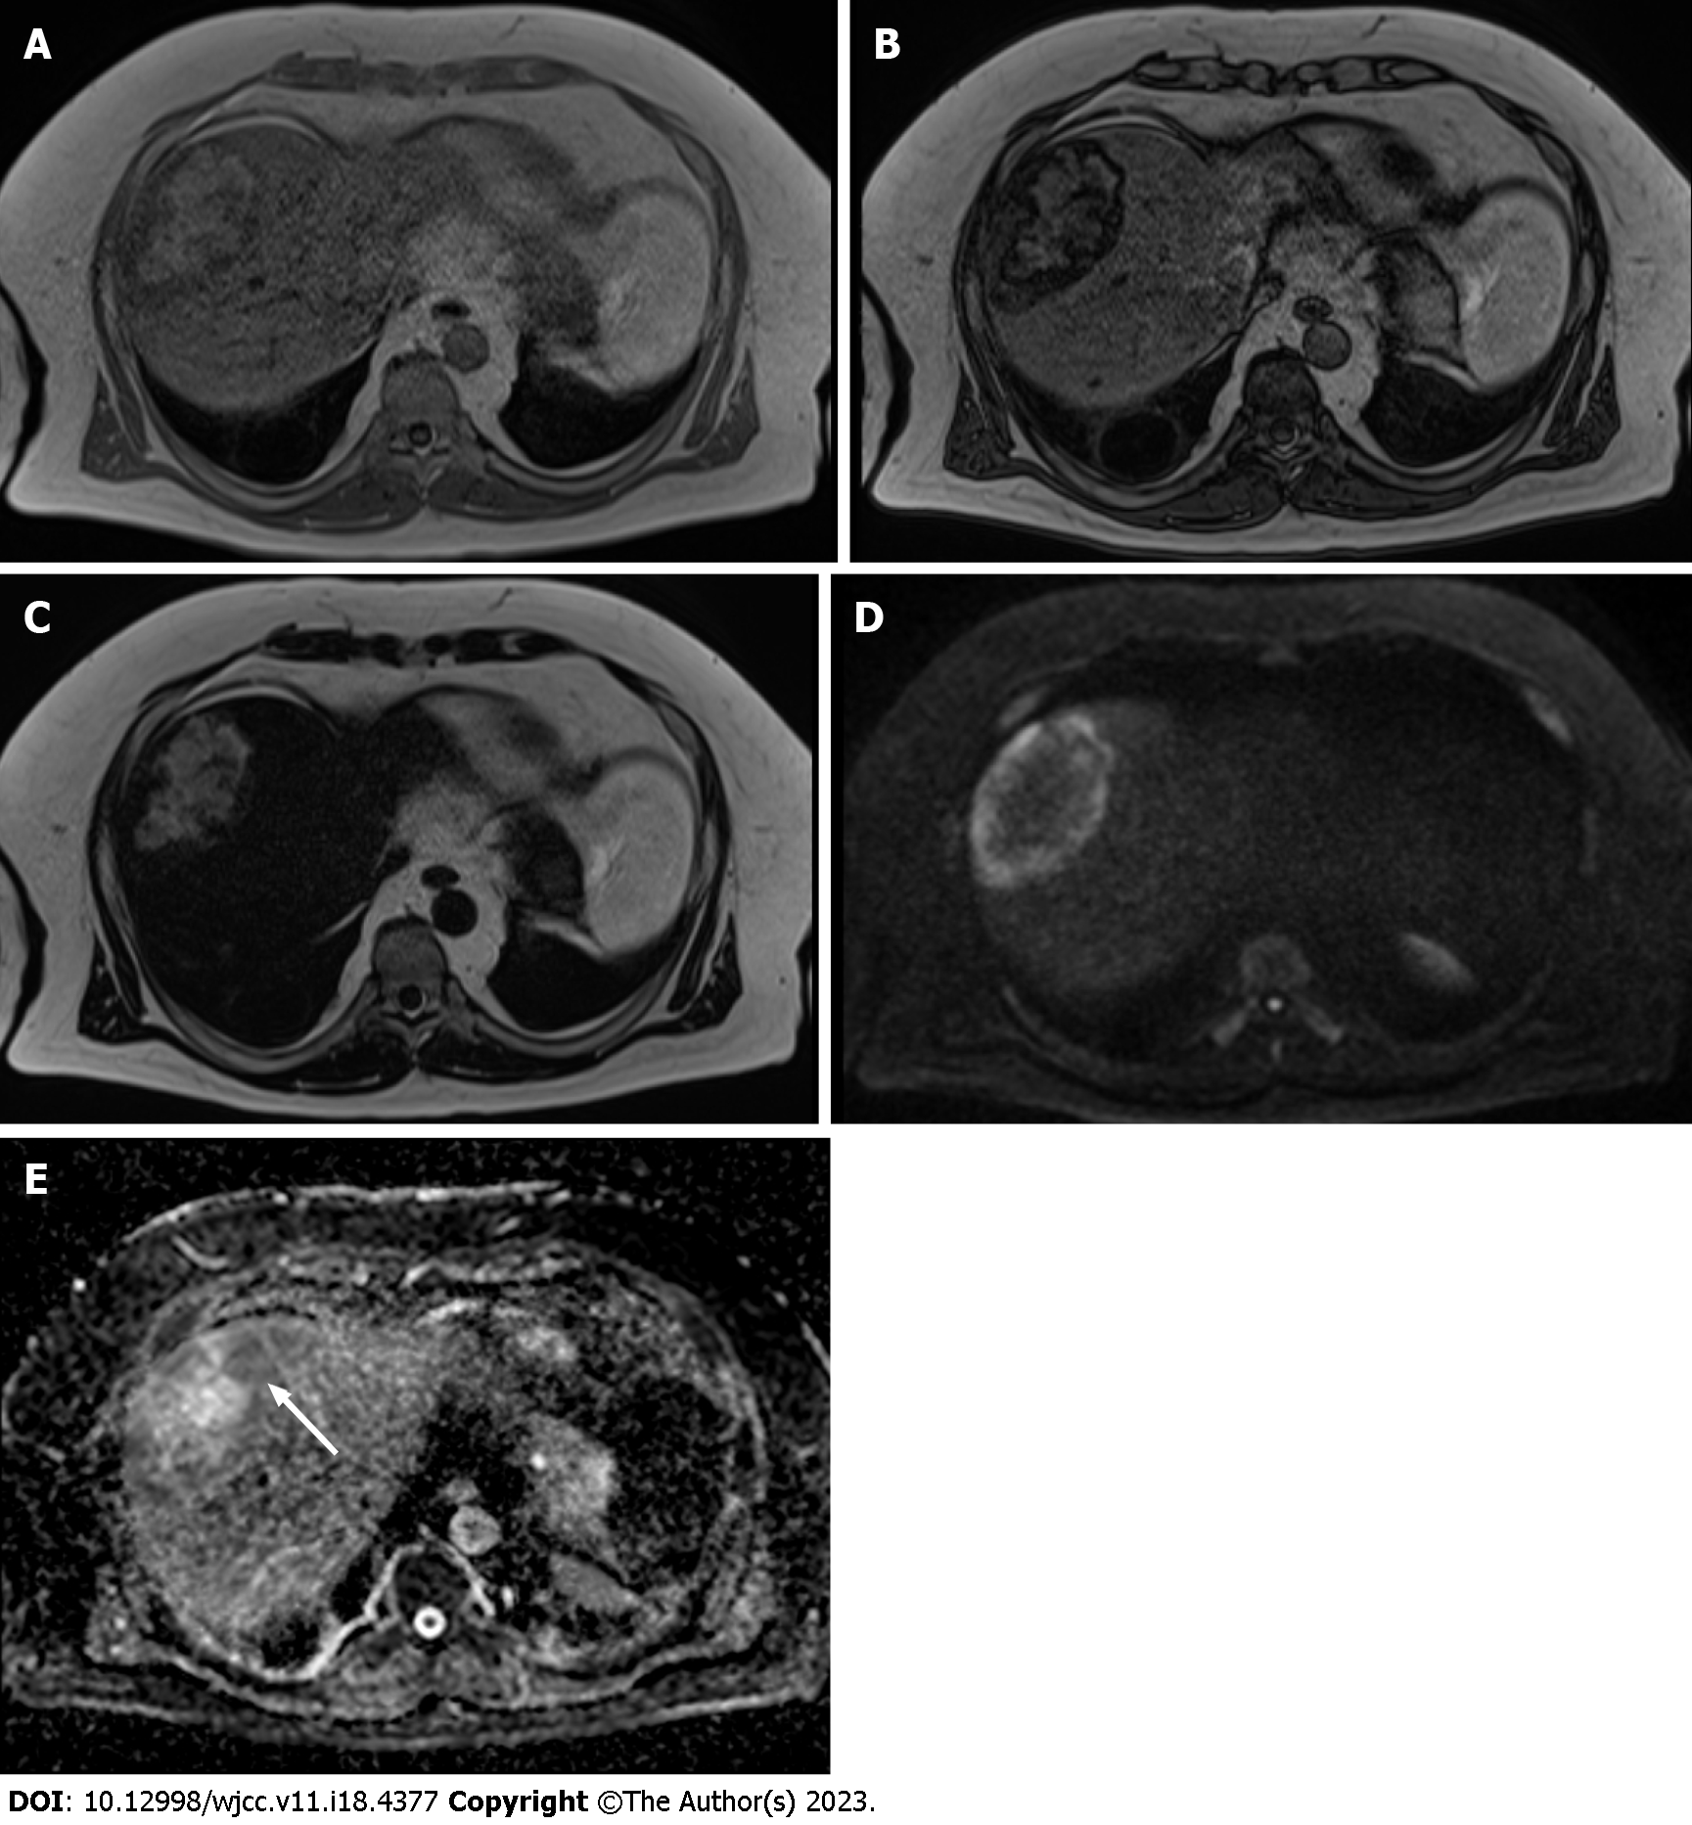
Figure 3 Plain magnetic resonance imaging. A: T1-weighted in phase image shows hyperintensity at the center area and hypointensity at the peripheral area of the lesion compared with the background liver parenchyma; B: T1-weighted opposed phase image demonstrates an apparent signal drop in the peripheral area of the lesion and a heterogeneous signal drop at the center of the lesion; C: T2-weighted image shows the lesion’s center hyperintensity equal to subcutaneous fat. The peripheral area of the lesion shows mild hyperintensity; D: Diffusion-weighted image shows the peripheral area of the lesion and hyperintensity on the diffusion-weighted image. The center of the fat-dominant area shows hypointensity; E: Apparent diffusion coefficient map shows the peripheral area of the lesion hypointensity (white arrow). This indicates that the diffusion in this area is restricted.

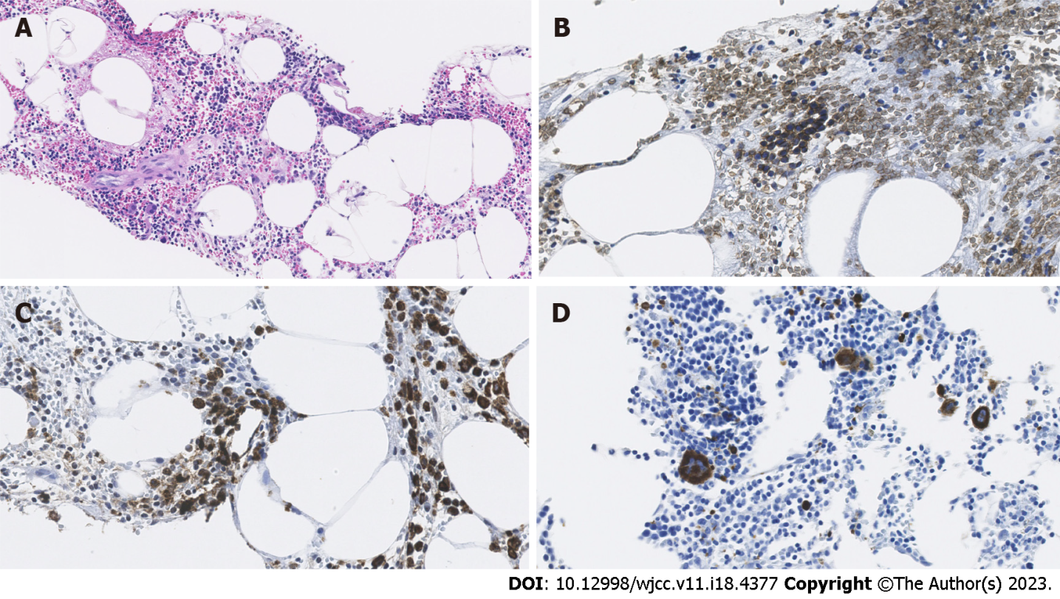
Figure 4 Histological and immunohistochemical findings. A: Hematoxylin and eosin staining with × 400 magnification of the specimen from biopsy to the lesion shows the adipose tissue (lucent areas) within the hematopoietic element; B: Glycophorin C staining with × 400 magnification field indicates the presence of erythroid cells (brown stained); C: Myeloperoxidase staining with × 400 magnification field shows the presence of myelocytes (brown stained); D: CD61 immunostaining with × 400 magnification field demonstrates the presence of megakaryocytes (brown stained).

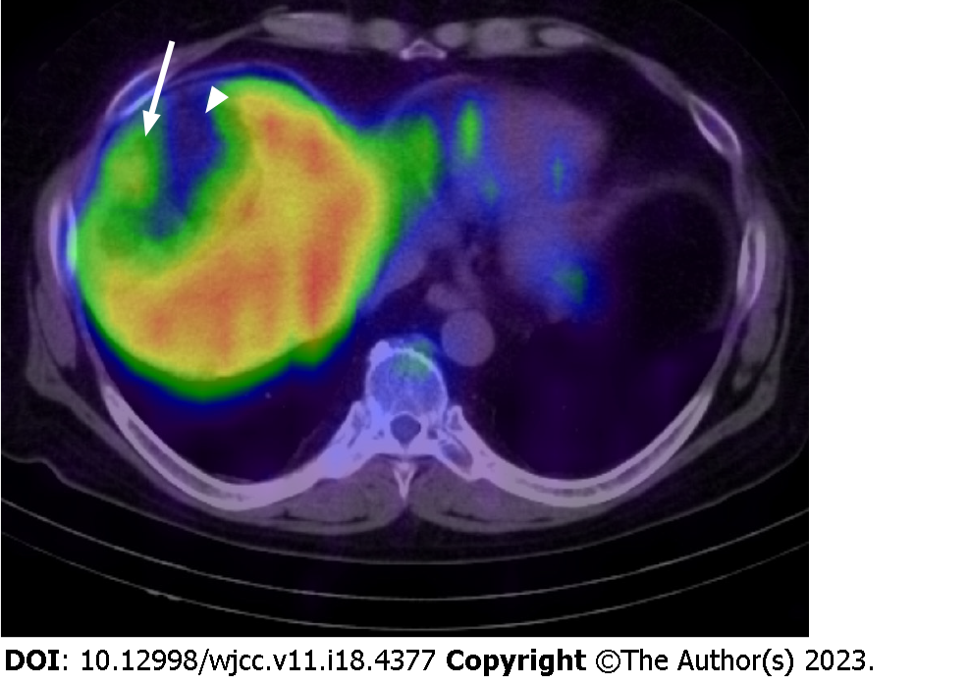
Figure 5 A fusion image with single photon emission computed tomography using ¹¹¹InCl₃ and computed tomography. The image shows the mild accumulation of radiopharmaceutical in the peripheral area of the lesion (white arrow). Poor accumulation was observed in the central region corresponding to the dominant fat area (white arrowhead).

Table 1 Timeline of the case
First indication | Twenty years ago
Second indication | One month ago
Referred to our hospital and ultrasound examination | Day 0
Magnetic resonance cholangiopancreatography | Day 23
Biopsy | Day 75
Hepatic MRI | Day 287
¹¹¹InCl₃ scintigraphy and single-photon emission computed tomography/CT | Day 662
MRI: Magnetic resonance imaging; CT: Computed tomography.

Published by Baishideng Publishing Group Inc
7041 Koll Center Parkway, Suite 160, Pleasanton, CA 94566, USA
Telephone: +1-925-3991568
E-mail: bpgoffice@wjgnet.com
Help Desk: https://www.f6publishing.com/helpdesk
https://www.wjgnet.com

© 2023 Baishideng Publishing Group Inc. All rights reserved.

