Name of journal: World Journal of Gastroenterology
ESPS Manuscript NO:742
Columns: CASE REPORT

Endoscopic Resection of Co-existing of Severe Dysplasia and a Small Esophageal Leiomyoma

Sun Young Ahn, Seong Woo Jeon

Running title: A Synchronous Lesion in Esophagus
Ahn Sun Young, Seong Woo Jeon, Division of Gastroenterology and Hepatology, Department of Internal Medicine, Kyungpook National University Hospital, Samduk 2-50, Junggu, Daegu, 700-721, South Korea

Author Contributions : Ahn SY and Jeon SW contributed equally to this work; Ahn SY and Jeon SW designed this article and discussed the clinical features; Ahn SY wrote the paper; Seong Woo Jeon contributed revising this article critically for important intellectual content.

Correspondence to: Seong Woo Jeon, M.D., Ph.D, Division of Gastroenterology and Hepatology, Department of Internal Medicine, Kyungpook National University Hospital, Samduk 2-50, Junggu, Daegu, South Korea. swjeon@knu.ac.kr
Telephone: +82-53-200-3517, Fax: +82-53-426-8773
Received: Revised: Accepted: Published online:

Abstract

Leiomyoma is the most common benign mesenchymal tumor of the esophagus. A small leiomyomas covered with endoscopically normal mucosa have a characteristic endoscopic ultrasonographic appearance, slow growth rate, and negligible risk of malignant transformation; therefore the histology doses not need to be proven. Synchronous tumors of epithelial tumor and small subepithelial tumor in the upper gastrointestinal tract are uncommon. We describe a case of co-existence of a small leiomyoma and severe dysplasia in the esophagus that were resected completely by endoscopic mucosal resection.

Key words : synchronous tumor, leiomyoma, dysplasia
Peer reviewer:
INTRODUCTION
Leiomyoma is the most common benign mesenchymal tumor in the esophagus^{[1, 2]}. A small and asymptomatic leiomyoma covered with endoscopically normal mucosa is known that it dosen’t need treatment like as resection because it has a characteristic endoscopic ultrasonographic appearance, slow growth rate, and negligible risk of malignant transformation^{[3]}. A few cases involving co-existing tumors of epithelial tumor and subepithelial tumor in the esophagus have been reported. However, all of these reports were cases of larger than 1cm and squamous cell carcinoma^{[4-8]}. And most of them were treated by surgery. A subepithelial lesion smaller than 1cm combined with epithelial dysplasia is extremely unusual. We present the case of an epithelial lesion of severe dysplasia overlying a small leiomyoma from the muscularis mucosae of esophagus and the two lesions were removed completely by endoscopic mucosal resection at one section.

CASE REPORT
A 67-year-old male patient visited our hospital for an incidentally found subepithelial lesion at mid-esophagus. He was non-smoker and had no previous medical history with good performance. Esophagogastroscopic examination showed a protruding mass, measuring 1×1 cm in dimension, without any ulcer or erosion, covered with normal mucosa (Figure 1A). We examined the lesion using narrow-band imaging (NBI) which showed scattered brown dots and dilated and tortuous vessels on the top of the lesion (Figure 1B). We judged that the lesion might have dysplasia. Endoscopic ultrasonography was performed in order to determine the depth and nature of the tumor. Findings indicated that the lesion, which measured 5.0 × 4.0 mm in size, was a homogenous hypoechoic mass, confined to the second layer, muscularis mucosa (Figure 2A). We performed a mucosal biopsy. Histological examination of the specimen indicated severe dysplasia. We diagnosed severe dysplasia overlying a small leiomyoma from the muscularis mucosa. Therefore, we planned en bloc resection by endoscopy for removal of the synchronous lesions. Endoscopic resection was performed using endoscopic mucosal resection (EMR) method. Following injection of hyaluronic acid into submucosa, resection was performed using a snare (Figure 2B, 2C). There was no occurrence of complication related to procedure (Figure 2D). Histopathological examination of the tumor revealed high grade dysplasia with a clear resection margin and results of immunohistochemical analyses revealed that the leiomyoma was negative for C-kit and CD 34, and positive for smooth muscle actin (Figure 3A, 3B, 3C, 3D).

DISCUSSION
The present case was that severe epithelial dysplasia overlying a small subepithelial tumor, which were treated with EMR.
Due to improvement of diagnostic tools and prolonged lifespan rates, diagnostic rates of esophageal subepithelial lesions are increasing. Leiomyoma is the most common tumor of subepithelial tumor of the esophagus. Esophageal leiomyomas account for approximately 12% of all gastrointestinal leiomyomas^{[9]}. Esophageal leiomyomas may occur from the muscularis propria layer or the muscularis mucosa of the esophagus. With development of the high frequency ultrasonic endoprobe, detection of the origin of leiomyoma of even small lesions appears to be easier^{[10]}. On occasion, those arising from muscularis mucosa can present as polypoid intraluminal tumors. In a review of 838 cases, only 1% were the polypoid intraluminal type^{[11]}. The question of whether leiomyoma can show malignant degeneration is controversial. If it were possible, the risk would be negligible. Thus, when a small leiomyoima covered with normal mucosa is encountered on endoscopy, a biopsy should not be recommended^{[1]}.
Co-existing epithelial lesion and subepithelial lesion were rare. Twelve patients in ten case reports with carcinoma located in the mucosa over a benign tumor have been reported^{[6, 12, 4, 5]}. All cases were squamous cell carcinoma and subepithelial lesions were larger than 1cm. Eight patients were treated surgically. However, this is the first case of development of epithelial dysplasia above a leiomyoma measuring less than 1cm in the esophagus.
It is not clear whether two lesions occurred at the same time and whether there were any causative relations. However, as a hypothesis, we suggest development of synchronous subepithelial and epithelial lesions. After development of leiomyoma, external stimuli might change the mucosa. Epithelial dysplasia is the principal precursor lesion of esophageal squamous cell carcinoma. Studies have shown that esophageal squamous cell carcinoma develops through a progressive sequence from mild to severe dysplasia^{[13]}. Predisposition to esophageal dysplasia may be related to certain carcinogenic stimuli, dietary factors, and individual genetic susceptibility^{[13]}. The patient was a non-smoker and did not have any medical history. He didn’t have any risk factors for esophageal cancer. We assumed that focal mechanical stimuli might induce mucosa dysplasia. However, unfortunately determination of a dysplastic lesion on conventional endoscopy is difficult, even when using an iodine stain. The prevalence of severe dysplasia derived from iodine stained tissue is quite low (<1%)^{[14]}. Specificity of NBI for severe dysplasia performed by experienced endoscopists has been reported up to 100%^{[15]}. Therefore, subepithelial lesion presenting with an intraluminal polypoid mass should be examined closely using electronic chromoendoscopy with NBI and tissue biopsy. However, tissue biopsy is at risk for bleeding and scattering malignant cells. Furthermore, the scaring after tissue biopsy can have problems removing lesion clearly. To doubt simultaneous lesions is important. If the NBI findings suggest dysplastic change, it is better to resect the lesion without tissue biopsy. Severe dysplasia overlying a leiomyoma originating from muscularis mucosa could be removed safely using an endoscopical technique^{[10]}.
In conclusion, a polypoid subepithelial tumor of the esophagus is ever so small; however it can be occurred with simultaneous epithelial dysplastic change. If the lesions were detected early by a novel endoscopic image, it could be removed endoscopically.

REFERENCE
1 SW Fountain. Leiomyoma of the esophagus. Thorac Cardiovasc Surg 1986; 34(3): 194-195 [PMID: 2426836 DOI: 10.1055/s-2007-1020408]
2 A Punpale, A Rangole, N Bhambhani, G Karimundackal, N Desai, A de Souza, CS Pramesh, N Jambhekar and RC Mistry. Leiomyoma of esophagus. Ann Thorac Cardiovasc Surg 2007; 13(2): 78-81 [PMID: 17505413]
3 CJ Mutrie, DM Donahue, JC Wain, CD Wright, HA Gaissert, HC Grillo, DJ Mathisen and JS Allan. Esophageal leiomyoma: a 40-year experience. Ann Thorac Surg 2005; 79(4): 1122-1125 [PMID: 15797036 DOI: 10.1016/j.athoracsur.2004.08.029]
4 H Kuwano, N Sadanaga, M Watanabe, M Yasuda, T Nozoe and K Sugimachi. Esophageal squamous cell carcinoma occurring in the surface epithelium over a benign tumor. J Surg Oncol 1995; 59(4): 268-272 [PMID: 7630176]
5 M Watanabe, T Baba and M Hotchi. A case of leiomyoma of the lamina muscularis mucosae of the esophagus with a complication of carcinoma in situ of the overlying mucosa. Acta Pathol Jpn 1987; 37(11): 1845-1851 [PMID: 3439459]
6 T Iizuka, H Kato, H Watanabe, M Itabashi and T Hirota. Superficial carcinoma of the esophagus coexisting with esophageal leiomyoma: a case report and review of the Japanese literature. Jpn J Clin Oncol 1984; 14(1): 115-122 [PMID: 6708309]
7 T Iwaya, C Maesawa, N Uesugi, T Kimura, K Ikeda, Y Kimura, S Mitomo, K Ishida, N Sato and G Wakabayashi. Coexistence of esophageal superficial carcinoma and multiple leiomyomas: A case report. World J Gastroenterol 2006; 12(28): 4588-4592 [PMID: 16874880]
8 S Mizobuchi, K Kuge, Y Matsumoto, Y Yokoyama, K Ookawauchi, S Tamura, A Kurabayashi and S Sasaguri. Co-existence of early esophageal carcinoma and leiomyoma: a case report. Jpn J Clin Oncol 2004; 34(12): 751-754 [PMID: 15640507 DOI: 10.1093/jjco/hyh133]
9 CK Choong and BF Meyers. Benign esophageal tumors: introduction, incidence, classification, and clinical features. Semin Thorac Cardiovasc Surg 2003; 15(1): 3-8 [PMID: 12813683]
10 SJ Lee, YH Paik, DK Lee, KS Lee and SI Lee. The diagnostic value of endoprobe for small esophageal leiomyomas derived from the muscularis mucosae. Yonsei Med J 2005; 46(1): 61-65 [PMID: 15744806 PMCID: 2823058]
11 MG Seremetis, WS Lyons, VC deGuzman and JW Peabody, Jr. Leiomyomata of the esophagus. An analysis of 838 cases. Cancer 1976; 38(5): 2166-2177 [PMID: 991129]
12 R Ishihara, S Yamamoto, H Iishi, Y Takeuchi, M Kato, E Masuda, K Tatsumi, K Higashino, N Uedo and M Tatsuta. Endoscopic resection of the esophageal squamous cell carcinoma overlying leiomyoma. Gastrointest Endosc 2008; 67(4): 745-747 [PMID: 18206883 DOI: 10.1016/j.gie.2007.09.021]
13 WM Mao, WH Zheng and ZQ Ling. Epidemiologic risk factors for esophageal cancer development. Asian Pac J Cancer Prev 2011; 12(10): 2461-2466 [PMID: 22320939]
14 RB Fagundes, SG de Barros, AC Putten, ES Mello, M Wagner, LA Bassi, MA Bombassaro, D Gobbi and EB Souto. Occult dysplasia is disclosed by Lugol chromoendoscopy in alcoholics at high risk for squamous cell carcinoma of the esophagus. Endoscopy 1999; 31(4): 281-285 [PMID: 10376452 DOI: 10.1055/s-1999-122]
15 R Ishihara, Y Takeuchi, R Chatani, T Kidu, T Inoue, N Hanaoka, S Yamamoto, K Higashino, N Uedo, H Iishi, M Tatsuta, Y Tomita and S Ishiguro. Prospective evaluation of narrow-band imaging endoscopy for screening of esophageal squamous mucosal high-grade neoplasia in experienced and less experienced endoscopists. Dis Esophagus 2010; 23(6): 480-486 [PMID: 20095991 DOI: 10.1111/j.1442-2050.2009.01039.x]

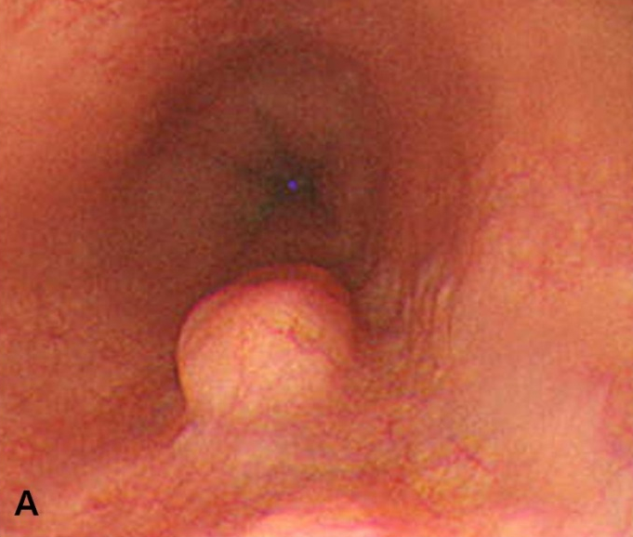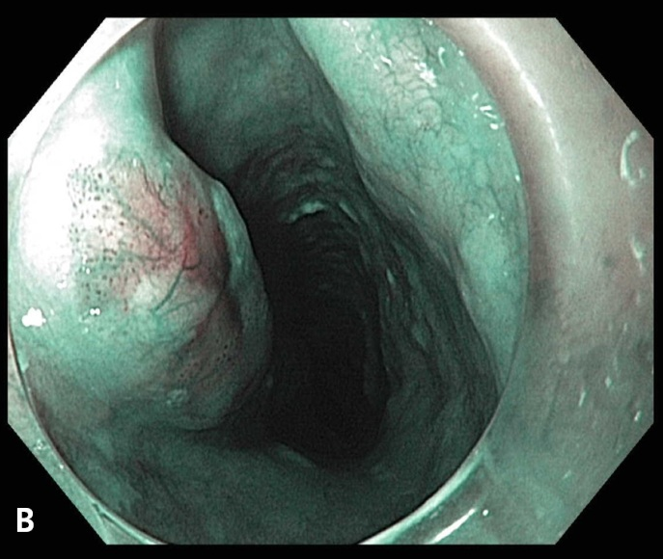

Figure 1 Endoscopic findings. A:Endoscopic finding demonstrates a subepithelial tumor with intact overlying mucosa; B:Chromoendoscopy with narrow band image showed scattered brown dots and dilated and tortuous vessels on the top of the lesion.

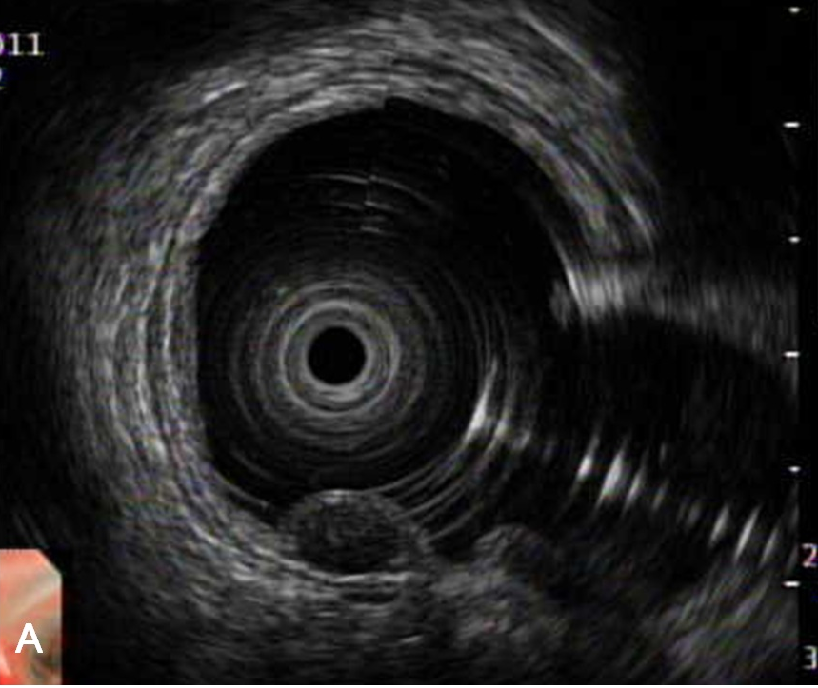
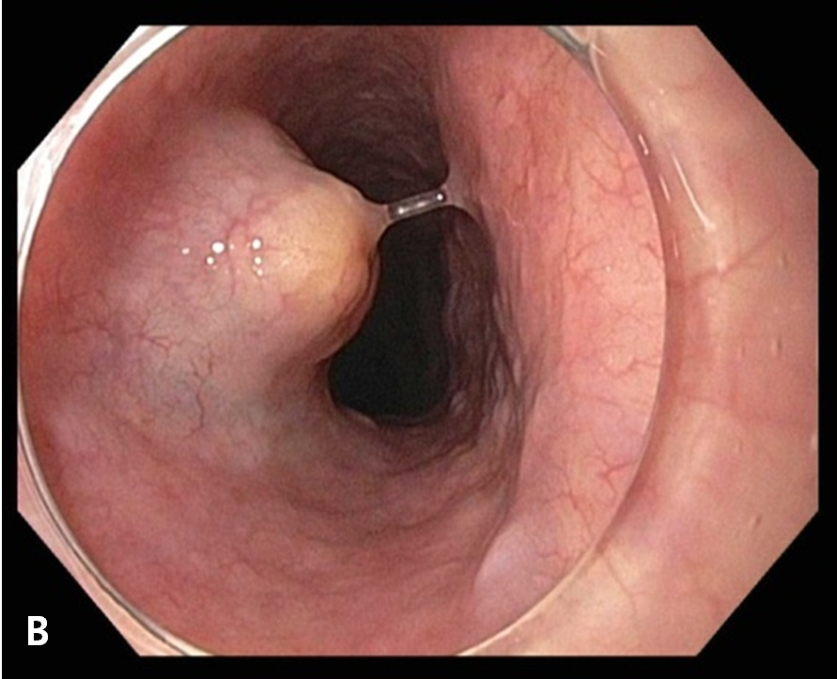
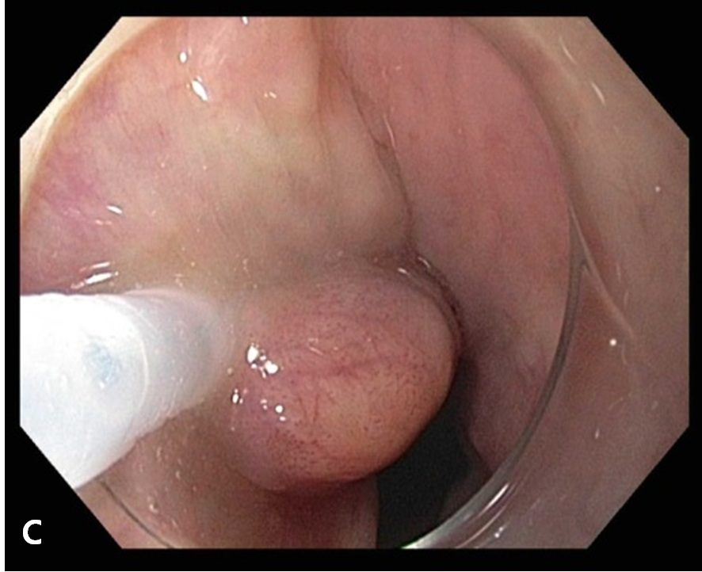
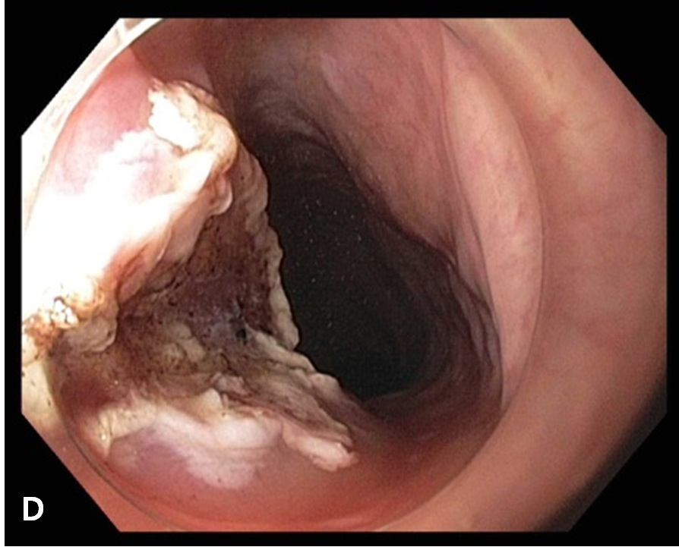

Figure 2 Endoscopic ultrasound finding and procedures of endoscopic mucosal resection. A: High frequency ultrasonic endoscopic finding showed a clear homogenous hypoechoic mass derived from the second layer of the esophagus; B:After a making submucosal bleb; C:The subepithelial lesion was captured using a snare; D:There was no immediate occurrence of complication after endoscopic mucosal resection.

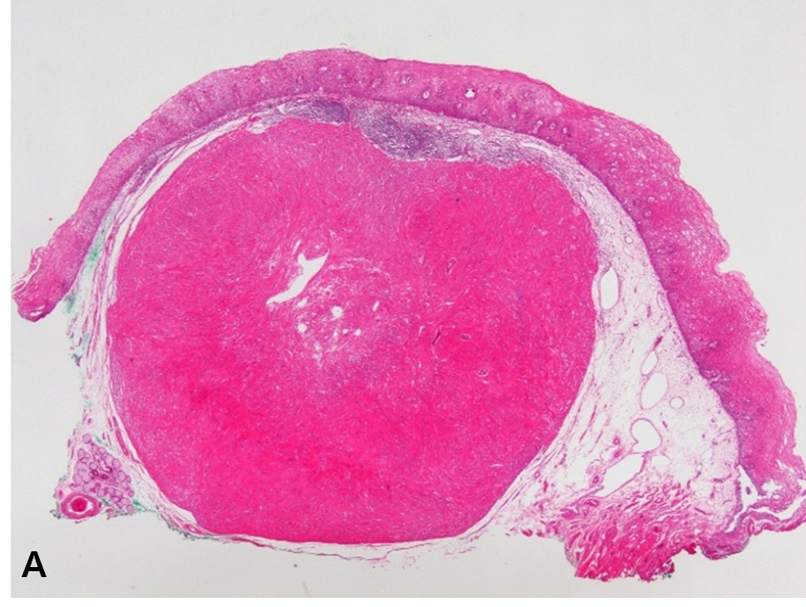
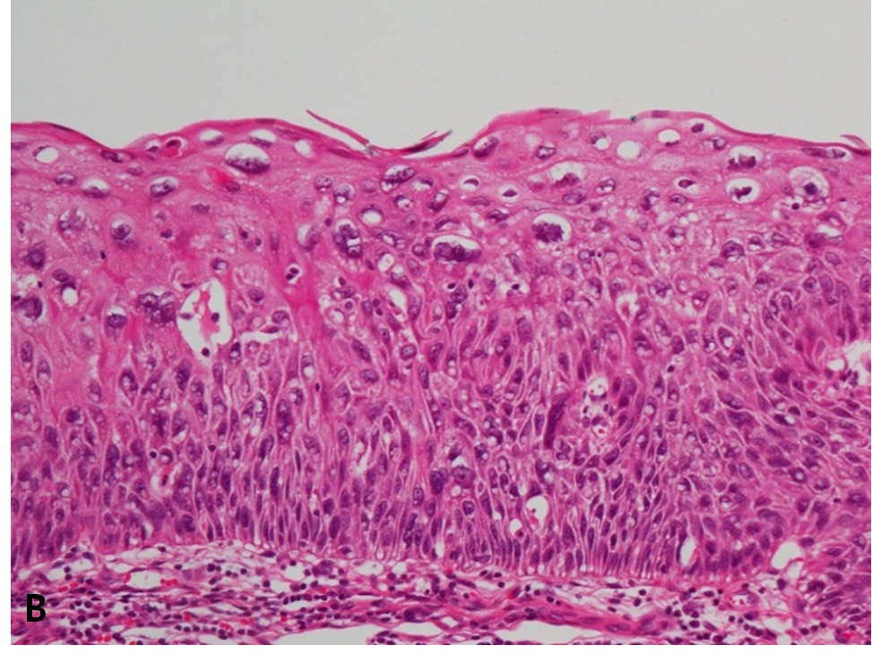
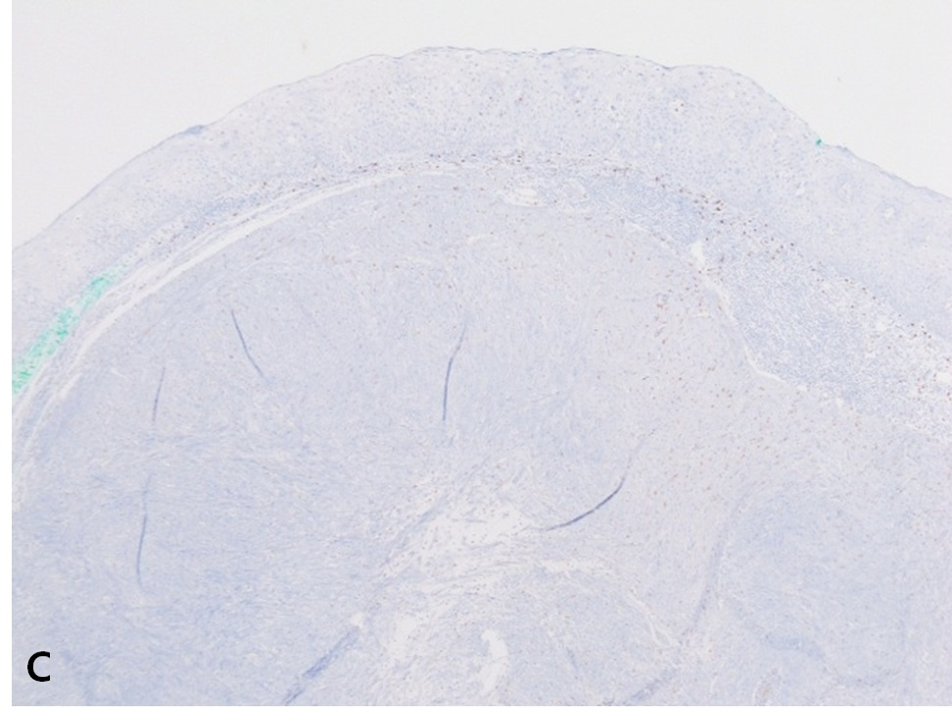
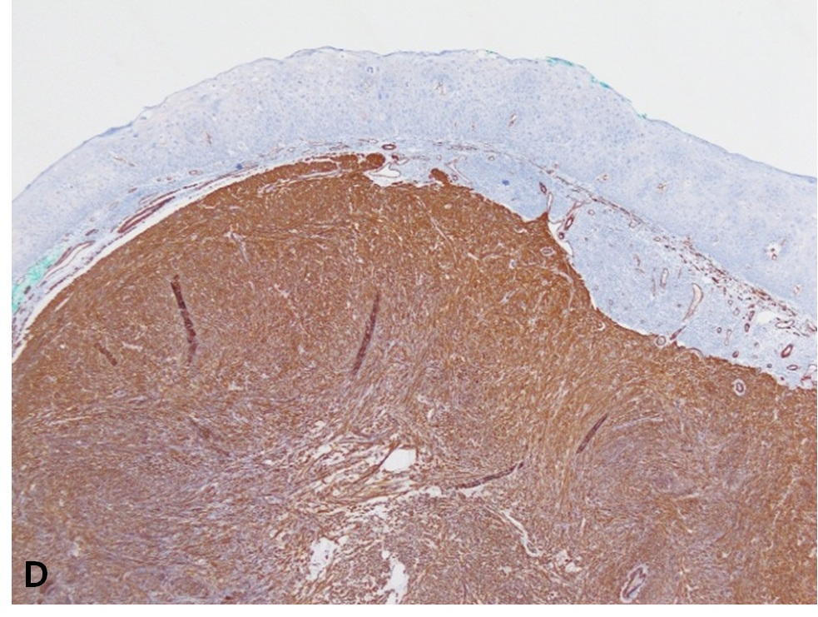
Figure 3 Histopathologic findings. A:Esophageal leiomyoma arising from muscularis mucosae (H&E, 20x); B:Atypical cells in all thirds of the epithelium but not full thickness showed severe dysplasia (H&E, 200x); C:The esophageal leiomyoma was negative for CD117 (C-Kit); D:The esophageal leiomyoma showed strong and diffuse positive for smooth muscle actin (200x).

