Name of Journal: World Journal of Clinical Cases
Manuscript NO: 50534
Manuscript Type: CASE REPORT

Six families with balanced chromosome translocation associated with reproductive risks in Hainan Province: Case reports and review of the literature

Chen YC et al. Six families with balanced chromosome translocation with reproductive risks

Yun-Chun Chen, Xu-Ning Huang, Chang-Ying Kong, Jian-Dong Hu

Yun-Chun Chen, Department of Laboratory Medicine, Haikou Branch of Yueyang Hospital of Integrated Traditional Chinese and Western Medicine, Shanghai University of Traditional Chinese Medicine (Haikou Hospital of Traditional Chinese Medicine), Haikou 570300, Hainan Province, China

Xu-Ning Huang, Department of Ultrasound Medicine, Second Affiliated Hospital of Hainan Medical University, Haikou 570300, Hainan Province, China

Chang-Ying Kong, Department of Gynecology, Second Affiliated Hospital of Hainan Medical University, Haikou 570300, Hainan Province, China

Jian-Dong Hu, Department of Internal Medicine, Haikou Branch of Yueyang Hospital of Integrated Traditional Chinese and Western Medicine, Shanghai University of Traditional Chinese Medicine (Haikou Hospital of Traditional Chinese Medicine), Haikou 570300, Hainan Province, China

Author contributions: Chen YC and Hu JD designed and performed the study; Huang XN and Kong CY participated in acquisition, analysis, or interpretation of the data; Chen YC and Hu JD wrote the paper; all authors read and approved the final manuscript.

Supported by Natural Science Foundation of Hainan Province, NO. 819MS148.

Corresponding author: Jian-Dong Hu, MD, Doctor, Department of Internal Medicine, Haikou Branch of Yueyang Hospital of Integrated Traditional Chinese and Western Medicine, Shanghai University of Traditional Chinese Medicine (Haikou Hospital of Traditional Chinese Medicine), No. 45, Jinpan Road, Haikou 570216, Hainan Province, China. hamlethu@163.com

Received: July 28, 2019
Revised: November 28, 2019
Accepted: December 13, 2019
Published online: January 6, 2020

Abstract
BACKGROUND
Balanced translocation refers to the process where breakage and reconnection of chromosomes occur at abnormal positions. As the genetic substance with balanced translocation in individuals does not change, which is usually characterized by normal phenotype and intelligence, the individuals seek medical service after many miscarriages, resulting in considerable mental and physical burdens of the family members. In the current era with rapid advances in detection technology, cytogenetic examination, as a definitive approach, still plays an essential role.

CASE SUMMARY
We report six cases with balanced chromosome translocation: Case 1: 46,XY,t(3;12)(q27;q24.1), infertility after 3 years of marriage; Case 2: 46,XX,t(4;16)(q31;q12), small uterus and irregular menstruation; Case 3: 46,XY,t(4;5)(q33;q13),9qh+, not pregnant after arrested fetal development; Case 4: 46,XX,t(11;17)(q13;p11.2), not pregnant after two times of spontaneous abortion; Case 5: 46,XX,t(10;13)(q24;q21.2), not pregnant after arrested fetal development for once; Case 6: 46,XX,t(1;4)(p36.1;q31.1), not pregnant after arrested fetal development for two times. The first four cases had chromosomal aberration karyotypes.

CONCLUSION
These results suggested that balanced chromosomal translocation carriers are associated with reproductive risks and a very high probability of abnormal pregnancy. The discovery of the first four reported chromosomal aberration karyotypes provides an important basis for studying the occurrence of genetic diseases.

Key words: Reproductive risk; Balanced translocation; Abnormal pregnancy; Genetic counseling; Case report

Chen YC, Huang XN, Kong CY, Hu JD. Six families with balanced chromosome translocation associated with reproductive risks in Hainan Province: Case reports and review of the literature. World J Clin Cases 2019; 8(1): 222-233 URL: https://www.wjgnet.com/2307-8960/full/v8/i1/222.htm DOI: https://dx.doi.org/10.12998/wjcc.v8.i1.222

Core tip: The genetic substance with balanced translocation in individuals does not change, which is usually characterized by normal phenotype. Here, we report six cases with balanced chromosome translocation: Case 1: 46,XY,t(3;12)(q27;q24.1), infertility for 3 years; Case 2: 46,XX,t(4;16)(q31;q12), small uterus and irregular menstruation; Case 3: 46,XY,t(4;5)(q33;q13),9qh+, infertility; Case 4: 46,XX,t(11;17)(q13;p11.2), two times of spontaneous abortion; Case 5: 46,XX,t(10;13)(q24;q21.2), arrested fetal development for one time; Case 6: 46,XX,t(1;4)(p36.1;q31.1), arrested fetal development for two times. This study suggested that balanced chromosomal translocation carriers are associated with reproductive risks. The first four reported chromosomal aberration karyotypes provide an important basis for studying the occurrence of genetic diseases.

INTRODUCTION
Chromosomal disorder is defined as a genetic disease caused by abnormalities in number, morphology, or structure of chromosomes, often resulting in miscarriage, congenital mental retardation, mental retardation, and multiple malformations clinically. This seriously threatens the health of humans. Chromosomal abnormalities cannot be treated in the current medical field, as they are irreversible. Balanced translocation is referred to as the situation where both breakage and reconnection of chromosomes occur at abnormal positions. Currently, the specific mechanisms underlying balanced translocation remain unclear. Translocation might be a completely harmless process or may cause serious health problems based on specific scenarios. In the first scenario, as the amount of individual chromosomal substance with balanced translocation does not change, which is usually characterized by normal phenotype and intelligence, the individuals look for medical services after undergoing many miscarriages. Chromosomes with balanced translocation can be inherited from parents or caused by the occurrence of new mutations^{[1]}. Hence, in the present study, six families with balanced chromosome translocation are described, where four individuals had chromosomal aberration karyotypes, and so further observation and analyses were performed. Further verification of these detection results of abnormal karyotypes has significance in guiding patients with clinical indications, such as spontaneous abortion, infertility, mental retardation, and fetal ultrasound abnormalities^{[2]}.

CASE PRESENTATION
Chief complaints
(1) Case 1: Infertility after 3 years of marriage; (2) Case 2: Irregular menstruation; (3) Case 3: Not pregnant after arrested fetal development; (4) Case 4: Not pregnant after two times of spontaneous abortion; (5) Case 5: Not pregnant after arrested fetal development for one time; and (6) Case 6: Not pregnant after arrested fetal development for two times.

History of present illness
Five patients (Cases 1, 3, 4, 5, and 6) had infertility, and Case 2 had small uterus and irregular menstruation.

History of past illness
(1) Case 1: No significant past medical history; (2) Case 2: She received long-term traditional Chinese medicine for menstrual induction. The specific drugs and time were unknown. The uterus was small in size, and menstruation showed brown secretions; (3) Case 3: The medical abortion was reported during the first gestation, and arrested fetal development was reported after 60 d of pregnancy during the second gestation; (4) Case 4: Spontaneous abortion was reported after 50 d of pregnancy for two gestations; (5) Case 5: After 3 years of marriage, she underwent miscarriage after 1 mo of pregnancy due to no fetal heart. During her second pregnancy, blood was seen after 3 mo, and developmental arrest was noted. When engaged in physical work, she reported physical weakness, and advanced menstruation occurred often; and (6) Case 6: Arrested fetal development was observed after 60 d of pregnancy during the two gestations.

Personal and family history
Five patients (Cases 1, 3, 4, 5, and 6) had no significant personal or family history, and Case 2 had small uterus and irregular menstruation, but had no significant personal or family history.

Physical examination upon admission
(1) Case 1: The proband was a 30-year-old man who was 170 cm in height, and his phenotypic features and intelligence appeared normal; (2) Case 2: The proband was a 22-year-old unmarried woman who was 158 cm in height, and her phenotype and intelligence were normal; (3) Case 3: The proband was a 28-year-old man who was 172 cm in height, and his phenotype and intelligence were normal; (4) Case 4: The proband was a 32-year-old woman with a height of 153 cm, and her phenotype and intelligence were normal; (5) Case 5: The proband was a 24-year-old woman with a height of 158 cm, and her phenotype and intelligence were normal; and (6) Case 6: The proband was a 32-year-old woman with a height of 160 cm, and her phenotype and intelligence were normal.

Laboratory examinations
(1) Case 1: The results of semen examination based on three items (UU-DNA, CT-DNA, and NG-DNA) were normal, and showed anti-sperm antibody (-); (2) Case 2: Five items for sex hormones were unremarkable [luteinizing hormone (LH), follicle stimulating hormone (FSH), estradiol (E2), progesterone (PRG), and prolactin (PRL)], and the total testosterone (TES) level was normal; (3) Case 3: The results of routine semen tests were unremarkable; (4) Case 4: Five items of sex hormones (LH, FSH, E2, PRG, and PRL) were unremarkable. TES and insulin levels were normal. She had anti-sperm antibody (-); (5) Case 5: The five sex hormones (such as LH, FSH, E2, PRG, and PRL) were unremarkable. Her TES level was normal; and (6) Case 6: The five items of sex hormones (LH, FSH, E2, PRG, and PRL) were unremarkable. The TES was normal. Anti-sperm antibody was negative, and –α 4.2 thalassemia gene deletion type (heterozygous) was observed.

Imaging examinations
Five patients (Cases 1, 3, 4, 5, and 6) had normal imaging examinations, and Scanning under bladder filling in Case 2 showed that the uterus was small in size (3.9 mm × 2.5 mm × 3.1 mm).

FINAL DIAGNOSIS
Four chromosomal aberration karyotypes were identified by the expert group of Chinese Database of Human Abnormal Chromosome Karyotypes. No relevant report was found in the “Chinese Human Chromosome Abnormality Karyotype Database”, “Cytogenetics Database”. Therefore, the karyotypes were included in the “Chinese Human Chromosome Abnormal Nuclei Database” (Database Numbers: 4222, 4059, 4238, and 4223). The genetic pedigree diagrams were drawn using Microsoft PowerPoint (Figures 1-6). The comparison of family history is shown in Table 1

Case 1
G-banding chromosome analysis of peripheral blood (Database Number: 4222) showed 46,XY,t(3;12)(q27;q24.1) (Figure 1A). The genetic pedigree diagram is shown in Figure 1B.

Case 2
G-banding chromosome analysis of peripheral blood showed 46,XX,t(4;16)(q31;q12) (Figure 2A). The genetic pedigree diagram is shown in Figure 2B.

Case 3
G-banding chromosome analysis of peripheral blood showed 46,XY,t(4;5)(q33;q13),9qh+ (Figure 3A). The genetic pedigree diagram is shown in Figure 3B.

Case 4
G-banding chromosome analysis of peripheral blood (Database Number: 4059) showed 46,XX,t(11;17)(q13;p11.2) (Figure 4A). The genetic pedigree diagram was shown in Figure 4B.

Case 5
G-banding chromosome analysis of peripheral blood (Database Number: 4238) showed 46,XX,t(10;13)(q24;q21.2) (Figure 5A). The genetic pedigree diagram was shown in Figure 5B.

Case 6
G-banding chromosome analysis of peripheral blood (Database Number: 4223) showed 46,XX,t(1;4)(p36.1;q31.1) (Figure 6A). The genetic pedigree diagram was shown in Figure 6B.

TREATMENT
Case 1
In 2016, he underwent in vitro fertilization-embryo transfer (IVF-ET).

Case 2
The patient took drugs such as estrogen and progesterone to adjust the menstrual cycle.

Cases 3 and 4
In 2014, they underwent IVF-ET.

Cases 5 and 6
In 2016, they underwent IVF-ET.

OUTCOME AND FOLLOW-UP
(1) Case 1: No successful pregnancy; (2) Case 2: Menstruation was basically normal; (3) Case 3: No successful pregnancy; (4) Case 4: No successful pregnancy; (5) Case 5: No successful pregnancy; and (6) Case 6: Had first successful gestation for 5 mo in January 2019.

Discussion
The six probands in the present study had a history of abnormal pregnancy or irregular menstruation. Cytogenetic karyotype analysis showed autosomal balanced translocation, and four of them were identified to have the world’s first reported chromosomal aberration karyotypes. Despite the rapid development of molecular technology, cytogenetic analysis remains an indispensable tool^{[3,4]}.
Chromosome breakage and recombination occur during spermatogenesis or oogenesis, or during fertilization process. The problem caused by these changes has a small probability, and moreover, these changes are unknown. The case reports by Sha et al^{[5]} and Mas et al^{[6]} showed that complex balanced translocation may be an important cause of oligospermia, suggesting that chromosomes with balanced translocation impedes the meiosis of germ cells, and leads to the damage of spermatogenesis. The reciprocal translocation of chromosomes occurs in the process of meiosis during gametogenesis. When the chromosomes are homologously paired, a quadriradial chromosome is formed. By alternate, adjacent, and 3:1 separations, 18 gametes are formed, in which there is a normal one and a balanced one, and the remaining 16 gametes are unbalanced. From references^{[7-9]}, we know that the development of zygotes formed by these unbalanced gametes through fertilization forms a monosome or partial monosome, trisome, or partial trisome, leading to adverse outcomes of spontaneous abortion, stillbirth, fetal malformations, or neonatal death. Therefore, the likelihood of abnormal pregnancy for carriers is quite high, and this also explains the reasons for the six families with a history of abnormal pregnancy or irregular menstruation.
The chromosomal abnormality rate in the general population in China is 0.5%-1.0%, and the rate of chromosomal abnormalities in patients with a history of adverse pregnancy is 2%-10%^{[10,11]}. We retrospectively analyzed 36 articles from a population with a poor maternal history (Table 2): Among them, the detection rate of chromosomal abnormalities in 20 provinces and cities in China was 5.86% (2703/46133), the incidence of autosomal equilibrium translocation was 1.74% (804/46133), the detection rate of chromosomal abnormalities in 16 countries was 5.15% (1139/22134), and the incidence of autosomal equilibrium translocation was 2.35% (521/22134). The total detection rate of chromosomal abnormalities in patients with a poor maternal history in 20 provinces and cities in China and 16 countries was 5.62% (3842/68267), basically consistent with the aforementioned literature. The total incidence of autosomal balanced translocation was 1.97% (1325/68267). This analysis demonstrates that chromosomal abnormalities may be one of the important causes of a poor maternal history and it is necessary to carry out cytogenetic examination.
The study conducted by Clementini et al^{[12]} reported that each couple should undergo karyotyping in the infertility centers in Europe before receiving assisted reproductive therapy, with an aim to reduce the incidence of miscarriage or congenital anomalies. Studies have concluded that all women who require assisted reproductive therapy should undergo cytogenetic screening.
Recurrent miscarriage (RM) is defined as two or more consecutive spontaneous abortions, which accounted for 1% to 3% in couples^{[13,14]}. Zhu et al^{[15]} studied 42 balanced translocation carriers with a total of 90 pregnancies, in which spontaneous abortion occurred for 75 times during the early pregnancy, reaching an incidence of up to 83.4%. From the pedigree chart of Case 5 in this study, the mother of the proband was also accompanied by four adverse pregnancies. Although chromosomal detection was not performed, it was speculated to be inherited from the mother. The probands in the five families showed a history of adverse pregnancies. Multiple miscarriages can lead to emotional and physical trauma. To avoid the birth of infants with chromosomal abnormalities, intrauterine diagnosis is recommended for balanced chromosome translocation carriers at 16 to 20 wk of pregnancy. For couples with balanced translocations, the probability of birth of normal offspring is very small, and so assisted reproductive technology is recommended and preimplantation genetic diagnosis should be performed. Moreover, transplantation of normal embryos can significantly reduce the reproductive risk and pain of balanced translocation carriers, thus achieving the purpose of good childbearing and sound child-bearing^{[16]}, for example, Case 6 reported successful conception after about 3 years.
Chromosomal examinations should be performed on those with a history of abnormal pregnancy, and if possible, the chromosomes of family members should be examined. A computerized database generated from the literature on cytogenetic studies in couples experiencing repeated pregnancy losses has been put in place at the University of Quebec at Chicoutimi. It contains data on 22199 couples (44398 individuals). It also appears that only translations are linked to a higher risk of pregnancy wastage^{[17]}. Bernardi et al^{[18]} suggested chromosome testing of the second miscarriage, to determine whether a recurrent pregnancy loss (RPL) evaluation is required. Selective RPL evaluation, which is based upon chromosome testing of the subsequent miscarriage, is a cost-saving strategy for couples with RPL when compared with universal RPL evaluation.
Kaneko et al^{[19]} believed that although the detection causes a variety of complex psychological problems for the probands, they believed that it was important to be aware as to which parent to inherit from. For example, studies by Bache et al^{[20]} resulted in changes in genetic counseling practice in Denmark. When balanced chromosome translocation carriers aged over 18 years underwent examinations during prenatal period or childhood, parents will receive a letter to remind the family regarding the importance of potential reproductive risks involved and recommend participation in genetic counseling. This helps us to identify the risks faced by future generations, and is extremely necessary for individuals to undergo targeted examinations as well as provide guidance for good childbearing and sound child-bearing.
The detection of new karyotypes of human chromosomes provides abundant data of medical genetics for genetic counseling and prenatal diagnosis. Our four cases had first reported chromosomal aberration karyotypes in this study, which can help us to better understand the balanced autosomal translocation involved in infertility. Also, the discovery and declaration of abnormal karyotypes provide an important basis for studying the occurrence, development, prevention, clinical diagnosis, and treatment of genetic diseases. Furthermore, pre-pregnancy and prenatal diagnosis is also important for good childbearing and sound child-bearing, decreasing the birth of infants with malformations and hypophrenia.
However, our study had a few limitations, such as inclusion of small sample size and unavailability of cytogenetic analysis of miscarriage materials, history of the diagnosis, and previous history of treatment. In future, a study with large sample size should be conducted to provide more useful insight for clinical diagnosis.

ConclusioN
This study suggested that balanced chromosomal translocation carriers are associated with reproductive risks. The first four reported chromosomal aberration karyotypes provide an important basis for studying the occurrence of genetic diseases. This analysis demonstrates that chromosomal abnormalities may be one of the important causes of a poor maternal history and it is necessary to carry out cytogenetic examination.

REFERENCES
1 Wilch ES, Morton CC. Historical and Clinical Perspectives on Chromosomal Translocations. Adv Exp Med Biol 2018; 1044: 1-14 [PMID: 29956287 DOI: 10.1007/978-981-13-0593-1_1]
2 Ou S, Du J, Chen SK, Zheng CG, Meng DH, Zhang HY, Qiu QM, Liu TS, Tang B. [Cytogenetic analysis of 105 new human abnormal karyotypes]. Yi Chuan 2013; 35: 885-889 [PMID: 23853359 DOI: 10.3724/SP.J.1005.2013.00885]
3 Yokoyama E, Del Castillo V, Sánchez S, Ramos S, Molina B, Torres L, Navarro MJ, Avila S, Castrillo JL, García-De Teresa B, Asch B, Frías S. Derivative chromosomes involving 5p large rearranged segments went unnoticed with the use of conventional cytogenetics. Mol Cytogenet 2018; 11: 30 [PMID: 29760780 DOI: 10.1186/s13039-018-0374-4]
4 Verma S, Shah R, Bhat A, Bhat GR, Dada R, Kumar R. A Familial Case Report of a 13;22 Chromosomal Translocation with Recurrent Intracytoplasmic Sperm Injection Failure. Balkan J Med Genet 2018; 21: 73-77 [PMID: 30984530 DOI: 10.2478/bjmg-2018-0017]
5 Sha YW, Mei LB, Ji ZY, Ding L, Ge Y, Wu Q, Kong H, Su ZY, Li P. Two cases of complex balanced autosomal translocations associated with severe oligozoospermia. Gene 2018; 663: 126-130 [PMID: 29684482 DOI: 10.1016/j.gene.2018.04.052]
6 Mas J, Sabouni R, Bocca S. A novel male 2;4;14 complex chromosomal translocation with normal semen parameters but 100% embryonic aneuploidy. J Assist Reprod Genet 2018; 35: 907-912 [PMID: 29380280 DOI: 10.1007/s10815-018-1126-4]
7 Zhang K, Huang Y, Dong R, Yang Y, Wang Y, Zhang H, Zhang Y, Gai Z, Liu Y. Familial intellectual disability as a result of a derivative chromosome 22 originating from a balanced translocation (3;22) in a four generation family. Mol Cytogenet 2018; 11: 18 [PMID: 29467824 DOI: 10.1186/s13039-017-0349-x]
8 De Krom G, Arens YH, Coonen E, Van Ravenswaaij-Arts CM, Meijer-Hoogeveen M, Evers JL, Van Golde RJ, De Die-Smulders CE. Recurrent miscarriage in translocation carriers: no differences in clinical characteristics between couples who accept and couples who decline PGD. Hum Reprod 2015; 30: 484-489 [PMID: 25432924 DOI: 10.1093/humrep/deu314]
9 Crippa M, Giangiobbe S, Villa R, Bestetti I, De Filippis T, Fatti L, Taurino J, Larizza L, Persani L, Bellini F, Finelli P, Bonati MT. A balanced reciprocal translocation t (10;15) (q22.3; q26.1) interrupting ACAN gene in a family with proportionate short stature. J Endocrinol Invest 2018; 41: 929-936 [PMID: 29302920 DOI: 10.1007/s40618-017-0819-3]
10 Codina-Pascual M, Navarro J, Oliver-Bonet M, Kraus J, Speicher MR, Arango O, Egozcue J, Benet J. Behaviour of human heterochromatic regions during the synapsis of homologous chromosomes. Hum Reprod 2006; 21: 1490-1497 [PMID: 16484310 DOI: 10.1093/humrep/del028]
11 Liu Y, Kong XD, Wu QH, Li G, Song L, Sun YP. Karyotype analysis in large-sample infertile couples living in Central China: a study of 14965 couples. J Assist Reprod Genet 2013; 30: 547-553 [PMID: 23474860 DOI: 10.1007/s10815-013-9964-6]
12 Clementini E, Palka C, Iezzi I, Stuppia L, Guanciali-Franchi P, Tiboni GM. Prevalence of chromosomal abnormalities in 2078 infertile couples referred for assisted reproductive techniques. Hum Reprod 2005; 20: 437-442 [PMID: 15567875 DOI: 10.1093/humrep/deh626]
13 Rull K, Nagirnaja L, Laan M. Genetics of recurrent miscarriage: challenges, current knowledge, future directions. Front Genet 2012; 3: 34 [PMID: 22457663 DOI: 10.3389/fgene.2012.00034]
14 McCarthy FP, Moss-Morris R, Khashan AS, North RA, Baker PN, Dekker G, Poston L, McCowan L, Walker JJ, Kenny LC, O'Donoghue K. Previous pregnancy loss has an adverse impact on distress and behaviour in subsequent pregnancy. BJOG 2015; 122: 1757-1764 [PMID: 25565431 DOI: 10.1111/1471-0528.13233]
15 Zhu YY, Dai Mj, Tao Zh, Zhu Sy. The effect of balanced translocation of chromosome on pregnancy outcome. Zhongguo Fuyou Baojian Zazhi 2008; 23: 204-206 [doi: 10.3969/j.issn.1001-4411.2008.02.032]
16 Hao Xs, Ma Hq, Yang Lm, Liu Xl, Guo Zj, Zhu Jz. An analysis of 2 patients with chromosome karyotype being balanced translocation. Zhongguo Yousheng Yu Yichuan Zazhi 2018; 11: 57
17 De Braekeleer M, Dao TN. Cytogenetic studies in couples experiencing repeated pregnancy losses. Hum Reprod 1990; 5: 519-528 [PMID: 2203803 DOI: 10.1093/oxfordjournals.humrep.a137135]
18 Bernardi LA, Plunkett BA, Stephenson MD. Is chromosome testing of the second miscarriage cost saving? A decision analysis of selective versus universal recurrent pregnancy loss evaluation. Fertil Steril 2012; 98: 156-161 [PMID: 22516510 DOI: 10.1016/j.fertnstert.2012.03.038]
19 Kaneko M, Ohashi H, Takamura T, Kawame H. Psychosocial Responses to being Identified as a Balanced Chromosomal Translocation Carrier: a Qualitative Investigation of Parents in Japan. J Genet Couns 2015; 24: 922-930 [PMID: 25787091 DOI: 10.1007/s10897-015-9828-6]
20 Bache I, Brondum-Nielsen K, Tommerup N. Genetic counseling in adult carriers of a balanced chromosomal rearrangement ascertained in childhood: experiences from a nationwide reexamination of translocation carriers. Genet Med 2007; 9: 185-187 [PMID: 17413423 DOI: 10.1097GIM.0b013e3180314671]
21 Chen yc, Wang xf, Xu yn, Cao xq, Zheng cJ, Lin ly, Hu Jd. Cytogenetic analysis of 3353 genetic counselors in Hainan area. Zhongguo Yousheng Yu Yichuan Zazhi 2019; 7: 827-829
22 Hao sJ, Yan ys. Genetic examination and clinical analysis of chromosomal abnormalities in Lanzhou area. Zhongguo Yousheng Yu Yichuan Zazhi 2007;15: 31 [DOI: 10.3969/j.issn.1006-9534.2007.07.019]
23 Zhan fs, Wan Y, Ma YJ, Sui RZ, Wang GP, Huo ZH. Karyotype analysis of peripheral blood of 512 couples with recurrent spontaneous abortion in Ningxia region. Shandong Yiyao Zazhi 2019; 59: 52-54 [doi: 10.3969/j.issn.1002-266X.2019.29.015]
24 Yang WX, Qin L, Gao RH, Wang DT, Chen BL, Zhang JF. Relationship between adverse pregnancy history and chromosomal abnormalities. Zhongguo Yousheng Yu Yichuan Zazhi 2019; 27: 1070-1071 [doi: 10.13404/j.cnki.cjbhh.2019.09.017]
25 Zhang J, Ma YR, Guo KJ, Liu YY, Guo LL, Zheng SY, Han x, Guo QQ. Clinical study on prevention of birth defects in prenatal diagnosis by pedigree analysis of chromosomal karyotype abnormalities. Zhongguo Fuyou Baojian Zazhi 2019; 34:4258-4262
26 Liu xg, Liu xy, Chen f, Wang w, Zhang Js. Cytogenetic analysis of 3348 infertile patients. Zhongguo Yousheng Yu Yichuan Zazhi 2019; 27: 299-300
27 Chen yf, Zou b, Wang zy. Cytogenetic analysis of 3335 patients with genetic counseling in Ningbo area. Zhongguo Yousheng Yu Yichuan Zazhi 2013; 21: 33
28 Yu J, Gong B, Hou YP, Hu HY, Zhang L. Clinical analysis of balanced translocation and inversion of chromosomes in couples with spontaneous abortion. Zhongguo Yousheng Yu Yichuan Zazhi 2016; 44: 58-60
29 Xiao ys, Kong H, Zeng H, Wu HN, Shen YY, Wu Q, Ge YS, Zhou YL. Cytogenetic analysis of 1055 couples with adverse pregnancy history. Xiandai Yixue Zazhi 2014; 42: 1433-1435 [doi: 10.3969/j.issn.1671-7562.2014.12.014]
30 Yang X, Zhu LN, Ma N, Wang CZ. Cytogenetic analysis of 200 couples with adverse pregnancy history. Zhongguo Fuyou Baojian Zazhi 2012; 27: 4957-4960
31 Tang J, Zhang ZG. Cytogenetic analysis of 6600 patients with infertility. Anhui Yixue Zazhi 2019; 40: 406-409 [doi: 10.3969/j.issn.1000-0399.2019.04.014]
32 Chen qq, Ren W, Xiong GP. Major chromosomal abnormalities and chromosome polymorphism in 1559 couples with recurrent miscarriages. Zhongguo Fuyou Jiankang Yanjiu Zazhi 2018; 29: 126-129 [doi: 10.3969/j.issn.1673-5293.2018.10.030]
33 Li GP, Wang B. Cytogenetic analysis of 625 couples with adverse pregnancy history in Guiyang. Zhongguo Yousheng Yu Yichuan Zazhi 2013; 21: 59-60
34 Qian y, Xiao X, Zhang L, Guo Z, Lu L. Cytogenetic analysis of 100 couples with abnormal pregnancy history. Kunming Yixueyuan Xueban 2010; 31: 127,139 [DOI: 10.3969/j.issn.1003-4706.2010.02.036]
35 Dong GF, Kang JL. Genetic analysis of 1273 cases with adverse pregnancy history in Guangzhou. Zhongguo Yousheng Yu Yichuan Zazhi 2018; 26: 60-61
36 Zhang SH, Xu YX, Fu D, Ju Y. Cytogenetic study of 5292 patients with adverse pregnancy history in Yangzhou area. Zhongguo Yousheng Yu Yichuan Zazhi 2017; 25: 54-56
37 Hu l, Li HX, Peng Y, Long ZG, Wen J, Wu LC. Retrospective analysis of cytogenetics in 1770 couples with spontaneous abortion. Guoji shengzhi jiankang zazhi 2014; 3: 168-171
38 Zhao XG, Song QC, Liu MX, Gao J. Cytogenetics of 455 genetic counselors in Daqing area. Zhongguo Yousheng Yu Yichuan Zazhi 2009; 17: 42, 57
39 Zhang Z, Ma YX, Zhao YS, Wu JL, Zhao H. Cytogenetics of 182 couples with history of spontaneous abortion. Zhongguo Yousheng Yu Yichuan Zazhi 2011; 06: 45-46 [doi: 10.3969/j.issn.1006-9534.2002.05.033]
40 Hu WJ, Liu YP. Genetic analysis of 2643 exceptional perihemocytes. Huaxi Yixue Zazhi 2008; 5: 1064-1065
41 Vasilevska M, Ivanovska E, Kubelka Sabit K, Sukarova-Angelovska E, Dimeska G. The incidence and type of chromosomal translocations from prenatal diagnosis of 3800 patients in the republic of macedonia. Balkan J Med Genet 2013; 16: 23-28 [PMID: 24778559 DOI: 10.2478/bjmg-2013-0027]
42 Flynn H, Yan J, Saravelos SH, Li TC. Comparison of reproductive outcome, including the pattern of loss, between couples with chromosomal abnormalities and those with unexplained repeated miscarriages. J Obstet Gynaecol Res 2014; 40: 109-116 [PMID: 24033546 DOI: 10.1111/jog.12133]
43 Tunç E, Tanrıverdi N, Demirhan O, Süleymanova D, Çetinel N. Chromosomal analyses of 1510 couples who have experienced recurrent spontaneous abortions. Reprod Biomed Online 2016; 32: 414-419 [PMID: 26874988 DOI: 10.1016/j.rbmo.2016.01.006]
44 Kochhar PK, Ghosh P. Reproductive outcome of couples with recurrent miscarriage and balanced chromosomal abnormalities. J Obstet Gynaecol Res 2013; 39: 113-120 [PMID: 22672580 DOI: 10.1111/j.1447-0756.2012.01905.x]
45 Makino T, Tabuchi T, Nakada K, Iwasaki K, Tamura S, Iizuka R. Chromosomal analysis in Japanese couples with repeated spontaneous abortions. Int J Fertil 1990; 35: 266-270 [PMID: 1980661]
46 Elkarhat Z, Kindil Z, Zarouf L, Razoki L, Aboulfaraj J, Elbakay C, Nassereddine S, Nasser B, Barakat A, Rouba H. Chromosomal abnormalities in couples with recurrent spontaneous miscarriage: a 21-year retrospective study, a report of a novel insertion, and a literature review. J Assist Reprod Genet 2019; 36: 499-507 [PMID: 30470960 DOI: 10.1007/s10815-018-1373-4]
47 Ghazaey S, Keify F, Mirzaei F, Maleki M, Tootian S, Ahadian M, Abbaszadegan MR. Chromosomal analysis of couples with repeated spontaneous abortions in northeastern iran. Int J Fertil Steril 2015; 9: 47-54 [DOI: 10.22074/ijfs.2015.4208]
48 De la Fuente-Cortés BE, Cerda-Flores RM, Dávila-Rodríguez MI, García-Vielma C, De la Rosa Alvarado RM, Cortés-Gutiérrez EI. Chromosomal abnormalities and polymorphic variants in couples with repeated miscarriage in Mexico. Reprod Biomed Online 2009; 18: 543-548 [DOI: 10.1016/S1472-6483(10)60132-0]
49 Goud TM, Mohammed Al Harassi S, Khalfan Al Salmani K, Mohammed Al Busaidy S, Rajab A. Cytogenetic studies in couples with recurrent miscarriage in the Sultanate of Oman. Reprod Biomed Online 2009; 18: 424-429 [DOI: 10.1016/s1472-6483(10)60104-6]
50 Awartani KA, Al Shabibi MS. Description of cytogenetic abnormalities and the pregnancy outcomes of couples with recurrent pregnancy loss in a tertiary-care center in Saudi Arabia. Saudi Med J 2018; 39: 239-242 [PMID: 29543300 DOI: 10.15537/smj.2018.3.21592]
51 Tóth A, Gaál M, Bösze P, László J. Chromosome abnormalities in 118 couples with recurrent spontaneous abortions. Gynecol Obstet Invest 1984; 18: 72-77 [PMID: 6479698 DOI: 10.1159/000299052]
52 Azim M, Khan AH, Khilji ZL, Pal JA, Khurshid M. Chromosomal abnormalities as a cause of recurrent abortions: a hospital experience. J Pak Med Assoc 2003; 53: 117
53 Sasiadek M, Haus O, Lukasik-Majchrowska M, Slezak R, Paprocka-Borowicz M, Busza H, Plewa R, Bułło A, Jagielski J. [Cytogenetic analysis in couples with spontaneous abortions]. Ginekol Pol 1997; 68: 248-252 [PMID: 9480240 DOI: 10.4103/0256-4947.75785]
54 Pylyp LY, Spinenko LO, Verhoglyad NV, Kashevarova OO, Zukin VD. Chromosomal abnormalities in patients with infertility. Tsitol Genet 2015; 49: 173-177 [DOI: 10.3103/S009545271503010X]
55 Ayed W, Messaoudi I, Belghith Z, Hammami W, Chemkhi I, Abidli N, Guermani H, Obay R, Amouri A. Chromosomal abnormalities in 163 Tunisian couples with recurrent miscarriages. Pan Afr Med J 2017; 28: 99 [PMID: 29255569 DOI: 10.11604/pamj.2017.28.99.11879]
56 Fortuny A, Carrio A, Soler A, Cararach J, Fuster J, Salami C. Detection of balanced chromosome rearrangements in 445 couples with repeated abortion and cytogenetic prenatal testing in carriers. Fertility and Sterility 1988; 49: 774-779 [DOI: 10.1016/S0015-0282(16)59882-3]
Footnotes
Informed consent statement: Written informed consent was obtained from the patient for publication of this report and any accompanying images.

Conflict-of-interest statement: The authors declare that they have no conflict of interest.

CARE Checklist (2016) statement: The authors have read the CARE Checklist (2016), and the manuscript was prepared and revised according to the CARE Checklist (2016).

Open-Access: This article is an open-access article which was selected by an in-house editor and fully peer-reviewed by external reviewers. It is distributed in accordance with the Creative Commons Attribution Non Commercial (CC BY-NC 4.0) license, which permits others to distribute, remix, adapt, build upon this work non-commercially, and license their derivative works on different terms, provided the original work is properly cited and the use is non-commercial. See: http://creativecommons.org/licenses/by-nc/4.0/

Manuscript source: Unsolicited manuscript

Peer-review started: July 28, 2019
First decision: November 12, 2019
Article in press: December 13, 2019

Specialty type: Medicine, research and experimental
Country of origin: China
Peer-review report classification
Grade A (Excellent): 0
Grade B (Very good): 0
Grade C (Good): C
Grade D (Fair): D
Grade E (Poor): 0

P-Reviewer: Gheita T, Huang AHC S-Editor: Zhang L L-Editor: Wang TQ E-Editor: Liu MY
Figure Legends

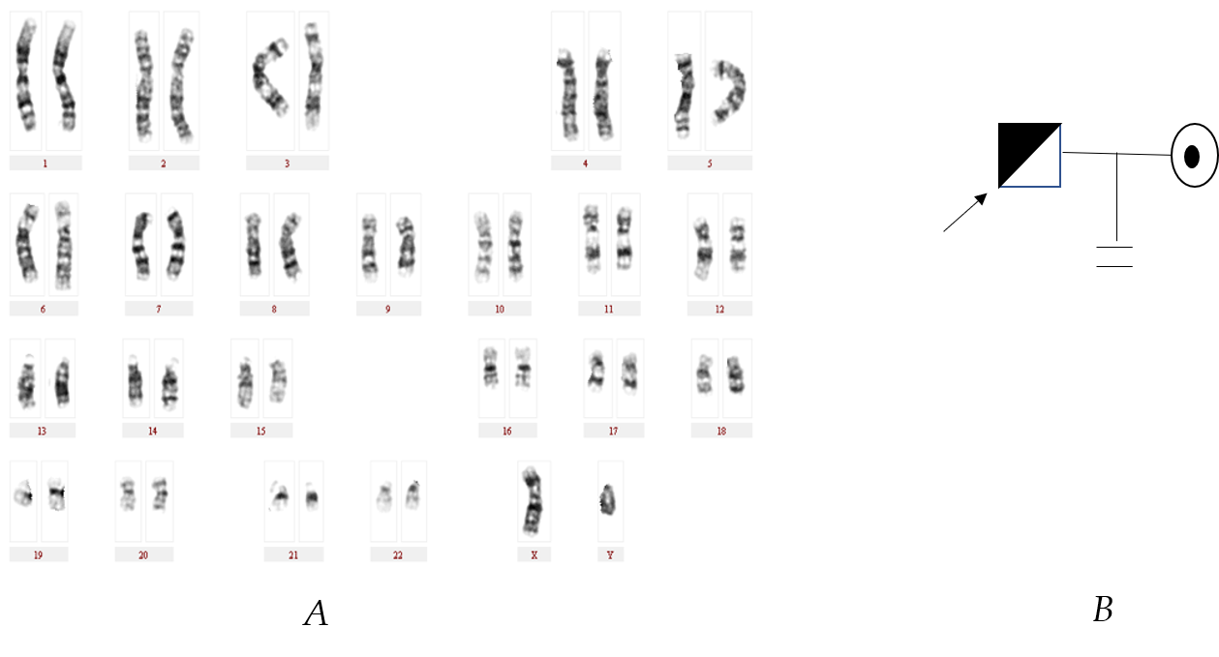
Figure 1 G-banding chromosome analysis and genetic pedigree diagram of Case 1. A: Karyogram (Database Number: 4222): 46,XY,t(3;12)(q27;q24.1); B: Genetic pedigree diagram.
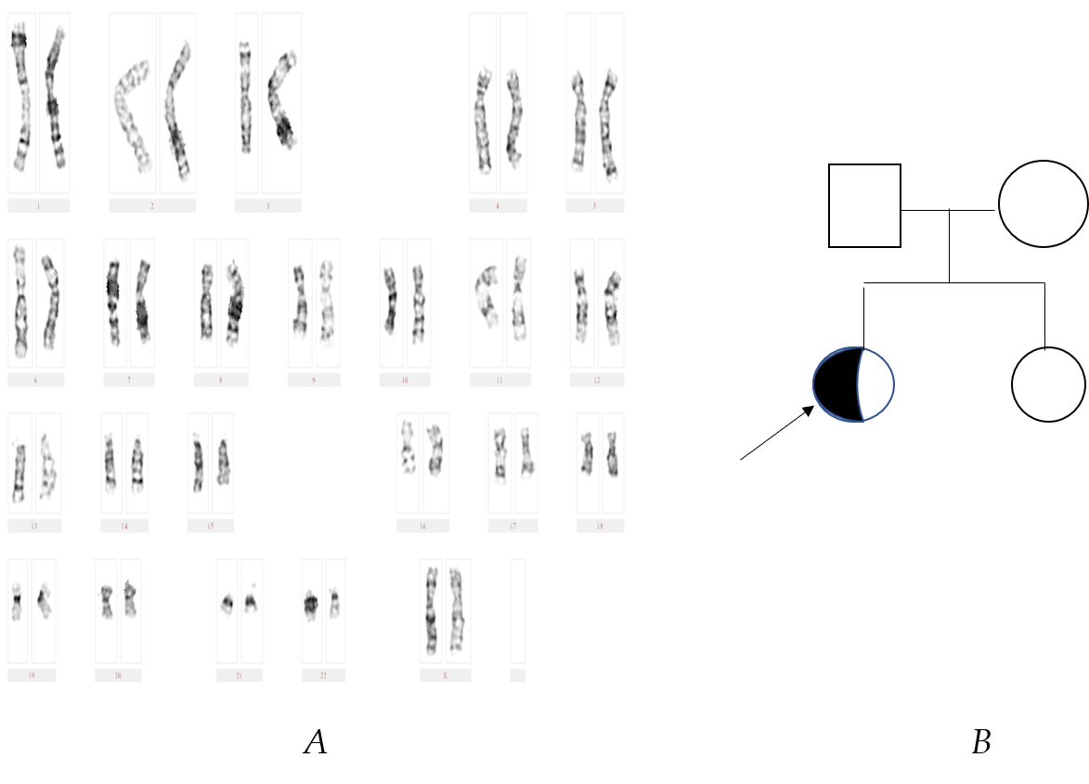
Figure 2 G-banding chromosome analysis and genetic pedigree diagram of Case 2. A: Karyogram: 46,XX,t(4;16)(q31;q12); B: Genetic pedigree diagram.
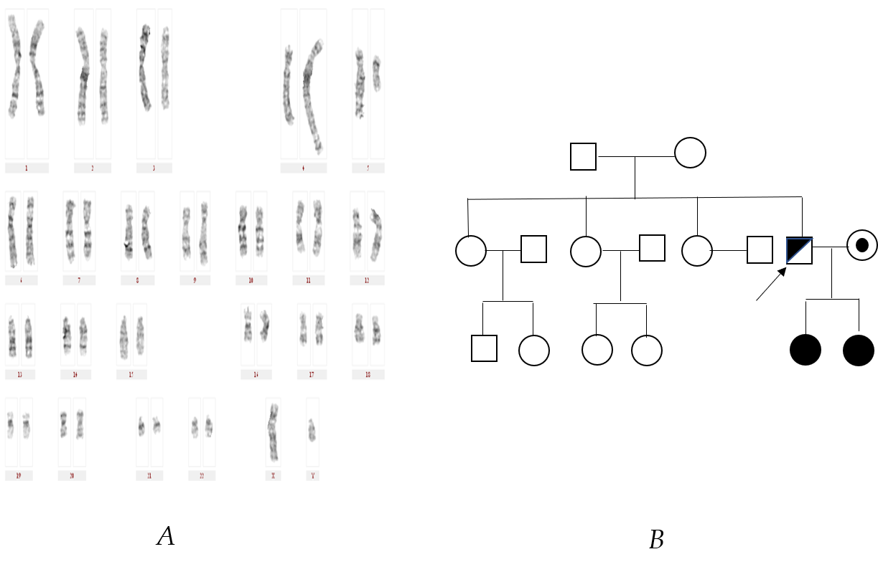
Figure 3 G-banding chromosome analysis and genetic pedigree diagram of Case 3. A: Karyogram: 46,XY,t(4;5)(q33;q13),9qh+; B: Genetic pedigree diagram.
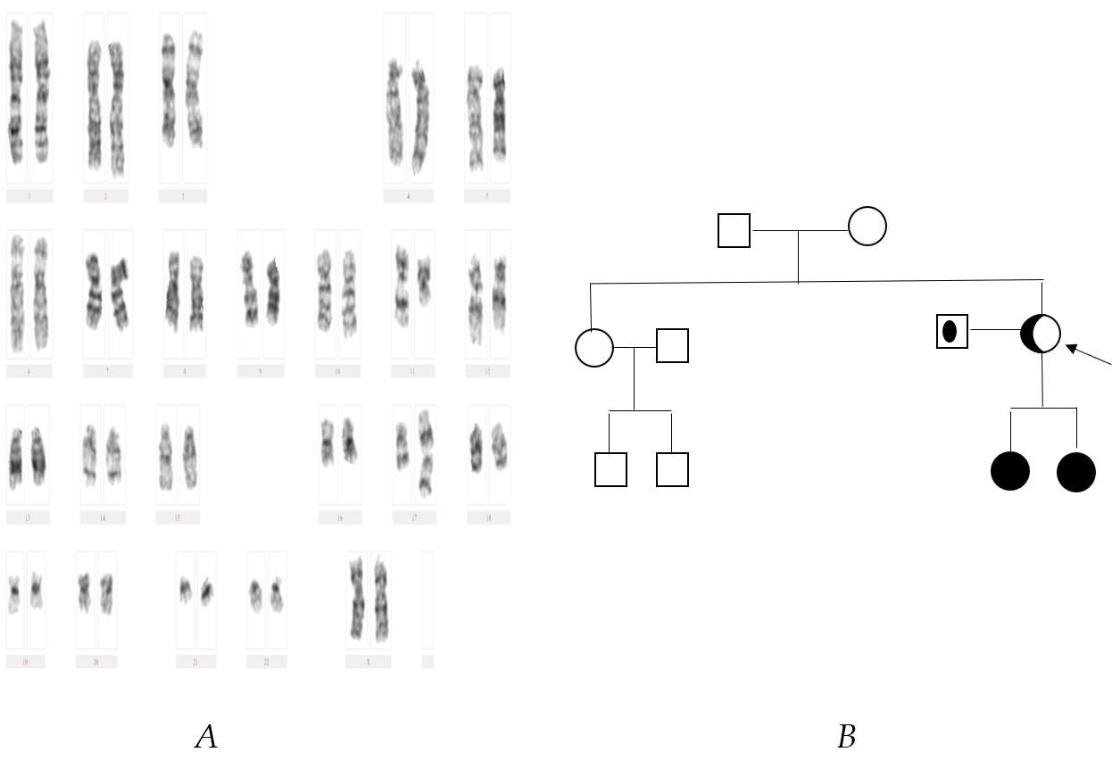
Figure 4 G-banding chromosome analysis and genetic pedigree diagram of Case 4. A: Karyogram (Database Number: 4059): 46,XX,t(11;17)(q13;p11.2); B: Genetic pedigree diagram.
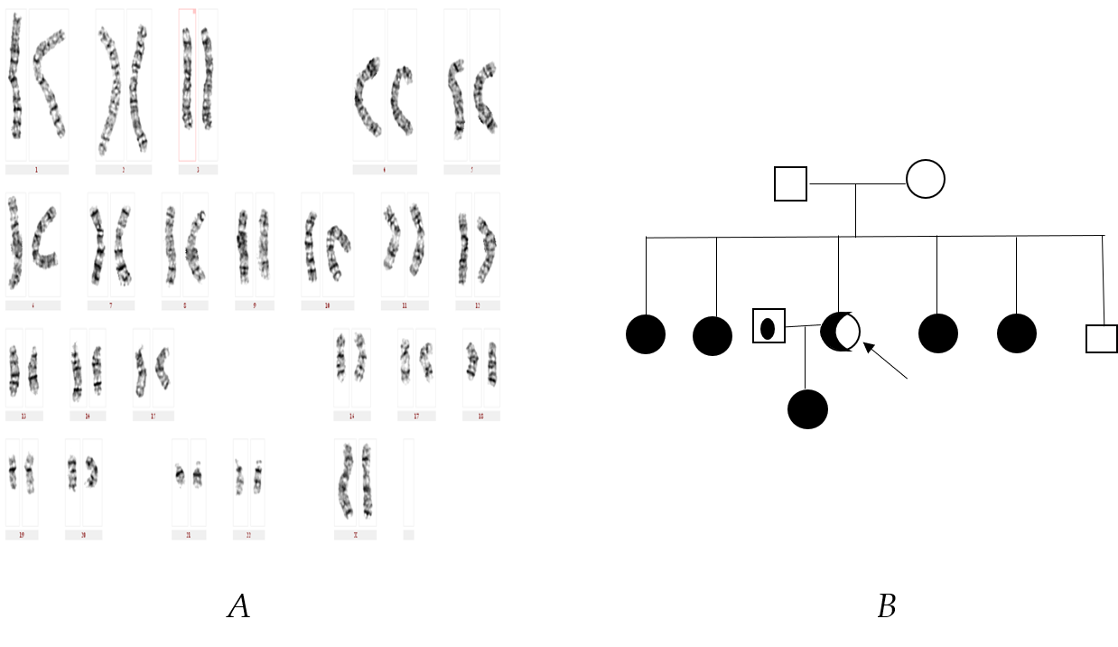
Figure 5 G-banding chromosome analysis and genetic pedigree diagram of Case 5. A: Karyogram (Database Number: 4238): 46,XX,t(10;13)(q24;q21.2); B: Genetic pedigree diagram.
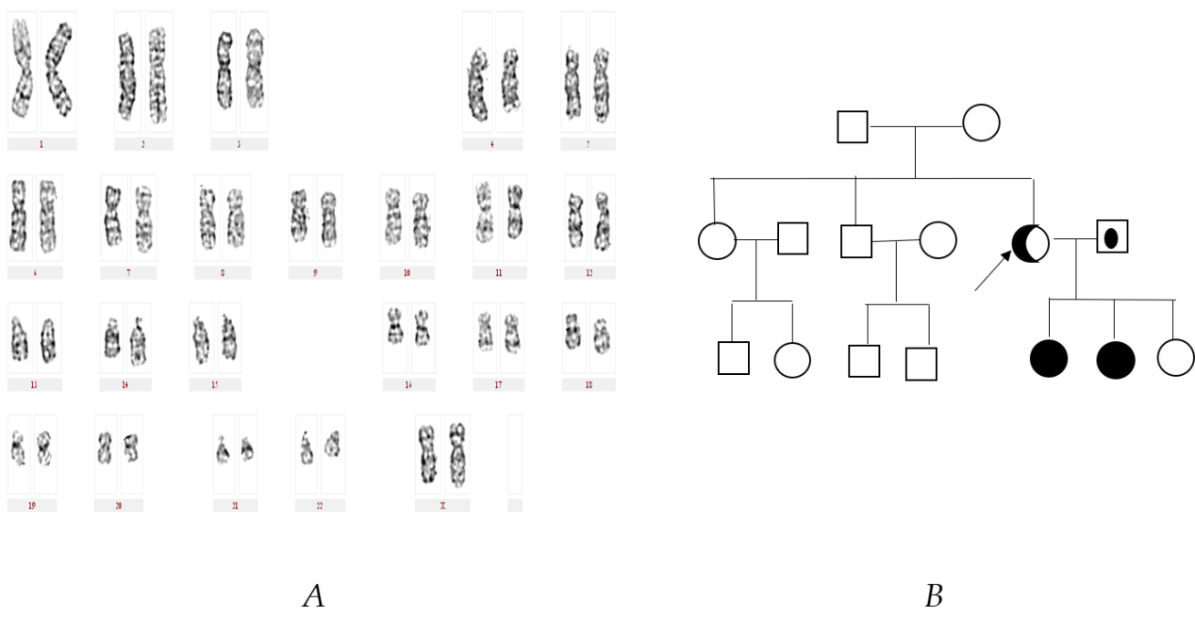
Figure 6 G-banding chromosome analysis and genetic pedigree diagram of Case 6. A: Karyogram (Database Number: 4223): 46,XX,t(1;4)(p36.1;q31.1); B: Genetic pedigree diagram.

Table 1 History comparison table of the six families
Items | Family 1 | Family 2 | Family 3 | Family 4 | Family 5 | Family 6
Area | Haikou, Hainan Province | Danzhou, Hainan Province | Wenchang, Hainan Province | Dongfang, Hainan Province | Haikou, Hainan Province | Qionghai, Hainan Province
Age (yr) | 30 | 22 | 28 | 32 | 24 | 32
Sex | M | F | M | F | F | F
Ethnicity | Han | Han | Han | Han | Han | Han
Occupation | Office worker | Office worker | Civil servant | Office worker | Civil servant | Civil servant
Height (cm) | 170 | 158 | 172 | 153 | 158 | 160
Visiting time | 2016 | 2015 | 2014 | 2014 | 2016 | 2016
Reasons for medical visit | Infertility after 3 yr of marriage | Small uterus, irregular menstruation | Not pregnant after arrested fetal development | Not pregnant after two times of spontaneous abortion | Not pregnant after arrested fetal development for one time | Not pregnant after arrested fetal development for two times
Pregnancy history of self or spouse | G0P0 | Unmarried | G2P0 | G2P0 | G1P0 | G3P0
Proband karyotype | 46,XY,t(3;12)(q27;q24.1) (Database number: 4222) | 46,XX,t(4;16)(q31;q12) | 46,XY,t(4;5)(q33;q13),9qh+ | 46,XX,t(11;17)(q13;p11.2) (Database number: 4059) | 46,XX,t(10;13)(q24;q21.2) (Database number: 4238) | 46,XX,t(1;4)(p36.1;q31.1) (Database number: 4223)
Spouse karyotype | 46,XX | 0 | 46,XX | 46,XY | 46,XY | 46,XY
Spouse’s age | 30 | 0 | 25 | 38 | 28 | 35

Table 2 Chromosome detection rates in China’s 20 provinces and cities and 16 countries
No | Region | Anomaly chromosome detection rate | Incidence of autosomal balanced translocation | Medical history
1 | Hainan Province, China^{[21]} | 10.5% (353/3353) | 0.44% (15/3353) | Genetic counselors
2 | Gansu Province, China^{[22]} | 3.91% (51/1304) | 1% (13/1304) | Genetic counselors
3 | Ningxia Hui Autonomous Region, China^{[23]} | 3.52% (36/1024) | 2.5% (26/1024) | Recurrent spontaneous abortion
4 | Shanxi Province, China^{[24]} | 23.76% (307/1292) | 14% (185/1292) | Abnormal child-bearing history
5 | Shandong Province, China^{[25]} | 4.73% (309/6534） | 0.39% (26/6534) | Abnormal child-bearing history
6 | Hebei Province, China^{[26]} | 2.09% (70/3348) | 1.1% (36/3348) | Infertility
7 | Zhejiang Province, China^{[27]} | 6.6% (106/1601) | 0.5% (8/1601) | Infertility
8 | Shanghai, China^{[28]} | 3.96% (111/2798) | 1.24% (37/2798) | Natural abortion
9 | Fujian Province, China^{[29]} | 4.32% (87/2110) | 1.18% (25/2110) | Abnormal child-bearing history
10 | Beijing, China^{[30]} | 7 % (28/400) | 2.5% (10/400) | Abnormal child-bearing history
11 | Anhui Province, China^{[31]} | 5.35% (353/6600) | 2.98% (197/6600) | Infertility
12 | Hubei Province, China^{[32]} | 20.2% (315/1559) | 3.72% (58/1559) | Recurrent abortion
13 | Guizhou Province, China^{[33]} | 5.12% (32/625) | 4.16% (26/625) | Abnormal child-bearing history
14 | Yunnan Province, China^{[34]} | 1.5% (3/200) | 1% (2/200) | Abnormal child-bearing history
15 | Guangdong Province, China^{[35]} | 10.37% (132/1273) | 1.1% (14/1273) | Abnormal child-bearing history
16 | Jiangsu Province, China^{[36]} | 1.7% (90/5292) | 0.6% (32/5292) | Infertility
17 | Hunan Province, China^{[37]} | 3.14% (111/3540) | 1.67% (59/3540) | Natural abortion
18 | Heilongjiang Province, China^{[38]} | 4.51% (82/455) | 3.3% (15/455) | Genetic counselors
19 | Henan Province, China^{[39]} | 11.5% (21/182) | 4.4% (8/182) | Natural abortion
20 | Sichuan Province, China^{[40]} | 4% (106/2643) | 0.45% (12/2643) | Genetic counselors
21 | Republic of Macedonia^{[41]} | 0.47% (16/3800) | 0.21% (8/3800) | Natural abortion
22 | United Kingdom of Great Britain and Northern Ireland^{[42]} | 3.52% (56/1590) | 2.26% (36/1590) | Recurrent abortion
23 | Turkey^{[43]} | 4.1% (124/3020) | 0.99% (30/3020) | Natural abortion
24 | Republic of India^{[44]} | 6.8% (54/788) | 5.9% (47/788) | Recurrent abortion
25 | Japan^{[45]} | 4.3% (55/1278) | 1.5% (19/1278) | Recurrent abortion
26 | Morocco^{[46]} | 11% (137/1254) | 2.71% (34/1254) | Recurrent abortion
27 | Islamic Republic of Iran^{[47]} | 11.7% (170/1456) | 7.35% (107/1456) | Recurrent abortion
28 | the United Mexican States^{[48]} | 7.6% (24/316) | 1.27% (4/316) | Recurrent abortion
29 | Sultanate of Oman^{[49]} | 3.42% (26/760) | 2.8% (21/760) | Recurrent abortion
30 | Kingdom of Saudi Arabia^{[50]} | 7.2% (154/2148) | 3.35% (72/2148) | Recurrent abortion
31 | Magyarország^{[51]} | 3.39% (8/236) | 0.85% (2/236) | Recurrent abortion
32 | Islamic Republic of Pakistan^{[52]} | 5.3% (32/600) | 2.3% (14/600) | Recurrent abortion
33 | The Republic Of Poland^{[53]} | 6.2% (16/258) | 4.65% (12/258) | Recurrent abortion
34 | Russia^{[54]} | 2.37% (81/3414) | 1.9% (65/3414) | Infertility
35 | Tunis^{[55]} | 8.5% (28/326) | 3.68% (12/326) | Recurrent abortion
36 | Spain^{[56]} | 17.7% (158/890) | 4.27% (38/890) | Recurrent abortion
Total (1-20) |  | 5.86% (2703/46133) | 1.74% (804/46133)
Total (21-36) |  | 5.15% (1139/22134) | 2.35% (521/22134)
Total (1-36) |  | 5.62% (3842/68267) | 1.97% (1325/68267)

