Name of Journal: World Journal of Transplantation
Manuscript NO: 31626
Manuscript Type: Original Article

Basic Study
Copper as an alternative antimicrobial coating for implants - an in vitro study

Bergemann C et al. Copper-coated implants

Claudia Bergemann, Sarah Zaatreh, Katharina Wegner, Kathleen Arndt, Andreas Podbielski, Rainer Bader, Cornelia Prinz, Ulrich Lembke, J Barbara Nebe

Claudia Bergemann, J Barbara Nebe, Department of Cell Biology, University Medical Center Rostock, 18057 Rostock, Germany

Sarah Zaatreh, Katharina Wegner, Rainer Bader, Biomechanics and Implant Technology Research Laboratory, University Medical Center Rostock, 18057 Rostock, Germany

Kathleen Arndt, Andreas Podbielski, Institute of Medical Microbiology, Virology and Hygiene, University Medical Center Rostock, 18057 Rostock, Germany

Cornelia Prinz, Ulrich Lembke, DOT GmbH, 18059 Rostock, Germany

Author contributions: Bergemann C, Wegner K and Arndt K performed research study; Lembke U contributed material samples; Bergemann C, Wegner K and Arndt K analyzed data; Bergemann C, Zaatreh S and Wegner K wrote the manuscript; Podbielski A, Bader R, Prinz C and Nebe JB designed the study.

Supported by The Federal Ministry of Education and Research of Germany (BMBF, project CEMOSTOBAS), No. 13N12105.

Institutional review board statement: This study does not involve any human or animal subjects.

Institutional animal care and use committee statement: This study does not involve any animal subjects.

Conflict-of-interest statement: To the best of our knowledge, no conflict of interest exists.

Data sharing statement: No additional data are available.

Open-Access: This article is an open-access article which was selected by an in-house editor and fully peer-reviewed by external reviewers. It is distributed in accordance with the Creative Commons Attribution Non Commercial (CC BY-NC 4.0) license, which permits others to distribute, remix, adapt, build upon this work non-commercially, and license their derivative works on different terms, provided the original work is properly cited and the use is non-commercial. See: http://creativecommons.org/licenses/by-nc/4.0/

Manuscript source: Invited manuscript

Correspondence to: Dr. J Barbara Nebe, Professor, Department of Cell Biology, University Medical Center Rostock, Schillingallee 69, 18057 Rostock, Germany. barbara.nebe@med.uni-rostock.de
Telephone: +49-381-4947771
Fax: +49-381-4947764

Received: November 28, 2016
Peer-review started: December 3, 2016
First decision: March 28, 2017
Revised: April 25, 2017
Accepted: May 12, 2017
Article in press:
Published online:

Abstract
AIM
To investigate osteoconductive and antimicrobial properties of a titanium-copper-nitride (TiCuN) film and an additional BONIT® coating on titanium substrates.

METHODS
For micro-structuring, the surface of titanium test samples was modified by titanium plasma spray (TPS). On the TPS-coated samples, the TiCuN layer was deposited by physical vapor deposition. The BONIT® layer was coated electrochemically. The concentration of copper ions released from TiCuN films was measured by atomic absorption spectrometry. MG-63 osteoblasts on TiCuN and BONIT® were analyzed for cell adhesion, viability and spreading. In parallel, Staphylococcus epidermidis (S. epidermidis) were cultivated on the samples and planktonic and biofilm-bound bacteria were quantified by counting of the colony-forming units.

RESULTS
Field emission scanning electron microscopy (FESEM) revealed rough surfaces for TPS and TiCuN and a special crystalline surface structure on TiCuN + BONIT®. TiCuN released high amounts of copper quickly within 24 h. These release dynamics were accompanied by complete growth inhibition of bacteria and after 2 d, no planktonic or adherent S. epidermidis were found on these samples. On the other hand viability of MG-63 cells was impaired during direct cultivation on the samples within 24 h. However, high cell colonization could be found after a 24 h pre-incubation step in cell culture medium simulating the in vivo dynamics closer. On pre-incubated TiCuN, the osteoblasts span the ridges and demonstrate a flattened, well-spread phenotype. The additional BONIT®-coating reduced the copper release of the TiCuN layer significantly and showed a positive effect on the initial cell adhesion.

CONCLUSION
The TiCuN-coating inhibits the formation of bacterial biofilms on orthopedic implants by influencing the “race for the surface” to the advantage of osteoblasts.

Key words: Implant-coating; Antimicrobial effect; Titanium-copper-nitride; Titanium plasma spray; BONIT®; Osteoconductivity

© The Author(s) 2017. Published by Baishideng Publishing Group Inc. All rights reserved.

Core tip: Implant-associated infection is the most feared complication after joint replacement. We investigated the osteoconductive and antimicrobial properties of a titanium-copper-nitride (TiCuN) film and an additional BONIT® coating on titanium. TiCuN released high amounts of copper quickly within 24 h and after 2 d, no planktonic or adherent Staphylococcus epidermidis were found on these samples. A high colonization by osteoblast-like MG-63 cells was found after pre-incubation in medium for 24 h. TiCuN inhibits the formation of bacterial bio-films on orthopedic implants by influencing the “race for the surface” to the advantage of osteoblasts.

Bergemann C, Zaatreh S, Wegner K, Arndt K, Podbielski A, Bader R, Prinz C, Lembke U, Nebe JB. Copper as an alternative antimicrobial coating for implants - an in vitro study. World J Transplant 2017; In press

INTRODUCTION
Materials commonly used for permanent implants such as knee and hip prostheses are for the most part inert. However, researchers have recently taken up the challenge of designing biomaterials which have been physically and/or chemically modified to promote the regenerative processes of the affected tissues^{[1-3]}. Increased surface area (roughness) on implants improves bone-to-implant contact after the implant placement and enhances functional activity of bone cells in contact with the biomaterial^{[4-7]}. Titanium is one of the most common materials used for orthopedic implants^{[8,9]} and surface modifications are created by sandblasting, plasma spraying or etching to accelerate osseointegration^{[10]}.
Despite aseptic operation conditions and perioperative antibiotic prophylaxis, implant-associated infections remain one of the most severe complications after joint replacement^{[11-14]}, occurring even more frequently after revision arthroplasty^{[15]}. Staphylococcus epidermidis (S. epidermidis) and Staphylococcus aureus are the most frequently found microorganisms causing such implant-associated infections. The pathogenesis of infections associated with biomaterials is as follows: After an initial, reversible adhesion of the bacteria, a biofilm is formed^{[16-18]} which enables the bacteria to avoid immune responses and circumvent antibiotics^{[19]}. Antimicrobial agents do not succeed as well against biofilm bacteria as against planktonic bacteria^{[19]}. In addition, infected medical devices continue to pose problems in orthopedic surgery, thus warranting further development of effective prevention and treatment strategies, including the use of thin coatings based on metal-ions^{[20]}. There are several metal ions (Cu²⁺, Ag⁺, Zn⁺) which are known to have antibacterial properties and which could be deposited on the surface of implants^{[21,22]}. Silver, for example, has been in use as an antibacterial coating for medical devices^{[23-26]}. However, the lower toxicity and higher cytocompatibility of copper commends this metal ion for deposition on implant surfaces^{[22]}. Furthermore, copper can be metabolized^{[27]}, whereas silver tends to resist metabolization, increasing body’s silver serum level^{[28]}. Although the general antimicrobial effects of copper have been recognized, to date researchers have little experience with the use of copper as an antimicrobial agent on medical implant surfaces^{[29-31]}. This lack of data on the effects of copper prompted us to study its qualities as an antibacterial agent in this context. We studied the effects of the deposition of a copper-based inter-metallic thin film on titanium plasma spray optimized (TPS) titanium substrates. Our particular interest was in finding a deposited film which exhibits an antimicrobial effect while allowing for sufficient growth and vitality of osteoblasts on the surface. Taking these two factors into account, we investigated the properties and effects of titanium-copper-nitride (TiCuN) films deposited by physical vapor deposition (PVD). For this purpose we studied the chemical composition of the coating and the release of copper from it, investigating its antibacterial properties and the influence on cell growth, as well as determining the influence of an additional osteoconductive coating with a BONIT® layer.

MATERIALS AND METHODS
Preparation of coatings and test samples
Commercially pure titanium (grade 5, DOT, Rostock, Germany) of technical purity was used in the form of cylindrical plates of 11 mm in diameter and 2 mm thick. For micro-structuring, the surface of the test samples was modified by TPS. For the TPS coating, argon is ionized in a high temperature plasma flame in a vacuum chamber. The argon gas heats up and expands rapidly being expelled at high speed through an anode. Simultaneously titanium powder is inserted into the plasma flame and the molten titanium particles adhere to the substrate surface, cool rapidly and fuse to the implant surface. On the TPS-coated titanium test samples, a TiCuN layer with an average copper load of 1-3 µg/mm² was deposited by PVD (DOT). Copper and titanium were released from a target by electricity, ionized and deposited on the sample surface. The procedure developed a face-centered cubic network of titanium atoms with nitrogen ions inserted in the gaps. The TiCuN coating is very thin and only modifies the implant surface, leaving the mechanical properties of the implant unchanged^{[32-35]}. The second coating on the TiCuN-layered samples was a BONIT® layer (DOT) applied using an electrochemical process. Samples were packed into sterilization foils (Direct, Konstanz, Germany), sealed, and gamma-sterilized with a minimum dose of 25 kGy of Co-60 radiation (BBF Sterilisationsservice, Kernen-Rommelshausen, Germany).
We refer to these different samples as follows: TPS: Commercially pure titanium modified by TPS; TiCuN: TPS + TiCuN; TiCuN + BONIT®: TPS + TiCuN + BONIT®.

Characterization of the coatings
Roughness of the sample surfaces was analyzed by a Hommel tester (Hommel Etanic T 8000, Jenoptik, Jena, Germany). Coating thickness and porosity was determined according to the Standard Test Method for Stereological Evaluation of Porous Coatings on Medical Implants ASTM F 1854. Adhesive strength of the coatings was determined according to DIN EN 582 with the universal tensile testing machine Shimadzu AG-50KNG (Shimadzu, Kyōto, Japan). To investigate the surfaces of the different materials, samples were gold sputtered by a coater (SCD 004, BAL-TEC, Balzers, Liechtenstein) and the surfaces were examined by field emission scanning electron microscopy (FESEM, SUPRA 25, Carl Zeiss, Oberkochen, Germany).

Copper release measurement
The concentration of copper released from the samples was measured by atomic absorption spectrometry (AAS) (ZEEnit 650, Analytik Jena AG, Jena, Germany) with electro-thermal atomization as described earlier^{[36]}. Briefly, the substrates were stored in 1 mL Dulbecco’s modified Eagle medium (DMEM, Invitrogen, Darmstadt, Germany) with 10% fetal calf serum (FCS, Superior, Biochrome, Berlin, Germany) and 1% gentamicin (Ratiopharm, Ulm, Germany) at 37 °C in a humidified atmosphere with 5% CO₂. The copper concentration of this DMEM solution was measured after 24 h and after incubation for another 24 h on three samples each per coating method. Nitric acid was used to stabilize copper ions released in the DMEM after storage. The supernatant was diluted to 1:100000 and a volume of 20 μL of the diluted solution was used for analysis. The intensity measured was compared with the standard reference intensity to obtain the number of copper atoms released from the sample (n = 3). Copper release from samples seeded with MG-63 osteoblasts (see paragraph cell culture) was determined in the supernatant accordingly.

Investigations of antibacterial effects
Estimation of the antibacterial potential against S. epidermidis on test samples was completed according to the protocols described earlier^{[37,38]}. The biofilm-forming strain of S. epidermidis (ATCC 35984, American Type Culture Collection, Manassas, Virginia, United States) was routinely cultured on Columbia blood agar plates (Thermo Fisher Scientific, Waltham, Massachusetts, United States). Previous to the test, an overnight culture (37 °C, microaerobic conditions) of S. epidermidis was prepared in a tryptic soya broth medium (Sigma-Aldrich, St. Louis, Missouri, United States). Afterwards, the overnight culture was centrifuged at 4000 rpm for 10 min at 4 °C, after a washing step the bacteria pellet was diluted in 1 × PBS and adjusted to its strain-specific OD at 600 nm to obtain 1 × 10⁸ CFU/mL in tryptic soya broth medium. For the experiments, bacteria were diluted in DMEM containing 10% FCS until 1 × 10³ CFU/mL was achieved. After 2 d of incubation at 37 °C, 5% CO₂, S. epidermidis within the biofilm on the test samples were detached by ultrasonic treatment with a sonication bath for 4 min at 35 kHz (BactoSonic, Bandelin Electronic, Berlin, Germany) and deposited into glass test tubes (Greiner Bio-One, Kremsmünster, Austria) with 1 mL of PBS. Subsequently, the solution was serially diluted in PBS and afterwards plated on TSB-agar with the help of a spiral plater (Eddy Jet 2, IUL, S.A., Barcelona, Spain). After 24 h of incubation at 37 °C, 5% CO₂, colony-forming units were determined. To analyze the planktonic, unbound S. epidermidis, supernatants of the test-samples were shifted into 15 mL centrifuge tubes (Greiner Bio-One) with 1 mL of PBS after 2 d of incubation. Supernatants were centrifuged at 4000 rpm for 10 min at 4 °C and diluted consecutively in PBS. To determine the quantity of colony-forming units, dilutions were plated on TSB-agar plates as described above (n = 6).

Cell culture
Human MG-63 osteoblast-like cells (ATCC, No. CRL-1427™, LGC Promochem, Wesel, Germany) were cultured in Dulbecco’s modified Eagle medium (DMEM) with 10% FCS and 1% gentamicin at 37 °C in a humidified atmosphere containing 5% CO₂. At subconfluency, cells were detached with 0.05% trypsin/0.02% EDTA (PAA Laboratories, Cölbe, Germany) for 5 min at 37 °C. After stopping the trypsinization by the addition of complete cell culture medium, an aliquot of 100 μL was put into 10 mL of CASY® ton buffer solution (Roche Innovatis, Reutlingen, Germany) and the cell number was measured in the counter CASY® Model DT (Schärfe System, Reutlingen, Germany). An appropriate cell number was seeded onto the samples as described for the following applications. Two different experimental arrangements were used: (1) the MG-63 cells were directly cultivated on the samples and (2) to simulate the in vivo dynamics closer, the samples were pre-incubated in cell culture medium DMEM with 10% FCS and 1% gentamicin at 37 °C in a humidified atmosphere with 5% CO₂ for 24 h, then the medium was changed and the cells were seeded onto the surfaces and cultivated for another 24 h.

Cell viability
To study the influence of TiCuN on cell metabolism and vitality the MTS assay (CellTiter 96® Aqueous One Solution Cell Proliferation Assay, Promega, Mannheim, Germany) was performed. Forty thousand cells were seeded onto the samples in 24-well plates either directly or on pre-incubated samples at a volume of 1 mL. After 24 h, the cell culture medium was replaced by 800 μL of fresh medium and 200 μL of the MTS solution and incubated for 3 h at 37 °C in a 5% CO₂ atmosphere. The spectrophotometric absorption of 5 × 100 µL of the culture medium of 3 samples was analyzed on a 96-well plate by an ELISA reader (Anthos 2010, Anthos Labtec Instruments, Wals-Siezenheim, Austria) at 490 nm (n = 3). The extinction is proportional to the number and the metabolic activity of the cells.

Flow cytometric measurement of cell adhesion
The cell adhesion of MG-63 osteoblasts on the different material surfaces was determined as already described^{[39]}. Briefly, suspended MG-63 cells in DMEM with 10% FCS (5 × 10⁴ cells/0.3 mL) were seeded directly onto sample discs. To avoid the seeding of cells beside samples, discs were laterally fixed in adhesive tapes (Carl Roth, Karlsruhe, Germany). After 10 min to allow cell sedimentation and adhesion to the surface, the supernatant containing the non-adherent cells was then drawn up with a pipette, transferred into 12 mm × 75 mm test tubes (BD Biosciences, Heidelberg, Germany) and analyzed by flow cytometry (FACSCalibur™; BD Biosciences). Cell adhesion of 3 independent experiments was then calculated in percent (n = 3).

Cell morphology and spreading
Material samples were pre-incubated in DMEM with 10% FCS and 1% gentamicin at 37 °C in a humidified atmosphere with 5% CO₂. After 24 h the medium was changed and 4.0 × 10⁴ MG-63 cells were seeded onto the samples. After cultivation for 24 h, cells were washed with PBS, fixed with 4% glutaraldehyde (1 h, Merck, Darmstadt, Germany), dehydrated through a graded series of ethanol (30% 5 min, 50% 5 min, 75% 10 min, 90% 10 min, and 100% 2 × 10 min) and dried in a critical point dryer (K850, EMITECH, Cambridge, United Kingdom). Gold sputtering was performed with the coater (SCD 004, BAL-TEC). The morphology of the cells on the substrate surfaces was investigated by scanning electron microscopy (SEM DSM 960A, Carl Zeiss). Spreading of the cells was quantified by ImageJ (Rasband, W.S., ImageJ, United States National Institutes of Health, Bethesda, Maryland, United States, http://imagej.nih.gov/ij/, 1997-2016). The cell area of 30 cells in 2 independent experiments was analyzed (n = 60).

Statistical analysis
The statistical significance was calculated using SPSS 21.0 for Windows (SPSS Inc., Chicago, United States). Data are expressed as mean values ± standard deviation (SD) and analyzed using Mann-Whitney U test or the t-test. Values were compared to TPS at the same time point and differences for all experiments were considered statistically significant at P < 0.05 (ªP < 0.05, ^{b}P < 0.01, ^{d}P < 0.001).

RESULTS
Sample characteristics
We tested TPS-coated titanium samples equipped with both a TiCuN layer and a BONIT® layer in order to determine their suitability as bone implants encompassing anti-microbial and osteoconductive characteristics. Samples were purchased from DOT Coating (Rostock, Germany). The characteristics of the different coatings are shown in Table 1.
Figure 1 shows FESEM images of the surfaces of the different samples. The visibly rough surface of the samples is caused by the titanium plasma spray technique for TPS and TiCuN. A special crystalline surface structure is visible on TiCuN + BONIT®. BONIT® is an absorbable composite layer of two thin crystalline calcium phosphate phases with different solubility, the more soluble outer calcium phosphate phase (brushite) and the inner crystalline hydroxyapatite phase (≥ 70% brushite and ≤ 30% hydroxyapatite). BONIT® was shown to promote a fast on growth of bone cells and bone formation on implant materials in earlier studies^{[40-42]}. Therefore, we used this coating additionally on the TiCuN films to study the antimicrobial as well as osteoconductive properties combined in one sample.

Copper release
The results of copper release measurements from the samples in 1 mL of DMEM, indicated as mmol/L unit and dependent upon storage conditions, are shown in Figure 2. The highest copper release after 24 h was measured for TiCuN samples at about 3.8 mmol/L. Copper release was further elevated when samples were seeded with MG-63 osteoblastic cells and incubated for 24 h (around 4.6 mmol/L). For TiCuN samples which were pre-incubated in DMEM for 24 h and seeded with cells for another 24 h after exchanging the medium, copper release was significantly reduced to 0.6 mmol/L. TiCuN + BONIT® samples showed nearly constant low copper values between 0.5 and 0.8 mmol/L independently of the storage conditions. The BONIT® coating seems to slow down the release of copper from the TiCuN layer, resulting in a prolonged time of release.

Antibacterial effect
Heavy metal ions like copper ion can deactivate the central catabolic and biosynthetic pathways and become toxic^{[43]}. We employed S. epidermidis strain RP 62A (ATCC35984) to study the influence of the TiCuN samples on the growth of bacteria. The antimicrobial effect of TiCuN films on S. epidermidis is presented in Figure 3. Only the TiCuN coating demonstrated growth inhibition; this indicates that the copper species was released into the medium at a high rate of diffusion. After 2 d, no planktonic or adherent S. epidermidis were found on the TiCuN samples. In contrast, the TPS discs proved to have 7.62 × 10⁷ CFU/mL planktonic bacteria in the incubation fluids and 2.52 × 10⁸ CFU/mL adherent bacteria in the rinsed fluids. The concentration of planktonic bacteria reached 1.08 × 10⁸ CFU/mL in the incubation fluids from the TiCuN + BONIT® samples. An equal amount of biofilm-bound bacteria (1.33 × 10⁸ CFU/mL) could be detected. Thus, no antibacterial potential was found after 24 h for TiCuN + BONIT®; it can be surmised that the low amount of copper released by this coating (between 0.5 and 0.8 mmol/L, see Figure 2) prevented any significant antibacterial effect. The fast copper release from TiCuN samples can efficiently kill bacteria in the initial state of implantation and we assume that the risk of implant infection can thereby be significantly reduced.
Copper ions attack the bacteria at different sites^{[44-46]}. They can interact with the outer membrane of bacteria and subsequently disintegrate the bacterial cell wall which is known as the bacteriolytic effect. If copper ions get into the bacteria, they can bind to the DNA and become involved in cross-linking within nucleic acid strands with the result that the bacteria cannot replicate. Furthermore copper ions generate reactive oxygen species and can cause lipid peroxidation and protein oxidation^{[47]}.
In addition, copper is an essential trace element present in many cell processes; a defect in the homeostasis of copper is a direct cause of certain human diseases^{[48]}. Copper also plays a role in the control of cell proliferation^{[23]}. Thus bioceramic scaffolds loaded with copper sulphate were shown to stimulate osteoblast activity and proliferation and the angiogenesis^{[49,50]}.
To determine the influence of the TiCuN and BONIT® coating on osteoblasts, we investigated the initial cell adhesion, the cell viability, the cell morphology and the cell spreading of MG-63 osteoblast-like cells after culturing on these surfaces.

Initial cell adhesion
Initial osteoblast cell adhesion was analyzed after 10 min of culturing (Figure 4). After direct seeding of MG-63 cells onto the samples, the non-adherent cells in the supernatant were measured by FACS. The adhesion of the cells was significantly reduced on TiCuN to about 26% compared to TPS where around 56% of the cells were adherent after 10 min. On the other hand, TiCuN + BONIT® enhanced initial cell adherence significantly (to about 87%).

Cell viability and spreading
The experiments to determine cell viability employed two different setups: (1) MG-63 cells were cultivated on the surfaces themselves and (2) the samples underwent pre-incubation in cell culture medium DMEM for 24 h and cells were seeded onto the surfaces after a complete exchange of the medium. In this way the in vivo situation was simulated more closely, where dead cells and the persistent bacteria inside these cells are removed and new cells can adhere and proliferate on the surface. After incubation of the cells for 24 h, the cell viability was determined. Cultivation of the cells for 24 h directly on TiCuN reduced cell viability of the MG 63 cells to about 10% and on TiCuN + BONIT® for the same period to about 29% compared to TPS. Cells on TiCuN + BONIT® showed higher viability in comparison with TiCuN. This corresponds with the lower copper release values on these samples due to the BONIT® coating. Interestingly, the incubation of TiCuN samples for 24 h in DMEM prior to cultivating the cells led to an increase in cell viability by about 30%. During the pre-incubation period, a substantial amount of copper is released from the TiCuN film (Figure 2), after which the cells are able to grow onto the substrate surface. Although present, this effect is not as pronounced for TiCuN + BONIT®: Here, cell viability is increased by only 10%. So, on both samples cell viability reached around 40%. This corresponds to the low copper release measured on TiCuN and TiCuN + BONIT® after pre-incubation (between 0.6 and 0.7 mmol/L). The copper amounts released are slightly higher than the copper concentration limit identified for cell survival in earlier studies^{[5,51]}. These studies showed that cell proliferation of hMSC is stimulated by copper concentrations below 0.3 mmol/L, whereas cell viability decreases significantly to around 30% at copper concentrations higher than 0.5 mmol/L (Figure 5).
Figure 6 shows SEM images of the osteoblasts growing on the sample surfaces. MG-63 osteoblasts were seeded onto the pre-incubated samples and cultivated for 24 h. It can be seen that the osteoblasts on the TPS reference and the TiCuN surfaces exhibit a flattened, well-spread phenotype and bridge the gaps between the ridges. The cells spread less readily on TiCuN + BONIT® and seem to be covered by small crystals evolved from the BONIT® layer. This is understandable, considering that BONIT® consists of a brushite and a hydroxyapatite phase. The more soluble brushite is metastable at a physiological pH and converts to a less soluble apatite phase^{[52,53]}. During this phase transformation, loose crystal particles are released onto the settled cells and the surface cannot be considered solid. This explains the reduction in cell area on TiCuN + BONIT® compared to TiCuN and TPS, as revealed by the statistical analysis (Figure 7).

DISCUSSION
Our cell biological investigation revealed a cytotoxic effect on osteoblasts within 24 h by the TiCuN coating. On the other hand, the TiCuN surface showed a strong antibacterial influence on both planktonic and biofilm-bound S. epidermidis. The BONIT® coating reduced the copper release significantly within 24 h and as a consequence, no antibacterial effect could be demonstrated on TiCuN + BONIT® samples. The viability of osteoblasts on the TiCuN samples could be enhanced by a pre-incubation step. The copper-coated materials and controls were incubated in cell culture medium for 24 h and cell seeding was performed after a complete exchange of the medium. In this way the in vivo dynamics were simulated: Dead cells and the persistent bacteria inside these cells are removed and new cells can adhere and proliferate on the surface. Using this approach the osteoblasts were able to grow properly. Stranak et al^{[36]} found similar results for copper-doped titanium surfaces: over a short period of time these released significant amounts of copper. Stranak et al^{[36]} used dual high-power impulse magnetron sputtering which produced copper containing films on TiAlV alloys that released high amounts of copper (about 6 mM) completely and quickly within 24 h. They were able to show an initial antibacterial effect within 24 h and high colonization by osteoblasts after replacement of the cell culture medium and cell seeding for another 24 h. A critical step in the development of implant-related infections is the surface adhesion of bacteria; this represents the first stage in the colonization process, the so-called “race for the surface” on the biomaterial^{[22,30]}. Burghardt et al^{[6]} demonstrated that complete killing of adherent bacteria within 24 h could be achieved by a final concentration of 1.75 mmol/L copper in the culture medium. The indicated bactericidal properties of copper can be used to hamper the settlement of an implant material by bacteria. It is, however, important to take into consideration the sensitivity to concentration displayed by copper’s functional effects. It was found that copper acts as an antibacterial agent above concentrations of 0.5 mmol/L^{[50]} and an osteoinductive one in the range of 0.05-0.3 mmol/L copper^{[6]}. Therefore, it is suggested to use implants which initially introduce copper onto the surface at a high concentration to create an antibacterial effect in the vicinity of the implant. The stimulating effect on osteoblasts will prevail at a greater distance from the implant surface and later on. Some studies reported an additional advantage of depositing copper: it has lower toxicity and higher cytocompatibility compared to other antimicrobial metals. A relatively lower concentration of silver or zinc could have strong toxicity to the tissue cells; however, a relatively higher concentration of copper still had no toxic effect on the cells^{[24,27]}. Further, copper represents an essential cofactor in collagen formation through its facilitation of the enzyme lysyl oxidase^{[54]}. Recent studies which introduced copper combined with hyaluronan into elastin-vascular constructs were able to demonstrate increased synthesis of lysyl oxidase and collagen as well as stimulated elastin-crosslinking^{[55]}. Various studies have shown the proliferation of human mesenchymal stem cells to be stimulated by copper ions; this makes the incorporation of copper into implant surfaces an interesting approach for tissue engineering in regenerative medicine^{[36,48,50,51,56,57]}. In the study presented here we could show that TiCuN coating on TPS-optimized titanium combines a rough TPS surface with the antibacterial function of copper ions while maintaining the excellent properties required for good osteoblast cell growth. Our data were acquired by in vitro experiments, investigating processes within the first 48 h of material cell contact with osteoblast-like MG-63 cells. In future research, data will be verified by in vitro analyses after longer periods of time and with primary osteoblasts. In an animal study, we will examine the in vivo acceptance of the TiCuN and BONIT® coating on TPS-optimized titanium implants. Patients’ first experiences provided in a clinical case report indicated that TiCuN-coated implants can be suitable as temporary spacers for two-stage septic joint revisions^{[16]}. In conclusion, the TiCuN coating is indicated as a suitable method of reducing bacteria adhesion and promoting the growth of osteoblasts on implants. The additional BONIT® layer could be accomplished by another TiCuN coating or usage of an antibiotic to preserve the antibacterial effect and the osteoinductive influence.
In this study the antibacterial effect of TiCuN-coated, TPS-optimized titanium was examined. We showed that TiCuN has a strong ability to kill planktonic bacteria as well as bacteria adhering as a biofilm, and after pre-incubation we found low cytotoxicity. The antibacterial role should inhibit the formation of bacterial bio-films on orthopedic implants by influencing the “race for the surface” to the advantage of the osteoblasts.

ACKNOWLEDGEMENTS
The authors thank H.-G. Neumann (DOT GmbH Rostock) for industrial support. We would like to thank U. Schweers and S. Krüger (University Rostock) for their help. We thank Frank M, Labs W, Fulda G (EMZ Rostock, Rostock University Medical Center) and R. Lange (Institute for Electronic Appliances and Circuits, University Rostock) for their assistance and support with the scanning electron microscopy and field emission scanning electron microscopy.

COMMENTS
Background
Titanium is one of the most common materials used for orthopedic implants. Increasing the roughness of the implant surface improves bone-to-implant contact after implant placement and enhances the functional activity of bone cells in contact with the biomaterial. Implant-associated infections remain one of the most severe complications after joint replacement. Bacteria interact with the surface of the material and after an initial reversible adhesion, a biofilm is formed. Such biofilms enable bacteria to evade antibiotics and immune responses.

Research frontiers
The problems associated with infected medical devices in orthopedic surgery necessitate further research and the development of alternative treatment and prevention strategies, such as thin metal-ion based surfaces.

Innovations and breakthroughs
Some studies reported that copper represents a promising metal ion for deposition applications because of its lower toxicity and higher cytocompatibility compared to other antimicrobial metals. The authors investigated the properties and effects of titanium-copper-nitride (TiCuN) films deposited by physical vapor deposition. We studied the chemical composition and copper release with respect to antibacterial properties and cell growth and the influence of an additional osteoconductive coating with a BONIT® layer. The authors were able to show that a TiCuN coating on TPS-optimized titanium combines the rough TPS surface with the antibacterial function of copper ions, while maintaining the excellent properties required for good osteoblast cell growth.

Applications
In conclusion, the TiCuN coating is an interesting agent to inhibit the formation of bacterial bio-films on orthopedic implants by influencing the “race for the surface” to the advantage of the osteoblasts.

Terminology
TPS: Titanium plasma spray; TiCuN: Titanium-copper-nitride.

Peer-review
This is a very interesting topic and very well-presented scientific research. The study design is solid and meticulously and flawlessly conducted, the results of this study can be very important to professionals who perform these procedures.

REFERENCES
1 de Jonge LT, Leeuwenburgh SC, Wolke JG, Jansen JA. Organic-inorganic surface modifications for titanium implant surfaces. Pharm Res 2008; 25: 2357-2369 [PMID: 18509601 DOI: 10.1007/s11095-008-9617-0]
2 Hench LL, Polak JM. Third-generation biomedical materials. Science 2002; 295: 1014-1017 [PMID: 11834817 DOI: 10.1126/science.1067404]
3 Goodman SB, Yao Z, Keeney M, Yang F. The future of biologic coatings for orthopaedic implants. Biomaterials 2013; 34: 3174-3183 [PMID: 23391496 DOI: 10.1016/j.biomaterials.2013.01.074]
4 Passeri G, Cacchioli A, Ravanetti F, Galli C, Elezi E, Macaluso GM. Adhesion pattern and growth of primary human osteoblastic cells on five commercially available titanium surfaces. Clin Oral Implants Res 2010; 21: 756-765 [PMID: 20636730 DOI: 10.1111/j.1600-0501.2009.01906.x]
5 Lüthen F, Lange R, Becker P, Rychly J, Beck U, Nebe JG. The influence of surface roughness of titanium on beta1- and beta3-integrin adhesion and the organization of fibronectin in human osteoblastic cells. Biomaterials 2005; 26: 2423-2440 [PMID: 15585246 DOI: 10.1016/j.biomaterials.2004.07.054]
6 Anselme K, Linez P, Bigerelle M, Le Maguer D, Le Maguer A, Hardouin P, Hildebrand HF, Iost A, Leroy JM. The relative influence of the topography and chemistry of TiAl6V4 surfaces on osteoblastic cell behaviour. Biomaterials 2000; 21: 1567-1577 [PMID: 10885729 DOI: 10.1016/S0142-9612(00)00042-9]
7 Bächle M, Kohal RJ. A systematic review of the influence of different titanium surfaces on proliferation, differentiation and protein synthesis of osteoblast-like MG63 cells. Clin Oral Implants Res 2004; 15: 683-692 [PMID: 15533129 DOI: 10.1111/j.1600-0501.2004.01054.x]
8 Geetha M, Singh AK, Asokamani R, Gogia AK. Ti based biomaterials, the ultimate choice for orthopaedic implants - A review. Prog Mater Sci 2009; 54: 397-425 [DOI: 10.1016/j.pmatsci.2008.06.004]
9 Mantripragada VP, Lecka-Czernik B, Ebraheim NA, Jayasuriya AC. An overview of recent advances in designing orthopedic and craniofacial implants. J Biomed Mater Res A 2013; 101: 3349-3364 [PMID: 23766134 DOI: 10.1002/jbm.a.34605]
10 Wennerberg A, Albrektsson T. On implant surfaces: a review of current knowledge and opinions. Int J Oral Maxillofac Implants 2010; 25: 63-74 [PMID: 20209188]
11 Moyad TF, Thornhill T, Estok D. Evaluation and management of the infected total hip and knee. Orthopedics 2008; 31: 581-598; quiz 581-588 [PMID: 18661881 DOI: 10.3928/01477447-20080601-22]
12 Geipel U, Herrmann M. [The infected implant. Part 1: bacteriology]. Orthopade 2004; 33: 1411-1426; 1411-1426 [PMID: 15551049 DOI: 10.1007/s00132-004-0741-1]
13 Harris WH, Sledge CB. Total hip and total knee replacement (2) N Engl J Med 1990; 323: 801-807 [PMID: 2136367 DOI: 10.1056/Nejm199009203231206]
14 Montanaro L, Speziale P, Campoccia D, Ravaioli S, Cangini I, Pietrocola G, Giannini S, Arciola CR. Scenery of Staphylococcus implant infections in orthopedics. Future Microbiol 2011; 6: 1329-1349 [PMID: 22082292 DOI: 10.2217/Fmb.11.117]
15 Saleh KJ, Celebrezze M, Kassim R, Dykes DC, Gioe TJ, Callaghan JJ, Salvati EA. Functional outcome after revision hip arthroplasty: a metaanalysis. Clin Orthop Relat Res 2003: 254-264 [PMID: 14646768 DOI: 10.1097/01.blo.0000093006.90435.43]
16 Costerton JW, Stewart PS, Greenberg EP. Bacterial biofilms: a common cause of persistent infections. Science 1999; 284: 1318-1322 [PMID: 10334980]
17 Busscher HJ, van der Mei HC, Subbiahdoss G, Jutte PC, van den Dungen JJ, Zaat SA, Schultz MJ, Grainger DW. Biomaterial-associated infection: locating the finish line in the race for the surface. Sci Transl Med 2012; 4: 153rv10 [PMID: 23019658 DOI: 10.1126/scitranslmed.3004528]
18 Gristina AG. Biomaterial-centered infection: microbial adhesion versus tissue integration. Science 1987; 237: 1588-1595 [PMID: 3629258 DOI: 10.1126/science.3629258]
19 Davies D. Understanding biofilm resistance to antibacterial agents. Nat Rev Drug Discov 2003; 2: 114-122 [PMID: 12563302 DOI: 10.1038/nrd1008]
20 Borkow G, Gabbay J. Copper as a biocidal tool. Curr Med Chem 2005; 12: 2163-2175 [PMID: 16101497 DOI: 10.2174/0929867054637617]
21 Grass G, Rensing L, Rensing C. Metal toxicity. Metallomics 2011; 3: 1095-1097 [PMID: 22025262 DOI: 10.1039/c1mt90048j]
22 Heidenau F, Mittelmeier W, Detsch R, Haenle M, Stenzel F, Ziegler G, Gollwitzer H. A novel antibacterial titania coating: metal ion toxicity and in vitro surface colonization. J Mater Sci Mater Med 2005; 16: 883-888 [PMID: 16167096 DOI: 10.1007/s10856-005-4422-3]
23 Collinge CA, Goll G, Seligson D, Easley KJ. Pin tract infections: silver vs uncoated pins. Orthopedics 1994; 17: 445-448 [PMID: 8036188 DOI: 10.3928/0147-7447-19940501-11]
24 Oloffs A, Grosse-Siestrup C, Bisson S, Rinck M, Rudolph R, Gross U. Biocompatibility of silver-coated polyurethane catheters and silver-coated Dacron material. Biomaterials 1994; 15: 753-758 [PMID: 7986938 DOI: 10.1016/0142-9612(94)90028-0]
25 Wassall MA, Santin M, Isalberti C, Cannas M, Denyer SP. Adhesion of bacteria to stainless steel and silver-coated orthopedic external fixation pins. J Biomed Mater Res 1997; 36: 325-330 [PMID: 9260103 DOI: 10.1002/(Sici)1097-4636(19970905)36: 3<325: : Aid-Jbm7>3.0.Co; 2-G]
26 Bosetti M, Massè A, Tobin E, Cannas M. Silver coated materials for external fixation devices: in vitro biocompatibility and genotoxicity. Biomaterials 2002; 23: 887-892 [PMID: 11771707 DOI: 10.1016/S0142-9612(01)00198-3]
27 Shirai T, Tsuchiya H, Shimizu T, Ohtani K, Zen Y, Tomita K. Prevention of pin tract infection with titanium-copper alloys. J Biomed Mater Res B Appl Biomater 2009; 91: 373-380 [PMID: 19507137 DOI: 10.1002/jbm.b.31412]
28 Massè A, Bruno A, Bosetti M, Biasibetti A, Cannas M, Gallinaro P. Prevention of pin track infection in external fixation with silver coated pins: clinical and microbiological results. J Biomed Mater Res 2000; 53: 600-604 [PMID: 10984710 DOI: 10.1002/1097-4636(200009)53: 5<600: : AID-JBM21>3.0.CO; 2-D]
29 Jing H, Yu Z, Li L. Antibacterial properties and corrosion resistance of Cu and Ag/Cu porous materials. J Biomed Mater Res A 2008; 87: 33-37 [PMID: 18080302 DOI: 10.1002/jbm.a.31688]
30 Wheeldon LJ, Worthington T, Lambert PA, Hilton AC, Lowden CJ, Elliott TS. Antimicrobial efficacy of copper surfaces against spores and vegetative cells of Clostridium difficile: the germination theory. J Antimicrob Chemother 2008; 62: 522-525 [PMID: 18544601 DOI: 10.1093/jac/dkn219]
31 Ellenrieder M, Haenle M, Lenz R, Bader R, Mittelmeier W. Titanium-copper-nitride coated spacers for two-stage revision of infected total hip endoprostheses. GMS Krankenhhyg Interdiszip 2011; 6: Doc16 [PMID: 22242097 DOI: 10.3205/dgkh000173]
32 Prinz C. Antibakterielle Optimierung von Implantatoberflächen [Dissertation]. Rostock: Universität Rostock, Agrar-und Umweltwissenschaftliche Fakultät, 2010. Available from: URL: http://rosdok.uni-rostock.de/file/rosdok_derivate_000000004369/Dissertation_Prinz_000000002010.pdf
33 Lembke U, Neumann HG, Prinz C. inventor; DOT GmbH, Antibakterielle Beschichtung für ein Implantat. Germany patent DE 102010054046, [2012 June 14]. Available from: URL: http://www.freepatentsonline.com/de102010054046.html&ie=utf-8&sc_us=14696478605722856047
34 Neumann HG, Prinz C, Lembke U. inventor; DOT GmbH, Antibacterial coating for an implant and method for producing said coating. United States patent US 9107981. [2013 Sept 26]. Available from: URL: http://www.freepatentsonline.com/9107981.html&ie=utf-8&sc_us=6643309015689531805
35 Neumann HG, Prinz C, Lembke U. inventor; DOT GmbH, Antibacterial coating for an implant and method for producing said coating. European patent EP 2648773. [2015 Jan 14]. Available from: URL: http://www.freepatentsonline.com/9107981.html&ie=utf-8&sc_us=6643309015689531805
36 Stranak V, Wulff H, Rebl H, Zietz C, Arndt K, Bogdanowicz R, Nebe B, Bader R, Podbielski A, Hubicka Z, Hippler R. Deposition of thin titanium-copper films with antimicrobial effect by advanced magnetron sputtering methods. Mat Sci Eng C-Mater 2011; 31: 1512-1519 [DOI: 10.1016/j.msec.2011.06.009]
37 Zaatreh S, Wegner K, Strauß M, Pasold J, Mittelmeier W, Podbielski A, Kreikemeyer B, Bader R. Co-Culture of S. epidermidis and Human Osteoblasts on Implant Surfaces: An Advanced In Vitro Model for Implant-Associated Infections. PLoS One 2016; 11: e0151534 [PMID: 26982194 DOI: 10.1371/journal.pone.0151534]
38 Patenge N, Arndt K, Eggert T, Zietz C, Kreikemeyer B, Bader R, Nebe B, Stranak V, Hippler R, Podbielski A. Evaluation of antimicrobial effects of novel implant materials by testing the prevention of biofilm formation using a simple small scale medium-throughput growth inhibition assay. Biofouling 2012; 28: 267-277 [PMID: 22435853 DOI: 10.1080/08927014.2012.671305]
39 Kunz F, Rebl H, Quade A, Matschegewski C, Finke B, Nebe JB. Osteoblasts with impaired spreading capacity benefit from the positive charges of plasma polymerised allylamine. Eur Cell Mater 2015; 29: 177-188; discussion 188-189 [PMID: 25738585 DOI: 10.22203/eCM]
40 Reigstad O, Franke-Stenport V, Johansson CB, Wennerberg A, Røkkum M, Reigstad A. Improved bone ingrowth and fixation with a thin calcium phosphate coating intended for complete resorption. J Biomed Mater Res B Appl Biomater 2007; 83: 9-15 [PMID: 17318821 DOI: 10.1002/jbm.b.30762]
41 ten Broeke RH, Alves A, Baumann A, Arts JJ, Geesink RG. Bone reaction to a biomimetic third-generation hydroxyapatite coating and new surface treatment for the Symax hip stem. J Bone Joint Surg Br 2011; 93: 760-768 [PMID: 21586774 DOI: 10.1302/0301-620X.93B6.24986]
42 Reigstad O, Johansson C, Stenport V, Wennerberg A, Reigstad A, Røkkum M. Different patterns of bone fixation with hydroxyapatite and resorbable CaP coatings in the rabbit tibia at 6, 12, and 52 weeks. J Biomed Mater Res B Appl Biomater 2011; 99: 14-20 [PMID: 21648067 DOI: 10.1002/jbm.b.31866]
43 Macomber L, Imlay JA. The iron-sulfur clusters of dehydratases are primary intracellular targets of copper toxicity. Proc Natl Acad Sci USA 2009; 106: 8344-8349 [PMID: 19416816 DOI: 10.1073/pnas.0812808106]
44 Kaur G, Kumar S, Dilbaghi N, Bhanjana G, Guru SK, Bhushan S, Jaglan S, Hassan PA, Aswal VK. Hybrid surfactants decorated with copper ions: aggregation behavior, antimicrobial activity and anti-proliferative effect. Phys Chem Chem Phys 2016; 18: 23961-23970 [PMID: 27523253 DOI: 10.1039/c6cp03070j]
45 Wang X, Liu S, Li M, Yu P, Chu X, Li L, Tan G, Wang Y, Chen X, Zhang Y, Ning C. The synergistic antibacterial activity and mechanism of multicomponent metal ions-containing aqueous solutions against Staphylococcus aureus. J Inorg Biochem 2016; 163: 214-220 [PMID: 27569414 DOI: 10.1016/j.jinorgbio.2016.07.019]
46 Dupont CL, Grass G, Rensing C. Copper toxicity and the origin of bacterial resistance--new insights and applications. Metallomics 2011; 3: 1109-1118 [PMID: 21984219 DOI: 10.1039/c1mt00107h]
47 Tamayo L, Azócar M, Kogan M, Riveros A, Páez M. Copper-polymer nanocomposites: An excellent and cost-effective biocide for use on antibacterial surfaces. Mater Sci Eng C Mater Biol Appl 2016; 69: 1391-1409 [PMID: 27612841 DOI: 10.1016/j.msec.2016.08.041]
48 Turski ML, Thiele DJ. New roles for copper metabolism in cell proliferation, signaling, and disease. J Biol Chem 2009; 284: 717-721 [PMID: 18757361 DOI: 10.1074/jbc.R800055200]
49 Ewald A, Käppel C, Vorndran E, Moseke C, Gelinsky M, Gbureck U. The effect of Cu(II)-loaded brushite scaffolds on growth and activity of osteoblastic cells. J Biomed Mater Res A 2012; 100: 2392-2400 [PMID: 22528604 DOI: 10.1002/jbm.a.34184]
50 Barralet J, Gbureck U, Habibovic P, Vorndran E, Gerard C, Doillon CJ. Angiogenesis in calcium phosphate scaffolds by inorganic copper ion release. Tissue Eng Part A 2009; 15: 1601-1609 [PMID: 19182977 DOI: 10.1089/ten.tea.2007.0370]
51 Luthen F, Bergemann C, Bulnheim U, Prinz C, Neumann H, Podbielski A, Bader R, Rychly J. A dual role of copper on the surface of bone implants. Mater Sci Forum 2010; 638-642: 600-605 [DOI: 10.4028/www.scientific.net/MSF.638-642.600]
52 Bohner M, Theiss F, Apelt D, Hirsiger W, Houriet R, Rizzoli G, Gnos E, Frei C, Auer JA, von Rechenberg B. Compositional changes of a dicalcium phosphate dihydrate cement after implantation in sheep. Biomaterials 2003; 24: 3463-3474 [PMID: 12809775 DOI: 10.1016/S0142-9612(03)00234-5]
53 Tamimi F, Sheikh Z, Barralet J. Dicalcium phosphate cements: brushite and monetite. Acta Biomater 2012; 8: 474-487 [PMID: 21856456 DOI: 10.1016/j.actbio.2011.08.005]
54 Kim BE, Nevitt T, Thiele DJ. Mechanisms for copper acquisition, distribution and regulation. Nat Chem Biol 2008; 4: 176-185 [PMID: 18277979 DOI: 10.1038/Nchembio.72]
55 Kothapalli CR, Ramamurthi A. Biomimetic regeneration of elastin matrices using hyaluronan and copper ion cues. Tissue Eng Part A 2009; 15: 103-113 [PMID: 18847363 DOI: 10.1089/ten.tea.2007.0390]
56 Itoh S, Kim HW, Nakagawa O, Ozumi K, Lessner SM, Aoki H, Akram K, McKinney RD, Ushio-Fukai M, Fukai T. Novel role of antioxidant-1 (Atox1) as a copper-dependent transcription factor involved in cell proliferation. J Biol Chem 2008; 283: 9157-9167 [PMID: 18245776 DOI: 10.1074/jbc.M709463200]
57 Burghardt I, Lüthen F, Prinz C, Kreikemeyer B, Zietz C, Neumann HG, Rychly J. A dual function of copper in designing regenerative implants. Biomaterials 2015; 44: 36-44 [PMID: 25617124 DOI: 10.1016/j.biomaterials.2014.12.022]

P-Reviewer: Gürel P, Hilmi I, Lopez-Jornet P S-Editor: Ji FF L-Editor: E-Editor:

Specialty type: Transplantation
Country of origin: Germany
Peer-review report classification
Grade A (Excellent): 0
Grade B (Very good): B, B, B
Grade C (Good): 0
Grade D (Fair): 0
Grade E (Poor): 0

Coating | TPS +TiCuN | TiCuN + BONIT®
Coating thickness (µm) | 200-400 | 10-30
Roughness Ra (µm) | 30-60 | -
Porosity (%) | 20-40 | 60
Adhesive strength (Mpa) | 74 | 15
Table 1 Characterization of the coatings
TPS: Titanium plasma spray; TiCuN: Titanium-copper-nitride.

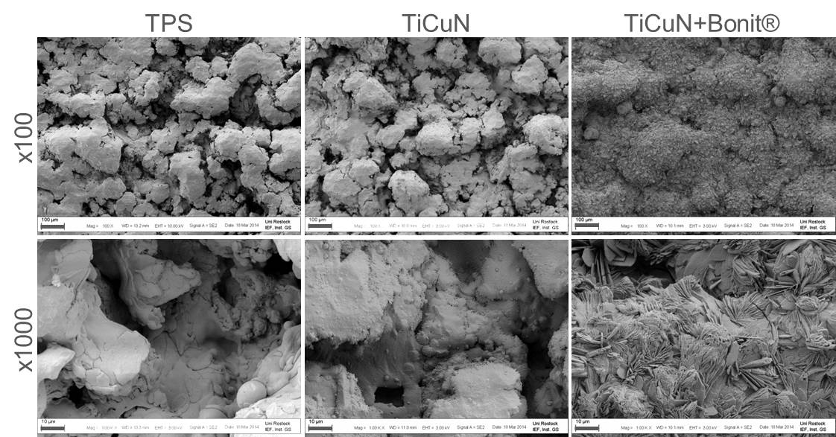
Figure 1 Surface topography of the coated materials vs titanium plasma spray control (field emission scanning electron microscopy, magnification × 100, × 1000, bars = 100 µm, 10 µm, respectively). TPS: Titanium plasma spray; TiCuN: Titanium-copper-nitride.

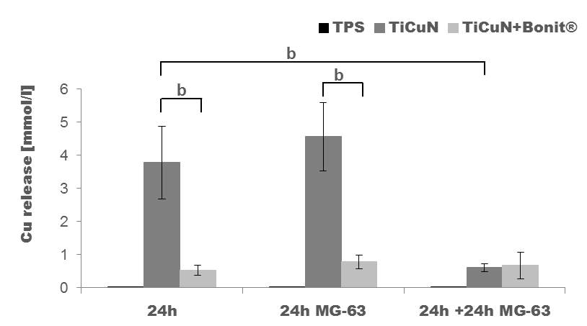
Figure 2 Copper release in Dulbecco’s modified Eagle medium. A high amount of copper is released from the TiCuN layer after incubation in DMEM for 24 h. The copper release is reduced on TiCuN + BONIT® due to the BONIT® layer. A complete exchange of the medium and seeding with MG-63 cells for another 24 h reveals significantly reduced copper release from TiCuN. The amount is equalized to the level on TiCuN + BONIT® (n = 3, mean value ± SD, t-test, ^{b}P < 0.01). TPS: Titanium plasma spray; TiCuN: Titanium-copper-nitride; DMEM: Dulbecco’s modified Eagle medium.

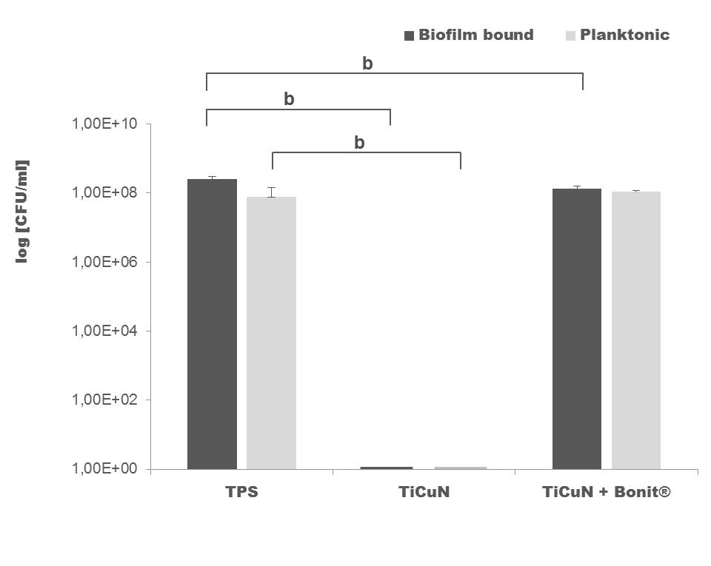
Figure 3 Antibacterial effect of the Titanium-copper-nitride coating on Staphylococcus epidermidis bacteria for planktonic and biofilm state after 2 d. On TiCuN, planktonic and biofilm-bound bacteria were killed completely. On TiCuN + BONIT®, no antibacterial effect could be observed (n = 6, mean value ± SD, U-test, ^{b}P < 0.01). TPS: Titanium plasma spray; TiCuN: Titanium-copper-nitride.

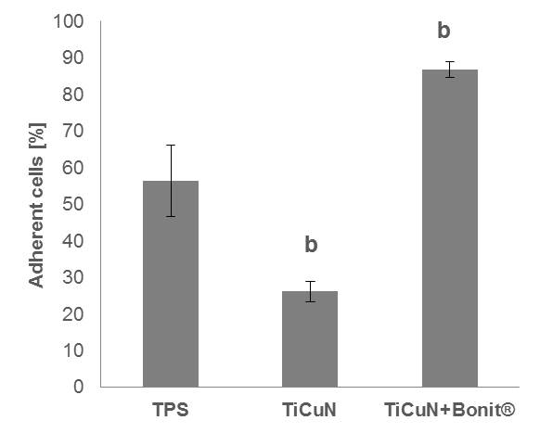
Figure 4 Initial cell adhesion of MG-63 osteoblasts on the titanium-copper-nitride. surfaces compared to the titanium plasma spray control after 10 min. The MG-63 cells were directly seeded onto the samples and cultivated for 10 min. Cell adhesion was significantly reduced on TiCuN, but TiCuN + BONIT® enhanced cell adherence significantly (n = 3, mean value ± SD, t-test, ^{b}P < 0.01). TPS: Titanium plasma spray; TiCuN: Titanium-copper-nitride.

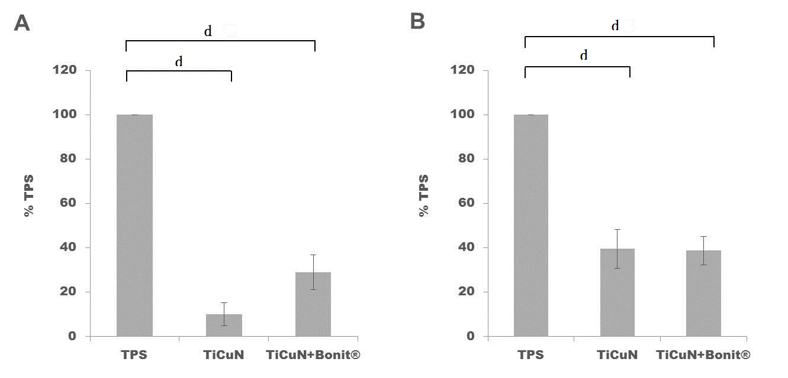
Figure 5 Viability of MG-63 osteoblasts on the titanium-copper-nitride surfaces. Two different experimental arrangements were used: (A) the MG-63 cells were directly cultivated on the TiCuN surfaces for 24 h and (B) the samples were pre-incubated in DMEM for 24 h and after this the cells were seeded onto the surfaces for another 24 h. Cell viability was significantly reduced after direct seeding on TiCuN. Cell viability was higher on TiCuN + BONIT® compared to TiCuN. Pre-incubation of the samples in DMEM for 24 h before seeding elevated cell viability on both samples (n = 3, mean value ± SD, t-test, ^{d}P < 0.001). TPS: Titanium plasma spray; TiCuN: Titanium-copper-nitride; DMEM: Dulbecco’s modified Eagle medium.

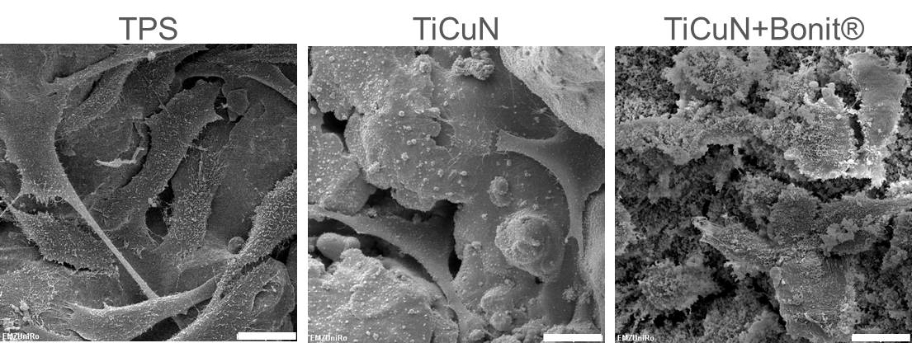
Figure 6 Scanning electron microscopy images of MG-63 osteoblasts on the pre-incubated surfaces. Samples were pre-incubated in DMEM for 24 h. After a complete exchange of medium, cells were seeded onto the surface and cultivated for another 24 h. Cells spread well on TPS and TiCuN surfaces but seem to be smaller on TiCuN + BONIT® (magnification × 1000, bar = 20 µm). TPS: Titanium plasma spray; TiCuN: Titanium-copper-nitride; DMEM: Dulbecco’s modified Eagle medium.

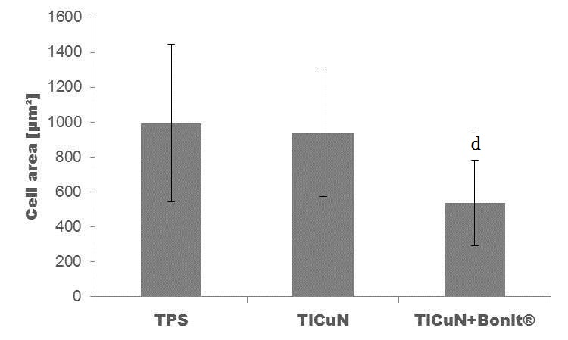
Figure 7 Spreading of MG-63 osteoblasts on pre-incubated samples after 24 h. Cell area is unchanged on TiCuN compared to TPS but significantly reduced on TiCuN + BONIT® due to the additional BONIT® layer (n = 60, mean value ± SD, t-test, ^{d}P < 0.001). Titanium plasma spray; TiCuN: Titanium-copper-nitride.

