Name of Journal: World Journal of Radiology
Manuscript NO: 50623
Manuscript Type: CASE REPORT

Giant intraventricular and paraventricular cavernous malformations with multifocal subependymal cavernous malformations in pediatric patients: Two case reports

Eng-Chuan S et al. Giant cavernous hemangioma

Suwadee Eng-Chuan, Supika Kritsaneepaiboon, Anukoon Kaewborisutsakul, Kanet Kanjanapradit

Suwadee Eng-Chuan, Supika Kritsaneepaiboon, Department of Radiology, Faculty of Medicine, Prince of Songkla University, Hat Yai 90110, Thailand

Anukoon Kaewborisutsakul, Neurosugery Unit, Department of Surgery, Faculty of Medicine, Prince of Songkla University, Hat Yai 90110, Thailand

Kanet Kanjanapradit, Department of Pathology, Faculty of Medicine, Prince of Songkla University, Hat Yai 90110, Thailand

ORCID number: Suwadee Eng-Chuan (0000-0002-3047-9791); Supika Kritsaneepaiboon (0000-0002-7749-5908); Anukoon Kaewborisutsakul (0000-0001-9548-3006); Kanet Kanjanapradit (0000-0003-0591-0751).

Author contributions: Eng-Chuan S, Kritsaneepaiboon S were the radiologists reviewed the literature, interpreted imaging findings and contributed to manuscript drafting; Kaewborisutsakul A was the patient’s neurosurgeon performed the operation, reviewed the literature and contributed to manuscript drafting; Kanjanapradit K interpreted the histologic tissue and contributed to manuscript; Eng-Chuan S, Kritsaneepaiboon S were responsible for the revision of the manuscript for important intellectual content; all authors issued final approval for the version to be submitted.

Informed consent statement: Informed consents were obtained from the patients and the information used anonymous clinical data.

Conflict-of-interest statement: The authors declare that they have no conflict of interest.

CARE Checklist (2016) statement: The authors have read the CARE Checklist (2013), and the manuscript was prepared and revised according to the CARE Checklist (2016).

Open-Access: This article is an open-access article which was selected by an in-house editor and fully peer-reviewed by external reviewers. It is distributed in accordance with the Creative Commons Attribution Non Commercial (CC BY-NC 4.0) license, which permits others to distribute, remix, adapt, build upon this work non-commercially, and license their derivative works on different terms, provided the original work is properly cited and the use is non-commercial. See: http://creativecommons.org/licenses/by-nc/4.0/

Manuscript source: Unsolicited manuscript

Corresponding author: Supika Kritsaneepaiboon, MD, Lecturer, Department of Radiology, Faculty of Medicine, Prince of Songkla University, 15 Karnjanavanich Road, Hat Yai 90110, Thailand. supikak@yahoo.com
Telephone: +66-74-451501
Fax: +66-74-451501

Received: August 2, 2019
Peer-review started: August 2, 2019
First decision: November 6, 2019
Revised: November 21, 2019
Accepted: December 5, 2019
Article in press:
Published online:

Abstract
BACKGROUND
Giant cavernous malformation (GCM) is rarely found in intraventricular or paraventricular locations.

CASE SUMMARY
We present two cases of 6-mo and 21-mo boys with intraventricular and paraventricular GCMs including a literature review focused on location and imaging findings. Characteristic magnetic resonance imaging findings such as multicystic lesions and a hemosiderin ring or bubbles-of-blood appearance can assist in the differential diagnosis of a hemorrhagic intraventricular and/or paraventricular mass.

CONCLUSION
Multifocal intraventricular and/or paraventricular GCM in small children is rare. The characteristic magnetic resonance imaging findings can help to differentiate GCMs from other intraventricular tumors.

Key words: Cavernous malformation; Giant intraventricular; Paraventricular; Multifocal subependymal; Children; Case report

© The Author(s) 2019. Published by Baishideng Publishing Group Inc. All rights reserved.

Core tip: We present two rare cases of multifocal intraventricular and/or paraventricular giant cavernous malformation (GCM) in small children including a literature review focused on location and imaging findings. The GCM is a rare entity. Intraventricular cavernous malformations are very rare and account for 2.5% of all brain cavernous malformations and are mostly found in the third ventricle. Characteristic magnetic resonance imaging findings such as multicystic lesions and a hemosiderin ring or bubbles-of-blood appearance can assist to differentiate GCMs from other intraventricular tumors/masses.

Eng-Chuan S, Kritsaneepaiboon S, Kaewborisutsakul A, Kanjanapradit K. Giant intraventricular and paraventricular cavernous malformations with multifocal subependymal cavernous malformations in pediatric patients: Two case reports. World J Radiol 2019; In press

INTRODUCTION
The overall prevalence of intracranial cavernous malformation (CM), cavernous hemangioma, cavernous angioma or cavernoma is 0.4%-0.6% and the mean age of presentation is 30.6 years^{[1]}. Its prevalence in children is very rare at 0.37%-0.53%^{[2,3]}. The most common location is the cerebral hemisphere^{[1]}. Intraventricular CMs are very rare and account for 2.5% of all brain CMs and are mostly found in the third ventricle^{[4,5]}. The size of the CMs varies between 1 mm and 75 mm (mean size 14.2 mm)^{[4-6]}. The giant cavernous malformation (GCM) is a rare entity and there is no standard size definition, with some prior studies defining a GCM as having a diameter greater than 4-6 cm^{[7,8]}. The most common presenting symptoms are seizure, neurological deficits, and hemorrhage^{[8,9]}. The current standard treatment for symptomatic patient is surgical removal, particularly for lesions in noneloquent areas^{[8-10]}. The surgical outcome is good despite the large size^{[10,11]}. Herein we reported two cases of paraventricular and intraventricular GCMs with intraventricular hemorrhage in small children.

CASE PRESENTATION
Case 1
Chief complaints: A 6-mo-old boy presented with increased head circumference and delayed development.

History of present illness: Delayed gross motor development started a month ago with increased head circumference for 1 wk.

History of past illness: The patient had no previous medical history and uneventful perinatal and postnatal periods. He had no underlying disease or family history of brain tumor.

Physical examination: The patient had bulging anterior fontanel sized about 4 cm and his head circumference is about 48.5 cm (> P97).

Laboratory examinations: The patient’s routine laboratory investigations were within normal limits.

Imaging examinations: Brain computed tomography (CT) showed a mixed solid-cystic intraventricular tumor with multiple internal calcifications involving the body and trigone of the lateral ventricle and third ventricle with severe hydrocephalus (Figure 1A). Magnetic resonance imaging (MRI) of the brain revealed a large mixed minimal heterogeneous enhancing solid cystic intraventricular mass with internal calcification and perilesional brain edema mainly located at the left trigone and body of the left lateral ventricle resulting in moderate hydrocephalus, subfalcine and left descending transtentorial herniation. Two other small subependymal nodules at the posterior bodies of the left and right lateral ventricles were seen. Associated intraventricular hemorrhage and subarachnoid hemorrhage were found (Figure 1B-F). The provisional diagnosis from the MRI findings was choroid plexus papilloma.

Treatment: He underwent right frontal ventriculostomy with shunt placement and a left frontoparietal craniotomy with partial tumor removal. A hypervascular intraventricular tumor with lobulated shape was found in the left lateral ventricle with signs of an old hemorrhage.

Final diagnosis: The pathological diagnosis was compatible with “cavernous hemangioma with hemorrhage” (Figure 2).

Outcome and follow-up: An MRI study 2 years later after the patient had developed chorea showed a larger size CM and. He was scheduled for a second surgical tumor removal.

Case 2
Chief complaints: A 21-mo-old boy was referred to our institute due to left hemiparesis.

History of present illness: The left hemiparesis has been progressed for 5 mo.

History of past illness: The patient had no previous medical history and no relevant family history.

Physical examination: The patient had left hemiparesis grade 4. The other general conditions of the patients were normal.

Laboratory examinations: The patient’s routine laboratory investigations were within normal limits.

Imaging examinations: A brain MRI study showed multifocal multilobulated cystic masses with variously staged hemorrhages at the right periventricular region, right foramen of Monro, right ventricular trigone and occipital horn of the right lateral ventricle with perilesional brain edema. The largest mass involved the right basal ganglia and right thalamus. Old intraventricular hemorrhage and superficial hemosiderosis were evident. A mass effect caused subfalcine, mild right uncal herniation and moderate hydrocephalus. There was no associated venous angioma (Figure 3).

Treatment: The patient underwent a keyhole right parieto-temporal craniotomy with partially tumor removal. The operative findings were a mulberry-liked solid-cystic mass and old blood clot and mild cerebral edema with hemosiderin straining along the arachnoid plane.

Final diagnosis: The pathological diagnosis was fibrous tissue, calcification, and hemorrhage (Figure 4) and compatible with cavernous hemangioma.

Outcome and follow-up: After the operation, his motor power was partially improved.

DISCUSSION
Relevant articles were searched for using the keywords GCM, pediatric, intraventricular, paraventricular and intraventricular hemorrhage. Seven articles were found, including 13 cases of intraventricular and paraventricular GCM^{[8,12-17]}. The details are shown in Table 1. The GCM is rare and can occur along the neural axis as a CM with the most common location at supratentorial region^{[8,12]}. Intraventricular and paraventricular GCMs are uncommon locations and 44% of them are located in the third ventricle, 27% in the lateral ventricle, 20% in the trigone, and 9% in the fourth ventricle^{[5]}.
The pathogenesis of CMs is still unclear. Various studies have proposed that integrin-binding protein ICAP-1 and Krev interaction trapped protein 1 may play important roles in the pathogenesis of the cerebral CM (CCM) and GCM^{[18]}. The increase in size of GCMs is thought to involve a process of cavernous proliferation from repetitive hemorrhages, pseudo-capsule formation, and expansion. The osmotic effect of the breakdown of blood products in cysts causes characteristic multicystic lesions with blood in various stages and surrounded by hemosiderin rings or bubbles of blood appearance on MRI^{[17]}. One of our cases had a larger-than-normal size, and an intralesional hemorrhage was one possible reason for the growth of CM.
The papers also found that in children with CM, about 10% of cases were familial and about 17% had multiple lesions^{[1,19]}. Most of the multiple-lesion cases were familial, up to 84%, and the rest were sporadic (30%)^{[17]}. Only one case of intraventricular and paraventricular GCMs, which presented at 18 mo, had multiple lesions detected on T2* sequence (Table 1)^{[17]}. One of our cases was first reported as multiple paraventricular GCMs at 6 mo of age. The studies also suggest that multiple CMs had a greater risk of de novo cavernoma-genesis than solitary CMs (7.1% and 0.6% per lesion per year)^{[19]}. Both of our cases had multiple lesions, unfortunately genetic studies were not performed.
Initial CT imaging of our cases revealed solid-cystic masses with internal calcifications and small multifocal subependymal lesions that mislead us to suspect intra-/paraventricular tumors and subependymal seedings. MRI helped characterize the lesions by revealing bubbles of blood appearances and multi-stage hemorrhages mimicking solid components on CT. The MR imaging findings of our cases were characteristic imaging features of CMs, showing multicystic lesions with various stages of hemorrhages and hemosiderin rims. Minimally enhanced lesion in one of our cases could be from heterogeneity of CCMs relative to blood–brain barrier behavior^{[20]}.
Pediatric CMs are classified by imaging according to the Mottolese et al^{[2]}’s study. The findings in our cases seem to fall-between Mottolese classification type IIIA (non-enhancing macroscopic cysts of mixed signal intensities surrounded by lower signal of hemosiderin rim on T2 weighted image) and IIIC (large solid mass with heterogeneous inner signal on T1 and T2 and peripheral low signal on T2* weighted image) that can mimic neoplasm. None of the paraventricular GCM in all of the previous reports had intraventricular hemorrhage as in both of our cases. CCMs in pediatric patients have about a 0.5% per lesion per year risk for hemorrhage^{[19]}. The history of previous hemorrhage increases the annual hemorrhagic risk to 11.3%^{[19]}.
The differential diagnosis of a hemorrhagic intraventricular mass in small children includes choroid plexus tumor, teratoma and subependymal giant astrocytoma. All neoplasms reveal significant enhancement in post-contrast enhancement. Minimal enhancement, bubbles of blood and absence of associated findings of tuberous sclerosis such as cortical tubers may help to differentiate a GCM from intraventricular tumors.
The standard treatment of CCM is conservative or surgical removal^{[10]}. Conservative treatment is preserved for asymptomatic patients. Most GCMs are symptomatic or occasionally indistinguishable from brain tumors, so the surgical removal is the treatment of choice. In our cases, the GCMs were partially removed because the tumors were located in eloquent areas and leading to limited choice of surgical technique^{[11]}.

CONCLUSION
In conclusion, we present two rare cases of multifocal intraventricular/ paraventricular GCM in small children. CT findings in GCMs can show a mixed solid-cystic mass with internal calcified solid components. The characteristic MRI findings of multicystic lesions and hemosiderin ring or bubbles of blood appearance can help to differentiate GCMs from other intraventricular tumors.

REFERENCES
1 Gross BA, Lin N, Du R, Day AL. The natural history of intracranial cavernous malformations. Neurosurg Focus 2011; 30: E24 [PMID: 21631226 DOI: 10.3171/2011.3.FOCUS1165]
2 Mottolese C, Hermier M, Stan H, Jouvet A, Saint-Pierre G, Froment JC, Bret P, Lapras C. Central nervous system cavernomas in the pediatric age group. Neurosurg Rev 2001; 24: 55-71; discussion 72-3 [PMID: 11485241 DOI: 10.1007/pl00014581]
3 Acciarri N, Galassi E, Giulioni M, Pozzati E, Grasso V, Palandri G, Badaloni F, Zucchelli M, Calbucci F. Cavernous malformations of the central nervous system in the pediatric age group. Pediatr Neurosurg 2009; 45: 81-104 [PMID: 19307743 DOI: 10.1159/000209283]
4 Tatagiba M, Schönmayr R, Samii M. Intraventricular cavernous angioma. A survey. Acta Neurochir (Wien) 1991; 110: 140-145 [PMID: 1927606 DOI: 10.1007/BF01400682]
5 Reyns N, Assaker R, Louis E, Lejeune JP. Intraventricular cavernomas: three cases and review of the literature. Neurosurgery 1999; 44: 648-54; discussion 654-5 [PMID: 10069603 DOI: 10.1097/00006123-199903000-00119]
6 Kim DS, Park YG, Choi JU, Chung SS, Lee KC. An analysis of the natural history of cavernous malformations. Surg Neurol 1997; 48: 9-17; discussion 17-18 [PMID: 9199678 DOI: 10.1016/S0090-3019(96)00425-9]
7 Lawton MT, Vates GE, Quinones-Hinojosa A, McDonald WC, Marchuk DA, Young WL. Giant infiltrative cavernous malformation: clinical presentation, intervention, and genetic analysis: case report. Neurosurgery 2004; 55: 979-980 [PMID: 15934180 DOI: 10.1227/01.neu.0000137277.08281.48]
8 Kan P, Tubay M, Osborn A, Blaser S, Couldwell WT. Radiographic features of tumefactive giant cavernous angiomas. Acta Neurochir (Wien) 2008; 150: 49-55; discussion 55 [PMID: 18066488 DOI: 10.1007/s00701-007-1455-z]
9 Son DW, Lee SW, Choi CH. Giant cavernous malformation : a case report and review of the literature. J Korean Neurosurg Soc 2008; 43: 198-200 [PMID: 19096644 DOI: 10.3340/jkns.2008.43.4.198]
10 Kivelev J, Niemelä M, Hernesniemi J. Treatment strategies in cavernomas of the brain and spine. J Clin Neurosci 2012; 19: 491-497 [PMID: 22325075 DOI: 10.1016/j.jocn.2011.08.015]
11 Ghali MG, Srinivasan VM, Mohan AC, Jones JY, Kan PT, Lam S. Pediatric cerebral cavernous malformations: Genetics, pathogenesis, and management. Surg Neurol Int 2016; 7: S1127-S1134 [PMID: 28194299 DOI: 10.4103/2152-7806.196921]
12 van Lindert EJ, Tan TC, Grotenhuis JA, Wesseling P. Giant cavernous hemangiomas: report of three cases. Neurosurg Rev 2007; 30: 83-92; discussion 92 [PMID: 16988810 DOI: 10.1007/s10143-006-0042-8]
13 Kawagishi J, Suzuki M, Kayama T, Yoshimoto T. Huge multilobular cavernous angioma in an infant: case report. Neurosurgery 1993; 32: 1028-30; discussion 1030-1 [PMID: 8327078 DOI: 10.1227/00006123-199306000-00026]
14 Gezen F, Karatas A, Is M, Yildirim U, Aytekin H. Giant cavernous haemangioma in an infant. Br J Neurosurg 2008; 22: 787-789 [PMID: 18686064 DOI: 10.1080/02688690802108780]
15 Nieto J, Hinojosa J, Muñoz MJ, Esparza J, Ricoy R. Intraventricular cavernoma in pediatric age. Childs Nerv Syst 2003; 19: 60-62 [PMID: 12541090 DOI: 10.1007/s00381-002-0643-7]
16 Kumar GS, Poonnoose SI, Chacko AG, Rajshekhar V. Trigonal cavernous angiomas: report of three cases and review of literature. Surg Neurol 2006; 65: 367-371, discussion 371 [PMID: 16531197 DOI: 10.1016/j.surneu.2005.09.015]
17 Ozgen B, Senocak E, Oguz KK, Soylemezoglu F, Akalan N. Radiological features of childhood giant cavernous malformations. Neuroradiology 2011; 53: 283-289 [PMID: 21046093 DOI: 10.1007/s00234-010-0783-5]
18 Zawistowski JS, Serebriiskii IG, Lee MF, Golemis EA, Marchuk DA. KRIT1 association with the integrin-binding protein ICAP-1: a new direction in the elucidation of cerebral cavernous malformations (CCM1) pathogenesis. Hum Mol Genet 2002; 11: 389-396 [PMID: 11854171 DOI: 10.1093/hmg/11.4.389]
19 Gross BA, Du R, Orbach DB, Scott RM, Smith ER. The natural history of cerebral cavernous malformations in children. J Neurosurg Pediatr 2016; 17: 123-128 [PMID: 26474098 DOI: 10.3171/2015.2.PEDS14541]
20 Retta SF, Glading AJ. Oxidative stress and inflammation in cerebral cavernous malformation disease pathogenesis: Two sides of the same coin. Int J Biochem Cell Biol 2016; 81: 254-270 [PMID: 27639680 DOI: 10.1016/j.biocel.2016.09.011]

P-Reviewer: Gao BL, Movahed A S-Editor: Yan JP
L-Editor: E-Editor:

Specialty type: Radiology, nuclear medicine and medical imaging
Country of origin: Thailand
Peer-review report classification
Grade A (Excellent): 0
Grade B (Very good): B
Grade C (Good): C
Grade D (Fair): 0
Grade E (Poor): 0

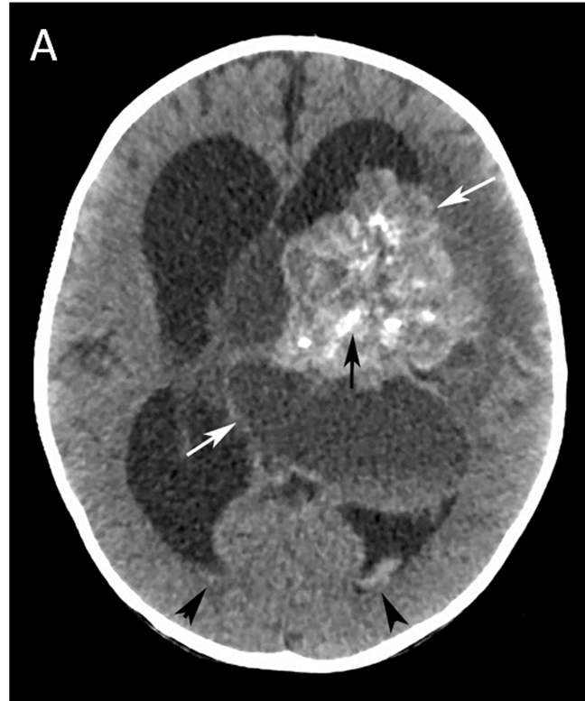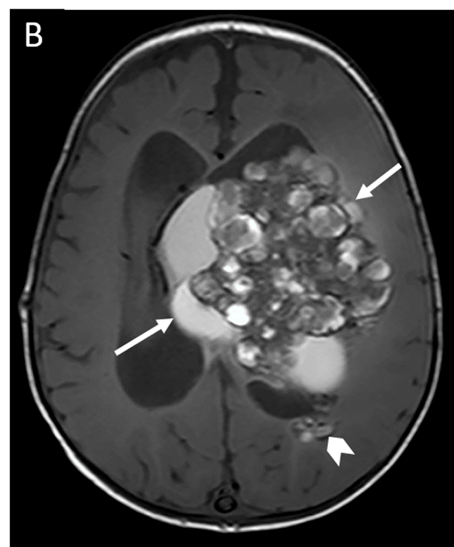

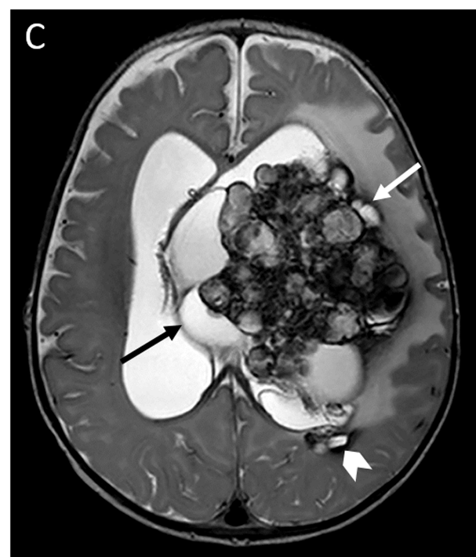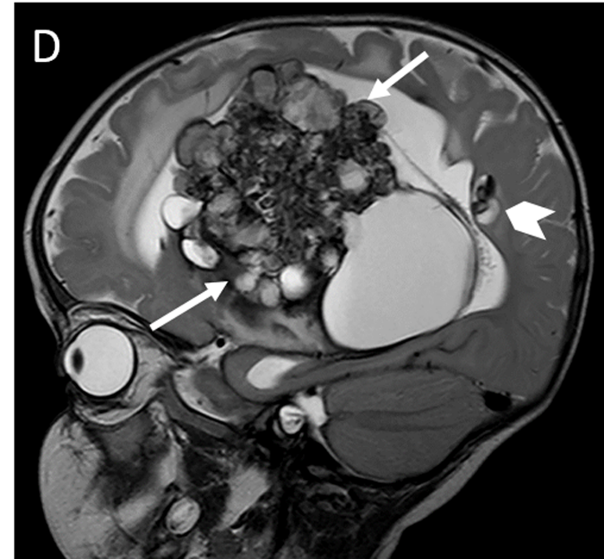

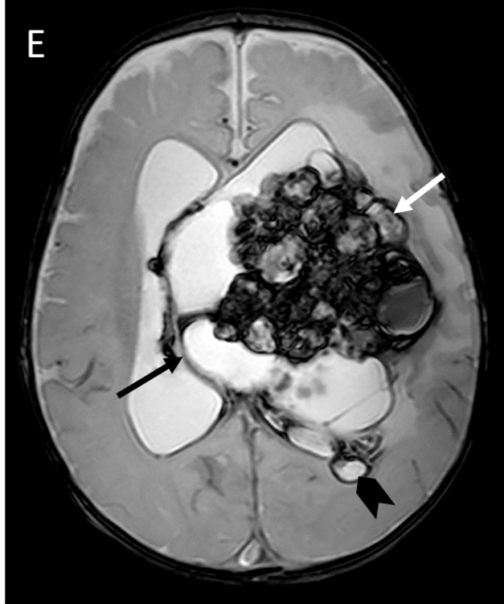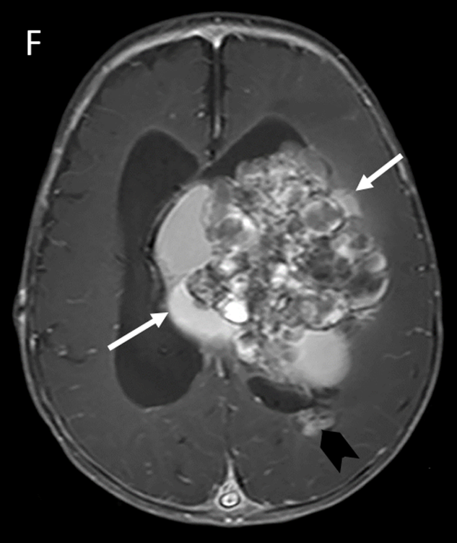

Figure 1 Pre-operative brain computed tomography and magnetic resonance imaging. A: Non-contrast computed tomography shows cystic-solid mass (white arrows) with internal calcifications (black arrows) in body of left lateral ventricle and intraventricular hemorrhage (arrowheads) resulting in hydrocephalus; B: Axial T1 weighted image; C: Axial T2 weighted image; D: Sagittal T2 weighted image; E: Axial T2* weighted mage; F: Axial T1 weighted post gadolinium administration image show a solid-cystic intraventricular mass (arrows) at the left trigone and body of left lateral ventricle with internal calcification, perilesional brain edema and various stages of hemorrhage; bubbles of blood appearance. Another small slightly enhanced nodule (arrowhead) at the subependymal region of the posterior body of the left lateral ventricle is seen.

Figure 2 Histopathology of the post-operative removed mass. Histological findings revealed multiple medium-sized vessels (asterisk) lined by endothelial cells with an area of hemorrhage (arrow). Hematoxylin and eosin stain, original magnification × 100).

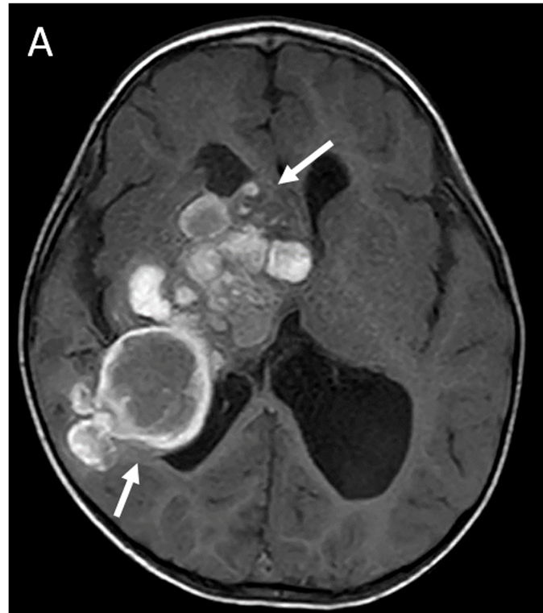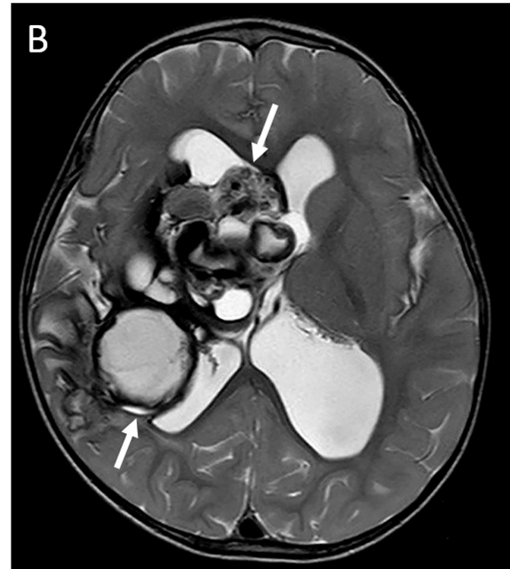

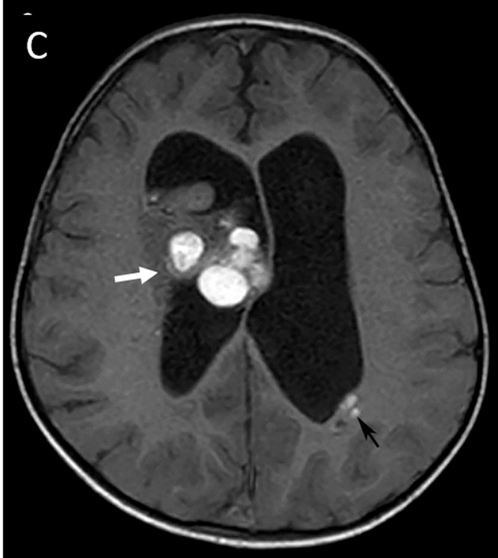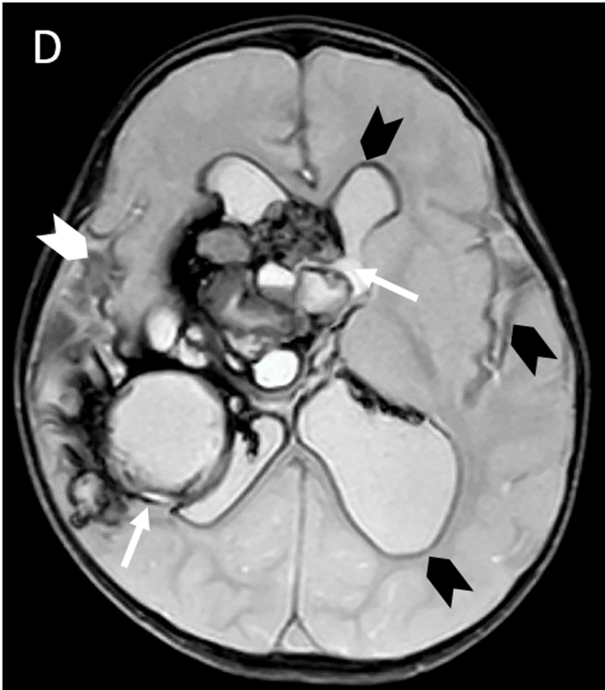

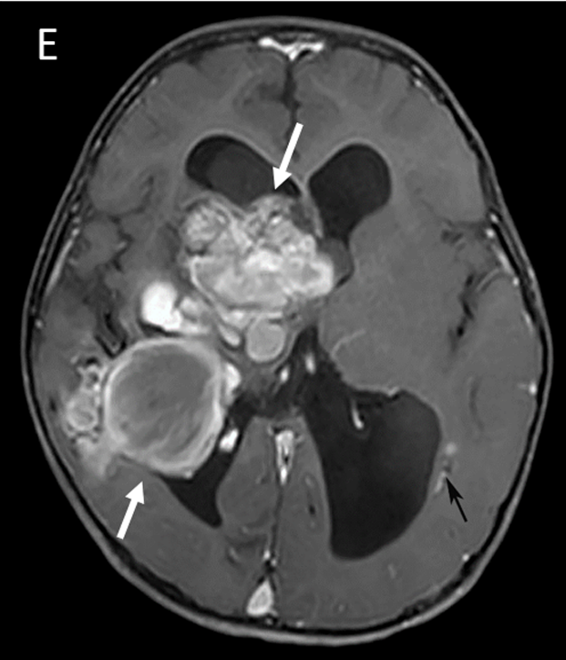

Figure 3 Pre-operative magnetic resonance imaging. A: Axial T1 weighted image; B: Axial T2 weighted image; C: Axial FLAIR image; D: Axial T2* weighted image; E: Axial T1 weighted post-contrast image show multifocal multilobulated cystic masses with various stages of hemorrhage or bubbles of blood appearance, at the right periventricular region, right foramen of Monro, right trigone, occipital horn of the right lateral ventricle (white arrows) and body of left lateral ventricle (black arrow) with moderate hydrocephalus. Old intraventricular hemorrhage and superficial siderosis (arrowheads) at both fronto-temporal sulci and all subependymal lining are in axial T2* weighted image.

Figure 4 Histopathology of the post-operative removed mass. Histological findings revealed fibrous tissue (arrow) with calcification and hemorrhage (asterisk) (Hematoxylin and eosin stain, original magnification × 100).

Table 1 Intraventricular and paraventricular giant cavernous malformations in pediatric patients reported in the literature
No. | Ref. | Age, sex | Size (cm) | Location | Lesion Number | Symptoms | Computed tomography scan | Magnetic resonance imaging | Post- operative status
1 | Kawagishi et al^{[11]}, 1993 | 11 mo, boy | 10 | Right paraventricle | Single | Left hemiparesis | Multilobular high density enhanced rim/septum | Heterogeneous signal intensity on T1w/T2w with hemosiderin rim | Improved
2 | Van Lindert et al^{[10]}, 2007 | 3 mo, girl | 6-7 | Left paraventricle | Single | Generalized seizure | Left fronto-temporal multicystic | - | Improved
3 | Gezen et al^{[12]}, 2008 | 10 mo, boy | 6 × 4 × 4.5 | Left paraven  tricular parietal lobe | Single | Focal seizure | - | Lobulated, hemorrhages | Hemi-  paresis
4 | Nieto et al^{[13]}, 2003 | 11 yr, girl | 5 | Left trigone | Single | Seizure | - | Rounded and well-delineated | Improved
5 | Kumar et al^{[14]}, 2006 | 8 yr, boy | 5 | Right trigone | Single | Mass effect | Hyperdense enhanced, calcifications | - | Improved
6 | Kan et al^{[8]}, 2008 | 0.9 yr, boy | 9 × 6 | Left fronto-parietal, intraventricle | Single | Seizure, right hemiparesis | Hyperdense, heterogeneous calcifications | Multicystic with multiple hemosiderin rings | NA
7 | Ozgen et al^{[15]}, 2011, 7 reported cases | 2 yr, girl | > 4 cm | Left parietal | Single | Seizure | - | Macroscopic cysts and huge calcification | NA
8 |  | 4 yr, boy | > 4 cm | Medial temporal | Single | Seizure | - | Multicystic hemosiderin ring | NA
9 |  | 8 mo, girl | > 4 cm | Left parietal | Single | Seizure | - | Multicystic cysts with subacute hematoma | NA
10 |  | 18 mo, boy | > 4 cm | Peri-atrial of left parietal region | Multiple | Seizure | - | Multicystic with fluid level | NA
11 |  | 1 yr, girl | > 4 cm | Left parietal | Single | Vomiting, altered consciousness | - | Macroscopic cysts, huge calcification | NA
12 |  | 9 yr, girl | > 4 cm | Left parietal | Single | Seizure | - | Solid, well-defined | NA
13 |  | 8 yr, boy | > 4 cm | Intraventricle | Single | Headache | - | Solid, well-defined | NA
14 | Two present cases | 6 mo, boy | 9.4 cm | Left  intraventricle | Multiple | Increased head circumference | Solid-cystic | Heterogeneous enhancing solid cyst | Hemi-paresis
15 |  | 21 mo, boy | 8.2 cm | Right paraventricle | Multiple | Left hemiparesis | Multilobulate rim enhancement | Multicystic hemorrhage
NA: Not available.

