Name of Journal: World Journal of Gastrointestinal Endoscopy
Manuscript NO: 55513
Manuscript Type: ORIGINAL ARTICLE

Retrospective Study
Which scope is appropriate for endoscopic retrograde cholangiopancreatography after Billroth II reconstruction: An esophagogastroduodenoscope or a colonoscope?

Sugimoto M et al. Appropriate scope for ERCP after B-II

Mitsuru Sugimoto, Tadayuki Takagi, Rei Suzuki, Naoki Konno, Hiroyuki Asama, Yuki Sato, Hiroki Irie, Ko Watanabe, Jun Nakamura, Hitomi Kikuchi, Mika Takasumi, Minami Hashimoto, Tsunetaka Kato, Takuto Hikichi, Hiromasa Ohira

Mitsuru Sugimoto, Tadayuki Takagi, Rei Suzuki, Naoki Konno, Hiroyuki Asama, Yuki Sato, Hiroki Irie, Ko Watanabe, Jun Nakamura, Hitomi Kikuchi, Mika Takasumi, Hiromasa Ohira, Department of Gastroenterology, School of Medicine, Fukushima Medical University, Fukushima 9601247, Japan

Ko Watanabe, Jun Nakamura, Minami Hashimoto, Tsunetaka Kato, Takuto Hikichi, Department of Endoscopy, Fukushima Medical University Hospital, Fukushima 9601247, Japan

Author contributions: Sugimoto M designed and performed the study; Sugimoto M, Takagi T, and Ohira H analyzed the data; Sugimoto M, Takagi T, and Ohira H wrote the paper; Suzuki R, Konno N, Asama H, Hikichi T, Watanabe K, Nakamura J, Kikuchi H, Takasumi M, Sato Y, Hashimoto M, Kato T and Irie H provided clinical advice; and Hikichi T and Ohira H supervised the study.

Corresponding author: Mitsuru Sugimoto, MD, PhD, Assistant Professor, Doctor, Department of Gastroenterology, Fukushima Medical University, School of Medicine, Hikarigaoka 1, Fukushima 9601295, Japan. kitachuuou335@yahoo.co.jp

Received: March 21, 2020
Revised: May 19, 2020
Accepted: July 19, 2020
Published online:

Abstract
BACKGROUND
Recently, with the advent of more advanced devices and endoscopic techniques, endoscopic retrograde cholangiopancreatography (ERCP) in Billroth II (B-II) patients has been increasingly performed. However, the procedures are difficult, and the techniques and strategies have not been defined.

AIM
To reveal the appropriate scope for ERCP in B-II patients.

METHODS
Sixty ERCP procedures were performed on B-II patients between June 2005 and May 2018 at Fukushima Medical University Hospital, and in 44 cases, this was the first ERCP procedure performed by esophagogastroduodenoscopy (EGDS) or colonoscopy (CS) after B-II gastrectomy. These cases were divided into two groups: 17 cases of ERCP performed by EGDS (EGDS group) and 27 cases of ERCP performed by CS (CS group). The patient characteristics and ERCP procedures were compared between the EGDS and CS groups.

RESULTS
The procedural time was significantly shorter in the EGDS group than in the CS group [median (range): 60 (20-100) vs 90 (40-128) min, P value < 0.01]. CS was an independent factor of a longer ERCP procedural time according to the univariate and multivariate analyses (odds ratio: 3.97, 95%CI: 1.05-15.0, P value = 0.04).

CONCLUSION
Compared to CS, EGDS shortened the procedural time of ERCP in B-II patients.

Key words: Endoscopic retrograde cholangiopancreatography; Billroth II reconstruction; Esophagogastroduodenoscope; Colonoscope

Sugimoto M, Takagi T, Suzuki R, Konno N, Asama H, Sato Y, Irie H, Watanabe K, Nakamura J, Kikuchi H, Takasumi M, Hashimoto M, Kato T, Hikichi T, Ohira H. Which scope is appropriate for endoscopic retrograde cholangiopancreatography after Billroth II reconstruction: An esophagogastroduodenoscope or a colonoscope? World J Gastrointest Endosc 2020; In press

Core tip: This study aimed to reveal the appropriate scope for endoscopic retrograde cholangiopancreatography (ERCP) in Billroth II (B-II) patients. Sixty ERCP procedures were performed in B-II patients, and in 44 cases, this was the first ERCP procedure performed by esophagogastroduodenoscopy (EGDS) or colonoscopy (CS) after B-II gastrectomy. The procedural time was significantly shorter in the EGDS group than in the CS group. CS was an independent factor of a longer ERCP procedural time according to the univariate and multivariate analyses. Compared to CS, EGDS shortened the procedural time of ERCP in B-II patients.

INTRODUCTION
In the past, percutaneous cholangiography or biliary drainage was mainly performed in patients who underwent gastrectomy or intestinal reconstructive surgery^{[1]}. Recently, with the advent of more advanced devices and endoscopic techniques, endoscopic cholangiography and biliary drainage have been increasingly performed in these patients. Although endoscopic retrograde cholangiopancreatography (ERCP) in Billroth II (B-II) patients has been previously reported^{[2-19]}, the procedures are difficult, and the techniques and strategies have not been defined.
Initially, ERCP was performed in B-II patients using a side-viewing endoscope^{[2,3]}. However, it is difficult to insert the side-viewing endoscope into the afferent loop, and the risk of bowel perforation was reported to be greater for ERCP in B-II patients when a side-viewing endoscope was used than when a forward-viewing endoscope was used^{[20]}. Therefore, a forward-viewing endoscope has recently been used for this procedure and has been shown to be as effective as a side-viewing endoscope for ERCP in B-II patients^{[20-22]}.
Among the reports describing the use of a forward-viewing endoscope, some have described the use of esophagogastroduodenoscopy (EGDS)^{[9,12,15,17,19]}, and others have described the use of long endoscopes (e.g., a colonoscope, single-balloon endoscope, or double-balloon endoscope)^{[7,8,16,19]}. Therefore, this study aimed to reveal which scope (an esophagogastroduodenoscope or a colonoscope) is appropriate for ERCP in B-II patients.

MATERIALS AND METHODS
Study design and ethics
This study was a retrospective study to investigate the appropriate scope for ERCP in B-II patients. This study was approved by the Institutional Review Board of Fukushima Medical University.

Patients
Sixty ERCP procedures were performed in B-II patients between June 2005 and May 2018 at Fukushima Medical University Hospital (Figure 1). Among these cases, 44 involved ERCP by EGDS or colonoscopy (CS) after B-II gastrectomy. Sixteen cases were excluded from this study because in these cases, this was not the first ERCP performed by EGDS or CS. Five cases involved ERCP by both EGDS and CS. The 44 patients were divided into two groups: 17 cases of ERCP by EGDS (EGDS group) and 27 cases of ERCP by CS (CS group). Patients were not required to provide informed consent for this study because this investigation used anonymous clinical data obtained after each patient had agreed to examination or treatment by written consent. For full disclosure, see the details of this study published on the home page of Fukushima Medical University.

Endoscopic retrograde cholangiopancreatography procedure
Before ERCP was started, patients were intravenously administered 300 mg of gabexate mesylate. After the patients were sedated with midazolam under blood pressure and oxygen saturation monitoring, an endoscope with a cap attached to the tip was inserted. The endoscope used was randomly chosen by each endoscopist. After the entrance of both the afferent loop and the efferent loop was observed, the endoscope was advanced to the afferent loop, reaching the papilla of Vater. Insertion into the afferent loop was performed with confirmation of the running direction by X-ray images. In the EGDS group, cannulation was initiated after the papilla was turned to the 9 to 11 o’clock position (Figure 2A). In the CS group, cannulation was initiated after the papilla was turned to the 6 o’clock position (Figure 3A and B). In patients with biliary or pancreatic ductal strictures, a biliary stent was inserted after endoscopic sphincterotomy (EST). The type of scope was determined randomly by each endoscopist.
In patients with biliary ductal stones, EST and endoscopic papillary balloon dilation (EPBD) or endoscopic papillary large balloon dilation (EPLBD) were performed, as appropriate (Figures 2 and 3). EPBD was performed if the transverse diameter of the largest stone was > 8 mm and bile duct stones were difficult to remove by EST alone or if a peripapillary diverticulum was present. EPLBD was performed if the transverse diameter of the largest stone was > 12 mm, if many bile duct stones were difficult to remove by EST alone or if sufficient EST was difficult because of a peripapillary diverticulum. Stones that were too large to be ejected after EPBD or EPLBD were destroyed by catheter fragmentation. If complete stone clearance was difficult, then a biliary stent was inserted.
A GIF-Q240X, GIF-Q260, or GIF-Q260J (Olympus, Tokyo, Japan) scope was used in the EGDS group. A PCF-Q260AI, PCF-Q260AL, PCF-PQ260L, or SIF-Q260 (Olympus) scope was used in the CS group. PCF-PQ260L and SIF-Q260 scopes were used in one patient each. A D-201-11304 (Olympus) was used as the cap attached to the tip of the GIF-Q240 scope. A D-201-10704 (Olympus) was used as the cap attached to the tip of the GIF-Q260 scope. A D-201-12704 (Olympus) was used as the cap attached to the tip of the PCF-Q260AI and PCF-Q260AL scopes. A D-201-10704 (Olympus) was used as the cap attached to the tip of the PCF-PQ260L and SIF-Q260 scopes. A Tandem XL (Boston Scientific Japan, Tokyo, Japan), MTW ERCP tapered catheter (MTW Endoskopie, Wesel, Germany) or a Swing Tip PR-233Q (Olympus) was used as the ERCP catheter. EST was performed using an RX needle knife XL (Boston Scientific) or Billroth II sphincterotome (Cook Japan, Tokyo, Japan). A Hurricane RX biliary balloon dilatation catheter (Boston Scientific) was used for EPBD. A CRE biliary balloon dilatation catheter (Boston Scientific) or a Giga or Giga II balloon (Century Medical, Tokyo, Japan) was used for EPLBD. A Trapezoid RX basket catheter (Boston Scientific) or an FG-V425PR basket catheter (Olympus) was used to crush and remove stones. A Flexima biliary stent (Boston Scientific) or a Zimmon biliary stent (Cook Japan, Tokyo, Japan) was used as the biliary stent. All of these devices can be used with both the GIF-Q260J and PCF-Q260AI colonoscopes. The Swing Tip PR-233Q, Hurricane RX biliary balloon dilatation catheter, Giga balloon, Trapezoid RX basket catheter, and Flexima biliary stent cannot be used with both the GIF-Q240X and the GIF-Q260 scopes. The Swing Tip PR-233Q, Hurricane RX biliary balloon dilatation catheter, and Trapezoid RX basket catheter cannot be used with the PCF-Q260AL scope. In the two patients in whom the PCF-PQ260AL or SIF-Q260 scope was used, the papilla of Vater could not be observed, and ERCP devices were not used with the scope.

Examination items
The characteristics of the patients (age, sex, period after B-II reconstruction, diseases treated with B-II reconstruction, untreated papilla of Vater, antithrombotic drug use, periampullary diverticulum, diseases, transverse diameter of the largest stone, and number of stones) and ERCP procedure details [EST, EPBD or EPLBD, procedural time, papilla of Vater access, stone clearance, stone destruction, procedural success, and post-ERCP pancreatitis (PEP)] were compared between the EGDS and CS groups. Additionally, the relationship between the duodenal and catheter directions (cross or parallel) and the observation of papilla of Vater in the front were compared as factors of scope usability between the EGDS and CS groups (Figure 4). The duodenal and catheter directions were determined from the X-ray images of the biliary cannulation. An untreated papilla of Vater was defined as one that had not undergone incision or dilation. If all biliary stones were removed, the intended procedures (for example, biliary duct or pancreatic duct investigation or stenting) were performed using the first endoscope, and this was defined as stone clearance or procedural success. The diagnosis of PEP was performed according to Cotton’s criteria^{[23]}. If patients were observed to have an elevated serum amylase level more than three times the normal upper limit with abdominal pain at more than 24 h after ERCP, they were diagnosed with PEP. Furthermore, peripancreatic inflammation was confirmed in all PEP cases by contrast-enhanced CT.

Statistical analysis
Age, period after B-II reconstruction, and transverse diameter of the largest stone were compared by Student’s t test. The procedural time and number of stones were compared using the Mann-Whitney U test. Nominal variables were compared by Fisher’s exact test. Factors influencing the ERCP procedural time were investigated by logistic regression analysis. A P value < 0.05 was defined as statistically significant. All statistical analyses were performed using the Easy R platform (Saitama Medical Center, Jichi Medical University, Saitama, Japan), which is a graphical user interface for R (The R Foundation for Statistical Computing, Vienna, Austria). Easy R is a modified version of the R commander, which was designed to perform functions that are frequently used in biostatistics^{[24]}.

RESULTS
The patient characteristics were not significantly different between the two groups (Table 1). The ERCP procedural time was significantly shorter in the EGDS group than in the CS group [median (range): 60 (20-100) vs 90 (40-128) min, P value < 0.01] (Table 2).
The procedural success rate was not significantly different between the EGDS group and the CS group (82.4% vs 63.0%, P value = 0.20). Procedural success was difficult to achieve in three patients in the EGDS group. Among them, one patient underwent surgery; in another patient, procedural success by ERCP was not achieved using an SIF-H290-S (Olympus) single-balloon scope, and the patient finally underwent conservative treatment; in the last patient, procedural success was not achieved by ERCP using an SIF-H290-S scope but was finally achieved by ERCP using a PCF-Q260AL scope. Procedural success was not achieved in ten patients in the CS group. Among them, procedural success was achieved in four patients by ERCP using a Q260J scope and in one patient by a second ERCP procedure using a PCF-Q260AI scope. Percutaneous transhepatic biliary drainage was performed in four patients (procedural success was achieved in two patients by ERCP with the rendezvous technique). One patient subsequently underwent conservative treatment.
CS was an independent factor of a longer ERCP procedural time, as determined by univariate and multivariate analyses (Table 3).
Regarding the factors influencing scope usability, crossing of the duodenal and catheter directions was observed more often in the EGDS group than in the CS group (cross/parallel: 11/3 P 8/15, P value = 0.02) (Table 4). Observation of the papilla of Vater in the front was achieved more often in the EGDS group than in the CS group.

DISCUSSION
In this study, EGDS was compared with CS for performing ERCP in B-II patients. The results showed that compared to CS, EGDS shortened the ERCP procedural time.
An increasing number of ERCP procedures after gastrectomy have been performed in patients who have undergone B-II reconstruction, and several scopes have been used. As mentioned in the introduction, the side-viewing endoscope was initially used for ERCP in B-II patients^{[2,3]}. However, recently, forward-viewing endoscopes have been used. Byun et al^{[9]}, Park et al^{[12]}, Ki et al^{[17]}, and Jang et al^{[15]} used an esophagogastroduodenoscope. However, Abdelhafez et al^{[19]} used a colonoscope, and Itoi et al^{[7]} and Kawamura et al^{[16]} used a single-balloon enteroscope. Lin et al^{[8]} used a double-balloon endoscope. Although it is unknown which scope is most efficient, the esophagogastroduodenoscope was reported to shorten the procedural time. In most reports, the procedural time was not described. However, a study reported that the average EGDS procedural time was 36.3 min^{[15]}, which is a short time. EGDS was superior to procedures with a longer scope because the papilla of Vater can be observed in the front (Figures 2A, 3A, 3 B, 4A, 4B, 4E, 5A, and 5B) because the esophagogastroduodenoscope can be curved up to 210 degrees, while a colonoscope can be curved up to 180 degrees. The duodenal direction and the catheter direction could easily be crossed in ERCP using EGDS (Figure 4 and Table 4). However, these two directions tended to run parallel in ERCP using CS. In fact, in three cases, it was difficult to cannulate the bile duct by CS, whereas bile duct cannulation was successful by EGDS (Figure 5).
Interestingly, although the procedural success rate was not significantly different between the two groups, the procedural time was shorter in the EGDS group. For patients who have undergone B-II reconstruction, the radiation exposure dose is decreased with EGDS. The exposure dose is also lower for the medical staff, who can thus perform more ERCP procedures. As such, EGDS is the first choice for ERCP in patients who have undergone B-II reconstruction.
There are several limitations to this study. First, this study was a retrospective and small study, and it was performed at a single institute. In the future, prospective and multicenter studies are needed. Second, due to the retrospective nature of this study, ERCP procedures were not performed by specified endoscopists. However, ERCP was performed by pancreaticobiliary specialists who had experience performing at least 2000 ERCP procedures or by trainees under the guidance of these specialists. Therefore, the quality of the ERCP procedure was constant. Third, the exact cannulation time was not recorded. However, as described above, the scope was chosen randomly. Additionally, the patient characteristics, diameter or number of stones, and factors related to ERCP were not significantly different between the two groups. Therefore, if EGDS is used for ERCP in B-II patients, the duration of the whole procedure, including insertion and cannulation, could be shortened.

Research conclusions
Compared to a longer scope, the esophagogastroduodenoscope shortened the procedural time of ERCP for patients who had undergone B-II reconstruction.

ARTICLE HIGHLIGHTS
Research background
Recently, with the advent of more advanced devices and endoscopic techniques, endoscopic retrograde cholangiopancreatography (ERCP) in Billroth II (B-II) patients has been increasingly performed. However, the procedures are difficult, and the techniques and strategies have not been defined.

Research motivation
The forward-viewing endoscope has been used for ERCP in B-II patients. By using the forward-viewing endoscope, ERCP in B-II patients was performed safely and as effectively as ERCP using a side-viewing endoscope. As forward-viewing endoscopes, esophagogastroduodenoscopy (EGDS) or colonoscopy (CS) is used for ERCP in B-II patients. However, which scope (EGDS or CS) should be used remains unknown.

Research objectives
To reveal the appropriate scope for ERCP in B-II patients.

Research methods
For the 44 included cases, this was the first ERCP procedure performed by EGDS or CS after B-II gastrectomy. These cases were divided into two groups: 17 cases of ERCP by EGDS (EGDS group) and 27 cases of ERCP by CS (CS group). The patient characteristics and ERCP procedures were compared between the EGDS and CS groups.

Research results
The procedural time was significantly shorter in the EGDS group than in the CS group. CS was an independent factor of a longer ERCP procedural time.

Research conclusions
Compared with CS, EGDS shortened the procedural time of ERCP for patients who had undergone B-II reconstruction.

Research perspectives
The results in this study could contribute to choosing an ERCP scope for patients who have undergone B-II reconstruction.

ACKNOWLEDGEMENTS
We thank all of the staff at the Department of Gastroenterology of Fukushima Medical University, the Department of Endoscopy of Fukushima Medical University Hospital, and the gastroenterology ward of Fukushima Medical University Hospital. We also thank American Journal Experts for providing English language editing.

REFERENCES
1 Jeong EJ, Kang DH, Kim DU, Choi CW, Eum JS, Jung WJ, Kim PJ, Kim YW, Jung KS, Bae YM, Cho M. Percutaneous transhepatic choledochoscopic lithotomy as a rescue therapy for removal of bile duct stones in Billroth II gastrectomy patients who are difficult to perform ERCP. Eur J Gastroenterol Hepatol 2009; 21: 1358-1362 [PMID: 19282768 DOI: 10.1097/MEG.0b013e328326caa1]
2 Forbes A, Cotton PB. ERCP and sphincterotomy after Billroth II gastrectomy. Gut 1984; 25: 971-974 [PMID: 6469083]
3 Osnes M, Rosseland AR, Aabakken L. Endoscopic retrograde cholangiography and endoscopic papillotomy in patients with a previous Billroth-II resection. Gut 1986; 27: 1193-1198 [PMID: 3781333]
4 Ciçek B, Parlak E, Dişibeyaz S, Koksal AS, Sahin B. Endoscopic retrograde cholangiopancreatography in patients with Billroth II gastroenterostomy. J Gastroenterol Hepatol 2007; 22: 1210-1213 [PMID: 17688662 DOI: 10.1111/j.1440-1746.2006.04765.x]
5 Nakahara K, Horaguchi J, Fujita N, Noda Y, Kobayashi G, Ito K, Obana T, Takasawa O. Therapeutic endoscopic retrograde cholangiopancreatography using an anterior oblique-viewing endoscope for bile duct stones in patients with prior Billroth II gastrectomy. J Gastroenterol 2009; 44: 212-217 [PMID: 19214665 DOI: 10.1007/s00535-008-2299-x]
6 Itoi T, Ishii K, Itokawa F, Kurihara T, Sofuni A. Large balloon papillary dilation for removal of bile duct stones in patients who have undergone a billroth ii gastrectomy. Dig Endosc 2010; 22 Suppl 1: S98-S102 [PMID: 20590782 DOI: 10.1111/j.1443-1661.2010.00955.x]
7 Itoi T, Ishii K, Sofuni A, Itokawa F, Tsuchiya T, Kurihara T, Tsuji S, Ikeuchi N, Umeda J, Moriyasu F. Single-balloon enteroscopy-assisted ERCP in patients with Billroth II gastrectomy or Roux-en-Y anastomosis (with video). Am J Gastroenterol 2010; 105: 93-99 [PMID: 19809409 DOI: 10.1038/ajg.2009.559]
8 Lin CH, Tang JH, Cheng CL, Tsou YK, Cheng HT, Lee MH, Sung KF, Lee CS, Liu NJ. Double balloon endoscopy increases the ERCP success rate in patients with a history of Billroth II gastrectomy. World J Gastroenterol 2010; 16: 4594-4598 [PMID: 20857532]
9 Byun JW, Kim JW, Sung SY, Jung HY, Jeon HK, Park HJ, Kim MY, Kim HS, Baik SK. Usefulness of Forward-Viewing Endoscope for Endoscopic Retrograde Cholangiopancreatography in Patients with Billroth II Gastrectomy. Clin Endosc 2012; 45: 397-403 [PMID: 23251888 DOI: 10.5946/ce.2012.45.4.397]
10 Choi CW, Choi JS, Kang DH, Kim BG, Kim HW, Park SB, Yoon KT, Cho M. Endoscopic papillary large balloon dilation in Billroth II gastrectomy patients with bile duct stones. J Gastroenterol Hepatol 2012; 27: 256-260 [PMID: 21793902 DOI: 10.1111/j.1440-1746.2011.06863.x]
11 Jang HW, Lee KJ, Jung MJ, Jung JW, Park JY, Park SW, Song SY, Chung JB, Bang S. Endoscopic papillary large balloon dilatation alone is safe and effective for the treatment of difficult choledocholithiasis in cases of Billroth II gastrectomy: a single center experience. Dig Dis Sci 2013; 58: 1737-1743 [PMID: 23392745 DOI: 10.1007/s10620-013-2580-6]
12 Park SB, Kim HW, Kang DH, Choi CW, Yoon KT, Cho M, Song BJ. Sphincterotomy by triple lumen needle knife using guide wire in patients with Billroth II gastrectomy. World J Gastroenterol 2013; 19: 9405-9409 [PMID: 24409069 DOI: 10.3748/wjg.v19.i48.9405]
13 Yamauchi H, Kida M, Okuwaki K, Miyazawa S, Iwai T, Takezawa M, Kikuchi H, Watanabe M, Imaizumi H, Koizumi W. Short-type single balloon enteroscope for endoscopic retrograde cholangiopancreatography with altered gastrointestinal anatomy. World J Gastroenterol 2013; 19: 1728-1735 [PMID: 23555161 DOI: 10.3748/wjg.v19.i11.1728]
14 Okabe Y, Ishida Y, Kuraoka K, Ushijima T, Tsuruta O. Endoscopic bile duct and/or pancreatic duct cannulation technique for patients with surgically altered gastrointestinal anatomy. Dig Endosc 2014; 26 Suppl 2: 122-126 [PMID: 24750161 DOI: 10.1111/den.12274]
15 Jang JS, Lee S, Lee HS, Yeon MH, Han JH, Yoon SM, Chae HB, Youn SJ, Park SM. Efficacy and Safety of Endoscopic Papillary Balloon Dilation Using Cap-Fitted Forward-Viewing Endoscope in Patients Who Underwent Billroth II Gastrectomy. Clin Endosc 2015; 48: 421-427 [PMID: 26473126 DOI: 10.5946/ce.2015.48.5.421]
16 Kawamura T, Uno K, Suzuki A, Mandai K, Nakase K, Tanaka K, Yasuda K. Clinical usefulness of a short-type, prototype single-balloon enteroscope for endoscopic retrograde cholangiopancreatography in patients with altered gastrointestinal anatomy: preliminary experiences. Dig Endosc 2015; 27: 82-86 [PMID: 25040667 DOI: 10.1111/den.12322]
17 Ki HS, Park CH, Jun CH, Park SY, Kim HS, Choi SK, Rew JS. Feasibility of cap-assisted endoscopic retrograde cholangiopancreatography in patients with altered gastrointestinal anatomy. Gut Liver 2015; 9: 109-112 [PMID: 25167794 DOI: 10.5009/gnl13447]
18 Frimberger E, Abdelhafez M, Schmid RM, von Delius S. A novel mechanical simulator for cannulation and sphincterotomy after Billroth II or Roux-en-Y reconstruction. Endosc Int Open 2016; 4: E922-E926 [PMID: 27540584 DOI: 10.1055/s-0042-111905]
19 Abdelhafez M, Frimberger E, Klare P, Haller B, Schmid RM, von Delius S. Comparison of endoscopic sphincterotomy techniques after Billroth II gastrectomy using a novel mechanical simulator. Surg Endosc 2017; 31: 5342-5347 [PMID: 28597287 DOI: 10.1007/s00464-017-5613-y]
20 Park TY, Bang CS, Choi SH, Yang YJ, Shin SP, Suk KT, Baik GH, Kim DJ, Yoon JH. Forward-viewing endoscope for ERCP in patients with Billroth II gastrectomy: a systematic review and meta-analysis. Surg Endosc 2018; 32: 4598-4613 [PMID: 29777352 DOI: 10.1007/s00464-018-6213-1]
21 El Hajj II, Al-Haddad M. Challenges in ERCP post-Billroth II gastrectomy: Is it the scope, tools or technique? Saudi J Gastroenterol 2019; 25: 333-334 [PMID: 31823864 DOI: 10.4103/sjg.SJG_583_19]
22 Li JS, Zou DW, Jin ZD, Chen J, Shi XG, Li ZS, Liu F. Endoscopic retrograde cholangiopancreatography in Billroth II gastrectomy patients: Outcomes and potential factors affecting technical failure. Saudi J Gastroenterol 2019; 25: 355-361 [PMID: 31187782 DOI: 10.4103/sjg.SJG_118_19]
23 Cotton PB, Lehman G, Vennes J, Geenen JE, Russell RC, Meyers WC, Liguory C, Nickl N. Endoscopic sphincterotomy complications and their management: an attempt at consensus. Gastrointest Endosc 1991; 37: 383-393 [PMID: 2070995 DOI: 10.1016/s0016-5107(91)70740-2]
24 Kanda Y. Investigation of the freely available easy-to-use software 'EZR' for medical statistics. Bone Marrow Transplant 2013; 48: 452-458 [PMID: 23208313 DOI: 10.1038/bmt.2012.244]

Footnotes
Institutional review board statement: This study was reviewed and approved by the Ethics Committee of Fukushima Medical University.

Informed consent statement: Patients were not required to provide informed consent for the study because the analysis used anonymous clinical data obtained after each patient agreed to treatment by written consent. For full disclosure, see the details of the study published on the home page of Fukushima Medical University.

Conflict-of-interest statement: We have no financial relationships to disclose.

Data sharing statement: No additional data are available.

Open-Access: This article is an open-access article that was selected by an in-house editor and fully peer-reviewed by external reviewers. It is distributed in accordance with the Creative Commons Attribution NonCommercial (CC BY-NC 4.0) license, which permits others to distribute, remix, adapt, build upon this work non-commercially, and license their derivative works on different terms, provided the original work is properly cited and the use is non-commercial. See: http://creativecommons.org/licenses/by-nc/4.0/

Manuscript source: Invited manuscript

Peer-review started: March 21, 2020
First decision: April 25, 2020

Specialty type: Gastroenterology and hepatology
Country/Territory of origin: Japan
Peer-review report’s scientific quality classification
Grade A (Excellent): 0
Grade B (Very good): 0
Grade C (Good): C, C
Grade D (Fair): D
Grade E (Poor): 0

P-Reviewer: Amornyotin S, Kayaalp C, Shi H S-Editor: Zhang L L-Editor: E-Editor:

Figure Legends
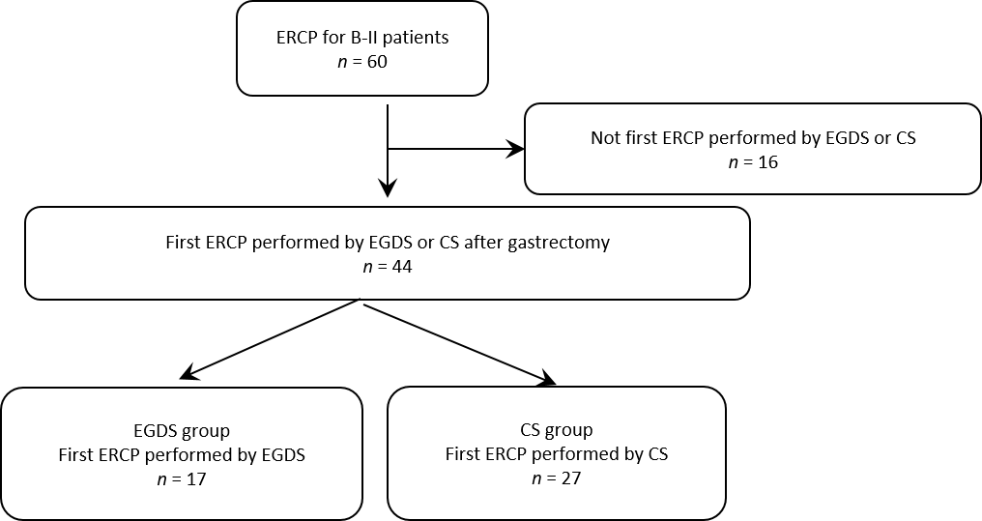
Figure 1 Target of this study. In all, 60 cases of endoscopic retrograde cholangiopancreatography (ERCP) after Billroth II were performed. Among them, 44 cases were first procedures performed by esophagogastroduodenoscopy (EGDS) or colonoscopy (CS) after gastrectomy. Seventeen patients who underwent the first ERCP procedure by EGDS were included in the EGDS group. Twenty-seven patients who underwent the first ERCP procedure by CS were included in the CS group. ERCP: Endoscopic retrograde cholangiopancreatography; EGDS: Esophagogastroduodenoscopy; CS: Colonoscopy; B II: Billroth II.

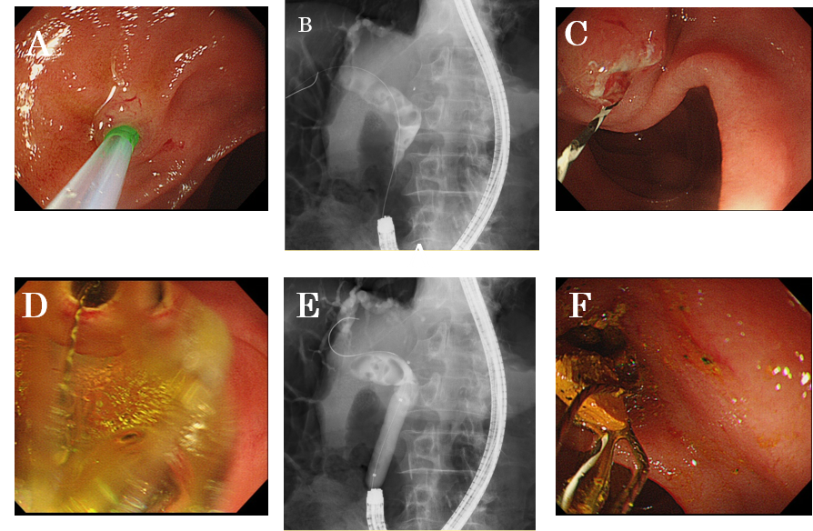
Figure 2 A case from the esophagogastroduodenoscopy group. A: After the papilla was positioned at 11 o’clock, biliary cannulation was performed; B: Common bile duct stones were confirmed by cholangiography; C and D: Endoscopic sphincterotomy and endoscopic papillary large balloon dilation were performed; E and F: Common bile duct stones were removed.

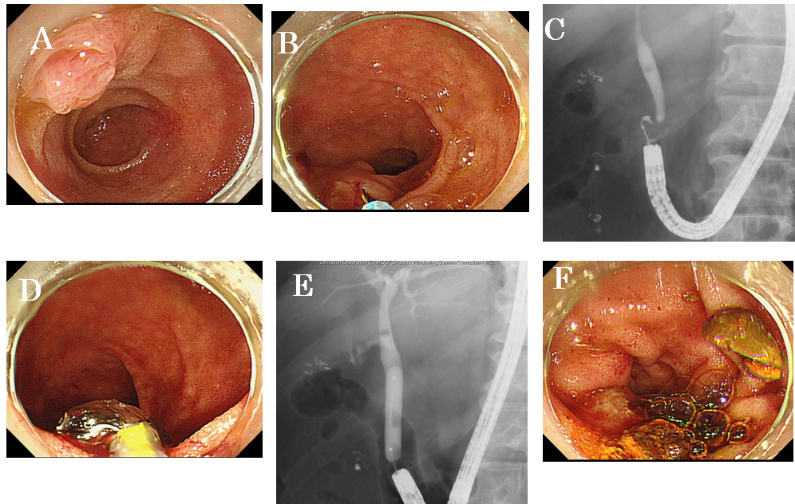
Figure 3 A case from the colonoscopy group. A: The papilla of Vater was difficult to observe in the front; B: The papilla was positioned at 6 o’clock; C: A common bile duct stone was confirmed by cholangiography; D and E: Endoscopic papillary large balloon dilation was performed after endoscopic sphincterotomy; and F: Common bile duct stones were removed.

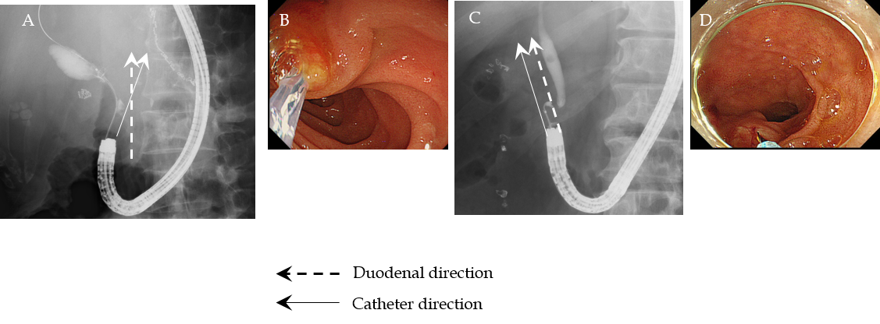
Figure 4 The duodenal and catheter directions in esophagogastroduodenoscopy and colonoscopy groups. A and B: The duodenal direction and catheter direction crossed when endoscopic retrograde cholangiopancreatography was performed by esophagogastroduodenoscopy; C and D: The duodenal direction and catheter direction ran parallel in endoscopic retrograde cholangiopancreatography when colonoscopy was performed.

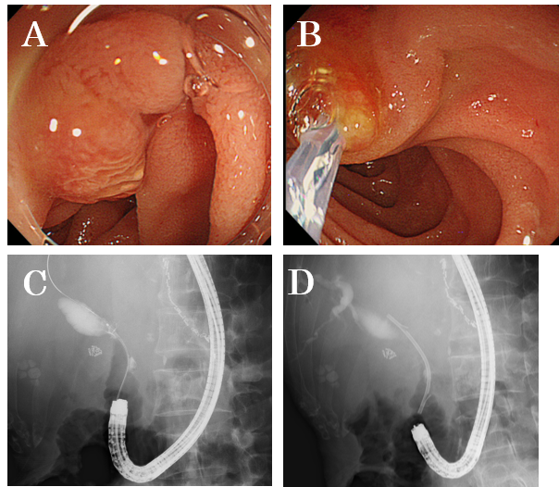
Figure 5 A case of treatment that was not successful by colonoscopy was successful by esophagogastroduodenoscopy. A: Cannulation to the papilla of Vater was not achieved because the papilla was difficult to observe in the front by colonoscopy; B: The papilla was observed in front by esophagogastroduodenoscopy, and cannulation was achieved; C: A common bile duct stricture caused by pancreatic cancer was observed by cholangiography; and D: A biliary stent was inserted.

Table 1 Comparison of patient characteristics between the esophagogastroduodenoscopy and colonoscopy groups
 | EGDS group (n = 17) | CS group (n = 27) | P value
Age (yr, mean ± SD) | 75.2 ± 13.0 | 75.7 ± 13.0 | 0.88
Sex, male/female | 15/2 | 22/5 | 0.69
Period after B-II reconstruction (yr, mean ± SD) | 36.8 ± 13.8 | 36.8 ± 13.8 | 1.0
Diseases treated with B-II reconstruction
Gastric ulcer, n | 10 | 11
Duodenal ulcer, n | 3 | 9
Gastric cancer, n | 2 | 4
Pyloric stenosis, n | 1 | 1
Gastric ptosis, n | 1 | 1
Unknown, n |  | 1
Untreated papilla of Vater, n (%) | 15 (88.2) | 27 (100) | 0.14
Antithrombotic drugs, n (%) | 2 (11.8) | 5 (18.5) | 0.69
Periampullary diverticulum, n (%) | 1 (5.9) | 3 (11.1) | 1.0
Disease, n
Bile duct stone | 11 | 20 | 0.52
Others | 6 | 7
Biliary ductal cancer | 3 | 2
Pancreatic cancer | 1 | 3
Chronic pancreatitis | 1 | 1
Benign biliary stricture | 1 | 1
Transverse diameter of the largest stone (mm, mean ± SD) | 10.2 ± 4.8 | 12.2 ± 3.8 | 0.24
Number of stones [n, median (range)] | 4 (1 - 30) | 2 (1 - 6) | 0.18
EGDS: Esophagogastroduodenoscopy; CS: Colonoscopy; B-II: Billroth II.
Table 2 Comparison of endoscopic retrograde cholangiopancreatography procedural characteristics between the esophagogastroduodenoscopy and colonoscopy groups
 | EGDS group (n = 17) | CS group (n = 27) | P value
EST, n (%) | 7 (41.2) | 19 (70.4) | 0.07
EPBD or EPLBD, n (%) | 6 (35.3) | 13 (48.1) | 0.54
Procedural time [min, median (range)] | 60 (20-100) | 90 (40-128) | < 0.01
Papilla of Vater access, n (%) | 14 (82.4) | 25 (92.6) | 0.36
Stone clearance, n (%) | 6/11 (54.5) | 8/19 (42.1) | 1.0
Stone destruction, n (%) | 3/11 (27.3) | 6/19 (31.6) | 1.0
Procedural success, n (%) | 14 (82.4) | 17 (63.0) | 0.20
Adverse events, n (%) | 0 (0) | 0 (0)
PEP, n (%) | 0 (0) | 0 (0)
EST: Endoscopic sphincterotomy; EPBD: Endoscopic papillary balloon dilation; EPLBD: Endoscopic papillary large balloon dilation; PEP: Post endoscopic retrograde cholangiopancreatography pancreatitis; CS: Colonoscopy.
Table 3 Factors influencing the endoscopic retrograde cholangiopancreatography procedural time
 |  | Univariate analysis |  |  | Multivariate analysis
 | Procedural time ≥ 70 min, n (yes/no) | OR | 95%CI | P value | OR | 95%CI | P value
Age ≥ 76 yr | 13/9 | 2.09 | 0.63–6.94 | 0.23
Sex, male | 17/20 | 0.34 | 0.06–1.98 | 0.23
Period after B-II reconstruction ≥ 40 | 11/11 | 1.0 | 0.31–3.26 | 1.0
Untreated papilla of Vater | 21/21 | 1.0 | 0.06–17.1 | 1.0
Antithrombotic drug use | 3/4 | 0.71 | 0.14–3.63 | 0.68
Periampullary diverticulum | 1/3 | 0.30 | 0.03–3.15 | 0.32
Bile duct stone | 15/16 | 0.8 | 0.22–2.94 | 0.74
Transverse diameter of largest stone ≥ 12.2 mm | 7/8 | 0.77 | 0.18–3.21 | 0.72
Number of stones ≥ 2 | 10/7 | 2.29 | 0.52–10.0 | 0.27
CS group | 17/10 | 4.08 | 1.11–5.0 | 0.035 | 3.97 | 1.05–15.0 | 0.04
EST | 14/12 | 1.46 | 0.44–4.88 | 0.54
EPBD or EPLBD | 10/9 | 1.20 | 0.37–3.97 | 0.76
Papilla of Vater access | 20/19 | 1.58 | 0.24–10.5 | 0.64
Stone clearance | 8/8 | 1.0 | 0.24–4.2 | 1.0
Stone destruction | 6/3 | 2.67 | 0.52–13.7 | 0.24
Procedural success | 15/19 | 0.34 | 0.07–1.54 | 0.16 | 0.36 | 0.07–1.74 | 0.2
EST: Endoscopic sphincterotomy; EPBD: Endoscopic papillary balloon dilation; EPLBD: Endoscopic papillary large balloon dilation; CS: Colonoscopy; B-II: Billroth II.
Table 4 The upper bending angle of esophagogastroduodenoscopy was greater than that of colonoscopy
 | EGDS group | CS group | P value
 | GIF-Q240X | PCF-Q260AI/AL
 | GIF-Q260 | PCF-PQ260L
 | GIF-Q260J | SIF-Q260
Upper bending angle (degree) | 210 | 180
Duodenal direction and catheter direction (cross/parallel)¹ | 11/3 | 8/15 | 0.02
Observation of papilla of Vater in the front, n (%)² | 11 (78.6) | 1 (3.8) | < 0.01
The duodenal and catheter directions crossed more frequently in the esophagogastroduodenoscopy group than in the Colonoscopy group. The observation of the papilla of Vater papilla could easily be achieved by esophagogastroduodenoscopy. ¹The cases with unsuccessful biliary cannulation were excluded. ²The cases with unsuccessful papilla of Vater identification were excluded. EGDS: Esophagogastroduodenoscopy; CS: Colonoscopy.

