Name of Journal: World Journal of Gastroenterology
ESPS Manuscript NO: 21032
Manuscript Type: Topic Highlights

2015 Advances in Colorectal Cancer

Dealing with robot-assisted surgery for rectal cancer: current status and perspectives

Roberto B et al. Robotic surgery for rectal cancer

Biffi Roberto, Luca Fabrizio, Bianchi Paolo Pietro, Cenciarelli Sabina, Petz Wanda, Monsellato Igor, Valvo Manuela, Cossu Maria Laura, Ghezzi Tiago Leal, Shmaissany Kassem

Biffi Roberto, Luca Fabrizio, Bianchi Paolo Pietro, Cenciarelli Sabina, Petz Wanda, Monsellato Igor, Valvo Manuela, Cossu Maria Laura, Ghezzi Tiago Leal, Shmaissany Kassem, Department of Gastrointestinal surgery, European Institute of Oncology, 20141 Milan, Italy

Author contributions: Roberto B, Fabrizio L, Pietro BP, Sabina C, Wanda P, Igor M and Manuela V substantially contributed to conception and design of the study, acquisition of data, or analysis and interpretation of data; Roberto B, Fabrizio L, Pietro BP, Laura cm, Leal GT and Kassem s contributed to drafting the article or making critical revisions related to important intellectual content of the manuscript; Roberto B and Kassem S final approved the version of the article to be published.

Conflict-of-interest statement: Authors declare they have no conflicting interests to disclose, related to the work they have submitted for consideration of publication.

Open-Access: This article is an open-access article which was selected by an in-house editor and fully peer-reviewed by external reviewers. It is distributed in accordance with the Creative Commons Attribution Non Commercial (CC BY-NC 4.0) license, which permits others to distribute, remix, adapt, build upon this work non-commercially, and license their derivative works on different terms, provided the original work is properly cited and the use is non-commercial. See: http://creativecommons.org/licenses/by-nc/4.0/

Correspondence to: Biffi Roberto, MD, FSPS, Medical Director, Department of Gastrointestinal surgery, European Institute of Oncology, Via G.Ripamonti 435, 20141, Milan, Italy. roberto.biffi@ieo.it
Telephone: +39-2-57489710
Fax: +39-2-94379215

Received: June 28, 2015
Peer-review started: July 1, 2015
First decision: July 20, 2015
Revised: September 8, 2015
Accepted: November 13, 2015
Article in press:
Published online:

Abstract
The laparoscopic approach for treatment of rectal cancer has been proven feasible and oncologically safe, and is able to offer better short-term outcomes than traditional open procedures, mainly in terms of reduced length of hospital stay and time to return to working activity. In spite of this, the laparoscopic technique is usually practised only in high-volume experienced centres, mainly because it requires a prolonged and demanding learning curve. It has been estimated that over 50 operations are required for an experienced colorectal surgeon to achieve proficiency with this technique. Robotic surgery enables the surgeon to perform minimally invasive operations with better vision and more intuitive and precise control of the operating instruments, thus promising to overcome some of the technical difficulties associated with standard laparoscopy. It has high-definition three-dimensional vision, it translates the surgeon’s hand movements into precise movements of the instruments inside the patient, the camera is held and moved by the first surgeon, and a fourth robotic arm is available as a fixed retractor. The aim of this review is to summarise the current data on clinical and oncologic outcomes of robot-assisted surgery in rectal cancer, focusing on short- and long-term results, and providing original data from the authors’ centre.

Key words: Rectal cancer; Robotic total mesorectal excision; Robotic surgery; Robotic resection; Circumferential resection margin; Lymph node yield; Distal resection margin positivity

© The Author(s) 2015. Published by Baishideng Publishing Group Inc. All rights reserved.

Core tip: The aim of this review is to summarise the current data on clinical and oncologic outcomes of robot-assisted surgery in rectal cancer, focusing on short- and long-term results, and providing original data from the authors’ centre. A detailed review of this topic is provided, including the most recent findings of prospective studies. Future perspectives are also analyzed.

Roberto B, Fabrizio L, Pietro BP, Sabina C, Wanda P, Igor M, Manuela V, Laura CM, Leal GT, Kassem S. Dealing with robot-assisted surgery for rectal cancer: current status and perspectives. World J Gastroenterol 2015; In press

INTRODUCTION
The optimization of surgical technique with the introduction of total mesorectal excision (TME)^{[1,2]} was a main innovation for the treatment of rectal cancer, together with the introduction of multimodal preoperative chemo-radiation therapy for locally advanced stage disease.
In some series, correctly-performed TME surgery has been demonstrated to decrease the rate of local recurrence to less than 10%, when compared to conventional dissection^{[3]}, and TME surgery, preceded by neoadjuvant chemo-radiation, emerged as the standard treatment for locally advanced rectal cancer^{[4]}, Figure 1.
Laparoscopic colectomy has proven to be a feasible and oncologically safe procedure with an increasing diffusion, but minimally-invasive TME is still less adopted, because of its technical difficulties. The percentage of conversions to open surgery remains quite high, confirming the technical difficulties of the procedure and also the necessity of an accurate selection of patients^{[5-8]}.
The general opinion in the oncologic surgical community is that LTME (Laparoscopic Total Mesorectal Excision) is a difficult operation to master, and has been associated with learning curves as high as 50-150 cases to achieve consistent results^{[9]}.
In the United States, laparoscopic rectal resection did not make up 20% of the overall rectal resections and its conversion rate to open surgery is still high (46.2%), without any significant improvement in recent years^{[10]}.For this reason, still in 2012, the National Comprehensive Cancer Network guidelines for treatment in rectal cancer recommended the use of laparoscopy for rectal cancer treatment only within a study protocol and in highly specialized centers^{[4]}. It is therefore commonly believed that TME as originally proposed by Heald is per se a technically demanding operation^{[4]}, and that the addition of laparoscopic technique seems to increase these technical difficulties.
Robotic surgery has emerged as a new technique that might overcome some difficulties of the standard laparoscopic approach in the pelvis, providing magnified three-dimensional optics, surgeon-controlled camera vision, working arms allowing very stable retraction and unparalleled ergonomics of instrument motion, with much less fatigue for the surgeon. These are all the rational reasons for its increasing use in rectal cancer, with the addition of a reduced learning curve, if compared with the traditional laparoscopy procedure^{[11-13]}.
Recently, our group and others demonstrated that robot-assisted tumor-specific mesorectal excision for rectal cancer was technically feasible and a safe surgical option in terms of the long-term oncologic outcomes^{[14,15]}, while results of randomized trials are awaited to provide concrete evidence for this approach.
This review summarizes the current status of robotic TME (RTME), in addition to experience and notes from the authors’ institution and future perspectives of this topic

Robotic TME – review of current status: Short and long-term outcomes
The results so far available on RTME are quite limited, as they mainly originate from single-center experiences (usually from academic high-volume centers) and few from large prospective studies, all contributing to the assumption that RTME is a safe and effective procedure. A variety of approaches - both totally robotic and hybrid procedures performing part of the operation laparoscopically - have been used, but in all patients the TME was performed as entirely robotic procedure^{[15-22]}.
Our group first proposed with others a full robotic technique to perform RTME, with preliminary good quality results^{[23]}. In this study we described a method that standardizes robot and trocar position, and allows for a complete mobilization of the left colon and the rectum, without repositioning of the surgical cart, Figures 2 and 3.
A total of 55 consecutive patients affected by rectal and left colon cancer were operated on, with full robotic technique, using the Da Vinci robot. The following procedures were performed: 27 left colectomies, 17 anterior resections, 4 intersphincteric resections, 7 abdominoperineal resections. There were 21 female and 34 male patients with a mean age of 63 ± 9.9 years. Mean operative time was 290 ± 69 min, ranging from 164 to 487 min. None were converted to open surgery. The median number of lymph nodes harvested was 18.5 ± 8.3 (range 5-45), and circumferential margin was negative in all cases. Distal margin was 25.15 ± 12.9 mm (range 6-55) for patients with rectal cancer, and 31.6 ± 20 mm for all the patients in this series. Anastomotic leak rate was 12.7% (7/55); in all cases conservative treatment was successful.
We could conclude that full robotic colorectal surgery is a safe and effective technique that exploits the advantages of the Da Vinci robot during the whole intervention, without the need to make use of hybrid operations, Figure 4. Outcome and pathology findings are comparable with those observed in open and laparoscopy procedures.
Few studies have compared robotic surgery to standard treatment of open resection, and in these studies robotic surgery resulted oncologically safe in terms of length of specimen, resection margins, and number of lymph nodes harvested^{[24,25]}. As robotic views of the operating field during RTME procedures require a relatively bloodless field, robotic resection might be expected to lead to less operative blood loss than open conventional rectal surgery. This has some interest for clinicians, as it has been reported that allogenic blood transfusion might be associated with an increased risk of tumor recurrence after colorectal cancer surgery^{[26]}. Studies of blood loss after open rectal cancer surgery have had variable results, with rates of perioperative transfusions ranging from 20% to 75%^{[27]}. To date, some studies have reported estimated blood loss (EBL) after RTME^{[28,29]}, but no study has investigated this topic as a case-matched model, comparing open and robotic approaches. A study from our group compared blood loss as measured by EBL, mean drop in hemoglobin levels with surgery, and blood product use in patients undergoing open and robotic TME in different periods of time at the same institution, maintaining the same guidelines for transfusion in the postoperative period^{30]}. Briefly, forty-nine patients in the RTME and 105 in the OTME group were matched for age, gender, BMI (body mass index), ASA (American Society of Anesthesiology) class, tumor–node–metastasis (TNM) classification and UICC (Union for International Cancer Control) stage, distance of the lower edge of the tumor from the anal verge, presence of co morbidities, and preoperative hemoglobin (Hb). EBL was significantly higher in the open group (P < 0.001); twelve units of packed red blood cells were globally transfused in the open group, compared to one unit only in the robotic one (P = 0.051). A significantly higher postoperative Hb drop (3.0 vs 2.4 g/dL, P = 0.015) was registered in the OTME patients. The length of hospital stay was much lower for the RTME group (8.4 vs 12.4 d, P = 0.001). The number of harvested lymph nodes (17.4 vs 13.5, P = 0.006) and extent of distal margin (2.9 vs 1.9 cm, P = 0.001) were significantly higher in the RTME group. Open surgery was confirmed as the sole variable significantly associated (P = 0.001) with blood loss (OR = 4.41, 95%CI: 2.06–9.43). It was a confirmed prognosticator of blood loss (P = 0.006) when a preoperative clinical predictive model was built, using multivariate analysis (OR = 3.95, 95%CI: 1.47–10.6). In conclusion, RTME produced less operative blood loss and less drop in postoperative hemoglobin when compared to OTME. Other clinically relevant outcomes were similar or superior to OTME, Table 1.
The evidence for the equivalence of LTME and the open approach (OTME) for rectal cancer surgery was provided by the findings of a couple of multicenter randomized controlled trial, the MRC CLASICC (Medical Research Council Conventional vs Laparoscopic-Assisted Surgery In Colorectal Cancer ) trial^{[30-32]} and the COREAN trial (Comparison of Open vs laparoscopic surgery for mid and low REctal cancers After Neoadjuvant chemoradiotherapy)^{[33]}, both comparing laparoscopy to open surgery in rectal cancer. Subgroup ex-post analysis of CLASICC Trial revealed oncologic outcomes of LTME to be equal to those of open TME, with a substantial limitation for LTME represented by a high conversion rate to open surgery of 34%, and an increased radial margin positivity rate of 12% in the laparoscopic arm, compared to 4% in the open arm, though this did not translate into an increase in recurrence rate or worse overall survival^{[34]}. In the COREAN Trial the conversion rates and CRM positivity were very low, as compared to the CLASICC study. Although participating surgeons had greater experience in laparoscopic surgery than did surgeons participating in the CLASICC trial, the differences in percentage of CRM positivity were similar in the two groups: 4.1% in the open group and 2.9% in the laparoscopic group, Table 2^{[35]}.
It is important to underline that the surgeons in the COREAN study were highly experienced, with a median case load of 75 cases before the trial and that the trial was performed by only three highly trained surgeons as against a mean case load of only 20 colorectal operations in the MRC study and multiple participating centers. The most recently published COLOR II study^{[36]}, also comparing laparoscopic to open surgery in rectal resections, did not reveal any significant difference between the two procedures in terms of morbidity, mortality, and complication rates, and confirmed the benefits of the minimally invasive approach as less blood loss, more rapid recovery of bowel function, and shorter hospital stay. Although the participating surgeons were all experts in laparoscopic surgery, the conversion rate to open surgery was still high (16%), confirming the technical challenges of laparoscopic TME.
Recently, some meta-analyses comparing robotic and laparoscopy TME have been already published, despite the lack of evidence^{[37-41]}. In all of these studies, the only significant data was that robotic surgery resulted in a lower percentage of conversion to open surgery, compared to the laparoscopic groups. Regarding short-term clinical and oncologic outcomes, no significant differences were found between laparoscopy and robotic surgery, Tables 3-5^{[42]} showed that RTME in the treatment of mid or low rectal cancer was associated with decreased analgesia use, less postoperative pain, and a shorter hospital stay. Recently, Park et al^{[43]} furthermore reported that the rate of conversion was significantly lower for RTME than LTME (0.0% vs 7.1%, P = 0.003). Similarly, the short-term outcomes from two meta-analyses revealed that RTME was associated with a significantly lower conversion rate and equivalent oncologic adequacy compared with LTME^{[44]}.
The only published randomized data from a pilot study comparing laparoscopic and robotic TME with 18 patients in each arm, found no difference in operative time, conversion rates or pathologic quality of the specimen^{[45]}. A statistically significant shorter hospital stay was however found favouring the robotic arm (Standard laparoscopic arm, 8.7 ± 1.3 d; robotic assisted arm 6.9 ± 1.3 d; P < 0.001). There are at present a number of publications involving systematic reviews and case matched series, which show equivalent clinical and oncologic outcomes. The meta-analysis by Trastulli which focused on short-term outcomes revealed a markedly lower conversion rate in the Robotic arm (2% vs 7.5%, P = 0.0007) with operative time, lymph node harvest, CRM positivity rate and anastomotic leak rates being similar. Another large meta-analysis by Xiong et al^{[44]} showed statistically significant lower CRM positivity and conversion rates favouring the robotic approach with operative times and local recurrence rates remaining similar. Long-term outcomes (3 year) expressed as disease-free survivals are between 73.7% and 79.2%, whereas overall survivals range between 92% and 97% (Table 6).
Randomized clinical trials such as the COLRAR trial (NCT01423214) and ROLARR trial (NCT01196000) are currently ongoing to clarify this issue, and more objective data may be obtained from these clinical trials in the future.
Our own data on long-term results are synthetized in a recent case-control paper, that provided long-term oncologic results; perioperative outcomes were comparable to open surgery, with a significantly decreased blood loss, while long term oncologic outcomes were equivalent especially with reference to mesorectal grade, CRM positivity, lymph node yield and disease free and overall survival. We however found a significant reduction in local recurrence rate and a higher, though not statistically significant long-term cancer specific survival in the RTME group Figure 5^{[40]}.

Genitourinary Function After Robotic TME
This is an important aspect of Robotic TME, as better visualization of the autonomic plexii in the pelvis could translate into better preservation of genitourinary function as assessed by erectile dysfunction and voiding function. Although the introduction of TME has resulted in improved genitourinary functional preservation, most colorectal surgeons are still faced with challenging conditions such as injuries to the hypogastric nerves and/or the sacral splanchnic nerve during pelvic dissection^{[46]}. As a matter of fact, the MRC CLASICC trial showed a trend towards increased sexual dysfunction in the laparoscopic arm in comparison to the open group^{[31]}. Theoretically, the use of a robotic system can decrease the risk of collateral injury to the pelvic autonomic nerves. However, there are currently only limited studies evaluating the impact of robotic technology on urogenital complications after TME. Thus, whether these theoretical advantages of R-TME translate into significant favorable urogenital function still remains to be determined. Comparison of robotic and laparoscopicroups in the study by Kim et al^{[47]} showed decreased sexual desire and voiding function in both groups one month after surgery with more rapid and complete recovery of both parameters in the robotic group; this is possibly due to a more delicate operation with the robotic apparatus.
Another study on 60 patients (males only) reported a quicker and complete recovery of erectile function in the robotic group and partially in the laparoscopy-treated group^{[48]}.
Our group found better preservation of voiding and sexual function in both genders with robotic TME in comparison with open and laparoscopic TME as provided by the literature, with complete recovery of both functions one year after surgery^{[49]}. A total of 74 patients undergoing fully robotic resection for rectal cancer were prospectively included in this study. Urinary and sexual dysfunctions affecting quality of life were assessed with specific self-administered questionnaires in all patients undergoing robotic RTME. The analyses of the questionnaires completed by the 74 patients who underwent RTME showed that sexual function and general sexual satisfaction decreased significantly one month after intervention for erectile function and for general satisfaction in men, and for arousal and general satisfaction, respectively, in women. Subsequently, both parameters increased progressively, and one year after surgery, the values were comparable to those measured before surgery. Concerning urinary function, the grade of incontinence measured one year after the intervention was unchanged for both sexes. We could conclude that RTME allows for preservation of urinary and sexual functions. This is probably due to the superior movements of the wristed instruments that facilitate fine dissection, coupled with a stable and magnified view that helps in recognizing the inferior hypogastric plexus. Clearly, all these findings need confirmation by larger randomized studies (Table 7).

Cost Issues
One of the main concerns about robotic technology is the high costs of purchase and maintenance of the equipment. Robotic surgery is more expensive than laparoscopic or open surgery for a number of reasons, including the fixed costs of purchase and maintenance which have to be amortized, the increased operative time and the cost of consumable items, as instruments have limited lifespan and need to be changed. In addition, the da Vinci surgical system (Intuitive surgical Inc, Sunnyvale CA, United States) is the only surgical robot currently available for use. The lack of competition may be a factor keeping costs static and high today.
Baek et al^{[50]} showed increased costs in robotic rectal resection compared to those in the standard laparoscopic procedure, with a significantly lower hospital profit in the robotic group. Similarly, one study of our group demonstrated that robotic surgery was much more expensive in comparison to open as well as laparoscopic procedures, overall morbidity rates being similar among groups and perioperative mortality nil^{[51]}.
Operative time is a critical issue when studying outcomes of robotic rectal surgery because it decreases the number of procedures that can be performed and drives up the operating room costs. Operative times are related to some extent to the learning curves and with increasing surgeon and institution volumes the gulf between robotic and laparoscopic colorectal procedure times is steadily decreasing. D’Annibale et al^{[48]}, published their experience showing no difference in total operating times between laparoscopic and robotic groups, though patient preparation and operating room times were prolonged in the robotic group^{[52]}. They found that the time added in robotic docking was balanced by faster, more accurate dissection due to use of the robot. Standardization of the procedure, consistency of surgical-nursing teams, and incremental increase in surgeon experience and volumes all have the potential to decrease operative time.
Cost needs to be weighed against parameters such as shorter length of stay and oncologic outcomes. Without robust randomized data however, cost continues to remain an issue especially in systems where robotic surgery is paid on par with laparoscopic surgery. The additional cost is borne either by the hospital or the patient and does not make for a good economic model. Another emerging problem in the costs’ evaluation is the appropriate use of the technology by low volume centers/surgeons; in fact a higher number of complications are reported by Keller et al^{[52]} in the low volume users when compared to middle- and high-volume centers and surgeons.
One modifiable factor, which can decrease this cost, is an increase in the annual caseload of robotic procedures, which reduces the amortized costs of the robot and the annual maintenance per procedure^{[53]}. Having a consistent team of surgeons, perioperative nurses and scrub personnel also reduces setup times markedly, as shown by Hanly et al^{[54]}, who demonstrated reduced setup times by 29.2% and 56.1% on the second and third robotic setups respectively.

CONCLUSION
In conclusion, robotic total mesorectal excision has several benefits in the treatment of rectal cancer, especially in technically demanding cases such as narrow male pelvis and very low located huge tumours. Therefore, a robot-assisted technique should be part of the armamentarium of the experienced surgeon dealing with this disease. The intraoperative ergonomics are superbly facilitated by excellent vision and manoeuvrability, and this translates into a more reproducible operation, which could be an advantage for teaching and tutoring. While cost remains an issue, as with laparoscopy costs are expected to decrease with time, especially in a multispecialty setup where multiple departments are using the robot^{[55]}. Operative time is still higher than that in the laparoscopic approach, but it rapidly decreases with experience and is likely to be less of an issue once advanced platforms that permit multiquadrant surgery without the need for re-docking are more widely available.
A couple of very recent studies - comparing robot assisted and laparoscopy TME - added more data to the conclusion that robotic surgery for rectal cancer failed so far to offer any oncologic or clinical benefits as compared with laparoscopy, despite an increased cost. The first study analyzed 217 patients enrolled prospectively, who underwent minimally invasive surgery for rectal cancer with stage I-III disease (robot, n = 133; laparoscopy, n = 84). Perioperative clinicopathologic outcomes demonstrated no significant differences, except for the conversion rate and length of hospital stay. No significant differences were found in the 5-year overall, disease-free survival and local recurrence rates between robotic and laparoscopic surgical procedures^{[43]}.
The second is a case-matched study aimed at comparing the postoperative complications and short- and long-term outcomes of RTME and LTME for rectal cancer. Authors identified 278 rectal cancer patients who underwent RTME; a propensity score matching was used to match this group with 278 patients who underwent LTME. The conversion rate, length of hospital stay, and recovery of pain and bowel motility were similar between both groups. The rates of circumferential resection margin involvement and early complications were similar between both groups (L-TME vs R-TME: 4.7% vs 5.0%, P = 1.000; and 23.7% vs 25.9%, P = 0.624, respectively), as were the 5-year overall survival, disease-free survival, and local recurrence rates (93.1% vs 92.2%, P = 0.422; 79.6% vs 81.8%, P = 0.538; 3.9% vs 5.9%, P = 0.313, respectively)^{[56]}. This study showed that RTME was significantly associated with a much lower incidence of late voiding dysfunction than LTME (0.7% vs 4.3%, P = 0.012).
Both these studies are not randomized, and most conclusions should be taken with caution. In addition, sexual adverse effects were not here investigated.
The ROLARR Trial (Robotic assisted vs laparoscopic assisted resection for rectal cancer) is an international multicenter prospective, controlled, unblended, parallel group superiority trial of robotic-assisted vs standard laparoscopic surgery for the curative treatment of rectal cancer, which randomized > 200 patients in each arm^{[57]}.
Initial results of ROLARR trial were presented at the ASCRS conference in Boston on 1st June 2015 and again at the EAES conference in Bucharest on 6th June. These results included analysis of data up to 30 days post operatively, including the primary endpoint of conversion to open surgery, CRM positivity and safety data up to 30 days post operatively. These data did not show any statistically significant differences between the arms (laparoscopy and robot-assisted surgery) with respect to a number of variables. Here the most relevent conclusions are listed: Observed conversion rate lower following robotic surgery, but no statistically significant evidence of superiority compared to laparoscopic surgery. In a subgroup analysis, a possible benefit in males, low anterior resection and obese patients was found, but this requires further research to be confirmed. Among the secondary end-points, similar rates in CRM positivity were observed, as well as rates of 30-d complications and mortality (Personal communication from Dr D. Jayne).
Although the results available on robotic surgery are still few, robotic assistance seems to reduce the percentage of conversions to open surgery among expert surgeons and is promising as a method to attenuate the learning curve of a well-conducted TME^{[58-63]}. At the moment, the robotic system has higher costs than laparoscopy and its use should be planned within a clearly defined educational program, preferably in a hospital conducting high volumes of minimally invasive colorectal procedures, in order to avoid an increase in complication rates and related costs.

Acknowledgments
The authors gratfully thank Darina Tamayo, MSC and Claudia Crescio, MSC for their activity and support in data management.

References
1 Heald RJ, Husband EM, Ryall RD. The mesorectum in rectal cancer surgery--the clue to pelvic recurrence? Br J Surg 1982; 69: 613-616 [PMID: 6751457 DOI: 10.1002/bjs.1800691019]
2 Heald RJ, Ryall RD. Recurrence and survival after total mesorectal excision for rectal cancer. Lancet 1986; 1: 1479-1482 [PMID: 2425199 DOI: 10.1016/S0140-6736(86)91510-2]
3 Allaix ME, Fichera A. Modern rectal cancer multidisciplinary treatment: the role of radiation and surgery. Ann Surg Oncol 2013; 20: 2921-2928 [PMID: 23604783]
4 NCCN Clinical Practice Guidelines on Oncology (NCCN Guidelines). Rectal Cancer. Version 3. (2012). Available from: URL: http://www.NCCN.org
5 Siegel R, Cuesta MA, Targarona E, Bader FG, Morino M, Corcelles R, Lacy AM, Påhlman L, Haglind E, Bujko K, Bruch HP, Heiss MM, Eikermann M, Neugebauer EA. Laparoscopic extraperitoneal rectal cancer surgery: the clinical practice guidelines of the European Association for Endoscopic Surgery (EAES). Surg Endosc 2011; 25: 2423-2440 [PMID: 21701921]
6 Laurent C, Leblanc F, Wütrich P, Scheffler M, Rullier E. Laparoscopic versus open surgery for rectal cancer: long-term oncologic results. Ann Surg 2009; 250: 54-61 [PMID: 19561481 DOI: 10.1097/SLA.0b013e3181ad6511]
7 Huang MJ, Liang JL, Wang H, Kang L, Deng YH, Wang JP. Laparoscopic-assisted versus open surgery for rectal cancer: a meta-analysis of randomized controlled trials on oncologic adequacy of resection and long-term oncologic outcomes. Int J Colorectal Dis 2011; 26: 415-421 [PMID: 21174107 DOI: 10.1007/s00384-010-1091-6]
8 Ng SS, Lee JF, Yiu RY, Li JC, Hon SS, Mak TW, Leung WW, Leung KL. Long-term oncologic outcomes of laparoscopic versus open surgery for rectal cancer: a pooled analysis of 3 randomized controlled trials. Ann Surg 2014; 259: 139-147 [PMID: 23598381 DOI: 10.1097/SLA.0b013e31828fe119]
9 Kayano H, Okuda J, Tanaka K, Kondo K, Tanigawa N. Evaluation of the learning curve in laparoscopic low anterior resection for rectal cancer. Surg Endosc 2011; 25: 2972-2979 [PMID: 21512883 DOI: 10.1007/s00464-011-1655-8]
10 Kang CY, Halabi WJ, Luo R, Pigazzi A, Nguyen NT, Stamos MJ. Laparoscopic colorectal surgery: a better look into the latest trends. Arch Surg 2012; 147: 724-731 [PMID: 22508667]
11 Bokhari MB, Patel CB, Ramos-Valadez DI, Ragupathi M, Haas EM. Learning curve for robotic-assisted laparoscopic colorectal surgery. Surg Endosc 2011; 25: 855-860 [PMID: 20734081 DOI: 10.1007/s00464-010-1281-x]
12 Akmal Y, Baek JH, McKenzie S, Garcia-Aguilar J, Pigazzi A. Robot-assisted total mesorectal excision: is there a learning curve? Surg Endosc 2012; 26: 2471-2476 [PMID: 22437950 DOI: 10.1007/s00464-012-2216-5]
13 Kim YW, Lee HM, Kim NK, Min BS, Lee KY. The learning curve for robot-assisted total mesorectal excision for rectal cancer. Surg Laparosc Endosc Percutan Tech 2012; 22: 400-405 [PMID: 23047381 DOI: 10.1097/SLE.0b013e3182622c2d]
14 Ghezzi TL, Luca F, Valvo M, Corleta OC, Zuccaro M, Cenciarelli S, Biffi R. Robotic versus open total mesorectal excision for rectal cancer: comparative study of short and long-term outcomes. Eur J Surg Oncol 2014; 40: 1072-1079 [PMID: 24646748 DOI: 10.1016/j.ejso.2014.02.235]
15 Pigazzi A, Luca F, Patriti A, Valvo M, Ceccarelli G, Casciola L, Biffi R, Garcia-Aguilar J, Baek JH. Multicentric study on robotic tumor-specific mesorectal excision for the treatment of rectal cancer. Ann Surg Oncol 2010; 17: 1614-1620 [PMID: 20087780 DOI: 10.1245/s10434-010-0909-3]
16 Hellan M, Anderson C, Ellenhorn JD, Paz B, Pigazzi A. Short-term outcomes after robotic-assisted total mesorectal excision for rectal cancer. Ann Surg Oncol 2007; 14: 3168-3173 [PMID: 17763911 DOI: 10.1245/s10434-007-9544-z]
17 Baik SH, Kwon HY, Kim JS, Hur H, Sohn SK, Cho CH, Kim H. Robotic versus laparoscopic low anterior resection of rectal cancer: short-term outcome of a prospective comparative study. Ann Surg Oncol 2009; 16: 1480-1487 [PMID: 19290486 DOI: 10.1245/s10434-009-0435-3]
18 Choi DJ, Kim SH, Lee PJ, Kim J, Woo SU. Single-stage totally robotic dissection for rectal cancer surgery: technique and short-term outcome in 50 consecutive patients. Dis Colon Rectum 2009; 52: 1824-1830 [PMID: 19966627 DOI: 10.1007/DCR.0b013e3181b13536]
19 Baek JH, McKenzie S, Garcia-Aguilar J, Pigazzi A. Oncologic outcomes of robotic-assisted total mesorectal excision for the treatment of rectal cancer. Ann Surg 2010; 251: 882-886 [PMID: 20395863 DOI: 10.1097/SLA.0b013e3181c79114]
20 Baik SH, Kim NK, Lim DR, Hur H, Min BS, Lee KY. Oncologic outcomes and perioperative clinicopathologic results after robot-assisted tumor-specific mesorectal excision for rectal cancer. Ann Surg Oncol 2013; 20: 2625-2632 [PMID: 23417433 DOI: 10.1245/s10434-013-2895-8]
21 deSouza AL, Prasad LM, Ricci J, Park JJ, Marecik SJ, Zimmern A, Blumetti J, Abcarian H. A comparison of open and robotic total mesorectal excision for rectal adenocarcinoma. Dis Colon Rectum 2011; 54: 275-282 [PMID: 21304296 DOI: 10.1007/DCR.0b013e3182060152]
22 Park JS, Choi GS, Lim KH, Jang YS, Jun SH. S052: a comparison of robot-assisted, laparoscopic, and open surgery in the treatment of rectal cancer. Surg Endosc 2011; 25: 240-248 [PMID: 20552367 DOI: 10.1007/s00464-010-1166-z]
23 Luca F, Cenciarelli S, Valvo M, Pozzi S, Faso FL, Ravizza D, Zampino G, Sonzogni A, Biffi R. Full robotic left colon and rectal cancer resection: technique and early outcome. Ann Surg Oncol 2009; 16: 1274-1278 [PMID: 19242762 DOI: 10.1245/s10434-009-0366-z]
24 Park YA, Kim JM, Kim SA, Min BS, Kim NK, Sohn SK, Lee KY. Totally robotic surgery for rectal cancer: from splenic flexure to pelvic floor in one setup. Surg Endosc 2010; 24: 715-720 [PMID: 19688388 DOI: 10.1007/s00464-009-0656-3]
25 Kim JC, Yang SS, Jang TY, Kwak JY, Yun MJ, Lim SB. Open versus robot-assisted sphincter-saving operations in rectal cancer patients: techniques and comparison of outcomes between groups of 100 matched patients. Int J Med Robot 2012; 8: 468-475 [PMID: 22893623 DOI: 10.1002/rcs.1452]
26 Tang R, Wang JY, Chien CR, Chen JS, Lin SE, Fan HA. The association between perioperative blood transfusion and survival of patients with colorectal cancer. Cancer 1993; 72: 341-348 [PMID: 8319167 DOI: 10.1002/1097-0142(19930715)72: 2<341: : AID-CNCR2820720206>3.0.CO; 2-E]
27 de Cannière L, Rosière A, Michel LA. Synchronous abdominoperineal resection without transfusion. Br J Surg 1993; 80: 1194-1195 [PMID: 8402131 DOI: 10.1002/bjs.1800800945]
28 D'Annibale A, Morpurgo E, Fiscon V, Trevisan P, Sovernigo G, Orsini C, Guidolin D. Robotic and laparoscopic surgery for treatment of colorectal diseases. Dis Colon Rectum 2004; 47: 2162-2168 [PMID: 15657669]
29 Hellan M, Stein H, Pigazzi A. Totally robotic low anterior resection with total mesorectal excision and splenic flexure mobilization. Surg Endosc 2009; 23: 447-451 [PMID: 19057962 DOI: 10.1007/s00464-008-0193-5]
30 Biffi R, Luca F, Pozzi S, Cenciarelli S, Valvo M, Sonzogni A, Radice D, Ghezzi TL. Operative blood loss and use of blood products after full robotic and conventional low anterior resection with total mesorectal excision for treatment of rectal cancer. J Robot Surg 2011; 5: 101-107 [PMID: 21765876]
31 Guillou PJ, Quirke P, Thorpe H, Walker J, Jayne DG, Smith AM, Heath RM, Brown JM. Short-term endpoints of conventional versus laparoscopic-assisted surgery in patients with colorectal cancer (MRC CLASICC trial): multicentre, randomised controlled trial. Lancet 2005; 365: 1718-1726 [PMID: 15894098 DOI: 10.1016/S0140-6736(05)66545-2]
32 Jayne DG, Thorpe HC, Copeland J, Quirke P, Brown JM, Guillou PJ. Five-year follow-up of the Medical Research Council CLASICC trial of laparoscopically assisted versus open surgery for colorectal cancer. Br J Surg 2010; 97: 1638-1645 [PMID: 20629110 DOI: 10.1002/bjs.7160]
33 Kang SB, Park JW, Jeong SY, Nam BH, Choi HS, Kim DW, Lim SB, Lee TG, Kim DY, Kim JS, Chang HJ, Lee HS, Kim SY, Jung KH, Hong YS, Kim JH, Sohn DK, Kim DH, Oh JH. Open versus laparoscopic surgery for mid or low rectal cancer after neoadjuvant chemoradiotherapy (COREAN trial): short-term outcomes of an open-label randomised controlled trial. Lancet Oncol 2010; 11: 637-645 [PMID: 20610322 DOI: 10.1016/S1470-2045(10)70131-5]
34 Green BL, Marshall HC, Collinson F, Quirke P, Guillou P, Jayne DG, Brown JM. Long-term follow-up of the Medical Research Council CLASICC trial of conventional versus laparoscopically assisted resection in colorectal cancer. Br J Surg 2013; 100: 75-82 [PMID: 23132548 DOI: 10.1002/bjs.8945]
35 Kwon S, Billingham R, Farrokhi E, Florence M, Herzig D, Horvath K, Rogers T, Steele S, Symons R, Thirlby R, Whiteford M, Flum DR. Adoption of laparoscopy for elective colorectal resection: a report from the Surgical Care and Outcomes Assessment Program. J Am Coll Surg 2012; 214: 909-18.e1 [PMID: 22533998]
36 van der Pas MH, Haglind E, Cuesta MA, Fürst A, Lacy AM, Hop WC, Bonjer HJ. Laparoscopic versus open surgery for rectal cancer (COLOR II): short-term outcomes of a randomised, phase 3 trial. Lancet Oncol 2013; 14: 210-218 [PMID: 23395398]
37 Memon S, Heriot AG, Murphy DG, Bressel M, Lynch AC. Robotic versus laparoscopic proctectomy for rectal cancer: a meta-analysis. Ann Surg Oncol 2012; 19: 2095-2101 [PMID: 22350601]
38 Trastulli S, Farinella E, Cirocchi R, Cavaliere D, Avenia N, Sciannameo F, Gullà N, Noya G, Boselli C. Robotic resection compared with laparoscopic rectal resection for cancer: systematic review and meta-analysis of short-term outcome. Colorectal Dis 2012; 14: e134-e156 [PMID: 22151033]
39 González Fernández AM, Mascareñas González JF. [Total laparoscopic mesorectal excision versus robot-assisted in the treatment of rectal cancer: a meta-analysis]. Cir Esp 2012; 90: 348-354 [PMID: 22537895]
40 Yang Y, Wang F, Zhang P, Shi C, Zou Y, Qin H, Ma Y. Robot-assisted versus conventional laparoscopic surgery for colorectal disease, focusing on rectal cancer: a meta-analysis. Ann Surg Oncol 2012; 19: 3727-3736 [PMID: 22752371]
41 Lin S, Jiang HG, Chen ZH, Zhou SY, Liu XS, Yu JR. Meta-analysis of robotic and laparoscopic surgery for treatment of rectal cancer. World J Gastroenterol 2011; 17: 5214-5220 [PMID: 22215947]
42 Kang J, Yoon KJ, Min BS, Hur H, Baik SH, Kim NK, Lee KY. The impact of robotic surgery for mid and low rectal cancer: a case-matched analysis of a 3-arm comparison--open, laparoscopic, and robotic surgery. Ann Surg 2013; 257: 95-101 [PMID: 23059496 DOI: 10.1097/SLA.0b013e3182686bbd]
43 Park EJ, Cho MS, Baek SJ, Hur H, Min BS, Baik SH, Lee KY, Kim NK. Long-term oncologic outcomes of robotic low anterior resection for rectal cancer: a comparative study with laparoscopic surgery. Ann Surg 2015; 261: 129-137 [PMID: 24662411 DOI: 10.1097/SLA.0000000000000613]
44 Baik SH, Ko YT, Kang CM, Lee WJ, Kim NK, Sohn SK, Chi HS, Cho CH. Robotic tumor-specific mesorectal excision of rectal cancer: short-term outcome of a pilot randomized trial. Surg Endosc 2008; 22: 1601-1608 [PMID: 18270772 DOI: 10.1007/s00464-008-9752-z]
45 Xiong B, Ma L, Zhang C, Cheng Y. Robotic versus laparoscopic total mesorectal excision for rectal cancer: a meta-analysis. J Surg Res 2014; 188: 404-414 [PMID: 24565506 DOI: 10.1016/j.jss.2014.01.027]
46 Masui H, Ike H, Yamaguchi S, Oki S, Shimada H. Male sexual function after autonomic nerve-preserving operation for rectal cancer. Dis Colon Rectum 1996; 39: 1140-1145 [PMID: 8831531 DOI: 10.1007/BF02081416]
47 Kim JY, Kim NK, Lee KY, Hur H, Min BS, Kim JH. A comparative study of voiding and sexual function after total mesorectal excision with autonomic nerve preservation for rectal cancer: laparoscopic versus robotic surgery. Ann Surg Oncol 2012; 19: 2485-2493 [PMID: 22434245 DOI: 10.1245/s10434-012-2262-1]
48 D'Annibale A, Pernazza G, Monsellato I, Pende V, Lucandri G, Mazzocchi P, Alfano G. Total mesorectal excision: a comparison of oncological and functional outcomes between robotic and laparoscopic surgery for rectal cancer. Surg Endosc 2013; 27: 1887-1895 [PMID: 23292566 DOI: 10.1007/s00464-012-2731-4]
49 Luca F, Valvo M, Ghezzi TL, Zuccaro M, Cenciarelli S, Trovato C, Sonzogni A, Biffi R. Impact of robotic surgery on sexual and urinary functions after fully robotic nerve-sparing total mesorectal excision for rectal cancer. Ann Surg 2013; 257: 672-678 [PMID: 23001075 DOI: 10.1097/SLA.0b013e318269d03b]
50 Baek SJ, Kim SH, Cho JS, Shin JW, Kim J. Robotic versus conventional laparoscopic surgery for rectal cancer: a cost analysis from a single institute in Korea. World J Surg 2012; 36: 2722-2729 [PMID: 22855217]
51 Bertani E, Chiappa A, Biffi R, Bianchi PP, Radice D, Branchi V, Cenderelli E, Vetrano I, Cenciarelli S, Andreoni B. Assessing appropriateness for elective colorectal cancer surgery: clinical, oncological, and quality-of-life short-term outcomes employing different treatment approaches. Int J Colorectal Dis 2011; 26: 1317-1327 [PMID: 21750927 DOI: 10.1007/s00384-011-1270-0]
52 Keller DS, Hashemi L, Lu M, Delaney CP. Short-term outcomes for robotic colorectal surgery by provider volume. J Am Coll Surg 2013; 217: 1063-9.e1 [PMID: 24041555]
53 Nayeemuddin M, Daley SC, Ellsworth P. Modifiable factors to decrease the cost of robotic-assisted procedures. AORN J 2013; 98: 343-352 [PMID: 24075331 DOI: 10.1016/j.aorn.2013.08.012]
54 Hanly EJ, Marohn MR, Bachman SL, Talamini MA, Hacker SO, Howard RS, Schenkman NS. Multiservice laparoscopic surgical training using the daVinci surgical system. Am J Surg 2004; 187: 309-315 [PMID: 14769327 DOI: 10.1016/j.amjsurg.2003.11.021]
55 Pai A, Melich G, Marecik SJ, Park JJ, Prasad LM. Current status of robotic surgery for rectal cancer: A bird's eye view. J Minim Access Surg 2015; 11: 29-34 [PMID: 25598596 DOI: 10.4103/0972-9941.147682]
56 Cho MS, Baek SJ, Hur H, Min BS, Baik SH, Lee KY, Kim NK. Short and long-term outcomes of robotic versus laparoscopic total mesorectal excision for rectal cancer: a case-matched retrospective study. Medicine (Baltimore) 2015; 94: e522 [PMID: 25789947 DOI: 10.1097/MD.0000000000000522]
57 Collinson FJ, Jayne DG, Pigazzi A, Tsang C, Barrie JM, Edlin R, Garbett C, Guillou P, Holloway I, Howard H, Marshall H, McCabe C, Pavitt S, Quirke P, Rivers CS, Brown JM. An international, multicentre, prospective, randomised, controlled, unblinded, parallel-group trial of robotic-assisted versus standard laparoscopic surgery for the curative treatment of rectal cancer. Int J Colorectal Dis 2012; 27: 233-241 [PMID: 21912876 DOI: 10.1007/s00384-011-1313-6]
58 Park IJ, Choi GS, Lim KH, Kang BM, Jun SH. Multidimensional analysis of the learning curve for laparoscopic colorectal surgery: lessons from 1,000 cases of laparoscopic colorectal surgery. Surg Endosc 2009; 23: 839-846 [PMID: 19116741]
59 Kwak JM, Kim SH, Kim J, Son DN, Baek SJ, Cho JS. Robotic vs laparoscopic resection of rectal cancer: short-term outcomes of a case-control study. Dis Colon Rectum 2011; 54: 151-156 [PMID: 21228661]
60 Bianchi PP, Petz W, Luca F, Biffi R, Spinoglio G, Montorsi M. Laparoscopic and robotic total mesorectal excision in the treatment of rectal cancer. Brief review and personal remarks. Front Oncol 2014; 4: 98 [PMID: 24834429]
61 Allardyce RA. Is the port site really at risk? Biology, mechanisms and prevention: a critical view. Aust N Z J Surg 1999; 69: 479-485 [PMID: 10442917]
62 Kim SH, Kwak JM. Robotic total mesorectal excision: operative technique and review of the literature. Tech Coloproctol 2013; 17 Suppl 1: S47-S53 [PMID: 23307506 DOI: 10.1007/s10151-012-0939-x]
63 Patriti A, Ceccarelli G, Bartoli A, Spaziani A, Biancafarina A, Casciola L. Short- and medium-term outcome of robot-assisted and traditional laparoscopic rectal resection. JSLS 2009; 13: 176-183 [PMID: 19660212]

P-Reviewer: Ozkan ov S-Editor: Ma YJ L-Editor: E-Editor:

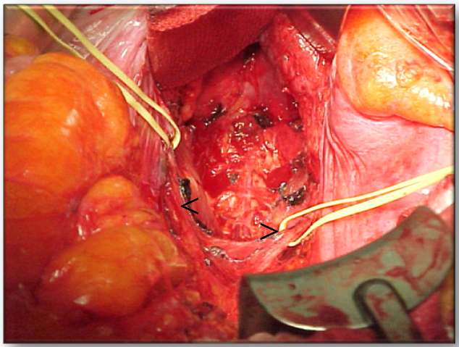
Figure 1 View of male pelvic cavity after total mesorectal excision and rectal resection, hypogastric nerves are identified and preserved (arrow heads).

Figure 2 Position of the robotic cart.

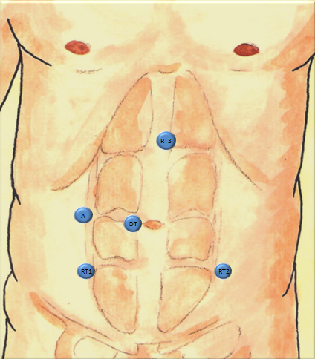
A
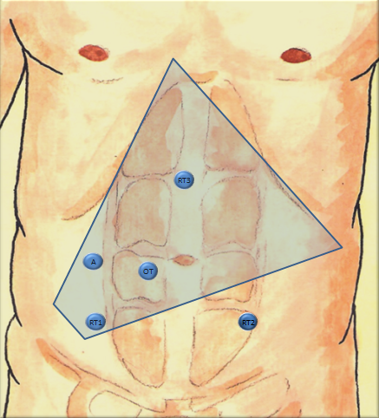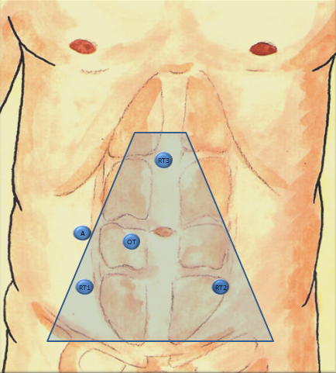
B C
Figure 3 Placement of the trocars, ROBOTIC LAR (A); IMA, IMV and splenic flexure, ROBOTIC LAR (B) and total mesorectal excision (C). OT: Optical trocar; R: Robotic arms; A: Assistant.
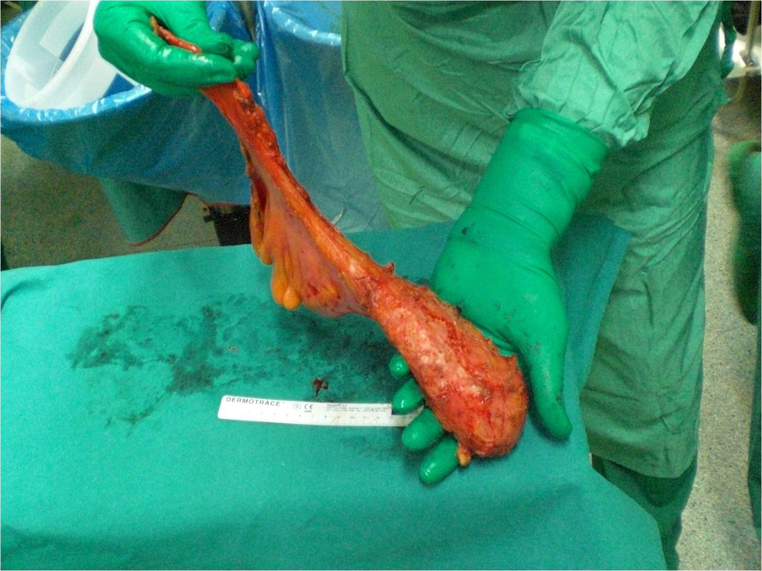
A
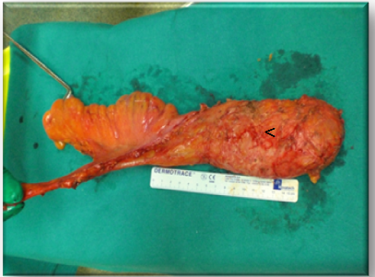
B
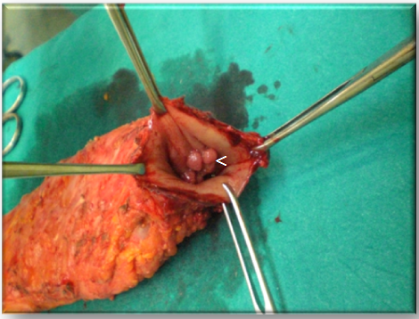
C
Figure 4 surgical specimen of robot-assisted total mesorectal excision. a: this figure shows a very smooth mesorectal fat pad which tapers distally consistent with complete excision of the mesorectum. Grade 3 according to Quirke; b: Grade 3 complete excision according to Quirke showing the wisps of fascia that surrounds the mesorectum indicating that a fascial plane actually exists and points to a complete excision by surgeon, mesorectal vessels contained within the mesorectum can be seen; arrow head; c: opened specimen showing the tumor; arrow head.
Figure 5 Comparison of 5-year local recurrence. Modified from Ref. [14].

Table 1 Clinically relevant outcomes
Outcome | Open-LAR | Robotic-LAR | P-value¹
Intraoperative transfusions | 0 | 0 | -
Death | 0 | 0 | -
Postoperative transfusions patients n (%) | 6 (5.7) | 1 (2.0) | 0.432
Surgical complications (30th postop day)
Units | 12 | 1 | 0.051
Infectious | 15 (14.3) | 8 (16.3) | 0.189
Non-infectious | 11 (10.5) | 10 (20.4)
Both | 5 (4.5) | 0
Overall | 31 (29.5) | 18 (36.7) | 0.371
Reinterventions (30th postop day) | 0 | 2 (4.1) | 0.100
Length of hospital stay (d) mean ± SD (Median) | 12.4 ± 3.2 (12.0) | 8.4 ± 9.3 (7.0) | < 0.001
Post-operative Hb (g/dL) mean ± SD (Median) | 10.6 ± 1.6 (10.8) | 11.0 ± 1.4 (10.8) | 0.124
Hb drop (g/dL) mean ± SD (Median) | 3.0 ± 1.4 (2.9) | 2.4 ± 1.6 (2.0) | 0.015
¹Two-sample two-sided Wilcoxon test, unpaired t-test, ² or two-sided Fisher’s exact test as appropriate. Modify from Biffi et al^{[30]}.

Table 2 Comparison between MRC CLASICC and COREAN trial
Variable | MRC CLASICC | COREAN Trial
Number of participating Centers | 27 | 3
Number of procedures per surgeon before Trial | 20 | 75
Conversion rate, n (%) | 82 (34) | 2 (1.2)
CRM involvement | 16% | 2.9%

CRM: Circumferential resection margin.

Table 3 Perioperative outcomes of robotic total mesorectal excision for rectal cancer n (%)
Ref. | n | BMI (kg/m²) | OR time (min) | Conversion rate) | Anastomotic leak rate
Hellan et al ^{[16]} | 39 | 26 (16-44) | 285 (180-540) | 1 (2.6) | 4 (12.1)
Baik et al ^{[17]} | 56 | 23.4 (18-33) | 178 (120-315) | 0 | 1 (1.8)
Choi et al^{[18]} | 50 | 23.2 (19.4-29.2)¹ | 304.8 (190-485)³ | 0 | 4 (8.3)
Baek et al^{[19]} | 64 | 26.8 (16.5-44) | 270 (150-540) | [9.4] | 4 (7.7)
Pigazzi et al^{[15]} [multicentric study] | 143 | 26.5 (16.5-44)² | 297 (90-660)³ | 7 (4.9) | 16 (10.5)
Baik et al^{[20]} | 370 | 23.3 ± 2.9 (13.8-32.7)² | 363.3 ± 94.8 (138.0–702.0)² | 3 (0.8) | 28 (7.7)
IEO series^{[14]} | 102 | 28.2 (17.6-43) | 330 (155-540) | 2 (1.9%) | 5 (6.6)

Only sphincter-saving operations included for calculating leak rates, values expressed as median (range) except where specified, ¹mean (range); ²mean ± SD (range); ³mean (range).

Table 4 Clinical results of laparoscopic and robotic surgery for rectal cancer
Ref. | Conversions (%) |  | P-value | Hospital stay (d) |  | P-value | Complications (%) |  | P-value
 | ROB | LAP |  | ROB | LAP |  | ROB | LAP
Park et al^{[58]} | 0 | 0 | 1 | 9.9 | 9.4 | 0.5 | 29.3 | 23.2 | 0.4
kang et al^{[33]} | 2 | 3 | 1 | 11.7 | 14.4 | 0.006 | 20 | 27 | 0.4
Kwak et al^{[59]} | 0 | 3.4 | 0.4 | NA | NA |  | 32 | 27 | Ns
Baek et al^{[50]} | 7.3 | 22 | 0.116 | 6.5 | 6.6 | 0.8 | 22 | 27 | 1
Bianchi et al^{[60]} | 0 | 4 | NA | 6.5 | 6 | 0.4 | 16 | 24 | 0.5
Baik et al^{[17]} | 0 | 10.5 | 0.013 | 5.7 | 7.6 | 0.001 | 10.7 | 19.3 | 0.025
Patriti et al^{[63]} | 0 | 19 | < 0.05 | 11.9 | 9.6 | > 0.05 | 30.6 | 18.9 | > 0.05
ROB: Robotic resection; LAP: Laparoscopic resection; NA: Not available; ns: Not significant.

Table 5 Oncologic results of laparoscopic and robotic surgery for rectal cancer
Ref. | Harvested lymph nodes (n) |  | P-value | Distal resection margin (cm) |  | P-value | Positive CRM (%) |  | P-value
 | ROB | LAP |  | ROB | LAP |  | ROB | LAP
Park et al^{[58]} | 17.3 | 14.2 | 0.06 | 2.1 | 2.3 | ns | 4.9 | 3.7 | 0.5
Kang et al^{[33]} | 14.7 | 16.6 | ns | 2.7 | 2.6 | 0.09 | 3 | 2 | ns
Kwak et al^{[59]} | 20 | 21 | 0.7 | 2.2 | 2.8 | 0.8 | 1.7 | 0 | > 0.9
Baek et al^{[50]} | 13 | 16 | 0.07 | 3.6 | 3.8 | 0.6 | 2.4 | 4.9 | 1
Bianchi et al^{[60]} | 18 | 17 | 0.7 | 2 | 2 | 1.0 | 0 | 4 | 0.9
Baik et al^{[17]} | 18.4 | 18.7 | 0.8 | 4 | 3.6 | 0.4 | 7 | 8 | 0.7
Patriti et al^{[63]} | 10.3 | 11.2 | > 0.05 | 2.1 | 435 | > 0.05 | 0 | 0 | ns
CRM: Circumferential resection margin; ROB: Robotic resection margin; LAP: Laparoscopic resection; ns: Not significant.

Table 6 Short-term and long-term oncologic outcomes of robotic TME for rectal cancer
Ref. |  | LN yield | CRM+ n (%) | DRM+ n (%) | FU (mo) | LR (%) | DR (%) | DFS (3 yr), (%) | OS (3 yr), (%)
Hellan et al^{[16]} | 13 (7-28)¹ |  | 0 | 0 | 13² | 0 | 10.3 | ___ | ___
Baik et al^{[17]} | 17.5 (4-43)¹ |  | 4 (7.1) | 0 | 14.3² | 0 | 3.6 | ___ | ___
Choi et al^{[18]} | 20.6 (6-48)³ |  | 1 (2) | 0 | ___ |  |  | ___ | ___
Baek et al^{[19]} | 14.5 (3-28)¹ |  | 0 | 0 | 20.2⁴ | 3.1 | 9.4 | 73.7 | 96.2
Pigazzi et al^{[15]}  Multicenter study | 14.1 (1-39)³ |  | 1 (0.7) | 1 (0.9) | 17.4⁴ | 1.5 | 9.0 | 77.6 | 97
Baik et al^{[20]} | 15.6 ± 9.0  (1-49)⁺ |  | 21 (5.7) |  | 26.5⁴ | 3.6 | 17.6 | 79.2 | 93.1
Ieo series, Ghezzi et al^{[14]} | 14.5 (2-45)³ |  | 5 (4.9) | 2 (1.9) | 30.0² | 4.0 | 10.7 | 79.2 | 92
¹mean ± SD (range); ²median follw-up; ³mean lymphnode yield; ⁴mean followup. LN: Lymph node; CRM+: Circumferential resection margin positivity; DRM+: Distal resection margin positivity; FU: Follow up; LR: Local recurrence; DR: Distant recurrence; DFS: Disease free survival; OS: Overall survival.

Table 7 Urinary and sexual dysfunctions results in robotic rectal resection
Ref. | Study | Results
Kim et al^{[13]}, 2012 | 39 LAP vs 30 ROB (urinary) | Earlier recovery of normal voiding and sexual function
 | 20 LAP vs 18 ROB (sexual male only)
D’Annibale et al^{[48]}, 2013 | 30 LAP vs 30 ROB (male only) | Erectile function was restored completely in the ROB group and partially in the LAP group
Luca et al^{[49]}, 2013 | 74 ROB (38 males and 36 females) | Sexual function and general sexual satisfaction were restored completely. Urinary function unchanged after surgery
LAP: Laparoscopic rectal surgery; ROB: Robotic rectal surgery.

