Name of Journal: World Journal of Gastroenterology
ESPS Manuscript NO: 25643
Manuscript Type: Review

Metastasis-associated long noncoding RNAs in gastrointestinal cancer: implications for novel biomarkers and therapeutic targets

Zhang FF et al. Metastasis-associated lncRNAs in gastrointestinal cancer

Fei-Fei Zhang, Yu-Hao Luo, Hui Wang, Liang Zhao

Fei-Fei Zhang, Yu-Hao Luo, Department of Pathology, Nanfang Hospital, Southern Medical University, Guangzhou 510000, Guangdong Province, China

Hui Wang, Department of Medical Oncology, Affiliated Tumor Hospital of Guangzhou Medical University, Guangzhou 510000, Guangdong Province, China

Liang Zhao, Department of Pathology, Nanfang Hospital and School of Basic Medical Sciences, Southern Medical University, Guangzhou 510000, Guangdong Province, China

Author contributions: Zhang FF and Luo YH contributed equally to this work; Zhang FF, Luo YH, Wang H, and Zhao L prepared the manuscript.

Supported by the National Natural Science Foundation of China, No. 81272762 and No.81201635; and the Guangdong Natural Science Funds for Distinguished Young Scholar, No. S20120011334.

Conflict-of-interest statement: Authors declare no conflict of interests for this article.

Open-Access: This article is an open-access article selected by an in-house editor and fully peer-reviewed by external reviewers. It is distributed in accordance with the Creative Commons Attribution-NonCommercial (CC BY-NC 4.0) license, which permits others to distribute, remix, adapt, build upon this work non-commercially, and license their derivative works on different terms, provided the original work is properly cited and the use is non-commercial. See: http://creativecommons.org/licenses/by-nc/4.0/

Manuscript source: Invited manuscript

Correspondence to: Liang Zhao, MD, Department of Pathology, Nanfang Hospital, Southern Medical University, No. 1838 Guangzhoudadao South Road, Guangzhou 510000, Guangdong Province, China. liangsmu@foxmail.com
Telephone: +86-20-62789365
Fax: +86-20-62789365

Received: March 17, 2016
Peer-review started: March 20, 2016
First decision: June 20, 2016
Revised: July 5, 2016
Accepted: August 23, 2016
Article in press:
Published online:

Abstract
Long non-coding RNAs (lncRNAs), a newly discovered class of non-coding RNA (ncRNA) molecules, have been widely identified as crucial regulators of various diseases including cancer. Increasing numbers of studies have demonstrated that lncRNAs are involved in diverse physiological and pathophysiological processes, such as cell cycle progression, chromatin remodeling, gene transcription, and posttranscriptional processing. Aberrant expression of lncRNAs frequently occurs in gastrointestinal cancer (GC) and plays emerging roles in cancer metastasis. In this review, we focus on and outline the regulatory functions of recently identified metastasis-associated lncRNAs, and evaluate the potential roles of lncRNAs as novel diagnostic biomarkers and therapeutic targets in gastrointestinal cancer.

Key words: gastrointestinal cancer; tumor metastasis; long noncoding RNAs; epithelial-to-mesenchymal transition; microRNAs

© The Author(s) 2016. Published by Baishideng Publishing Group Inc. All rights reserved.

Core tip: Long non-coding RNAs (lncRNAs), a newly discovered class of non-coding RNA molecules, have been widely identified as crucial regulators of various diseases including cancer. Aberrant expression of lncRNAs frequently occurs in gastrointestinal cancer (GC) and plays emerging roles in cancer metastasis. We focus on and outline the regulatory functions of recently identified metastasis-associated lncRNAs and evaluate the potential roles of lncRNAs as novel diagnostic biomarkers and therapeutic targets in gastrointestinal cancer.

Zhang FF, Luo YH, Wang H, Zhao L. Metastasis-associated long noncoding RNAs in gastrointestinal cancer: implications for novel biomarkers and therapeutic targets. World J Gastroenterol 2016; In press

Introduction
Gastrointestinal cancers (GCs) represent some of the most lethal cancers worldwide. In 2012, there were estimated to be more than 2.8 million new cases and 1817200 deaths worldwide^{[1]}. Though multimodal therapeutic regimens have been applied, survival from gastrointestinal cancers remains in the narrow range of 25% to 30% in most countries^{[2]}. One reason for this poor survival rate is distant metastasis before diagnosis. Metastasis is one of the most significant features of cancer and frequently occurs in multiple sequential steps. Thus, a detailed understanding of the precise molecular mechanisms underlying GC metastasis is urgently required.
Recent studies have revealed that protein-coding genes and non-protein-coding genes are abundantly transcribed in the human genome, especially ncRNAs, which account for more than 70% of the human genome^{[3-5]}. A large number of transcripts are ncRNAs, including miRNAs (miRNAs) and lncRNAs, as well as several other types of RNAs. MiRNAs are mostly known ncRNAs, with molecules of around 22 nucleotides in length that regulate target gene expression at the post-transcriptional level^{[6]}. lncRNAs are roughly defined as molecules greater than 200 nucleotides in length that are devoid of evident open reading frames (ORFs)^{[5]}. With the development of high-throughput sequencing, increasing numbers of lncRNAs are being revealed and extensively investigated. It is now recognized that lncRNA alterations are highly tumor and lineage-specific and regulate various stages of cancer, including chromatin remodeling, gene transcription, and posttranscriptional modifications^{[7-10]}. Over the past decades, multiple studies have demonstrated that lncRNAs are aberrantly expressed in gastrointestinal cancers and are associated with tumor metastasis. In this article, we summarize the molecular mechanisms of lncRNAs identified in GCs, especially those that are significantly associated with tumor metastasis, and discuss the potential of lncRNAs as novel diagnostic biomarkers and therapeutic targets.

Overview of lncRNAs
LncRNAs can be generated at any region of the genome by RNA polymerase II/III, and most of them are polyadenylated and located within nuclear or cytosolic fractions^{[3]}. Interestingly, lncRNAs can undergo alternative splicing similar to protein coding RNAs, and develop secondary and even tertiary structures to form specific functional domains. These domains provide greater potential for interaction with DNA, RNA or proteins^{[11,12]}. The detailed classification of lncRNAs can be complex. According to the genome position with their neighboring protein-coding genes, lncRNAs can be divided into sense, antisense, intronic, intergenic, and divergent lncRNAs (Figure 1). Sense lncRNAs are transcribed from the same strand as protein-coding genes, while antisense lncRNAs are generated from antisense strands. Both can overlap with exonic or intronic regions, or cover entire protein-coding regions. Intronic lncRNAs are entirely generated from introns of protein-coding genes, while intergenic lncRNAs are transcribed from the regions between two protein-coding genes. Divergent lncRNAs are located on the opposite strands of the protein-coding genes, the transcription of which starts within 1000 base pairs. Compared to protein-coding genes, lncRNAs are lower in abundance and poorer in interspecies sequence conservation, and frequently occur in the nucleus^{[13]}. The location of lncRNAs can be nuclear or cytoplasmic, and different biological functions are implicated depending on their subcellular localization (Figure 2).

Nuclear lncRNAs
Multiple lines of evidence have indicated that nuclear lncRNAs function by guiding chromatin modifiers to their specific genomic loci^{[10]}. Genomic DNA is surrounded by histone proteins and packaged into an advanced structure termed chromatin. Histones can be modified in various ways, and as a result can influence the potential DNA functional state. Recent studies have demonstrated that most nuclear lncRNAs function by interacting with and modulating the activity of chromatin regulatory complexes, thereby guiding them to their specific genomic loci^{[8,10]}. For example, they can recruit protein complexes from the Trithorax group (TrxG) or Polycomb group (PcG), and guide these protein complexes to specific sites for action^{[14,15]}. Generally, TrxG proteins are essential for active gene expression, while PcG proteins function by repressing expression^{[16,17]}. Transcriptional activation may be promoted by lncRNAs via recruitment of chromatin regulatory complexes such as histone H3K4 methyltransferase, which is frequently located at the promoter regions of the transcribed genes. Furthermore, the common marks of silenced heterochromatin contain di- and tri-methylated H3K9, trimethylated H3K27 and Polycomb Repressive Complex 2 (PRC2). PCR2 is composed of four core components including Enhancer of zeste (EZH), Suppressor of zeste 12 homolog (Suz12), Embryonic ectoderm development (Eed) and RbAp46/48^{[18,19]}. As lncRNAs are frequently located in the nucleus, their molecular functions can be divided into three main categories: modification of chromatin structures, transcriptional control, and mRNA/miRNA processing. For example, the X-inactive specific transcript (Xist) gene was the first lncRNA identified to be directly involved in the formation of repressive chromatin domains, which is necessary for reducing X-chromosome gene expression in female genomes^{[20]}. Xist is expressed from the X chromosome targeted for inactivation (Xi), and produces multiple transcripts to “coat” Xi^{[21]}. As lncRNAs can develop secondary or even tertiary structures, they are proposed to be molecular scaffolds through combinations of regulatory proteins. During X inactivation, one of the steps in initiating the process is the recruitment of PRC2 in cis by RepA RNA, which originates from the 5′ end of Xist^{[22]}. Furthermore, the transcriptional repressor Yin Yang 1 (YY1) may be involved in the interaction between the Xist and chromatin, because its deletion leads to a loss of Xist loading on Xi^{[23]}. Recent studies have revealed that YY1 can facilitate the loading of PRC2 to DNA and initiate DNA methylation and chromatin silencing, these findings suggest that YY1 is the docking factor for the cis-acting nature of Xist^{[22,23]}. Due to the development of RNA technology, increasing numbers of lncRNAs are being discovered, and are verified to be associated with modification of chromatin. HOX transcript antisense intergenic RNA (HOTAIR) is another classical case. HOTAIR is a 2.2 kb lncRNA expressed from the HOXC locus, which cooperates with PRC2 to repress transcription of HOX genes^{[24]}. Tsai et al demonstrated that besides the 5′ domain of HOTAIR binding to PRC2, the 3′ domain binds to LSD1, resulting in H3K27me3 and H3K4me2 methylation, which in turn leads to HOXD silencing ^{[25,26]}.
Nuclear lncRNAs also play important roles in transcriptional control. Some lncRNAs can form RNA-protein complexes with transcription factors and modulate gene transcription. For example, the lncRNA heat shock RNA 1 (HSR1) interacts with heat-shock transcription factor 1 (HSF1)to form a protein complex that induces expression of heat-shock proteins during cellular heat-shock stress^{[27]}. As well as roles in positive regulation, lncRNAs can function as transcription co-repressors. Those transcribed from the Cyclin D1 (CCND1) promoter region are reported to change the RNA-binding protein, translocated in liposarcoma (TLS) from an inactive to an active conformation. This causes TLS to bind to and inhibit the enzymatic activities of CBP and p300, which in turn leads to the silencing of CCND^{[28]}.
Interestingly, lncRNAs are not only involved in gene transcription but also in mRNA/miRNA processing. For example, metastasis-associated lung adenocarcinoma transcript 1 (MALAT1) is a cancer-related lncRNA, and whose expression is deregulated in many cancers including gastrointestinal cancers^{[29,30]}. MALAT1 regulates the phosphorylation of the serine/arginine-rich (SR) family of nuclear phosphoproteins (SR proteins) and influences the distribution of splicing factors in nuclear speckle domains^{[31]}. In addition, lncRNA FGFR2 impairs binding of a repressive chromatin-splicing adaptor complex via recruitment of PRC2 and KDM2a, leading to the epithelial-specific alternative splicing of FGFR2^{[32]}. In some cases, lncRNAs are located antisense to their known protein-coding genes. These lncRNAs are also called natural antisense transcripts (NATs). Recent studies indicated that NATs are associated with mRNA processing. For instance, they influence the splicing patterns of mRNAs at v-myc avian myelocytomatosis viral oncogene homolog (MYC)^{[33]}, tyrosine kinase containing immunoglobulin and epidermal growth factor homology domain-1 (Tie-1)^{[34]}, and zinc-finger E-box binding homeobox 2 (ZEB2)^{[35]}. In these cases, lncRNAs form RNA-RNA duplexes with pre-mRNAs and inhibit splicing. Processing of miRNAs can also be affected by lncRNAs. For example, lncRNA H19 can be spliced into pri-miRNA of miR-675, and miR-675 is derived from nucleotides 1014−1036 of human H19 RNA^{[36]}.

Cytoplasmic lncRNAs
Many lncRNAs are located in the cytoplasm, and these lncRNAs often regulate gene expression through sequence complementarity with target genes by base pairing. In the cytoplasm, lncRNAs are responsible for modulating translational control, promoting or inhibiting mRNA stability and serving as molecular “sponges” for miRNAs. For example, ubiquitin carboxy-terminal hydrolase L1 antisense RNA 1 (Uchl1-AS1) lncRNA is produced from the Uchl1 (ubiquitin carboxy-terminal hydrolase L1) locus. The mature lncRNA contains a 73-nucleotide complementary site with the 5′ end of the Uchl1 mRNA, which serves to upregulate translation of Uchl1 mRNA^{[37]}. By contrast, tumor protein p53 pathway corepressor 1 (Trp53cor1, also known as lincRNA-p21) lncRNA negatively regulates gene translation in human cervical carcinoma^{[38]}. Similarly, lncRNAs can modulate mRNA stability positively or negatively. The lncRNA-activated by TGF-β (lncRNA-ATB) is upregulated in hepatocellular carcinoma (HCC). It binds IL-11 mRNA and triggers STAT3 signaling, promoting the colonization of organs by disseminated tumor cells^{[39]}. By contrast, Alu repeat-containing lncRNAs are associated with targeting mRNA transcripts for Staufen-mediated decay (SMD), and destabilizing the target mRNA^{[40]}. Aside from binding to mRNA, lncRNAs can act as decoys to attenuate miRNA regulation. For example, HOTAIR functions as a competing endogenous RNA by "sponging" miR-331-3p, thereby modulating the derepression of human epidermal growth factor receptor 2 (HER2) and promoting GC progression^{[41]}. Furthermore, another study demonstrated that HOTAIR is involved in the upregulation of HLA-G through inhibition of miR-152 in GC^{[42]}. As increasing numbers of lncRNAs are being identified, we believe that new perspectives on the mechanisms of lncRNA function will be come to light in the near future.

Aberrant expression of lncRNAs in gastrointestinal cancer
The development of gastrointestinal cancer is a complex process, although several serum tumor markers such as carcinoembryonic antigen (CEA) and CA19.9 are recommended for clinical applications, their low sensitivity and specificity remain a severe challenge for clinicians. Recent observations demonstrate that lncRNAs are aberrantly expressed in gastrointestinal cancers, and have been identified as having roles in tumorigenesis. Among the most prominent deregulated lncRNAs in gastrointestinal cancer are HOTAIR, MALAT1, and H19, which are upregulated in various cancers and are involved in migration, invasion, metastasis, dissemination and are associated with a more advanced tumor, node, metastasis (TNM) stage. For example, high HOTAIR expression in cancerous tissues closely correlates with poor prognosis in gastrointestinal cancer^{[43-45]}. Surprisingly, for colorectal cancer (CRC) patients, plasma levels of HOTAIR were significantly higher than those in healthy controls, and high levels of HOTAIR were associated with an unfavorable prognosis. This indicated that the HOTAIR plasma level could act as a new biomarker for CRC patients^{[46]}. In GC, circulating H19 in plasma was also higher than in healthy controls, and after surgery, circulating H19 was reduced^{[47]}. In GC tissues, lncRNA AA174084 expression was found to be downregulated compared to expression in the paired normal tissues, although the AA174084 plasma level was positively associated with invasion and metastasis. Plasma levels of AA174084 dropped after surgical treatment, and A174084 levels in gastric juice were significantly higher in GC patients. These observations provide evidence that A174084 could be a potential biomarker for early diagnosis in GC^{[48]}. Resveratrol, a monomer extracted from a Chinese herbal medicine Polygonum cuspidatum, is known to inhibit metastasis of CRC. Studies have shown that Resveratrol exerts anti-tumor effects via MALAT1-mediated Wnt/β-Catenin signaling; co-repression of MALAT1 led to the enhancement of Resveratrol-induced anti-cancer effects^{[49]}. These emerging studies elegantly indicate that lncRNAs could be promising future diagnostic markers or therapeutic targets, and that combining lncRNA-based strategies with existing methods would improve the accuracy of diagnostics and efficacy of treatments in a clinical setting. Increasing evidence demonstrates that lncRNA expression levels correlate with GC. A summary of aberrantly expressed lncRNAs, their gene locus, product size, expression status, and biological function are shown in Table 1^{[41-46,48-90]}.

lncRNAs are associated with cancer-related pathways
Cancer-related pathways play essential roles in cancer metastasis. For example, miR-29b can inactivate the MAPK/ERK and PI3K/AKT pathways via dephosphorylation of ERK1/2 and AKT in CRC, which leads to repression of metastatic capacity in cancer cells^{[91]}. Pathway regulation is mediated not only by miRNAs, but also by lncRNAs. PVT-1 is located at 8q24, whose copy number is amplified in CRC. As observed using gene expression microarray analysis, the TGF-β signaling pathway is upregulated by PVT-1 knockdown^{[65]}. MALAT1 was first identified in lung cancer, and is an indicator of probability of survival and metastasis in early-stage non-small cell lung cancer^{[92]}. However, it also plays oncogenic roles in other cancers. MALAT1 was demonstrated to be an independent prognostic parameter in gallbladder carcinoma (GBC); its downregulation reduced phosphorylated MEK1/2, ERK 1/2, MAPK, and JNK 1/2/3, and inactivation of the ERK/MAPK pathway led to the partial impairment of proliferation and metastasis^{[76]}.
Wnt/β-catenin signaling is a classical pathway in cancer, and frequently correlates with cancer metastasis. During Wnt/β-catenin signaling activation, β-catenin often translocates to the nucleus from the cytoplasm, and cooperates with transcription factors such as TCF/LEF to induce downstream target genes such as c-Myc, MMP-7, and CD44. In CRC, MALAT1 was found to increase the nuclear localization of β-catenin, activating Wnt/β-catenin signaling to enhance expression of c-Myc and MMP-7, which are involved in CRC cell metastasis^{[49]}. HOTAIR cooperates with the PRC2 complex, leading to H3K27me3 and H3K4me2 methylation and HOXD gene silencing^{[25,26]}. In esophageal squamous cell carcinoma (ESCC), HOTAIR is significantly upregulated, and has been shown to promote migration and invasion of ESCC cells in vitro^{[43]}. Gene microarray analysis indicated that in cells overexpressing HOTAIR, WNT/β-catenin associated gene WIF-1 was the gene with the most significantly affected levels of expression. A further study showed that HOTAIR promoted H3K27 methylation in the promoter region of WIF-1 and inhibited WIF-1 expression, and that the low expression of WIF-1 triggered Wnt/β-catenin signaling, thereby promoting ESCC invasion and migration.

lncRNAs participate in Epithelial-to-mesenchymal transition
The epithelial-mesenchymal transition (EMT) is a biological process in which polarized epithelial cells acquire a mesenchymal cell phenotype. It is a process known to enhance cancer cell metastasis, invasiveness, and chemoresistance. Recent studies have verified that noncoding RNAs are frequently involved in the EMT process, especially miRNAs. For example, miR-187, as a downstream target of TGFβ, inhibits EMT by suppressing the expression of multiple targets in CRC^{[93]}. The maturation of high throughput genomic tools, such as high-resolution microarray and massively parallel sequencing technology, has led to the discovery of an extensive range of lncRNAs. There is a growing understanding that lncRNAs and their associated signaling networks may participate in the induction and regulation of EMT to modulate cancer metastasis^{[94]}. Esophagus epithelial intergenic specific transcript (Epist) acts as a tumor suppressor by inhibiting EMT^{[95]}, and TGFβ stimulation significantly suppresses the expression of Epist. These findings reveal a new plausible mechanism by which TGFβ-induced EMT could take place.
Taurine upregulated gene 1 (TUG1) was originally reported as a transcript that is upregulated by taurine, and it was also observed to be up-regulated in CRC^{[66]}. TUG1 overexpression was shown to enhance the migration and invasion capacity of CRC cells significantly. A decrease in the epithelial hallmark E-cadherin combined with an increase in the mesenchymal markers N-cadherin, vimentin, and fibronectin, indicated that TUG1 promoted CRC metastasis by mediating EMT. Another two studies suggested that HOTAIR^{[56]} and highly upregulated in liver cancer (HULC)^{[88]} promoted metastasis of CRC by participating in EMT, although the underlying mechanisms require further investigation. In GC, microarray and quantitative real-time PCR identified a new, specific, differentially expressed lncRNA termed LEIGC^{[89]}. LEIGC is a 2659 nt transcript located at 2q14.1, and contains two exons. Intriguingly, LEIGC knockdown in MGC803 cells induced them to assume a spindle-shaped morphology, whereas LEIGC-overexpression induced a cobblestone-like phenotype, suggesting that LEIGC may be involved in EMT. Further investigation revealed that LEIGC knockdown reduced E-cadherin expression while increasing expression of vimentin, Snail, Slug, Zeb, and Twist. These data indicated that LEIGC may be a potential EMT inhibitor in GC.
Mounting evidence suggests that tumor-associated dendritic cells and the tumor microenvironment are critical factors for cancer metastasis. Many inflammatory factors such as chemokines and cytokines have been implicated as being strongly associated with EMT and metastasis. Increasing numbers of studies support the hypothesis that tumor-associated dendritic cells (TADCs) influence the inflammatory cancer microenvironment and contribute to an aggressive cancer phenotype. Kan et al^{[60]} found that TADCs secreted high levels of Chemokine (C-C motif) ligand 5 (CCL5), and that CCL5 stimulation upregulated MALAT1 expression in CRC cells. This in turn led to an increase in Snail expression, resulting in enhanced EMT and cancer progression.
HOTAIR is known to play important roles in epigenetic regulation^{[24-26]}. In GC tissue, HOTAIR expression was shown to correlate negatively with E-cadherin expression^{[96]}. Western blot assays confirmed that HOTAIR could promote EMT. Bioinformatics analysis showed that miR-34a, which is known to be involved in the C-Met (HGF/C-Met/Snail pathway) and Snail pathway and to repress EMT, was a downstream microRNA of HOTAIR. RNA immunoprecipitation (RIP) assays indicated that HOTAIR could recruit and bind to the PRC2 complex and repress miR-34a epigenetically in GC. This research provided a new insight into the RNA regulatory network, and supported the hypothesis that chromatin modification not only affects protein levels, but also controls miRNA expression.

MALAT1
MALAT1 is a highly conserved lncRNA that was originally identified and is highly expressed in metastatic non-small-cell lung cancer. Recent studies have demonstrated that MALAT1 is overexpressed in other human malignancies, including CRC, GC, and ESCC, and is associated with tumor metastasis. The underlying mechanism of MALAT1 in promoting metastasis is complex. One fragment (6918 nt-8441 nt) of MALAT1 located at the 3′ end of the MALAT1 gene has biological functions in CRC, providing a strong case for MALAT1 as an accurate therapeutic target in CRC^{[58]}. Using genome-wide expression profiling analysis, a novel downstream target, PRKA kinase anchor protein 9 (AKAP-9) was identified, providing a novel insight into the mechanism of MALAT1 involvement in in CRC development^{[59]}. MALAT1 can activate several cancer-related pathways such as the ERK/MAPK pathway^{[76]} and Wnt/β-catenin pathway^{[49]}. MALAT1 can also interact with other proteins, such as splicing factor proline/glutamine rich (SFPQ), leading to the release of polypyrimidine tract binding protein 2 (PTBP2) from the SFPQ/PTBP2 complex^{[75]}. In addition to proteins, MALAT1 also interacts with RNAs, such as the tumor suppressor miRNAs miR-101 and miR-217, and affects their posttranscriptional regulation^{[74]}. One study also showed that MALAT1 is regulated by tumor-associated dendritic cells (TADCs)^{[60]}, providing a novel insight into the interaction between TADCs and cancer metastasis, and indicating that targeting MALAT1 is a potential strategy to improve immunotherapy efficacy. Taken together, the results of these studies support an oncogenic role for MALAT1 in GC (Figure 3), presenting it as a promising biomarker and therapeutic target for metastatic cancers.

HOTAIR
HOTAIR is a 2.2 kb lncRNA expressed from HOXC locus, which is known to participate in epigenetic regulation in cooperation with the PRC2 complex, leading to H3K27me3 and H3K4me2 methylation and gene silencing^{[24]}. Overexpression of HOTAIR has been observed in GC^{[84,85]}, ESCC^{[72]}, gastrointestinal stromal tumor^{[97]} and CRC^{[56]}. Notably, the level of HOTAIR expression in the blood as well as within the primary tumors was also a reliable biomarker for metastasis in CRC and GC^{[46,47]}. Although HOTAIR is known to cooperate with the PRC2 complex, it is still not known whether this regulation exists in CRC. A cDNA microarray and gene set enrichment analysis (GSEA) provided evidence for a correlation between HOTAIR and PRC2 complex expression in CRC^{[45]}. HOTAIR can also modulate HER2 and HLA-G expression by competitively binding to their miRNAs, such as miR-331-3p and miR-152^{[41,42]}. Therefore, HOTAIR could be a promising prognostic biomarker and a target for therapy in gastrointestinal cancer (Figure 4).

H19
H19 is localized at 11p15.5, where a highly conserved cluster of imprinted genes is encoded, such as paternally expressed insulin-like growth factor 2 (IGF2) and maternally expressed H19. The oncogenic role of H19 has been found in a number of cancers. A case-control study in the Chinese Han population revealed that the presence of H19 single nucleotide polymorphisms (SNPs) rs217727C>T and rs2839698C>T significantly correlated with susceptibility to GC^{[98]}. These findings indicated an important role for H19 variants in gastric carcinogenesis. In ESCC, Gao et al^{[70]} found that hypermethylation of CBS6 on H19 was related to loss of imprinting (LOI) of IGF2, which indicated overexpression of the gene. Enhanced expression of IGF2 was closely correlated with cancer metastasis, suggesting that H19 CBS6 methylation might be a novel, clinically relevant epigenetic marker for poor prognosis and ESCC metastasis. In GC, H19 was a novel target of c-Myc, in SGC-7901 and in BGC-823 cells. Exogenous c-Myc significantly induced H19 expression to approximately 3-fold higher levels compared to controls. However, the underlying molecular mechanisms remain to be fully elucidated^{[82]}. Investigations showed that H19 is a precursor of miR-675, and that H19 is involved in biological functions that are partly dependent on the activity of miR-675. Li et al^{[83]} developed a H19/miR-675 knockdown model in the GC cell line MKN45, and found that calneuron 1 (CALN1) was a target of miR-675. H19 suppressed CALN1 by promoting the generation of miR-675. Conversely, H19 also upregulated expression of its binding protein isthmin 1 (ISM1) directly, suggesting that this function of H19 could be independent of miR-675 activity. In addition, recent reports confirmed that eukaryotic translation initiation factor 4A3 (eIF4A3) also binds to H19 in CRC^{[99]}, and that H19 recruited eIF4A3 with the result of obstructing the interaction between eIF4A3 and cell-cycle gene mRNA (Figure 5).

Other potential metastasis-associated lncRNAs
LncRNA 91H is located in the H19/IGF2 locus, and low expression of 91H is associated with imprinting control region (ICR) methylation of H19^{[67]}, which is known to cause IGF2 overexpression via loss of genomic imprinting^{[70]}. Through the indirect inhibition of IGF-2 in ESCC, 91H inhibits the occurrence, progression, and prognosis of ESCC. Conversely, another study suggested that 91H was overexpressed in CRC tissues as well as cell lines^{[50]}, and might be associated with copy number variation (CNV) in the 11p15.5 region. These findings showed that lncRNAs are highly tumor and lineage specific, and that different regulatory mechanisms might lead to different biological functions in cancer.
A novel specific lncRNA expressed in GC is termed gastric adenocarcinoma predictive long intergenic noncoding RNA (GAPLINC). High expression of GAPLINC indicates severe lymph node invasion and poor prognosis. Ectopic expression of GAPLINC in MGC803 and SGC901 cell lines significantly enhances their invasive capacity. GAPLINC regulates CD44 mRNA at post-transcriptional level, and miR-221-3p targets both GAPLINC and CD44. GAPLINC increases CD44 expression by competing for miR-211-3p, which contributes to a reduced rate of degradation of CD44 mRNA in cytoplasm^{[81]}.
Olfactory receptor, family 3, subfamily A, member 4 (OR3A4) is a novel lncRNA overexpressed in GC. High OR3A4 expression levels are significantly associated with metastasis. Functional experiments performed in SGC7901 and NCI-N87 indicated that OR3A4 promotes GC cell proliferation, migration, invasion, tubule formation, vasculogenic mimicry, angiogenesis, and tumorigenicity. Four target genes of OR3A4 have been identified: PDLIM2, MACC1, NTN4, and GNB2L1. These results suggest that OR3A4 might play an important role in GC progression^{[90]}.
In order to search lncRNA signatures to predict prognosis of CRC, Hu et al. analyzed lncRNA expression in large CRC cohorts obtained from Gene Expression Ominus (GEO) databases. Six of the identified lncRNAs included two genes with enhanced expression in CRC, AK024680, AK026784, and four lower expressed genes with reduced expression, AK123657, CR622106, BX649059, and BX648207. These six genes were significantly correlated (positively or negatively) with disease free survival (DFS). Among them, functional experiments demonstrated three downregulated lncRNAs AK123657, BX648207, and BX649059 were required for the efficient suppression of invasion and proliferation in CRC cell lines. The lncRNAs identified in this study could be potential biomarkers and therapeutic targets for CRC in the future^{[80]}.

Molecular mechanismS of lncRNAs in gastrointestinal cancer
Previously, we have categorized the molecular mechanisms of lncRNAs into modification of chromatin structures, transcriptional control, mRNA/miRNA processing, translational control, mRNA stability control, and roles as molecular “sponges” for miRNAs. However, these mechanisms are not absolutely independent of each other, and one lncRNA may use several processing controls. In this section, we will focus on the molecular mechanisms of metastasis-associated-lncRNAs in gastrointestinal cancer, and provide insights into interpreting results of previous investigation of lncRNAs .

The role of lncRNAs in chromatin modification
Many lncRNAs are located in the nucleus and form secondary or tertiary structures. They can interact with specific chromatin regulatory complexes and participate in chromatin modification, leading to DNA methylation and gene control, including expression of miRNAs. HOTAIR is known to cooperate with the PRC2 complex and repress transcription of HOX genes^{[24-26]}. In ESCC, WIF-1 expression is decreased by HOTAIR^{[43]}. Mechanistically, HOTAIR promotes histone H3K27 methylation in the promoter region of the WIF-1 gene, and directly decreases WIF-1 expression. In GC, HOTAIR recruits and binds to the PRC2 complex and epigenetically represses miR34a, leading to the enhancement of C-Met (HGF/C-Met/Snail pathway) and Snail activation, and thus contributes to EMT and metastasis^{[55]}. This work provided a new insight into the RNA regulation network, and demonstrated that chromatin modification not only affects protein levels, but also controls miRNA expression. Another study showed that HNF1A antisense RNA 1 (HNF1A-AS1), a 2455 nt lncRNA located at chromosomal band 12q24.31, is markedly upregulated in esophageal adenocarcinoma (EAC) and that HNF1A-AS1 knockdown significantly inhibits cell proliferation, migration, and invasion. Microarray analysis and GO enrichment analysis revealed that HNF1A-AS1 knockdown affected chromatin/nucleosome assembly by inhibition of lncRNA H19, which contributed to cancer metastasis^{[71]}.

The role of lncRNAs in translational control
Colon cancer associated transcript 2 (CCAT2), a novel lncRNA encompassing the rs6983267 SNP, is highly overexpressed in microsatellite-stable (MSS) CRC, and promotes cancer growth and metastasis. Genomics analysis showed that the oncogene MYC is located in the same region as CCAT2. CCAT2 regulated MYC expression and affected MYC downstream genes such as miR-17-5p and miR-20a. Transcription factor 7 like 2 (TCF7L2) was confirmed as the promoter of MYC, and physical interaction between CCAT2 and TCF7L2 enhanced TCF7L2 transcriptional activity. This resulted in an increase in MYC and a change in downstream gene expression and pathway activity^{[54]}. Notably, CCAT2 itself was a downstream target of TCF7L2-mediated WNT signaling, indicating existence of a feedback loop during carcinogenesis.

The role of lncRNAs in mRNA/miRNA processing
H19 was reported to be the precursor of miR-675, a regulator of CALN1. H19 promoted metastasis of GC via regulation of the miR-675/CALN1 axis. However, H19 banded to ISM1 and upregulated ISM1 expression directly, which suggested that H19 could also work in an miR-675 independent manner^{[83]}.

The role of lncRNAs as “sponges” for miRNAs
lncRNAs and mRNAs may share some of the same response elements of miRNAs. In these cases, lncRNAs may serve as competing endogenous RNAs (ceRNAs) to sponge miRNAs, regulating target gene expression in post-transcriptional regulation. The function of ceRNAs is one of the most commonly investigated mechanisms of lncRNA activity, and completes the post-transcriptional regulatory network.
miR-331-3p and miR-124 directly target HOTAIR, which is reported to play a critical role in GC metastasis. Moreover, miR-331-3p also targets HER2 at the 3′-UTR region, providing compelling evidence that targeting HOTAIR would be a useful therapeutic strategy in GC^{[41]}. HOTAIR competitively binds to miR-152 and attenuates its expression in GC, leading to the release of human leukocyte antigen (HLA)-G, which has been identified as a target of miR-152 and is associated with cancer metastasis^{[42]}.
lncRNA AC130710 is overexpressed in GC, and its expression is significantly associated with tumor size, TNM stage, and distal metastasis. Bioinformatics analysis uncovered that AC130710 had nine complementary binding sites to miR-129-5p. A miR-129-5p mimic significantly decreased AC130710 expression, suggesting that miR-129-5p could regulate AC130710 expression through binding with complementary sites^{[77]}.
A newly described lncRNA, termed gastric adenocarcinoma associated, positive CD44 regulator, long intergenic non-coding RNA (GAPLINC) is associated with CNV and expression of oncogenic transcription factors in GC^{[81]}. In GC cells, GAPLINC and CD44 were identified as common targets of miR-211-3p^{[81]}. GAPLINC regulated CD44 as a decoy for miR-211-3p.
MALAT1, an acknowledged metastasis-associated lncRNA, was predicted as a target of miR-101, miR-217, miR-383, and miR-503 using bioinformatics analysis. Among them, miR-101 and miR-217 mimics decreased MALAT1 expression and were identified as tumor suppressor genes in GC. This was proposed as the mechanism involved in MALAT1 suppression on a posttranscriptional level^{[74]}.
Through combining lncRNA microarray, bioinformatics algorithm databases such as miRcode, and the miRNA target database TarBase, Xia et al^{[100]} constructed an lncRNA-miRNA-mRNA network in GC. Furthermore, in vitro experiments showed that lncRNA-FER1L4 promoted the target gene RB transcriptional corepressor 1 (RB1) expression by binding to miR-106a-5p. Based on the previous report, FER1L4 suppresses oncogenesis by inhibiting miR-106a-5p expression^{[55]}.

Conclusion
Gastrointestinal cancers are still one of the greatest challenges to human health, and metastasis is the leading cause of death from these cancers worldwide. Recently, lncRNAs have attracted remarkable attention from researchers, and increasing evidence suggests that lncRNAs are frequently aberrantly expressed in cancers, and play vital roles in various biological processes including cancer metastasis. In this review, we focus on the metastasis-associated lncRNAs in gastrointestinal cancers. Characterization of their deregulated expression, especially in blood or other fluids, could provide novel biomarkers for cancer diagnosis and prognosis, including early diagnostics and observation of cancer progression ^{[46-48]}. Many lncRNAs have been demonstrated to participate in cancer metastasis by influencing the process of EMT and affecting pathways required for cancer metastasis. The molecular mechanisms of lncRNA involvement in cancer include chromatin modification, transcriptional control, mRNA/miRNA processing, translational control, mRNA stability control and acting as “sponges” for miRNAs. However, the roles and mechanisms of metastasis-associated lncRNAs in gastrointestinal cancer still require further investigation and evaluation. Through promoting the understanding of lncRNAs in cancer, lncRNAs may be implicated as new targets for biological therapeutics.

References
1 Torre LA, Bray F, Siegel RL, Ferlay J, Lortet-Tieulent J, Jemal A. Global cancer statistics, 2012. CA Cancer J Clin 2015; 65: 87-108 [PMID: 25651787 DOI: 10.3322/caac.21262]
2 Allemani C, Weir HK, Carreira H, Harewood R, Spika D, Wang XS, Bannon F, Ahn JV, Johnson CJ, Bonaventure A, Marcos-Gragera R, Stiller C, Azevedo e Silva G, Chen WQ, Ogunbiyi OJ, Rachet B, Soeberg MJ, You H, Matsuda T, Bielska-Lasota M, Storm H, Tucker TC, Coleman MP. Global surveillance of cancer survival 1995-2009: analysis of individual data for 25,676,887 patients from 279 population-based registries in 67 countries (CONCORD-2). Lancet 2015; 385: 977-1010 [PMID: 25467588 DOI: 10.1016/S0140-6736(14)62038-9]
3 Derrien T, Johnson R, Bussotti G, Tanzer A, Djebali S, Tilgner H, Guernec G, Martin D, Merkel A, Knowles DG, Lagarde J, Veeravalli L, Ruan X, Ruan Y, Lassmann T, Carninci P, Brown JB, Lipovich L, Gonzalez JM, Thomas M, Davis CA, Shiekhattar R, Gingeras TR, Hubbard TJ, Notredame C, Harrow J, Guigó R. The GENCODE v7 catalog of human long noncoding RNAs: analysis of their gene structure, evolution, and expression. Genome Res 2012; 22: 1775-1789 [PMID: 22955988 DOI: 10.1101/gr.132159.111]
4 Ezkurdia I, Juan D, Rodriguez JM, Frankish A, Diekhans M, Harrow J, Vazquez J, Valencia A, Tress ML. Multiple evidence strands suggest that there may be as few as 19,000 human protein-coding genes. Hum Mol Genet 2014; 23: 5866-5878 [PMID: 24939910 DOI: 10.1093/hmg/ddu309]
5 Mattick JS, Rinn JL. Discovery and annotation of long noncoding RNAs. Nat Struct Mol Biol 2015; 22: 5-7 [PMID: 25565026 DOI: 10.1038/nsmb.2942]
6 He L, Hannon GJ. MicroRNAs: small RNAs with a big role in gene regulation. Nat Rev Genet 2004; 5: 522-531 [PMID: 15211354 DOI: 10.1038/nrg1379]
7 Prensner JR, Chinnaiyan AM. The emergence of lncRNAs in cancer biology. Cancer Discov 2011; 1: 391-407 [PMID: 22096659 DOI: 10.1158/2159-8290.CD-11-0209]
8 Khorkova O, Hsiao J, Wahlestedt C. Basic biology and therapeutic implications of lncRNA. Adv Drug Deliv Rev 2015; 87: 15-24 [PMID: 26024979 DOI: 10.1016/j.addr.2015.05.012]
9 Yan X, Hu Z, Feng Y, Hu X, Yuan J, Zhao SD, Zhang Y, Yang L, Shan W, He Q, Fan L, Kandalaft LE, Tanyi JL, Li C, Yuan CX, Zhang D, Yuan H, Hua K, Lu Y, Katsaros D, Huang Q, Montone K, Fan Y, Coukos G, Boyd J, Sood AK, Rebbeck T, Mills GB, Dang CV, Zhang L. Comprehensive Genomic Characterization of Long Non-coding RNAs across Human Cancers. Cancer Cell 2015; 28: 529-540 [PMID: 26461095 DOI: 10.1016/j.ccell.2015.09.006]
10 Guttman M, Rinn JL. Modular regulatory principles of large non-coding RNAs. Nature 2012; 482: 339-346 [PMID: 22337053 DOI: 10.1038/nature10887]
11 Cabili MN, Trapnell C, Goff L, Koziol M, Tazon-Vega B, Regev A, Rinn JL. Integrative annotation of human large intergenic noncoding RNAs reveals global properties and specific subclasses. Genes Dev 2011; 25: 1915-1927 [PMID: 21890647 DOI: 10.1101/gad.17446611]
12 Novikova IV, Hennelly SP, Sanbonmatsu KY. Sizing up long non-coding RNAs: do lncRNAs have secondary and tertiary structure? Bioarchitecture 2012; 2: 189-199 [PMID: 23267412 DOI: 10.4161/bioa.22592]
13 Nakagawa S, Kageyama Y. Nuclear lncRNAs as epigenetic regulators-beyond skepticism. Biochim Biophys Acta 2014; 1839: 215-222 [PMID: 24200874 DOI: 10.1016/j.bbagrm.2013.10.009]
14 Mattick JS, Amaral PP, Dinger ME, Mercer TR, Mehler MF. RNA regulation of epigenetic processes. Bioessays 2009; 31: 51-59 [PMID: 19154003 DOI: 10.1002/bies.080099]
15 Wang KC, Chang HY. Molecular mechanisms of long noncoding RNAs. Mol Cell 2011; 43: 904-914 [PMID: 21925379 DOI: 10.1016/j.molcel.2011.08.018]
16 Bracken AP, Helin K. Polycomb group proteins: navigators of lineage pathways led astray in cancer. Nat Rev Cancer 2009; 9: 773-784 [PMID: 19851313 DOI: 10.1038/nrc2736]
17 Schuettengruber B, Martinez AM, Iovino N, Cavalli G. Trithorax group proteins: switching genes on and keeping them active. Nat Rev Mol Cell Biol 2011; 12: 799-814 [PMID: 22108599 DOI: 10.1038/nrm3230]
18 Cao R, Wang L, Wang H, Xia L, Erdjument-Bromage H, Tempst P, Jones RS, Zhang Y. Role of histone H3 lysine 27 methylation in Polycomb-group silencing. Science 2002; 298: 1039-1043 [PMID: 12351676 DOI: 10.1126/science.1076997]
19 Kuzmichev A, Nishioka K, Erdjument-Bromage H, Tempst P, Reinberg D. Histone methyltransferase activity associated with a human multiprotein complex containing the Enhancer of Zeste protein. Genes Dev 2002; 16: 2893-2905 [PMID: 12435631 DOI: 10.1101/gad.1035902]
20 Penny GD, Kay GF, Sheardown SA, Rastan S, Brockdorff N. Requirement for Xist in X chromosome inactivation. Nature 1996; 379: 131-137 [PMID: 8538762 DOI: 10.1038/379131a0]
21 Lee JT. Lessons from X-chromosome inactivation: long ncRNA as guides and tethers to the epigenome. Genes Dev 2009; 23: 1831-1842 [PMID: 19684108 DOI: 10.1101/gad.1811209]
22 Zhao J, Sun BK, Erwin JA, Song JJ, Lee JT. Polycomb proteins targeted by a short repeat RNA to the mouse X chromosome. Science 2008; 322: 750-756 [PMID: 18974356 DOI: 10.1126/science.1163045]
23 Jeon Y, Lee JT. YY1 tethers Xist RNA to the inactive X nucleation center. Cell 2011; 146: 119-133 [PMID: 21729784 DOI: 10.1016/j.cell.2011.06.026]
24 Rinn JL, Kertesz M, Wang JK, Squazzo SL, Xu X, Brugmann SA, Goodnough LH, Helms JA, Farnham PJ, Segal E, Chang HY. Functional demarcation of active and silent chromatin domains in human HOX loci by noncoding RNAs. Cell 2007; 129: 1311-1323 [PMID: 17604720 DOI: 10.1016/j.cell.2007.05.022]
25 Wu SC, Kallin EM, Zhang Y. Role of H3K27 methylation in the regulation of lncRNA expression. Cell Res 2010; 20: 1109-1116 [PMID: 20680032 DOI: 10.1038/cr.2010.114]
26 Tsai MC, Manor O, Wan Y, Mosammaparast N, Wang JK, Lan F, Shi Y, Segal E, Chang HY. Long noncoding RNA as modular scaffold of histone modification complexes. Science 2010; 329: 689-693 [PMID: 20616235 DOI: 10.1126/science.1192002]
27 Shamovsky I, Ivannikov M, Kandel ES, Gershon D, Nudler E. RNA-mediated response to heat shock in mammalian cells. Nature 2006; 440: 556-560 [PMID: 16554823 DOI: 10.1038/nature04518]
28 Wang X, Arai S, Song X, Reichart D, Du K, Pascual G, Tempst P, Rosenfeld MG, Glass CK, Kurokawa R. Induced ncRNAs allosterically modify RNA-binding proteins in cis to inhibit transcription. Nature 2008; 454: 126-130 [PMID: 18509338 DOI: 10.1038/nature06992]
29 Fang XY, Pan HF, Leng RX, Ye DQ. Long noncoding RNAs: novel insights into gastric cancer. Cancer Lett 2015; 356: 357-366 [PMID: 25444905 DOI: 10.1016/j.canlet.2014.11.005]
30 Xie X, Tang B, Xiao YF, Xie R, Li BS, Dong H, Zhou JY, Yang SM. Long non-coding RNAs in colorectal cancer. Oncotarget 2016; 7: 5226-5239 [PMID: 26637808 DOI: 10.18632/oncotarget.6446]
31 Tripathi V, Ellis JD, Shen Z, Song DY, Pan Q, Watt AT, Freier SM, Bennett CF, Sharma A, Bubulya PA, Blencowe BJ, Prasanth SG, Prasanth KV. The nuclear-retained noncoding RNA MALAT1 regulates alternative splicing by modulating SR splicing factor phosphorylation. Mol Cell 2010; 39: 925-938 [PMID: 20797886 DOI: 10.1016/j.molcel.2010.08.011]
32 Gonzalez I, Munita R, Agirre E, Dittmer TA, Gysling K, Misteli T, Luco RF. A lncRNA regulates alternative splicing via establishment of a splicing-specific chromatin signature. Nat Struct Mol Biol 2015; 22: 370-376 [PMID: 25849144 DOI: 10.1038/nsmb.3005]
33 Krystal GW, Armstrong BC, Battey JF. N-myc mRNA forms an RNA-RNA duplex with endogenous antisense transcripts. Mol Cell Biol 1990; 10: 4180-4191 [PMID: 1695323]
34 Li K, Blum Y, Verma A, Liu Z, Pramanik K, Leigh NR, Chun CZ, Samant GV, Zhao B, Garnaas MK, Horswill MA, Stanhope SA, North PE, Miao RQ, Wilkinson GA, Affolter M, Ramchandran R. A noncoding antisense RNA in tie-1 locus regulates tie-1 function in vivo. Blood 2010; 115: 133-139 [PMID: 19880500 DOI: 10.1182/blood-2009-09-242180]
35 Beltran M, Puig I, Peña C, García JM, Alvarez AB, Peña R, Bonilla F, de Herreros AG. A natural antisense transcript regulates Zeb2/Sip1 gene expression during Snail1-induced epithelial-mesenchymal transition. Genes Dev 2008; 22: 756-769 [PMID: 18347095 DOI: 10.1101/gad.455708]
36 Cai X, Cullen BR. The imprinted H19 noncoding RNA is a primary microRNA precursor. RNA 2007; 13: 313-316 [PMID: 17237358 DOI: 10.1261/rna.351707]
37 Carrieri C, Cimatti L, Biagioli M, Beugnet A, Zucchelli S, Fedele S, Pesce E, Ferrer I, Collavin L, Santoro C, Forrest AR, Carninci P, Biffo S, Stupka E, Gustincich S. Long non-coding antisense RNA controls Uchl1 translation through an embedded SINEB2 repeat. Nature 2012; 491: 454-457 [PMID: 23064229 DOI: 10.1038/nature11508]
38 Yoon JH, Abdelmohsen K, Srikantan S, Yang X, Martindale JL, De S, Huarte M, Zhan M, Becker KG, Gorospe M. LincRNA-p21 suppresses target mRNA translation. Mol Cell 2012; 47: 648-655 [PMID: 22841487 DOI: 10.1016/j.molcel.2012.06.027]
39 Yuan JH, Yang F, Wang F, Ma JZ, Guo YJ, Tao QF, Liu F, Pan W, Wang TT, Zhou CC, Wang SB, Wang YZ, Yang Y, Yang N, Zhou WP, Yang GS, Sun SH. A long noncoding RNA activated by TGF-β promotes the invasion-metastasis cascade in hepatocellular carcinoma. Cancer Cell 2014; 25: 666-681 [PMID: 24768205 DOI: 10.1016/j.ccr.2014.03.010]
40 Gong C, Maquat LE. lncRNAs transactivate STAU1-mediated mRNA decay by duplexing with 3' UTRs via Alu elements. Nature 2011; 470: 284-288 [PMID: 21307942 DOI: 10.1038/nature09701]
41 Liu XH, Sun M, Nie FQ, Ge YB, Zhang EB, Yin DD, Kong R, Xia R, Lu KH, Li JH, De W, Wang KM, Wang ZX. Lnc RNA HOTAIR functions as a competing endogenous RNA to regulate HER2 expression by sponging miR-331-3p in gastric cancer. Mol Cancer 2014; 13: 92 [PMID: 24775712 DOI: 10.1186/1476-4598-13-92]
42 Song B, Guan Z, Liu F, Sun D, Wang K, Qu H. Long non-coding RNA HOTAIR promotes HLA-G expression via inhibiting miR-152 in gastric cancer cells. Biochem Biophys Res Commun 2015; 464: 807-813 [PMID: 26187665 DOI: 10.1016/j.bbrc.2015.07.040]
43 Ge XS, Ma HJ, Zheng XH, Ruan HL, Liao XY, Xue WQ, Chen YB, Zhang Y, Jia WH. HOTAIR, a prognostic factor in esophageal squamous cell carcinoma, inhibits WIF-1 expression and activates Wnt pathway. Cancer Sci 2013; 104: 1675-1682 [PMID: 24118380 DOI: 10.1111/cas.12296]
44 Lv XB, Lian GY, Wang HR, Song E, Yao H, Wang MH. Long noncoding RNA HOTAIR is a prognostic marker for esophageal squamous cell carcinoma progression and survival. PLoS One 2013; 8: e63516 [PMID: 23717443 DOI: 10.1371/journal.pone.0063516]
45 Kogo R, Shimamura T, Mimori K, Kawahara K, Imoto S, Sudo T, Tanaka F, Shibata K, Suzuki A, Komune S, Miyano S, Mori M. Long noncoding RNA HOTAIR regulates polycomb-dependent chromatin modification and is associated with poor prognosis in colorectal cancers. Cancer Res 2011; 71: 6320-6326 [PMID: 21862635 DOI: 10.1158/0008-5472.CAN-11-1021]
46 Svoboda M, Slyskova J, Schneiderova M, Makovicky P, Bielik L, Levy M, Lipska L, Hemmelova B, Kala Z, Protivankova M, Vycital O, Liska V, Schwarzova L, Vodickova L, Vodicka P. HOTAIR long non-coding RNA is a negative prognostic factor not only in primary tumors, but also in the blood of colorectal cancer patients. Carcinogenesis 2014; 35: 1510-1515 [PMID: 24583926 DOI: 10.1093/carcin/bgu055]
47 Arita T, Ichikawa D, Konishi H, Komatsu S, Shiozaki A, Shoda K, Kawaguchi T, Hirajima S, Nagata H, Kubota T, Fujiwara H, Okamoto K, Otsuji E. Circulating long non-coding RNAs in plasma of patients with gastric cancer. Anticancer Res 2013; 33: 3185-3193 [PMID: 23898077]
48 Shao Y, Ye M, Jiang X, Sun W, Ding X, Liu Z, Ye G, Zhang X, Xiao B, Guo J. Gastric juice long noncoding RNA used as a tumor marker for screening gastric cancer. Cancer 2014; 120: 3320-3328 [PMID: 24986041 DOI: 10.1002/cncr.28882]
49 Ji Q, Liu X, Fu X, Zhang L, Sui H, Zhou L, Sun J, Cai J, Qin J, Ren J, Li Q. Resveratrol inhibits invasion and metastasis of colorectal cancer cells via MALAT1 mediated Wnt/β-catenin signal pathway. PLoS One 2013; 8: e78700 [PMID: 24244343 DOI: 10.1371/journal.pone.0078700]
50 Deng Q, He B, Gao T, Pan Y, Sun H, Xu Y, Li R, Ying H, Wang F, Liu X, Chen J, Wang S. Up-regulation of 91H promotes tumor metastasis and predicts poor prognosis for patients with colorectal cancer. PLoS One 2014; 9: e103022 [PMID: 25058480 DOI: 10.1371/journal.pone.0103022]
51 Hu Y, Chen HY, Yu CY, Xu J, Wang JL, Qian J, Zhang X, Fang JY. A long non-coding RNA signature to improve prognosis prediction of colorectal cancer. Oncotarget 2014; 5: 2230-2242 [PMID: 24809982 DOI: 10.18632/oncotarget.1895]
52 Alaiyan B, Ilyayev N, Stojadinovic A, Izadjoo M, Roistacher M, Pavlov V, Tzivin V, Halle D, Pan H, Trink B, Gure AO, Nissan A. Differential expression of colon cancer associated transcript1 (CCAT1) along the colonic adenoma-carcinoma sequence. BMC Cancer 2013; 13: 196 [PMID: 23594791 DOI: 10.1186/1471-2407-13-196]
53 He X, Tan X, Wang X, Jin H, Liu L, Ma L, Yu H, Fan Z. C-Myc-activated long noncoding RNA CCAT1 promotes colon cancer cell proliferation and invasion. Tumour Biol 2014; 35: 12181-12188 [PMID: 25185650 DOI: 10.1007/s13277-014-2526-4]
54 Ling H, Spizzo R, Atlasi Y, Nicoloso M, Shimizu M, Redis RS, Nishida N, Gafà R, Song J, Guo Z, Ivan C, Barbarotto E, De Vries I, Zhang X, Ferracin M, Churchman M, van Galen JF, Beverloo BH, Shariati M, Haderk F, Estecio MR, Garcia-Manero G, Patijn GA, Gotley DC, Bhardwaj V, Shureiqi I, Sen S, Multani AS, Welsh J, Yamamoto K, Taniguchi I, Song MA, Gallinger S, Casey G, Thibodeau SN, Le Marchand L, Tiirikainen M, Mani SA, Zhang W, Davuluri RV, Mimori K, Mori M, Sieuwerts AM, Martens JW, Tomlinson I, Negrini M, Berindan-Neagoe I, Foekens JA, Hamilton SR, Lanza G, Kopetz S, Fodde R, Calin GA. CCAT2, a novel noncoding RNA mapping to 8q24, underlies metastatic progression and chromosomal instability in colon cancer. Genome Res 2013; 23: 1446-1461 [PMID: 23796952 DOI: 10.1101/gr.152942.112]
55 Yue B, Sun B, Liu C, Zhao S, Zhang D, Yu F, Yan D. Long non-coding RNA Fer-1-like protein 4 suppresses oncogenesis and exhibits prognostic value by associating with miR-106a-5p in colon cancer. Cancer Sci 2015; 106: 1323-1332 [PMID: 26224446 DOI: 10.1111/cas.12759]
56 Wu ZH, Wang XL, Tang HM, Jiang T, Chen J, Lu S, Qiu GQ, Peng ZH, Yan DW. Long non-coding RNA HOTAIR is a powerful predictor of metastasis and poor prognosis and is associated with epithelial-mesenchymal transition in colon cancer. Oncol Rep 2014; 32: 395-402 [PMID: 24840737 DOI: 10.3892/or.2014.3186]
57 Qi P, Xu MD, Ni SJ, Huang D, Wei P, Tan C, Zhou XY, Du X. Low expression of LOC285194 is associated with poor prognosis in colorectal cancer. J Transl Med 2013; 11: 122 [PMID: 23680400 DOI: 10.1186/1479-5876-11-122]
58 Xu C, Yang M, Tian J, Wang X, Li Z. MALAT-1: a long non-coding RNA and its important 3' end functional motif in colorectal cancer metastasis. Int J Oncol 2011; 39: 169-175 [PMID: 21503572 DOI: 10.3892/ijo.2011.1007]
59 Yang MH, Hu ZY, Xu C, Xie LY, Wang XY, Chen SY, Li ZG. MALAT1 promotes colorectal cancer cell proliferation/migration/invasion via PRKA kinase anchor protein 9. Biochim Biophys Acta 2015; 1852: 166-174 [PMID: 25446987 DOI: 10.1016/j.bbadis.2014.11.013]
60 Kan JY, Wu DC, Yu FJ, Wu CY, Ho YW, Chiu YJ, Jian SF, Hung JY, Wang JY, Kuo PL. Chemokine (C-C Motif) Ligand 5 is Involved in Tumor-Associated Dendritic Cell-Mediated Colon Cancer Progression Through Non-Coding RNA MALAT-1. J Cell Physiol 2015; 230: 1883-1894 [PMID: 25546229 DOI: 10.1002/jcp.24918]
61 Yin DD, Liu ZJ, Zhang E, Kong R, Zhang ZH, Guo RH. Decreased expression of long noncoding RNA MEG3 affects cell proliferation and predicts a poor prognosis in patients with colorectal cancer. Tumour Biol 2015; 36: 4851-4859 [PMID: 25636452 DOI: 10.1007/s13277-015-3139-2]
62 Qi P, Xu MD, Ni SJ, Shen XH, Wei P, Huang D, Tan C, Sheng WQ, Zhou XY, Du X. Down-regulation of ncRAN, a long non-coding RNA, contributes to colorectal cancer cell migration and invasion and predicts poor overall survival for colorectal cancer patients. Mol Carcinog 2015; 54: 742-750 [PMID: 24519959 DOI: 10.1002/mc.22137]
63 Yan B, Gu W, Yang Z, Gu Z, Yue X, Gu Q, Liu L. Downregulation of a long noncoding RNA-ncRuPAR contributes to tumor inhibition in colorectal cancer. Tumour Biol 2014; 35: 11329-11335 [PMID: 25119598 DOI: 10.1007/s13277-014-2465-0]
64 Li Y, Li Y, Chen W, He F, Tan Z, Zheng J, Wang W, Zhao Q, Li J. NEAT expression is associated with tumor recurrence and unfavorable prognosis in colorectal cancer. Oncotarget 2015; 6: 27641-27650 [PMID: 26314847 DOI: 10.18632/oncotarget.4737]
65 Takahashi Y, Sawada G, Kurashige J, Uchi R, Matsumura T, Ueo H, Takano Y, Eguchi H, Sudo T, Sugimachi K, Yamamoto H, Doki Y, Mori M, Mimori K. Amplification of PVT-1 is involved in poor prognosis via apoptosis inhibition in colorectal cancers. Br J Cancer 2014; 110: 164-171 [PMID: 24196785 DOI: 10.1038/bjc.2013.698]
66 Sun J, Ding C, Yang Z, Liu T, Zhang X, Zhao C, Wang J. The long non-coding RNA TUG1 indicates a poor prognosis for colorectal cancer and promotes metastasis by affecting epithelial-mesenchymal transition. J Transl Med 2016; 14: 42 [PMID: 26856330 DOI: 10.1186/s12967-016-0786-z]
67 Gao T, He B, Pan Y, Xu Y, Li R, Deng Q, Sun H, Wang S. Long non-coding RNA 91H contributes to the occurrence and progression of esophageal squamous cell carcinoma by inhibiting IGF2 expression. Mol Carcinog 2015; 54: 359-367 [PMID: 24706416 DOI: 10.1002/mc.22106]
68 Wu W, Bhagat TD, Yang X, Song JH, Cheng Y, Agarwal R, Abraham JM, Ibrahim S, Bartenstein M, Hussain Z, Suzuki M, Yu Y, Chen W, Eng C, Greally J, Verma A, Meltzer SJ. Hypomethylation of noncoding DNA regions and overexpression of the long noncoding RNA, AFAP1-AS1, in Barrett's esophagus and esophageal adenocarcinoma. Gastroenterology 2013; 144: 956-966.e4 [PMID: 23333711 DOI: 10.1053/j.gastro.2013.01.019]
69 Zhang X, Xu Y, He C, Guo X, Zhang J, He C, Zhang L, Kong M, Chen B, Zhu C. Elevated expression of CCAT2 is associated with poor prognosis in esophageal squamous cell carcinoma. J Surg Oncol 2015; 111: 834-839 [PMID: 25919911 DOI: 10.1002/jso.23888]
70 Gao T, He B, Pan Y, Gu L, Chen L, Nie Z, Xu Y, Li R, Wang S. H19 DMR methylation correlates to the progression of esophageal squamous cell carcinoma through IGF2 imprinting pathway. Clin Transl Oncol 2014; 16: 410-417 [PMID: 23943562 DOI: 10.1007/s12094-013-1098-x]
71 Yang X, Song JH, Cheng Y, Wu W, Bhagat T, Yu Y, Abraham JM, Ibrahim S, Ravich W, Roland BC, Khashab M, Singh VK, Shin EJ, Yang X, Verma AK, Meltzer SJ, Mori Y. Long non-coding RNA HNF1A-AS1 regulates proliferation and migration in oesophageal adenocarcinoma cells. Gut 2014; 63: 881-890 [PMID: 24000294 DOI: 10.1136/gutjnl-2013-305266]
72 Li X, Wu Z, Mei Q, Li X, Guo M, Fu X, Han W. Long non-coding RNA HOTAIR, a driver of malignancy, predicts negative prognosis and exhibits oncogenic activity in oesophageal squamous cell carcinoma. Br J Cancer 2013; 109: 2266-2278 [PMID: 24022190 DOI: 10.1038/bjc.2013.548]
73 Chen FJ, Sun M, Li SQ, Wu QQ, Ji L, Liu ZL, Zhou GZ, Cao G, Jin L, Xie HW, Wang CM, Lv J, De W, Wu M, Cao XF. Upregulation of the long non-coding RNA HOTAIR promotes esophageal squamous cell carcinoma metastasis and poor prognosis. Mol Carcinog 2013; 52: 908-915 [PMID: 24151120 DOI: 10.1002/mc.21944]
74 Wang X, Li M, Wang Z, Han S, Tang X, Ge Y, Zhou L, Zhou C, Yuan Q, Yang M. Silencing of long noncoding RNA MALAT1 by miR-101 and miR-217 inhibits proliferation, migration, and invasion of esophageal squamous cell carcinoma cells. J Biol Chem 2015; 290: 3925-3935 [PMID: 25538231 DOI: 10.1074/jbc.M114.596866]
75 Ji Q, Zhang L, Liu X, Zhou L, Wang W, Han Z, Sui H, Tang Y, Wang Y, Liu N, Ren J, Hou F, Li Q. Long non-coding RNA MALAT1 promotes tumour growth and metastasis in colorectal cancer through binding to SFPQ and releasing oncogene PTBP2 from SFPQ/PTBP2 complex. Br J Cancer 2014; 111: 736-748 [PMID: 25025966 DOI: 10.1038/bjc.2014.383]
76 Wu XS, Wang XA, Wu WG, Hu YP, Li ML, Ding Q, Weng H, Shu YJ, Liu TY, Jiang L, Cao Y, Bao RF, Mu JS, Tan ZJ, Tao F, Liu YB. MALAT1 promotes the proliferation and metastasis of gallbladder cancer cells by activating the ERK/MAPK pathway. Cancer Biol Ther 2014; 15: 806-814 [PMID: 24658096 DOI: 10.4161/cbt.28584]
77 Xu C, Shao Y, Xia T, Yang Y, Dai J, Luo L, Zhang X, Sun W, Song H, Xiao B, Guo J. lncRNA-AC130710 targeting by miR-129-5p is upregulated in gastric cancer and associates with poor prognosis. Tumour Biol 2014; 35: 9701-9706 [PMID: 24969565 DOI: 10.1007/s13277-014-2274-5]
78 Wang Y, Liu X, Zhang H, Sun L, Zhou Y, Jin H, Zhang H, Zhang H, Liu J, Guo H, Nie Y, Wu K, Fan D, Zhang H, Liu L. Hypoxia-inducible lncRNA-AK058003 promotes gastric cancer metastasis by targeting γ-synuclein. Neoplasia 2014; 16: 1094-1106 [PMID: 25499222 DOI: 10.1016/j.neo.2014.10.008]
79 Park SM, Park SJ, Kim HJ, Kwon OH, Kang TW, Sohn HA, Kim SK, Moo Noh S, Song KS, Jang SJ, Sung Kim Y, Kim SY. A known expressed sequence tag, BM742401, is a potent lincRNA inhibiting cancer metastasis. Exp Mol Med 2013; 45: e31 [PMID: 23846333 DOI: 10.1038/emm.2013.59]
80 Xu TP, Huang MD, Xia R, Liu XX, Sun M, Yin L, Chen WM, Han L, Zhang EB, Kong R, De W, Shu YQ. Decreased expression of the long non-coding RNA FENDRR is associated with poor prognosis in gastric cancer and FENDRR regulates gastric cancer cell metastasis by affecting fibronectin1 expression. J Hematol Oncol 2014; 7: 63 [PMID: 25167886 DOI: 10.1186/s13045-014-0063-7]
81 Hu Y, Wang J, Qian J, Kong X, Tang J, Wang Y, Chen H, Hong J, Zou W, Chen Y, Xu J, Fang JY. Long noncoding RNA GAPLINC regulates CD44-dependent cell invasiveness and associates with poor prognosis of gastric cancer. Cancer Res 2014; 74: 6890-6902 [PMID: 25277524 DOI: 10.1158/0008-5472.CAN-14-0686]
82 Zhang EB, Han L, Yin DD, Kong R, De W, Chen J. c-Myc-induced, long, noncoding H19 affects cell proliferation and predicts a poor prognosis in patients with gastric cancer. Med Oncol 2014; 31: 914 [PMID: 24671855 DOI: 10.1007/s12032-014-0914-7]
83 Li H, Yu B, Li J, Su L, Yan M, Zhu Z, Liu B. Overexpression of lncRNA H19 enhances carcinogenesis and metastasis of gastric cancer. Oncotarget 2014; 5: 2318-2329 [PMID: 24810858 DOI: 10.18632/oncotarget.1913]
84 Hajjari M, Behmanesh M, Sadeghizadeh M, Zeinoddini M. Up-regulation of HOTAIR long non-coding RNA in human gastric adenocarcinoma tissues. Med Oncol 2013; 30: 670 [PMID: 23888369 DOI: 10.1007/s12032-013-0670-0]
85 Endo H, Shiroki T, Nakagawa T, Yokoyama M, Tamai K, Yamanami H, Fujiya T, Sato I, Yamaguchi K, Tanaka N, Iijima K, Shimosegawa T, Sugamura K, Satoh K. Enhanced expression of long non-coding RNA HOTAIR is associated with the development of gastric cancer. PLoS One 2013; 8: e77070 [PMID: 24130837 DOI: 10.1371/journal.pone.0077070]
86 Lee NK, Lee JH, Park CH, Yu D, Lee YC, Cheong JH, Noh SH, Lee SK. Long non-coding RNA HOTAIR promotes carcinogenesis and invasion of gastric adenocarcinoma. Biochem Biophys Res Commun 2014; 451: 171-178 [PMID: 25063030 DOI: 10.1016/j.bbrc.2014.07.067]
87 Okugawa Y, Toiyama Y, Hur K, Toden S, Saigusa S, Tanaka K, Inoue Y, Mohri Y, Kusunoki M, Boland CR, Goel A. Metastasis-associated long non-coding RNA drives gastric cancer development and promotes peritoneal metastasis. Carcinogenesis 2014; 35: 2731-2739 [PMID: 25280565 DOI: 10.1093/carcin/bgu200]
88 Zhao Y, Guo Q, Chen J, Hu J, Wang S, Sun Y. Role of long non-coding RNA HULC in cell proliferation, apoptosis and tumor metastasis of gastric cancer: a clinical and in vitro investigation. Oncol Rep 2014; 31: 358-364 [PMID: 24247585 DOI: 10.3892/or.2013.2850]
89 Han Y, Ye J, Wu D, Wu P, Chen Z, Chen J, Gao S, Huang J. LEIGC long non-coding RNA acts as a tumor suppressor in gastric carcinoma by inhibiting the epithelial-to-mesenchymal transition. BMC Cancer 2014; 14: 932 [PMID: 25496320 DOI: 10.1186/1471-2407-14-932]
90 Guo X, Yang Z, Zhi Q, Wang D, Guo L, Li G, Miao R, Shi Y, Kuang Y. Long noncoding RNA OR3A4 promotes metastasis and tumorigenicity in gastric cancer. Oncotarget 2016; Epub ahead of print [PMID: 26863570 DOI: 10.18632/oncotarget.7217]
91 Wang B, Li W, Liu H, Yang L, Liao Q, Cui S, Wang H, Zhao L. miR-29b suppresses tumor growth and metastasis in colorectal cancer via downregulating Tiam1 expression and inhibiting epithelial-mesenchymal transition. Cell Death Dis 2014; 5: e1335 [PMID: 25032858 DOI: 10.1038/cddis.2014.304]
92 Ji P, Diederichs S, Wang W, Böing S, Metzger R, Schneider PM, Tidow N, Brandt B, Buerger H, Bulk E, Thomas M, Berdel WE, Serve H, Müller-Tidow C. MALAT-1, a novel noncoding RNA, and thymosin beta4 predict metastasis and survival in early-stage non-small cell lung cancer. Oncogene 2003; 22: 8031-8041 [PMID: 12970751 DOI: 10.1038/sj.onc.1206928]
93 Zhang F, Luo Y, Shao Z, Xu L, Liu X, Niu Y, Shi J, Sun X, Liu Y, Ding Y, Zhao L. MicroRNA-187, a downstream effector of TGFβ pathway, suppresses Smad-mediated epithelial-mesenchymal transition in colorectal cancer. Cancer Lett 2016; 373: 203-213 [PMID: 26820227 DOI: 10.1016/j.canlet.2016.01.037]
94 Xu Q, Deng F, Qin Y, Zhao Z, Wu Z, Xing Z, Ji A, Wang QJ. Long non-coding RNA regulation of epithelial-mesenchymal transition in cancer metastasis. Cell Death Dis 2016; 7: e2254 [PMID: 27277676 DOI: 10.1038/cddis.2016.149]
95 Wei G, Luo H, Sun Y, Li J, Tian L, Liu W, Liu L, Luo J, He J, Chen R. Transcriptome profiling of esophageal squamous cell carcinoma reveals a long noncoding RNA acting as a tumor suppressor. Oncotarget 2015; 6: 17065-17080 [PMID: 26158411 DOI: 10.18632/oncotarget.4185]
96 Liu YW, Sun M, Xia R, Zhang EB, Liu XH, Zhang ZH, Xu TP, De W, Liu BR, Wang ZX. LincHOTAIR epigenetically silences miR34a by binding to PRC2 to promote the epithelial-to-mesenchymal transition in human gastric cancer. Cell Death Dis 2015; 6: e1802 [PMID: 26136075 DOI: 10.1038/cddis.2015.150]
97 Niinuma T, Suzuki H, Nojima M, Nosho K, Yamamoto H, Takamaru H, Yamamoto E, Maruyama R, Nobuoka T, Miyazaki Y, Nishida T, Bamba T, Kanda T, Ajioka Y, Taguchi T, Okahara S, Takahashi H, Nishida Y, Hosokawa M, Hasegawa T, Tokino T, Hirata K, Imai K, Toyota M, Shinomura Y. Upregulation of miR-196a and HOTAIR drive malignant character in gastrointestinal stromal tumors. Cancer Res 2012; 72: 1126-1136 [PMID: 22258453 DOI: 10.1158/0008-5472.CAN-11-1803]
98 Yang C, Tang R, Ma X, Wang Y, Luo D, Xu Z, Zhu Y, Yang L. Tag SNPs in long non-coding RNA H19 contribute to susceptibility to gastric cancer in the Chinese Han population. Oncotarget 2015; 6: 15311-15320 [PMID: 25944697 DOI: 10.18632/oncotarget.3840]
99 Han D, Gao X, Wang M, Qiao Y, Xu Y, Yang J, Dong N, He J, Sun Q, Lv G, Xu C, Tao J, Ma N. Long noncoding RNA H19 indicates a poor prognosis of colorectal cancer and promotes tumor growth by recruiting and binding to eIF4A3. Oncotarget 2016; Epub ahead of print [PMID: 26989025 DOI: 10.18632/oncotarget.8063]
100 Xia T, Liao Q, Jiang X, Shao Y, Xiao B, Xi Y, Guo J. Long noncoding RNA associated-competing endogenous RNAs in gastric cancer. Sci Rep 2014; 4: 6088 [PMID: 25124853 DOI: 10.1038/srep06088]
P-Reviewer: Lakatos PT, Mocellin S, Nakajima N, Voutsadakis IA
S-Editor: Gong ZM L-Editor: E-Editor:

Specialty type: Gastroenterology and hepatology
Country of origin: China
Peer-review report classification
Grade A (Excellent): 0
Grade B (Very good): B
Grade C (Good): C, C, C
Grade D (Fair): 0
Grade E (Poor): 0

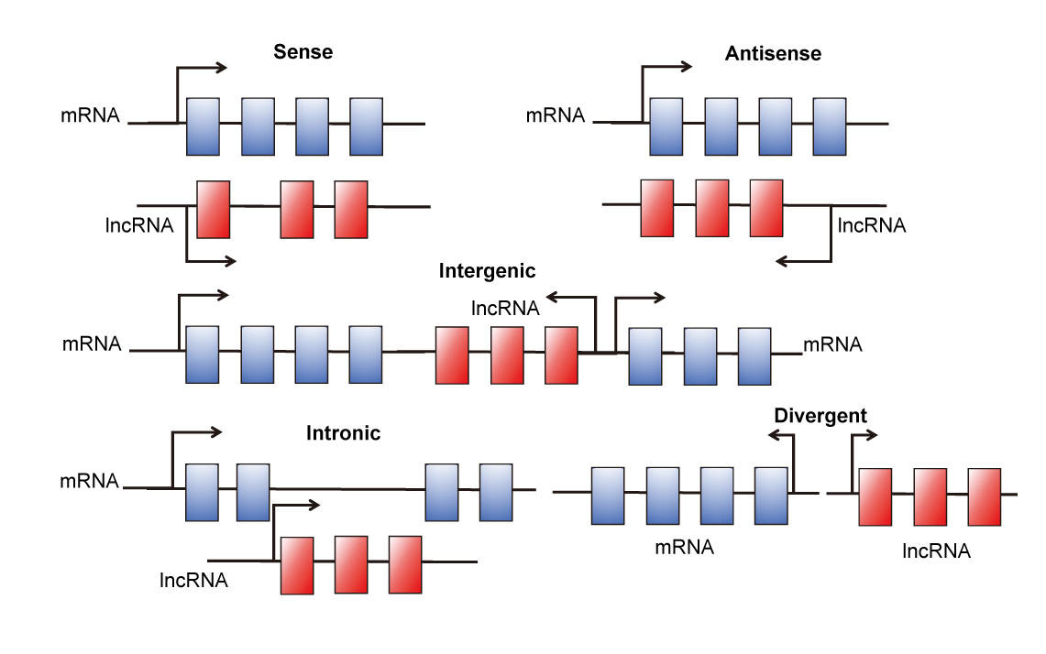
Figure 1 Five brief categories of long noncoding RNAs based on the genome position. lncRNAs: long noncoding RNAs.

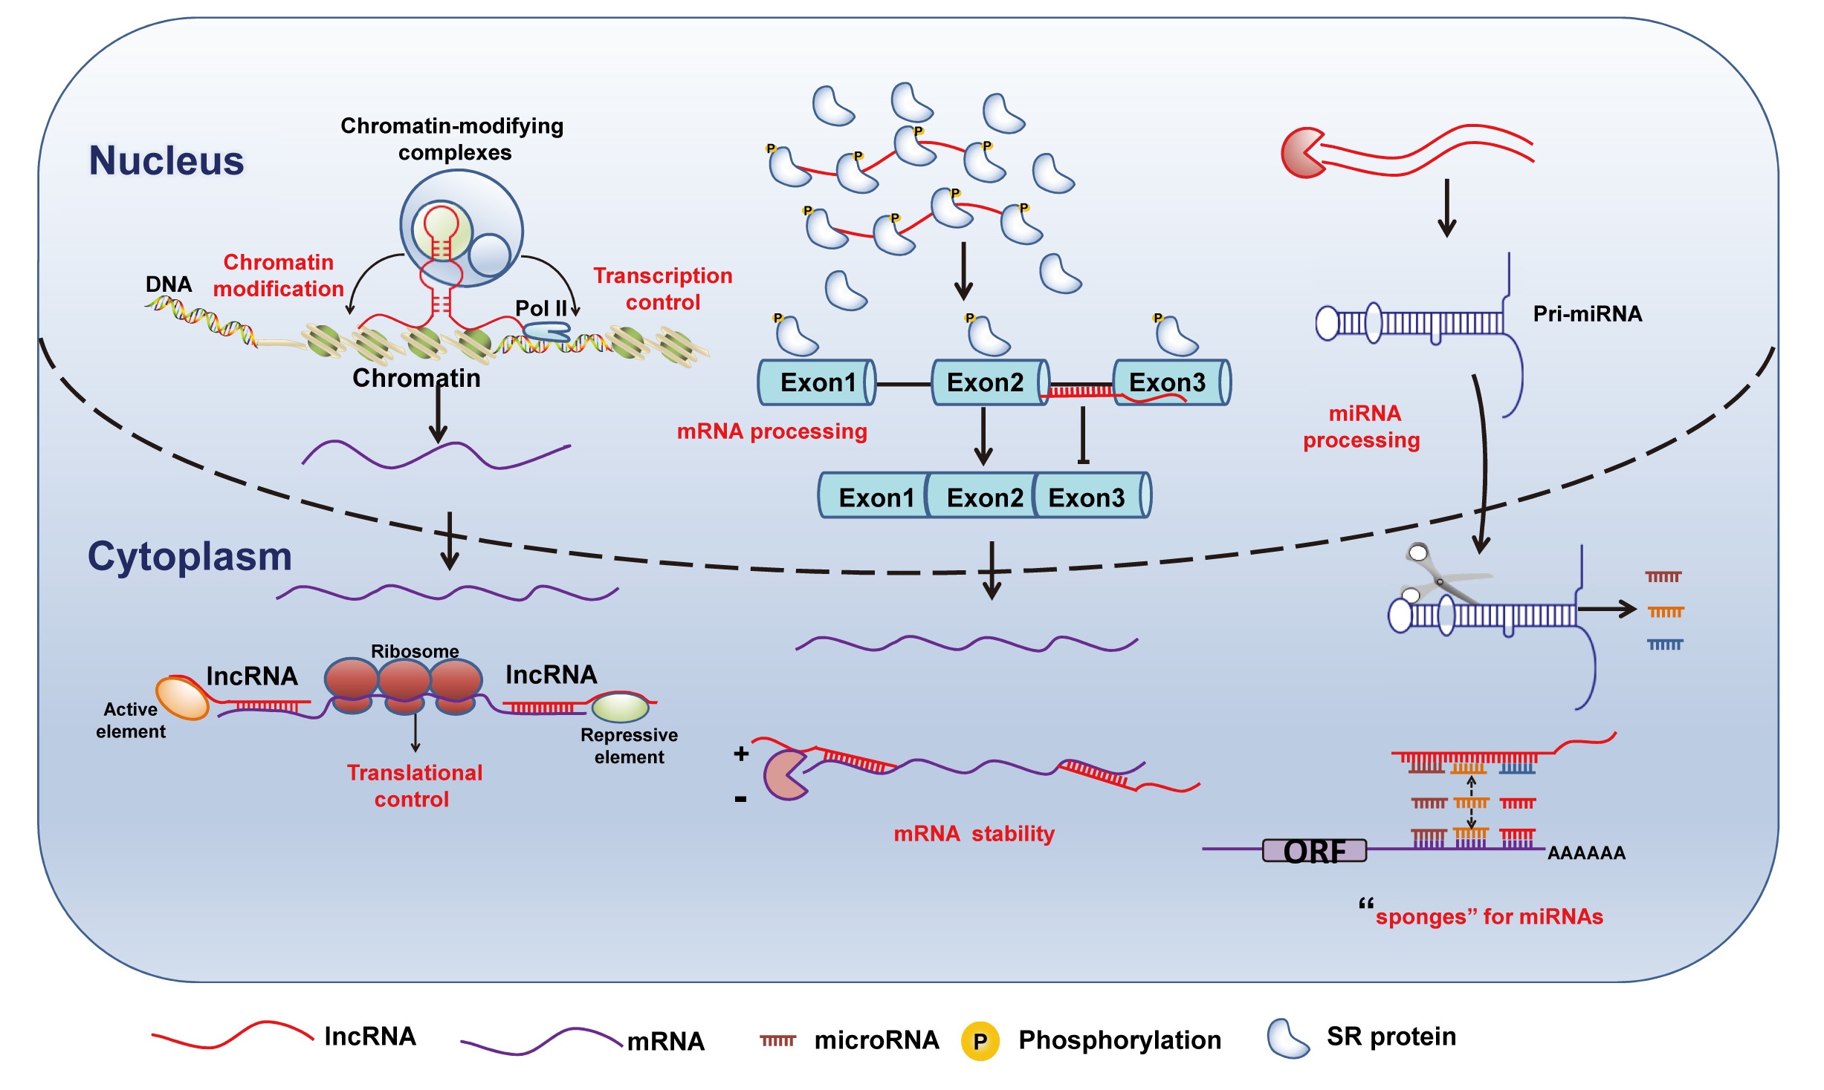
Figure 2 Mechanisms of long noncoding RNAs according to the subcellular localization. lncRNAs in nucleus frequently interact with protein complexes (such as PRC2) to modify chromatin structures. LncRNAs can also recruit transcription factors to promote or repress gene transcription, through regulating SR proteins or form RNA-RNA duplexes with pre-mRNAs. Some lncRNAs (such as H19) are splice into pri-miRNAs, which contributed to miRNA processing. In cytoplasm, lncRNAs may form specific structures with mRNA and interact with some active elements or repressive elements to modulate mRNA translation. By forming RNA-RNA complementary sites with mRNA or microRNA, lncRNAs can promote or inhibit mRNA stability and serve as “sponges” for miRNAs. lncRNAs: long noncoding RNAs; PRC2: polycomb repressive complex2.

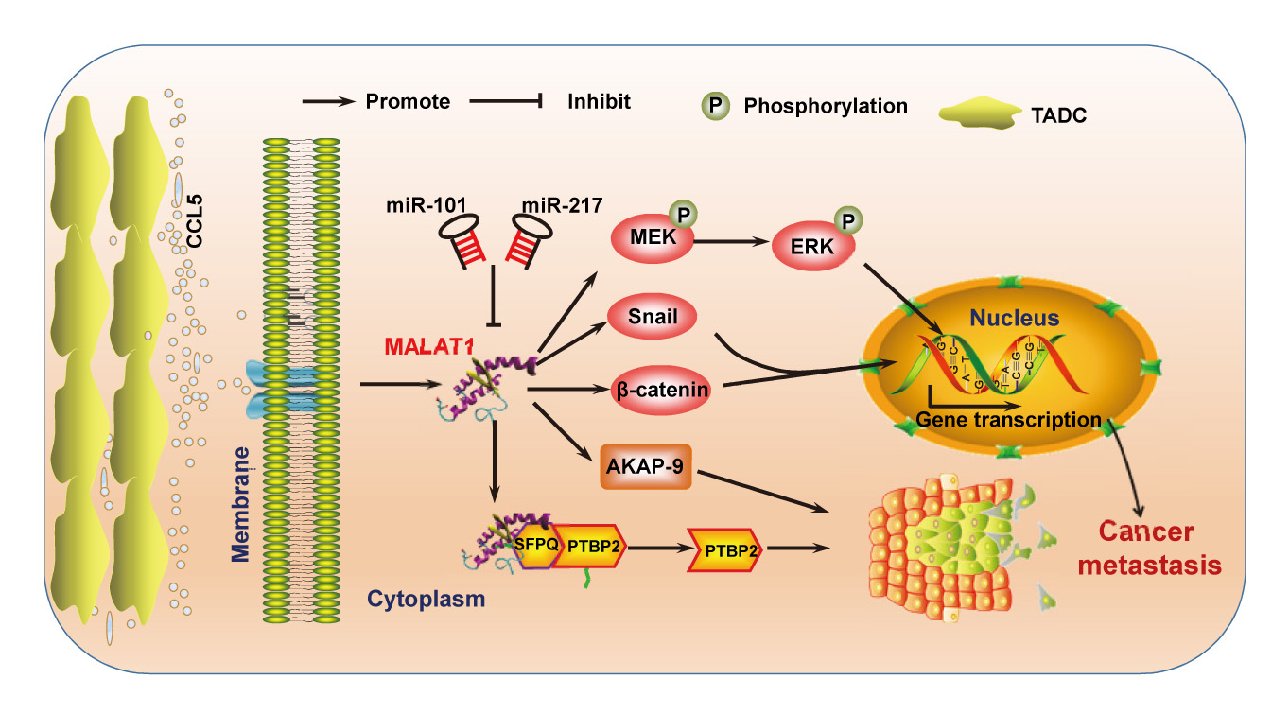
Figure 3 Regulate function of metastasis-associated lung adenocarcinoma transcript 1 in gastrointestinal cancer. CCL5 secreted by tumor-associated dendritic cells (TADCs) can promote MALAT1 expression. MALAT1 activates the ERK/MAPK pathway and Wnt/β-catenin pathway. Snail and AKAP-9 are downstream targets of MALAT1. miR-101 and miR-217 can regulate MALAT1 in 3’UTR region. MALAT1 can also bind to SFPQ/PTBP2 complex and promote the release of PTBP2. MALAT1: Metastasis-associated lung adenocarcinoma transcript 1.

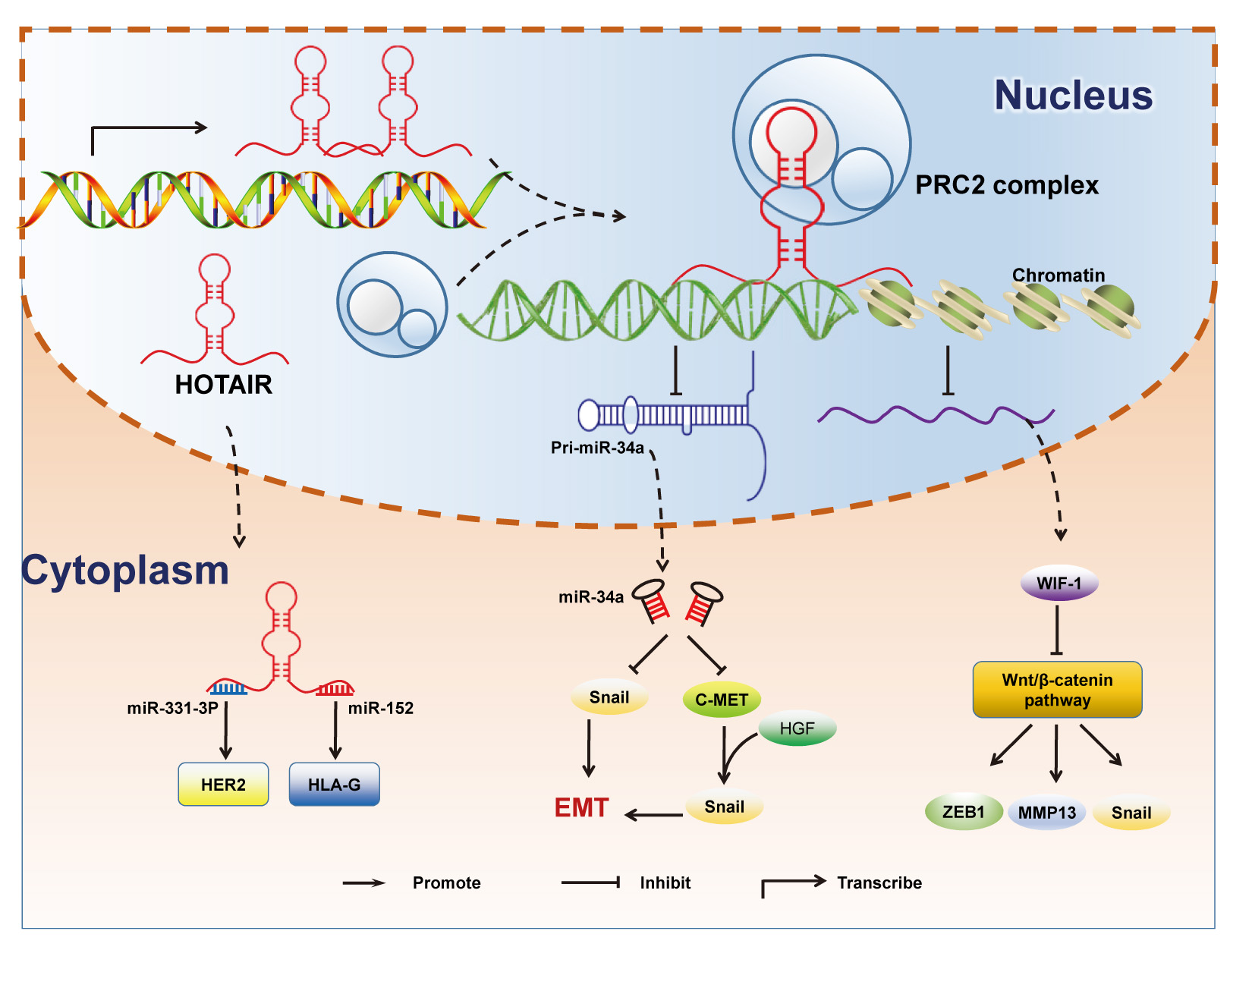
Figure 4 Regulate function of HOTAIR in gastrointestinal cancer. In Nucleus, HOTAIR recurits PRC2 complex and represses pri-miR-34a transcription epigenetically. By inducing histone H3K27 methylation in WIF-1’s promoter region, HOTAIR decreases WIF-1 expression. In cytoplasm, HOTAIR serves as “sponges” for miR-331-3p and miR-152, leading to the increase of target genes HER2 and HLA-G. PRC2: polycomb repressive complex2.

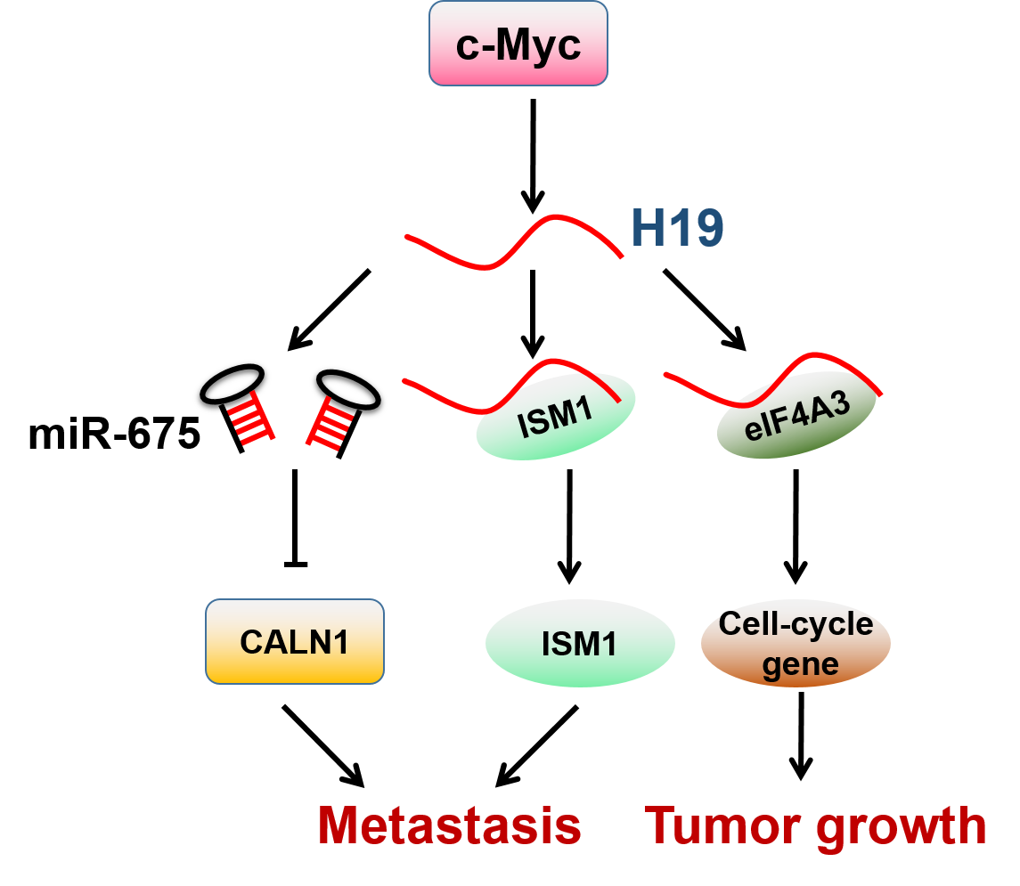
Figure 5 Regulate function of H19 in gastrointestinal cancer. H19 is transcribed by transcription factor c-Myc. H19 can be spliced into pre-miRNA of miR-675, and suppresses miR-675 target gene CALN1. On the other hand, H19 binds with its binding protein ISM1 or Eif4A3 and promotes metastasis or growth.

Table 1 Summarization of aberrant expression lncRNAs and their gene locus, product size, expression status and biological function
lncRNAs | Cancer type | Gene Locus | Size | Expression | Correlation with metastasis | Biological function
91H | CRC | 11p15.5  (H19/IGF2 locus) | 119392nt | Up | Positive | Migration and invasiveness^{[50]}
AK123657  BX649059  BX648207 | CRC | NA | 2126 nt  3967 nt  5032 nt | Down  Down  Down | Negative  Negative  Negative | Inhibit cell invasion, serve as promising biomarkers for prognosis^{[51]}
CCAT1 | CRC | 8q24.21 | 2628 nt | Up | Positive | Up-regulated across the colon adenoma-carcinoma sequence and activated by C-myc to promote metastatic process^{[52,53]}
CCAT2 | CRC | 8q24.21 | 1752 nt | Up | Positive | Interacts with TCF7L2 which leads to genomic instability, cell invasion and forms a feedback loop with WNT signaling^{[54]}
FER1L4 | CRC | 20q11.22 | 6717 nt | Down | Negative | Suppresses oncogenesis via inhibiting miR-106a-5p^{[55]}
HOTAIR | CRC | 12q13.13 | 2370 nt | Up | Positive | Interacts with PRC2 complex and participates in EMT^{[45, 56]}; the blood levels of HOTAIR also serves as a negative prognostic factor^{[46]}
LOC285194 | CRC | 3q13.31 | 2105 nt | Down | NA | Novel biomarker of cancer metastasis^{[57]}
MALAT1 | CRC | 11q13.1 | 8758 nt | Up | Positive | 3' end of MALAT-1 (6918 nt-8441 nt) promotes migration and invasion and AKAP-5 is a downstream target protein^{[58,59]}; Mediates Wnt/β-catenin signalling^{[49]}; Up regulated by tumor-associated dendritic cells expressed CCL5 and enhance Snail to promote migration, invasion and EMT ^{[60]}
MEG3 | CRC | 14q32 | 1595 nt | Down | NA | Potential marker for prognosis^{[61]}
ncRAN | CRC | 17q25.1 | 2538 nt | Up | Positive | Promotes migration and invasion^{[62]}
ncRuPAR | CRC | 5q13.3 | 486 nt | Down | NA | Potential biomarker^{[63]}
NEAT1 | CRC | 11q13.1 | 3756 nt | Up | NA | Indicator of tumor differentiation, invasion and metastasis^{[64]}
PVT-1 | CRC | 8q24 | 1957 nt | Up | NA | Antiapoptotic activity^{[65]}
TUG1 | CRC | 22q12.2 | 7598 nt | Up | Positive | Activates EMT and promotes migration, invasion^{[66]}
91H | ESCC | 11p15.5  (H19/IGF2 locus) | 119.392kb | Down | Negative | Inhibits IGF2 expression and regulates tumor development^{[67]}
AFAP1-AS1 | ESCC | 4p16.1  (AFAP1 locus) | 6810 nt | Down | Positive | Hypomethylated and overexpressed in ESCC, promotes migration and invasion in a AFAP1 independent manner^{[68]}
CCAT2 | ESCC | 8q24.21 | 1752 nt | Up | Negative | Potential prognostic biomarker and therapeutic target^{[69]}
H19 | ESCC | 11p15.5  (IGF2 locus) | 2362 nt | Up | Positive | H19 CBS6 hypermethylation leads to IGF2 overexpression and cancer progression^{[70]}
HNF1A-AS1 | ESCC | 12q24.31  (HNF1A locus) | 2455 nt | Up | Positive | Upregulated in primary ESCC , affects assembly of chromatin and the nucleosome process by H19 induction^{[71]}
HOTAIR | ESCC | 12q13.13 | 2370 nt | Up | Positive | Medicates migratory capacity^{[44,72,73]} ; promotes histone H3K27 methylation and activates Wnt/β-catenin signaling and decreases WIF-1, lead to metastasis^{[43]}
MALAT1 | ESCC | 11q13.1 | > 8 kb | Up | Positive | Target of miR-101 and miR-217 and promotes migration, invasion and metastasis^{[74]}
MALAT1 | GBC | 11q13.1 | 8758 nt | Up | Positive | Bind to SFPQ, lead to PTBP2 releasing from SFPQ/PTBP2 complex^{[75]}; Activates the ERK/MAPK pathway and promotes metastasis^{[76]}
AA174084 | GC | 13q33.1 | 601 nt | Up | NA | The expression level in gastric juice is a Potential marker for the early diagnosis of GC^{[48]}
AC130710 | GC | 2p24.3 | 984 nt | Up | NA | As a target of miR-129-5p and may be a potential biomarker for GC prognosis^{[77]}
AK058003 | GC | 10q22 | 1197 nt | Up | NA | Induced by hypoxia and regulate SNCG to promote metastasis^{[78]}
BM742401 | GC | 18q11.2 | 1788 nt | Down | Negative | Decreases expression of MMP9 and inhibits metastasis-related phenotypes^{[79]}
FENDRR | GC | 3q13.31 | 3099 nt | Down | Negative | Downregulates FN1 and MMP2/MMP9 to suppress invasion and migration^{[80]}
GAPLINC | GC | 18p11.31 | 924 nt | Up | Positive | Competes to bind with miR-211-3p,which leads to the increased translation of CD44 and promotes proliferation, migration, and angiogenesis^{[81]}
H19 | GC | 11p15.5  (IGF2 locus) | 2362 nt | Up | Positive | Target of c-Myc and promotes migration, invasion and metastasis by the direct upregulation of ISM1 and indirect suppression of CALN1 via miR-675 ^{[82,83]}
HOTAIR | GC | 12q13.13 | 2370 nt | Up | Positive | Novel biomarker for prognosis and promotes metastasis via PCBP1 inhibition^{[61,84-87]}; as a ceRNA of miR-331-3p and modulates the derepression of HER2^{[41]}; Up regulates HLA-G via inhibiting miR-152^{[42]}; binds to PRC2 complex and epigenetically represses miR34a, which inhibits HGF/Met/Snail pathway and Snail, leads to EMT and metastasis^{[55]}
HULC | GC | 6p24.3 | ~1.6 kb | Up | Positive | Promotes EMT^{[88]}
LEIGC | GC | 2q14.1 | 2659 nt | Down | Negative | Inhibit EMT^{[89]}
OR3A4 | GC | 17p13.3 | 1202 nt | Up | Positive | Promotes migration, invasion, tubule formation, vasculogenic mimicry, angiogenesis by regulating PDLIM2, MACC1, NTN4, and GNB2L1^{[90]}
CRC: colorectal cancer; GBC: gallbladder carcinoma; GC: Gastric cancer; ESCC: Asophageal squamous cell carcinoma; NA: data not available.

