Name of Journal: World Journal of Clinical Cases
Manuscript NO: 69810
Manuscript Type: ORIGINAL ARTICLE

Retrospective Study
Perforating and nonperforating indications in repeated surgeries for Crohn’s disease

Shen WS et al. Perforating and nonperforating indications

Wei-Song Shen, Xiao-Hui Huang, Rui-Qing Liu, Chen-Yang Li, Yi Li, Wei-Ming Zhu

Wei-Song Shen, Department of Gastrointestinal Surgery, Peking University People’s Hospital, Beijing 100044, China

Xiao-Hui Huang, Department of General Surgery, Chinese PLA General Hospital First Medical Center, Beijing 100853, China

Rui-Qing Liu, Department of General Surgery, The affiliated Hospital of Qingdao University, Qingdao 266000, Shandong Province, China

Chen-Yang Li, Peking University School of Nursing, Peking University School of Nursing, Beijing 100191, China

Yi Li, Wei-Ming Zhu, Department of General Surgery, Jinling Hospital, Medical School of Nanjing University, Nanjing 210002, Jiangsu Province, China

Author contributions: Shen WS, Huang XH, and Liu RQ contributed equally to this work, studied conception and design, and drafting of manuscript; Li CY contributed to acquisition of data; Li Y analysis and interpretation of data; Zhu WM contributed to critical revision.

Supported by Peking University Medicine Fund of Fostering Young Scholars’ Scientific& Technological Innovation Supported by the Fundamental Research Funds for the Central Universities, No. BMU2021PYB009; Peking University People’s Hospital Research and Development Funds, No. RDY2020-14; National Natural Science Foundation of China, No. 82100546.

Corresponding author: Wei-Ming Zhu, MD, Chief Doctor, Department of General Surgery, Jinling Hospital, Medical School of Nanjing University, No. 305 East Zhongshan Road, Nanjing 210002, Jiangsu Province, China. zhuweimingnj@163.com

Received: July 12, 2021
Revised: December 27, 2021
Accepted: February 19, 2022
Published online: March 26, 2022

Abstract
BACKGROUND
Despite advances in medical therapy for Crohn’s disease (CD), most patients with CD require repeated resection surgeries.

AIM
To analyze the perforating and nonperforating indications of repeated CD operations and identify the anastomosis characteristics for postoperative CD.

METHODS
We retrospectively reviewed 386 patients who underwent at least one resection for CD between 2003 and 2013.Clinical characteristics of each surgery were collected. Univariate and multivariate analyses were performed to determine risk factors for recurrence.

RESULTS
The indication for reoperation in CD tends to be the same as that for primary operation, i.e., perforating disease tends to represent as perforating disease and nonperforating as nonperforating. Concordance was found between the first surgery and second surgery in terms of the indication for the operation (P = 0.006), and the indication for the third surgery was also correlated with that for the second surgery (P = 0.033). Even if the correlation of surgical indications between repeated operations, the rate of perforating indication for the second and third surgeries was significantly higher than that of the first surgery. In addition, the presence of perforating CD was a predictor of recurrence for both the first and second surgeries. Moreover, anastomotic lesions were the most common sites of recurrence after the operation. Based on the importance of anastomosis, anastomosis might be a new type of disease location for the classification of postoperative CD.

CONCLUSION
CD not only has stable characteristics but also progresses chronically. Perforation is a progressive surgical indication for Crohn’s disease. For CD after surgery, anastomosis may be a new classification of disease location.

Key Words: Crohn’s Disease; Anastomosis; Perforation; Nonperforating

©The Author(s) 2022. Published by Baishideng Publishing Group Inc. All rights reserved.

Citation: Shen WS, Huang XH, Liu RQ, Li CY, Li Y, Zhu WM. Perforating and nonperforating indications in repeated surgeries for Crohn’s disease. World J Clin Cases 2022; 10(9): 2733-2742
URL: https://www.wjgnet.com/2307-8960/full/v10/i9/2733.htm
DOI: https://dx.doi.org/10.12998/wjcc.v10.i9.2733

Core Tip: It was well-known that Crohn’s disease (CD) is a chronic disease characterized by progressive bowel destruction. Our findings suggest that CD becomes more severe and more extensive with the increase in number of surgeries. CD not only has stable characteristics, but also progresses chronically. Perforation is a progressive surgical indication for CD. For CD after operation, anastomosis may be a new classification of disease location.

INTRODUCTION
Crohn’s disease (CD) is a chronic inflammatory bowel disease (IBD) of unknown etiology; it is extremely difficult to predict the clinical course of CD patients. In recent years, the incidence of CD has increased dramatically in China^{[1]}. Despite advances in medical therapy for CD (such as antitumor necrosis factor antibodies and immunosuppressive drugs), antitumor necrosis factor antibodies can effectively promote the healing of intestinal mucosa and reduce the operation risk and hospitalization rate. However, in clinical practice, up to 30% of patients have a loss of response to biological therapy. Most CD patients still require partial bowel resection at least once during the CD course^{[2,3]}.
Surgical intervention is necessary for patients with acute perforation, internal fistulae, peritoneal abscess, intestinal obstruction, toxic dilatation, hemorrhage, and/or failed response to medical therapy^{[4]}. Surgery is effective in removing the lesions and relieving symptoms; however, surgical resection is not curative for CD, and postoperative recurrence is common. Recurrence may occur in 25%-38% of CD patients, necessitating a second surgery within 5 years postoperatively. Moreover, a third surgery owing to recurrent CD is required in an estimated 33% of these patients^{[5]}. Postoperative prophylaxis can reduce CD recurrence rates^{[6]}, but only patients with risk factors for earlier postoperative recurrence should be considered for postoperative prophylaxis due to the risks of immunosuppressive therapy. Therefore, to delay postoperative recurrence, it is important to analyze the clinical characteristics and predict postoperative recurrence for surgical patients. Several studies have assessed the risk factors for postoperative CD recurrence. Reported risk factors for postoperative recurrence include a smoking habit, family history, young age at diagnosis, ileocolonic disease, perianal disease, preoperative duration and perforating lesions^{[7-10]}.
The aim of the current study was to compare the clinical characteristics between the first, second and third surgeries, analyze correlations of the perforating and nonperforating indications, and identify the anastomosis characteristics for postoperative CD.

MATERIALS AND METHODS
Patients
Data were retrospectively reviewed from CD patients treated between 2003 and 2013 in Jinling Hospital, Medical School of Nanjing University. All included patients were preoperatively diagnosed with CD based on conventional clinical features, abdominal computed tomography, and endoscopy, and the CD diagnosis was postoperatively confirmed by histological analysis of the surgical specimen. Patients who had undergone at least one surgical resection for CD were considered for study enrollment. Endoscopies were performed at 3 mo, 6 mo and every year after surgery. All patients were contacted by telephone and asked to participate in the study. All patients gave informed written consent. This study was approved by the Jinling Hospital Ethics Committee.

Definitions
Patient age and disease location were based on the Montreal classification^{[11]}. Indication for surgery was defined as the main reason for surgical resection based on clinical features, preoperative diagnostic examinations, and intraoperative findings. The indications were classified into two categories based on the report by Simillis et al^{[12]} perforating indications included acute free perforation, internal or external fistula, and abscess; nonperforating indications included intestinal obstruction, medical intractability, and hemorrhage. Recurrence was defined as the need for reoperative surgery.

Data collection
Clinical characteristics, including age at diagnosis, sex, age at the time of surgery, appendectomy history, preoperative duration, smoking history, perianal disease, indication for surgery, and disease location, were retrospectively collected for each patient by two independent individuals (W.S. and X.H.). We also collected operative records, including resection range and occurrence of postoperative intra-abdominal septic complications (IASCs). Serum albumin, C-reactive protein, and BMI were also collected after patient admission. The deadline for follow-up was February 2017. All patients were followed-up at regular intervals.

Statistical analysis
Statistical analysis was performed using SPSS version 19.0 (Chicago, IL, United States). Correlations of clinical characteristics between the repeated surgeries were tested for statistical significance using Pearson’s χ² test. The paired-samples t-test was used to assess differences in recurrence-free survival after the first and second surgeries. For analysis of recurrence-free survival data related to perforating indication, cumulative survival curves were created using the Kaplan–Meier method; the difference between the curves was analyzed by the log-rank test. Univariate and multivariate survival analyses were carried out using the Cox proportional hazards model. Spearman’s correlation coefficient test was used to assess associations of perforating indications for multiple operations. A value of P < 0.05 was considered statistically significant, and all P values were two-sided.

RESULTS
Clinical characteristics of patients
There were 386 hospitalized patients who had undergone at least one surgical resection in our department; 155 of these patients had undergone two surgical resections, and 41 of these 155 patients had undergone at least three surgical resections. A final total of 386 CD patients were included in this study. The clinical features are shown in Table 1. There were no significant differences between surgeries in sex, appendectomy history, smoking history, perianal disease or IASCs (P > 0.05).

Surgical indication between multiple operations
The perforating and nonperforating indications of the initial surgery were correlated with the surgical indication of the second surgery (P = 0.006, r = 0.220), and the surgical indication of the second surgery was also correlated with that of the third surgery (P = 0.033, r = 0.334) (Figure 1). Perforating disease tends to represent as perforating disease and nonperforating as nonperforating. Even with the correlation of surgical indications between repeated operations, the rate of CD perforation behavior as an indication for the second and third surgeries was significantly higher than that for the first surgery (Figure 2). Therefore, although CD can retain disease behavior after surgery, CD is a chronic disease characterized by progressive bowel destruction and will eventually develop a perforation. CD not only has stable characteristics but also progresses chronically.

Postoperative recurrence
After the first surgery, perforating indication (HR 1.456, 95%CI 1.051-2.016) and preoperative disease duration (HR 1.003, 95%CI 1.000-1.006) were significantly associated with recurrence-free survival in the univariate analysis. In multivariate analysis, only perforating indication significantly affected the outcome of recurrence and appeared to be an independent prognostic factor (HR 1.425, 95%CI 1.015-2.000) (Table 2).
Table 3 shows the results of the univariate and multivariate Cox proportional hazard model analyses after the second surgery. In the univariate analysis, only perforating indication (HR 2.036, 95%CI 1.043-3.968) was significantly associated with recurrence-free survival. In the multivariate analysis, none of the factors affected the outcome of recurrence.

Postoperative anastomosis characteristics
Anastomotic lesions were the most common sites of recurrence after the operation. In the second surgery, 79% of lesions occurred at anastomotic sites. The surgical indication of the second surgery was correlated with the behavior of anastomosis (P = 0.000, r = 0.917) (Figure 3). In the third surgery, 90% of lesions occurred at anastomotic sites. Concordance was found between anastomotic lesion behavior and indication for the third surgery (P = 0.000, r = 0.940) (Figure 4).

DISCUSSION
Due to the relatively low morbidity and clinical experience in CD in China, there is limited research on CD in our country, especially regarding surgical treatment. In the current study, we analyzed the clinical characteristics of repeated operations in CD, assessed the risk factors for surgical recurrence, and identified the clinical characteristics of perforating indications as common risk factors for postoperative recurrence among CD patients treated with different surgical frequencies. Moreover, our study analyzed correlations and anastomosis characteristics in repeated surgeries for Crohn’s disease.
The evaluation of clinical characteristics included each operation of CD patients. There were no significant differences in sex, appendectomy history, smoking history, perianal disease or IASCs between the primary, second and third surgeries. Our data suggested that the surgical indication of the initial surgery was correlated with the surgical indication of the second surgery. Similarly, the surgical indication of the second surgery was also correlated with that of the third surgery. Perforating CD presents as perforating disease, and nonperforating CD presents as nonperforating disease^{[12]}. Our study confirms this concept. However, the rate of perforating indications for the second and third surgeries was higher than that for the primary surgery. CD is a chronic disease characterized by progressive bowel destruction^{[13]}. The respective rates of inflammation, stricture, and penetrating disease are reportedly 12%, 18%, and 70% after 20 years^{[14]}, respectively, and most patients with CD will eventually develop a perforation. With the increase in surgical frequency and longer preoperative disease duration, the disease becomes more severe and more extensive. Our data showed that CD not only has stable characteristics but also progresses chronically, and perforation is a progressive surgical indication for Crohn’s disease.
Postoperative recurrence is a major problem for CD patients^{[15,16]}. Identifying the risk factors associated with postoperative recurrence will markedly benefit patients with CD and will permit doctors to maintain close postoperative surveillance in high-risk cases and optimize CD therapy^{[17,18]}. Although there are conflicting results in the reports according to whether the perforating indication for surgery affects postoperative recurrence^{[19,20]}, some studies have indicated that perforating CD is a risk factor for earlier recurrence^{[21]}. Our results showed that the perforating indication was a predictor of surgical recurrence, which confirmed the concept that the perforating indication for surgery was associated with decreased recurrence-free survival. Moreover, we found that a longer preoperative disease duration was significantly associated with a shorter period of postoperative recurrence after the first surgery. As the duration of CD symptoms before surgery may be uncertain, relatively few studies have shown a significant association between preoperative disease duration and earlier recurrence of postoperative CD. Our results agree with that of Lautenbach et al^{[22]}, who reported an association between higher recurrence rates and a longer preoperative duration. Antitumor necrosis factor antibodies have been proven to prevent postoperative recurrence^{[23]}. However, infliximab therapy did not significantly affect the outcome of postoperative recurrence in the univariate and multivariate analyses in our study. Moreover, anastomotic lesions were the most common sites of recurrence after the operation. anastomosis might be a new type of disease location for the classification of CD after surgery.
Several limitations of our study need to be considered. As most medical records were collected retrospectively, a potential bias may exist. Additionally, patients may not accurately remember their smoking habits, which may affect the significance of smoking as a risk factor. However, as an IBD center that focuses on surgical treatment in China, most data were accurately collected in our academic database or acquired by interviewing CD patients.

CONCLUSION
In conclusion, patients can retain their disease behavior after surgery, and the rate of perforating CD increases as the surgical frequency increases. CD not only has stable characteristics but also progresses chronically. Perforation is a progressive surgical indication for Crohn’s disease. Anastomosis might be a new classification of disease location for postoperative CD. These factors may help to stratify patients for preventive treatment.

ARTICLE HIGHLIGHTS
Research background
It was well-known that Crohn’s disease (CD) is a chronic disease characterized by progressive bowel destruction. Despite advances in medical therapy for CD, most patients with CD require repeated resection surgeries.

Research motivation
To delay postoperative recurrence, it is important to analyze the clinical characteristics and predict postoperative recurrence for surgical patients. Patients with risk factors for earlier postoperative recurrence should be considered for postoperative prophylaxis.

Research objectives
The aim of the current study was to analyze the perforating and nonperforating indications of repeated CD operations and identify the anastomosis characteristics for postoperative CD.

Research methods
Clinical characteristics of each surgery were collected. Univariate and multivariate analyses were performed to determine risk factors for recurrence.

Research results
Even if the correlation of surgical indications between repeated operations, the rate of perforating indication for the second and third surgeries was significantly higher than that of the first surgery. Anastomosis might be a new type of disease location for the classification of postoperative CD.

Research conclusions
CD not only has stable characteristics but also progresses chronically. Perforation is a progressive surgical indication for Crohn’s disease. For CD after surgery, anastomosis may be a new classification of disease location.

Research perspectives
More study analyze the anastomosis characteristics for postoperative CD and develop new typing standardsfor postoperative CD.

ACKNOWLEDGEMENTS
We thank all the people who participated in this article and the support of the hospital and department.

REFERENCES
1 Yang H, Li Y, Wu W, Sun Q, Zhang Y, Zhao W, Lv H, Xia Q, Hu P, Li H, Qian J. The incidence of inflammatory bowel disease in Northern China: a prospective population-based study. PLoS One 2014; 9: e101296 [PMID: 25029440 DOI: 10.1371/journal.pone.0101296]
2 Dasharathy SS, Limketkai BN, Sauk JS. What's New in the Postoperative Management of Crohn's Disease? Dig Dis Sci 2021 [PMID: 34406585 DOI: 10.1007/s10620-021-07205-w]
3 Papamichael K, Lin S, Moore M, Papaioannou G, Sattler L, Cheifetz AS. Infliximab in inflammatory bowel disease. Ther Adv Chronic Dis 2019; 10: 2040622319838443 [PMID: 30937157 DOI: 10.1177/2040622319838443]
4 Bislenghi G, Sucameli F, Fieuws S, Ferrante M, Sabino J, Wolthuis A, Vermeire S, D'Hoore A. Non-conventional versus conventional strictureplasties for Crohn's disease. A Systematic Review and Meta-analysis of Treatment Outcomes. J Crohns Colitis 2021 [PMID: 34406378 DOI: 10.1093/ecco-jcc/jjab146]
5 Riss S, Schuster I, Papay P, Mittlböck M, Stift A. Repeat intestinal resections increase the risk of recurrence of Crohn's disease. Dis Colon Rectum 2013; 56: 881-887 [PMID: 23739195 DOI: 10.1097/DCR.0b013e31828cb80c]
6 Battat R, Sandborn WJ. Advances in the Comprehensive Management of Postoperative Crohn's Disease. Clin Gastroenterol Hepatol 2021 [PMID: 33819666 DOI: 10.1016/j.cgh.2021.03.048]
7 Fortinsky KJ, Kevans D, Qiang J, Xu W, Bellolio F, Steinhart H, Milgrom R, Greenberg G, Cohen Z, Macrae H, Stempak J, McLeod R, Silverberg MS. Rates and Predictors of Endoscopic and Clinical Recurrence After Primary Ileocolic Resection for Crohn's Disease. Dig Dis Sci 2017; 62: 188-196 [PMID: 27778204 DOI: 10.1007/s10620-016-4351-7]
8 Dal Piaz G, Mendolaro M, Mineccia M, Randazzo C, Massucco P, Cosimato M, Rigazio C, Guiotto C, Morello E, Ercole E, Lavagna A, Rocca R, Ferrero A, Daperno M. Predictivity of early and late assessment for post-surgical recurrence of Crohn's disease: Data from a single-center retrospective series. Dig Liver Dis 2021; 53: 987-995 [PMID: 33526411 DOI: 10.1016/j.dld.2020.09.018]
9 Wasmann KATGM, van Amesfoort J, van Montfoort ML, Koens L, Bemelman WA, Buskens CJ. The Predictive Value of Inflammation at Ileocecal Resection Margins for Postoperative Crohn's Recurrence: A Cohort Study. Inflamm Bowel Dis 2020; 26: 1691-1699 [PMID: 31879766 DOI: 10.1093/ibd/izz290]
10 Kline BP, Weaver T, Brinton DL Jr, Harris L, Yochum GS, Berg AS, Koltun WA. Clinical and Genetic Factors Impact Time to Surgical Recurrence After Ileocolectomy for Crohn's Disease. Ann Surg 2021; 274: 346-351 [PMID: 31714311 DOI: 10.1097/SLA.0000000000003660]
11 Satsangi J, Silverberg MS, Vermeire S, Colombel JF. The Montreal classification of inflammatory bowel disease: controversies, consensus, and implications. Gut 2006; 55: 749-753 [PMID: 16698746 DOI: 10.1136/gut.2005.082909]
12 Simillis C, Yamamoto T, Reese GE, Umegae S, Matsumoto K, Darzi AW, Tekkis PP. A meta-analysis comparing incidence of recurrence and indication for reoperation after surgery for perforating versus nonperforating Crohn's disease. Am J Gastroenterol 2008; 103: 196-205 [PMID: 17900320 DOI: 10.1111/j.1572-0241.2007.01548.x]
13 Peyrin-Biroulet L, Loftus EV Jr, Colombel JF, Sandborn WJ. Early Crohn disease: a proposed definition for use in disease-modification trials. Gut 2010; 59: 141-147 [PMID: 20176633 DOI: 10.1136/gut.2009.187120]
14 Pariente B, Cosnes J, Danese S, Sandborn WJ, Lewin M, Fletcher JG, Chowers Y, D'Haens G, Feagan BG, Hibi T, Hommes DW, Irvine EJ, Kamm MA, Loftus EV Jr, Louis E, Michetti P, Munkholm P, Oresland T, Panés J, Peyrin-Biroulet L, Reinisch W, Sands BE, Schoelmerich J, Schreiber S, Tilg H, Travis S, van Assche G, Vecchi M, Mary JY, Colombel JF, Lémann M. Development of the Crohn's disease digestive damage score, the Lémann score. Inflamm Bowel Dis 2011; 17: 1415-1422 [PMID: 21560202 DOI: 10.1002/ibd.21506]
15 Chen ZX, Chen YL, Huang XM, Lin XT, He XW, Lan P. Risk factors for recurrence after bowel resection for Crohn's disease. World J Gastrointest Pharmacol Ther 2019; 10: 67-74 [PMID: 31692953 DOI: 10.4292/wjgpt.v10.i4.67]
16 Ikeda A, Miyoshi N, Fujino S, Iijima H, Takahashi H, Haraguchi N, Nishimura J, Hata T, Matsuda C, Doki Y, Mori M, Mizushima T. A Novel Predictive Nomogram for Early Endoscopic Recurrence after Intestinal Resection for Crohn's Disease. Digestion 2019; 100: 269-276 [PMID: 30602165 DOI: 10.1159/000495981]
17 Rottoli M, Vallicelli C, Ghignone F, Tanzanu M, Vitali G, Gionchetti P, Rizzello F, Poggioli G. Predictors of early recurrence after strictureplasty for Crohn's disease of the small bowel during the years of biologics. Dig Liver Dis 2019; 51: 663-668 [PMID: 30583997 DOI: 10.1016/j.dld.2018.11.027]
18 Burr NE, Hall B, Hamlin PJ, Selinger CP, Ford AC, O'Connor A. Systematic Review and Network Meta-Analysis of Medical Therapies to Prevent Recurrence of Post-Operative Crohn's Disease. J Crohns Colitis 2019; 13: 693-701 [PMID: 30561586 DOI: 10.1093/ecco-jcc/jjy216]
19 Aaltonen G, Keränen I, Carpelan-Holmström M, Lepistö A. Risk factors for anastomotic recurrence after primary ileocaecal resection in Crohn's disease. Eur J Gastroenterol Hepatol 2018; 30: 1143-1147 [PMID: 30024490 DOI: 10.1097/MEG.0000000000001206]
20 Maggiori L, Brouquet A, Zerbib P, Lefevre JH, Denost Q, Germain A, Cotte E, Beyer-Berjot L, Munoz-Bongrand N, Desfourneaux V, Rahili A, Duffas JP, Pautrat K, Denet C, Bridoux V, Meurette G, Faucheron JL, Loriau J, Souche R, Vicaut E, Panis Y, Benoist S; GETAID chirurgie group. Penetrating Crohn Disease Is Not Associated With a Higher Risk of Recurrence After Surgery: A Prospective Nationwide Cohort Conducted by the Getaid Chirurgie Group. Ann Surg 2019; 270: 827-834
21 Corrigendum to Predicting Risk of Postoperative Disease Recurrence in Crohn's Disease: Patients With Indolent Crohn's Disease Have Distinct Whole Transcriptome Profiles at the Time of First Surgery. Inflamm Bowel Dis 2019; 25: e167 [PMID: 31329224 DOI: 10.1093/ibd/izz145]
22 Lautenbach E, Berlin JA, Lichtenstein GR. Risk factors for early postoperative recurrence of Crohn's disease. Gastroenterology 1998; 115: 259-267 [PMID: 9679030 DOI: 10.1016/s0016-5085(98)70191-x]
23 Liu C, Li N, Zhan S, Tian Z, Wu D, Li T, Zeng Z, Zhuang X. Anti -TNFα agents in preventing the postoperative recurrence of Crohn's disease: Do they still play a role in the biological era? Expert Opin Biol Ther 2021; 21: 1509-1524 [PMID: 34350811 DOI: 10.1080/14712598.2021.1964469]

Footnotes
Institutional review board statement: This study was approved by the Jinling Hospital Ethics Committee. All methods were carried out in accordance with relevant guidelines and regulations.

Informed consent statement: All patients were contacted by telephone and asked to participate in the study. All patients gave informed written consent.

Conflict-of-interest statement: The authors declare that they have no competing interests.

Data sharing statement: No additional data are available.

Open-Access: This article is an open-access article that was selected by an in-house editor and fully peer-reviewed by external reviewers. It is distributed in accordance with the Creative Commons Attribution NonCommercial (CC BY-NC 4.0) license, which permits others to distribute, remix, adapt, build upon this work non-commercially, and license their derivative works on different terms, provided the original work is properly cited and the use is non-commercial. See: https://creativecommons.org/Licenses/by-nc/4.0/

Provenance and peer review: Unsolicited article; Externally peer reviewed.
Peer-review model: Single blind

Peer-review started: July 12, 2021
First decision: December 17, 2021
Article in press: February 19, 2022

Specialty type: Gastroenterology and hepatology
Country/Territory of origin: China
Peer-review report’s scientific quality classification
Grade A (Excellent): 0
Grade B (Very good): B
Grade C (Good): C
Grade D (Fair): D
Grade E (Poor): 0

P-Reviewer: Khalili AS, Sassaki LY S-Editor: Liu JH L-Editor: A P-Editor: Liu JH
Figure Legends
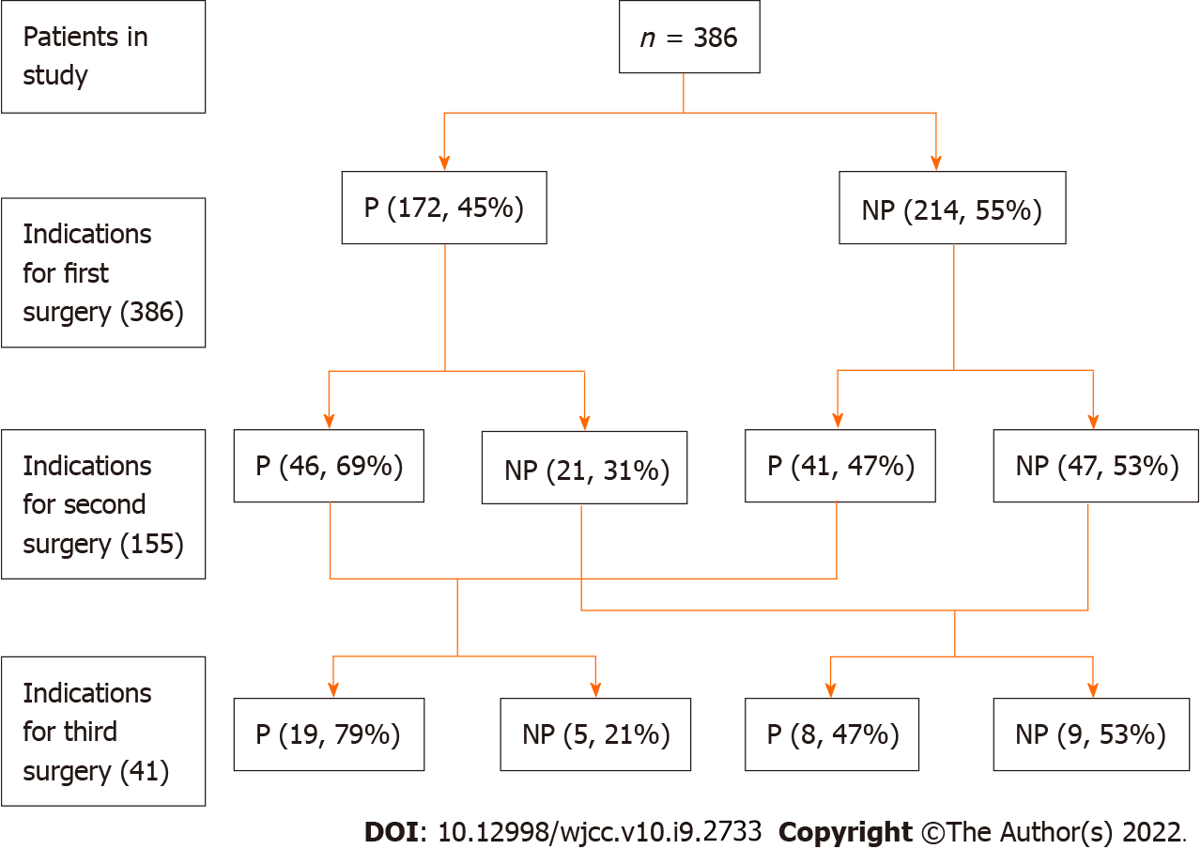
Figure 1 Correlations of perforating and nonperforating indications for Crohn's disease. P: Perforating indication; NP: Nonperforating indication.
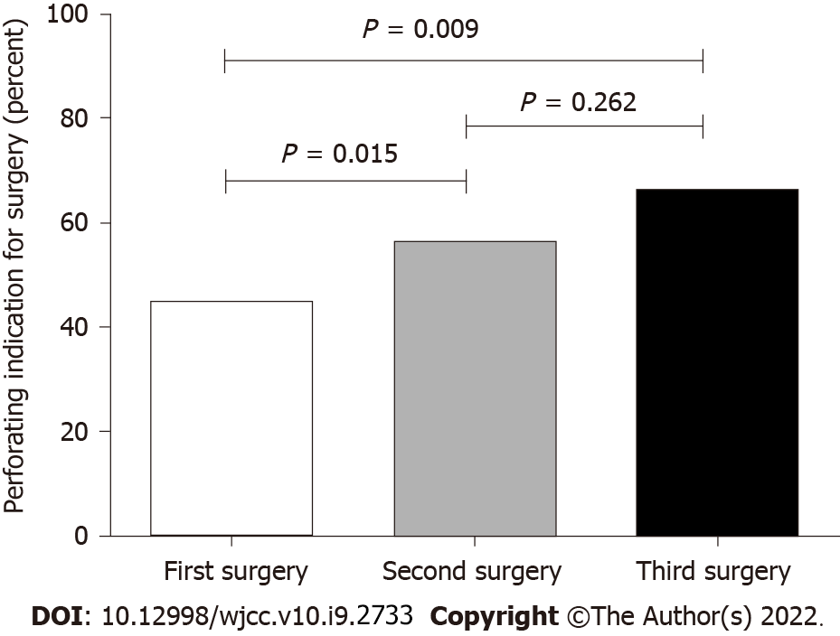
Figure 2 Percentage of perforating indications for Crohn's disease.
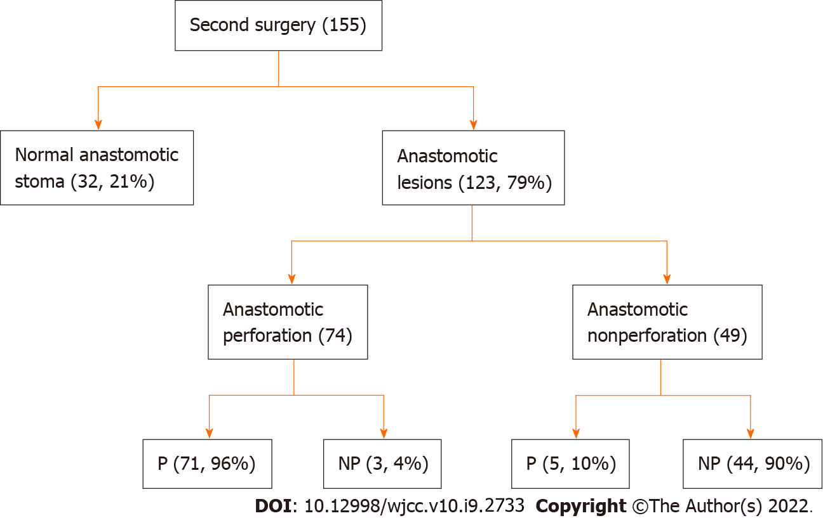
Figure 3 Anastomosis characteristics for the second surgery. P: Perforating indication; NP: Nonperforating indication.
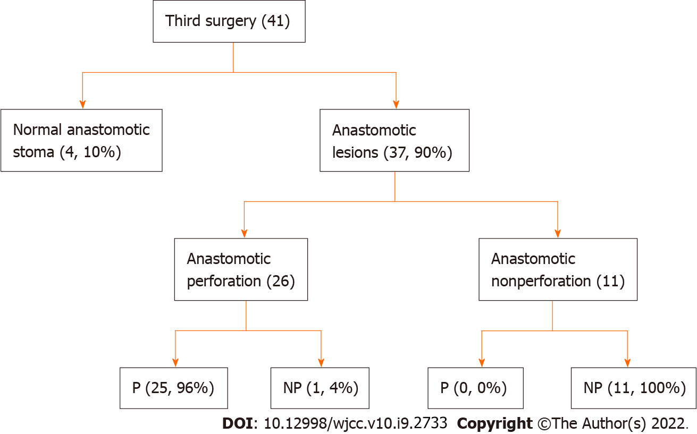
Figure 4 Anastomosis characteristics for the third surgery. P: Perforating indication; NP: Nonperforating indication.
Table 1 Characteristics of repeated operations patients with Crohn’s disease
 | First surgery (n = 386), % | Second surgery (n = 155), % | Third surgery (n = 41), % | P value
Sex |  |  |  | 0.405
Man | 290 (76.69) | 124 (80.00) | 33 (80.49)
Female | 96 (23.31) | 31 (20.00) | 8 (19.51)
Age (year) |  |  |  | 0.037
A1 (≤ 16) | 5 (1.30) | 2 (1.29) | 0 (00.00)
A2 (17-40) | 264 (68.39) | 92 (59.35) | 20 (48.78)
A3 (> 40) | 117 (30.31) | 61 (39.35) | 21 (51.22)
Appendectomy |  |  |  | 0.152
Yes | 76 (19.69) | 37 (23.87) | 13 (31.70)
No | 310 (80.31) | 118 (76.13) | 28 (68.29)
Smoking history |  |  |  | 0.576
Never smoker | 320 (82.90) | 128 (82.58) | 37 (90.24)
Past smoker | 49 (12.69) | 23 (14.84) | 3 (7.32)
Active smoker | 17 (4.40) | 4 (2.58) | 1 (2.44)
Preoperative treatment
Immunomodulator | 97 (25.13) | 48 (30.97) | 12 (29.27) | 0.362
Enteral Nutrition | 178 (46.11) | 80 (51.61) | 16 (39.02) | 0.288
5-aminosalicylates | 32 (8.29) | 23 (14.84) | 4 (9.76) | 0.074
Corticosteroids | 49 (12.69) | 30 (19.35) | 7 (17.07) | 0.130
Infliximab | 8 (2.07) | 5 (3.23) | 1 (2.44) | 0.743
Perianal disease |  |  |  | 0.265
Yes | 73 (16.77) | 39 (25.16) | 9 (21.95)
No | 313 (83.22) | 116 (74.84) | 32 (78.05)
Indication for surgery |  |  |  | 0.004
Free perforation | 65 (16.83) | 9 (5.81) | 2 (4.87)
Fistula or abscess | 107 (27.72) | 78 (50.32) | 25 (60.97)
Obstruction | 162 (41.96) | 57 (36.77) | 10 (24.39)
Medical intractability | 41 (10.62) | 5 (3.23) | 1 (2.44)
Hemorrhage | 11 (2.85) | 6 (3.87) | 3 (7.32)
Location |  |  |  | 0.028
L1 (ileal) | 145 (37.56) | 56 (36.13) | 10 (24.39)
L2 (colonic) | 47 (12.18) | 7 (4.52) | 5 (12.20)
L3 (ileocolonic) | 194 (50.26) | 92 (59.35) | 26 (63.41)
IASCs |  |  |  | 0.569
Yes | 27 (6.99) | 15 (9.68) | 3 (7.32)
No | 359 (93.01) | 140 (90.32) | 38 (92.68)
IASCs: Intra-abdominal septic complications.
Table 2 Univariate and multivariate analysis of risk factors associated with postoperative recurrence after first surgery
Covariates | Univariate |  |  | Multivariate
 | HR | 95%CI | P value | HR | 95%CI | P value
Age at diagnosis | 1.000 | 0.987-1.014 | 0.966
Preoperative duration | 1.003 | 1.000-1.006 | 0.021 | 1.002 | 0.999-1.005 | 0.112
Age | 1.005 | 0.992-1.018 | 0.496 | 1.004 | 0.991-1.018 | 0.533
Sex | 0.934 | 0.628-1.387 | 0.734
Appendectomy | 1.288 | 0.874-1.898 | 0.200
Smoking history | 1.026 | 0.676-1.558 | 0.903 | 1.048 | 0.670-1.639 | 0.838
Preoperative treatment | 0.915 | 0.630-1.330 | 0.642
Perianal disease | 0.925 | 0.606-1.413 | 0.719 | 0.951 | 0.619-1.461 | 0.819
Location | 1.027 | 0.864-1.222 | 0.761 | 1.040 | 0.871-1.241 | 0.665
Perforating indication | 1.456 | 1.051-2.016 | 0.024 | 1.425 | 1.015-2.000 | 0.041
Resection range | 0.949 | 0.799-1.128 | 0.553
IASCs | 0.666 | 0.381-1.164 | 0.154
IASCs: Intra-abdominal septic complications.
Table 3 Univariate and multivariate analysis of risk factors associated with postoperative recurrence after second surgery
Covariates | Univariate |  |  | Multivariate
 | HR | 95%CI | P value | HR | 95%CI | P value
Preoperative duration | 0.998 | 0.990-1.007 | 0.666 | 1.001 | 0.991-1.011 | 0.872
Interval from first to second | 1.001 | 0.992-1.010 | 0.831
Age at diagnosis | 1.012 | 0.984-1.041 | 0.406
Sex | 0.804 | 0.368-1.755 | 0.583
Appendectomy | 0.822 | 0.419-1.610 | 0.567
Smoking history | 0.918 | 0.323-2.606 | 0.872 | 1.228 | 0.371-4.065 | 0.737
Preoperative treatment | 1.349 | 0.667-2.752 | 0.405
Perianal disease | 1.554 | 0.673-3.592 | 0.302 | 1.448 | 0.593-3.532 | 0.416
Age | 1.008 | 0.980-1.036 | 0.590 | 1.009 | 0.977-1.042 | 0.579
Location | 1.130 | 0.798-1.600 | 0.491 | 1.182 | 0.802-1.742 | 0.397
Perforating indication | 2.036 | 1.043-3.968 | 0.037 | 1.919 | 0.959-3.846 | 0.065
Resection range | 0.955 | 0.682-1.337 | 0.788
IASCs | 0.862 | 0.378-1.966 | 0.725
IASCs: Intra-abdominal septic complications.

Published by Baishideng Publishing Group Inc
7041 Koll Center Parkway, Suite 160, Pleasanton, CA 94566, USA
Telephone: +1-925-3991568
E-mail: bpgoffice@wjgnet.com
Help Desk: https://www.f6publishing.com/helpdesk
https://www.wjgnet.com

© 2022 Baishideng Publishing Group Inc. All rights reserved.

