Name of the journal: World Journal of Gastrointestinal Oncology
Manuscript NO: 40058
Manuscript type: MINIREVIEWS

Histo-molecular oncogenesis of pancreatic cancer: From precancerous lesions to invasive ductal adenocarcinoma

Riva G et al. Oncogenesis of pancreatic cancer

Giulio Riva, Antonio Pea, Camilla Pilati, Giulia Fiadone, Rita Teresa Lawlor, Aldo Scarpa, Claudio Luchini

Giulio Riva, Giulia Fiadone, Aldo Scarpa, Claudio Luchini, Department of Diagnostics and Public Health, Section of Pathology, University and Hospital Trust of Verona, Verona 37134, Italy

Antonio Pea, Department of Surgery, University and Hospital trust of Verona, Verona 37134, Italy

Camilla Pilati, Personalized Medicine, Pharmacogenomics, Therapeutic Optimization, Paris-Descartes University, Paris 75006, France

Rita Teresa Lawlor, ARC-Net Research Center, University and Hospital Trust of Verona, Verona 37134, Italy

ORCID number: Giulio Riva (0000-0001-6636-0605); Antonio Pea (0000-0002-0509-6756); Camilla Pilati (0000-0002-1781-5180); Giulia Fiadone (0000-0003-2351-789X); Rita Teresa Lawlor (0000-0003-3160-0634); Aldo Scarpa (0000-0003-1678-739X); Claudio Luchini (0000-0003-4901-4908).

Author contributions: Luchini C, Scarpa A and Lawlor RT study conception and design; Riva G, Pea A, Lawlor RT and Luchini C literature review; all authors literature analysis and interpretation; Riva G, Pea A, Scarpa A and Luchini C wrote the manuscript; all authors final editing and approval of the manuscript in its present form.

Supported by the Associazione Italiana Ricerca sul Cancro, No. 12182; and Cassini Project.

Conflict-of-interest statement: No potential conflict of interest.

Open-Access: This article is an open-access article which was selected by an in-house editor and fully peer-reviewed by external reviewers. It is distributed in accordance with the Creative Commons Attribution Non Commercial (CC BY-NC 4.0) license, which permits others to distribute, remix, adapt, build upon this work non-commercially, and license their derivative works on different terms, provided the original work is properly cited and the use is non-commercial. See: http://creativecommons.org/licenses/by-nc/4.0/

Manuscript source: Invited Manuscript

Correspondence to: Claudio Luchini, MD, PhD, Assistant Professor, Department of Diagnostics and Public Health, University and Hospital Trust of Verona, Piazzale L.A. Scuro, 10, Verona 37134, Italy. claudio.luchini@univr.it
Telephone: +39-45-8124835
Fax: +39-45-8027136

Received: May 30, 2018
Peer-review started: May 30, 2018
First decision: July 3, 2018
Revised: July 13, 2018
Accepted: August 12, 2018
Article in press:
Published online:

Abstract
Pancreatic cancer is a lethal malignancy, whose precursor lesions are pancreatic intraepithelial neoplasm, intraductal papillary mucinous neoplasm, intraductal tubulopapillary neoplasm and mucinous cystic neoplasm. To better understand the biology of pancreatic cancer, it is fundamental to know its precursors and to study the mechanisms of carcinogenesis. Each of these precursors displays peculiar histological features, as well as specific molecular alterations. Starting from such pre-invasive lesions, this review aims at summarizing the most important aspects of carcinogenesis of pancreatic cancer, with also a specific focus on the recent advances and the future perspectives of the research on this lethal tumor type.

Key Words: Pancreatic cancer; oncogenesis; Carcinogenesis; Pancreatic ductal adenocarcinoma; Intraductal papillary mucinous neoplasm; Intraductal tubulopapillary neoplasm; Mucinous cystic neoplasm; Pancreatic intraepithelial neoplasm, KRAS

© The Author(s) 2018. Published by Baishideng Publishing Group Inc. All rights reserved.

Core tip: Pancreatic intraepithelial neoplasm, intraductal papillary mucinous neoplasm, intraductal tubulopapillary neoplasm and mucinous cystic neoplasm are precursor lesions of invasive pancreatic cancer. Each of these precursors displays peculiar histological and molecular features, which have been summarized in this review with the most important aspects of pancreatic carcinogenesis. The most recent advances and the future perspectives of the research on this topic have been also highlighted.

Riva G, Pea A, Pilati C, Fiadone G, Lawlor RT, Scarpa A, Luchini C. Histo-molecular oncogenesis of pancreatic cancer: From precancerous lesions to invasive ductal adenocarcinoma. World J Gastrointest Oncol 2018; In press

INTRODUCTION
Precursor lesions of pancreatic cancer
Precursor lesions of pancreatic ductal adenocarcinoma (PDAC) are non-invasive lesions, which can progress to infiltrating carcinoma^{[1]}. Following 2010 World Health Organization classification, different consensus conferences and international meetings have provided the basis for the current view of the definition and classification of pancreatic precursor lesions^{[2-4]}.
One major issue regards the grading of dysplasia of pre-invasive lesions, which should be restricted to the two categories of “low-grade” and “high-grade”, with the elimination of the poorly reproducible intermediate entity of “moderate dysplasia”^{[5]}. Furthermore, small intraductal papillary mucinous lesions (PanIN) ranging from 0.5 to 1.0 cm would be better defined as “incipient intraductal papillary mucinous neoplasm (IPMN)”^{[5]}.
Three PDAC precursors have been recognized: PanIN, IPMN, and mucinous cystic neoplasm (MCN); furthermore, also intratubular papillary neoplasms (ITPNs) display the features of pre-invasive lesion. Each of these entities has distinct clinical, histological as well as molecular profiles. Through a multi-step carcinogenesis, with the accumulation of cellular and molecular alterations, each of these precursors may lead to the development of invasive ductal adenocarcinoma.

CLINICAL FEATURES OF PRECURSOR LESIONS OF PANCREATIC CANCER
PanIN
PanIN represents the most common PDAC precursor, affecting equally both men and women; its incidence increases directly with age^{[5]}. The strict correlation with PDAC is suggested first of all by the fact that these lesions can be found in more than 80% of pancreas with invasive carcinoma^{[1,6]}, and by a reported multifocality in patients with PDAC familial history^{[7,8]}. Usually, due to their small size (by definition < 0.5 cm), these lesions are classically found incidentally during histological examination, and are not associated with clinical symptoms or specific signs. From the radiological point of view, PanINs are more often associated with acinar atrophy and/or fibrosis, but this correlations is not specific^{[9,10]}.

IPMN
IPMNs are grossly-visible lesions with intraductal growth, with a papillary architecture and mucous producing cells; their first definition as IPMNs has been indicated in 1994 by Morohoshi et al^{[11]}. The median age of IPMN patients ranges from 60 to 66 years; they are more common in men than in women (ratio: 3/1.3 in Europe, 3/2.1 in USA and 3/1.8 in Asia) and arise most frequently in the proximal pancreatic head and the “uncinatus” process^{[12]}. Although rare, IPMN involving more than a pancreatic segment or even the entire pancreas have been described (Figure 1)^{[12]}. It is estimated that IPMNs may require up to 6 years to become invasive, although such estimation may be affected by multiple biases, including the specific IPMN histotype^{[13-15]}. Similarly to PanINs, IPMNs are found more frequently in patients with PDAC familial history, this highlighting the importance of a genetic predisposition to carcinogenesis of IPMN patients. In fact, such precursors have been found also in the context of multi-organ syndromes as Peutz-Jeghers, familial adenomatous polyposis, Lynch and McCune-Albright syndromes^{[16-18]}. Moreover, patients with IPMNs have an increased risk to develop other extrapancreatic cancers^{[19]}.
One of the most important distinctions between IPMNs and PanINs is the possibility that IPMNs may be detected with imaging techniques. Patients with IPMNs should be followed-up according to specific protocols, mainly based on radiological examination^{[20]}. The typical intraductal growth of IPMNs leads to cystic dilation of the pancreatic ductal tree ducts^{[21]}. Based on their location, IPMNs may be classified from the topographic point of view in: (1) main-duct IPMNs, where Wirsung’s duct is involved; (2) branch-duct IPMNs, in case of the involvement of secondary ducts; or (3) mixed IPMNs, in case of contemporaneous involvement of the main and the branch ducts^{[1,20,21]}. Although this distinction cannot be always confirmed by histopathological examination, since some branch duct-IPMNs may display some degrees of Wirsung’s duct involvement^{[22]}, at the same time this topographic definition has an important clinical impact. Indeed, main-duct IPMNs are more often associated with PDAC development and patients with this type of lesion must follow stringent surveillance protocols^{[20]}. IPMN-associated carcinomas display usually a better prognosis than conventional PDACs^{[1]}.

MCN
MCNs are typical lesions of perimenopausal women, with few cases described in men^{[4]}. They usually arise in the distal part of the pancreas (body and/or tail), and, by definition, do not communicate with the pancreatic ductal tree^{[1]}. It has been hypothesized that the predominance in female of MCNs may be due to embryogenesis or by a carcinogenetic process stimulated by female hormones^{[23,24]}. This theory is also corroborated by their histological aspect, since under their mucinous, non-papillary epithelium, there is a classic ovarian-like stroma^{[1]}. The mean age of presentation of patients with MCNs is about 44 years, and that of MCNs with an associated adenocarcinoma is about 55 years^{[20]}. This observation is in line with the status of MCN as PDAC precursor lesion. The association with PDAC is present in up to one third of MCNs^{[25,26]}. Differently from PanINs, but similarly to IPMNs, MCNs can be detected by imaging; MCN patients must undergo strict follow-up or pancreatic resection, since there is a non-negligible risk of PDAC development^{[21]}.

ITPN
ITPNs are rare intraductal neoplasms of the pancreas, composed by mucinous cells displaying a tubule-papillary architecture^{[1,5]}. Their incidence is similar in women and in men^{[1]}. These lesions are more commonly located in the head of the pancreas^{[1]}, and their symptoms are unspecific, including undefined abdominal pain and vomiting. Notably, about 40% of ITPNs harbor an associated invasive carcinoma^{[21]}; PDACs arising in association with ITPNs have usually a better prognosis than that of conventional PDACs, with a 5-year survival rate of more than 30%^{[21]}.

HISTOPATHOLOGY OF PRECURSOR LESIONS OF PANCREATIC CANCER
PanIN
PanINs are non-infiltrating microscopic intraductal lesions, by definition with a diameter < 0.5 cm^{[1,3]}. From the histological point of view, they are composed by cuboid to columnar mucinous cells, with varying degrees of dysplasia, reflecting the different degrees of cytologic and/or architectural atypia^{[1,3]}. In the vast majority of cases, PanINs show gastric/foveolar differentiation^{[21]}. Hruban et al^{[4]} classified PanINs into a three-tiered scale, based on the degree of dysplasia. In this scheme, PanIN-1 shows low-grade dysplasia, PanIN-2 shows intermediate dysplasia and PanIN-3 has high-grade dysplasia characterized by marked cell atypia, presence of mitotic figures, loss of polarity and complex architecture. To improve inter-observer agreement and in order to report only the most important histological information, a recent consensus suggested a new classification system, distinguishing low-grade PanINs, which includes the previously called PanIN-1 and PanIN-2, and high-grade PanINs that includes PanIN-3 (Figure 2)^{[5]}. In high-grade PanINs, cribriform structures, atypical mitosis, tufting of epithelial cells in the lumen and even necrosis may be present, but in case these features are concomitant with a PDAC, the most important differential diagnosis of high-grade PanINs is with non-dysplastic ducts, which have been colonized by PDAC cells^{[27]}. Notably, high-grade PanINs have been reported almost exclusively in association with an infiltrating PDAC^{[1,21]}. However, a recent report pointed out that high-grade dysplasia PanINs may be found without concomitant infiltrating PDAC, and, when they involve the main duct, they may cause stenosis with extensive upstream duct dilation^{[28]}. At the immunohistochemical level, PanINs show an increased expression of mucins 1 and 5AC (MUC1 and MUC5AC) and a decreased expression of mucin 6 (MUC6)^{[29-32]}.

IPMN
IPMNs are non-infiltrating neoplasms > 1.0 cm by definition and with intraductal growth, composed by mucinous cells with a papillary architecture^{[1,5]}; lesions with such features but with a size > 0.5 cm but < 1.0 cm should be classified as “incipient IPMN”^{[5]}. Similarly to PanINs, a recent consensus suggested to grade IPMNs into low-grade and high-grade, and avoid the intermediate-grade dysplasia, which should be included into the low-grade category^{[5]}. IPMNs can be classified not only basing on topography (main duct, branch duct or mixed type), but also from the histological point of view, based on the histotype of the predominant epithelium, which also influence their biological behavior: gastric, pancreatobiliary, intestinal and oncocytic^{[1,33-41]} (Figure 3).
Gastric-type IPMNs usually do not involve the Wirsung’s duct. They are composed by cells with the features of the gastric foveolar epithelium; there is a single layer of mucinous cells with polarized nuclei, located at the basis of the cells. Usually this epithelium is associated with low-grade dysplasia; it can show a mixture of papillary, pseudopapillary and flat structures^{[1]}. When high-grade dysplasia is present in a gastric-type IPMN, with complex structure and atypical cells, the lesion becomes histologically very similar to a pancreatobiliary-type IPMN^{[33]}. Questions are still open if these aspects represent different degrees of gastric-epithelial dysplasia, or could represent intratumor heterogeneity of IPMNs, with low-grade gastric epithelium and high-grade pancreatobiliary epithelium coexisting in the same lesion^{[33-36]}.
Pancreatobiliary IPMNs, at variance with the gastric type, usually involve the Wirsung’s duct. They are composed by irregular cells, usually with enlarged nuclei and prominent nucleoli. Typically, the dysplasia in this type of lesions is of high-grade. Among the different IPMN subtypes, they have the highest risk to progress into PDAC^{[21,33-41]}. Indeed, a recent meta-analysis including 14 studies for a total of 1617 patients, showed that pancreatobiliary IPMNs are associated with the most aggressive behavior, while gastric IPMNs display the lowest risk of cancer progression^{[37]}.
Intestinal IPMNs, differently from gastric type and similarly to pancreaticobiliary type, usually involve Wirsung’s duct. They are histologically similar to villous adenoma of the large bowel. Their most evident morphological feature is represented by the presence of goblet cells; furthermore, the papillae are long, sometimes branching, and the nuclei of the cells are hyperchromatic, elongated and show different degrees of pseudostratification^{[1,21]}. Although their risk is lower than pancreaticobiliary type, intestinal IPMNs can progress into invasive adenocarcinoma as well. Interestingly, the latter is not usually represented by a conventional adenocarcinoma but by a colloid carcinoma (Figure 4), which displays a better prognosis than conventional PDAC^{[1]}.
Oncocytic IPMNs are rare lesions, which may involve both mainly and/or branch ducts, and even the entire pancreatic ductal tree. They are composed by cells with a typical eosinophilic and granular cytoplasm, due to the abundancy of accumulated mitochondria^{[32]}. Not only the cytological appearance, but also the architecture of these lesions is peculiar: oncocytic IPMN form arborizing papillae, lined by 1 to 5 layers of cuboidal cells; a specific feature is represented by punched-out spaces in the epithelium^{[1,21,32]}.
The best strategy for pathologists to classify IPMN histotypes is coupling morphology with immunohistochemistry, particularly in case of high-grade dysplasia. Immunohistochemistry based on mucins staining appears of great importance in this setting (Table 1)^{[1,33-41]}. However, also in case of this integrated approach, about 25% of cases remain of difficult histological sub-classification, mainly due to the presence of phenotypic heterogeneity or of dedifferentiated areas^{[42]}.

MCN
MCNs are histologically composed by columnar cells with abundant mucin located in the luminal part of the cells. The dysplasia of MCNs should be classified with a two-tiered scale (MCNs with low-grade including also the previously called intermediate dysplasia, vs MCNs with high-grade dysplasia), following the recommendation of the latest consensus conference^{[5]}. If MCNs with low-grade dysplasia show mild cell atypia and lack of architectural complexity, their counterpart with high-grade dysplasia is composed by atypical cells, often with enlarged nuclei and multi-layer stratification (Figure 5). The diagnostic clues for the diagnosis of MCNs are represented by the lack of communication with the pancreatic ductal tree (always present in IPMNs), and the presence of an ovarian-like stroma located under the mucinous epithelium (Figure 5)^{[1,5,43]}. These stromal cells usually exhibit immunostaining for progesterone and estrogen receptors as well as for alfa-inhibin^{[44-45]}. In case of an associated invasive adenocarcinoma, the latter is usually represented by a conventional PDAC^{[21]}.

ITPN
ITPNs are composed by relatively uniform and cuboidal cells, without a significant amount of mucin, arranged in densely packed tubules and back-to-back glands, with a typical intraductal, tubulopapillary growth (Figure 6)^{[1]}. In this type of lesions, extracellular mucin production may be lacking or very focal, with less common cyst formation as direct consequence; an intestinal-type necrosis may be also present^{[46]}. At immunohistochemistry, ITPNs are typically negative for MUC5AC, while MUC6 is often strongly positive (Table 1)^{[1,46]}. Because of their potential progression to invasiveness as well as for their non-negligible association with PDAC, also ITPNs are considered as a PDAC precursor lesion^{[1,21]}.

MOLECULAR PROFILES OF PRECURSOR LESIONS OF PANCREATIC CANCER
The study of the molecular landscape of PDAC precursor lesions has generated a growing body of knowledge, very useful not only to the comprehension of its oncogenetic process but also to plan future strategies for their early detection. From the molecular point of view, KRAS, TP53, CDKN2A and SMAD4 represent the four major driver genes of PDAC^{[1,27]}, and it is of great interest the timing in which its precursors acquire alterations in such genes during their specific carcinogenetic process. The most important aspect in this process, which is common to each precursor, is KRAS mutation as a fundamental and early event.

PanIN
The generally accepted definition of PanIN as a true precursor lesion of PDAC has been necessarily confirmed through their molecular characterization. Seminal researches on this topic have indeed showed that there are molecular evidences of the progression of PanIN towards PDAC. Early lesions (low-grade PanINs) display KRAS somatic mutations, and high-grade PanINs harbor CDKN2A, TP53 and SMAD4 mutations^{[47-53]}. In PanIN carcinogenetic cascade, TP53 and SMAD4 inactivation appear as the latest events^{[53]}.

IPMN
A recent whole-exome sequencing study on IPMNs has showed an average of 26 mutated genes per case^{[54]}. The most frequently mutated genes in IPMNs are GNAS and KRAS, which are altered in up to 60% and to 80% of cases, respectively^{[54,55]}. Notably, recent studies pointed out that the carcinogenetic process of IPMNs may follow two distinct pathways: the first, linked to GNAS mutations, regards intestinal IPMNs progressing to colloid adenocarcinomas, and the second, linked to KRAS mutations, is typical of pancreatobiliary IPMNs and leads to conventional PDAC^{[56-59]}. Another frequently mutated genes in IPMNs is represented by RNF43, an E3 ubiquitin-protein ligase, which functions as a negative regulator of the Wnt-signaling pathway^{[54,60]}. Lastly, BRAF, TP53 and SMAD4 mutations can be found in IPMN with high-grade dysplasia; TP53 and SMAD4 mutations, similarly to high-grade PanINs, are the latest molecular events also in IPMNs^{[60]}.

MCN
A recent whole-exome sequencing study of MCNs revealed an average of 16 somatic mutations per case^{[54]} and, compared to IPMNs, there was a lower percentage of cases with loss of heterozygosity events, a molecular feature associated to poor prognosis^{[54,61]}. The fewer number of mutations and chromosomal alterations in MCNs could explain the lower frequency of progression to PDAC of this type of precursor, when compared with IPMNs. In MCNs, somatic mutations involving the four classic PDAC driver genes (KRAS, CDKN2A, TP53, and SMAD4) and RNF43 have been also reported^{[54]}.

ITPN
Also this type of lesion shows a peculiar molecular profile. Particularly, mutations involving KRAS, NRAS and GNAS are very rare, differently from IPMNs^{[60,62,63]}. At the same time, PIK3CA mutations and AKT alterations (and consequently the involvement of the druggable mTOR pathway) are more frequently seen in ITPNs, with a non-negligible percentage of cases, ranging from 21% to 27%^{[62,63]}.

RECENT ADVANCES AND FUTURE PERSPECTIVES ON PANCREATIC CARCINOGENESIS
Recent molecular advances on pancreatic carcinogenesis has given new interesting insights for the comprehension of the biological behavior of PDAC; the study of the genetic landscape of its precursor lesions has highlighted important implications for the early detection and for the clinical management of patients with pre-invasive and invasive pancreatic tumors.

PanIN
The most recent advances on the genetics of PanINs come from the study by Hosoda et al^{[64]} of a series of isolated PanINs, i.e. those occurring in the absence of a concomitant PDAC. Whole-exome or targeted sequencing of 23 isolated high-grade PanINs found that KRAS mutations were present in the vast majority of lesions (> 90%), and CDKN2A and RFN43 mutations were relatively frequent (about 20%-25% of cases), but other genes considered so far as important in high-grade PanINs, i.e. TP53, SMAD4, GNAS, ARID1A, PIK3CA and TGFBR2, were very rarely mutated or not altered^{[64]}. In the same study, also 16 adjacent low-grade PanINs have been sequenced, showing very frequent KRAS mutations (> 90% of cases) and lack of mutations in TP53, CDKN2A and SMAD4 tumor suppressor genes^{[64]}. The main conclusion of this paper is that mutations of TP53 and SMAD4 are events mainly associated with invasive PDAC and not with PanIN precursor lesions. Also the inactivation of chromatin remodeler genes such as ARID1A tumor suppressor gene, known as important in PDAC and other invasive malignancies^{[65-68]}, appears more associated with infiltrating cancers rather than precursor lesions in the pancreas. The refinement of our knowledge on the morphological and molecular alterations of PanINs should be taken into account by future researchers, in order to improve the possibilities of PDAC early detection.

IPMN
The clinical management of IPMNs has changed in the last decade. The most recent guidelines indicate the need of combining clinical and radiological information in order to define the best therapeutic choice. Particular features, whose presence has different implications, have been distinguished in IPMN patients and indicated as “high-risk stigmata” and “worrisome features”^{[69]}. The “high-risk stigmata” are represented by: (1) obstructive jaundice in a patient with cystic lesion of the head of the pancreas; (2) enhancing mural nodule > 5 mm; and (3) main pancreatic duct > 10 mm. The “worrisome features” comprise: (a) clinical pancreatitis; (b) cyst > 3 cm, (c) enhancing mural nodule < 5 mm; (d) thickened/enhancing cyst walls; (e) main duct size 5–9 mm; (f) abrupt change in caliber of pancreatic duct with distal pancreatic atrophy; (g) lymphadenopathy; (h) increased serum level of CA19-9; and (i) cyst growth rate > 5 mm/2 years^{[69]}. Thus, patients with IPMN should be followed-up through a stringent protocol, which integrates imaging (endoscopic ultrasonography, computed tomography and magnetic resonance) and clinical data, on the basis of their importance and their specific risk of progression to invasive cancer. From the molecular point of view, the recent advances in this field have provided interesting information from the genetic analysis of cyst fluids^{[70]}. Future protocols should integrate clinical-radiological information with molecular data, to obtain for each patient an integrated estimation of the risk of PDAC development. This approach, however, should also take into account the issue of field-effect carcinogenesis of PDAC. Indeed, IPMNs and PDACs are not necessarily genetically related as recently reported by Felsenstein et al^{[71]}, who demonstrated that about 20% of coexisting IPMNs and PDACs are molecularly unrelated, indicating the possibility of PDAC development independently from a coexisting IPMN. The main implication of this research regards the strategy of surveillance of patients with IPMN^{[72]}. Also the local recurrence of IPMN or PDAC after pancreatic resection for a IPMN may be genetically unrelated, highlighting the existence of a field-effect carcinogenesis of PDAC^{[73]}.

MCN and ITPN
The clinical management of patients with MCNs and ITPNs should take into account the more recent molecular knowledge. MCNs and ITPNs represent indeed true PDAC precursor lesions, thus an integrated approach with clinical-radiological information and molecular data should be implemented, in order to define stringent protocols for the surveillance of low-risk subjects, as well as precise parameters indicating the need of pancreatic resection in high-risk patients.

Cell of origin of pancreatic cancer
Another recent fascinating advance for the comprehension of pancreatic carcinogenesis regards the putative cells of origin of this tumor type. Indeed, recent evidence from engineered mice-models suggests that PanIN development seems to be the result of the transdifferentiation of acinar cells, while IPMNs seem to arise from the progenitor niche of the pancreatic ductal epithelium^{[74-76]}. These new concepts have totally changed the previous convictions, which indicated the differentiated ductal cells as the progenitor of PDAC. The comprehension of these two different pathways of PDAC carcinogenesis, one starting from acinar epithelium and one from ductal epithelium, could also partly explain the different biological behaviors of PanINs and IPMNs and their progression into an overt PDAC^{[74-76]}.

CONCLUSIONS
The histopathological and molecular features of PDAC precursor lesions have been summarized in Table 2 to have a complete vision on this important topic. They represent a fundamental issue for the comprehension of PDAC carcinogenesis and its biological behavior. Only an integrated approach coupling histopathology and molecular analysis may guarantee a decisive step for the early detection of PDAC and to design more effective therapeutic strategies.

REFERENCES
1 Bosman FT, Carneiro F, Hruban RH, Theise ND. WHO classification of tumours of the digestive system. Lyon: IARC Press, 2010
2 Hruban RH, Takaori K, Klimstra DS, Adsay NV, Albores-Saavedra J, Biankin AV, Biankin SA, Compton C, Fukushima N, Furukawa T, Goggins M, Kato Y, Klöppel G, Longnecker DS, Lüttges J, Maitra A, Offerhaus GJ, Shimizu M, Yonezawa S. An illustrated consensus on the classification of pancreatic intraepithelial neoplasia and intraductal papillary mucinous neoplasms. Am J Surg Pathol 2004; 28: 977-987 [PMID: 15252303 DOI: 10.1097/01.pas.0000126675.59108.80]
3 Furukawa T, Klöppel G, Volkan Adsay N, Albores-Saavedra J, Fukushima N, Horii A, Hruban RH, Kato Y, Klimstra DS, Longnecker DS, Lüttges J, Offerhaus GJ, Shimizu M, Sunamura M, Suriawinata A, Takaori K, Yonezawa S. Classification of types of intraductal papillary-mucinous neoplasm of the pancreas: a consensus study. Virchows Arch 2005; 447: 794-799 [PMID: 16088402 DOI: 10.1007/s00428-005-0039-7]
4 Hruban RH, Adsay NV, Albores-Saavedra J, Compton C, Garrett ES, Goodman SN, Kern SE, Klimstra DS, Klöppel G, Longnecker DS, Lüttges J, Offerhaus GJ. Pancreatic intraepithelial neoplasia: a new nomenclature and classification system for pancreatic duct lesions. Am J Surg Pathol 2001; 25: 579-586 [PMID: 11342768 DOI: 10.1097/00000478-200105000-00003]
5 Basturk O, Hong SM, Wood LD, Adsay NV, Albores-Saavedra J, Biankin AV, Brosens LA, Fukushima N, Goggins M, Hruban RH, Kato Y, Klimstra DS, Klöppel G, Krasinskas A, Longnecker DS, Matthaei H, Offerhaus GJ, Shimizu M, Takaori K, Terris B, Yachida S, Esposito I, Furukawa T; Baltimore Consensus Meeting. A Revised Classification System and Recommendations From the Baltimore Consensus Meeting for Neoplastic Precursor Lesions in the Pancreas. Am J Surg Pathol 2015; 39: 1730-1741 [PMID: 26559377 DOI: 10.1097/PAS.0000000000000533]
6 Andea A, Sarkar F, Adsay VN. Clinicopathological correlates of pancreatic intraepithelial neoplasia: a comparative analysis of 82 cases with and 152 cases without pancreatic ductal adenocarcinoma. Mod Pathol 2003; 16: 996-1006 [PMID: 14559982 DOI: 10.1097/01.MP.0000087422.24733.62]
7 Brune K, Abe T, Canto M, O'Malley L, Klein AP, Maitra A, Volkan Adsay N, Fishman EK, Cameron JL, Yeo CJ, Kern SE, Goggins M, Hruban RH. Multifocal neoplastic precursor lesions associated with lobular atrophy of the pancreas in patients having a strong family history of pancreatic cancer. Am J Surg Pathol 2006; 30: 1067-1076 [PMID: 16931950]
8 Shi C, Klein AP, Goggins M, Maitra A, Canto M, Ali S, Schulick R, Palmisano E, Hruban RH. Increased Prevalence of Precursor Lesions in Familial Pancreatic Cancer Patients. Clin Cancer Res 2009; 15: 7737-7743 [PMID: 19996207 DOI: 10.1158/1078-0432.CCR-09-0004]
9 Takaori K, Matsusue S, Fujikawa T, Kobashi Y, Ito T, Matsuo Y, Oishi H, Takeda H. Carcinoma in situ of the pancreas associated with localized fibrosis: a clue to early detection of neoplastic lesions arising from pancreatic ducts. Pancreas 1998; 17: 102-105 [PMID: 9667529 DOI: 10.1097/00006676-199807000-00015]
10 Detlefsen S, Sipos B, Feyerabend B, Klöppel G. Pancreatic fibrosis associated with age and ductal papillary hyperplasia. Virchows Arch 2005; 447: 800-805 [PMID: 16021508 DOI: 10.1007/s00428-005-0032-1]
11 Morohoshi T, Kanda M, Asanuma K, Klöppel G. Intraductal papillary neoplasms of the pancreas. A clinicopathologic study of six patients. Cancer 1989; 64: 1329-1335 [PMID: 2548703 DOI: 10.1002/1097-0142(19890915)64:6<1329::AID-CNCR2820640627>3.0.CO;2-S]
12 Ingkakul T, Warshaw AL, Fernández-Del Castillo C. Epidemiology of intraductal papillary mucinous neoplasms of the pancreas: sex differences between 3 geographic regions. Pancreas 2011; 40: 779-780 [PMID: 21673537 DOI: 10.1097/MPA.0b013e31821f27fb]
13 Ingkakul T, Sadakari Y, Ienaga J, Satoh N, Takahata S, Tanaka M. Predictors of the presence of concomitant invasive ductal carcinoma in intraductal papillary mucinous neoplasm of the pancreas. Ann Surg 2010; 251: 70-75 [PMID: 20009749 DOI: 10.1097/SLA.0b013e3181c5ddc3]
14 Chari ST, Yadav D, Smyrk TC, DiMagno EP, Miller LJ, Raimondo M, Clain JE, Norton IA, Pearson RK, Petersen BT, Wiersema MJ, Farnell MB, Sarr MG. Study of recurrence after surgical resection of intraductal papillary mucinous neoplasm of the pancreas. Gastroenterology 2002; 123: 1500-1507 [PMID: 12404225 DOI: 10.1053/gast.2002.36552]
15 Salvia R, Fernández-del Castillo C, Bassi C, Thayer SP, Falconi M, Mantovani W, Pederzoli P, Warshaw AL. Main-duct intraductal papillary mucinous neoplasms of the pancreas: clinical predictors of malignancy and long-term survival following resection. Ann Surg 2004; 239: 678-85; discussion 685-7 [PMID: 15082972 DOI: 10.1097/01.sla.0000124386.54496.15]
16 Sparr JA, Bandipalliam P, Redston MS, Syngal S. Intraductal papillary mucinous neoplasm of the pancreas with loss of mismatch repair in a patient with Lynch syndrome. Am J Surg Pathol 2009; 33: 309-312 [PMID: 18987546 DOI: 10.1097/PAS.0b013e3181882c3d]
17 Su GH, Hruban RH, Bansal RK, Bova GS, Tang DJ, Shekher MC, Westerman AM, Entius MM, Goggins M, Yeo CJ, Kern SE. Germline and somatic mutations of the STK11/LKB1 Peutz-Jeghers gene in pancreatic and biliary cancers. Am J Pathol 1999; 154: 1835-1840 [PMID: 10362809 DOI: 10.1016/S0002-9440(10)65440-5]
18 Gaujoux S, Chanson P, Bertherat J, Sauvanet A, Ruszniewski P. Hepato-pancreato-biliary lesions are present in both Carney complex and McCune Albright syndrome: comments on P. Salpea and C. Stratakis. Mol Cell Endocrinol 2014; 382: 344-345 [PMID: 24161590 DOI: 10.1016/j.mce.2013.10.020]
19 Panic N, Macchini F, Solito S, Boccia S, Leoncini E, Larghi A, Berretti D, Pevere S, Vadala S, Marino M, Zilli M, Bulajic M. Prevalence of Extrapancreatic Malignancies Among Patients With Intraductal Papillary Mucinous Neoplasms of the Pancreas. Pancreas 2018; 47: 721-724 [PMID: 29771766 DOI: 10.1097/MPA.0000000000001072]
20 Tanaka M. Intraductal Papillary Mucinous Neoplasm of the Pancreas as the Main Focus for Early Detection of Pancreatic Adenocarcinoma. Pancreas 2018; 47: 544-550 [PMID: 29702531 DOI: 10.1097/MPA.0000000000001047]
21 Noë M, Brosens LA. Pathology of Pancreatic Cancer Precursor Lesions. Surg Pathol Clin 2016; 9: 561-580 [PMID: 27926360 DOI: 10.1016/j.path.2016.05.004]
22 Fritz S, Klauss M, Bergmann F, Strobel O, Schneider L, Werner J, Hackert T, Büchler MW. Pancreatic main-duct involvement in branch-duct IPMNs: an underestimated risk. Ann Surg 2014; 260: 848-55; discussion 855-6 [PMID: 25379856 DOI: 10.1097/SLA.0000000000000980]
23 Zamboni G, Scarpa A, Bogina G, Iacono C, Bassi C, Talamini G, Sessa F, Capella C, Solcia E, Rickaert F, Mariuzzi GM, Klöppel G. Mucinous cystic tumors of the pancreas: clinicopathological features, prognosis, and relationship to other mucinous cystic tumors. Am J Surg Pathol 1999; 23: 410-422 [PMID: 10199470 DOI: 10.1097/00000478-199904000-00005]
24 Ridder GJ, Maschek H, Flemming P, Nashan B, Klempnauer J. Ovarian-like stroma in an invasive mucinous cystadenocarcinoma of the pancreas positive for inhibin. A hint concerning its possible histogenesis. Virchows Arch 1998; 432: 451-454 [PMID: 9645445 DOI: 10.1007/s004280050190]
25 Reddy RP, Smyrk TC, Zapiach M, Levy MJ, Pearson RK, Clain JE, Farnell MB, Sarr MG, Chari ST. Pancreatic mucinous cystic neoplasm defined by ovarian stroma: demographics, clinical features, and prevalence of cancer. Clin Gastroenterol Hepatol 2004; 2: 1026-1031 [PMID: 15551256 DOI: 10.1016/S1542-3565(04)00450-1]
26 Baker ML, Seeley ES, Pai R, Suriawinata AA, Mino-Kenudson M, Zamboni G, Klöppel G, Longnecker DS. Invasive mucinous cystic neoplasms of the pancreas. Exp Mol Pathol 2012; 93: 345-349 [PMID: 22902940 DOI: 10.1016/j.yexmp.2012.07.005]
27 Luchini C, Capelli P, Scarpa A. Pancreatic Ductal Adenocarcinoma and Its Variants. Surg Pathol Clin 2016; 9: 547-560 [PMID: 27926359 DOI: 10.1016/j.path.2016.05.003]
28 Yokode M, Akita M, Fujikura K, Kim MJ, Morinaga Y, Yoshikawa S, Terada T, Matsukiyo H, Tajiri T, Abe-Suzuki S, Itoh T, Hong SM, Zen Y. High-grade PanIN presenting with localised stricture of the main pancreatic duct: A clinicopathological and molecular study of 10 cases suggests a clue for the early detection of pancreatic cancer. Histopathology 2018; 73: 247-258 [PMID: 29660164 DOI: 10.1111/his.13629]
29 Nagata K, Horinouchi M, Saitou M, Higashi M, Nomoto M, Goto M, Yonezawa S. Mucin expression profile in pancreatic cancer and the precursor lesions. J Hepatobiliary Pancreat Surg 2007; 14: 243-254 [PMID: 17520199 DOI: 10.1007/s00534-006-1169-2]
30 Adsay NV, Merati K, Andea A, Sarkar F, Hruban RH, Wilentz RE, Goggins M, Iocobuzio-Donahue C, Longnecker DS, Klimstra DS. The dichotomy in the preinvasive neoplasia to invasive carcinoma sequence in the pancreas: differential expression of MUC1 and MUC2 supports the existence of two separate pathways of carcinogenesis. Mod Pathol 2002; 15: 1087-1095 [PMID: 12379756 DOI: 10.1097/01.MP.0000028647.98725.8B]
31 Moriya T, Kimura W, Semba S, Sakurai F, Hirai I, Ma J, Fuse A, Maeda K, Yamakawa M. Biological similarities and differences between pancreatic intraepithelial neoplasias and intraductal papillary mucinous neoplasms. Int J Gastrointest Cancer 2005; 35: 111-119 [PMID: 15879625 DOI: 10.1385/IJGC:35:2:111]
32 Basturk O, Khayyata S, Klimstra DS, Hruban RH, Zamboni G, Coban I, Adsay NV. Preferential expression of MUC6 in oncocytic and pancreatobiliary types of intraductal papillary neoplasms highlights a pyloropancreatic pathway, distinct from the intestinal pathway, in pancreatic carcinogenesis. Am J Surg Pathol 2010; 34: 364-370 [PMID: 20139757 DOI: 10.1097/PAS.0b013e3181cf8bb6]
33 Furukawa T, Hatori T, Fujita I, Yamamoto M, Kobayashi M, Ohike N, Morohoshi T, Egawa S, Unno M, Takao S, Osako M, Yonezawa S, Mino-Kenudson M, Lauwers GY, Yamaguchi H, Ban S, Shimizu M. Prognostic relevance of morphological types of intraductal papillary mucinous neoplasms of the pancreas. Gut 2011; 60: 509-516 [PMID: 21193453 DOI: 10.1136/gut.2010.210567]
34 Mino-Kenudson M, Fernández-del Castillo C, Baba Y, Valsangkar NP, Liss AS, Hsu M, Correa-Gallego C, Ingkakul T, Perez Johnston R, Turner BG, Androutsopoulos V, Deshpande V, McGrath D, Sahani DV, Brugge WR, Ogino S, Pitman MB, Warshaw AL, Thayer SP. Prognosis of invasive intraductal papillary mucinous neoplasm depends on histological and precursor epithelial subtypes. Gut 2011; 60: 1712-1720 [PMID: 21508421 DOI: 10.1136/gut.2010.232272]
35 Distler M, Kersting S, Niedergethmann M, Aust DE, Franz M, Rückert F, Ehehalt F, Pilarsky C, Post S, Saeger HD, Grützmann R. Pathohistological subtype predicts survival in patients with intraductal papillary mucinous neoplasm (IPMN) of the pancreas. Ann Surg 2013; 258: 324-330 [PMID: 23532107 DOI: 10.1097/SLA.0b013e318287ab73]
36 Kim J, Jang KT, Mo Park S, Lim SW, Kim JH, Lee KH, Lee JK, Heo JS, Choi SH, Choi DW, Rhee JC, Lee KT. Prognostic relevance of pathologic subtypes and minimal invasion in intraductal papillary mucinous neoplasms of the pancreas. Tumour Biol 2011; 32: 535-542 [PMID: 21190101 DOI: 10.1007/s13277-010-0148-z]
37 Koh YX, Zheng HL, Chok AY, Tan CS, Wyone W, Lim TK, Tan DM, Goh BK. Systematic review and meta-analysis of the spectrum and outcomes of different histologic subtypes of noninvasive and invasive intraductal papillary mucinous neoplasms. Surgery 2015; 157: 496-509 [PMID: 25656693 DOI: 10.1016/j.surg.2014.08.098]
38 Nakata K, Ohuchida K, Aishima S, Sadakari Y, Kayashima T, Miyasaka Y, Nagai E, Mizumoto K, Tanaka M, Tsuneyoshi M, Oda Y. Invasive carcinoma derived from intestinal-type intraductal papillary mucinous neoplasm is associated with minimal invasion, colloid carcinoma, and less invasive behavior, leading to a better prognosis. Pancreas 2011; 40: 581-587 [PMID: 21499213 DOI: 10.1097/MPA.0b013e318214fa86]
39 Sadakari Y, Ohuchida K, Nakata K, Ohtsuka T, Aishima S, Takahata S, Nakamura M, Mizumoto K, Tanaka M. Invasive carcinoma derived from the nonintestinal type intraductal papillary mucinous neoplasm of the pancreas has a poorer prognosis than that derived from the intestinal type. Surgery 2010; 147: 812-817 [PMID: 20060146 DOI: 10.1016/j.surg.2009.11.011]
40 Yonezawa S, Higashi M, Yamada N, Yokoyama S, Goto M. Significance of mucin expression in pancreatobiliary neoplasms. J Hepatobiliary Pancreat Sci 2010; 17: 108-124 [PMID: 19787286 DOI: 10.1007/s00534-009-0174-7]
41 Kobayashi M, Fujinaga Y, Ota H. Reappraisal of the Immunophenotype of Pancreatic Intraductal Papillary Mucinous Neoplasms (IPMNs)-Gastric Pyloric and Small Intestinal Immunophenotype Expression in Gastric and Intestinal Type IPMNs-. Acta Histochem Cytochem 2014; 47: 45-57 [PMID: 25221363 DOI: 10.1267/ahc.13027]
42 Schaberg KB, DiMaio MA, Longacre TA. Intraductal Papillary Mucinous Neoplasms Often Contain Epithelium From Multiple Subtypes and/or Are Unclassifiable. Am J Surg Pathol 2016; 40: 44-50 [PMID: 26469398 DOI: 10.1097/PAS.0000000000000528]
43 Tanaka M, Fernández-del Castillo C, Adsay V, Chari S, Falconi M, Jang JY, Kimura W, Levy P, Pitman MB, Schmidt CM, Shimizu M, Wolfgang CL, Yamaguchi K, Yamao K; International Association of Pancreatology. International consensus guidelines 2012 for the management of IPMN and MCN of the pancreas. Pancreatology 2012; 12: 183-197 [PMID: 22687371 DOI: 10.1016/j.pan.2012.04.004]
44 Shiono S, Suda K, Nobukawa B, Arakawa A, Yamasaki S, Sasahara N, Hosokawa Y, Suzuki F. Pancreatic, hepatic, splenic, and mesenteric mucinous cystic neoplasms (MCN) are lumped together as extra ovarian MCN. Pathol Int 2006; 56: 71-77 [PMID: 16445818 DOI: 10.1111/j.1440-1827.2006.01926.x]
45 Izumo A, Yamaguchi K, Eguchi T, Nishiyama K, Yamamoto H, Yonemasu H, Yao T, Tanaka M, Tsuneyoshi M. Mucinous cystic tumor of the pancreas: immunohistochemical assessment of "ovarian-type stroma". Oncol Rep 2003; 10: 515-525 [PMID: 12684617]
46 Yamaguchi H, Shimizu M, Ban S, Koyama I, Hatori T, Fujita I, Yamamoto M, Kawamura S, Kobayashi M, Ishida K, Morikawa T, Motoi F, Unno M, Kanno A, Satoh K, Shimosegawa T, Orikasa H, Watanabe T, Nishimura K, Ebihara Y, Koike N, Furukawa T. Intraductal tubulopapillary neoplasms of the pancreas distinct from pancreatic intraepithelial neoplasia and intraductal papillary mucinous neoplasms. Am J Surg Pathol 2009; 33: 1164-1172 [PMID: 19440145 DOI: 10.1097/PAS.0b013e3181a162e5]
47 Klimstra DS, Longnecker DS. K-ras mutations in pancreatic ductal proliferative lesions. Am J Pathol 1994; 145: 1547-1550 [PMID: 7992857]
48 Lemoine NR, Jain S, Hughes CM, Staddon SL, Maillet B, Hall PA, Klöppel G. Ki-ras oncogene activation in preinvasive pancreatic cancer. Gastroenterology 1992; 102: 230-236 [PMID: 1309358 DOI: 10.1016/0016-5085(92)91805-E]
49 Cooper CL, O'Toole SA, Kench JG. Classification, morphology and molecular pathology of premalignant lesions of the pancreas. Pathology 2013; 45: 286-304 [PMID: 23442735 DOI: 10.1097/PAT.0b013e32835f2205]
50 DiGiuseppe JA, Hruban RH, Offerhaus GJ, Clement MJ, van den Berg FM, Cameron JL, van Mansfeld AD. Detection of K-ras mutations in mucinous pancreatic duct hyperplasia from a patient with a family history of pancreatic carcinoma. Am J Pathol 1994; 144: 889-895 [PMID: 8178941]
51 Delpu Y, Hanoun N, Lulka H, Sicard F, Selves J, Buscail L, Torrisani J, Cordelier P. Genetic and epigenetic alterations in pancreatic carcinogenesis. Curr Genomics 2011; 12: 15-24 [PMID: 21886451 DOI: 10.2174/138920211794520132]
52 Moskaluk CA, Hruban RH, Kern SE. p16 and K-ras gene mutations in the intraductal precursors of human pancreatic adenocarcinoma. Cancer Res 1997; 57: 2140-2143 [PMID: 9187111]
53 Brosens LA, Hackeng WM, Offerhaus GJ, Hruban RH, Wood LD. Pancreatic adenocarcinoma pathology: changing "landscape". J Gastrointest Oncol 2015; 6: 358-374 [PMID: 26261723 DOI: 10.3978/j.issn.2078-6891.2015.032]
54 Wu J, Jiao Y, Dal Molin M, Maitra A, de Wilde RF, Wood LD, Eshleman JR, Goggins MG, Wolfgang CL, Canto MI, Schulick RD, Edil BH, Choti MA, Adsay V, Klimstra DS, Offerhaus GJ, Klein AP, Kopelovich L, Carter H, Karchin R, Allen PJ, Schmidt CM, Naito Y, Diaz LA Jr, Kinzler KW, Papadopoulos N, Hruban RH, Vogelstein B. Whole-exome sequencing of neoplastic cysts of the pancreas reveals recurrent mutations in components of ubiquitin-dependent pathways. Proc Natl Acad Sci U S A 2011; 108: 21188-21193 [PMID: 22158988 DOI: 10.1073/pnas.1118046108]
55 Wu J, Matthaei H, Maitra A, Dal Molin M, Wood LD, Eshleman JR, Goggins M, Canto MI, Schulick RD, Edil BH, Wolfgang CL, Klein AP, Diaz LA Jr, Allen PJ, Schmidt CM, Kinzler KW, Papadopoulos N, Hruban RH, Vogelstein B. Recurrent GNAS mutations define an unexpected pathway for pancreatic cyst development. Sci Transl Med 2011; 3: 92ra66 [PMID: 21775669 DOI: 10.1126/scitranslmed.3002543]
56 Tan MC, Basturk O, Brannon AR, Bhanot U, Scott SN, Bouvier N, LaFemina J, Jarnagin WR, Berger MF, Klimstra D, Allen PJ. GNAS and KRAS Mutations Define Separate Progression Pathways in Intraductal Papillary Mucinous Neoplasm-Associated Carcinoma. J Am Coll Surg 2015; 220: 845-854.e1 [PMID: 25840541 DOI: 10.1016/j.jamcollsurg.2014.11.029]
57 Hosoda W, Sasaki E, Murakami Y, Yamao K, Shimizu Y, Yatabe Y. GNAS mutation is a frequent event in pancreatic intraductal papillary mucinous neoplasms and associated adenocarcinomas. Virchows Arch 2015; 466: 665-674 [PMID: 25796395 DOI: 10.1007/s00428-015-1751-6]
58 Molin MD, Matthaei H, Wu J, Blackford A, Debeljak M, Rezaee N, Wolfgang CL, Butturini G, Salvia R, Bassi C, Goggins MG, Kinzler KW, Vogelstein B, Eshleman JR, Hruban RH, Maitra A. Clinicopathological correlates of activating GNAS mutations in intraductal papillary mucinous neoplasm (IPMN) of the pancreas. Ann Surg Oncol 2013; 20: 3802-3808 [PMID: 23846778 DOI: 10.1245/s10434-013-3096-1]
59 Yamada M, Sekine S, Ogawa R, Taniguchi H, Kushima R, Tsuda H, Kanai Y. Frequent activating GNAS mutations in villous adenoma of the colorectum. J Pathol 2012; 228: 113-118 [PMID: 22374786 DOI: 10.1002/path.4012]
60 Amato E, Molin MD, Mafficini A, Yu J, Malleo G, Rusev B, Fassan M, Antonello D, Sadakari Y, Castelli P, Zamboni G, Maitra A, Salvia R, Hruban RH, Bassi C, Capelli P, Lawlor RT, Goggins M, Scarpa A. Targeted next-generation sequencing of cancer genes dissects the molecular profiles of intraductal papillary neoplasms of the pancreas. J Pathol 2014; 233: 217-227 [PMID: 24604757 DOI: 10.1002/path.4344]
61 Southern JF, Warshaw AL, Lewandrowski KB. DNA ploidy analysis of mucinous cystic tumors of the pancreas. Correlation of aneuploidy with malignancy and poor prognosis. Cancer 1996; 77: 58-62 [PMID: 8630940 DOI: 10.1002/(SICI)1097-0142(19960101)77:13.0.CO;2-7]
62 Yamaguchi H, Kuboki Y, Hatori T, Yamamoto M, Shiratori K, Kawamura S, Kobayashi M, Shimizu M, Ban S, Koyama I, Higashi M, Shin N, Ishida K, Morikawa T, Motoi F, Unno M, Kanno A, Satoh K, Shimosegawa T, Orikasa H, Watanabe T, Nishimura K, Harada Y, Furukawa T. Somatic mutations in PIK3CA and activation of AKT in intraductal tubulopapillary neoplasms of the pancreas. Am J Surg Pathol 2011; 35: 1812-1817 [PMID: 21945955 DOI: 10.1097/PAS.0b013e31822769a0]
63 Yamaguchi H, Kuboki Y, Hatori T, Yamamoto M, Shimizu K, Shiratori K, Shibata N, Shimizu M, Furukawa T. The discrete nature and distinguishing molecular features of pancreatic intraductal tubulopapillary neoplasms and intraductal papillary mucinous neoplasms of the gastric type, pyloric gland variant. J Pathol 2013; 231: 335-341 [PMID: 23893889 DOI: 10.1002/path.4242]
64 Hosoda W, Chianchiano P, Griffin JF, Pittman ME, Brosens LA, Noë M, Yu J, Shindo K, Suenaga M, Rezaee N, Yonescu R, Ning Y, Albores-Saavedra J, Yoshizawa N, Harada K, Yoshizawa A, Hanada K, Yonehara S, Shimizu M, Uehara T, Samra JS, Gill AJ, Wolfgang CL, Goggins MG, Hruban RH, Wood LD. Genetic analyses of isolated high-grade pancreatic intraepithelial neoplasia (HG-PanIN) reveal paucity of alterations in TP53 and SMAD4. J Pathol 2017; 242: 16-23 [PMID: 28188630 DOI: 10.1002/path.4884]
65 Luchini C, Nottegar A. The Roles of Chromatin Remodeling Genes in Pancreatic-Biliary Malignancies. Crit Rev Oncog 2017; 22: 471-479 [PMID: 29604925 DOI: 10.1615/CritRevOncog.2017020587]
66 Waddell N, Pajic M, Patch AM, Chang DK, Kassahn KS, Bailey P, Johns AL, Miller D, Nones K, Quek K, Quinn MC, Robertson AJ, Fadlullah MZ, Bruxner TJ, Christ AN, Harliwong I, Idrisoglu S, Manning S, Nourse C, Nourbakhsh E, Wani S, Wilson PJ, Markham E, Cloonan N, Anderson MJ, Fink JL, Holmes O, Kazakoff SH, Leonard C, Newell F, Poudel B, Song S, Taylor D, Waddell N, Wood S, Xu Q, Wu J, Pinese M, Cowley MJ, Lee HC, Jones MD, Nagrial AM, Humphris J, Chantrill LA, Chin V, Steinmann AM, Mawson A, Humphrey ES, Colvin EK, Chou A, Scarlett CJ, Pinho AV, Giry-Laterriere M, Rooman I, Samra JS, Kench JG, Pettitt JA, Merrett ND, Toon C, Epari K, Nguyen NQ, Barbour A, Zeps N, Jamieson NB, Graham JS, Niclou SP, Bjerkvig R, Grützmann R, Aust D, Hruban RH, Maitra A, Iacobuzio-Donahue CA, Wolfgang CL, Morgan RA, Lawlor RT, Corbo V, Bassi C, Falconi M, Zamboni G, Tortora G, Tempero MA; Australian Pancreatic Cancer Genome Initiative, Gill AJ, Eshleman JR, Pilarsky C, Scarpa A, Musgrove EA, Pearson JV, Biankin AV, Grimmond SM. Whole genomes redefine the mutational landscape of pancreatic cancer. Nature 2015; 518: 495-501 [PMID: 25719666 DOI: 10.1038/nature14169]
67 Luchini C, Veronese N, Solmi M, Cho H, Kim JH, Chou A, Gill AJ, Faraj SF, Chaux A, Netto GJ, Nakayama K, Kyo S, Lee SY, Kim DW, Yousef GM, Scorilas A, Nelson GS, Köbel M, Kalloger SE, Schaeffer DF, Yan HB, Liu F, Yokoyama Y, Zhang X, Pang D, Lichner Z, Sergi G, Manzato E, Capelli P, Wood LD, Scarpa A, Correll CU. Prognostic role and implications of mutation status of tumor suppressor gene ARID1A in cancer: a systematic review and meta-analysis. Oncotarget 2015; 6: 39088-39097 [PMID: 26384299 DOI: 10.18632/oncotarget.5142]
68 Luchini C, Veronese N, Yachida S, Cheng L, Nottegar A, Stubbs B, Solmi M, Capelli P, Pea A, Barbareschi M, Fassan M, Wood LD, Scarpa A. Different prognostic roles of tumor suppressor gene BAP1 in cancer: A systematic review with meta-analysis. Genes Chromosomes Cancer 2016; 55: 741-749 [PMID: 27223342 DOI: 10.1002/gcc.22381]
69 Tanaka M, Fernández-Del Castillo C, Kamisawa T, Jang JY, Levy P, Ohtsuka T, Salvia R, Shimizu Y, Tada M, Wolfgang CL. Revisions of international consensus Fukuoka guidelines for the management of IPMN of the pancreas. Pancreatology 2017; 17: 738-753 [PMID: 28735806 DOI: 10.1016/j.pan.2017.07.007]
70 Springer S, Wang Y, Dal Molin M, Masica DL, Jiao Y, Kinde I, Blackford A, Raman SP, Wolfgang CL, Tomita T, Niknafs N, Douville C, Ptak J, Dobbyn L, Allen PJ, Klimstra DS, Schattner MA, Schmidt CM, Yip-Schneider M, Cummings OW, Brand RE, Zeh HJ, Singhi AD, Scarpa A, Salvia R, Malleo G, Zamboni G, Falconi M, Jang JY, Kim SW, Kwon W, Hong SM, Song KB, Kim SC, Swan N, Murphy J, Geoghegan J, Brugge W, Fernandez-Del Castillo C, Mino-Kenudson M, Schulick R, Edil BH, Adsay V, Paulino J, van Hooft J, Yachida S, Nara S, Hiraoka N, Yamao K, Hijioka S, van der Merwe S, Goggins M, Canto MI, Ahuja N, Hirose K, Makary M, Weiss MJ, Cameron J, Pittman M, Eshleman JR, Diaz LA Jr, Papadopoulos N, Kinzler KW, Karchin R, Hruban RH, Vogelstein B, Lennon AM. A combination of molecular markers and clinical features improve the classification of pancreatic cysts. Gastroenterology 2015; 149: 1501-1510 [PMID: 26253305 DOI: 10.1053/j.gastro.2015.07.041]
71 Felsenstein M, Noë M, Masica DL, Hosoda W, Chianchiano P, Fischer CG, Lionheart G, Brosens LAA, Pea A, Yu J, Gemenetzis G, Groot VP, Makary MA, He J, Weiss MJ, Cameron JL, Wolfgang CL, Hruban RH, Roberts NJ, Karchin R, Goggins MG, Wood LD. IPMNs with co-occurring invasive cancers: neighbours but not always relatives. Gut 2018; : [PMID: 29500184 DOI: 10.1136/gutjnl-2017-315062]
72 Scarpa A, Real FX, Luchini C. Genetic unrelatedness of co-occurring pancreatic adenocarcinomas and IPMNs challenges current views of clinical management. Gut 2018; : [PMID: 29661802 DOI: 10.1136/gutjnl-2018-316151]
73 Pea A, Yu J, Rezaee N, Luchini C, He J, Dal Molin M, Griffin JF, Fedor H, Fesharakizadeh S, Salvia R, Weiss MJ, Bassi C, Cameron JL, Zheng L, Scarpa A, Hruban RH, Lennon AM, Goggins M, Wolfgang CL, Wood LD. Targeted DNA Sequencing Reveals Patterns of Local Progression in the Pancreatic Remnant Following Resection of Intraductal Papillary Mucinous Neoplasm (IPMN) of the Pancreas. Ann Surg 2017; 266: 133-141 [PMID: 27433916 DOI: 10.1097/SLA.0000000000001817]
74 Yamaguchi J, Yokoyama Y, Kokuryo T, Ebata T, Nagino M. Cells of origin of pancreatic neoplasms. Surg Today 2018; 48: 9-17 [PMID: 28260136 DOI: 10.1007/s00595-017-1501-2]
75 Yamaguchi J, Mino-Kenudson M, Liss AS, Chowdhury S, Wang TC, Fernández-Del Castillo C, Lillemoe KD, Warshaw AL, Thayer SP. Loss of Trefoil Factor 2 From Pancreatic Duct Glands Promotes Formation of Intraductal Papillary Mucinous Neoplasms in Mice. Gastroenterology 2016; 151: 1232-1244.e10 [PMID: 27523981 DOI: 10.1053/j.gastro.2016.07.045]
76 Sánchez-Arévalo Lobo VJ, Fernández LC, Carrillo-de-Santa-Pau E, Richart L, Cobo I, Cendrowski J, Moreno U, Del Pozo N, Megías D, Bréant B, Wright CV, Magnuson M, Real FX. c-Myc downregulation is required for preacinar to acinar maturation and pancreatic homeostasis. Gut 2018; 67: 707-718 [PMID: 28159836 DOI: 10.1136/gutjnl-2016-312306]

P-Reviewer: Guo JC, Yang F, Guo XZ, Mukaida N S-Editor: Dou Y L-Editor: E-Editor:

Specialty type: Oncology
Country of origin: Italy
Peer-review report classification
Grade A (Excellent): 0
Grade B (Very good): B, B
Grade C (Good): C
Grade D (Fair): 0
Grade E (Poor): E

Table 1 Immunohistochemical markers for intraductal papillary mucinous neoplasm/intraductal tubulo-papillary neoplasm histopathological classification
Type of lesion | Subtype | MUC1 | MUC2 | MUC5AC | MUC6 | CDX2
IPMN | G | negative | negative | positive | negative | negative
 | PB | positive | negative | positive | positive | negative
 | INT | negative | positive | positive | negative | positive
 | ONC | positive | negative | positive | positive | negative
ITPN |  | positive | negative | negative | positive | negative

IPMN: Intraductal papillary mucinous neoplasm; ITPN: Intraductal tubulo-papillary neoplasm; G: Gastric; PB: Pancreaticobiliary; INT: Intestinal; ONC: Oncocytic. If the positivity of a marker is very intense at the immunohistochemical level (++), it has been indicated in italics.

Table 2 Precursor lesions and their most important histopathological and molecular features

Precursor lesions | Main histopathological features | Molecular hallmarks
PanIN | Non-infiltrating lesions involving pancreatic ducts and < 0.5 cm, composed by cuboid to columnar mucinous cells, with 2 degrees of dysplasia: (1) Low-grade PanINs include the previously called PanIN-1 and PanIN-2; and (2) high-grade PanINs include PanIN-3 | KRAS somatic mutations are early molecular events (Low-grade PanINs); CDKN2A, TP53 and SMAD4 mutations are late molecular events (High-grade PanINs)
IPMN | Non-infiltrating intraductal neoplasms > 1.0 cm composed by mucinous cells with a papillary architecture. IPMNs have 2 degrees of dysplasia: (1) Low-grade IPMNs; and (2) High-grade IPMNs. IPMNs can be classified basing on topography (main duct, branch duct or mixed) and also on histology (gastric, pancreaticobiliary, intestinal or oncocytic type, see Table 1) | GNAS and KRAS are altered in up to 60% and to 80% of IPMNs, respectively  There are 2 possible carcinogenetic processes: (1) the first is associated to GNAS mutations, regards intestinal IPMNs and progresses to colloid carcinomas; and (2) the second is associated to KRAS mutations, is more typical of pancreaticobiliary IPMNs and leads to conventional PDAC. Other frequently mutated genes in IPMNs are RNF43, BRAF, TP53 and SMAD4
MCN | Composed by columnar cells with abundant mucin located in the upper part. There are 2 degrees of dysplasia: (1) Low-grade MCN; and (2) High-grade MCN. The histopathologic clues for MCN diagnosis are the lack of communication with the pancreatic ductal tree and the presence of an ovarian-like stroma under the mucinous epithelium | There is a fewer number of mutations and of chromosomal alterations in MCNs compared with other precursors, and this could explain the lower frequency of progression of MCN to PDAC. Frequent altered genes in MCNs are KRAS, CDKN2A, TP53, SMAD4 and RNF43
ITPN | Composed by uniform, cuboidal cells, without a significant amount of mucin, arranged in densely packed tubules and back-to-back glands, with a typical intraductal, tubulopapillary growth | PIK3CA mutations and AKT alterations are frequently seen in ITPNs. Mutations involving KRAS, NRAS and GNAS are very rare in ITPNs

PanIN: Pancreatic intraepithelial neoplasm; IPMN: Intraductal papillary mucinous neoplasm; MCN: Mucinous cystic neoplasm; ITPN: Intratubular papillary neoplasm; PDAC: Pancreatic ductal adenocarcinoma.

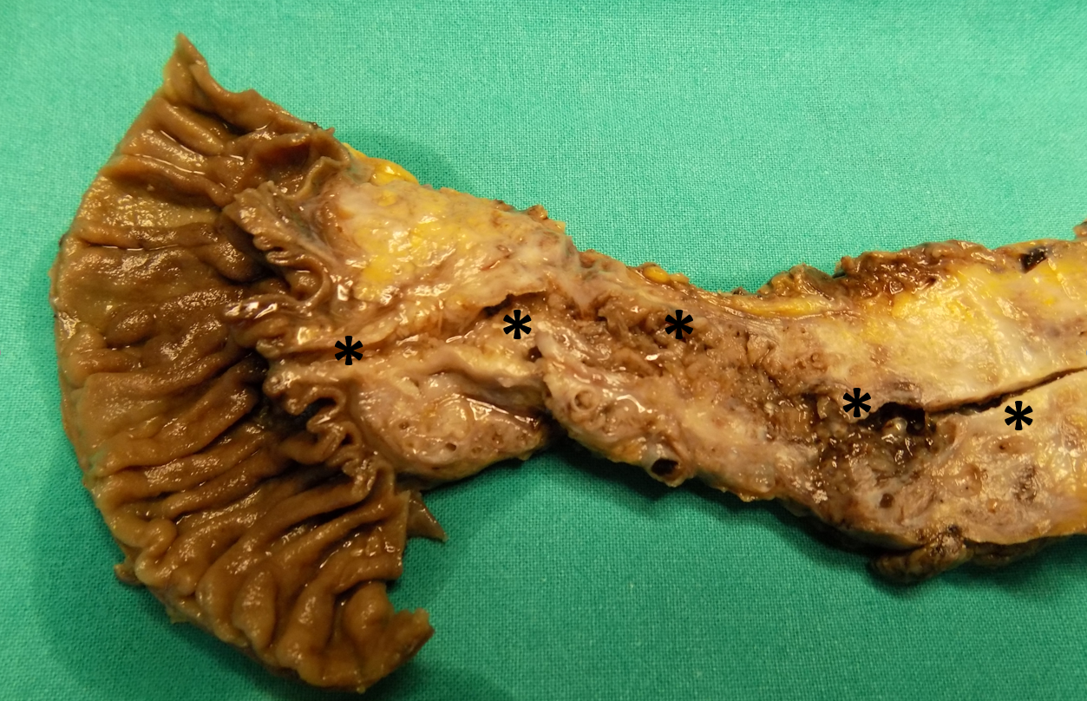
Figure 1 Extensive involvement of the pancreas by an intraductal papillary mucinous neoplasm. This neoplasm involves almost all the pancreatic ductal tree. The asterisks indicate Wirsung's duct along its course.

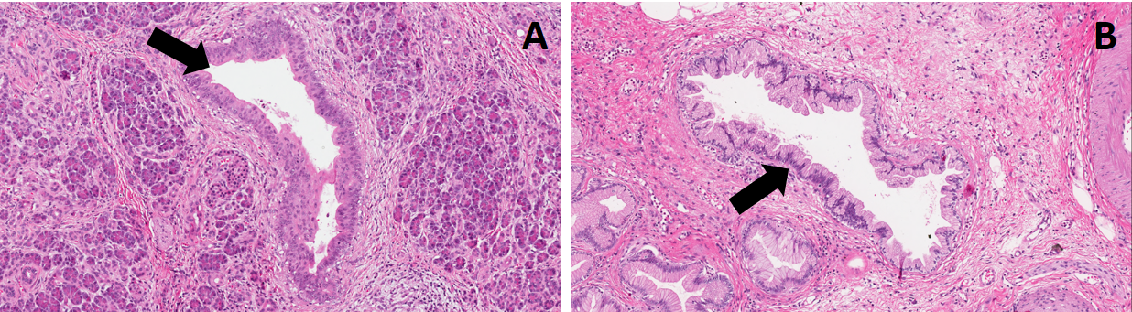
Figure 2 Pancreatic intraepithelial neoplasm precursor lesions. A: High-grade pancreatic intraepithelial neoplasm (PanIN); B: low-grade PanIN. Original magnification: ×10. Black arrows indicate ducts involved by PanINs.

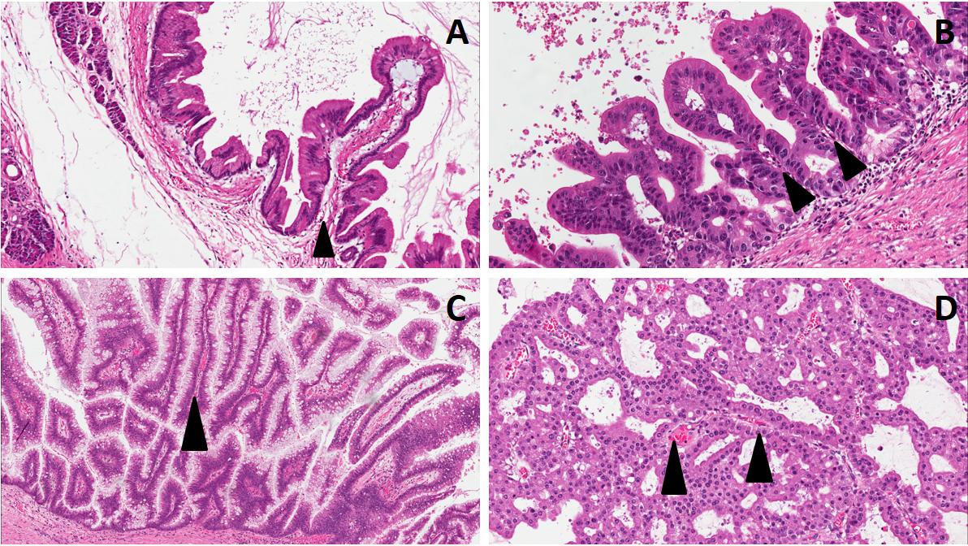
Figure 3 The four different types of intraductal papillary mucinous neoplasm. A: Gastric, B: Pancreatobiliary; C: Intestinal; D: Oncocytic. Original magnification: A and C: × 10; B and D: × 20. Black arrowheads indicate the fibro-vascular axis of the papillary structures.

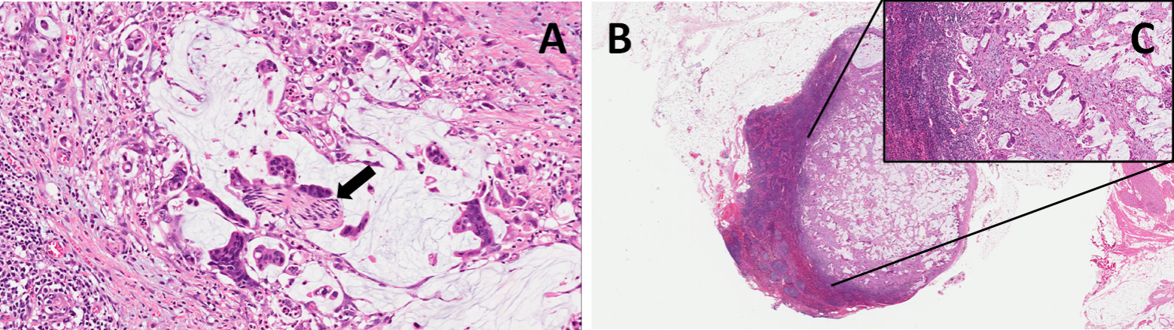
Figure 4 Colloid carcinoma with perineural invasion (A, black arrow) and nodal metastasis (B: low magnification; C: higher magnification of the same metastasis). Original magnification: A: × 10; B: × 4; C: × 20.

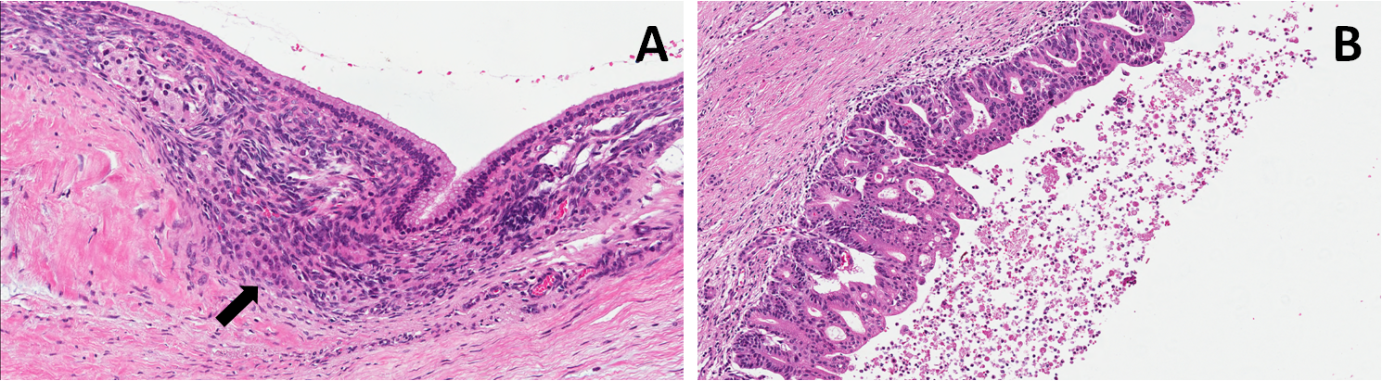
Figure 5 Mucinous cystic neoplasm precursor lesions. A: Low-grade mucinous cystic neoplasm (MCN); B: High-grade MCN. The black arrow indicates the ovarian-like stroma, a typical component of this type of lesions. Original magnification: × 10.

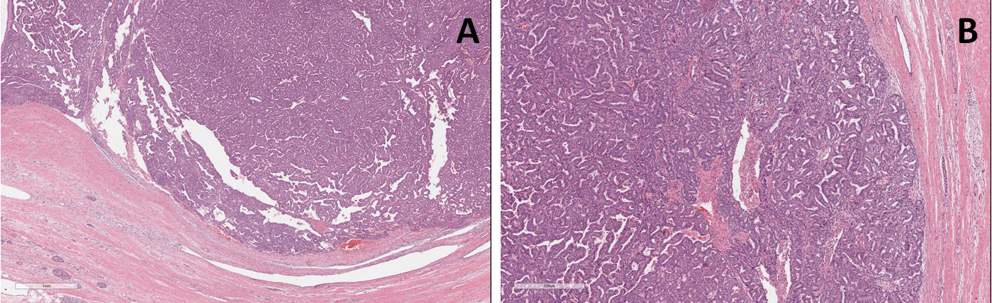
Figure 6 Intratubular papillary neoplasm precursor lesions. A: Low magnification showing an extensive intraductal growth; B: Higher magnification. Original magnification A: × 1; B: × 4.

