Name of Journal: World Journal of Hepatology
Manuscript NO: 64974
Manuscript Type: FRONTIER

Role of endoscopic ultrasound in the field of hepatology: Recent advances and future trends

Dhar J et al. EUS in hepatology

Jahnvi Dhar, Jayanta Samanta

Jahnvi Dhar, Jayanta Samanta, Department of Gastroenterology, Post Graduate Institute of Medical Education and Research, Chandigarh 160012, India

Author contributions: Dhar J contributed conception and design, data acquisition and analysis, drafted the article, final approval; Samanta J contributed conception and design, data interpretation, critical revision and intellectual content of the draft, final approval.

Corresponding author: Jayanta Samanta, MBBS, MD, DM, Assistant Professor, Doctor, Department of Gastroenterology, Post Graduate Institute of Medical Education and Research, Sector 12, Chandigarh 160012, India. dj_samanta@yahoo.co.in

Received: February 26, 2021
Revised: July 19, 2021
Accepted: September 3, 2021
Published online:

Abstract
The role of endoscopic ultrasound (EUS) as a diagnostic and therapeutic modality for the management of various gastrointestinal diseases has been expanding. The imaging or intervention for various liver diseases has primarily been the domain of radiologists. With the advances in EUS, the domain of endosonologists is rapidly expanding in the field of hepatology. The ability to combine endoscopy and sonography in one hybrid device is a unique property of EUS, together with the ability to bring its probe/transducer near the liver, the area of interest. Its excellent spatial resolution and ability to provide real-time images coupled with several enhancement techniques, such as contrast-enhanced (CE) EUS, have facilitated the growth of EUS. The concept of “Endo-hepatology” encompasses the wide range of diagnostic and therapeutic procedures that are now gradually becoming feasible for managing various liver diseases. Diagnostic advancements can enable a wide array of techniques from elastography and liver biopsy for liver parenchymal diseases, to CE-EUS for focal liver lesions to portal pressure measurements for managing various liver conditions. Similarly, therapeutic advancements range from EUS-guided eradication of varices, drainage of bilomas and abscesses to various EUS-guided modalities of liver tumor management. We provide a comprehensive review of all the different diagnostic and therapeutic EUS modalities available for the management of various liver diseases. A synopsis of all the technical details involving each procedure and the available data has been tabulated, and the future trends in this area have been highlighted.

Key Words: Endoscopic ultrasound; Liver disease; Elastography; Varices; Liver tumor; Liver biopsy

Dhar J, Samanta J. Role of endoscopic ultrasound in the field of hepatology: Recent advances and future trends. World J Hepatol 2021; In press

Core Tip: The advancements in the field of endoscopic ultrasound (EUS) have enabled endosonologists to rapidly expand their wings in the field of hepatology. “Endo-hepatology” encompasses the wide range of diagnostic and therapeutic endoscopic procedures that can be used for the management of various liver diseases. Diagnostic advancements range from elastography for liver parenchymal diseases, contrast-enhanced EUS for a focal liver lesion to portal pressure measurements. Therapeutic advancements range from EUS-guided eradication of varices to drainage of abscesses to liver tumor ablation. In this comprehensive review, all the various diagnostic and therapeutic EUS modalities available for the management of liver diseases have been detailed.
INTRODUCTION
The armamentarium of endoscopic ultrasound (EUS) has grown considerably in recent years, both as an investigative and a therapeutic modality. The established diagnostic tools for the study of liver diseases include trans-abdominal ultrasound (USG), computed tomography (CT) scan and magnetic resonance imaging (MRI). While in the past, interventions in liver disease have predominantly been performed by the percutaneous or vascular route, EUS is now more and more being used for both diagnostic and therapeutic purposes. The ability to combine endoscopy and sonography in one hybrid device is a unique property of EUS, together with the ability to bring its probe/transducer in close proximity to the liver, the area of interest. In addition, its excellent spatial resolution and ability to provide real-time images, along with additional techniques, such as contrast-enhanced (CE) EUS, have facilitated the growth of EUS.
Furthermore, EUS guided intervention is also used as a rescue modality when the percutaneous approach is not favorable. EUS has opened doors to a variety of other procedures which are being explored, such as portal vein (PV) sampling for cancer cells, delivery of chemotherapy in the PV, measurement of portosystemic pressure gradient, and EUS guided transjugular intrahepatic portosystemic shunt (TIPS) creation. Harnessing its use in various liver-related interventions paves the way for a new zone of specialty, “Endo-hepatology.” Herein we provide a comprehensive review on the use of EUS in the field of hepatology, both diagnostic and therapeutic, discussing the various recent advances and future trends (Figure 1).

Literature search
A search was performed in PubMed and Embase and the search strategy is outlined in Supplementary Doc 1. All studies such as case reports, series, clinical studies, animal models and reviews regarding EUS applications in liver disorders, including portal hypertension (PHTN), were reviewed. Non-English language literature was not included in the review. EUS applications for extrahepatic bile duct obstruction, gallbladder, etc., including their interventions, are beyond the scope of this review and have been excluded.

EUS for liver parenchyma associated diseases
EUS can be used for the diagnosis, assessment and therapeutic management of ascites, liver parenchymal pathologies, space-occupying lesions (SOLs), liver biopsy, drainage of liver abscesses, bilomas and the management of hepatic tumors.

Ascites: Assessment and paracentesis
Ascites can be due to benign or malignant diseases. Although the differential diagnosis is broad, around 80%-90% of cases are attributed to underlying cirrhosis and PHTN^{[1]}. Traditionally, routine paracentesis is performed bedside and sometimes with abdominal ultrasound guidance. However, abdominal paracentesis may become difficult in the presence of multiple abdominal scars, previous puncture marks, obesity, dilated bowel loops, dilated/tortuous veins, or the presence of omental or peritoneal nodules^{[1-3]}. EUS guided paracentesis (EUS-P) is more sensitive than CT in detecting ascites^{[2,4]}. The presence of ascites not visualized on imaging (CT/USG) as well as compartmentalization of fluid (such as benign etiologies like tuberculosis or tumor implants in peritoneal carcinomatosis) makes EUS-P a very promising tool in these areas^{[4,5]}. With EUS-P, even small amounts of fluid (as little as 2.7 mL) can be aspirated and provide valuable diagnostic information^{[6]}. In addition, EUS-P can be used as a rescue procedure in the case of previously failed percutaneous paracentesis or part of diagnostic workup during diagnostic EUS (Figure 2).
Additionally, EUS guided fine needle aspiration (EUS-FNA) of suspicious nodules in the omentum/peritoneum can be performed simultaneously while performing paracentesis for targeted cytological diagnosis^{[7]}. Contrast-enhanced EUS (CE-EUS) has also been evaluated to identify enhancement patterns of peritoneal nodules or omental caking and differentiate benign or malignant causes of undiagnosed ascites^{[8]}.

The technique of EUS-P: The technique of EUS-P is detailed in Table 1.

Future trends: Since the first report of EUS-FNA of ascites and pleural fluid performed in 1995, various reports of EUS-P with/out FNA of peritoneal deposits have been published subsequently with excellent diagnostic capability and correlation with intraoperative findings^{[12]}. Some cases of development of infectious complications (attributed to traversing the contaminated gastrointestinal wall) such as self-limited fever (3.3%) and bacterial peritonitis (4%) have been reported^{[5,10]}. Recent developments include the deployment of double plastic stents in loculated ascites (benign/malignant), leading to internal drainage causing significant improvement in quality of life^{[13,14]} (Figure 3). A clinical trial is also recruiting patients for EUS guided placement of a plastic prosthesis for refractory malignant ascites^{[15]}. The various studies on EUS-P are summarized in Table 2.
Thus, EUS-P is an excellent tool (sensitivity 94%, specificity 100%) to detect a small quantity of ascites^{[10]} and therapeutic drainage where the percutaneous approach is not amenable. Furthermore, FNA of peritoneal/omental nodules is an added advantage that can increase the diagnostic yield.

Assessment of liver parenchyma/SOLs: Anatomy of the liver, its segments and surrounding structures
The requirement for three-dimensional conceptualization of the liver parenchyma makes EUS assessment of the liver and surrounding structures different from the conventional methods of USG/CT/MRI. Depending on the position of the EUS scope, either in the stomach or duodenum, various structures can be identified (Table 3 and Figure 4) such as^{[17]}: (1) From the gastric end: Segments I (caudate lobe), left lobe segments (II, III, IV), right lobe (V, VIII), umbilical part of the left PV and ligamentum teres, ligamentum venosum, inferior vena cava, and hilum. (2) From the duodenal bulb: Segments VI, VII; the hepatoduodenal ligament structures and PV and hepatic artery branches, the liver hilum and the segmental divisions of the right PV and hepatic artery.
Although transabdominal USG or CT scan is the first-line approach for evaluation of liver parenchyma or focal lesions, EUS has additional features which can add to its diagnostic/therapeutic potential^{[18,19]}: (1) Transducer proximity enables better identification of the structures; (2) Combination of real-time images with elastography enables semi-quantitative measurements of liver parenchymal stiffness; (3) Newer generation EUS machines with color, power and pulsed Doppler systems helps easy assessment of the vasculature; (4) CE-EUS or harmonic EUS increases the diagnostic performance of focal liver lesions; and (5) Simultaneous assessment and interventions such as management of varices and liver biopsy can be performed in a single setting.

Techniques of assessment: Elastography and contrast enhancement techniques
Real-time elastography (RTE) has been developed for the assessment and quantification of liver tissue stiffness. Qualitative RTE uses the degree of deformation by the compression of structures as an indicator of tissue stiffness and is depicted using a color map wherein hard tissue is blue, intermediate stiffness is green and soft tissue is red. Quantitative RTE, on the other hand, uses hue histogram and strain ratio. While the former is a graphical representation of the color distribution in a selected image field, the strain ratio is calculated as the ratio of the target area (A) by reference area (B) (Figure 5)^{[20]}.
CE-EUS is a more valuable technique to improve the diagnostic performance of focal liver lesions. It is of 2 types: CE-EUS with the Doppler method (CE-EUS-D) and CE-EUS with harmonic imaging (CE-EUS-H). The former helps distinguish vascular-rich and hypovascular areas of a liver SOL, whereas the latter helps provide a detailed roadmap of the vasculature of the same. Of the contrast agents available, Sonovue and Sonazoid are more commonly used^{[21]}.
The concept of CE-EUS depends on the dual blood supply of the liver and has 3 phases: arterial phase (20-45 s), portal venous phase (lasting up to 120 s), and the late phase (contrast agent clearance, around 6 min)^{[21]}.
The advantages of CE-EUS over CT and MRI are that: (1) It provides real-time imaging; (2) Contrast is not excreted by the kidneys, and thus can be used in cases with renal insufficiency; (3) Contrast is confined to the vascular space only and so has prolonged enhancement of vascular system; (4) Higher resolution helps in targeted biopsies; and (5) Can characterize lesions less than 1 cm.

EUS imaging in chronic liver diseases
Certain tests such as transient elastography (TE), Fibroscan, and RTE can aid in the diagnosis of the degree of liver fibrosis. However, these tests are fraught with limitations in people with obesity and ascites. EUS can be used similarly with probably better diagnostic sensitivity for the same. Schulman et al^{[22]} reported the liver fibrosis index (LFI) was correlated with abdominal imaging (LFI in normal, fatty liver and cirrhosis patients were 0.8, 1.4 and 3.2, respectively). Similar findings were replicated in liver fibrosis assessment for chronic hepatitis C cases (LFI of 2.38 had an area under the receiver operating characteristic curve of 0.73) compared with the gold standard of liver biopsy. Histogram acquisition was successful in 82% of patients^{[23]}. A recent study by Tu et al^{[24]} in early-stage cirrhosis showed that the accuracy of a combination of EUS, EUS-RTE, acoustic radiation force impulse (AFRI) and aspartate aminotransferase-to-platelet ratio (APRI) had the highest diagnostic rate (sensitivity 87%). Thus, EUS can provide a one-stop diagnostic modality to screen and rule out a host of conditions in patients with liver disease, from the screening of varices, pancreaticobiliary pathology to hepatic parenchymal/SOL assessment.

EUS imaging in focal liver lesions
The diagnostic accuracy of EUS in detecting focal liver lesions, mostly less than 1 cm, exceeds that of USG, CT, and MRI^{[25,26]}. Singh et al^{[27]} addressed the diagnostic yield of EUS vs CT for hepatic metastasis (98% vs 92%), wherein EUS identified a significantly greater number of metastatic lesions (40 vs 19). Diagnostic criteria proposed by Fujii-Lau et al^{[28]} can be used to differentiate between benign and malignant metastatic hepatic lesions based on EUS findings with a positive predictive value of 82%. Lesion shape, borders, echogenicity, homogeneity, and size are used to delineate malignant lesions. It is said to be neoplastic if it meets at least three criteria: (1) Lack of isoechoic/slightly hyperechoic center; (2) Post-acoustic enhancement; (3) Adjacent structures distortion; (4) Hypoechogenicity (slightly or distinctly); and (5) At least 10 mm in size.
With the advent of EUS-RTE, the characterization of liver SOLs and their biopsies have become better (Figure 6). A study reported a hue histogram cutoff of 170 to discriminate between benign and malignant tumors (sensitivity 92.5%, accuracy 88.6%)^{[29]}. In addition, the usage of contrast agents in CE-EUS helps in differentiating primary tumors and metastasis^{[30]}. CE-EUS has also been utilized for the assessment of treatment response in hepatocellular carcinoma (HCC) post-trans-arterial catheter embolization^{[31]}. Hence, EUS with RTE, CE-EUS and CE-EUS-H might be a promising tool for diagnosing focal liver lesions and targeted intervention.

EUS-FNA of focal liver lesions
Several studies exist on the use of EUS-FNA/FNB (fine needle biopsy) for solid liver lesions with a complication rate of 0%-6% (Table 4). A recent systematic review by Ichim et al^{[42]} showed the diagnostic yield of EUS-FNA to be 80%-100%.

Future trends
Studies have reported additional assessment of KRAS mutation in inconclusive cytological samples, which has resulted in an improved diagnostic yield from 89.3% to 96.4%^{[43]}. Similarly, an animal study has evaluated the art of in vivo cytological observation using a high-resolution micro-endoscopy (HRME) system under EUS guidance^{[44]} to decrease the number of needle-passes and subsequent adverse events. Recently, Minaga et al^{[45]} have reported the additive role of CE-EUS-H in the detection of left lobe liver metastasis from pancreatic ductal adenocarcinoma. The diagnostic accuracy of CH-EUS was 98.4% compared to 90.6% with CECT.

EUS guided liver biopsy
Despite the advances in various non-invasive testing available to determine the degree of fibrosis, liver biopsy remains the gold standard method for accurate assessment in diagnosis and staging. As first described in 1883 by Dr. Paul Ehlrich, percutaneous liver biopsy (PC-LB) has evolved from a mere percussion method to an “image-guided” technique in the last ten years using ultrasound/CT imaging to accomplish it. However, despite image guidance, the risk of bleeding persists, occurring in up to 0.6% of cases, including other adverse events like pneumothorax and gallbladder puncture and even death in a few cases^{[46]}. The transjugular technique of liver biopsy, introduced in 1973, can help reduce this risk, especially in patients with underlying coagulopathy. However, this method also carried added risks of local site hematoma, intraperitoneal bleeding, arrhythmia and carotid puncture^{[47]}.
EUS guided liver biopsy (EUS-LB) initiated as early as 2007 is currently emerging as a cost-effective, safe and well-tolerated procedure and helps in more representative sampling. The American Association for the Study of Liver Diseases recommends a tissue length of at least 2-3 cm with ≥ 11 or more complete portal tracts (CPTs) for determining the adequacy of liver biopsy samples^{[48]}. The mean tissue length and CPTs for EUS-LB, PC-LB and TJLB, as shown in various studies is 36.9, 9 and 17.7 mm, and 7.7, 13.5 and 6.8 mm, respectively^{[49,50]}. This can be achieved with a regular 19 G EUS-FNA needle (71). Similarly, a meta-analysis on EUS-LB revealed that pooled successful histological diagnosis was achieved in 93.9% of cases. Adverse event rates with EUS-LB, PC-LC and TJLB were 2.3%, 0.09%-3.1% and 0.56%-6.5%, respectively^{[48,51,52]}. A recent meta-analysis between the three techniques revealed that EUS-LB was comparable to PC-LB in terms of CPT, but tissue length was better with the former with no complication rates^{[53]}.
EUS-LB has been used in the setting where patients undergo other endoscopic procedures such as screening of the biliary tree, assessment of surrounding structures and lymph nodes and variceal screening in those not affected with ascites and obesity^{[50]}, thereby saving time and resources. Furthermore, EUS-LB is theoretically less painful as it does not require skin puncture, eliminates the need for breath-hold and allows visualization and avoidance of blood vessels even 1 mm in size and is suitable for anxious patients by using adequate sedation (Figure 7). Moreover, bilobar biopsy can be achieved, reducing sampling error and helping in better assessment of disease activity and fibrosis^{[54]}.

Technique: The technique of EUS-LB is described in Table 5.

Future trends: In attempts to acquire better quality and quantity of specimens, various studies have been published on different needles and methods of executing a EUS-LB procedure. A recent RCT comparing a 19 G FNB needle (fork-tip) vs 19 G standard FNA needle yielded better results with the former (pre-processing length 2.09 cm vs 1.47 cm and more CPTs)^{[55]}. In contrast, a recent meta-analysis showed the superiority of FNA needles over core biopsy needles in terms of better tissue acquisition^{[51]}. Thus, 19 G FNA needle may be used for EUS-LB procedures except for the cases where immunohistochemistry and architecture characterization are warranted, in whom core biopsy needle may be used.
Mok et al^{[56]} showed that the “wet heparin” suction technique had greater tissue yield compared to “dry suction” (aggregate specimen length 49.2 mm vs 23.9 mm; mean CPT count 7 vs 4). Thus, the combination of wet-heparinized suction and a 19-G second-generation (FNA/FNB) needle might help achieve better specimens with minimal fragmentation.
The various studies using EUS-LB (FNA/FNB) in patients with chronic liver disease are highlighted in Table 6. The average technical success and diagnostic yield for EUS-FNA and EUS-FNB-guided liver biopsy are 100% and 89.8%, respectively, with a complication rate of 3.3%, consisting entirely of minor events^{[70]}. In addition, studies reporting the use of EUS-LB in patients with NAFLD (overall technical success rate 100%, yield 96.8% with 7.7% complication rate) are reported in Supplementary Table 1.

EUS guided therapeutic management of liver cysts, liver abscess and biloma
Symptomatic liver cysts, abscesses and bilomas may require drainage. Traditionally, these were approached through surgical or interventional radiology using percutaneous catheter drainage (PCD). Recently, EUS guidance has been used to drain simple intrahepatic cysts of varied etiologies, liver abscesses and bilomas. EUS guided drainage may be superior to PCD as it enables a one-step approach, leading to internal drainage and thus avoiding the complications of catheter dislodgement, pericatheter leak, multiple interventions and movement restrictions.

EUS guided treatment of hepatic cysts: The most frequent liver cysts encountered for drainage via EUS include simple hepatic cysts and intrahepatic pancreatic pseudocysts. Those located in the left lobe of the liver or the caudate lobe can be drained via EUS guidance. PCD would be preferred for right lobe cysts as it is difficult to access the right lobe in the duodenal bulb with an unstable scope position. Therapies offered by EUS include fine-needle aspiration, ethanol lavage and transmural stent placement.
In a retrospective study by Lee et al^{[71]}, 19 cases of hepatic cysts were treated by PCD and EUS guided ethanol lavage and reported a 97.5% reduction in cyst volume at 11.5 mo of follow-up in the PCD group and a 100% reduction at 15 mo in the EUS arm. The studies on EUS guided treatment of hepatic cysts are outlined in Supplementary Table 2.

EUS guided drainage of liver abscess: Traditionally, pyogenic and amoebic liver abscesses have been drained by PCD with a high technical success rate. However, EUS guided drainage of liver abscesses is a promising new approach, especially for difficult-to-reach locations. Additionally, the advantage of internal drainage with a single-step procedure and easy access from the stomach makes transmural drainage of left and caudate lobe abscess convenient.
The technique was first described by Seewald et al^{[72]}, who reported complete resolution 4 weeks post-procedure. Literature on EUS guided drainage is limited to retrospective case series only in which the majority have been drained with double pigtail plastic stents^{[73-75]}. Recently, data are emerging on the use of fully covered self-expandable metal stents (SEMS)^{[76]} for the same. Ogura et al^{[77]} reported retrospective comparative data on EUS vs PCD guided abscess drainage wherein EUS guided abscess drainage (EUS-AD) cases showed greater clinical success (100% vs 89%) with shorter hospital stay (21 d vs 41 d). Studies on EUS-AD are listed in Supplementary Table 3.

EUS guided drainage of biloma: Biloma is defined as a well-demarcated collection of bile outside the biliary tree, which can be extrahepatic or intrahepatic, encapsulated or without a capsule^{[78]}. It is most frequently caused by iatrogenic biliary tree injury during cholecystectomy. It has been traditionally managed with PCD or surgery. However, large bilomas in opposition to the gastric wall can be taken up for transmural drainage (Figure 8). Similar to EUS-AD, earlier plastic stents were utilized for the same, but now SEMS has been in vogue for biloma drainage with excellent results. Post drainage, such patients should be evaluated to determine the need for endoscopic retrograde cholangiopancreatography, or sphincterotomy with/out biliary stenting or surgery^{[79]}. Studies on EUS guided drainage of bilomas are described in Supplementary Table 4.
Despite it being a point of contention, EUS guided drainage of intrahepatic lesions (cysts, abscesses and bilomas) is an upcoming promising technique and may be considered in conditions where PCD is not amenable or has failed.

EUS guided treatment of liver tumors
A thrilling offshoot of EUS guided therapeutic interventions has been EUS guided local treatment of tumor lesions (both pancreatic and hepatic tumors)^{[80]}. EUS-guided tumor management is a new experimental application that has shown promise in reaching difficult lesions (left lobe, caudate lobe), provided a rescue option in refractory cases, and has potential to improve quality of life by minimizing systemic side effects^{[81,82]}. This procedure has been extensively studied in cases of pancreatic neoplasm, but its role in hepatic tumors (primary or metastatic) is still in its infancy.
Various techniques of EUS guided liver tumor management have been described.

Fine needle injection therapy: Ethanol ablation
Percutaneous injection of ablative injections is most commonly used worldwide to manage HCC, although EUS guided fine needle injection can be performed using acetic acid or ethanol (pure alcohol 95%-99%)^{[83]}. Its advantage is that it enables real-time imaging during delivery of ethanol to the tumorous lesion and thus can help avoid collateral damage.
Initial case reports using 22 G and 25 G FNA needles have been reported with excellent technical success and complete resolution of HCC^{[84-87]}. For example, Nakaji et al^{[87]} reported a high-resolution rate at 31 mo in 12 cases of caudate lobe HCC, whereas Jiang et al^{[88]} only showed 30% complete resolution at 12 mo. This technique has also been evaluated for the treatment of hepatic metastasis from pancreatic adenocarcinoma^{[89]}.

Thermal ablative therapy
Radiofrequency ablation: Radiofrequency ablation (RFA) uses a high-frequency alternating current (375 kHz to 500 kHz) and is minimally invasive with good tolerability^{[90]}. It can be delivered percutaneously, intraoperatively, via an endoluminal approach or endosonographic (transmural) route. Emerging data on the latter have resulted in its application in cases wherein the percutaneous approach fails. Obesity, tumor nodules in the left lobe or caudate lobe, deep-seated and subcapsular/sub-diaphragmatic lesions that carry an inherent risk of hemothorax or pleural effusion are some of the conditions where it has been applied^{[81,90]}. A specifically designed needle tip electrode for performing EUS-RFA (EUSRA RFA Electrode, STARmed, Koyang, Korea) with a designed internally cooled needle electrode is the most extensively studied. Only a few case reports exist on EUS-RFA using EUSRA in HCC^{[91-93]}. Also, hybrid models combining EUS-RFA with cryoablation in the bovine liver have demonstrated better efficacy of the combination treatment^{[94]}.

Laser ablation by neodymium:yttrium-aluminum-garnet: Neodymium:yttrium-aluminum-garnet (Nd-YAG) is a type of LITT (laser interstitial thermotherapy) wherein laser waves are introduced through the EUS needle directly into the tumor tissue leading to cell apoptosis and eventual necrosis. Only two human studies have been published so far for the treatment of HCC. Di Matteo et al^{[95]} reported complete HCC resolution in 2 mo in a case of previously failed caudate lobe HCC. Similarly, Jiang et al^{[96]} reported resolution at 3 mo with an encouraging safety profile.

Cryotherapy ablation: Cryotherapy ablation (CYA) destroys tissue through multiple freezing-thawing cycles leading to osmotic dehydration and injury to the intracellular structures and cell death^{[90]}. No human study exists for its use in liver lesions. However, a single animal study showed the efficacy of a hybrid EUS-RFA and cryoderm device in a porcine model^{[97]}.

High-intensity focused ultrasound: This is a non-invasive technique that causes tissue necrosis via heat generation and acoustic cavitation by the formation and collapse of bubbles produced by intense USG waves^{[90]}. Its use in EUS has only been tested in animal models^{[98,99]}, showing complete necrosis of the lesions with no immediate side effects.

Brachytherapy
This treatment modality has been used for various cancers with the advantage of less toxicity to surrounding tissues over external beam radiotherapy^{[81,90]}. For example, EUS guided brachytherapy with permanent seed placement of Iodine (I125) or palladium (Pd103) has been performed for head-neck, esophageal, and pancreatic cancer^{[100-102]}. In addition, Jiang et al^{[88]} have used EUS guided I125 seed implantation for liver tumors with high efficacy and safety.
Studies on EUS guided liver tumor treatments are outlined in Table 7.

EUS guided vascular interventions
The presence of real-time, high-resolution sonographic imaging with Doppler, along with the relative proximity of the gastrointestinal tract to the major blood vessels in the abdomen and the mediastinum, has led to a growing interest to explore the role of EUS in the field of vascular interventions. EUS may be preferred over the percutaneous route, especially in obesity, ascites and overlying distended bowel^{[104]}.

Esophageal and gastric varices: diagnosis and management
EUS guided vascular intervention in patients with PHTN has been well established in managing varices (esophageal, gastric, duodenal, and ectopic).

Management of esophageal varices: Endoscopic variceal band ligation (EVL) has been the standard treatment of esophageal varices (EV) (both primary and secondary prophylaxis). However, re-bleeding rates of 15%-65% have been reported due to the failure to obliterate perforating veins and collaterals feeding the varices^{[105]}. Lahoti et al^{[106]} described the first report of EUS guided sclerotherapy in 5 cases, wherein sclerosant (sodium morrhuate) was injected under EUS guidance (2-4 mL per injection site) directed at the perforating vessels as determined by color Doppler with complete eradication of the varices. An RCT comparing EUS vs direct sclerotherapy revealed no difference in both arms^{[107]}. Thus, although EUS carries a theoretical advantage for identifying the feeders, more studies are needed to assess its practical clinical benefit.

Management of gastric varices: In patients with PHTN, gastric varices (GV) are present in up to 20% with a 50%-65% re-bleeding rate^{[108]}. Endoscopic injection of CYA glue for GVs has been the treatment of choice since its first description in 1986 but is still prone to a re-bleeding rate of 40%^{[109]}. In the current era of EUS guided vascular interventions, management of GVs by EUS has many conceptual advantages, both diagnostic and therapeutic such as^{[110,111]}: (1) A higher detection rate (6 times) over conventional endoscopy; (2) Greater success in differentiating varices from thick gastric folds; (3) Confirmation of the cessation of blood flow post-treatment; (4) Real-time varix visualization and hence accurate delivery of hemostatic agent to the varix; and (5) Targeted treatment for feeder vessels.
The first description of EUS guided CYA injection in GVs was given by Romero-Castro et al^{[111]} and Lee et al^{[112]}. To reduce the chances of embolization with CYA, stainless steel coils alone or in combination with CYA glue have been introduced. The advantage is three-pronged: additive hemostasis and varix obliteration, reducing the volume of glue needed and acting as a scaffold to retain the glue within the varix, thereby decreasing embolization. Various studies, including RCTs, have favored coil over glue. Bhat et al^{[113]} reported a complete obliteration in 93% with only 3% re-bleeding rates using coils and glue combination. Similarly, two RCTs and a meta-analysis have reported the combination therapy of coil with glue to be superior to either agent alone^{[114-116]}. Newer treatments of utilizing coils with gelatin sponge and sclerotherapy or isolated thrombin injection have been reported in various case series and have shown good results^{[117-119]}.
The technical steps of the EUS guided coil and glue placement for the obliteration of GV are outlined in Table 8 and Figure 9.

Use of EUS in the prediction of re-bleeding from EV/GV: EUS with Doppler has a higher sensitivity for detecting esophageal and GV than upper GI endoscopy and can also be used to predict re-bleeding. Certain parameters can help guide us in this direction^{[120,121]}: (1) EUS can help in demonstrating collaterals or feeders, a strong indicator to a future occurrence of a re-bleed; (2) Hematocystic spots on EVs identified as saccular aneurysms on EUS is associated with a high risk of variceal rupture; (3) Digital image analysis on EUS can help to determine the cross-sectional area of EVs in the distal esophagus and a cutoff of 0.45 cm² has a sensitivity of 83% for future re-bleeding; and (4) Para-esophageal diameter after EVL is a better recurrence predictor (cutoff 4 mm has a 70.6% sensitivity).
Thus, there is a huge prospect for using EUS in PHTN, namely in the evaluation of vascular changes of the digestive wall, hemodynamic assessment by measurement of PV pressure gradient, management of variceal bleeding and re-bleeding prediction and currently liquid biopsy via PV sampling. Nonetheless, despite the diversity of possible uses, more data on efficacy and safety are warranted.

EUS guided PV access
The PV can be accessed from both the stomach and duodenum and is in very close juxtaposition with the tip of the echoendoscope. The most frequent location to target is the intrahepatic PV through the hepatic parenchyma. The other less commonly used technique is the extrahepatic PV via the duodenum^{[122,123]}.

Technique of the procedure: After confirming the vascular structure with color Doppler and pulse-wave verification, PV puncture is done via the EUS-FNA needle. Studies have shown that 25 G needle causes the least trauma. The trans-gastric, trans-hepatic approach is safer than the trans-duodenal approach. CO2 is better than using iodine as a contrast (allows better PV visualization and easier intravascular administration through the small-caliber FNA needle). After PV puncture, on withdrawal of the needle, the track is monitored with color Doppler to check for bleeding. In cases of blood flow being identified, the needle is kept in place until the flow has stopped^{[122,123]}.

Animal studies: The first case of PV access was reported in 2004 by Lai et al^{[124]}, wherein a EUS guided trans-duodenal access to extrahepatic PV was adopted with a 22 G FNA needle in 21 swine models, proving the technical feasibility of the procedure. Thereafter, PV angiography was reported for the first time in 2007 by Magno et al^{[125]}, wherein autopsies revealed no injuries with a 25 G needle and a hematoma with 19 G needle. Subsequently, Giday et al^{[123,126]} reported trans-hepatic access to the PV with a 25 G needle.

EUS guided portal pressure gradient measurement
Measurement of PHTN is useful in determining the stage, progression, prognosis and complications of cirrhosis. Currently, the standard practice of measuring the portal pressure gradient (PPG) is the percutaneous route. However, both direct PV access and hepatic venous pressure gradient (HVPG) measurement are invasive procedures and have high complication rates. Moreover, HVPG correlated poorly in presinusoidal PHTN cases. Therefore, EUS guided PPG can be performed to overcome these difficulties. Moreover, additional analyses such as assessment of varices and liver biopsy can be carried out in the same sitting. The technique of PPG measurement and the studies (human and animal models) on the same are shown in Supplementary Tables 5 and 6.

EUS guided TIPS
TIPS has an established role in managing PHTN-related complications like variceal bleeding (pre-emptive or rescue) and refractory ascites. EUS-guided TIPS creation in a live porcine model (8 cases) was first described by Buscaglia et al^{[127]}, wherein the hepatic vein (HV) and PV were sequentially punctured, and a metal stent was inserted with the distal end in the PV and proximal end in the HV. In addition, Binmoeller and Shah^{[128]}, and Schulman et al^{[129]} have both reported using a lumen apposing metal stent (LAMS) in porcine models for the same purpose.

EUS guided PV sampling
“Liquid biopsy” for hepatobiliary malignancies is gaining momentum in view of the PV harboring circulating tumor cells (CTCs) from the primary tumor. These CTCs are the forerunners of future metastasis of solid organ cancers and help predict the development of liver metastasis^{[130]}. They have been inconsistently found in the peripheral blood due to hepatic sequestration. They reflect tumor signature, help in prognostic stratification, and potentially form organoids for future tumor study.
Catenacci et al^{[131]} reported the first human study of PV sampling wherein a 19 G FNA needle was used to sample the PV as four 7.5 mL aliquots of blood. CTCs were detected in 100% cases from the PV vs 4 (22.2%) cases from peripheral blood. Liu et al^{[132]} reported similar findings in cases of advanced pancreatic cancer (100% detection of CTCs in PV vs 54% in peripheral blood). Besides these, further studies are needed to establish the clinical utility of EUS guided liquid biopsies.

EUS guided FNA of PV thrombosis
The presence of malignant PV thrombosis (PVT) usually portends a poor prognosis. Therefore, differentiating bland and malignant thrombus needs FNA confirmation. Various case reports have suggested the use of EUS guided FNA of the PVT by overcoming the complications encountered via the percutaneous route^{[133-135]} with excellent results.

EUS guided PV injection chemotherapy
Both systemic palliative chemotherapy and transarterial microbead injection into the hepatic artery for diffuse liver metastasis are fraught with complications. However, Faigel et al^{[136]} reported the feasibility of EUS guided PV injection chemotherapy in 24 porcine models using drug-eluting microbeads and nanoparticles. In comparison with systemic injection, systemic levels were halved, but the hepatic concentration of drugs was doubled. Human studies are warranted for the same.

EUS guided PV embolization
Preoperative PV embolization before liver resection in hepatobiliary malignancies induces affected lobe atrophy and ultimately hypertrophy in the functional liver^{[137]}. However, preliminary studies in the animal model by Matthes et al^{[138]} and Park et al^{[139]} using EUS guided PV embolization using ethylene-vinyl alcohol copolymer and coil with CYA glue embolization, respectively, reported high success rates.

EUS guided PV stent placement
EUS directed PV access has opened up avenues for stent placement via this route in PV occlusion or thrombosis. Park et al^{[140]} reported 100% technical success (all uncovered stents) in 6 swine models.

Future advances
Photodynamic therapy
Photodynamic therapy (PDT) is a commonly used modality for treating malignant biliary obstruction, requiring pretreatment with a photosensitizer followed by exposure to selective tissue wavelength of light-generating singlet oxygen species (tissue necrosis from 6-40 mm depth)^{[141]}. Preliminary animal studies exist on the use of EUS guided PDT on the porcine pancreas^{[141,142]} and pancreaticobiliary malignancies (with lesions in the caudate lobe)^{[143]}.

EUS guided fiducial marker placement
Stereotactic body radiation therapy demands high targeting accuracy to minimize toxicity to surrounding organs. Placement of fiducial markers can help localize and track the target and can be placed via a percutaneous or surgical approach. EUS guided fiducial marker placement has come into the forefront for targeting even deeper abdominal lesions not amenable via standard means^{[144,145]}. However, no studies exist on its use in liver malignancies.

Artificial intelligence
Artificial intelligence (AI) is a prediction technique using mathematical algorithms to create automated learning and recognize patterns in the fed data. Artificial neural network (ANN) and deep learning (DL) are powerful machine-learning-based tools used to provide high yield predictions and are being used more and more in the medical field to aid in diagnosis. Just like its widespread use in the field of endoscopic diagnosis of polyps and other lesions, AI has also found its place in the arena of diagnostic EUS. Studies have used ANN for the interpretation of EUS-elastography and CE-EUS^{[146]}. However, to date, only two studies have used DL for EUS image analysis. With the availability of additional studies, AI can add to the diagnostic armamentarium of EUS and lead to much better accuracy.

CONCLUSION
Hepatologists have always turned to radiologists for imaging and intervention of various liver-related conditions. However, with the expansion of this intersection of endoscopy in EUS and hepatology, the field of “Endo-hepatology” may soon evolve into a sub-specialty with hepatologists trained in interventional EUS. Starting from EUS-guided liver biopsy to PV interventions, the merger of EUS and hepatology seems to show invigorating scope in the future. However, more studies are needed to establish the safety and efficacy of these newer modalities in regular mainstream practice.

REFERENCES
1 European Association for the Study of the Liver. EASL Clinical Practice Guidelines for the management of patients with decompensated cirrhosis. J Hepatol 2018; 69: 406-460 [PMID: 29653741 DOI: 10.1016/j.jhep.2018.03.024]
2 Nguyen PT, Chang KJ. EUS in the detection of ascites and EUS-guided paracentesis. Gastrointest Endosc 2001; 54: 336-339 [PMID: 11522974 DOI: 10.1067/mge.2001.117544]
3 Varadarajulu S, Drelichman ER. EUS-guided therapeutic paracentesis. Gastrointest Endosc 2008; 67: 758-759 [PMID: 18178210 DOI: 10.1016/j.gie.2007.08.025]
4 Lee YT, Ng EK, Hung LC, Chung SC, Ching JY, Chan WY, Chu WC, Sung JJ. Accuracy of endoscopic ultrasonography in diagnosing ascites and predicting peritoneal metastases in gastric cancer patients. Gut 2005; 54: 1541-1545 [PMID: 15955787 DOI: 10.1136/gut.2004.055772]
5 DeWitt J, LeBlanc J, McHenry L, McGreevy K, Sherman S. Endoscopic ultrasound-guided fine-needle aspiration of ascites. Clin Gastroenterol Hepatol 2007; 5: 609-615 [PMID: 17336593 DOI: 10.1016/j.cgh.2006.11.021]
6 Chin MA. EUS-guided paracentesis and ascitic fluid analysis. Endosc Ultrasound 2018; 7: 223-227 [PMID: 30117483 DOI: 10.4103/eus.eus_31_18]
7 Levy MJ, Abu Dayyeh BK, Fujii LL, Clayton AC, Reynolds JP, Lopes TL, Rao AS, Clain JE, Gleeson FC, Iyer PG, Kendrick ML, Rajan E, Topazian MD, Wang KK, Wiersema MJ, Chari ST. Detection of peritoneal carcinomatosis by EUS fine-needle aspiration: impact on staging and resectability (with videos). Gastrointest Endosc 2015; 81: 1215-1224 [PMID: 25660979 DOI: 10.1016/j.gie.2014.10.028]
8 Que Y, Wang X, Tao C, Zhang Y, Wan W, Chen B. Peritoneal metastases: evaluation with contrast-enhanced ultrasound. Abdom Imaging 2011; 36: 327-332 [PMID: 20959976 DOI: 10.1007/s00261-010-9651-3]
9 ASGE Standards of Practice Committee, Khashab MA, Chithadi KV, Acosta RD, Bruining DH, Chandrasekhara V, Eloubeidi MA, Fanelli RD, Faulx AL, Fonkalsrud L, Lightdale JR, Muthusamy VR, Pasha SF, Saltzman JR, Shaukat A, Wang A, Cash BD. Antibiotic prophylaxis for GI endoscopy. Gastrointest Endosc 2015; 81: 81-89 [PMID: 25442089 DOI: 10.1016/j.gie.2014.08.008]
10 Kaushik N, Khalid A, Brody D, McGrath K. EUS-guided paracentesis for the diagnosis of malignant ascites. Gastrointest Endosc 2006; 64: 908-913 [PMID: 17140897 DOI: 10.1016/j.gie.2005.11.058]
11 Suzuki R, Irisawa A, Bhutani MS, Hikichi T, Takagi T, Shibukawa G, Sato A, Sato M, Ikeda T, Watanabe K, Nakamura J, Annangi S, Tasaki K, Obara K, Ohira H. An automated spring-loaded needle for endoscopic ultrasound-guided abdominal paracentesis in cancer patients. World J Gastrointest Endosc 2014; 6: 55-59 [PMID: 24567793 DOI: 10.4253/wjge.v6.i2.55]
12 Chang KJ, Albers CG, Nguyen P. Endoscopic ultrasound-guided fine needle aspiration of pleural and ascitic fluid. Am J Gastroenterol 1995; 90: 148-150 [PMID: 7801920]
13 Köck R, Jürgensen C, Fischer-Lampsatis R. Endosonography-guided drainage of loculated malignant ascites using double-pigtail plastic stents. Endosc Int Open 2018; 6: E902-E906 [PMID: 29978013 DOI: 10.1055/a-0605-3587]
14 Romero-Castro R, Jimenez-Garcia VA, Boceta-Osuna J, Castilla-Guerra L, Pellicer-Bautista F, Caunedo-Alvarez A, Herrerias-Gutierrez JM, Romero-Gómez M, Giovannini M. Endoscopic ultrasound-guided placement of plastic pigtail stents for the drainage of refractory malignant ascites. Endosc Int Open 2017; 5: E1096-E1099 [PMID: 29250586 DOI: 10.1055/s-0043-118746]
15 Romero-Castro R. EUS-Guided Drainage of Refractory Malignant Ascites. [accessed 2021 Feb 15]. In: ClinicalTrials.gov [Internet]. Bethesda (MD): U.S. National Library of Medicine. Available from: https://clinicaltrials.gov/ct2/show/NCT03550560 ClinicalTrials.gov Identifier: NCT03550560
16 Wardeh R, Lee JG, Gu M. Endoscopic ultrasound-guided paracentesis of ascitic fluid: a morphologic study with ultrasonographic correlation. Cancer Cytopathol 2011; 119: 27-36 [PMID: 21072835 DOI: 10.1002/cncy.20123]
17 Bhatia V, Hijioka S, Hara K, Mizuno N, Imaoka H, Yamao K. Endoscopic ultrasound description of liver segmentation and anatomy. Dig Endosc 2014; 26: 482-490 [PMID: 24355092 DOI: 10.1111/den.12216]
18 Friedberg SR, Lachter J. Endoscopic ultrasound: Current roles and future directions. World J Gastrointest Endosc 2017; 9: 499-505 [PMID: 29085560 DOI: 10.4253/wjge.v9.i10.499]
19 Campos S, Poley JW, van Driel L, Bruno MJ. The role of EUS in diagnosis and treatment of liver disorders. Endosc Int Open 2019; 7: E1262-E1275 [PMID: 31579708 DOI: 10.1055/a-0958-2183]
20 Iglesias-García J, Lariño-Noia J, Domínguez-Muñoz JE. New Imaging Techniques: Endoscopic Ultrasound-Guided Elastography. Gastrointest Endosc Clin N Am 2017; 27: 551-567 [PMID: 28918798 DOI: 10.1016/j.giec.2017.06.001]
21 Alvarez-Sánchez MV, Napoléon B. Contrast-enhanced harmonic endoscopic ultrasound imaging: basic principles, present situation and future perspectives. World J Gastroenterol 2014; 20: 15549-15563 [PMID: 25400439 DOI: 10.3748/wjg.v20.i42.15549]
22 Schulman AR, Lin MV, Rutherford A, Chan WW, Ryou M. A Prospective Blinded Study of Endoscopic Ultrasound Elastography in Liver Disease: Towards a Virtual Biopsy. Clin Endosc 2018; 51: 181-185 [PMID: 29566479 DOI: 10.5946/ce.2017.095]
23 Marques S, Carmo J, Túlio MA, Bispo M, Matos L, Chagas C. Diagnostic Performance of Real-Time Elastography in the Assessment of Advanced Fibrosis in Chronic Hepatitis C. GE Port J Gastroenterol 2016; 23: 13-18 [PMID: 28868425 DOI: 10.1016/j.jpge.2015.10.008]
24 Tu CH, Li J, Wang CY, Zhou L, Ma Y, Gao M, Wang J, Zeng QM, Lu W. [Diagnostic value of endoscopic ultrasonography, fibroscan, acoustic radiation pulse imaging, serological index, and their combination for early stage liver cirrhosis]. Zhonghua Gan Zang Bing Zazhi 2019; 27: 615-620 [PMID: 31594079 DOI: 10.3760/cma.j.issn.1007-3418.2019.08.006]
25 Ichim VA, Chira RI, Mircea PA, Nagy GA, Crisan D, Socaciu MA. Accuracy of endoscopic ultrasound-guided biopsy of focal liver lesions. Med Ultrason 2020; 22: 20-25 [PMID: 32096783 DOI: 10.11152/mu-2078]
26 Singh P, Erickson RA, Mukhopadhyay P, Gopal S, Kiss A, Khan A, Ulf Westblom T. EUS for detection of the hepatocellular carcinoma: results of a prospective study. Gastrointest Endosc 2007; 66: 265-273 [PMID: 17543307 DOI: 10.1016/j.gie.2006.10.053]
27 Singh P, Mukhopadhyay P, Bhatt B, Patel T, Kiss A, Gupta R, Bhat S, Erickson RA. Endoscopic ultrasound vs CT scan for detection of the metastases to the liver: results of a prospective comparative study. J Clin Gastroenterol 2009; 43: 367-373 [PMID: 18981929 DOI: 10.1097/MCG.0b013e318167b8cc]
28 Fujii-Lau LL, Abu Dayyeh BK, Bruno MJ, Chang KJ, DeWitt JM, Fockens P, Forcione D, Napoleon B, Palazzo L, Topazian MD, Wiersema MJ, Chak A, Clain JE, Faigel DO, Gleeson FC, Hawes R, Iyer PG, Rajan E, Stevens T, Wallace MB, Wang KK, Levy MJ. EUS-derived criteria for distinguishing benign from malignant metastatic solid hepatic masses. Gastrointest Endosc 2015; 81: 1188-96.e1-7 [PMID: 25660980 DOI: 10.1016/j.gie.2014.10.035]
29 Sandulescu L, Padureanu V, Dumitrescu C, Braia N, Streba CT, Gheonea DI, Cazacu S, Ciurea T, Rogoveanu I, Saftoiu A. A pilot study of real time elastography in the differentiation of focal liver lesions. Curr Health Sci J 2012; 38: 32-35 [PMID: 24778839]
30 Kitano M, Kamata K. Contrast-enhanced harmonic endoscopic ultrasound: Future perspectives. Endosc Ultrasound 2016; 5: 351-354 [PMID: 28000625 DOI: 10.4103/2303-9027.195852]
31 Liu M, Lin MX, Lu MD, Xu ZF, Zheng KG, Wang W, Kuang M, Zhuang WQ, Xie XY. Comparison of contrast-enhanced ultrasound and contrast-enhanced computed tomography in evaluating the treatment response to transcatheter arterial chemoembolization of hepatocellular carcinoma using modified RECIST. Eur Radiol 2015; 25: 2502-2511 [PMID: 25702094 DOI: 10.1007/s00330-015-3611-9]
32 Nguyen P, Feng JC, Chang KJ. Endoscopic ultrasound (EUS) and EUS-guided fine-needle aspiration (FNA) of liver lesions. Gastrointest Endosc 1999; 50: 357-361 [PMID: 10462656 DOI: 10.1053/ge.1999.v50.97208]
33 TenBerge J, Hoffman BJ, Hawes RH, Van Enckevort C, Giovannini M, Erickson RA, Catalano MF, Fogel R, Mallery S, Faigel DO, Ferrari AP, Waxman I, Palazzo L, Ben-Menachem T, Jowell PS, McGrath KM, Kowalski TE, Nguyen CC, Wassef WY, Yamao K, Chak A, Greenwald BD, Woodward TA, Vilmann P, Sabbagh L, Wallace MB. EUS-guided fine needle aspiration of the liver: indications, yield, and safety based on an international survey of 167 cases. Gastrointest Endosc 2002; 55: 859-862 [PMID: 12024141 DOI: 10.1067/mge.2002.124557]
34 DeWitt J, LeBlanc J, McHenry L, Ciaccia D, Imperiale T, Chappo J, Cramer H, McGreevy K, Chriswell M, Sherman S. Endoscopic ultrasound-guided fine needle aspiration cytology of solid liver lesions: a large single-center experience. Am J Gastroenterol 2003; 98: 1976-1981 [PMID: 14499774 DOI: 10.1111/j.1572-0241.2003.07638.x]
35 Hollerbach S, Willert J, Topalidis T, Reiser M, Schmiegel W. Endoscopic ultrasound-guided fine-needle aspiration biopsy of liver lesions: histological and cytological assessment. Endoscopy 2003; 35: 743-749 [PMID: 12929021 DOI: 10.1055/s-2003-41593]
36 McGrath K, Brody D, Luketich J, Khalid A. Detection of unsuspected left hepatic lobe metastases during EUS staging of cancer of the esophagus and cardia. Am J Gastroenterol 2006; 101: 1742-1746 [PMID: 16790035 DOI: 10.1111/j.1572-0241.2006.00665.x]
37 Crowe DR, Eloubeidi MA, Chhieng DC, Jhala NC, Jhala D, Eltoum IA. Fine-needle aspiration biopsy of hepatic lesions: computerized tomographic-guided vs endoscopic ultrasound-guided FNA. Cancer 2006; 108: 180-185 [PMID: 16634071 DOI: 10.1002/cncr.21912]
38 Prachayakul V, Aswakul P, Kachintorn U. EUS guided fine needle aspiration cytology of liver nodules suspicious for malignancy: yields, complications and impact on management. J Med Assoc Thai 2012; 95 Suppl 2: S56-S60 [PMID: 22574530]
39 Oh D, Seo DW, Hong SM, Jun JH, Song TJ, Park DH, Son BK, Lee SS, Lee SK, Kim MH. The usefulness of contrast-enhanced harmonic EUS-guided fine-needle aspiration for evaluation of hepatic lesions (with video). Gastrointest Endosc 2018; 88: 495-501 [PMID: 29859228 DOI: 10.1016/j.gie.2018.05.019]
40 Lee YN, Moon JH, Kim HK, Choi HJ, Choi MH, Kim DC, Lee TH, Lee TH, Cha SW, Kim SG, Kim YS. Usefulness of endoscopic ultrasound-guided sampling using core biopsy needle as a percutaneous biopsy rescue for diagnosis of solid liver mass: Combined histological-cytological analysis. J Gastroenterol Hepatol 2015; 30: 1161-1166 [PMID: 25684303 DOI: 10.1111/jgh.12922]
41 Chon HK, Yang HC, Choi KH, Kim TH. Endoscopic Ultrasound-Guided Liver Biopsy Using a Core Needle for Hepatic Solid Mass. Clin Endosc 2019; 52: 340-346 [PMID: 31302987 DOI: 10.5946/ce.2018.175]
42 Ichim VA, Chira RI, Mircea PA. Diagnostic yield of endoscopic ultrasound-guided biopsy of focal liver lesions. Med Pharm Rep 2019; 92: 15-20 [PMID: 30957081 DOI: 10.15386/cjmed-1066]
43 Choi HJ, Moon JH, Kim HK, Lee YN, Lee TH, Cha SW, Cho YD, Park SH. KRAS mutation analysis by next-generation sequencing in endoscopic ultrasound-guided sampling for solid liver masses. J Gastroenterol Hepatol 2017; 32: 154-162 [PMID: 27118240 DOI: 10.1111/jgh.13423]
44 Suzuki R, Shin D, Richards-Kortum R, Coghlan L, Bhutani MS. In vivo cytological observation of liver and spleen by using high-resolution microendoscopy system under endoscopic ultrasound guidance: A preliminary study using a swine model. Endosc Ultrasound 2016; 5: 239-242 [PMID: 27503155 DOI: 10.4103/2303-9027.187867]
45 Minaga K, Kitano M, Nakai A, Omoto S, Kamata K, Yamao K, Takenaka M, Tsurusaki M, Chikugo T, Matsumoto I, Chiba Y, Watanabe T, Kudo M. Improved detection of liver metastasis using Kupffer-phase imaging in contrast-enhanced harmonic EUS in patients with pancreatic cancer (with video). Gastrointest Endosc 2021; 93: 433-441 [PMID: 32592778 DOI: 10.1016/j.gie.2020.06.051]
46 Tapper EB, Lok AS. Use of Liver Imaging and Biopsy in Clinical Practice. N Engl J Med 2017; 377: 756-768 [PMID: 28834467 DOI: 10.1056/NEJMra1610570]
47 Rösch J, Hanafee WN, Snow H. Transjugular portal venography and radiologic portacaval shunt: an experimental study. Radiology 1969; 92: 1112-1114 [PMID: 5771827 DOI: 10.1148/92.5.1112]
48 Rockey DC, Caldwell SH, Goodman ZD, Nelson RC, Smith AD; American Association for the Study of Liver Diseases. Liver biopsy. Hepatology 2009; 49: 1017-1044 [PMID: 19243014 DOI: 10.1002/hep.22742]
49 Cholongitas E, Senzolo M, Standish R, Marelli L, Quaglia A, Patch D, Dhillon AP, Burroughs AK. A systematic review of the quality of liver biopsy specimens. Am J Clin Pathol 2006; 125: 710-721 [PMID: 16707372 DOI: 10.1309/W3XC-NT4H-KFBN-2G0B]
50 Stavropoulos SN, Im GY, Jlayer Z, Harris MD, Pitea TC, Turi GK, Malet PF, Friedel DM, Grendell JH. High yield of same-session EUS-guided liver biopsy by 19-gauge FNA needle in patients undergoing EUS to exclude biliary obstruction. Gastrointest Endosc 2012; 75: 310-318 [PMID: 22248599 DOI: 10.1016/j.gie.2011.09.043]
51 Mohan BP, Shakhatreh M, Garg R, Ponnada S, Adler DG. Efficacy and safety of EUS-guided liver biopsy: a systematic review and meta-analysis. Gastrointest Endosc 2019; 89: 238-246.e3 [PMID: 30389469 DOI: 10.1016/j.gie.2018.10.018]
52 Kalambokis G, Manousou P, Vibhakorn S, Marelli L, Cholongitas E, Senzolo M, Patch D, Burroughs AK. Transjugular liver biopsy--indications, adequacy, quality of specimens, and complications--a systematic review. J Hepatol 2007; 47: 284-294 [PMID: 17561303 DOI: 10.1016/j.jhep.2007.05.001]
53 Mony S, Shah I, Vyas N, Sofi A, Das A. Su1375 Meta-analysis of EUS guided liver biopsy in comparison with percutaneous and transjugular liver biopsy for the diagnosis of parenchymal liver disease. Gastrointest Endosc 2018; 87: AB328-AB329
54 Khurana S, Butt W, Khara HS, Johal AS, West SF, Chen ZE, Berger AL, Diehl DL. Bi-lobar liver biopsy via EUS enhances the assessment of disease severity in patients with non-alcoholic steatohepatitis. Hepatol Int 2019; 13: 323-329 [PMID: 30993598 DOI: 10.1007/s12072-019-09945-4]
55 Ching-Companioni RA, Diehl DL, Johal AS, Confer BD, Khara HS. 19 G aspiration needle vs 19 G core biopsy needle for endoscopic ultrasound-guided liver biopsy: a prospective randomized trial. Endoscopy 2019; 51: 1059-1065 [PMID: 31342474 DOI: 10.1055/a-0956-6922]
56 Mok SRS, Diehl DL, Johal AS, Khara HS, Confer BD, Mudireddy PR, Kirchner HL, Chen ZE. A prospective pilot comparison of wet and dry heparinized suction for EUS-guided liver biopsy (with videos). Gastrointest Endosc 2018; 88: 919-925 [PMID: 30120956 DOI: 10.1016/j.gie.2018.07.036]
57 Pineda JJ, Diehl DL, Miao CL, Johal AS, Khara HS, Bhanushali A, Chen EZ. EUS-guided liver biopsy provides diagnostic samples comparable with those via the percutaneous or transjugular route. Gastrointest Endosc 2016; 83: 360-365 [PMID: 26301407 DOI: 10.1016/j.gie.2015.08.025]
58 Shuja A, Alkhasawneh A, Fialho A, Fialho A, Shukri A, Harris C, Smotherman C, Malespin M, de Melo SW Jr. Comparison of EUS-guided vs percutaneous and transjugular approaches for the performance of liver biopsies. Dig Liver Dis 2019; 51: 826-830 [PMID: 30755347 DOI: 10.1016/j.dld.2019.01.006]
59 Diehl DL, Johal AS, Khara HS, Stavropoulos SN, Al-Haddad M, Ramesh J, Varadarajulu S, Aslanian H, Gordon SR, Shieh FK, Pineda-Bonilla JJ, Dunkelberger T, Gondim DD, Chen EZ. Endoscopic ultrasound-guided liver biopsy: a multicenter experience. Endosc Int Open 2015; 3: E210-E215 [PMID: 26171433 DOI: 10.1055/s-0034-1391412]
60 Gor N, Salem SB, Jakate S, Patel R, Shah N, Patil A. Histological adequacy of EUS-guided liver biopsy when using a 19-gauge non-Tru-Cut FNA needle. Gastrointest Endosc 2014; 79: 170-172 [PMID: 23916397 DOI: 10.1016/j.gie.2013.06.031]
61 Shah ND, Sasatomi E, Baron TH. Endoscopic Ultrasound-guided Parenchymal Liver Biopsy: Single Center Experience of a New Dedicated Core Needle. Clin Gastroenterol Hepatol 2017; 15: 784-786 [PMID: 28126424 DOI: 10.1016/j.cgh.2017.01.011]
62 Nieto J, Khaleel H, Challita Y, Jimenez M, Baron TH, Walters L, Hathaway K, Patel K, Lankarani A, Herman M, Holloman D, Saab S. EUS-guided fine-needle core liver biopsy sampling using a novel 19-gauge needle with modified 1-pass, 1 actuation wet suction technique. Gastrointest Endosc 2018; 87: 469-475 [PMID: 28551024 DOI: 10.1016/j.gie.2017.05.013]
63 Mathew A. EUS-guided routine liver biopsy in selected patients. Am J Gastroenterol 2007; 102: 2354-2355 [PMID: 17897349 DOI: 10.1111/j.1572-0241.2007.01353_7.x]
64 Patel HK, Saxena R, Rush N, Patel SK, Dasari CS, Mneimneh W, Quickery A, Rahal MA, Temnykh L, DeWitt J, Al-Haddad M. A Comparative Study of 22G vs 19G Needles for EUS-Guided Biopsies for Parenchymal Liver Disease: Are Thinner Needles Better? Dig Dis Sci 2021; 66: 238-246 [PMID: 32128647 DOI: 10.1007/s10620-020-06165-x]
65 Gleeson FC, Clayton AC, Zhang L, Clain JE, Gores GJ, Rajan E, Smyrk TC, Topazian MD, Wang KK, Wiersema MJ, Levy MJ. Adequacy of endoscopic ultrasound core needle biopsy specimen of nonmalignant hepatic parenchymal disease. Clin Gastroenterol Hepatol 2008; 6: 1437-1440 [PMID: 19081532 DOI: 10.1016/j.cgh.2008.07.015]
66 Dewitt J, McGreevy K, Cummings O, Sherman S, Leblanc JK, McHenry L, Al-Haddad M, Chalasani N. Initial experience with EUS-guided Tru-cut biopsy of benign liver disease. Gastrointest Endosc 2009; 69: 535-542 [PMID: 19231495 DOI: 10.1016/j.gie.2008.09.056]
67 Nakai Y, Samarasena JB, Iwashita T, Park DH, Lee JG, Hu KQ, Chang KJ. Autoimmune hepatitis diagnosed by endoscopic ultrasound-guided liver biopsy using a new 19-gauge histology needle. Endoscopy 2012; 44 Suppl 2 UCTN: E67-E68 [PMID: 22396285 DOI: 10.1055/s-0031-1291567]
68 Sey MS, Al-Haddad M, Imperiale TF, McGreevy K, Lin J, DeWitt JM. EUS-guided liver biopsy for parenchymal disease: a comparison of diagnostic yield between two core biopsy needles. Gastrointest Endosc 2016; 83: 347-352 [PMID: 26278654 DOI: 10.1016/j.gie.2015.08.012]
69 Hasan MK, Kadkhodayan K, Idrisov E, Ali S, Rafiq E, Ben-Ami Shor D, Abdel-Jalil A, Navaneethan U, Bang J, Varadarajulu S, Hawes R, Pernicone P. Endoscopic ultrasound-guided liver biopsy using a 22-G fine needle biopsy needle: a prospective study. Endoscopy 2019; 51: 818-824 [PMID: 31365947 DOI: 10.1055/a-0967-3640]
70 Sbeit W, Kadah A, Mahamid M, Pellicano R, Mari A, Khoury T. A State-of-the-Art Review on the Evolving Utility of Endoscopic Ultrasound in Liver Diseases Diagnosis. Diagnostics (Basel) 2020; 10 [PMID: 32717886 DOI: 10.3390/diagnostics10080512]
71 Lee S, Seo DW, Paik WH, Park DH, Lee SS, Lee SK, Kim MH. Ethanol lavage of huge hepatic cysts by using EUS guidance and a percutaneous approach. Gastrointest Endosc 2014; 80: 1014-1021 [PMID: 24890421 DOI: 10.1016/j.gie.2014.03.037]
72 Seewald S, Imazu H, Omar S, Groth S, Seitz U, Brand B, Zhong Y, Sikka S, Thonke F, Soehendra N. EUS-guided drainage of hepatic abscess. Gastrointest Endosc 2005; 61: 495-498 [PMID: 15758937 DOI: 10.1016/s0016-5107(04)02848-2]
73 Noh SH, Park DH, Kim YR, Chun Y, Lee HC, Lee SO, Lee SS, Seo DW, Lee SK, Kim MH. EUS-guided drainage of hepatic abscesses not accessible to percutaneous drainage (with videos). Gastrointest Endosc 2010; 71: 1314-1319 [PMID: 20400078 DOI: 10.1016/j.gie.2009.12.045]
74 Itoi T, Ang TL, Seewald S, Tsuji S, Kurihara T, Tanaka R, Itokawa F. Endoscopic ultrasonography-guided drainage for tuberculous liver abscess drainage. Dig Endosc 2011; 23 Suppl 1: 158-161 [PMID: 21535224 DOI: 10.1111/j.1443-1661.2011.01115.x]
75 Medrado BF, Carneiro FO, Vilaça TG, Gouveia TS, Frazão MS, de Moura EG, Sakai P, Otoch JP, Artifon EL. Endoscopic ultrasound-guided drainage of giant liver abscess associated with transgastric migration of a self-expandable metallic stent. Endoscopy 2013; 45 Suppl 2: E331-E332 [PMID: 24150733 DOI: 10.1055/s-0033-1344128]
76 Alcaide N, Vargas-Garcia AL, de la Serna-Higuera C, Sancho Del Val L, Ruiz-Zorrilla R, Perez-Miranda M. EUS-guided drainage of liver abscess by using a lumen-apposing metal stent (with video). Gastrointest Endosc 2013; 78: 941-942 [PMID: 24016354 DOI: 10.1016/j.gie.2013.07.034]
77 Ogura T, Masuda D, Saori O, Wataru T, Sano T, Okuda A, Miyano A, Kitano M, Abdel-Aal UM, Takeuchi T, Fukunishi S, Higuchi K. Clinical Outcome of Endoscopic Ultrasound-Guided Liver Abscess Drainage Using Self-Expandable Covered Metallic Stent (with Video). Dig Dis Sci 2016; 61: 303-308 [PMID: 26254774 DOI: 10.1007/s10620-015-3841-3]
78 Della Valle V, Eshja E, Bassi EM. Spontaneous biloma: a case report. J Ultrasound 2015; 18: 293-296 [PMID: 26261461 DOI: 10.1007/s40477-013-0053-6]
79 Sandha GS, Bourke MJ, Haber GB, Kortan PP. Endoscopic therapy for bile leak based on a new classification: results in 207 patients. Gastrointest Endosc 2004; 60: 567-574 [PMID: 15472680 DOI: 10.1016/s0016-5107(04)01892-9]
80 Sbeit W, Kadah A, Mari A, Mahamid M, Khoury T. A Comprehensive Narrative Review on the Evolving Role of Endoscopic Ultrasound in Focal Solid Liver Lesions Diagnosis and Management. Diagnostics (Basel) 2020; 10 [PMID: 32932960 DOI: 10.3390/diagnostics10090688]
81 Lakhtakia S, Seo DW. Endoscopic ultrasonography-guided tumor ablation. Dig Endosc 2017; 29: 486-494 [PMID: 28171697 DOI: 10.1111/den.12833]
82 Chua T, Faigel DO. Endoscopic Ultrasound-Guided Ablation of Liver Tumors. Gastrointest Endosc Clin N Am 2019; 29: 369-379 [PMID: 30846159 DOI: 10.1016/j.giec.2018.11.007]
83 Schoppmeyer K, Weis S, Mössner J, Fleig WE. Percutaneous ethanol injection or percutaneous acetic acid injection for early hepatocellular carcinoma. Cochrane Database Syst Rev 2009: CD006745 [PMID: 19588401 DOI: 10.1002/14651858.CD006745.pub2]
84 Nakaji S, Hirata N, Iwaki K, Shiratori T, Kobayashi M, Inase M. Endoscopic ultrasound (EUS)-guided ethanol injection for hepatocellular carcinoma difficult to treat with percutaneous local treatment. Endoscopy 2012; 44 Suppl 2 UCTN: E380 [PMID: 23139031 DOI: 10.1055/s-0032-1309918]
85 Lisotti A, Piscaglia F, Fusaroli P. Contrast-enhanced harmonic endoscopic ultrasound-guided ethanol injection for a small hepatocellular carcinoma. Endoscopy 2019; 51: E317-E318 [PMID: 31163490 DOI: 10.1055/a-0915-1385]
86 Nakaji S, Hirata N, Kobayashi M, Shiratori T, Sanagawa M. Endoscopic ultrasonography-guided ethanol injection as a treatment for ruptured hepatocellular carcinoma in the left hepatic lobe. Endoscopy 2015; 47 Suppl 1: E558-E560 [PMID: 26610083 DOI: 10.1055/s-0034-1393394]
87 Nakaji S, Hirata N, Mikata R, Kobayashi M, Shiratori T, Ogasawara S, Ooka Y, Tsuyuguchi T, Yamaguchi T, Yokosuka O. Clinical outcomes of endoscopic ultrasound-guided ethanol injection for hepatocellular carcinoma in the caudate lobe. Endosc Int Open 2016; 4: E1111-E1115 [PMID: 27747288 DOI: 10.1055/s-0042-116146]
88 Jiang TA, Deng Z, Tian G, Zhao QY, Wang WL. Efficacy and safety of endoscopic ultrasonography-guided interventional treatment for refractory malignant left-sided liver tumors: a case series of 26 patients. Sci Rep 2016; 6: 36098 [PMID: 27958384 DOI: 10.1038/srep36098]
89 Barclay RL, Perez-Miranda M, Giovannini M. EUS-guided treatment of a solid hepatic metastasis. Gastrointest Endosc 2002; 55: 266-270 [PMID: 11818938 DOI: 10.1067/mge.2002.120784]
90 Nault JC, Sutter O, Nahon P, Ganne-Carrié N, Séror O. Percutaneous treatment of hepatocellular carcinoma: State of the art and innovations. J Hepatol 2018; 68: 783-797 [PMID: 29031662 DOI: 10.1016/j.jhep.2017.10.004]
91 Armellini E, Leutner M, Stradella D, Ballarè M, Occhipinti P. EUS-guided radiofrequency ablation: an option for the extrapancreatic region. Endosc Ultrasound 2018; 7: 282-283 [PMID: 29536950 DOI: 10.4103/eus.eus_103_17]
92 Attili F, Boškoski I, Bove V, Familiari P, Costamagna G. EUS-guided radiofrequency ablation of a hepatocellular carcinoma of the liver. VideoGIE 2018; 3: 149-150 [PMID: 29916463 DOI: 10.1016/j.vgie.2018.02.006]
93 de Nucci G, Della Corte C, Reati R, Imperatore N, Arena I, Larghi A, Manes G. Endoscopic ultrasound-guided radiofrequency ablation for hepatocellular carcinoma in cirrhosis: a case report test for efficacy and future perspectives. Endosc Int Open 2020; 8: E1713-E1716 [PMID: 33140029 DOI: 10.1055/a-1236-3105]
94 Hines-Peralta A, Hollander CY, Solazzo S, Horkan C, Liu ZJ, Goldberg SN. Hybrid radiofrequency and cryoablation device: preliminary results in an animal model. J Vasc Interv Radiol 2004; 15: 1111-1120 [PMID: 15466798 DOI: 10.1097/01.RVI.0000136031.91939.EC]
95 Di Matteo F, Grasso R, Pacella CM, Martino M, Pandolfi M, Rea R, Luppi G, Silvestri S, Zardi E, Costamagna G. EUS-guided Nd:YAG laser ablation of a hepatocellular carcinoma in the caudate lobe. Gastrointest Endosc 2011; 73: 632-636 [PMID: 21030019 DOI: 10.1016/j.gie.2010.08.019]
96 Jiang T, Tian G, Bao H, Chen F, Deng Z, Li J, Chai W. EUS dating with laser ablation against the caudate lobe or left liver tumors: a win-win proposition? Cancer Biol Ther 2018; 19: 145-152 [PMID: 29303406 DOI: 10.1080/15384047.2017.1414760]
97 Carrara S, Arcidiacono PG, Albarello L, Addis A, Enderle MD, Boemo C, Neugebauer A, Campagnol M, Doglioni C, Testoni PA. Endoscopic ultrasound-guided application of a new internally gas-cooled radiofrequency ablation probe in the liver and spleen of an animal model: a preliminary study. Endoscopy 2008; 40: 759-763 [PMID: 18702032 DOI: 10.1055/s-2008-1077520]
98 Pioche M, Lafon C, Constanciel E, Vignot A, Birer A, Gincul R, Lépilliez V, Prat F, Roman S, Chapelon JY, Saurin JC, Ponchon T. High-intensity focused ultrasound liver destruction through the gastric wall under endoscopic ultrasound control: first experience in living pigs. Endoscopy 2012; 44 Suppl 2 UCTN: E376-E377 [PMID: 23012031 DOI: 10.1055/s-0032-1310061]
99 Li T, Khokhlova T, Maloney E, Wang YN, D'Andrea S, Starr F, Farr N, Morrison K, Keilman G, Hwang JH. Endoscopic high-intensity focused US: technical aspects and studies in an in vivo porcine model (with video). Gastrointest Endosc 2015; 81: 1243-1250 [PMID: 25759124 DOI: 10.1016/j.gie.2014.12.019]
100 Lah JJ, Kuo JV, Chang KJ, Nguyen PT. EUS-guided brachytherapy. Gastrointest Endosc 2005; 62: 805-808 [PMID: 16246706 DOI: 10.1016/j.gie.2005.07.019]
101 Martínez-Monge R, Subtil JC, López-Picazo JM. Transoesophageal endoscopic-ultrasonography-guided 125I permanent brachytherapy for unresectable mediastinal lymphadenopathy. Lancet Oncol 2006; 7: 781-783 [PMID: 16945775 DOI: 10.1016/S1470-2045(06)70865-8]
102 Sun S, Xu H, Xin J, Liu J, Guo Q, Li S. Endoscopic ultrasound-guided interstitial brachytherapy of unresectable pancreatic cancer: results of a pilot trial. Endoscopy 2006; 38: 399-403 [PMID: 16680642 DOI: 10.1055/s-2006-925253]
103 Hu YH, Tuo XP, Jin ZD, Liu Y, Guo Y, Luo L. Endoscopic ultrasound (EUS)-guided ethanol injection in hepatic metastatic carcinoma: a case report. Endoscopy 2010; 42 Suppl 2: E256-E257 [PMID: 20931470 DOI: 10.1055/s-0030-1255653]
104 Samarasena JB, Chang KJ. Endoscopic Ultrasound-Guided Interventions for the Measurement and Treatment of Portal Hypertension. Gastrointest Endosc Clin N Am 2019; 29: 311-320 [PMID: 30846155 DOI: 10.1016/j.giec.2018.12.004]
105 Helmy A, Hayes PC. Review article: current endoscopic therapeutic options in the management of variceal bleeding. Aliment Pharmacol Ther 2001; 15: 575-594 [PMID: 11328251 DOI: 10.1046/j.1365-2036.2001.00950.x]
106 Lahoti S, Catalano MF, Alcocer E, Hogan WJ, Geenen JE. Obliteration of esophageal varices using EUS-guided sclerotherapy with color Doppler. Gastrointest Endosc 2000; 51: 331-333 [PMID: 10699783 DOI: 10.1016/s0016-5107(00)70363-4]
107 de Paulo GA, Ardengh JC, Nakao FS, Ferrari AP. Treatment of esophageal varices: a randomized controlled trial comparing endoscopic sclerotherapy and EUS-guided sclerotherapy of esophageal collateral veins. Gastrointest Endosc 2006; 63: 396-402; quiz 463 [PMID: 16500386 DOI: 10.1016/j.gie.2005.10.039]
108 Sarin SK, Lahoti D, Saxena SP, Murthy NS, Makwana UK. Prevalence, classification and natural history of gastric varices: a long-term follow-up study in 568 portal hypertension patients. Hepatology 1992; 16: 1343-1349 [PMID: 1446890 DOI: 10.1002/hep.1840160607]
109 Garcia-Tsao G, Sanyal AJ, Grace ND, Carey W; Practice Guidelines Committee of the American Association for the Study of Liver Diseases; Practice Parameters Committee of the American College of Gastroenterology. Prevention and management of gastroesophageal varices and variceal hemorrhage in cirrhosis. Hepatology 2007; 46: 922-938 [PMID: 17879356 DOI: 10.1002/hep.21907]
110 Iwase H, Suga S, Morise K, Kuroiwa A, Yamaguchi T, Horiuchi Y. Color Doppler endoscopic ultrasonography for the evaluation of gastric varices and endoscopic obliteration with cyanoacrylate glue. Gastrointest Endosc 1995; 41: 150-154 [PMID: 7721004 DOI: 10.1016/s0016-5107(05)80599-1]
111 Romero-Castro R, Pellicer-Bautista FJ, Jimenez-Saenz M, Marcos-Sanchez F, Caunedo-Alvarez A, Ortiz-Moyano C, Gomez-Parra M, Herrerias-Gutierrez JM. EUS-guided injection of cyanoacrylate in perforating feeding veins in gastric varices: results in 5 cases. Gastrointest Endosc 2007; 66: 402-407 [PMID: 17643723 DOI: 10.1016/j.gie.2007.03.008]
112 Lee YT, Chan FK, Ng EK, Leung VK, Law KB, Yung MY, Chung SC, Sung JJ. EUS-guided injection of cyanoacrylate for bleeding gastric varices. Gastrointest Endosc 2000; 52: 168-174 [PMID: 10922086 DOI: 10.1067/mge.2000.107911]
113 Bhat YM, Weilert F, Fredrick RT, Kane SD, Shah JN, Hamerski CM, Binmoeller KF. EUS-guided treatment of gastric fundal varices with combined injection of coils and cyanoacrylate glue: a large U.S. experience over 6 years (with video). Gastrointest Endosc 2016; 83: 1164-1172 [PMID: 26452992 DOI: 10.1016/j.gie.2015.09.040]
114 Robles-Medranda C, Oleas R, Valero M, Puga-Tejada M, Baquerizo-Burgos J, Ospina J, Pitanga-Lukashok H. Endoscopic ultrasonography-guided deployment of embolization coils and cyanoacrylate injection in gastric varices vs coiling alone: a randomized trial. Endoscopy 2020; 52: 268-275 [PMID: 32126576 DOI: 10.1055/a-1123-9054]
115 Lôbo MRA, Chaves DM, DE Moura DTH, Ribeiro IB, Ikari E, DE Moura EGH. Safety and efficacy of EUS-guided coil plus cyanoacrylate versus conventional cyanoacrylate technique in the treatment of gastric varices: a randomized controlled trial. Arq Gastroenterol 2019; 56: 99-105 [PMID: 31141079 DOI: 10.1590/S0004-2803.201900000-08]
116 McCarty TR, Bazarbashi AN, Hathorn KE, Thompson CC, Ryou M. Combination therapy versus monotherapy for EUS-guided management of gastric varices: A systematic review and meta-analysis. Endosc Ultrasound 2020; 9: 6-15 [PMID: 31417066 DOI: 10.4103/eus.eus_37_19]
117 Irisawa A, Shibukawa G, Hoshi K, Yamabe A, Sato A, Maki T, Yoshida Y, Yamamoto S, Obara K. Endoscopic ultrasound-guided coil deployment with sclerotherapy for isolated gastric varices: Case series of feasibility, safety, and long-term follow-up. Dig Endosc 2020; 32: 1100-1104 [PMID: 32147871 DOI: 10.1111/den.13666]
118 Bazarbashi AN, Wang TJ, Thompson CC, Ryou M. Endoscopic ultrasound-guided treatment of gastric varices with coil embolization and absorbable hemostatic gelatin sponge: a novel alternative to cyanoacrylate. Endosc Int Open 2020; 8: E221-E227 [PMID: 32010757 DOI: 10.1055/a-1027-6708]
119 Frost JW, Hebbar S. EUS-guided thrombin injection for management of gastric fundal varices. Endosc Int Open 2018; 6: E664-E668 [PMID: 29868631 DOI: 10.1055/a-0599-0440]
120 Carneiro FO, Retes FA, Matuguma SE, Albers DV, Chaves DM, Dos Santos ME, Herman P, Chaib E, Sakai P, Carneiro D'Albuquerque LA, Maluf Filho F. Role of EUS evaluation after endoscopic eradication of esophageal varices with band ligation. Gastrointest Endosc 2016; 84: 400-407 [PMID: 26905936 DOI: 10.1016/j.gie.2016.02.006]
121 Kuramochi A, Imazu H, Kakutani H, Uchiyama Y, Hino S, Urashima M. Color Doppler endoscopic ultrasonography in identifying groups at a high-risk of recurrence of esophageal varices after endoscopic treatment. J Gastroenterol 2007; 42: 219-224 [PMID: 17380280 DOI: 10.1007/s00535-006-1992-x]
122 Hashimoto R, Chang KJ. Endoscopic ultrasound guided hepatic interventions. Dig Endosc 2021; 33: 54-65 [PMID: 32145117 DOI: 10.1111/den.13661]
123 Giday SA, Clarke JO, Buscaglia JM, Shin EJ, Ko CW, Magno P, Kantsevoy SV. EUS-guided portal vein catheterization: a promising novel approach for portal angiography and portal vein pressure measurements. Gastrointest Endosc 2008; 67: 338-342 [PMID: 18226699 DOI: 10.1016/j.gie.2007.08.037]
124 Lai L, Poneros J, Santilli J, Brugge W. EUS-guided portal vein catheterization and pressure measurement in an animal model: a pilot study of feasibility. Gastrointest Endosc 2004; 59: 280-283 [PMID: 14745408 DOI: 10.1016/s0016-5107(03)02544-6]
125 Magno P, Ko CW, Buscaglia JM, Giday SA, Jagannath SB, Clarke JO, Shin EJ, Kantsevoy SV. EUS-guided angiography: a novel approach to diagnostic and therapeutic interventions in the vascular system. Gastrointest Endosc 2007; 66: 587-591 [PMID: 17725951 DOI: 10.1016/j.gie.2007.01.011]
126 Giday SA, Ko CW, Clarke JO, Shin EJ, Magno P, Jagannath SB, Buscaglia JM, Kantsevoy SV. EUS-guided portal vein carbon dioxide angiography: a pilot study in a porcine model. Gastrointest Endosc 2007; 66: 814-819 [PMID: 17905028 DOI: 10.1016/j.gie.2007.05.056]
127 Buscaglia JM, Dray X, Shin EJ, Magno P, Chmura KM, Surti VC, Dillon TE, Ducharme RW, Donatelli G, Thuluvath PJ, Giday SA, Kantsevoy SV. A new alternative for a transjugular intrahepatic portosystemic shunt: EUS-guided creation of an intrahepatic portosystemic shunt (with video). Gastrointest Endosc 2009; 69: 941-947 [PMID: 19327481 DOI: 10.1016/j.gie.2008.09.051]
128 Binmoeller KF, Shah JN. Sa1428 EUS-guided transgastric intrahepatic portosystemic shunt using the axios stent. Gastrointest Endosc 2011; 73: AB167
129 Schulman AR, Ryou M, Aihara H, Abidi W, Chiang A, Jirapinyo P, Sakr A, Ajeje E, Ryan MB, Thompson CC. EUS-guided intrahepatic portosystemic shunt with direct portal pressure measurements: a novel alternative to transjugular intrahepatic portosystemic shunting. Gastrointest Endosc 2017; 85: 243-247 [PMID: 27468858 DOI: 10.1016/j.gie.2016.07.041]
130 Chapman CG, Waxman I. Portal-vein blood samples as a new diagnostic entity for pancreatic cancer. Expert Rev Gastroenterol Hepatol 2016; 10: 665-667 [PMID: 27077275 DOI: 10.1080/17474124.2016.1176911]
131 Catenacci DV, Chapman CG, Xu P, Koons A, Konda VJ, Siddiqui UD, Waxman I. Acquisition of Portal Venous Circulating Tumor Cells From Patients With Pancreaticobiliary Cancers by Endoscopic Ultrasound. Gastroenterology 2015; 149: 1794-1803.e4 [PMID: 26341722 DOI: 10.1053/j.gastro.2015.08.050]
132 Liu X, Li C, Li J, Yu T, Zhou G, Cheng J, Li G, Zhou Y, Lou W, Wang X, Gong G, Liu L, Chen Y. Detection of CTCs in portal vein was associated with intrahepatic metastases and prognosis in patients with advanced pancreatic cancer. J Cancer 2018; 9: 2038-2045 [PMID: 29896289 DOI: 10.7150/jca.23989]
133 Lai R, Stephens V, Bardales R. Diagnosis and staging of hepatocellular carcinoma by EUS-FNA of a portal vein thrombus. Gastrointest Endosc 2004; 59: 574-577 [PMID: 15044903 DOI: 10.1016/s0016-5107(04)00007-0]
134 Storch I, Gomez C, Contreras F, Schiff E, Ribeiro A. Hepatocellular carcinoma (HCC) with portal vein invasion, masquerading as pancreatic mass, diagnosed by endoscopic ultrasound-guided fine needle aspiration (EUS-FNA). Dig Dis Sci 2007; 52: 789-791 [PMID: 17268833 DOI: 10.1007/s10620-006-9325-8]
135 Moreno M, Gimeno-García AZ, Corriente MM, Nicolás-Pérez D, Brito-García A, García-Castro C, Quintero E. EUS-FNA of a portal vein thrombosis in a patient with a hidden hepatocellular carcinoma: confirmation technique after contrast-enhanced ultrasound. Endoscopy 2014; 46 Suppl 1 UCTN: E590-E591 [PMID: 25502254 DOI: 10.1055/s-0034-1390734]
136 Faigel DO, Lake DF, Landreth TL, Kelman CC, Marler RJ. EUS-guided portal injection chemotherapy for treatment of hepatic metastases: feasibility in the acute porcine model. Gastrointest Endosc 2016; 83: 444-446 [PMID: 26358330 DOI: 10.1016/j.gie.2015.08.064]
137 Loffroy R, Favelier S, Chevallier O, Estivalet L, Genson PY, Pottecher P, Gehin S, Krausé D, Cercueil JP. Preoperative portal vein embolization in liver cancer: indications, techniques and outcomes. Quant Imaging Med Surg 2015; 5: 730-739 [PMID: 26682142 DOI: 10.3978/j.issn.2223-4292.2015.10.04]
138 Matthes K, Sahani D, Holalkere NS, Mino-Kenudson M, Brugge WR. Feasibility of endoscopic ultrasound-guided portal vein embolization with Enteryx. Acta Gastroenterol Belg 2005; 68: 412-415 [PMID: 16432991]
139 Park TY, Seo DW, Kang HJ, Song TJ, Park DH, Lee SS, Lee SK, Kim MH. Feasibility and safety of EUS-guided selective portal vein embolization with a coil and cyanoacrylate in a live porcine model. Endosc Ultrasound 2018; 7: 389-394 [PMID: 30246708 DOI: 10.4103/eus.eus_18_18]
140 Park TY, Seo DW, Kang HJ, Cho MK, Song TJ, Park DH, Lee SS, Lee SK, Kim MH. Endoscopic ultrasonography-guided placement of a transhepatic portal vein stent in a live porcine model. Endosc Ultrasound 2016; 5: 315-319 [PMID: 27803904 DOI: 10.4103/2303-9027.191611]
141 Chan HH, Nishioka NS, Mino M, Lauwers GY, Puricelli WP, Collier KN, Brugge WR. EUS-guided photodynamic therapy of the pancreas: a pilot study. Gastrointest Endosc 2004; 59: 95-99 [PMID: 14722560 DOI: 10.1016/s0016-5107(03)02361-7]
142 Yusuf TE, Matthes K, Brugge WR. EUS-guided photodynamic therapy with verteporfin for ablation of normal pancreatic tissue: a pilot study in a porcine model (with video). Gastrointest Endosc 2008; 67: 957-961 [PMID: 18178203 DOI: 10.1016/j.gie.2007.08.020]
143 Choi JH, Oh D, Lee JH, Park JH, Kim KP, Lee SS, Lee YJ, Lim YS, Song TJ, Lee SS, Seo DW, Lee SK, Kim MH, Park DH. Initial human experience of endoscopic ultrasound-guided photodynamic therapy with a novel photosensitizer and a flexible laser-light catheter. Endoscopy 2015; 47: 1035-1038 [PMID: 26070006 DOI: 10.1055/s-0034-1392150]
144 DiMaio CJ, Nagula S, Goodman KA, Ho AY, Markowitz AJ, Schattner MA, Gerdes H. EUS-guided fiducial placement for image-guided radiation therapy in GI malignancies by using a 22-gauge needle (with videos). Gastrointest Endosc 2010; 71: 1204-1210 [PMID: 20598247 DOI: 10.1016/j.gie.2010.01.003]
145 Varadarajulu S, Trevino JM, Shen S, Jacob R. The use of endoscopic ultrasound-guided gold markers in image-guided radiation therapy of pancreatic cancers: a case series. Endoscopy 2010; 42: 423-425 [PMID: 20232282 DOI: 10.1055/s-0029-1243989]
146 Kuwahara T, Hara K, Mizuno N, Haba S, Okuno N, Koda H, Miyano A, Fumihara D. Current status of artificial intelligence analysis for endoscopic ultrasonography. Dig Endosc 2021; 33: 298-305 [PMID: 33098123 DOI: 10.1111/den.13880]

Footnotes
Conflict-of-interest statement: All the authors declare no potential conflicts of interest.

Open-Access: This article is an open-access article that was selected by an in-house editor and fully peer-reviewed by external reviewers. It is distributed in accordance with the Creative Commons Attribution NonCommercial (CC BY-NC 4.0) license, which permits others to distribute, remix, adapt, build upon this work non-commercially, and license their derivative works on different terms, provided the original work is properly cited and the use is non-commercial. See: http://creativecommons.org/Licenses/by-nc/4.0/

Manuscript source: Invited manuscript

Corresponding Author's Membership in Professional Societies: American Society for Gastrointestinal Endoscopy, No. 159772; American College of Gastroenterology, No. 55899.

Peer-review started: February 26, 2021
First decision: July 18, 2021
Article in press:

Specialty type: Gastroenterology and hepatology
Country/Territory of origin: India
Peer-review report’s scientific quality classification
Grade A (Excellent): A
Grade B (Very good): 0
Grade C (Good): 0
Grade D (Fair): 0
Grade E (Poor): 0

P-Reviewer: Matsubara S S-Editor: Gao CC L-Editor: Webster JR P-Editor:

Figure Legends
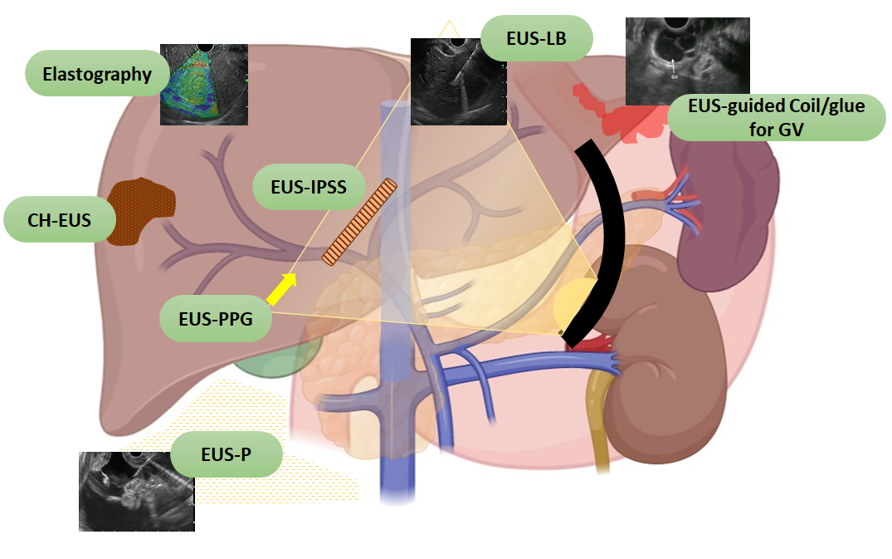
Figure 1 Spectrum of endoscopic ultrasound in hepatology. EUS: Endoscopic ultrasound; CH-EUS: Contrast harmonic endoscopic ultrasound; EUS-IPSS: Endoscopic ultrasound guided intrahepatic portosystemic shunt; EUS-LB: Endoscopic ultrasound guided liver biopsy; EUS-PPG: Endoscopic ultrasound guided portal pressure gradient; EUS-P: Endoscopic ultrasound guided paracentesis; GV: Gastric varices.
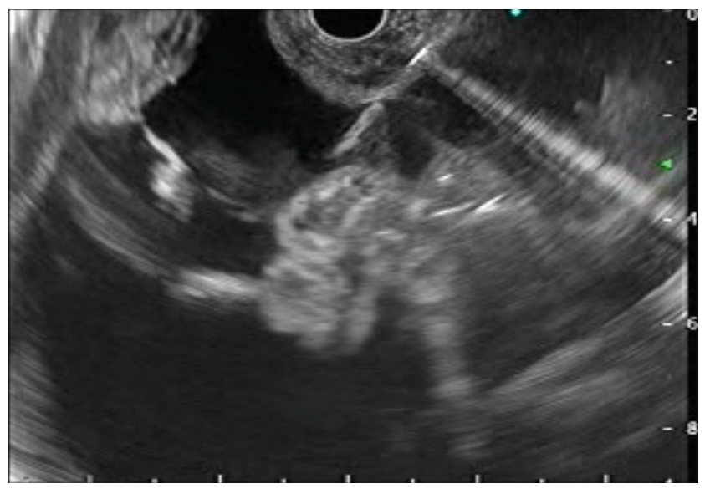
Figure 2 Endoscopic ultrasound guided paracentesis. Needle is visualized in the ascitic fluid.
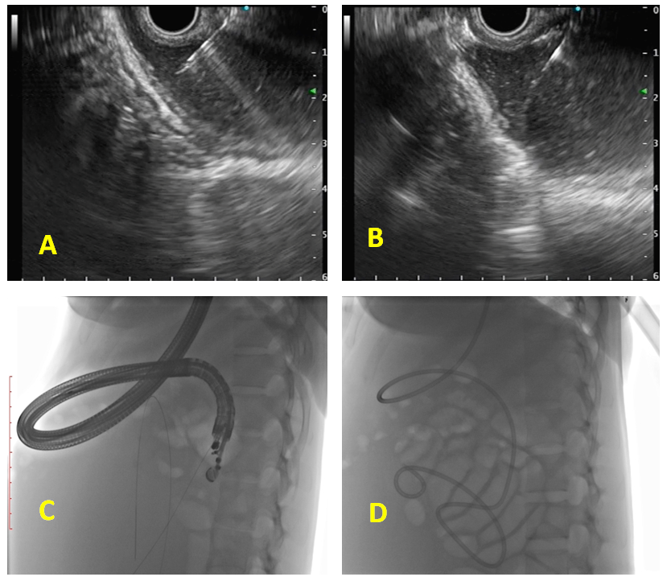
Figure 3 Endoscopic ultrasound-guided internal drainage of loculated ascites. A: Puncture of the loculated ascites with 19-G aspiration needle; B: Guidewire negotiated across as visualized on endoscopic ultrasound; C: Fluoroscopic view of guidewire coiled inside the loculated ascites; D: Naso-cystic drain placed inside the loculated ascites.
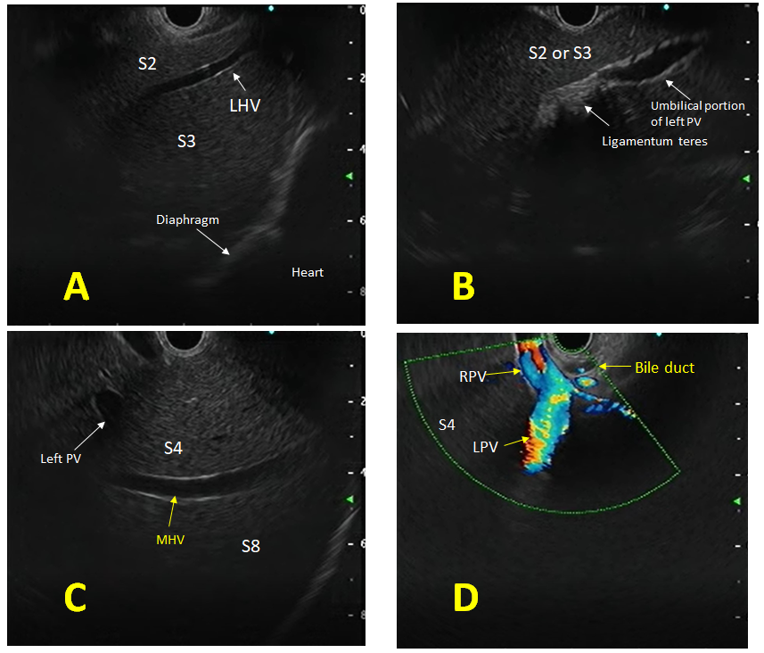
Figure 4 Endoscopic ultrasound anatomy of liver segments. A: Anatomy of the left lobe with S2 and S3 segments; B: Ligamentum teres with umbilical portion of the left portal vein; C: Middle hepatic vein with segments of the liver; D: Anatomy of the bifurcation of portal vein from the duodenal bulb. PV: Portal vein; MHV: Middle hepatic vein; LHV: Left hepatic vein; RPV: Right portal vein; LPV: Left portal vein.
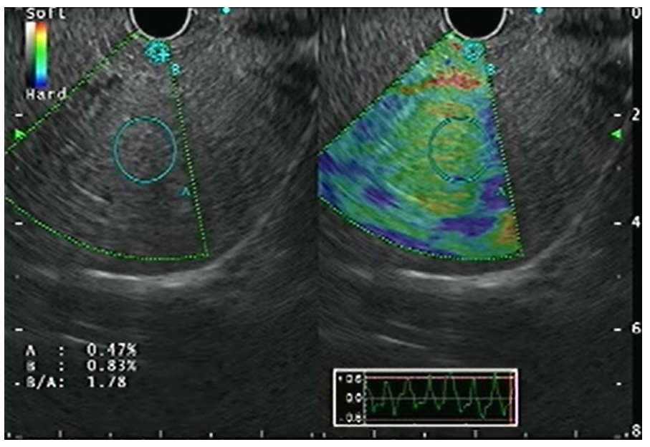
Figure 5 Endoscopic ultrasound elastography of the liver parenchyma.
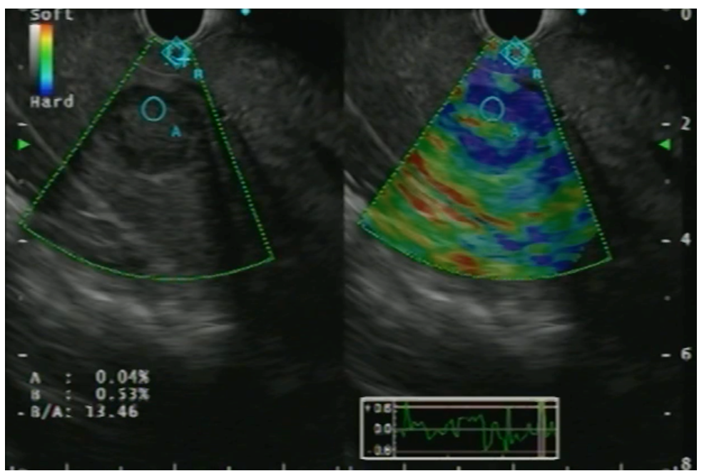
Figure 6 Endoscopic ultrasound elastography of a focal liver lesion with strain ratio calculation.
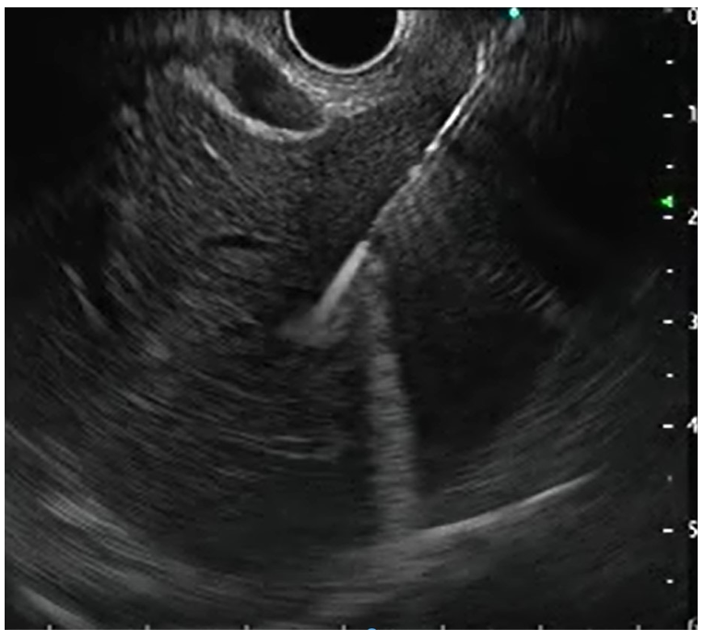
Figure 7 Endoscopic ultrasound-guided liver biopsy.
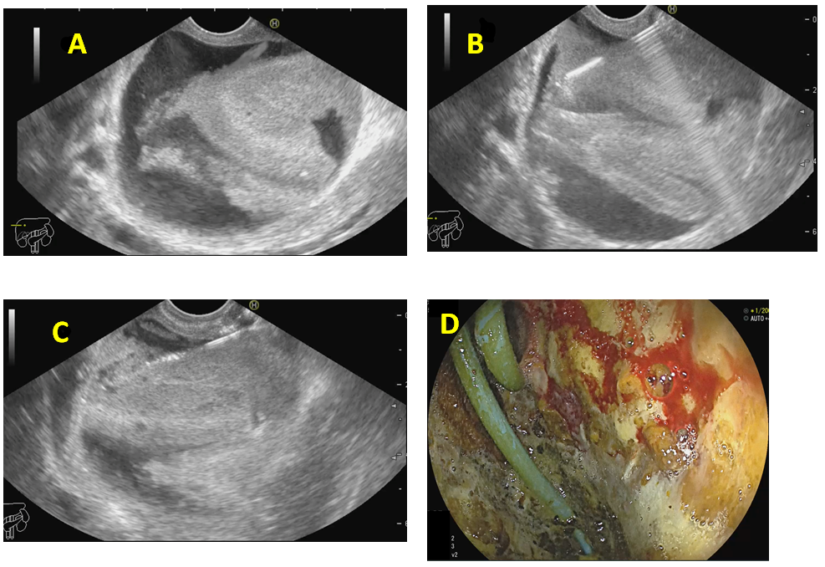
Figure 8 Endoscopic ultrasound-guided drainage of biloma. A: Post-operative biloma noted on endoscopic ultrasound (EUS) with internal echoes; B: EUS-guided puncture of the biloma; C: Guidewire negotiated into the collection followed by placement of naso-cystic drain; D: Endoscopic view of the cavity entered with catheter noted in situ.
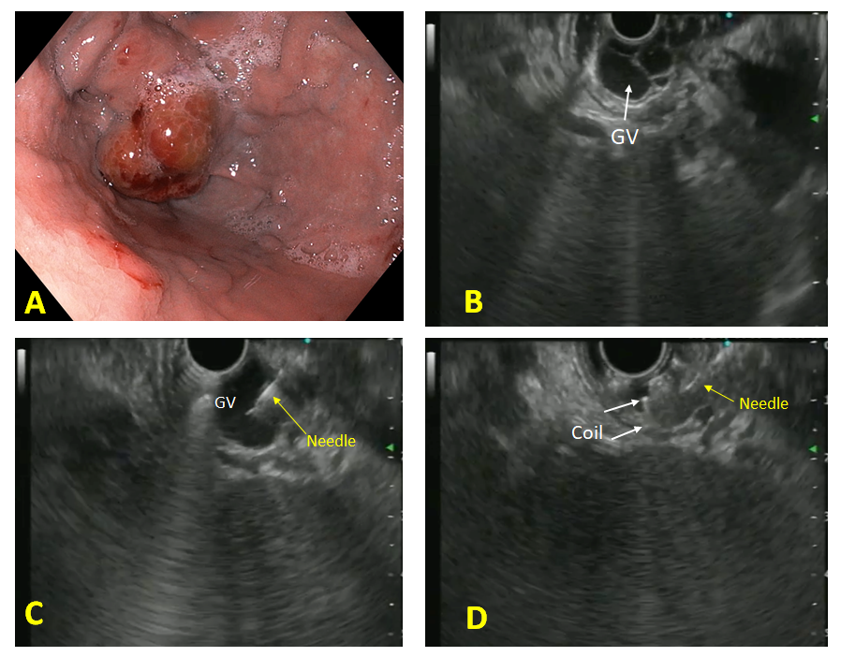
Figure 9 Endoscopic ultrasound-guided coil embolization of fundal varix. A: Endoscopic view of the fundal varix; B: Endoscopic ultrasound (EUS) view of the fundal varix; C: EUS guided puncture of the varix with a 22-G needle; D: Coil deployment inside the varix. GV: Gastric varices.
Table 1 Technique of endoscopic ultrasound guided paracentesis^{[1-3,9-11]}
Pre-procedure requirements
(1) No recommendations exist for EUS-P, although most studies have been performed under the cover of pre/peri-procedural antibiotics; and (2) Patient is usually fasted for 4-6 h before the procedure
Technical aspects
(1) EUS-P is usually performed using a 22 G/25 G FNA needle. A specialized spring‑loaded 22 G FNA needle can also be used for the same; (2) The approach can be transgastric or transduodenal. The tip of the needle is visualized under EUS guidance in the ascites; (3) At the time of puncture, care is taken to avoid a trajectory involving any tumor/vessels to avoid peritoneal seeding or bleeding; (4) For therapeutic paracentesis, a suction tube attached to a vacuum canister can be used; (5) Repositioning of the needle is carried out in case it gets blocked by the tumor or omentum; (6) Two and fro motion is usually not needed; (7) CE-EUS followed by FNA of the peritoneal/omental nodules can also be done for added diagnostic value; and (8) The sample aspirated is sent for routine cytological assessment and for any additional tests that might be needed
Post procedure
The administration of albumin post 5 L of paracentesis and post procedure observation are carried out as per standard recommendations (EASL, AASLD)
EUS: Endoscopic ultrasound; EUS-FNA: Endoscopic ultrasound guided fine needle aspiration; EUS-P: Endoscopic ultrasound guided paracentesis; G: Gauge; CE-EUS: Contrast enhanced endoscopic ultrasound; EASL: European Association for the Study of Liver; AASLD: American Association for the Study of Liver Diseases.

Table 2 Studies on endoscopic ultrasound guided paracentesis
Ref. | Study design | Patient population | Imaging | Age (yr) | Gender (M/F) | Needle | Route (TG/TD) | Amount of fluid aspirated | Diagnosis on EUS | Actual diagnosis | Complications
Chang et al^{[12]}, 1995 | Case report | 2 cases | CT (pleural effusion and ascites) | - | - | - | - | - | - | Malignant effusion and ascites | -
Romero-Castro et al^{[14]}, 2017 | Case series | 3 cases | DLBCL (1 case), HCC (2 cases) | 60/74/55 | 3/- | 19 G FNA (all cases) | TG (3 cases) | Double Pigtail placement (3 cases) | - | Malignant ascites (3 cases) | None
Wardeh et al^{[16]}, 2011 | Retrospective study | 101 | Ascites not detected in 6/9 cases on CT | 68.3 | 54/47 | 19 G FNA | NA | 10 mL (max) in 90 cases, 2 smears in 11 cases | 74 negative | 84 malignant | None
Suzuki et al^{[11]}, 2014 | Retrospective study | 11 cases | CT (no ascites in 4) | 66.4 | 7/4 | 22 G (automated  spring-loaded) | NA | 14.1 mL (range 0.5-38 mL) | Benign 5; malignant 6 | NA | None
Kaushik et al^{[10]}, 2006 | Retrospective study | 25 | NA | 66-70 | 16/9 | 22/25 G FNA | Both | 6.8 mL (range, 1-20 mL) | 64% malignant (benign 9; malignant 16) | Benign 8; malignant 17 | 1 cases (4%) (bacterial peritonitis)
Lee et al^{[4]}, 2005 | Retrospective study | 250 cases | CT in all | 60.3 | 160/90 | NA | NA | NA | 37% ascites, 28% peritoneal metastasis | All malignant | None
Dewitt et al^{[5]}, 2007 | Retrospective study | 60 | CT/MRI/USG in all (ascites 31 cases (51%) | 67 | 33/27 | 22 G | 55 (TG), 5 (TD) | 8.9 (1-40) mL | Benign 42; malignant/atypical 18 | Benign 15; malignant 45 | 2 cases fever
Köck et al^{[13]}, 2018 | Case report | 2 cases | Rectal cancer, ovarian cancer | 36, 56 | -/2 | 19 G | Both TG | Pigtail (plastic) placed | - | - | None
Nguyen and Chang^{[2]}, 2001 | Retrospective study | 31 cases (of 85) | CT had ascites in 14/79 (18%) | NA | NA | NA | NA | 7.9 (1-40 mL) | Malignant 5; benign 26 | NA | None
Varadarajulu and Drelichman^{[3]}, 2008 | Case report | 1 | SCC anus | 31 | -/1 | 19 G | TG (1) | 10 mL (diagnostic); 5 L (therapeutic) | Malignant ascites | NA | None
DLBCL: Diffuse large B cell lymphoma; TG: Transgastric; TD: Transduodenal; M: Male; F: Female; G: Gauge; EUS: Endoscopic ultrasound; CT: Computed tomography; FNA: Fine needle aspiration; SCC: Squamous cell carcinoma; USG: Ultrasound; MRI: Magnetic resonance imaging.

Table 3 Structures visualized with endoscopic ultrasound in the liver
Structure | Features | Doppler
Portal vein branches | Thick and hyperechoic walls | Positive signal
Hepatic vein branches | Thin, non-reflective walls, straight course | Positive signal
Biliary radical | Hyperechoic walls, irregular course | Negative signal
Ligaments (teres and venosum) | Thick, hyperechoic (no lumen) (between vessels and Glisson’s capsule) | Negative signal
Gallbladder | Cystic structure, hyperechoic walls, anechoic content | Negative signal
Falciform ligament | Thick, hyperechoic (no lumen); on the left anterior to segment III, on the right anterior to segment IVa and IVb | Negative signal
Hepatic artery | Thick with reflective walls | Positive signal

Table 4 Studies on endoscopic ultrasound guided fine needle aspiration/fine needle biopsy of focal liver lesions
Ref. | Design | Patients | Diagnostic yield (%) | Needle passes (median) | Complications
EUS-FNA
Nguyen et al^{[32]} | Prospective | 14 | 100 | 2 | 0
TenBerge et al^{[33]} | Retrospective | 26 | 88.6 | - | 3.8% (fever)
DeWitt et al^{[34]} | Retrospective | 77 | 91 | 3.4 (mean) | 0
Hollerbach et al^{[35]} | Prospective | 33 | 94 | 1.4 ± 0.6 | 6.1% (self-limited bleeding)
McGrath et al^{[36]} | Prospective | 7 | 100 | 2 | 0
Singh et al^{[26]} | Prospective | 9 | 88.9 | 2 | 0
Singh et al^{[27]} | Prospective | 26 | 96 | 2.1 | 0
Crowe et al^{[37]} | Retrospective | 16 | 75 | 3 (minimum) | 0
Prachayakul et al^{[38]} | Retrospective | 14 | 100 |  | 0
Oh et al^{[39]} | Prospective | 47 | 90.5 | 3 | 0
Ichim et al^{[25]} | Prospective | 48 | 98 | 2 | 0
EUS-FNB
Lee et al^{[40]} | Prospective | 21 | 90.5 | 2 | 0
Chon et al^{[41]} | Retrospective | 58 | 89.7 | 2 | 1.7% (bleed)
EUS: Endoscopic ultrasound; FNA: Fine needle aspiration; FNB: Fine needle biopsy.
Table 5 Technique of endoscopic ultrasound guided liver biopsy^{[50,51]}
Pre-biopsy: The following workup is needed in all cases of liver biopsy
(1) Coagulation work up including platelet count, PT/INR and BT/CT; (2) Prior to the biopsy, the medications should be stopped as follows: anti-platelet medications 7 d, warfarin 5 d, heparin and related products discontinued 12-24 h prior to biopsy; and (3) Use of conscious sedation such as midazolam and nalbuphine or propofol as per operator’s preference or patient comfort
Procedural details of EUS-LB
(1) A linear array echoendoscope (Olympus GF-UCT180, Center Valley, United States) is generally used for the procedure; (2) Prior to the procedure, Doppler imaging is done to ensure that no vascular structures are present along the expected trajectory of the needle; (3) The EUS-LB can be performed using a 19 G EUS-FNA/FNB needle; (4) The left lobe is identified first, as that liver parenchyma which is a few centimeters below the gastro-esophageal junction with the scope torqued clockwise. The right lobe if needed to be biopsied, is accessed from the duodenal bulb. Two site biopsy can be undertaken at the discretion of the endosonographer; (5) A preferably long vessel free trajectory allowing free passage of the needle to a depth of at least 3 cm or more is usually selected; (6) For wet heparin suction, the stylet is removed and the needle is primed with a heparin flush and the suction syringe is reattached to the needle hub; (7) The needle is then introduced into the echoendoscope channel; (8) Once liver parenchymal penetration is achieved with the needle (around 1-2 cm), full suction is applied with the 20 mL vacuum syringe with fluid column; (9) One pass consists of a total of 4-5 to-and-fro needle motions using the fanning technique under direct EUS guided visualization of the tip of the needle. Two such passes are usually taken (maximum 10 actuations); and (10) The specimen is pushed from the needle directly into the formalin solution using the stylet or saline flush
Post-liver biopsy: The following instructions are to be followed in all cases post liver biopsy
(1) The patient post biopsy, irrespective of the type of procedure, is transferred to the post procedure recovery room and monitored as per the AASLD protocol^{[69]}; (2) The minimum observation period is 2-4 h; (3) Post-procedure pain and need for analgesics to be noted and provided; and (4) Patient is asked to report adverse events at specific time intervals (as per institute policy)
EUS: Endoscopic ultrasound; PT Prothrombin time; INR International normalized ratio; BT: Bleeding time; CT: Clotting time; EUS-LB: Endoscopic ultrasound guided liver biopsy; FNA: Fine needle aspiration; FNB: Fine needle biopsy; AASLD: American Association for the Study of Liver Diseases.

Table 6 Studies on endoscopic ultrasound guided fine needle aspiration guided and endoscopic ultrasound guided fine needle biopsy guided liver biopsy in patients with chronic liver disease
Ref. | Design of the study | Patients | Technical success (%) | Diagnostic yield (%) | Specimen length (median, range) (mm) | CPT (median, range) | Needle used for EUS-LB | Needle passes (median) | Complications, n (%)
EUS-FNA guided liver biopsy
Pineda et al^{[57]} | Retrospective | 110 | 100 | 98 | 38 (24-81) | 14 (9-27) | 19 G | - | 0
Shuja et al^{[58]} | Retrospective | 69 | 100 | 100 | 45.8 (mean) | 10.84 (mean) | 19 G | 3 | 0
Stavropoulos et al^{[50]} | Prospective case series | 22 | 100 | 91 | 36.9 (2-184.6) | 9 (1-73) | 19 G | 2 (1-3) | 0
Diehl et al^{[59]} | Prospective non randomized | 110 | 100 | 98 | 38 (0-203) | 14 (0-68) | 19 G | 1.5 (1-2) | 1 (0.9) (mild bleeding)
Gor et al^{[60]} | Retrospective case series | 10 | 100 | 100 | 13 (6-23) | 8 (6-15) | 19 G | - | 0
EUS-FNB guided liver biopsy
Shah et al^{[61]} | Retrospective | 24 | 100 | 96 | 65.6 (17-167.4) | 32.5 (5-85) | 19 G (SharkCore) | 2 (1-3) | 2 (8.3)
Nieto et al^{[62]} | Retrospective | 165 | 100 | 100 | 60 (43-80) | 18 (13-24) | 19 G (SharkCore) | 1 | 3 (1.8)
Mathew^{[63]} | Case report | 2 | 100 | 100 | - | - | 19 G (QuickCore) | - | 0
Ching et al^{[55]} | Prospective (RCT) | 20; 20 | 100; 100 | 100; 100 | 114 (mean); 153.2 (mean) | 16.5 (6-38); 38 (0-81) | 19 G (FNA); 19 G (Acquire) | -  - | 8 (40); 7 (35)
Mok et al^{[56]} | Prospective (RCT) | 40; 40 | 100; 100 | 88; 68 | -; - | -; - | 19 G (FNA); 22 G (SharkCore) | -; - | 0; 1 (2.5)
Patel et al^{[64]} | Retrospective | 30; 50; 28; 27 | 100; 100; 100; 100 | 66.7; 46; 82.1; 81.5 | 1.8 (mean); 4.7 (mean); 1.9 (mean); 8.4 (mean) | 6.9 (mean); 3 (mean); 7.3 (mean); 16.9 (mean) | Acquire 22 G; QuickCore 19 G; ProCore 19 G; Expect 19 G | -; -; -; - | -; -; -; -
Gleeson et al^{[65]} | Retrospective | 9 | 100 | 100 | 13 (8-28) | 7 (5-8) | 19 G (QuickCore) | 2 (1-3) | 0
DeWitt et al^{[66]} | Prospective case series | 21 | 100 | 90.5 | 9 (1-23) | 2 (0-10) | 19 G (QuickCore) | 3 (1-4) | 0
Nakai et al^{[67]} | Case report | 1 | 100 | 100 | 15 | 8 | ProCore 19 G |  | 0
Sey et al^{[68]} | Prospective cross sectional study | 45; 30 | 100; 100 | 73.3; 96.7 | 9 (0-25); 20 (5-60) | 2 (0-15); 5 (0-24) | QuickCore 19 G; ProCore 19 G | 3; 2 | 2 (4.4); 0
Hasan et al^{[69]} | Prospective (RCT) | 40 | 100 | 100 | 55 (44.5-68) | 42 (28.5-53) | Acquire 22 G | - | 6 (15)
CPT: Complete portal triad; EUS-LB: Endoscopic ultrasound guided liver biopsy; FNA: Fine needle aspiration; FNB: Fine needle biopsy; RCT: Randomized controlled trial; G: Gauge.
Table 7 Studies in humans demonstrating the role of endoscopic ultrasound guided therapies for liver lesions
EUS guided treatment | Study design | Patients | Location of the lesion | Technical success (%) | Response to therapy | Complications
Ethanol ablation in HCC
Nakaji et al^{[84]} | Case report | 1 | Segment 8 | 100 | Complete | 0
Lisotti et al^{[85]} | Case report | 1 | Segment 2 | 100 | Complete | 0
Nakaji et al^{[86]} | Case report | 1 | Segment 3 | 100 | Complete | 0
Nakaji et al^{[87]} | Retrospective | 12 | Caudate lobe | 100 | Complete | 2 (16.7%)
Jiang et al^{[88]} | RCT | 10 | Left lobe | 92 | Partial (30%) | 0
Alcohol ablation in liver metastasis
Barclay et al^{[89]} | Case report | 1 | Left lobe | 100 | Complete | Self-limited sub-capsular hematoma
Hu et al^{[103]} | Case report | 1 | Left lobe | 100 | Complete | Low grade fever
RFA (radiofrequency ablation) in HCC
Armellini et al^{[91]} | Case report | 1 | Left lobe | 100 | Complete | None
Attili et al^{[92]} | Case report | 1 | Segment 3 | 100 | Complete | None
de Nucci et al^{[93]} | Case report | 1 | Segment 2-3-4b | 100 | 70% reduction | None
Ablation by Nd-YAG
Di Matteo et al^{[95]} | Case report | 1 | Caudate lobe | 100 | Complete | 0
Jiang et al^{[96]} | Prospective | 10 | Left lobe | 100 | Complete | 0
Brachytherapy (Iodine-125)
Jiang et al^{[88]} | RCT | 13 | Left lobe | 92 | Near complete | 0
EUS: Endoscopic ultrasound; HCC: Hepatocellular carcinoma; RCT: Randomized controlled trial; Nd-YAG: Neodymium:yttium-aluminum-garnet; RFA: Radiofrequency ablation.

Table 8 Steps of endoscopic ultrasound guided coil and glue placement for gastric varices obliteration
Pre-procedure requirements
(1) All procedures are done under the cover of pre/peri-procedural antibiotics; (2) Patient is usually fasted for 4-6 h before the procedure; and (3) Adequate resuscitation of the patient, in case of active bleeding is ensured, prior to the procedure
Technical aspects
(1) The echoendoscope is usually positioned either in the distal esophagus or the gastric fundus; (2) Water is filled intra-luminally in the fundus. This enables a good acoustic coupling for better visualization of the gastric varices. Adequate examination of the fundus, the intramural varices and the feeder vessels is carried out; (3) The approach can be trans-esophageal or transgastric, wherein the trans-esophageal route is given preference; (4) EUS-guided coil and glue embolization is usually performed using a 22 G/19 G (gauge) FNA needle. The size of the coil is determined by the short axis of the diameter of the varix; (5) After puncture of the varix, blood is aspirated to confirm the location. This is followed by flushing of the needle with saline; (6) The coils are then deployed into the varix using the stylet as a pusher. Once the coils are deployed, flushing of the needle is done with normal saline; (7) After coil deployment, 1-2 mL of cyanoacrylate glue is injected over 30-45 s followed by rapid flushing with saline; and (8) Once, the varix is obliterated, visualized by absence of flow on color Doppler, the sheath of the needle is advanced beyond the endoscope tip for 2-3 cm before withdrawing the scope. This avoids contact of glue with the endoscope tip. The sample aspirated is sent for routine cytological assessment as well as for any additional tests that might be needed
Post procedure
(1) The patients are kept under observation for 12 h; (2) Repeat EUS can be done after 2 d to look for residual varices; and (3) Follow-up EUS can be performed at 1- and 3-mo intervals
EUS: Endoscopic ultrasound; FNA: Fine needle aspiration; G: Gauge.

