Name of Journal: World Journal of Cardiology
Manuscript NO: 88546
Manuscript Type: ORIGINAL ARTICLE

Retrospective Study
Do changes in intracoronary pressure aid coronary spasm diagnosis using the spasm provocation test?

Teragawa H et al. Changes in intracoronary pressure and VSA diagnosis

Hiroki Teragawa, Chikage Oshita, Yuko Uchimura

Hiroki Teragawa, Chikage Oshita, Yuko Uchimura, Department of Cardiovascular Medicine, JR Hiroshima Hospital, Hiroshima 732-0057, Japan

Author contributions: Oshita C and Uchimura Y contributed to the acquisition of data and Teragawa H contributed to the writing and revision of the manuscript; All the authors approved the final version of the manuscript.

Corresponding author: Hiroki Teragawa, FACC, FACP, FAHA, FESC, MD, PhD, Chief Physician, Doctor, Department of Cardiovascular Medicine, JR Hiroshima Hospital, 3-1-36 Futabanosato, Higashi-ku, Hiroshima 732-0057, Japan. hiroki-teragawa@jrhh.or.jp

Received: September 27, 2023
Revised: December 11, 2023
Accepted: December 28, 2023
Published online: January 26, 2024

Abstract
BACKGROUND
Although the spasm provocation test (SPT) can diagnose coronary spasms, it would be helpful if it could also predict their occurrence.

AIM
To investigate whether coronary spasms can be predicted using changes in intracoronary artery pressure measured using a pressure wire during the SPT.

METHODS
Seventy patients underwent SPTs with pressure-wire measurement of intracoronary artery pressure. During each SPT, the pressure wire was advanced into the distal portion of the right coronary artery (RCA) and left anterior descending coronary artery, and the ratio of intracoronary pressure to aortic pressure (Pd/Pa) was monitored. Coronary spasm was defined as an arterial narrowing of > 90% in response to the administration of acetylcholine (ACh), with chest symptoms and/or ischemic electrocardiographic changes. ACh was administered to the RCA at low, moderate, or high doses of 20, 50, or 80 µg, respectively, and to the left coronary artery (LCA) at low, moderate, or high doses of 50, 100, or 200 µg, respectively. Coronary arteries with coronary spasms at low doses of ACh were defined as group L, and those with coronary spasms at moderate or high doses were defined as group MH. Those who did not occur coronary spasms at any ACh dose were designated as group N.

RESULTS
Among the 132 coronary arteries assessed using a pressure wire, there were 49 in group N, 25 in group L, and 58 in group MH. Baseline Pd/Pa was the lowest in group L (P = 0.001). The decrease in the ΔPd/Pa between baseline to low doses of ACh was lower in group MH than in group N (P < 0.001). A receiver-operating characteristics analysis showed that the cutoff baseline Pd/Pa value for predicting group L was 0.95, with a sensitivity of 0.600 (15/25) and a specificity of 0.713 (76/107) and that the cutoff value of ΔPd/Pa from baseline to low doses of ACh for predicting group MH was −0.04, with a sensitivity of 0.741 (43/58) and a specificity of 0.694 (34/49).

CONCLUSION
These findings suggest that indices of intracoronary pressure during SPT may be useful means for predicting the occurrence of coronary spasms.

Key Words: Acetylcholine; Coronary spasm; Intracoronary pressure; Pressure wire; Spasm provocation test; Vasospastic angina

©The Author(s) 2024. Published by Baishideng Publishing Group Inc. All rights reserved.

Citation: Teragawa H, Oshita C, Uchimura Y. Do changes in intracoronary pressure aid coronary spasm diagnosis using the spasm provocation test? World J Cardiol 2024; 16(1): 16-26
URL: https://www.wjgnet.com/1949-8462/full/v16/i1/16.htm
DOI: https://dx.doi.org/10.4330/wjc.v16.i1.16

Core Tip: The spasm provocation test (SPT) is a well-established tool for diagnosing coronary spasms. However, it is associated with several complications that can make the test a stressful experience. We investigated whether coronary spasms detected in the SPT can be estimated using intracoronary artery pressure measured with a pressure wire. We found that coronary spasms induced by low acetylcholine doses were associated with decreased intracoronary pressure at baseline. Coronary spasms induced by moderate-to-high acetylcholine doses showed decreased intracoronary pressure from baseline to low acetylcholine doses. These indices of intracoronary pressure may be used to predict coronary spasms.

INTRODUCTION
Vasospastic angina (VSA) is a condition in which transient vasoconstriction of the epicardial coronary arteries causes myocardial ischemia^{[1-4]}. In recent years, VSA, angina with nonobstructive coronary artery disease (ANOCA)^{[5,6]}, and myocardial infarction with nonobstructive coronary artery (MINOCA)^{[7]} have attracted increasing research attention. A diagnosis of VSA is made when transient electrocardiographic changes are observed in addition to typical anginal pain^{[8]}. However, in actual clinical practice, electrocardiographic changes cannot always be detected^{[9,10]} and the final diagnosis of VSA is made by performing a spasm provocation test (SPT).
In SPT, acetylcholine (ACh) or ergonovine maleate are used as provocative drugs. ACh is usually administered in small, gradual doses^{[6,11]}. The physical response to this allows the diagnosis of VSA based on chest symptoms, electrocardiographic changes, and significant coronary vasoconstriction. However, VSA and/or SPT-related complications have also been reported to occur^{[12,13]}. It is undeniable that SPT can be stressful, even for the person performing the test. Therefore, if the cardiologist performing the SPT can predict that coronary spasm will occur with the next provocation, they can respond quickly. The ability to predict coronary spasm during the test would be highly useful and allow both practical and mental preparation.
In some cases, coronary spasm tests are performed after evaluation of coronary microcirculatory dysfunction (CMD)^{[14,15]}. In such cases, the SPT is often performed with a pressure wire in place. In our previous research, we demonstrated the utility of measuring changes in intracoronary pressure using a pressure wire during SPTs for the diagnosis of VSA or assessment of VSA status^{[16]}. In the present study, we investigated whether spasm provocation could be predicted by changes in intracoronary pressure measured using a pressure wire.

MATERIALS AND METHODS
Study patients
This observational retrospective study included patients who underwent coronary angiography (CAG) and the SPT using a pressure wire at our institution between January 2012 and August 2015 (n = 79). The exclusion criteria were as follows: Significant coronary stenosis (% stenosis > 50%, n = 5) or a history of percutaneous coronary intervention (n = 4). Finally, 70 patients (mean age, 68 years; 36 men, 34 women) were enrolled (Figure 1). The study protocol was approved by the ethics committee of our institution, No. 2023-11. Written informed consent was obtained from all participants for SPT. The opt-out method (http://www.jrhh.sakura.ne.jp/annnai/torikumi.html) was used to confirm final agreement to participate.

CAG and SPT using a pressure wire
The SPT procedure has previously been described^{[16]}. Coronary vasodilators were withdrawn at least 48 h before each SPT. Subsequently, the SPT was performed on the right coronary artery (RCA). After the initial CAG, a 5-Fr catheter was used to insert a 0.014-inch pressure wire (PrimeWire Prestige Plus guidewire or Verrata Pressure guidewire; Phillips Volcano, Amsterdam, Holland) into the distal part of the RCA. The pressure between the catheter tips and pressure wire was previously calibrated at the ostium of the coronary arteries. The ratio of distal intracoronary pressure (Pd) detected by the pressure wire to the proximal intracoronary pressure (Pa) detected by the catheter tips was continuously monitored using the Pd/Pa indices. Then, an injection of 20 µg was made into the RCA, followed by another of 50 µg. If 50 µg ACh failed to induce coronary spasm, an 80 µg of ACh was injected. When the Pd/Pa index dropped during a coronary spasm, the lowest Pd/Pa value in response to each ACh dose was recorded, as were the Pd/Pa values immediately prior to the angiogram. CAG was performed after coronary spasm or maximum ACh infusion. When coronary spasms occurred but disappeared on their own without intracoronary 0.3 mg nitroglycerin (NTG) injection into the RCA, SPT of the left coronary artery (LCA) was performed. In such cases, NTG was injected into the RCA and, after completion of the LCA SPT, CAG was performed once more. If coronary spasms were prolonged or severe enough to result in hemodynamic instability, an intracoronary NTG injection was administered to treat them. SPT was subsequently performed on the LCA. A pressure wire was introduced into the distal segments of the left anterior descending coronary artery (LAD) during the LCA SPT, following the second pressure calibration at the LCA ostium. Similar to the RCA SPT, the LCA was infused with ACh doses. In the LCA test, the ACh doses were 50 and 100 µg, followed by 200 µg if the previous doses did not induce a coronary spasm. Following the commencement of a coronary spasm or the maximum ACh infusion, whichever came first, CAG was administered. A 0.3 mg NTG intracoronary injection and the last CAG for the LCA were then performed. According to this study, the appropriate low, moderate, and high ACh dosages for the RCA and LCA were 20, 50, and 80 µg and 50, 100, and 200 µg, respectively. Since the number of spasm-positive cases at high doses was not large, we divided the lesions into three groups: Group N consisted of lesions that did enter the coronary spasm, group L consisted of lesions in which coronary spasm was induced by the lowest dose of ACh, and group MH consisted of lesions in which coronary spasm was induced by the moderate or high-dose ACh.
When the Pd/Pa index decreased during a coronary spasm, the data immediately before the angiogram were used instead of the minimal Pd/Pa index in response to each ACh dose. The minimal Pd/Pa at low doses of ACh minus the Pd/Pa at baseline was used to define the difference in the Pd/Pa at low doses of ACh. When a PrimeWire Prestige Plus guidewire was available, the instantaneous free-wave ratio (iFR) was assessed immediately before ACh administration. The usual technique for the intravenous administration of adenosine triphosphate was used to test the fractional flow reserve (FFR) in patients with coronary atherosclerosis. We employed an autoinjector using a previously described method^{[16]}. The diameter of the coronary artery was measured. Atherosclerotic lesions were defined as those with between a stenosis between 20% and 50%.

Definitions of VSA-related parameters
There are three categories of angina pectoris activity: Resting, exertion, and combined rest and exertion. When induced, VSA was defined as > 90% constriction of the coronary arteries as measured by angiogram, along with typical chest symptoms and/or an ST-segment deviation on electrocardiogram^{[6]}. Those who had a coronary spasm in at least one major coronary artery were classified as the VSA group, and those who had no spasms in any coronary artery as the non-VSA group. Based on the classifications of the American Heart Association (AHA), focal spasms are defined as temporary arterial narrowing of more than 90% that remains within the boundaries of a single isolated coronary segment^{[17]}. Diffuse vasoconstriction is defined by the AHA as > 90% arterial narrowing in two coronary artery segments^{[17]}. The coronary spasm endotype observed in the RCA and LCA of each patient can differ. Coronary spasms that affect more than two major coronary arteries are referred to as multivessel spasms. We were unable to identify multivessel spasms in cases in which the unavoidable use of NTG was followed by a negative SPT. Each coronary artery at the site of the coronary spasm was separated into three sections (proximal, mid, and distal) for lesion studies, and the central area of the coronary spasm was labeled as diffuse.

Other clinical characteristics measured
Patient information was collected regarding current and former smoking habits and alcohol consumption, family history of coronary artery disease (CAD)^{[16]}, and comorbid hypertension, dyslipidemia, diabetes mellitus, or chronic kidney disease (CKD), all defined using the accepted criteria^{[16,18-20]}. Using cardiac ultrasonography (UCG), the left ventricular ejection fraction (LVEF) was calculated using the modified Simpson’s method. Flow-mediated dilation (FMD), endothelium-dependent function, endothelium-independent function, and NTG-induced dilation (NID), were also measured and recorded in the majority of the patients (n = 62)^{[16,21]}.

Statistical analyses
For nonnormally distributed data and noncontinuous variables, data were presented as mean and SD or median and interquartile range. Student’s unpaired t-tests, Wilcoxon signed-rank tests, or 2 analyses were used for between-group comparisons of variables at baseline. The causes of coronary spasms caused by low-dose or moderate-to-high doses of ACh were identified using logistic regression analyses. Optimal cutoff values were determined using receiver-operating characteristic (ROC) analyses. JMP version 17 was used to perform statistical analyses (SAS Institute Inc., United States). Statistical significance was set as P-values < 0.05.

RESULTS
Characteristics of patients in the VSA and non-VSA groups
There were 53 patients (76%) in the VSA group and 17 patients (24%) in the non-VSA group. Patient characteristics are summarized in Table 1. There were no significant differences in age, body mass index, coronary risk factors, alcohol consumption, smoking, family history of CAD, or CKD between the two groups, but there were significantly more males in the VSA group than in the non-VSA group (P = 0.001). UCG showed no significant difference in LVEF. Brachial artery ultrasonography showed no difference in brachial artery diameter at baseline between the two groups; however, in the VSA group, FMD was significantly lower (P = 0.008) and NID tended to be lower (P = 0.061). Coronary vasodilator use, which was stopped at least 48 h before the SPT, was clearly lower in the VSA group (P = 0.018), but no differences were observed for other medications.

Changes in intracoronary pressure with coronary spasms and ACh
In most patients, a pressure wire was inserted into the RCA and LAD. However, eight coronary vessels were excluded. This was because the RCA was too small to perform the SPT (n = 2), the catheter could not engage into the RCA (n = 2), the pressure wire could not be inserted into the distal portion of RCA due to meandering (n = 3), or the pressure wire could not be inserted into the LAD (n = 1). Thus, a pressure wire was inserted into the remaining 132 coronary vessels, including 63 RCA and 69 LAD.
Coronary spasms were induced by low, moderate, and high doses of ACh in 25, 51, and 7 vessels, respectively. No coronary spasms occurred in the remaining 49 vessels (group N). In seven vessels, spasms were induced by the high dose but were insufficient to clarify the statistical results. Thus, as described in the Methods, vessels in which coronary spasms were induced by moderate and high doses of ACh were combined into group MH. There were 49 vessels in group N, 25 in group L, and 58 in group MH. The lesion characteristics are listed in Table 2. There were no differences between the RCA and LAD in coronary vessels, in the rate of atherosclerosis, or in the unavoidable need for NTG administration. There was no difference between group L and MH in whether induced coronary spasms were focal or diffuse (P = 0.456) and whether the coronary arteries were proximal, mid, or distal (P = 0.610). We found no significant differences in iFR (P = 0.104) or FFR (P = 0.093) among the three groups. The Pd/Pa values at baseline were the lowest in group L (P = 0.001) (Figure 2). The Pd/Pa value at low doses of ACh was lowest in group L and highest in group N (Figure 3A). The difference between baseline and low-dose ACh was lowest in group L and highest in group N (Figure 3B). Pd/Pa at moderate-to-high doses of ACh was significantly lower in group MH than in N (P < 0.001).
Predictions of coronary spasms at low and moderate-high doses of ACh were made based on Pd/Pa at baseline and changes in Pd/Pa.
In univariate analysis, the only significant indicator of coronary spasm induced by low doses of ACh was Pd/Pa at baseline (P = 0.002). Pd/Pa at baseline was negatively correlated with LAD (P < 0.001) and the presence of atherosclerosis (P = 0.030). Logistic regression analysis of positive SPT at the low dose of ACh, using Pd/Pa at baseline, the LAD, and the presence of atherosclerosis found Pd/Pa at baseline was the only significant predictor (P = 0.003). ROC analysis showed an area under the curve (AUC) of 0.688 and a cutoff Pd/Pa at baseline of 0.95 for predicting the induction of coronary spasm by low doses of ACh (group L), with sensitivity and specificity of 0.600 (15/25) and 0.713 (76/107), respectively (Figure 4A). In an analysis of the 107 Lesions in group N and MH, the factors that predicted the induction of coronary spasms by moderate or high doses of ACh were Pd/Pa at baseline (P = 0.019, AUC 0.626), Pd/Pa at low doses of ACh (P < 0.001, AUC 0.739), and the ΔPd/Pa from baseline to low ACh dose (P < 0.001, AUC 0.742). ΔPd/Pa, which had the highest AUC, did not correlate with the presence of atherosclerosis (P = 0.141) or with the LAD (P = 0.393). ROC analysis showed that the optimal ΔPd/Pa from baseline to the low dose of ACh was −0.04, with a sensitivity of 0.741 (43/58) and a specificity of 0.694 (34/49) (Figure 4B).

DISCUSSION
This study examined whether baseline Pd/Pa values and changes in this value, as measured by a pressure wire, could be used to predict the next coronary spasm when the SPT was performed using a pressure wire. We found that intracoronary pressure at baseline decreased in cases where coronary spasms were induced by a low dose of ACh, indicating that decreased intracoronary pressure at baseline may predict these coronary spasms. Furthermore, coronary spasms induced by moderate-to-high doses of ACh were not only correlated with lower intracoronary pressure at baseline, but also with lower intracoronary pressure from baseline to low-dose ACh administration, indicating that this intracoronary pressure trend is useful in the prediction of coronary spasms induced by moderate-to-high dose ACh provocation. When pressure wires are used in the SPT, these indices may be useful for predicting coronary spasms.
The SPT is a reliable and well-established test that is useful for the diagnosis of coronary spasms and the evaluation of their activity and prognosis^{[6,17,22-25]}. However, a certain percentage of SPTs have known complications, some of which are the result of the induced spasms. In this sense, the test is by no means stress-free for either the patient or the cardiologist. The ability to predict the likelihood of coronary spasms at the next provocation in SPT has the potential to attenuate this stress to some degree. We attempted to determine whether the next coronary spasm during the SPT could be predicted based on the Pd/Pa value and its changes measured using a pressure wire.
To date, there have been no reports on the measurement of changes in intracoronary pressure during SPT. However, several studies have examined this pressure using quantitative CAG and coronary blood flow velocity using Doppler wires^{[26,27]}. In our previous study^{[26]}, the baseline coronary artery diameter in patients with VSA (mean, 2.95 mm) was slightly lower than that of non-VSA patients (mean, 3.14 mm), although not significantly. We also showed that a 2 min infusion of ACh at a dose of 3 µg/min caused significant vasocontraction of the coronary artery but did not induce coronary spasms^{[26]}. Similarly, Feenstra et al^{[27]} found that an 8.6 µg/min dose of ACh for 3 min causes a nonsignificant coronary artery contraction in patients with epicardial coronary spasm. Despite the differences due to the part of the measured coronary artery and the dose of ACh infusion, the baseline coronary artery diameter and changes in this diameter in response to small doses of ACh can cause a decrease in baseline intracoronary pressure, with greater decreases in patients with VSA.
There are several reasons why performing the SPT with a pressure wire can be useful: (1) A decrease in intracoronary pressure when a coronary spasm occurs, indicating that a spasm has occurred before CAG; (2) Improvements in intracoronary pressure following NTG administration shows whether a coronary spasm is immediately relieved, reducing the need for additional NTG and/or contrast medium; and (3) The insertion of a pressure wire stabilizes the catheter's engagement, especially in the RCA. The present study showed the feasibility of predicting coronary spasm provocation using intracoronary pressure at baseline and its changes during low-dose ACh infusion. However, we do not recommend routine use of a pressure wire with SPT. Insertion of a pressure wire prolongs fluoroscopy time and increases medical costs. In addition, there is a risk of coronary artery trauma due to pressure-wire insertion, which cannot always be inserted all the way to the distal end of the coronary artery. The insertion of the wire can potentially obscure the findings of the SPT or cause the accordion phenomenon. Hence, there are many possible disadvantages of pressure-wire insertion. In recent years, there has been increased research attention on the SPT and the functional testing of CMD, as many patients with ANOCA or MINOCA conditions do not have significant stenosis of the coronary arteries^{[5,6]} and clarification of causes can improve prognosis^{[28]}. A pressure wire is sometimes used to evaluate CMD before the SPT^{[14,15]}. The number of cases in which a pressure wire is used to induce coronary spasm is likely to increase in the future. In such cases, the results of the present study can be used as a reference for predicting coronary spasms. We hope that the validity of the results of this study will be strengthened in future research.
This study had several limitations. First, because this was a single-center study with a small sample size, our results may not be generalizable to all patients with coronary spasms. Second, although coronary artery diameters should be measured during drug provocation from quantitative CAG, in asymptomatic cases, no electrocardiographic changes, or no changes in intracoronary pressure, CAG was omitted or only a test shot was taken, and changes in coronary artery diameters were not evaluated. This was a significant impediment to our findings. Third, some negative coronary spasm cases may have completed provocation following a moderate dose of ACh. Recently, the usefulness of high-dose ACh provocation^{[29,30]} and sequential provocation^{[31]} proposed by Sueda et al was reported, and it is possible that such provocation would have changed the results to positive. The rates of coronary vasodilators in the VSA and non-VSA groups differed, which may have had some effect on the SPT results, although their use was stopped for at least 48 h before the SPT. Fourth, the present study included patients with chest symptoms but no significant stenosis in the coronary arteries. Some patients had positive Holter ECG or exercise stress ECG results, but not all patients had confirmed ischemic findings. From this point of view, the patients included in the study were ANOCA patients. Finally, the use of pressure wires during the SPT may have been higher in our sample because the SPT was performed after CMD assessment, in which case, ACh provocation would occur after NTG administration. Because of the small number of patients in this study who required NTG, the changes in intracoronary pressure during ACh provocation recorded after NTG administration may not have been consistent with our main results.

CONCLUSION
We performed SPT using a pressure wire to investigate whether coronary spasm could be predicted from changes in the intracoronary artery pressure during the test. Decreased intracoronary pressure at baseline may be a useful means of inferring coronary spasms induced by a low-dose ACh provocation. A decrease in intracoronary pressure from baseline following low-dose ACh provocation may be useful for predicting subsequent moderate-to-high dose ACh-induced coronary spasms. Although pressure wires are not recommended for routine use in the SPT, when they are used, the intracoronary pressure findings appear to be useful in the prediction of coronary spasms. We hope that the validity of our results will be evaluated in future studies.

ARTICLE HIGHLIGHTS
Research background
Although the spasm provocation test (SPT) can diagnose coronary spasms, there are some complications related to SPT.

Research motivation
To reduce complications related to SPT, it would be helpful if it could also predict the occurrence of coronary spasm during the SPT.

Research objectives
We investigated whether coronary spasms can be predicted using changes in intracoronary artery pressure measured using a pressure wire during the SPT.

Research methods
Seventy patients underwent SPTs with pressure-wire measurement of intracoronary artery pressure. During each SPT, the pressure wire was advanced into the distal portion of the right coronary artery (RCA) and left anterior descending coronary artery, and the ratio of intracoronary pressure to aortic pressure (Pd/Pa) was monitored. Coronary spasm was defined as an arterial narrowing of > 90% in response to the administration of acetylcholine (ACh), with chest symptoms and/or ischemic electrocardiographic changes. ACh was administered to the RCA at low, moderate, or high doses of 20, 50, or 80 µg, respectively, and to the left coronary artery (LCA) at low, moderate, or high doses of 50, 100, or 200 µg, respectively. Coronary arteries with coronary spasms at low doses of ACh were defined as group L, and those with coronary spasms at moderate or high doses were defined as group MH. Those who did not occur coronary spasms at any ACh dose were designated as group N.

Research results
Among the 132 coronary arteries assessed using a pressure wire, there were 49 in group N, 25 in group L, and 58 in group MH. Baseline Pd/Pa was the lowest in group L (P = 0.001). The decrease in the ΔPd/Pa between baseline to low doses of ACh was lower in group MH than in group N (P < 0.001). A receiver-operating characteristics analysis showed that the cutoff baseline Pd/Pa value for predicting group L was 0.95, with a sensitivity of 0.600 (15/25) and a specificity of 0.713 (76/107) and that the cutoff value of ΔPd/Pa from baseline to low doses of ACh for predicting group MH was −0.04, with a sensitivity of 0.741 (43/58) and a specificity of 0.694 (34/49).

Research conclusions
These findings suggest that indices of intracoronary pressure during SPT may be useful for predicting coronary spasms induced by both low doses and moderate-high doses of ACh.

Research perspectives
We do not recommend that all patients undergo SPT testing with a pressure wire in all cases. However, if SPT is performed after evaluation of coronary microvascular function using a pressure wire, it may be possible to leave the pressure wire in place, which may help predict coronary spasm. It is necessary to confirm the results of this study by accumulating more data in the future.

ACKNOWLEDGEMENTS
We thank Ms. Akemi Seno for her secretarial assistance. We also thank the staff of the catheterization laboratory, cardiovascular ward, and cardiovascular outpatient clinic at our institution.

REFERENCES
1 Yasue H, Nakagawa H, Itoh T, Harada E, Mizuno Y. Coronary artery spasm--clinical features, diagnosis, pathogenesis, and treatment. J Cardiol 2008; 51: 2-17 [PMID: 18522770 DOI: 10.1016/j.jjcc.2008.01.001]
2 Jewulski J, Khanal S, Dahal K. Coronary vasospasm: A narrative review. World J Cardiol 2021; 13: 456-463 [PMID: 34621490 DOI: 10.4330/wjc.v13.i9.456]
3 Rehan R, Weaver J, Yong A. Coronary Vasospastic Angina: A Review of the Pathogenesis, Diagnosis, and Management. Life (Basel) 2022; 12 [PMID: 36013303 DOI: 10.3390/life12081124]
4 Beltrame JF. Management of vasospastic angina. Heart 2022; 109: 70-77 [PMID: 36371661 DOI: 10.1136/heartjnl-2022-321268]
5 Kunadian V, Chieffo A, Camici PG, Berry C, Escaned J, Maas AHEM, Prescott E, Karam N, Appelman Y, Fraccaro C, Louise Buchanan G, Manzo-Silberman S, Al-Lamee R, Regar E, Lansky A, Abbott JD, Badimon L, Duncker DJ, Mehran R, Capodanno D, Baumbach A. An EAPCI Expert Consensus Document on Ischaemia with Non-Obstructive Coronary Arteries in Collaboration with European Society of Cardiology Working Group on Coronary Pathophysiology & Microcirculation Endorsed by Coronary Vasomotor Disorders International Study Group. Eur Heart J 2020; 41: 3504-3520 [PMID: 32626906 DOI: 10.1093/eurheartj/ehaa503]
6 Hokimoto S, Kaikita K, Yasuda S, Tsujita K, Ishihara M, Matoba T, Matsuzawa Y, Mitsutake Y, Mitani Y, Murohara T, Noda T, Node K, Noguchi T, Suzuki H, Takahashi J, Tanabe Y, Tanaka A, Tanaka N, Teragawa H, Yasu T, Yoshimura M, Asaumi Y, Godo S, Ikenaga H, Imanaka T, Ishibashi K, Ishii M, Ishihara T, Matsuura Y, Miura H, Nakano Y, Ogawa T, Shiroto T, Soejima H, Takagi R, Tanaka A, Tanaka A, Taruya A, Tsuda E, Wakabayashi K, Yokoi K, Minamino T, Nakagawa Y, Sueda S, Shimokawa H, Ogawa H; Japanese Circulation Society and Japanese Association of Cardiovascular Intervention and Therapeutics and Japanese College of Cardiology Joint Working Group. JCS/CVIT/JCC 2023 Guideline Focused Update on Diagnosis and Treatment of Vasospastic Angina (Coronary Spastic Angina) and Coronary Microvascular Dysfunction. Circ J 2023; 87: 879-936 [PMID: 36908169 DOI: 10.1253/circj.CJ-22-0779]
7 Montone RA, Niccoli G, Fracassi F, Russo M, Gurgoglione F, Cammà G, Lanza GA, Crea F. Patients with acute myocardial infarction and non-obstructive coronary arteries: safety and prognostic relevance of invasive coronary provocative tests. Eur Heart J 2018; 39: 91-98 [PMID: 29228159 DOI: 10.1093/eurheartj/ehx667]
8 JCS Joint Working Group. Guidelines for diagnosis and treatment of patients with vasospastic angina (Coronary Spastic Angina) (JCS 2013). Circ J 2014; 78: 2779-2801 [PMID: 25273915 DOI: 10.1253/circj.cj-66-0098]
9 Sueda S, Miyoshi T, Sasaki Y, Ohshima K, Sakaue T, Habara H, Kohno H. Complete definite positive spasm on acetylcholine spasm provocation tests: comparison of clinical positive spasm. Heart Vessels 2016; 31: 143-151 [PMID: 25366988 DOI: 10.1007/s00380-014-0595-3]
10 Sueda S, Miyoshi T, Sasaki Y, Sakaue T, Habara H, Kohno H. Approximately half of patients with coronary spastic angina had pathologic exercise tests. J Cardiol 2016; 68: 13-19 [PMID: 26952355 DOI: 10.1016/j.jjcc.2016.01.009]
11 Suzuki S, Kaikita K, Yamamoto E, Jinnouchi H, Tsujita K. Role of acetylcholine spasm provocation test as a pathophysiological assessment in nonobstructive coronary artery disease. Cardiovasc Interv Ther 2021; 36: 39-51 [PMID: 33108592 DOI: 10.1007/s12928-020-00720-z]
12 Sueda S, Saeki H, Otani T, Mineoi K, Kondou T, Yano K, Ochi T, Ochi N, Hayashi Y, Tsuruoka T, Kawada H, Matsuda S, Uraoka T. Major complications during spasm provocation tests with an intracoronary injection of acetylcholine. Am J Cardiol 2000; 85: 391-394, A10 [PMID: 11078314 DOI: 10.1016/s0002-9149(99)00754-7]
13 Takahashi T, Samuels BA, Li W, Parikh MA, Wei J, Moses JW, Fearon WF, Henry TD, Tremmel JA, Kobayashi Y; Microvascular Network. Safety of Provocative Testing With Intracoronary Acetylcholine and Implications for Standard Protocols. J Am Coll Cardiol 2022; 79: 2367-2378 [PMID: 35710187 DOI: 10.1016/j.jacc.2022.03.385]
14 Ford TJ, Ong P, Sechtem U, Beltrame J, Camici PG, Crea F, Kaski JC, Bairey Merz CN, Pepine CJ, Shimokawa H, Berry C; COVADIS Study Group. Assessment of Vascular Dysfunction in Patients Without Obstructive Coronary Artery Disease: Why, How, and When. JACC Cardiovasc Interv 2020; 13: 1847-1864 [PMID: 32819476 DOI: 10.1016/j.jcin.2020.05.052]
15 Feenstra RGT, Seitz A, Boerhout CKM, Bukkems LH, Stegehuis VE, Teeuwisse PJI, de Winter RJ, Sechtem U, Piek JJ, van de Hoef TP, Ong P, Beijk MAM. Principles and pitfalls in coronary vasomotor function testing. EuroIntervention 2022; 17: 1271-1280 [PMID: 34278990 DOI: 10.4244/EIJ-D-21-00402]
16 Teragawa H, Oshita C, Uchimura Y. Does the intracoronary pressure differ according to two types (diffuse or focal) of coronary spasm? World J Cardiol 2023; 15: 1-12 [PMID: 36714369 DOI: 10.4330/wjc.v15.i1.1]
17 Sato K, Kaikita K, Nakayama N, Horio E, Yoshimura H, Ono T, Ohba K, Tsujita K, Kojima S, Tayama S, Hokimoto S, Matsui K, Sugiyama S, Yamabe H, Ogawa H. Coronary vasomotor response to intracoronary acetylcholine injection, clinical features, and long-term prognosis in 873 consecutive patients with coronary spasm: analysis of a single-center study over 20 years. J Am Heart Assoc 2013; 2: e000227 [PMID: 23858100 DOI: 10.1161/JAHA.113.000227]
18 Matsuo S, Imai E, Horio M, Yasuda Y, Tomita K, Nitta K, Yamagata K, Tomino Y, Yokoyama H, Hishida A; Collaborators developing the Japanese equation for estimated GFR. Revised equations for estimated GFR from serum creatinine in Japan. Am J Kidney Dis 2009; 53: 982-992 [PMID: 19339088 DOI: 10.1053/j.ajkd.2008.12.034]
19 National Kidney Foundation. K/DOQI clinical practice guidelines for chronic kidney disease: evaluation, classification, and stratification. Am J Kidney Dis 2002; 39: S1-266 [PMID: 11904577 DOI: 10.1016/s0272-6386(02)70081-4]
20 Friedewald WT, Levy RI, Fredrickson DS. Estimation of the concentration of low-density lipoprotein cholesterol in plasma, without use of the preparative ultracentrifuge. Clin Chem 1972; 18: 499-502 [PMID: 4337382 DOI: 10.1093/clinchem/18.6.499]
21 Maruhashi T, Kajikawa M, Kishimoto S, Takaeko Y, Yamaji T, Harada T, Hashimoto Y, Han Y, Aibara Y, Yusoff FM, Nakano Y, Chayama K, Nakashima A, Goto C, Yoshimura K, Higashi Y. Serum Potassium Levels of 4.5 to Less Than 5.0 mmol/L Are Associated with Better Vascular Function. J Atheroscler Thromb 2022; 29: 1588-1602 [PMID: 34937833 DOI: 10.5551/jat.63285]
22 Okumura K, Yasue H, Matsuyama K, Goto K, Miyagi H, Ogawa H, Matsuyama K. Sensitivity and specificity of intracoronary injection of acetylcholine for the induction of coronary artery spasm. J Am Coll Cardiol 1988; 12: 883-888 [PMID: 3047196 DOI: 10.1016/0735-1097(88)90449-4]
23 Takagi Y, Takahashi J, Yasuda S, Miyata S, Tsunoda R, Ogata Y, Seki A, Sumiyoshi T, Matsui M, Goto T, Tanabe Y, Sueda S, Sato T, Ogawa S, Kubo N, Momomura S, Ogawa H, Shimokawa H; Japanese Coronary Spasm Association. Prognostic stratification of patients with vasospastic angina: a comprehensive clinical risk score developed by the Japanese Coronary Spasm Association. J Am Coll Cardiol 2013; 62: 1144-1153 [PMID: 23916938 DOI: 10.1016/j.jacc.2013.07.018]
24 Nishimiya K, Suda A, Fukui K, Hao K, Takahashi J, Matsumoto Y, Mitsuishi K, Watanabe T, Ohyama K, Sugisawa J, Tsuchiya S, Satoh K, Shindo T, Godo S, Kikuchi Y, Shiroto T, Yasuda S, Shimokawa H. Prognostic Links Between OCT-Delineated Coronary Morphologies and Coronary Functional Abnormalities in Patients With INOCA. JACC Cardiovasc Interv 2021; 14: 606-618 [PMID: 33736768 DOI: 10.1016/j.jcin.2020.12.025]
25 Ishii M, Kaikita K, Sato K, Tanaka T, Sugamura K, Sakamoto K, Izumiya Y, Yamamoto E, Tsujita K, Yamamuro M, Kojima S, Soejima H, Hokimoto S, Matsui K, Ogawa H. Acetylcholine-Provoked Coronary Spasm at Site of Significant Organic Stenosis Predicts Poor Prognosis in Patients With Coronary Vasospastic Angina. J Am Coll Cardiol 2015; 66: 1105-1115 [PMID: 26337988 DOI: 10.1016/j.jacc.2015.06.1324]
26 Teragawa H, Mitsuba N, Ishibashi K, Nishioka K, Kurisu S, Kihara Y. Evaluation of coronary microvascular function in patients with vasospastic angina. World J Cardiol 2013; 5: 1-7 [PMID: 23390571 DOI: 10.4330/wjc.v5.i1.1]
27 Feenstra RGT, Boerhout CKM, Vink CEM, Woudstra J, Wittekoek ME, de Waard GA, Appelman Y, Eringa EC, Marques KMJ, de Winter RJ, van de Hoef TP, Beijk MAM, Piek JJ. Haemodynamic characterisation of different endotypes in coronary artery vasospasm in reaction to acetylcholine. Int J Cardiol Heart Vasc 2022; 42: 101105 [PMID: 36017267 DOI: 10.1016/j.ijcha.2022.101105]
28 Ford TJ, Stanley B, Good R, Rocchiccioli P, McEntegart M, Watkins S, Eteiba H, Shaukat A, Lindsay M, Robertson K, Hood S, McGeoch R, McDade R, Yii E, Sidik N, McCartney P, Corcoran D, Collison D, Rush C, McConnachie A, Touyz RM, Oldroyd KG, Berry C. Stratified Medical Therapy Using Invasive Coronary Function Testing in Angina: The CorMicA Trial. J Am Coll Cardiol 2018; 72: 2841-2855 [PMID: 30266608 DOI: 10.1016/j.jacc.2018.09.006]
29 Sueda S, Kohno H, Miyoshi T, Sakaue T, Sasaki Y, Habara H. Maximal acetylcholine dose of 200 μg into the left coronary artery as a spasm provocation test: comparison with 100 μg of acetylcholine. Heart Vessels 2015; 30: 771-778 [PMID: 25179297 DOI: 10.1007/s00380-014-0563-y]
30 Sueda S, Fujimoto K, Sasaki Y, Sakaue T, Kohno H. Dose maximal acetylcholine dose into the left coronary artery affect the positive provoked spasm in the left circumflex artery? Coron Artery Dis 2019; 30: 547-548 [PMID: 31135405 DOI: 10.1097/MCA.0000000000000756]
31 Sueda S, Miyoshi T, Sasaki Y, Sakaue T, Habara H, Kohno H. Sequential spasm provocation tests might overcome a limitation of the standard spasm provocation tests. Coron Artery Dis 2015; 26: 490-494 [PMID: 25974266 DOI: 10.1097/MCA.0000000000000267]

Footnotes
Institutional review board statement: The study was reviewed and approved by the JR Hiroshima Hospital Institutional Review Board, No. 2023-11.

Informed consent statement: Patients were not required to give informed consent to the study because the analysis used anonymous clinical data that were obtained after each patient agreed to treatment by written consent.

Conflict-of-interest statement: Hiroki Teragawa, Yuko Uchimura and Chikage Oshita have no Conflict-of-interest statement regarding the present manuscript.

Data sharing statement: No additional data not shown in this paper are available.

Open-Access: This article is an open-access article that was selected by an in-house editor and fully peer-reviewed by external reviewers. It is distributed in accordance with the Creative Commons Attribution NonCommercial (CC BY-NC 4.0) license, which permits others to distribute, remix, adapt, build upon this work non-commercially, and license their derivative works on different terms, provided the original work is properly cited and the use is non-commercial. See: https://creativecommons.org/Licenses/by-nc/4.0/

Provenance and peer review: Invited article; Externally peer reviewed.

Peer-review model: Single blind

Peer-review started: September 27, 2023
First decision: November 28, 2023
Article in press: December 28, 2023

Specialty type: Cardiac and cardiovascular systems
Country/Territory of origin: Japan
Peer-review report’s scientific quality classification
Grade A (Excellent): 0
Grade B (Very good): B
Grade C (Good): 0
Grade D (Fair): 0
Grade E (Poor): 0

P-Reviewer: El-Serafy AS, Egypt S-Editor: Li L L-Editor: A P-Editor: Zhao S

Figure Legends
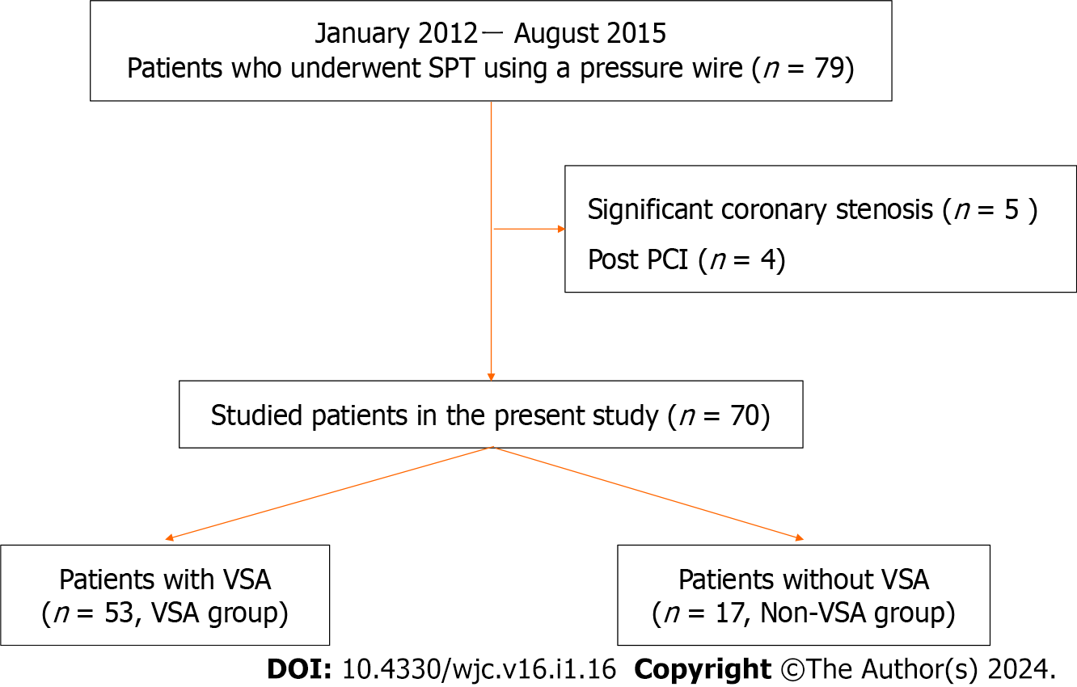
Figure 1 Flowchart of the present study. PCI: Percutaneous coronary intervention; SPT: Spasm provocation test; VSA: Vasospastic angina.

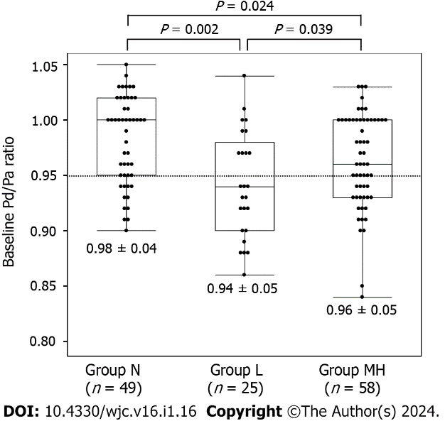
Figure 2 The distal pressure/aortic pressure ratio at baseline in lesions with no coronary spasm in response to spasm provocation test (group N), lesions in which coronary spasm was induced by a low dose of acetylcholine (group L), and lesions in which coronary spasm was induced by a moderate or high-dose acetylcholine (group MH). This value was lower in group L than in groups MH and N. ACh: Acetylcholine; Pa: Aortic pressure; Pd: Distal pressure; SPT: Spasm provocation test.

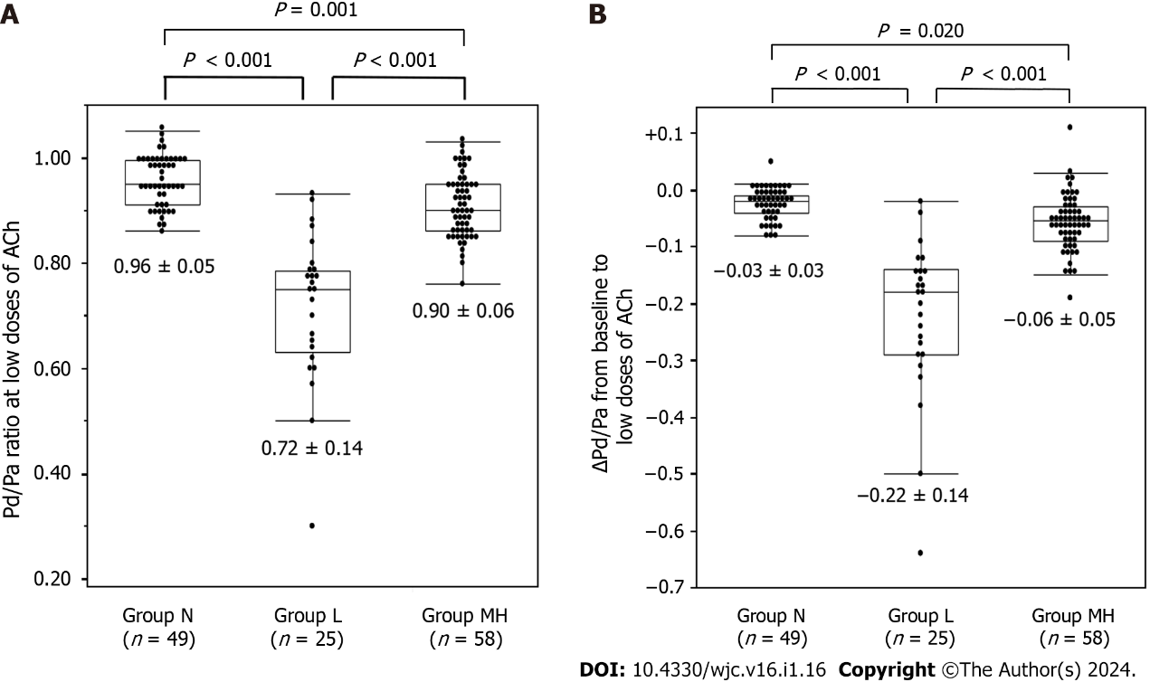
Figure 3 The distal pressure/aortic pressure ratio at low doses of acetylcholine and ΔPd/Pa between baseline and low doses of acetylcholine in the three coronary spasm groups. A: Shows distal pressure/aortic pressure (Pd/Pa) at low doses of acetylcholine (ACh). The value was lowest in group L and highest in group N; B: Shows the ΔPd/Pa between baseline and low doses of ACh. This value was also lowest in group L and highest in group N. ACh: Acetylcholine; Pa: Aortic pressure; Pd: Distal pressure.

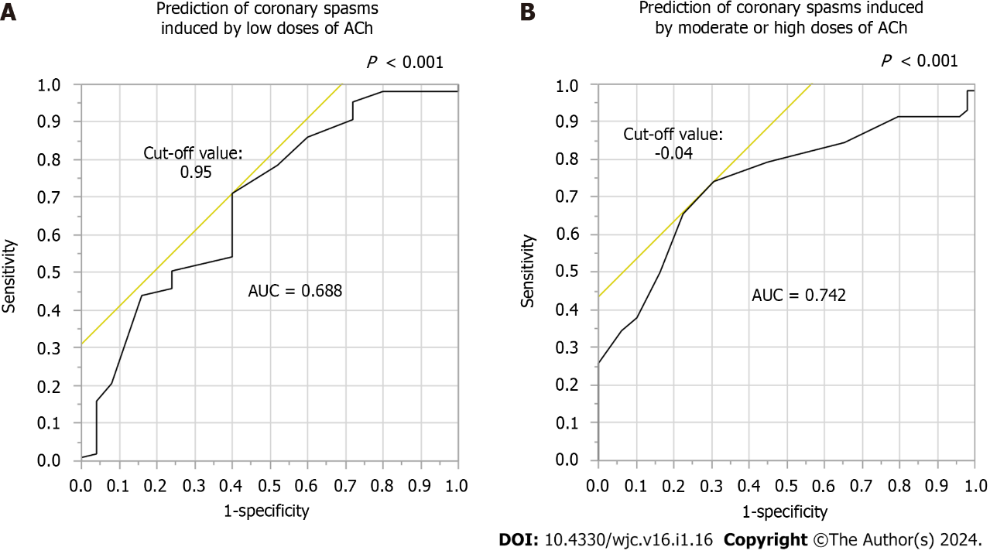
Figure 4 The results of a receiver-operating characteristics analysis of the data from this study. A: Shows the cutoff value of the distal pressure/aortic pressure (Pd/Pa) ratio at baseline for the prediction of coronary spasms induced by low doses of acetylcholine (ACh); B: Shows the cutoff value of the ΔPd/Pa between baseline and low-doses ACh. ACh: Acetylcholine; Pa: Aortic pressure; Pd: Distal pressure; ROC: Receiver-operating characteristics; AUC: Area under the curve.

Table 1 Patients’ characteristics
 | Non-VSA | VSA | P value
n (%) | 17 (24) | 53 (18)
Age (yr) | 68 ± 10 | 68 ± 9 | 0.775
Male/Female | 3/14 | 33/20 | 0.001
Body mass index | 24.4 ± 4.1 | 24.5 ± 3.8 | 0.914
Coronary risk factors (%)
Smoking (active/former/never) | 2/2/13 | 11/16/26 | 0.134
Hypertension | 14 (82) | 39 (74) | 0.463
Dyslipidemia | 11 (65) | 32 (60) | 0.750
Diabetes mellitus | 4 (24) | 18 (34) | 0.420
Alcohol consumer (%) | 10 (13) | 5 (29) | 0.09
Family history of CAD (%) | 4 (24) | 14 (26) | 0.813
CKD (%) | 7 (41) | 17 (32) | 0.492
LVEF on UCG (%) | 69 ± 7 | 66 ± 9 | 0.200
Brachial artery ultrasonography (n) | 14 | 48
Brachial artery diameter at baseline (mm) | 3.8 ± 0.8 | 3.9 ± 0.7 | 0.711
FMD (%) | 6.2 ± 4.8 | 3.0 ± 3.6 | 0.008
NID (%) | 17.7 ± 7.7 | 13.6 ± 6.9 | 0.061
Medications
Any kind of coronary vasodilator (%) | 13 (76) | 23 (43) | 0.018
No. of coronary vasodilators | 1 (0.5, 1) | 0 (0, 1) | 0.059
Beta-receptor blockers (%) | 1 (6) | 4 (8) | 0.817
RAS inhibitors (%) | 7 (41) | 12 (23) | 0.135
Lipid-lowering drugs (%) | 4 (41) | 17 (32) | 0.492
Anti-platelet drugs (%) | 4 (24) | 18 (34) | 0.420
CAD: Coronary artery disease; CKD: Chronic kidney disease; FMD: Flow-mediated dilation; LVEF: Left ventricular ejection fraction; NID: Nitroglycerin-induced dilation; RAS: Renin-angiotensin system; UCG: Cardiac ultrasonography; VSA: Vasospastic angina.

Table 2 Characteristics of lesions based on the occurrence of coronary spasms during spasm provocation tests and the dose of acetylcholine
 | Group N | Group L | Group MH | P value
n | 49 | 25 | 58
RCA/LAD | 27/22 | 9/16 | 27/31 | 0.290
Atherosclerosis (%) | 23 (47) | 9 (36) | 28 (48) | 0.568
Unavoidable use of NTG | 4 (8) | 3 (12) | 5 (9) | 0.851
Coronary spasm
Focal/diffuse |  | 8/17 | 14/44
Proximal/mid/distal |  | 4/15/6 | 5/35/18
iFR | 0.98 ± 0.04 | 0.92 ± 0.09 | 0.98 ± 0.06 | 0.104
n | 15 | 5 | 11
Pd/Pa
Baseline | 0.98 ± 0.04 | 0.94 ± 0.05 | 0.96 ± 0.05 | 0.001
Low dose of ACh | 0.96 ± 0.05 | 0.72 ± 0.14 | 0.90 ± 0.06 | < 0.001
ΔPd/Pa (Low dose-baseline) | −0.03 ± 0.03 | −0.22 ± 0.14 | −0.06 ± 0.05 | < 0.001
Moderate-high doses of ACh | 0.93 ± 0.06 |  | 0.78 ± 0.13 | < 0.001
FFR | 1.01 | 0.81 ± 0.09 | 0.87 ± 0.09 | 0.093
n | 1 | 6 | 13
Coronary arteries with coronary spasms at low doses of Acetylcholine (Ach) were defined as group L, and those with coronary spasms at moderate or high doses were defined as group MH. Those who did not occur coronary spasms at any ACh dose were designated as group N. ACh: Acetylcholine; FFR: Fractional flow reserve; iFR: Instantaneous free-wave ratio; LAD: Left anterior descending coronary artery; NTG: Nitroglycerin; Pa: Aortic pressure; Pd: Distal pressure; RCA: Right coronary artery.

Published by Baishideng Publishing Group Inc
7041 Koll Center Parkway, Suite 160, Pleasanton, CA 94566, USA
Telephone: +1-925-3991568
E-mail: office@baishideng.com
Help Desk: https://www.f6publishing.com/helpdesk
https://www.wjgnet.com

© 2024 Baishideng Publishing Group Inc. All rights reserved.

