Name of journal: World Journal of Gastroenterology
ESPS Manuscript NO: 11523
Columns: RETROSPECTIVE STUDY

Prognostic implications of estrogen receptor1 and vascular endothelial growth factor A in primary gallbladder carcinoma

Zhang LQ et al. ER1 and VEGF-A in GBC prognosis

Ling-Qiang Zhang, Xin-Sen Xu, Yong Wan, Si-Dong Song, Wei Chen, Zhi-Xin Wang, Hu-Lin Chang, Ji-Chao Wei, Ya-Feng Dong, Chang Liu

Ling-Qiang Zhang, Xin-Sen Xu, Yong Wan, Si-Dong Song, Wei Chen, Zhi-Xin Wang, Hu-Lin Chang, Ji-Chao Wei, Chang Liu, Department of Hepatobiliary Surgery, The First Affiliated Hospital of Medical College, Xi'an Jiaotong University, Xi’an 710061, Shaanxi Province, China

Ya-Feng Dong, Department of Obstetrics and Gynecology, University of Kansas School of Medicine, KS 66160, United States

Author contributions: Zhang LQ and Xu XS contributed equally to this work; Zhang LQ and Xu XS performed the immunohistochemistry experiments and writing of the paper; Wan Y and Song SD performed data collection and analysis; Chen W took part in data collection; Wang ZX performed data analysis; Chang HL and Wei JC participated in literature searches; Dong YF participated in revising of the paper; Liu C participated in research design.

Supported by National Natural Science Foundation of China, No. 81272644 and No. 81201549

Correspondence to: Chang Liu, MD, PHD, Department of Hepatobilciary Surgery, The First Affiliated Hospital of Medical College, Xi'an Jiaotong University, No.28, Xianning West Road, Xi’an 710061, Shaanxi Province, China. liuchangdoctor@163.com

Telephone: +86-29-85323900 Fax: +86-29-82654746
Received: May 26, 2014 Revised: July 6, 2014
Accepted: September 5, 2014

Published online:

Abstract
AIM: To investigate the prognostic significance of estrogen receptor1 (ER1) and vascular endothelial growth factor A (VEGF-A) in primary gallbladder carcinoma (GBC) patients after surgery, so as to identify new prognostic markers for GBC.

METHODS: By immunohistochemistry methods, we investigated the ER1 and VEGF-A expressions in 78 GBC and 78 cholelithiasis (CS) tissues. The results were implicated with clinic-pathological features. Univariate and multivariate analysis were performed to evaluate the relationship between ER1 and VEGF-A expressions and patients’ prognosis. Further Kaplan-Meier survival analysis was also performed.

RESULTS: ER1 and VEGF-A were higher expressed in the GBC compared with CS (47/78 vs 28/78, P < 0.05; 51/78 vs 33/78, P < 0.05). ER1 expression was correlated with gender (P < 0.05) and VEGF-A expression was correlated with tumor differentiation in GBC patients (P < 0.05). In univariate analysis, age and tumor node metastasis (TNM) stage were factors associated with GBC prognosis (P < 0.05). Although there was no statistical difference between the expressions of ER1 and VEGF-A and overall survival, the high expressions of ER1 combined with VEGF-A predicted a poor prognosis for GBC patients (16.30 ± 1.87 vs 24.97 ± 2.09, log-rank P < 0.05). In multivariate analysis, ER1 combined with VEGF-A, TNM stage were independent prognostic factors for GBC patients (P < 0.05).

CONCLUSION: ER1 combined with VEGF-A is potential prognostic marker for GBC patients. Clinical detections of ER1 and VEGF-A in surgically resected GBC tissues would provide important reference for decision-making of postoperative treatment programs.

© 2014 Baishideng Publishing Group Inc. All rights reserved.

Key words: Gallbladder carcinoma; Estrogen recptor1; Vascular endothelial growth factor A

Core tip: Gallbladder carcinoma (GBC) is a serious threat to public health for its poor prognosis. The authors found that estrogen receptor 1 (ER1) and vascular endothelial growth factor A (VEGF-A) were higher expressed in GBC than cholelithiasis tissues, and high expression of ER1 combined with VEGF-A conferred a poor prognosis in GBC patients after surgery. ER1 combined with VEGF-A was an independent factor associated with GBC prognosis. As potential prognostic marker, clinical detections for ER1 and VEGF-A may guide postoperative clinical treatment of GBC patients.

Zhang LQ, Xu XS, Wan Y, Song SD, Chen W, Wang ZX, Chang HL, Wei JC, Dong YF, Liu C. Prognostic implications of estrogen receptor1 and vascular endothelial growth factor A in primary gallbladder carcinoma. World J Gastroenterol 2014; In press

INTRODUCTION
Primary gallbladder carcinoma (GBC), originated from bile duct epithelium, is characterized by poor prognosis^{[1,2]}. Most of GBC patients were asymptomatic until the disease has progressed to an advanced and non-curative stage. According to epidemic investigations, the 5-year survival rate for GBC patients was less than 10%, with the overall mean survival time of 6 months. In clinic, the tumor node metastasis (TNM) staging system sometimes could not predict GBC patients’ prognosis accurately. In spite of this, except for TNM staging system, there were no other molecular markers available to facilitate the evaluation of GBC prognosis. Therefore, it is imperative to explore new predictive factors to guide the postoperative treatments for GBC patients.
Due to the female predominance in GBC incidence, it is speculated that estrogen may play important roles in the genesis and progress of GBC^{[3-5]}. Estrogen execute its biological functions by binding with estrogen receptors (ER), and a number of studies have reported that ER was associated with carcinogenesis^{[6-10]}. ER includes two subtypes, ER1 (or ER-α) and ER2 (or ER-β). In spite of similar molecular structure, ER1 and ER2 exhibited an antagonistic effect in some biological processes. As far as our knowledge, ER1 is able to promote tumor development and indicates poor prognosis, while ER2 usually suppress tumor progression and prefigures good survival^{[11-13]}. Therefore, some researchers assumed that ER1 possibly keep a subtle balance with ER2 in normal conditions^{[14]}. Sumi et al^{[13]} have reported the relationship between ER2 and GBC prognosis. However, although ER1 has been detected in GBC samples, the clinical significance is still equivocal.
Angiogenesis is essential for cancer growth, invasion and metastasis. It is well-known that vascular endothelial growth factor (VEGF) is a potent vascular active molecule which directly stimulate the proliferation of vascular endothelial cells^{[15]}. Accumulated evidences suggested that VEGF plays important roles in many kinds of tumors by inducing neoangiogenesis. In human cholangiocarcinoma, VEGF-A was positive expression, and was considered to mediate the proliferative effects of estrogen^{[16]}. Similar to other tumors, adequate blood supply and sufficiant angiogenesis are fundamental requirements for the growth of GBC. In GBC, the VEGF-A single nucleotide polymorphisms were implicated with GBC risk^{[17]}. There was also investigations indicated that VEGF-A was highly expressed in GBC and was correlated with a poor prognosis^{[18]}. Nevertheless, Giatromanolaki et al^{[19]} reported that VEGF was not associated with GBC patient survival, yet both VEGF and thymidine phosphorylase (TP) expression were considered as unfavorable prognostic factors. Therefore, it is still controversial in regards of the prognostic significance of VEGF in GBC.
ER1 and VEGF-A play important roles in GBC. Estrogen can modulate VEGF expression^{[20-23]}. However, there was no relevant reports about the prognostic significance of ER1 and VEGF-A in GBC. Hence, we decided to investigate the expression status of ER1 and VEGF-A in resected human GBC tissues, and to evaluate the prognostic values in GBC.

MATERIALS AND METHODS
Tissue specimens
In the present study, tissue specimens were collected from 156 consecutive patients who had undergone surgical resection of GBC at the First Affiliated Hospital of Medical College, Xi'an Jiaotong University (Xi'an, China) between October 2009 and October 2010: 78 patients with GBC confirmed by postoperative pathological diagnosis, and 78 patients with cholelithiasis (CS) underwent cholecystectomy. None of them received any preoperative radiochemotherapy. The two groups were matched in age and gender. The clinic-pathological information was obtained from the hospital’s medical records. The following data of each patient was included: age, gender, gallstone status, tumor differentiation, TNM (tumor, lymph nodes, and metastases) stage. All GBC patients were closely followed-up after surgery ranged from 4 to 53 months, and we defined that GBC patient’s death was the only positive outcome in our study.

Immunohistochemistry process
Immunohistochemistry-streptavidin-peroxidase (SP) method was performed using rabbit polyclonal antibody to ER1 and VEGF-A obtained from Santa Cruz Biotechnology to detect the expression of ER1 and VEGF-A in GBC and CS tissues. The whole process was described briefly as following: formalin-fixed and paraffin-embedded specimens were cut into 4 μm sections, mounted onto slides treated with poly-L-lysine, deparaffinized, and rehydrated; the slides were heated at 96-98 ˚C in a microwave for 15 min in a citrate buffer solution at pH 6.0 and cooled for 30 min in room temperature to retrieve antigen. To quench the endogenous peroxidase activity, sections were dealt with 0.3% H₂O₂ for 30 min. Subsequently, the sections were treated with 5% normal goat serum in phosphate-buffered saline for 1 h to block nonspecific sites. All sections in a humidified box were incubated overnight at 4 ˚C with specific antibodies detecting ER1 and VEGF-A, and then incubated with biotinylated antirabbit IgG and avidin-biotin-peroxidase complex, respectively. Finally, antibody binding was visualized by exposure to diaminobenzidine (DAB). Then，hematoxylin was used to weakly counterstain sections. And then, the sections were dehydrated in graded alcohol and cleared in transparent solution of xylene in turn. Finally, all sections were mounted with neutral gum.

Immunohistochemical assess of ER1 and VEGF-A
According to previous literatures^{[18,24,25]}, semiquantitative manner was used to evaluate the staining of ER1 and VEGF-A. All of the sections were assessed by two separate investigators in a blind manner under a transmission light microscope. We assessed both the intensity of staining (IS) and the percentage of positive staining (PS) cells. The IS was scored as 0 (absent), l (weak), 2 (moderate), and 3 (strong). The percentage of tissues PS was scored as 0 (none), 1 (1% to 25%), 2 (26% to 50%), 3 (51% to 75%), and 4 (76% to 100%). 5 fields per case and 100 tumor cells per × 40 field were examined. The mean value obtained was the final score for each case. A final score (FS) was calculated using the formula: FS = IS + PS. Finally, all the sections were defined as “low” expression with FS 0-4 or “high” expression with FS 5-7 for assessment of ER1 and VFGF-A staining. The typical histology of each histological scores used in this study was shown in Figure 1.

Statistical analysis
Fisher’s exact test or Chi-square test as appropriate was performed to assess the associations between the ER1 and VEGF-A expressions and clinic-pathological variables. Kaplan and Meier method were used to plot survival curves, and the log-rank test was used to determine statistical differences. Multivariate analysis was performed using Cox proportional hazard model. P value less than 0.05 was considered statistically significant. All statistical analysis was based on SPSS 13.0 program.

RESULTS
ER1 and VEGF-A are higher expressed in GBC tissues compared with CS tissues
The expression status of ER1 and VEGF-A were shown in Figure 2. VEGF-A was expressed in cytoplasmic compartment, and ER1 was expressed in cell nucleus. The expression of ER1 and VEGF-A were both significantly higher in GBC compared with CS (Table 1). Higher ER1 expression was observed in more GBC (47/78, 60.3%) than in CS (28/78, 35.9%) (P = 0.002). Similarly, higher expression of VEGF-A was observed in more GBC (51/78, 65.4%) than CS (33/78, 42.3%) (P = 0.004). In GBC patients, there was no statistical significance between the histological scores of ER1 and VEGF-A (r = 0.176, P = 0.124).

Relationship between the expressions of ER1 and VEGF-A and clinic-pathological GBC features
ER1 expression was associated with gender. ER1 expression was more frequent in female than male (P = 0.022). In addition, VEGF-A expression was correlated with tumor differentiation (P = 0.01). No other significant difference was found between the expression of ER1 and VEGF-A with clinic-pathological factors (Table 2).

Expressions of ER1 and VEGF-A and GBC prognosis
By univariate analysis (Table 3), age and TNM stage were associated with GBC prognosis (P < 0.05). Patients with GBC in stage 2 have a better survival than stage 3 and stage 4 (Figure 3A). Although there was no statistical difference between ER1 and VEGF-A expression status and GBC prognosis, respectively (Figure 3B and 3C, P > 0.05), the expression of ER1 combined with VEGF-A was correlated with postoperative survival of GBC patients (Figures 3D and 4, P < 0.05). GBC patients with simultaneously high expressions of ER1 and VEGF-A have a poorer prognosis. By multivariate analysis, TNM stage, ER1 combined with VEGF-A expression were identified as independent prognostic factors (P < 0.05) (Table 4). There was no statistical significance between ER1 and VEGF-A expression and GBC recurrence (P > 0.05).

DISCUSSION
The present study examined the expression status of ER1 and VEGF-A in resected human GBC and CS tissues. The main findings are following aspects: (1) ER1 and VEGF-A expressions were both higher expressed in GBC than CS tissues; ER1 level was implicated with gender, and VEGF-A expression was associated with tumor differentiation; and (2) high expression of ER1 combined with VEGF-A in GBC predicted a poor prognosis. This is the first time to report prognostic significance of ER1 combined with VEGF-A in GBC.
GBC’s poor prognosis caused wide public attentions. Despite of rapid improvement in medical technology in past decades, the survival time of GBC patients are far from satisfactory. Based on lots of clinical and molecular investigations about GBC, we speculated that the dismal prognosis of GBC patients may be attributed to the following aspects: (1) early diagnosis is difficult and most GBC patients are confirmed at an advanced stage, so as to lose the best surgical chances; (2) In respect of treatment options, GBC is relatively resistant to chemotherapy and radiation; apart from surgical resection, lack other effective measures; and (3) Postoperative therapy for GBC patients should be selected according to patients’ prognosis. Despite a number of studies have been conducted about GBC molecular mechanisms, there were no effective prognostic biomarkers for GBC to guide postoperative treatment. The present study exhibited that ER1 combined VEGF-A were associated with GBC prognosis, and would favor postoperative treatment.
ER1 has been investigated in several tumors as a promising factor. In ER-negative breast cancer, ER1 expression was necessary and sufficient in the bone marrow-derived cells themselves to promote tumor formation in response to estrogen^{[12]}. In biliary tract cancers (including tumors of the gallbladder, bile duct and ampulla of Vater), the single nucleotide polymorphisms of gene coding ER1 were correlated with risks of these tumors^{[26]}. In our study, the results showed that ER1 was higher expressed in GBC compared with CS. This indicated that ER1 probably play an important role in GBC, despite that the exact mechanisms are unclear at present. In addition, ER1 expression in GBC tissue exhibited a female predominance. It is well known that the overall level of estrogen in female is obviously higher than male. So, it is likely that estrogen induced the ER overexpression in female. In the meanwhile, our findings may partially explain why GBC is more frequent in female. Nevertheless, there was no statistical difference between ER1 expression and postoperative survival.
VEGF-A, a classic biological molecule in the angiogenesis, has been investigated in various kinds of cancers. In human intra-hepatic cholangiocarcinoma, VEGF-A mediated the proliferative effect of estrogen to promote cholangiocarcinoma growth^{[16]}. As to VEGF-A and GBC，there have been many literature reports^{[17,18,24,25]}. Recently, there was a report revealed that VEGF-A was highly expressed in GBC and correlated with poor prognosis^{[18]}. Additionally, there was another report showed that VEGF-A expression in GBC tissues is correlated with histologic differentiation and is independent prognostic factor^{[24]}. Our results were inconsistent with these previous investigations. Nevertheless, of note in our results, the high expression of ER1 combined with VEGF-A in GBC tissues predicted a poor prognosis. Based on this finding, we speculated that there were potentially synergistic effects between VEGF-A and ER1 in GBC progress. From perspective of biological significance, the assumption is possible. Estrogen binding with ER can promote production of VEGF as mentioned before. Increasing VEGF can induce the angiogenesis to provide plenty of oxygen and nutrients, and then promote GBC growth, invasion and metastasis, and finally lead to a poor survival. Of course, this assumption needs to be confirmed through further investigations.
Some limitations should be taken into account. Firstly, the sample size of this study is small. Secondly, our study is not deep, and very little information is about molecular mechanisms.
In conclusion, our study suggested that ER1 combined with VEGF-A confers a particularly poor post-operative survival outcome, and represents potential prognostic biomarker for GBC. Clinical detections for ER1 and VEGF-A in surgically resected GBC tissues may provide reference for decision-making of postoperative treatment programs. GBC patients，once have high expressions of ER1 and VEGF-A, deserve a close surveillance to reduce postoperative mortality.

Prospect
Although ER1 and VEGF-A have been considered to be involved in many kinds of tumor progress, the roles of ER1 and VEGF-A in GBC development has not been reported. Further investigations to explore the potential roles of ER1 and VEGF-A in GBC progress is meaningful for clarifying the molecular mechanism of GBC. In addition, ER1 combined VEGF-A may represent potential therapeutic targets and adjuvant endocrine therapy may be new approaches for GBC.

COMMENTS
Background
Primary gallbladder carcinoma (GBC) is characterized by poor prognosis. In clinic, there was no effective biomarker to predict the prognosis of GBC patients. Estrogen receptor1 (ER1) and vascular endothelial growth factor A (VEGF-A) are involved in several kinds of malignancies. However, the prognostic significance of ER1 and VEGF-A in GBC are controversial, and need further to be confirmed.

Research frontiers
According to epidemiology, the 5-year postoperative survival of GBC patients is less than 10%. Therefore, it is a current hotspot that exploring effective prognostic markers to guide postoperative treatment for GBC patients so as to improve survival after surgery.

Applications
Clinical detections of ER1 and VEGF-A expressions can predict prognosis of GBC patients, and provide references for making-decision of postoperative treatment programs. In addition, the identification of ER1 and VEGF-A expressions in human GBC tissues would help to investigate deeply into molecular mechanisms of GBC.

Terminology
ER1 also named estrogen receptor alpha, a kind of ligand-regulated transcription factor, mediated biological actions of estrogen. ER1 is implicated in several kinds of tumors. VEGF-A (vascular endothelial growth factor A), can promote physiological and pathological angiogenesis, and is believed to play an important role in various tumors.

Peer review
The authors reported that ER1 combined with VEGF-A assessed by immunohistochemistry was potential prognostic marker for GBC patients after surgery. Their findings were useful for the postoperative clinical treatment of GBC patients.

REFERENCES
1 Lazcano-Ponce EC, Miquel JF, Muñoz N, Herrero R, Ferrecio C, Wistuba II, Alonso de Ruiz P, Aristi Urista G, Nervi F. Epidemiology and molecular pathology of gallbladder cancer. CA Cancer J Clin 2001; 51: 349-364 [PMID: 11760569 DOI: 10.3322/canjclin.51.6.349]
2 Boutros C, Gary M, Baldwin K, Somasundar P. Gallbladder cancer: past, present and an uncertain future. Surg Oncol 2012; 21: e183-e191 [PMID: 23025910 DOI: 10.1016/j.suronc.2012.08.002]
3 Alvaro D, Alpini G, Onori P, Perego L, Svegliata Baroni G, Franchitto A, Baiocchi L, Glaser SS, Le Sage G, Folli F, Gaudio E. Estrogens stimulate proliferation of intrahepatic biliary epithelium in rats. Gastroenterology 2000; 119: 1681-1691 [PMID: 11113090]
4 Alvaro D, Onori P, Metalli VD, Svegliati-Baroni G, Folli F, Franchitto A, Alpini G, Mancino MG, Attili AF, Gaudio E. Intracellular pathways mediating estrogen-induced cholangiocyte proliferation in the rat. Hepatology 2002; 36: 297-304 [PMID: 12143037 DOI: 10.1053/jhep.2002.34741]
5 DeMorrow S. Cholangiocarcinoma: estrogen-induced autocrine effects of VEGF on cell proliferation. Dig Liver Dis 2009; 41: 164-165 [PMID: 19112054 DOI: 10.1016/j.dld.2008.11.005]
6 Sica V, Nola E, Contieri E, Bova R, Masucci MT, Medici N, Petrillo A, Weisz A, Molinari AM, Puca GA. Estradiol and progesterone receptors in malignant gastrointestinal tumors. Cancer Res 1984; 44: 4670-4674 [PMID: 6467220]
7 Dunnwald LK, Rossing MA, Li CI. Hormone receptor status, tumor characteristics, and prognosis: a prospective cohort of breast cancer patients. Breast Cancer Res 2007; 9: R6 [PMID: 17239243 DOI: 10.1186/bcr1639]
8 Fisher RI, Neifeld JP, Lippman ME. Oestrogen receptors in human malignant melanoma. Lancet 1976; 2: 337-339 [PMID: 60569]
9 Honma N, Horii R, Iwase T, Saji S, Younes M, Takubo K, Matsuura M, Ito Y, Akiyama F, Sakamoto G. Clinical importance of estrogen receptor-beta evaluation in breast cancer patients treated with adjuvant tamoxifen therapy. J Clin Oncol 2008; 26: 3727-3734 [PMID: 18669459 DOI: 10.1200/jco.2007.14.2968]
10 Park SK, Andreotti G, Sakoda LC, Gao YT, Rashid A, Chen J, Chen BE, Rosenberg PS, Shen MC, Wang BS, Han TQ, Zhang BH, Yeager M, Chanock S, Hsing AW. Variants in hormone-related genes and the risk of biliary tract cancers and stones: a population-based study in China. Carcinogenesis 2009; 30: 606-614 [PMID: 19168589 DOI: 10.1093/carcin/bgp024]
11 Liu MM, Albanese C, Anderson CM, Hilty K, Webb P, Uht RM, Price RH, Pestell RG, Kushner PJ. Opposing action of estrogen receptors alpha and beta on cyclin D1 gene expression. J Biol Chem 2002; 277: 24353-24360 [PMID: 11986316 DOI: 10.1074/jbc.M201829200]
12 Iyer V, Klebba I, McCready J, Arendt LM, Betancur-Boissel M, Wu MF, Zhang X, Lewis MT, Kuperwasser C. Estrogen promotes ER-negative tumor growth and angiogenesis through mobilization of bone marrow-derived monocytes. Cancer Res 2012; 72: 2705-2713 [PMID: 22467173 DOI: 10.1158/0008-5472.can-11-3287]
13 Sumi K, Matsuyama S, Kitajima Y, Miyazaki K. Loss of estrogen receptor beta expression at cancer front correlates with tumor progression and poor prognosis of gallbladder cancer. Oncol Rep 2004; 12: 979-984 [PMID: 15492781]
14 Matthews J, Gustafsson JA. Estrogen signaling: a subtle balance between ER alpha and ER beta. Mol Interv 2003; 3: 281-292 [PMID: 14993442 DOI: 10.1124/mi.3.5.281]
15 Ferrara N, Davis-Smyth T. The biology of vascular endothelial growth factor. Endocr Rev 1997; 18: 4-25 [PMID: 9034784 DOI: 10.1210/edrv.18.1.0287]
16 Mancino A, Mancino MG, Glaser SS, Alpini G, Bolognese A, Izzo L, Francis H, Onori P, Franchitto A, Ginanni-Corradini S, Gaudio E, Alvaro D. Estrogens stimulate the proliferation of human cholangiocarcinoma by inducing the expression and secretion of vascular endothelial growth factor. Dig Liver Dis 2009; 41: 156-163 [PMID: 18395502 DOI: 10.1016/j.dld.2008.02.015]
17 Mishra K, Behari A, Kapoor VK, Khan MS, Prakash S, Agrawal S. Vascular endothelial growth factor single-nucleotide polymorphism in gallbladder cancer. J Gastroenterol Hepatol 2013; 28: 1678-1685 [PMID: 23962084 DOI: 10.1111/jgh.12343]
18 Letelier P, Garcia P, Leal P, Ili C, Buchegger K, Riquelme I, Sandoval A, Tapia O, Roa JC. Immunohistochemical Expression of Vascular Endothelial Growth Factor A in Advanced Gallbladder Carcinoma. Appl Immunohistochem Mol Morphol 2013; Epub ahead of print [PMID: 24185122 DOI: 10.1097/PAI.0b013e3182a318a9]
19 Giatromanolaki A, Koukourakis MI, Simopoulos C, Polychronidis A, Sivridis E. Vascular endothelial growth factor (VEGF) expression in operable gallbladder carcinomas. Eur J Surg Oncol 2003; 29: 879-883 [PMID: 14624781]
20 Buteau-Lozano H, Ancelin M, Lardeux B, Milanini J, Perrot-Applanat M. Transcriptional regulation of vascular endothelial growth factor by estradiol and tamoxifen in breast cancer cells: a complex interplay between estrogen receptors alpha and beta. Cancer Res 2002; 62: 4977-4984 [PMID: 12208749]
21 Losordo DW, Isner JM. Estrogen and angiogenesis: A review. Arterioscler Thromb Vasc Biol 2001; 21: 6-12 [PMID: 11145928]
22 Hyder SM, Huang JC, Nawaz Z, Boettger-Tong H, Mäkelä S, Chiappetta C, Stancel GM. Regulation of vascular endothelial growth factor expression by estrogens and progestins. Environ Health Perspect 2000; 108 Suppl 5: 785-790 [PMID: 11035983]
23 Buteau-Lozano H, Velasco G, Cristofari M, Balaguer P, Perrot-Applanat M. Xenoestrogens modulate vascular endothelial growth factor secretion in breast cancer cells through an estrogen receptor-dependent mechanism. J Endocrinol 2008; 196: 399-412 [PMID: 18252963 DOI: 10.1677/joe-07-0198]
24 Sun XN, Cao WG, Wang X, Wang Q, Gu BX, Yang QC, Hu JB, Liu H, Zheng S. Prognostic impact of vascular endothelial growth factor-A expression in resected gallbladder carcinoma. Tumour Biol 2011; 32: 1183-1190 [PMID: 21853312 DOI: 10.1007/s13277-011-0221-2]
25 Alvarez H, Corvalan A, Roa JC, Argani P, Murillo F, Edwards J, Beaty R, Feldmann G, Hong SM, Mullendore M, Roa I, Ibañez L, Pimentel F, Diaz A, Riggins GJ, Maitra A. Serial analysis of gene expression identifies connective tissue growth factor expression as a prognostic biomarker in gallbladder cancer. Clin Cancer Res 2008; 14: 2631-2638 [PMID: 18451226 DOI: 10.1158/1078-0432.ccr-07-1991]
26 Park SK, Andreotti G, Rashid A, Chen J, Rosenberg PS, Yu K, Olsen J, Gao YT, Deng J, Sakoda LC, Zhang M, Shen MC, Wang BS, Han TQ, Zhang BH, Yeager M, Chanock SJ, Hsing AW. Polymorphisms of estrogen receptors and risk of biliary tract cancers and gallstones: a population-based study in Shanghai, China. Carcinogenesis 2010; 31: 842-846 [PMID: 20172949 DOI: 10.1093/carcin/bgq038]
P-Reviewer: Miyoshi E S-Editor: Ma YJ L-Editor: E-Editor:

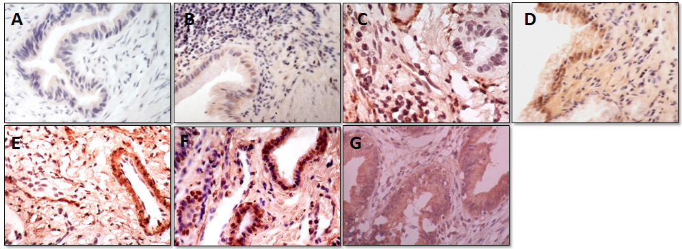
Figure 1 Typical histology of each histological scores. A, B, C, D, E, F, G, H was scored as 0, 2, 3, 4, 5, 6, 7, respectively.

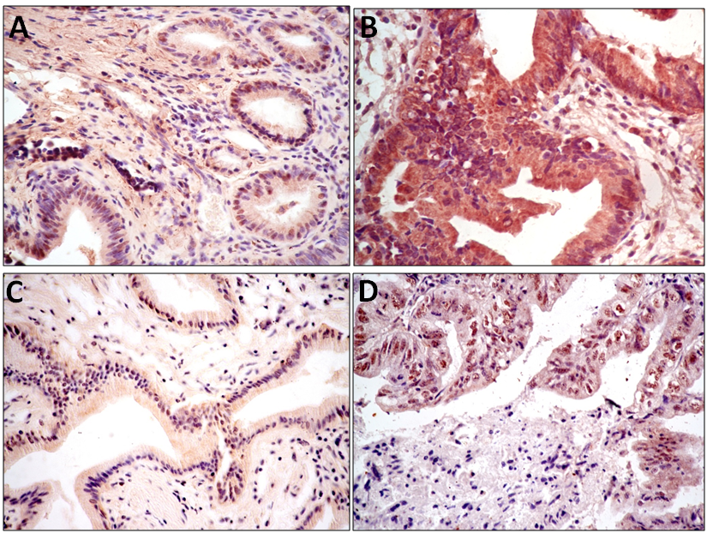
Figure 2 Immunohistochemical staining of estrogen receptor1 and vascular endothelial growth factor A expressions in gallbladder carcinoma and cholelithiasis specimens. A and B show expression status of vascular endothelial growth factor A (VEGF-A) (A: low VEGF-A expression in CS tissues; B: high VEGF-A expression in GBC tissues); C and D show estrogen receptor 1(ER1) expression status (C: low ER1 expression in CS tissues; D: high ER1 expression in GBC tissues).

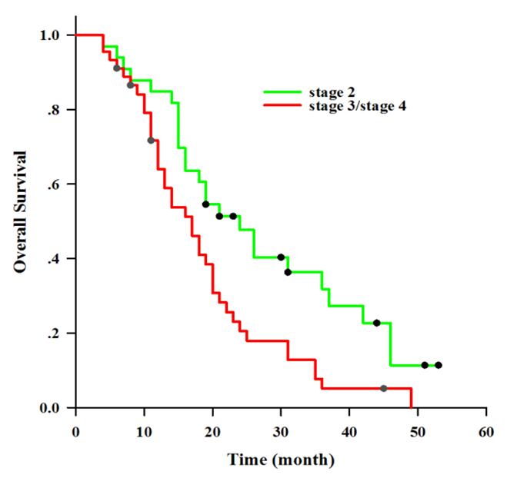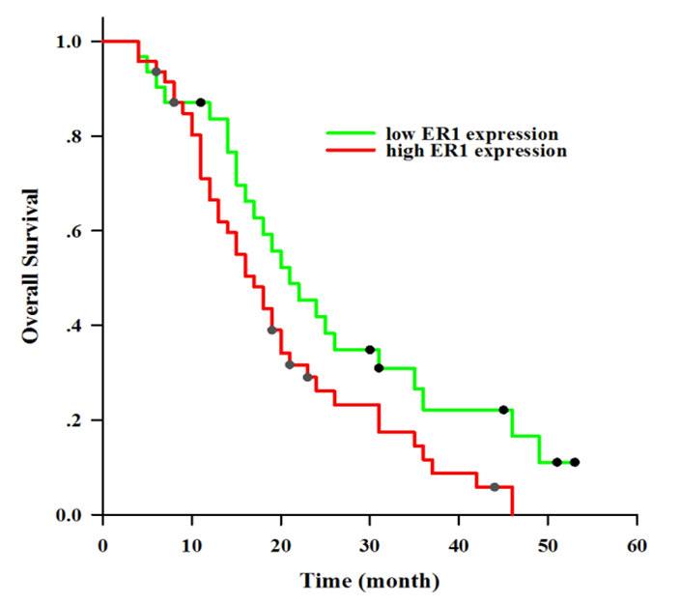
A B
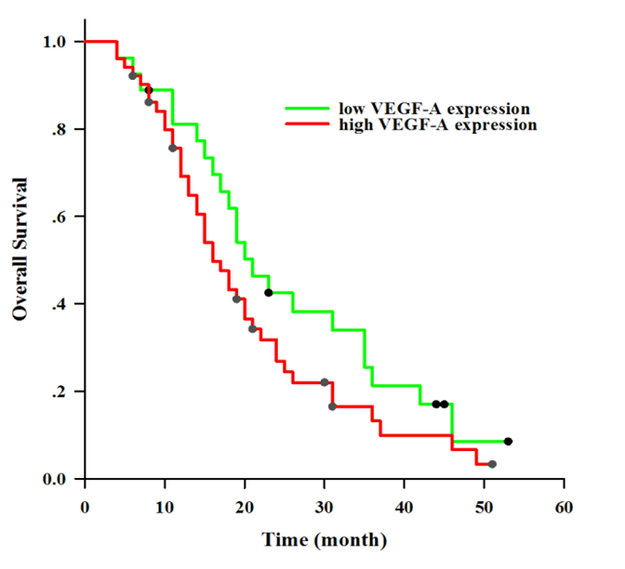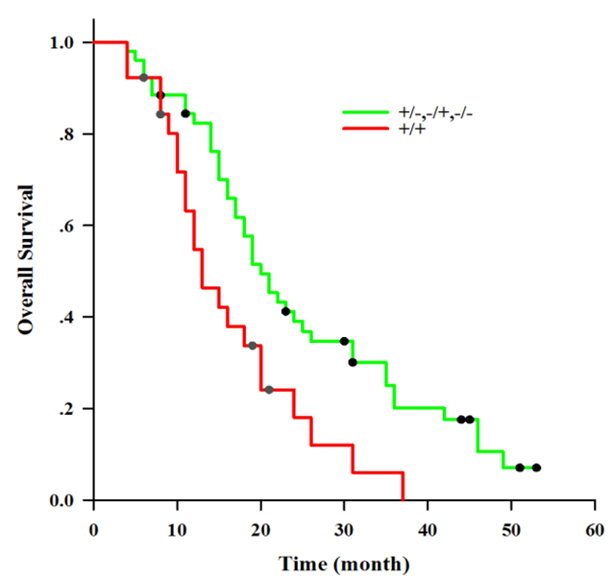
C D
Figure 3 Kaplan–Meier survival curves. A: stratified for estrogen receptor 1 expression status. Low estrogen receptor1 (ER1) expression has a better survival time than high ER1 expression, but there was no statistical significance between the two groups (P = 0.053); B: stratified for vascular endothelial growth factor A expression status. Low vascular endothelial growth factor A (VEGF-A) expression has a better survival time than high VEGF-A expression, but there was no statistical significance between two groups (P = 0.155); C: stratified for tumor node metastasis stage. Patients in stage 2 have a better prognosis than patients in stage 3 and stage 4 (P = 0.07); D: stratified for estrogen receptor and vascular endothelial growth factor A expressions. All patients were clarified into two groups: high expression of estrogen receptor1 (ER1) and vascular endothelial growth factor A (VEGF-A) group (+/+), and low expression of ER1 and VEGF-A group (+/-, -/+, -/-). Patients in high expression of ER1 and VEGF-A group have a worse prognosis than high expression of ER1 and VEGF-A group (P = 0.009). +/+: high ER1 expression and high VEGF-A expression; +/-: high ER1 expression and low VEGF-A expression; -/+: low ER1 expression and high VEGF-A expression; -/-: low ER1 expression and low VEGF-A expression.

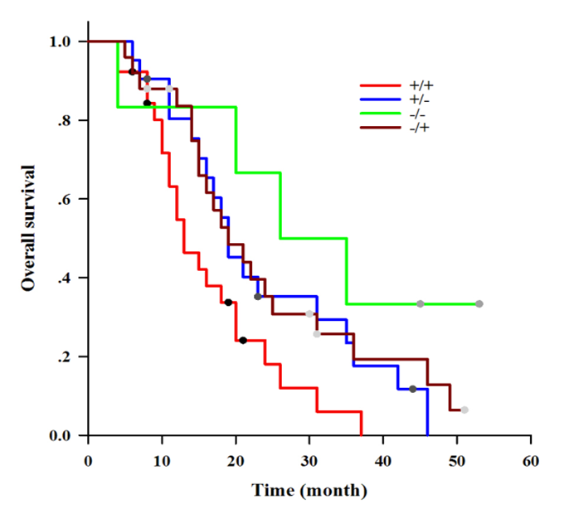
Figure 4 Kaplan–Meier survival curves stratified for estrogen receptor1 and vascular endothelial growth factor A expressions. Patients with high expression of estrogen receptor1 (ER1) combined with vascular endothelial growth factor A (VEGF-A) (+/+) have worst prognosis than other groups (+/-,-/+,-/-) (P = 0.007). +/+: high ER1 expression and high VEGF-A expression; +/-: high ER1 expression and low VEGF-A expression; -/+: low ER1 expression and high VEGF-A expression; -/-: low ER1 expression and low VEGF-A expression.

Table 1 Comparison of expressions of estrogen receptor1 and vascular endothelial growth factor A between gallbladder carcinoma and cholelithiasis
Group | ER1 expression |  | P value | VEGF-A expression |  | P value
 | High | Low |  | High | Low
GBC | 47 | 31 | 0.002 | 51 | 27 | 0.004
CS | 28 | 50 |  | 33 | 45
GBC: Gallbladder carcinoma; CS: Cholelithiasis; ER1: Estrogen receptor 1; VEGF-A: Vascular endothelial growth factor A.

Table 2 Association between estrogen receptor 1 and vascular endothelial growth factor A expressions and clinic-pathological characteristics of patients with gallbladder carcinoma
Characteristics | ER1 expression |  | P value | VEGF-A expression |  | P value
 | High | Low |  | High | Low
Gender |  |  | 0.022 |  |  | 0.099
Male | 15 | 18 |  | 25 | 8
Female | 32 | 13 |  | 26 | 19
Age |  |  | 0.151 |  |  | 0.095
≤ 55 | 18 | 17 |  | 23 | 12
> 55 | 29 | 14 |  | 28 | 15
Gallstone |  |  | 0.370 |  |  | 0.056
Present | 32 | 24 |  | 33 | 23
Absent | 15 | 7 |  | 18 | 4
TNM stage |  |  | 0.177 |  |  | 0.781
Ⅱ | 17 | 16 |  | 21 | 12
Ⅲ/Ⅳ | 30 | 15 |  | 30 | 15
Differentiation |  |  | 0.205 |  |  | 0.010
Well | 16 | 15 |  | 15 | 16
Moderately/Poor | 31 | 16 |  | 36 | 11
ER1: estrogen receptor 1; VEGF-A: vascular endothelial growth factor A; TNM: tumor node metastasis.

Table 3 Univariate analysis of prognostic factors associated with overall survival in patients with gallbladder carcinoma
Risk factor | Survival time(month) (mean ± SE) |  |  | P value (Log-rank test)
Gender |  |  | 0.682
Male |  | 23.24 ± 4.09
Female |  | 21.97 ± 1.72
Age(year) |  |  | 0.015
≤ 55 |  | 26.34 ± 2.71
> 55 |  | 18.77 ± 1.71
Gallstones |  |  | 0.068
Present |  | 17.69 ± 2.06
Absent |  | 23.96 ± 2.02
TNM stage |  |  | 0.007
Ⅱ |  | 27.16 ± 2.77
Ⅲ/Ⅳ |  | 18.59 ± 1.74
Differentiation |  |  | 0.685
Well |  | 23.19 ± 2.94
Moderately/Poor |  | 21.65 ± 1.86
ER1 level |  |  | 0.053
High |  | 19.81 ± 1.79
Low |  | 25.85 ± 2.86
VEGF-A level |  |  | 0.155
High |  | 20.35 ± 1.87
Low |  | 25.65 ± 2.86
ER1 combined VEGF-A level |  |  | 0.007
+/+ |  | 16.30 ± 1.87
+/-, -/+, -/- |  | 24.97 ± 2.09
ER1: Estrogen receptor 1; VEGF-A: Vascular endothelial growth factor A; TNM: Tumor node metastasis; +/+: High ER1 expression and high VEGF-A expression; +/-: High ER1 expression and low VEGF-A expression; -/+: Low ER1 expression and high VEGF-A expression; -/-: Low ER1 expression and low VEGF-A expression.

Table 4 Multivariate analysis of factors associated with survival in patients with gallbladder carcinoma
Items | Hazard ratio | 95% CI | P value
Age |  |  | 0.076
≤ 55 vs > 55 | 0.615 | 0.359-1.053
TNM stage |  |  | 0.031
Ⅲ/Ⅳ vs Ⅱ | 1.781 | 1.054-3.011
ER1 combined VEGF-A |  |  | 0.042
+/+ vs +/-, -/+, -/- | 1.773 | 1.021-3.080
ER1: Estrogen receptor 1; VEGF-A: Vascular endothelial growth facto; TNM: Tumor node metastasis; +/+: High ER1 expression and high VEGF-A expression; +/-: High ER1 expression and low VEGF-A expression; -/+: Low ER1 expression and high VEGF-A expression; -/-: Low ER1 expression and low VEGF-A expression.

