Name of Journal: World Journal of Gastrointestinal Oncology
Manuscript NO: 58329
Manuscript Type: CASE REPORT

Cutaneous metastases of pancreatic carcinoma to the labia majora: A case report and review of literature

Shi et al. Metastases of carcinoma to labia majora

Ying Shi, Shan-Shan Li, Dan-Yan Liu, Yan Yu

Ying Shi, Yan Yu, Department of Dermatology, First Hospital of Jilin University, Changchun 130021, Jilin Province, China

Shan-Shan Li, Department of Dermatology and Venereology, First Hospital of Jilin University, Changchun 130021, Jilin Province, China

Dan-Yan Liu, Department of Radiology, First Hospital of Jilin University, Changchun 130021, Jilin Province, China

Author contributions: All authors contributed equally to this paper with the conception and design of the study, literature review and analysis, manuscript drafting, critical revision, and editing, and approval of the final version.

Corresponding author: Yan Yu, MD, Chief Doctor, Department of Dermatology, First Hospital of Jilin University, No. 71 Xinmin Street, Changchun 130021, Jilin Province, China. yuyan741206@126.com

Received: August 12, 2020
Revised: September 29, 2020
Accepted: October 19, 2020
Published online:

Abstract
BACKGROUND
Cutaneous metastases originating from pancreatic cancer are relatively rare. The most common reported site of metastasis is the umbilicus, and this manifestation is known as the Sister Mary Joseph’s nodule. Non-umbilical cutaneous metastases are far less common, with only a few cases reported in the literature. Our case is the first case report, to our knowledge, on metastasis involving the labia majora and flat papules.

CASE SUMMARY
A 49-year-old Chinese female patient presented with a number of red, swollen papules on the vulva for 2 mo. Histological examination of the labia majora lesion revealed metastatic adenocarcinoma. The serum levels of tumor biomarkers CA199, CA242, and CA125 were significantly elevated. B-mode ultrasound-guided needle biopsy of the pancreas demonstrated moderately and poorly differentiated adenocarcinoma. The patient finally declined treatment for financial reasons and died 3 mo later.

CONCLUSION
Metastatic cutaneous lesions could indicate pancreatic cancer. Serum levels of tumor biomarkers may aid in diagnosing metastatic pancreatic adenocarcinoma.

Key Words: Pancreatic cancer; Cutaneous; Metastasis; Non-umbilical; Biomarker; Case report

Shi Y, Li SS, Liu DY, Yu Y. Cutaneous metastases of pancreatic carcinoma to the labia majora: A case report and review of literature. World J Gastrointest Oncol 2020; In press

Core Tip: Cutaneous metastasis from pancreatic cancer is uncommon. The most common site of the skin lesion is the umbilicus. The majority of skin lesions are singular, particularly in patients exhibiting the Sister Mary Joseph’s nodule. We describe an unusual case of flat papules on the labia majora that metastasized from pancreatic cancer. The lesion was the first sign of metastatic disease, and serum levels of CA199, CA242, and CA125 were also elevated. We report this case to improve the understanding of cutaneous metastasis of pancreatic cancer and emphasize the importance of serum levels of CA199, CA242, and CA125 in diagnosing pancreatic cancer.
INTRODUCTION
Pancreatic cancer is one of the most lethal human malignancies and is often diagnosed late in the course of the disease. Cutaneous metastases originating from pancreatic cancer are relatively rare. The most common reported site of metastasis is the umbilicus, and this manifestation is known as the Sister Mary Joseph’s nodule. Non-umbilical cutaneous metastases are far less common, with only a few cases reported in the literature. To our knowledge, there are no previous reports on metastasis involving the labia majora and flat papules. This report describes a case of cutaneous pancreatic metastases on the labia majora in a Chinese woman, and a review of previously reported non-umbilical cutaneous pancreatic carcinoma metastases (by conducting a detailed PubMed search). Furthermore, an analysis of 34 reported cases of non-umbilical cutaneous metastasis from pancreatic cancer was conducted with regard to the clinical characteristics.

CASE PRESENTATION
Chief complaints
A 49-year-old female patient with a number of red, swollen papules on the vulva for 2 mo was referred to our department.

History of present illness
The patient had developed red, swollen papules on the vulva 3 mo previously. She attended a local hospital, where she was diagnosed with contact dermatitis and took regular anti-allergy treatment. There was no obvious improvement in her symptoms. Erythema gradually affected the abdomen and lower extremities. The patient had experienced intermittent shortness of breath and coughed up white sputum during this period.

History of past illness
The patient had experienced hypertension for 2 years and had a history of sulfonamide allergy.

Personal and family history
There was not a personal or family history of pancreatic cancer.

Physical examination
Physical examination revealed diffuse erythema and swelling on the chest, abdomen, and vulva; right leg edema; and a number of flat skin-colored or gray papules on the labia majora (Figure 1).

Laboratory examinations
Routine laboratory testing revealed that the patient was human immunodeficiency virus (HIV) negative; the results of blood and urine tests and levels of renal and hepatic markers and antinuclear antibodies were within the normal ranges. There was a remarkable elevation in the serum concentrations of tumor markers, comprising cytokeratin 19 (8.98 g/L; normal: < 5 µg/L), CA242 (> 500 U/mL; normal: < 20 U/mL), CA125 (52.41 U/mL; normal: < 35 U/mL), and CA199 (726.54 U/mL; normal: < 37 U/mL).

Imaging examinations
An ultrasound scan showed bilateral mammary gland hyperplasia, no other gynecological abnormalities, and right leg lymphedema. A chest computerized tomography (CT) scan revealed inflammation, with patterns of interstitial change scattered across both lungs and a little pleural effusion in the left lung. An abdominal CT scan demonstrated many enlarged lymph nodes, associated with the abdominal aorta, bilateral iliac artery, and bilateral inguinal region, as well as changes in the pancreatic and peripancreatic morphology. A positron emission tomography (PET)-CT scan showed increased metabolic activity in the tail of the pancreas and multiple enlarged lymph nodes throughout the body, as well as subcutaneous tissue edema (Figure 2).

Further diagnostic work-up
A punch biopsy was performed on the abdomen and labia majora lesions. The abdominal epidermis was normal, and there were dilated small blood vessels and lymph vessels in the dermis, and small quantities of infiltrating lymphocytes. Histological examination of the labia majora papules showed nests of moderately differentiated atypical cells partly forming adenomatous structures in the collagen bundles of the dermis and lymphangiectasia (pathologic dilation of the lymph vessels) in the dermis (Figure 3). The immunohistochemical staining results (Figure 4) were as follows: CK7 (+), panCK (+), CK19 (+), CA19-9 (+), CDX-2 (+), CK20 (+), D2-40 (-), and P63 (-), which is consistent with a possible pancreatic source of the metastasis.
In addition, a large amount of milky fluid was drained from the skin biopsy sites. While the serum triglyceride level was normal, the level in the fluid was 1.55 mmol/L, indicating lymphocytosis. Neither bacteria (including Mycobacterium tuberculosis) nor fungi were found in the fluid. According to the laboratory and histopathologic findings, a diagnosis of chylous reflux fluid was made.
Thereafter, B-mode ultrasound-guided needle biopsy of the pancreas demonstrated moderately and poorly differentiated adenocarcinoma (Figure 5).

FINAL DIAGNOSIS
According to the clinical manifestations and histopathologic findings, a diagnosis of metastatic pancreatic carcinoma was established.

TREATMENT
The patient declined treatment for financial reasons.

OUTCOME AND FOLLOW-UP
The patient died 3 mo later.

DISCUSSION
Cutaneous metastases are rare, occurring in 0.7%-9.0% of all patients with cancer^{[1]}. Breast, lung, and colon cancer are the most frequent origins of cutaneous metastases.
Pancreatic cancer is one of the most lethal cancers, with a 5 year survival rate of 5%. Owing to a lack of early clinical features and the fulminant disease course, early diagnosis is difficult and the metastasis rate is high, with a median overall survival of 5 mo^{[2]}. Pancreatic cancer is often known to metastasize via the lymphatic system, with direct invasion at an early stage and hematogenous dissemination at a later stage. The incidence of cutaneous metastases is significantly more frequent for cancers of the pancreatic body and tail than for pancreatic head cancer^{[3]}.
The most frequent organs involved in the metastasis are the liver, peritoneum, lungs, bones, and brain^{[2]}. Indeed, only 2% of the first metastases from pancreatic cancer are cutaneous metastases, making cutaneous metastases relatively rare^{[4]}. The most common site of cutaneous metastasis from the pancreas is the umbilicus, and this manifestation is known as Sister Mary Joseph’s nodule^{[5]}. Horino et al^{[6]} reviewed 42 reported cases of pancreatic metastasis from 1950 to 2011, and included only 14 cases of non-umbilical cutaneous metastasis, involving the head, neck, and truncal region. The patients with pancreatic metastasis had such symptoms as subcutaneous nodules (in 26 patients) and inﬂammatory erythema (in 3 patients).
We collected all case reports of non-umbilical metastatic skin cancer from 1950 to 2020 on the electronic PubMed database (www.ncbi.nlm.nih.gov/pubmed; up to July 2020) by searching using Medical Subject Headings (www.nlm.nih. gov/mesh) and keywords, and by limiting the search to human studies (Table 1)^{[1-4,6-30]}. The terms pancreatic cancer, pancreatic neoplasm, pancreatic carcinoma, cutaneous metastasis, and skin metastasis were used. The abstracts were reviewed, and articles that were associated with umbilical metastasis were excluded. Duplicate references as well as repeated publications were discarded. All of the studies that were considered to be eligible were retrieved and the final selection was based on the full article.
Our case is unique in that the cutaneous pancreatic cancer metastases were found on the labia majora. Our patient had papules on the labia majora, with diffuse swelling on the skin of the chest, abdomen, and vulva. In addition, there was oozing of chyle from the skin biopsy sites.
Chyle originates in the bowel lacteals (lymphatic capillaries that absorb dietary fats), is absorbed by the intestinal lymphatic vessels, passes through the collecting lymphatic vessels into the intestinal trunk (truncus intestinalis), and then passes through the cisterna chyli and thoracic duct to the bloodstream. If the reflux is obstructed, chylous reflux occurs; the chyle flows backward or leaks into the serosal cavity, external genitalia, lower limbs, etc. Chylous reflux is divided into primary and secondary types. Secondary chylous reflux is usually caused by neoplasia, trauma, inflammation, or surgery^{[7]}. According to the PET-CT scan, the metastatic cancer cells may have traveled to the labia majora via the lymphatic pathways. The abnormal lymphatic system, caused by tumor metastasis, may have been the underlying cause for the backflow of chyle to the skin. The patient was advised to undergo lymphangiography to confirm this, but declined for financial reasons.
The serum levels of tumor biomarkers CA199, CA242, and CA125 were significantly elevated in our case. It has been shown that the sensitivity and specificity of CA199 for diagnosing pancreatic cancer are 77% and 88%, respectively. Ozkan et al^{[8]} revealed that CA242 was significantly increased in 75% of pancreatic cancer patients. To sum up, Mao et al^{[9]} suggested that assessment of the combination of CA199, CA242, CEA, and CA125 levels is a simple, noninvasive, and effective method for early diagnosis of pancreatic cancer.
We present a case of pancreatic adenocarcinoma metastasizing to the vulva, with a number of flat papules. This condition is extremely rare and easy to misdiagnose.

CONCLUSION
Cutaneous metastasis from pancreatic carcinoma is a rare finding and mostly occurs around the umbilicus. Subcutaneous nodules are the most common clinical manifestation. To our knowledge, we describe the first case of cutaneous pancreatic metastasis to the vulva, with a number of flat papules. Clinicians should be aware of the possibility of metastatic cutaneous lesions in pancreatic adenocarcinoma and screen for tumor markers as promptly as possible.

REFERENCES
1 Bdeiri K, Kamar FG. Cutaneous metastasis of pancreatic adenocarcinoma as a first clinical manifestation: a case report and review of the literature. Gastrointest Cancer Res 2013; 6: 61-63 [PMID: 23745161]
2 Zhou HY, Wang XB, Gao F, Bu B, Zhang S, Wang Z. Cutaneous metastasis from pancreatic cancer: A case report and systematic review of the literature. Oncol Lett 2014; 8: 2654-2660 [PMID: 25364444 DOI: 10.3892/ol.2014.2610]
3 Takeuchi H, Kawano T, Toda T, Minamisono Y, Nagasaki S, Yao T, Sugimachi K. Cutaneous metastasis from pancreatic adenocarcinoma: a case report and a review of the literature. Hepatogastroenterology 2003; 50: 275-277 [PMID: 12630040 DOI: 10.1016/j.fct.2008.12.023]
4 Taniguchi S, Hisa T, Hamada T. Cutaneous metastases of pancreatic carcinoma with unusual clinical features. J Am Acad Dermatol 1994; 31: 877-880 [PMID: 7525667 DOI: 10.1016/s0190-9622(94)70250-0]
5 Gabriele R, Conte M, Egidi F, Borghese M. Umbilical metastases: current viewpoint. World J Surg Oncol 2005; 3: 13 [PMID: 15723695 DOI: 10.1186/1477-7819-3-13]
6 Horino K, Takamori H, Ikuta Y, Nakahara O, Chikamoto A, Ishiko T, Beppu T, Baba H. Cutaneous metastases secondary to pancreatic cancer. World J Gastrointest Oncol 2012; 4: 176-180 [PMID: 22844548 DOI: 10.4251/wjgo.v4.i7.176]
7 Huang HY, Chiu WT. Primary chylous reflux presenting with vulvar vesicles. Arch Dermatol 2010; 146: 683-684 [PMID: 20566942 DOI: 10.1001/archdermatol.2010.122]
8 Ozkan H, Kaya M, Cengiz A. Comparison of tumor marker CA 242 with CA 19-9 and carcinoembryonic antigen (CEA) in pancreatic cancer. Hepatogastroenterology 2003; 50: 1669-1674 [PMID: 14571813 DOI: 10.1002/jcb.20532]
9 Mao QQ, Yan WL, Sun X, Hu Y, Zhong L. The value of serum CAl99,CA242 and CAl25 in the diagnosis and prognosis of pancreatic cancer. Biaoji Mianyi Fenxi Yu Linchunag Zazhi 2009; 16: 79-82 [DOI: 10.3969/j.issn.1006-1703.2009.02.006]
10 EDELSTEIN JM. Pancreatic carcinoma with unusual metastasis to the skin and subcutaneous tissue simulating cellulitis. N Engl J Med 1950; 242: 779-781 [PMID: 15416899 DOI: 10.1056/NEJM195005182422003]
11 Kotsantis I, Economopoulou P, Dritsakos K, Oikonomopoulos N, Bakogeorgos M, Rapti C, Kentepozidis N. Extensive cutaneous metastases of pancreatic adenocarcinoma: a case report and review of the literature. Clin Case Rep 2017; 5: 51-56 [PMID: 28096990 DOI: 10.1002/ccr3.737]
12 Sironi M, Radice F, Taccagni GL, Braga M, Zerbi M. Fine needle aspiration of a pancreatic oxyphilic carcinoma with pulmonary and subcutaneous metastases. Cytopathology 1991; 2: 303-309 [PMID: 1724921 DOI: 10.1111/j.1365-2303.1991.tb00505.x]
13 Lookingbill DP, Spangler N, Helm KF. Cutaneous metastases in patients with metastatic carcinoma: a retrospective study of 4020 patients. J Am Acad Dermatol 1993; 29: 228-236 [PMID: 8335743 DOI: 10.1016/0190-9622(93)70173-q]
14 Puri AS, Saraswat VA, Krishnani N, Salunke PN. Cutaneous metastases in pancreatic adenocarcinoma. Indian J Pathol Microbiol 1995; 38: 99-101 [PMID: 8919476]
15 Nakano S, Narita R, Yamamoto M, Ogami Y, Osuki M. Two cases of pancreatic cancer associated with skin metastases. Am J Gastroenterol 1996; 91: 410-411 [PMID: 8607535 DOI: 10.2958/suizo.24.521]
16 Miyahara M, Hamanaka Y, Kawabata A, Sato Y, Tanaka A, Yamamoto A, Ueno T, Nishihara K, Suzuki T. Cutaneous metastases from pancreatic cancer. Int J Pancreatol 1996; 20: 127-130 [PMID: 8968868]
17 Horino K, Hiraoka T, Kanemitsu K, Tsuji T, Inoue K, Tanabe D, Takamori H, Matsuoka M, Kitamura N. Subcutaneous metastases after curative resection for pancreatic carcinoma: a case report and review of the literature. Pancreas 1999; 19: 406-408 [PMID: 10547202 DOI: 10.1097/00006676-199911000-00013]
18 Flórez A, Rosón E, Sánchez-Aguilar D, Peteiro C, Toribio J. Solitary cutaneous metastasis on the buttock: a disclosing sign of pancreatic adenocarcinoma. Clin Exp Dermatol 2000; 25: 201-203 [PMID: 10844494 DOI: 10.1046/j.1365-2230.2000.00614.x]
19 Gawrieh S, Massey BT, Komorowski RA. Scalp metastases as the first manifestation of pancreatic cancer. Dig Dis Sci 2002; 47: 1469-1471 [PMID: 12141802 DOI: 10.1023/a:1015842413562]
20 Otegbayo JA, Oluwasola OA, Akere A, Yakubu A, Daramola OO, Ogun GO. Pancreatic carcinoma presenting as cutaneous nodules in a diabetic Nigerian male. West Afr J Med 2005; 24: 180 [PMID: 16092324]
21 Jun DW, Lee OY, Park CK, Choi HS, Yoon BC, Lee MH, Lee DH. Cutaneous metastases of pancreatic carcinoma as a first clinical manifestation. Korean J Intern Med 2005; 20: 260-263 [PMID: 16295788 DOI: 10.3904/kjim.2005.20.3.260]
22 Ambro CM, Humphreys TR, Lee JB. Epidermotropically metastatic pancreatic adenocarcinoma. Am J Dermatopathol 2006; 28: 60-62 [PMID: 16456328 DOI: 10.1097/01.dad.0000157460.72334.fa]
23 Takemura N, Fujii N, Tanaka T. Cutaneous metastasis as the first clinical manifestation of pancreatic adenocarcinoma: a case treated with gemcitabine. J Dermatol 2007; 34: 662-664 [PMID: 17727372 DOI: 10.1111/j.1346-8138.2007.00353.x]
24 Hafez HZ. Cutaneous pancreatic metastasis: a case report and review of literature. Indian J Dermatol 2008; 53: 206-209 [PMID: 19882039 DOI: 10.4103/0019-5154.44806]
25 van Akkooi AC, Dokter J, Boxma H. Unusual first presentation of metastatic pancreatic cancer as skin metastases in a burn patient. Burns 2010; 36: e111-e114 [PMID: 20392566 DOI: 10.1016/j.burns.2009.12.004]
26 Pontinen T, Melin A, Varadi G, Khanmoradi K, Chewaproug D, Kung SC, Zaki R, Ortiz J. Cutaneous metastasis of pancreatic adenocarcinoma after kidney transplant: a case report and review of the literature. Exp Clin Transplant 2010; 8: 273-276 [PMID: 21143091]
27 Saif MW, Brennan M, Penney R, Hotchkiss S, Kaley K. Cutaneous metastasis in a patient with pancreatic cancer. JOP 2011; 12: 306-308 [PMID: 21546714]
28 Kaoutzanis C, Chang MC, Abdul Khalek FJ, Kreske E. Non-umbilical cutaneous metastasis of a pancreatic adenocarcinoma. BMJ Case Rep 2013; 2013: [PMID: 23307465 DOI: 10.1136/bcr-2012-007931]
29 Shin WY, Lee KY, Ahn SI, Park SY, Park KM. Cutaneous metastasis as an initial presentation of a non-functioning pancreatic neuroendocrine tumor. World J Gastroenterol 2015; 21: 9822-9826 [PMID: 26361431 DOI: 10.3748/wjg.v21.i33.9822]
30 Ito H, Tajiri T, Hiraiwa SI, Sugiyama T, Ito A, Shinma Y, Kaneko M, Anzai K, Tsuda S, Ichikawa H, Nagata J, Kojima S, Watanabe N. A Case of Rare Cutaneous Metastasis from Advanced Pancreatic Cancer. Case Rep Oncol 2020; 13: 49-54 [PMID: 32110219 DOI: 10.1159/000505322]

Footnotes
Informed consent statement: Informed consent was obtained from the patient.

Conflict-of-interest statement: All the authors are aware of the content of the manuscript and have no conflict of interest to disclose.

CARE Checklist (2016) statement: The authors have read the CARE Checklist (2016), and the manuscript was prepared and revised according to the CARE Checklist (2016).

Open-Access: This article is an open-access article that was selected by an in-house editor and fully peer-reviewed by external reviewers. It is distributed in accordance with the Creative Commons Attribution NonCommercial (CC BY-NC 4.0) license, which permits others to distribute, remix, adapt, build upon this work non-commercially, and license their derivative works on different terms, provided the original work is properly cited and the use is non-commercial. See: http://creativecommons.org/Licenses/by-nc/4.0/

Manuscript source: Unsolicited manuscript

Peer-review started: August 12, 2020
First decision: September 16, 2020
Article in press:

Specialty type: Oncology
Country/Territory of origin: China
Peer-review report’s scientific quality classification
Grade A (Excellent): 0
Grade B (Very good): 0
Grade C (Good): C
Grade D (Fair): 0
Grade E (Poor): 0

P-Reviewer: Buanes T S-Editor: Gao CC L-Editor: Wang TQ P-Editor:
Figure Legends
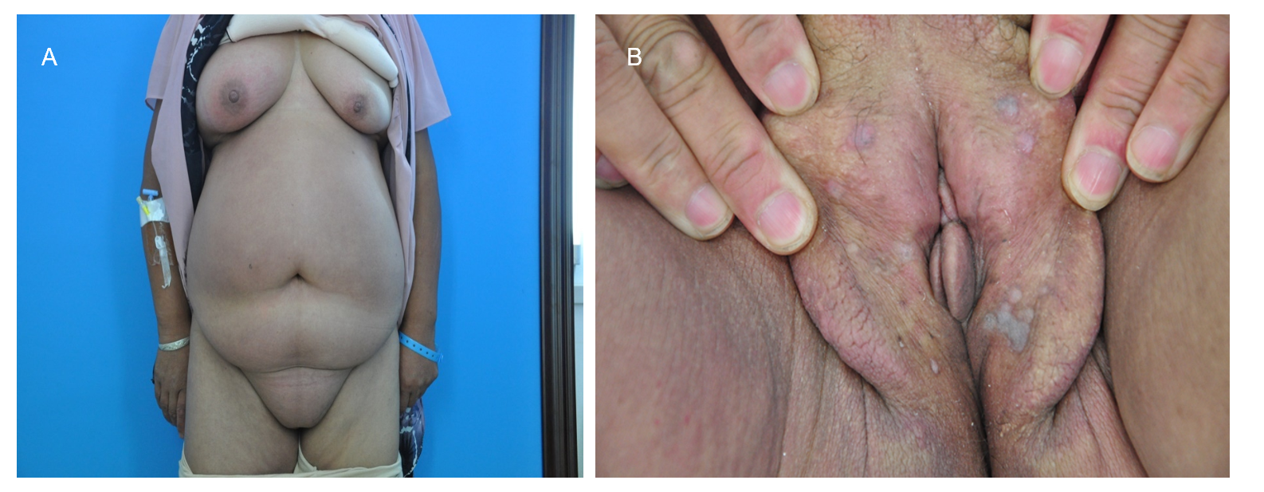
Figure 1 Photographs of our patient. A: Diffuse erythema and swelling on the chest, abdomen, and right leg; B: Edema and a number of flat skin-colored or gray papules on the labia majora.
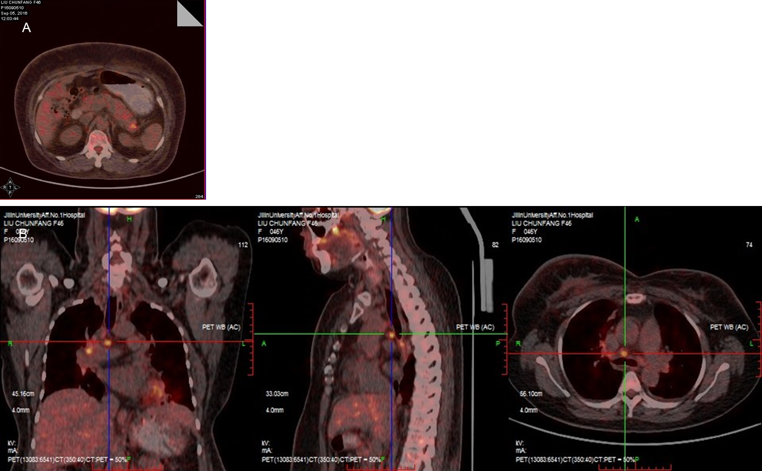
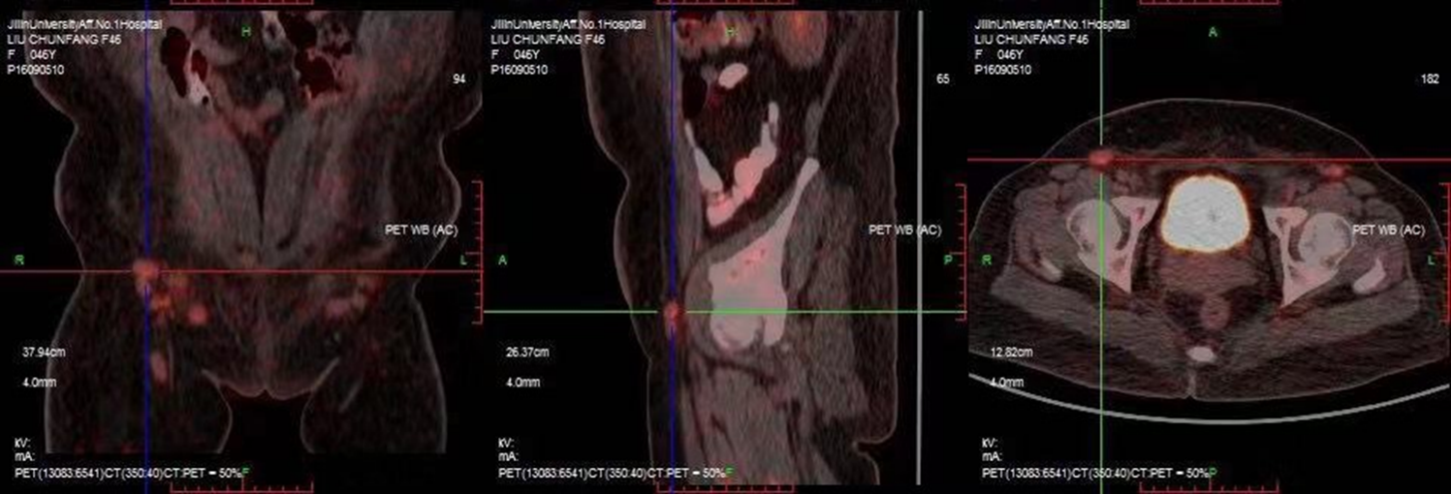
Figure 2 Positron emission tomography-computed tomography scan showing increased metabolic activity. A: The tail of the pancreas; B: Mediastinum, hilus of the lung, and postperitoneal lymph nodes.
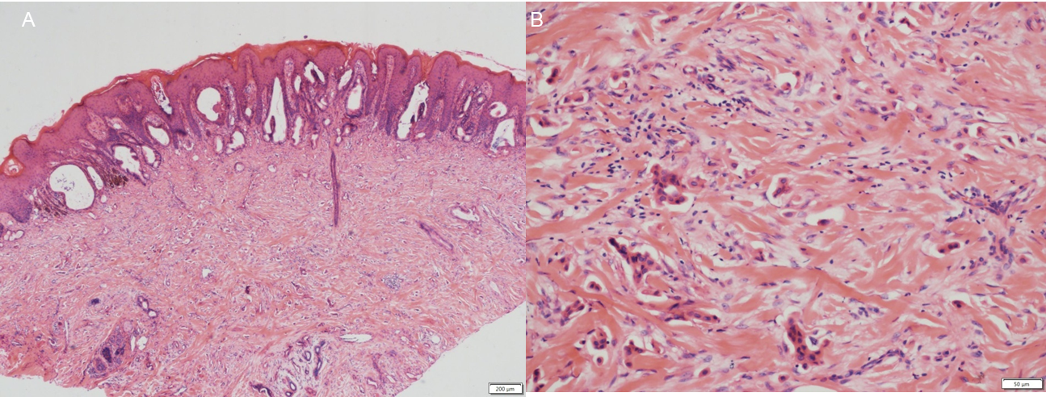
Figure 3 Pathology of cutaneous metastasis. A: Histological examination of the labia majora papule showing nests of moderately differentiated atypical cells partly forming adenomatous structures in the collagen bundle of the dermis and lymphangiectasis in the dermis [hematoxylin-eosin (HE) staining, × 40]; B: Dermis occupied by mass of numerous tumor cells (HE staining, × 200).
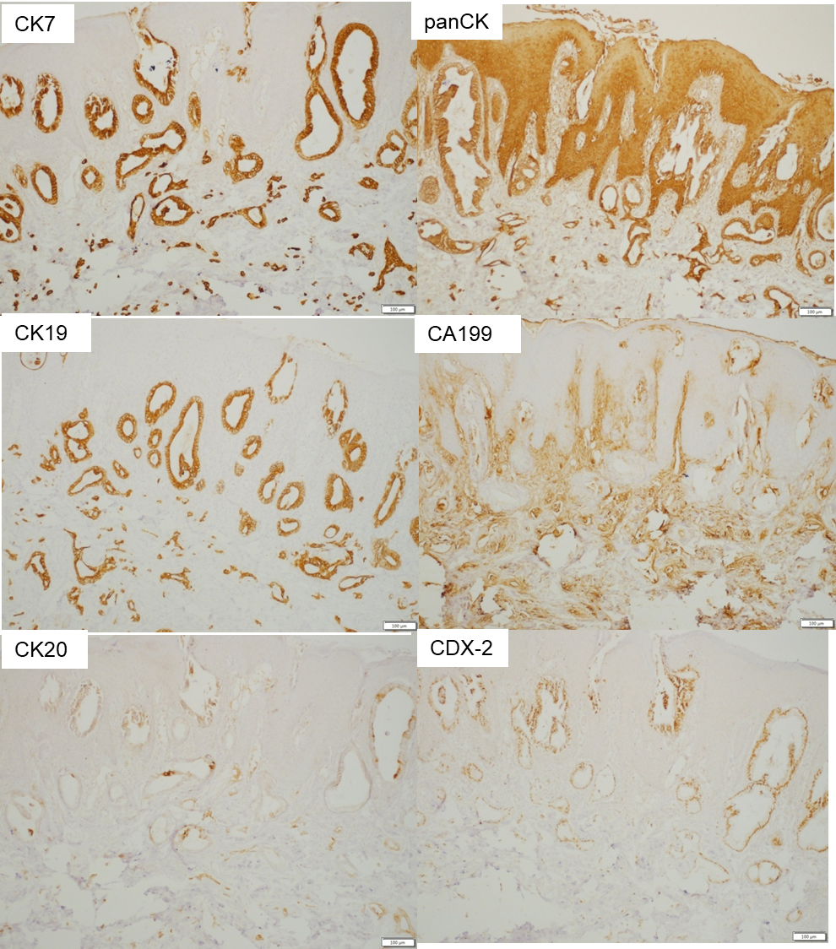
Figure 4 Neoplastic glands showing a positive reaction to immunohistochemical staining (100 ×). A: CK7 (+); B: panCK (+); C: CK19 (+); D: CA199 (+); E: CK20 (+); F: CDX-2 (+).
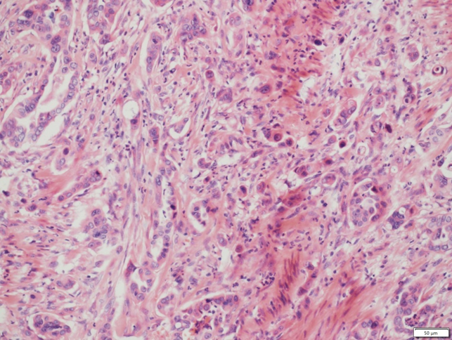
Figure 5 B-mode ultrasound-guided needle biopsy of the pancreas showing the moderately and poorly differentiated adenocarcinoma (hematoxylin-eosin staining, × 200).
Table1 Review of case reports of nonumbilical cutaneous metastasis from pancreatic cancer
 | Ref. | Age (yr) | Sex | Appearance | Metastatic site | Primary | Year
1 | Edelstein et al^{[10]} | 60 | M | Cellulitis | Face, neck | NA | 1950
2 | Sakai et al | 47 | M | Herpes zoster-like | No details | Head | 1969
3 | Sironi et al^{[12]} | 72 | M | Nodule | Right thigh | Head | 1991
4 | Lookingbill et al^{[13]} | No details | No details | Nodule | Abdomen | No details | 1993
5 | Taniguchi et al^{[4]} | 63 | F | Erythematousplaques, nodule | Left axilla, chest | No details | 1994
6 | Ohashi et al | 79 | M | Nodule | Neck, chest, abdomen | No details | 1995
7 | Ohashi et al | 65 | M | Nodule | Back | No details | 1995
8 | Fukui et al | 49 | M | Nodule | Face, chest | No details | 1995
9 | Puri et al^{[14]} | 45 | M | Nodule | Scalp, face, neck, back | No details | 1995
10 | Nakano et al^{[15]} | 80 | M | Nodule | Occipital scalp | Tail | 1996
11 | Miyahara et al^{[16]} | 43 | M | Nodule | Scalp | Uncus | 1996
12 | Miyahara et al^{[16]} | 65 | M | Nodule | Mentum | Uncus | 1996
13 | Horino et al^{[17]} | 65 | F | Nodule | Chest wall | Head | 1999
14 | Flórez et al^{[18]} | 48 | M | Nodule | Buttock | Head | 2000
15 | Gawrieh et al^{[19]} | 45 | F | Nodule | Temporal scalp | No details | 2002
16 | Takeuchi et al^{[3]} | 77 | M | Nodule | Left axilla | Tail | 2003
17 | Otegbayo et al^{[20]} | 59 | M | Nodule | Face, chest, abdomen, back | No details | 2005
18 | Jun et al^{[21]} | 68 | M | Nodule | Right forearm, chest | Body, tail | 2005
19 | Ambro et al^{[22]} | 63 | M | Nodule | Scalp | Ductal | 2006
20 | Takemura et al^{[23]} | 85 | M | Nodule | Left temple | No details | 2007
21 | Hafez et al^{[24]} | 55 | F | Nodule | Neck | Head | 2008
22 | Kimura et al | 50 | M | Nodule | Lateral abdomen | Body | 2008
23 | van Akkooi et al^{[25]} | 59 | M | Nodule | Scalp | No details | 2010
24 | Bdeiri et al^{[1]} | 59 | F | Nodule | Scalp | Tail | 2010
25 | Pontinen et al^{[26]} | 67 | F | Nodule | Lower abdomen | Tail | 2010
26 | Saif et al^{[27]} | 46 | F | Nodule | Chest, abdomen, right supraclavicular area | No details | 2011
27 | Horino et al^{[6]} | 58 | F | Nodule | Lower abdomen | Body | 2012
28 | Horino et al^{[6]} | 65 | F | Nodule | Lower abdomen | Tail | 2012
29 | Bdeiri et al^{[1]} | 70 | F | Nodule | Scalp | Tail | 2013
30 | Kaoutzanis et al^{[28]} | 43 | M | Nodule | Scalp | Head | 2013
31 | Zhou et al^{[2]} | 76 | F | Nodule | Scalp, chest, abdomen | Tail | 2014
32 | Shin et al^{[29]} | 60 | M | Mass | Left hip | Body | 2015
33 | Kotsantis et al^{[11]} | 62 | M | Edema | Scrotum, trunk, chest wall | Head | 2017
34 | Ito et al^{[30]} | 71 | F | Ulcer | Scalp | Tail | 2020
NA: Not available; F: Female; M: Male.

