Name of Journal: World Journal of Clinical Cases
Manuscript NO: 82614
Manuscript Type: CASE REPORT

Pancreatic neuroendocrine tumor detected by technetium-99m methoxy-2-isobutylisonitrile single photon emission computed tomography/computed tomography: A case report

Liu CJ et al. 99mTc-MIBI SPECT/CT for pancreatic NET

Chang-Jiang Liu, Hua-Jun Yang, Yan-Chun Peng, De-Yu Huang

Chang-Jiang Liu, Department of Nuclear Medicine, Xingyi People’s Hospital, Xingyi 562400, Guizhou Province, China

Hua-Jun Yang, Department of Pulmonary and Critical Care Medicine, Xingyi People’s Hospital, Xingyi 562400, Guizhou Province, China

Yan-Chun Peng, Department of Hepatobiliary, Pancreatic and Splenic Surgery, Xingyi People’s Hospital, Xingyi 562400, Guizhou Province, China

De-Yu Huang, Department of Pathology, Xingyi People’s Hospital, Xingyi 562400, Guizhou Province, China

Author contributions: Liu CJ and Yang HJ conceived the idea; Liu CJ designed the research; Liu CJ, Yang HJ, Peng YC, and Huang DY analyzed the data and wrote the manuscript; all authors have read and agreed to the published version of the manuscript.

Corresponding author: Chang-Jiang Liu, MD, Academic Fellow, Department of Nuclear Medicine, Xingyi People’s Hospital, No. 1 Yingxiong Road, Xingyi 562400, Guizhou Province, China. liucj_009@163.com

Received: January 19, 2023
Revised: February 10, 2023
Accepted: March 24, 2023
Published online: April 26, 2023

Abstract
BACKGROUND
Pancreatic neuroendocrine tumors (NETs) account for about 1%–2% of pancreatic tumors and about 8% of all NETs. Computed tomography (CT), magnetic resonance imaging, and endoscopic ultrasound are common imaging modalities for the diagnosis of pancreatic NETs. Furthermore, somatostatin receptor imaging is of great value for diagnosing pancreatic NETs. Herein, we report the efficacy of technetium-99m methoxy-2-isobutylisonitrile (^{99m}Tc-MIBI) single photon emission CT (SPECT)/CT for detecting pancreatic NETs.

CASE SUMMARY
A 57-year-old woman presented to our hospital with a 1-d history of persistent upper abdominal distending pain. The distending pain in the upper abdomen was aggravated after eating, with nausea and retching. Routine blood test results showed a high neutrophil percentage, low leukomonocyte and monocyte percentages, and low leukomonocyte and eosinophil counts. Amylase, liver and kidney function, and tumor markers alpha-fetoprotein, carcinoembryonic antigen, and cancer antigen (CA) 125, CA72-4, CA19-9, and CA153 were normal. Abdominal CT showed a mass, with multiple calcifications between the pancreas and the spleen. The boundary between the mass and the pancreas and spleen was poorly defined. Contrast-enhanced CT revealed that the upper abdominal mass was unevenly and gradually enhanced. ^{99m}Tc-MIBI SPECT/CT revealed that a focal radioactive concentration, with mild radioactive concentration extending into the upper abdominal mass, was present at the pancreatic body and tail. The ^{99m}Tc-MIBI SPECT/CT manifestations were consistent with the final pathological diagnosis of pancreatic NET.

CONCLUSION
^{99m}Tc-MIBI SPECT/CT appears to be a valuable tool for detecting pancreatic NETs.

Key Words: Neuroendocrine tumors; Pancreas; Tc-99m-Methoxy-2-isobutylisonitrile; Single photon emission computed tomography; X-ray computed tomography; Case report

©The Author(s) 2023. Published by Baishideng Publishing Group Inc. All rights reserved.

Citation: Liu CJ, Yang HJ, Peng YC, Huang DY. Pancreatic neuroendocrine tumor detected by technetium-99m methoxy-2-isobutylisonitrile single photon emission computed tomography/computed tomography: A case report. World J Clin Cases 2023; 11(12): 2825-2831
URL: https://www.wjgnet.com/2307-8960/full/v11/i12/2825.htm
DOI: https://dx.doi.org/10.12998/wjcc.v11.i12.2825

Core Tip: Neuroendocrine tumors (NETs) are rare. The gastroenteropancreatic tract is the most common site for NETs. Pancreatic NETs account for about 1%-2% of pancreatic tumors and about 8% of all NETs. Endoscopic ultrasound, computed tomography (CT), and magnetic resonance imaging are common imaging modalities for the diagnosis of pancreatic NETs. In addition, somatostatin receptor imaging is of great value for the diagnosis of pancreatic NETs. We experienced a case of pancreatic NET detected by technetium-99m methoxy-2-isobutylisonitrile (^{99m}Tc-MIBI) single-photon emission CT/CT, which was consistent with the final pathological diagnosis of pancreatic NET.

INTRODUCTION
Neuroendocrine tumors (NETs) are relatively rare tumors arising from cells in the diffuse neuroendocrine system, occurring mainly in the gastroenteropancreatic (GEP) tract and lungs^{[1]}. The GEP tract is the most common site for NETs^{[2]}. Pancreatic NETs account for about 1%-2% of all pancreatic tumors^{[3]} and about 8% of all NETs^{[4]}. The diagnostic imaging modalities for pancreatic NETs include computed tomography (CT), magnetic resonance imaging, endoscopic ultrasound, and somatostatin receptor imaging^{[5]}. However, the application of technetium-99m methoxy-2-isobutylisonitrile (^{99m}Tc-MIBI) single photon emission CT (SPECT)/CT for detecting pancreatic NET has not been reported.

CASE PRESENTATION
Chief complaints
A 57-year-old woman presented with upper abdominal distending pain lasting 1 d.

History of present illness
The patient had persistent pain that was aggravated after eating, accompanied by nausea and retching. Her abdominal CT findings revealed an upper abdominal tumor originating from the spleen or pancreas. Therefore, she was admitted to the hospital for further examination and treatment.

History of past illness
The patient underwent traumatic abdominal exploratory surgery more than 30 years ago.

Physical examination
An old surgical scar with a longitudinal length of about 6 cm was observed on the upper abdomen. A mass was palpable in the left-upper abdomen, which was hard, poor in mobility, and slightly tender.

Laboratory examinations
Routine blood test results showed a high neutrophil percentage, low lymphocyte and monocyte percentages, and a low eosinophil count. Routine urine and stool test results were normal. The levels of electrolytes (sodium, chlorine, calcium, and magnesium) were normal. Amylase, liver and kidney function, and tumor markers alpha-fetoprotein, carcinoembryonic antigen, carbohydrate antigen (CA) 125, CA72-4, CA19-9, and CA153 were also normal.

Imaging examinations
CT and contrast-enhanced CT of the abdomen: Abdominal CT showed a mass with multiple calcifications between the pancreas and the spleen. The boundary between the mass and the pancreas and spleen was poorly defined (Figure 1). The maximum cross section of the mass was about 9.0 cm × 8.6 cm. Contrast-enhanced CT revealed that the upper abdominal mass was unevenly and gradually enhanced (Figure 2).

Abdominal ^{99m}Tc-MIBI SPECT/CT: ^{99m}Tc-MIBI SPECT/CT was performed 5 d after contrast-enhanced CT imaging. Scanning began 30 min after the injection of 740 MBq of ^{99m}Tc-MIBI. Abdominal ^{99m}Tc-MIBI SPECT/CT was performed using a PRECEDENCE SPECT/CT (Philips Medical Systems, Eindhoven, the Netherlands) system. CT scanning was performed in a spiral mode over the entire abdomen at 250 mAs per slice, 120 Kv, and with a slice thickness of 3.0 mm. Immediately after CT scanning, SPECT acquisition of the abdomen was performed. The SPECT system was equipped with low-energy, high-resolution parallel-hole collimators. The SPECT acquisition followed an elliptical orbit, with a step-and-shoot acquisition of 64 angles over 360° (180° per detector) and an acquisition time of 20 s per frame. The SPECT data were reconstructed with attenuation correction from CT acquisition and iterative reconstruction via AutoSPECT Pro software with astonish, four iterations, and 16 subsets. The ^{99m}Tc-MIBI SPECT/CT fused images were processed using Fusion Viewer (version 2.1) procedures. The SPECT slice thickness was the same as that of CT.
The ^{99m}Tc-MIBI SPECT/CT images showed the presence of a focal radioactive concentration, with mild radioactive concentration extending into the upper abdominal mass at the pancreatic body and tail (Figure 3).

FINAL DIAGNOSIS
The pathology of the pancreatic lesion indicated a well-differentiated pancreatic NET by hematoxylin and eosin staining (Figure 4A and B). The pathology of the spleen showed normal spleen cells by hematoxylin and eosin staining (Figure 4C). Immunohistochemical analysis showed that the tumor cells were positive for insulinoma-associated protein 1, synaptophysin, and cluster of differentiation 56 (Figure 5). The Ki-67 (marker of proliferation Ki-67) proliferative index was assessed at 10% (Figure 6).

TREATMENT
Two days after ^{99m}Tc-MIBI SPECT/CT, the pancreatic body and tail, the upper abdominal mass discovered by CT (the mass with multiple calcifications between the pancreas and the spleen), and the spleen were excised. During the operation, a pancreatic lesion was seen to expand outward and extend into the spleen. This was inconsistent with the abdominal CT findings.

OUTCOME AND FOLLOW-UP
The patient was followed up 35 d after surgery. She complained of dull pain in her upper abdomen. Abdominal CT results showed encapsulated effusion in the surgical area (Figure 7), with no obvious abnormality in the remaining area. The patient’s condition improved after ultrasound-guided closed abdominal drainage.

DISCUSSION
Pancreatic NETs are often divided into functional and nonfunctional pancreatic NETs. The majority of pancreatic NETs are nonfunctional^{[5]}. The symptoms of a nonfunctional pancreatic NET include abdominal or back pain, nausea, vomiting, pancreatitis, and obstructive jaundice^{[5]}. Patients with functional pancreatic NETs often present with symptoms caused by hormone production of the tumor, leading to an early diagnosis^{[6]}.
Endoscopic ultrasound, CT, and magnetic resonance imaging are common imaging modalities for the diagnosis of pancreatic NETs. In addition, somatostatin receptor imaging is of great value for the diagnosis of pancreatic NETs^{[7]}, but the method is not easily available in our hospital.
More than 90% of well-differentiated GEP NETs express somatostatin receptors^{[8]}. Functional imaging technique of gallium-68 dota-octreotate (⁶⁸Ga-DOTATATE) positron emission tomography (PET)/CT uses radiolabeled somatostatin analogs to localize NETs. Research showed that the sensitivity of ⁶⁸Ga-DOTATATE PET/CT was about 95% for detecting pancreatic NETs^{[7]}. Unlike ⁶⁸Ga-DOTATATE, ^{99m}Tc-MIBI is a nonspecific tumor imaging agent. However, compared with ⁶⁸Ga-DOTATATE PET/CT, ^{99m}Tc-MIBI SPECT/CT is a relatively cheap and easily available imaging modality. Herein, we present a case of pancreatic NETs detected by ^{99m}Tc-MIBI SPECT/CT.
^{99m}Tc-MIBI is a lipophilic univalent cationic agent. Driven by cytoplasmic and mitochondrial transmembrane potential gradients, ^{99m}Tc-MIBI penetrates reversibly into the cytoplasm and concentrates in mitochondria^{[9]}. In one study, there were greater electrical gradients from outside the cell to the mitochondria in carcinoma cells than in normal epithelial cells, and the uptake of ^{99m}Tc-MIBI increased tenfold in carcinoma cells^{[9]}.
^{99m}Tc-MIBI SPECT/CT may be a useful tool for detecting lymph node and lung metastases in patients with differentiated thyroid carcinoma^{[10]}. Additionally, ^{99m}Tc-MIBI SPECT can be used to differentiate benign from malignant solitary pulmonary nodules and thyroid nodes^{[11,12]}. Lu et al^{[13]} reported a case of mediastinal typical carcinoid tumor detected by ^{99m}Tc-MIBI SPECT/CT.
Our patient was a 57-year-old woman with symptoms that started 1 d previously. The age for the occurrence of pancreatic NETs is equivalent to the mean age (57-58 years) previously identified for this type of tumor^{[5]}. The patient’s abdominal CT showed a mass with multiple calcifications between the pancreas and spleen. The boundary between the mass and pancreas and spleen was poorly defined. These findings indicated that the tumor might have originated from the spleen or pancreas. Contrast-enhanced CT revealed that the mass was unevenly and gradually enhanced. This indicated the possibility of a malignant tumor. However, ^{99m}Tc-MIBI SPECT/CT showed the presence of a focal radioactive concentration, with mild radioactive concentration extending into the upper abdominal mass at the pancreatic body and tail. This finding strongly suggested that the upper abdominal mass originated from the pancreas. The CT manifestations of the pancreatic tissue corresponding to the focal radioactive concentration were solid and homogenous. A previous study reported that pancreatic NETs tended to appear as solid and homogenous lesions on CT imaging^{[7]}. In our case study, the ^{99m}Tc-MIBI SPECT/CT manifestations were consistent with the final pathological diagnosis of pancreatic NET.

CONCLUSION
^{99m}Tc-MIBI SPECT/CT appears to be valuable for diagnosing pancreatic NETs. However, subsequent large-sample studies are needed to confirm this finding.

REFERENCES
1 Ohmoto A, Morizane C. Genomic Profiles and Current Therapeutic Agents in Neuroendocrine Neoplasms. Curr Drug Targets 2020; 21: 389-405 [PMID: 31633473 DOI: 10.2174/1389450119666191014105211]
2 Iabichino G, Di Leo M, Arena M, Rubis Passoni GG, Morandi E, Turpini F, Viaggi P, Luigiano C, De Luca L. Diagnosis, treatment, and current concepts in the endoscopic management of gastroenteropancreatic neuroendocrine neoplasms. World J Gastroenterol 2022; 28: 4943-4958 [PMID: 36160644 DOI: 10.3748/wjg.v28.i34.4943]
3 Ito T, Sasano H, Tanaka M, Osamura RY, Sasaki I, Kimura W, Takano K, Obara T, Ishibashi M, Nakao K, Doi R, Shimatsu A, Nishida T, Komoto I, Hirata Y, Nakamura K, Igarashi H, Jensen RT, Wiedenmann B, Imamura M. Epidemiological study of gastroenteropancreatic neuroendocrine tumors in Japan. J Gastroenterol 2010; 45: 234-243 [PMID: 20058030 DOI: 10.1007/s00535-009-0194-8]
4 Dasari A, Shen C, Halperin D, Zhao B, Zhou S, Xu Y, Shih T, Yao JC. Trends in the Incidence, Prevalence, and Survival Outcomes in Patients With Neuroendocrine Tumors in the United States. JAMA Oncol 2017; 3: 1335-1342 [PMID: 28448665 DOI: 10.1001/jamaoncol.2017.0589]
5 Scott AT, Howe JR. Evaluation and Management of Neuroendocrine Tumors of the Pancreas. Surg Clin North Am 2019; 99: 793-814 [PMID: 31255207 DOI: 10.1016/j.suc.2019.04.014]
6 Halfdanarson TR, Rabe KG, Rubin J, Petersen GM. Pancreatic neuroendocrine tumors (PNETs): incidence, prognosis and recent trend toward improved survival. Ann Oncol 2008; 19: 1727-1733 [PMID: 18515795 DOI: 10.1093/annonc/mdn351]
7 Hu HF, Li Z, Chen K, Liu MQ, Ye Z, Chen XM, Zhang Y, Yu XJ, Xu XW, Ji SR. Multimodality imaging differentiation of pancreatic neuroendocrine tumors and solid pseudopapillary tumors with a nomogram model: A large single-center study. Front Surg 2022; 9: 970178 [PMID: 36277293 DOI: 10.3389/fsurg.2022.970178]
8 Grey N, Silosky M, Lieu CH, Chin BB. Current status and future of targeted peptide receptor radionuclide positron emission tomography imaging and therapy of gastroenteropancreatic-neuroendocrine tumors. World J Gastroenterol 2022; 28: 1768-1780 [PMID: 35633909 DOI: 10.3748/wjg.v28.i17.1768]
9 Moretti JL, Hauet N, Caglar M, Rebillard O, Burak Z. To use MIBI or not to use MIBI? That is the question when assessing tumour cells. Eur J Nucl Med Mol Imaging 2005; 32: 836-842 [PMID: 15902437 DOI: 10.1007/s00259-005-1840-x]
10 Okudan B, Seven B, Gülaldı NCM, Çapraz M, Açıkgöz Y. The Value of (99m)Tc-MIBI SPECT/CT in the Postoperative Assessment of Patients with Differentiated Thyroid Carcinoma. Curr Med Imaging 2022; 18: 404-408 [PMID: 34749623 DOI: 10.2174/1573405617666211108154028]
11 Xia G, An C, Ming Z, Guo H, Liu L, Li Y. 18F-FDG-PET/CT versus 99Tcm-MIBI-SPECT: which is better for detection of solitary pulmonary nodules ? J BUON 2017; 22: 1246-1251 [PMID: 29135109]
12 Schenke SA, Campennì A, Tuncel M, Bottoni G, Sager S, Bogovic Crncic T, Rozic D, Görges R, Özcan PP, Groener D, Hautzel H, Klett R, Kreissl MC, Giovanella L. Diagnostic Performance of (99m)Tc-Methoxy-Isobuty-Isonitrile (MIBI) for Risk Stratification of Hypofunctioning Thyroid Nodules: A European Multicenter Study. Diagnostics (Basel) 2022; 12 [PMID: 35741167 DOI: 10.3390/diagnostics12061358]
13 Lu C, Wang Z, Wang G, Wang X, Liu X. Superior mediastinal typical carcinoid detected by 99mTc-MIBI SPECT/CT imaging: A case report. Medicine (Baltimore) 2017; 96: e9457 [PMID: 29384931 DOI: 10.1097/MD.0000000000009457]

Footnotes
Informed consent statement: Informed consent was obtained from the subject at the time of admission.

Conflict-of-interest statement: All authors report no relevant conflicts of interest for this article.

CARE Checklist (2016) statement: The authors have read the CARE Checklist (2016), and the manuscript was prepared and revised according to the CARE Checklist (2016).

Open-Access: This article is an open-access article that was selected by an in-house editor and fully peer-reviewed by external reviewers. It is distributed in accordance with the Creative Commons Attribution NonCommercial (CC BY-NC 4.0) license, which permits others to distribute, remix, adapt, build upon this work non-commercially, and license their derivative works on different terms, provided the original work is properly cited and the use is non-commercial. See: https://creativecommons.org/Licenses/by-nc/4.0/

Provenance and peer review: Unsolicited article; Externally peer reviewed.
Peer-review model: Single blind

Peer-review started: January 19, 2023
First decision: February 2, 2023
Article in press: March 24, 2023

Specialty type: Medicine, research and experimental
Country/Territory of origin: China
Peer-review report’s scientific quality classification
Grade A (Excellent): 0
Grade B (Very good): B
Grade C (Good): C, C
Grade D (Fair): 0
Grade E (Poor): E

P-Reviewer: Akbulut S, Turkey; Ampollini L, Italy; Saglam S, Turkey S-Editor: Zhao S L-Editor: Filipodia P-Editor: Zhao S

Figure Legends
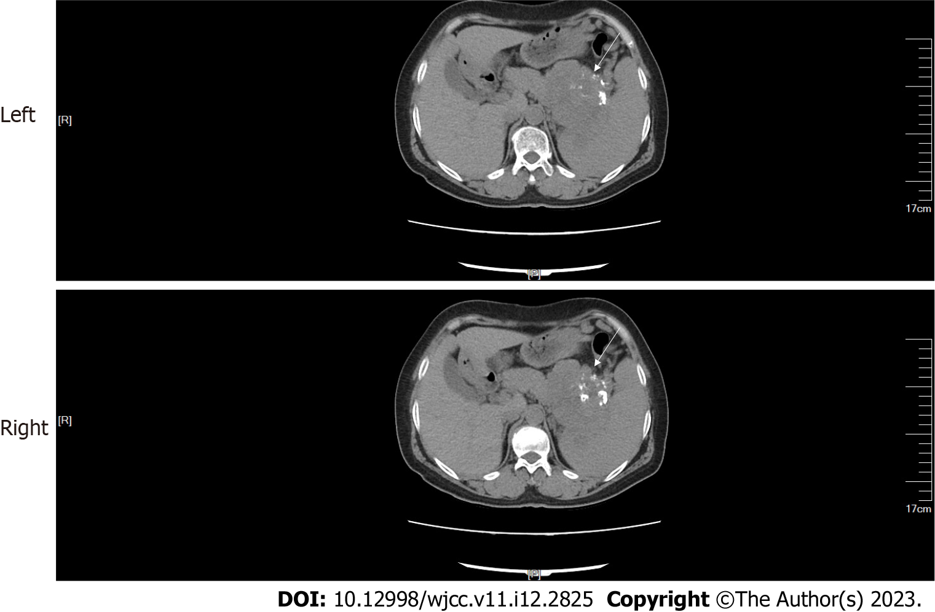
Figure 1 Abdominal computed tomography. A mass (arrow) with multiple calcifications between the pancreas and the spleen was observed. The boundary between the mass and the pancreas and spleen was poorly defined.

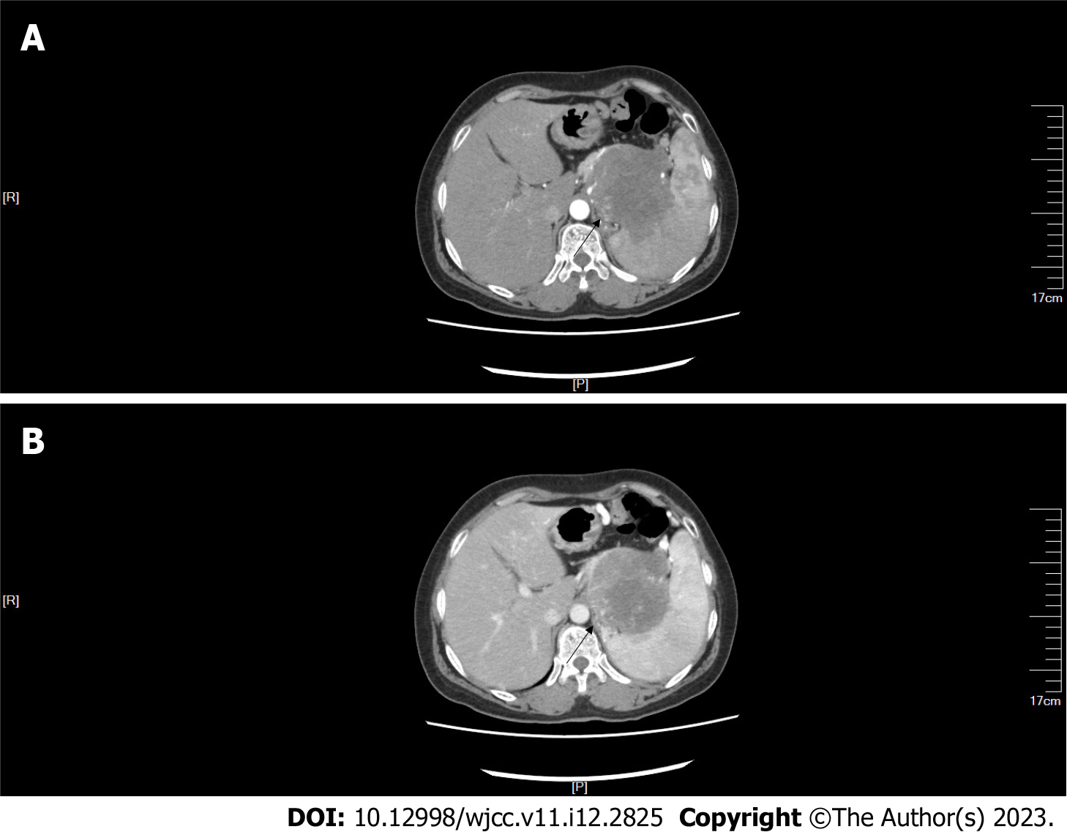
Figure 2 Abdominal computed tomography with contrast showed that the upper abdominal mass was unevenly and gradually enhanced (arrow). A: Arterial time; B: Venous time.

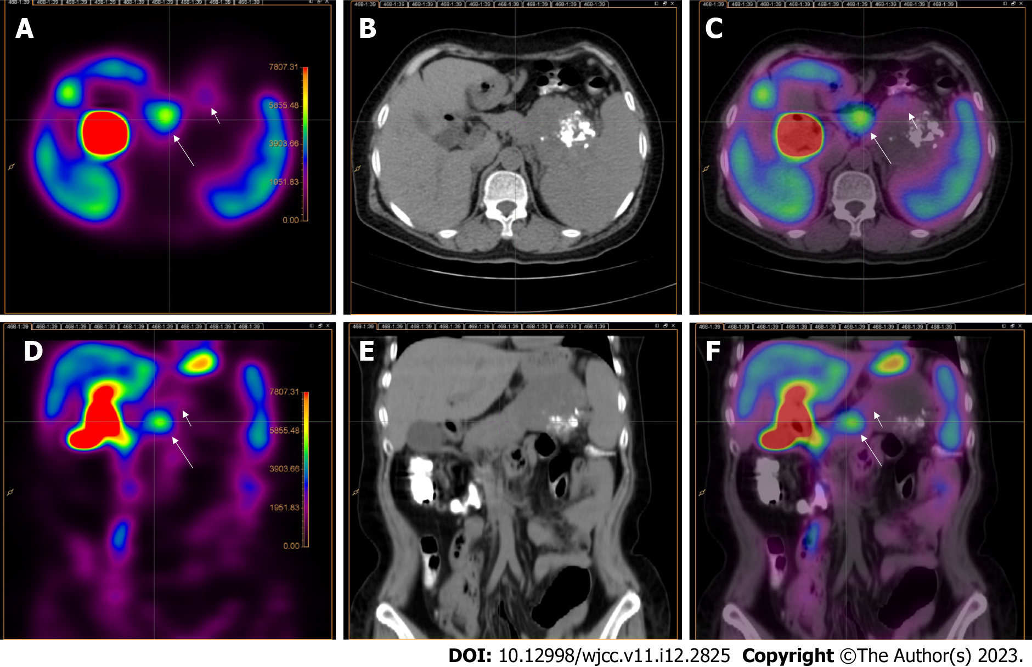
Figure 3 Abdominal technetium-99m methoxy-2-isobutylisonitrile single photon emission computed tomography/computed tomography. Technetium-99m methoxy-2-isobutylisonitrile single photon emission computed tomography (SPECT)/CT of the abdomen showed that a focal radioactive concentration (long arrow) with mild radioactive concentration (short arrow) was present on SPECT (A, D) and technetium-99m methoxy-2-isobutylisonitrile SPECT/CT fusion images (C, F) at the sites corresponding to the pancreatic body and tail and the upper abdominal mass discovered by CT (B, E). A-C: Transverse axis; D-F: Coronal axis.

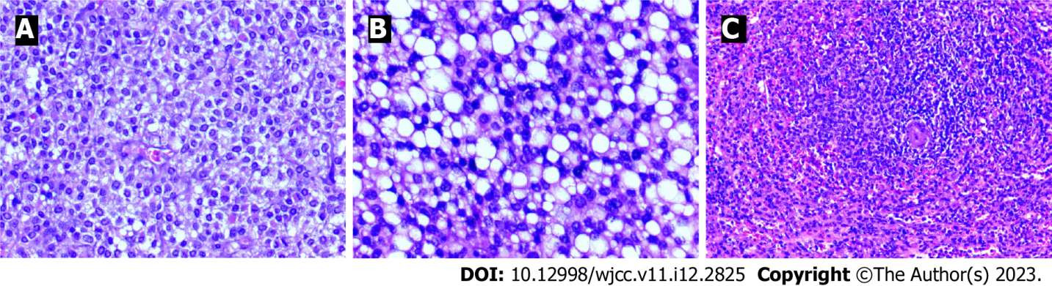
Figure 4 Hematoxylin and eosin staining. A: The pathology of the focal radioactive concentration of the pancreatic body and tail shown on technetium-99m methoxy-2-isobutylisonitrile single photon emission computed tomography (CT)/CT indicated a well-differentiated pancreatic neuroendocrine tumor via hematoxylin and eosin staining (× 200); B: The pathology of the upper abdominal mass shown on CT indicated a well-differentiated pancreatic neuroendocrine tumor via hematoxylin and eosin staining (× 200); C: Normal spleen cells observed after hematoxylin and eosin stain (× 100).

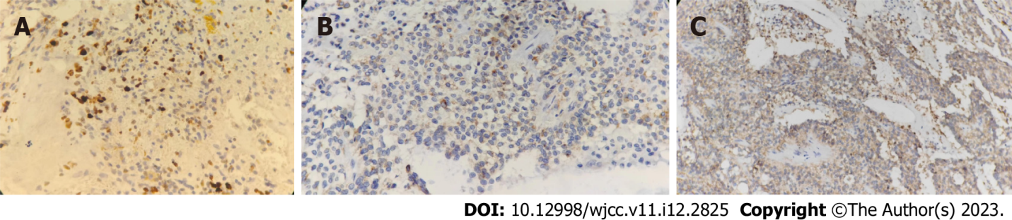
Figure 5 Immunohistochemical staining of tumor cells. A: Positive for insulinoma-associated protein 1; B: Positive for synaptophysin; C: Positive for cluster of differentiation 56 (× 200).

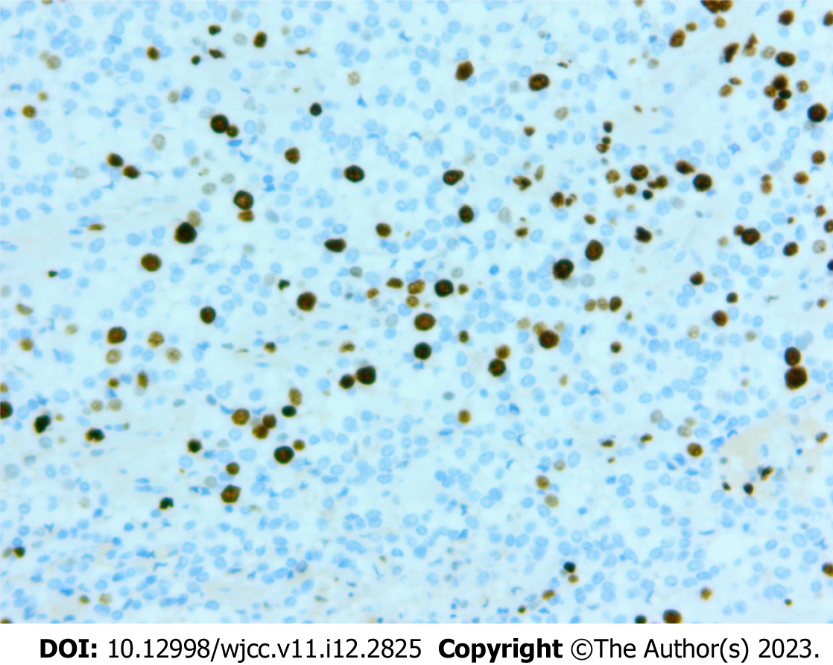
Figure 6 Immunohistochemical staining (EnVision technique) showed Ki-67 (marker of proliferation Ki-67) proliferative index of 10% (× 400).

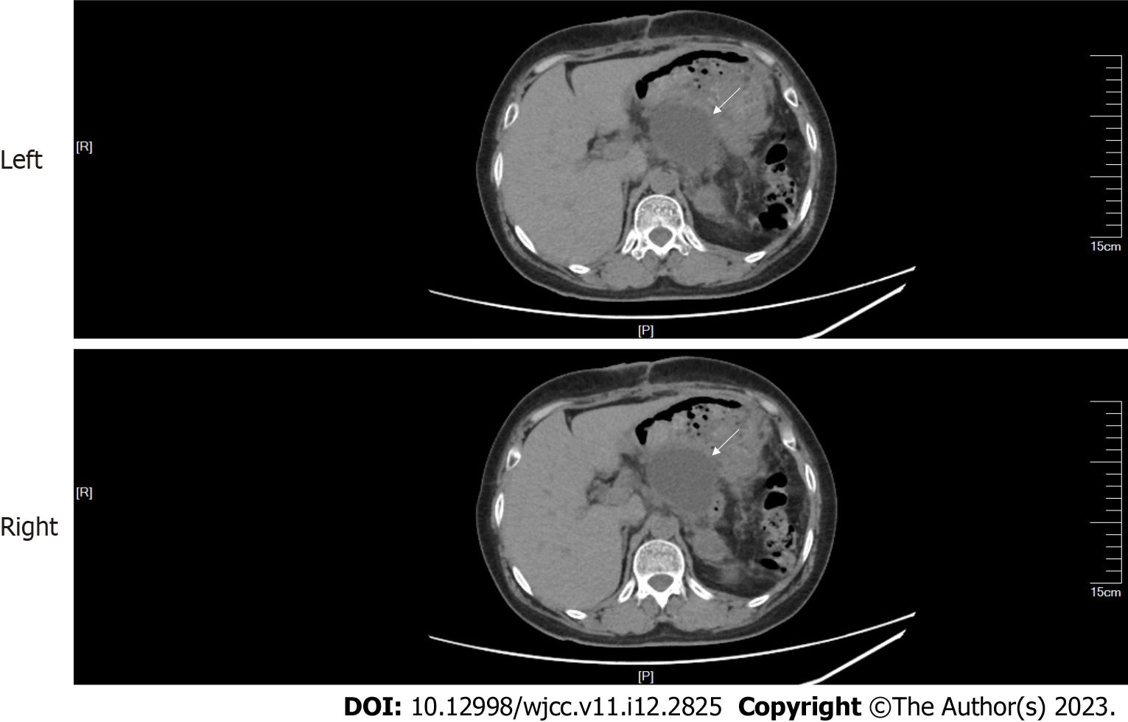
Figure 7 Encapsulated effusion (arrow) in the surgical area.

Published by Baishideng Publishing Group Inc
7041 Koll Center Parkway, Suite 160, Pleasanton, CA 94566, USA
Telephone: +1-925-3991568
E-mail: bpgoffice@wjgnet.com
Help Desk: https://www.f6publishing.com/helpdesk
https://www.wjgnet.com

© 2023 Baishideng Publishing Group Inc. All rights reserved.

