Name of Journal: World Journal of Gastroenterology
Manuscript NO: 72558
Manuscript Type: LETTER TO THE EDITOR

Comments on “Effect of type 2 diabetes mellitus in the prognosis of acute-on-chronic liver failure patients in China”

Wang W et al. Evaluation of the impact of type 2 diabetes

Wei Wang, Chen-Chen Pan, Wen-Ying Zhao, Jin-Yu Sheng, Qi-Qi Wu, Si-Si Chen

Wei Wang, Department of Interventional Oncology, Taizhou Municipal Hospital, Taizhou 318000, Zhejiang Province, China

Chen-Chen Pan, Wen-Ying Zhao, Jin-Yu Sheng, Qi-Qi Wu, School of Medicine Taizhou University, Taizhou 318000, Zhejiang Province, China

Si-Si Chen, Department of Obstetrics and Gynecology, Taizhou Women and Children’s Hospital of Wenzhou Medical University, Taizhou 318000, Zhejiang Province, China

Author contributions: Wang W and Chen SS contributed equally to this work; Wang W, Chen SS, Pan CC, Zhao WY, Sheng JY and Wu QQ designed the research study; Wang W, Chen SS, Pan CC and Zhao WY performed the research; Wang W and Chen SS contributed to new reagents and analytic tools; Wang W, Pan CC and Zhao WY analyzed the data and wrote the manuscript; All authors have read and approve the final manuscript.

Corresponding author: Si-Si Chen, MD, Occupational Physician, Department of Obstetrics and Gynecology, Taizhou Women and Children’s Hospital of Wenzhou Medical University, No. 188 Qianjin Village, Jiajia Street, Jiaojiang District, Taizhou 318000, Zhejiang Province, China. chensisiobstetrics@126.com

Received: October 20, 2021
Revised: January 13, 2022
Accepted: March 16, 2022
Published online:

Abstract
A study addressing the influence of type 2 diabetes on the prognosis of acute-on-chronic liver failure patients was reviewed. Some statistical deficiencies were found in the reviewed article, and the sample size was too small to support the study. In addition, age should have been considered as one of the prognostic factors.

Key Words: Type 2 diabetes mellitus; Liver failure; Complication; Prognosis; Age

Wang W, Pan CC, Zhao WY, Sheng JY, Wu QQ, Chen SS. Comments on “Effect of type 2 diabetes mellitus in the prognosis of acute-on-chronic liver failure patients in China”. World J Gastroenterol 2022; In press

Core Tip: This is a comment on a study of the influence of type 2 diabetes on the prognosis of patients with acute-on-chronic liver failure. We believe that the conclusion of this study can provide more significant data.

TO THE EDITOR
We were pleased to read the high-level article published by Lai et al^{[1]}. The results of their study showed a significant relationship between the prognosis of diabetes mellitus (DM) and acute-on-chronic liver failure (ACLF) patients. ACLF patients with DM have higher in-hospital mortality and infection rates than patients without DM. This is an important study that has made a significant contribution to the study of prognostic indicators for ACLF patients. However, there are still questionable issues in this study that we would like to discuss with the authors.
First, the Materials and Methods section needs to be more detailed and refined. The author should list the number of diabetic patients included and the number of people after grouping. The author should state the time for follow-up of the patients and redefine the concept of follow-up. If the author regards the discharge time as the end of the follow-up event, it may cause data loss. Therefore, another reference could be added for loss to follow-up. We notice that they performed multivariate analysis on parameters with P < 0.1 in univariate analysis, which is not convincing. A P value less than 0.05 would make the results more convincing. In addition, a sample of 200 for a study period of 7 years is small; the author should calculate the population size and analyze the sample size.
There are problems in the statistical analyses. Statistical analyses should be described in detail. In the table in the Results section, the author should provide more accurate statistical values, such as Student’s t-values or χ² values. Table 1 shows that there are statistical differences in age between the DM group and non-DM group. Therefore, the author should describe the frequency and distribution of age in more detail and discuss the possible impact of age as a potential risk factor on the disease. For example, the author could divide the patients into different levels in the DM and non-DM groups according to age and statistically analyze the impact of different ages in each level on the mortality and infection rate of related diseases. According to the criteria of the World Health Organization in 2012^{[1,2]}, a younger age was defined as less than 45 years, and an older age was defined as greater or equal to 45 years. Therefore, the author could divide the original two groups into four groups. In Figure 1 (Figure in the manuscript "Effect of type 2 diabetes mellitus in the prognosis of acute-on-chronic liver failure patients in China"^{[1]}), the author should indicate the time unit. We do not know how long the patients lived. In addition, we also noticed that the author did not indicate the corresponding P value when stating some conclusions.
In the paper, the author repeatedly proposed that DM could predict ACLF. This is a confusing statement. The study only proves that DM has a certain influence on ACLF. To further predict ACLF through DM, a survival model would need to be established. The author should provide more detailed data, such as median follow-up and survival times, to build up the survival model.
In the Discussion section, the author explained that albumin (ALB) has nothing to do with the prognosis of liver failure in this study and believed that exogenous injection of ALB interfered with the experimental results. Inferring from this, we believe that the author neglected interference caused by the patients’ medications on the experimental results during treatment. ALB constitutes about half of serum proteins. ALB is involved in scavenging free radicals, maintaining colloidal osmotic pressure and protecting neuronal cells and is closely related to nutritional level^{[3]} and systemic inflammatory response^{[4]}. The author should describe in detail in the Methods section the type, dosage and method of drug injection during the treatment process. Actually, well-established indications for the use of human ALB in patients with cirrhosis pertain to conditions that are characterized by an acute deterioration of effective hypovolemia^{[5]}, such as renal dysfunction secondary to spontaneous bacterial peritonitis and hepatorenal syndrome, as shown by the international guidelines on the management of decompensated cirrhosis^{[6]}. The current established indications for ALB use in patients with cirrhosis, such as preventing renal dysfunction induced by systolic blood pressure, suggest that patients should receive 1.5 g/kg body weight at diagnosis +1 g/kg body weight at day 3^{[7]}.
All in all, this is a high-level article in the field of diabetes and liver cirrhosis. Although there are some statistical deficiencies in the article, the author may be able to expand the sample and establish a multicenter prospective cohort study. For example, age factors could be considered for related diseases to evaluate the impact of DM on the prognosis in ACLF patients.

REFERENCES
1 Lai RM, Chen TB, Hu YH, Wu G, Zheng Q. Effect of type 2 diabetic mellitus in the prognosis of acute-on-chronic liver failure patients in China. World J Gastroenterol 2021; 27: 3372-3385 [PMID: 34163118 DOI: 10.3748/wjg.v27.i23.3372]
2 D'Angio RG. Is there a role for albumin administration in nutrition support? Ann Pharmacother 1994; 28: 478-482 [PMID: 8038474 DOI: 10.1177/106002809402800411]
3 Zaccherini G, Bernardi M. The role and indications of albumin in advanced liver disease. Acta Gastroenterol Belg 2019; 82: 301-308 [PMID: 31314192]
4 Garcia-Martinez R, Caraceni P, Bernardi M, Gines P, Arroyo V, Jalan R. Albumin: pathophysiologic basis of its role in the treatment of cirrhosis and its complications. Hepatology 2013; 58: 1836-1846 [PMID: 23423799 DOI: 10.1002/hep.26338]
5 European Association for the Study of the Liver. EASL Clinical Practice Guidelines for the management of patients with decompensated cirrhosis. J Hepatol 2018; 69: 406-460 [PMID: 29653741 DOI: 10.1016/j.jhep.2018.03.024]
6 Margarson MP, Soni N. Serum albumin: touchstone or totem? Anaesthesia 1998; 53: 789-803 [PMID: 9797524 DOI: 10.1046/j.1365-2044.1998.00438.x]
7 World Health Day 2012 focuses on ageing and health. East Mediterr Health J 2012; 18: 303 [PMID: 22768689]

Footnotes
Conflict-of-interest statement: Each author has reviewed the statement by the Baishideng Publishing Group on conflict of interest, and every author stated that there is no conflict of interest.

Open-Access: This article is an open-access article that was selected by an in-house editor and fully peer-reviewed by external reviewers. It is distributed in accordance with the Creative Commons Attribution NonCommercial (CC BY-NC 4.0) license, which permits others to distribute, remix, adapt, build upon this work non-commercially, and license their derivative works on different terms, provided the original work is properly cited and the use is non-commercial. See: https://creativecommons.org/Licenses/by-nc/4.0/

Provenance and peer review: Unsolicited article; Externally peer reviewed.

Peer-review model: Single blind

Peer-review started: October 20, 2021
First decision: December 27, 2021
Article in press:

Specialty type: Gastroenterology and hepatology
Country/Territory of origin: China
Peer-review report’s scientific quality classification
Grade A (Excellent): 0
Grade B (Very good): 0
Grade C (Good): 0
Grade D (Fair): D
Grade E (Poor): E

P-Reviewer: Javed N, Pakistan; Saha S, India S-Editor: Fan JR L-Editor: Filipodia P-Editor: Fan JR

Figure Legends
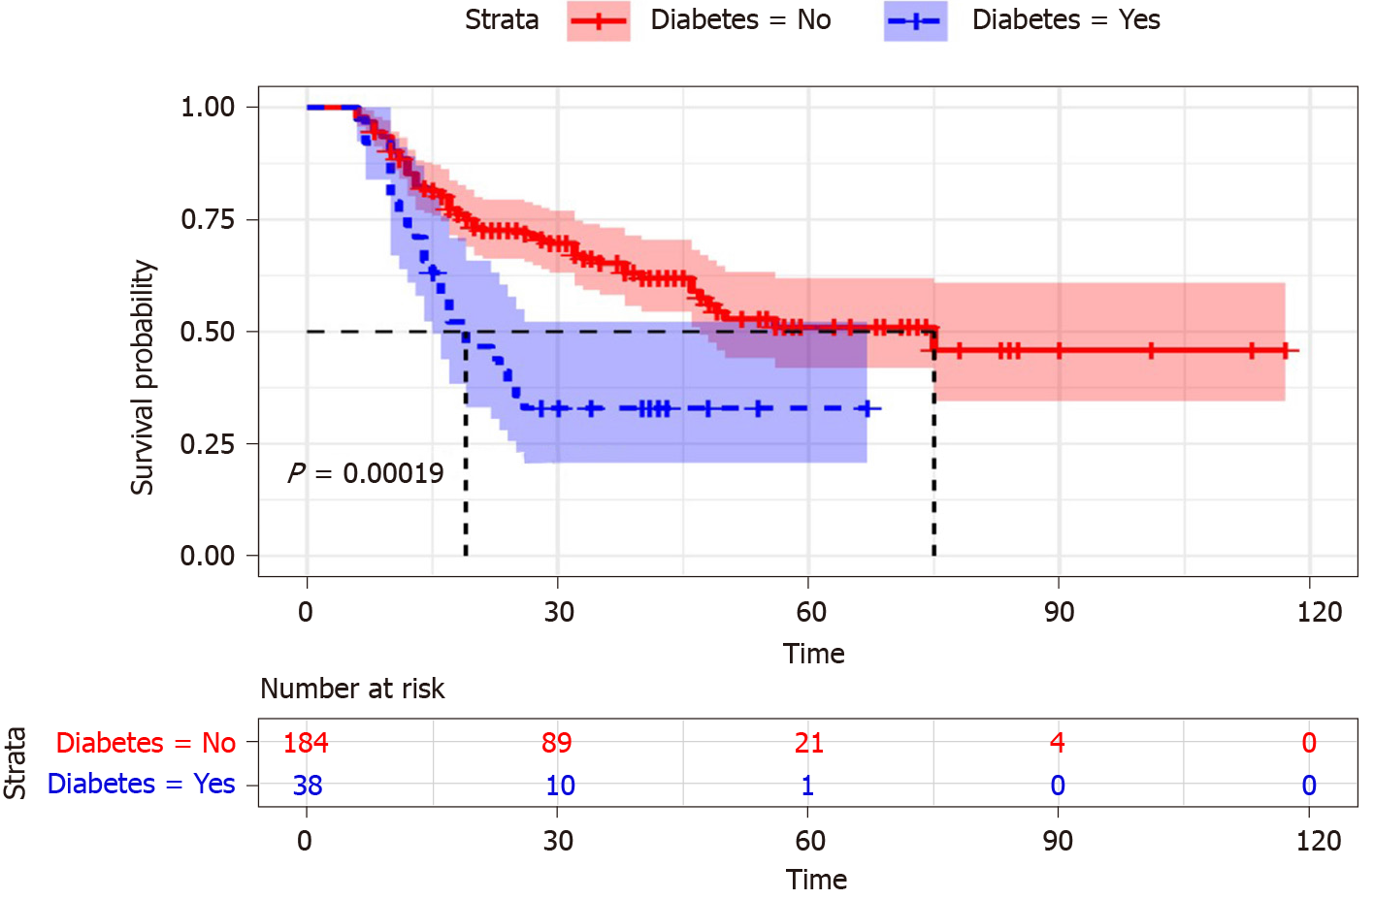
Figure 1 Cumulative survival time in acute-on-chronic liver failure patients with diabetic mellitus and non-diabetic mellitus^{[1]}. Citation: Lai RM, Chen TB, Hu YH, Wu G, Zheng Q. Effect of type 2 diabetic mellitus in the prognosis of acute-on-chronic liver failure patients in China. World J Gastroenterol 2021; 27: 3372-3385. Copyright© The Authors 2020. Published by Baishideng Publishing Group Inc.

Table 1 Demographic characteristics and clinical features of the patients between diabetic mellitus and non-diabetic mellitus^{[1]}
 | DM (yes) (n = 38) | DM (no) (n = 184) | P value
Age (yr) | 56.32 ± 14.23 | 49.16 ± 12.84 | 0.002
Gender, n (%) |  |  | 0.309
Male | 28 (73.68) | 149 (80.98)
Female | 10 (26.32) | 35 (19.02)
Cause of disease, n (%) |  |  | 0.201
Hepatitis B virus | 26 (68.42) | 139 (75.54)
Hepatitis B virus + other | 5 (13.16) | 20 (10.87)
Alcohol | 2 (5.26) | 15 (8.15)
Others | 5 (13.16) | 10 (5.44)
WBC (10⁹/L) | 6.17 ± 4.03 | 7.35 ± 3.58 | 0.07
RBC (10¹²/L) | 3.68 ± 0.87 | 3.94 ± 0.84 | 0.084
Hb (g/L) | 117.21 ± 24.71 | 121.95 ± 23.13 | 0.257
PLT (10⁹/L) | 100.34 ± 42.20 | 118.79 ± 59.09 | 0.069
PT (s) | 23.01±5.38 | 24.45 ± 6.95 | 0.229
INR | 1.97 ± 0.45 | 2.10 ± 0.59 | 0.229
ALT (U/L) | 396.08 ± 448.56 | 560.36 ± 693.06 | 0.163
AST (U/L) | 365.95 ± 391.18 | 419.99 ± 513.42 | 0.541
γ-GGT (U/L) | 174.16 ± 305.61 | 137.57 ± 127.33 | 0.231
TBIL (μmol/L) | 320.71 ± 141.31 | 309.56 ± 134.00 | 0.664
ALB (g/L) | 29.25 ± 4.51 | 30.73 ± 4.03 | 0.045
Scr (μmol/L) | 56.37 ± 22.00 | 63.45 ± 27.28 | 0.134
BUN (mmol/L) | 3.94 ± 2.65 | 4.25 ± 2.98 | 0.56
TCHO (mmol/L) | 2.67 ± 0.81 | 2.65 ± 1.05 | 0.919
TG (mmol/L) | 1.45 ± 0.67 | 1.26 ± 0.70 | 0.124
Na⁺ (mmol/L) | 136.98 ± 3.97 | 136.86 ± 4.43 | 0.878
K⁺ (mmol/L) | 3.90 ± 0.46 | 4.08 ± 0.58 | 0.072
AMON (μmol/L) | 3.90 ± 0.46 | 4.08 ± 0.58 | 0.332
AFP (ng/mL) | 64.40 ± 40.39 | 128.19 ± 192.02 | 0.784
BMI (kg/m²) | 24.99 ± 3.32 | 22.78 ± 3.03 | < 0.001
FBG (mmol/L) | 5.34 ± 1.87 | 3.83 ± 1.07 | < 0.001
Scoring systems
CTP | 10.79 ± 1.49 | 10.40 ± 1.35 | 0.115
MELD | 19.38 ± 4.52 | 20.74 ± 5.06 | 0.128
MELD-Na | 20.89 ± 5.00 | 22.27 ± 6.84 | 0.239
Death, n (%) | 25 (65.79) | 69 (37.5) | 0.001
γ-GGT: Gamma-glutamyl transpeptidase; AFP: Alpha fetal protein; ALB: Albumin; ALT: Alanine aminotransferase; AMON: Ammonia; AST: Aspartate aminotransferase; BMI: Body mass index; BUN: Blood urea nitrogen; CTP: Child-Turcotte-Pugh; DM: Diabetic mellitus; FBG: Fasting blood-glucose; Hb: Hemoglobin; INR: International normalized ratio; K+: Kalium; MELD: Model for End-Stage Liver Disease; MELD-Na: Model for End-Stage Liver Disease with serum sodium; Na+: Natrium ion; PLT: Platelet count; PT: Prothrombin time; Scr: Serum creatinine; TBIL: Total bilirubin; TCHO: Total cholesterol; TG: Triglyceride; RBC: Red blood cell; WBC: White blood cell. Citation: Lai RM, Chen TB, Hu YH, Wu G, Zheng Q. Effect of type 2 diabetic mellitus in the prognosis of acute-on-chronic liver failure patients in China. World J Gastroenterol 2021; 27: 3372-3385. Copyright© The Authors 2020. Published by Baishideng Publishing Group Inc.

