Name of Journal: World Journal of Gastrointestinal Surgery
Manuscript NO: 88628
Manuscript Type: ORIGINAL ARTICLE

Retrospective Cohort Study
Will partial splenic embolization followed by splenectomy increase intraoperative bleeding?

Huang L et al. Splenic embolism increases bleeding risk

Long Huang, Qing-Lin Li, Qing-Sheng Yu, Hui Peng, Zhou Zhen, Yi Shen, Qi Zhang

Long Huang, Qing-Sheng Yu, Hui Peng, Yi Shen, Qi Zhang, Department of No. 1 Surgery, The First Hospital Affiliated to Anhui University of Traditional Chinese Medicine, Hefei 230031, Anhui Province, China

Qing-Lin Li, Anhui University of Traditional Chinese Medicine, Anhui University of Traditional Chinese Medicine, Hefei 230038, Anhui Province, China

Zhou Zhen, Department of Surgery, The Second Hospital Affiliated to Anhui University of Traditional Chinese Medicine, Hefei 230061, Anhui Province, China

Author contributions: Huang L wrote the paper; Huang L, Li QL and Yu QS designed the research; Shen Y and Zhang Q performed the research; Peng H and Zhen Z analyzed the data; All authors made substantial intellectual contributions to this paper.

Supported by National Natural Science Foundations of China, No. 82174160; and Anhui Natural Science Foundation, No. 2008085QH389.

Corresponding author: Long Huang, MD, Chief Doctor, Doctor, Professor, Department of No. 1 Surgery, The First Hospital Affiliated to Anhui University of Traditional Chinese Medicine, No. 117 Meishan Road, Hefei 230031, Anhui Province, China. huanglong658@163.com

Received: October 2, 2023
Revised: December 17, 2023
Accepted: January 25, 2024
Published online: February 27, 2024

Abstract
BACKGROUND
Partial splenic embolization (PSE) has been suggested as an alternative to splenectomy in the treatment of hypersplenism. However, some patients may experience recurrence of hypersplenism after PSE and require splenectomy. Currently, there is a lack of evidence-based medical support regarding whether preoperative PSE followed by splenectomy can reduce the incidence of complications.

AIM
To investigate the safety and therapeutic efficacy of preoperative PSE followed by splenectomy in patients with cirrhosis and hypersplenism.

METHODS
Between January 2010 and December 2021, 321 consecutive patients with cirrhosis and hypersplenism underwent splenectomy at our department. Based on whether PSE was performed prior to splenectomy, the patients were divided into two groups: PSE group (n = 40) and non-PSE group (n = 281). Patient characteristics, postoperative complications, and follow-up data were compared between groups. Propensity score matching (PSM) was conducted, and univariable and multivariable analyses were used to establish a nomogram predictive model for intraoperative bleeding (IB). The receiver operating characteristic curve, Hosmer-Lemeshow goodness-of-fit test, and decision curve analysis (DCA) were employed to evaluate the differentiation, calibration, and clinical performance of the model.

RESULTS
After PSM, the non-PSE group showed significant reductions in hospital stay, intraoperative blood loss, and operation time (all P = 0.00). Multivariate analysis revealed that spleen length, portal vein diameter, splenic vein diameter, and history of PSE were independent predictive factors for IB. A nomogram predictive model of IB was constructed, and DCA demonstrated the clinical utility of this model. Both groups exhibited similar results in terms of overall survival during the follow-up period.

CONCLUSION
Preoperative PSE followed by splenectomy may increase the incidence of IB and a nomogram-based prediction model can predict the occurrence of IB.

Key Words: Partial splenic embolization; Splenectomy; Hypertension, Portal; Liver Cirrhosis; Intraoperative bleeding

©The Author(s) 2024. Published by Baishideng Publishing Group Inc. All rights reserved.

Citation: Huang L, Li QL, Yu QS, Peng H, Zhen Z, Shen Y, Zhang Q. Will partial splenic embolization followed by splenectomy increase intraoperative bleeding? World J Gastrointest Surg 2024; 16(2): 318-330
URL: https://www.wjgnet.com/1948-9366/full/v16/i2/318.htm
DOI: https://dx.doi.org/10.4240/wjgs.v16.i2.318

Core Tip: Partial splenic embolization (PSE) has been suggested as an alternative to splenectomy for treating hypersplenism, but some patients may experience recurrence of hypersplenism after PSE and still require splenectomy. Preoperative PSE followed by splenectomy may increase the incidence of intraoperative bleeding (IB), and a nomogram-based prediction model can predict the occurrence of IB.

INTRODUCTION
Cirrhosis, an end-stage chronic liver injury, is frequently accompanied by severe complications such as portal hypertension (PH), esophageal and gastric variceal bleeding (EGVB), splenomegaly, and hypersplenism^{[1,2]}. Previously, splenectomy has been used to treat patients with cirrhosis and hypersplenism^{[3]}. Furthermore, a combined approach of splenectomy and peri esophagogastric devascularization has been shown to be an effective treatment option for cirrhotic patients with EGVB and PH. However, it is important to note that this procedure carries the risk of postoperative complications, including abdominal hemorrhage, pancreatic fistula, and portal vein thrombosis (PVT)^{[4]}. Therefore, partial splenic embolization (PSE) has been proposed as an alternative to splenectomy for managing hypersplenism^{[5]}.
Currently, PSE has emerged as a crucial treatment modality for hypersplenism associated with PH. It effectively treats hypersplenism, lowers portal pressure, and improves liver function^{[6,7]}. The occurrence of acute ischemia of the splenic segment tissue and subsequent splenic infarction were attributed to PSE. The subsequent absorption of necrotic tissue and the development of splenic tissue fibrosis results in spleen atrophy and a reduction in spleen volume. The reduction in spleen volume enhances the space within the splenic pedicle, leading to a more precise disconnection between the perisplenic ligament and the splenic pedicle vessels. Consequently, this reduces the occurrence of complications^{[8]}. Despite the therapeutic effectiveness of PSE in treating hypersplenism and reducing PH, some patients may experience recurrence of hypersplenism following PSE treatment, leading to the need for splenectomy^{[9]}.
Previous research has indicated that PSE reduces surgical complexity and lowers the occurrence of postoperative complications^{[10]}. However, some studies suggest that PSE increases perisplenic adhesions and intraoperative bleeding (IB) during splenectomy^{[11]}. Despite these findings, there is insufficient evidence-based medical support to determine whether preoperative PSE followed by splenectomy reduces complications and the optimal timing for performing splenectomy after PSE remains uncertain. Furthermore, research on predictive factors for complications in patients undergoing preoperative PSE followed by splenectomy is limited.
This study aimed to assess the safety and therapeutic efficacy of preoperative PSE followed by splenectomy in patients with cirrhosis and hypersplenism. The aim of this study was to examine the occurrence of these complications. To achieve these objectives, we retrospectively analyzed the clinical data of patients who underwent preoperative PSE followed by splenectomy at our hospital over a period of 6 years. The ultimate goal was to develop a reliable risk model to identify the independent risk factors for IB in patients with cirrhosis.

MATERIALS AND METHODS
Prior to commencing this study, the objectives and specific details were comprehensively explained to the participants and informed consent was obtained from each participant or their respective representatives. This study was conducted in accordance with The Code of Ethics of the World Medical Association (Declaration of Helsinki, revised in Fortaleza, Brazil, October 2013). The study protocol was approved by the Institutional Review Board of Anhui Provincial Traditional Chinese Hospital (ID: 2020AH-13).

Patient selection and study design
From January 2017 to June 2023, 344 consecutive patients underwent splenectomy at the First Hospital affiliated with Anhui University of Traditional Chinese Medicine. After careful application of the inclusion and exclusion criteria, 321 patients were enrolled in the study. This study employed a retrospective cohort design in which patients were divided into two groups based on whether they underwent preoperative PSE: The PSE group and the non-PSE group. Detailed assessments were conducted to evaluate the clinical characteristics of the patients, including age, sex, etiology of cirrhosis, spleen size, and portal vein system diameter. Additionally, intraoperative outcomes such as blood loss, operation time, and postoperative complications such as PVT and postoperative pancreatic fistula (PPF) were collected and analyzed. Furthermore, the study reviewed the follow-up data on the overall survival (OS) of patients.
We meticulously collected and analyzed clinical data from a standardized database of patients during the perioperative period. Color Doppler ultrasound was used to measure the diameters of the portal and splenic veins, assess the spleen size, and determine the presence of PVT.
All patients included in the study met the following inclusion criteria: (1) A diagnosis of cirrhosis and PH of any etiology; (2) display secondary splenomegaly and hypersplenism attributed to cirrhosis. Hypersplenism is defined as a leukocyte count less than 3.5 × 10⁹/L and a platelet count less than 7.5 × 10⁹/L^{[12]}; and (3) have not previously undergone splenectomy.
The study excluded participants who had the following conditions: (1) Liver cirrhosis without hypersplenism or splenomegaly; (2) severe coagulation dysfunction; (3) liver or any other malignancy; (4) declined to participate; and (5) underwent early postoperative transfer. All surgical procedures were non-emergency procedures.

PSE and surgical technique
The puncture point for the right femoral artery, located under the inguinal ligament, was chosen as the most prominent point of femoral artery pulse. The right femoral artery was punctured using the modified Seldinger technique under digital subtraction angiography guidance. Imaging results were used to super selectively advance the microcatheter into the splenic artery. The extent of splenic artery embolism typically ranges from 50% to 70%.
All patients enrolled in the study underwent endotracheal intubation and received intravenous anesthesia for open splenectomy. The splenic artery was fully exposed for ligation, and the serosal tissue in front of the splenic pedicle space was separated and dissected after separating the perisplenic adhesions (Figure 1). To ensure safe dissection, dissection should be performed as close as possible to the splenic parenchyma to avoid the pancreatic tail and stomach. Each secondary splenic pedicle vessel was carefully dissected and ligated under direct visualization. Subsequently, splenic tissue was removed, ligated, and sutured. Finally, a drainage tube was placed in the splenic fossa.

Postoperative complications
This study collected and analyzed data on postoperative complications following splenectomy during hospitalization. These complications included PVT, postoperative abdominal hemorrhage, abdominal infection, PPF, liver failure, severe ascites, and encephalopathy. The criteria for diagnosing PPF were as follows: (1) Drainage duration exceeding 3 d; (2) amylase level in drainage fluid more than three times the upper limit of normal; and (3) no record of biochemical leakage^{[13]}. PVT was defined as the presence of thrombosis in the portal vein (trunk and intrahepatic branches), mesenteric vein, or splenic vein confirmed by Doppler ultrasound displaying hyperechoic or isoechoic filling in the cavity. Postoperative abdominal hemorrhage was defined as abdominal bleeding exceeding 300 mL within 24 h after surgery. Additionally, clinical details of the surgery, such as operation time, intraoperative blood loss, and length of hospital stay, were recorded.

Follow-up
All patients who underwent splenectomy received routine follow-up assessments either via telephone or at the outpatient department. The follow-up assessment was completed on June 30, 2023. The primary endpoint was OS. OS was defined as the duration from surgery to death from any cause. Patients who survived until the last follow-up were excluded.

Statistical analysis
Statistical analyses and plotting were conducted using the SPSS Version 24.0 software (IBM Corp., Chicago, IL, United States) and R (Version 4.2.2). Continuous variables following a normal distribution were reported as mean ± SD. Non-normally distributed variables were reported as medians with interquartile ranges (P25 and P75). Group comparisons of measurement data were performed using an independent t-test. Categorical variables were evaluated using the χ² test, with or without Fisher's exact test, as appropriate.
Propensity score matching (PSM) was performed to eliminate confounding variables associated with clinical characteristics between the two groups. PSM was performed using the 1:1 nearest-neighbor caliper matching method with the caliper value set at 0.2^{[14]}. Factors influencing IB were assessed using univariate analysis. Variables that showed statistical significance (P < 0.05) were further evaluated using multivariable logistic analysis to identify the main independent risk factors. A nomogram was constructed using R software (version 4.2.2), and nomogram differentiation was assessed by calculating the area under the curve (AUC) of the receiver operating characteristic (ROC) curve. To evaluate the clinical utility of the nomogram model, a decision curve analysis (DCA) was conducted using the R "rmda" package. Survival curves were plotted using the Kaplan-Meier method, and differences between the two groups were assessed using the log-rank test. Statistical significance was considered at the 5% level, and 2-tailed test were used for the analysis.

RESULTS
Comparison between the two groups by PSM analysis
Of the 344 patients who met the initial inclusion criteria, 23 were excluded from the study. Among them, eight patients had idiopathic thrombocytopenic purpura, four patients had hereditary spherocytosis and underwent splenectomy, showing no symptoms of hypersplenism or splenomegaly, four patients developed severe coagulopathy, three patients had liver malignancy, and four patients experienced early postoperative complications. Ultimately, 321 patients who met the inclusion criteria were enrolled in this study. Among the 321 patients, there were 173 men and 148 were female. The PSE group included 40 patients, while the non-PSE group included 281 patients (Figure 2).
When comparing the baseline clinical data between the PSE group and non-PSE group, no significant differences were observed in various indicators, including age, sex, etiology of cirrhosis, and portal and splenic vein diameters (SVDs) (all P > 0.05). Additionally, no significant differences were observed in parameters including white blood cell (WBC), red blood cell (RBC), hemoglobin (HGB), alanine aminotransferase (ALT), prothrombin time (PT), and operation between the two groups (all P > 0.05). In contrast to the PSE group, the non-PSE group demonstrated significantly reduced hospital stays (13.99 ± 3.57d vs 17.10 ± 4.42 d), intraoperative blood loss (267.36 ± 161.07 mL vs 399.50 ± 240.76 mL), and operation time (181.64 ± 36.57 min vs 202.98 ± 36.38 min) (all P = 0.00).
Table 1 presents the results of PSM conducted at a 1:1 ratio, with 23 patients in each group. Following PSM, the clinical data of the matched PSE group were comparable to those of the matched non-PSE group, with all P values exceeding 0.05. Furthermore, the matched non-PSE group demonstrated significantly reduced hospital stays (13.52 ± 2.25 d compared to 16.70 ± 4.18 d), intraoperative blood loss (250.13 ± 129.02 mL compared to 450.00 ± 268.40 mL), and operation time (178.78 ± 37.42 min compared to 220.09 ± 35.41 min) when compared to the matched PSE group.

Comparison among pre- or post-PSE
Notable variations were observed in multiple indices between pre- and post-PSE, specifically in the diameters of the portal and splenic veins, along with changes in the HGB, platelet, total bilirubin, ALT, aspartate aminotransferase, albumin (ALB), and PT levels (all P < 0.05). No significant differences were observed in spleen length (LS) and thickness as well as WBC, RBC, and D-dimer levels (all P > 0.05) (Table 2).

Risk factors of IB using the uni- and multi-variable analyses
IB was defined as a volume exceeding 300 mL, determined by the median IB volume. A total of 26 patients (56.5%) experienced IB during splenectomy. Univariate analysis revealed significant differences in various indicators, including ALB, PT, LS, spleen thickness, portal vein diameter (PVD), SVD, and PSE history (all P < 0.05), when assessing the predictive factors of IB. Multivariable logistic analysis further confirmed that LS, PVD, SVD, and PSE history were independent risk factors for PVT (Table 3).

The construction of prediction model
Univariate and multivariate logistic regressions were employed to develop the clinical prediction model, with the occurrence of IB serving as the dependent variable, and incorporating the four selected variables derived from the Least Absolute Shrinkage and Selection Operator (LASSO) regression analysis. The findings revealed that the length of the spleen, PVD, SVD, and PSE history significantly influenced the occurrence of IB (P < 0.05). A nomogram constructed using the predicted variables is shown in Figure 3.
The predictive performance of the differentiation model was assessed by generating a ROC curve and calculating the AUC to predict IB (Figure 4). The AUC value was 0.929 (95%CI: 0.950-0.846), indicating a strong discriminatory ability of the prediction model. Furthermore, the Hosmer-Lemeshow goodness-of-fit test (P = 0.89) demonstrated that the predicted probability of the model closely matched the actual probability, indicating a high degree of calibration. In summary, the nomogram models displayed superior predictive performance (Figure 5).
The DCA of the IB risk nomogram is shown in Figure 6. The results demonstrate that the net benefits are greater for threshold probabilities within the range of 20%-99%, suggesting that intervention within this range is more favorable.

Follow-up
The follow-up rates in the non-PSE group were 92.2% (259/281) and 92.5% (37/40). The median follow-up time in the control group was 43 mo (range: 29-56 mo), while that in the study group was 34 months (range: 15-51 mo). The log-rank test (P = 0.62) indicated no significant differences in the follow-up data between the two groups (Figure 7).
In the non-PSE group, there were five deaths, whereas in the PSE group, there was one death. Three patients in the Non-PSE group died of liver failure during follow-up. One patient in the non-PSE group developed refractory ascites and subsequently died of a spontaneous ascitic fluid infection. In both groups, one patient died of pulmonary infection.

DISCUSSION
With advancements in interventional radiology, PSE has gained widespread use in clinical practice for treating liver cirrhosis and hypersplenism. PSE is commonly used for patients with liver cirrhosis and hypersplenism who are in poor physical condition and are unable to undergo surgical treatment or preoperative treatment prior to splenectomy^{[15]}. PSE has been demonstrated to reduce splenic volume, thereby improving surgical visibility and intraoperative exposure^{[16]}. However, preoperative PSE prior to splenectomy reduces surgical risk. Some institutions have performed preoperative PSE followed by splenectomy and have arrived at conclusions that differ from ours^{[17-19]}.
PSE has the potential to reduce splenic venous blood flow, lower PH, and suppress splenic hyperfunction by impeding blood flow through the secondary splenic artery^{[20]}. Furthermore, ischemic infarction may occur in the splenic region, and reducing splenic volume can be advantageous for splenectomy^{[21,22]}. In contrast to previous studies, our study indicates that PSE followed by splenectomy may lead to increased perisplenic adhesions, prolonged surgical duration, and increased IB. We used PSM to control for confounding variables related to clinical characteristics between the two groups and performed logistic regression analysis to identify independent risk factors for IB. The results of our study suggest that parameters such as LS, PVD, SVD, and a history of PSE significantly affect the occurrence of IB. Additionally, both AUC and DCA indicated the strong discriminative capabilities of the prediction model. The findings of this study suggest a potential increase in IB associated with preoperative PSE, followed by splenectomy.
A comprehensive analysis of the surgical procedures revealed that the disparity lies in the timing of the preoperative PSE. According to the literature^{[23]}, splenectomy within 24 h after PSE may reduce surgical risk. However, our findings indicate that performing splenectomy after a period exceeding 1 mo after PSE increases surgical complexity and the likelihood of IB.
Post-PSE complications can influence therapeutic outcomes. Complications include splenic infarction, splenic abscess, pleural effusion, spontaneous bacterial peritonitis, ectopic embolization, portal and splenic vein thrombosis, ascites, jaundice, and liver failure^{[24]}. Splenic infarction is classified into four stages: Hyperacute, acute, subacute, and chronic^{[25]}. The first stage lasts approximately 1 d, during which the spleen tissue exhibits congestion and edema. The second stage lasts around 1 wk and is characterized by inflammatory exudation in the spleen tissue and the formation of mild perisplenic adhesions. The third stage lasts from 1 wk to 1 mo and is characterized by a reduction in inflammation in the spleen tissue, leading to the development of dense adhesions with the surrounding tissues, such as the omentum. The fourth stage lasts for over a month and is characterized by fibrosis and scar formation in the spleen tissue^{[26]}. Therefore, if splenectomy is performed more than a month after PSE, dense adhesions around the spleen can result in IB. However, only a small number of patients undergo splenectomy within a day after PSE, and the purpose of PSE sequential splenectomy is to reduce the intraoperative splenic volume and facilitate surgery. Therefore, for most patients, splenectomy is performed more than a month after PSE^{[27]}.
Unlike previous studies^{[28]}, our splenectomy was typically performed 1 mo or more after PSE, which may have contributed to the increased IB. Enlarged spleens can limit surgical space and exposure, and increase surgical risk. PSE can reduce the size of the spleen, enhance operating space, and facilitate exposure. PSE can mitigate PH, improve liver function, and alleviate symptoms of hypersplenism, making it a potential alternative to splenectomy. Preoperative PSE before laparoscopic splenectomy can reduce surgical complexity and postoperative complication rates^{[29,30]}. Some studies suggest that patients with PSE are at risk of massive IB due to splenic infarction, extensive adhesions, and thickened collateral circulation vessels. Patients with PSE who undergo splenectomy may experience prolonged operative times, substantial bleeding, and postoperative complications due to blood protein and coagulation factor loss. They also had longer hospital stays than those who did not undergo PSE. Currently, there is no consensus on the preferred embolization plan or optimal timing for splenectomy after embolization.
The optimal duration between embolization and splenectomy requires further investigation. It has been established that a PSE and splenectomy duration of less than 24 h effectively reduces splenic volume and enhances surgical visibility and exposure, thereby decreasing the risk of surgical complications. However, this study only considered cases with a duration exceeding 1mo. These results suggest that while a duration exceeding 1 mo may increase the risk of splenic adhesion-related complications, it can also improve liver function and facilitate surgical exposure by reducing the size of the spleen.
This study focused on PSE cases with embolization durations exceeding 1 mo. A significant reduction in spleen size was observed when comparing color Doppler ultrasound images before and after embolization. However, during intraoperative exploration, extensive inflammatory exudation and adhesions around the spleen were observed, resulting in a significant increase in IB and prolonged hospital stay. Therefore, based on the findings of this study, it is necessary to adopt precise intraoperative procedures and carefully separate adhesions in patients with embolization duration exceeding 1 mo to minimize IB.
Moreover, LS, PVD, and SVD were significant contributing factors for IB. The elongated shape of the spleen can result in adhesion between its upper end and the stomach, which can further complicate dissection of the short gastric artery and lead to increased surgical complexity and IB. Similarly, an increase in the diameter of the portal and splenic veins can lead to tortuous dilation of vessels within the splenic pedicle, making separation more challenging. Consequently, detaching the splenic pedicle can lead to an increase in IB. This finding suggests that further investigation is needed to evaluate the long-term efficacy of PSE as a treatment for patients with cirrhosis with PH and hypersplenism.
Nomograms, which are graphically intuitive representations of mathematical models, can be used to predict specific end points by integrating multiple influencing factors. This is because of their ability to provide personalized assessments, thereby facilitating disease management and clinical decision making^{[31]}. Our study examined the clinical characteristics, hematology, and complications of patients diagnosed with cirrhosis and PH. Using LASSO and univariate and multivariate regression analyses, we identified several factors influencing IB, including history of LS, PVD, SVD, and PSE. To facilitate the visual analysis of complications, we developed a nomogram. In this study, we identified four factors that influence IB. Subsequently, the established model was validated, both internally and externally. The AUC was 0.929 (95%CI: 0.950-0.846), indicating the robustness of the model, as revealed by the Hosmer-Lemeshow goodness-of-fit test (P = 0.89). Furthermore, the DCA plot indicated a favorable net clinical benefit for the nomogram.
This study has several limitations. First, the retrospective nature of the study and its focus on a single institution limits the generalizability of the findings. Additionally, a small proportion of discharged patients were lost to follow-up and the sample size of patients with preoperative PSE was limited. A prospective, randomized, multicenter study is recommended to draw more comprehensive conclusions. Furthermore, it is crucial to investigate the molecular mechanisms of perisplenic adhesion after PSE using animal and cell experiments, as this remains an area of uncertainty.

CONCLUSION
In summary, preoperative PSE followed by splenectomy may increase the incidence of IB in patients with severe splenic adhesion. This results in significantly prolonged surgery duration and increased surgical risk. Additionally, the nomogram-based prediction model effectively predicted the occurrence of IB.

ARTICLE HIGHLIGHTS
Research background
Partial splenic embolization (PSE) has been suggested as an alternative to splenectomy for the treatment of hypersplenism; however, some patients may experience recurrence of hypersplenism after PSE and still require splenectomy. Studies have demonstrated that PSE can reduce surgical complexity and occurrence of postoperative complications. Currently, there is a lack of evidence-based medical support regarding whether preoperative PSE followed by splenectomy can reduce the incidence of complications.

Research motivation
There is a lack of clear evidence-based medical support regarding whether preoperative PSE followed by splenectomy can decrease complications and the optimal timing for performing splenectomy after PSE remains uncertain. Addressing these questions is crucial for providing evidence-based guidance for clinicians to decrease perioperative complications.

Research objectives
This study aimed to investigate the safety and therapeutic efficacy of preoperative PSE followed by splenectomy in patients with cirrhosis and hypersplenism.

Research methods
Between January 2010 and December 2021, 321 consecutive patients with cirrhosis and hypersplenism who underwent splenectomy were enrolled. Based on whether PSE was performed prior to splenectomy, the patients were divided into two groups: PSE group (n = 40) and non-PSE group (n = 281). Patient characteristics, postoperative complications, and follow-up data were compared between groups. Propensity score matching (PSM) was conducted, and univariable and multivariable analyses were used to establish a nomogram predictive model for intraoperative bleeding (IB). The receiver operating characteristic curve, Hosmer-Lemeshow goodness-of-fit test, and decision curve analysis (DCA) were employed to evaluate the differentiation, calibration, and clinical performance of the model.

Research results
After PSM, the non-PSE group showed significant reductions in hospital stay, intraoperative blood loss, and operation time (all P = 0.00). Multivariate analysis revealed that spleen length, portal vein diameter, splenic vein diameter, and history of PSE were independent predictive factors for IB. A nomogram predictive model of IB was constructed, and DCA demonstrated the clinical utility of this model. Both groups exhibited similar results in terms of overall survival during the follow-up period.

Research conclusions
Preoperative PSE followed by splenectomy may increase the incidence of IB and a nomogram-based prediction model can predict the occurrence of IB. Meticulous separation of splenic adhesions is imperative for achieving safe and efficacious surgical outcomes.

Research perspectives
Future research should focus on the duration between embolization and splenectomy to enhance the benefits of this approach and reduce the surgical risks. Additional prospective randomized controlled trials are necessary to expand the findings of this study.

ACKNOWLEDGEMENTS
We would like to acknowledge the support of the Department of No. 1 Surgery, the First Affiliated Hospital of Anhui Chinese Medical University, Hefei, China.

REFERENCES
1 Peck-Radosavljevic M. Thrombocytopenia in chronic liver disease. Liver Int 2017; 37: 778-793 [PMID: 27860293 DOI: 10.1111/liv.13317]
2 Chikamori F, Inoue A, Okamoto H, Kuniyoshi N, Kawashima T, Takase Y. Relationships between types of esophagogastric varices and systemic hemodynamics in patients with liver cirrhosis. Hepatogastroenterology 2011; 58: 909-915 [PMID: 21830415]
3 Ushitora Y, Tashiro H, Takahashi S, Amano H, Oshita A, Kobayashi T, Chayama K, Ohdan H. Splenectomy in chronic hepatic disorders: portal vein thrombosis and improvement of liver function. Dig Surg 2011; 28: 9-14 [PMID: 21293126 DOI: 10.1159/000321886]
4 Du Z, Dong J, Zhang J, Bi J, Wu Z, Lv Y, Zhang X, Wu R. Incidence and risk factors associated with a high comprehensive complication index score after splenectomy in cirrhotic patients with hypersplenism. J Surg Res 2018; 222: 69-74 [PMID: 29273377 DOI: 10.1016/j.jss.2017.09.045]
5 Koconis KG, Singh H, Soares G. Partial splenic embolization in the treatment of patients with portal hypertension: a review of the english language literature. J Vasc Interv Radiol 2007; 18: 463-481 [PMID: 17446537 DOI: 10.1016/j.jvir.2006.12.734]
6 Ueda J, Mamada Y, Taniai N, Yoshioka M, Matsushita A, Mizutani S, Kawano Y, Shimizu T, Kanda T, Takata H, Furuki H, Aoki Y, Kawashima M, Irie T, Ohno T, Haruna T, Yoshida H. Evaluation of splenic infarction ratio and platelet increase ratio after partial splenic artery embolization. J Int Med Res 2023; 51: 3000605231190967 [PMID: 37560966 DOI: 10.1177/03000605231190967]
7 Ishikawa T, Sasaki R, Nishimura T, Matsuda T, Iwamoto T, Saeki I, Hidaka I, Takami T, Sakaida I. Splenic non-infarction volume determines a clinically significant hepatic venous pressure gradient response to partial splenic embolization in patients with cirrhosis and hypersplenism. J Gastroenterol 2021; 56: 382-394 [PMID: 33629147 DOI: 10.1007/s00535-021-01762-7]
8 Van Der Veken E, Laureys M, Rodesch G, Steyaert H. Perioperative spleen embolization as a useful tool in laparoscopic splenectomy for simple and massive splenomegaly in children: a prospective study. Surg Endosc 2016; 30: 4962-4967 [PMID: 26961344 DOI: 10.1007/s00464-016-4838-5]
9 Tan Y, Wang J, Sun L, Ye Y. Repeated partial splenic artery embolization for hypersplenism improves platelet count. Open Med (Wars) 2022; 17: 808-815 [PMID: 35574181 DOI: 10.1515/med-2022-0479]
10 Naoum JJ, Silberfein EJ, Zhou W, Sweeney JF, Albo D, Brunicardi FC, Kougias P, El Sayed HF, Lin PH. Concomitant intraoperative splenic artery embolization and laparoscopic splenectomy versus laparoscopic splenectomy: comparison of treatment outcome. Am J Surg 2007; 193: 713-718 [PMID: 17512282 DOI: 10.1016/j.amjsurg.2006.09.043]
11 Ekeh AP, Khalaf S, Ilyas S, Kauffman S, Walusimbi M, McCarthy MC. Complications arising from splenic artery embolization: a review of an 11-year experience. Am J Surg 2013; 205: 250-4; discussion 254 [PMID: 23375704 DOI: 10.1016/j.amjsurg.2013.01.003]
12 Ikegami T, Soejima Y, Taketomi A, Kawanaka H, Yoshizumi T, Shimada M, Maehara Y. Hypersplenism after living donor liver transplantation. Hepatogastroenterology 2009; 56: 778-782 [PMID: 19621701]
13 Bassi C, Marchegiani G, Dervenis C, Sarr M, Abu Hilal M, Adham M, Allen P, Andersson R, Asbun HJ, Besselink MG, Conlon K, Del Chiaro M, Falconi M, Fernandez-Cruz L, Fernandez-Del Castillo C, Fingerhut A, Friess H, Gouma DJ, Hackert T, Izbicki J, Lillemoe KD, Neoptolemos JP, Olah A, Schulick R, Shrikhande SV, Takada T, Takaori K, Traverso W, Vollmer CR, Wolfgang CL, Yeo CJ, Salvia R, Buchler M; International Study Group on Pancreatic Surgery (ISGPS). The 2016 update of the International Study Group (ISGPS) definition and grading of postoperative pancreatic fistula: 11 Years After. Surgery 2017; 161: 584-591 [PMID: 28040257 DOI: 10.1016/j.surg.2016.11.014]
14 Austin PC. Some methods of propensity-score matching had superior performance to others: results of an empirical investigation and Monte Carlo simulations. Biom J 2009; 51: 171-184 [PMID: 19197955 DOI: 10.1002/bimj.200810488]
15 Hadduck TA, McWilliams JP. Partial splenic artery embolization in cirrhotic patients. World J Radiol 2014; 6: 160-168 [PMID: 24876920 DOI: 10.4329/wjr.v6.i5.160]
16 Wu Z, Zhou J, Pankaj P, Peng B. Comparative treatment and literature review for laparoscopic splenectomy alone versus preoperative splenic artery embolization splenectomy. Surg Endosc 2012; 26: 2758-2766 [PMID: 22580870 DOI: 10.1007/s00464-012-2270-z]
17 Rollins Z, Rehman R, Al-Hadidi A, Lapkus M, Novotny N, Brahmamdam P, Metz T, Akay B, Stallion A. Preoperative Splenic Artery Embolization for Massive Splenomegaly in Children: A Single Center Experience. J Laparoendosc Adv Surg Tech A 2022; 32: 1249-1254 [PMID: 36445756 DOI: 10.1089/lap.2022.0243]
18 Reso A, Brar MS, Church N, Mitchell P, Dixon E, Debru E. Outcome of laparoscopic splenectomy with preoperative splenic artery embolization for massive splenomegaly. Surg Endosc 2010; 24: 2008-2012 [PMID: 20419317 DOI: 10.1007/s00464-010-0896-2]
19 Iwase K, Higaki J, Yoon HE, Mikata S, Miyazaki M, Nishitani A, Hori S, Kamiike W. Splenic artery embolization using contour emboli before laparoscopic or laparoscopically assisted splenectomy. Surg Laparosc Endosc Percutan Tech 2002; 12: 331-336 [PMID: 12409699 DOI: 10.1097/00129689-200210000-00005]
20 Helaly AZ, Al-Warraky MS, El-Azab GI, Kohla MA, Abdelaal EE. Portal and splanchnic hemodynamics after partial splenic embolization in cirrhotic patients with hypersplenism. APMIS 2015; 123: 1032-1039 [PMID: 26547369 DOI: 10.1111/apm.12470]
21 Zhu S, Chang S. Clinical application value of preoperative selective partial splenic embolization before splenectomy plus portal-azygous disconnection. Int J Clin Exp Pathol 2015; 8: 9574-9579 [PMID: 26464721]
22 Zheng L, Deng C, Li J, Wang L, You N, Wu K, Wang W. Treatment of hemangioma of the spleen by preoperative partial splenic embolization plus laparoscopic partial splenectomy: A case report. Medicine (Baltimore) 2018; 97: e0498 [PMID: 29703013 DOI: 10.1097/MD.0000000000010498]
23 Nitta T, Fujii K, Kawasaki H, Takasaka I, Kawata S, Onaka M, Ishibashi T. Efficacy and surgical procedures of preoperative splenic artery embolization for laparoscopic splenectomy of a massive splenomegaly: A case report. Int J Surg Case Rep 2015; 16: 174-176 [PMID: 26479782 DOI: 10.1016/j.ijscr.2015.10.002]
24 Talwar A, Gabr A, Riaz A, Desai K, Thornburg B, Mouli S, Lewandowski RJ, Salem R. Adverse Events Related to Partial Splenic Embolization for the Treatment of Hypersplenism: A Systematic Review. J Vasc Interv Radiol 2020; 31: 1118-1131.e6 [PMID: 32014400 DOI: 10.1016/j.jvir.2019.08.015]
25 Jaroch MT, Broughan TA, Hermann RE. The natural history of splenic infarction. Surgery 1986; 100: 743-750 [PMID: 3764696]
26 Chapman J, Helm TA, Kahwaji CI. Splenic Infarcts. 2023 Jul 17. In: StatPearls [Internet]. Treasure Island (FL): StatPearls Publishing; 2024 Jan- [PMID: 28613652]
27 Jiao S, Chen H, Wang Y, Zhu J, Tan J, Gao J. Splenectomy versus Partial Splenic Embolization for Massive Splenomegaly Secondary to Hepatitis B-Related Liver Cirrhosis: A Case-Control Study. Gastroenterol Res Pract 2016; 2016: 3471626 [PMID: 27418925 DOI: 10.1155/2016/3471626]
28 Baú PC, Cavazolla SA, Souza HP, Garicochea B. Preoperative embolization of the splenic artery in patients that underwent splenectomy for immune thrombocytopenic purpura. Acta Cir Bras 2007; 22: 470-473 [PMID: 18235936 DOI: 10.1590/s0102-86502007000600010]
29 Li J, You N, Deng C, Wu K, Wang L, Huang X, Wang W, Fan J, Zheng L. Use of Iodized Oil and Gelatin Sponge Embolization in Splenic Artery Coiling Reduces Bleeding from Laparoscopic Splenectomy for Cirrhotic Portal Hypertension Patients with Complicating Hypersplenic Splenomegaly: A Comparative Study. J Laparoendosc Adv Surg Tech A 2018; 28: 713-720 [PMID: 29608435 DOI: 10.1089/lap.2017.0596]
30 Ransom KJ, Kavic MS. Laparoscopic splenectomy following embolization for blunt trauma. JSLS 2008; 12: 202-205 [PMID: 18435899]
31 Alhulaili ZM, Linnemann RJ, Dascau L, Pleijhuis RG, Klaase JM. A Transparent Reporting of a multivariable prediction model for Individual Prognosis Or Diagnosis analysis to evaluate the quality of reporting of postoperative pancreatic fistula prediction models after pancreatoduodenectomy: A systematic review. Surgery 2023; 174: 684-691 [PMID: 37296054 DOI: 10.1016/j.surg.2023.04.058]

Footnotes
Institutional review board statement: The study was reviewed and approved by the Anhui Provincial Traditional Chinese Hospital.

Informed consent statement: All study participants or their legal guardian provided informed written consent about personal and medical data collection prior to study enrollment.

Conflict-of-interest statement: All the Authors have no conflict of interest related to the manuscript.

Data sharing statement: Technical appendix, statistical code, and dataset available from the corresponding author at huanglong658@163.com.

STROBE statement: The authors have read the STROBE Statement-checklist of items, and the manuscript was prepared and revised according to the STROBE Statement-checklist of items.

Open-Access: This article is an open-access article that was selected by an in-house editor and fully peer-reviewed by external reviewers. It is distributed in accordance with the Creative Commons Attribution NonCommercial (CC BY-NC 4.0) license, which permits others to distribute, remix, adapt, build upon this work non-commercially, and license their derivative works on different terms, provided the original work is properly cited and the use is non-commercial. See: https://creativecommons.org/Licenses/by-nc/4.0/

Provenance and peer review: Unsolicited article; Externally peer reviewed.

Peer-review model: Single blind

Peer-review started: October 2, 2023
First decision: December 6, 2023
Article in press: January 25, 2024

Specialty type: Gastroenterology and hepatology
Country/Territory of origin: China
Peer-review report’s scientific quality classification
Grade A (Excellent): 0
Grade B (Very good): 0
Grade C (Good): C
Grade D (Fair): 0
Grade E (Poor): 0

P-Reviewer: Joshi MK, India S-Editor: Qu XL L-Editor: Filipodia P-Editor: Zheng XM
Figure Legends
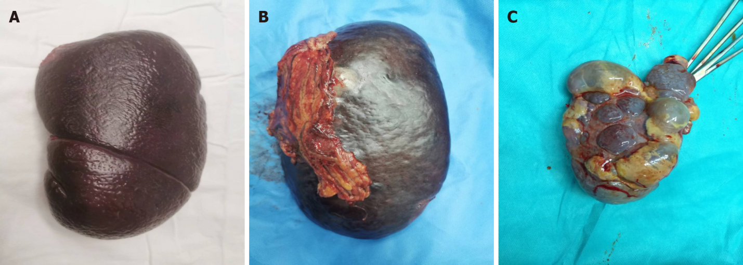
Figure 1 Situation of the spleen with/without partial splenic embolization. A: Splenomegaly without partial splenic embolization (PSE); B: Adhesion between spleen and omentum with preoperative PSE; C: Splenic infarction with preoperative PSE.

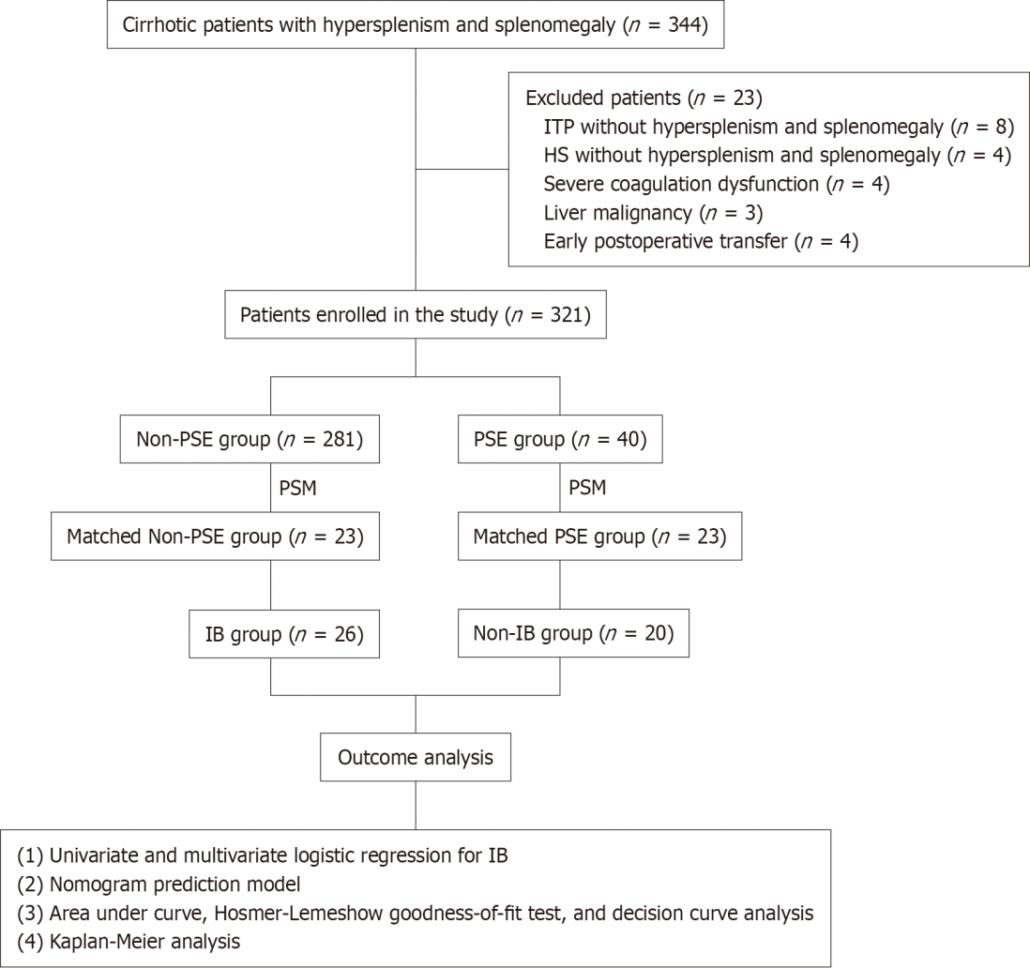
Figure 2 Classification and flow diagram of the study population. HS: Hereditary spherocytosis; IB: Intraoperative bleeding; ITP: Idiopathic thrombocytopenic purpura; PSE: Partial splenic embolization; PSM: Propensity score matching.

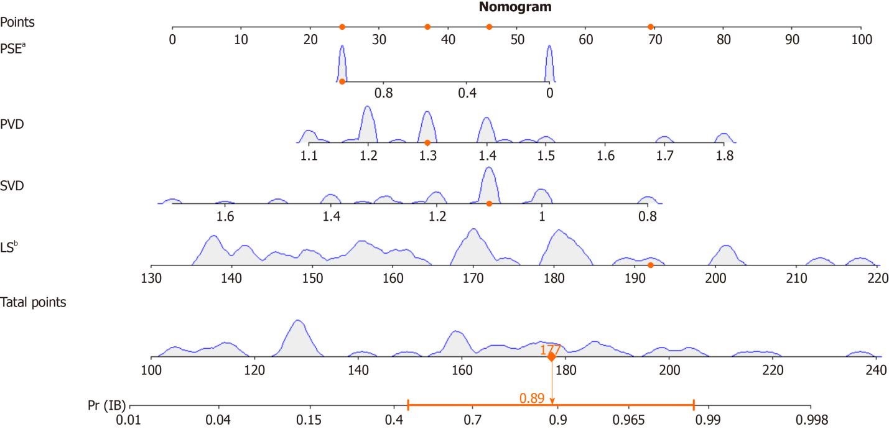
Figure 3 Nomogram predictive model for the risk of intraoperative bleeding in patients with cirrhosis and hypersplenism. The nomogram gives every predictive variable a score on the point scale. A total score was calculated by summing the points from each variable, marking the estimated probability of intraoperative bleeding occurrence in included patients. ªP < 0.05. ^{b}P < 0.01. LS: Length of the spleen; PSE: Partial splenic embolization; PVD: Portal vein diameter; SVD: Splenic vein diameter.

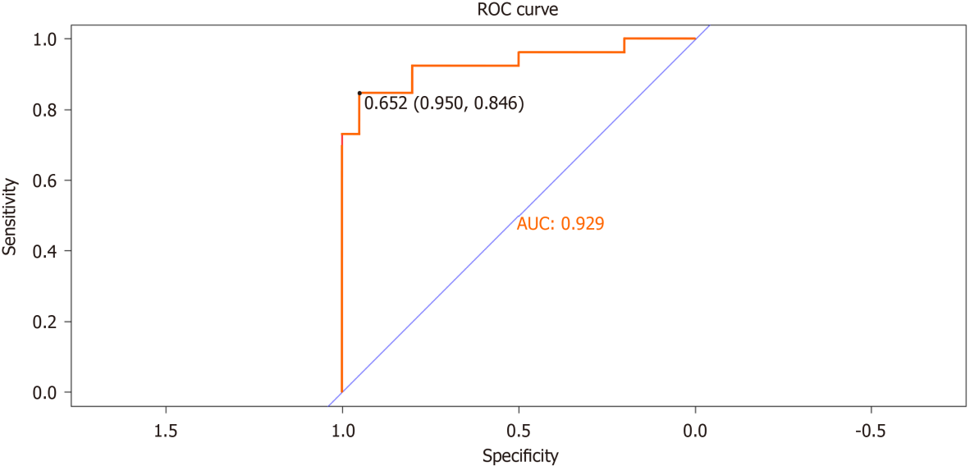
Figure 4 Discrimination of receiver operating characteristic curve curves of the nomogram model. AUC: Area under curve; ROC: Receiver operating characteristic curve.
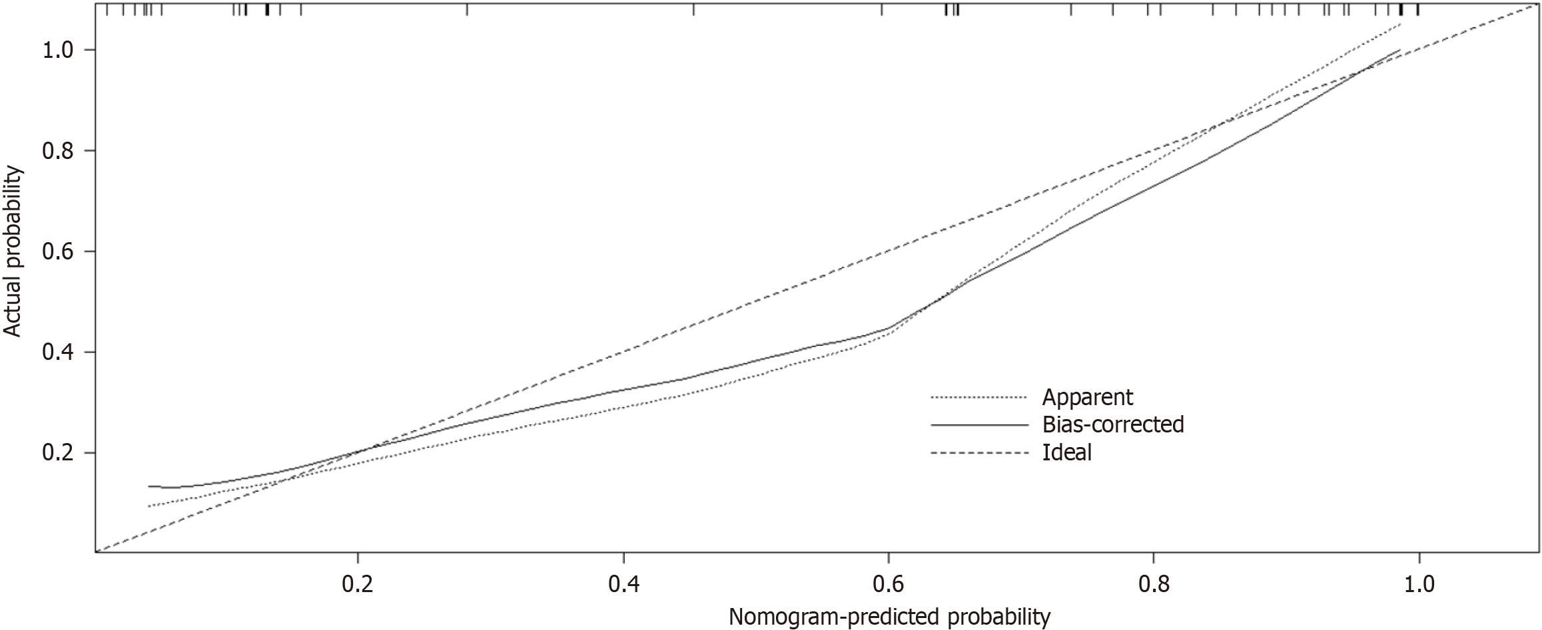
Figure 5 Nomogram calibration curve to predict the risk of intraoperative bleeding in in patients with cirrhosis and hypersplenism based on Hosmer-Lemeshow goodness-of-fit test. X-axis represents the probability of nomogram prediction of intraoperative bleeding (IB), and Y-axis represents the actual incidence of IB.

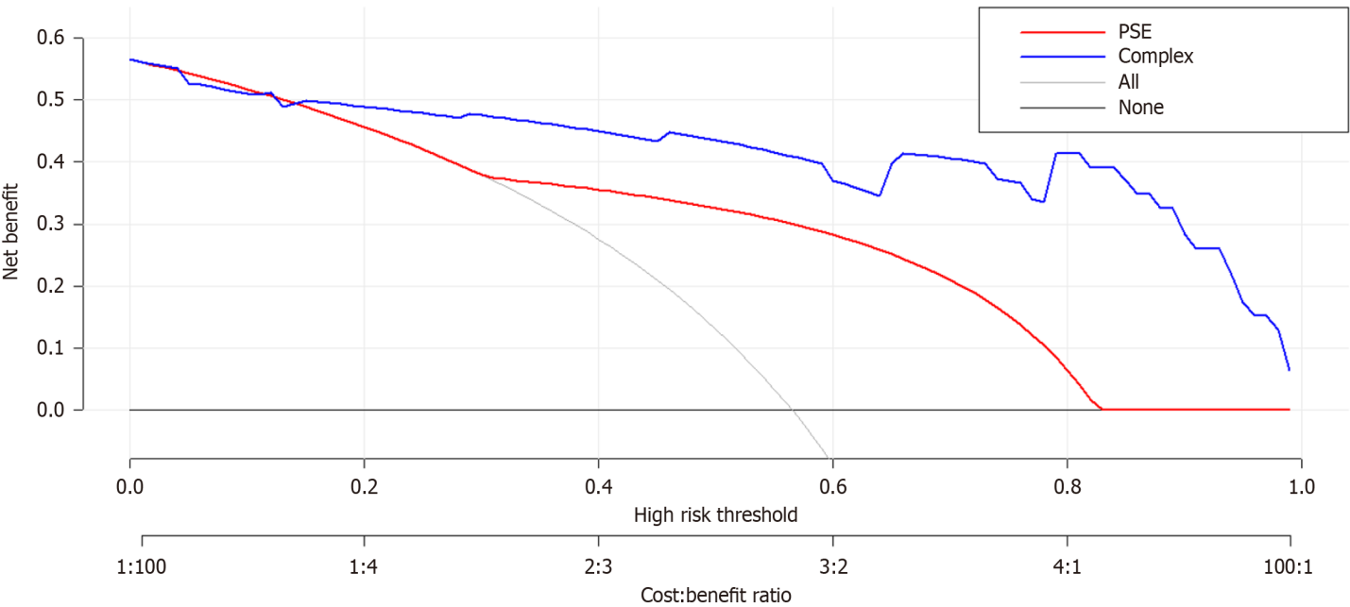
Figure 6 Nomogram decision curve analysis for intraoperative bleeding prediction in included patients. The Y-axis represents the net benefit, which was calculated as the true incidence of intraoperative bleeding minus the false-positive rate (true positive rate), the red and blue lines represent the nomogram prediction probability, and the gray line represents the extremes of intervention and non-intervention. PSE: Partial splenic embolization.

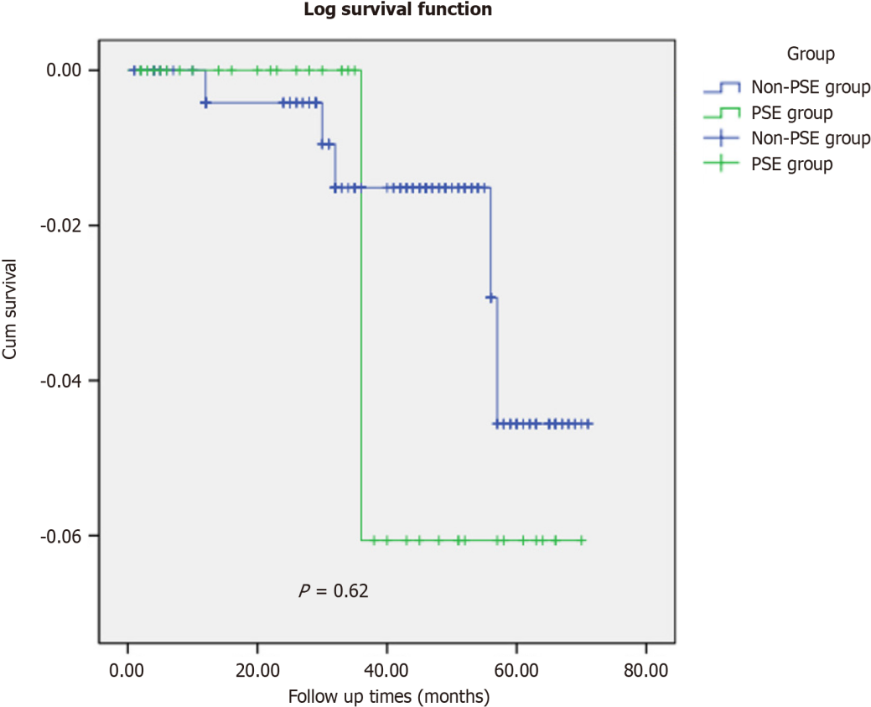
Figure 7 Overall survival data between the two groups in the follow-up. PSE: Partial splenic embolization.
Table 1 Comparison of perioperative characteristics of included patients between the two groups by propensity score matching analysis
Variables | Unmatched |  | P value | Matched |  | P value
 | PSE group, n = 40 | Non-PSE group, n = 281 |  | PSE group, n = 23 | Non-PSE group, n = 23
Age in yr | 33.95 ± 12.21 | 35.07 ± 14.74 | 0.65 | 33.57 ± 13.56 | 34.04 ± 12.23 | 0.90
Sex, n (%) |  |  | 0.12 |  |  | 0.57
Male | 17 | 156 |  | 12 | 10
Female | 23 | 125 |  | 11 | 13
Etiology of cirrhosis, n (%) |  |  | 0.88 |  |  | 0.30
HLD cirrhosis | 34 | 222 |  | 19 | 17
HBV cirrhosis | 4 | 48 |  | 3 | 4
HCV cirrhosis | 1 | 3 |  | 1 | 1
Schistosomiasis cirrhosis | 0 | 1 |  | 0 | 0
Alcoholic cirrhosis | 0 | 2 |  | 0 | 0
Autoimmunity cirrhosis | 1 | 3 |  | 0 | 1
Unknown | 0 | 1
The size of spleen in mm
Length of spleen | 161.85 ± 21.26 | 171.21 ± 26.74 | 0.04 | 170.13 ± 15.64 | 163.00 ± 25.33 | 0.26
Thickness of spleen | 66.45 ± 11.03 | 73.06 ± 16.91 | 0.02 | 69.74 ± 8.77 | 64.43 ± 15.88 | 0.17
The diameter of portal vein system in cm
Portal vein | 1.35 ± 0.16 | 1.41 ± 0.24 | 0.15 | 1.38 ± 0.19 | 1.28 ± 0.17 | 0.50
Splenic vein | 1.24 ± 0.21 | 1.23 ± 0.24 | 0.71 | 1.23 ± 0.23 | 1.13 ± 0.17 | 0.10
Preoperative blood examination
WBC as 10⁹/L | 2.69 ± 1.05 | 3.13 ± 2.08 | 0.19 | 2.51 ± 1.09 | 3.12 ± 2.44 | 0.28
RBC as 10¹²/L | 3.76 ± 0.37 | 3.91 ± 0.65 | 0.16 | 3.77 ± 0.43 | 3.58 ± 0.54 | 0.18
HGB in g/L | 106.40 ± 18.31 | 109.75 ± 18.71 | 0.29 | 103.61 ± 16.80 | 104.96 ± 15.08 | 0.75
PLT as 10⁹/L | 66.35 ± 30.04 | 50.03 ± 28.68 | 0 | 59.26 ± 29.86 | 59.04 ± 48.48 | 0.99
TBIL in μmol/L | 34.54 ± 25.58 | 22.98 ± 15.61 | 0 | 30.09 ± 26.63 | 28.14 ± 22.13 | 0.79
ALT in U/L | 30.20 ± 13.31 | 29.01 ± 17.01 | 0.67 | 28.74 ± 13.03 | 28.96 ± 21.20 | 0.97
AST in U/L | 38.00 ± 16.13 | 30.00 ± 11.44 | 0 | 33.57 ± 11.18 | 35.48 ± 17.46 | 0.66
ALB in g/L | 35.04 ± 3.42 | 37.60 ± 4.60 | 0 | 34.77 ± 3.07 | 34.98 ± 3.98 | 0.84
PT in s | 14.95 ± 3.44 | 14.70 ± 2.43 | 0.57 | 15.08 ± 3.49 | 14.30 ± 2.26 | 0.37
D-dimer in mg/L | 1.46 ± 4.28 | 0.67 ± 0.83 | 0.01 | 0.47 ± 0.26 | 0.56 ± 0.54 | 0.47
Operation, n (%)
Splenectomy only | 18 | 237 | 0 | 11 | 11 | 1
Concomitant pericardial devascularization | 22 | 44 |  | 12 | 12
Intraoperative outcomes
Intraoperative blood loss in mL | 399.50 ± 240.76 | 267.36 ± 161.07 | 0 | 450.00 ± 268.40 | 250.13 ± 129.02 | 0
Operation time in min | 202.98 ± 36.38 | 181.64 ± 36.57 | 0.01 | 220.09 ± 35.41 | 189.78 ± 37.42 | 0.01
Postoperative complications, n (%)
PVT | 14 | 107 | 0.71 | 8 | 6 | 0.53
PPF | 6 | 27 | 0.30 | 4 | 4 | 1
Abdominal hemorrhage | 3 | 6 | 0.06 | 2 | 3 | 0.65
Hospital stay in d | 17.10 ± 4.42 | 13.99 ± 3.57 | 0 | 16.70 ± 4.18 | 13.52 ± 2.25 | 0
ALB: Albumin; ALT: Alanine aminotransferase; AST: Aspartate aminotransferase; HBV: Hepatitis B virus; HCV: Hepatitis C virus; HGB: Hemoglobin; HLD: Hepatolenticular degeneration; PLT: Platelet; PPF: Postoperative pancreatic fistula; PSE: Partial splenic embolization; PSM: Propensity score matching; PT: Prothrombin time; PVT: Portal vein thrombosis; RBC: Red blood cell; TBIL: Total bilirubin; WBC: White blood cell.

Table 2 Demographic and preoperative clinical characteristics between pre-/post-propensity score matching
Variables | Groups |  | t | P value
 | Pre-PSE group, n = 40 | Post-PSE group, n = 40
Frequency | 1.50 ± 0.82
Time from last PSE to surgery in mo | 5.03 ± 9.53
The size of spleen in mm
Length of spleen | 171.70 ± 25.07 | 161.85 ± 21.26 | 18.28 | 0.06
Thickness of spleen | 71.45 ± 14.07 | 66.45 ± 11.03 | 7.309 | 0.08
The diameter of portal vein system in cm
Portal vein | 1.57 ± 0.16 | 1.35 ± 0.16 | 8.953 | 0
Splenic vein | 1.47 ± 0.19 | 1.24 ± 0.21 | 5.956 | 0
Preoperative blood examination
WBC as 10⁹/L | 2.87 ± 0.93 | 2.69 ± 1.05 | 3.684 | 0.40
RBC as 10¹²/L | 3.67 ± 0.23 | 3.76 ± 0.37 | 0.609 | 0.18
HGB in g/L | 119.1 ± 6.30 | 106.40 ± 18.31 | 1.071 | 0
PLT as 10⁹/L | 28.55 ± 14.29 | 66.35 ± 30.04 | 4.15 | 0
TBIL in μmol/L | 54.68 ± 16.26 | 34.54 ± 25.58 | 5.195 | 0
ALT in U/L | 58.0 ± 17.32 | 30.20 ± 13.31 | 3.378 | 0
AST in U/L | 77.15 ± 17.02 | 38.00 ± 16.13 | 8.136 | 0
ALB in g/L | 29.90 ± 1.49 | 35.04 ± 3.42 | 1.844 | 0
PT in s | 17.97 ± 1.09 | 14.95 ± 3.44 | 2.091 | 0
D-dimer in mg/L | 0.33 ± 0.12 | 1.46 ± 4.28 | 3.756 | 0.10
ALB: Albumin; ALT: Alanine aminotransferase; AST: Aspartate aminotransferase; HGB: Hemoglobin; PLT: Platelet; PSE: Partial splenic embolization; PT: Prothrombin time RBC: Red blood cell; TBIL: Total bilirubin; WBC: White blood cell.

Table 3 Risk factors of intraoperative bleeding using the uni- and multi-variate analyses
Characteristics | Univariate analysis |  |  | Multivariate analysis
 | Non-IB group, n = 20 | IB group, n = 26 | P value | β | S.E. | Wald | Odds ratio | 95%CI | P value
ALB in g/L | 36.34 ± 3.49 | 33.75 ± 3.15 | 0.01 | -0.73 | 0.42 | 2.982 | 0.482 | 0.21-1.104 | 0.08
PT in s | 13.70 ± 2.66 | 15.45 ± 2.95 | 0.04 | 0.336 | 0.34 | 3.724 | 1.94 | 0.99-3.802 | 0.05
LS in mm | 152.25 ± 13.21 | 177.58 ± 19.51 | 0 | 0.123 | 0.06 | 5.003 | 1.131 | 1.015-1.259 | 0.03
Thickness of spleen in mm | 62.10 ± 13.96 | 70.92 ± 10.92 | 0.02 | 0.095 | 0.05 | 3.216 | 1.1 | 0.991-1.221 | 0.07
PVD in cm | 1.25 ± 0.15 | 1.40 ± 0.19 | 0.01 | 18.86 | 8.64 | 4.761 | 2E + 08 | 6.806-3.516E + 15 | 0.03
SVD in cm | 1.11 ± 0.18 | 1.24 ± 0.22 | 0.04 | -20 | 9.26 | 4.658 | 0 | 0-0.16 | 0.03
PSE history, n | 0.8 ± 0.41 | 0.27 ± 0.45 | 0 | -4.44 | 2.01 | 4.863 | 0.012 | 0-0.610 | 0.03
ALB: Albumin; IB: Intraoperative bleeding; LS: The length of the spleen; PSE: Partial splenic embolization; PT: Prothrombin time; PVD: Portal vein diameter; SVD: Splenic vein diameter.

Published by Baishideng Publishing Group Inc
7041 Koll Center Parkway, Suite 160, Pleasanton, CA 94566, USA
Telephone: +1-925-3991568
E-mail: office@baishideng.com
Help Desk: https://www.f6publishing.com/helpdesk
https://www.wjgnet.com

© 2024 Baishideng Publishing Group Inc. All rights reserved.

